Supplementary Material

Supplementary figures:

C
B
A

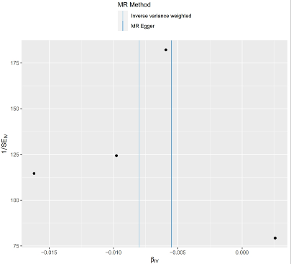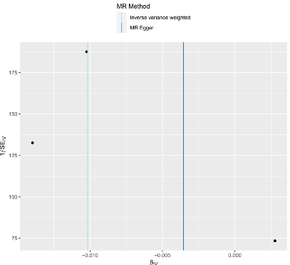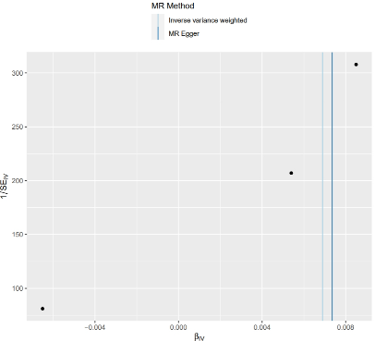
D
F
E

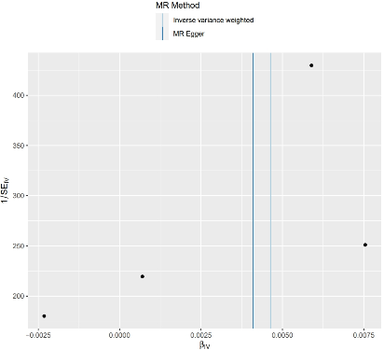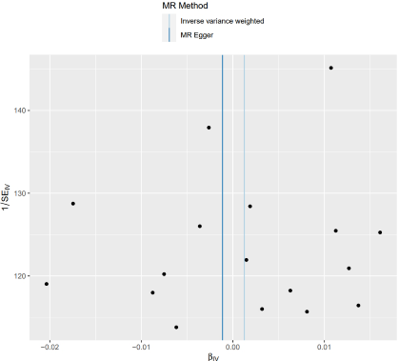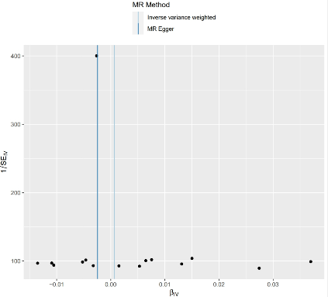
Supplementary Figure S1. Funnel plot for IVW and MR-Egger method. (A) Unswitched memory B cell % lymphocyte and PCa; (B) CD24+ CD27+ B cell %lymphocyte and PCa; (C)CD62L- monocytes Absolute Count and PCa; (D) CD62L− monocyte %monocyte and PCa.（E）CMPF levels and PCa; (F)SA ratio and PCa.

C
B
A

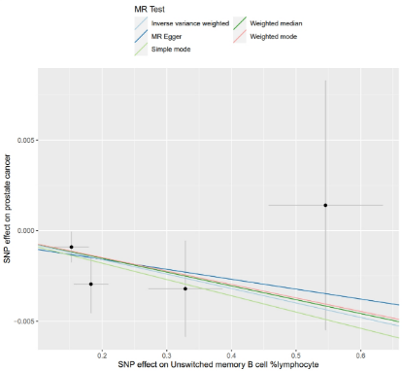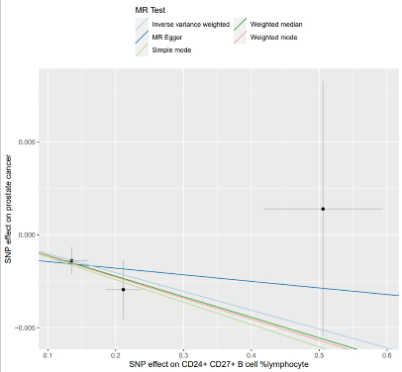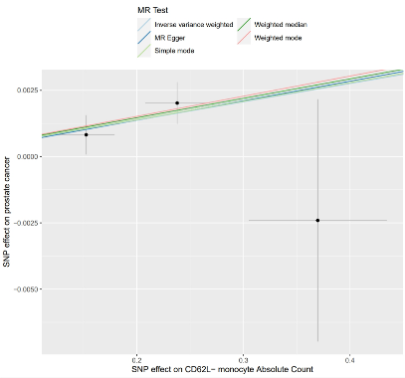
E
F
D

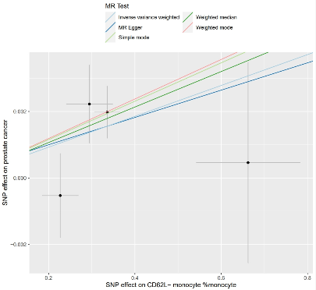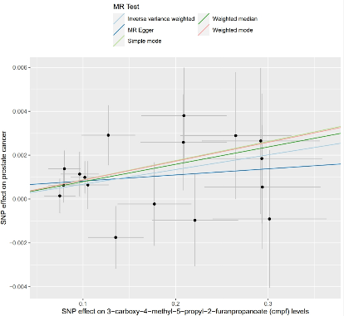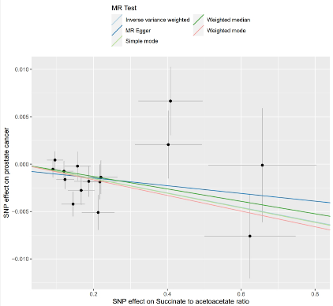

Supplementary Figure S2. Scatter plot using all IVs. (A) Unswitched memory B cell % lymphocyte and PCa; (B) CD24+ CD27+ B cell %lymphocyte and PCa; (C)CD62L- monocytes Absolute Count and PCa; (D) CD62L− monocyte %monocyte and PCa.（E）CMPF levels and PCa; (F)SA ratio and PCa.

C
B
A

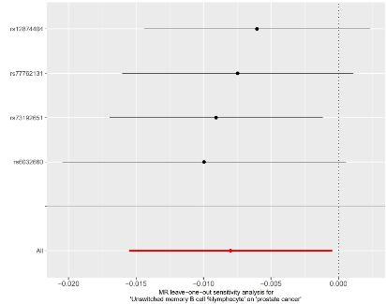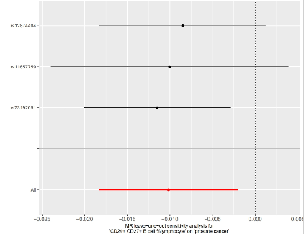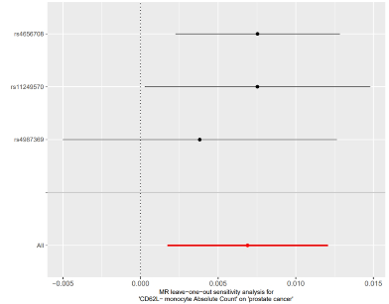
F
E`
D

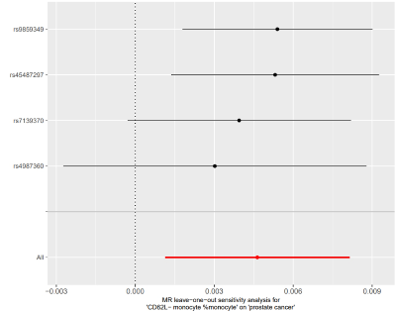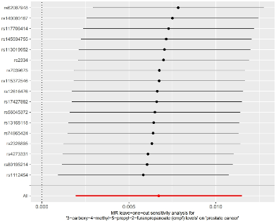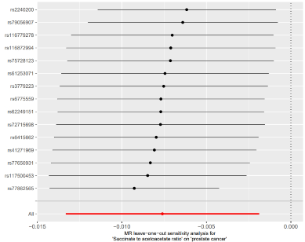
F

Supplementary Figure S3. Leave-one-out sensitivity analysis. (A) Unswitched memory B cell % lymphocyte and PCa; (B) CD24+ CD27+ B cell %lymphocyte and PCa; (C)CD62L- monocytes Absolute Count and PCa; (D) CD62L− monocyte %monocyte and PCa.（E）CMPF levels and PCa; (F)SA ratio and PCa.

Supplementary tables:

Supplementary Table 1: Genetic Variants (n=4) of the unswitched memory B cell % lymphocyte used in MR analyses.
SNPs | Effect allele | Other allele | Beta | Se | pval | F
rs12874404 | G | A | 0.1827 | 0.02625 | 4.02E-12
  48.4
rs6032660 | A | G | -0.1525 | 0.02629 | 7.20E-09
  33.6
rs73192651 | T | C | 0.5455 | 0.08807 | 6.54E-10
  38.1
rs77762131 | C | G | 0.3287 | 0.05701 | 8.75E-09
  33.2

Supplementary Table 2: Genetic Variants (n=3) of the CD24+ CD27+ B cell %lymphocyte used in MR analyses.
SNPs | Effect allele | Other allele | Beta | Se | pval | F
rs11657759 | C | A | -0.1352 | 0.02397 | 1.81E-08 | 31.8
rs12874404 | G | A | 0.2114 | 0.02614 | 8.09E-16 | 65.4
rs73192651 | T | C | 0.5056 | 0.08768 | 8.75E-09 | 33.2

Supplementary Table 3: Genetic Variants (n=3) of the CD62L- monocytes Absolute Count used in MR analyses.
SNPs | Effect allele | Other allele | Beta | Se | pval | F
rs11249570 | G | A | -0.1525 | 0.02632 | 7.66E-09
  33.5
rs4656708 | A | G | -0.3696 | 0.0647 | 1.22E-08 | 32.6
rs4987369 | T | C | 0.2378 | 0.03006 | 3.61E-15 | 62.5

Supplementary Table 4: Genetic Variants (n=4) of the CD62L− monocyte %monocyte used in MR analyses.
SNPs | Effect allele | Other allele | Beta | Se | pval | F
rs45487297 | A | T | 0.6623 | 0.1201 | 3.74E-08 | 30.4
rs4987360 | G | A | 0.3359 | 0.02969 | 4.37E-29 | 29.9
rs7139370 | T | C | 0.2947 | 0.0539 | 4.96E-08 | 29.3
rs9859349 | A | G | 0.227 | 0.04151 | 4.89E-08 | 127.9

Supplementary Table 5: Genetic Variants (n=17) of the CMPF levels used in MR analyses.
SNPs | Effect allele | Other allele | Beta | Se | pval | F
rs1112454 | G | A | -0.12734 | 0.028608 | 8.54E-06 | 19.8
rs113019952 | C | G | 0.293771 | 0.064768 | 2.77E-06 | 32.0
rs115372546 | T | G | -0.29314 | 0.016541 | 6.01E-06 | 20.5
rs117706414 | A | G | 0.301408 | 0.046631 | 9.34E-07 | 24.1
rs12616476 | G | A | 0.078854 | 0.039642 | 1.87E-06
  22.7
rs13168118 | C | A | -0.09637 | 0.017252 | 2.56E-06
  22.1
rs140080167 | T | G | -0.22091 | 0.020491 | 1.97E-06
  22.6
rs145934755 | C | A | -0.17707 | 0.015076 | 7.94E-06
  20.0
rs17427882 | T | G | 0.291915 | 0.05987 | 4.03E-06
  21.2
rs2328895 | T | C | -0.10198 | 0.063324 | 1.34E-11
  45.7
rs2334 | G | T | -0.07491 | 0.062671 | 6.34E-06
  20.4
rs4273331 | C | T | -0.07994 | 0.016591 | 3.60E-06
  21.5
rs56045372 | A | C | -0.26501 | 0.046445 | 9.58E-06
  19.6
rs62087948 | G | A | -0.13529 | 0.022344 | 6.23E-06
  20.4
rs7039675 | T | C | 0.105252 | 0.04575 | 2.47E-06
  22.2
rs74965424 | T | C | 0.208477 | 0.06145 | 7.79E-06
  20.0
rs80195214 | C | T | -0.20896 | 0.029942 | 4.94E-06
  20.9

Supplementary Table 6: Genetic Variants (n=15) of the SA ratio used in MR analyses.
SNPs | Effect allele | Other allele | Beta | Se | pval | F
rs116779278 | T | C | -0.16638 | 0.0358025 | 3.37E-06
  21.6
rs116872994 | G | A | -0.62369 | 0.122835 | 3.83E-07
  25.8
rs117500453 | T | C | 0.402341 | 0.0906746 | 9.11E-06
  19.7
rs2240200 | C | T | -0.14439 | 0.0312582 | 3.85E-06
  21.3
rs3779223 | G | C | 0.217037 | 0.0463806 | 2.88E-06 | 21.9
rs41271969 | T | C | -0.65718 | 0.146503 | 7.27E-06 | 20.1
rs61253071 | C | G | -0.18696 | 0.0398307 | 2.68E-06 | 22.0
rs62249151 | T | G | -0.08968 | 0.0201465 | 8.54E-06 | 19.8
rs6415662 | T | A | -0.15631 | 0.0350569 | 8.24E-06 | 19.9
rs6775559 | A | C | 0.119612 | 0.0249517 | 1.64E-06 | 23.0
rs72715698 | T | C | 0.219753 | 0.0442095 | 6.67E-07 | 24.8
rs75728123 | G | A | -0.12261 | 0.0234446 | 1.70E-07 | 27.3
rs77650931 | G | A | 0.09537 | 0.0214578 | 8.81E-06 | 19.7
rs77862565 | A | G | -0.40832 | 0.0866827 | 2.47E-06 | 22.2
rs79056907 | A | C | 0.212223 | 0.0440854 | 1.48E-06 | 23.2

Supplementary Table 7: Mediating roles of metabolites between immune cells and PCa.
Exposure | Outcome | Mediator  (metabolitesl) | Mediation effect  OR (95% CI) | Total effect  OR (95% CI) | Direct effect | indirect.product.1 | indirect.product.2 | Proportion (%)
CD62L- monocyte %monocyte | Prostate cancer | Succinate to acetoacetate ratio | 0.00077(-0.00755~ 0.00909) | 1.005(1.001~ 1.008) | 0.856 | -0.101 | -0.008 | 16.6%

