Supplementary Information

Systematic Design and Evaluation of Aptamers for Specific Detection of VEGF and PLGF Biomarkers of Preeclampsia

Samavath Mallawarachchi^{a,†}, Rümeysa E. Cebecioglu^{b,†}, Majed Althumayri^{d,e,†}, Levent Beker^{c}, Sandun Fernandoª, Hatice Ceylan Koydemir*^{d e}

ª Department of Biological and Agricultural Engineering, Texas A&M University, College Station, TX 77843
^{b} Department of Biomedical Sciences and Engineering, Koç University, Rumelifeneri Yolu, Sarıyer, Istanbul, 34450 Turkey
^{c} Department of Mechanical Engineering, Koç University, Rumelifeneri Yolu, Sarıyer, Istanbul, 34450 Turkey
^{d} Department of Biomedical Engineering, Texas A&M University, College Station, TX, 77843, USA
^{e} Center for Remote Health Technologies and Systems, Texas A&M Engineering Experiment Station, College Station, TX, 77843, USA

†Contributed equally


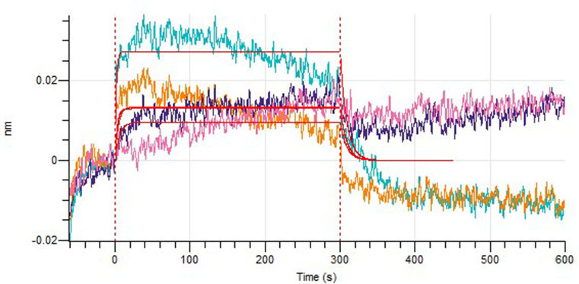
a)

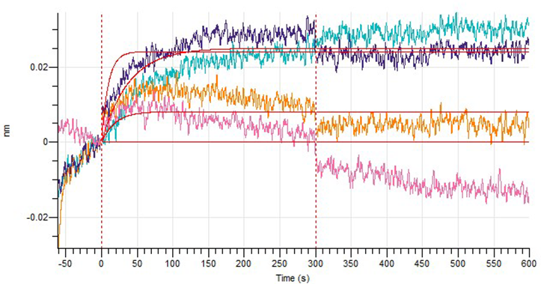

b)

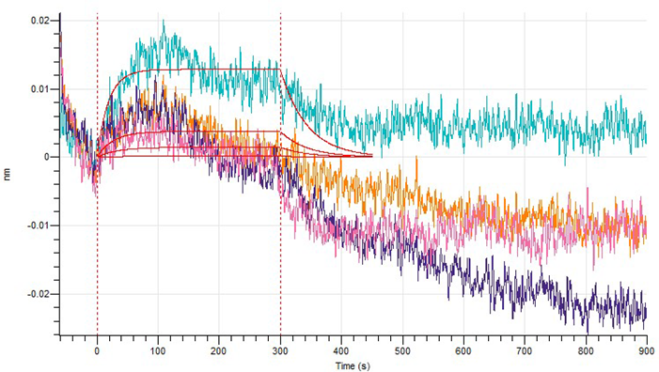

c)

Fig. S1. Association and dissociation curves for the binding of a) PlGF-Apt2, b) PlGF-Apt3, and c) PlGF-Apt4 on PlGF. Association occurs during the first 300 s, and dissociation occurs during the last 600 s.

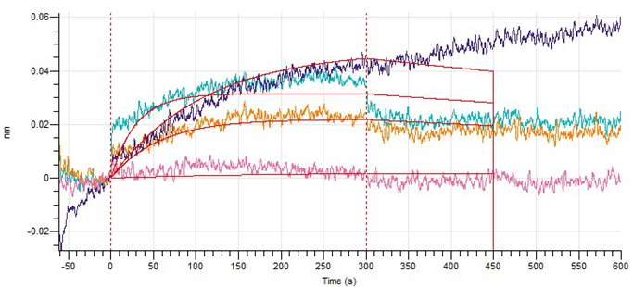

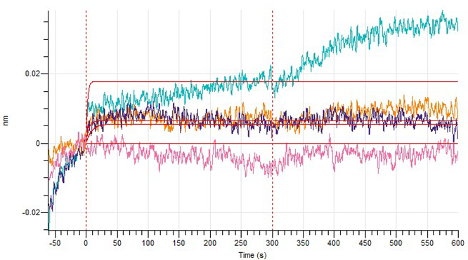

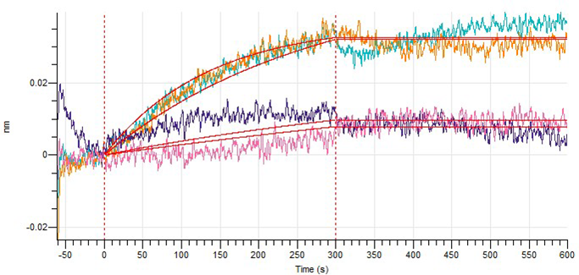

Fig. S2. Association and dissociation curves for the binding of a) VEGF-Apt1, b) VEGF-Apt2, and c) VEGF-Apt3 on VEGF. Association occurs during the first 300 s, and dissociation occurs during the last 600 s.

