Towards the Prediction of Drug Solubility in Binary Solvent Mixtures at Various Temperatures Using Machine Learning

Zeqing Bao¹, Gary Tom²³⁴, Austin Cheng²³⁴, Alán Aspuru-Guzik²³⁴⁵⁶⁷⁸⁹, Christine Allen¹⁶⁹*

¹Leslie Dan Faculty of Pharmacy, University of Toronto, Toronto, ON M5S 3M2, Canada
²Department of Chemistry, University of Toronto, Toronto, ON M5S 3H6, Canada
³Department of Computer Science, University of Toronto, Toronto, ON M5S 2E4, Canada
⁴Vector Institute for Artificial Intelligence, Toronto, ON M5S 1M1, Canada
⁵Lebovic Fellow, Canadian Institute for Advanced Research (CIFAR), Toronto, ON M5S 1M1, Canada
⁶Department of Chemical Engineering & Applied Chemistry, University of Toronto, Toronto, ON M5S 3E5, Canada
⁷Department of Materials Science & Engineering, University of Toronto, Toronto, ON M5S 3E4, Canada
⁸CIFAR Artificial Intelligence Research Chair, Vector Institute, Toronto, ON M5S 1M1, Canada
⁹Acceleration Consortium, Toronto, ON M5S 3H6, Canada

Corresponding author: Christine Allen (cj.allen@utoronto.ca)
Leslie Dan Faculty of Pharmacy, University of Toronto, Toronto, ON M5S 3M2, Canada

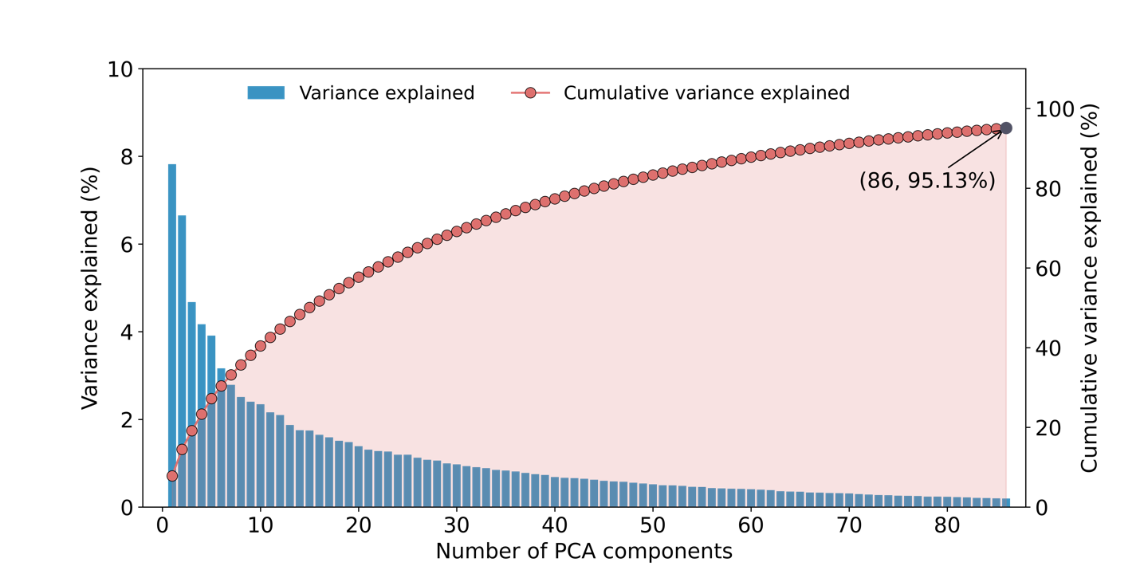
Figure S1. The graph illustrates the variance explained by principal components in a principal component analysis (PCA). Each bar represents the percentage of total variance in the dataset accounted for by an individual principal component, ordered by their significance. The cumulative percentage of variance explained is shown by the line graph with connected circles. The graph highlights that 86 principal components together explain a significant portion of the information in the dataset (>95%).

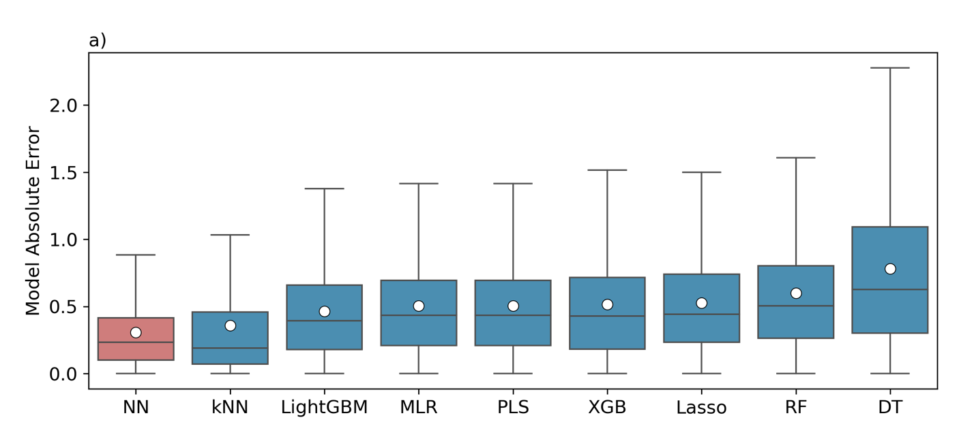
b)
 | NN | kNN | LightGBM | MLR | PLS | XGB | Lasso | RF | DT
MAE | 0.306 | 0.358 | 0.465 | 0.503 | 0.503 | 0.514 | 0.525 | 0.599 | 0.78
MedAE | 0.232 | 0.19 | 0.394 | 0.433 | 0.936 | 0.429 | 0.443 | 0.505 | 0.626
RMSE | 0.422 | 0.572 | 0.589 | 0.642 | 0.642 | 0.668 | 0.661 | 0.761 | 1.006
MSE | 0.178 | 0.327 | 0.348 | 0.413 | 0.413 | 0.447 | 0.437 | 0.579 | 1.011

Figure S2. A panel of ML models were trained using the dataset refined based on principal component analysis (86 components). (a) Illustrates the distribution of absolute errors between experimental values and predictions for nine models, based on evaluations with the test subset. Each boxplot highlights the mean absolute error (MAE) and median absolute error (MedAE) using white circles and black lines, respectively. (b) Summarizes the performance of these models using four metrics: MAE, MedAE, root mean square error (RMSE), and mean square error (MSE).

Table S1. A summary of the model hyperparameter search space.
Model | Hyperparameters
DT | {'max_depth': Integer(low=3, high=20, prior='uniform', transform='identity'), 'splitter': Categorical(categories=('best', 'random'), prior=None), 'min_samples_split': Real(low=0.01, high=0.1, prior='uniform', transform='identity'), 'min_samples_leaf': Integer(low=1, high=20, prior='uniform', transform='identity'), 'max_features': Categorical(categories=('auto', 'sqrt', 'log2'), prior=None)}
RF | {'n_estimators': Integer(low=10, high=400, prior='uniform', transform='identity'), 'max_depth': Integer(low=3, high=20, prior='uniform', transform='identity'), 'min_samples_split': Real(low=0.01, high=0.1, prior='uniform', transform='identity'), 'min_samples_leaf': Integer(low=1, high=20, prior='uniform', transform='identity'), 'max_features': Categorical(categories=('auto', 'sqrt', 'log2'), prior=None), 'bootstrap': Categorical(categories=(True, False), prior=None)}
XGB | {'n_estimators': Integer(low=10, high=400, prior='uniform', transform='identity'), 'learning_rate': Real(low=0.01, high=0.3, prior='log-uniform', transform='identity'), 'max_depth': Integer(low=3, high=20, prior='uniform', transform='identity'), 'subsample': Real(low=0.5, high=1.0, prior='uniform', transform='identity'), 'colsample_bytree': Real(low=0.5, high=1.0, prior='uniform', transform='identity'), 'gamma': Real(low=0, high=5, prior='uniform', transform='identity')}
NN | {'hidden_layer_sizes': Integer(low=2, high=64, prior='uniform', transform='identity'), 'alpha': Real(low=0.0001, high=0.1, prior='log-uniform', transform='identity'), 'learning_rate_init': Real(low=0.001, high=0.1, prior='log-uniform', transform='identity'), 'activation': Categorical(categories=('relu', 'tanh', 'logistic'), prior=None)}
LightGBM | {'num_leaves': Integer(low=10, high=400, prior='uniform', transform='identity'), 'max_depth': Integer(low=3, high=20, prior='uniform', transform='identity'), 'learning_rate': Real(low=0.01, high=0.3, prior='log-uniform', transform='identity'), 'n_estimators': Integer(low=100, high=1000, prior='uniform', transform='identity'), 'bagging_fraction': Real(low=0.5, high=1, prior='uniform', transform='identity'), 'feature_fraction': Real(low=0.5, high=1, prior='uniform', transform='identity'), 'min_child_samples': Integer(low=5, high=100, prior='uniform', transform='identity')}
MLR | {'fit_intercept': Categorical(categories=(True, False), prior=None), 'positive': Categorical(categories=(True, False), prior=None)}
Lasso | {'alpha': Real(low=0.0001, high=1, prior='log-uniform', transform='identity'), 'selection': Categorical(categories=('cyclic', 'random'), prior=None)}
kNN | {'n_neighbors': Integer(low=2, high=50, prior='uniform', transform='identity'), 'weights': Categorical(categories=('uniform', 'distance'), prior=None), 'algorithm': Categorical(categories=('auto', 'ball_tree', 'kd_tree', 'brute'), prior=None), 'leaf_size': Integer(low=10, high=100, prior='uniform', transform='identity'), 'p': Integer(low=1, high=2, prior='uniform', transform='identity')}
PLS | {'n_components': Integer(low=2, high=6, prior='uniform', transform='identity'), 'max_iter': Integer(low=250, high=1000, prior='uniform', transform='identity')}

Table S2. A summary of the optimized model hyperparameters.
Model | Best Hyperparameter
DT | {'best_estimator': DecisionTreeRegressor(max_depth=20, max_features='auto', min_samples_leaf=8,  min_samples_split=0.01, random_state=0,  splitter='random'), 'best_params': OrderedDict([('max_depth', 20), ('max_features', 'auto'), ('min_samples_leaf', 8), ('min_samples_split', 0.01), ('splitter', 'random')]), 'best_score': -0.4700293292782832}
RF | {'best_estimator': RandomForestRegressor(bootstrap=False, max_depth=18, max_features='sqrt',  min_samples_split=0.01, n_estimators=354, n_jobs=6,  random_state=0), 'best_params': OrderedDict([('bootstrap', False), ('max_depth', 18), ('max_features', 'sqrt'), ('min_samples_leaf', 1), ('min_samples_split', 0.01), ('n_estimators', 354)]), 'best_score': -0.43535884700904787}
XGB | {'best_estimator': XGBRegressor(base_score=None, booster=None, callbacks=None,  colsample_bylevel=None, colsample_bynode=None,  colsample_bytree=0.5040916758108805, early_stopping_rounds=None,  enable_categorical=False, eval_metric=None, feature_types=None,  gamma=0.0018482782618796866, gpu_id=None, grow_policy=None,  importance_type=None, interaction_constraints=None,  learning_rate=0.06702702670829803, max_bin=None,  max_cat_threshold=None, max_cat_to_onehot=None,  max_delta_step=None, max_depth=8, max_leaves=None,  min_child_weight=None, missing=nan, monotone_constraints=None,  n_estimators=400, n_jobs=6, num_parallel_tree=None, predictor=None,  random_state=0, ...), 'best_params': OrderedDict([('colsample_bytree', 0.5040916758108805), ('gamma', 0.0018482782618796866), ('learning_rate', 0.06702702670829803), ('max_depth', 8), ('n_estimators', 400), ('subsample', 0.5494224999097781)]), 'best_score': -0.3046320069044893}
NN | {'best_estimator': MLPRegressor(alpha=0.08107364178627034, hidden_layer_sizes=64,  learning_rate_init=0.013788672221631097, random_state=0), 'best_params': OrderedDict([('activation', 'relu'), ('alpha', 0.08107364178627034), ('hidden_layer_sizes', 64), ('learning_rate_init', 0.013788672221631097)]), 'best_score': -0.3546500841613265}
LightGBM | {'best_estimator': LGBMRegressor(bagging_fraction=0.5, feature_fraction=0.5,  learning_rate=0.040803979776290245, max_depth=8,  min_child_samples=100, n_estimators=674, n_jobs=6, num_leaves=400,  random_state=0), 'best_params': OrderedDict([('bagging_fraction', 0.5), ('feature_fraction', 0.5), ('learning_rate', 0.040803979776290245), ('max_depth', 8), ('min_child_samples', 100), ('n_estimators', 674), ('num_leaves', 400)]), 'best_score': -0.30810222432342665}
MLR | {'best_estimator': LinearRegression(fit_intercept=False, positive=True), 'best_params': OrderedDict([('fit_intercept', False), ('positive', True)]), 'best_score': -1.8330044483378316}
Lasso | {'best_estimator': Lasso(alpha=0.00406296567400916, selection='random'), 'best_params': OrderedDict([('alpha', 0.00406296567400916), ('selection', 'random')]), 'best_score': -0.4691269289354791}
kNN | {'best_estimator': PLSRegression(max_iter=444, n_components=6), 'best_params': OrderedDict([('max_iter', 444), ('n_components', 6)]), 'best_score': -0.5055389403105537}
PLS | {'best_estimator': KNeighborsRegressor(algorithm='ball_tree', leaf_size=10, n_jobs=6,  n_neighbors=6, p=1), 'best_params': OrderedDict([('algorithm', 'ball_tree'), ('leaf_size', 10), ('n_neighbors', 6), ('p', 1), ('weights', 'uniform')]), 'best_score': -0.3728498148103473}

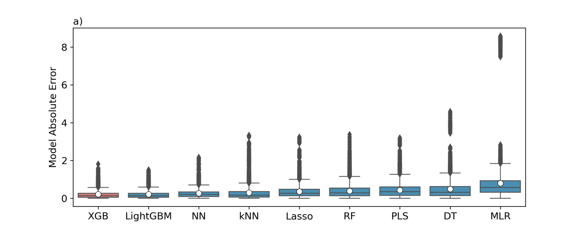

Figure S3. (a) Illustrates the distribution of absolute error between experimental values and predictions for nine models, based on evaluations with the test subset. Each boxplot highlights the mean absolute error (MAE), median absolute error (MedAE), and outliers using white circles, black lines, and black dots, respectively.

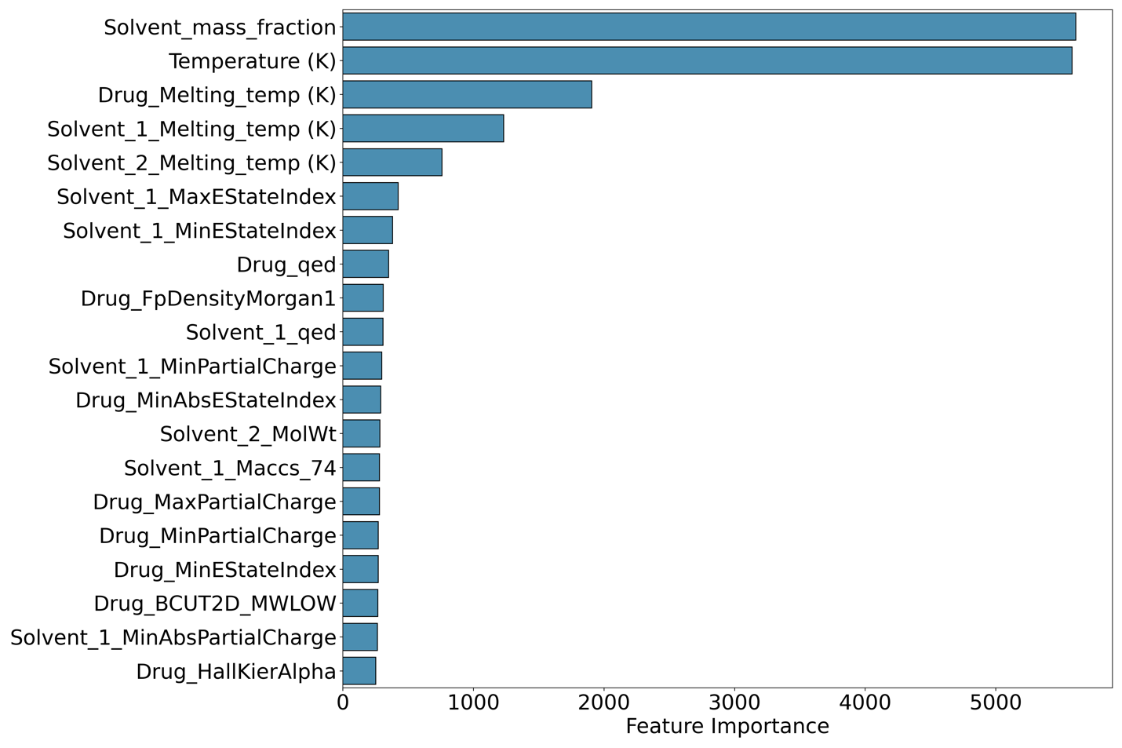
Figure S4. A summary of the ranking of the top 20 most important features identified by the XGB model, ordered by their importance from top to bottom.

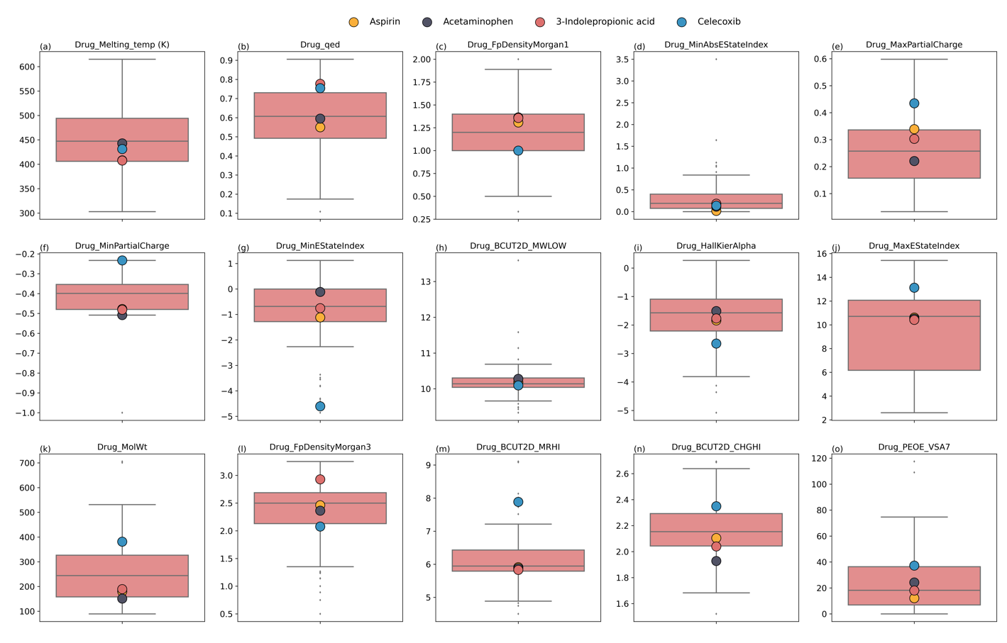
Figure S5. (a-o) Comparison of the top 15 solute features identified by the XGB model for the four compounds evaluated in the prospective study, juxtaposed against the distribution of these features across all solutes within the dataset. This includes a graphical representation to illustrate how these compounds align with or diverge from the dataset range.

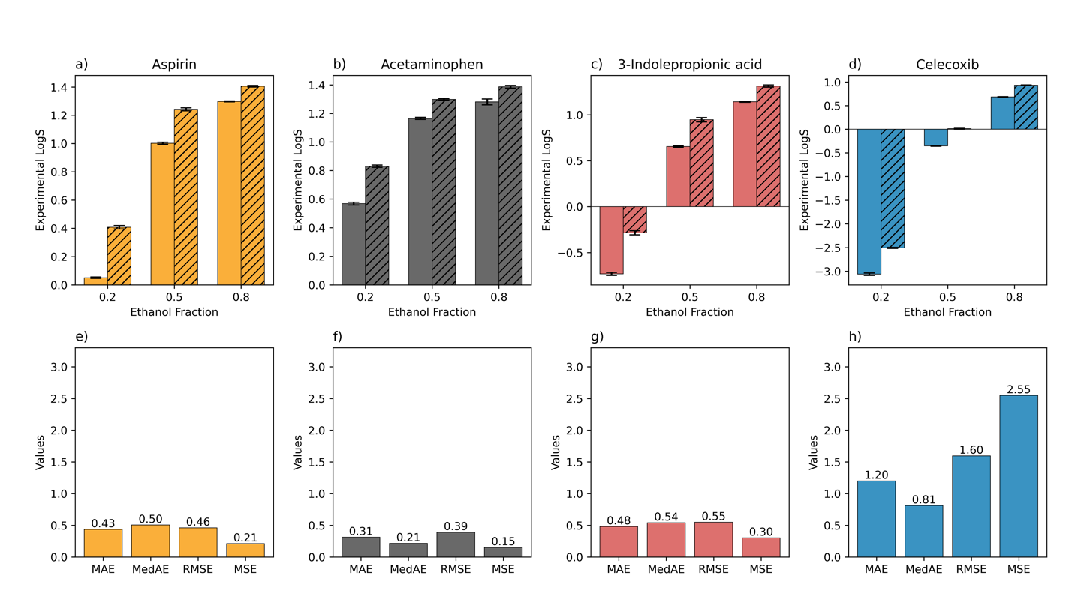
Figure S6. (a-d) The experimental solubility data for aspirin, acetaminophen, 3-indolepropinoic acid, and celecoxib across three ethanol/water mixture ratios at temperatures of 298.15 K (non-slashed bars) and 313.15 K (slashed bars). (e-h) The predictive accuracy of the LightGBM model for these solubility measurements, evaluated through various metrics including mean absolute error (MAE), median absolute error (MedAE), root mean square error (RMSE), and mean square error (MSE).
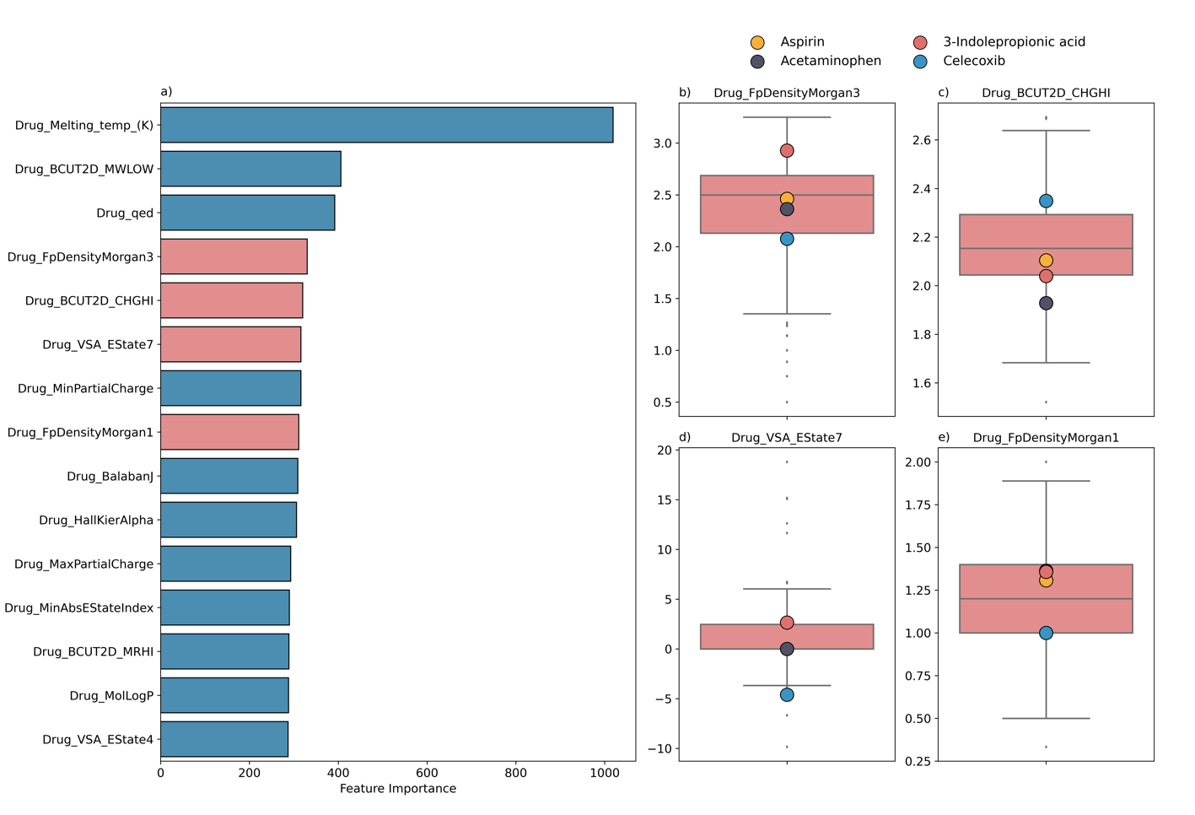
Figure S7. (a) The ranking of the top 15 most important solute features identified by the LightGBM model, ordered by their importance from top to bottom, with representative features for further analysis highlighted in red. (b-e) Comparison of the values of these features for the four compounds evaluated in the prospective study, juxtaposed against the distribution of these features across all solutes in the dataset, providing a visual depiction of their alignment or deviation from the dataset range.

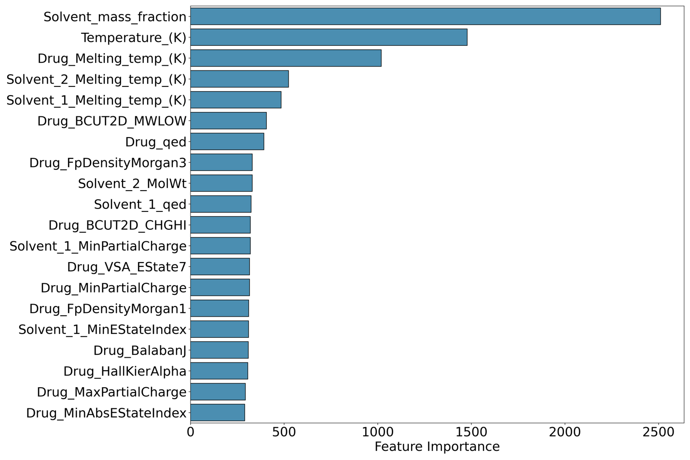
Figure S8. A summary of the ranking of the top 20 most important features identified by the LightGBM model, ordered by their importance from top to bottom.

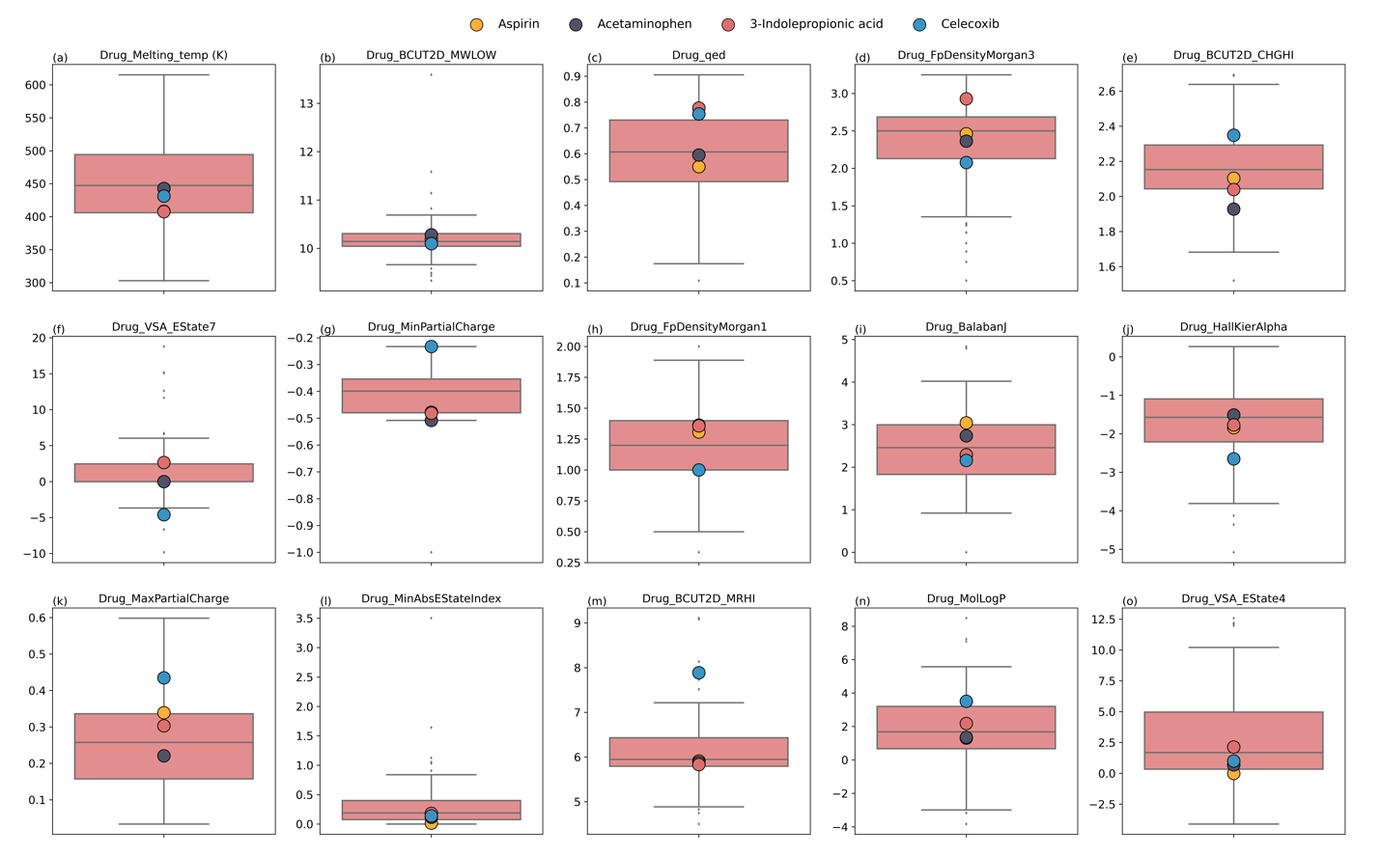
Figure S9. (a-o) Comparison of the top 15 solute features identified by the LightGBM model for the four compounds evaluated in the prospective study, juxtaposed against the distribution of these features across all solutes within the dataset. This includes a graphical representation to illustrate how these compounds align with or diverge from the dataset range.

Table S3. HPLC parameters, including mobile phases, column temperatures, flowrates, and detection wavelengths, for the quantification of aspirin (ASA), acetaminophen (ACM), 3-indolepropionic acid (IPA), and celecoxib (CXB).
Compound | ASA | ACM | IPA | CXB
Mobile phase A | Water  (0.1% TFA) | Water  (50 mM ammonium acetate, pH=4) | Water  (0.1% TFA) | Water
Mobile phase B | ACN  (0.1% TFA) | ACN | ACN  (0.1% TFA) | MeOH
Mobile phase ratio  (A/B, v/v) | 75/25 | 0 min: 90/10  4 min: 50/50  4.1 min: 90/10  6 min: 90/10  10 min: 90/10 | 60/40 | 20/80
Column temperature  (°C) | 30 | Room temperature | 35 | Room temperature
Flowrate  (mL/min) | 1 | 1 | 1 | 1
Detection wavelength  (nm) | 238 | 250 | 282 | 251
*The salicylic acid (resulting from ASA hydrolysis) was quantified simultaneously with ASA to account for ASA hydrolysis.

