Additional File 1

eTable 1 2
eTable 2 3
eFigure 1 4
eFigure 2a-c 5
eFigure 3 6
eFigure 4 7

eTable 1. Inclusion criteria based on SpO₂ at various FiO₂-values approximating a PaO₂/FiO₂ ratio of 20 kPa (150 mmHg).

FiO₂ | SpO₂
0.40 | ≤ 90%
0.45 | ≤ 92%
0.50 | ≤ 94%
0.55 | ≤ 96%
0.60 | ≤ 98%

eTable 2. Interim analysis criteria for early trial termination.
Criteria | Definition
Futility | Lack of effect or lack of patients fulfilling the inclusion criteria
Safety | Unexpected increase in the rate of intubation in the intervention group or increased occurrence of severe or unexpected adverse events.
Efficacy | If the reduction in the rate of intubation is more than 40%

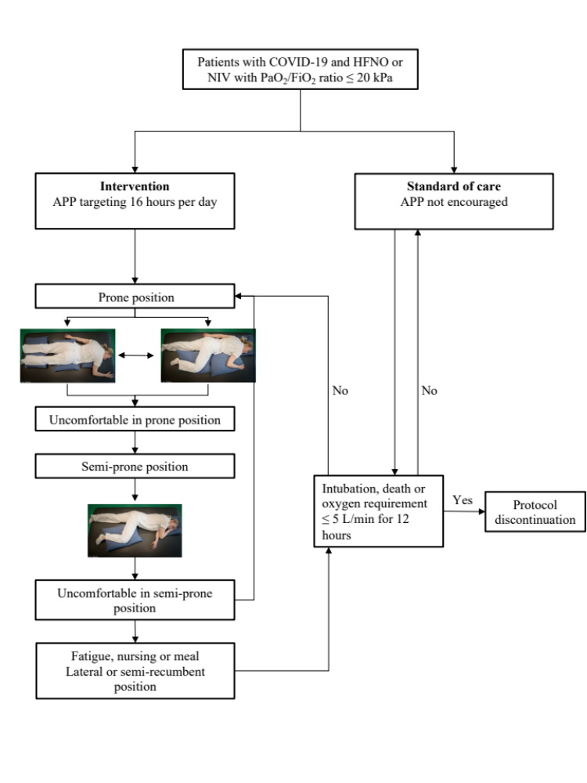
eFigure 1. Trial protocol flow-chart.

COVID-19: Coronavirus disease 2019. HFNO: High-flow nasal oxygen. APP: Awake prone positioning.

eFigure 2a-c. Trial definitions of prone and semi-prone position.

eFigure 2a. Prone position version 1.
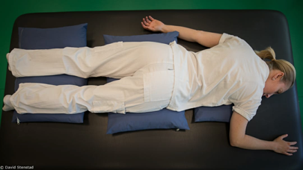

eFigure 2b. Prone position version 2.
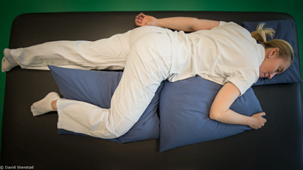

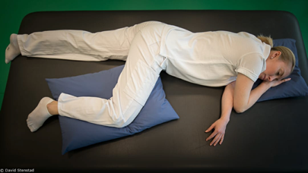
eFigure 2c. Semi-prone position.

eFigure 3. Results of the exploratory analysis of patients with shorter (n=26) than 3 hours or longer (n=26) than 9 h duration of awake prone positioning irrespective of group allocation presented as Kaplan-Meier graphs.

eFigure 4. Results of the exploratory analysis of patients in the control group (n=13) and prone group (n=14) with PaO2/FiO2 ratio ≤ 15 kPa presented as Kaplan-Meier graphs.

