Appendix 1 – specific calibration of TDM and correction factors
In this study, the sap flow density (J_{s}, gH2O m⁻²s⁻¹; Granier, 1985; 1987; Lu et al., 2003) is written as:
$J_{s}=aK^{b}$ (A1.1)
where a and b were locally calibrated (Rana et al., 2019) by measuring J as:
$J_{m}=\frac{{Tr}/{Dp}}{\overline{SWA}}$ (A1.2)
with Tr the actual transpiration (kgH2O m⁻²) at plot scale, Dp the plant density (tree m⁻²) and $\overline{SWA}$ the average sapwood area of the gauged trees at height of measurement.
Tr was determined by partitioning actual evapotranspiration measured by eddy covariance (EC) method in the peach field in soil nonstomatal evaporation and stomatal transpiration. The partitioning was carried out in the period 1 – 14 May 2021, when the mulching strips were not yet present on the field, using the flux-variance similarity method (Scanlon and Sahu, 2008; Scanlon and Kustas, 2010; Palatella et al., 2014; Sulman et al., 2016). The “fluxpart” software (Skaggs et al., 2018) was used in the present study.
The EC equipment was placed at 1.2 m above the top of the canopy (2.7 m height); all sensors were used as described in Rana et al. (2019). Micrometeorological measurements were taken every 0.1 s (10 Hz) by a data logger (MeteoFlux, Servizi Territorio, S.n.c., Cinisello Balsamo, Italy) and recorded as 60-min averages.
The calibration curve is obtained plotting the J_{sm} (Eq. A1.2) vs the K values; the obtained a and b values (Figure A1.1) are 155 and 1.307, respectively.
Following Ferrara et al. (2023; 2024) the sap flow flux density measured in each sampled tree is calculated as:
$J_{s}=C_{a}a{\left(C_{w}K\right)}^{b}$ (A1.3)
where C_{w} is the correction coefficient the effect of wounds (Wiedemann et al., 2016); C_{a} is the correction coefficient for the azimuthal variations of mass sap flow density (Shinohara et al., 2013). To account for radial gradient in sap flow density from the youngest to oldest channels through sapwood area, sapwood depth of each sampled tree was divided in a set of 20 mm increments and a Gaussian function was applied to estimate the sap flux density in each increment as suggested by Pataki et al. (2011) for gymnosperms and verified in the field:
$J_{si}=1.257J_{i}exp\left[-0.5{\left(\frac{x+0.3724}{0.662}\right)}^{2}\right]$ (A1.4)
where J_{si} is the sap flux density in each increment i, x is the normalized depth of each sapwood increment (0 ≤ x< 1) and J_{si} is calculated using Eq. (A1.3).
The assessment of above-mentioned corrections was performed in the period June-August 2023. For the wounds effect correction, a couple of TDM probes (30 mm) were installed in parallel to the already measuring probes (installed at the beginning of trial in 2023) in two trees, with the procedure of the already installed ones. Hence, since the wound effect is due to the probe insertion in the trunk and then, affects the measured ΔT, correction is limited to the K parameter and was found equal to C_{w}=1.15.
The azimuthal variations of sap flux density were analysed in two sampled trees, by adding two couples of TDM probes (30 mm) at 120° and 240°. To extrapolate sap flux density in the north direction, using the north sensor as a reference to the three integrated directions (averaged over the three directions). Hence, the correction coefficient is calculated as the ratio of the mean sap flux density in the three directions to sap flux density in the north direction and was found equal to C_{a}=1.27.
Furthermore, to validate the used function (Eq. 1.4) over the active sapwood (Rana et al., 2019), two new sets of TDM probe, of 20- and 10-mm length respectively, were installed in parallel in three sampled trees, at the same height and 20 mm from the other ones. From the sap flow density measured from the couple of probes the Ji values in the layer 10–20 mm of the sapwood depth was derived according to Iida and Tanaka (2010) as follows:
$J_{s 10-20}=\frac{J_{s 0-20}-αJ_{s 0-10}}{β}$ (A1.5)
where α and β are the proportions of the sapwood area from depths of 0–10 mm to that of 0–20 mm, and from depths of 10–20 mm to that of 0–20 mm, respectively. The result of this validation is reported in Figure A1.2.

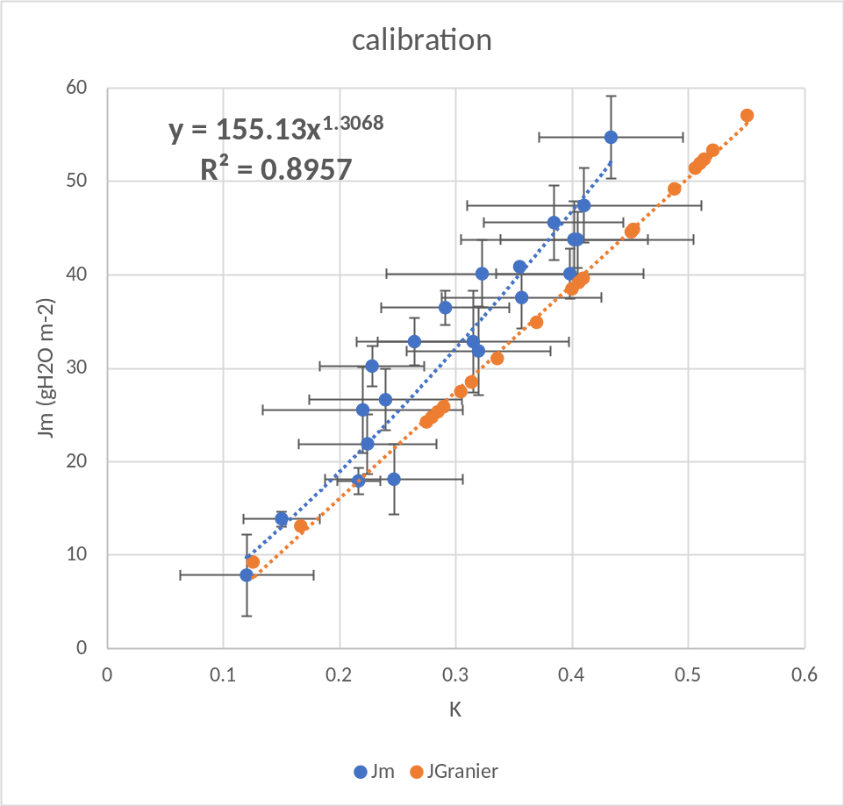
Figure A.1 Relationship between mean hourly values of the flow index (K), measured by TD probes J_{m} determined through Eq. (A1.2). The orange line represents the equation proposed by Granier.

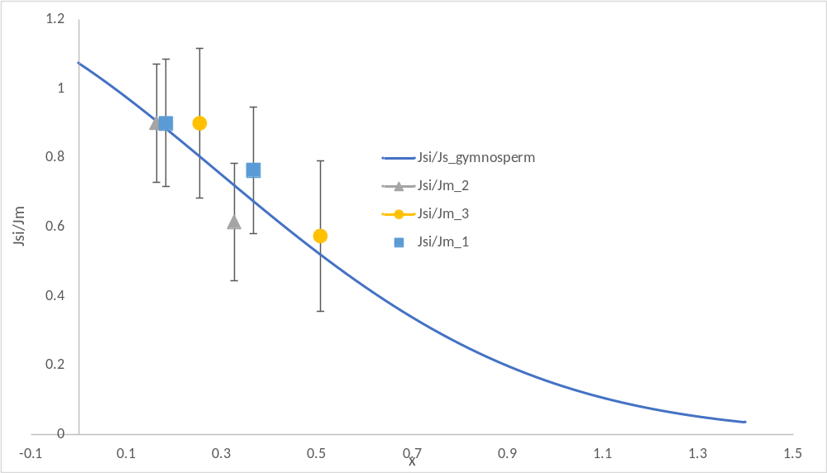
Figure A.2 Sap flow density ratio (Js/Jm ) in the three sampled trees in the two layers of 0-10 and 10-20 mm vs the normalized depth of each sapwood increment (x).

