Title: Dexamethasone reduces cisplatin-induced ototoxicity by inducing cisplatin resistance through metallothionein-2

Supplementary Figures and Tables
Supplementary Table S1. List of primers used for quantitative RT-PCR.
Gene | Primer sequence (5′ to 3′)
mt2 | Forward: | AATGGACCCCTGCGAAT
mt2 | Reverse: | GGTAGCACCACAGTTGCAA
β-actin | Forward: | GAGGCTCTCTTCCAGCCTTC
β-actin | Reverse: | CGGATGTCCACGTCGCACT
RT-PCR program included 95°C for 30 sec, followed by 40 cycles of 5 sec at 95°C plus 30 s at 60°C using the above primers. Gene expression was normalized to β-actin.

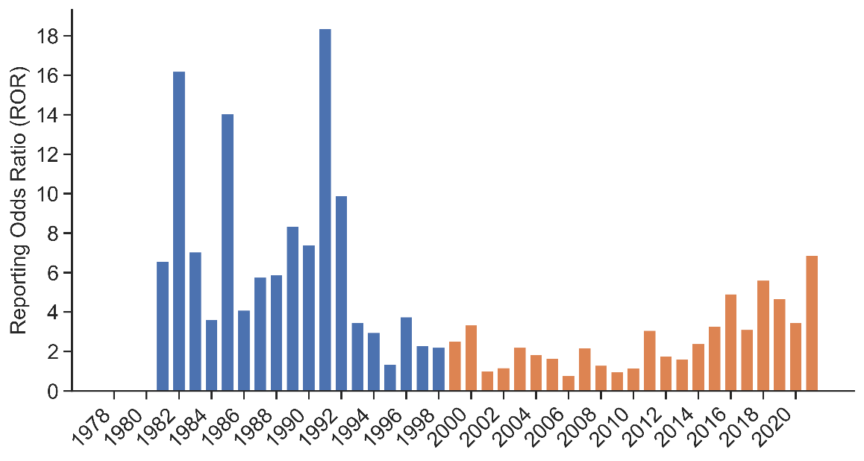
Supplementary Fig. S1. Chronological trend of ROR in CDDP-induced ototoxicity. Before and after the ASCO guidelines, in which DEX was first recommended as antiemetic therapy for cancer patients in 1999, and ototoxicity in patients receiving CDDP decreased.

Supplementary Table S2. List of the oligonucleotides used in the CRISPR/Cas9 system.
crRNA | Sequence of crRNA and tracrRNA (5′ to 3′)
mt2-crRNA | UACUCUUGGCACAUUCGCAGguuuuagagcuaugcuguuuug
tyr-crRNA | UGUCCAGUCUGGCCCGGCGAguuuuagagcuaugcuguuuug
tracrRNA | aaacagcauagcaaguuaaaauaaggcuaguccguuaucaacuugaaaaaguggcaccgagucggugcu

Supplementary Table S3. PCR primer pairs used to confirm mt2 knockout by CRISPR/Cas9.
Gene | Primer sequence (5′ to 3′) |  | Size(bp)
mt2 | Forward | TTCACAAGCTGAGTGAACGA | 249
mt2 | Reverse | TGCAGGTAGTACACTGGCAATTAG | 249

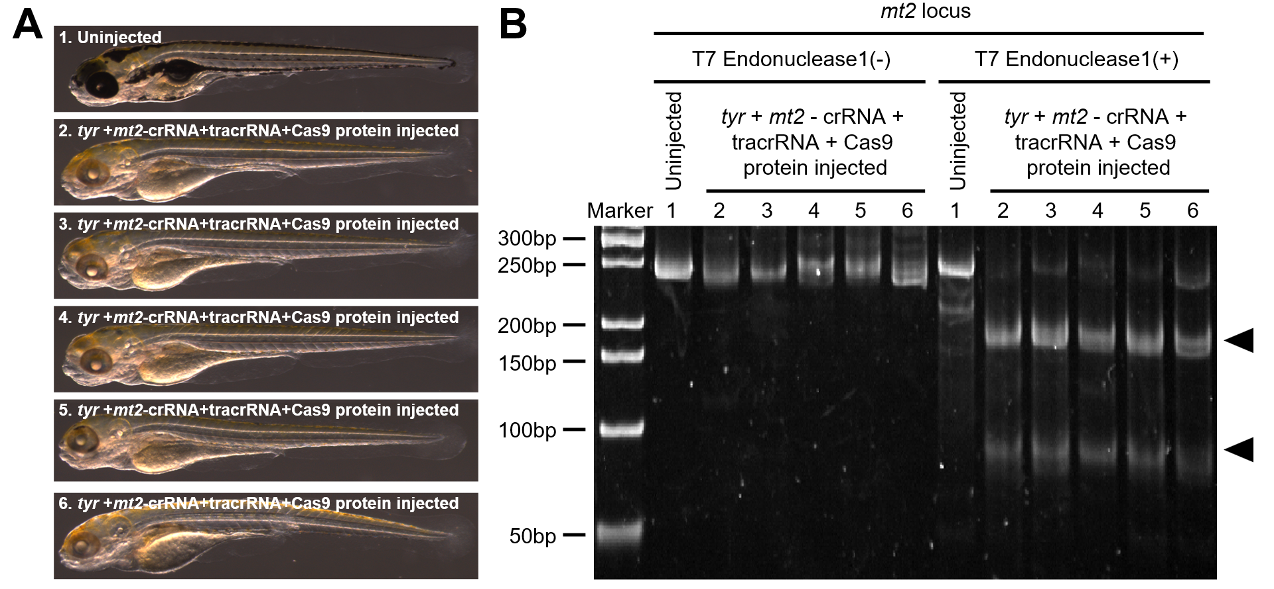

Supplementary Fig. S2 (A) gDNA was extracted from the control and each mt2 + tyr -crRNA-injected fish at 96 hpf, and an HMA assay was performed. (B) 15% polyacrylamide gel electrophoresis showing that fish injected with mt2 + tyr-crRNA contained hetero-duplex double-strand breaks.

