Methods
1. study design
China Health and Retirement Longitudinal Study (CHARLS), a survey targeting individuals aged 45 and older, along with their partners, across China. Its primary aim is to provide a high-quality, nationally representative dataset to support research on aging to health, economic status, and quality of life(1). The survey covers a wide range of topics including demographics, financial aspects, health and cognition, family dynamics, healthcare usage, employment, expectations, biomarkers, and insurance coverage. The initial CHARLS wave took place from June 2011 to March 2012, employing a stratified, multistage probability sampling method. This method first involved selecting county-level units based on various criteria, followed by household selection via a unique CHARLS-GIS mapping software. The process aimed to randomly choose one individual over 40 from each household for participation. The dataset now includes respondents from several waves, adding refreshment samples in subsequent waves to maintain demographic representation. It captures a vast array of information ranging from demographic and family details to health, income, housing, and employment, excluding non-public data.
2. Frailty assessment
The construction of the Frailty Index (FI) incorporates 32 items(2), including limitations in functionality (based on self-reported difficulties in Activities of Daily Living (ADLs), Instrumental Activities of Daily Living (IADLs), and other activities), self-assessed health status and changes, components of depressive symptoms (based on the 8-item version of the Center for Epidemiologic Studies Depression Scale), disease conditions (based on self-reported diagnoses by physicians), and cognitive status (based on a combination of external physician diagnoses and cognitive scores). These elements are derived from participants' self-reported information and objective measurements. Functional limitations are sourced from ADLs and IADL capabilities, along with other self-reported subjective activity restrictions. Self-assessed health status and its changes are gauged through participants' self-evaluation of their overall health condition. Components of depressive symptoms are extracted from the 8-item version of the Epidemiological Studies Depression Scale, encompassing eight questions that address the participants' emotional indicators over the week preceding the interview, with each question offering binary responses (yes or no). Disease conditions are extracted from self-reported diagnoses by physicians, with each wave employing a verification procedure to help participants confirm whether they were diagnosed with the condition in the previous wave. Cognitive status is measured based on a combination of self-reported diagnoses and cognitive scores.
2. MetS score assessment
In both baseline and follow-up datasets, physical examinations or blood pressure checks were conducted to assess the five Metabolic Syndrome (MetS) risk factors, including high-density lipoprotein cholesterol(HDL-C), triglycerides, fasting blood glucose, waist circumference, and mean arterial pressure. Waist circumference was measured while participants were in a seated position and at rest, using a uniform instrument for three measurements and then calculating the average. The mean arterial pressure (MAP) was calculated using the formula. Venous blood samples were collected after at least 8 hours of fasting to measure HDL, triglycerides, and fasting blood glucose levels. The specific MetS score formulas are provided in the sTable2(3).
sTable1. The 32 items used to construct the frailty index
No | Description of the items | Cut-off value
1 | Self-reported physician diagnosed hypertension | Yes = 1, No = 0
2 | Self-reported physician diagnosed diabetes | Yes = 1, No = 0
3 | Self-reported physician diagnosed heart disease | Yes = 1, No = 0
4 | Self-reported physician diagnosed stroke | Yes = 1, No = 0
5 | Self-reported physician diagnosed cancer | Yes = 1, No = 0
6 | Self-reported physician diagnosed arthritis | Yes = 1, No = 0
7 | Self-reported physician diagnosed chronic lung disease | Yes = 1, No = 0
8 | Self-reported physician diagnosed asthma | Yes = 1, No = 0
9 | Self-reported physician diagnosed any emotional, nervous, or psychiatric problems | Yes = 1, No = 0
10 | Self-reported physician diagnosed memory-related disease | Yes = 1, No = 0
11 | Self-reported vision problems | Yes = 1, No = 0
12 | Self-reported hearing problems | Yes = 1, No = 0
13 | Self-reported general health status | Poor or fair = 1, excellent, very good, or good = 0
14 | Difficulty with dressing | Yes = 1, No = 0
15 | Difficulty with bathing or showering | Yes = 1, No = 0
16 | Difficulty with eating | Yes = 1, No = 0
17 | Difficulty with getting in and out of bed | Yes = 1, No = 0
18 | Difficulty with using the toilet | Yes = 1, No = 0
19 | Difficulty with managing money | Yes = 1, No = 0
20 | Difficulty with taking medications | Yes = 1, No = 0
21 | Difficulty with shopping for groceries | Yes = 1, No = 0
22 | Difficulty with preparing meals | Yes = 1, No = 0
23 | Difficulty with doing housework | Yes = 1, No = 0
24 | Mobility: difficulty with walking 100 yards | Yes = 1, No = 0
25 | Mobility: difficulty with getting up from a chair after sitting for long periods | Yes = 1, No = 0
26 | Mobility: difficulty with climbing several flights of stairs without resting | Yes = 1, No = 0
27 | Mobility: difficulty with lifting or carrying weights over 10 pounds/jins | Yes = 1, No = 0
28 | Mobility: difficulty with picking up a coin from the table | Yes = 1, No = 0
29 | Mobility: difficulty with stooping, kneeling, or crouching | Yes = 1, No = 0
30 | Mobility: difficulty with reaching arms above shoulder level | Yes = 1, No = 0
31 | Depression: CESD-10 questionnaire | CESD-10 ≤10 =0 >10 =1
32 | Cognition: (memory test score + orientation test score) / 14 | Continuous, ranging from 0 to 1
Depression is evaluated using the Center for Epidemiologic Studies Depression Scale (CESD). In the CHARLS, CESD-10 is used, and the total score ranges from 0 to 30. The memory score is the average of words that are not recalled in the immediate and delayed word recall tasks. The memory score ranges from 0 to 10. The orientation test comprises four questions about the day of the week, the month, the date of the month, and the year. One point is given for each wrong answer, and the range is from 0 to 4.

sTable2 Age-sex-specific metabolic syndrome scoring equation
Groups | Equations
Overall | −3.1436 + 0.0258*WC + 0.361*TG-0.9348*HDL-C + 0.0128*MAP + 0.1224*FBG
Male
<60 | −2.9092 + 0.0262*WC + 0.3098*TG-0.944*HDL-C + 0.0097*MAP + 0.0745*FBG
≥60 | −2.3741 + 0.0264*WC + 0.4933*TG-0.999*HDL-C + 0.0054*MAP + 0.0821*FBG
Female
<60 | −2.4981 + 0.0199*WC + 0.5218*TG-0.8616*HDL-C + 0.0110*MAP + 0.1074*FBG
≥60 | −0.5682 + 0.0153*WC + 0.4587*TG-1.3567*HDL-C + 0.0036*MAP + 0.0688*FBG
Abbreviations: FBG fasting blood glucose (mmol/L), HDL-C high-density lipoprotein cholesterol (mmol/L), MAP mean arterial pressure (mmHg), TG triglycerides (mmol/L), WC waist circumference (cm).

sTable3 Baseline Characteristics of the Study Population by Quartiles of MetS score (including participants with baseline frailty)
 |  | Quartiles of MetS score
Characteristic | Overall | Q1 | Q2 | Q3 | Q4 | p-value
N | 7,915 | 1993 | 1973 | 1972 | 1977
Age, mean (SD), y | 59.10 (9.19) | 59.36 (9.28) | 58.73 (9.50) | 59.14 (9.13) | 59.18 (8.82) | 0.037
Age, n(%) |  |  |  |  |  | 0.015
<60 | 4,411 (55.7) | 1,110 (55.7) | 1,158 (58.7) | 1,072 (54.4) | 1,071 (54.2)
≥60 | 3,504 (44.3) | 883 (44.3) | 815 (41.3) | 900 (45.6) | 906 (45.8)
Female, n(%) | 4,208 (53.2) | 724 (36.3) | 1,035 (52.5) | 1,126 (57.1) | 1,323 (66.9) | <0.001
Residence, n(%) |  |  |  |  |  | <0.001
Urban | 2,799 (35.4) | 523 (26.2) | 642 (32.5) | 754 (38.2) | 880 (44.5)
Rural | 5,116 (64.6) | 1,470 (73.8) | 1,331 (67.5) | 1,218 (61.8) | 1,097 (55.5)
Educational level, n(%) |  |  |  |  |  | 0.8
Below high school | 7,161 (90.5) | 1,809 (90.8) | 1,788 (90.6) | 1,774 (90.0) | 1,790 (90.5)
High school or above | 754 (9.5) | 184 (9.2) | 185 (9.4) | 198 (10.0) | 187 (9.5)
Marital status, n(%) |  |  |  |  |  | 0.5
Married or partnered | 6,967 (88.0) | 1,751 (87.9) | 1,734 (87.9) | 1,723 (87.4) | 1,759 (89.0)
Other | 948 (12.0) | 242 (12.1) | 239 (12.1) | 249 (12.6) | 218 (11.0)
Physically active , n(%) | 5,293 (66.9) | 1,463 (73.4) | 1,375 (69.7) | 1,273 (64.6) | 1,182 (59.8) | <0.001
Health insurance, n(%) |  |  |  |  |  | 0.9
Uninsured | 424 (5.4) | 100 (5.0) | 106 (5.4) | 110 (5.6) | 108 (5.5)
Public | 7,440 (94.0) | 1,883 (94.5) | 1,856 (94.1) | 1,848 (93.7) | 1,853 (93.7)
Private | 51 (0.6) | 10 (0.5) | 11 (0.6) | 14 (0.7) | 16 (0.8)
Alcohol consumption, n(%) | 1,251 (15.8) | 520 (26.1) | 300 (15.2) | 240 (12.2) | 191 (9.7) | <0.001
Current smoking, n(%) | 2,400 (30.3) | 863 (43.3) | 624 (31.6) | 512 (26.0) | 401 (20.3) | <0.001
Household income, n(%) |  |  |  |  |  | <0.001
low | 2,574 (32.5) | 647 (32.5) | 657 (33.3) | 658 (33.4) | 612 (31.0)
middle | 2,688 (34.0) | 717 (36.0) | 691 (35.0) | 656 (33.3) | 624 (31.6)
high | 2,653 (33.5) | 629 (31.6) | 625 (31.7) | 658 (33.4) | 741 (37.5)
Living alone, n(%) | 367 (4.6) | 102 (5.1) | 91 (4.6) | 87 (4.4) | 87 (4.4) | 0.7
MetS score, mean(SD) | 0.20 (0.88) | -0.84 (0.38) | -0.13 (0.15) | 0.41 (0.17) | 1.35 (0.54) | <0.001
Frailty index, median (IQR) | 14.51 (10.71, 23.21) | 13.95 (10.16, 20.87) | 13.95 (10.27, 20.65) | 16.41 (10.94, 23.66) | 17.08 (11.16, 25.89) | <0.001
Frailty, n (%) | 1,695 (21.4) | 379 (19.0) | 344 (17.4) | 462 (23.4) | 510 (25.8) | <0.001
Categorical variables were shown as n(percent, %). Continuous variables were shown as mean (standard deviation,SD) or median(Interquartile range,IQR): P values for differences between groups were derived using a Kruskal-Wallis rank sum test or Pearson’s Chi-squared test. Other marital status refers to divorced, separated, widowed, or never married statuses. Abbreviations: MetS score, metabolic syndrome score.

sTable4 Baseline characteristics of the study population by quartiles of Cumulative MetS score
 |  | Quartiles of Cumulative MetS score
Characteristic | Overall | Q1 | Q2 | Q3 | Q4 | p-value
N | 3,632 | 908 | 908 | 908 | 908
Age, mean (SD), y | 57.96 (8.47) | 58.61 (8.54) | 57.51 (8.55) | 58.04 (8.59) | 57.70 (8.15) | 0.024
Age, n(%) |  |  |  |  |  | 0.037
<60 | 2,172 (59.8) | 517 (56.9) | 575 (63.3) | 532 (58.6) | 548 (60.4)
≥60 | 1,460 (40.2) | 391 (43.1) | 333 (36.7) | 376 (41.4) | 360 (39.6)
Female, n(%) | 1,853 (51.0) | 293 (32.3) | 447 (49.2) | 519 (57.2) | 594 (65.4) | <0.001
Residence, n(%) |  |  |  |  |  | <0.001
Urban | 1,261 (34.7) | 228 (25.1) | 290 (31.9) | 346 (38.1) | 397 (43.7)
Rural | 2,371 (65.3) | 680 (74.9) | 618 (68.1) | 562 (61.9) | 511 (56.3)
Educational level, n(%) |  |  |  |  |  | 0.3
Below high school | 3,276 (90.2) | 825 (90.9) | 814 (89.6) | 808 (89.0) | 829 (91.3)
High school or above | 356 (9.8) | 83 (9.1) | 94 (10.4) | 100 (11.0) | 79 (8.7)
Marital status, n(%) |  |  |  |  |  | 0.5
Married or partnered | 3,271 (90.1) | 815 (89.8) | 823 (90.6) | 808 (89.0) | 825 (90.9)
Other | 361 (9.9) | 93 (10.2) | 85 (9.4) | 100 (11.0) | 83 (9.1)
Physically active , n(%) | 2,503 (68.9) | 685 (75.4) | 641 (70.6) | 619 (68.2) | 558 (61.5) | <0.001
Health insurance, n(%) |  |  |  |  |  | 0.14
Uninsured | 169 (4.7) | 33 (3.6) | 46 (5.1) | 51 (5.6) | 39 (4.3)
Public | 3,440 (94.7) | 872 (96.0) | 856 (94.3) | 853 (93.9) | 859 (94.6)
Private | 23 (0.6) | 3 (0.3) | 6 (0.7) | 4 (0.4) | 10 (1.1)
Alcohol consumption, n(%) | 614 (16.9) | 255 (28.1) | 137 (15.1) | 115 (12.7) | 107 (11.8) | <0.001
Current smoking, n(%) | 1,156 (31.8) | 425 (46.8) | 288 (31.7) | 239 (26.3) | 204 (22.5) | <0.001
Household income, n(%) |  |  |  |  |  | 0.4
low | 1,101 (30.3) | 283 (31.2) | 281 (30.9) | 272 (30.0) | 265 (29.2)
middle | 1,257 (34.6) | 330 (36.3) | 316 (34.8) | 311 (34.3) | 300 (33.0)
high | 1,274 (35.1) | 295 (32.5) | 311 (34.3) | 325 (35.8) | 343 (37.8)
Living alone, n(%) | 132 (3.6) | 37 (4.1) | 28 (3.1) | 38 (4.2) | 29 (3.2) | 0.5
MetS score, mean(SD) | 0.62 (2.34) | -2.17 (1.03) | -0.23 (0.40) | 1.17 (0.45) | 3.71 (1.46) | <0.001
Frailty index, median (IQR) | 13.50 (9.82, 17.30) | 11.72 (8.37, 17.08) | 13.23 (8.93, 16.96) | 13.50 (10.27, 17.41) | 13.95 (10.49, 18.19) | <0.001
Categorical variables were shown as n(percent, %). Continuous variables were shown as mean (standard deviation,SD) or median(Interquartile range,IQR): P values for differences between groups were derived using a Kruskal-Wallis rank sum test or Pearson’s Chi-squared test. Another marital status refers to divorced, separated, widowed, or never-married statuses. Abbreviations: MetS score, metabolic syndrome score.

sTable5 Baseline characteristics of the study population by quartiles of Cumulative MetS score(including participants with baseline frailty)
 |  | Quartiles of MetS score
Characteristic | Overall | Q1 | Q2 | Q3 | Q4 | p-value
N | 4,599 | 1,155 | 1,147 | 1,158 | 1,139
Age, mean (SD), y | 58.69 (8.57) | 59.10 (8.50) | 58.40 (8.86) | 58.95 (8.63) | 58.29 (8.25) | 0.047
Age, n(%) |  |  |  |  |  | 0.083
<60 | 2,585 (56.2) | 629 (54.5) | 670 (58.4) | 628 (54.2) | 658 (57.8)
≥60 | 2,014 (43.8) | 526 (45.5) | 477 (41.6) | 530 (45.8) | 481 (42.2)
Female, n(%) | 2,486 (54.1) | 426 (36.9) | 590 (51.4) | 690 (59.6) | 780 (68.5) | <0.001
Residence, n(%) |  |  |  |  |  | <0.001
Urban | 1,534 (33.4) | 281 (24.3) | 361 (31.5) | 414 (35.8) | 478 (42.0)
Rural | 3,065 (66.6) | 874 (75.7) | 786 (68.5) | 744 (64.2) | 661 (58.0)
Educational level, n(%) |  |  |  |  |  | 0.3
Below high school | 4,202 (91.4) | 1,065 (92.2) | 1,040 (90.7) | 1,048 (90.5) | 1,049 (92.1)
High school or above | 397 (8.6) | 90 (7.8) | 107 (9.3) | 110 (9.5) | 90 (7.9)
Marital status, n(%) |  |  |  |  |  | 0.1
Married or partnered | 4,089 (88.9) | 1,030 (89.2) | 1,011 (88.1) | 1,015 (87.7) | 1,033 (90.7)
Other | 510 (11.1) | 125 (10.8) | 136 (11.9) | 143 (12.3) | 106 (9.3)
Physically active , n(%) | 3,100 (67.4) | 852 (73.8) | 791 (69.0) | 778 (67.2) | 679 (59.6) | <0.001
Health insurance, n(%) |  |  |  |  |  | 0.2
Uninsured | 205 (4.5) | 41 (3.5) | 60 (5.2) | 56 (4.8) | 48 (4.2)
Public | 4,368 (95.0) | 1,110 (96.1) | 1,081 (94.2) | 1,097 (94.7) | 1,080 (94.8)
Private | 26 (0.6) | 4 (0.3) | 6 (0.5) | 5 (0.4) | 11 (1.0)
Alcohol consumption, n(%) | 707 (15.4) | 301 (26.1) | 169 (14.7) | 126 (10.9) | 111 (9.7) | <0.001
Current smoking, n(%) | 1,365 (29.7) | 505 (43.7) | 344 (30.0) | 286 (24.7) | 230 (20.2) | <0.001
Household income, n(%) |  |  |  |  |  | 0.11
low | 1,496 (32.5) | 379 (32.8) | 385 (33.6) | 371 (32.0) | 361 (31.7)
middle | 1,573 (34.2) | 418 (36.2) | 402 (35.0) | 386 (33.3) | 367 (32.2)
high | 1,530 (33.3) | 358 (31.0) | 360 (31.4) | 401 (34.6) | 411 (36.1)
Living alone, n(%) | 183 (4.0) | 47 (4.1) | 43 (3.7) | 55 (4.7) | 38 (3.3) | 0.4
MetS score, mean(SD) | 0.21 (0.88) | -0.76 (0.44) | -0.08 (0.31) | 0.40 (0.34) | 1.31 (0.63) | <0.001
Frailty index, median (IQR) | 14.40 (10.71, 23.10) | 13.95 (10.16, 20.70) | 14.06 (10.49, 20.54) | 14.51 (10.94, 23.44) | 17.19 (11.16, 26.00) | <0.001
Categorical variables were shown as n(percent, %). Continuous variables were shown as mean (standard deviation,SD) or median(Interquartile range,IQR): P values for differences between groups were derived using a Kruskal-Wallis rank sum test or Pearson’s Chi-squared test. Other marital status refers to divorced, separated, widowed, or never married statuses. Abbreviations: MetS score, metabolic syndrome score.

sTable6 Associations of MetS with Frailty based on inverse probability-weighted samples
 | Crude Model |  | Model 1 |  | Model 2
 | HR(95% CI) | p-value | HR(95% CI) | p-value | HR(95% CI) | p-value
MetS Score, per SD | 1.188 (1.121,1.258) | <0.001 | 1.187 (1.119,1.259) | <0.001 | 1.197 (1.128,1.271) | <0.001
MetS Score quartiles
Q1 | Ref. |  | Ref. |  | Ref.
Q2 | 1.059 (0.921,1.218) | 0.418 | 1.051 (0.914,1.209) | 0.484 | 1.028 (0.894,1.182) | 0.7
Q3 | 1.212 (1.055,1.392) | 0.007 | 1.212 (1.055,1.392) | 0.007 | 1.212 (1.055,1.391) | 0.006
Q4 | 1.413 (1.228,1.626) | <0.001 | 1.415 (1.23,1.628) | <0.001 | 1.419 (1.233,1.633) | <0.001
P for trend | <0.001 |  | <0.001 |  | <0.001
Crude model: non-adjusted (univariate analysis); Model1:Sex and Age were adjusted. Model2: Model1 plus Residence, Marital status, Alcohol consumption, Physically active, Health insurance, Current smoking, Household income, Living alone, and Educational level were adjusted. HR was calculated using the Cox regression model, which estimated the associations between MetS score and the risk of frailty. Abbreviations: Ref, Reference; MetS score, metabolic syndrome score; CI, confidence interval; HR, Hazard Ratio.

sTable7 Longitudinal association between MetS score and rate of change in FI based on inverse probability-weighted samples
Characteristic | Rate of change in FI, SD/y
Characteristic | β(95% CI) | p-value
MetS score, per SD | 0.103 (0.065,0.142) | <0.001
MetS score quartiles
Q1 | Ref. | Ref.
Q2 | 0.084 (-0.005,0.174) | 0.064
Q3 | 0.143 (0.052,0.234) | 0.002
Q4 | 0.261 (0.168,0.353) | <0.001
P for trend | <0.001
β Coefficient was estimated using linear mixed models, with the positive value representing accelerated frailty. Adjusted covariates include sex and age, residence, marital status, alcohol consumption, physically active, health insurance, current smoking, household income, living alone, and educational level. Abbreviations: Ref, Reference; MetS score, metabolic syndrome score; FI, frailty index score.

sTable8 Associations of MetS score with FI trajectory by GBTM
 | Binary logistic  regression |  |  | Multinomial logistic regression
 | Accelerated FI increase |  |  | Moderate FI increase |  | Accelerated FI increase
 | OR(95% CI) | p-value |  | OR(95% CI) | p-value | OR(95% CI) | p-value
MetS score, per SD | 1.301 (1.202,1.409) | <0.001 |  | 1.287 (1.187,1.395) | <0.001 | 1.63 (1.198,2.218) | 0.002
MetS score quartiles
Q1 | Ref. |  |  | Ref. |  | Ref.
Q2 | 1.028 (0.846,1.249) | 0.779 |  | 1.001 (0.821,1.22) | 0.994 | 1.854 (0.783,4.393) | 0.161
Q3 | 1.279 (1.054,1.553) | 0.013 |  | 1.271 (1.045,1.547) | 0.017 | 1.522 (0.61,3.794) | 0.368
Q4 | 1.702 (1.405,2.065) | <0.001 |  | 1.655 (1.361,2.013) | <0.001 | 3.155 (1.356,7.341) | 0.008
P for trend | <0.001 |  |  | <0.001 |  | <0.001
In the binary logistic regression model, Group 1(Stable FI increase trajectory) was the reference group, and Group 2 and Group 3 were used as the accelerated FI increase trajectory as the outcome. In the multivariate logistic regression model, Group 1(stable FI increase trajectory) was the reference group, Group 2 (Moderate FI increase trajectory), and Group 3(Accelerated FI increase trajectory) as the outcomes, respectively. Adjusted covariates include sex and age, residence, marital status, alcohol consumption, physically active, health insurance, current smoking, household income, living alone, and educational level. Abbreviations: Ref, Reference; MetS score, metabolic syndrome score; CI, confidence interval; OR, odds ratio.

sTable9 Associations of the change in MetS score and FI trajectory by GBTM
 | Binary logistic  regression |  |  | Multinomial logistic regression
 | Accelerated FI increase |  |  | Moderate FI increase |  | Accelerated FI increase
 | OR(95% CI) | p-value |  | OR(95% CI) | p-value | OR(95% CI) | p-value
Cumulative MetS Score, per SD | 1.211 (1.126,1.303) | <0.001 |  | 1.179 (1.091,1.274) | <0.001 | 1.339 (1.183,1.516) | <0.001
Cumulative MetS Score quartiles
Q1 | Ref. |  |  | Ref. |  | Ref.
Q2 | 1.096 (0.897,1.339) | 0.369 |  | 1.047 (0.845,1.297) | 0.673 | 1.316 (0.907,1.909) | 0.148
Q3 | 1.191 (0.974,1.457) | 0.089 |  | 1.124 (0.906,1.394) | 0.288 | 1.499 (1.036,2.167) | 0.032
Q4 | 1.625 (1.326,1.993) | <0.001 |  | 1.49 (1.199,1.851) | <0.001 | 2.266 (1.576,3.258) | <0.001
P for trend
Change in the MetS score
class1 | Ref. |  |  | Ref. |  | Ref.
class2 | 1.019 (0.839,1.239) | 0.851 |  | 0.959 (0.779,1.181) | 0.695 | 1.293 (0.897,1.862) | 0.168
class3 | 1.251 (1.019,1.537) | 0.032 |  | 1.171 (0.941,1.457) | 0.157 | 1.627 (1.115,2.376) | 0.012
class4 | 1.743 (1.345,2.26) | <0.001 |  | 1.607 (1.22,2.117) | 0.001 | 2.395 (1.523,3.766) | <0.001
Change in MetS score from 2012 to 2015 was analyzed and classified into 4 classes using K-means clustering. In the binary logistic regression model, Group 1(Stable FI increase trajectory) was the reference group, and Group 2 and Group 3 were used as the accelerated FI increase trajectory as the outcome. In the multivariate logistic regression model, Group 1(stable FI increase trajectory) was the reference group, Group 2 (Moderate FI increase trajectory), and Group 3(Accelerated FI increase trajectory) as the outcomes, respectively. Adjusted covariates include sex and age, residence, marital status, alcohol consumption, physically active, health insurance, current smoking, household income, living alone, and educational level. Abbreviations: Ref, Reference; MetS score, metabolic syndrome score; CI, confidence interval; OR, odds ratio.

sTable10 Longitudinal association between different classes of MetS score and rate of change in FI (including participants with baseline frailty)
Characteristic | Rate of change in FI, SD/y
Characteristic | β(95% CI) | p-value
All participants
MetS score, per SD | 0.11 (0.069,0.151) | <0.001
MetS score quartiles
Q1 | ref. | ref.
Q2 | 0.088 (-0.029,0.204) | 0.141
Q3 | 0.136 (0.02,0.252) | 0.022
Q4 | 0.288 (0.172,0.405) | <0.001
P for trend | <0.001
Cumulative MetS Score, per SD | 0.114 (0.075,0.154) | <0.001
Cumulative MetS Score, quartiles
Q1 | ref. | ref.
Q2 | 0.093 (-0.001,0.186) | 0.054
Q3 | 0.114 (0.021,0.207) | 0.017
Q4 | 0.286 (0.192,0.38) | <0.001
P for trend | <0.001
Change in the MetS score
class1 | ref. | ref.
class2 | 0.106 (-0.008,0.22) | 0.069
class3 | 0.188 (0.069,0.306) | 0.002
class4 | 0.358 (0.209,0.508) | <0.001
Change in MetS score from 2012 to 2015 was analyzed and classified into 4 classes using K-means clustering. β Coefficient was estimated using linear mixed models, with the positive value representing accelerated frailty. Adjusted covariates include sex and age, residence, marital status, alcohol consumption, physically active, health insurance, current smoking, household income, living alone, and educational level. Abbreviations: Ref, Reference; MetS score, metabolic syndrome score; FI, frailty index score.

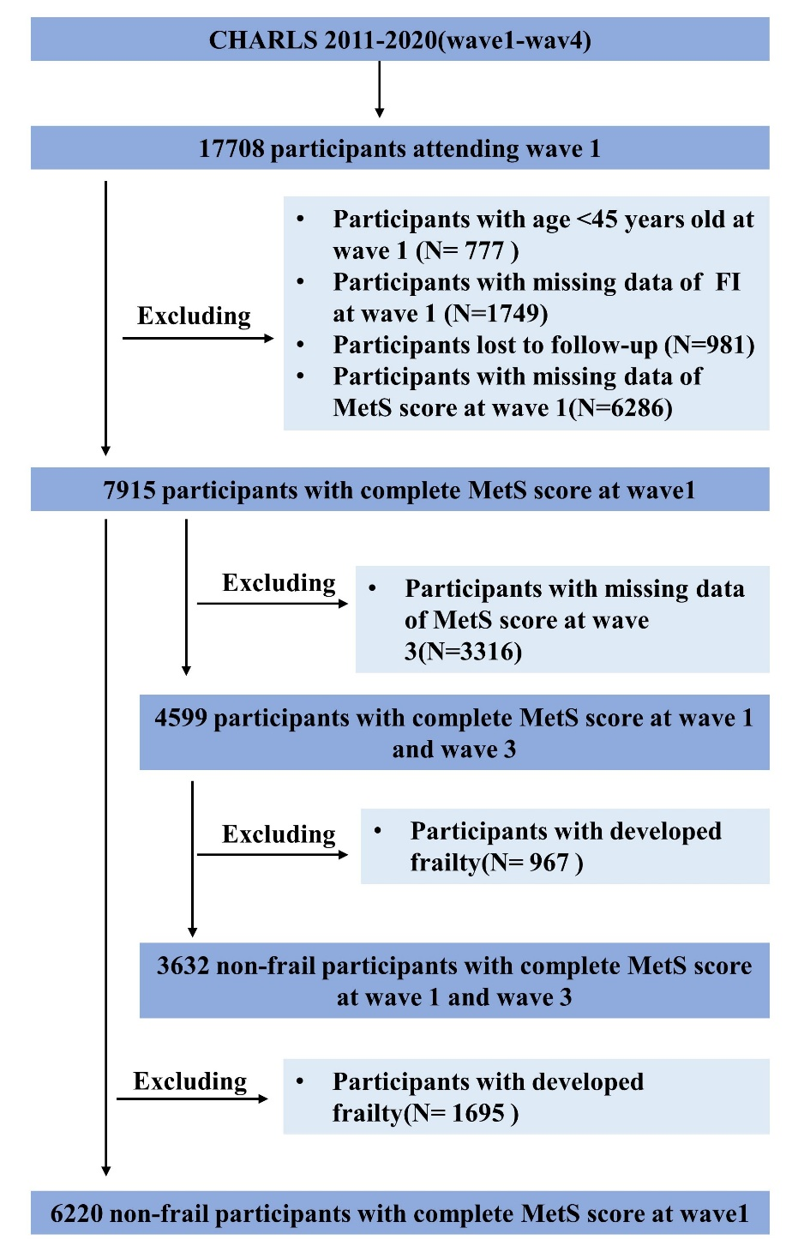
sFigure 1 Flowchart of the population included in our final analysis.

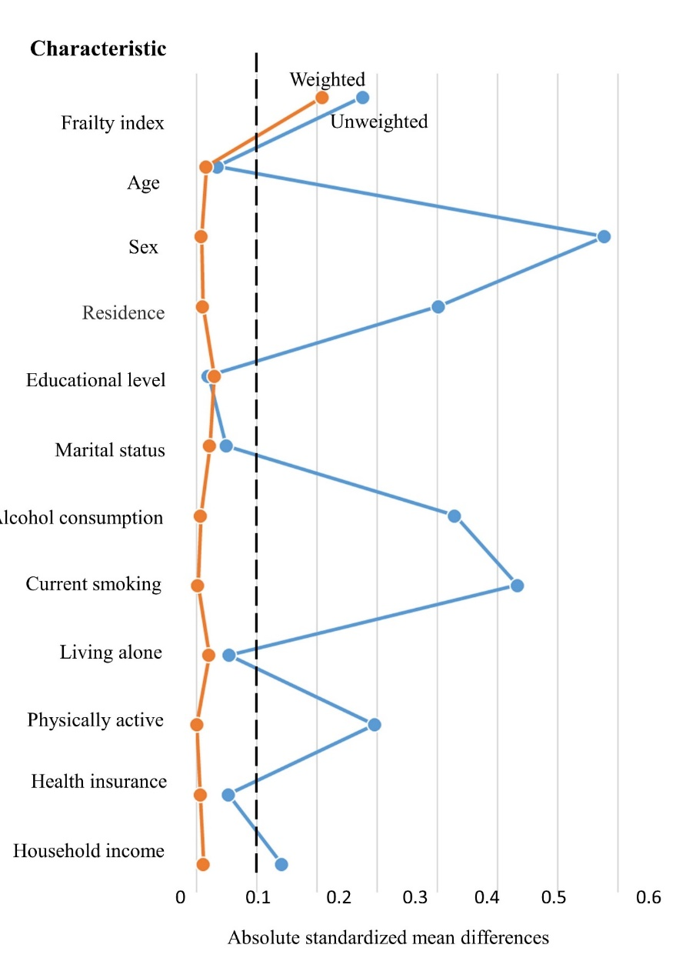
sFigure 2 Differences in characteristics between included and excluded participants.
Absolute standardized mean difference represents the absolute value of the mean difference of 1 standard deviation between the two groups, and Absolute standardized mean difference <0.1 indicates good balance.

Reference
1. Zhao Y, Hu Y, Smith JP, Strauss J, Yang G. Cohort profile: the China Health and Retirement Longitudinal Study (CHARLS). Int J Epidemiol. 2014;43(1):61-8.
2. Searle SD, Mitnitski A, Gahbauer EA, Gill TM, Rockwood K. A standard procedure for creating a frailty index. BMC Geriatr. 2008;8:24.
3. Yang S, Yu B, Yu W, Dai S, Feng C, Shao Y, et al. Development and validation of an age-sex-ethnicity-specific metabolic syndrome score in the Chinese adults. Nat Commun. 2023;14(1):6988.

