Report on roadkill of Particolored flying squirrel (Hylopetes alboniger) (Hodgson, 1836) from Kaziranga, Assam.

Sourav Gupta¹, Ramie H. Begum^{2*}, M. Firoz Ahmed^{3,} Jayanta Kumar Roy⁴
^{1,3,4}Aaranyak, 13, Tayab Ali Byelane, Bishnu Rabha Path, Guwahati, Assam 781028, India.
^{1,2}Department of Life Science and Bioinformatics, Assam University, Diphu Campus, Karbi Anglong, Assam 782460, India.
souravassamwild@gmail.com (0000-0001-5918-2302)¹; ani.ara73@gmail.com (0000-0001-7076-7643)^{2*}; mfa.aaranyak@gmail.com (0000-0002-2652-1360)³; roy.jayantakumar47@gmail.com (0000-0001-8949-3726)⁴
Corresponding Author*: Ramie H. Begum
Abstract: Notably, flying squirrels, essential yet understudied components of ecosystems, face heightened risks due to their cryptic habits. We report the first documented roadkill case of a particolored flying squirrel (Hylopetes alboniger) in Assam, India, highlighting the need for comprehensive roadkill surveys to inform mitigation strategies in biodiverse regions facing increasing anthropogenic pressures.

Keywords: wildlife-vehicle collisions, biodiversity, mitigation strategies, road ecology

The Impact of roads and vehicular traffic on wildlife through vehicle collisions spans all taxonomic groups, although a few taxa overshadow the others in the roadkill scenario. The roadkill phenomena are underestimated in almost every Environmental Impact Assessment (EIA), especially on small vertebrate animals (González-Gallina et al. 2013). Roads negatively affect a wide range of species via direct mortality, barriers to movement and behaviour alteration (Trombulak & Frissell 2000). Roads are the largest sources of anthropogenic mortality for many vertebrates (Hill et al. 2019). Ray et al. 2023, Sur et al. 2023, Sur et al. 2022, and Das et al. 2007 reported the mortality along the NH 37 passing by the Kaziranga National Park. Flying squirrels are one of the world's lesser-known mammals. Due to their crepuscular and cryptic habits, research on these species is limited and irregular. In India, there are a total of 13 species of flying squirrels (Mukherjee & Mhanagore 2022). Flying squirrels are an essential component of the ecological system, as they aid in seed dispersal (Nandani 2008). In India, particolored flying squirrel (Hylopetes alboniger) is distributed in Arunachal Pradesh, Meghalaya, Manipur, Nagaland, Sikkim, West Bengal and Assam (Talukdar et al. 2021).

On 23rd November 2022, a roadkill specimen of particolored flying squirrel (Figure 1) was found at 06:32 h, at an altitude of 103 m als in Halowa NC village (26°35'26.83"N; 93°25'7.37"E) situated along NH 37 passing adjacent to Kaziranga National Park in the Golaghat district of Assam, India. This was an opportunistic observation made while travelling on the highway. The species was identified based on its morphological characteristics- dorsal brown hair confined to its back, while the rest of its upper body exhibits a grey hue, and its underside is white, excluding the tail. The tail, too, shares the grey color, with a darker shade along its underside (Thorington et al. 2012; Molur et al. 2005).

This is the first observation of a particolored flying squirrel reported as ‘roadkill’ from Assam and the third species of flying squirrel from India after the Hairy-footed flying squirrel (Belomys pearsonii) from Arunachal Pradesh (Mukherjee & Mhanagore 2022) and the Indian giant flying squirrel (Petaurista philippensis) from Tamil Nadu (Arockianathan 2014). The particolored flying squirrels are found in tropical forest to subtropical montane forest with elevations ranging from 100 - 4000 m asl. (Molur et al. 2005, Krishna et al. 2013). Roadkill surveys often yield ecological insights that may not be attainable through other means. Moreover, they offer valuable morphological data on nocturnal species, which are typically difficult to observe except for brief glimpses (Mukherjee & Mhanagore 2022).
The expansion of the human population has extended anthropogenic pressures into wildlife habitats, leading to wildlife-vehicle collisions becoming a significant cause of high mortality rates for many wildlife species (Schwartz et al. 2022). Concentrated investigation into wildlife and its interaction with roadway infrastructure in biodiverse regions can aid in developing efficient mitigation strategies for linear development activities like roads and railways.

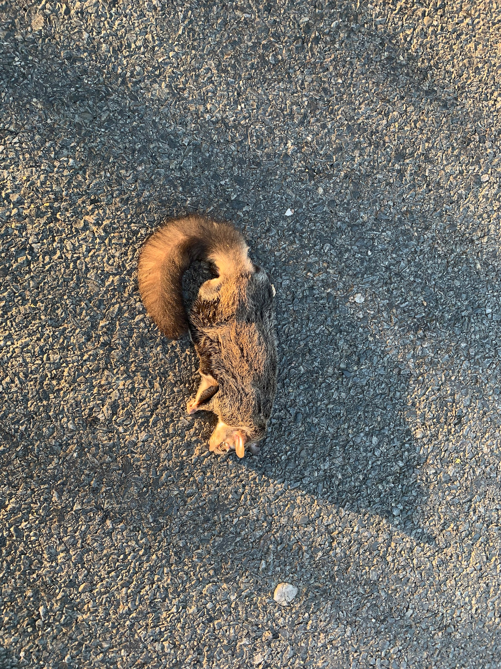
Figure 1: Roadkill of particolored flying squirrel (Hylopetes alboniger) on NH 37 highway, passing through Halowa NC village, Kaziranga National Park, Assam.

Acknowledgement
We sincerely thank Najirul Haque, a naturalist, from Kaziranga for accompanying us during the trip. We would like to thank Aaranyak for support and logistics.
Competing interests: The authors declare no competing interests.
Authors Contribution: SG – data collection and draft preparation. JKR – Final draft preparation. RHB & MFA – Supervising and final draft preparation.
Funding: No Funding
Data Availability: Not Applicable.
Declarations: Not Applicable.
Ethical Approval: Not Applicable
References

Arockianathan S. 2014. Road kill of Indian giant flying squirrel (Petaurista philippensis) in Coonoor to Mettupalayam Highway, The Nilgiris.International Research Journal of Natural and Applied Sciences.1:10-14.

Das, Abhijit & Ahmed, Mohammad Firoz & Lahkar, Bibhuti & Sarma, Pranjit. 2007. A preliminary report on reptilian mortality on road due to vehicular movements near Kaziranga National Park, Assam, India. CASE REPORT ZOOS' PRINT JOURNAL. 22. 2742-2744. 10.11609/JoTT.ZPJ.1541.2742-4.

González-Gallina, A., Benítez-Badillo, G., Rojas-Soto, O. R., & Hidalgo-Mihart, M. G. 2013. The small, the forgotten and the dead: highway impact on vertebrates and its implications for mitigation strategies. Biodiversity and Conservation, 22, 325-342.

Hill JE, DeVault TL, Belant JL. 2019. Cause-specific mortality of the world’s terrestrial vertebrates. Glob Ecol Biogeogr 28:680–689. https://doi.org/10.1111/geb.12881

Krishna CM, Ray PC, Sarma K, Kumar A. 2013. Observations on Particolored flying squirrel Hylopetes alboniger (Hodgson 1836) in northeast India. Zoo’s Print 28: 18–20.

Krishna MC, Kumar A, Tripathi OP, Koprowski JL .2016. Diversity, Distribution and Status of Gliding Squirrels in Protected and Non-protected Areas of Eastern Himalayas in India. Hystrix, the Italian Journal of Mammalogy 27(2). https://doi.org/10.4404/ hystrix-27.2-11688.

Mukherjee, S., & Mhangore, M. 2022. First record of a roadkill hairy-footed flying squirrel Belomys pearsonii (Gray, 1842) from Arunachal Pradesh, India. Acta Entomology and Zoology, 3(1), 12-14.

Molur S, Srinivasulu C, Srinivasulu B, et al. Conservation Assessment & Management Plan (C.A.M.P.) Workshop Report, 2005, 612.

Nandini R, Parthasarathy N. 2008. Food Habits of the Indian Giant Flying Squirrel (Petaurista philippensis) in a Rain Forest Fragment, Western Ghats. J Mammal. 89:1550-1556. https://doi.org/10.1644/08- MAMM-A-063.1

Ray, S. D., Quadros, G., Dey, P., Pramod, P., and Singh, R. P. 2023. Wildlife casualties from the road stretches adjacent to two national parks of Assam, North-East India. Asian Journal of Conservation Biology, 12(2), 314–325

Schwartz ALW, Shilling FM, Perkins SE. 2020. The value of monitoring wildlife roadkill. Eur J Wildl Res.;66:18. https://doi.org/10.1007/s10344-019-1357-4

Sur, S., Saikia, P. K., and Saikia, M. K. 2022. Speed thrills but kills: A case study on seasonal variation in roadkill mortality on National Highway 715 (new) in Kaziranga-Karbi Anglong Landscape, Assam, India. Nature Conservation 47: 87–104. doi: 10.3897/natureconservation.47.73036

Sur, S., Saikia, P. K., and Saikia, M. K. 2023. Roadkill records of two civet species on National High-way 715 passing through Kaziranga-Karbi Anglong landscape complex, Assam, India. Journal of Threatened Taxa 15(5): 23210–23215. https://doi.org/10.11609/jott.7270.15.5.23210-23215

Trombulak, S. & C. Frissell, 2000. Review of ecological effects of roads on terrestrial and aquatic communities. Conservation Biology 14: 18–30.

