Supplementary Information

Universal Hydrogel Adhesives with Robust Chain Entanglement for Bridging Soft Electronic Materials

Yejin Jo^{1†}, Yurim Lee^{1†}, Jeong Hyun Heo², Yeonzu Son³, Tae Young Kim¹, Kijun Park¹, Soye Kim¹, Yoonhee Jin², Seongjun Park^{3,4,5,6}, Jungmok Seo¹*

1. School of Electronic and Electronic Engineering, Yonsei University, Seoul 03722, Republic of Korea

2. Department of Physiology Yonsei University College of Medicine Seoul 03722, Republic of Korea

3. Program of Brain and Cognitive Engineering, Korea Advanced Institute of Science and Technology (KAIST), 291 Daehak-ro, Yuseong-gu, Daejeon 34141, Republic of Korea

4. Department of Bio and Brain Engineering, Korea Advanced Institute of Science and Technology (KAIST), 291 Daehak-ro, Yuseong-gu, Daejeon 34141, Republic of Korea

5. Department of Materials Science and Engineering, Korea Advanced Institute of Science and Technology (KAIST), 291 Daehak-ro, Yuseong-gu, Daejeon 34141, Republic of Korea

6. KAIST Institute for NanoCentury (KINC), 291 Daehak-ro, Yuseong-gu, Daejeon 34141, Republic of Korea

† These authors contributed equally to this work.
*Corresponding author: Jungmok Seo (jungmok.seo@yonsei.ac.kr)

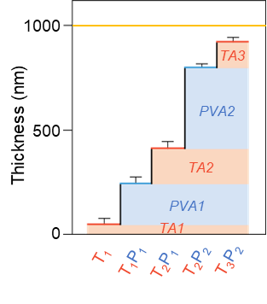
Supplementary Figure 1. Thickness of each coating layer after layer-by-layer deposition (n=3).
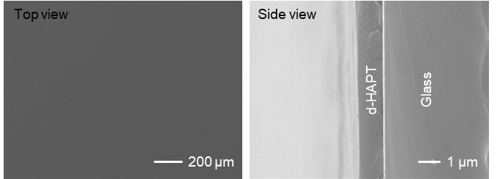
Supplementary Figure 2. Top and side view of d-HAPT coated on the glass.

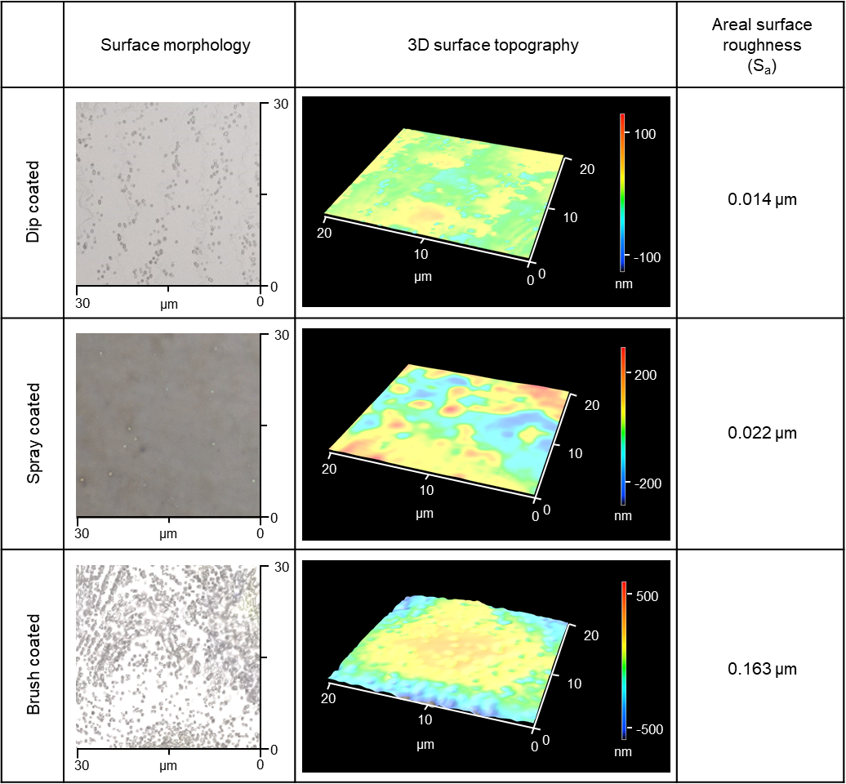
Supplementary Figure 3. Surface morphology, three-dimensional (3D) surface topography image of dip, spray, brush-coated adhesive layer, and areal surface analyzed by laser confocal microscope (VK-X3050, Keyence).

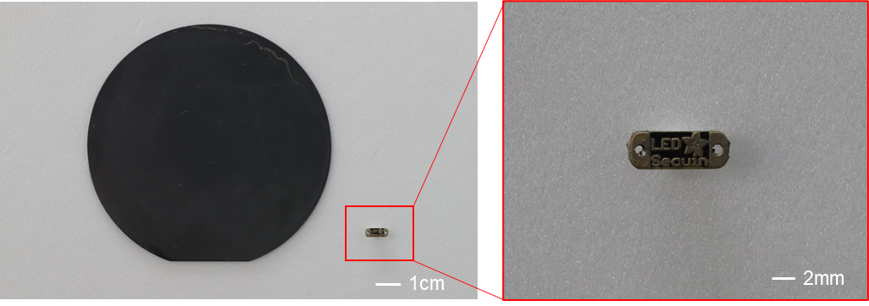
Supplementary Figure 4. The optical image of spray coated wafer and brush coated LED electrodes.

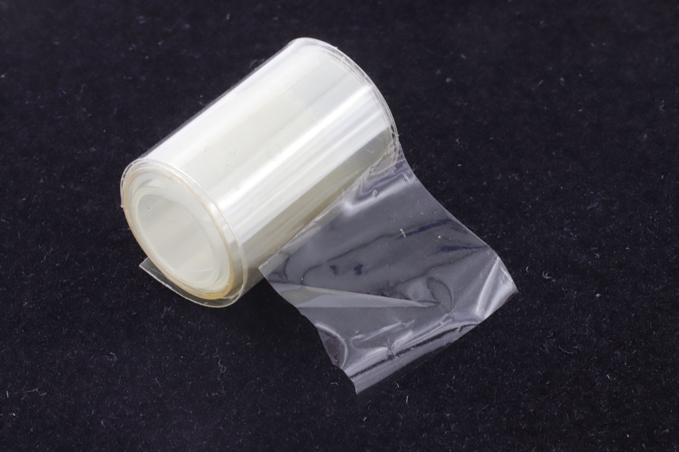
Supplementary Figure 5. The image of d-HAPT produced in film.
.

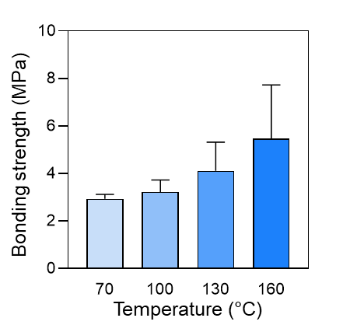
Supplementary Figure 6. Bonding strength of stainless steel (SS) under various temperature conditions. (n=4: n is the sample size for each group)
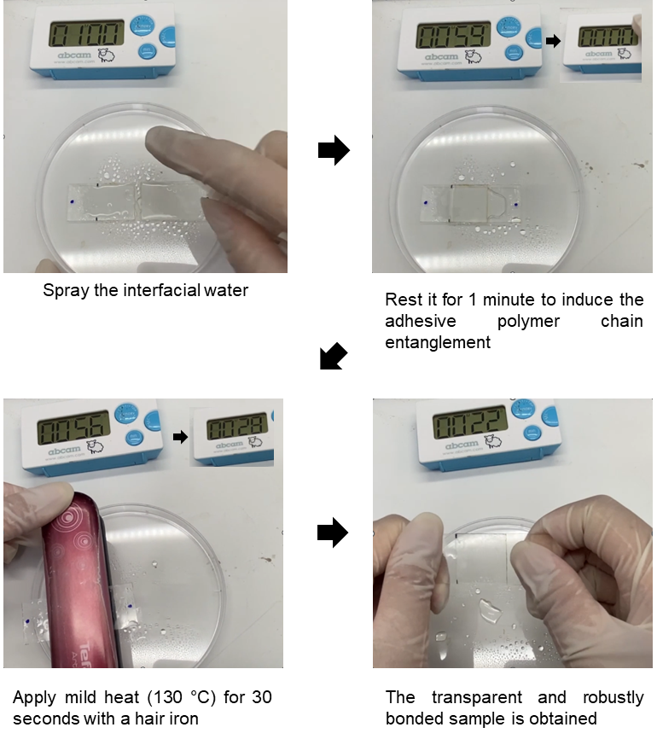
Supplementary Figure 7. Instant bonding (< 90 s) of glass samples using a hair iron.

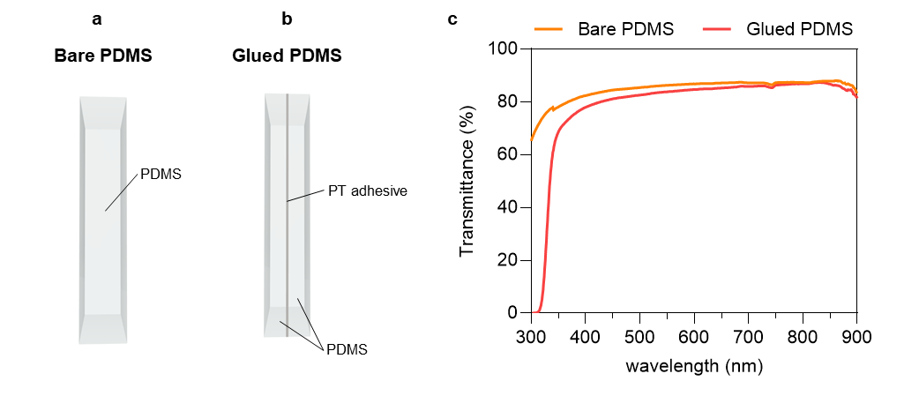
Supplementary Figure 8. The illustration of (a) bare PDMS and (b) glued PDMS using PT adhesive. (c)Transmittance of PDMS samples using PT adhesive.
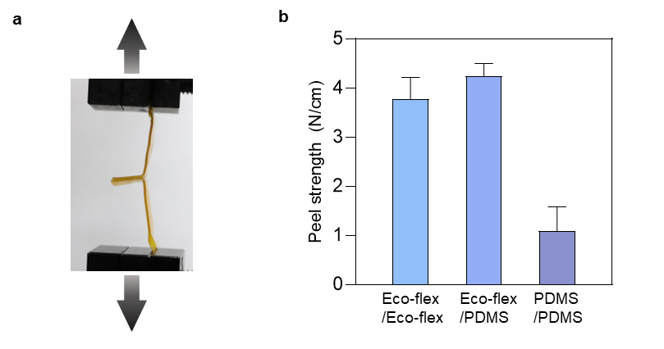
Supplementary Figure 9. (A) Optical image of T-peel test. (B) The T-peel strength of Eco-flex and PDMS substrates assembled by d-HAPT. (n=4)

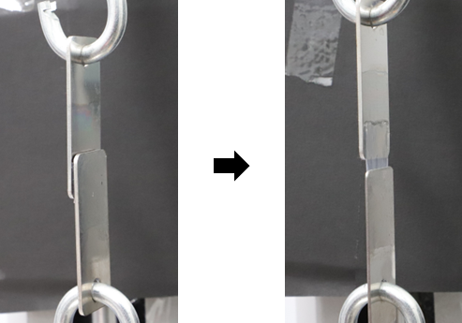
Supplementary Figure 10. Optical image of PVA hydrogel bonded to SS substrate during lap shear test.

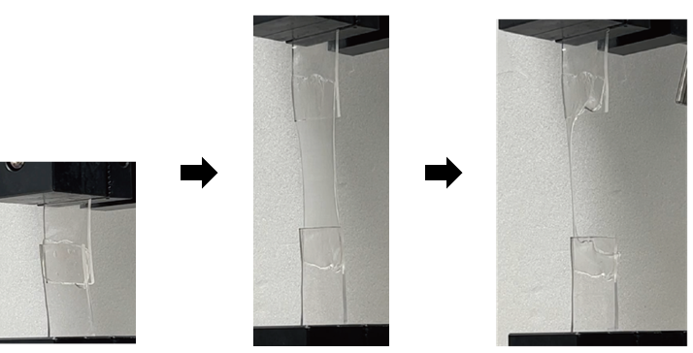
Supplementary Figure 11. Optical image of PAAm-Alginate hydrogel bonded to PDMS substrate during lap shear test.
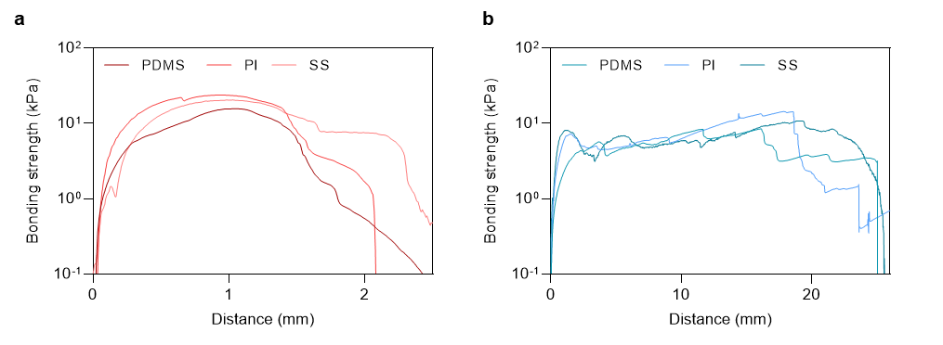
Supplementary Figure 12. Lap sheer curves of (a) PVA-TA hydrogel and (b) PVA hydrogel.
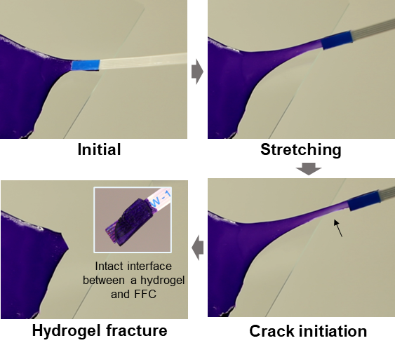
Supplementary Figure 13. The connection between the dyed ionic hydrogel and FFC maintained firmly during stretching.

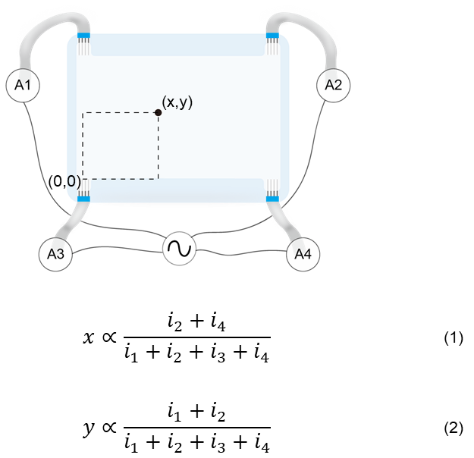
Supplementary Figure 14. Formulas used to calculate the position of a touch point.

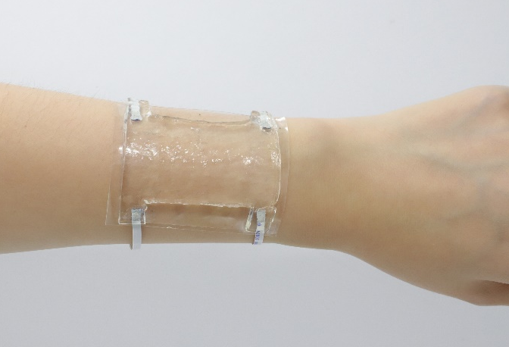
Supplementary Figure 15. The wearable touch panel is placed on the arm conformally.

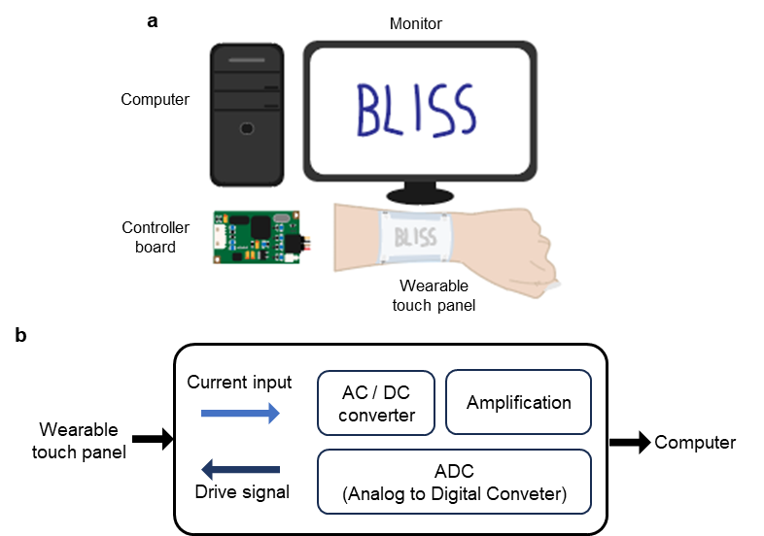
Supplementary Figure 16. (a) Operation of the wearable touch panel. When the word was drawn on the wearable touch panel, current signal was transferred to the computer through the controller board. (b) A diagram of the controller board for connection between the wearable touch panel and the computer.
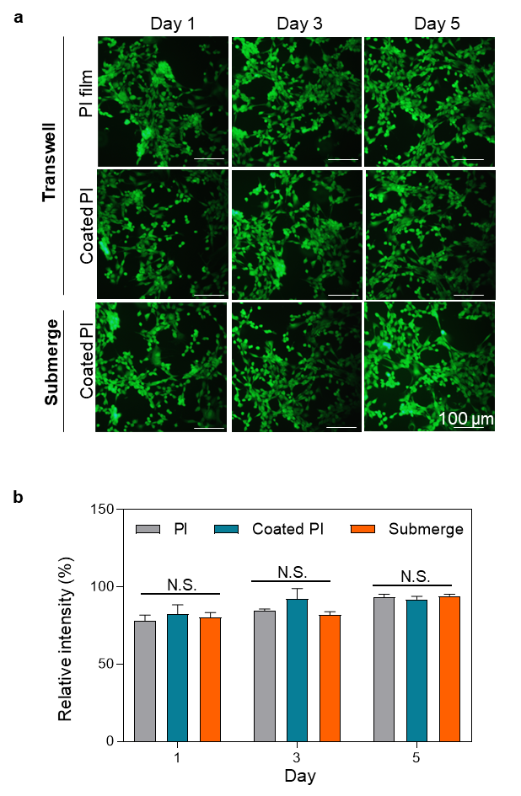
Supplementary Figure 17. (a-b) Fluorescence microscopic images of NIH 3T3 cells of bare PI film and coated PI film and statistical analysis (n=3) (scale bars, 100 µm). (*P < 0.05, **P < 0.01, ***P < 0.001, and ****P < 0.0001). ns, not significant.
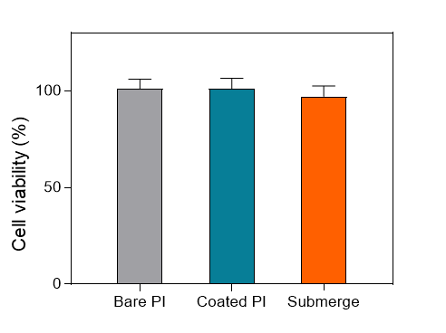
Supplementary Figure 18. Relative cell viability measurement with CCK-8 kit (n=5). (*P < 0.05, **P < 0.01, ***P < 0.001, and ****P < 0.0001). ns, not significant.

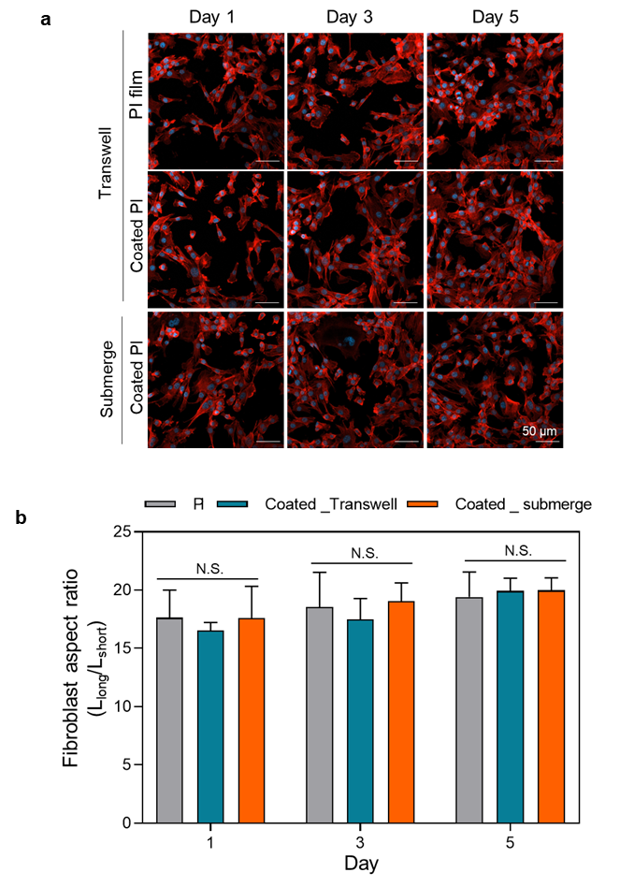
Supplementary Figure 19. (a-b) Fluorescence microscopic images of NIH 3T3 cells of bare PI film and coated PI and statistical analysis (n=3) (scale bars, 50 µm). (*P < 0.05, **P < 0.01, ***P < 0.001, and ****P < 0.0001). ns, not significant.
Supplementary Table 1. The bonding strength of PDMS under various temperature conditions and bonding time. All samples are fractured during the tensile test, indicating robust adhesion regardless of the bonding conditions.
Bonding time | Bonding temperature
 | 70 °C | 100 °C | 130 °C
1 min | O | O | O
5 min | O | O | O
Supplementary Table 2. Comparison of performance with previously reported adhesives for integrating soft materials in soft electronics. Indicators such as bonding strength, thickness, and bonding time are comprehensively compared. d-HAPT enables robust bonding between the soft materials (shear strength ≈ 200 kPa, T-peel strength ≈ 4 N/cm) within a minute. Additionally, it has a thickness of less than 1 µm.
Materials | Bonding strength | Thickness | Bonding time | Reference
PVA and TA | ~ 200 kPa (PDMS/PDMS)  4 N/cm (Eco-flex/PDMS) | <1 µm | < 1 min | This work
Polyzwitterion-clay nanocomposite hydrogel | 10 kPa (VHB tape)  <10 kPa (silicone rubber) | 3 mm | <1 min | [33]
Poly (AGE-co-HEA) | ~1.5 N/cm (PDMS/PDMS)  ~3 N/cm (Eco-flex/Eco-flex) | ~500 nm | 2 days | [34]
Polyurea-based adhesive | 16.4 kPa (PDMS/PDMS)  ~17 kPa (Latex/Latex) | 1 mm | <1 min | [35]
Poly(TA-DIB-Fe) | <200 kPa (silicone rubber) | 50 µm | 5 min | [36]

Supplementary Table 3. Comparison of various adhesion methods that attach various building blocks of soft electronics.
Materials | DD bonding | WD bonding | Biocompatibility | Electrical applications | References
PVA/TA | rigid/rigid  soft/soft  rigid/soft | hydrogel/rigid  hydrogel/soft | O | Stretchable circuit  Wearable touch panel  Wearable strain sensors  sciatic nerve stimulator  ECG sensor | This  work
Polyzwitterion-clay nanocomposite hydrogel | soft, rigid materials | X | O | Wearable touch panel | [33]
Poly (AGE-co-HEA) | soft/soft | X | X | Stretchable circuit | [34]
Polyurea-based adhesive | rigid/rigid  soft/soft | X | X | strain sensor  robotic hand  tiboelectric sensor  soft robot | [35]
Poly(TA-DIB-Fe) | rigid/rigid  soft/soft | X | X | X | [36]
PHEMA hydrogel | rigid/rigid | X | X | X | [42]
PVA/Graphene oxide | X | tissue/rigid  tissue/soft | O | Wearable circuit  ECG sensor | [23]
PEG-LA-DA/sodium alginate | X | tissue/soft | O | optoelectronic systems  wireless pacemakers  flexible epicardial arrays | [24]
Functionalized silanes | X | hydrogel/rigid | O | stretchable circuit | [37]
Benzophenone | X | hydrogel/soft | X | stretchable circuit | [38]
Cyanoacrylate-based adhesive | X | hydrogel/rigid  hydrogel/soft | O | soft adaptive lens  energy havester  stretchable battery  stretchable circuit  electronic skin | [41]

Supplementary Movie 1. Biaxial stretching of elastomers attached with DD bonding.

Supplementary Movie 2. Hydrogel-based LED circuit integrated with WD bonding.

Supplementary Movie 3. DD bonding process.

Supplementary Movie 4. Hydrogel-based stretchable circuit.

Supplementary Movie 5. Cable adhesion on wearable touch panel.

Supplementary Movie 6. Drawing demonstration using wearable touch panel.

Supplementary Movie 7. Game playing demonstration using wearable touch panel.

Supplementary Movie 8. Sciatic nerve stimulation with varying applied current

