SUPPLEMENTARY INFORMATION

ZEB1 directly inhibits GPX4 transcription contributing to ROS accumulation in breast cancer cells
Xiao Han², Xianxian Duan¹, Zhanzhao Liu¹, Yaping Long¹, Chang Liu¹, Jing Zhou¹, Ning Li³, Junfang Qin*¹, Yue Wang*^{1,4}

Contents:

Page 2:
Fig. S1, ZEB1 expression after lentiviral-based vector pLV-H1-EF1α-puro used to express shRNA (shZEB1) in MDA-MB-231 cells was detected by RT-PCR and Western bolt.
Fig. S2, ZEB1 expression after ZEB1 silencing with three targeting genes, the sequence of siZEB1#1 (GGCAAGTGTTGGAGAATAA), siZEB1#2 (CCAGAAATACACAGGGTTA) and siZEB1#3(CGGACGAGAGAGAGAGTTT) in MCF7 cells was detected by RT-PCR and Western bolt.

Page 3-4:
Fig. S3, 12 of 81 metabolic DEGs are ROS-related (15%) that are transcriptional suppressed by ZEB1. Data was obtained from RNA-Seq.

Fig. S4, Relative MFI (mean fluorescent intensity) was analyzed by flow cytometry. Values represented as means SD (n=3). *P < 0.05.
Fig. S1, ZEB1 expression after lentiviral-based vector pLV-H1-EF1α-puro used to express shRNA (shZEB1) in MDA-MB-231 cells was detected by RT-PCR and Western bolt.
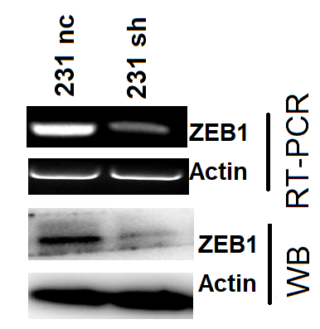
Fig. S2, ZEB1 expression after ZEB1 silencing with three targeting genes, the sequence of siZEB1#1 (GGCAAGTGTTGGAGAATAA), siZEB1#2 (CCAGAAATACACAGGGTTA) and siZEB1#3(CGGACGAGAGAGAGAGTTT) in MCF7 cells was detected by RT-PCR and Western bolt.
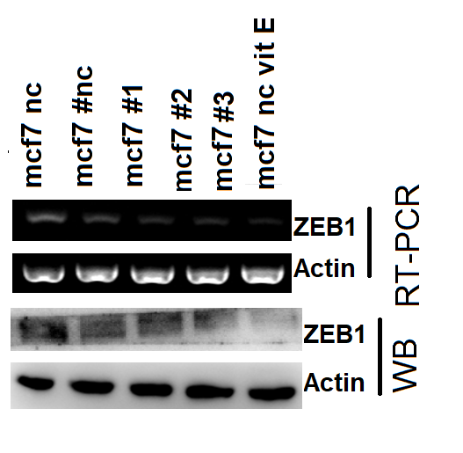
Fig. S3, 12 of 81 metabolic DEGs are ROS-related (15%) that are transcriptional suppressed by ZEB1. Data was obtained from RNA-Seq.
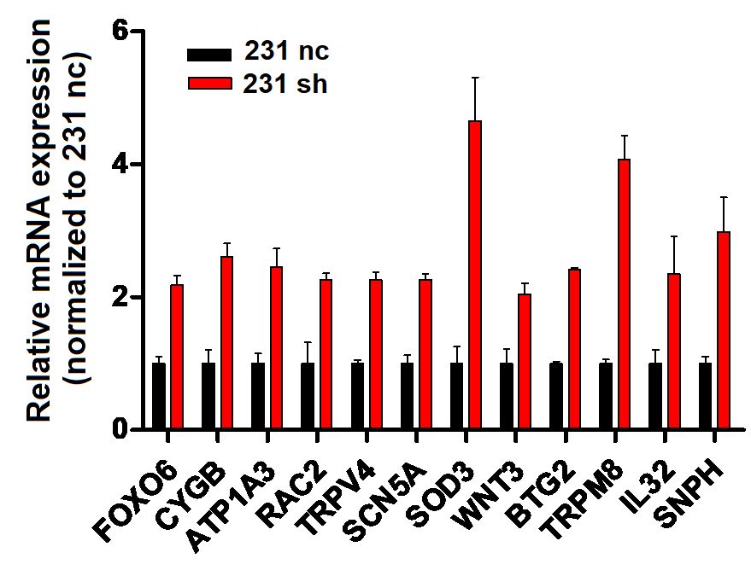

Fig. S4, Relative MFI (mean fluorescent intensity) was analyzed by flow cytometry. Values represented as means SD (n=3). *P < 0.05.

