Supplementary Information for

Characterizing the in vitro motor properties of two kinesin-9 family members from Tetrahymena

Hiroto Ishii ª, Masahiko Yamagishi ^{a,b}, and Junichiro Yajima ^{a,b,c,}*

ª Department of Life Sciences, Graduate School of Arts and Sciences, The University of Tokyo, 3-8-1 Komaba, Meguro-ku, Tokyo 153-8902, Japan
^{b} Komaba Institute for Science, The University of Tokyo, 3-8-1 Komaba, Meguro-ku, Tokyo 153-8902, Japan
^{c} Research Center for Complex Systems Biology, The University of Tokyo, 3-8-1 Komaba, Meguro-ku, Tokyo, 153-8902, Japan
* Correspondence should be addressed to J.Y. (yajima@bio.c.u-tokyo.ac.jp)

Supplementary figures and movies:
Supplementary Figure 1 Polarity-marked microtubule gliding driven by Tetrahymena kinesin-9 molecules
Supplementary Figure 2 Photobleaching properties of Tetrahymena kinesin-9A fused to either mStayGold or mEGFP
Supplementary Figure 3 Extended loop 2 and loop 8 of kinesin-9 family members
Supplementary Movie 1 Microtubule gliding driven by Tetrahymena kinesin-9 molecules
Supplementary Movie 2 Polarity-marked microtubule gliding driven by Tetrahymena kinesin-9 molecules
Supplementary Movie 3 Single-molecule assays of Tetrahymena kinesin-9 dimers

Supplementary Figure
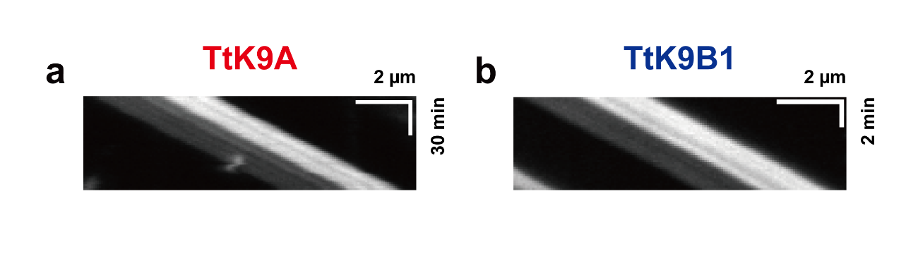
Supplementary Figure 1. Polarity-marked microtubule gliding driven by Tetrahymena kinesin-9 molecules. (a, b) Kymographs of Polarity-marked microtubule gliding driven by TtK9A and TtK9B1. Both showed plus-end directed motilities with bright minus ends of microtubules leading.

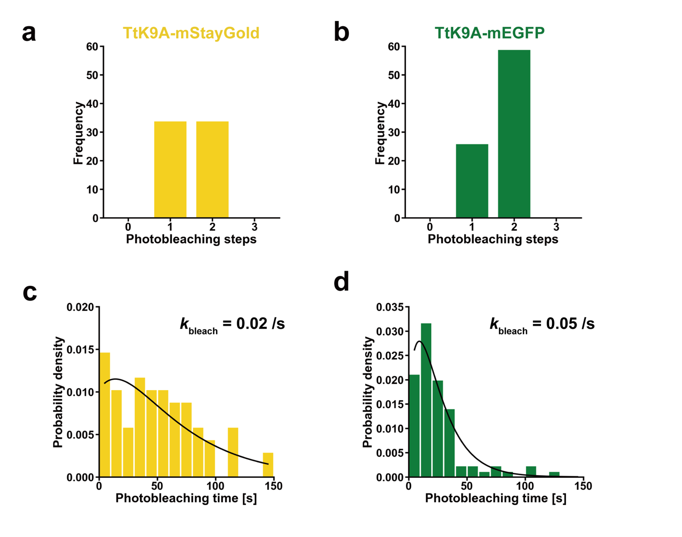
Supplementary Figure 2. Photobleaching properties of Tetrahymena kinesin-9A fused to either mStayGold or mEGFP. (a, b) Histograms of the number of photobleaching steps for TtK9A-mStayGold (n = 68) and TtK9A-mEGFP (n = 85) bound to the glass surface. (c, d) Histograms of photobleaching time for TtK9A-mStayGold and TtK9A-mEGFP under the same intense laser irradiation. Data are fitted to the mixture of one and two fluorophores bleaching distributions: ${P = k}_{bleach}(2-ρ)exp(-k_{bleach}t)+2k_{bleach}(ρ-1)exp(-2k_{bleach}t)$. The ratio between one and two fluorophores $ρ$ was measured from (a) and (b). $k_{bleach}$ is the only fitting parameter. $ρ$: 0.5 and 0.305, $k_{bleach}$: 0.02 s⁻¹ and 0.05 s⁻¹, respectively.

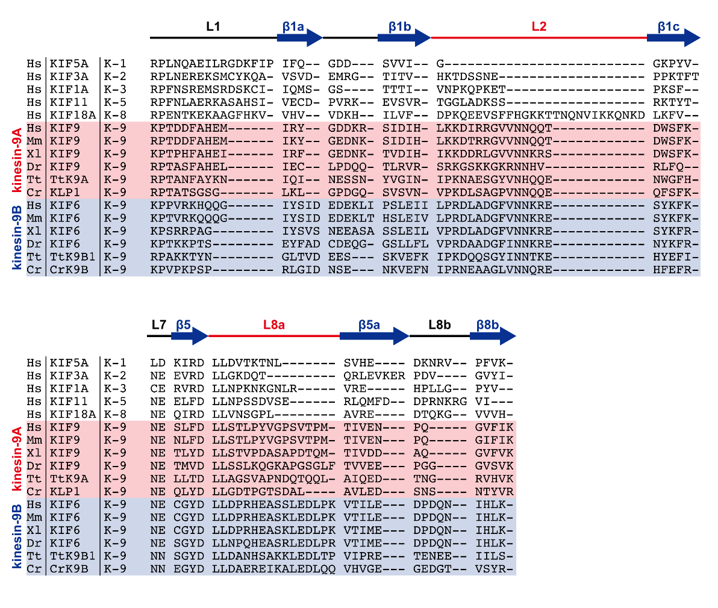
Supplementary Figure 3. Extended loop 2 and loop 8 of kinesin-9 family members. Sequences of kinesins are segmented by secondary structures, such as loops (L) or β-strands (β). Secondary structures of human KIFs were estimated from structural data (PDB: 4UXT, 4UXO, 2GM1, 3LRE, 3NWN) or Alphafold2 structure predictions (AFDB: AF-Q9Y496-F1, AF-Q6ZMV9-F1). Secondary structures of kinesin-9 motor domains were estimated from multiple sequence alignment among kinesin-9 (K-9) family members. All kinesins-9 have the extended loop 2 (L2) compared to other kinesin family members, except for kinesin-8 (K-8) family, and all kinesins-9, except for Chlamydomonas KLP1, have the extended loop 8a (L8a) compared to others.

Supplementary Movie legend
Supplementary Movie 1. Microtubule gliding assays driven by Tetrahymena kinesin-9 molecules. (a, b) Microtubule gliding driven by TtK9A and TtK9B1, respectively. Timestamps are HH:MM:SS. Microtubule tracking data were corrected for drift using red beads (bright spots in movie) as a reference.

Supplementary Movie 2. Polarity-marked microtubule gliding assays driven by Tetrahymena kinesin-9 molecules. (a, b) Polarity-marked microtubule gliding driven by TtK9A and TtK9B1, respectively. Timestamps are HH:MM:SS. Both showed plus-end directed motilities with the bright minus-end of microtubules leading.

Supplementary Movie 3. Single-molecule assays of Tetrahymena kinesin-9 dimers. (a, b) Merged movie of TtK9A_473-mStayGold or TtK9B1_506-mEGFP (green) moving on polarity-marked microtubules (magenta). Both kinesins move towards the dim plus-end of the microtubule. The plus (+) and minus (−) signs refer to the plus and minus-ends of the microtubule.

