Supplementary Material
Unravelling promise of Indian herbal compounds as potential COVID-19 therapeutic agent
Shahenvaz Alam¶, Syeda Warisul Fatima¶ and Sunil K. Khare*
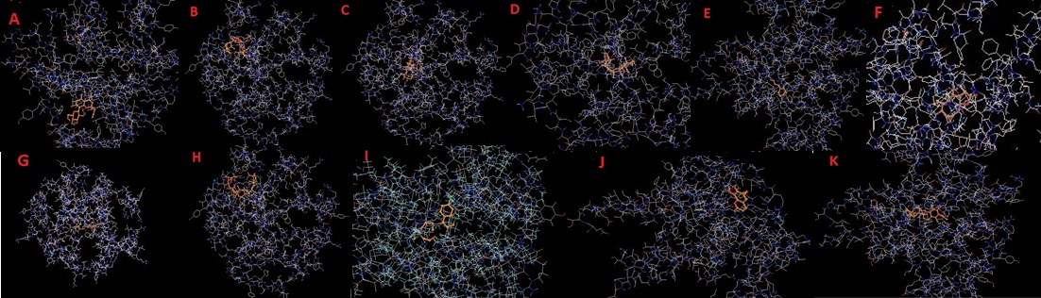
Fig. S1. Docking of the ligand with target protein was screened using PyRX virtual screening tool. Compounds were combined and Autodock vina tool in the software was used for affinity binding. A-Aleosin; B-Azadirachtin; C-Azithramycin; D- β Boswellic acid; E-Cinnamaldehyde; F- Germacranolide; G- Gingerols; H- Glycyrrhizic acid; I-Hydroxychloroquine; J- Isofraxidin; K- Tocopherol
Orthosteric site of cavity 1 and cavity 2 has critical amino acid residues which takes part in the catalysis and mostly ligands bind with them
Using CavityPlus tool, these critical residues were determined. Amino acid was written in three letter code and positions were also illustrated along with Chain A.
Cavity 1- ASN:1:A, LEU:2:A, VAL:3:A, ASN:4:A, PHE:5:A, HIS:6:A, ARG:7:A, ILE:9:A, GLU:16:A, ALA:17:A, ALA:18:A, LEU:19:A, SER:20:A, TYR:21:A, GLY:22:A, PHE:23:A, TYR:24:A, HIS:27:A, CYS:28:A, GLY:29:A, VAL:30:A, GLY:31:A, GLY:32:A, CYS:43:A, CYS:44:A, VAL:45:A, THR:46:A, HIS:47:A, ASP:48:A, CYS:49:A, CYS:50:A, TYR:51:A, LYS:52:A, ARG:53:A, GLU:55:A, THR:61:A, LYS:62:A, PHE:63:A, ASP:91:A, ALA:94:A, PHE:98:A, CYS:124:A
Cavity 2- HIS:27:A, GLY:34:A, SER:35:A, PRO:36:A, LYS:37:A, ASP:38:A, ALA:39:A, ASP:41:A, ARG:42:A, CYS:43:A, CYS:44:A, VAL:45:A, THR:46:A, HIS:47:A, ASP:48:A, CYS:49:A, CYS:50:A, ARG:53:A, ARG:118:A, GLY:119:A, SER:120:A, THR:121:A, PRO:122:A, ARG:123:A, CYS:124:A
Critical residues in cavity2 are less and it is not readily used for ligand binding.

