Supplementary Material
Sanitary napkins are a valid urine collection tool to asses iodine and methylmalonic acid

Franziska Delgas¹, Lisa Bitsch¹, Pauline Kriegler¹, Ekaterina Petrov¹, Karin Scholten¹, Sandra Renz², Maren C. Podszun¹
¹Institute of Nutritional Medicine, University of Hohenheim, Stuttgart, Germany
² Core Facility Hohenheim, University of Hohenheim, Stuttgart, Germany

Figure S1

Fluid recovery of the three postpartum pads (product #1-3), the two sanitary napkins (product #4-5) and the standard uricol collection pad (product #4) either with water (A) or urine (B).

Figure S2
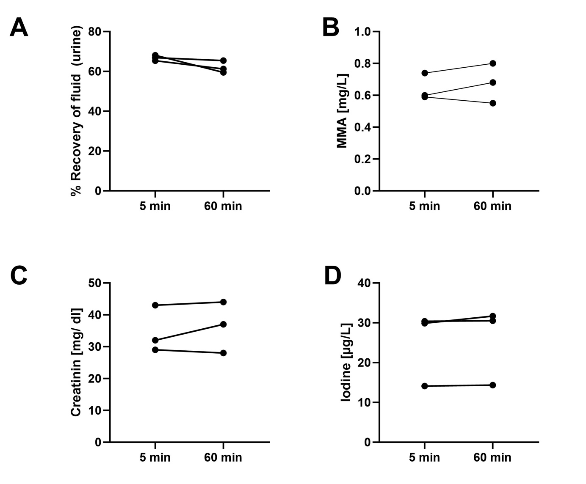
Comparison of fluid recovery (A), methylmalonic acid (B), creatinine (C) and iodine (D) concentration after either 5- or 60-minutes incubation of the sanitary napkin. Data is shown as mean ± SD, n=3. Statistical differences between the groups was calculated by using a paired t-test.

