Supplementary Figure 1A. MR plots for causal effects of the association between loneliness and neuroticism.

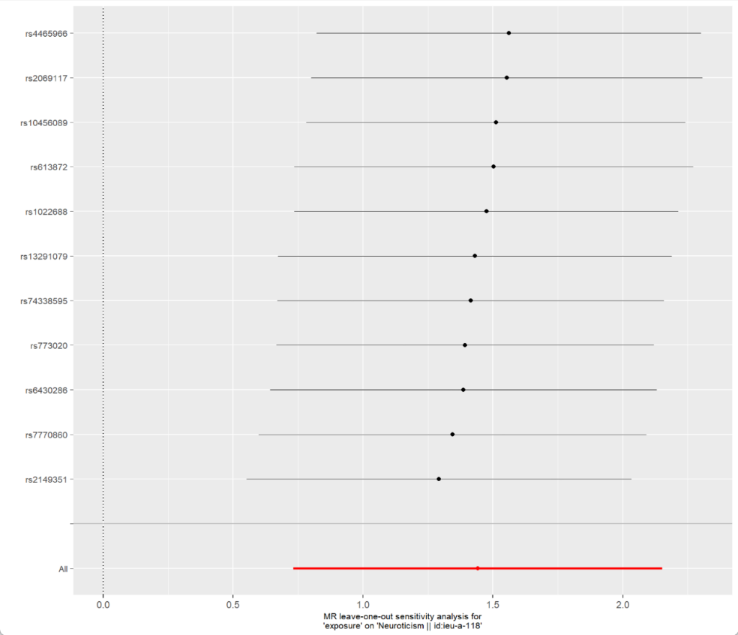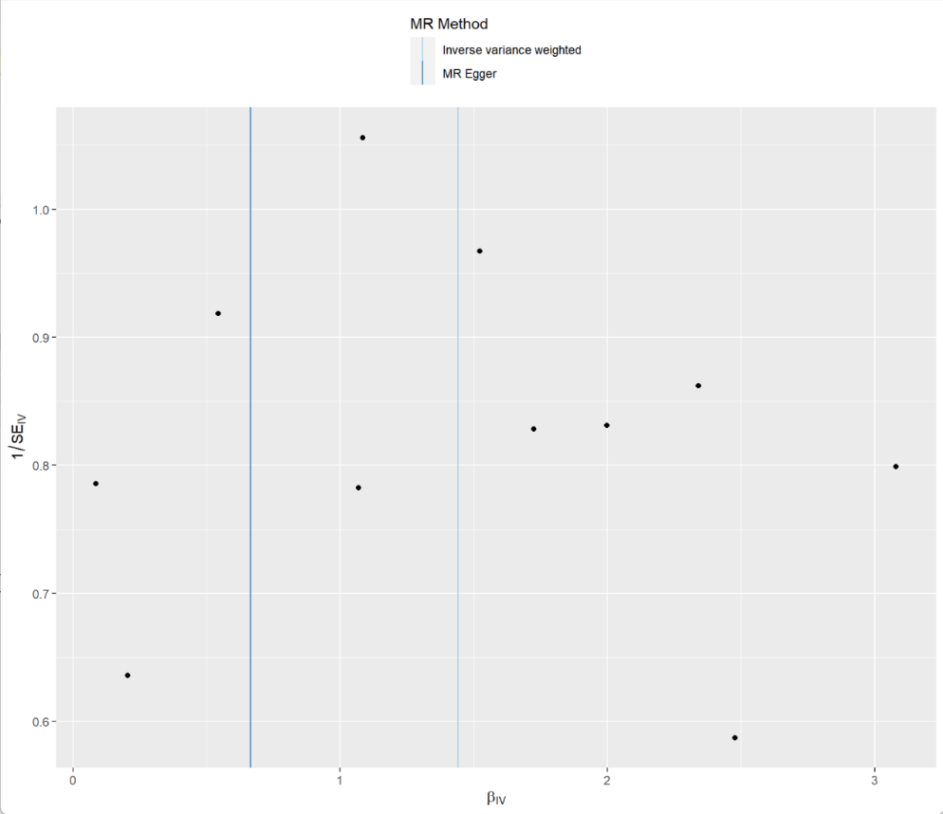
A) Leave-one-out analysis for association between loneliness and neuroticism.
B) Funnel plot of MR analysis for association between loneliness and neuroticism.
MR: Mendelian randomization.

Supplementary Figure 1B. MR plots for causal effects of the association between loneliness (MTAG) and neuroticism.

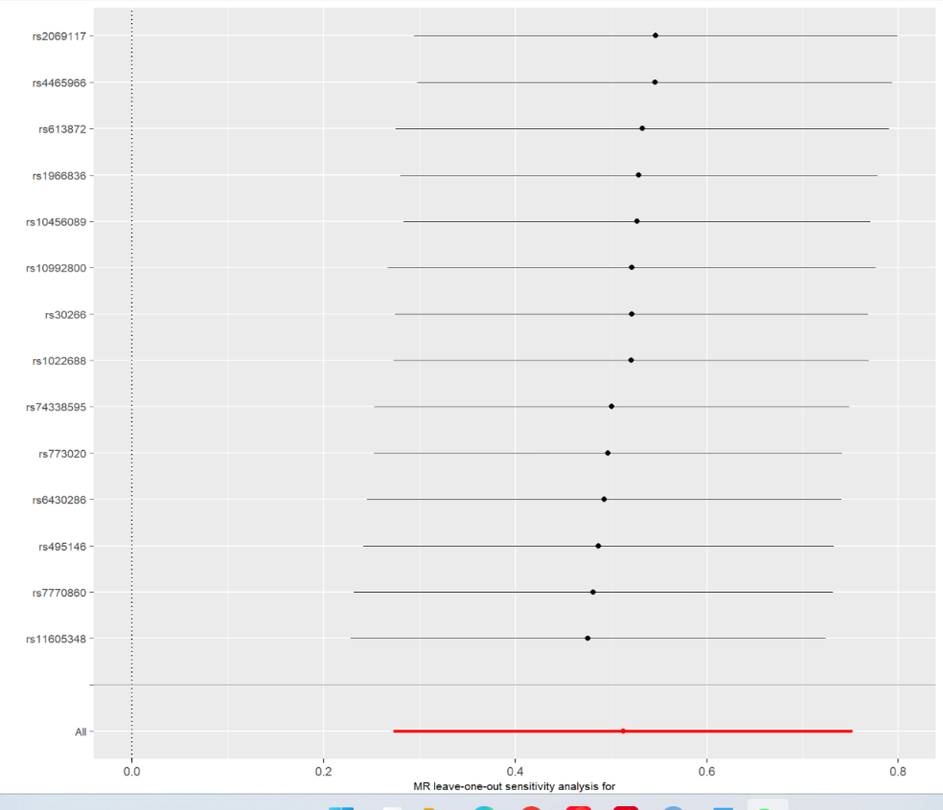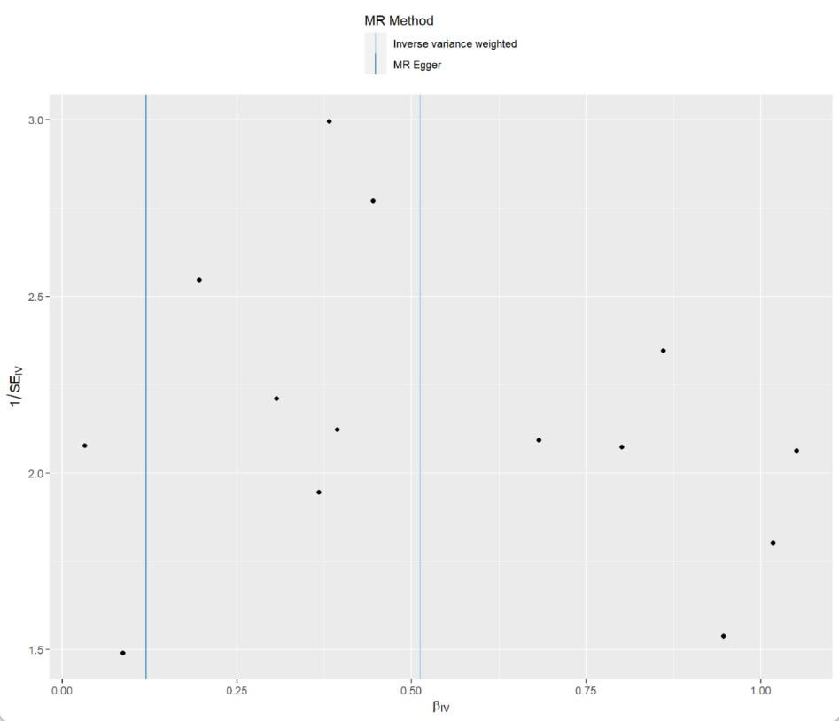

A) Leave-one-out analysis for association between loneliness (MTAG) and neuroticism.
B) Funnel plot of MR analysis for association between loneliness (MTAG) and neuroticism.
MR: Mendelian randomization.

