Multiple-Stimuli Fluorescent Responsive Metallo-Organic Helicated Cage Arising from Monomer and Excimer Emission

Zhe Zhang,^{‡[a]} Qixia Bai,^{‡[a]} Zirui Zhai,^{[a]} Qingwu Long,^{[b]} Ermeng Han,^{[c]} He Zhao,^{[c]} Chuang-Wei Zhou,^{[d]} Haobo Lin,^{[e]} Wei Zhang,^{[e]} Guo-Hong Ning,^{[d]} Ting-Zheng Xie,^{[a]} Pingshan Wang,*^{[a]} Tun Wu*^{[a]}

^{[a]} Institute of Environmental Research at Greater Bay Area, Key Laboratory for Water Quality and Conservation of the Pearl River Delta, Ministry of Education, Guangzhou University, Guangzhou 510006
^{[b]} College of Light Chemical Industry and Materials Engineering, Shunde Polytechnic, Foshan, 528333, China
^{[c]} Hunan Key Laboratory of Micro & Nano Materials Interface Science; College of Chemistry and Chemical Engineering, Central South University, Changsha 410083
^{[d]} College of Chemistry and Materials Science, and Guangdong Provincial Key Laboratory of Functional Supramolecular Coordination Materials and Applications, Jinan University, Guangzhou 510632, China
^{[e]} School of Physics and Materials Science, Guangzhou University, Guangzhou 510006, China

Table of Content
1. Synthetic route of ligand L 2
2. Experimental section 1
3. Synthesis of the compounds and metallo-organic cage MTH 3
4. ESI-MS spectra data of metallo-organic cage MTH (PF₆¯ as counterion) 9
5. ¹H, ¹³C, COSY, NOESY, DOSY NMR spectrum 10
6. X-ray crystallographic data and structures 20
7. Investigation of the fluorescence properties of metallo-organic cage MTH 24
8. Estimated method of energy difference between monomer and excimer 31
9. Stability measurement of metallo-organic cage MTH 33
10. Reference 34

Synthetic route of ligand L
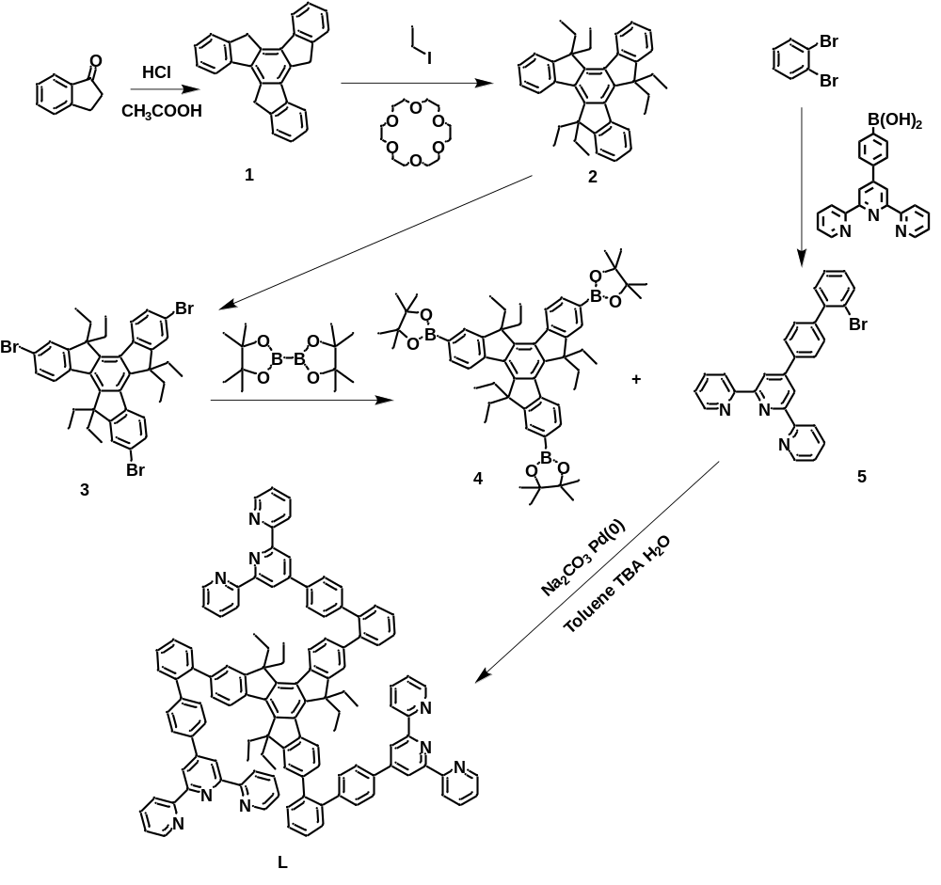
Supplementary Fig. 1 Synthesis of ligand L.

Experimental section
General procedures. Chemicals were purchased from Sigma/Aldrich, Energy Chemical, Bidepharm and used without further purification. Thin-layer chromatography (TLC) was conducted on flexible sheets (Baker-flex) precoated with Al₂O₃ (IB-F) or SiO₂ (IB2-F). Column chromatography was conducted using basic Al₂O₃ Brockman Activity I (60-325 mesh) or SiO₂ (60-200 mesh) from Fisher Scientific. NMR spectra were recorded on Bruker NMR 400 or 500 MHz spectrometers, using CDCl₃ for ligands, CD₃CN for metallo-products. ESI mass spectrometry (MS) experiments were performed on a Waters Synapt HDMS G2-Si quadrupole/time-of-flight (Q/TOF) tandem mass spectrometer. This instrument contains a triwave device between the Q and TOF analyzers, consisting of three collision cells in the order trap cell, ion mobility cell, and transfer cell. Trap and transfer cells are pressurized with Ar, and the ion mobility cell is pressurized with N₂ flowing in a direction opposite to that of the entering ions.
Mass Spectrometry and Ion Mobility. ESI-MS and TWIM-MS were recorded with a Waters Synapt G2-Si tandem mass spectrometer, using solutions of 0.01 mg sample in 1 mL of CHCl₃/CH₃OH (1:3, v/v) for ligands or 0.5 mg sample in 1 mL of DMF/CH₃OH (3:1, v/v) for complexes. All samples were infused into the ESI source at a flow rate of 6 μL/min by a syringe pump (KDS-100, KD Scientific). The TWIM-MS experiments were performed under the following conditions: ESI capillary voltage, 2 kV; sample cone voltage, 35 V; source offset, 42 V; source temperature 150 ºC; desolvation temperature, 250 ºC; cone gas flow, 10 L/h; desolvation gas flow, 700 L/h (N₂); source gas control, 0 mL/min; trap gas control, 3 mL/min; helium cell gas control, 120 mL/min; ion mobility (IM) cell gas control, 30 mL/min; sample flow rate, 8 μL/min; IM traveling wave height, 25 V; and IM traveling wave velocity, 1200 m/s. Data were collected and analyzed by using Mass Lynx 4.2 and Drift Scope 2.9.
Molecular Modeling. Energy minimization of the macrocycles was conducted with the Materials Studio version 6.0 program, using the Anneal and Geometry Optimization tasks in the Forcite module (Accelrys Software, Inc.). The counterions were omitted. Geometry optimization used a universal forcefield with atom-based summation and cubic spline truncation for both the electrostatic and van der Waals parameters.
UV-vis absorption and fluorescence properties. UV-vis absorption spectra were recorded on a Thermo Fisher Scientific Evolution 201 spectrophotometer at room temperature in DMF and were corrected with the background spectrum of the solvent. Fluorescence properties were performed on Edinburgh-FS5 Fluorescence spectrometer at 300 K in DMF.
Single crystal X-ray diffraction. Single crystals of metallo-cage suitable for X-ray diffraction were obtained by crystallization from DMF-ethyl acetate solution (10 mg/mL) at 15 ℃. Single-crystals X-ray diffraction data for metallo-cage MTH was collected on a Bruker D8 VENTURE diffractometer using a mirror monochromated Ga-Kα radiation. Using Olex2, the structures were solved with the SIR2004 [2] structure solution program using Direct Methods and refined with the XH [3] refinement package using CGLS minimisation. Data refinement and reduction were undertaken with Bruker SAINT. The structures were solved by direct methods and refined by full-matrix least-squares on F2 with anisotropic displacement using the SHELXTL software package. Details on crystals data collection and refinement were summarized in Table S1. CCDC: 2300228.
Preparation of doped PMMA films. The DMF solution of metal cage MTH at a concentration of 5 mg/mL was doped into the DMF solution of PMMA at 10 mg/mL. Then, the corresponding solution was dropped onto a glass substrate to make a flexible luminescent film under vacuum at 25 °C.

- Synthesis of the compounds and metallo-organic cage MTH
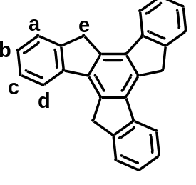
Compound 1: Compound 1 was synthesized by dissolving 1-indanone (1.36 g, 10.3 mmol) in the mixture of HCl (3.16 mL, 0.1 mmol) and CH₃COOH (5.89 mL, 0.10 mmol), under an argon atmosphere. After stirring at 100 °C for 16 h, the mixture was poured into ice water and filtered. The solid was washed with water, acetone and CH₂Cl₂ to get compound 1 as a white solid (0.98 g, 72%).¹ ¹H NMR (400 MHz, CDCl₃) δ 7.97 (d, J = 7.5 Hz, 1H, Ph-H^{d}), 7.71 (d, J = 7.0 Hz, 1H, Ph-Hª), 7.51 (t, J = 7.0 Hz, 1H, Ph-H^{c}), 7.40 (t, J = 7.0 Hz, 1H, Ph-H^{b}), 4.29 (s, 2H, -CH₂-H^{e}).
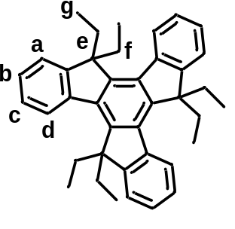
Compound 2: Firstly, 18-crown-6 (45 mg, 0.17 mmol) was added in the ice-cold suspension of compound 1 (0.20 g, 0.57 mmol) and t-BuOK (0.82 g, 7.31 mmol) in dry THF (15 mL) under an argon atmosphere. Then, iodoethane (0.75 mL, 9.36 mmol) was added dropwise, and the mixture was heated at 40 °C for another 2 h. Finally, the solution was cooled to 0 °C followed by adding iodoethane (0.75 mL, 9.36 mmol) again and heated at 40 °C for 20 h. After cooling to room temperature, the solution was poured into water and extracted with ethyl acetate. The organic phase was washed with saturated salt water and dried with anhydrous sodium sulfate. The solvent was evaporated, and the residue was purified by silica gel column chromatography using petroleum ether as the eluent. The final yellow solid was obtained in a yield of 85%. ¹H NMR (500 MHz, CDCl₃) δ 8.35 (s, 1H, Ph-H^{d}), 7.46 (d, J = 9.0 Hz, 1H, Ph-Hª), 7.38 (t, J = 9.5 Hz, 2H, Ph-H^{c,b}), 3.01 (t, J = 10.5 Hz, 2H, -CH₂-H^{e}), 2.14 (dd, 2H, -CH₂-H^{f}), 0.31-0.09 (m, 6H, -CH₃-H^{g}). ¹³C NMR (101 MHz, CDCl₃) δ 153.02, 144.07, 140.84, 139.05, 126.64, 126.26, 124.75, 122.46, 56.91, 29.59, 8.69.
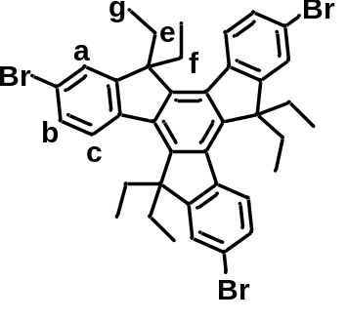
Compound 3: The compound 2 (5.48 g, 12.8 mmol) in dichloromethane (270 mL) was placed into a 3-neck 500-mL flask. To the solution, bromine (7.17 g, 2.30 mL, 44.9 mmol) was added and the mixture was stirred at room temperature for 7.5 h. To the reaction mixture, saturated aqueous solution of sodium thiocarbonate (200 mL) was added. The organic layer was extracted by CH₂Cl₂ (100 mL × 2) and the combined organic layer was washed with brine (100 mL) and dried over magnesium sulfate. After filtration, the solvent was evaporated in vacuo. Recrystallization from hot CH₂Cl₂/CH₃OH gave compound 3 in 92% (7.79 g, gray powder).² ¹H NMR (500 MHz, CDCl₃) δ 8.16 (d, J = 8.5 Hz, 1H, Ph-H^{c}), 7.57 (s, 1H, Ph-Hª), 7.52 (d, J = 8.0 Hz, 1H, Ph-H^{b}), 2.97-2.81 (m, 2H, -CH₂-H^{e}), 2.18-2.01 (m, 2H, -CH₂-H^{f}), 0.20 (t, 6H, -CH₃-H^{g}). ¹³C NMR (101 MHz, CDCl₃) δ 155.40, 144.29, 139.47, 138.48, 129.83, 126.20, 125.96, 121.50, 57.44, 29.67, 8.79.

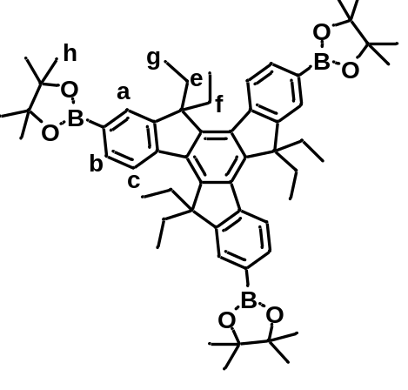
Compound 4: A mixture of compound 3 (500 mg, 0.67 mmol), Bis-(pinacolato)diboron (764.88 mg, 3.0 mmol), Pd(dppf)Cl₂ (109.75 mg, 0.10 mmol) and potassium acetate (798.04 mg, 8.04 mmol) was degassed three times. After that, 80 ml anhydrous DMSO was added and then the mixture was stirred at 80 ºC for 48 h. At the end of the reaction, it was cooled to room temperature and extracted with CH₂Cl₂ and saturated salt water to collect the organic phase. The organic phase was dried with anhydrous Na₂SO₄ and the solvent was removed by vacuum distillation. The crude product had poor solubility, so it was purified by dry column chromatography (SiO₂), and CH₂Cl₂/Hexane (3:1, v/v) was used as the eluent to obtain 0.389 g white solid 65.3% yield). ¹H NMR (400 MHz, CDCl₃) δ 8.38 (d, J = 14.0 Hz, 1H, Ph-H^{c}), 7.88 (d, J = 9.1 Hz, 2H, Ph-H^{a,b}), 2.99 (dt, 2H, -CH₂-H^{e}), 2.23 (td, 2H, -CH₂-H^{f}), 1.60 (s, 6H, -CH₂-H^{g}), 1.40 (s, 12H, -CH₂-H^{h}). ¹³C NMR (101 MHz, CDCl₃) δ 156.34, 155.99, 152.22, 149.84, 149.16, 144.19, 143.04, 140.90, 140.22, 139.32, 139.01, 138.50, 136.95, 136.41, 130.77, 130.63, 127.92, 127.49, 127.24, 127.05, 124.82, 124.61, 123.86, 121.47, 118.62, 56.63, 29.32, 8.76.
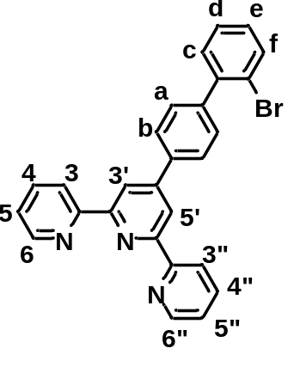
Compound 5: The 1,3-Dibromobenzene (1.5 g, 6.3 mmol), 4-tripyridyl phenylboric acid (2.13 g, 5.99 mmol), Pd(PPh₃)₂Cl₂ (223.96 mg, 0.32 mmol) were added to a 250 mL three-necked flask and sodium carbonate (2.00 g, 18.9 mmol), followed by adding 32 mL H₂O, 80 mL toluene and 16 mL tert-butanol under nitrogen. The mixture was stirred at 75 ºC for 1 day. After cooling to room temperature, the mixture was extracted with CH₂Cl₂, and the combined organic layer was washed with saturated salt water. After drying by anhydrous Na₂SO_{4,} vacuum concentration was carried out by rotary evaporator. The residue was separated by silica gel column and eluted with dichloromethane and methanol (100:0.5, v/v) as eluent to obtain 1.52 g white solid (52% yield). ¹H NMR (400 MHz, CDCl₃) δ 8.73 (s, 2H, tpy-H^{3’,5’}), 8.67 (d, J = 4.5 Hz, 2H, tpy-H^{6,6’’}), 8.63 (d, J = 8.0 Hz, 2H, tpy-H^{3,3’’}), 7.84 (m, 4H, Ph-H^{a,d,e,f}), 7.50 (dd, 2H, tpy-H^{4,4’’}), 7.32 (m, 4H, tpy-H^{5,5’’}, Ph-H^{b,c}). ¹³C NMR (101 MHz, CDCl₃) δ 156.38, 156.07, 149.94, 149.23, 142.03, 140.58, 137.40, 137.10, 129.01, 127.87, 127.76, 127.28, 123.99, 121.58, 118.91. ESI-TOF (m/z): Calcd. for [C₂₇H₁₈BrN₃ + H]⁺: 465.37, found: 465.38.
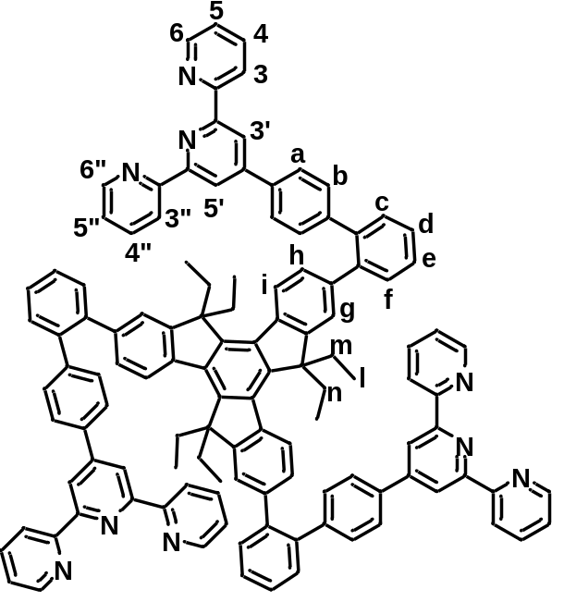
Ligand L: Compound 4 (100 mg, 0.112 mmol), Compound 5 (261mg, 0.562 mmol), Pd(PPh₃)₄ (20 mg, 0.017 mmol) and sodium carbonate (142 mg, 1.344 mmol) were added into a 250 mL three-necked flask. 25 mL toluene, 15 mL H₂O and 10 mL tert-butyl alcohol were added under N₂. The mixture was stirred at 85 ºC for 4 days. After cooling to room temperature, the mixture was extracted with CH₂Cl₂. The combined organic layer was washed with brine, dried over anhydrous Na₂SO_{4,} and then concentrated in vacuo, the residue was purified by dry column chromatography (Al₂O₃), eluting with DCM/MeOH (100:1, v/v) to give the product as 100 mg white solid (yield 53.7 %). ¹H NMR (400 MHz, CDCl₃) δ 8.68 (s, 2H, tpy-H^{3’,5’}), 8.65-8.59 (m, 4H, tpy-H^{3,3’’,6,6’’}), 8.11 (d, J = 8.0 Hz, 1H, Ph-H^{i}), 7.81 (m, 4H, Ph-H^{f,h,a}), 7.57-7.50 (m, 2H, tpy-H^{4,4’’}), 7.45 (m, 2H, Ph-H^{c,e}), 7.35 (m, 2H, Ph-H^{d,b}), 7.29 (d, J = 6.0 Hz, 2H, tpy-H^{6,6’’}), 6.89 (s, 1H, Ph-H^{g}), 2.69 (t, J = 13.0 Hz, 2H, -CH₂-H^{m}), 1.55 (d, J = 13.5 Hz, 2H, -CH₂-H^{n}), 0.07 (t, J = 6.0 Hz, 6H, -CH₃-H^{l}). ¹³C NMR (101 MHz, CDCl₃) δ 156.45, 156.14, 153.84, 150.76, 149.29, 144.65, 142.38, 142.29, 140.39, 139.47, 139.28, 138.77, 137.08, 132.28, 129.58, 128.63, 128.06, 126.55, 126.28, 125.80, 125.11, 124.01, 121.62, 121.13, 119.37, 57.28, 57.24, 29.82, 8.91, 8.83, 8.72, 1.15. ESI-TOF (m/z): Calcd. for [C₁₂₀H₉₃N₉ + H]⁺: 1662.13, found: 1662.13.

MTH (Zn₃L₂): To a solution of ligand L (5.0 mg, 3.48 μmol) in CHCl₃ (10 mL), a solution of Zn(NO₃)₂•6H₂O (1.34 mg, 5.22 μmol) in MeOH (10 mL) was added. The mixture was stirred at 60 ºC for 8 h and then cooled to room temperature, then excess NH₄PF₆ was added for the anion exchange, a precipitate was formed and washed with water, dried in vacuum to give the product as a yellow solid (6.0 mg, 95.0%). ¹H NMR (400 MHz, CD₃CN) δ 8.78 (s, 2H, tpy-H^{A3’,5’}), 8.73 (s, 4H, tpy-^{B3’,5’}), 8.51 (d, J = 10.0 Hz, 2H, tpy-H^{A3,3’’}), 8.46 (d, J = 8.0 Hz, 4H, tpy-H^{B3,3’’}), 8.29 (d, J = 8.0 Hz, 2H, Ph-H^{i,h}), 8.18 (d, J = 7.0 Hz, 2H, Ph-H^{,f}), 8.01 (s, 3H, Ph-H^{e}), 7.99 (m,, 6H, tpy-H^{A4,4’’}, tpy-H^{B4,4’’}), 7.93 (m, 6H, Ph-H^{Aa}, Ph-H^{Ba}), 7.67 (s, 2H, Ph-H^{Ab}), 7.63 (d, J = 7.0 Hz, 4H, Ph-H^{Ba}), 7.57 (s, 4H, tpy-H^{B6,6’’}), 7.53 (s, 2H, tpy-H^{A6,6’’}), 7.36 (s, 3H, Ph-H^{d}), 7.28 (d, J = 7.0 Hz, 3H, Ph-H^{c}), 7.22 (s, 2H, tpy-H^{A5,5’’}), 7.19-7.15 (m, 4H, tpy-H^{B6,6’’}), 7.09 (s, 1H, Ph-H^{g}), 1.27 (s, 6H, -CH₂-H^{m}), 0.86 (d, J = 8.5 Hz, 6H, -CH₂-H^{n}), -0.22 (s, 18H, -CH₃-H^{l}). ESI-TOF (m/z): 586.36 [M−6PF₆¯]⁶⁺ (calcd m/z: 586.36), 732.63 [M−5PF₆¯]⁵⁺ (calcd m/z: 732.63), 952.04 [M−4PF₆¯]⁴⁺ (calcd m/z: 952.04), 1317.73 [M−3PF₆¯]³⁺ (calcd m/z: 1317.73), 2049.09 [M−2PF₆¯]²⁺ (calcd m/z: 2049.09).

- ESI-MS spectra data of metallo-organic cage MTH (PF₆¯ as counterion)
Supplementary Fig. 2 Measured (bottom) and calculated (top) isotope patterns for different charge states observed from metallo-organic cage MTH (PF₆¯ as counterion).
- ¹H, ¹³C, COSY, NOESY, DOSY NMR spectrum
Supplementary Fig. 3 ¹H NMR (400 MHz, CDCl₃, 300 K) spectrum of compound 1.
Supplementary Fig. 4 ¹H NMR (500 MHz, CDCl₃, 300 K) spectrum of compound 2.
Supplementary Fig. 5 ¹³C NMR (101 MHz, CDCl₃, 300 K) spectrum of compound 2.
Supplementary Fig. 6 ¹H NMR (500 MHz, CDCl₃, 300 K) spectrum of compound 3.

Supplementary Fig. 7 ¹³C NMR (101 MHz, CDCl₃, 300 K) spectrum of compound 3.
Supplementary Fig. 8 ¹H NMR (400 MHz, CDCl₃, 300 K) spectrum of compound 4.
Supplementary Fig. 9 ¹³C NMR (101 MHz, CDCl₃, 300 K) spectrum of compound 4.
Supplementary Fig. 10 ¹H NMR (400 MHz, CDCl₃, 300 K) spectrum of compound 5.
Supplementary Fig. 11 ¹³C NMR (101 MHz, CDCl₃, 300 K) spectrum of compound 5.
Supplementary Fig. 12 ¹H NMR (400 MHz, CDCl₃, 300 K) spectrum of Ligand L.

Supplementary Fig. 13 ¹³C NMR (101 MHz, CDCl₃, 300 K) spectrum of Ligand L.
Supplementary Fig. 14 ¹H NMR (400 MHz, CD₃CN, 300 K) spectrum of metallo-organic cage MTH (full spectrum).
Supplementary Fig. 15 ¹H NMR (400 MHz, CD₃CN, 300 K) spectrum of metallo-organic cage MTH (aromatic region).
Supplementary Fig. 16 2D COSY NMR (500 MHz, CD₃CN, 300 K) spectrum of metallo-organic cage MTH (full spectrum).
Supplementary Fig. 17 2D COSY NMR (500 MHz, CD₃CN, 300 K) spectrum of metallo-organic cage MTH (aromatic region).
Supplementary Fig. 18 2D NOESY NMR (500 MHz, CD₃CN, 300 K) spectrum of metallo-organic cage MTH (full spectrum).
Supplementary Fig. 19 2D NOESY NMR (500 MHz, CD₃CN, 300 K) spectrum of metallo-organic cage MTH (aromatic region).
Supplementary Fig. 20 2D DOSY NMR (500 MHz, CD₃CN, 300 K) spectrum of metallo-organic cage MTH.
- X-ray crystallographic data and structures
Table 1. Crystal Data and Structure Refinement for metallo-organic cage MTH.
Identification code | metallo-cage MTH
Empirical formula | C₂₄₁H_{186.75}F₂₉N₁₇P₅Zn₃
Moiety formula | C₂₄₁H_{186.75}F₂₉N₁₇P₅Zn₃
Formula weight | 4222.77
Temperature/K | 100.00(11)
Crystal system | triclinic
Space group | P-1
a/Å | 21.2938(19)
b/Å | 23.7477(19)
c/Å | 33.491(3)
α/° | 104.096(3)
β/° | 101.055(3)
γ/° | 105.331(3)
Volume/Å³ | 33518.7(8)
Z | 2
ρ_{calc}g/cm³ | 0.920
μ/mm⁻¹ | 0.661
F(000) | 4356.0
Crystal size/mm³ | 0.3 × 0.3 × 0.2
Radiation | GaKα (λ = 1.34138)
2Θ range for data collection/° | 2.46 to 67.96
Index ranges | -17≤h≤17, -19≤k≤19, -27≤l≤27
Reflections collected | 169725
Independent reflections | 17744 [R_{int} = 0.0782, R_{sigma} = 0.0575]
Data/restraints/parameters | 17744/314/2705
Goodness-of-fit on F² | 4.321
Final R indexes [I>=2σ (I)] | R₁ = 0.3184, wR₂ = 0.6759
Final R indexes [all data] | R1 = 0.3323, wR2 = 0.7019
Largest diff. peak/hole / e Å⁻³ | 7.45/-4.10
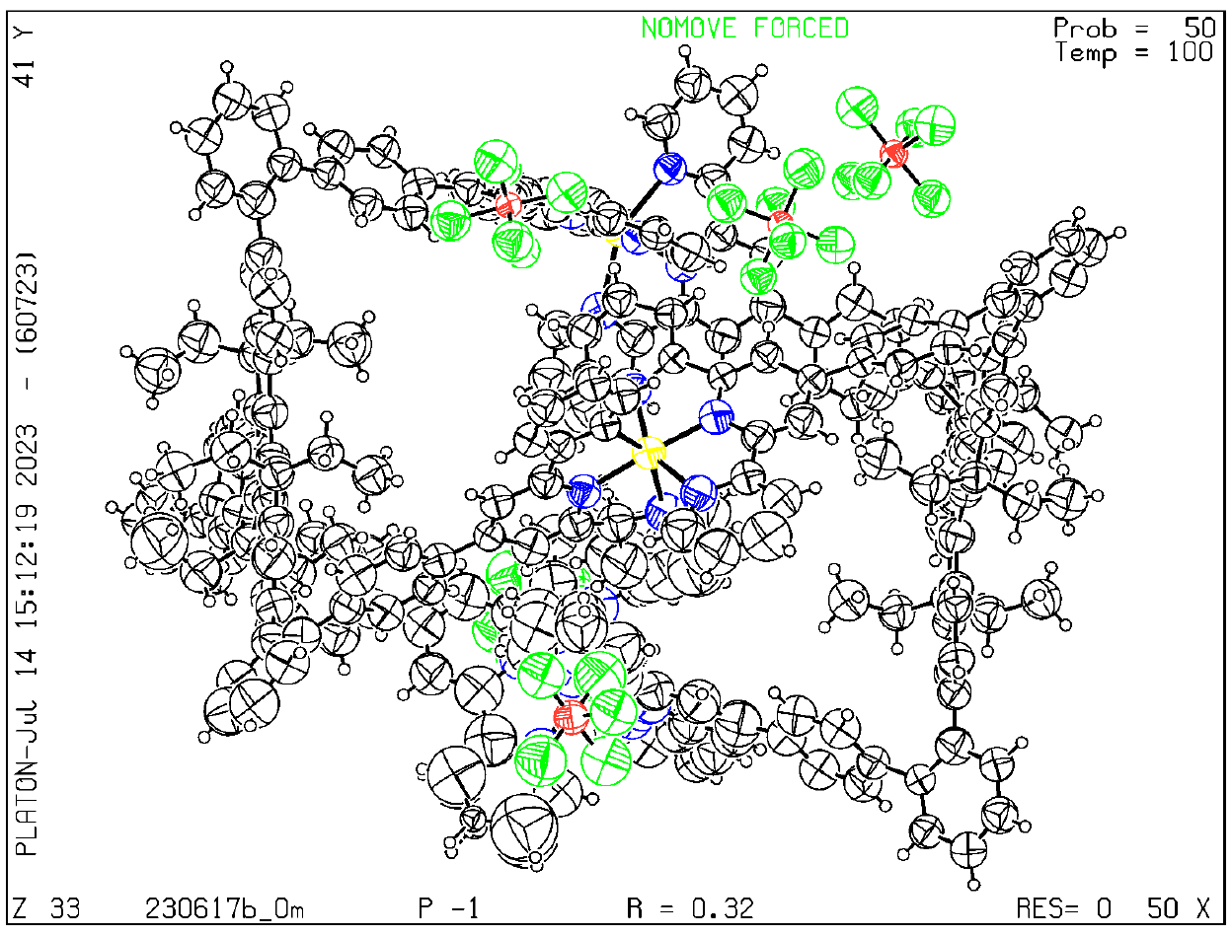
Supplementary Fig. 21 Ortep drawing of the asymmetric unit in the crystal structure of metallo-organic cage MTH at 50% probability level.
Supplementary Fig. 22 Supramolecular dimer (secondary structure) self-assembled by metallo-organic cage MTH within a unit cell. (a) top view, (b) side view and (c) front view.
Supplementary Fig. 23 Angle of axial torsion of three arms in metallo-organic cage MTH.
Supplementary Fig. 24 (a) Two types of terpyridine within metallo-organic cage MTH, (b) Two types of terpyridine in local enlargement, (c) Twisting angle of the benzene ring in type I terpyridine.
Supplementary Fig. 25 (a) (b) (c) The side, front and top views of the calculated planar conformation of metallo-organic cage MTH in the monomer state.
Supplementary Fig. 26 The calculation of metallo-organic cage MTH in the monomer state showed a planar conformation.

- Investigation of the fluorescence properties of metallo-organic cage MTH
Supplementary Fig. 27 UV/vis absorption of metallo-organic MTH in DMF at 1 × 10⁻⁵ M (300 K).
Supplementary Fig. 28 Fluorescence emission spectra of metallo-organic MTH in DMF with different concentrations (λ_{ex} = 320 nm) at 300 K from 2 × 10⁻⁵ M to 9 × 10⁻⁵ M.
Supplementary Fig. 29 Absolute fluorescence quantum yield of metallo-organic MTH in DMF at 1 × 10⁻⁵ M (300 K).
Supplementary Fig. 30 Absolute fluorescence quantum yield of metallo-organic MTH in DMF at 2 × 10⁻⁵ M (300 K).
Supplementary Fig. 301 Absolute fluorescence quantum yield of metallo-organic MTH in DMF at 2.1 × 10⁻⁵ M (300 K).
Supplementary Fig. 32 Absolute fluorescence quantum yield of metallo-organic MTH in DMF at 2.2 × 10⁻⁵ M (300 K).
Supplementary Fig. 33 Absolute fluorescence quantum yield of metallo-organic MTH in DMF at 5 × 10⁻⁵ M (300 K).
Supplementary Fig. 34. Absolute fluorescence quantum yield of metallo-organic MTH in DMF at 1 × 10⁻⁴ M (300 K).
Supplementary Fig. 35 Absolute fluorescence quantum yield of metallo-organic MTH in DMF at 5 × 10⁻⁴ M (300 K).
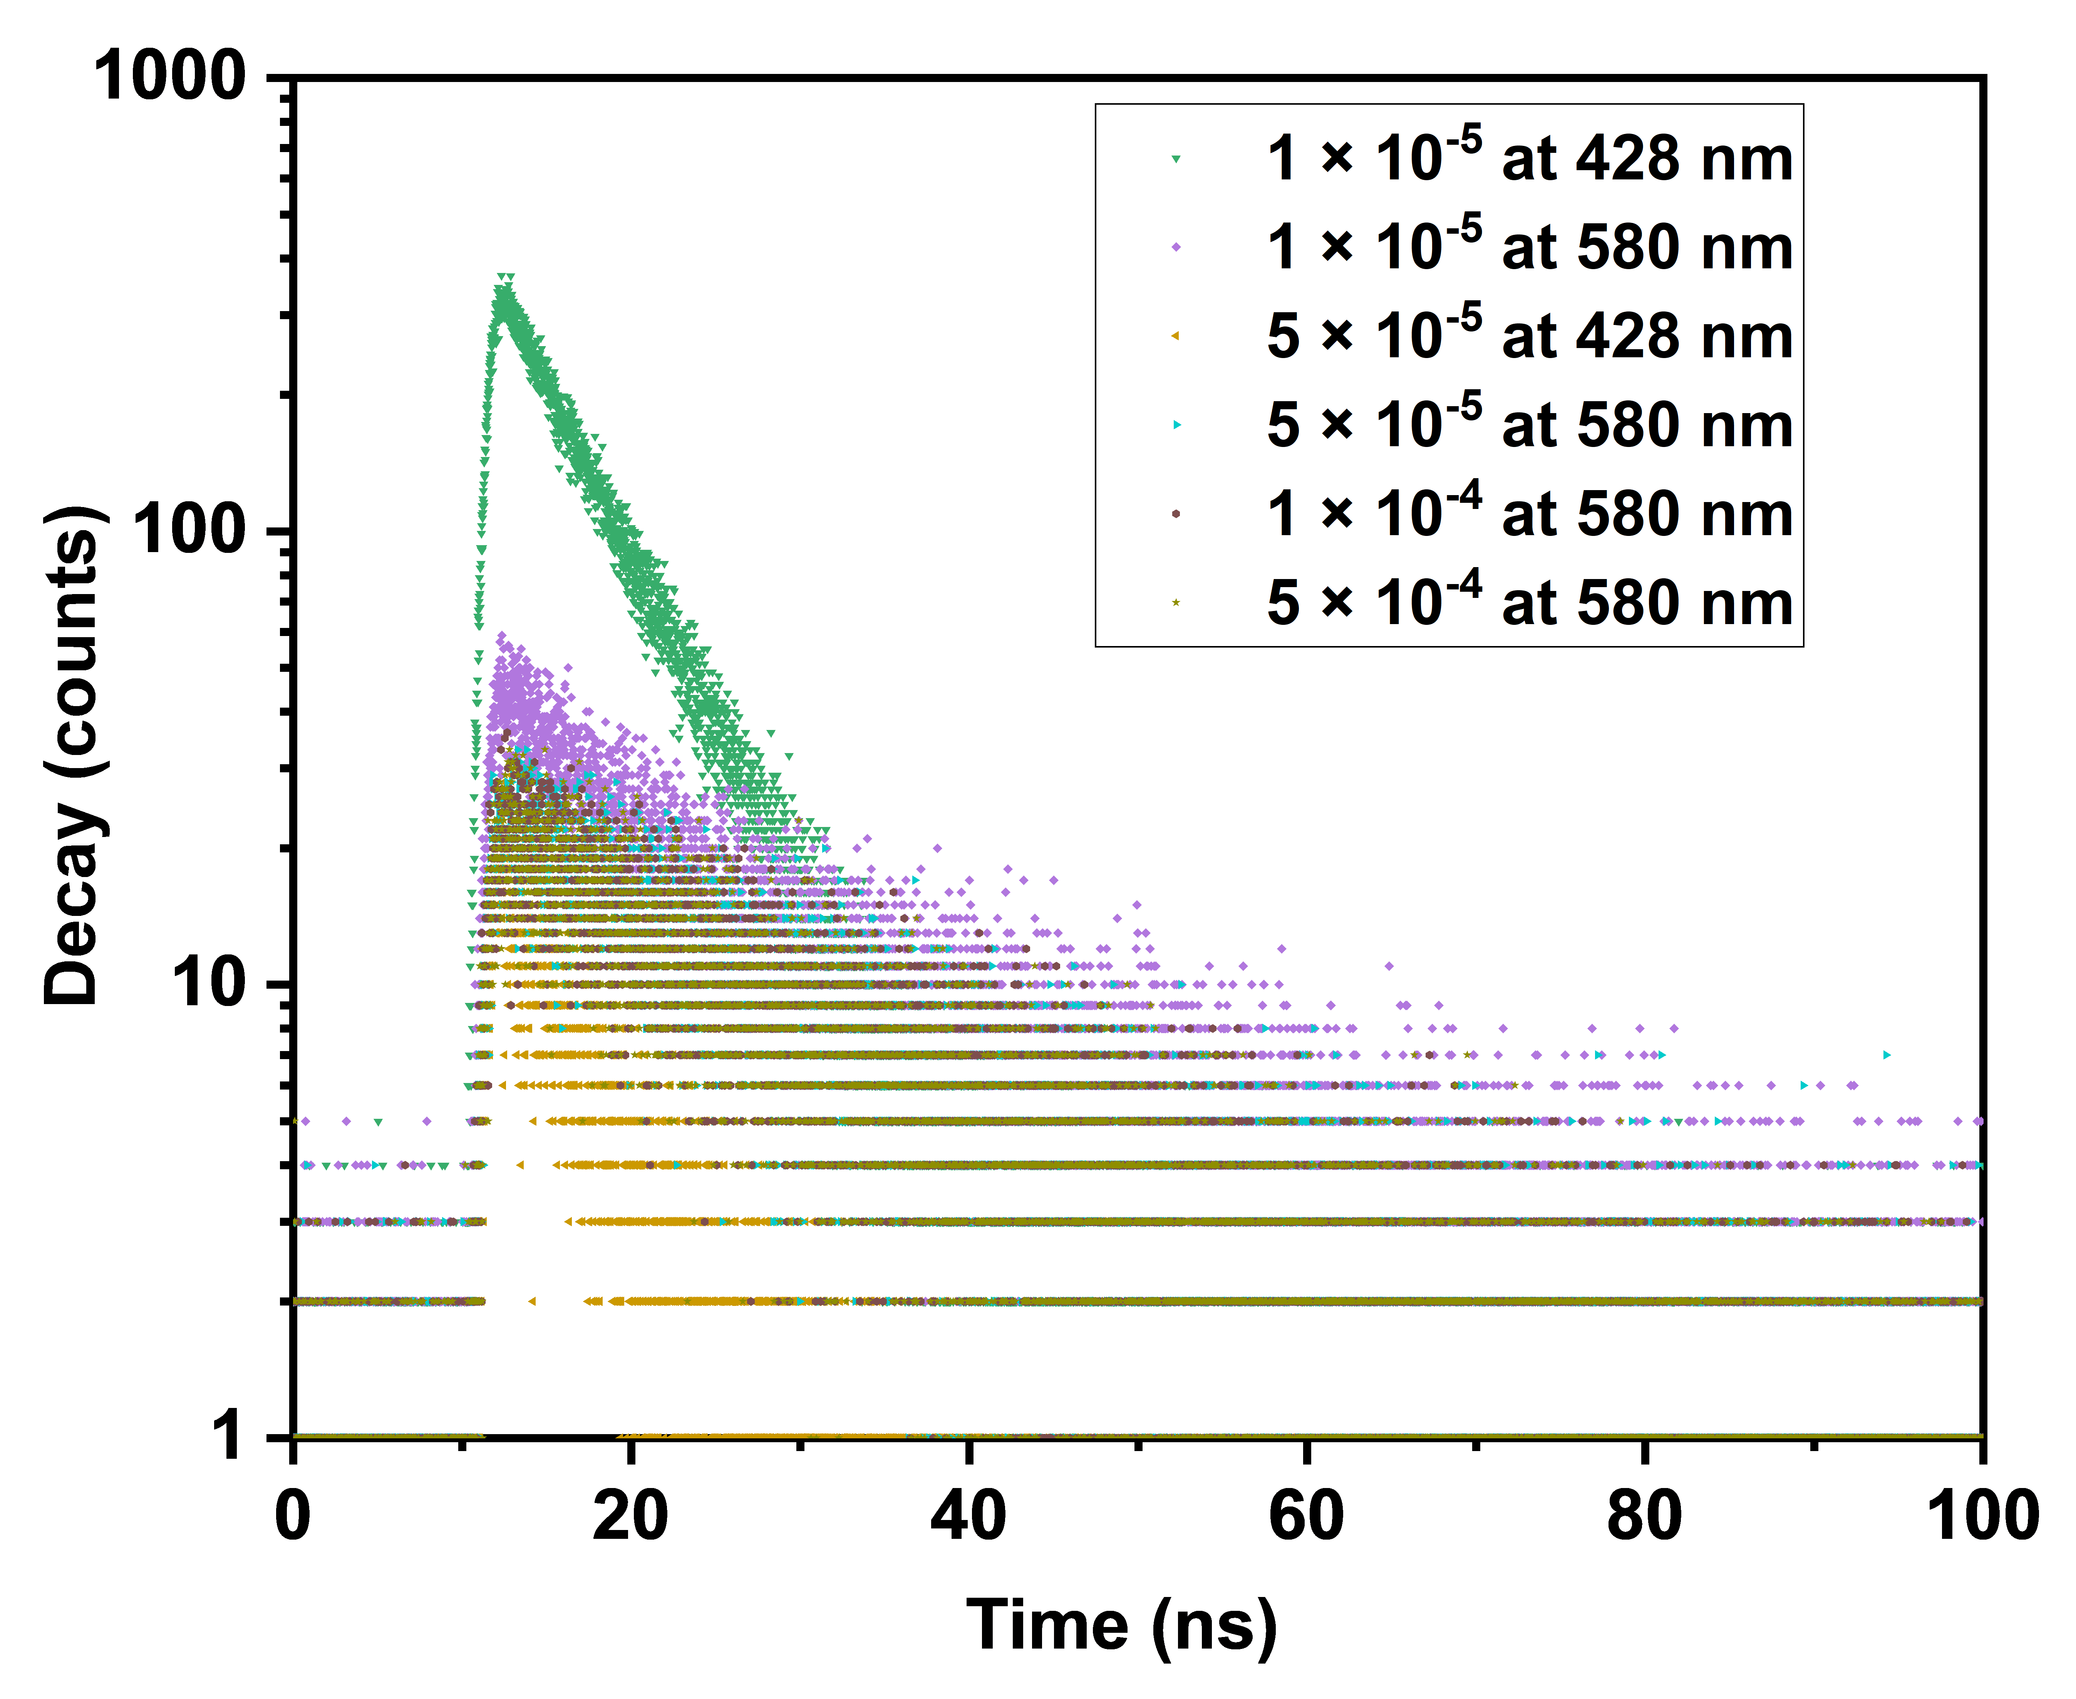
Supplementary Fig. 36 Fluorescent lifetime of metallo-organic cage MTH in DMF with different concentrations (λ_{em} = 428 or 580 nm, λ_{ex} = 320 nm) (300 K).

Supplementary Fig. 37 Fluorescence lifetime fitting of metallo-organic cage MTH in DMF at 1 × 10⁻⁵ M (λ_{em} = 428 nm or 580 nm, λ_{ex} = 320 nm) (300 K).
Supplementary Fig. 38 Fluorescence lifetime fitting of metallo-organic cage MTH in DMF at 5 × 10⁻⁵ M (λ_{em} = 428 nm or 580 nm, λ_{ex} = 320 nm) (300 K).
Supplementary Fig. 39 Fluorescence lifetime fitting of metallo-organic cage MTH in DMF at 1 × 10⁻⁴ M (λ_{em}= 580 nm, λ_{ex} = 320 nm) (300 K).
Supplementary Fig. 40 Fluorescence lifetime fitting of metallo-organic cage MTH in DMF at 5 × 10⁻⁴ M (λ_{ex} = 580nm, λ_{ex} = 320 nm) (300 K).
Table 2. The fluorescence lifetime of metallo-organic cage MTH at room temperature monitored at 428 and 580 nm, respectively (λ_{ex} = 320 nm).
 | 1 × 10⁻⁵ M | 5 × 10⁻⁵ M | 1 × 10⁻⁴ M | 5 × 10⁻⁴ M
428 nm | 5.65 ns | 5.75 ns
580 nm | 18.33 ns | 19.46 ns | 19.02 ns | 18.91 ns

Supplementary Fig. 41 Fluorescence emission spectrum of Ligand L in CHCl₃ with different concentrations (300 K).
Supplementary Fig. 42 Absolute fluorescence quantum yield of Ligand L in DMF at 1 × 10⁻⁵ M (300 K).
Supplementary Fig. 43 Fluorescence emission spectrum of ligand L in DMF (λ_{ex} = 320 nm) with (a) different concentrations at 300 K; (b) different temperatures at 1 × 10⁻⁵ M.

Supplementary Fig. 44 Fluorescence photographs of PMMA films with the “Sun” shape for metallo-cage MTH at different temperatures.
Supplementary Fig. 45 Fluorescence photographs of PMMA films with abbreviation of “Guangzhou University” for metallo-cage MTH at different temperatures.
- Estimated method of energy difference between monomer and excimer
For the current system, the transformation of monomer (M) and excimer (E) states can be expressed as:³
$$M+M\underset{↔}{K}D$$
where K is the equilibrium constant. According to the thermodynamic equilibrium theory, K can be described as:
$$K=\frac{\left[E\right]}{{\left[M\right]}^{2}} (S1)$$
Meanwhile, the relationship between K and Gibbs energy is given by
$$\ln{K}=-\frac{∆G}{RT}$$
where $∆G$ is Gibbs energy, T is the corresponding temperature. So, when T = T₁/T₂, the expression can be described as:
$$\ln{K_{T_{1}}}=-\frac{∆G}{RT_{1}} (S2)$$
$$\ln{K_{T_{2}}}=-\frac{∆G}{RT_{2}} (S3)$$
Subtraction of eq. S3 from eq. S2 yields
$$\ln{\frac{K_{T_{1}}}{K_{T_{2}}}}=\frac{∆G}{R} \left(\frac{1}{T_{2}}-\frac{1}{T_{1}}\right)=\ln{\frac{\left[D_{T_{1}}\right]{\left[M_{T_{2}}\right]}^{2}}{{\left[M_{T_{1}}\right]}^{2}\left[E_{T_{2}}\right]}} (S4)$$
Assuming that the concentration change of E can be negligible within small temperature range (within 10 K), and substitute the fluorophore concentration for fluorescence intensities, the function becomes
$$\ln{{\left(\frac{I_{T_{2}}}{I_{T_{1}}}\right)}^{2}=}\frac{∆G}{R} \left(\frac{1}{T_{2}}-\frac{1}{T_{1}}\right) (S5)$$
where I stands for the fluorescence intensity. Thus, the Gibbs energy can be calculated as:
$$∆G=\frac{RT_{1}T_{2}\ln{{\left(\frac{I_{T_{2}}}{I_{T_{1}}}\right)}^{2}}}{\left(T_{1}-T_{2}\right)} (S6)$$
$$∆G=\frac{RT_{1}T_{2}\ln{{\left(\frac{I_{T_{2}}}{I_{T_{1}}}\right)}^{2}}}{\left(T_{1}-T_{2}\right)} (S6)$$
When λ_{em} = 580 nm,
the T₁=300 K, T₂=400 K, I_{T1}= 24447, I_{T2}=21234,
R= 8.314472 J/(mol∙K)
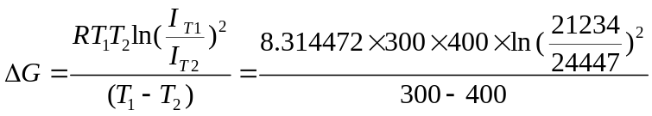
=2.679 ×10⁴ J/mol = 6.409 kcal/mol
- Stability measurement of metallo-organic cage MTH
Supplementary Fig. 46 ESI-MS spectra of metallo-organic cage MTH at different concentrations (the peak of 671.3 is an impurity peak in the solvent), (a) 5×10⁻⁴ M; (b) 1 × 10⁻⁴ M; (c) 5×10⁻⁵ M; (d) 1 × 10⁻⁵ M.
Supplementary Fig. 47 The ¹H NMR spectrum of metallo-organic cage MTH at different temperature (600 MHz, DMF-d₇).
- Reference
1. Wang M.-Y., Zhang Q.-J., Shen Q.-Q., Li Q.-Y., Ren S.-J. Truxene-based Conjugated Microporous Polymers via Different Synthetic Methods. Chin. J. Polym. Sci. 38, 151-157 (2020).
2. Tsuji H., Ota Y., Furukawa S., Mitsui C., Sato Y., Nakamura E. Tripyridyltruxenes: Thermally Stable Cathode Buffer Materials for Organic Thin-Film Solar Cells. Asian J. Org. Chem. 1, 34-37 (2012).
3. Shang C., et al. Excimer Formation of Perylene Bisimide Dyes within Stacking-Restrained Folda-Dimers: Insight into Anomalous Temperature Responsive Dual Fluorescence. CCS Chem. 4, 1949-1960 (2021).

