Table 1. Monthly mean meteorological parameters during the experimental years (June-2012 to June-2014)
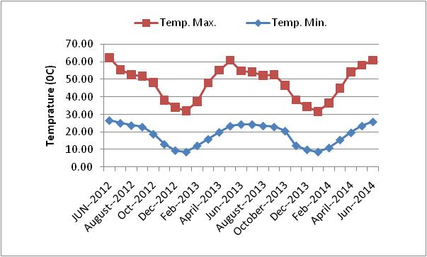
Humidity
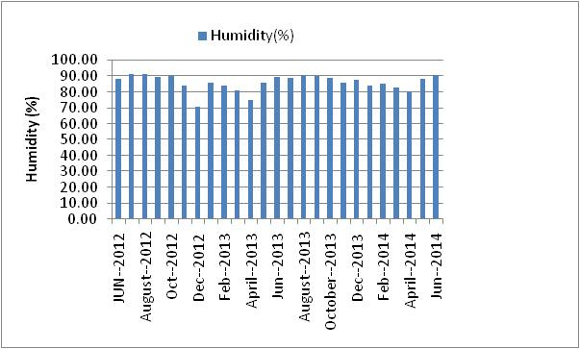

Rainfall

