Supplementary Fig. 1
Astrocyte-specific expression of AAV-GFAP_{0.7}-EGFP or AAV-GFAP_{0.7}-EGFP-T2A-iCre expression
a. Schematic diagram showing adult DAPS mouse models for astrocyte MEGF10/MERTK knock-out induced by dorsal striatum-specific virus expression. b-c. Representative confocal images of astrocyte-specific AAV-GFAP0.7-EGFP (control, b) or AAV-GFAP0.7-EGFP-T2A-iCre (DAPS, c) expression. DAPI (blue), AAV-infected astrocytes (green) and S100B (red) were indicated. Top: overall virus expressed astrocytes in dorsal striatum (scale bars= 20 μm); bottom: expanded views of the astrocyte (scale bars= 10 μm).

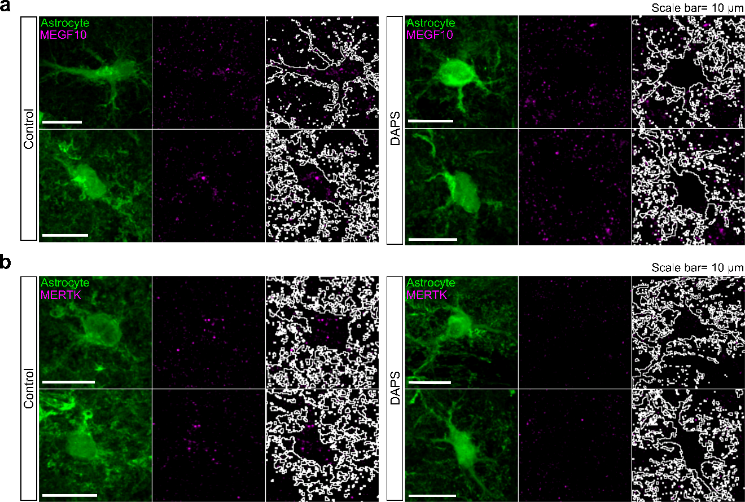

Supplementary Fig. 2
Astrocyte-specific deletion of MEGF10 and MERTK in the adult dorsal striatum
a-b. Representative confocal images of MEGF10 (a) or MERTK (b) with astrocytes in control and DAPS mice. White outlines show territories of observed astrocytes. Scale bars= 10 μm.

Supplementary Fig. 3
Cortical or thalamic input-specific expression of Alexa 568-labeled dextran tracer
Representative images of Alexa 568-labeled dextran expression in the motor cortex, thalamus and dorsal striatum following cortical or thalamic input region-specific injections. The white box in each brain region (scale bars= 500 μm) is expanded views of the Alexa 568-labeled dextran expression (Motor cortex and thalamus: scale bars= 100 μm; dorsal striatum: scale bars= 10 μm).

Supplementary Fig. 4
Monosynaptic and glutamatergic responses in corticostriatal and thalamostriatal pathway-dependent optogenetic light-evoked EPSPs.
a. Representative images showing corticostriatal or thalamostriatal projection-specific AAV-hSyn-Chronos-tdTomato expression and whole-cell patch clamp recording. b. Representative traces showing light-evoked EPSPs specific to the corticostriatal or thalamostriatal projections during drug treatment from control or DAPS slices. c. Dot plots depicting average changes in corticostriatal or thalamostriatal EPSPs depending on each drug treatment. Unpaired Student’s t-test. Mean ± s.e.m.

Supplementary Fig. 5
Comparable weight loss between control and DAPS mice.
a-c. Min to max plot summary data for body weight changes in control and DAPS mice during food restriction (b), FR1 training (c) and SO training (d). Control: n= 5 mice; DAPS: n= 10 mice. For all comparisons, unpaired Student’s t-test were performed. No statistical significance was found. All data are mean ± s.e.m.

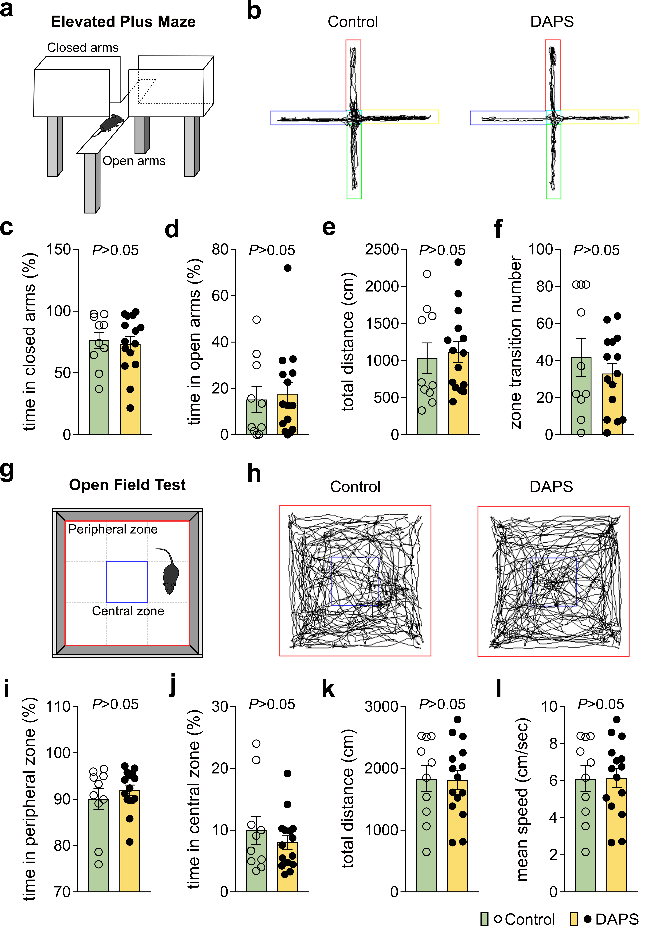

Supplementary Fig. 6
Normal locomotion and anxiety levels in DAPS mice.
a. Schematic illustration of elevated plus maze. b. Representative traces showing mouse-moving in an elevated plus maze in control (left) and DAPS mice (right). c-f. Bar graph depict percentage of time in closed arms (c), percentage of time in open arms (d), total distance (e) and transition number of zone (f) of control and DAPS mice. g. Schematic illustration of open field test. h. Representative traces showing mouse-traveling in an open field chamber in control (left) and DAPS mice (right). i-l. Bar graphs depict percentage of time in peripheral zone (i), percentage of time in central zone (j), total distance (k) and mean speed (l) of control and DAPS mice. Control: n= 10 mice; DAPS: n= 15 mice. For all comparisons, unpaired Student’s t-test were performed. No statistical significance was found. All data are mean ± s.e.m.

Supplementary Fig. 7
Astrocytic MEGF10/MERTK KO mice have normal motivation levels but reduced accuracy and learning rate
a. Average rate of lever pressing per minute of control and DAPS mice during fixed ration 1 (FR1) training. b-c. Bar graphs indicate the food consumption of control and DAPS mice during FR1 training (b) and SO training (c). d-f. Percentage of sequences completed in each potential order. LL: second step error sequences (d); RL: backward sequences (e); RR: first step error sequences (f). Control: n= 5 mice; DAPS: n= 10 mice. For all comparisons, unpaired Student’s t-test were performed. All data are mean ± s.e.m.

