Supplementary Information

CatPred: A comprehensive framework for deep learning in vitro enzyme kinetic parameters k_{cat}, K_{m} and K_{i}
Veda Sheersh Boorla¹, Costas D. Maranas^{1*}
* Corresponding author: cdm8@psu.edu
¹ Department of Chemical Engineering, The Pennsylvania State University, University Park, PA 16802, USA

Table S1. Statistics of in vitro kinetic measurements in BRENDA (v2022_2) and SABIO-RK (as of Nov. 2023)

 | k_{cat} | K_{m} | K_{i}
BRENDA | 83,662 | 172,917 | 45,684
SABIO-RK | 16,956 | 37,447 | 8,179

Table S2. Number of unique Enzyme Commission (EC) for BRENDA (v2022_2) entries with kinetic parameters
 | k_{cat} | K_{m} | K_{i}
Unique EC numbers | 3,336 | 4,885 | 1,986

Table S3. CatPred-DB dataset proportions with annotations of ‘natural substrate’

 | CatPred-DB-k_{cat} | CatPred-DB-K_{m} | CatPred-DB-K_{i}
Natural | 11,107 (47.8%) | 23,989 (58.3%) | 3,304 (27.7%)
Total | 23,197 | 41,174 | 11,929

Table S4. CatPred hyperparameter list – choices tested, and final values chosen. All other hyperparameters were not tuned and set to recommended values in chemprop¹ and are available on our Github repository.
 | Choices tested | Final value chosen
Batch size | [32, 64, 128] | 32
Sequence Embedding size | [36, 64, 128, 360, 480] | 36
Attention heads | [3, 6, 12] | 6

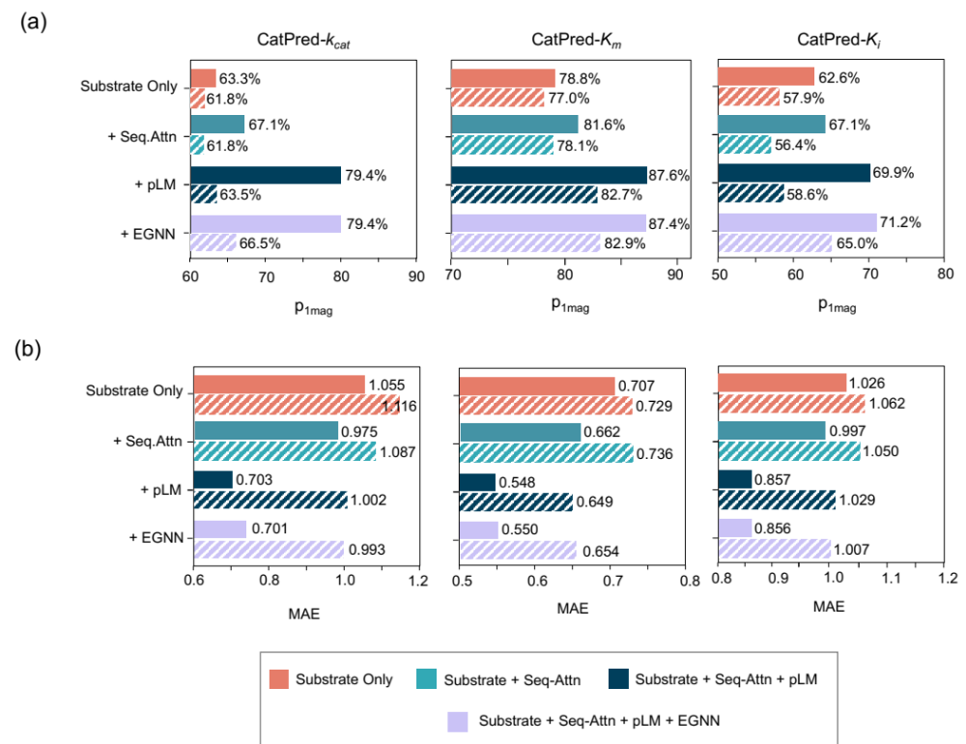
Figure S1. The performance metrics achieved by CatPred-k_{cat}, CatPred-K_{m} and CatPred-K_{i} models on hold-out test sets (solid bars) and on out-of-distribution samples (patterned bars). The (a) Percent of predictions within one order of magnitude error (p_{1mag}) and (b) Mean Absolute Error (MAE) are shown. ‘Substrate Only’ refers to CatPred models trained using only the substrate features; ‘Substrate+Seq-Attn’ (Sequence Attention) refers to CatPred models trained using substrate features and the Seq-Attn features; ‘Substrate+Seq-Attn+pLM’ (protein Langugae Model) refers to CatPred models trained using substrate features along with both the Seq-Attn and pLM features. ‘Substrate+Seq-Attn+pLM+EGNN’ (Equivariant Graph Neural Networks) refers to CatPred models trained using substrate features along with Seq-Attn+pLM and EGNN features.

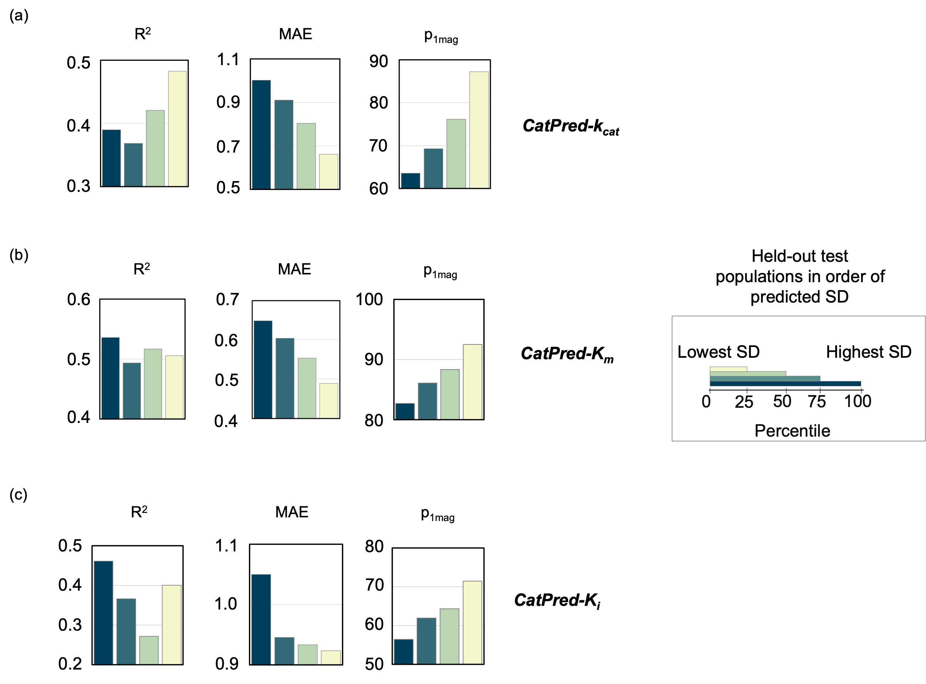

Figure S2 The performance metrics achieved by (a) CatPred-k_{cat}, (b) CatPred-K_{m} and (c) CatPred-K_{i} models on sub populations of the out-of-distribution test sets binned in order of their predicted uncertainty values (sum of aleatoric and epistemic uncertainty). Each colored bar denotes a sub population of the held-out set with uncertainty less than the 100th (Blue), 75th (Dark Green), 50th (Light Green), and 25th (Light yellow) percentile respectively. Within each figure, the subplots show the obtained co-efficient of regression (R²), Mean Absolute Error (MAE) and Percent of predictions within one oder of magintude error (p_{1mag}).

References:
- Heid, E. et al. Chemprop: A Machine Learning Package for Chemical Property Prediction. J Chem Inf Model 64, 9–17 (2024).

