Supplementary Materials for Deep learning based DNA:RNA triplex forming potential prediction

Yu Zhang¹, Yahui Long² and Chee Keong Kwoh^{1,*}

¹School of Computer Science and Engineering, Nanyang Technological University, 639798, Singapore, ²College of Computer Science and Electronic Engineering, Hunan University, Changsha 410000, China.

* To whom correspondence should be addressed. Tel: +65 6790 6057; Fax: +65 6792 6559; Email: asckkwoh@ntu.edu.sg

Tables
Table S1. The information of the wrongly predicted variants in lncRNA MIR100HG in all 5 times running. 2
Table S2. The information of the wrongly predicted variants in lncRNA MEG3 in all 5 times running.. 2
Table S3. The binding information for reported triplex lncRNA. 2
Figures
Figure S1. Determining the number of CNN layers and features in TriplexFPP. 3
Figure S2. The nucleotide frequency distribution in positive data (both triplexlncRNA and reported triplex lncRNA) and negative data in lncRNA triplex prediction model. 3
Figure S3. The demonstration of the number of variants for each gene. 4
Figure S4. The visualization of kmerscore (k=4,5,6) for correctly and wrongly predicted samples in triplex lncRNA leave-out validation for lncRNA MIR100HG and MEG3. 4
Figure S5. The distribution for predicted probability scores of the cross-fold validation test data. 5
Figure S6. The average values in each class. 6
Figure S7. Statistic of in cis & in trans lncRNAs in TriplexlncRNA. 6
Figure S8. Statistic of in cis & in trans lncRNAs in TriplexlncRNA. 7
Figure S9. Gene names and number of variants in two types of data in in cis / in trans lncRNA prediction. 7

Table S1. The information of the wrongly predicted variants in lncRNA MIR100HG in all 5 times running. The number of DBD and number of DBS are obtained from TDF.

name | Transcript id | Sequence length | Number of DBD | Number of DBS
MIR100HG-278 | ENST00000666485.1 | 3,010 | 8 | 5,190
MIR100HG-249 | ENST00000656226.1 | 4,530 | 13 | 10,500
MIR100HG-251 | ENST00000656682.1 | 4,180 | 12 | 13,600
MIR100HG-259 | ENST00000659296.1 | 1,490 | 7 | 10,900
MIR100HG-238 | ENST00000649626.1 | 3,370 | 11 | 27,000
MIR100HG-214 | ENST00000531629.1 | 1,820 | 3 | 4,770
MIR100HG-217 | ENST00000532350.1 | 972 | 1 | 621
MIR100HG-227 | ENST00000647967.1 | 980 | 2 | 2,100
MIR100HG-233 | ENST00000648576.1 | 1,320 | 3 | 2,480
MIR100HG-283 | ENST00000669993.1 | 507 | 1 | 19,600

Table S2. The information of the wrongly predicted variants in lncRNA MEG3 in all 5 times running. The number of DBD and number of DBS are obtained from TDF.

name | Transcript id | Sequence length | Number of DBD | Number of DBS
MEG3-220 | ENST00000522771.9 | 12,998 | 46 | 143,645
MEG3-213 | ENST00000455531.1 | 4,867 | 14 | 21,384
MEG3-250 | ENST00000662362.1 | 2,072 | 4 | 3,191
MEG3-201 | ENST00000398460.3 | 3,382 | 10 | 11,173

Table S3. The binding information for reported triplex lncRNA.

lncRNA | lncRNA chromosome | Bound DNA name and chromosome | type
HOTAIR | chr12 | PCDH7 chr4  HOXB2 chr17 [1,6] | In trans
MEG3 | chr14 | TGF-β chr3 [2,6] | In trans
PARTICL | chr2 | MAT2A chr2 [3,6] | In cis
MIR100HG | chr11 | P27(CDKN1B) chr12 [4] | In trans
FENDRR | chr16 | FOXF1 chr16 [5] | In cis

Figure S1. Determining the number of CNN layers and features in TriplexFPP. Upper panel: triplex lncRNA prediction model, lower panel: triplex DNA sites prediction model. Left: number of CNN layers, right: features.

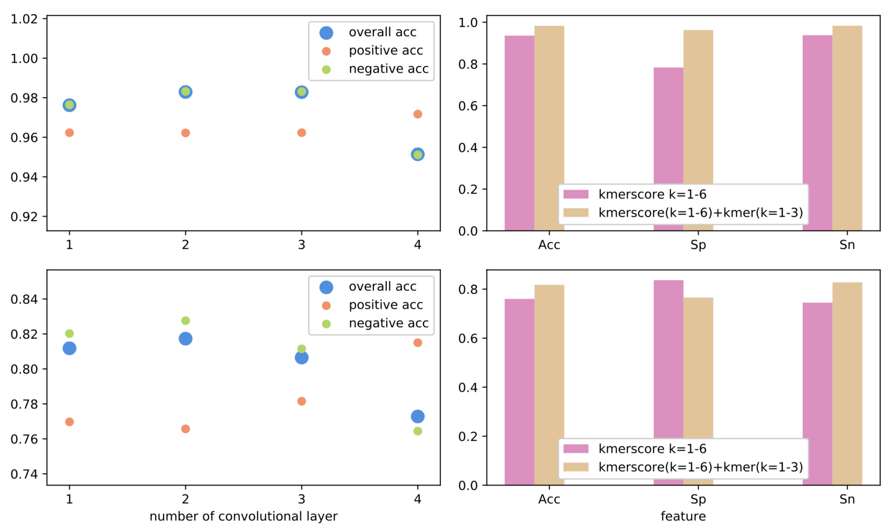

Figure S2. The nucleotide frequency distribution in positive data (both triplexlncRNA and reported triplex lncRNA) and negative data in lncRNA triplex prediction model.

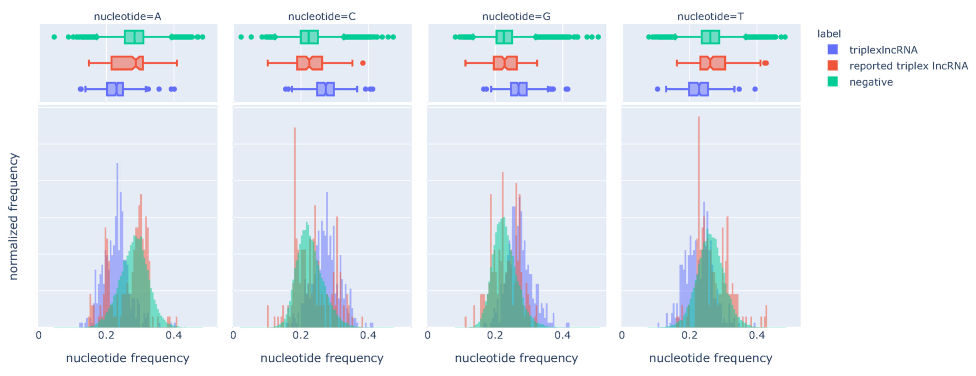

Figure S3. The demonstration of the number of variants for each gene, the light color to dark color means a small variant number to a large variant number, outer: triplexlncRNA, inner: reported triplex lncRNA.

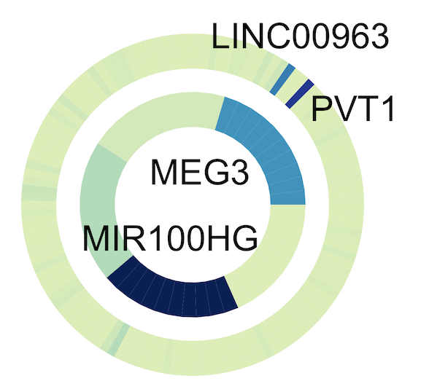

Figure S4. The visualization of kmerscore (k=4,5,6) for correctly and wrongly predicted samples in triplex lncRNA leave-out validation for lncRNA MIR100HG and MEG3.

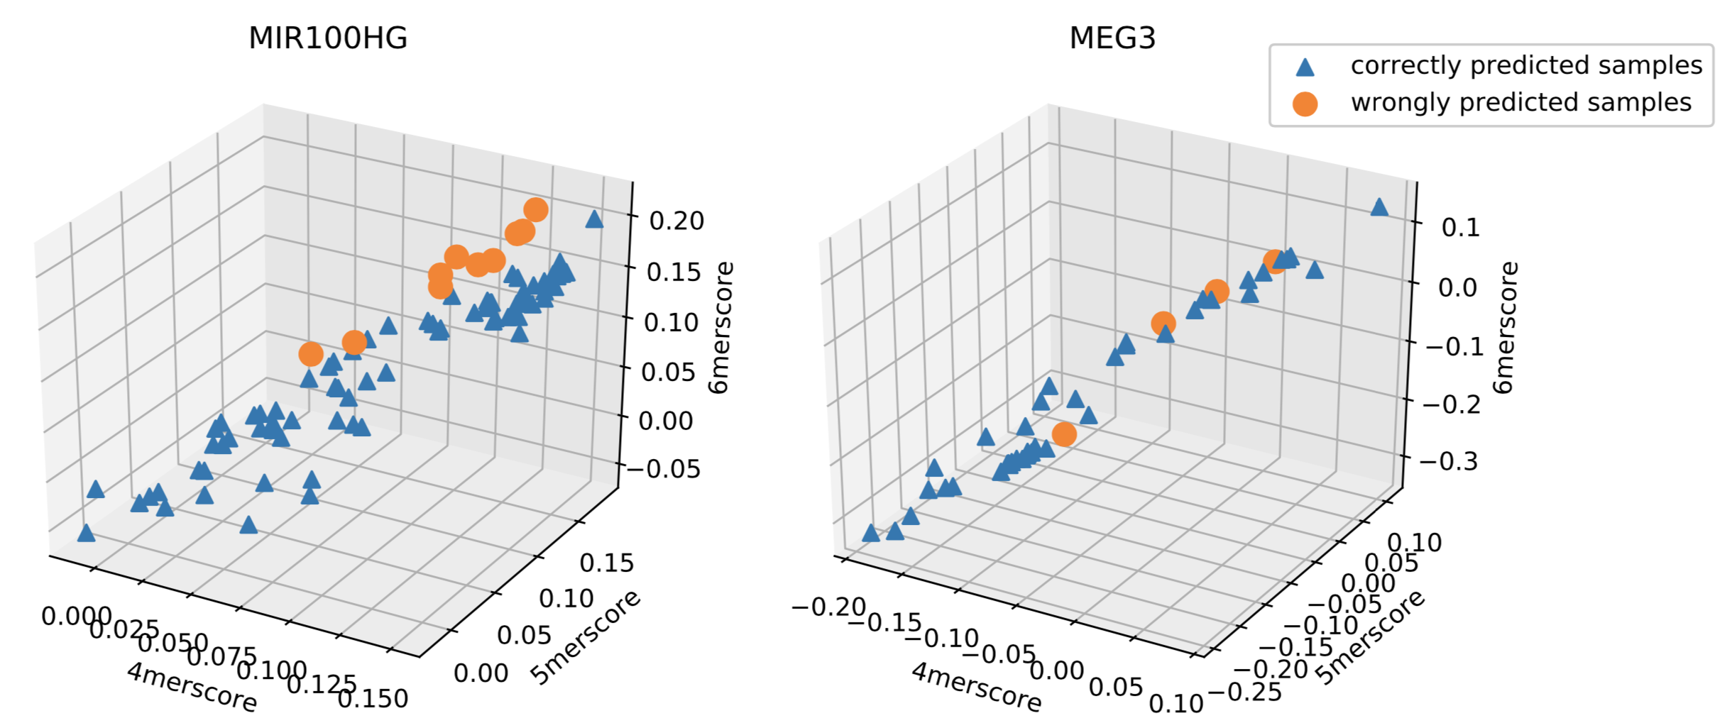

Figure S5. The distribution for predicted probability scores of the cross-fold validation test data. From upper left to lower right: fold 2 to fold 5.

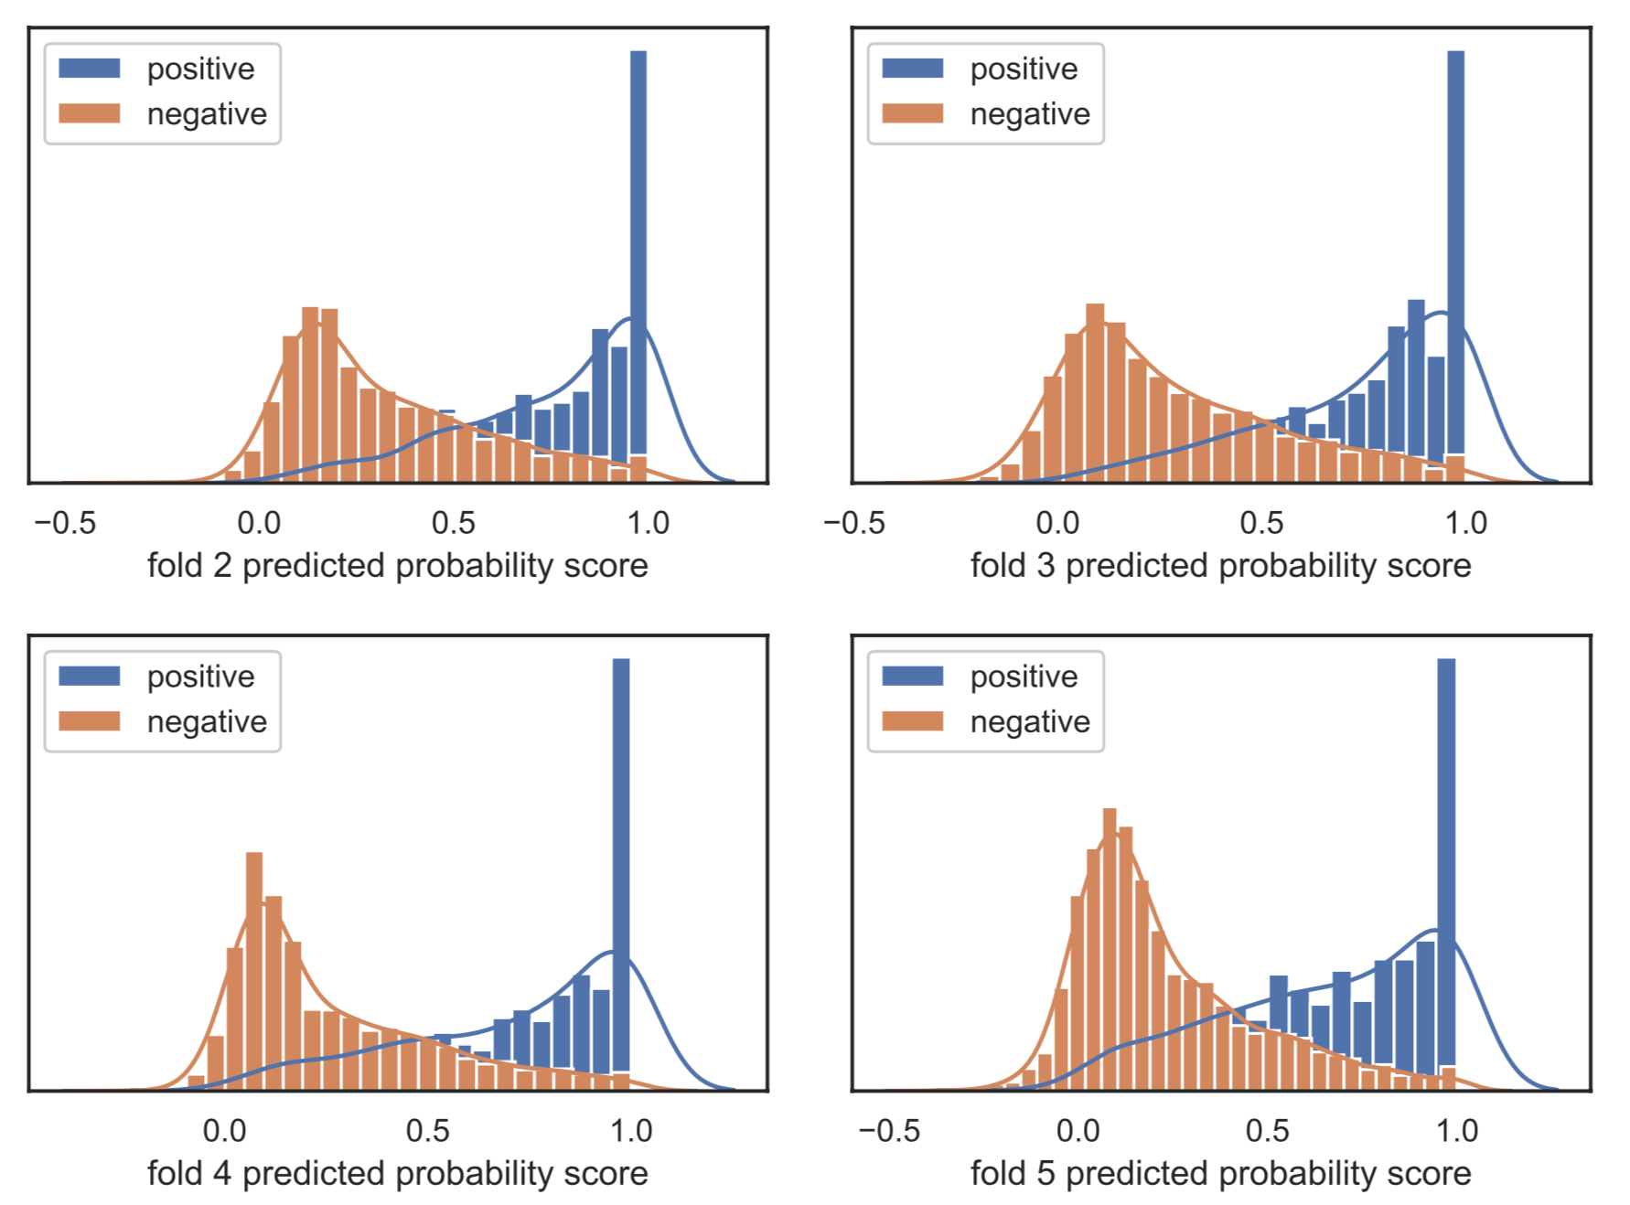

Figure S6. The average values in each class. Top: original features, middle: features after trained with 1 CNN layer, and bottom: features after trained with 2 CNN layers. Left: positive data, right: negative data.

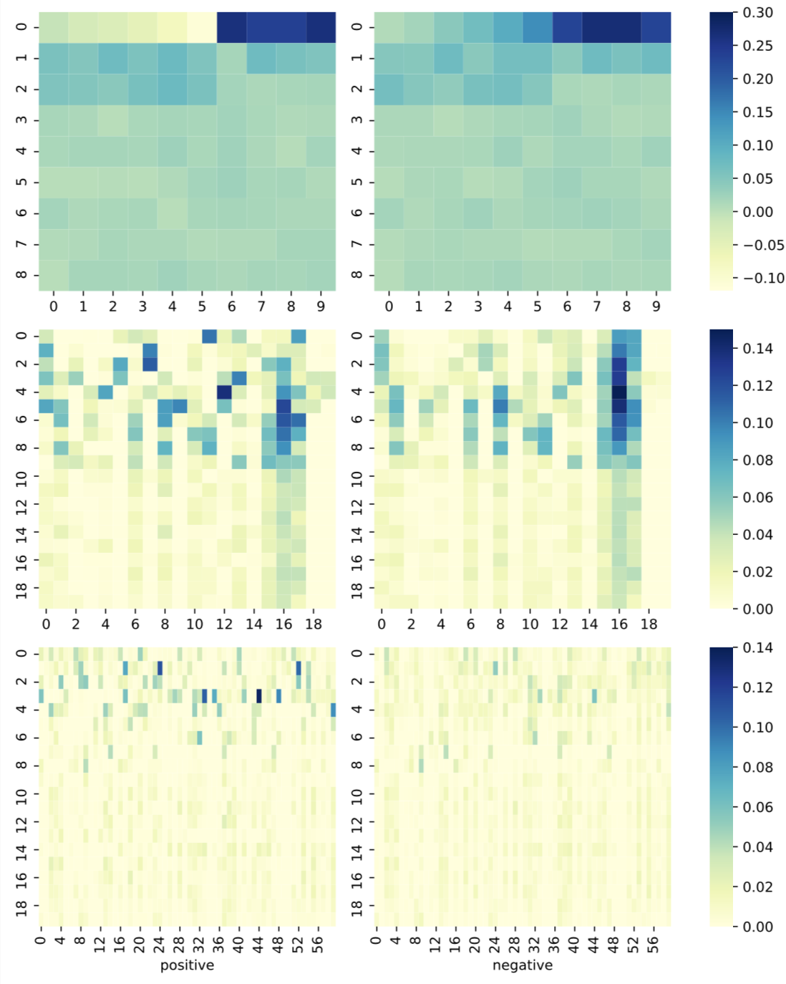

Figure S7. Statistic of in cis & in trans lncRNAs in TriplexlncRNA. Left: the number of lncRNAs in 2 classes, right: the distribution of the number of in cis binding sites for in cis & in trans lncRNAs.
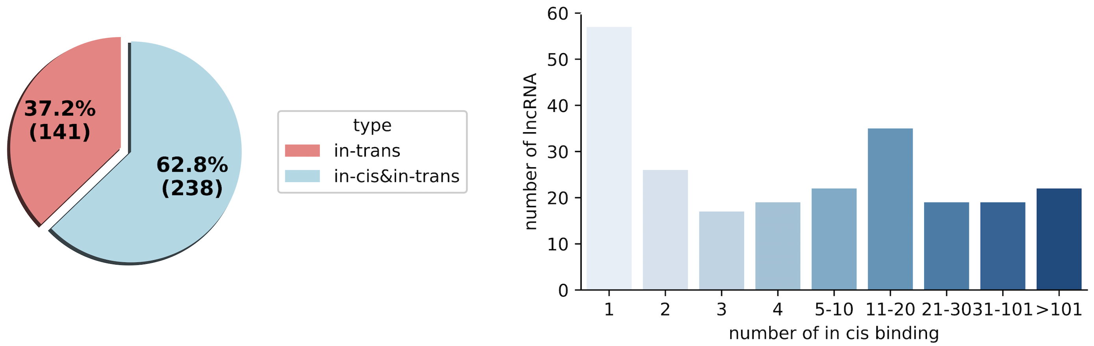

Figure S8. Statistic of in cis & in trans lncRNAs in TriplexlncRNA. Left: gene numbers in each type, right: variant numbers of PVT1 and LINC00963 in two classes.
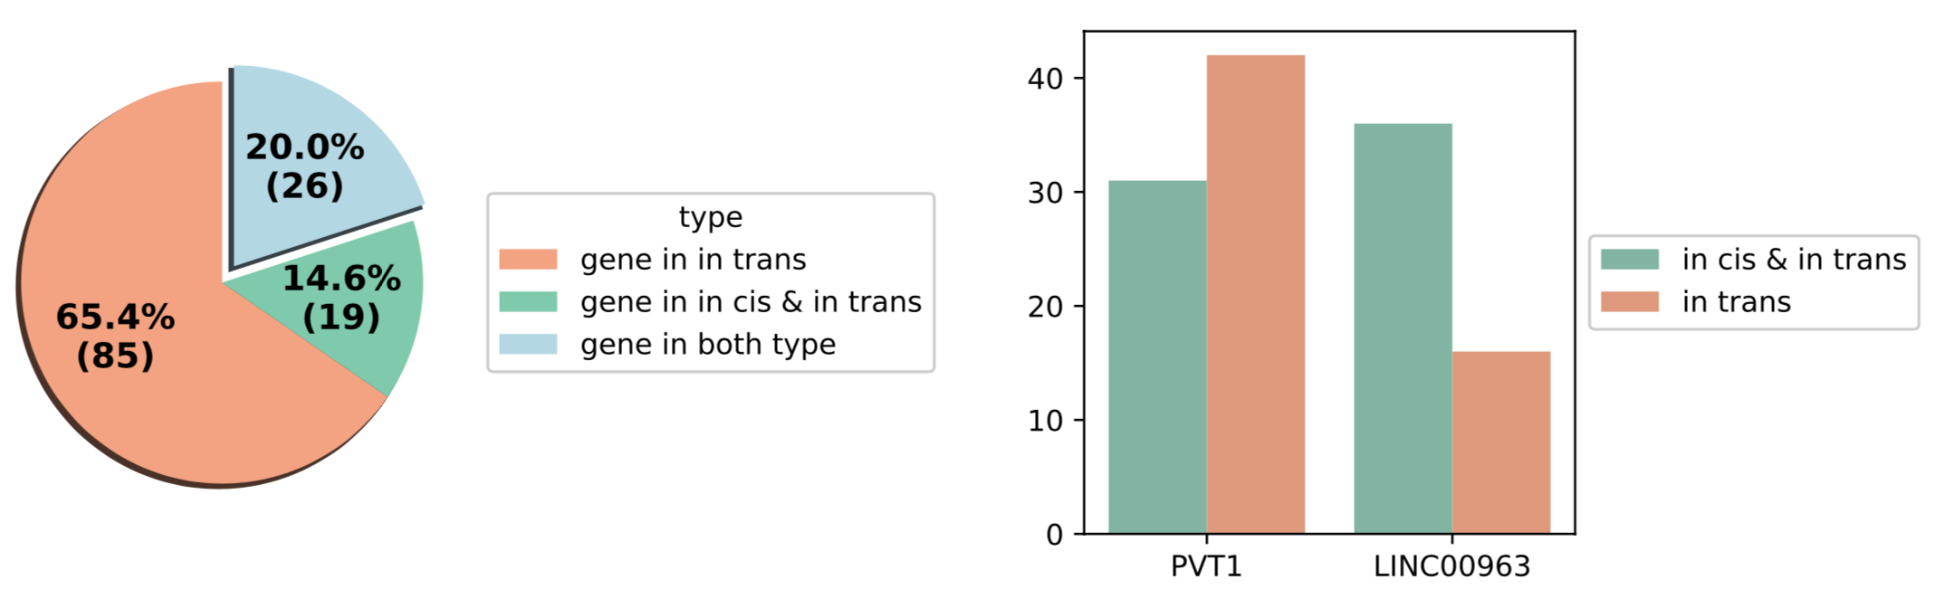

Figure S9. Gene names and number of variants in two types of data in in cis / in trans lncRNA prediction.

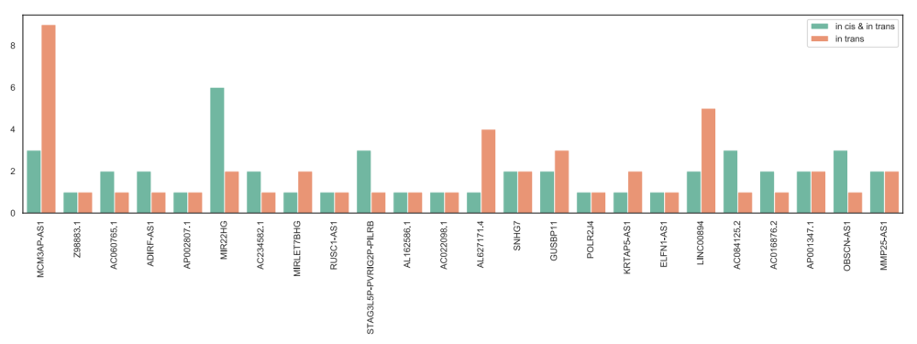

- Kalwa M, Hänzelmann S, Otto S, Kuo CC, Franzen J, Joussen S, Fernandez-Rebollo E, Rath B, Koch C, Hofmann A, Lee SH. The lncRNA HOTAIR impacts on mesenchymal stem cells via triple helix formation. Nucleic acids research. 2016 Dec 15;44(22):10631-43.
- [2] Mondal T, Subhash S, Vaid R, Enroth S, Uday S, Reinius B, Mitra S, Mohammed A, James AR, Hoberg E, Moustakas A. MEG3 long noncoding RNA regulates the TGF-β pathway genes through formation of RNA–DNA triplex structures. Nature communications. 2015 Jul 24;6:7743.
- O’Leary VB, Ovsepian SV, Carrascosa LG, Buske FA, Radulovic V, Niyazi M, Moertl S, Trau M, Atkinson MJ, Anastasov N. PARTICLE, a triplex-forming long ncRNA, regulates locus-specific methylation in response to low-dose irradiation. Cell reports. 2015 Apr 21;11(3):474-85.
- Wang S, Ke H, Zhang H, Ma Y, Ao L, Zou L, Yang Q, Zhu H, Nie J, Wu C, Jiao B. LncRNA MIR100HG promotes cell proliferation in triple-negative breast cancer through triplex formation with p27 loci. Cell death & disease. 2018 Jul 24;9(8):1-1.
- Navarro C, Cano C, Cuadros M, Herrera-Merchan A, Molina M, Blanco A. A mechanistic study of lncRNA Fendrr regulation of FoxF1 lung cancer tumor supressor. InInternational Conference on Bioinformatics and Biomedical Engineering 2016 Apr 20 (pp. 781-789). Springer, Cham.
- Li Y, Syed J, Sugiyama H. RNA-DNA triplex formation by long noncoding RNAs. Cell chemical biology. 2016 Nov 17;23(11):1325-33.

