Supplementary Methods

Human samples and sequencing
For patient P01, we collected bone marrow or peripheral blood samples at four distinct time points for single-cell sequencing: before CD19 CAR-T treatment (T1_Pre_CART), on day 28 after CD19 CAR-T treatment (T2_CART_D28), during myeloid relapse (T3_Relapse), and upon remission after chemotherapy (T4_Post_Chemo). For patient P02, we obtained bone marrow samples before CD19 CAR-T treatment and after myeloid relapse for scRNA-seq and whole-exome sequencing (WES). We acquired oral epithelial cells and peripheral blood samples for WES of P02. In addition, we collected bone marrow samples and performed targeted gene sequencing in P01 (T1_Pre_CART, T2_CART_D28, T3_Relapse, T4_Post_Chemo) and P02 (newly diagnosed, minimal residual disease, Post-CAR-T) at different time points.

Single-cell RNA-seq library preparation and sequencing
Single-cell RNA-seq libraries were prepared using the Chromium Next GEM Single Cell 3ʹ Reagent Kits v3.1 from 10X Genomics, following the manufacturer’s instructions. In brief, single cells were washed once with DPBS (Gibco) and counted cell density by TC20 Automated Cell Counter (Bio-Rad). Approximately 10,000 cells were captured in droplets to generate Gel beads in EMulsion (GEMs) and were used for the 10X Chromium single-cell 3’ gene expression library construction following the manufacturer’s instructions. The purified libraries were then sequenced on the Illumina NovaSeq 6000 platform with 150-base pair paired-end reads.

Processing and quality control of single-cell RNA-seq data
For single-cell RNA-seq data, FASTQ files were mapped to the human reference genome GRCh38 and generated the gene count matrix using the Cell Ranger toolkit (version 6.1.2, https://www.10xgenomics.com/support/software/cell-ranger/latest). Then cells with fewer than 200 genes detected or >15% mitochondrial UMI counts (genes initial as “MT-”) were filtered out by Scanpy (version 1.9.1)¹. To address potential doublets, the Scrublet² function within Scanpy was employed on each sequencing library, with an expected doublet rate set at 0.05, and the predicted doublet cells were subsequently filtered out. The normalized expression matrix was calculated based on the raw UMI counts after normalizing total counts per cell by scanpy.pp.normalize_total() function and then scaled by 1e6 and logarithmically transformed via scanpt.pp.log1p() function.

Dimension reduction and unsupervised clustering for scRNA-seq data
After quality control, the top 4,000 highly-variable genes (HVG) were selected via the scanpy.pp.highly_variable_genes() function. Then the scanpy.pp.regress_out() function was used to regress out the mitochondrial genes derived source of variation. As for dimension reduction, the principal component analysis (PCA) was first conducted through the scanpy.tl.pca() function to gain the main variation and denoise the high dimension data. Then, the neighborhood graph of cells using the PCA representation of the data matrix was computed by the scanpy.pp.neighbors() function. In addition, the non-linear dimension reduction like the Uniform Manifold Approximation and Projection (UMAP) was performed for visualization. To identify cell clusters based on their expression profiles, the unsupervised graph-based clustering algorithm, Leiden, was applied by the scanpy.tl.leiden() function. Each cluster’s marker genes or differentially expressed genes (DEGs) versus the rest of the clusters were calculated by the scanpy.tl.rank_genes_groups() function. Subsequently, we performed KEGG pathway enrichment analysis by KOBAS 3.0³.

Single-cell trajectory analysis and definition of cell states
To track the potential differentiation trajectory of the lineage switch process, related clusters were selected for Monocle (version 2.18.0)⁴ analysis based on its official documentation (https://cole-trapnell-lab.github.io/monocle-release/docs/). Biologically meaningful significant DEGs identified by Seurat (version 4.3.0) were used for dimensionality reduction and trajectory reconstruction by the reduceDimension() function with parameter “method = ‘DDRTree’”. Then the orderCells() function and the plot_cell_trajectory() function were applied to order cells and to visualize the trajectory in two-dimensional spaces.

Single cell variants calling by scRNA-seq data
For each sample of P01 and P02, sequencing data were mapped to the human reference genome (GRCh38) using STAR 2-pass method (version 2.7.8a) and sorted by SAMtools (version 1.9). The PCR duplicate reads were removed by Picard tools (version 2.10.5). Then, the bam files were processed by SplitNCigarReads, AddOrReplaceReadGroups”, base-quality recalibration and local indel realignment using the Genome Analysis Tool Kit (GATK, version 4.3.0.0)⁵. The variants were detected by Mutect2 and HaplotypeCaller in GATK. We extracted the single cell variant information from scRNA-seq data using VarTrix (version 1.1.16).

Single cell targeted DNA and membrane protein library preparation and sequence by Tapestri
The live cells (25,000 cells/μL) were resuspended in 40 μL cell staining buffer (BioLegend) and incubated with Human TruStain FcX (BioLegend) for 15 minutes blocking on ice. Then the reconstituted TotalSeq™-D Heme Oncology Cocktail (BioLegend) and TotalSeq™-D anti-human CD36 Antibody (BioLegend) were added and incubated 30 minutes on ice for membrane protein staining with 46 antibody-oligo conjugates as total. After incubation, cells were washed with pre-chilled cell staining buffer and resuspended in cell buffer (Mission Bio) as 3,000-4,000 cells/μL. The following steps were instructed by the user guide of Tapestri® Single-Cell DNA + Protein Sequencing. In brief, cells were first encapsulated using a Tapestri microfluidics cartridge to create a cell emulsion. Then, cell emulsions were lysed, barcoded, and broken for downstream target amplification. The targeted DNA panel was custom-designed based on the patient's clinical mutation information (Supplemental Table 3). Subsequently, the PCR products were cleaned up by Ampure XP beads (Beckman Coulter) and the DNA library and protein library were isolated and repurified by Ampure XP beads and streptavidin beads (Mission Bio) respectively. During target library PCR, the P5 and P7 adapter (Illumina) sequences were added to the amplicons required for sequencing followed by purification using Ampure XP beads. All libraries were quantified by Qubit Fluorometric Quantification (Thermo) during the library process and quantified by Agilent Bioanalyzer (Agilent) after finishing the library process. All libraries were sequenced on the Illumina NovaSeq 6000 platform.

Single cell DNA & Protein sequencing data analysis
In order to explore the molecular features at the single-cell level during lineage switch, we performed single cell DNA & Protein sequencing at different time points in P01. The raw data obtained from the Illumina NovaSeq 6000 platform were processed by the Tapestri pipeline. This pipeline includes adaptor sequences trimming, barcodes extracting, reads mapping (hg19), genotyping, and variant calling⁶. The “DNA and RNA” HD5 files for each sample generated by the Tapestri pipeline were analyzed by Mosaic (version 3.1.1). For DNA analysis, variants filtering was applied by the sample.dna.filter_variants() function with the recommended parameters. Non-silent somatic mutations were selected for downstream analysis. The variants clustering was performed by the sample.dna.find_clones() and sample.dna.scatterplot() function. For CNV analysis, the reads were normalized by the sample.cnv.normalize_reads() function, and visualized by using the sample.cnv.heatmap() function. For protein analysis, the reads were normalized by the sample.protein.normalize_reads('CLR') function. Then the sample.protein.run_pca() and sample.protein.run_umap() functions were used for clustering. The protein expression was visualized by the sample.protein.ridgeplot(), sample.protein.scatterplot() and sample.protein.heatmap() functions.

Whole-exome sequencing data analysis and somatic variants calling
For each sample in P02, sequencing data were mapped to the UCSC human reference genome (hg19). Then, the obtained bam files were further refined by Picard tools (version 2.10.5), including sorting and removal of PCR duplicate reads. For processed bam files, we performed base-quality recalibration and local indel realignment using the GATK. The GATK MuTect2 module was applied for somatic single-nucleotide variants (SNVs) and small insertions and deletions (InDels) calling with the recommended parameters. According to base substitution in all the variants, the “mutation signature” were calculated by the R Package deconstructSigs⁷. All the variants were annotated by ANNOVAR software⁸, and the impact of the variants predicted by PolyPhen-2, SIFT and CADD in ANNOVAR filter-based annotation (dbnsfp42a). The annotated variants were filtered by the following criteria: 1) common SNPs/indels in dbSNP version 138 were removed; 2) the depth of the variants in each sample > 20; 3) silent SNVs/indels were removed; 4) variants in repeat or centromeric region were removed; 5) variants with strand bias were removed, 6) variants with a population allele frequency > 1% were removed (The 1000 Genomes Project and The Genome Aggregation Database). The false-positive variants were manually checked by Integrative Genomics Viewer software⁹.

Targeted sequencing and variants filtering
For all B-ALL patients, we extracted DNA from bone marrow and performed deep target sequencing on a panel of 267 genes (Supplemental Table 10). The panel was applied to the clinical detection in out center. Sequencing data were analyzed by the same pipeline for WES. All the variants were filtered by the following criteria: 1) the depth of the variants in each sample > 1000; 2) variants with strand bias were removed; 3) the variants which FILTER flag marked as "PASS" were reserved; 4) mutant allele frequency >1%, number of mutant allele reads > 15; 5) variants with a population allele frequency > 1% were removed (The 1000 Genomes Project and The Genome Aggregation Database); 6) silent SNVs/indels were removed. We presented the mutational landscape present of B-ALL patients by the R Package maftools¹⁰.

Supplementary Figure Legends
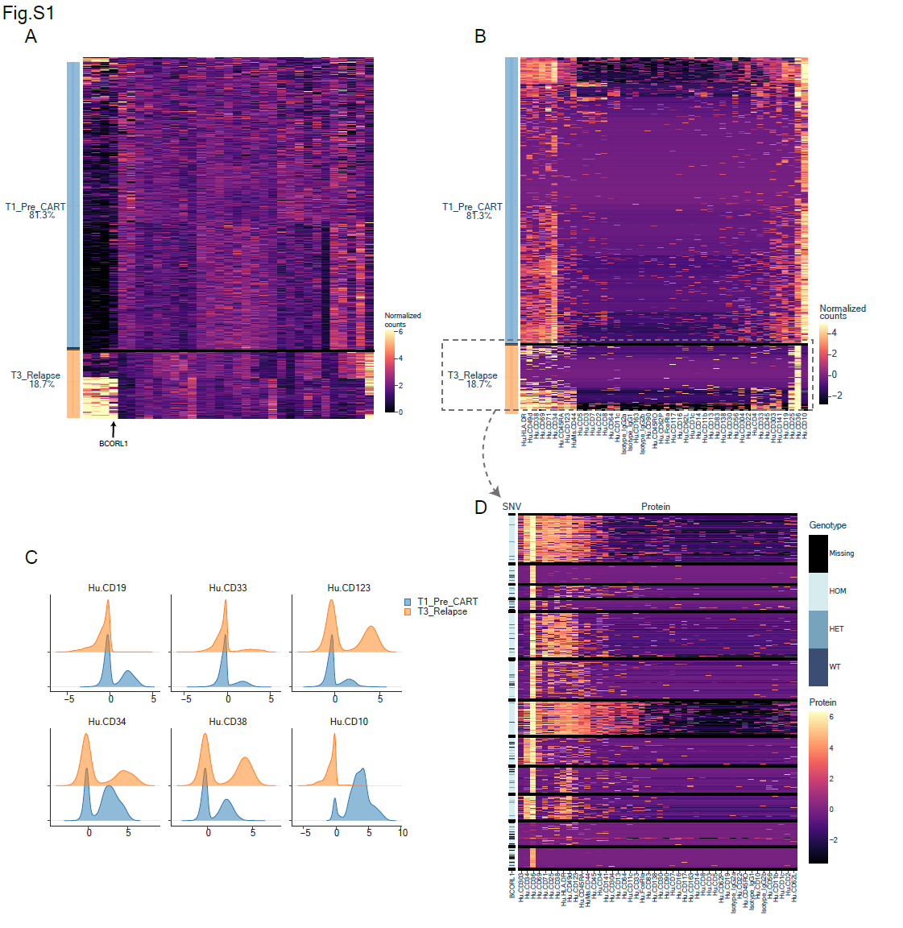
Supplementary Fig. 1. The gene and protein expression changes at the T1_Pre_CART and T3_Relapse time points. A The gene copy number changes at the T1_Pre_CART and T3_Relapse time points. The heatmap illustrates the copy numbers of various genes. The BCORL1 copy number was increased at the myeloid relapse time point. B The membrane protein expression profile at the T1_Pre_CART and T3_Relapse time points. The heatmap illustrates the 46 membrane protein expression level changes. C The ridge plots of selected proteins before and after myeloid relapse. D The membrane protein expression profile and BCORL1 mutation profile at the T3_Relapse time point.
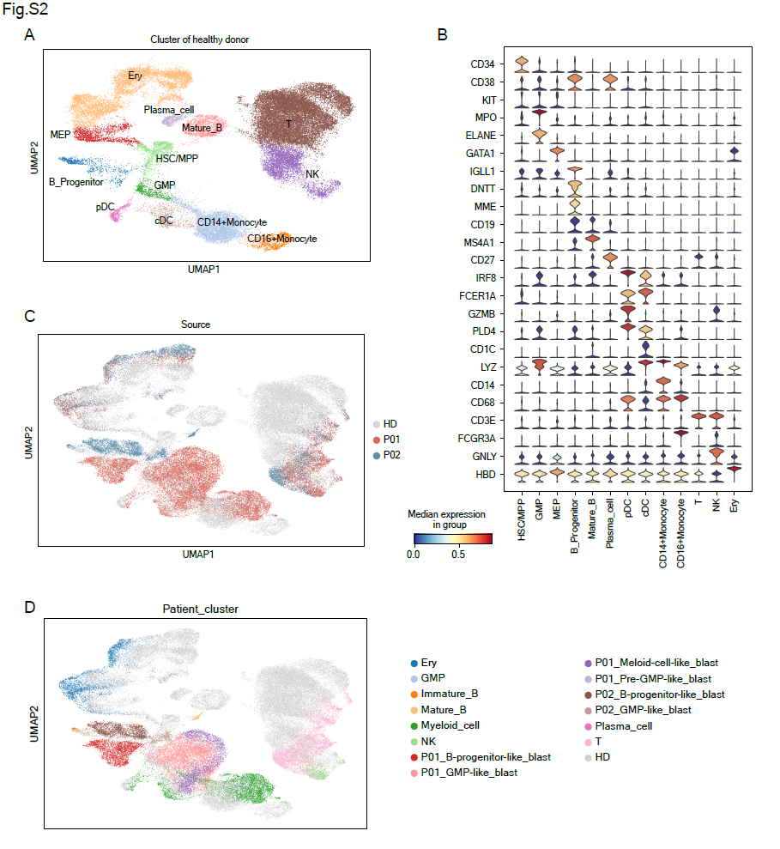
Supplementary Fig. 2. Projection of the P01 and P02 bone marrow cells to normal bone marrow cells. A The UMAP plot showing the unsupervised clustering results of healthy donors’ bone marrow cells¹¹. B The stacked violin plot of marker genes used for the manual annotation of healthy donor’s bone marrow cells. C Projection of P01 and P02 bone marrow scRNA-seq data to normal reference data. D The annotation of P01 and P02 bone marrow cells on integrated projection UMAP plot.
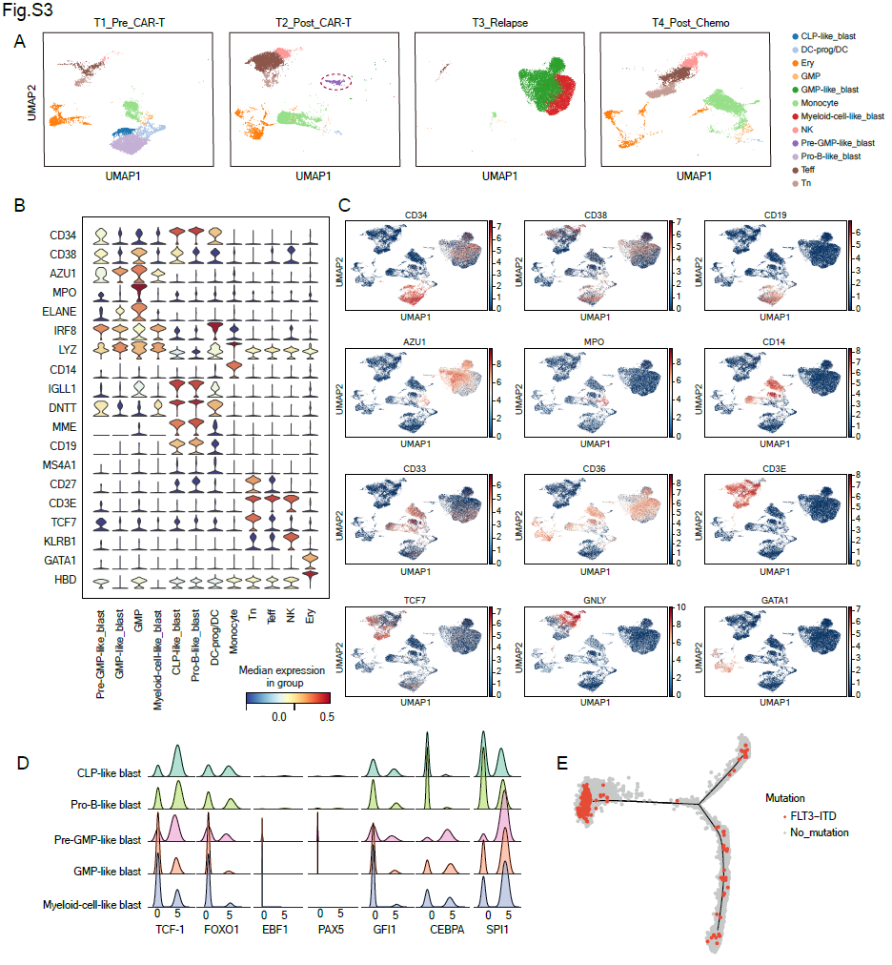
Supplementary Fig. 3. The transcriptional features of P01 at single cell level. A The UMAP plot showing the cluster distribution at four different time points. At the T2_Post_CAR-T time point, the pre-GMP-like blast was emphasized by a dashed circle. B The stacked violin plot of marker genes used for the manual annotation of P01’s bone marrow cells. C The feature plots showing the expression levels of selected genes. D The kernel density estimate (KDE) plot of lineage differentiation transcription factors in each blast cluster. E The pseudotime trajectory of blast cells showing the FLT3-ITD mutation which were distributed along the differentiation trajectory.

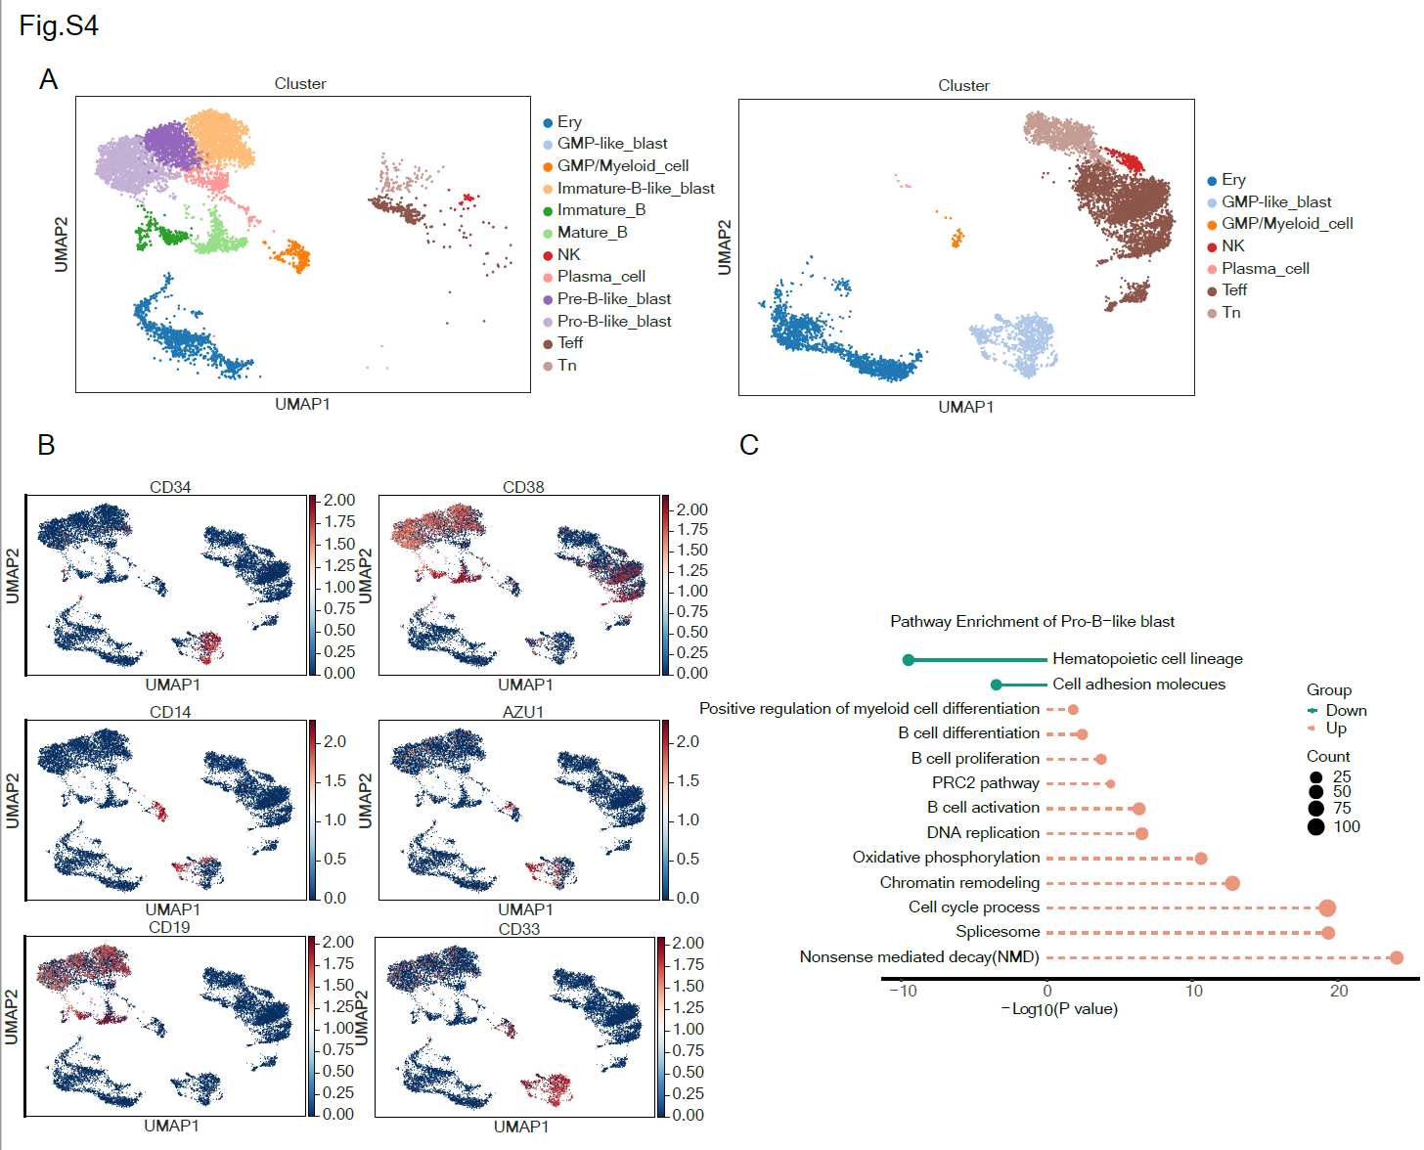
Supplementary Fig. 4. The transcriptional features of P02 at single cell resolution. A The UMAP plot of P02 showing the cluster distribution at two different time points. Cluster annotations were shown on the right margin. B The feature plots showing the expression levels of selected genes. C The pathway analysis of the differentially expressed genes of the pro-B-like cluster in P02. The green lines are down-regulated pathways while the pink dash lines are up-regulated pathways in pro-B-like blasts. The dot size indicates the gene counts.

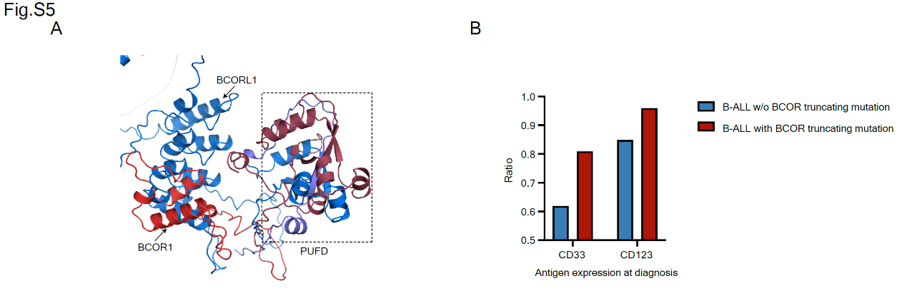
Supplementary Fig. 5. The features of BCOR/BCORL1 mutations in B-ALL. A The protein structure of BCOR/BCORL1 truncated parts. The homologous truncated protein structure of BCORL1 (blue) and BCOR (red) with RMSD equaled 8.283. Both truncated parts included the PUFD domain (BCORL1: purple region, BCOR: dark red region). B The antigen expression in newly diagnosed B-ALL patients with BCOR truncating mutation compared with Ph-negative B-ALL patients without BCOR truncating mutation.

Reference
1 Wolf FA, Angerer P, Theis FJ. SCANPY: large-scale single-cell gene expression data analysis. Genome Biol 2018; 19: 15.
2 Wolock SL, Lopez R, Klein AM. Scrublet: Computational Identification of Cell Doublets in Single-Cell Transcriptomic Data. Cell Syst 2019; 8: 281-291.e9.
3 Bu D, Luo H, Huo P, Wang Z, Zhang S, He Z et al. KOBAS-i: intelligent prioritization and exploratory visualization of biological functions for gene enrichment analysis. Nucleic Acids Res 2021; 49: W317–W325.
4 Trapnell C, Cacchiarelli D, Grimsby J, Pokharel P, Li S, Morse M et al. The dynamics and regulators of cell fate decisions are revealed by pseudotemporal ordering of single cells. Nat Biotechnol 2014; 32: 381–386.
5 McKenna A, Hanna M, Banks E, Sivachenko A, Cibulskis K, Kernytsky A et al. The Genome Analysis Toolkit: a MapReduce framework for analyzing next-generation DNA sequencing data. Genome Res 2010; 20: 1297–1303.
6 Albertí-Servera L, Demeyer S, Govaerts I, Swings T, De Bie J, Gielen O et al. Single-cell DNA amplicon sequencing reveals clonal heterogeneity and evolution in T-cell acute lymphoblastic leukemia. Blood 2021; 137: 801–811.
7 Rosenthal R, McGranahan N, Herrero J, Taylor BS, Swanton C. DeconstructSigs: delineating mutational processes in single tumors distinguishes DNA repair deficiencies and patterns of carcinoma evolution. Genome Biol 2016; 17: 31.
8 Wang K, Li M, Hakonarson H. ANNOVAR: functional annotation of genetic variants from high-throughput sequencing data. Nucleic Acids Res 2010; 38: e164.
9 Robinson JT, Thorvaldsdóttir H, Winckler W, Guttman M, Lander ES, Getz G et al. Integrative genomics viewer. Nat Biotechnol 2011; 29: 24–26.
10 Mayakonda A, Lin D-C, Assenov Y, Plass C, Koeffler HP. Maftools: efficient and comprehensive analysis of somatic variants in cancer. Genome Res 2018; 28: 1747–1756.
11 Oetjen KA, Lindblad KE, Goswami M, Gui G, Dagur PK, Lai C et al. Human bone marrow assessment by single-cell RNA sequencing, mass cytometry, and flow cytometry. JCI Insight 2018; 3: e124928, 124928.

