Supplementary material:
Title.
Comparative Effectiveness of Ultrathin vs. Standard Strut Drug-Eluting Stents: Insights from a Large-Scale Meta-Analysis with Extended Follow-up
Authors.
Ahmed Hassan^{1,2}, MD; Ahmed Mazen Amin³, MD; Ahmed Farid Gadelmawla⁴, MD; Ahmed Mansour⁵; Hamed Abdelma'aboud Mostafa⁶; Mariam Tarek Desouki⁷, MD; Mostafa Mahmoud Naguib⁶, MD; Bilal Ali⁸, MD; Aisha Siraj⁹, MD; Mustafa Suppah¹⁰, MD; Diaa Hakim^{11,12}, MD, PhD
Affiliations.
¹Faculty of Medicine, October 6 University, Giza, Egypt
²Department of Cardiology, Suez Medical Complex, Suez, Egypt
³Faculty of Medicine, Mansoura University, Mansoura, Egypt
⁴Faculty of Medicine, Menoufia University, Menoufia, Egypt
⁵Faculty of Medicine, Al-Azhar University, Cairo, Egypt
⁶Faculty of Medicine, Al-Azhar University, Damietta, Egypt
⁷Faculty of Medicine, Alexandria University, Alexandria, Egypt
⁸University Hospitals Cleveland Medical Center/Case Western Reserve University, Ohio, USA
⁹METROHEALTH medical center, Case Western Reserve University, Ohio, USA
¹⁰Department of Cardiovascular Medicine, Mayo Clinic, Arizona, USA
¹¹Department of Cardiology, Faculty of Medicine, Suez Canal University, Ismailia, Egypt
¹²Department of Cardiology, Brigham and Women's Hospital, Harvard Medical School, Boston, USA

Keywords.
ultrathin-strut drug eluting stent, DES, percutaneous coronary intervention, meta-analysis.
Contents:
Heterogeneity Assessment and Sensitivity Analysis.
Tables.
Table S1: Search strategy.
Table S2: Summary characteristics
Table S3: More details of stent characteristics
Table S4: Sensitivity analysis.
Figures.
Figure S1: Funnel plot of TLF at ≥ 1 year.
Figure S2: Funnel plot of TLF at ≥ 2 years.
Figure S3: Funnel plot of Cardiac death at ≥ 1 year.
Figure S4: Funnel plot of Cardiac death at ≥ 2 years.
Figure S5: Funnel plot of Cardiac death at ≥ 3 years.
Figure S6: Funnel plot of Target Vessel-Related Myocardial Infarction at ≥ 1 year.
Figure S7: Funnel plot of TLR at ≥ 1 year.
Figure S8: Funnel plot of TLR at ≥ 2 years.
Figure S9: Funnel plot of TLR at ≥ 3 years.
Figure S10: Funnel plot of TVR at ≥ 1 year.
Figure S11: Funnel plot of TVR at ≥ 2 years.
Figure S12: Funnel plot of TVR at ≥ 3 years.
Figure S13: Funnel plot of all-cause mortality at ≥ 1 year.
Figure S14: Funnel plot of all-cause mortality at ≥ 2 years.
Figure S15: Funnel plot of all-cause mortality at ≥ 3 years.
Figure S16: Forest plot of patient-oriented composite endpoint.
Figure S17: Funnel plot of patient-oriented composite endpoint at ≥ 1 year.
Figure S18: Forest plot of any myocardial infarction.
Figure S19: Funnel plot of any myocardial infarction at ≥ 1 year.
Figure S20: Funnel plot of any myocardial infarction at ≥ 2 years.
Figure S21: Funnel plot of any myocardial infarction at ≥ 3 years.
Figure S22: Forest plot of any repeat revascularization.
Figure S23: Funnel plot of any repeat revascularization at ≥ 1 year
Figure S24: Forest plot of any definite or probable stent thrombosis.
Figure S25: Funnel plot of any definite or probable stent thrombosis at ≥ 1 year
Figure S26: Funnel plot of any definite or probable stent thrombosis at ≥ 2 years.
Figure S27: Forest plot of definite stent thrombosis.
Figure S28: Funnel plot of any definite stent thrombosis at ≥ 1 year
Figure S29: Forest plot of probable stent thrombosis.
Figure S30: Forest plot of bleeding.

Heterogeneity Assessment and Sensitivity Analysis.
Primary Outcome
Target Lesion Failure (TLF)
The pooled studies were homogenous at ≥ 1 year (I²= 0%, P= 0.94), at ≥ two years (I²= 0%, P= 0.65), at ≥ three years (I²= 35%, P= 0.15), and at 5 years (I²= 0%, P= 0.54). Regarding TLF at ≥ 1 year and ≥ 2 years, we did not find asymmetry in the funnel plot, meaning that there was no significant publication bias (Egger’s P-value = 0.63) (Figure S1) and (Egger’s P-value = 0.44) (Figure S2), respectively.
Cardiac Death
The pooled studies were homogenous at ≥ 1 year (I²= 0%, P= 0.61), at ≥ 2 years (I²= 0%, P= 0.94), at ≥ 3 years (I²= 0%, P= 0.77), and at 5 years (I²= 0%, P= 0.99). Regarding cardiac death at ≥ 1 year, at ≥ 2 years, and at ≥ 3 years, no asymmetry was observed in the funnel plot, indicating no significant publication bias (Egger’s P-value = 0.63) (Figure S3), (Egger’s P-value = 0.55) (Figure S4), and (Egger’s P-value = 0.47) (Figure S5), respectively.
Target Vessel-Related Myocardial Infarction (TVMI)
The pooled studies were homogenous at ≥ 1 year (I²= 0%, P= 0.86), at ≥ 2 years (I²= 0%, P= 0.72), at ≥ 3 years (I²= 32%, P= 0.18), and at 5 years (I²= 33%, P= 0.16). Regarding TVMI at ≥ 1 year, we did not find asymmetry in the funnel plot, meaning that there was no significant publication bias (Egger’s P-value = 0.33) (Figure S6).
Target Lesion Revascularization (TLR)
The pooled studies were homogenous at five years (I²= 26%, P= 0.21). However, pooled studies were heterogeneous regarding TLR at ≥ 1 year (I²= 37%, P= 0.05), at ≥ 2 years (I²= 43%, P= 0.05), and at ≥3 years (I²= 59%, P= 0.009). Regarding TLR at ≥ 1 year, the heterogeneity was best resolved by excluding BIOSCIENCE (I²= 29%, P= 0.12), PRISON IV (I²= 22%, P= 0.19), and SORT OUT IX (I²= 13%, P= 0.29). Regarding TLR at ≥2 years, the heterogeneity was best resolved by excluding BIOFLOW-IV (I²= 31%, P= 0.13), BIOSCIENCE (I²= 34%, P= 0.11), and SORT OUT IX (I²= 30%, P= 0.15). Regarding TLR at ≥ 3 years, the heterogeneity was not resolved by leave-one-out sensitivity analysis (Table S2). Regarding TLR at ≥1 year, at ≥ 2 years, and at ≥ 3 years, we did not find asymmetry by inspecting the funnel plot, meaning that there was no significant publication bias (Egger’s P-value = 0.67) (Figure S7), (Egger’s P-value = 0.19) (Figure S8), and (Egger’s P-value = 0.12) (Figure S9), respectively.
Secondary outcome
Target Vessel Revascularization (TVR)
The pooled studies were homogenous at ≥ 1 year (I²= 0%, P= 0.60), at ≥ 2 years (I²= 5%, P= 0.39), at ≥ 3 years (I²= 1%, P= 0.43), and at 5 years (I²= 27%, P= 0.21). Regarding TVR at ≥ 1 year and at ≥ 3 years, we did not find asymmetry in the funnel plot, meaning that there was no significant publication bias (Egger’s P-value = 0.11) (Figure S10) and (Egger’s P-value = 0.58) (Figure S11), respectively. Regarding TVR at ≥2 years, we found asymmetry in the funnel plot with significant publication bias (Egger’s P-value = 0.09) (Figure S12).
All-Cause Mortality
The pooled studies were homogenous at ≥ 1 year (I²= 3%, P= 0.42), at ≥ two years (I²= 0%, P= 0.68), at ≥ 3 years (I²= 7%, P= 0.38), and at 5 years (I²= 29%, P= 0.19). Regarding all-cause mortality at ≥ 1 year and at ≥ 2 years, we did not find asymmetry by inspecting the funnel plot, meaning that there was no significant publication bias (Egger’s P-value = 0.50) (Figure S13) and (Egger’s P-value = 0.29) (Figure S14), respectively. Regarding all-cause mortality at ≥ 3 years, we found asymmetry by inspecting the funnel plot with significant publication bias (Egger’s P-value = 0.09) (Figure S15).
Patient oriented composite endpoint (POCE)
The pooled studies were homogenous at ≥ 1 year (I²= 9%, P= 0.36), at ≥ 2 years (I²= 0%, P= 0.64), and at 5 years (I²= 0%, P= 0.80). However, pooled studies were heterogeneous regarding POCE at ≥ 3 years (I²= 50%, P= 0.06). The heterogeneity was best resolved by excluding BIODEGRADE and SORT OUT VII (I²= 32%, P= 0.20) and (I²= 13%, P= 0.33), respectively (Table S2). Regarding POCE at ≥ 1 year, we did not find asymmetry in the funnel plot, meaning that there was no significant publication bias (Egger’s P value = 0.68) (Figure S17).
Myocardial Infarction (MI)
The pooled studies were homogenous at ≥ 1 year (I²= 17%, P= 0.24), at ≥ 2 years (I²= 0%, P= 0.58), at ≥ 3 years (I²= 24%, P= 0.22), and at 5 years (I²= 8%, P= 0.37). Regarding MI at ≥ 1 year, at ≥ 2 years, and at ≥ 3 years, we did not find asymmetry in the funnel plot, meaning that there was no significant publication bias (Egger’s P-value = 0.37) (Figure S19), (Egger’s P-value = 0.12) (Figure S20), and (Egger’s P-value = 0.87) (Figure S21), respectively.
Repeat Revascularization
The pooled studies were homogenous at ≥ 1 year (I²= 1%, P= 0.43), at ≥2 years (I²= 39%, P= 0.13), and at 5 years (I²= 24%, P= 0.27). However, pooled studies were heterogeneous regarding repeat revascularization at ≥ 3 years (I²= 47%, P= 0.09). The heterogeneity was best resolved by excluding BIODEGRADE (I²= 41%, P= 0.14), DESSOLVE III (I²= 38%, P= 0.17), ORIENT (I²= 48%, P= 0.10), and TALENT (I²= 41%, P= 0.15) (Table S2). Regarding repeat revascularization at ≥ 1 year, we did not find asymmetry by inspecting the funnel plot, meaning that there was no significant publication bias (Egger’s P-value = 0.21) (Figure S23).
Definite or Probable Stent Thrombosis (ST)
The pooled studies were homogenous at ≥ 1 year (I²= 0%, P= 0.76), at ≥ two years (I²= 0%, P= 0.55), at ≥ 3 years (I²= 13%, P= 0.33), and at 5 years (I²= 28%, P= 0.20). Regarding definite or probable ST at ≥ 1 year and at ≥ 2 years, we did not find asymmetry in the funnel plot, meaning that there was no significant publication bias (Egger’s P-value = 0.31) (Figure S25) and (Egger’s P-value = 0.89) (Figure S26), respectively.
Definite Stent Thrombosis (ST)
The pooled studies were homogenous at ≥ 1 year (I²= 21%, P= 0.25), at ≥ 2 years (I²= 4%, P= 0.40), at ≥ 3 years (I²= 37%, P= 0.16), and at 5 years (I²= 10%, P= 0.35). Regarding definite ST at ≥ 1 year, we did not find asymmetry in the funnel plot, meaning that there was no significant publication bias (Egger’s P-value = 0.70) (Figure S28).
Probable Stent Thrombosis (ST)
The pooled studies were homogenous at ≥ 1 year (I²= 0%, P= 0.82), at ≥ 2 years (I²= 0%, P= 0.50), at ≥ 3 years (I²= 0%, P= 0.81), and at 5 years (I²= 0%, P= 0.86).
Bleeding
The pooled studies were homogenous at ≥ 1 year (I²= 0%, P= 0.71), at ≥ 2 years (I²= 0%, P= 0.54), at ≥ 3 years (I²= 0%, P= 0.33), and at 5 years (I²= 0%, P= 0.92).

Table S1: Search strategy.
Search strategy:
((Ultrathin strut OR Thin strut OR Orsiro stent) AND (Sirolimus-eluting stent OR SES OR drug eluting stents OR DES) AND (Coronary artery intervention OR Percutaneous coronary intervention OR Coronary angioplasty OR Stent implantation))
Time: 20/11/2023
Data base | Search terms | Search filed | Search results
Pubmed | ((Ultrathin strut OR Thin strut OR Orsiro stent) AND (Sirolimus-eluting stent OR SES OR drug eluting stents OR DES) AND (Coronary artery intervention OR Percutaneous coronary intervention OR Coronary angioplasty OR Stent implantation)) | All filed | 434
WOS | ((Ultrathin strut OR Thin strut OR Orsiro stent) AND (Sirolimus-eluting stent OR SES OR drug eluting stents OR DES) AND (Coronary artery intervention OR Percutaneous coronary intervention OR Coronary angioplasty OR Stent implantation)) | All filed | 412
Cochrane  library | ((Ultrathin strut OR Thin strut OR Orsiro stent) AND (Sirolimus-eluting stent OR SES OR drug eluting stents OR DES) AND (Coronary artery intervention OR Percutaneous coronary intervention OR Coronary angioplasty OR Stent implantation)) | All filed | 240
Scopus | ((Ultrathin strut OR Thin strut OR Orsiro stent) AND (Sirolimus-eluting stent OR SES OR drug eluting stents OR DES) AND (Coronary artery intervention OR Percutaneous coronary intervention OR Coronary angioplasty OR Stent implantation)) | All filed | 578

Table S2: Summary characteristics
Study ID | Study design | country | Center | Recruitment | Number of patients |  | Follow up | primary outcome | secondary outcome
 |  |  |  |  | I | C | Follow up | primary outcome | secondary outcome
DESSOLVE-C⁽²⁰⁾ | RCT | China | 16 Center | July 2015 to November 2017 | 216 | 212 | 1-Year | - | -
CASTLE⁽²¹⁾ | RCT | Japan | 65 Center | May 2019 to March 2020 | 722 | 718 | 1-Year | TLF at 1 year, defined as the composite of cardiac death, TVMI, and TLR | POCE of all-cause death, all MI, and all revascularization, and ST, major adverse cardiac events.
SCAAR⁽²²⁾ | prospective registry | Sweden | 30 hospitals | October 2011 to June 2017 | 4561 | 69570 | 1 and 2 Year | Principle outcomes: ST, clinically relevant restenosis, TLR by PCI, MI and all-Cause Mortality.
BIODEGRADE^{(23,24)} | RCT | South Korea | 25 Centers | July 2014 to September 2017 | 1167 | 1160 | 18 months and 3 Year | Target lesion failure . | Death, Target vessel-related myocardial infarction.
SORT OUT IX^{(25,26)} | RCT | Denmark | 3 centers | Dec 14, 2015 to April 21, 2017 | 1,579 | 1,572 | 1 and 2 Year | TLF | Cardiac death, MI and definite ST
BIOFLOW VI⁽²⁷⁾ | RCT | China | 11 center | July 2014 to September 2016 | 220 | 220 | 1 Year | All-cause death, all MI, and TLR; TLF, cardiac death, TVMI, and TLR; target vessel failure, TVR, and definite or probable ST
BIOSTEMI^{(28–30)} | RCT | Switzerland | 10 centers | April 26, 2016, to Mar 9, 2018 | 649 | 651 | 1, 2, and 5 Year | TLF, a composite of cardiac death, TVMI, and clinically indicated TLR as assessed at 12 months. | -
BIOFLOW-IV^{(31,32)} | RCT | Japan, Europe, Australia and Israel | 46 center | Sept 2013 to Jan 2015 | 385 | 190 | 1 and 5 Year | TVF | TLF, TLR, TVR,MI and Death
TALENT^{(33–35)} | RCT | Netherlands, Poland, the UK, Spain, Bulgaria, Hungary, and Italy | 23 Center | October 2016 to July 2017 | 720 | 715 | 1, 2, and 3 Year | Non-inferiority comparison at 12 months between the Supraflex group and the Xience group regarding a device-oriented composite endpoint of cardiac death, TVMI, and TLR | All-cause death, MI, revascularization, TVF, cardiac death, TVMI, TVR, POCE, and ST
MeriT-V^{(36,37)} | RCT | Europe and Brazil | 15 center | Nov2014 to December 2016 | 170 | 86 | 1 and 2 Year | Three-point MACEs inclusive of cardiac death, TVR, and all MI was considered for the combined safety and efficacy evaluation at the 2-year landmark. | Individually evaluated, including TLR and late ST for the population that completed the 2-year follow-up.
BIONYX 3-year ^{(38–40)} | RCT | Netherlands, Belgium, and Israel | 7 Centers | Oct 7, 2015 to Dec 23, 2016 | 1,245 | 1,243 | 1,2, and 3 Year | TVF, a composite of cardiac death, TVMI, or TVR | All-cause death; MI, TLR, major bleeding; and ST
DESSOLVE III^{(41–43)} | RCT | Germany, France, Netherlands, and Poland. | 20 Center | March 20 to Dec 3, 2015 | 703 | 695 | 1, 2, and 3 Year | Device (DOCE); cardiac death, TVMI, or TLR | POCE, defined as the composite of any death, MI, or revascularization.
CARDIOBASE Bern PCI Registry⁽⁴⁴⁾ | prospective registry | Switzerland | Bern University Hospital | March 2011 to June 2015 | 1451 | 1451 | 1 Year | DOCE, including cardiac death, TVMI, and TLR | -
ORIENT^{(45,46)} | RCT | South Korea | 8 Centers | October 2013 to June 2014 | 250 | 122 | 1,2, and 3 Year | All-cause and cardiac death, TLR, TVR, MI (target or non-target vessel-related), definite or probable ST, TLF, a composite of cardiac death, TLR and TVMI at 12 months
PRISON IV^{(47–49)} | RCT | Netherlands and Belgium | 2 Belgian and 6 Dutch high-volume PCI centers. | February 2012 to June 2015 | 165 | 165 | 1, 3, and 5 Year | Segment late lumen loss on 9-month angiography assessment. | Secondary angiographic endpoints included in-stent late lumen loss, MLD, in-stent and in-segment percentage of diameter stenosis, binary restenosis, and reocclusions at 9 months.
BIO-RESORT^{(50–53)} | RCT | Netherlands | 4 Center | Dec 21, 2012, to Aug 24, 2015 | 1169 | 2345 | 1, 2, 3, and 5 Year | The primary composite endpoint of TVF assessed device efficacy and patient safety and consisted of cardiac death, TVMI, or TVR. | Secondary endpoints included: TLR, TLF, a composite of cardiac death, MI not clearly attributable to a non-target vessel, or TLR, MACE, a composite of all-cause death, MI, or emergent coronary bypass surgery, or repeat TLR, POCE, a composite of all-cause death, MI, or repeat revascularization, and definite-or-probable ST.
SORT OUT VII^{(54–57)} | RCT | Denmark | Multi center | November 2012 to February 2014 | 1261 | 1264 | 1,2,3,4, and 5 Year | TLF; Five-year TLF did not differ between O-SES (12.4%) and N-BES (13.1%). | Cardiac death
BIOFLOW V^{(58–61)} | RCT | Asia, Europe, Israel, and North America | 90 hospitals | May 8, 2015 to March 31, 2016 | 884 | 450 | 1,2,3, and 5 Year | 5-year primary endpoint assessment consisted of TLF, cardiac death, TVMI, or TLR and MACE (all-cause death, MI, or TLR), TVF (cardiac death, TVMI, or TVR). Also, individual components of the composite endpoints, and definite or probable ST Periprocedural MI was defined
DESSOLVE I and II^{(62–64)} | RCT | New Zealand, and Europe | Multi-centers | November 2010 to March 2011 | 123 | 61 | 2 and 5 Year | MACE was a composite of any death, MI, TVR. TLF was defined as cardiac death, MI, or TLR. TVF | All-cause mortality, rates of Q-wave and non-Q-wave MI, rates or TLR and TVR, rates of TLF and TVF
BIOFLOW-II^{(65,66)} | RCT | 8 European countries | 24 centers | July 2011 and March 2012 | 298 | 154 | 1 and 5 Year | In-stent late lumen loss | TLF, a composite of cardiac death, TVMI, and TLR; TVF TVR, all- cause mortality,MI; and definite ST
BIOSCIENCE^{(67–69)} | RCT | Switzerland | 9 center | February 2012 to May 2013 | 1063 | 1056 | 1, 2, and 5 Year | TLF, was a composite of cardiac death, TVMI, and TLR within 12 months. | -

Intervention (I), Control (C).
Abbreviations: Myocardial infarction (MI), Patient-oriented composite endpoint (POCE), Stent thrombosis (ST), Target lesion failure (TLF), Target lesion revascularization (TLR), Target vessel revascularization (TVR), Target vessel myocardial infarction (TVMI)

Outcome | No. of  Participants (/) | No. of  trials | Quantitative data synthesis |  |  |  | Heterogeneity analysis
Outcome | No. of  Participants (/) | No. of  trials | MD | 95% CI | Z value | p-value | df | p-value | I2 (%)
Any repeat revascularization ≥ 3 years.
BIODEGRADE | 4083/5113 | 5 | 0.97 | [0.82, 1.14] | 0.42 | 0.67 | 4 | 0.14 | 41%
BIONYX | 4005/5030 | 5 | 0.90 | [0.74, 1.10] | 1.03 | 0.31 | 4 | 0.08 | 51%
BIO-RESORT | 4081/3928 | 5 | 0.93 | [0.76, 1.15] | 0.64 | 0.52 | 4 | 0.05 | 58%
DESSOLVE III | 4547/5580 | 5 | 0.97 | [0.82, 1.15] | 0.33 | 0.74 | 4 | 0.17 | 38%
ORIENT | 5004/6156 | 5 | 0.91 | [0.77, 1.06] | 1.21 | 0.23 | 4 | 0.10 | 48%
TALENT | 4530/5558 | 5 | 0.89 | [0.75, 1.05] | 1.00 | 0.15 | 4 | 0.15 | 41%
Patient-oriented composite end point ≥ 3 years.
BIODEGRADE | 4488/5329 | 6 | 1.04 | [0.93, 1.16] | 0.67 | 0.50 | 5 | 0.20 | 32%
BIOFLOW-IV | 5270/6299 | 6 | 1.00 | [0.87, 1.14] | 0.06 | 0.95 | 5 | 0.04 | 58%
BIO-RESORT | 4486/4144 | 6 | 1.01 | [0.87, 1.18] | 0.19 | 0.85 | 5 | 0.05 | 55%
DESSOLVE III | 4952/5796 | 6 | 1.02 | [0.89, 1.18] | 0.33 | 0.74 | 5 | 0.07 | 50%
ORIENT | 5405/6367 | 6 | 0.99 | [0.87, 1.12] | 0.20 | 0.84 | 5 | 0.06 | 54%
SORT OUT VII | 4394/5225 | 6 | 0.95 | [0.85, 1.05] | 1.00 | 0.32 | 5 | 0.33 | 13%
TALENT | 4935/5774 | 6 | 0.99 | [0.85, 1.14] | 0.20 | 0.84 | 5 | 0.04 | 57%
Target lesion revascularization ≥ 1 year.
BIODEGRADE | 17545/82688 | 19 | 0.80 | [0.66, 0.98] | 2.14 | 0.03 | 18 | 0.04 | 39%
BIOFLOW-II | 18414/83694 | 19 | 10.79 | [0.65, 0.97] | 2.25 | 0.02 | 18 | 0.04 | 40%
BIOFLOW-IV | 18340/83667 | 19 | 0.78 | [0.64, 0.95] | 2.52 | 0.01 | 18 | 0.05 | 37%
BIOFLOW V | 17880/83426 | 19 | 0.79 | [0.64, 0.96] | 2.31 | 0.02 | 18 | 0.04 | 40%
BIOFLOW-VI | 18492/83628 | 19 | 0.79 | [0.65, 0.96] | 2.32 | 0.02 | 18 | 0.04 | 40%
BIONYX | 17467/82605 | 19 | 0.79 | [0.64, 0.98] | 2.20 | 0.03 | 18 | 0.04 | 40%
BIO-RESORT | 17543/81503 | 19 | 0.77 | [0.63, 0.95] | 2.49 | 0.01 | 18 | 0.05 | 38%
BIOSCIENCE | 17649/82792 | 19 | 0.75 | [0.62, 0.91] | 2.94 | 0.003 | 18 | 0.12 | 29%
BIOSTEMI | 18063/83197 | 19 | 0.80 | [0.66, 0.98] | 2.14 | 0.03 | 18 | 0.04 | 39%
Buccheri et al. 2021 (SCAAR) | 14151/14278 | 19 | 0.81 | [0.66, 1.00] | 1.95 | 0.05 | 18 | 0.06 | 36%
CASTLE | 17990/83130 | 19 | 0.80 | [0.65, 0.97] | 2.22 | 0.03 | 18 | 0.04 | 40%
DESSOLVE II | 18595/83788 | 19 | 0.79 | [0.65, 0.97] | 2.30 | 0.02 | 18 | 0.04 | 40%
DESSOLVE III | 18009/83153 | 19 | 0.79 | [0.64, 0.97] | 2.24 | 0.03 | 18 | 0.04 | 40%
meriT-V | 18544/83764 | 19 | 0.79 | [0.65, 0.96] | 2.36 | 0.02 | 18 | 0.04 | 40%
ORIENT | 18462/83726 | 19 | 0.80 | [0.65, 0.97] | 2.27 | 0.02 | 18 | 0.04 | 40%
PRISON IV | 18547/83683 | 19 | 0.76 | [0.64, 0.90] | 3.19 | 0.001 | 18 | 0.19 | 22%
SORT OUT IX | 17133/82276 | 19 | 0.84 | [0.71, 0.98] | 2.15 | 0.03 | 18 | 0.29 | 13%
SORT OUT VII | 17451/82584 | 19 | 0.80 | [0.65, 0.99] | 2.10 | 0.04 | 18 | 0.04 | 40%
TALENT | 17992/83133 | 19 | 0.79 | [0.64, 0.97] | 2.25 | 0.02 | 18 | 0.04 | 40%
Yamaji et al. 2018 (CARDIOBASE) | 17261/82397 | 19 | 0.76 | [0.63, 0.93] | 2.64 | 0.008 | 18 | 0.07 | 34%
Target lesion revascularization ≥ 2 years.
BIOFLOW-IV | 14304/79784 | 13 | 0.77 | [0.66, 0.90] | 3.27 | 0.001 | 12 | 0.13 | 31%
BIOFLOW V | 13873/79567 | 13 | 0.81 | [0.68, 0.97] | 2.28 | 0.02 | 12 | 0.05 | 43%
BIONYX | 13444/78731 | 13 | 0.79 | [0.65, 0.95] | 2.44 | 0.01 | 12 | 0.03 | 46%
BIO-RESORT | 13520/77629 | 13 | 0.79 | [0.65, 0.96] | 2.42 | 0.02 | 12 | 0.03 | 47%
BIOSCIENCE | 13626/78918 | 13 | 0.76 | [0.64, 0.90] | 3.14 | 0.002 | 12 | 0.11 | 34%
BIOSTEMI | 14040/79323 | 13 | 0.81 | [0.68, 0.97] | 2.26 | 0.02 | 12 | 0.05 | 42%
Buccheri et al. 2021 (SCAAR) | 10128/10404 | 13 | 0.81 | [0.67, 0.99] | 2.05 | 0.04 | 12 | 0.05 | 43%
DESSOLVE II | 14569/79914 | 13 | 0.79 | [0.66, 0.95] | 2.56 | 0.01 | 12 | 0.03 | 47%
DESSOLVE III | 13986/79279 | 13 | 0.79 | [0.65, 0.95] | 2.44 | 0.01 | 12 | 0.03 | 47%
meriT-V | 14521/79890 | 13 | 0.78 | [0.66, 0.93] | 2.77 | 0.006 | 12 | 0.05 | 43%
ORIENT | 14439/79852 | 13 | 0.80 | [0.66, 0.96] | 2.45 | 0.01 | 12 | 0.03 | 47%
SORT OUT IX | 13110/78402 | 13 | 0.83 | [0.70, 0.98] | 2.22 | 0.03 | 12 | 0.15 | 30%
SORT OUT VII | 13428/78710 | 13 | 0.79 | [0.65, 0.96] | 2.35 | 0.02 | 12 | 0.03 | 47%
TALENT | 13969/79259 | 13 | 0.77 | [0.64, 0.92] | 2.87 | 0.004 | 12 | 0.06 | 41%
Target lesion revascularization ≥ 3 years.
BIODEGRADE | 6782/7187 | 9 | 0.95 | [0.73, 1.22] | 0.42 | 0.67 | 8 | 0.01 | 58%
BIOFLOW-IV | 7564/8157 | 9 | 0.85 | [0.68, 1.05] | 1.49 | 0.14 | 8 | 0.05 | 48%
BIOFLOW V | 7065/7897 | 9 | 0.96 | [0.75, 1.22] | 0.37 | 0.71 | 8 | 0.03 | 53%
BIONYX | 6704/7104 | 9 | 0.90 | [0.67, 1.20] | 0.72 | 0.47 | 8 | 0.005 | 63%
BIO-RESORT | 6780/6002 | 9 | 0.92 | [0.69, 1.23] | 0.20 | 0.58 | 8 | 0.005 | 64%
DESSOLVE III | 7246/7654 | 9 | 0.92 | [0.69, 1.23] | 0.58 | 0.56 | 8 | 0.005 | 64%
ORIENT | 7699/8225 | 9 | 0.91 | [0.70, 1.19] | 0.69 | 0.49 | 8 | 0.005 | 64%
PRISON IV | 7784/8182 | 9 | 0.83 | [0.67,1.04] | 1.63 | 0.10 | 8 | 0.06 | 46%
SORT OUT VII | 6688/7083 | 9 | 0.91 | [0.68, 1.23] | 0.61 | 0.54 | 8 | 0.005 | 64%
TALENT | 7229/7632 | 9 | 0.89 | [0.67, 1.19] | 0.77 | 0.44 | 8 | 0.006 | 63%
Table S3: Sensitivity analysis.
MD: mean difference; CI: confidence interval; df: degrees of freedom; RR: risk ratio

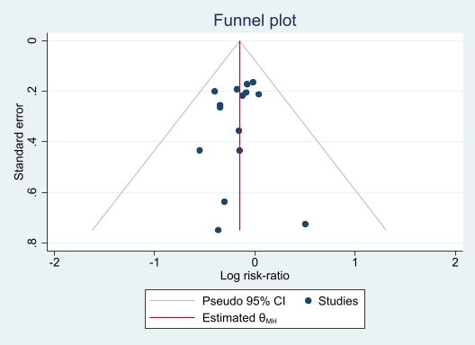
Figure S1: Funnel plot of TLF at ≥ 1 year.

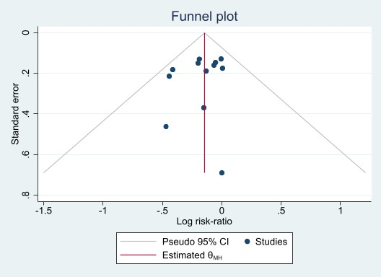
Figure S2: Funnel plot of TLF at ≥ 2 years.

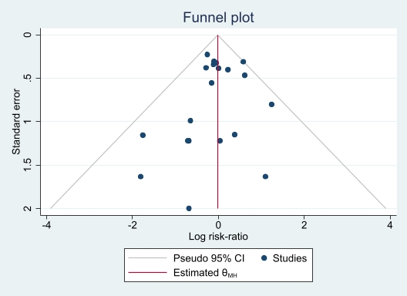
Figure S3: Funnel plot of Cardiac death at ≥ 1 year.

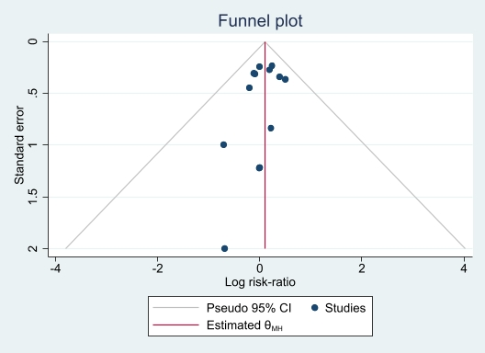
Figure S4: Funnel plot of Cardiac death at ≥ 2 years.

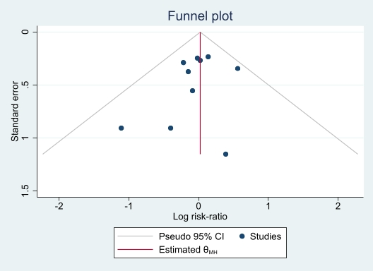
Figure S5: Funnel plot of Cardiac death at ≥ 3 years.

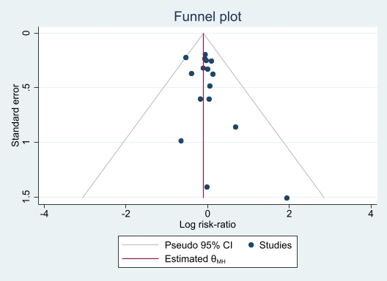
Figure S6: Funnel plot of Target Vessel-Related Myocardial Infarction at ≥ 1 year.

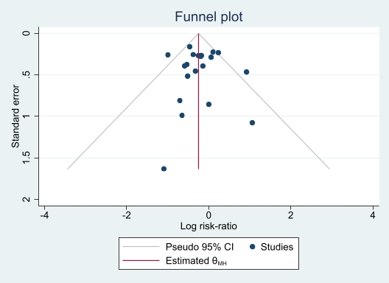
Figure S7: Funnel plot of TLR at ≥ 1 year.

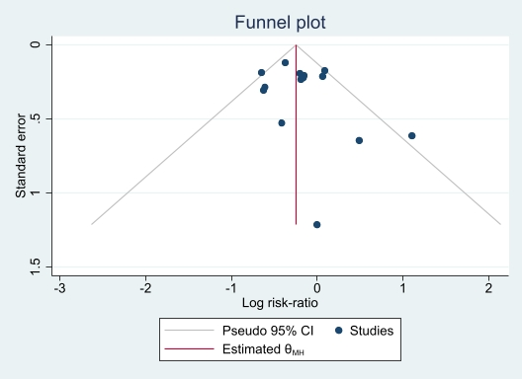
Figure S8: Funnel plot of TLR at ≥ 2 years.

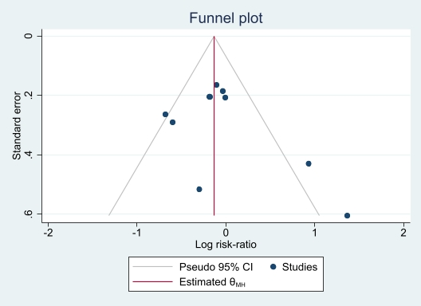
Figure S9: Funnel plot of TLR at ≥ 3 years.

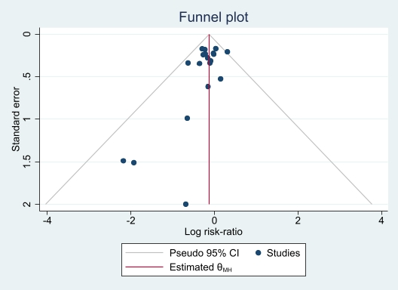
Figure S10: Funnel plot of TVR at ≥ 1 year.

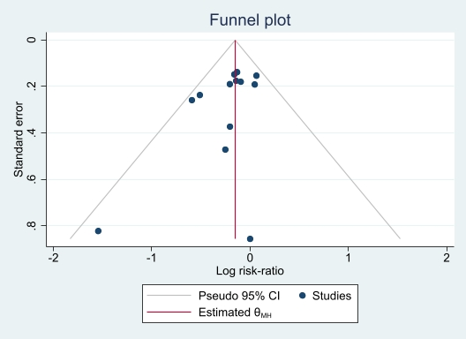
Figure S11: Funnel plot of TVR at ≥ 2 years.

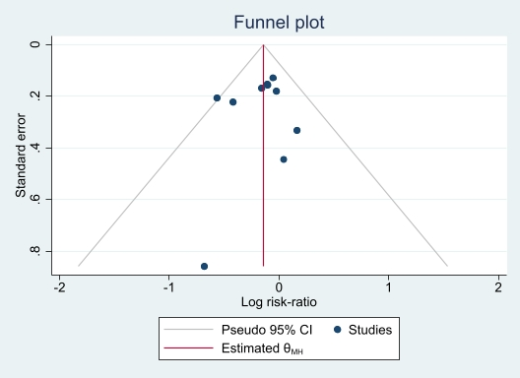
Figure S12: Funnel plot of TVR at ≥ 3 years.

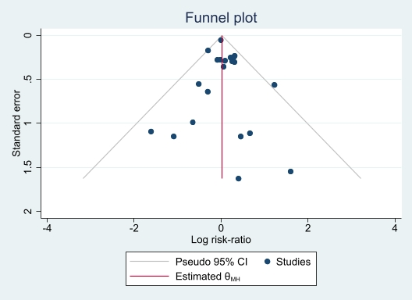
Figure S13: Funnel plot of all-cause mortality at ≥ 1 year.

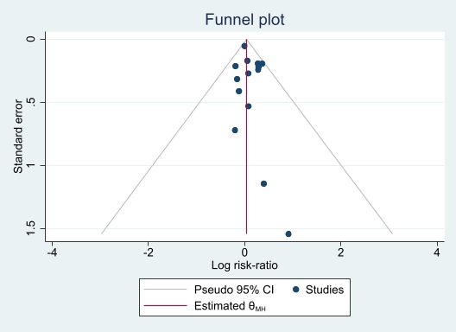
Figure S14: Funnel plot of all-cause mortality at ≥ 2 years.

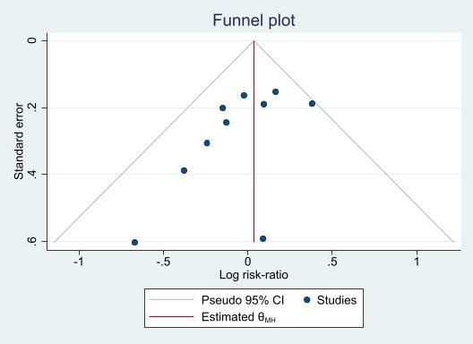
Figure S15: Funnel plot of all-cause mortality at ≥ 3 years.
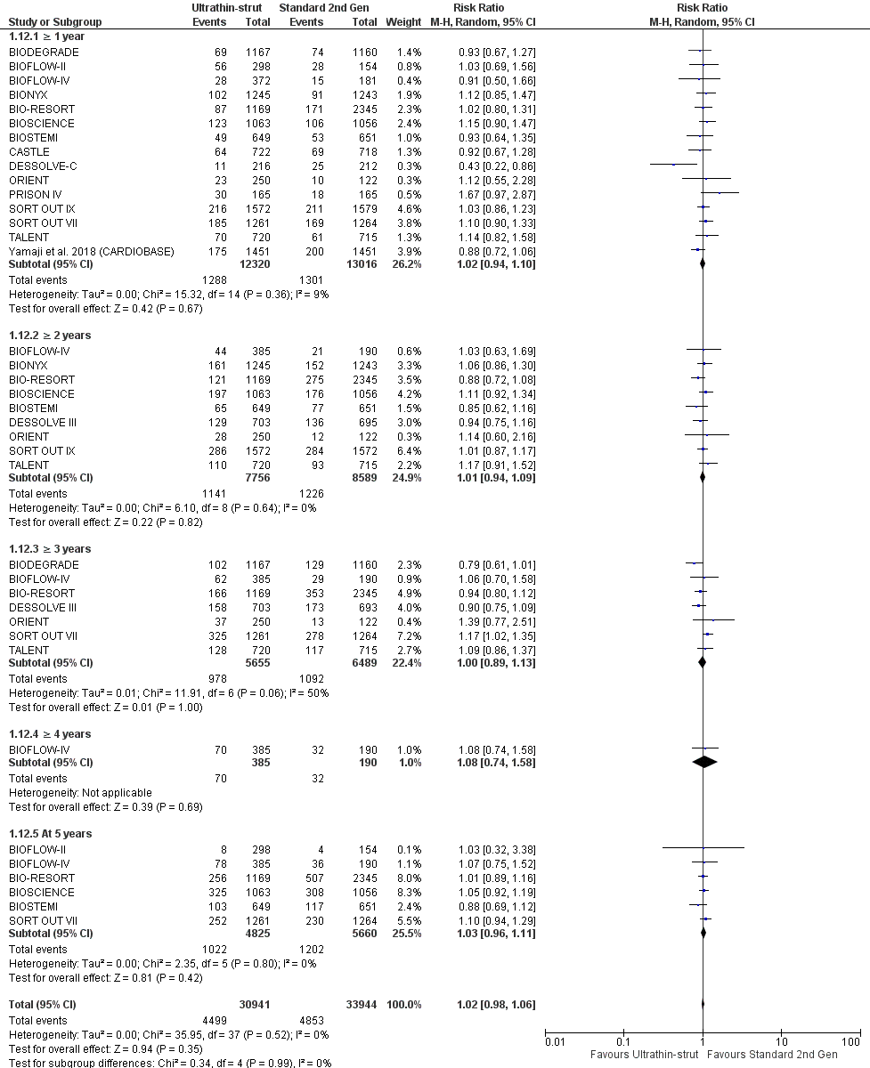
Figure S16: Forest plot of patient-oriented composite endpoint.

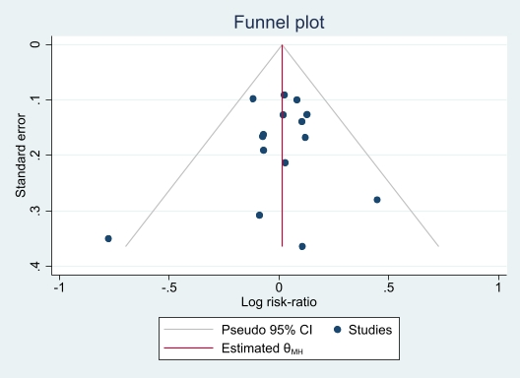
Figure S17: Funnel plot of patient-oriented composite endpoint at ≥ 1 year.

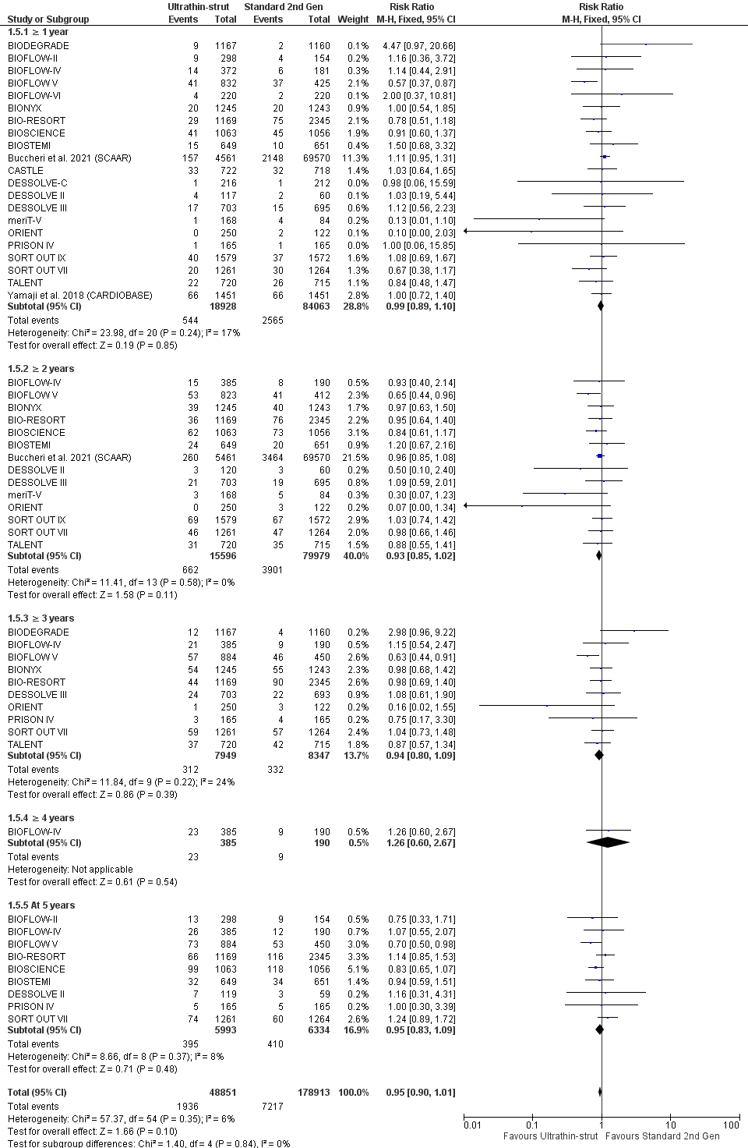
Figure S18: Forest plot of any myocardial infarction.

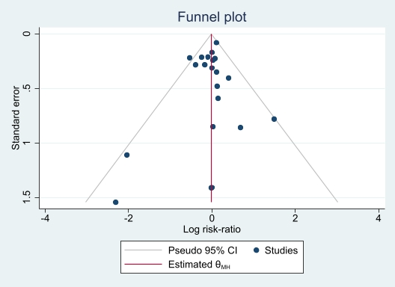
Figure S19: Funnel plot of any myocardial infarction at ≥ 1 year.

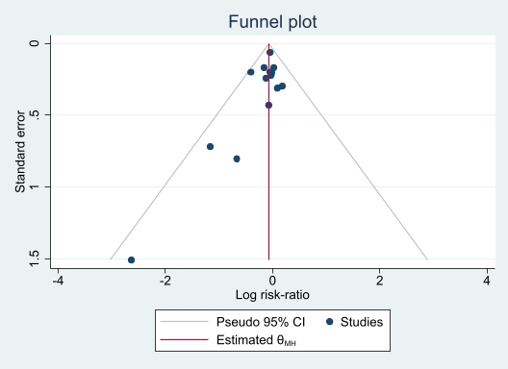
Figure S20: Funnel plot of any myocardial infarction at ≥ 2 years.

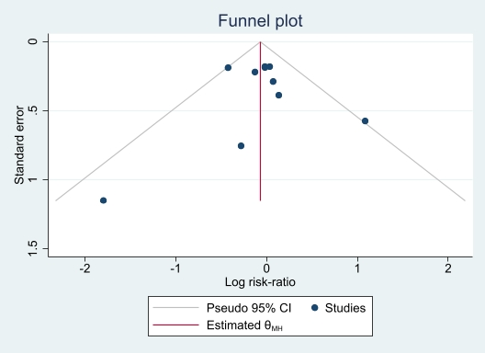
Figure S21: Funnel plot of any myocardial infarction at ≥ 3 years.

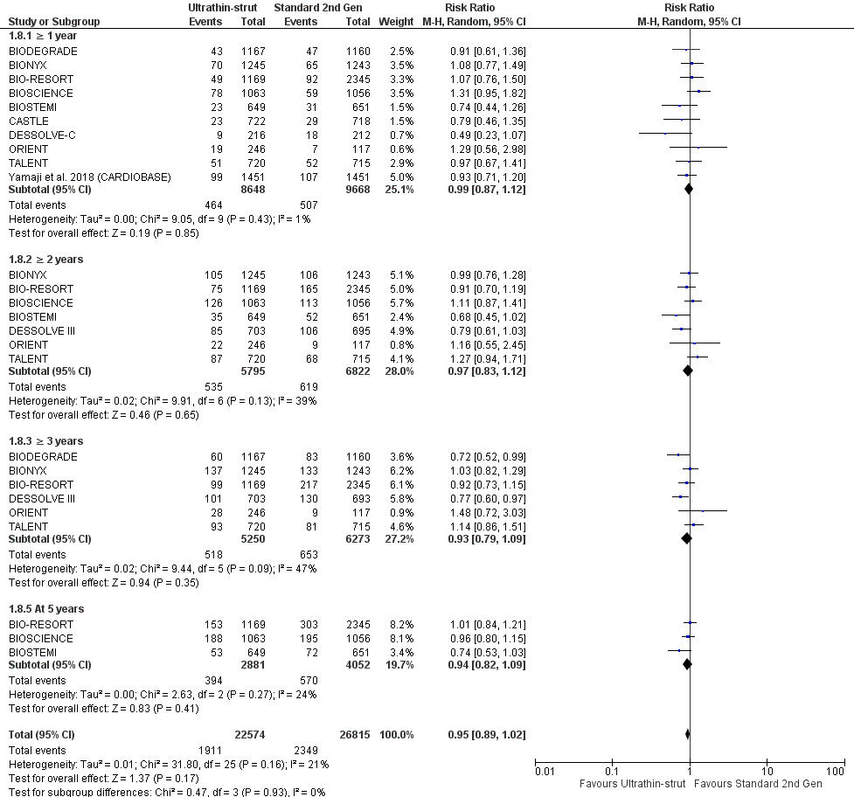
Figure S22: Forest plot of any repeat revascularization at ≥ 1 year.

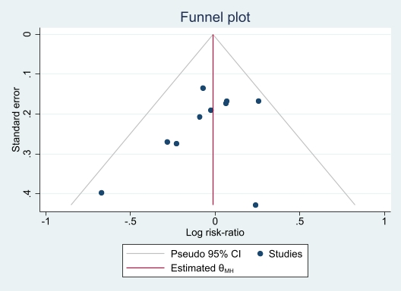
Figure S23: Funnel plot of any repeat revascularization at ≥ 1 years.

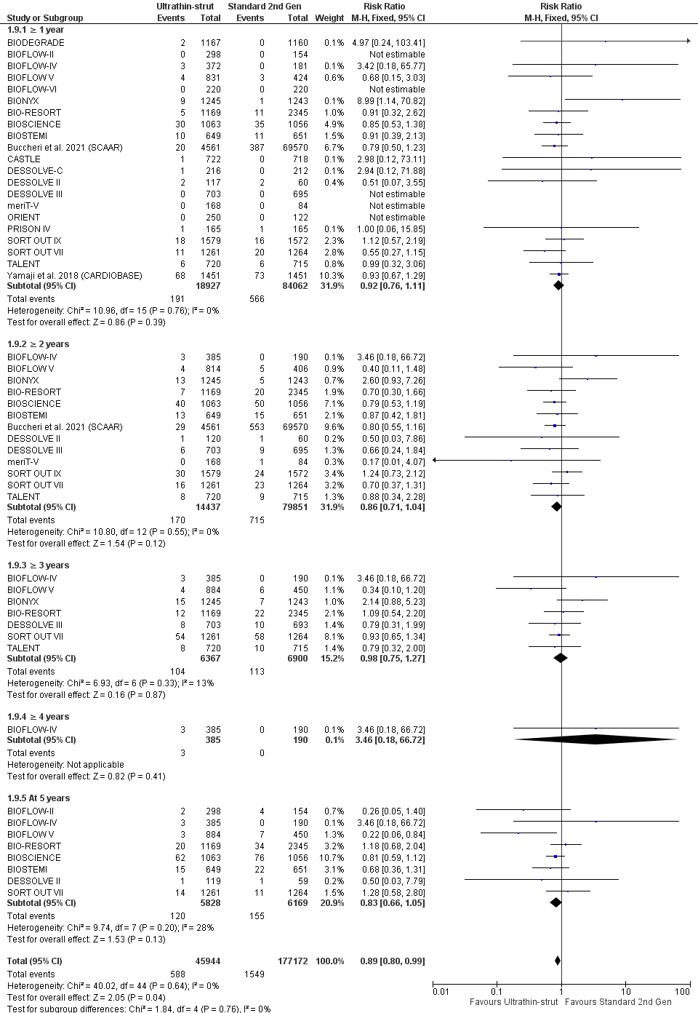
Figure S24: Forest plot of any definite or probable stent thrombosis.
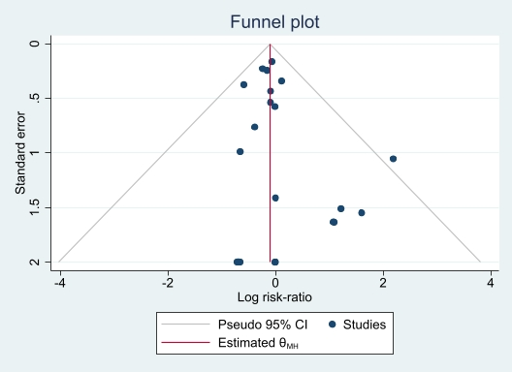
Figure S25: Funnel plot of any definite or probable stent thrombosis at ≥ 1 year

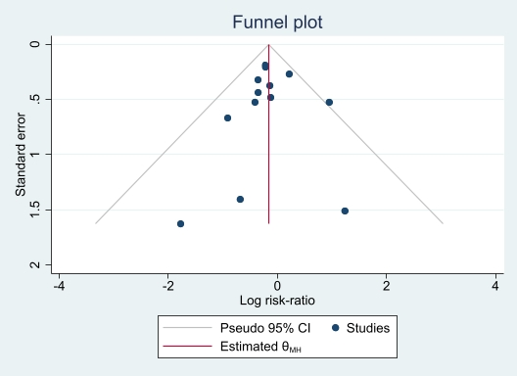
Figure S26: Funnel plot of any definite or probable stent thrombosis at ≥ 2 years.

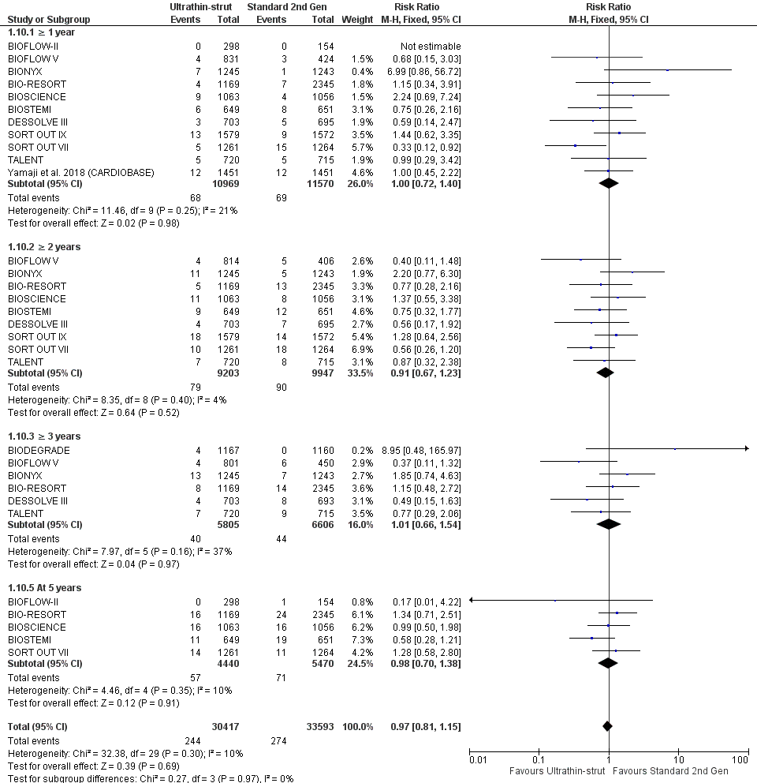
Figure S27: Forest plot of definite stent thrombosis.

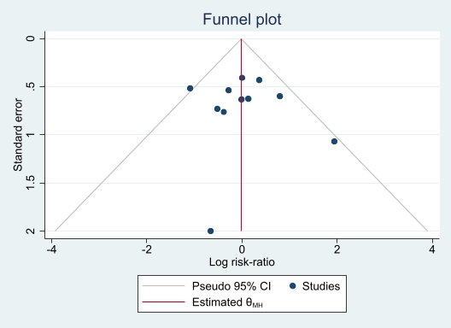
Figure S28: Funnel plot of definite stent thrombosis at ≥ 1 year.

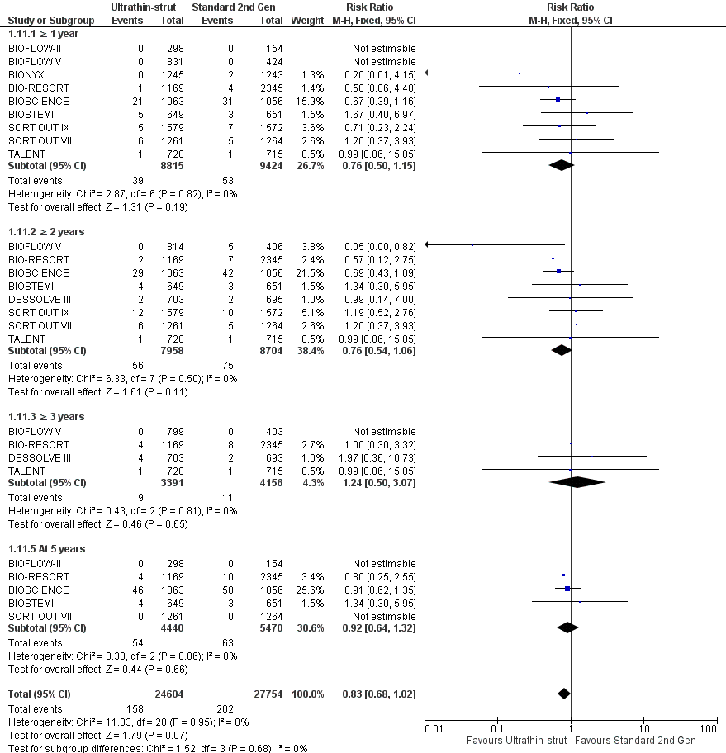
Figure S29: Forest plot of probable stent thrombosis.

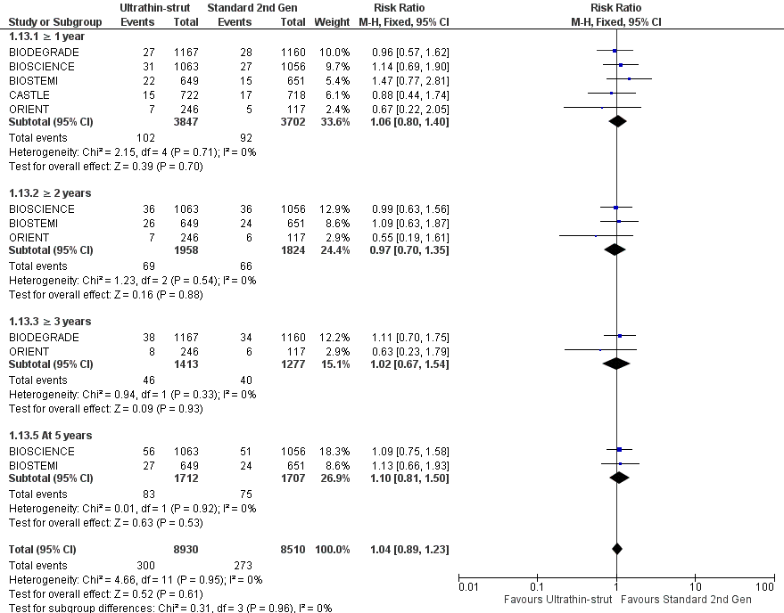
Figure S30: Forest plot of bleeding.

