Supplementary Information

This document includes:

Supplementary table legends
Flow cytometry gating strategies
Full western blots
Chemical Synthesis
Synthesis scheme
Experimental procedures
NMR spectra
HRMS spectra of fentomycin
Absorption/Emission spectra of fentomycin

Supplementary Table 1 | Quantitative mass spectrometry-based lipidomics of oxidised phospholipids in HT1080 cells treated with ferroptosis inducers.

Supplementary Table 2 | Quantitative mass spectrometry-based lipidomics of oxidised phospholipids in HT1080 cells treated with fentomycin and ferroptosis inhibitors.

Supplementary Table 3 | Quantitative mass spectrometry-based lipidomics of lysophospholipids in HT1080 cells treated with fentomycin.

Supplementary Table 4 | Quantitative mass spectrometry-based lipidomics of oxidised phospholipids and lysophospholipids of dissociated human tumours treated with fentomycin and tocopherol.

Supplementary Table 5 | Quantitative mass spectrometry-based lipidomics of oxidised phospholipids and lysophospholipids of dissociated 4T1 murine tumours.

Flow cytometry gating strategies

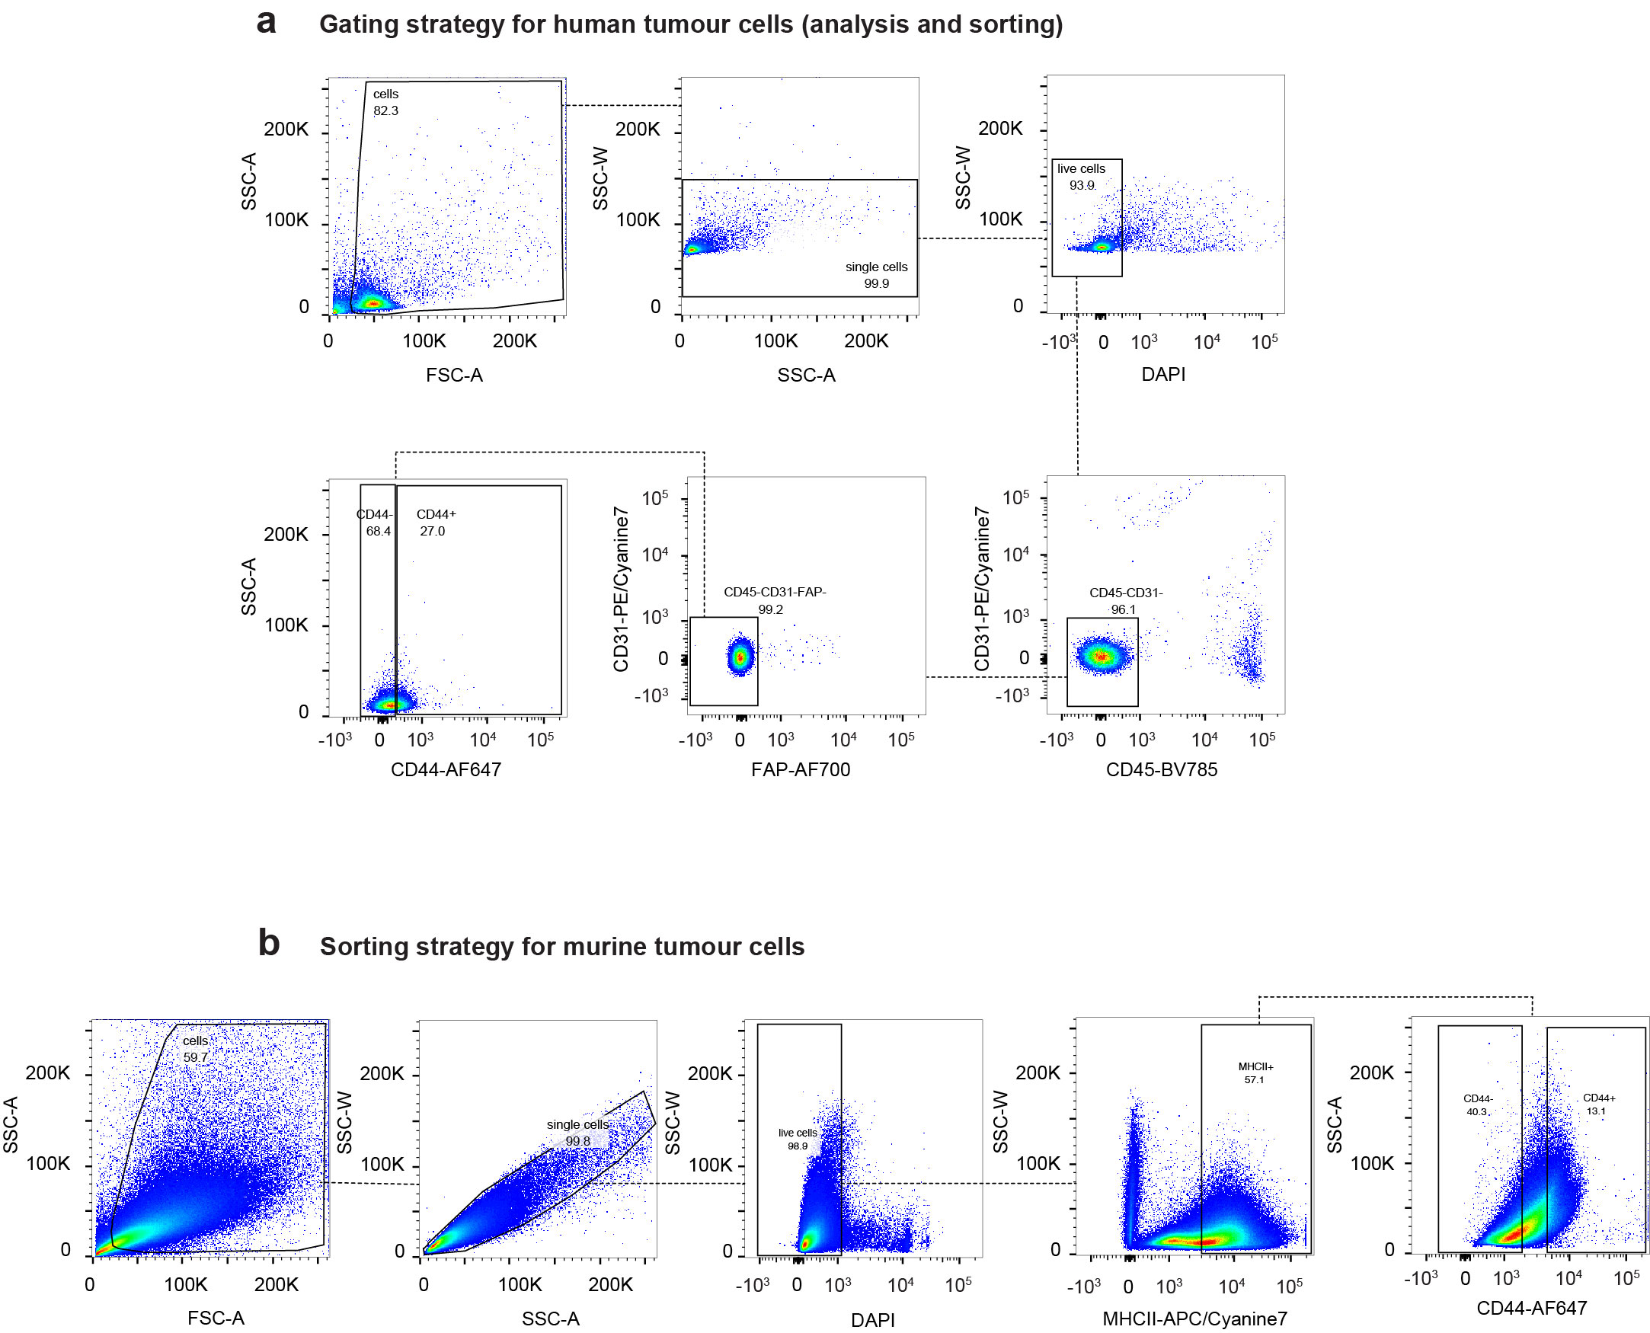

Western blot raw data

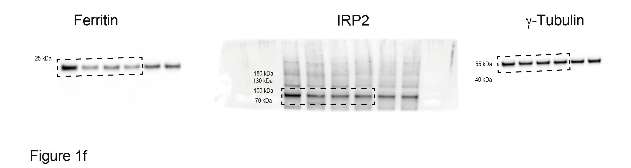

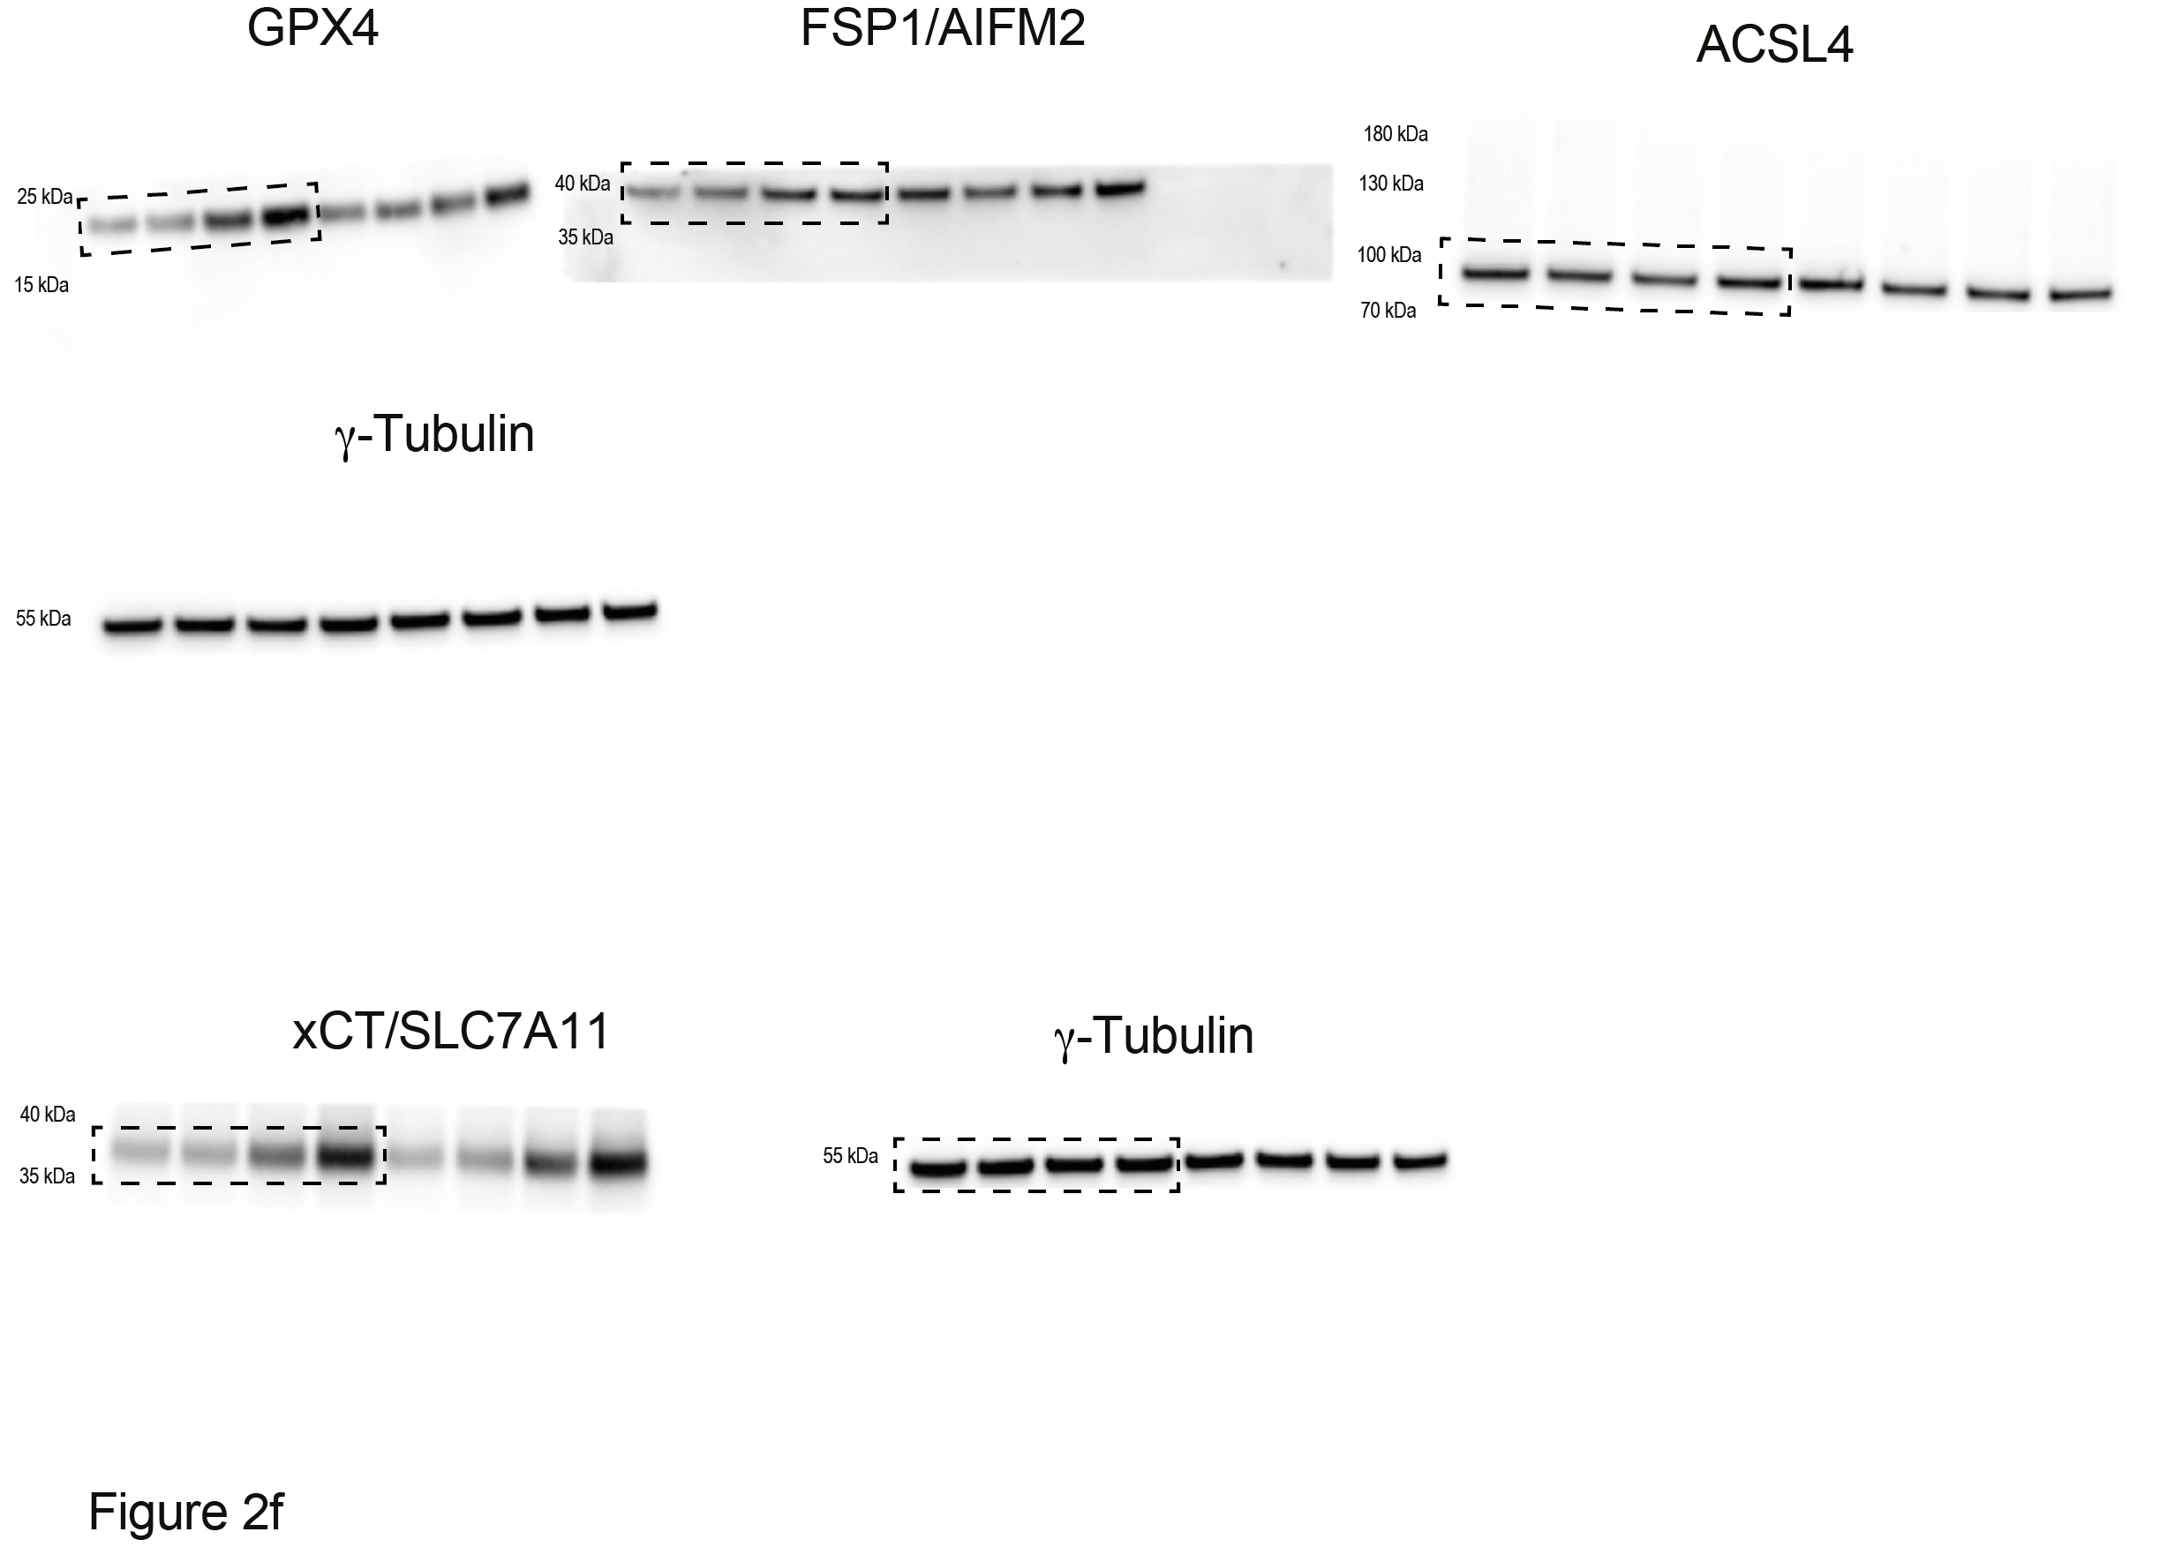

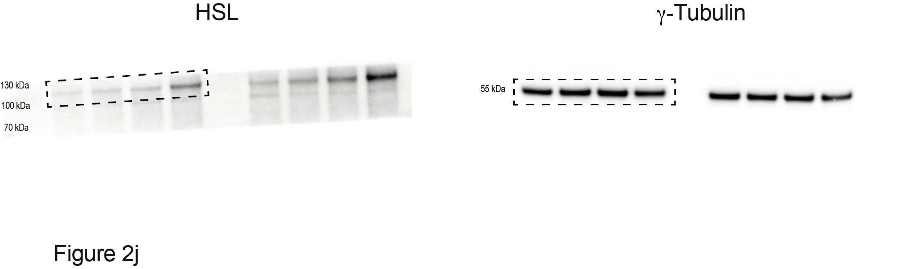
Abbreviations

Al₂O₃: Aluminum oxide
aq.: Aqueous
Ar: Argon
AU: Arbitrary units
BINAP: 2,2’-bis(diphenylphosphino)-1,1’-binaphthalene
Boc₂O: Di-tert-butyl dicarbonate
CAM: Cerium ammonium molybdate
Cs₂CO₃: Cesium carbonate
CuI: Copper iodide
DCM: Dichloromethane
DFO: Deferoxamine
DIPEA: N-N-Diisopropylethylamine
DMAP: Dimethylaminopyridine
DMF: Dimethylformamide
DMSO: Dimethylsulfoxide
DOPC: 1,2-dioleoyl-sn-glycero-3-phosphocholine
ESI-MS: Electrospray ionisation mass spectrometry
EtOAc: Ethyl acetate
EtOH: Ethanol
FA: Formic acid
Fe(OTf)₂: Iron(II) trifluoromethanesulfonate
n-Hex: n-Hexane
HATU: 1-[Bis(dimethylamino)methylene]-1H-1,2,3-triazolo[4,5-b]pyridinium 3-oxid hexafluorophosphate
HBTU: N,N,N′,N′-Tetramethyl-O-(1H-benzotriazol-1-yl)uronium hexafluorophosphate
HPLC: High performance liquid chromatography
HRMS: High resolution mass spectroscopy
K₂CO₃: Potassium carbonate
LRMS: Low resolution mass spectrometry
MeCN: Acetonitrile
MeOH: Methanol
MgSO₄: Magnesium sulfate
MOMCl: Chloromethyl methyl ether
MS: Mass spectrometry
NaHCO₃: Sodium bicarbonate
Na₂CO₃: Sodium carbonate
NH₄Cl: Ammonium chloride
NMR multiplicity: s (singlet), bs (broad singlet), d (doublet), dd (doublet of doublets), ddd (doublet of doublet of doublets), dt (doublet of triplets), dq (doublet of quadruplets), td (triplets of doublets), q (quadruplet), t (triplet), quint (quintet), m (multiplet)
NMR: Nuclear magnetic resonance
NaOH: Sodium hydroxide
PTSA: p-Toluenesulfonic acid
Pd(OAc)₂: Palladium(II) acetate

Pd(PPh₃)₂Cl₂: Bis(triphenylphosphine)palladium(II)

dichloride

POCl₃: Phosphorous trichloride

rpm: Revolution per minute
rt: Room temperature
sat.: Saturated
SOCl₂: Thionyl chloride
TBABr: Tetrabutylammonium bromide
TBAF: Tetrabutylammonium fluoride
TEA: Triethylamine
TFA: Trifluoroacetic acid
Tf₂O: Trifluoromethanesulfonic anhydride
THF: Tetrahydrofuran
TLC: Thin layer chromatography
TMS: Trimethylsilyl
TMSCl: Trimethylsilyl chloride
UPLC: Ultra-high performance liquid chromatography
UV: Ultraviolet

Chemical synthesis

Synthesis of cLip-1 (11)
Scheme 1. Synthesis of cLip-1. (a) 1, Boc₂O, NaHCO₃, THF, rt, 1 h, 96%. (b) trimethylsilylacetylene, CuI, Pd(PPh₃)₂Cl₂, TEA, DMF, 70 °C, 16 h, 85%. (c) TBAF (1 M in THF), THF, 0 °C to rt, 1 h, 94%. (d) TFA, DCM, 0 °C to rt, 1 h, 97%. (e) ethyl formate, 70 °C, 16 h, 97%. (f) POCl₃, DIPEA, DCM, -40 °C, 4 h, 55%. (g) i) 8, 9, MeOH, 40 – 50 °C, 3 h, ii) TMSCl, MeCN, 7, MeOH, 50 – 60 °C, 4 h, iii) rt, 16 h, 21%. (h) TFA, DCM, 0 °C to rt, 1 h, 75%.

Tert-butyl (3-bromobenzyl)carbamate (2)⁵⁴
To a solution of 1 (1.0 g, 5.4 mmol) in THF (5 mL) was added NaHCO₃ (0.92 g, 10.8 mmol). Then, a solution of Boc₂O (1.4 g, 6.5 mmol) in THF (2 mL) was added dropwise. After 1 h of stirring at room temperature the reaction mixture was filtered, the filter cake was washed with acetone and filtrates were concentrated to dryness under reduced pressure. The residue was purified by Combiflash on SiO₂ using n-Hex:EtOAc (95:5 to 85:15) to afford 2 as a white solid (1.5 g, 96%). Data is in accordance with the literature⁵⁴. ¹H NMR (500 MHz, methylene chloride-d₂) δ: 7.47 – 7.43 (m, 1H), 7.43 – 7.40 (m, 1H), 7.26 – 7.19 (m, 2H), 5.00 – 4.62 (bs, 1H), 4.38 – 4.20 (m, 2H), 1.50 – 1.26 (m, 9H) ppm.

Tert-butyl (3-((trimethylsilyl)ethynyl)benzyl)carbamate (3)⁵⁵
Over a flask under argon containing CuI (95.0 mg, 0.50 mmol) and Pd(PPh₃)₂Cl₂ (351.0 mg, 0.50 mmol) was added a solution of 2 (1.4 g, 5.0 mmol) and trimethylsilylacetylene (6.9 mL, 50.0 mmol) in anhydrous DMF (25 mL). Then, TEA (6.9 mL, 50.0 mmol) was added and the reaction mixture was stirred at 70 °C overnight. After cooling to room temperature, the mixture was poured into ice cold water (100 mL). The aqueous layer was extracted with EtOAc (2× 100 mL). Combined organic layers were washed with brine (100 mL), dried over anhydrous MgSO₄, filtered and concentrated to dryness under reduced pressure. The residue was purified by Combiflash on SiO₂ using n-Hex:EtOAc (95:5 to 90:10) to afford 3 as a brown liquid (1.3 g, 85%). Data is in accordance with the literature⁵⁵. ¹H NMR (500 MHz, dimethylsulfoxide-d₆) δ: 7.48 – 7.38 (m, 1H), 7.38 – 7.28 (m, 3H), 7.28 – 7.22 (m, 1H), 4.14 – 4.02 (m, 2H), 1.47 – 1.23 (m, 9H), 0.23 (bs, 9H) ppm.

tert-butyl (3-ethynylbenzyl)carbamate (4)⁵⁶
To a solution of 3 (1.3 g, 4.2 mmol) in THF (20 mL) was added TBAF (11.4 mL, 11.4 mmol, 1 M in THF) dropwise at 0 °C. The mixture was stirred at room temperature for 1 h. Then, the mixture was diluted with EtOAc (50 mL), washed with a sat. aq. solution of NH₄Cl (50 mL), brine (50 mL), dried over anhydrous MgSO₄, filtered and concentrated to dryness under reduced pressure. The residue was purified by Combiflash on SiO₂ using n-Hex:EtOAc (90:10) to afford 4 as a brown solid (906 mg, 94%). Data is in accordance with the literature⁵⁶. ¹H NMR (500 MHz, dimethylsulfoxide-d₆) δ: 7.51 – 7.38 (m, 1H), 7.38 – 7.30 (m, 3H), 7.30 – 7.22 (m, 1H), 4.17 (s, 1H), 4.14 – 4.00 (m, 2H), 1.50 – 1.25 (m, 9H) ppm.

(3-ethynylphenyl)methanamine (5)⁵⁷
To a solution of 4 (0.90 g, 3.9 mmol) in DCM (40 mL) was added TFA (4.8 mL, 62.6 mmol) at 0 °C. The mixture was stirred at room temperature for 1 h. Then, the mixture was concentrated to dryness under reduced pressure, dissolved in water (20 mL) and NaOH (2 N) was added to reach pH 14. The aqueous layer was extracted with EtOAc (2× 50 mL). Combined organic layers were washed with brine (50 mL), dried over anhydrous MgSO₄, filtered and concentrated to dryness under reduced pressure. The residue was purified by Combiflash on SiO₂ using DCM:MeOH:TEA (99:0:1 to 90:9:1) to afford 5 as a yellow liquid (496 mg, 97%). Data is in accordance with the literature⁵⁷. ¹H NMR (500 MHz, dimethylsulfoxide-d₆) δ: 7.50 – 7.45 (m, 1H), 7.40 – 7.36 (m, 1H), 7.36 – 7.30 (m, 2H), 4.16 (s, 1H), 3.75 (s, 2H) ppm.

N-(3-ethynylbenzyl)formamide (6)
A solution of 5 (0.48 g, 3.7 mmol) in ethyl formate (11 mL) was stirred at 70 °C overnight. Then, the mixture was concentrated to dryness under reduced pressure and purified by Combiflash on SiO₂ using DCM:MeOH (100:0 to 95:5) to afford 6 as a white solid (570 mg, 97%). ¹H NMR (400 MHz, dimethylsulfoxide-d₆) δ: 8.52 (bs, 1H), 8.14 (d, J = 1.8 Hz, 1H), 7.41 – 7.26 (m, 4H), 4.35 – 4.26 (m, 2H), 4.18 (s, 1H) ppm. ¹³C NMR (101 MHz, dimethylsulfoxide-d₆) δ: 161.2, 139.7, 130.4, 130.2, 128.7, 127.9, 121.7, 83.4, 80.7, 40.3 ppm. HRMS(ESI-MS) m/z calculated for C₁₀H₁₀NO [M+H]⁺ 160.0757, found 160.0758.

1-ethynyl-3-(isocyanomethyl)benzene (7)
To a solution of 6 (0.48 g, 3.0 mmol) in anhydrous DCM (10 mL) was added DIPEA (1.9 mL, 11.3 mmol) under argon. Then, the mixture was cooled to -40 °C and POCl₃ (341.0 µL, 3.6 mmol) was added dropwise. The mixture was stirred at -40 °C for 4 h. After this time, the mixture was diluted with DCM (10 mL), washed with a sat. aq. solution of Na₂CO₃ (10 mL), brine (10 mL) and an aq. solution of HCl (1 N, 2× 10 mL). The organic layer was dried over anhydrous MgSO₄, filtered and concentrated to dryness under reduced pressure. The residue was purified by Combiflash on SiO₂ using n-Hex:EtOAc (90:10) to afford 7 as a white solid (326 mg, 77%). ¹H NMR (500 MHz, dimethylsulfoxide-d₆) δ: 7.50 – 7.39 (m, 4H), 4.90 – 4.85 (m, 2H), 4.26 (s, 1H) ppm. ¹³C NMR (126 MHz, dimethylsulfoxide-d₆) δ: 156.9 (t, J_{13C-14N} = 5 Hz), 134.0, 131.3, 130.0, 129.3, 127.5, 122.2, 82.9, 81.4, 44.4 (t, J_{13C-14N} = 6.4 Hz) ppm.

tert-butyl 3'-((3-ethynylbenzyl)amino)-1'H-spiro[piperidine-4,2'-quinoxaline]-1-carboxylate (10)
A solution of 8 (77.0 mg, 0.71 mmol) and 9 (141.0 mg, 0.71 mmol) in anhydrous MeOH (0.7 mL) was stirred at 50 °C for 3 h under argon. Then, to the white suspension mixture was added successively a solution of TMSCl (90.0 µL, 0.71 mmol) in anhydrous MeCN (0.7 mL) and a solution of 7 (100.0 mg, 0.71 mmol) in anhydrous MeOH (0.7 mL). The limpid yellow mixture was stirred at 55 °C for 4 h and then at room temperature overnight. After this time an aq. solution of HCl (10 mL, 0.1 N) was added to the mixture and the aqueous layer was extracted with EtOAc (2× 10 mL). The combined organic layers were washed with brine (10 mL), dried over anhydrous MgSO₄, filtered and concentrated to dryness under reduced pressure. The residue was purified by preparative HPLC using H₂O:MeCN:FA (70:30:0.1 to 30:70:0.1) to afford 10 as a white solid (65 mg, 21%). ¹H NMR (500 MHz, methanol-d₄) δ: 7.45 (s, 1H), 7.39 – 7.25 (m, 3H), 6.95 (dd, J = 7.7, 1.2 Hz, 1H), 6.87 – 6.76 (m, 2H), 6.70 (ddd, J = 7.7, 7.1, 1.7 Hz, 1H), 4.55 (s, 2H), 3.96 (m, 2H), 3.44 (s, 1H), 3.29 – 3.05 (m, 2H), 1.92 – 1.79 (m, 2H), 1.75 – 1.68 (m, 2H), 1.45 (s, 9H) ppm. ¹³C NMR (126 MHz, methanol-d₄) δ: 160.5, 156.5, 141.3, 135.9, 135.6, 132.0, 131.5, 129.5, 129.0, 124.2, 123.7, 123.5, 120.5, 115.7, 84.5, 81.3, 78.4, 52.6, 44.8, 39.9, 38.9, 31.8 (2C), 28.7 (3C) ppm. HRMS(ESI-MS) m/z calculated for C₂₆H₃₁N₄O₂ [M+H]⁺ 431.2442, found 431.2444.

cLip-1 (11)
To a solution of 10 (50.0 mg, 0.12 mmol) in DCM (1 mL) was added dropwise TFA (133.0 µL, 1,74 mmol) at 0 °C. After stirring at room temperature for 1 h, the mixture was concentrated to dryness under reduced pressure and the product was purified by preparative HPLC using H₂O:MeCN:FA(95:5:0.1 to 70:30:0.1) to afford cLip-1 as white formate salt. The salt was dissolved in water (2 mL) and NaOH (1 N) was added until reach pH 14. The aqueous layer was extracted with DCM (10 mL). Combined organic layers were washed with brine (10 mL), dried over MgSO₄, filtered and concentrated to dryness under reduced pressure to afford cLip-1 as a white solid (30 mg, 75%). ¹H NMR (500 MHz, methanol-d₄) δ: 7.47 (s, 1H), 7.41 – 7.36 (m, 1H), 7.35 – 7.26 (m, 2H), 6.96 (d, J = 7.8 Hz, 1H), 6.88 – 6.77 (m, 2H), 6.70 (dt, J = 7.5, 1.3 Hz, 1H), 4.57 (s, 2H), 3.44 (s, 1H), 3.04 (dt, J = 12.8, 2.7 Hz, 2H), 2.96 – 2.89 (m, 2H), 1.87 (dt, J = 13.0, 4.6 Hz, 2H), 1.74 (dt, J = 13.8, 2.5 Hz, 2H) ppm. ¹³C NMR (126 MHz, methanol-d₄) δ: 160.4, 141.4, 135.6, 135.5, 132.0, 131.5, 129.5, 129.1, 124.1, 123.8, 123.0, 120.6, 115.8, 84.5, 78.5, 52.4, 45.4, 41.1 (2C), 31.8 (2C) ppm. HRMS(ESI-MS) m/z calculated for C₂₁H₂₃N₄ [M+H]⁺ 331.1917, found 331.1917.

Synthesis of metcLip-1 (13)
Scheme 2. Synthesis of metcLip-1. (a) i) 12, 9, MeOH, 40 – 50 °C, 3 h, ii) TMSCl, MeCN, 7, MeOH, 50 – 60 °C, 4 h, iii) rt, 16 h, (b) TFA, DCM, 0 °C to rt, 1 h (12% over 2 steps).
A solution of 12 (77.0 µL, 0.71 mmol) and 9 (141.0 mg, 0.71 mmol) in anhydrous MeOH (0.7 mL) was stirred at 50 °C for 3 h under argon. Then, over the dark pink solution was added successively a solution of TMSCl (90.0 µL, 0.71 mmol) in anhydrous MeCN (0.7 mL) and a solution of 7 (100.0 mg, 0.71 mmol) in anhydrous MeOH (0.7 mL). The dark pink mixture was stirred at 55 °C for 4 h and finally at room temperature overnight. After this time, water (10 mL) was added and the aqueous layer was extracted with DCM (20 mL). Combined organic layers were washed with brine (10 mL), dried over anhydrous MgSO₄, filtered and concentrated to dryness under reduced pressure. The residue was dissolved in DCM (1 mL) and TFA (810.0 µL, 10.6 mmol) was added dropwise to the mixture. After stirring for 1 h at room temperature, the mixture was concentrated to dryness under reduced pressure and the crude was purified by preparative HPLC using H₂O:MeCN:FA (90:10:0.1 to 50:50:0.1) to afford metcLip-1 as a white formate salt (32 mg, 12%) (visible traces of TFA). ¹H NMR (500 MHz, methanol-d₄) δ: 8.16 (s, 1H, formate), 7.50 (s, 1H), 7.42 – 7.29 (m, 3H), 7.21 (dd, J = 7.9, 1.0 Hz, 1H), 7.16 (m, 1H), 7.13 – 7.08 (m, 1H), 7.05 (td, J = 7.5, 1.0 Hz, 1H), 4.78 (s, 2H), 3.52 (s, 3H), 3.49 (s, 1H), 3.38 – 3.32 (m, 2H), 3.31 – 3.26 (m, 2H), 2.70 (s, 3H), 2.16 – 2.07 (m, 2H), 2.02 – 1.95 (m, 2H) ppm. ¹³C NMR (126 MHz, methanol-d₄) δ: 165.6 (formate), 154.7, 141.8, 136.7, 135.7, 132.1, 131.8, 129.8, 129.1, 125.6, 125.0, 124.0, 123.7, 121,7, 114.0, 84.3, 78.8, 56.6, 54.5, 41.6, 38.9, 38.3, 28.7 (2C) ppm. HRMS(ESI-MS) m/z calculated for C₂₃H₂₇N₄ [M+H]⁺ 359.2230, found 359.2226.

Synthesis of alcLip-1 (15)
Scheme 3. Synthesis of alcLip-1. (a) i) 14, 9, MeOH, 40 – 50 °C, 3 h, ii) TMSCl, MeCN, 7, MeOH, 50 – 60 °C, 4 h, iii) rt, 16 h (b) TFA, DCM, 0 °C to rt, 1 h (20% over 2 steps).

A solution of 14 (81.0 mg, 0.71 mmol) and 9 (141.0 mg, 0.71 mmol) in anhydrous MeOH (0.7 mL) was stirred at 50 °C for 3 h under argon. Then, over the white suspension was added successively a solution of TMSCl (90.0 µL, 0.71 mmol) in anhydrous MeCN (0.7 mL) and a solution of 7 (100 mg, 0.71 mmol) in anhydrous MeOH (0.7 mL). The mixture was stirred at 55 °C for 4 h and then at room temperature overnight. After this time, water (10 mL) was added and the aqueous layer was extracted with DCM (20 mL). The organic layer was washed with brine (10 mL), dried over anhydrous MgSO₄, filtered and concentrated to dryness under reduced pressure. The residue was dissolved in DCM (1 mL) and TFA (810.0 µL, 10.6 mmol) was added dropwise to the mixture. After stirring for 1 h at room temperature the solvent was removed under reduced pressure and the crude was purified by preparative HPLC using H₂O:MeCN:FA (95:5:0.1 to 70:30:0.1) to afford alcLip-1 as white formate salt (65 mg, 20%). ¹H NMR (500 MHz, methanol-d₄) δ: 8.49 (s, 2H), 7.48 – 7.42 (m, 2H), 7.40 (t, J = 7.6 Hz, 1H), 7.36 – 7.30 (m, 1H), 4.67 – 4.55 (m, 2H), 3.57 (s, 1H), 3.51 (td, J = 12.3, 3.8 Hz, 1H), 3.40 – 3.32 (m, 2H), 3.27 – 3.20 (m, 1H), 3.09 (ddd, J = 11.8, 9.4, 3.8 Hz, 1H), 2.70 (td, J = 13.6, 5.2 Hz, 1H), 2.50 (ddd, J = 11.4, 9.5, 3.7 Hz, 1H), 2.35 – 2.21 (m, 2H), 2.16 – 2.09 (m, 1H), 2.08 – 2.01 (m, 1H), 1.96 – 1.89 (m, 1H), 1.86 – 1.78 (m, 2H), 1.46 – 1.29 (m, 3H), 1.29 – 1.14 (m, 1 H) ppm. ¹³C NMR (126 MHz, methanol-d₄) δ: 170.1(formate), 168.3, 136.5, 132.8, 131.9, 130.2, 128.8, 124.5, 83.8, 79.6, 59.5, 55.8, 53.2, 45.7, 40.1, 40.0, 32.6, 31.9, 31.4, 30.7, 26.0, 25.2 ppm. HRMS (ESI-MS) m/z calculated for C₂₁H₂₉N₄ [M+H]⁺ 337.2387, found 337.2386.

Synthesis of fentomycin
Scheme 4. Synthesis of fentomycin. (a) 17, 19, toluene, 100 °C, 16 h, then concentrated to dryness; MeOH, rt, 4 h, then K₂CO₃, rt, 1 h, 33%. (b) Tf₂O, TEA, DCM, -78 °C to rt, 6 h, 78%. (c) 21, 27, CuI, K₂CO₃, toluene, 160 °C, sealed tube, 72 h, 33%. (d) BF₃·Et₂O, DCM, -78 °C to rt, 6 h, 62%. (e) Benzaldehyde dimethylacetal, PTSA, DMF, 40 °C (30 mbar), 16 h, 98%. (f) (iPr)₂EtN, MOMCl, DCM, rt, 72 h, 91%. (g) sec-Butyllithium (1.6 M in hexane), THF, -40 °C, 1.5 h, 61%. (h) O-benzylhydroxylamine HCl salt, NaOAc, EtOH, rt, 2 h, 90%. (i) Anhydrous CeCl₃, methyllithium (3 M in diethoxymethane), THF, -78 °C, 1 h; then 26, -78 °C to 0 °C, 2 h, 76%. (j) H₂, Pd/C, MeOH, rt, 16 h, 88%. (k) 48% wt/wt aq. HBF₄, MeCN, 82 °C, 2 h, 13%. (l) succinic acid, DMAP, anhydrous pyridine, 90 ºC, 40 h, 36%. (m) dimethylamine HCl salt, NaOH, H₂O, sealed tube, 155 ºC, 16 h, 91%. (n) SOCl₂, DCM, rt, 16 h, 93%. (o) Na₂CO₃, TBABr, anhydrous MeCN, 90 °C, 16 h, 27%. (p) Pd(OAc)₂, BINAP, Cs₂CO₃, dioxane, reflux, overnight, 66%. (q) SOCl₂, DCM, 0 ºC to rt, 16 h, 56%. (r) Na₂CO₃, TBABr, MeCN, reflux under Ar, 16 h, 66%. (s) TFA, DCM, 0 ºC then rt, 2 h, 69%. (t) HBTU, DIPEA, THF, rt, 4 h, 86%.

2-((2S,2'S)-[2,2'-bipyrrolidin]-1-ylmethyl)-N,N-dimethylpyridin-4-amine (33a)⁵⁸ and 2,2'-((2S,2'S)-[2,2'-bipyrrolidine]-1,1'-diylbis(methylene))bis(N,N-dimethylpyridin-4-amine) (33b)⁵⁹
Into a 100 mL Schlenk flask were mixed 2-chloromethyl-4-dimethylaminopyridine (31)⁶⁰ (0.79 g, 4.63 mmol) and (S,S)-2,2-bipyrrolidine (32) (0.65 g, 4.63 mmol) in anhydrous MeCN (45 mL). Then Na₂CO₃ (1.96 g, 18.54 mmol) and TBABr (0.29 g, 0.93 mmol) were added directly as solids and the resulting mixture was heated at reflux under argon for 16 h. After cooling to room temperature, the resulting brown mixture was filtered and the filter cake was washed with DCM. The combined filtrates were concentrated to dryness under reduced pressure. Over the resulting residue was added an aq. solution of NaOH (1 N, 10 mL) and the mixture was extracted with DCM (3× 10 mL). The combined organic layers were dried over anhydrous MgSO₄, filtered and concentrated to dryness under reduced pressure. The residue was purified by Combiflash on Al₂O₃ neutral using DCM:MeOH (100:0 to 95:5) to afford 33a as a brown oil (0.38 g, 27%). Data is in accordance with the literature⁵⁸. ¹H NMR (500 MHz, methanol-d₄) δ: 8.06 (d, J = 7.0 Hz, 1H), 6.62 (d, J = 5.1 Hz, 2H), 3.98 (dd, J = 15.2, 2.4 Hz, 1H), 3.77 (d, J = 15.2 Hz, 1H), 3.41 (q, J = 8.2 Hz, 1H), 3.26 – 3.24 (m, 1H), 3.09 – 2.96 (m, 9H), 2.63 (dt, J = 11.0, 7.0 Hz, 1H), 2.15 – 2.04 (m, 2H), 2.04 – 1.88 (m, 3H), 1.88 – 1.74 (m, 1H), 1.72 – 1.51 (m, 2H) ppm.

Product 33b was obtained as a side product of the reaction and as brown solid (0.13 g, 10%). Data is in accordance with the literature⁵⁹. ¹H NMR (400 MHz, methanol-d₄) δ: 7.95 (d, J = 6.1 Hz, 2H), 6.72 (d, J = 2.6 Hz, 2H), 6.48 (dd, J = 6.1, 2.7 Hz, 2H), 4.16 (d, J = 14.2 Hz, 2H), 3.42 (d, J = 14.2 Hz, 2H), 3.06 – 2.98 (m, 2H), 2.95 (s, 12H), 2.82 – 2.72 (m, 2H), 2.34 – 2.22 (m, 2H), 1.92 – 1.87 (m, 2H), 1.80 – 1.65 (m, 6H) ppm.

tert-butyl (4-((2-(hydroxymethyl)pyridin-4-yl)amino)butyl)carbamate (35)
In a dry Schlenk flask were added under argon (4-chloropyridin-2-yl)methanol (30) (1.0 g, 6.97 mmol), tert-butyl(4-aminobutyl)carbamate (34) (1.6 mL, 8.36 mmol), Pd(OAc)₂ (0.08 g, 0.35 mmol), BINAP (0.22 g, 0.35 mmol) and Cs₂CO₃ (3.40 g, 10.45 mmol). Then was added anhydrous dioxane (70 mL) and the reaction was stirred at reflux overnight. After cooling to room temperature, the mixture was concentrated to dryness under reduced pressure and the residue was purified by Combiflash on SiO₂ using DCM:MeOH:TEA (90:10:5) to afford 35 as a brown oil (1.35 g, 66%). ¹H NMR (500 MHz, methanol-d₄) δ: 7.90 (d, J = 5.8 Hz, 1H), 6.69 (s, 1H), 6.42 (d, J = 5.8 Hz, 1H), 4.52 (s, 2H), 3.17 (t, J = 6.8 Hz, 2H), 3.07 (t, J = 6.8 Hz, 2H), 1.63 – 1.60 (m, 2H), 1.59 – 1.54 (m, 2H), 1.43 (s, 9H) ppm. ¹³C NMR (126 MHz, methanol-d₄) δ: 161.5, 158.6, 157.0, 148.7, 106.9, 104.5, 79.9, 65.3, 43.0, 41.0, 28.8 (3C), 28.5, 27.1 ppm. HRMS(ESI-MS) m/z calculated for C₁₅H₂₆N₃O₃ [M+H]⁺ 296.1969, found 296.1967.

tert-butyl (4-((2-(chloromethyl)pyridin-4-yl)amino)butyl)carbamate (36)
To a Schlenk tube containing 35 (1.35 g, 4.58 mmol) was added anhydrous DCM (45 mL) and the solution was cooled at 0 ºC, then was added dropwise SOCl₂ (0.50 mL, 6.86 mmol). The reaction was allowed to reach room temperature and was stirred overnight. After this time the reaction was carefully quenched with a sat. aq. solution of Na₂CO₃ and extracted with DCM (3× 20 mL). The combined organic layers were dried over MgSO₄, filtered and concentrated to dryness under reduced pressure and the residue was purified by Combiflash on SiO₂ using DCM:MeOH (100:0 to 90:10) to afford 36 as a brown oil (0.80 g, 56%). ¹H NMR (400 MHz, methanol-d₄) δ: 7.94 (d, J = 5.9 Hz, 1H), 6.66 (d, J = 2.1 Hz, 1H), 6.46 (dd, J = 5.9, 2.3 Hz, 1H), 4.48 (s, 2H), 3.15 (t, J = 6.7 Hz, 2H), 3.07 (t, J = 6.6 Hz, 2H), 1.69 – 1.49 (m, 4H), 1.42 (s, 9H) ppm. ¹³C NMR (126 MHz, chloroform-d) δ: 156.9, 156.3, 154.5, 149.7 (2C), 106.8, 106.3, 50.9, 47.2, 42.5, 28.5 (3C), 27.9, 26.2 ppm. HRMS(ESI-MS) m/z calculated for C₁₅H₂₅ClN₃O₂ [M+H]⁺ 314.1630, found 314.1630.

tert-butyl (4-((2-(((2S,2'S)-1'-((4-(dimethylamino)pyridin-2-yl)methyl)-[2,2'-bipyrrolidin]-1-yl)methyl)pyridin-4-yl)amino)butyl)carbamate (37)
In a 10 mL Schlenk flask were mixed 36 (0.11 g, 0.34 mmol) and 33a (0.09 g, 0.34 mmol) in anhydrous MeCN (4 mL). Then were added Na₂CO₃ (0.14 g, 1.37 mmol) and TBABr (0.02 g, 0.07 mmol) directly as solids and the resulting mixture was heated at reflux under argon for 16 h. After cooling to room temperature, the resulting brown mixture was filtered and the filter cake was washed with DCM. The combined filtrates were concentrated to dryness under reduced pressure. To the resulting residue was added a sat. aq. solution of Na₂CO₃ (5 mL) and the mixture was extracted with DCM (3× 5 mL). The combined organic layers were dried over anhydrous MgSO₄, filtered and concentrated to dryness under reduced pressure. The residue was purified by Combiflash on neutral Al₂O₃ using DCM:MeOH (100:0 to 95:5) to afford 37 as a brown oil (0.124 g, yield 66%). ¹H NMR (400 MHz, chloroform-d) δ: 8.10 (d, J = 6.0 Hz, 1H), 8.05 (d, J = 5.7 Hz, 1H), 6.65 (d, J = 2.6 Hz, 1H), 6.55 (d, J = 2.4 Hz, 1H), 6.32 (dd, J = 5.9, 2.7 Hz, 1H), 6.24 (dd, J = 5.8, 2.4 Hz, 1H), 4.82 (bs, 1H), 4.29 (bs, 1H), 4.07 (dd, J = 17.6, 14.2 Hz, 2H), 3.37 (dd, J = 14.1, 12.4 Hz, 2H), 3.18 – 3.06 (m, 4H), 3.06 – 2.96 (m, 2H), 2.93 (s, 6H), 2.81 – 2.73 (m, 2H), 2.29 – 2.16 (m, 2H), 1.86 – 1.51 (m, 12H), 1.42 (s, 9H) ppm. ¹³C NMR (101 MHz, chloroform-d) δ: 160.4, 160.3, 156.2, 155.0, 154.1, 149.2, 148.9, 106.4, 105.7, 105.2, 105.1, 79.3, 65.7, 65.7, 61.7, 61.5, 55.4, 55.4, 42.4, 40.3, 39.2 (2C), 28.5 (3C), 27.9, 26.4, 26.4, 26.3, 23.8 (2C) ppm. HRMS(ESI-MS) m/z calculated for C₃₁H₅₀N₇O₂ [M+H]⁺ 552.4021, found 552.4025.

N¹-(2-(((2S,2'S)-1'-((4-(dimethylamino)pyridin-2-yl)methyl)-[2,2'-bipyrrolidin]-1-yl)methyl)pyridin-4-yl)butane-1,4-diamine (38)
Over a solution of 37 (0.084 g, 0.152 mmol) in anhydrous DCM (2 mL) at 0 ºC was added TFA (0.059 mL, 0.762 mmol). The reaction was allowed to reach room temperature and then was stirred for 2 h. After this time the mixture was concentrated to dryness under reduced pressure and the residue was redissolved in DCM, washed with an aq. solution of NaOH (1 N, 2 mL) and extracted with DCM (3× 2 mL). Combined organic layers were dried over anhydrous MgSO₄, filtered and concentrated to dryness under reduced pressure. The residue was purified by Combiflash on Al₂O₃ using DCM:MeOH:TEA (90:10:5) to afford 38 as a brown oil (0.047 g, yield 69%). ¹H NMR (500 MHz, methanol-d₄) δ: 7.96 (d, J = 6.1 Hz, 1H), 7.86 (d, J = 5.9 Hz, 1H), 6.72 (d, J = 2.6 Hz, 1H), 6.65 (d, J = 2.4 Hz, 1H), 6.49 (dd, J = 6.2, 2.7 Hz, 1H), 6.37 (dd, J = 5.9, 2.4 Hz, 1H), 4.16 – 4.06 (m, 2H), 3.43 – 3.34 (m, 2H), 3.12 – 3.04 (m, 2H), 3.04 – 2.97 (m, 2H), 2.96 (s, 6H), 2.80 – 2.71 (m, 2H), 2.64 (t, J = 7.0 Hz, 2H), 2.32 – 2.19 (m, 2H), 1.93 – 1.83 (m, 2H), 1.77 – 1.65 (m, 6H), 1.65 – 1.56 (m, 2H), 1.56 – 1.48 (m, 2H) ppm. ¹³C NMR (126 MHz, methanol-d₄) δ: 160.5, 160.4, 156.8, 156.6, 148.7 (2C), 106.9, 106.8, 106.6, 106.5, 67.8, 67.6, 62.3, 62.1, 56.4 (2C), 43.1, 42.3, 39.2 (2C), 31.3, 27.8 (2C), 27.3, 24.6, 24.6 ppm. HRMS(ESI-MS) m/z calculated for C₂₆H₄₂N₇ [M+H]⁺ 452.3496, found 452.3498.

Fentomycin (39)
A solution of marmysunate (29)^{35,61} (3.2 mg, 0.0062 mmol), HBTU (11.8 mg, 0.0312 mmol) and DIPEA (32.4 µL, 0.1860 mmol) in anhydrous THF (100 µL) was stirred 1 h at room temperature before the addition of 38 (14.1 mg, 0.0312 mmol) in anhydrous THF (100 µL). The reaction was stirred 4 h at room temperature until TLC in Al₂O₃ (DCM:MeOH, 95:5) showed a total conversion, then the mixture was concentrated to dryness under reduced pressure and the residue was purified by preparative HPLC using H₂O:MeCN:FA (95:5:0.1 to 0:100:0.1) to afford fentomycin as a red solid after freeze drying (formate salt, 5.0 mg, 86%). ¹H NMR (500 MHz, methanol-d₄) δ: 9.64 (s, 1H), 9.44 (d, J = 9.0 Hz, 1H), 8.54 (bs, 1H), 8.24 (d, J = 8.6 Hz, 1H), 8.09 (d, J = 8.6 Hz, 1H), 7.90 (dd, J = 6.3, 0.6 Hz, 1H), 7.82 (d, J = 6.5 Hz, 1H), 7.70 (d, J = 1.8 Hz, 1H), 7.53 (dd, J = 9.0, 1.8 Hz, 1H), 7.51 – 7.43 (m, 2H), 6.66 – 6.61(m, 2H), 6.59 – 6.52 (m, 2H), 4.84 (dd, J = 3.3, 1.9 Hz, 1H), 4.74 (d, J = 9.6 Hz, 1H), 4.12 (d, J = 15.1 Hz, 1H), 4.10 (d, J = 15.4 Hz, 1H), 3.65 (d, J = 15.1 Hz, 1H), 3.62 (d, J = 15.4 Hz, 1H), 3.33 (dq, J = 9.6, 6.1 Hz, 1H), 3.20 (t, J = 6.7 Hz, 2H,), 3.13 (t, J = 6.7 Hz, 2H), 3.08 – 2.98 (m, 8H), 2.93 – 2.83 (m, 2H), 2.82 – 2.65 (m, 2H), 2.58 (t, J = 6.5 Hz, 2H), 2.55 – 2.47 (m, 5H), 2.26 (ddd, J = 13.4, 3.3, 1.3 Hz, 1H), 2.00 – 1.69 (m, 7H), 1.68 – 1.51 (m, 6H), 1.38 (s, 3H), 1.04 (d, J = 6.1 Hz, 3H) ppm. ¹³C NMR (126 MHz, methanol-d₄) δ: 187.3, 186.4, 174.0, 173.7, 170.0, 158.6, 157.9, 155.0 (2C), 149.9, 144.0, 143.5, 140.2, 137.9, 137.5, 137.0, 135.9, 135.7, 133.1, 129.6 (2C), 129.2, 128.9, 128.4, 123.3, 116.7, 111.8, 107.2 (2C), 106.6 (2C), 80.7, 70.4, 69.0, 68.9, 67.8, 59.8, 59.2, 55.9 (2C), 52.3, 43.2, 39.7 (3C), 35.8, 31.2, 30.5, 28.2 (2C), 28.0, 26.7, 25.3, 24.9, 24.8, 21.6, 18.5 ppm. 2D NMR COSY, HSQC, HMBC (spectra in methanol-d₄ provided). HRMS(ESI-MS) m/z calculated for C₅₆H₆₇N₈O₆ [M+H]⁺ 947.5184, found 947.5174.

Synthesis of clickable White-Chen ligand (43, cWhite-Chen)
Scheme 5. Synthesis of cWhite-Chen. (a) TBABr, K₂CO₃, MeCN, 90 ºC, 16 h, 38%. (b) NaOH 1N/MeOH, rt, overnight, 38%. (c) HATU, DIPEA, THF, rt, 16 h, 14%.

Methyl 3-((2-(((2S,2'S)-1'-((4-(dimethylamino)pyridin-2-yl)methyl)-[2,2'-bipyrrolidin]-1-yl)methyl)pyridin-4-yl)(methyl)amino)propanoate (41)
In a dry Schlenk flask were added 40⁶² (0.30 g, 1.24 mmol), 33a (0.34 g, 1.24 mmol) and anhydrous MeCN (12 mL). Then were added Na₂CO₃ (0.52 g, 4.99 mmol) and TBABr (0.08 g, 0.25 mmol). The resulting mixture was heated at reflux for 16 h under argon. After cooling to room temperature, the resulting brown mixture was filtered and the filter cake was washed with DCM. The combined filtrates were concentrated to dryness under reduced pressure. To the resulting residue was added a sat. aq. solution of Na₂CO₃ (5 mL) and the mixture was extracted with DCM (3× 5 mL). The combined organic layers were dried over anhydrous MgSO₄, filtered and concentrated to dryness under reduced pressure. Subsequently, the residue was purified by Combiflash on neutral Al₂O₃ using DCM:MeOH (100:0 to 95:5) to afford 41 as a brown oil (0.23 g, 38%). ¹H NMR (500 MHz, methanol-d₄) δ: 7.97 (d, J = 6.2 Hz, 1H), 7.94 (d, J = 6.3 Hz, 1H), 6.76 (d, J = 2.7 Hz, 1H), 6.70 (d, J = 2.7 Hz, 1H), 6.56 – 6.49 (m, 2H), 4.22 – 4.12 (m, 2H), 3.67 (t, J = 7.0 Hz, 1H), 3.65 (s, 3H), 3.51 (d, J = 14.2 Hz, 2H), 3.10 – 2.99 (m, 3H), 2.96 (s, 6H), 2.94 (s, 3H), 2.88 – 2.78 (m, 2H), 2.56 (t, J = 7.0 Hz, 2H), 2.44 – 2.31 (m, 2H), 2.00 – 1.87 (m, 2H), 1.85 – 1.64 (m, 6H) ppm. ¹³C NMR (126 MHz, methanol-d₄) δ: 173.7, 160.2, 159.6, 156.9, 155.7, 148.8, 148.3, 106.7 (2C), 106.6 (2C), 68.4, 68.3, 62.4, 62.3, 56.3 (2C), 52.3, 48.2, 39.2 (2C), 37.8, 32.4, 28.2 (2C), 24.8, 24.7 ppm. HRMS(ESI-MS) m/z calculated for C₂₇H₄₁N₆O₂ [M+H]⁺ 481.3286, found 481.3288.

3-((2-(((2S,2'S)-1'-((4-(dimethylamino)pyridin-2-yl)methyl)-[2,2'-bipyrrolidin]-1-yl)methyl)pyridin-4-yl)(methyl)amino)propanoic acid (42)
A solution of 41 (214 mg, 0.446 mmol) in 5 mL of a mixture MeOH:NaOH 1 N (1:1) was stirred at room temperature overnight. Then the reaction was neutralised using an aq. solution of HCl (1 N) and concentrated to dryness under reduced pressure. The resultant residue was washed with MeOH and the salts were filtered off. The filtrate was concentrated to dryness under reduced pressure. The product was purified by preparative HPLC using H₂O:MeCN:FA (95:5:0.1 to 0:100:0.1). The product was obtained as a white solid (80 mg, 38%). ¹H NMR (500 MHz, methanol-d₄) δ: 7.98 (d, J = 6.9 Hz, 1H), 7.96 (d, J = 6.9 Hz, 1H), 6.86 (d, J = 2.7 Hz, 1H), 6.82 – 6.78 (m, 2H), 6.76 (dd, J = 6.9, 2.8 Hz, 1H), 4.35 – 4.21 (m, 2H), 3.87 – 3.79 (m, 2H), 3.76 (td, J = 7.1, 1.6 Hz, 2H), 3.17 – 3.09 (m, 11H), 3.04 – 2.93 (m, 2H), 2.67 – 2.58 (m, 2H), 2.44 (t, J = 7.1 Hz, 2H), 2.08 – 1.98 (m, 2H), 1.95 – 1.79 (m, 4H), 1.74 – 1.65 (m, 2H) ppm. ¹³C NMR (126 MHz, methanol-d₄) δ: 179.0, 158.3, 157.6, 154.6, 143.4, 143.3, 107.4, 107.2, 106.8, 106.6, 69.4, 69.3, 59.7, 59.5, 56.1, 56.0, 50.5, 39.9 (3C), 38.4, 36.0, 28.6, 28.5, 24.9, 24.8 ppm. HRMS(ESI-MS) m/z calculated for C₂₆H₃₉N₆O₂ [M+H]⁺ 467.3129, found 467.3242.

Clickable White-Chen ligand (43, cWhite-Chen ligand)
A solution of 42 (10 mg, 0.0214 mmol), HBTU (24.4 mg, 0.0644 mmol) and DIPEA (11.2 µL, 0.0644 mmol) in anhydrous THF (1mL) was stirred for 3 h at room temperature before the addition of propargylamine (4.1 µL, 0.0644 mmol). The reaction was stirred overnight at room temperature, then the mixture was concentrated to dryness under reduced pressure and the residue was purified by preparative HPLC using H₂O:MeCN:FA (95:5:0.1 to 0:100:0.1) to afford cWhite-Chen ligand as a colorless oil (formate salt, 1.5 mg, 14%). ¹H NMR (500 MHz, methanol-d₄) δ: 8.47 (bs, 2H), 8.00 (dd, J = 13.4, 6.7 Hz, 2H), 6.84 (d, J = 2.8 Hz, 1H), 6.83 – 6.71 (m, 3H), 4.25 (dd, J = 15.3, 1.9 Hz, 2H), 3.92 (d, J = 2.5 Hz, 2H), 3.84 – 3.76 (m, 4H), 3.19 – 3.09 (m, 8H), 3.08 (s, 3H), 3.07 – 3.01 (m, 2H), 2.72 – 2.61 (m, 2H), 2.59 (t, J = 2.5 Hz, 1H), 2.50 (t, J = 6.7 Hz, 2H), 2.09 – 1.98 (m, 2H), 1.97 – 1.90 (m, 2H), 1.90 – 1.79 (m, 2H), 1.78 – 1.68 (m, 2H) ppm. ¹³C NMR (126 MHz, methanol-d₄) δ: 172.7, 169.2 (formate), 158.3, 157.5, 154.9, 154.5, 144.4, 143.4, 107.6, 107.3, 107.2, 106.7, 80.4, 72.4, 69.0, 68.9, 59.8, 59.4, 55.9, 55.8, 49.0, 39.9 (2C), 38.3, 34.1, 29.5, 28.2, 28.1, 24.8 (2C) ppm. HRMS(ESI-MS) m/z calculated for C₂₉H₄₂N₇O [M+H]⁺ 504.3445, found 504.3450.

Synthesis of chemical probes

Lysosomal Fe³⁺ probe (RPE)⁶³
The lysosomal Fe³⁺ probe RPE was synthesised as previously reported and spectral data are in accordance with the literature⁶³. ¹H NMR (500 MHz, chloroform-d) δ: 8.72 (dd, J = 8.3, 1.0 Hz, 1H), 8.04 – 7.96 (m, 1H), 7.71 – 7.56 (m, 2H), 7.56 – 7.40 (m, 2H), 7.16 – 7.09 (m, 1H), 6.47 – 6.32 (m, 4H), 6.10 (dd, J = 8.7, 2.6 Hz, 2H), 3.90 (s, 3H), 3.40 – 3.17 (m, 8H), 1.12 (t, J = 7.1 Hz, 12H) ppm.

Lysosomal Fe²⁺ probe (RhoNox-M)⁶⁴
This Fe²⁺-specific lysosomal probe was synthesised in 3 steps according to a previously published procedure and spectra data are in accordance with the literature⁶⁴. ¹H NMR (300 MHz, chloroform-d) δ: 7.93 (d, J = 2.0 Hz, 1H), 7.45 (dd, J = 8.5, 2.0 Hz, 1H), 7.40–7.30 (m, 3H), 7.05 (d, J = 8.5 Hz, 1H), 6.90 (d, J = 7.0 Hz, 1H), 6.80 (d, J = 8.0 Hz, 1H), 6.50–6.44 (m, 2H), 5.28–5.35 (m, 2H), 3.62 (m, 6H), 2.97 (s, 6H) ppm.

Lysosomal GSH probe (SQSS)⁶⁵
The lysosomal GSH probe SQSS was synthesised as previously reported and spectral data are in accordance with the literature⁶⁵. ¹H NMR (500 MHz, dimethylsulfoxide-d₆) δ: 8.72 (t, J = 5.8 Hz, 2H), 7.82 (d, J = 7.6 Hz, 2H), 7.57 (d, J = 8.2 Hz, 2H), 7.49 – 7.42 (m, 6H), 7.22 – 7.14 (m, 4H), 6.75 (t, J = 7.6 Hz, 2H), 5.84 (s, 2H), 5.82 (s, 2H), 4.31 (q, J = 7.1 Hz, 4H), 4.02 (q, J = 7.2 Hz, 4H), 3.95 (q, J = 6.2 Hz, 4H), 3.24 (t, J = 6.8 Hz, 4H), 1.28 (t, J = 7.1 Hz, 6H), 1.23 (t, J = 6.9 Hz, 6H) ppm.

Lysosomal HO• Probe (1-Red)⁶⁶
The lysosomal HO• probe 1-Red was synthesised as previously reported and spectral data are in accordance with the literature⁶⁶. ¹H NMR (500 MHz, dimethylsulfoxide-d₆) δ: 7.90 – 7.78 (m, 3H), 7.48 (d, J = 7.5 Hz, 1H), 7.34 (d, J = 2.5 Hz, 1H), 7.18 (dd, J = 8.9, 2.6 Hz, 1H), 7.13 – 7.05 (m, 2H), 6.74 (td, J = 7.4, 0.8 Hz, 1H), 6.69 (d, J= 7.8 Hz, 1H), 4.13 (s, 1H), 3.89 (s, 3H), 2.62 (s, 3H), 1.39 (s, 3H), 0.65 (s, 3H) ppm.

Clickable deferoxamine (cDFO)⁷
Propargyl bromide (8.50 μL, 0.076 mmol, 80% in toluene) was added to a suspension of DFO mesylate (50 mg, 0.076 mmol) and NaHCO₃ (0.0192 mg, 0.2284 mmol) in anhydrous MeOH (1 mL) at 0 ºC and the reaction mixture was stirred overnight at room temperature. After filtration and concentration to dryness under reduced pressure, the crude residue was purified by preparative HPLC using H₂O:MeCN:TFA (95:5:0.1 to 0:100:0.1) to afford cDFO as a white TFA salt (9.2 mg, 17%). Spectral data are in agreement with the literature⁷. ¹H NMR (500 MHz, methanol-d₄) δ: 3.94 (d, J = 2.5 Hz, 2H), 3.71 – 3.53 (m, 6H), 3.25 (t, J = 2.5 Hz, 1H), 3.17 (t, J = 7.0 Hz, 4H), 3.08 (t, J = 7.5 Hz, 2H), 2.76 (t, J = 7.0 Hz, 4H), 2.46 (dt, J = 10.0, 7.0 Hz, 4H), 2.09 (s, 3H), 1.74 – 1.61 (m, 8H), 1.53 (quint., J = 7.0 Hz, 4H), 1.46 – 1.27 (m, 6H) ppm.

NMR spectra
¹H NMR spectrum of 6 in dimethylsulfoxide-d₆
¹³C NMR spectrum of 6 in dimethylsulfoxide-d₆

¹H NMR spectrum of 7 in dimethylsulfoxide-d₆
¹³C NMR spectrum of 7 in dimethylsulfoxide-d₆

¹H NMR spectrum of 10 in methanol-d₄
¹³C NMR spectrum of 10 in methanol-d₄
¹H NMR spectrum of cLip-1, 11 in methanol-d₄

¹³C NMR spectrum of cLip-1, 11 in methanol-d₄

¹H NMR spectrum of metcLip-1, 13 in methanol-d₄
¹³C NMR spectrum of metcLip-1, 13 in methanol-d₄

¹H NMR spectrum of alcLip-1, 15 in methanol-d₄
¹³C NMR spectrum of alcLip-1, 15 in methanol-d₄

¹H NMR spectrum of 35 in methanol-d₄
¹³C NMR spectrum of 35 in methanol-d₄

¹H NMR spectrum of 36 in methanol-d₄

¹³C NMR spectrum of 36 in chloroform-d

¹H NMR spectrum of 37 in chloroform-d

¹³C NMR spectrum of 37 in chloroform-d

¹H NMR spectrum of 38 in methanol-d₄

¹³C NMR spectrum of 38 in methanol-d₄

¹H NMR spectrum of fentomycin, 39 in methanol-d₄
¹³C NMR spectrum of fentomycin, 39 in methanol-d₄

COSY NMR spectrum of fentomycin, 39 in methanol-d₄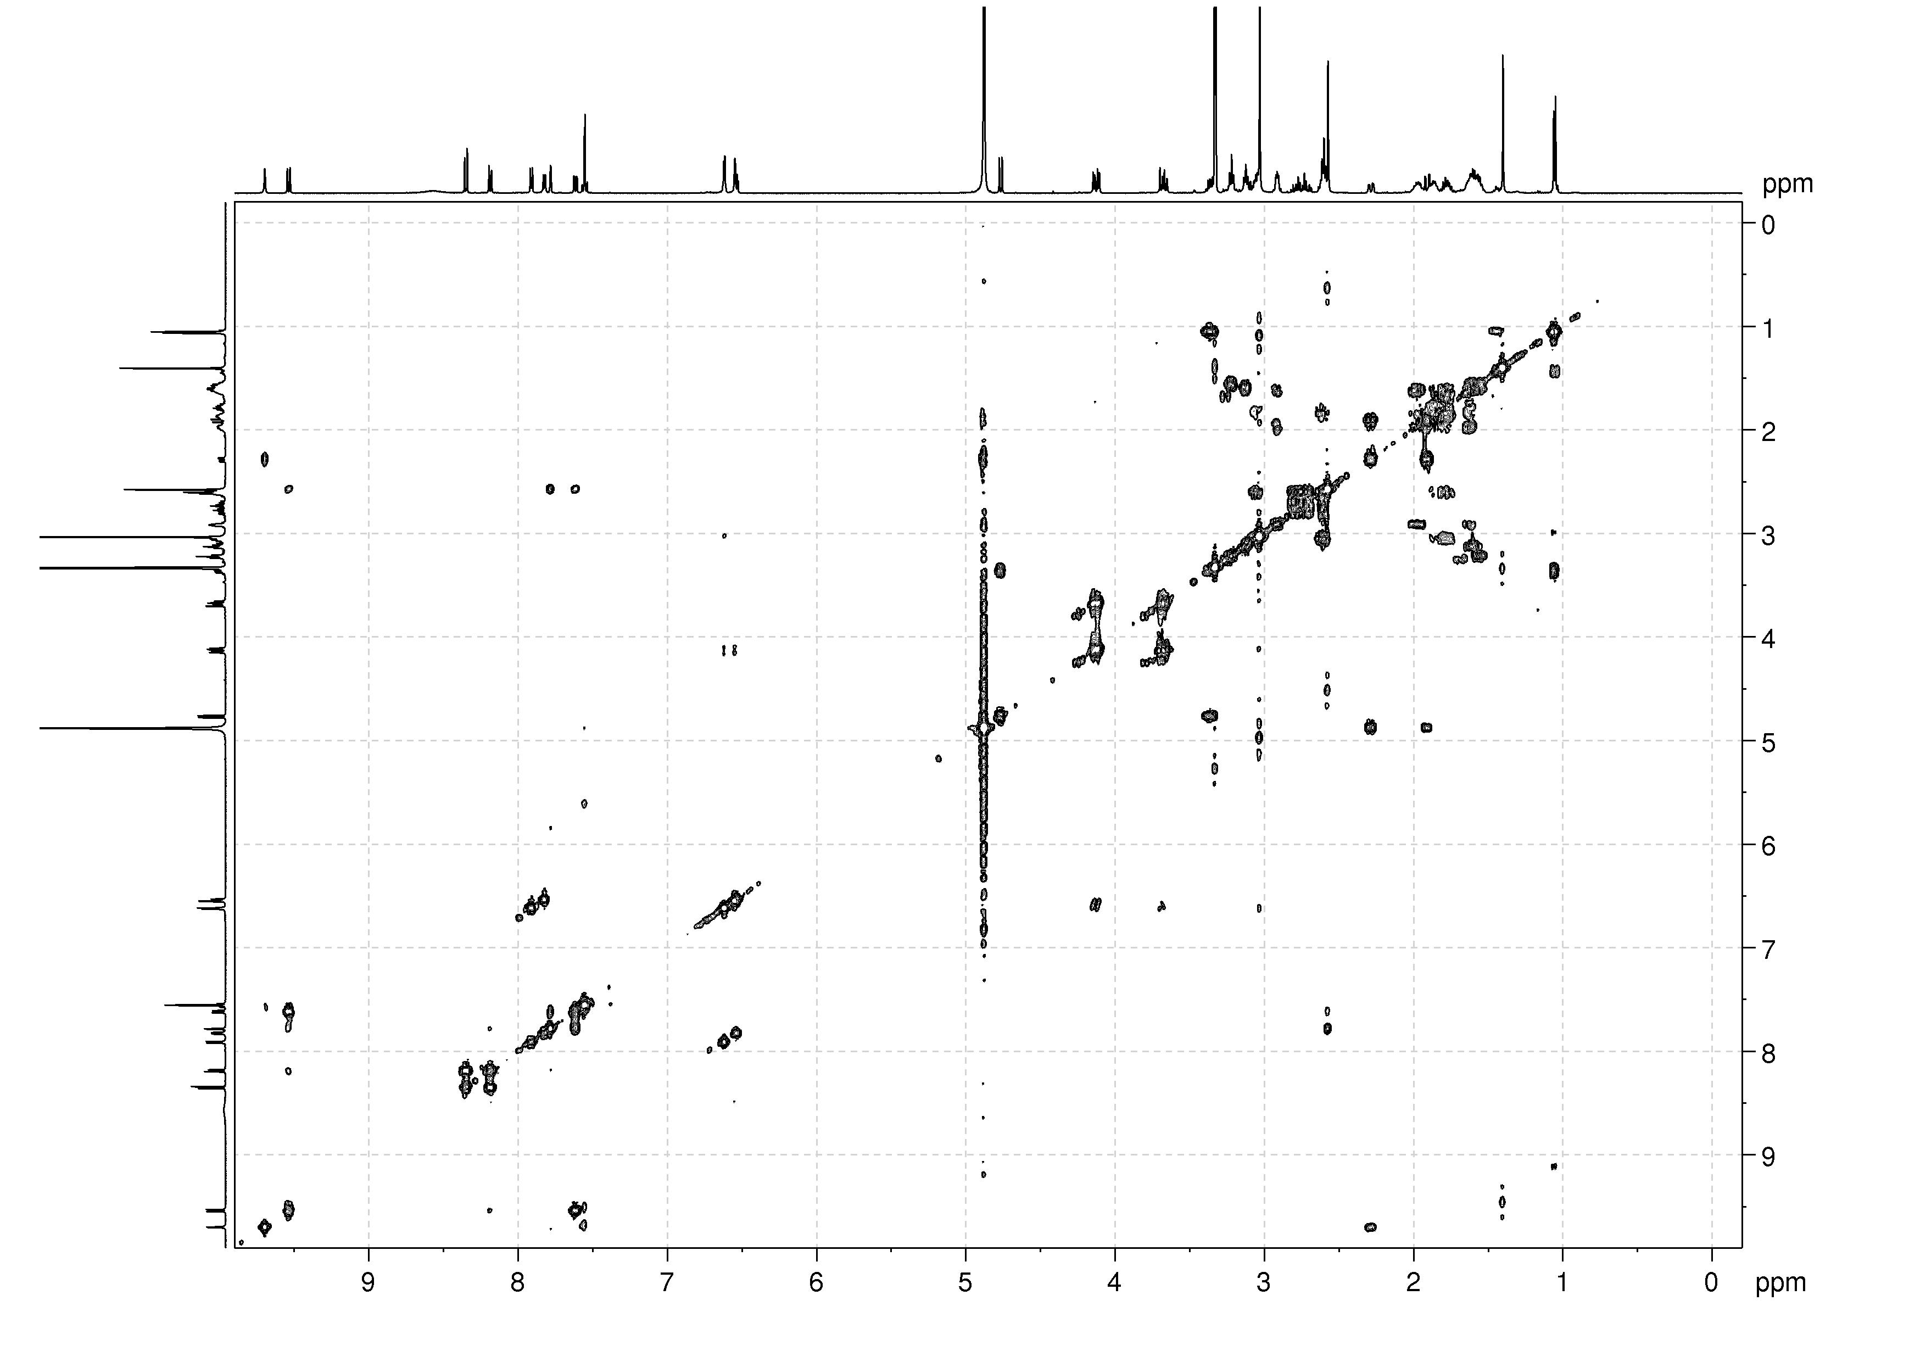
HSQC NMR spectrum of fentomycin, 39 in methanol-d₄
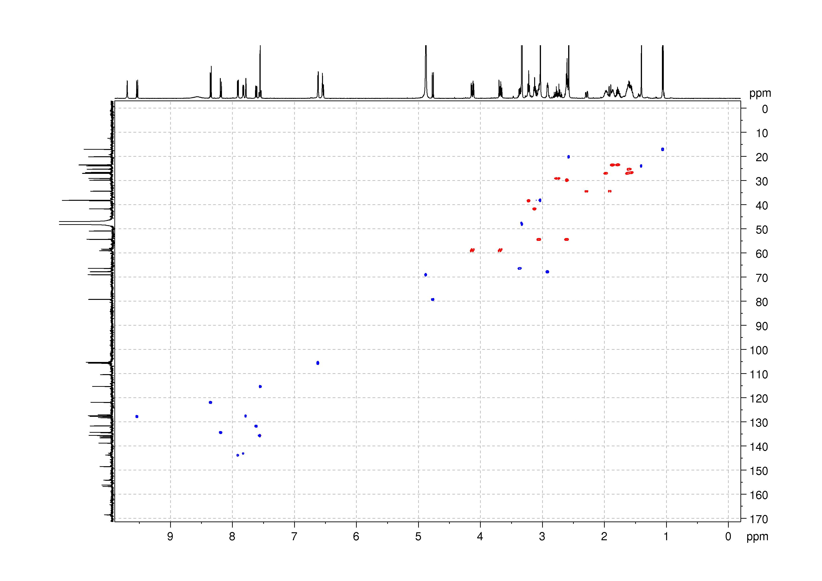
HMBC NMR spectrum of fentomycin, 39 in methanol-d₄
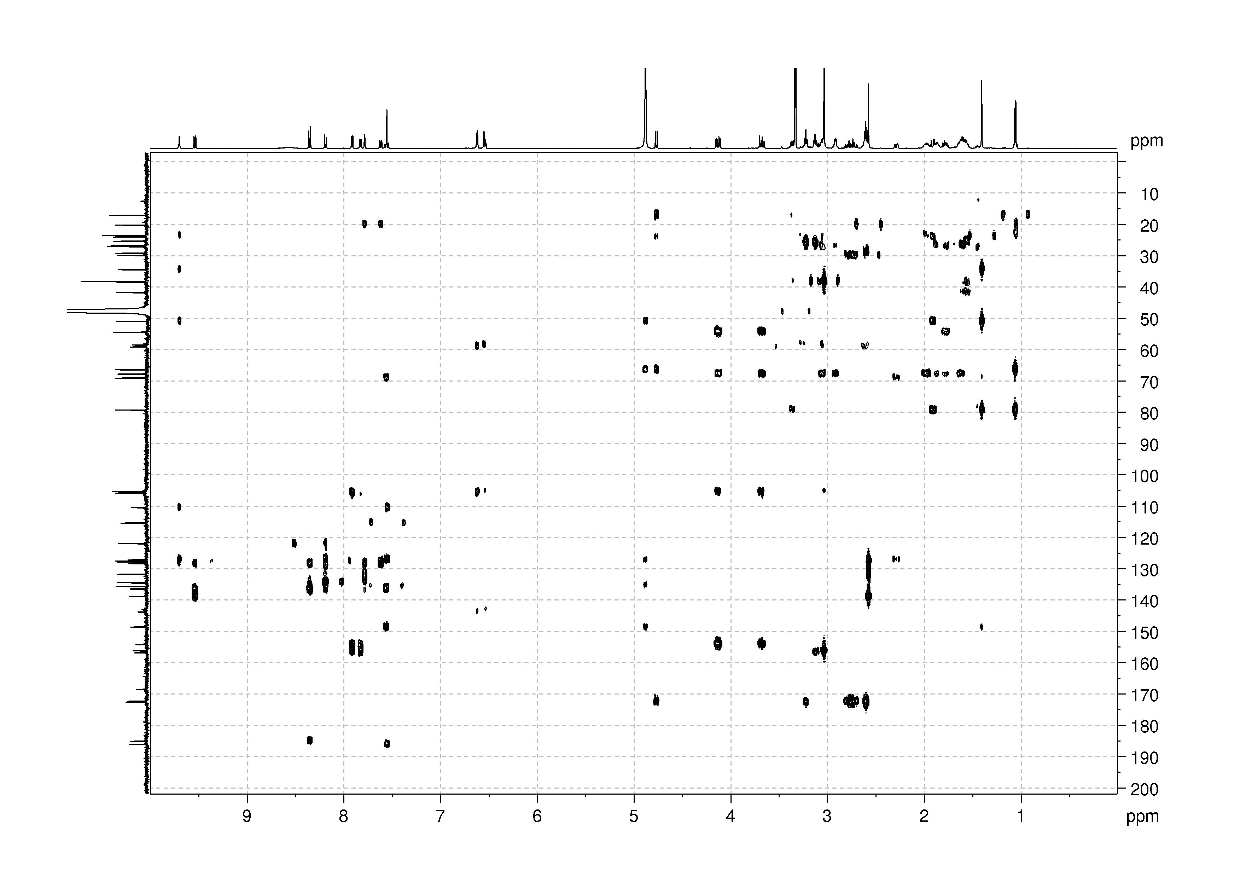
¹H NMR spectrum of 41 in methanol-d₄

¹³C NMR spectrum of 41 in methanol-d₄
¹H NMR spectrum of 42 in methanol-d₄

¹³C NMR spectrum of 42 in methanol-d₄
¹H NMR spectrum of cWhite-Chen ligand, 43 in methanol-d₄

¹³C NMR spectrum of cWhite-Chen ligand, 43 in methanol-d₄
HRMS spectrum of fentomycin

Absorption/Emission spectrum of fentomycin.

Spectroscopic measurements. The absorption of the samples was measured with a SpectraMax M2E Spectrometer (Molecular Devices). The emission was measured by irradiation of the sample in fluorescence quartz cuvettes (width 1 cm) in the wavelength range of 200-800 nm. Measurements were performed on the molecules dispersed in MeOH.

Fluorescence quantum yield measurements. For the determination of the fluorescence quantum yield, the samples were prepared in MeOH with an absorbance of 0.2 at 520 nm. This solution was irradiated in fluorescence quartz cuvettes (width 1 cm) on a SpectraMax M2E Spectrometer (Molecular Devices). The fluorescence quantum yields were determined by comparison with the reference Rhodamine in EtOH (Φ_{em} = 70%)⁵³ applying the following formula:
Φ_{fluo,sample} = Φ_{fluo.reference} × (F_{ref}/F_{sample}) × (I_{sample}/I_{ref}) × (n_{sample}/n_{ref})²
F= 1- 10^{-A}
Φ_{fluo} = fluorescence quantum yield, F = fraction of light absorbed, I = integrated emission intensities, n = refractive index, A = absorbance of the sample at the irradiation wavelength.

Photophysical characterisation of marmycin A and fentomycin in methanol

Compound | λ_{exc} (nm) | ε (L.mol⁻¹.cm⁻¹) | λ_{em} (nm) | ΦF
Marmycin A | 522 | 6456 | 650 | < 1%
Fentomycin | 516 | 2888 | 635 | 1%

+ 1 eq Fe²⁺
+ 5 eq Fe²⁺
+ 10 eq Fe²⁺
+ 1 eq Cu²⁺
+ 5 eq Cu²⁺
+ 10 eq Cu²⁺

