<Supplementary File>

Anti-inflammatory effect of Lactobacillus plantarum IDCC 3501 and its safety evaluation

Soo-Yeon Yang¹, Seung A Chae¹, Won Yeong Bang¹, O-Hyun Ban^{1,2}, Soo-Jung Kim³, Young Hoon Jung²*, Jungwoo Yang¹*

¹Ildong Bioscience, 17 Poseunggongdan-ro, Pyeongtaek-si, Gyeonggi-do, 17957, Republic of Korea
²School of Food Science and Biotechnology, Kyungpook National University, Daegu 41566, Republic of Korea
³Department of Integrative Food Bioscience and Biotechnology, Chonnam National University, Gwangju, 61186, Republic of Korea

Fig. S1. No hemolytic activity of L. plantarum IDCC 3501

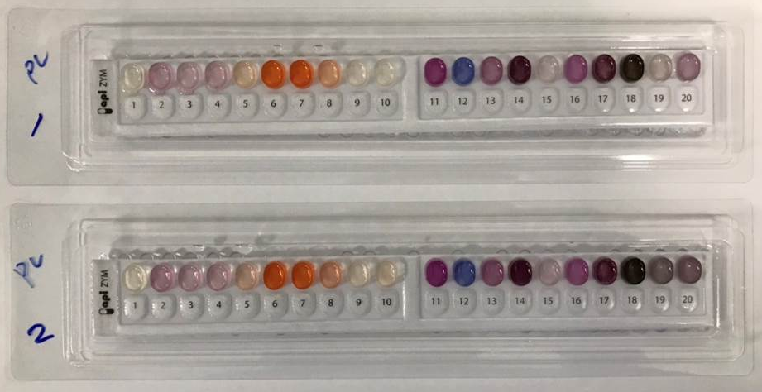

Fig. S2. Enzymatic activities of L. plantarum IDCC 3501 determined by API ZYM

Table S1. Primers used in this study
Gene |  | Sequence (5′ to 3′)
Cox2  iNOS  TNF-α  IL-1β  IL-6  GAPDH | Forward  Reverse  Forward  Reverse  Forward  Reverse  Forward  Reverse  Forward  Reverse  Forward  Reverse | CTGGTGCCTGGTCTGATGATGTATG  TCTCCTATGAGTATGAGTCTGCTGGTT  CAGCGGAGTGACGGCAAACAT  GCAAGACCAGAGGCAGCACATC  AACTAGTGGTGCCAGCCGAT  CTTCACAGAGCAATGACTCC  ACCTGGGCTGTCCTGATGAGAG  TGTTGATGTGCTGCTGCGAGAT  GTTCTCTGGGAAATCGTGGA  GGAAATTGGGGTAGGAAGGA  ACTCCACTCACGGCAAATTC  GTCATGAGCCCTTCCACAAT

