Supplementary material
Acquisition of Fc-afucosylation of PfEMP1-specific IgG is age-dependent and associated with clinical protection against malaria
Mary Lopez-Perez^{1*}, Zakaria Seidu^{1,2,3‡}, Mads Delbo Larsen^{4,5‡}, Jan Nouta⁶, Manfred Wuhrer⁶, Gestur Vidarsson^{4,5}, Michael F. Ofori², Lars Hviid^{1,7*}
¹Centre for translational Medicine and Parasitology, Department of Immunology and Microbiology, Faculty of Health and Medical Sciences, University of Copenhagen, Copenhagen, Denmark
²Department of Immunology, Noguchi Memorial Institute for Medical Research, College of Health Sciences, University of Ghana, Accra, Ghana
³West African Centre for Cell Biology of Infectious Pathogens, Department of Biochemistry, Cell and Molecular Biology, University of Ghana, Accra, Ghana
⁴Immunoglobulin Research Laboratory, Sanquin Research, Amsterdam, The Netherlands
⁵Department of Biomolecular Mass Spectrometry and Proteomics, Utrecht Institute for Pharmaceutical Sciences and Bijvoet Center for Biomolecular Research, Utrecht University, Utrecht, The Netherlands
⁶Center for Proteomics and Metabolomics, Leiden University Medical Center, Leiden, The Netherlands
⁷Department of Infectious Diseases, Rigshospitalet, Copenhagen, Denmark

Supplementary Figure S1. Fc-glycosylation pattern of HB3VAR06-specific IgG1 by infection and Hb phenotype.
(A) Glycoform abundance of HB3VAR06-specific IgG1 in PCR-negative (open symbols, n = 39) and -positive (closed symbols, n = 19) children. Medians and p values using Mann-Whitney test are shown. (B) Glycoform abundance of HB3VAR06-specific IgG1 in children with HbAA (n = 20), HbAS (n = 16), and HbAC (n = 22). Medians and p values using the Kruskal-Wallis test followed by Dunn's multiple comparisons test are shown. Average levels ± 2 SD of total plasma IgG1 of unexposed Dutch adults (n = 10) are included for comparison (shaded area).
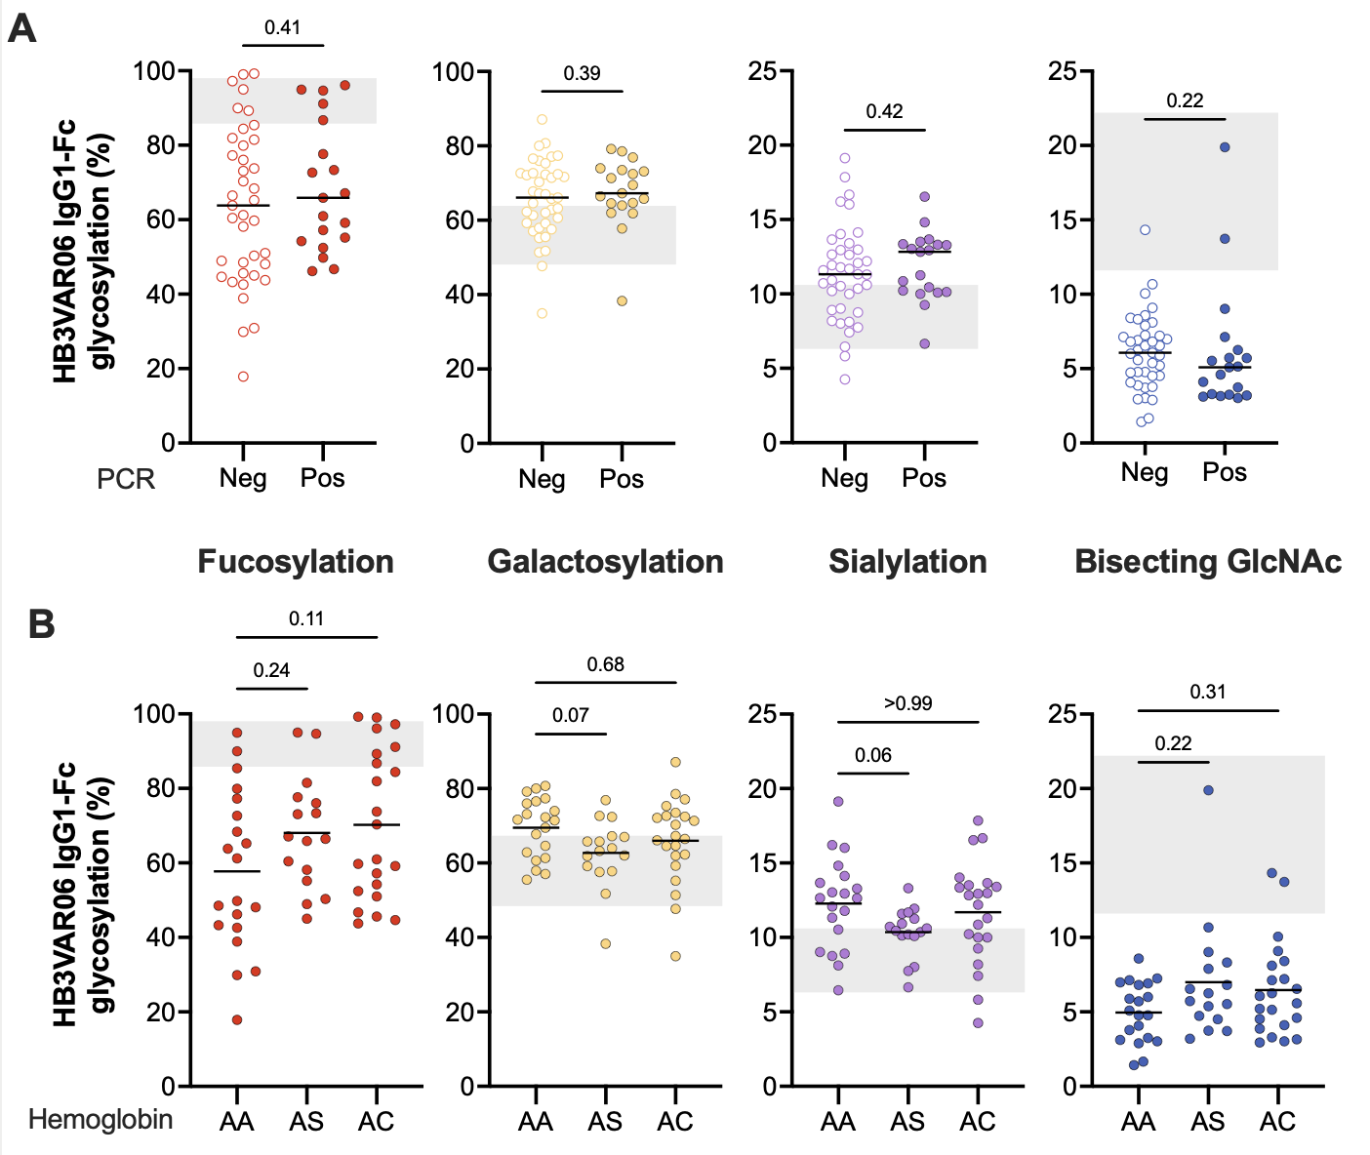

Supplementary Figure S2. Fc-glycosylation pattern of HB3VAR06-specific IgG3/4.
Glycoform abundance of total (n = 75), GLURP (n = 28), and HB3VAR06-specific (n = 75) IgG3/4 in children. Medians and p values using the Kruskal-Wallis test followed by Dunn's multiple comparisons test are shown. Average levels ± 2SD of total plasma IgG3 Fc-glycosylation in unexposed Dutch adults (n = 10) are included for comparison (shaded area).
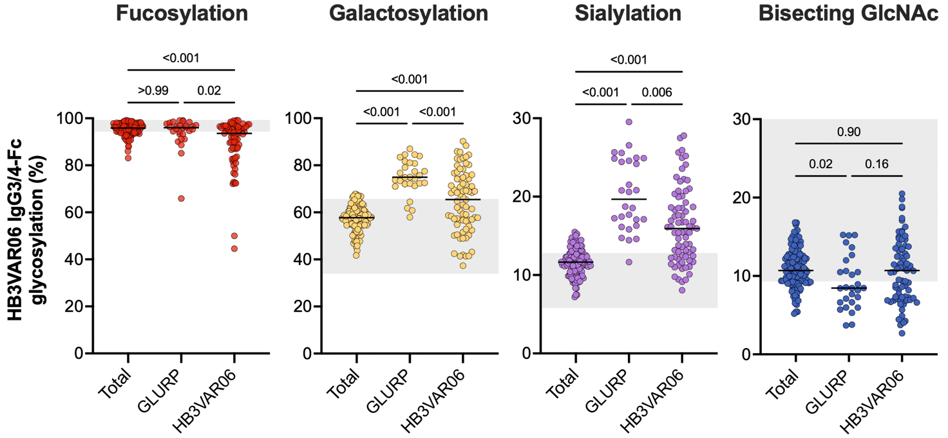

Supplementary Figure S3. Correlation among antibody features.
Correlation matrix plotted using levels for Spearman’s rank correlation (r_{s}) of antibody response to HB3VAR06. Positive correlations are displayed in blue and negative correlations are displayed in red (r_{s} color key). *Indicates a p-value < 0.05.
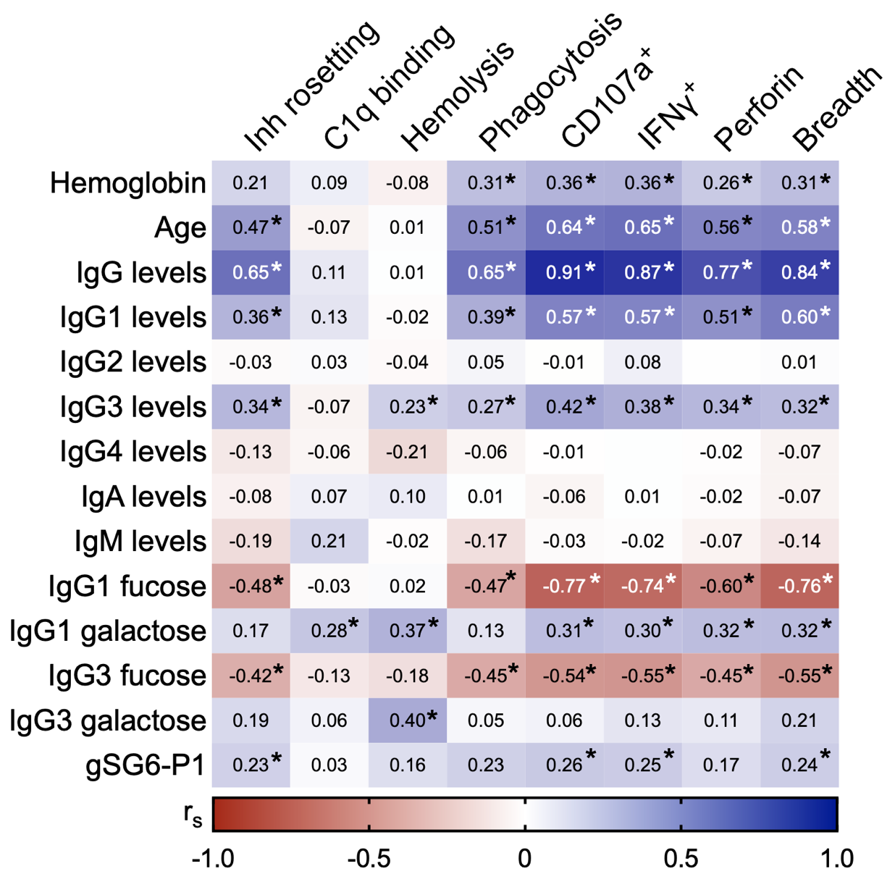

Supplementary Table 1. Demographic and clinical parameters of the studied population
Parameter | HbAA n = 40 |  | HbAS n = 40 |  | HbAC n = 40 |  | Total n = 120 | p valueª
Female | 16 (40%) |  | 12 (30%) |  | 14 (35%) |  | 42 (35%) | 0.64
Age | 6.5 [4-9] |  | 6 [4-9] |  | 6.5 [4-9] |  | 6 [4-9] | 0.99
PCR (positive) | 5 (13%) |  | 9 (23%) |  | 13 (33%) |  | 27 (23%) | 0.10
Hb (g/dL) | 10.9 [10.3-11.9] |  | 11.0 [10.0-11.6] |  | 10.8 [10.1-11.3] |  | 10.9 [10.2-11.6] | 0.60
P_{tot} | 1.9 × 10¹⁰ [1.1× 10⁸-4.3 × 10¹⁰] |  | 0.2× 10¹⁰ [3.6 × 10⁸ -0.9× 10¹⁰] |  | 1.0 × 10¹⁰ [11.2 × 10⁸ -3.9× 10¹⁰] |  | 0.6× 10¹⁰ [3.6 × 10⁸-2.8 × 10¹⁰] | 0.44
ªp value using Chi-square test for qualitative variables and Kruskal-Wallis test for quantitative variables. Hb, hemoglobin. P_{tot}, Total parasite biomass calculated from PfHRP2 plasma levels in 23 of the 27 children with P. falciparum infection. Interquartile ranges are presented in brackets.

Supplementary Table 2. Overview of included Fc glycopeptides, IgG1
N-Glycopeptide | [M+2H]²⁺ | [M+3H]³⁺ | Retention time (s)
IgG1 H3N4F1S0 [G0F] | 1317.526 | 878.687 | 67
IgG1 H4N4F1S0 [G1F] | 1398.552 | 932.704 | 65
IgG1 H5N4F1S0 [G2F] | 1479.579 | 986.722 | 64
IgG1 H3N5F1S0 [G0FN] | 1419.066 | 946.380 | 68
IgG1 H4N5F1S0 [G1FN] | 1500.092 | 1000.398 | 67
IgG1 H5N5F1S0 [G2FN] | 1581.119 | 1054.415 | 67
IgG1 H3N4F0S0 [G0] | 1244.497 | 830.001 | 70
IgG1 H4N4F0S0 [G1] | 1325.524 | 884.018 | 67
IgG1 H5N4F0S0 [G2] | 1406.550 | 938.036 | 66
IgG1 H4N4F1S1 [G1FS] | 1544.100 | 1029.736 | 65
IgG1 H5N4F1S1 [G2FS] | 1625.127 | 1083.754 | 63
IgG1 H5N4F0S1 [G2S] | 1552.098 | 1035.068 | 65
IgG1 H5N4F1S2 [G2FS2] | 1770.675 | 1180.786 | 62

Supplementary Table 3. Overview of included Fc glycopeptides, IgG3/4
N-Glycopeptide | [M+2H]²⁺ | [M+3H]³⁺ | Retention time (s)
IgG3/4 H3N4F1S0 [G0F] | 1309.529 | 873.355 | 109
IgG3/4 H4N4F1S0 [G1F] | 1390.556 | 927.373 | 107
IgG3/4 H5N4F1S0 [G2F] | 1471.582 | 981.390 | 106
IgG3/4 H3N5F1S0 [G0FN] | 1411.069 | 941.048 | 110
IgG3/4 H4N5F1S0 [G1FN] | 1492.095 | 995.066 | 108
IgG3/4 H5N5F1S0 [G2FN] | 1573.122 | 1049.084 | 107
IgG3/4 H4N4F0S0 [G1] | 1317.527 | 878.687 | 111
IgG3/4 H5N4F0S0 [G2] | 1398.553 | 932.704 | 108
IgG3/4 H4N4F1S1 [G1FS] | 1536.103 | 1024.405 | 107
IgG3/4 H5N4F1S1 [G2FS] | 1617.13 | 1078.422 | 105
IgG3/4 H5N4F0S1 [G2S] | 1544.101 | 1029.736 | 109

