Supplementary materials:

Patients who underwent hysterectomy whatever the approach at the Pitié-Salpêtrière University Hospital between 01/01/2016 and 21/12/2019
(N=380)

Patients excluded (N=169)
- Cancerology (N=21)
- Patients undergoing vaginal surgery (N=9)
- Patients undergoing open surgery (N=105)
- Main outcome missing (N=5)
- Subtotal hysterectomy (N=4)
- Patients not undergoing hysterectomy (N=3)
- Unoperated patients (N=3)
- Patient refusal (N=3)
- Hemostasis hysterectomy (N=1)
- Associated digestive resection (N=1)
- Uterine weight missing (N=1) or too large to be accessible by conventional laparoscopy (N=26)
- BMI and/or ASA missing (N=13)

Patients included (N=185)
- 99 patients in the robot-assited hysterectomy group
- 86 patients in the laparoscopic group

Fig S1 Flow chart of the study

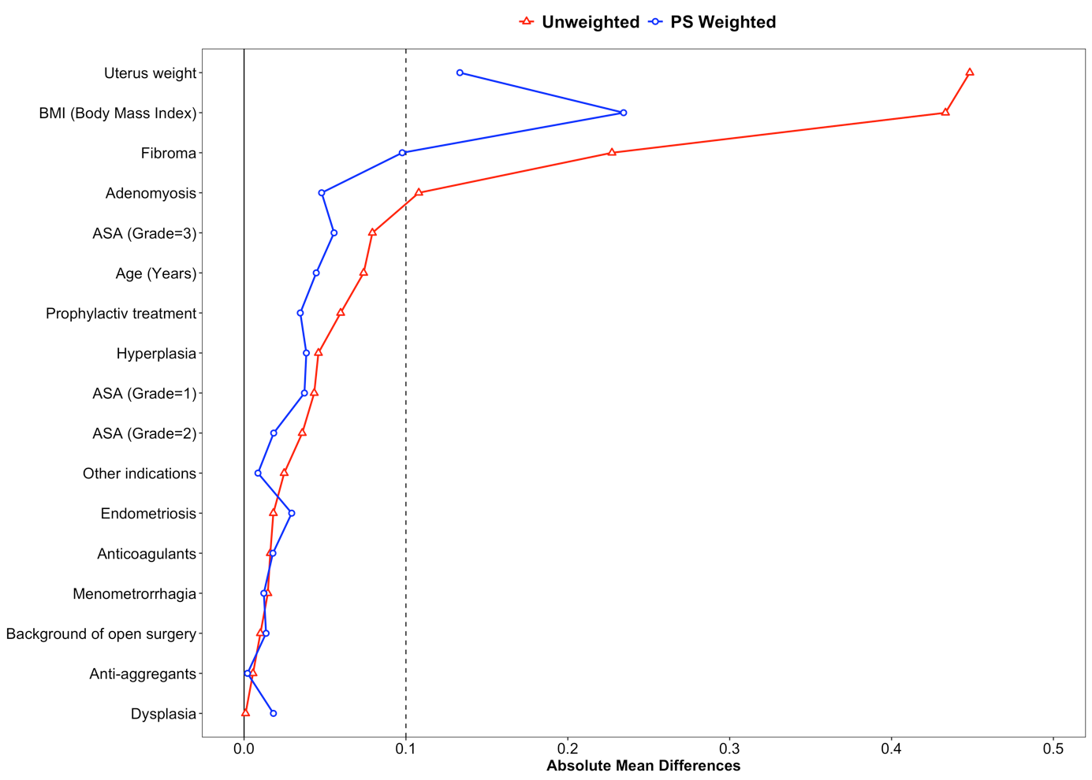
Fig S2 Standardized differences before and after propensity score weighted - Robot-assisted hysterectomy vs. laparoscopic hysterectomy

Table S1: Costs per unit in euros (€) of investments, maintenance and consumables used for each surgery.
 | Unit price
Robot-assisted hysterectomy
- Investment
- Da Vinci XI Dual Consol (surgical robot) | 2,760,000
- Mandrin robot 8 mm (UU) | 660
- Annual maintenance | 228,000
- Consumables
- Limited-use equipment
Fenestrated Bipolar Forceps | 204
Maryland Bipolar Forceps | 204
Large Needle Driver | 156
Large Suture Cut needle driver | 174
ProGrasp forceps | 132
Mega Suture Cut needle driver | 174
Mega needle driver | 264
Monopolar curved Scissors/ Hot Shears | 346
Pince Tenaculum | 264
Curved scissors | 171
Large clip applier | 15
Crochet monopolaire | 180
Cadiere forceps | 156
- Single-use equipment
Column Drape | 22
Arms drape | 62
Vessel Sealer Extend | 750
Gaine de protection | 24
5 mm - 8 mm cannula seal | 22
Suction irrigator | 36
Open hysterectomy
- Investment
- Standard box for open surgery | 5,148
- Maintenance | X
- Consumables
- Limited-use equipment | X
- Single-use equipment
LigaSure clamp | 318
Alexis spreaders | 48
Laparoscopic hysterectomy
- Investment
- HD video column | 45,000
- Bipolar classical generator | 10,000
- Standard box for laparoscopic surgery | 676,000
- Uterine manipulator box | 3,449
- Maintenance | X
- Consumables
- Limited-use equipment | X
- Single-use equipment
Ultra-cision stamp | 456
Hail bag | 2

Table S2. Patient characteristics after weighting – Robot-assisted hysterectomy vs. laparoscopic hysterectomy.
Mean (± standard deviation) or % | RAH  (n = 99) | LH  (n = 86)
Age, years | 47.52 (± 6.72) | 47.86 (±7.29)
BMI | 27.90 (± 6.57) | 26.45 (± 4.84)
Uterus weight, g | 249.63 (± 171.70) | 228.19 (± 158.60)
Anticoagulants | 2.64% | 4.42%
Anti-platelet | 3.21% | 3.00%
Adenomyosis | 28.26% | 33.05%
ASA 1 | 38.15% | 41.84%
ASA 2 | 55.32% | 57.19%
ASA 3 | 6.53% | 0.97%
Hyperplasia | 6.94% | 3.08%
Dysplasia | 7.52% | 5.69%
Prophylactic treatment | 1.27% | 4.74%
Fibroma | 69.96% | 60.27%
Menometrorrhagia | 1.33% | 2.55%
Other indications | 1.72% | 2.58%
History of open surgery | 1.36% | 0.00%
Endometriosis | 11.62% | 8.65%

RAH: robot-assisted hysterectomy, LH: laparoscopic hysterectomy, BMI: Body Mass Index, ASA: American Society of Anesthesiologists Physical Status Classification System

