SUPPLEMENTARY MATERIAL

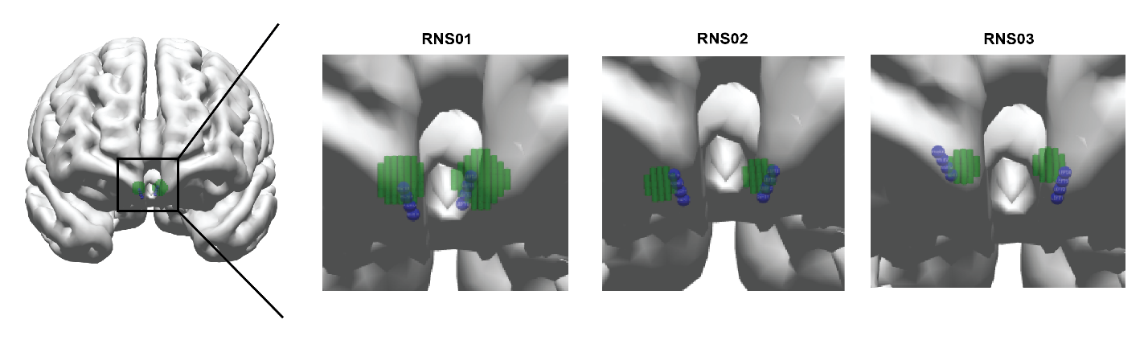
Supplemental Figure 1 | Final placement of responsive neurostimulator (RNS) electrodes RNS contacts are illustrated in the blue contacts in relation to the central median nuclei (green region of interest). Short 3.5 mm electrode spacing depth lead was used for the RNS electrodes in all 3 patients (2 mm electrode length, 1.5 mm inter-electrode distance)

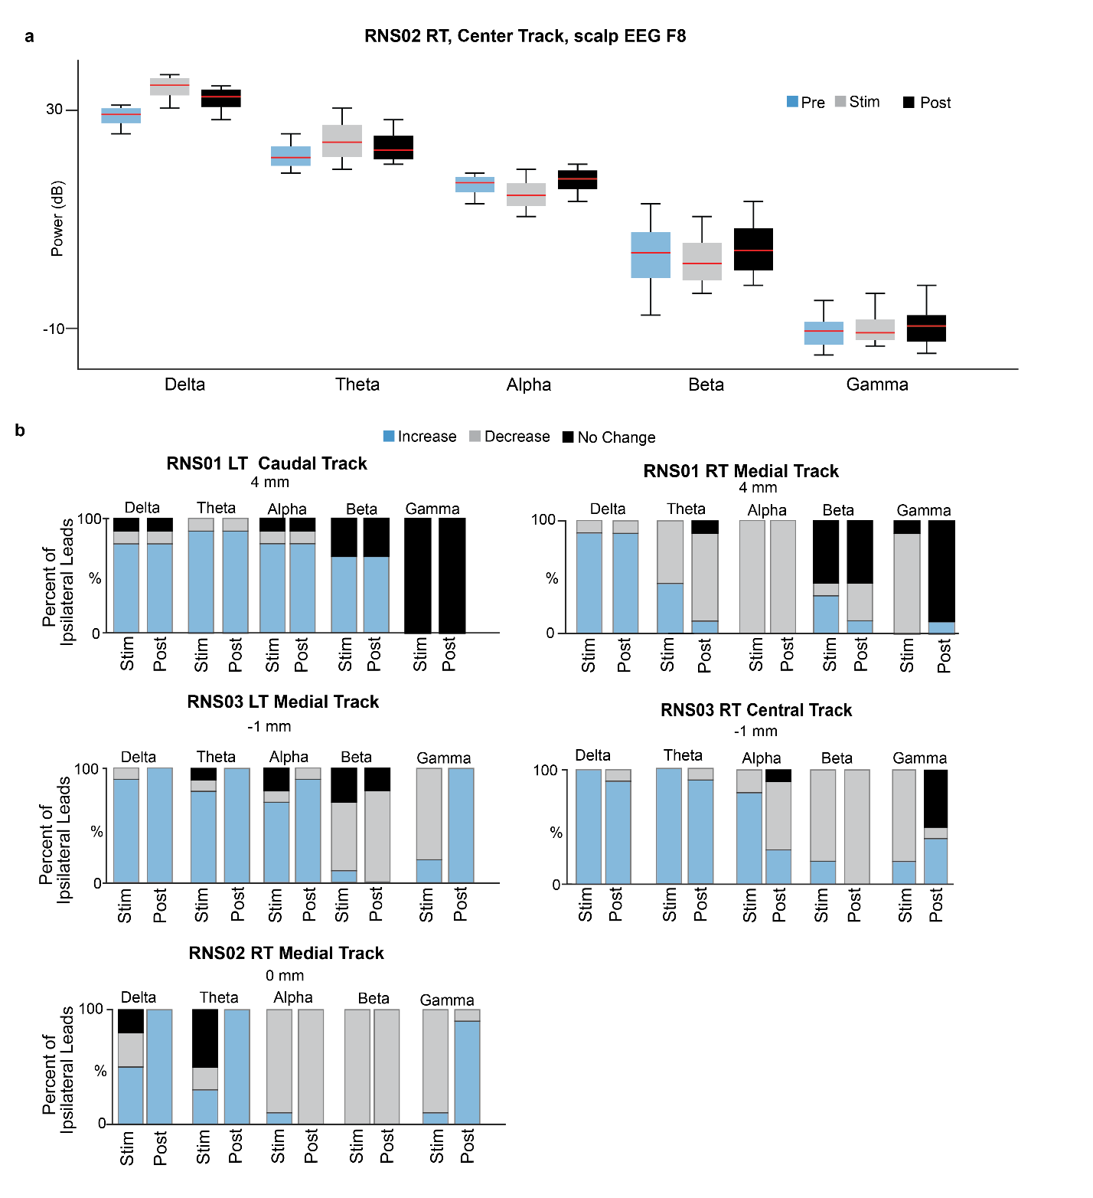
Supplemental Figure 2 | Potentiation Across Frequency Band and Ipsilateral Leads. A) Power of pre-stimulation (pre), stimulation (stim), and post-stimulation phases (post) across all frequency bands. B) The percentage of ipsilateral scalp EEG leads to a significant increase, decrease, or no change in delta, theta, alpha, beta, and gamma power in the depth of lower cell activity. We included both stimulation (stim) and post stimulation periods (post).

