SUPPLEMENTARY MATERIAL

Exploring the Trends in Sediment and Phosphorus Concentrations and Loads in Part of the Canadian Great Lakes Basin
Pranesh Kumar Paul¹, Anant Goswami¹, Ramesh Pall Rudra¹, Pradeep Kumar Goel², Prasad Daggupati^{1,*}

¹School of Engineering, University of Guelph, Guelph, ON N1G 2W1, Canada

²Ontario Ministry of the Environment, Conservation and Parks, Etobicoke, ON M9P 3V6, Canada

*Corresponding Author: Prasad Daggupati
Email: pdaggupa@uoguelph.ca

SM 1. Trends analysis in water quality
SM 1.1. Statistical models in water quality trend analysis

Trend analysis is used to determine whether the water quality variable measured values increase or decrease over a period. Based on the statistical definition, it helps to answer questions such as whether the probability distribution (e.g., mean or median) of the water quality variable data has changed over time. The amount or rate of change can be described simply using the change in central value such as a mean or median in the distribution (Hirsch & Slack, 1984; Hirsch et al., 1982).

The application of trend analysis to measure the impact on water-quality relies on the nature of the monitoring. Monotonic trend analysis is generally suitable that associate the dependent variable with an independent variable such as streamflow and time (Meals et al., 2011).

A variety of statistical tests are presented to recognize and analyze monotonic trends. Trend analysis in statistics is done using a hypothesis testing procedure. The null hypothesis (HO) states that there is no change in the dataset and the alternate hypothesis (Ha) is that there is a trend in the dataset. Failure in rejecting the null hypothesis (HO) is not a proof of no trend; it suggests that there is not enough evidence to assume that there is a trend with a certain degree of confidence. Many type of trend tests can be used over different circumstances considering the type of data distribution, adjustments for independent variables and to further account for seasonal effects (Meals et al., 2011). The type of data distribution further divides these tests into three classes: parametric, nonparametric, and mixed types. Parametric tests are mostly preferred for the dataset with a small number of samples to detect significant trends compared to nonparametric tests. However, it is usually recommended to use a non-parametric test unless the assumption of data to follow a normal distribution is met for the parametric test (Hirsch, 1991; Lettenmaier, 1976). Parametric and nonparametric tests assume that there is a constant variance in the dataset and the observations are independent. In the context of non-normality, nonparametric tests have greater statistical power and are resilient against outliers and longer gaps in the dataset (Meals et al., 2011). Some widely used tests for analyzing the trends in water quality constituents are shown in Table S1 (Hirsch et al., 1982).

These types of tests (Table 1) are widely used for analyzing the long-term trends in various water quality constituents. Stammler et al. (2017) analyzed the TP, SRP, alkalinity, chloride, and suspended sediment concentration trends over the period of 1979 to 2011 at 56 streams across Ontario over April to November period using Mann-Kendall test.

Table SM1 Statistical tests for water quality trend analysis.

Parametric tests | Nonparametric tests | Mixed-type test
A linear regression model considering time variable | Mann-Kendall test | Mann-Kendall test on residuals generated from a linear regression model
A multiple linear regression model considering time and additional seasonal variables | Seasonal Kendall test | Seasonal Kendall test on residuals generated from linear regression model
- | Mann-Kendall test on residuals generated from LOWESS | -
- | Seasonal Kendall test on residuals from LOWESS | -

Table SM2 Literatures used trend analysis for nutrient loss assessment in Canada

Author | Study Area | Nutrient (s) | Data Period | Trend Analysis | Type of Test
Yates et al. (2022) | Lake Winnipeg Basin | TN, TP and TSS Concentration and load | 1996–2016 | WRTDS_BT | Parametric
Debues et al. (2019) | over twelve tributaries in Lake Ontario | total phosphorus and nitrate nitrogen (NO3-N) concentration | 1971- 2010 | Kruskal-Wallis test | Non-parametric
Morales-Marín et al. (2017) | 18 long-term stream  monitoring sites of South Saskatchewan River catchment | TP and TN  load | Variable periods | multiplicative seasonal autoregressive integrated moving average  (ARIMA) model | Parametric
Stammler et al. (2017) | 56 streams across Ontario | TP, SRP, alkalinity, chloride, and suspended sediment concentration | 1979 to 2011 over April to November period | Mann-Kendall test
Bittman et al. (2016) | six major Eastern Lake Huron watersheds | TSS, TP, and NO3-N concentration and loads | 2011-2015 | Parametric test for normally distributed data and non-parametric Mann-Kendall test for non-normally distributed data | Both parametric test and non-parametric test
Rock and Mayer (2004) | Nine sites of Oldman River basin, southern Alberta | concentration and isotopic composition of nitrate sources | December  2000 to March 2001 | Sampling
Taylor and Hamilton (1993) | Nine sites of Saskatchewan River Basin | Total solute concentration | 1966-1984 | Moving averages and linear and sine curve regressions

SM 1.2. Major features of WRTDS
- It can detect and describe temporal trends that may not conform
- to linear or quadratic functional forms.
- It is suitable for use with irregularly spaced data.
- It does not assume that the discharge versus concentration
- relationship has the same shape throughout the period of
- record.
- It does not assume that the concentration residuals are
- homoscedastic.
- It does not assume that the seasonal pattern remains the same
- over the period of record.
- It can assess both concentrations and fluxes, recognizing that
- the trends in each of these measures of water quality can be
- quite different and even of different sign.
- It can not only provide estimates of the time series of annual
- mean concentrations and fluxes, but also time series of “flow normalized (FN)” mean concentrations and fluxes which integrate
- over the probability distribution of discharge to remove the
- effect of interannual streamflow variability.

SM 1.3. How Bootstrap improves WRTDS as WRTDS_BT
We use a bootstrap (Diaconis and Efron, 1983; Efron and Tibshirani, 1994) procedure to provide complimentary uncertainty information along with the graphical and numerical outputs already provided by the WRTDS method. We call this the WRTDS Bootstrap Test (WBT). The bootstrap procedure used here is a new type of block bootstrap designed to account for the influence of serial correlation on the test results without attempting to explicitly model the correlation structure. Modeling the serial correlation of these kinds of water quality data sets can be very problematic given the relatively sparse and often irregular sampling that is common to such data sets. The block bootstrap approach introduced here approximately preserves the serial correlation for lags on the order of weeks to months and thus achieves Type I error rates that are relatively close to the nominal Type I error rate.

The block bootstrap approach is evaluated using a set of Monte Carlo simulations to estimate the Type I error probability (probability of detecting a trend when a trend was not present) as compared to the nominal significance level for this method under the null hypothesis that water quality conditions have not changed over the period of analysis.

Type II error (the probability that a trend is present but not detected), although of great importance, was not evaluated here because of the multitude of different possible manifestations of departures from the null hypothesis that are possible. These include different rates of change, step functions versus ramp functions, and trends driven by point source changes versus those driven by non-point sources.
WRTDS is designed to be sensitive to a variety of different types of trend scenarios, whereas most of the more common types of trend tests assume a simple and rather rigid model of the trend.
Thus, it is reasonable to assume that the WRTDS method will have an advantage in terms of Type II errors for a wide range of trend scenarios,

But some disadvantages when the trend scenario postulated adheres closely to the assumptions around which other tests were designed.

The wide range of trend scenarios would add greatly to the complexity of this study and may not be very illuminating.

Hence the WBT uses some novel approaches to maximize computational speed. An important aim of this paper is to demonstrate (through Monte Carlo testing) that these approaches do not significantly compromise the validity of the test.

SM 2. Data Details

Table SM3 Landuse types across the three major basins in southern Ontario (Land Information Ontario, 2016).
Basin | Landuse type (%)
Basin | Agriculture | Forest | Pasture | Water | Residential | Range-grasses
Northern Lake Erie | 61 | 13 | 14 | 0.5 | 7.9 | 0.5
Eastern Lake Huron | 43 | 25 | 23 | 0.6 | 3.6 | 0.6
Lake Ontario and Niagara Peninsula | 12.5 | 40 | 15 | 4.8 | 12 | 7.1

SM 2.1. Data
This study mainly focused on analyzing trends of two water quality constituents that have a considerable relationship with streamflow (i.e., total suspended solids (TSS) and total phosphorus (TP)). Flow data were obtained from the Hydrometric database (HYDAT) operated by the Water Survey of Canada under the Environment and Climate Change Canada. The data is published in HYDAT (https://wateroffice.ec.gc.ca/search/historical_e.html) database includes daily observations of TSS and streamflow across several monitoring stations across Ontario. Ten HYDAT stations were selected for the study based on spatio-temporal coverage and available continuous streamflow dataset. TSS and TP data were obtained from the near by Provincial Water Quality Monitoring Network (PWQMN) database (https://www.ontario.ca/environment-and-energy/map-provincial-stream-water-quality-monitoring-network). Ten TSS and TP stations were selected for the study based on the nearest position of them comparing to HYDAT monitoring stations (Table SM4 and Figure 1). The monitoring stations are distributed across all three watersheds with a variable drainage area (Figure 1).

Table SM4 Description of TSS and TP sampling stations for trend analysis.

No | HYDAT Station for Streamflow Data (Name) | HYDAT Station for Streamflow Data (Name) | Longitude | Latitude | PWQMN Station No | PWQMN Station Name | Longitude | Latitude | Basin | Monitoring Period
1 | 02HC003 | HUMBER RIVER AT WESTON | -79.5204 | 43.6989 | 6008301902 | Humber River at Old Mill Rd, Etobicoke | -79.4913 | 43.65144 | Lake Ontario basin | 1979-2019
2 | 02HC024 | DON RIVER AT TODMORDEN | -79.3615 | 43.6859 | 6008501402 | Don River at Pottery Rd, Toronto | -79.3621 | 43.68847 | Lake Ontario basin | 1979-2019
3 | 02GE003 | THAMES RIVER AT THAMESVILLE | -81.9673 | 42.5449 | 4001305802 | White Ash Creek at Magnavilla Line, S. Of Thamesville | -81.9632 | 42.54025 | Norther n Lake Erie basin | 1976-2019
4 | 02GC026 | BIG OTTER CREEK NEAR CALTON | -80.8408 | 42.7107 | 16010900802 | Big Otter Creek at Calton Ln, Calton | -80.8402 | 42.71095 | Norther n Lake Erie Basin | 2002-2019
5 | 02GG003 | SYDENHAM RIVER AT FLORENCE | -82.0084 | 42.6506 | 4002701602 | Sydenham River at Lambton Ln, Florence | -82.0088 | 42.65068 | Norther n Lake Erie Basin | 2002-2019
6 | 02GD021 | THAMES RIVER AT INNERKIP | -80.6919 | 43.2153 | 4001308002 | Thames River at S. Thames Rvr, Oxford Co.Rd. 29, Innerkip | -80.6916 | 43.21543 | Norther n Lake Erie Basin | 1988-2019
7 | 02GC007 | BIG CREEK NEAR WALSINGHAM | -80.5385 | 42.6856 | 16012401102 | Big Creek at Conc 7, W. Of Hwy 59, Nw Of Walsingham | -80.5384 | 42.68583 | Norther n Lake Erie Basin | 2002-2019
8 | 02FC001 | SAUGEEN RIVER NEAR PORT ELGIN | -81.3264 | 44.4565 | 8012303002 | Saugeen River at Bruce Cnty Rd 3, N. Of Burgoyne | -81.326 | 44.4561 | Lake Huron basin | 2002-2019
9 | 02FF002 | AUSABLE RIVER NEAR SPRINGBANK | -81.6598 | 43.0719 | 800220202 | Ausable River at Springbank Rd, N. Of Springbank | -81.6603 | 43.07237 | Lake Huron basin | 2003-2019
10 | 02ED003 | NOTTAWASAGA RIVER NEAR BAXTER | -79.8214 | 44.2498 | 3005702902 | Nottawasaga River at Simcoe Cnty Rd 21, Murphy Rd, | -79.8216 | 44.24946 | Lake Huron basin | 2002-2019

SM 2.2. Flow duration curve with water quality samples for different flow conditions

Flow duration curve with water quality samples (Sediment and Phosphorous), for different flow conditions, are plotted with inspiration from Fig. 3 of van Driezem et al. (2019). Flow conditions are separated depending on the probability of exceedance (PE).
High flow: PE ≤ 5; Medium-high flow: 5 < PE ≤ 25; Medium flow: 25 < PE ≤ 75; Medium low flow: 75 < PE ≤ 95; low flow: 95 < PE.

SM 2.2.1. Flow duration curve with sediment samples for different flow condition

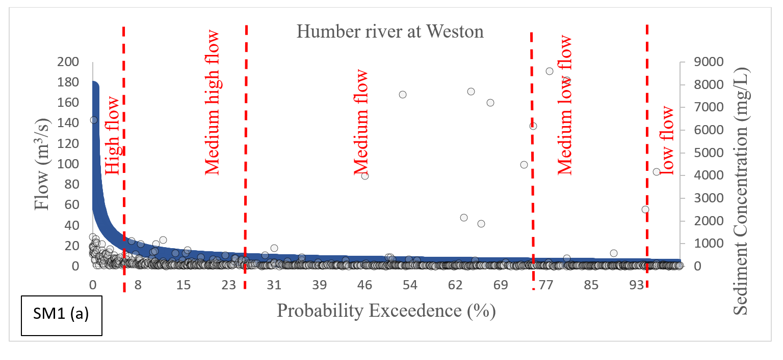
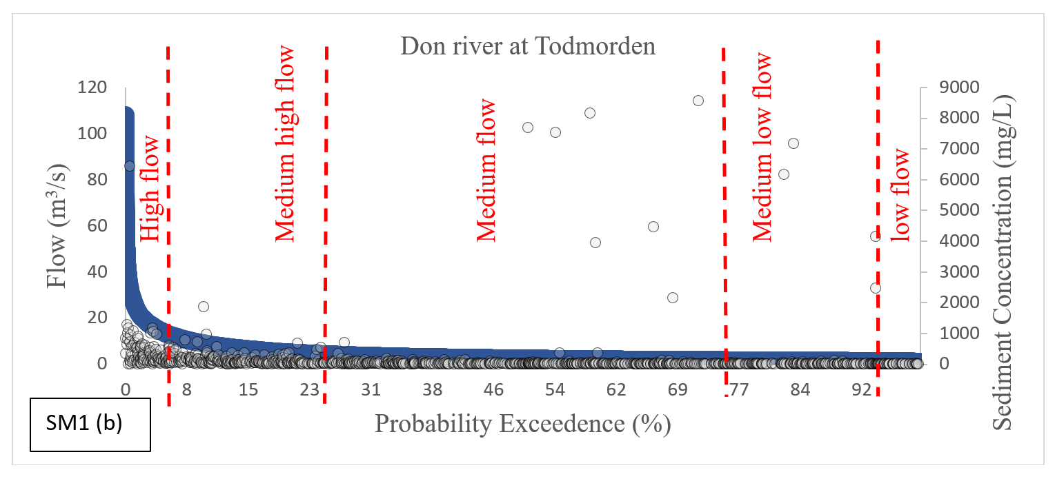

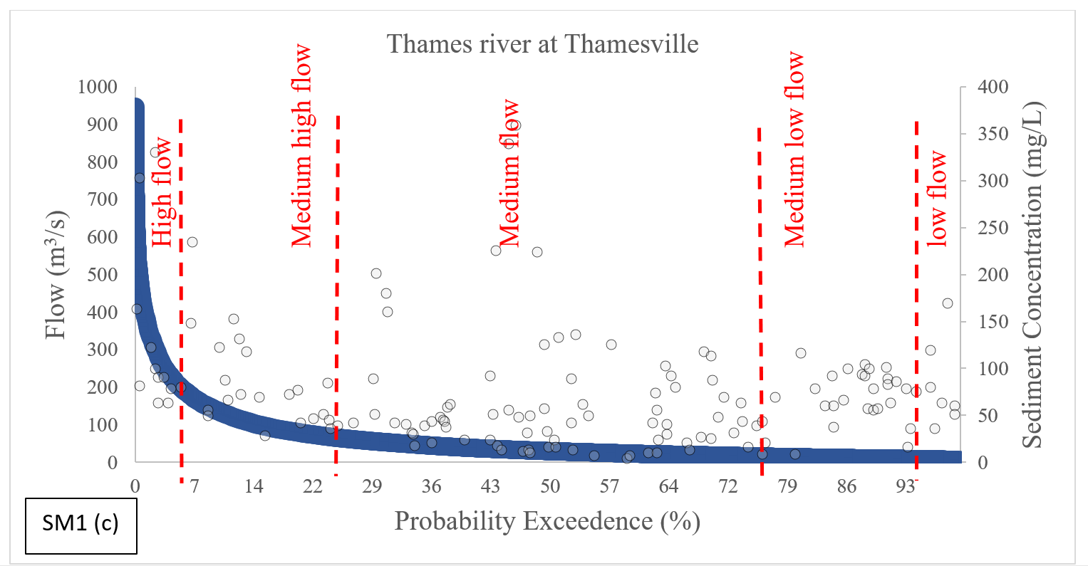

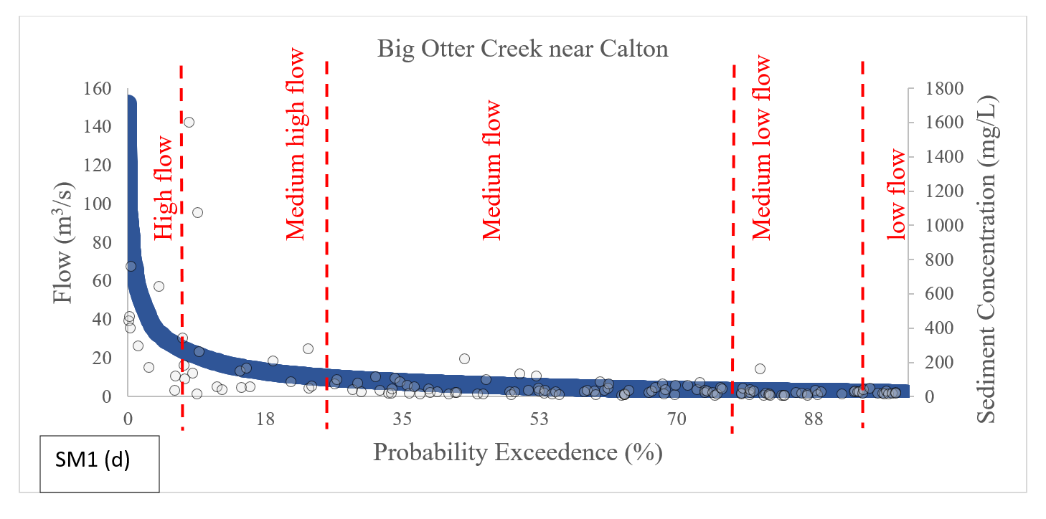

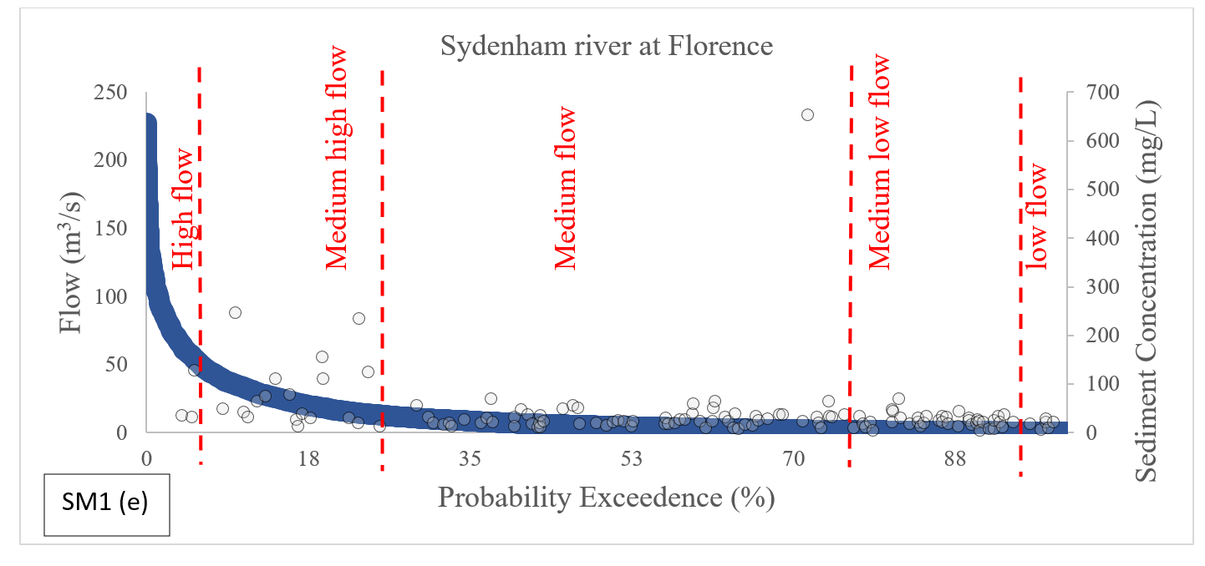

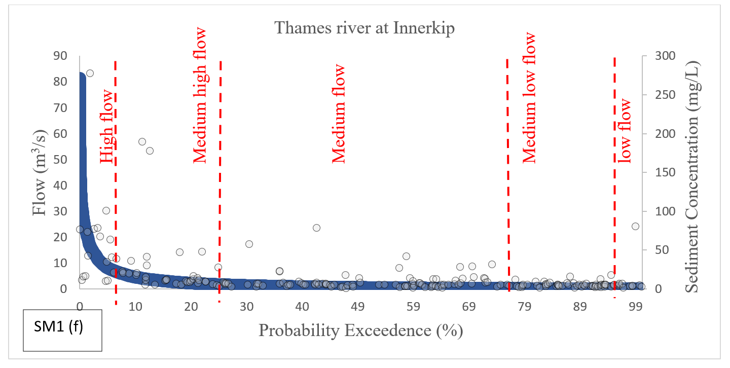

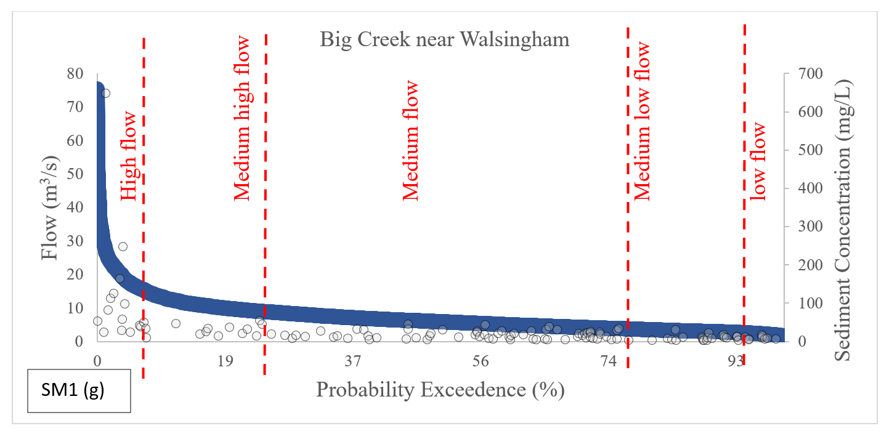

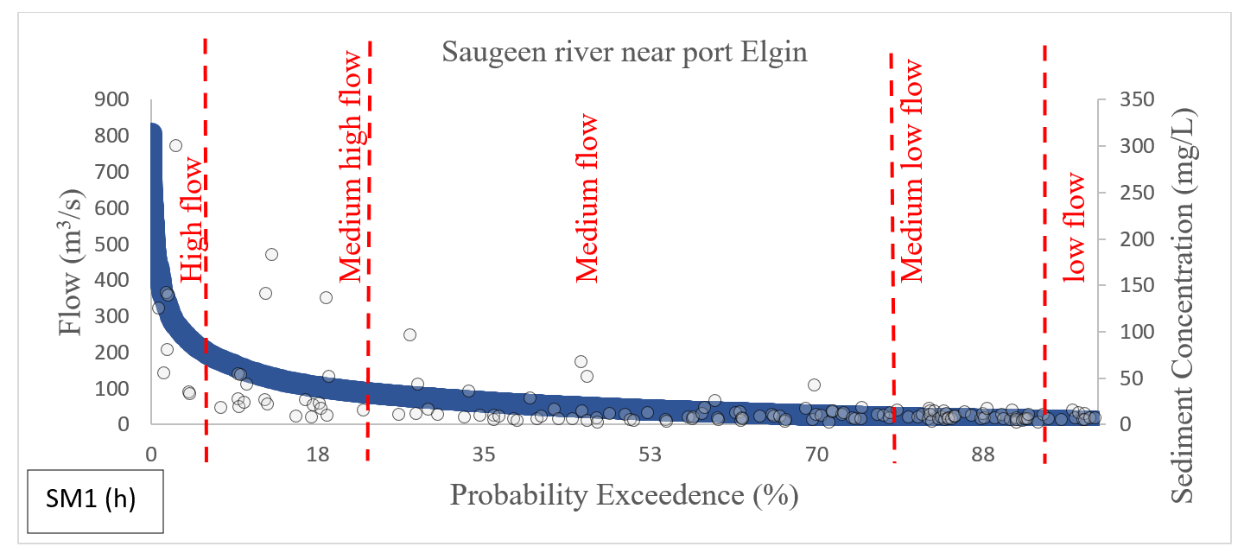

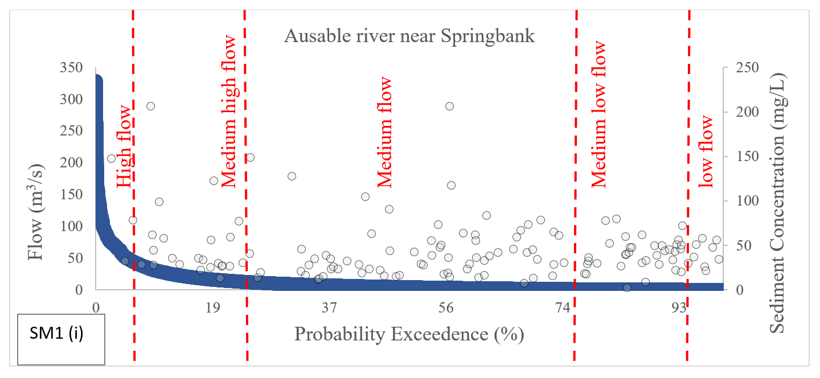

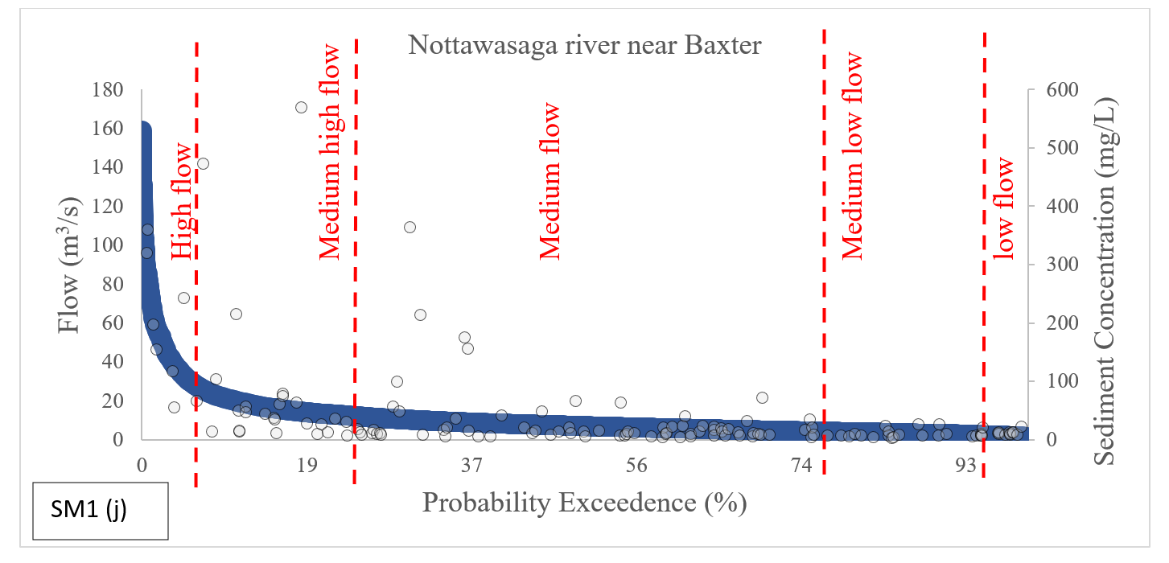

SM 2.2.2. Flow duration curve with phosphorous samples for different flow conditions

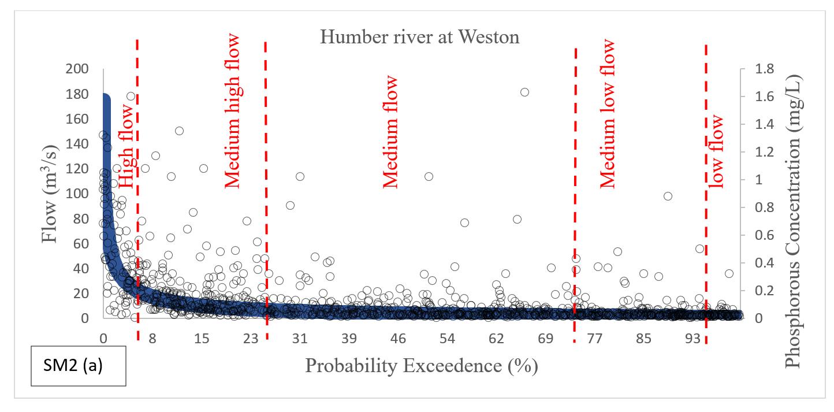

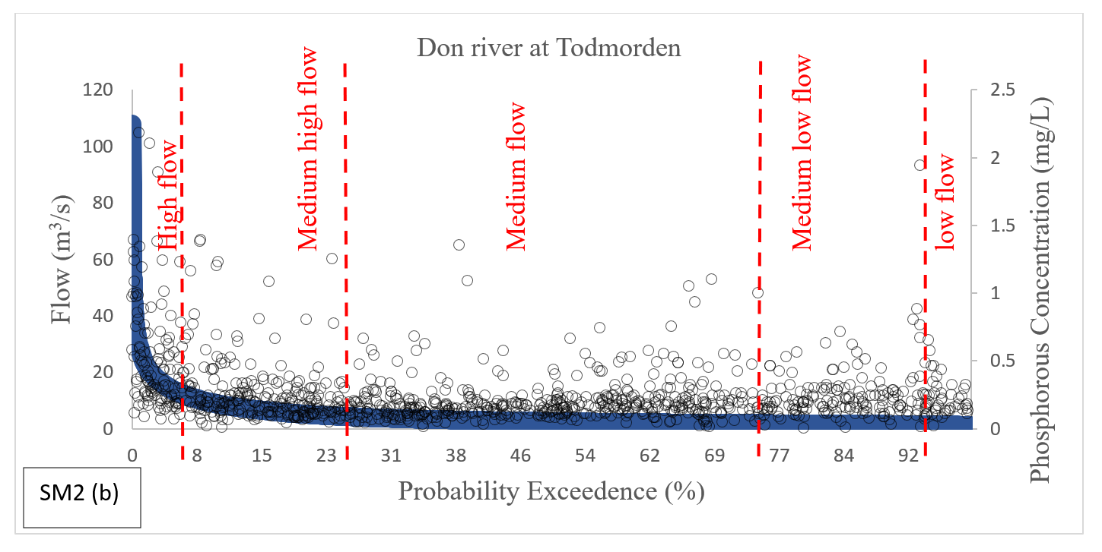

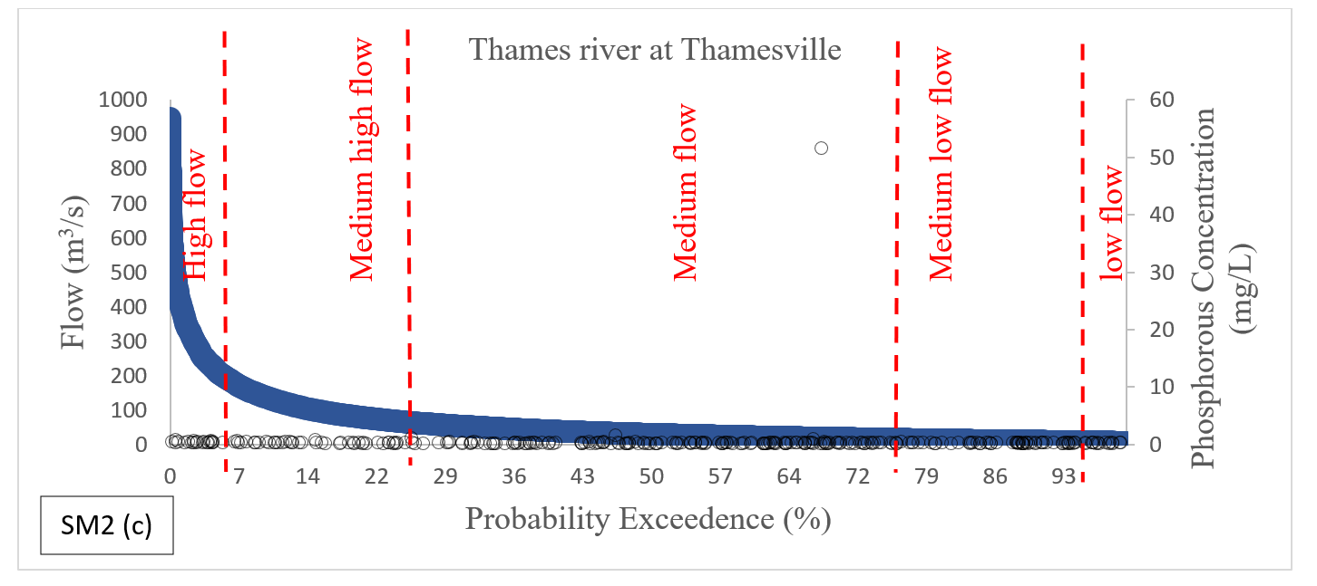

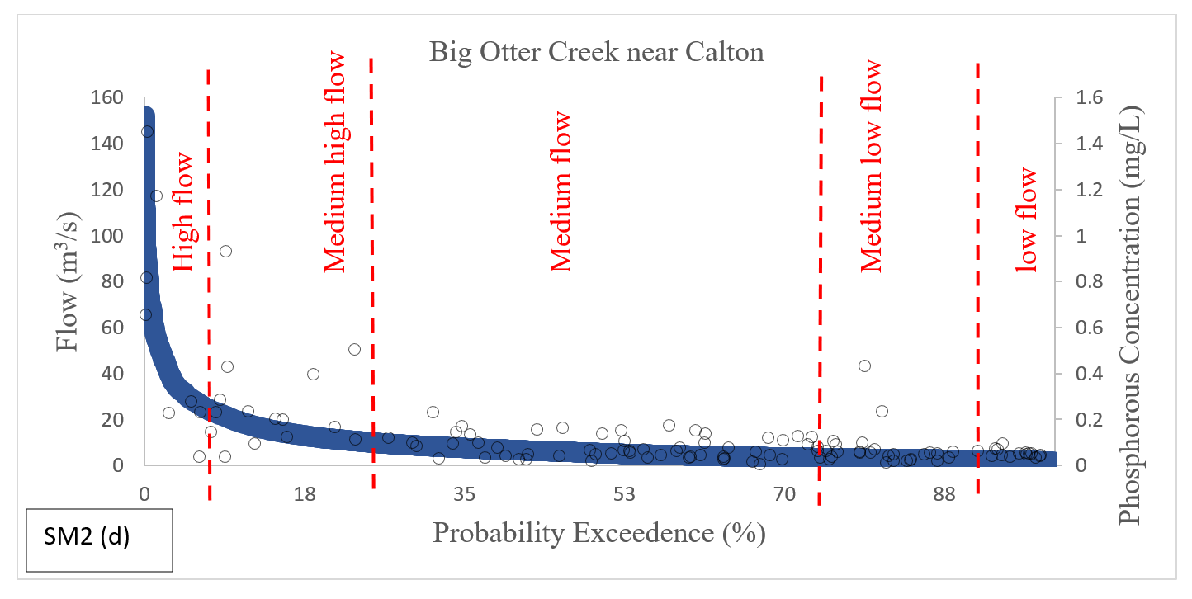

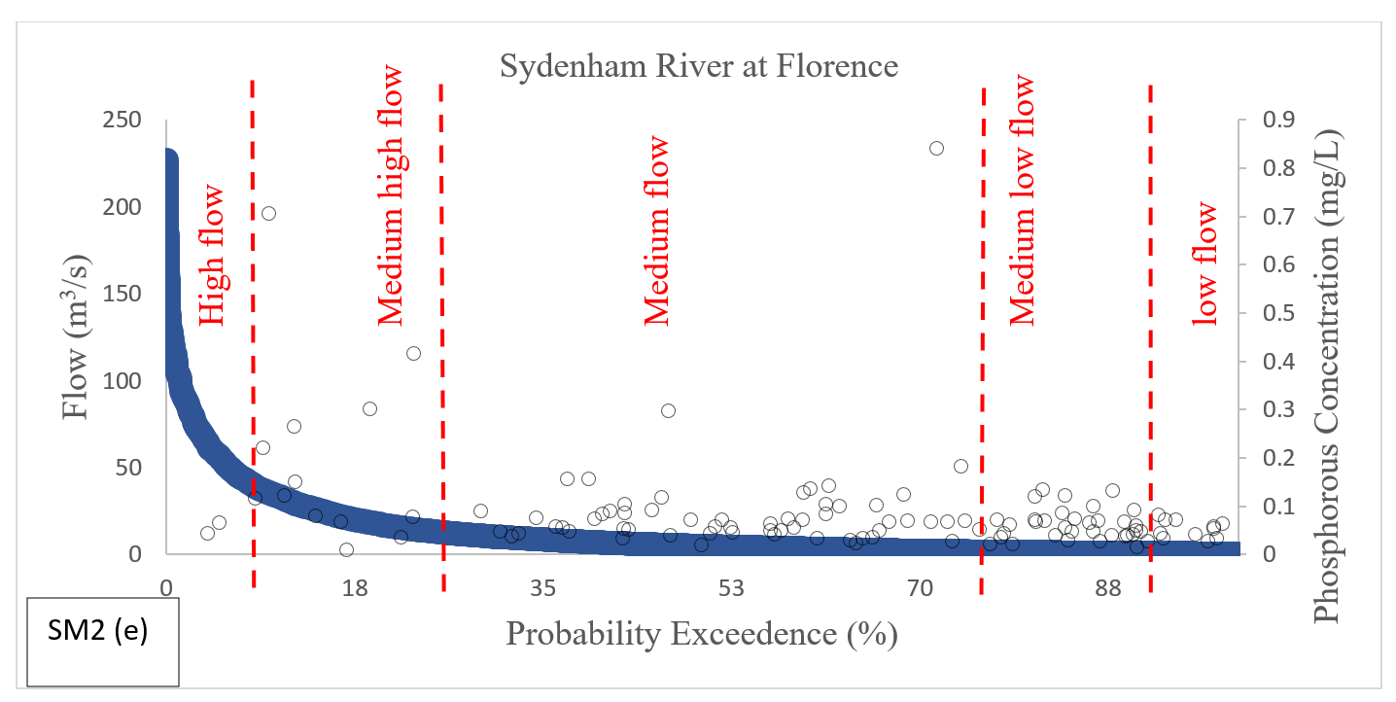

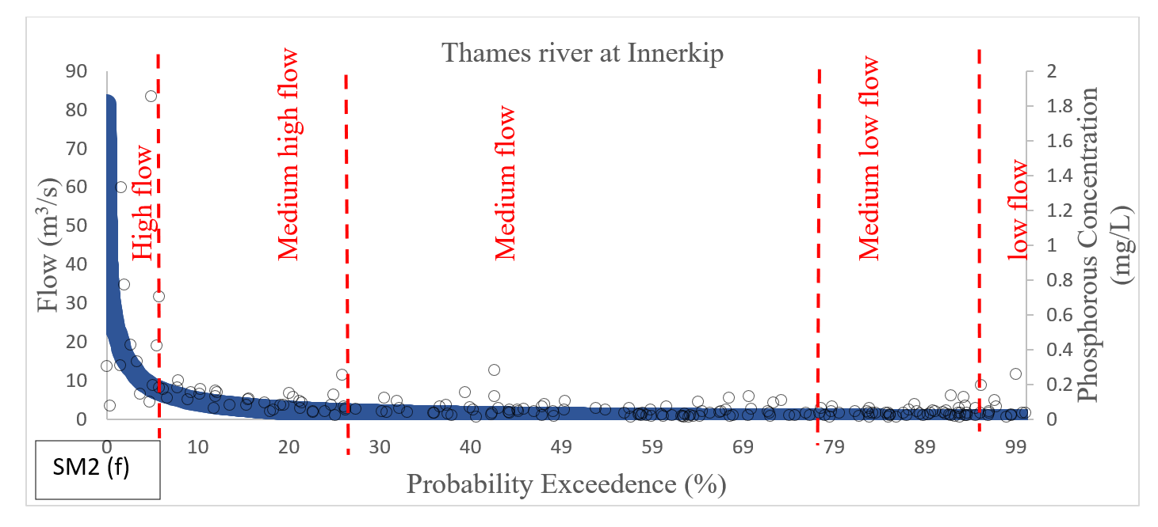

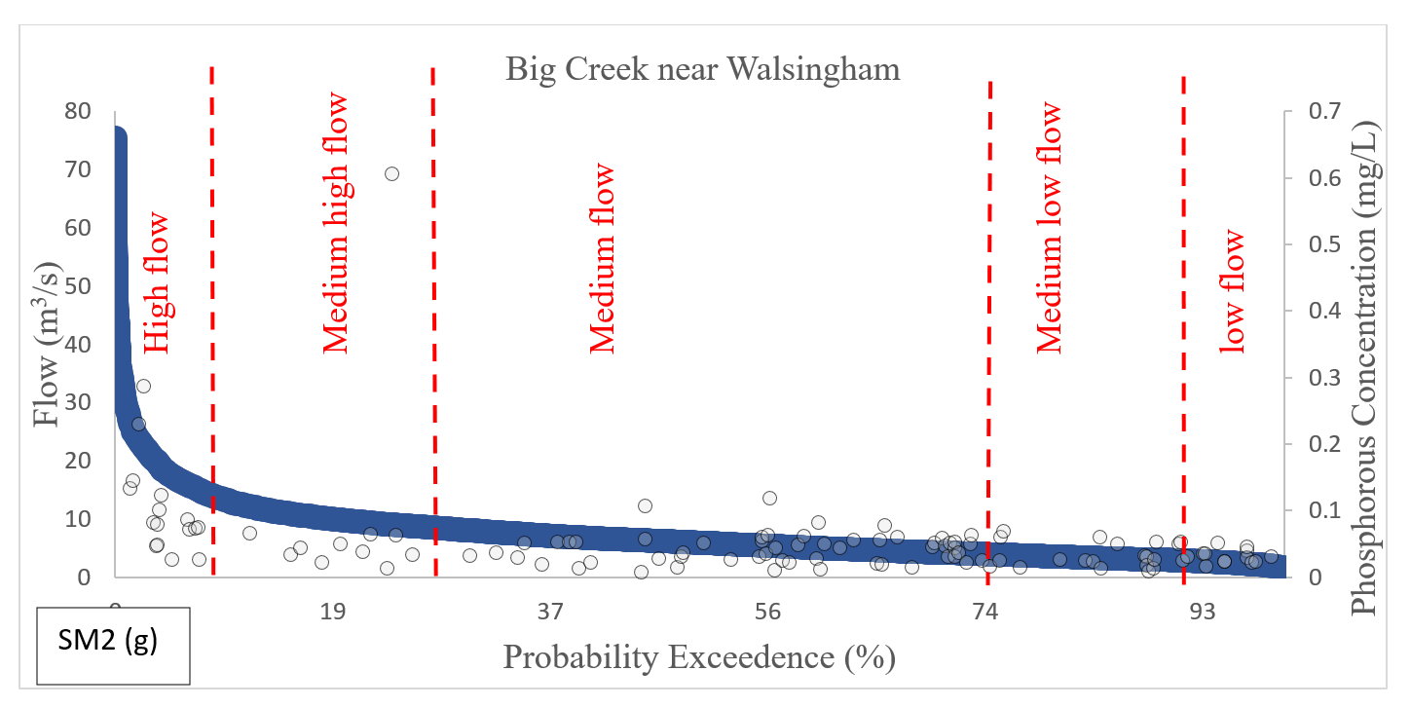

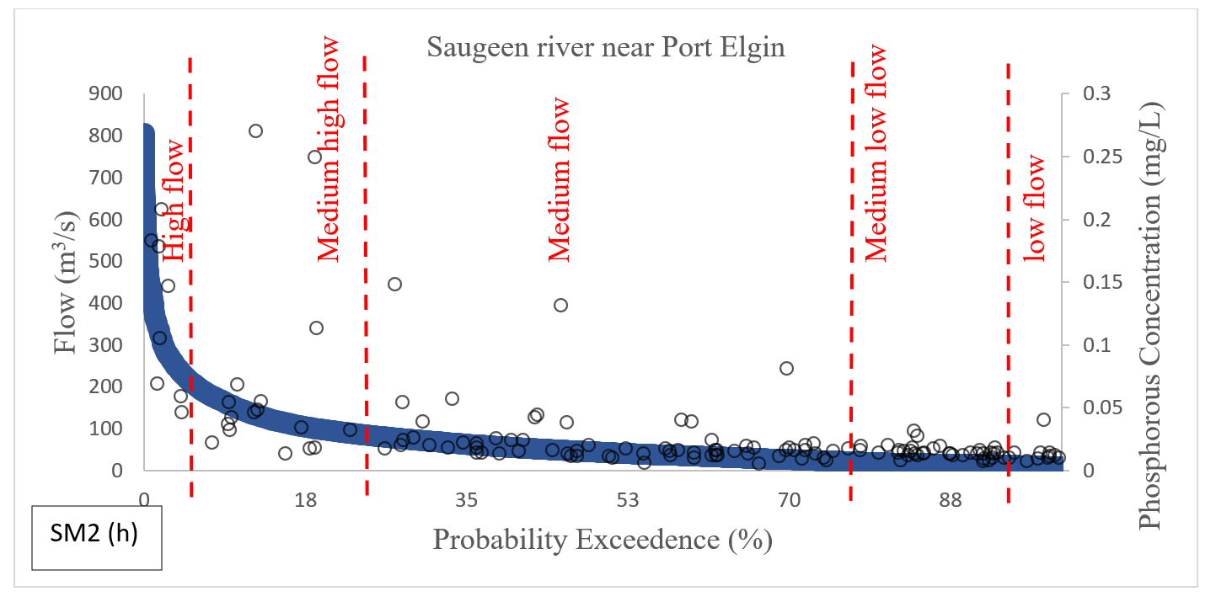

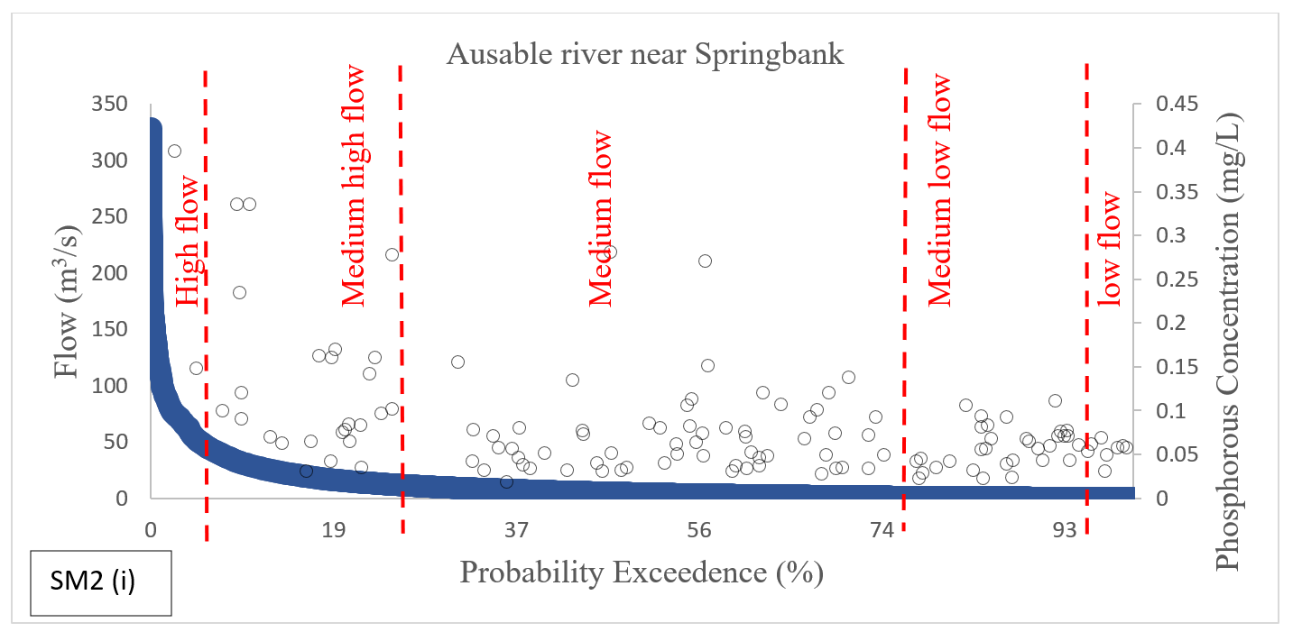

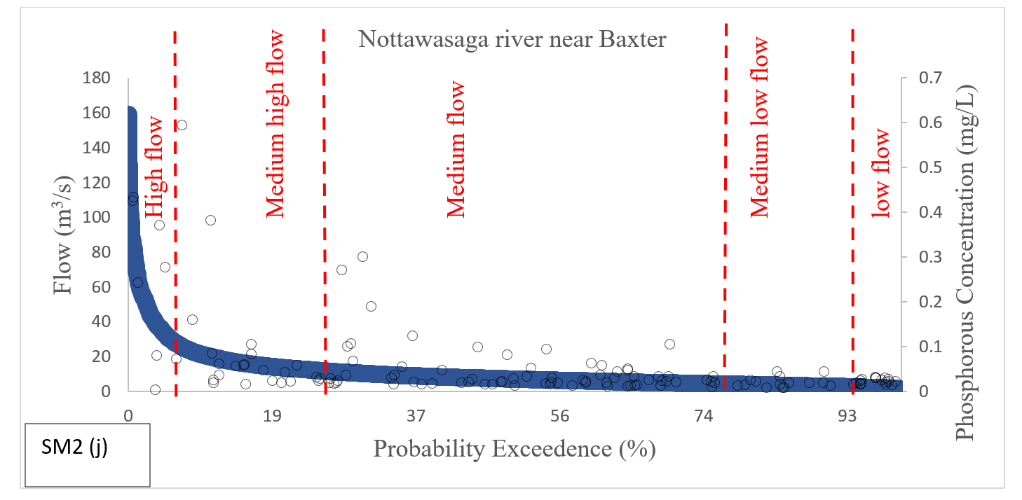

SM 3. Methodology of Trends analysis in water quality

SM 3. 1. Flexible model for trend analysis
All the trend tests that are described in supplementary sub-section SM2.1 rely on one feature that the existence of the trend and relationship among water-quality variables and independent variables such as streamflow and seasons and are based on many restrictive assumptions (Helsel et al., 2020). The application of smoothing methods (analogous to loess) to represent the changing pattern of the constituent concentrations to the components of streamflow, trend, and season is a recent development in water quality trend analysis (Helsel et al., 2020). The smoothing technique involves a reasonably large dataset and enables the concentration related to the independent variables to be free of functional form assumptions, enabling the description of water-quality changes to be driven by the data than a regular multiple regression model. The Weighted Regressions on Time, Discharge, and Season (WRTDS) model (Hirsch et al., 2010) works on a similar approach. The WRTDS model was designed to ease many of the assumptions common to the most trend models. The WRTDS model does not consider the shape of the discharge-concentration relationship to be constant over time, and it further does not consider these relationships to be the same in different seasons of the year. Over the full range of streamflow values, years, seasons, the WRTDS model does not assume the model variance to be constant, and so it varies smoothly over discharge-time space. The WRTDS model also computes the flow-normalized concentrations and flow-normalized load estimates. Flow-normalization is a technique to eliminate the effect of year-to-year fluctuations in streamflow to analyze water-quality trends. The WRTDS model also considers trends that may not follow a given functional form (such as linear or curved-linear) (Helsel et al., 2020).

Furthermore, trend analysis is done using tests presented in Table SM3. For this purpose, a single rule of displaying trends that are significant at the significance level (α) = 0.05 has been followed. However, there might be certain instances where there is reasonably clear evidence of an inclining or declining trend, but the hypothesis tests may suggest that the trend is not significant as it fails to meet the acceptable significance level (Helsel et al., 2020). Instead of eliminating trend results since they fail to reach a particular level of statistical significance, it is important to say how confident we can be about the direction or magnitude of the trend. A dialect is needed to explain the level of statistical support offered by the data as well as the associated analysis in terms of the probability of a positive or a negative change in direction over a given time-period (Helsel et al., 2020). The WRTDS model further accounts for such questions under Weighted Regression on WRTDS_BT for trend analysis. The WRTDS_BT approach provides the 90% confidence intervals on the magnitude of trend estimates, hypothesis test for trends in Flow Normalized Concentration (FNC) and Flow Normalized Load (FNL) so as to reject or fail to reject the null hypothesis at α = 0.1, p-values for the tests, and likelihood statements that are in numerical forms and also in the form of descriptive statements in section SM3.2.

SM 3. 2. Concepts of flow normalized concentration, load under WRTDS and WRTDS_BT
Explanation of WRTDS up till now was only limited to daily concentration and load estimates. Daily estimates of concentration and load are of immense importance in analyzing the real history of the water quality in a river (Hirsch et al., 2010). When the particular interest is to understand the water quality conditions of the downstream water bodies like lakes or reservoirs over the specific time period, it is of high importance to obtain the history of load integrated over the period of seasons or years. Similarly, if the emphasis is to analyze the concentration of various pollutants that can impact water supply intakes or on the ecology, then it is important to obtain the history of concentration integrated over the period of seasons or years. The flow conditions can heavily influence estimates of concentration and load. For instance, in the case of a constituent for which the concentration rises with streamflow, an extreme streamflow period of one or two years close to the end of the time-period may indicate a decrease in water-quality. Hence, the analysis done to evaluate the efficiency of pollution control efforts for such instances can extremely misperceive the results. Streamflow-driven variations produce a significant amount of obvious "noise", making it problematic to recognize the trend. For the analysis related to the efficiency or progress made with regards to the pollution control efforts or analyzing the change in the watershed over time of interest, trends that remove the effect of yearly fluctuations in streamflow is required (Hirsch et al., 2010).

WRTDS generates the flow normalized estimates of concentrations and loads that fall under the technique called Flow Normalization (FN). FN approach removes the effect of year-to-year variations of streamflow to compute the time series of FNC and FNL. FNC and FNL are a depiction of concentration and load that integrates over the probability distribution of streamflow in an attempt to eliminate the influence of year-to-year variability in streamflow. The FNC is computed using the equation:

$C_{ij}^{*}=\int_{0}^{∞}{w(Q, T_{i,j})}. g_{ij} \left(Q\right) dQ$ (SM1)

Where c*_{i,j} is the flow normalized concentration on a day i of year j, w(Q,T_{i,j}) is the WRTDS
estimate of concentration on a day i of year j, g_{ij}(Q) is the probability density function of discharge (Q) on a day i and year j. The estimate of the probability density function of streamflow on a day i is computed using observed discharge for that particular day over the record period and the probability of each of these values will be equal to 1/ny where ny is the total number of years of observed streamflow values for that particular day. Flow normalized concentration on i for the 20- year record will be computed as, WRTDS estimate of concentration w(Q_{i}T_{i}) multiplied by the probability density function (pdf) of discharge for a day i. Value of pdf of discharge for a day i will be computed using the discharge values for all ith days for the 20-year record resulting into 20 discharge values. The above procedure is repeated every single day in a record period which results in the time-series of the flow-normalized concentrations. Flow normalized flux is computed in similar ways as flow normalized concentration as:
$f_{ij}^{*}=\int_{0}^{∞}{Q*86.40*w(Q, T_{i,j})}. g_{ij} \left(Q\right) dQ$ (SM2)

Based on WRTDS estimates, the trend in flow-normalized concentration over the period of record can be computed as the difference between the annual mean flow normalized concentration for the last year (FNC_{ly}) and the annual mean flow-normalized concentration for the first year (FNC_{fy}):
$∆_{C}^{*}= {FNC}_{ly}- {FNC}_{fy}$ (SM3)

${FNC}_{ly}= \frac{1}{365}\sum_{i=1}^{365}{C_{ily}^{*}}$ (SM4)

${FNC}_{fy}= \frac{1}{365}\sum_{i=1}^{365}{C_{ify}^{*}}$ (SM5)

Where C*_{ify} is the estimated value of FNC on a day i of first year and C*_{ily} is the estimated value of FNC on a day i of last year over the record period. Based on the classical hypothesis testing approach for the trend analysis, the null hypothesis (H_{co}) represents no trend in FNC over the period and can also be summarized as:
$H_{C0}:∆_{C}^{*}=0$ (SM6)
And similarly, the alternative hypothesis (H_{c1}) represents a trend in FNC over the period of
record and can be summarized as:
$H_{C1}:∆_{C}^{*}≠0$ (SM7)
An alternative hypothesis is two-sided, meaning that FNC can be increasing or decreasing over
the period of record. Trend estimates for FNL are also computed in similar ways as trend
estimates of FNC.
$∆_{f}=2* \hat{∆_{f}^{*}}- D_{f}$ (SM8)

This procedure is repeated for every bootstrap replicate based on the number of bootstraps selected in the analysis. The change in concentration for a bootstrap replicate is done in similar ways as to load estimates and is denoted as Δc. The number of bootstrap replicates to be selected for the analysis is defined by the user. However, the approach also provides the flexibility to minimize the bootstrap replicates using an adaptive Bayesian approach which aims to provide the optimal number of replicates that would be needed for the analysis of trends considering the fact that adding additional replicates to the study will not influence the overall estimates. The WRTDS_BT approach provides various ways to analyze the trends in FNC and FNL. The WRTDS_BT approach provides the 90% confidence intervals on the magnitude of trend estimates, hypothesis test for trends in FNC and FNL such as reject or not to reject the null hypothesis at α = 0.1, p-values for the tests, and likelihood statements that are in numerical forms and also in the form of descriptive statements. The descriptive statements are based on the ̂π values, which is the posterior mean estimate of the probability of an increasing trend generated using n number of replicates. The explanation of the descriptive statements is shown in Table S3.

Table SM5 Descriptive (categorical) statements based on the range of π values from the WRTDS_BT test for trend analysis.
Range of π̂ values | Descriptive statements
Between 0.95-1 | Highly Likely
Between 0.90-0.95 | Very Likely
Between 0.66-0.90 | Likely
Between 0.33-0.66 | About as Likely as Not
Between 0.1-0.33 | Unlikely
Between 0.05-0.1 | Very Unlikely
Between 0-0.05 | Highly Unlikely

SM 4. Results
Table SM 4 (a) Results of bootstrap test for [FN-TSS] concentration change, 90 % confidence interval, trend direction, likelihood, and p-values. (The downward arrow indicates a declining trend; the upward arrow indicates an inclining trend; and the horizontal line indicates no trend.)
Site | Period | TSS Concentration
Site | Period | Mean Concentration change (mg/L) | 90 % confidence interval |  | Trend  with Direction | Likelihood | p-value
Site | Period | Mean Concentration change (mg/L) | Lower | Upper | Trend  with Direction | Likelihood | p-value
Humber River | 1979-2019 | -84 | -125.68 | 213.63 | Likely-Downward | 0.76 | 0.50
Don River | 1979-2019 | -128 | -193.40 | 583.50 | Likely-Downward | 0.79 | 0.43
Thames River at Thamesville | 1976-2019 | -10 | -22.89 | 5.00 | Likely-Downward | 0.86 | 0.27
Big Otter Creek | 2002-2019 | 16.9 | -15.71 | 95.33 | Likely-Upward | 0.74 | 0.54
Sydenham River | 2002-2019 | 1.23 | -7.14 | 9.97 | No Trend | 0.59 | 0.82
Thames River at Innerkip | 1988-2019 | -0.14 | -15.45 | 6.88 | Likely-Upward | 0.69 | 0.64
Big Creek | 2002-2019 | -15.60 | -26.57 | -2.82 | Highly Likely- Downward | 0.97 | 0.08
Saugeen River | 2002-2019 | -3.35 | -10.28 | 5.19 | Likely-Downward | 0.88 | 0.23
Ausable River | 2003-2019 | -3.56 | -10.27 | 2.77 | Likely-Downward | 0.81 | 0.36
Nottawasaga River | 2002-2019 | -10.80 | -21.11 | 3.74 | Likely-Downward | 0.90 | 0.21

Table SM 4 (b) Results of bootstrap test for [FN-TSS] load change, 90 % confidence interval, trend direction, likelihood, and p-values. The downward arrow indicates a declining trend, the upward arrow indicates an inclining trend and the horizontal line indicates no trend.
Site | Period | TSS Load
Site | Period | Mean Load change (t/ year) | 90 % confidence interval |  | Trend  with Direction | Likelihood | p-value
Site | Period | Mean Load change (t/ year) | Lower | Upper | Trend  with Direction | Likelihood | p-value
Humber River | 1979-2019 | -55.96 | -94.50 | 97.70 | Likely-  Downward | 0.76 | 0.46
Don River | 1979-2019 | -36.31 | -57.60 | 72.84 | Likely-  Downward | 0.69 | 0.61
Thames River at Thamesville | 1976-2019 | -13.82 | -104.70 | 85.80 | Likely as not-  No Trend | 0.61 | 0.75
Big Otter Creek | 2002-2019 | 25.45 | -11.51 | 113.19 | Likely-Upward | 0.84 | 0.32
Sydenham River | 2002-2019 | 2.63 | -8.71 | 15.46 | Likely-Upward | 0.74 | 0.55
Thames River at Innerkip | 1988-2019 | -0.65 | -7.51 | 2.25 | No Trend | 0.61 | 0.79
Big Creek | 2002-2019 | -8.81 | -18.18 | 1.71 | Highly Likely- Downward | 0.95 | 0.11
Saugeen River | 2002-2019 | -13.26 | -43.03 | 12.92 | Very Likely-  Downward | 0.90 | 0.22
Ausable River | 2003-2019 | 0.57 | -5.24 | 5.32 | Likely as not-  No Trend | 0.56 | 0.86
Nottawasaga River | 2002-2019 | -11.37 | -23.41 | 1.43 | Very Likely-Downward | 0.93 | 0.13

Table SM 5 (a) Results of bootstrap test for [FN-TP] concentration change, 90 % confidence interval, trend direction, likelihood, and p-values. The downward arrow indicates a declining trend, the upward arrow indicates an inclining trend and the horizontal line indicates no trend.
Site | Period | TP Concentration
Site | Period | Mean Concentration change (mg/L) | 90 % confidence interval |  | Trend  with Direction | Likelihood | p-value
Site | Period | Mean Concentration change (mg/L) | Lower | Upper | Trend  with Direction | Likelihood | p-value
Humber River | 1979-2019 | -0.08 | -0.13 | -0.04 | Highly Likely-Downward | 0.97 | 0.05
Don River | 1979-2019 | -0.39 | -0.51 | -0.30 | Highly Likely- Downward | 0.99 | 0.05
Thames River at Thamesville | 1976-2019 | -0.07 | -0.10 | -0.05 | Highly Likely- Downward | 0.99 | 0.05
Big Otter Creek | 2002-2019 | -0.02 | -0.06 | 0.05 | Likely as not-  No Trend | 0.54 | 0.90
Sydenham River | 2002-2019 | -0.02 | -0.04 | 0.01 | Likely-Downward | 0.76 | 0.49
Thames River at Innerkip | 1988-2019 | -0.05 | -0.11 | 0.01 | Very Likely-Downward | 0.93 | 0.14
Big Creek | 2002-2019 | -0.03 | -0.03 | -0.01 | Highly Likely- Downward | 0.97 | 0.05
Saugeen River | 2002-2019 | -0.01 | -0.02 | 0.01 | Likely- Downward | 0.86 | 0.28
Ausable River | 2003-2019 | -0.01 | -0.01 | 0.02 | Likely as not-  No Trend | 0.66 | 0.69
Nottawasaga River | 2002-2019 | -0.03 | -0.04 | -0.001 | Highly Likely- Downward | 0.95 | 0.01

Table SM 5 (b) Results of bootstrap test for [FN-TP] load change, 90 % confidence interval, trend direction, likelihood, and p-values. The downward arrow indicates a declining trend; the upward arrow indicates an inclining trend and the horizontal line indicates no trend.

Site | Period | TP Load
Site | Period | Mean Load change (t/ year) | 90 % confidence interval |  | Trend  with Direction | Likelihood | p-value
Site | Period | Mean Load change (t/ year) | Lower | Upper | Trend  with Direction | Likelihood | p-value
Humber River | 1979-2019 | -0.054 | -0.10 | 0.01 | Very Likely-Downward | 0.93 | 0.13
Don River | 1979-2019 | -0.07 | -0.10 | -0.04 | Highly Likely- Downward | 0.99 | 0.05
Thames River at Thamesville | 1976-2019 | -0.18 | -0.28 | -0.10 | Highly Likely- Downward | 0.99 | 0.05
Big Otter Creek | 2002-2019 | -0.01 | -0.05 | 0.06 | Likely as not-  No trend | 0.54 | 0.92
Sydenham River | 2002-2019 | -0.01 | -0.04 | 0.02 | Likely- Downward | 0.76 | 0.49
Thames River at Innerkip | 1988-2019 | -0.03 | -0.06 | -0.001 | Highly Likely-Downward | 0.95 | 0.10
Big Creek | 2002-2019 | -0.01 | -0.01 | -0.004 | Highly Likely- Downward | 0.97 | 0.05
Saugeen River | 2002-2019 | -0.03 | -0.7 | 0.02 | Very Likely-Downward | 0.90 | 0.19
Ausable River | 2003-2019 | 0.0002 | -0.01 | 0.03 | Likely-  Upward | 0.69 | 0.61
Nottawasaga River | 2002-2019 | -0.03 | -0.04 | 0.05 | Highly Likely- Downward | 0.95 | 0.11

SM 5. Limitations
The accuracy of water quality trend estimates and components relies on the data quality and model structure. Despite incorporating some uncertainty measures, unquantified uncertainty persists in our results, as highlighted in WRTDS sensitivity analyses by Oelsner et al. (2017); Lee et al. (2017). A significant portion of this uncertainty stems from sample numbers and, critically, the coverage of flow duration curve (FDC). To facilitate effective future analysis and enhance data monitoring policies, we have included the FDC curve in the supplementary section SM2.2. Several specific limitations of the study are outlined:

- The limited ability of PWQMN data to detect changes in TP concentrations, given its focus on the growing season and the exclusion of storm events and baseflow in the program (Stammler et al., 2017).

- Acknowledgment that TP losses are most significant during winter, spring, and large rain events (Lam et al., 2016), making PWQMN growing season data, with its low sample frequency, insufficient for a comprehensive understanding of year-round stream TP concentrations.

- The indication from TP concentrations in the most urban and agricultural watersheds across all decades that mean nongrowing season TP is generally higher than growing season TP concentrations.

- The potential for enhanced findings and deeper insights into the relationships between Land Use/Land Cover (LULC) changes and stream TP trends through the inclusion of comprehensive non-growing season and storm event data.

SM 6. Implications

Efforts by federal, state, and local governments, along with landowners and non-profit organizations, aim to enhance water quality in Canadian streams and rivers. Yet, the impact of these endeavors is often obscured by random variability and systematic changes in streamflow due to natural or anthropogenic causes. This study aims to pinpoint areas for more intensive measures to reduce nutrient losses below the Canadian Water Quality Guidelines (CWQG) and Provincial Water Quality Objectives (PWQO) levels. Additionally, it addresses stations where implemented measures are impacting the intended outcomes. Considering possible measures, factors contributing to observed decreases in TP in agricultural streams are diverse. Transitioning from pasture to row crops may reduce P losses linked to manure and animal-based soil erosion but could increase tillage-based soil erosion (Cournane et al., 2011). Conventional tillage decrease may lower sediment loss but increase overall P losses without effective P fertilizer incorporation (Tiessen et al., 2010). Enhanced tile drainage might decrease surface runoff but may still contribute to subsurface P export (King et al., 2015; Macrae et al., 2007). Decreases in P fertilizer sales and within-stream TP retention could also diminish overall TP losses (Smith, 2015; Jarvie et al., 2012).

Key measures to reduce TP loadings include:

- Precision Fertilization: Apply fertilizers judiciously to avoid over-application, considering both the amount needed by plants and the timing of application. Avoid applying it to frozen ground or before heavy rain to prevent washout.

- Reduce Hard Surfaces: Minimize pavement and hard surfaces on properties to allow rainwater absorption, preventing runoff that carries phosphorus and pollutants to water bodies via storm drains and ditches.

- Runoff Mitigation: Implement measures like rain gardens, rain barrels, or vegetation along watercourses to reduce and slow down runoff.

These measures collectively contribute to a comprehensive strategy for sustained water quality improvement.

References
Bittman, D., Veliz, M., & Wright, B. (2016). Healthy Lake Huron – Clean Water, Clean Beaches Southeastern Lake Huron Tributary Water Quality Synthesis and Modelling (October 2010 to September 2015) Prepared for: Environment Canada Prepared by : Dan Bittman , Mari Veliz , and Brynn Upsdell Wright. (October 2010).
Cournane FC, McDowell R, Littlejohn R, Condron L (2011). Effects of cattle, sheep and deer grazing on soil physical quality and losses of phosphorus and suspended sediment losses in surface runoff. Agric. Ecosyst. Environ. 140, 264–272.
DeBues Max J, Eimers MC, Watmough SA, Mohamed MN, Mueller J (2019). Stream nutrient and agricultural land-use trends from 1971 to 2010 in Lake Ontario tributaries. J Great Lakes Res 45, 752-761.
Diaconis P, Efron B (1983). Computer-intensive methods in statistics. Sci. Am. 248, 116e130.
Efron B, Tibshirani RJ (1994). An Introduction to the Bootstrap. CRC press.
Helsel DR, Hirsch RM, Ryberg KR, Archfield SA, Gilroy EJ (2020) Statistical Methods in Water Resources. Techniques and Methods 4-A3. https://doi.org/10.3133/tm4A3
Hirsch RM, De Cicco LA (2015) User guide to Exploration and Graphics for RivEr Trends (EGRET) and dataRetrieval: R packages for hydrologic data, Version 1.0: Originally posted October 8, 2014; Version 2.0: February 5, 2015 edn., Reston, VA, USA. doi:https://doi.org/10.3133/tm4A10
Hirsch RM, Moyer DL, Archfield SA (2010) Weighted regressions on time, discharge, and season (WRTDS), with an application to chesapeake bay river inputs. JAWRA 46(5): 857–880. https://doi.org/10.1111/j.1752-1688.2010.00482.x
Hirsch RM, Slack JR (1984). A Nonparametric Trend Test for Seasonal Data With Serial Dependence. Water Resources Research, 20(6), 727–732. https://doi.org/10.1029/WR020i006p00727
Hirsch RM, Slack JR, Smith RA (1982) Techniques of trend analysis for monthly water quality data. Water Resources Research, 18(1), 107–121. https://doi.org/10.1029/WR018i001p00107
Jarvie HP, Sharpley AN, Scott JT, Haggard BE, Bowes MJ, Massey LB (2012). Within river phosphorus retention: accounting for a missing piece in the watershed phosphorus puzzle. Environ. Sci. Technol. 46, 13284–13292.
King KW, Williams MR, Fausey NR (2015). Contributions of systematic tile drainage to watershed-scale phosphorus transport. J. Environ. Qual. 44, 486.
Lam WV, Macrae ML, English MC, O'Halloran IP, Wang YT (2016) Effects of tillage practices on phosphorus transport in tile drain effluent under sandy loam agricultural soils in Ontario, Canada. J. Great Lakes Res. 42, 1260–1270.
Land Information Ontario, (2016). The Ontario Land Cover Compilation (OLCC). Last accessed: 05-05-2023
Lee CJ, Murphy JC, Crawford CG, Deacon JR (2017). Methods for computing water quality loads at sites in the U.S. Geological Survey National Water Quality Network. U.S. Geological Survey Open-file Report 2017–1120 (20 pp.).
Macrae ML, English MC, Schiff SL, Stone M, (2007). Intra-annual variability in the contribution of tile drains to basin discharge and phosphorus export in a first-order agricultural catchment. Agric. Water Manag. 92, 171–182.
Meals DW, Spooner J, Dressing SA, Harcum JB (2011). Statistical analysis for monotonic trends, Tech Notes 6, November 2011. Developed for U.S. Environmental Protection Agency by Tetra Tech, Inc., Fairfax, VA, 23 p. Available online at https://www.epa.gov/polluted-runoff-nonpoint-source-pollution/nonpoint-sourcemonitoring-technical-notes. (Accessed 1-3-2013).
Morales-Marín LA, Chun KP, Wheater HS, Lindenschmidt KE (2017) Trend analysis of nutrient loadings in a large prairie catchment, Hydrological Sciences Journal, 62:4, 657-679, DOI: 10.1080/02626667.2016.1255747
Morse NB, Wollheim WM (2014). Climate variability masks the impacts of land use change on nutrient export in a suburbanizing watershed. Biogeochemistry 121, 245–259.
Oelsner GP, Sprague LA, Murphy JC, Zuellig RE, Johnson HM, Ryberg KR, Falcone JA, Stets EG, Vec-chia AV, Riskin ML, De Cicco LA, Mills TJ, Farmer WH (2017). Water-quality trends in the Nation's rivers and streams, 1972–2012—data preparation, statistical methods, and trend results. U.S. Geological Survey Scientific Investigations Report 2017–5006 (136 pp.).
Rock L, Mayer B (2004) Isotopic assessment of sources of surface water nitrate within the Oldman River basin, southern Alberta, Canada. Water, Air and Soil Pollution: Focus 4: 545–562.
Smith PG (2015). Long-term temporal trends in agri-environment and agriculture land use in Ontario, Canada: transformation, transition and significance. J. Geomagn. Geoelectr. 7, 32–55.
Stammler KL, Taylor WD, Mohamed MN (2017) Long-term decline in stream total phosphorus concentrations: A pervasive pattern in all watershed types in Ontario. J Great Lakes Res 43(5): 930–937. https://doi.org/10.1016/j.jglr.2017.07.005
Taylor BR, Hamilton HR (1993) Regional and temporal patterns of total solutes in the Saskatchewan Rive basin. JAWRA 29 (2): 221–234.
Tiessen KHD, Elliott JA, Yarotski J, Lobb DA, Flaten DN, Glozier NE (2010). Conventional and conservation tillage: influence on seasonal runoff, sediment, and nutrient Losses in the Canadian Prairies. J. Environ. Qual. 39: 964-980. https://doi.org/10.2134/jeq2009.0219
van Driezum IH, Derx J, Oudega TJ, Zessner M, Naus FL, Saracevic E, Kirschner AKT, Sommer R, Farnleitner AH, Blaschke AP (2019). Spatiotemporal resolved sampling for the interpretation of micropollutant removal during riverbank filtration. Science of the Total Environment, 649, 212–223. https://doi.org/10.1016/j.scitotenv.2018.08.300
Yates AG, Brua RB, Friesen A, Reedyk S, Benoy, G (2022). Nutrient and suspended solid concentrations, loads, and yields in rivers across the Lake Winnipeg Basin: A twenty year trend assessment. 44, 101249.

