Supplementary Table 1. Histological Assessability Score
Score
0 | The specimen does not contain alveolar structures and can therefore not be assessed as transbronchial biopsy
1 | Due to very poor specimens quality, it is not possible to assess the relevant morphological and histological features
2 | Due to poor specimen quality，assessment of relevant morphological and histological structures and features is severely compromised and not possible
3 | Despite high limitations in specimens quality assessment of the relevant morphological and histological structures and features is severely compromised but possible
4 | Despite moderate limitations in specimens quality assessment of the relevant morphological and histological structures and features is compromised but possible
5 | Despite low limitations in specimens quality assessment of the relevant morphological and histological structures and features are compromised but possible
6 | The specimen allow for complete and unrestricted assessment of all relevant morphologicand histological structures and features

Supplementary Table 2 Histopathological patterns
 | 1.9-mm cryoprobe  n=112 | 1.1-mm cryoprobe  n=112
Usual interstitial pneumonia | 26 | 25
Hypersensitivity pneumonitis † | 10 | 12
Sarcoidosis | 6 | 6
Respiratory bronchiolitis-ILD or desquamative interstitial pneumonia | 7 | 8
Non-specific interstitial pneumonia overlapping with organising pneumonia pattern | 32 | 25
Pulmonary alveolar proteinosis | 4 | 4
Lymphangioleiomyomatosis | 2 | 1
Eosinophilic pneumonia | 1 | 1
Pneumoconiosis | 2 | 7
Unclassifiable | 19 | 19
Non-diagnostic tissue | 2 | 3
Non-ILD diagnosis ‡ | 1 | 1
Abbreviations: ILD, interstitial lung disease.
†In the patients60% (6/10) cases in the 1.9-mm group were fibrotic and 50% (6/12) cases in the 1.1-mm group were fibrotic
‡Two patients had lepidic mucinous adenocarcinoma.

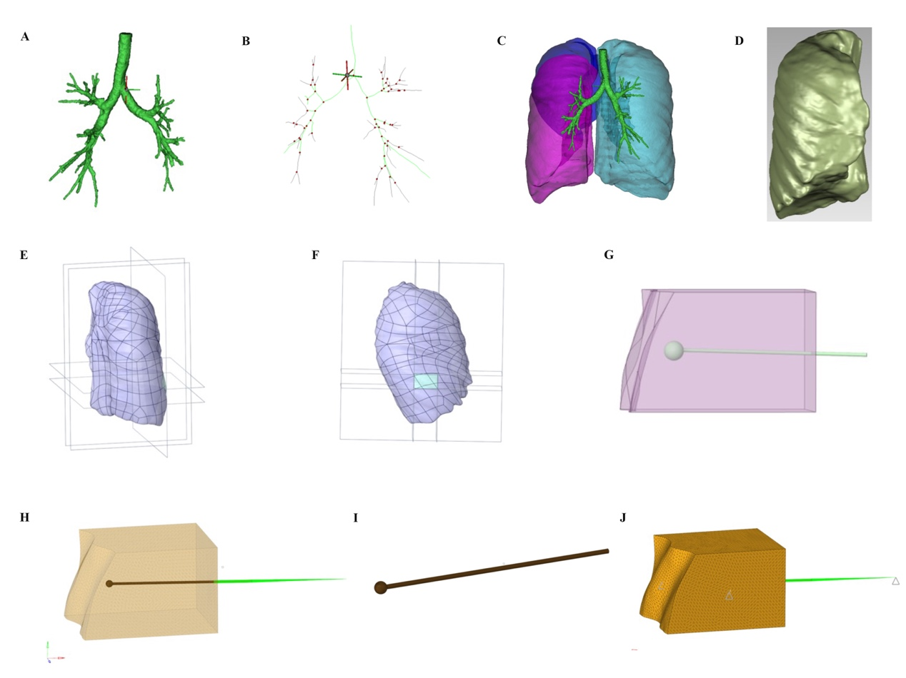
Supplementary figure 4. Schematic representation of 3D construction and finite element analysis of lung tissue. (A: The CT scan data were imported into MIMICS21.0, and the tracheal model was established according to the segment airway of mimics; B: The tracheal centerline was established according to the new centerline label; C: The lung tissue model was established according to the Central Line of the trachea. D: The right lobe of the lung was taken for model processing. E and F: The 3D model was segmented in Hypermesh to obtain lung blocks near the sampling; G, H and I: In Hypermesh, solid meshing is performed to generate volume meshes directly from face meshes. The lungs were divided into tetrahedral grids, the size of the surrounding grids was 0.2mm, the outer surface grid was 1.5mm, and the middle grid was uniform transition, with a total of 213,446 grids and 38,700 nodes; J: Volume meshing was performed separately for each group. Neo-Hookean constitutive model was used for lung material, C10=0.815, D=0.263. There was a contact relationship between the sample and the lung tissue, and the probe and the sample were integrated. The cross section of the lung was constrained for 6 degrees of freedom, and the sampling tube end was coupled to a point to which a displacement load of 10mm was applied.)

Supplementary table 2. Specific Scheme
Conditions | Frozen tissue size (mm)
1.1-mm cryoprobe
Tip length: 3 mm | 3
Diameter: 1.1 mm | 4
Lung tissues were cooled at -40 °C | 5
Pulling load required for pulling distance 0-10cm | 6
1.9-mm cryoprobe
Tip length: 3 mm | 3
Diameter: 1.9 mm | 4
Lung tissues were cooled at -40 °C | 5
Pulling load required for pulling distance 0-10cm | 6

Finite element analysis of frozen lung tissue
A three-dimensional digital model of the lung was established from the CT scan data of the chest. The finite element technique was used to analyze the changes of the probe diameter, the load required by the change of the sampling diameter, and the effect on the lung when the frozen lung tissue was sampled. This analysis involved the concepts of the pull-displacement curve, stress area distribution map, tension load, stress area, stress extremum, probe diameter, and lung tissue. These concepts relate to the relevant principles and methods in material mechanics and experimental mechanics, such as elastic modulus, constitutive relations, tensile testing, measurement and analysis. These principles and methods provide researchers with the tools and methods to measure and analyze material properties under experimental conditions of finite elements for a deeper understanding of the properties and mechanical behavior of lung tissue.
The CT scan data of lung tissue were used to repair and 3D materialize the model by Geomagic. Hypermesh was used to divide the mesh, and the probe models with diameters of 1.1mm, and 1.9mm were established. The load-displacement simulation experiments were carried out on frozen lung samples with different diameters of 3mm, 4mm, 5mm and 6mm, and the finite element analysis was performed by Abaqus. The finite element model of lung tissue established by us is highly repeatable and reliable after several parameter corrections and a large number of data calculations. Various load curves and stress clouds are in accordance with the basic laws of physics and material mechanics.
1. Tension Analysis
In this simulation experiment, it was observed that the tensile load of the samples gradually increased with an increase in diameter when using probes of the same size to pull frozen lung tissues with diameters of 3mm, 4mm, 5mm, and 6mm. According to Newton's second law, the acceleration of a body is directly proportional to the force acting on it and inversely proportional to its mass. Therefore, an increase in probe diameter results in a larger pulling force requirement to move the frozen lung tissue due to the larger mass of objects with larger diameters. This theory can explain the greater tensile load required to pull frozen lung tissue with diameters of 3mm, 4mm, 5mm, and 6mm. In conclusion, this pull-displacement load experiment adheres to the fundamental principles of force and motion in engineering mechanics.
The results of pulling frozen lung tissues with diameters of 3mm, 4mm, 5mm, and 6mm using probes of different sizes (with diameters of 1.1mm, and 1.9mm) can also be explained by principles from biomechanics and engineering mechanics. Biomechanics focuses on the study of the structure and motion of living organisms under the influence of forces, while engineering mechanics deals with the mechanical behavior and properties of objects. In this case, the frozen lung tissue is considered as a material, and probes with different diameters are treated as tools for force application.
When a probe with a diameter of 1.1mm pulls the lung tissue, it undergoes more squeezing and stretching due to the narrow channel, resulting in increased friction between the frozen lung tissue and the probe channel to accommodate the probe size. Consequently, a greater force is required to pull the larger diameter of the frozen lung tissue and the surrounding tissue. Therefore, pulling frozen lung tissue requires a larger tensile load.
In contrast, when probes with diameters of 1.9mm pull the lung tissue, the channel is wider, and a lower friction force is generated between the frozen lung tissue and the probe channel, allowing for easier adaptation to the probe size. As a result, less force is needed to pull the larger diameter frozen lung tissue and the surrounding tissue. Therefore, pulling frozen lung tissue requires a smaller pulling load.
2. Stress Analysis
Figure 3 is used to illustrate the distribution of stress regions formed in frozen lung tissue at a 1cm pull displacement for probes of different diameters. The cloud images are arranged from left to right and top to bottom, with each image representing the range of stress regions formed when a probe of a specific diameter is pulled on lung tissue of varying sizes. For instance, the images on the left depict the stress regions generated by 1.1mm, and 1.9mm diameter probes when pulling on a 3mm diameter frozen lung tissue. The subsequent images display the range of stress regions created by these probes when pulling on lung tissues with diameters of 4mm, and so on, following the same pattern of arrangement.
From the cloud diagram, it can be observed that at the same pull displacement, the smaller the probe diameter, the larger the area of the stress region and the maximum stress extreme value. Specifically, when the diameter is 1.1mm, the area of the stress region is the largest, and the stress extremum is also the largest. When the diameter is 1.9mm, the stress area and stress extreme value were smaller.
This result can be explained by the principles of biomechanics and engineering mechanics. When a material is subjected to a force, the distribution of stress is influenced by factors such as the applied force and the geometric characteristics of the material. Under the same pull displacement, a probe with a smaller diameter exerts a greater force, leading to higher stress on the surface of the probe, i.e., a larger stress extremum. Additionally, the distribution area of stress also varies with the diameter of the probe. When the probe diameter is small, the stress region has a larger area because the stress generated on the probe surface is relatively high. Conversely, when the probe diameter is large, the stress region has a smaller area because the stress on the probe surface is relatively low. This is because, under the same pull displacement, a probe with a larger diameter exerts a smaller force, resulting in lower stress on the probe surface.
This result can also be explained based on the principles of tensile mechanics, specifically tensile mechanics. During the process of stretching, there exists an interaction force between the probe and the tissue, known as tensile force, which generates local stress in the tissue.
When the probe and tissue sizes are similar, the applied tensile force by the probe will slightly stretch the surrounding tissue, but the stretching effect is relatively weak, resulting in minimal deformation of the tissue. Consequently, the generated local stress is also relatively low.
However, when there is a significant difference in size between the probe and the tissue, the tensile force applied by the probe cannot easily cause the surrounding tissue to expand. As a result, an expansion channel effect occurs, leading to more pronounced deformation of the local tissue. This necessitates a greater tensile force to stretch the tissue, resulting in a higher local stress level. This expansion channel effect is widely utilized in the fields of biology and medicine, such as during the histological sample preparation process in pathology.
This result can be expressed by the following formula: stress = force/area. Therefore, when the same tensile force is applied, the smaller the probe diameter, the greater the stress on the probe surface will be. At the same time, since the force remains constant, the area of the stress region will correspondingly increase. Conversely, in the case of a larger diameter, the stress on the probe surface is smaller, resulting in a smaller area of the stress region.
This paper discusses the application of the load-displacement curve and stress distribution map in studying the influence of probe diameter on the mechanical properties of lung tissue. By measuring and analyzing the load-displacement curve and stress distribution map, it was found that an increase in tensile load leads to an increase in the area of the stress region and the maximum stress value, indicating a linear relationship between strain and stress. Additionally, the study also revealed that probe diameter has a certain influence on the stress distribution and magnitude in lung tissue, suggesting that different probe diameters can have different effects on the results. These findings allow for a deeper investigation into the impact of probe diameter on the mechanical properties of lung tissue.

