Development and validation of a multivariable predictive model for Emergency Department Overcrowding based on the National Emergency Department Overcrowding Study (NEDOCS) score

Supplementary material
Authors
Diego Hernán Giunta^{1, 2, 3, 4}, Diego Sanchez Thomas¹, Maria Florencia Grande Ratti^{1, 5}, Bernardo Julio Martinez⁵

Affiliation
1. Internal Medicine Research Unit, Hospital Italiano de Buenos Aires, CABA, Argentina.
2. Research Department, Hospital Italiano de Buenos Aires, CABA, Argentina.
3. University Institute of Hospital Italiano de Buenos Aires (IUHI), CABA, Argentina.
4. National Council of Scientific and Technical Research (Consejo Nacional de Investigaciones Científicas y Técnicas - CONICET), Argentina.
5. Emergency Department, Hospital Italiano de Buenos Aires, CABA, Argentina.

Corresponding author: Diego H. Giunta - Hospital Italiano de Buenos Aires, Internal Medicine Research Unit. diego.giunta@hospitalitaliano.org.ar - ph +549 - 01149590200 int. 4806

Acknowledgments
To the Hospital Italiano de Buenos Aires Emergency Department for their everyday efforts in the frontline of medical care.
Funding
This study received funding from the AMPHI grant, the Hospital Italiano de Buenos Aires Emergency Department and the Hospital Italiano de Buenos Aires Internal Medicine Research Unit.
Conflicts of interest

The authors report not having any conflicts of interest with the presented topic.

Figure a1. Graphical representation of the study endpoint called Sustained Critical NEDOCS.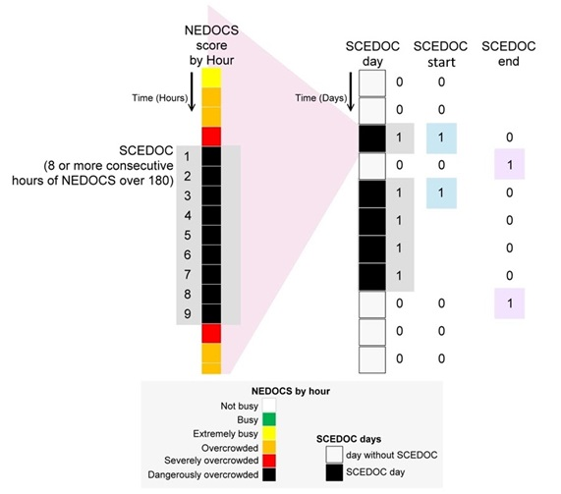

Figure a2. Calibration (A) and discrimination (B) graphs for the internal validation group.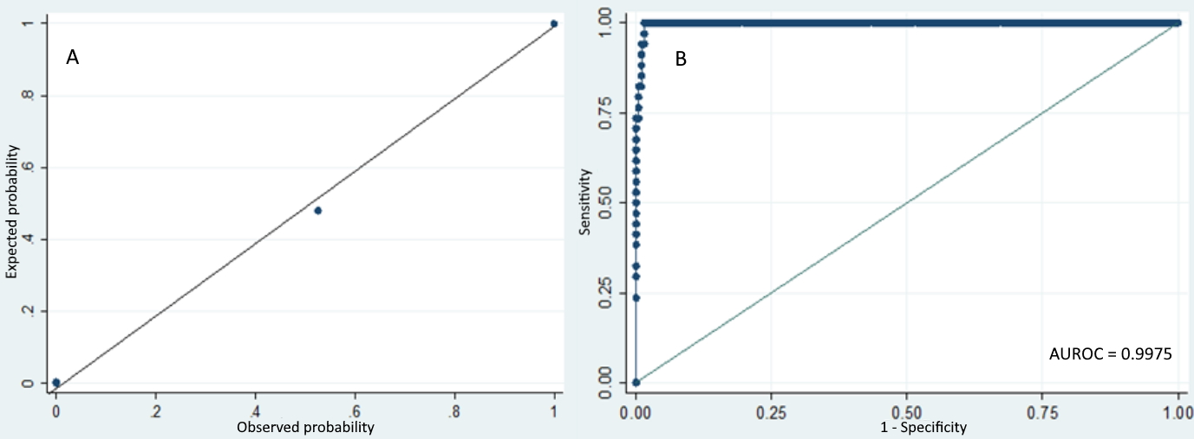
Table a1. Factors associated with Sustained Critical EDOC. We present crude ORs for each variable in the generation group for Sustained Critical EDOC, with their 95% confidence intervals and p values.
Characteristics | crude OR (95%CI)  (n = 487 days) | p value
Management variables*
Days of the week
Sunday (reference) | 1 | -
Monday | 1.474 (95%CI 0.492 - 4.409) | 0.488
Tuesday | 1.357 (95%CI 0.454 - 4.050 | 0.584
Wednesday | 1.658 (95%CI 0.576 - 4.774) | 0.348
Thursday | 1.838 (95%CI 0.647 - 5.222) | 0.253
Friday | 1.610 (95%CI 0.549 - 4.720) | 0.385
Saturday | 0.753 (95%CI 0.218 - 2.604) | 0.655
Non working day | 0.493 (95%CI 0.254 - 0.957) | 0.037
Day after a long weekend | 1.750 (95%CI 0.479 - 6.384) | 0.397
Day before a long weekend | 0.616 (95%CI 0.078 - 4.863) | 0.647
Winter holidays | 0.712 (95%CI 0.161 - 3.135) | 0.654
All holidays | 0.123 (95%CI 0.037 - 0.401) | 0.001
Weather variables
Relative ambient humidity in 1% increments | 1.003 (95%CI 0.983 - 1.025) | 0.712
Atmospheric pressure, for each 1 hPa increment | 1.044 (95%CI 1.000 - 1.091) | 0.048
Minimum temperature, in 1 °C increases | 0.885 (95%CI 0.839 - 0.933) | <0.001
Maximum temperature, in 1 °C increases | 0.916 (95%CI 0.876 - 0.958) | <0.001
Cold days | 2.503 (95%CI 1.116 - 5.609) | 0.026
Precipitation (in 1mm of water increments) | 0.974 (95%CI 0.935 - 1.015) | 0.222
Rainy days | 0.741 (95%CI 0.394 - 1.394) | 0.353
Variables related to patients visiting the ED
Average patient age from the previous day, for each 1 year increment | 0.93 (95%CI 0.767 - 1.145) | 0.528
Percentage of patients consulting on each day for ILD, for each 1% increment | 1.606 (95%CI 1.306 - 1.974) | <0.001
Percentage of patients consulting on previous day for ILD, for each 1% increment | 2.245 (95%CI 1.731 - 2.910) | <0.001
Percentage of green triage patients, for each 1% increment | 0.882 (95%CI 0.782 - 0.995) | 0.043
Percentage of yellow triage patients, for each 1% increment | 0.896 (95%CI 0.767 - 1.047) | 0.169
Percentage of red triage patients, for each 1% increment | 1.460 (95%CI 0.397 - 5.360) | 0.568
Percentage of white + blue triage patients, for each 1% increment | 1.114 (95%CI 1.018 - 1.219) | 0.019
Variables related to ED staff and to hospital staff†
Residents’ experience in days, for each 1 day increment | 0.991 (95%CI 0.988 - 0.994) | <0.001
Residents’ experience in months, for each 1 month increment | 0.773 (95%CI 0.703 - 0.851) | <0.001
ED administrative staff absenteeism, for each 1% increase | 0.884 (95%CI 0.824 - 0.948) | 0.001
ED nursing staff absenteeism, for each 1% increase | 0.962 (95%CI 0.895 - 1.033) | 0.291
Hospital administrative staff absenteeism, for each 1% increase | 0.997 (95%CI 0.945 - 1.052) | 0.928
Hospital nursing staff absenteeism, for each 1% increase | 0.942 (95%CI 0.860 - 1.031) | 0.197
Internal Medicine congress week | 2.8 (95%CI 0.531 - 14.755) | 0.225
Week before the internal medicine congress | 0.854 (95%CI 0.105 - 6.951) | 0.883
General surgery congress week | 2.327 (95%CI 0.459 - 11.797) | 0.308
Traumatology congress week | 2.306 (95%CI 0.236 - 22.523) | 0.472
Week after the anesthesiology congress | 1.990 (95%CI 0.404 - 9.805) | 0.397
Variables related to bed occupancy and inpatient flow
Previous day hospital LOS, for each 1 day increment | 1.360 (95%CI 1.104 - 1.676) | 0.004
Percentage of inpatients whose LOS is in the 4th quartile, for each 1% increment | 1.102 (95%CI 1.031 - 1.177) | 0.004
Previous day general bed occupancy, for each 1% increment | 1.220 (95%CI 1.109 - 1.342) | <0.001
Previous day critical care unit occupancy, for each 1% increment | 1.259 (95%CI 1.158 - 1.368) | <0.001
Total number of surgeries scheduled in a day, for each 1 surgery increment | 1.026 (95%CI 1.009 - 1.044) | 0.002
Variables related to previous day EDOC
Average previous day NEDOCS score, for each 1 point increment | 1.110 (95%CI 1.079 - 1.142) | <0.001
Previous day percentage of black NEDOCS hours, for each 1% increment | 1.215 (95%CI 1.156 - 1.276) | <0.001
Previous day percentage of black and red NEDOCS hours, for each 1% increment | 1.069 (95%CI 1.055 - 1.084) | <0.001
Percentage of LWOS patients, for each 1% increment | 1.305 (95%CI 1.170 - 1.456) | <0.001
Percentage of LWOS patients on the previous day, for each 1% increment | 1.135 (95%CI 1.013 - 1.271) | 0.029
*Because of insuficicient number of events, the following variables were omitted: 1. day before a short holiday, 2. day after a short holiday 3. week after the internal medicine congress, 4. week before the general surgery congress, 5. week after the general surgery congress, 6. week before the traumatology congress, 7. week of the anesthesiology congress, 8. week before the anesthesiology congress. 9. hot days
Abbreviations: hPa hectopascals; °C degrees centigrade, ILD Influenza-like disease; ED emergency department; LOS average hospital length of stay; LWOS left without being seen

Table a2. Estimation of sensitivity, specificity, positive predictive value (PPV), and negative predictive value (NPV) for each probability cut off predicted by model 10. Each estimator is presented with its 95% confidence interval. In this table the change in diagnostic performance of the Sustained Critical EDOC predictive model with each cut off for the values predicted by the model.
 | Total  697 days  (95%CI) | Generation  487 days  (95%CI) | Validation  243 days  (95%CI)
Cut off point 0.2
Sensitivity | 99%  (94.3% - 100%) | 98.4%  (91.3% - 100%) | 100%  (89.7% - 100%)
Specificity | 97.5%  (95.9% - 98.6%) | 97.3%  (95.2% - 98.6%) | 98%  (94.9% - 99.4%)
PPV | 86.4%  (78.5% - 92.2%) | 84.7%  (74.3% - 92.1%) | 89.5%  (75.2% - 97.1%)
NPV | 99.8%  (99.1% - 100%) | 99.7%  (98.6% - 100%) | 100%  (98.1% - 100%)
Cut-off point 0.5
Sensitivity | 92.7%  (85.6% - 97%) | 95.2%  (86.5% - 99%) | 88.2%  (72.5% - 96.7%)
Specificity | 99.3%  (98.3% - 99.8%) | 99.5%  (98.2% - 99.9%) | 99%  (96.4% - 99.9%)
PPV | 95.7%  (89.4% - 98.8%) | 96.7%  (88.7% - 99.6%) | 93.8%  (79.2% - 99.2%)
NPV | 98.8%  (97.6% - 99.5%) | 99.3%  (97.9% - 99.8%) | 98%  ( 94.9% - 99.4%)
Cut-off point 0.8
Sensitivity | 84.4%  (75.5% - 91%) | 85.5%  (74.2% - 93.1%) | 82.4%  (65.5% - 93.2%)
Specificity | 99.8%  (99.1% - 100%) | 100%  (99.1% - 100%) | 99.5%  (97.2% - 100%)
PPV | 98.8%  (93.4% - 100%) | 100%  (93.3% - 100%) | 96.6%  (82.2% - 99.9%)
NPV | 97.6%  (96% - 98.6%) | 97.8%  (95.9% - 99%) | 97%  (93.6% - 98.9%)
Cut-off point 0.9
Sensitivity | 79.2%  (69.7% - 86.8%) | 79.0%  (66.8% - 88.3%) | 79.4%  (62.1% - 91.3%)
Specificity | 99.8%  (99.1% - 100.0%) | 100.0%  (99.1% - 100.0%) | 99.5%  (97.2% - 100.0%)
PPV | 98.7%  (93.0% - 100.0%) | 100.0%  (92.7% - 100.0%) | 96.4%  (81.7% - 99.9%)
NPV | 96.8%  (95.1% - 98.0%) | 96.9%  (94.7% - 98.3%) | 96.6%  (93.0% - 98.6%)

Figure s1. Model-predicted probability for Sustained Critical EDOC (SCEDOC). In the graphs we see how the predicted probability discriminates days with and without Sustained Critical EDOC, both in the generation as in the validation group.
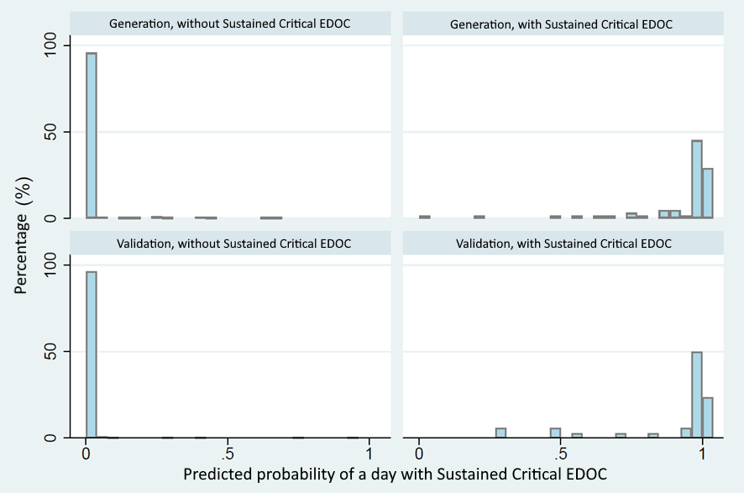

Table s1. Factors associated with Sustained Critical EDOC start. We present crude ORs for each variable for Sustained Critical EDOC, with their 95% confidence intervals and p values.
Characteristics | Crude OR  (95%CI)  (668 days) | p-value
Management variables*
Days of the week
Sunday (reference) | 1
Monday | 1.473 (CI95% 0.625 - 3.471) | 0.376
Tuesday | 1.888 (CI95% 0.831 - 4.291) | 0.129
Wednesday | 0.366 (CI95% 0.086 - 1.553) | 0.173
Thursday | 1.251 (CI95% 0.505 - 3.097) | 0.629
Friday | 2.206 (CI95% 0.999 - 4.867) | 0.050
Non working day | 0.180 (CI95% 0.054 - 0.595) | 0.005
Day after a long weekend | 5.325 (CI95% 1.668 - 16.993) | 0.005
Day before a long weekend | 1.136 (CI95% 0.146 - 8.821) | 0.903
Winter holidays | 0.614 (CI95% 0.081 - 4.640) | 0.636
All holidays | 0.147 (CI95% 0.035 - 0.619) | 0.009
Weather variables
Relative ambient humidity in 1% increments | 1.003 (CI95% 0.976 - 1.030) | 0.837
Atmospheric pressure, for each 1 hPa increment | 1.033 (CI95% 0.976 - 1.094) | 0.264
Minimum temperature, in 1 °C increases | 0.903 (CI95% 0.845 - 0.965) | 0.003
Maximum temperature, in 1 °C increases | 0.937 (CI95% 0.886 - 0.990) | 0.022
Cold days | 1.103 (CI95% 0.254 - 4.796) | 0.896
Precipitation (in 1mm of water increments) | 0.963 (CI95% 0.902 - 1.028) | 0.255
Rainy days | 0.54 (CI95% 0.220 - 1.327) | 0.180
Variables related to patients visiting the ED
Average patient age from the previous day, for each 1 year increment | 0.949 (CI95% 0.741 - 1.218) | 0.683
Percentage of patients consulting on each day for ILD, for each 1% increment | 1.278 (CI95% 0.959 - 1.702) | 0.094
Percentage of patients consulting on previous day for ILD, for each 1% increment | 1.587 (CI95% 1.174 - 2.145) | 0.003
Percentage of green triage patients, for each 1% increment | 0.854 (CI95% 0.734 - 0.994) | 0.042
Percentage of yellow triage patients, for each 1% increment | 0.901 (CI95% 0.737 - 1.101) | 0.309
Percentage of red triage patients, for each 1% increment | 1.576 (CI95% .257 - 9.652) | 0.623
Percentage of white + blue triage patients, for each 1% increment | 1.140 (CI95% 1.013 - 1.283) | 0.030
Variables related to ED staff and to hospital staff†
Resident’s experience in days, for each 1 day increment | 0.998 (CI95% 0.994 - 1.001) | 0.181
Resident’s experience in months, for each 1 month increment | 0.935 (CI95% 0.844 - 1.037) | 0.204
ED administrative staff absenteeism, for each 1% increase | 0.931 (CI95% 0.86 - 1.008) | 0.080
ED nursing staff absenteeism, for each 1% increase | 0.995 (CI95% 0.911 - 1.087) | 0.911
Hospital administrative staff absenteeism, for each 1% increase | 1.062 (CI95% 0.992 - 1.136) | 0.082
Hospital nursing staff absenteeism, for each 1% increase | 1.013 (CI95% 0.908 - 1.13) | 0.817
Internal Medicine congress week | 3.078 (CI95% 0.36 - 26.295) | 0.304
Week before the internal medicine congress | 3.141 (CI95% 0.675 - 14.614) | 0.144
General surgery congress week | 2.634 (CI95% 0.315 - 22.025) | 0.371
Traumatology congress week | 2.301 (CI95% 0.28 - 18.932) | 0.438
Week after the anesthesiology congress | 1.524 (CI95% 0.192 - 12.069) | 0.690
Variables related to bed occupancy and inpatient flow
Previous day hospital LOS, for each 1 day increment | 1.12 (CI95% 0.855 - 1.466) | 0.412
Percentage of inpatients whose LOS is in the 4th quartile, for each 1% increment | 1.024 (CI95% 0.942 - 1.113) | 0.575
Previous day general bed occupancy, for each 1% increment | 1.165 (CI95% 1.044 - 1.299) | 0.006
Previous day critical care unit occupancy, for each 1% increment | 1.235 (CI95% 1.120 - 1.362) | <0.001
Total number of surgeries scheduled in a day, for each 1 surgery increment | 1.046 (CI95% 1.02 - 1.073) | 0.001
Variables related to previous day EDOC
Average previous day NEDOCS score, for each 1 point increment | 1.114 (CI95% 1.081 - 1.149) | <0.001
Previous day percentage of black NEDOCS hours, for each 1% increment | 1.284 (CI95% 1.182 - 1.395) | <0.001
Previous day percentage of black and red NEDOCS hours, for each 1% increment | 1.060 (CI95% 1.046 - 1.075) | <0.001
Percentage of LWOS patients, for each 1% increment | 1.309 (CI95% 1.156 - 1.483) | <0.001
Percentage of LWOS patients on the previous day, for each 1% increment | 1.112 (CI95% 0.967 - 1.28) | 0.136
*We omitted 1. Saturdays, 2. Hot day, 3. General surgery, 4. week after general surgery congress, 5. week before traumatology congress, 6. week of anesthesiology congress, 7. week before anesthesiology congress due to lack of events within strata.
Abbreviations: hPa hectopascals; °C degrees centigrade, ILD Influenza-like disease; ED emergency department; LWOS left without being seen.

Table s2. Factors associated with Sustained Critical EDOC end. We present crude ORs for each variable for Sustained Critical EDOC, with their 95% confidence intervals and p values.
Characteristics | Crude OR  (95%CI)  (132 days) | p-value
Management variables*
Days of the week
Sunday (reference) | 1
Monday | 0.644 (CI95% 0.171 - 2.429) | 0.516
Tuesday | 0.241 (CI95% 0.053 - 1.095) | 0.065
Wednesday | 1.093 (CI95% 0.388 - 3.077) | 0.866
Thursday | 1.093 (CI95% 0.388 - 3.078) | 0.866
Friday | 0.878 (CI95% 0.318 - 2.422) | 0.801
Saturday | 2.486 (CI95% 0.894 - 6.911) | 0.081
Non working day | 2.176 (CI95% 0.940 - 5.037) | 0.069
Day before a short holiday | 2.743 (CI95% 0.167 - 45.046) | 0.480
Winter holidays | 0.895 (CI95% 0.090 - 8.895) | 0.925
All holidays | 1.367 (CI95% 0.239 - 7.809) | 0.725
Weather variables
Relative ambient humidity in 1% increments | 1.026 (CI95% 0.994 - 1.060) | 0.114
Atmospheric pressure, for each 1 hPa increment | 0.963 (CI95% 0.904 - 1.026) | 0.246
Minimum temperature, in 1 °C increases | 1.068 (CI95% 0.977 - 1.169) | 0.147
Maximum temperature, in 1 °C increases | 0.989 (CI95% 0.918 - 1.065) | 0.769
Cold days | 1.029 (CI95% 0.339 - 3.127) | 0.959
Precipitation (in 1mm of water increments) | 1.010 (CI95% 0.959 - 1.063) | 0.704
Rainy days | 1.906 (CI95% 0.795 - 4.574) | 0.148
Variables related to patients visiting the ED
Average patient age from the previous day, for each 1 year increment | 0.999 (CI95% 0.752 - 1.328) | 0.997
Percentage of patients consulting on each day for ILD, for each 1% increment | 0.956 (CI95% 0.740 - 1.237) | 0.733
Percentage of patients consulting on previous day for ILD, for each 1% increment | 0.619 (CI95% 0.422 - 0.909) | 0.014
Percentage of green triage patients, for each 1% increment | 1.095 (CI95% 0.905 - 1.325) | 0.349
Percentage of yellow triage patients, for each 1% increment | 1.260 (CI95% 0.987 - 1.610) | 0.063
Percentage of red triage patients, for each 1% increment | 2.492 (CI95% 0.529 - 11.736) | 0.248
Percentage of white + blue triage patients, for each 1% increment | 0.876 (CI95% 0.766 - 1.001) | 0.052
Variables related to ED staff and to hospital staff†
Resident’s experience in days, for each 1 day increment | 1.002 (CI95% 0.999 - 1.005) | 0.200
Resident’s experience in months, for each 1 month increment | 1.068 (CI95% 0.968 - 1.179) | 0.191
ED administrative staff absenteeism, for each 1% increase | 1.020 (CI95% 0.915 - 1.138) | 0.715
ED nursing staff absenteeism, for each 1% increase | 0.982 (CI95% 0.873 - 1.105) | 0.767
Hospital administrative staff absenteeism, for each 1% increase | 0.929 (CI95% 0.846 - 1.018) | 0.118
Hospital nursing staff absenteeism, for each 1% increase | 0.922 (CI95% 0.783 - 1.086) | 0.332
Internal Medicine congress week | 2.794 (CI95% 0.379 - 20.619) | 0.314
Week before the internal medicine congress | 1.357 (CI95% 0.119 - 15.439) | 0.806
General surgery congress week | 1.357 (CI95% 0.119 - 15.439) | 0.806
Variables related to bed occupancy and inpatient flow
Previous day hospital LOS, for each 1 day increment | 1.032 (CI95% 0.757 - 1.407) | 0.841
Percentage of inpatients whose LOS is in the 4th quartile, for each 1% increment | 1.003 (CI95% 0.911- 1.104) | 0.945
Previous day general bed occupancy, for each 1% increment | 0.831 (CI95% 0.732 - 0.943) | 0.004
Previous day critical care unit occupancy, for each 1% increment | 0.909 (CI95% 0.816 - 1.012) | 0.084
Total number of surgeries scheduled in a day, for each 1 surgery increment | 0.977 (CI95% 0.956 - 0.997) | 0.029
Variables related to previous day EDOC
Average previous day NEDOCS score, for each 1 point increment | 0.924 (CI95% 0.896 - 0.953) | <0.001
Previous day percentage of black NEDOCS hours, for each 1% increment | 0.834 (CI95% 0.780 - 0.893) | <0.001
Previous day percentage of black and red NEDOCS hours, for each 1% increment | 0.950 (CI95% 0.934 - 0.967) | <0.001
Percentage of LWOS patients, for each 1% increment | 0.833 (CI95% 0.701 - 0.991) | 0.040
Percentage of LWOS patients on the previous day, for each 1% increment | 0.833 (CI95% 0.692 - 1.002) | 0.054
*We omitted 1. day after short holiday, 2. week after internal medicine congress, 3. week before general surgery congress, 4. week after general surgery congress 5. week before traumatology congress, 6. week of anesthesiology congress, 7. week before anesthesiology congress, 8. hot day, 9.day before long weekend, 10. day after long weekend, 11 week of traumatology congress, 12 week after the traumatology congress, 13 week after anesthesiology congress due to lack of events within strata.
Abbreviations: hPa hectopascals; °C degrees centigrade, ILD Influenza-like disease; ED emergency department; LWOS left without being seen

Table s3. Collinearity testing. We present the collinearity testing for variables included in the Sustained Critical EDOC model n° 10.

 | Saturdays | Relative ambient humidity | Cold day | Winter + summer holidays | Percentage of patients whose LOS is in the 4th quartile | General ward bed occupancy on previous day | Previous day average NEDOCS score | Previous day percentage of red and black NEDOCS hours
Saturdays | 1
Relative ambient humidity | -0,0027 | 1
Cold day | -0,0285 | 0,1269 | 1
Winter + Summer holidays | 0,0173 | -0,1726 | -0,0096 | 1
Percentage of patients whose LOS is in the 4th quartile | 0,3933 | 0,0362 | 0,0541 | 0,0674 | 1
General ward bed occupancy on previous day | -0,3616 | 0,1001 | 0,0887 | -0,166 | -0,2723 | 1
Previous day average NEDOCS score | -0,0106 | 0,0615 | 0,1059 | -0,312 | 0,1244 | 0,3032 | 1
Previous day percentage of red and black NEDOCS hours | -0,0227 | 0,0444 | 0,0851 | -0,2706 | 0,1138 | 0,2287 | 0,8683 | 1
Previous day percentage of black NEDOCS hours | -0,0499 | 0,0292 | 0,1301 | -0,2169 | 0,1086 | 0,167 | 0,8195 | 0,7871

Table s4. Interaction terms tested during model construction. a) Multivariable analisis p-value for interaction term 0.241. b) Multivariable analisis p-value for interaction term 0.311. c) Multivariable analisis p-value for interaction term 0.258. All additional p values correspond to the multivariable model for Sustained Critical EDOC.

 | Winter + Summer holidays | Previous day average NEDOCS score | Previous day percentage of red and black NEDOCS hours | Previous day percentage of red and black NEDOCS hours | Cold Day | Percentage of red triage patients | Percentage of patients whose LOS is in the 4th quartile
Winter + Summer holidays | -
Previous day average NEDOCS score | 0,654 | -
Previous day percentage of red and black NEDOCS hours | 0,981 | 0,923 | -
Previous day percentage of black NEDOCS hours | 0,990 | 0,060^{b} | 0,258 | -
Cold day | 0,609 | 0,855 | 0,365 | 0,966 | -
Percentage of red triage patients | 0,166 | 0,474 | 0,8 | 0,858 | 0,276 | -
Percentage of patients whose LOS is in the 4th quartile | 0,530 | 0,413 | 0,327 | 0,484 | 0,222 | 0,549 | -
Relative ambient humidity | 0,005ª | 0,915 | 0,924 | 0,315 | 0,012^{c} | 0,349 | 0,130

Table s5. Calibration for the n°10 Sustained Critical EDOC predictive model. Estimated and observed probabilities are presented in deciles. In the table we show the high calibration evidence by a high concordance between predicted and observed deciles.
 | Apparent calibration  Generation cohort  (487 days) |  |  | Internal validation calibration  Validation cohort  (243 days)
Percentile | Number of days | Observed probability | Model estimated probability | Number of days | Observed probability | Model estimated probability
1 | 49 | 0 | 6.92*10⁻¹⁰ | 21 | 0 | 1.05*10⁻⁹
2 | 47 | 0 | 2.44*10⁻⁸ | 23 | 0 | 2.10*10⁻⁸
3 | 46 | 0 | 2.77*10⁻⁷ | 24 | 0 | 2.47*10⁻⁷
4 | 50 | 0 | 2.11*10⁻⁶ | 19 | 0 | 2.41*10⁻⁶
5 | 45 | 0 | 9.64*10⁻⁶ | 25 | 0 | 9.54*10⁻⁶
6 | 41 | 0 | 0.00004 | 29 | 0 | 0.00004
7 | 46 | 0 | 0.00023 | 23 | 0 | 0.0003
8 | 46 | 0.02 | 0.0024 | 24 | 0 | 0.003
9 | 51 | 0.31 | 0.33 | 19 | 0.53 | 0.48
10 | 45 | 1 | 1 | 24 | 1 | 1
Total | 466 | 0.13 | 0.13 | 231 | 0.15 | 0.14

Figure s2. Calibration by bootstrapping. Calibration graph adjusted for optimism of Sustained Critical EDOC predictive models showing high calibration. It was generated using a number of 200 bootstrapping samples of size 730.
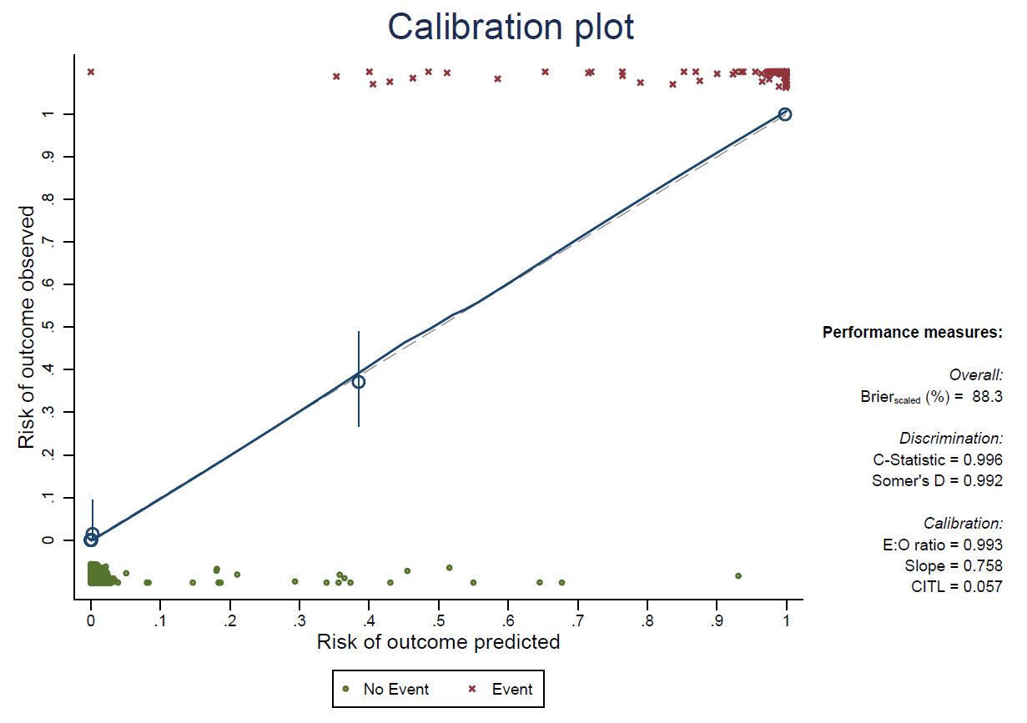

Figure s3. Discrimination. We present the AUROC for the generation and validation groups, as well as the ROC curves of each subgroup for Sustained Critical EDOC start.
Apparent discrimination  Generation group  (449 days) | Internal validation discrimination  Validation group  (219 days)
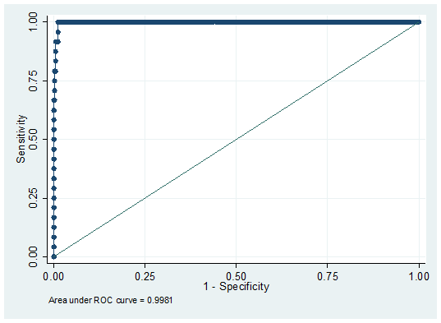 | 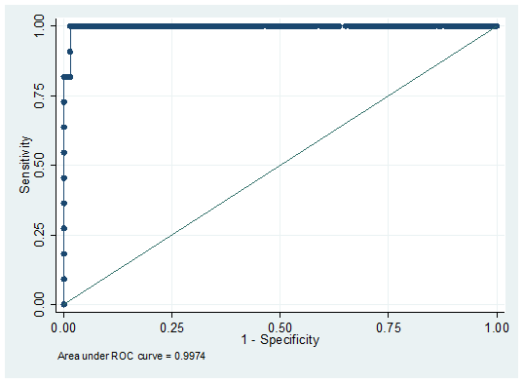
0.9981 (CI95% 0.995 - 1) | 0.9974 (CI95% 0.992 - 1)

Figure s4. Calibration graph for the Sustained Critical EDOC start predictive model using generation and validation days.
Apparent calibration  Generation group  (449 days) | Internal validation calibration  Validation group  (219 days)
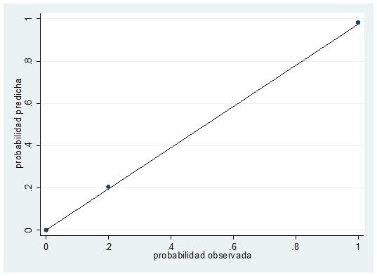 | 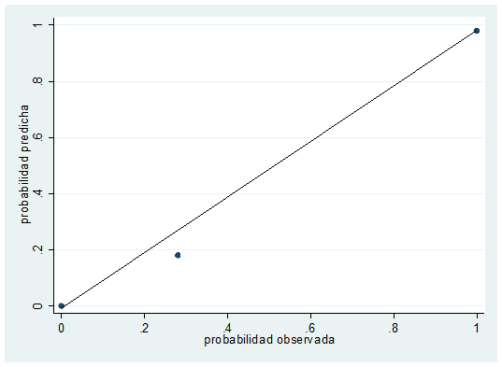

Figure s5. Discrimination. We present the AUROC for the generation and validation groups, as well as the ROC curves of each subgroup for Sustained Critical EDOC end.
Apparent discrimination  Generation group  (87 days) | Internal validation discrimination  Validation group  (45 days)
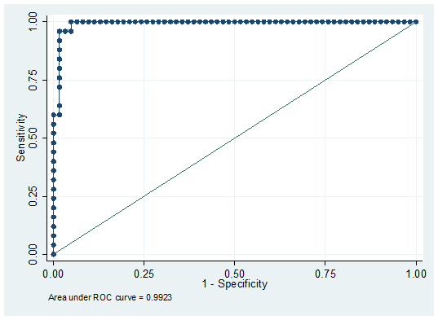 | 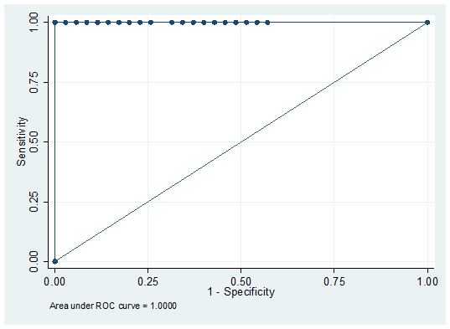
0.9923 (CI95% 0.978 - 1) | 1(CI95% 1-1)

Figure s6. Calibration graph for the Sustained Critical EDOC end predictive model using generation and validation days.
Apparent calibration  Generation group  (87 days) | Internal validation calibration  Validation group  (45 days)
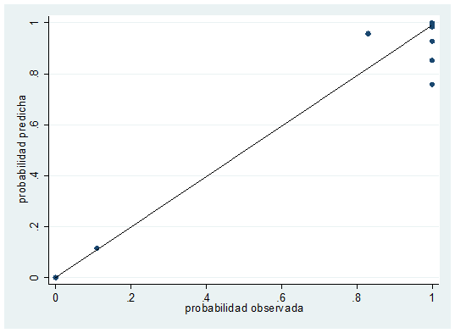 | 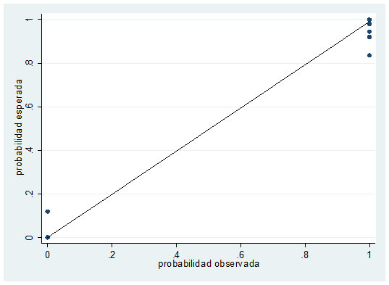

Figure s7. Here we show the absolute frequency of 4 NEDOCS components throughout the study period for the external temporal validation done in the HIBA Central hospital from 01jan2019 to 01jan2020. The x-axis represents the exact same parameter for all 4 graphs (individual hours in the study period), and the y-axis represents the parameter of interest. A) Longest waiting time for a bed for patients admitted from the ED, measured in hours by a function of each of the hours measured in the study; B) Number of patients intubated and ventilated in the ED, by a function of time. Note the large increment corresponding to the winter of 2017; C) Largest number of hours a patient had to wait until being seen by a physician in the ED, by a function of study time; D) Number of patients admitted to the ED, by a function of time.

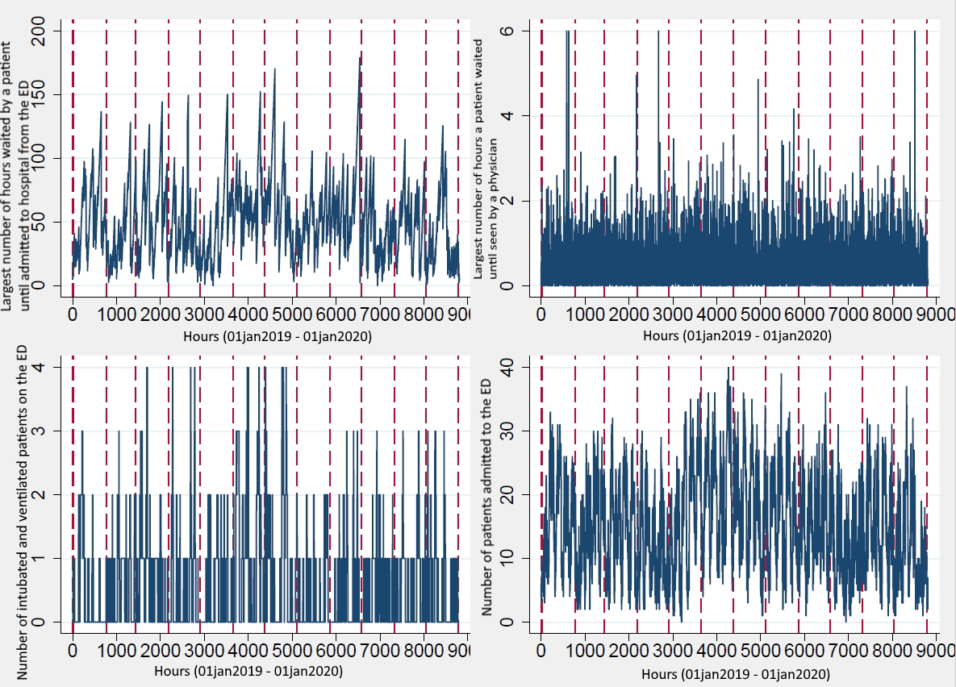

Figure s8. Contour graph showing the totality of days evaluated in the period 01jan2019 to 01jan2020, corresponding to external temporal validation in the HIBA Central hospital, with the hourly NEDOCS score represented as a color for each value range. Each small square in the graph represents an hour of the day. On the y axis, the days of the week are represented, Monday to Sunday from bottom to top (24 small squares x 7, for the 7 days of the week). On the x-axis, all weeks of the study period are plotted.
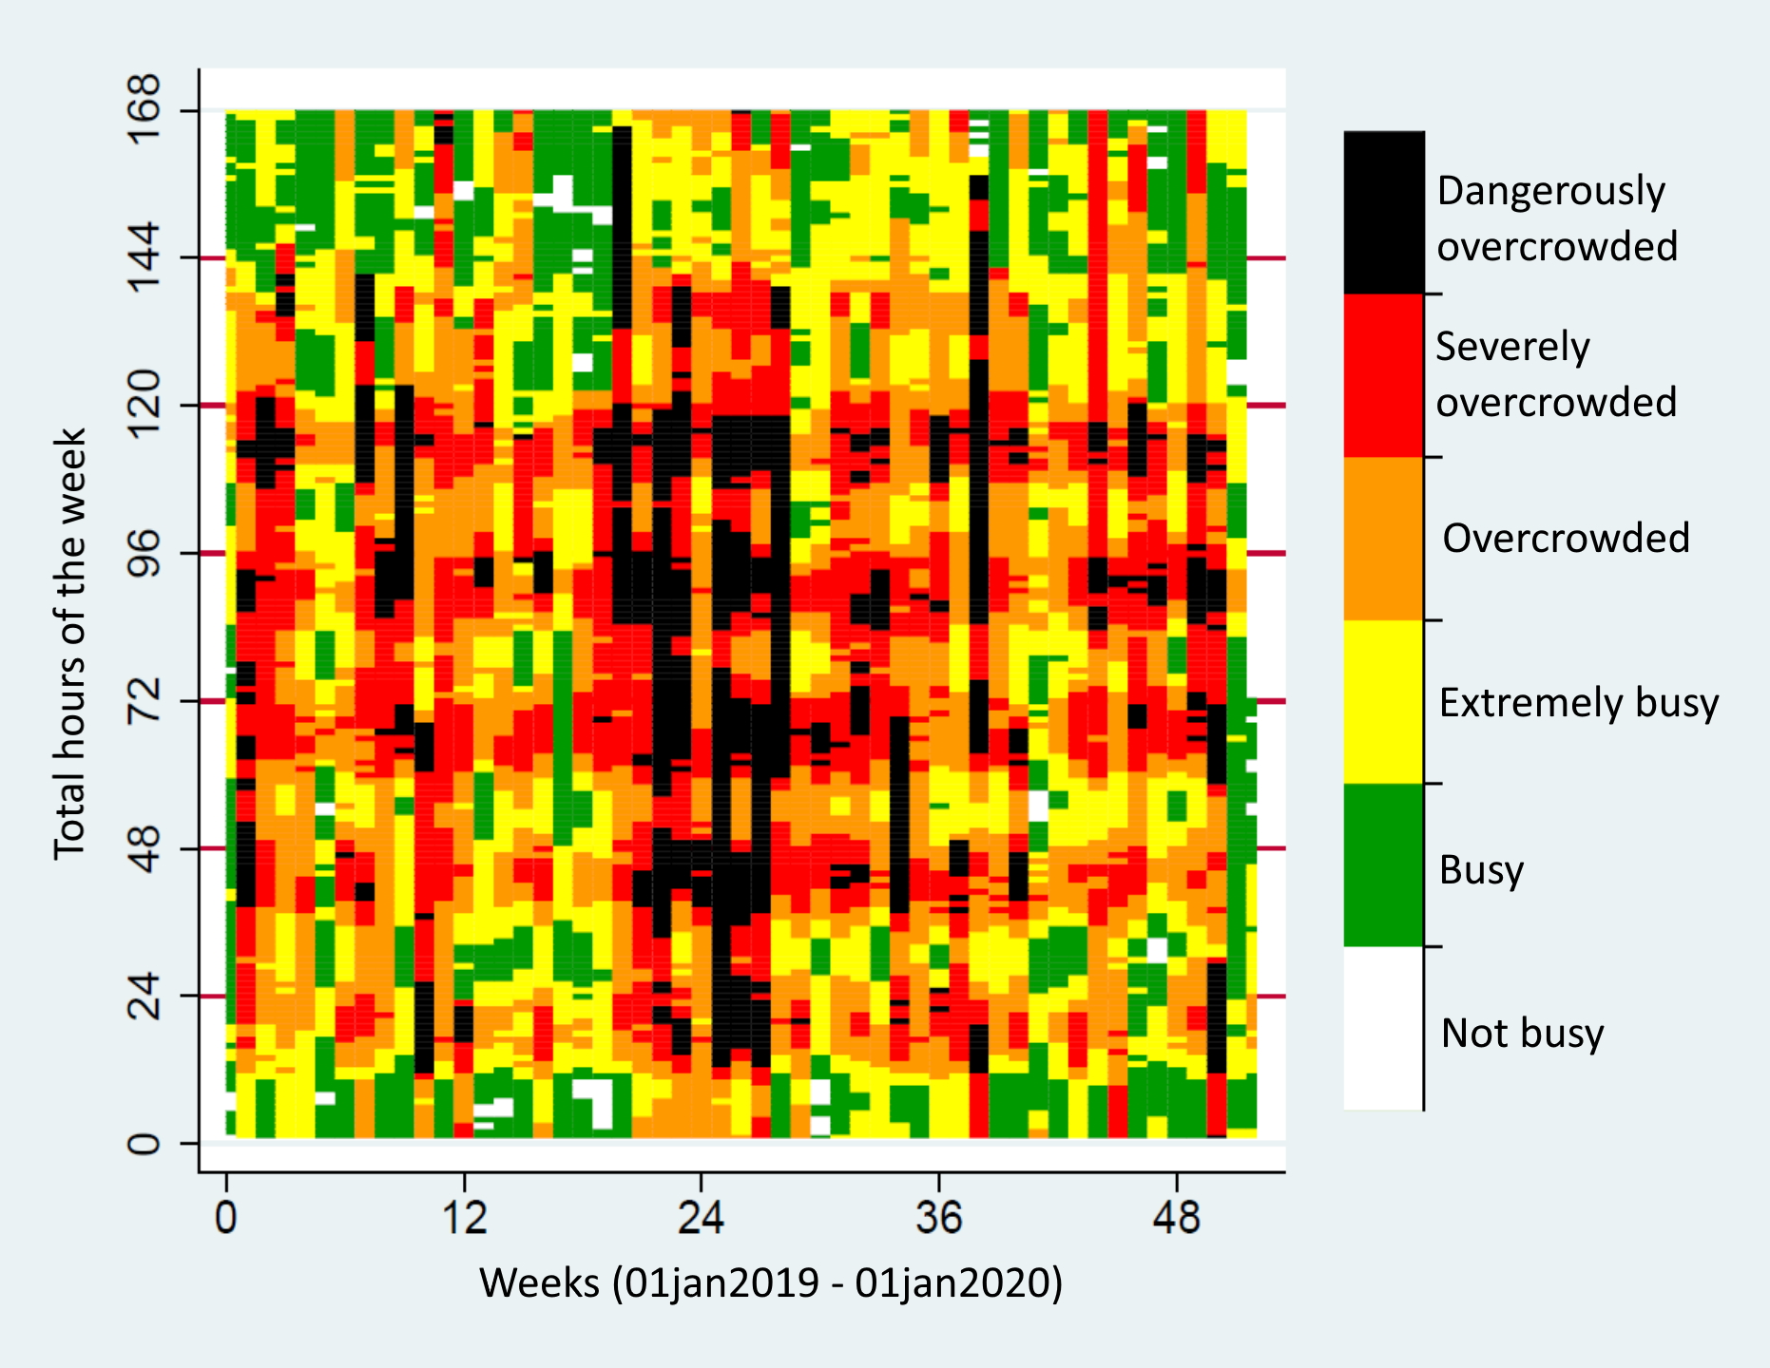
Figure s9. Here we show the absolute frequency of 4 NEDOCS components throughout the study period for the external validation done in the HIBA San Justo hospital from 01jan2019 to 01jan2020. The x-axis represents the exact same parameter for all 4 graphs (individual hours in the study period), and the y-axis represents the parameter of interest. A) Longest waiting time for a bed for patients admitted from the ED, measured in hours by a function of each of the hours measured in the study; B) Number of patients intubated and ventilated in the ED, by a function of time. Note the large increment corresponding to the winter of 2017; C) Largest number of hours a patient had to wait until being seen by a physician in the ED, by a function of study time; D) Number of patients admitted to the ED, by a function of time.
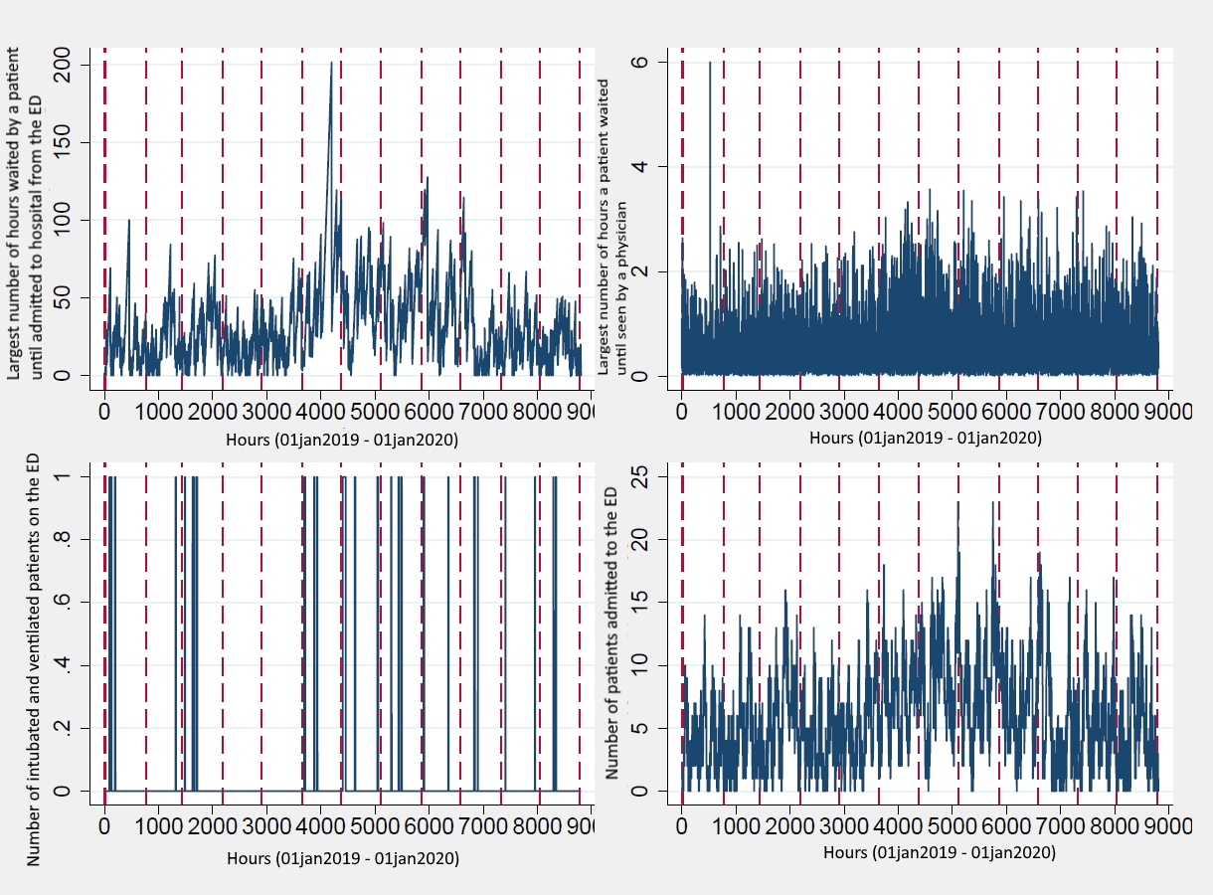

Figure s10. Contour graph showing the totality of days evaluated in the period 01jan2019 to 01jan2020, corresponding to external validation in the Hospital Italiano de San Justo hospital, with the hourly NEDOCS score represented as a color for each value range. Each small square in the graph represents an hour of the day. On the y axis, the days of the week are represented, Monday to Sunday from bottom to top (24 small squares x 7, for the 7 days of the week). On the x-axis, all weeks of the study period are plotted.
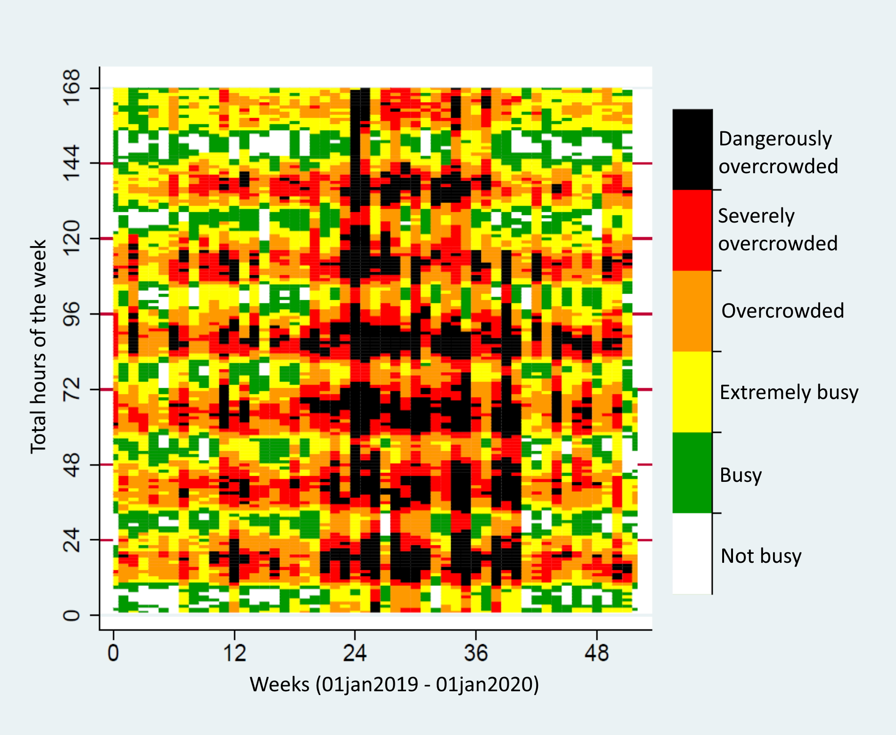

Figure s11. Discrimination in the external validation group. We present the AUROC in the HIBAC and HIBA San Justo hospitals for each subgroup and for the 3 predictive models. A) Sustained Critical EDOC model, temporal external validation HIBAC; B) Sustained Critical EDOC model, external validation HIBA San Justo; C) Sustained Critical EDOC start model, temporal external validation HIBAC; D) Sustained Critical EDOC start, external validation HIBA San Justo; E) Sustained Critical EDOC end model, temporal external validation HIBAC; F) Sustained Critical EDOC end, external validation HIBA San Justo. Acceptable sizes of AUROC are seen.
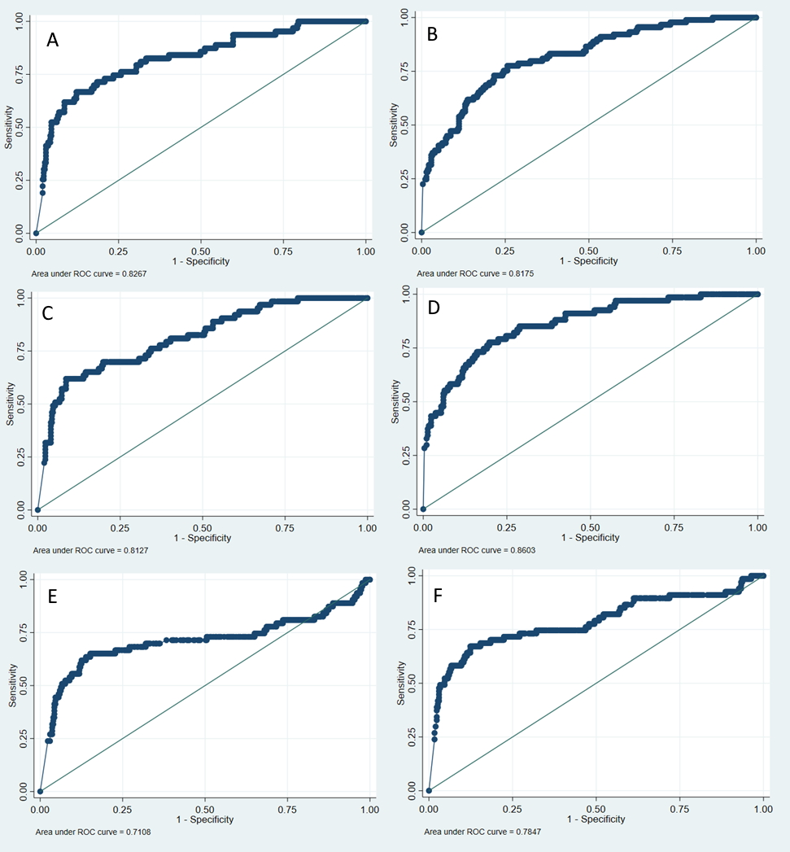

Figure s12. Calibration by groups in the external validation cohort. We present the calibration graphs in the external validation day group for HIBAC and HIBA San Justo hospitals for the 3 predictive models. A1 and A2 show the calibration graphs for the Sustained Critical EDOC model; B1 and B2 show the graph for the Sustained Critical EDOC start model and C1 and C2 show the graph for the Sustained Critical EDOC end model.
