Supplementary Material

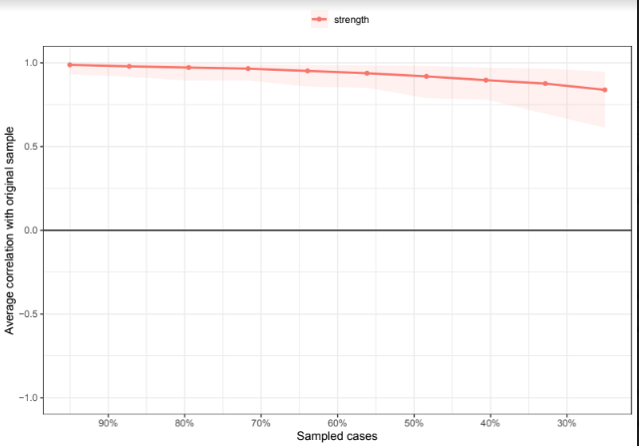
Supplementary figure 1. Stability of Centrality Estimates from Case-Dropping Bootstrap
Note. This figure shows the stability of the estimated strength in the network of ICD-11 C-PTSD symptoms under a case-dropping bootstrap. This was performed with 2500 bootstrapped samples with 10 levels, dropping between 5% and 75% of participants. The x-axis shows the proportion of the sample dropped, and the y-axis represents the correlation between the original and case-dropped centrality values. The figure shows how the centrality estimates were highly stable, with the correlation with the original sample remaining very strong even after 75% of the sample had been dropped.

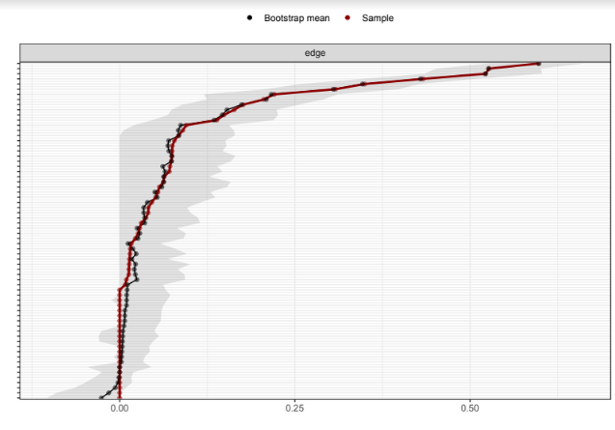
Supplementary figure 2. Accuracy of Edge Weights from Non-Parametric Bootstrap
Note. This figure shows the bootstrapped 95% confidence intervals (CIs) around the estimated edge weights/partial correlation coefficients in the network of ICD-11 C-PTSD. The x-axis values represent the edge weights. The ticks on the y-axis each represent one edge (labels removed to avoid cluttering), ordered by edge weight estimated in the sample. The red line indicates the sample values (a sample value of 0 means the edge was not included in the network), while the black line represents the mean edge weight across 2500 bootstraps. The gray area represents the bootstrapped CIs. The narrower the CI, the more accurate the estimated edge weight.

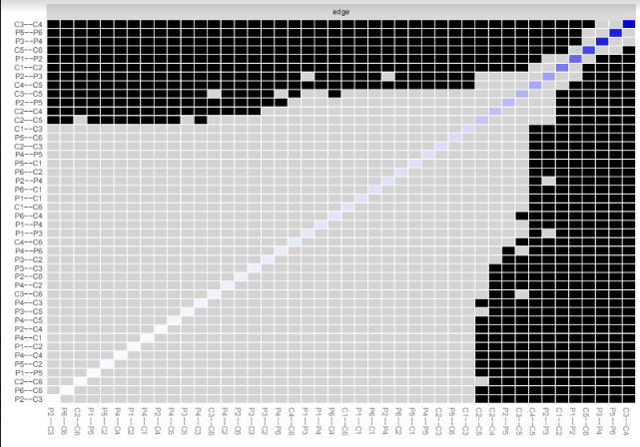
Supplementary figure 3. Significant Differences between Edges
Note. This figure shows the results of the bootstrapped difference tests between edge weights estimated to be non-zero in the network of C-PTSD symptoms. Black cells indicate a significant difference between the two corresponding edge weights at p˂.05. Gray cells indicate a non-significant difference.

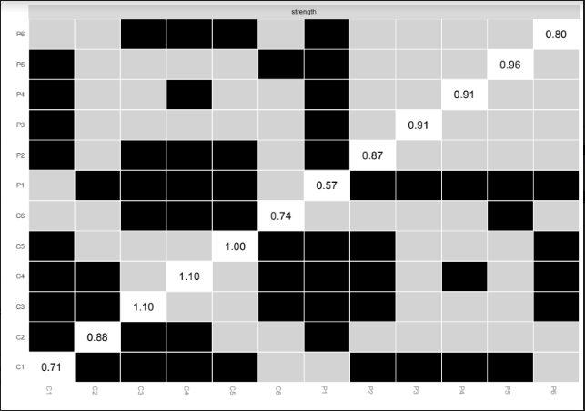
Supplementary figure 4. Significant Differences Between Strength
Node. This figure shows the results of the strength centrality difference tests for the C-PTSD symptom network. Black cells indicate a significant difference between the two corresponding edge weights at p˂.05. Gray cells indicate a non-significant difference.

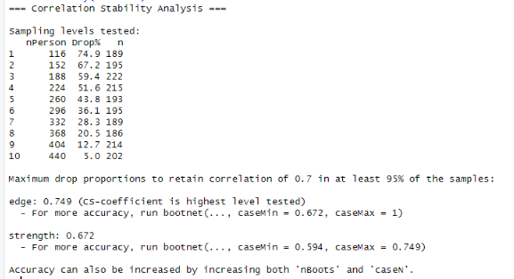
Supplementary figure 5. The correlation stability of C-PTSD symptoms network

