Supplementary Information

Investigating deformation and seismic data and their relationships during the ongoing unrest of Campi Flegrei caldera (Italy)

A.Bevilacqua⁽¹⁾, A. Neri^{(1,*)}, P. De Martino⁽²⁾, F. Giudicepietro⁽²⁾, G. Macedonio⁽²⁾, P. Ricciolino⁽²⁾

(1) Istituto Nazionale di Geofisica e Vulcanologia, Sezione di Pisa, Pisa
(2) Istituto Nazionale di Geofisica e Vulcanologia, Osservatorio Vesuviano, Napoli
(*) Corresponding author (augusto.neri@ingv.it)

Description

This supplementary information consists of 9 figures and 1 table, all referred to in the main text. Their content and meaning are briefly described in the main text and in the associated captions.

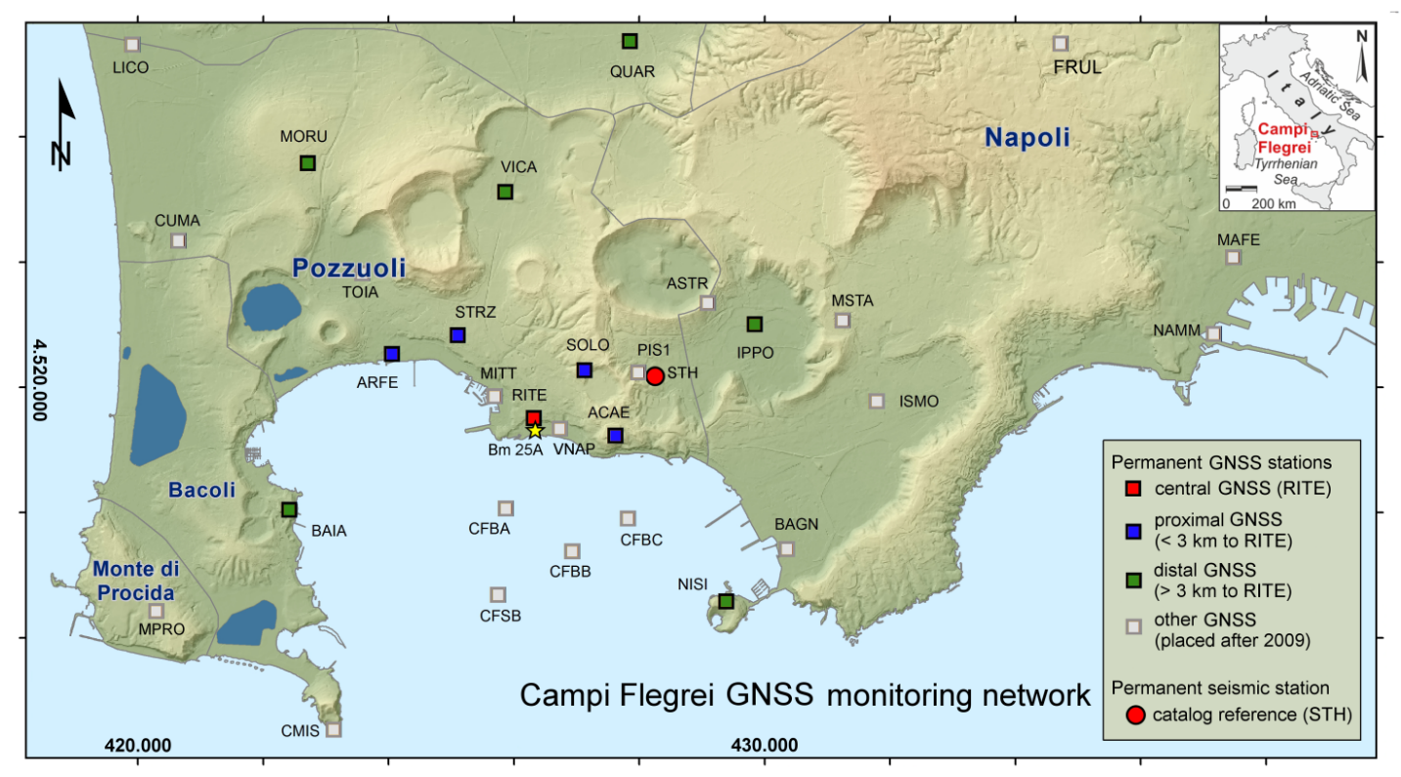
Figure 1-SI Map of Campi Flegrei caldera with locations of geophysical stations and geophysical data in the period 1981-2024. (a) GNSS and seismic monitoring networks at CFc. Background map modified from the INGV-OV periodic bulletin of CFc. The GNSS RITE station is in red whereas the other GNSS stations and buoys are in different colors (see legend). The seismic catalog reference station STH is a red circle.

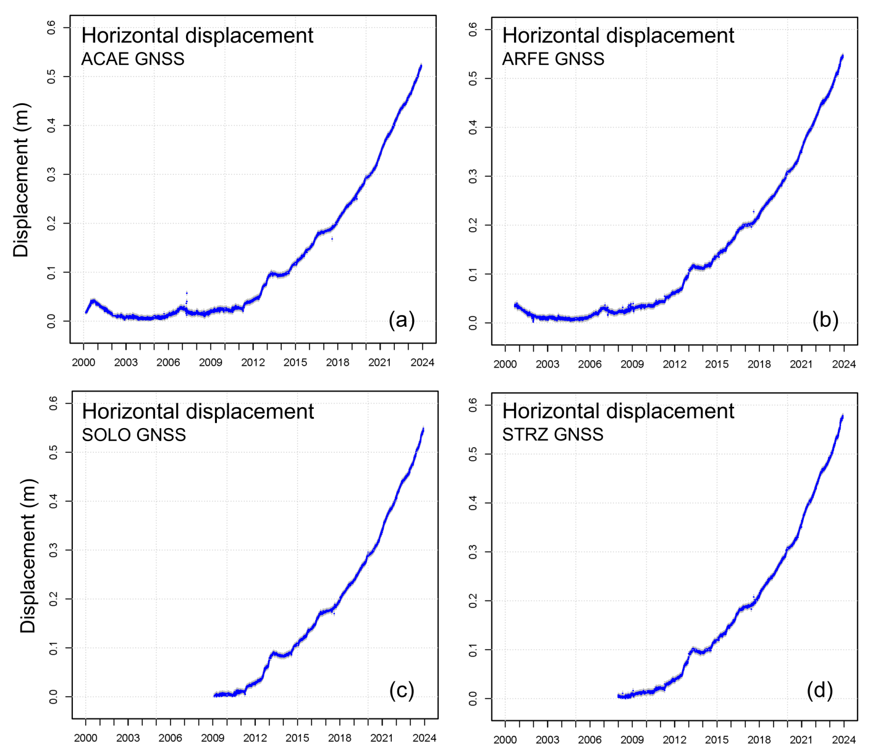

Figure 2-SI. Examples of horizontal displacement of various GNSS stations analyzed in the paper. Different datasets refer to different periods of functioning of the stations. The grey range shows the associated uncertainty. The plots are related to the four proximal stations mapped in Fig. 1a (blue squares).

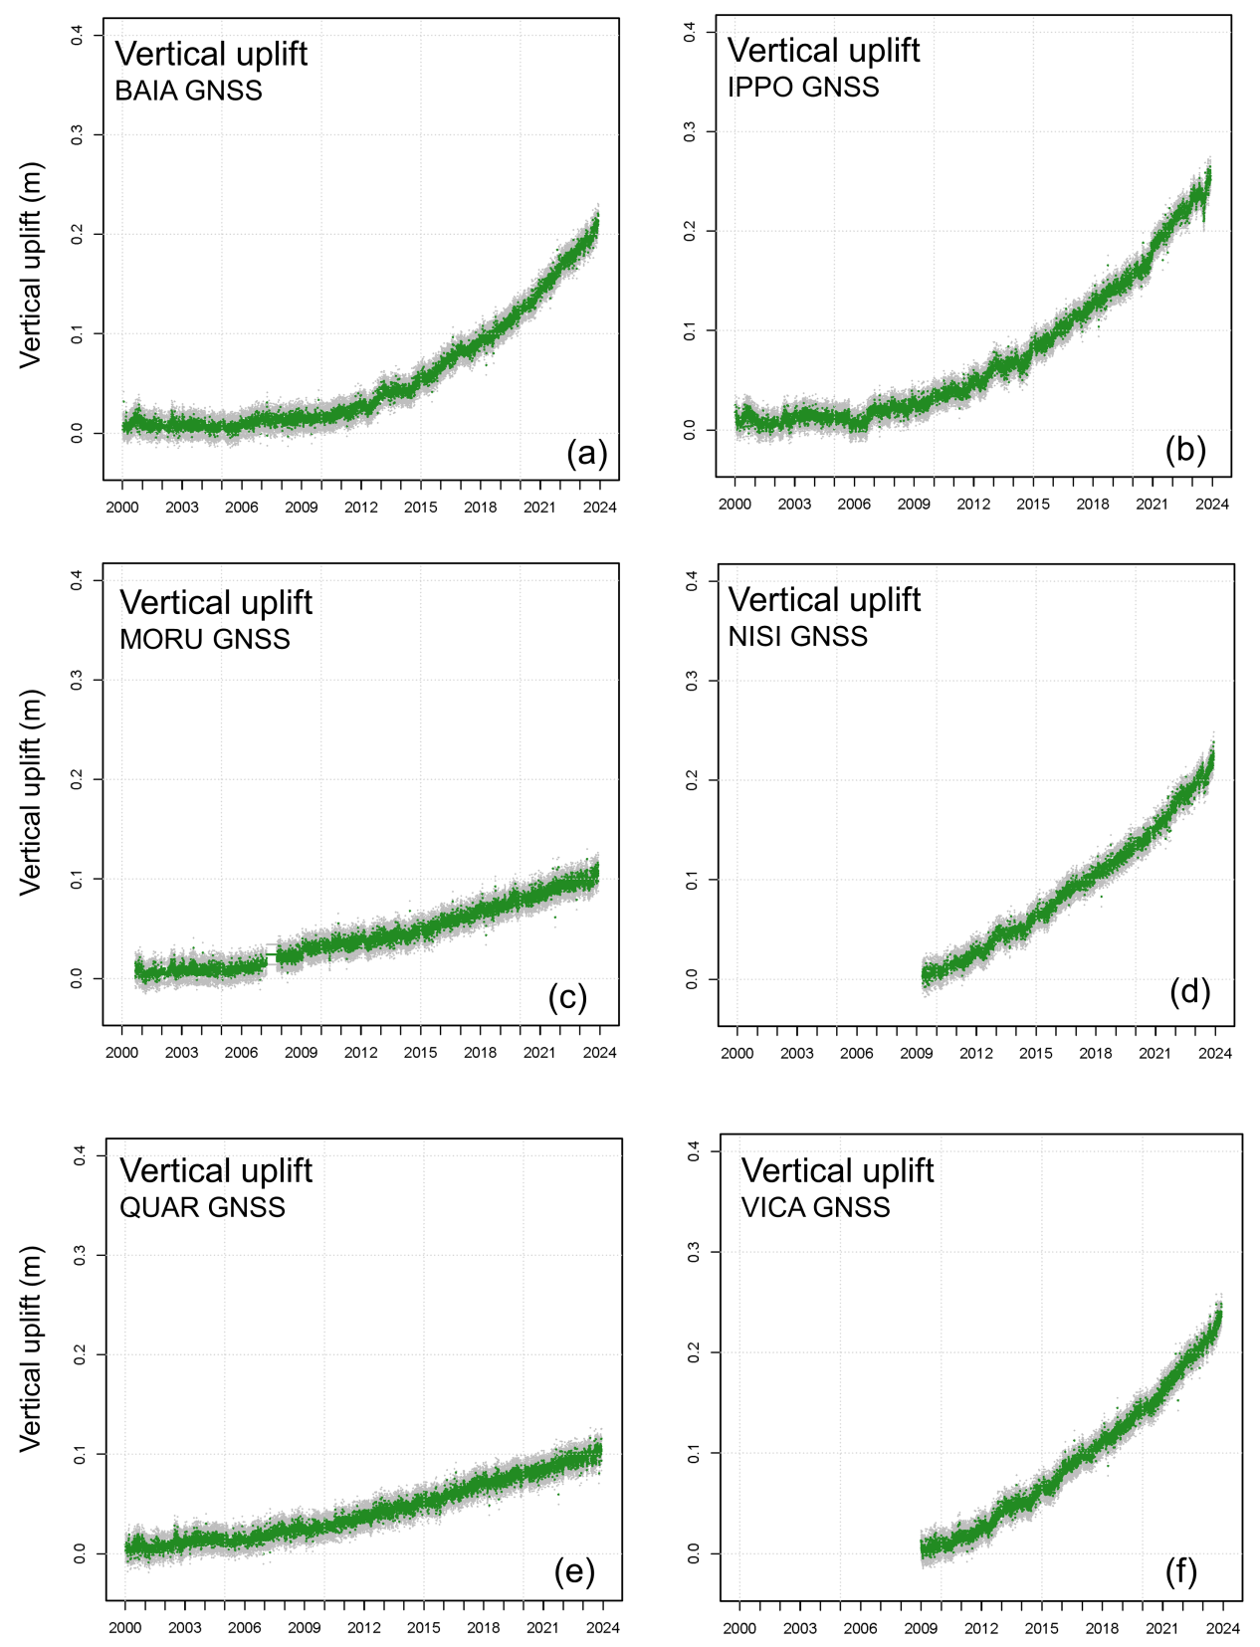

Figure 3-SI. Examples of vertical uplift of various GNSS stations analyzed in the paper. Different datasets refer to different periods of functioning of the stations. The grey range shows the associated uncertainty. The plots are related to the six distal stations mapped in Fig. 1a (green squares).

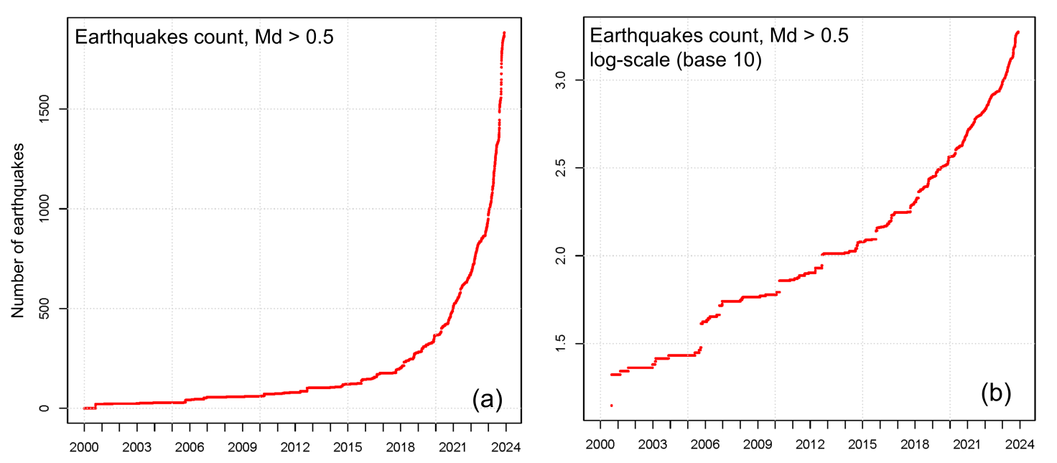

Figure 4-SI. Examples of seismic data analyzed in the paper. Plots (a,b) show the cumulative number of seismic events with M_{d} > 0.5. Plot (a) is in linear scale whereas plot (b) is in logarithmic scale (base 10).

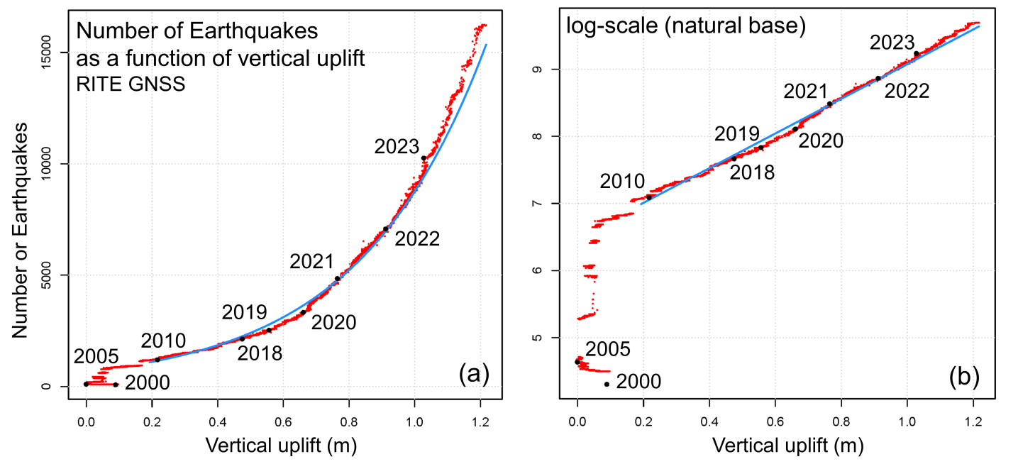

Figure 5-SI. Fitting of the deformation vs seismic count with one exponential function. The deformation refers to the vertical uplift of RITE GNSS station whereas the seismic count to all earthquakes recorded. Plot (a) shows relation with linear coordinates whereas plot (b) uses a log-scale (natural base) for the number of earthquakes. Reference years are indicated with the corresponding labels and black dots.

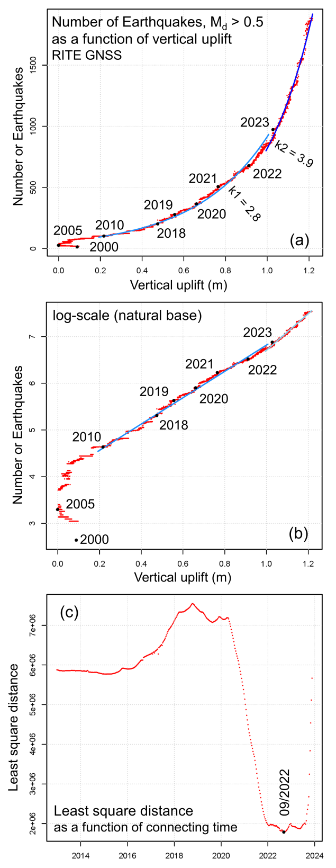

Figure 6-SI. (a) Relationships between vertical uplift at the RITE GNSS station and cumulative number of seismic events with M_{d} > 0.5 over the period 1/2000-11/2023. Data are represented as red dots. Years reported in the labels and as black dots mark the temporal evolution of the uplift. The light and dark blue curves indicate the two exponential functions best-fitting the data. Plot (b) shows the same data and labels of plot (a) but using a log scale (natural base) of the number of earthquakes. Plot (c) shows the quality of the fit, represented by the mean square distance between data and fitting curves, with the varying of the connecting time between the two exponential functions.

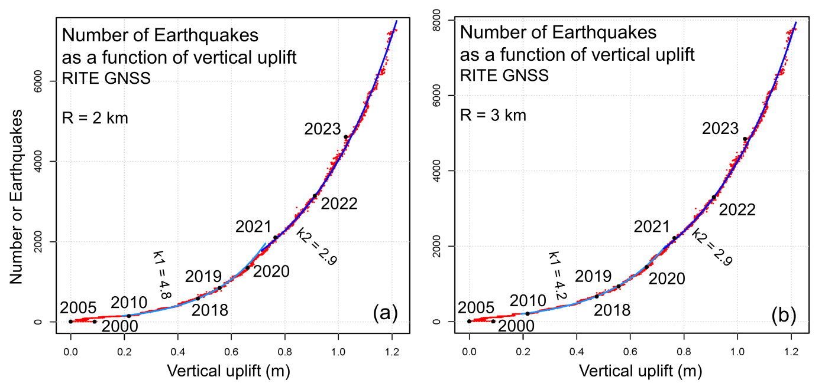

Figure 7-SI. Relationship between vertical uplift at the RITE GNSS station and cumulative number of seismic events with M_{d} > 0.5 over the period 2000-11/2023 considering data within (a) 2 km and (b) 3 km radius from the Solfatara-Pisciarelli area. Data are represented as red dots. Years reported in the labels and as black dots mark the temporal evolution of the uplift. The light and dark blue curves indicate the two exponential functions best-fitting the data.

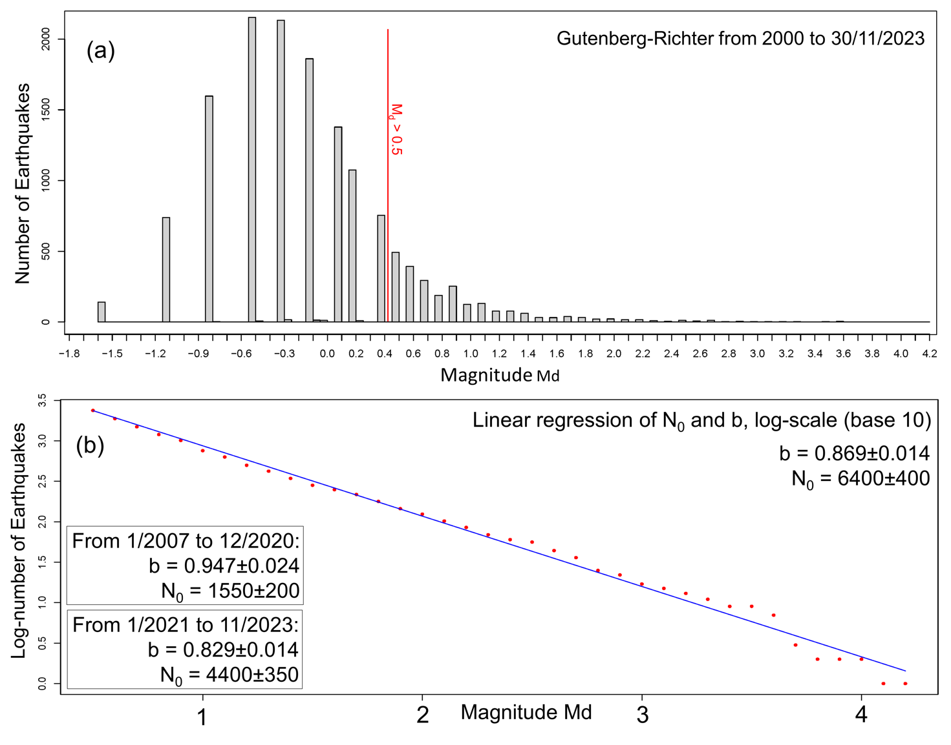

Figure 8-SI. (a) Histogram of the number of earthquakes as a function of magnitude M_{d} for the period 2000-11/2023. The assumed completeness threshold is equal to 0.5. (b) Logarithm to the base 10 of the number of earthquakes as function of M_{d} for the same parameters of plot (a). In the legend of plot (b) are reported the coefficients of the exponential law fitting the data for the above period and for two additional periods (see text for more explanation).

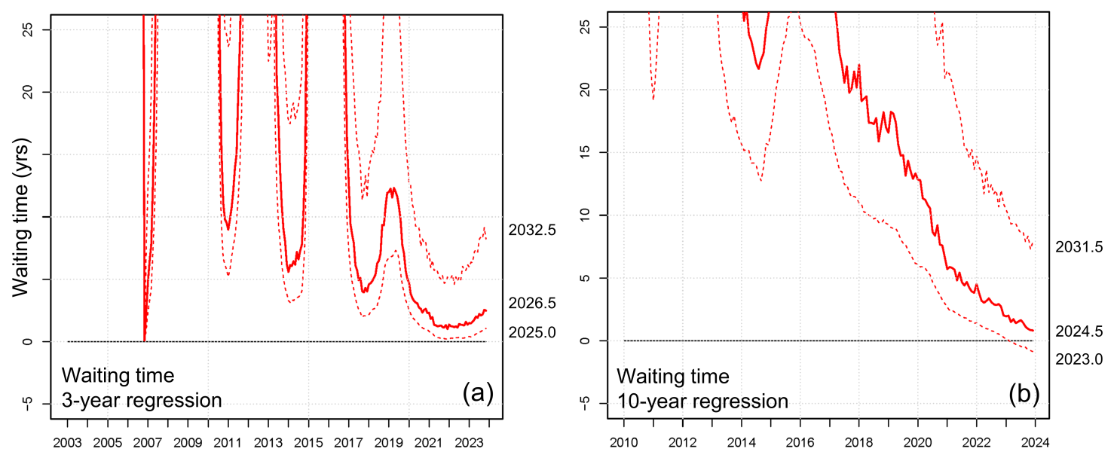

Figure 9-SI: Retrospective analysis of waiting time from 2000 to 11/2023 by using (a) 3-year regression, and (b) 10-year regression. The waiting time (t_{f} − t) from 2000 to 11/2023 is shown as a as a function of the time t at which the forecast was formulated. The bold red line is the mean forecast and the red dashed lines are the 5th and 95th percentiles of its uncertainty range. Both estimates are based on a 2-years average rate.

Table 1-SI: Number of expected earthquakes above various M_{d} thresholds in a population of 2,000 events with M_{d} > 0.5, as a function of the b-value. Values in red are related to magnitude greater than M_{d} = 4.2, the maximum magnitude observed and used in the regression of the Gutenberg-Richter law. The standard deviation σ of the b-value determines the percentage error reported.

 | b value | σ | b value | σ | b value | σ
M_{d} thr. | 0.829 | 0.014 | 0.869 | 0.014 | 0.947 | 0.024
2.5 | 53 | 6% | 45 | 6% | 32 | 11%
2.8 | 30 | 7% | 25 | 7% | 17 | 13%
3.0 | 20 | 8% | 16 | 8% | 11 | 14%
3.2 | 14 | 9% | 11 | 9% | 6.9 | 15%
3.5 | 7.9 | 10% | 6.0 | 10% | 3.6 | 17%
3.8 | 4.4 | 11% | 3.3 | 11% | 1.9 | 19%
4.0 | 3.0 | 12% | 2.2 | 12% | 1.2 | 21%
4.2 | 2.1 | 12% | 1.5 | 12% | 0.78 | 22%
4.5 | 1.2 | 13% | 0.82 | 13% | 0.41 | 24%
4.8 | 0.66 | 14% | 0.45 | 14% | 0.21 | 26%
5.0 | 0.45 | 15% | 0.30 | 15% | 0.14 | 28%

