Supplemental material
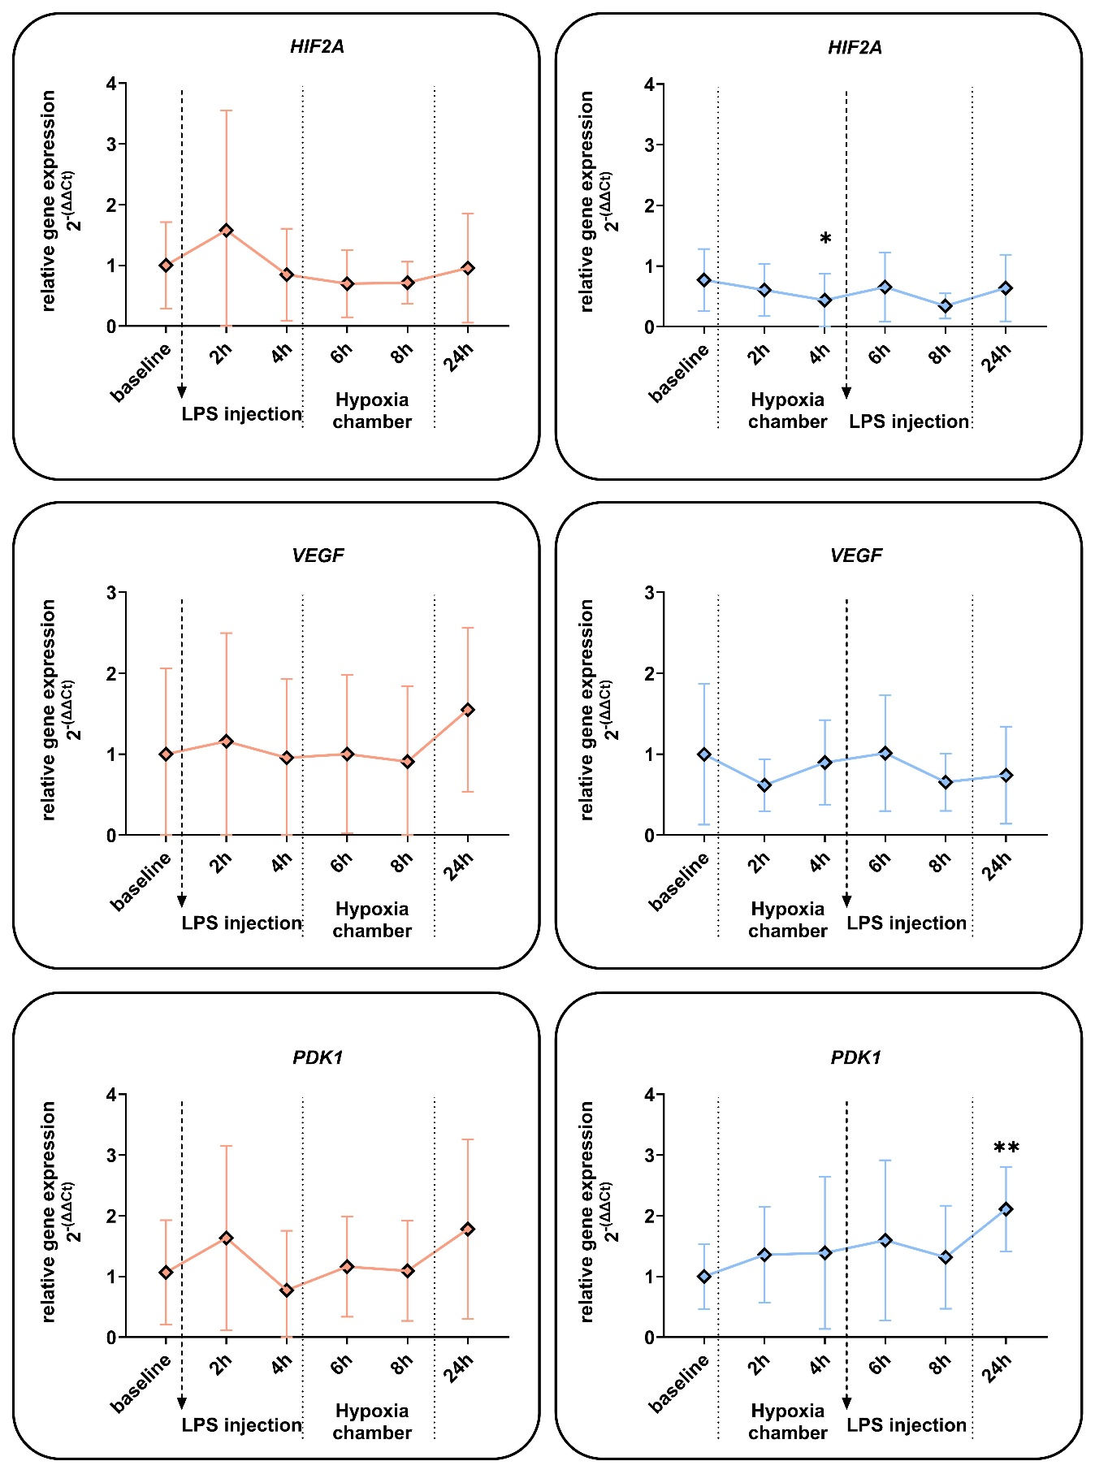
Supplemental Figure: Effects of hypoxia and LPS on HIF2A and HIF-related gene expression of whole blood cells
Relative gene expression of whole blood cells, from blood samples of human subjects that were treated with a single E. coli lipopolysaccharide (LPS) injection (0.4 ng/kg) and a 4-hour phase of exposure to hypoxia (normobaric, 10.5 % O2) prior or after LPS injection. Shown are mRNA expression fold changes from hypoxia-inducible factor 2α (HIF2A), vascular endothelial factor (VEGF) and pyruvate dehydrogenase kinase 1 (PDK1). Expression levels of mRNA were normalised to ACTB and are presented as 2-(ΔΔCT) values (mean ± SD, mixed-effects analysis with repeated measures and Tukey´s or Sidak´s multiple comparisons test; * = p < 0.05, ** = p < 0.01, n = 8 - 13).

Supplementary Table: Primer sequences of specific PCR products used for RNA quantifications of blood samples via RT-PCR.
Target gene | Primer | sequence
ACTB | 3´ | CAGCGGAACCGCTCATTGCCAATGG
ACTB | 5´ | TCACCCACACTGTGCCCATCTACGA
HIF1A | 3´ | CTCCATTACCCACCGCTGAA
HIF1A | 5´ | TCACTGGGACTATTAGGCTCAGGT
HIF2A | 3´ | CGGAGGTGTTCTATGAGCTGG
HIF2A | 5´ | AGCTTGTGTGTTCGCAGGAA
GLUT-1 | 3´ | CTAGCGCGATGGTCATGAGT
GLUT-1 | 5´ | TCTGGCATCAACGCTGTCTT
ADM | 3´ | AGTCGTGGGAAGAGGGAACT
ADM | 5´ | ATCCGGACTGCTGTCTTCGG
PDK1 | 3´ | TGAACGGATGGTGTCCTGAG
PDK1 | 5´ | GGCCAGGTGGACTTCTACG
VEGF-A | 3´ | CCGCCTCGGCTTGTCACA
VEGF-A | 5´ | GCAAGACAAGAAAATCCCTGTGGGCC
PHD1 | 3´ | TGGCCCTGGACTATATCGTG
PHD1 | 5´ | GGCACCAATGCTTCGACAG
PHD2 | 3´ | GCACGACACCGGGAAGTT
PHD2 | 5´ | CCAGCTTCCCGTTACAGT
PHD3 | 3´ | CACAGCGAGGGAATGAACCT
PHD3 | 5´ | TCCTGCTGTTAAGGCTTCCG
IL6 | 3´ | CCACTCACCTCTTCAGAACGAA
IL6 | 5´ | TGCATCTAGATTCTTTGCCTTTTT
TNFA | 3´ | CTCAGCTTGAGGGTTTGCTAC
TNFA | 5´ | TGCACTTTGGAGTGATCGGC

