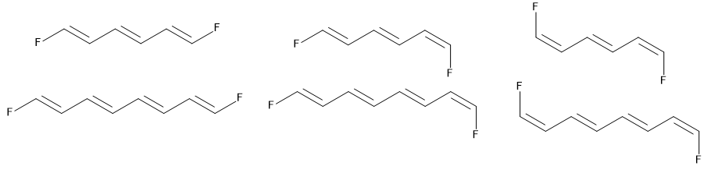
ZZ | ZE | EE

Scheme 1 Different structures of the trans isomers of 1,6-diflourohexa-1,3,5-triene (DFT) and 1,8-diflouroocta-1,3,5,7-tetraene (DOT): first row: (1E,3E,5E)-, (1Z,3E,5Z)-, and (1Z,3E,5E)-DFT; second row: (1E,3E,5E,7E)- DOT, (1Z,3E,5E,7E)- DOT, and (1Z,3E,5E,7Z)-DOT.

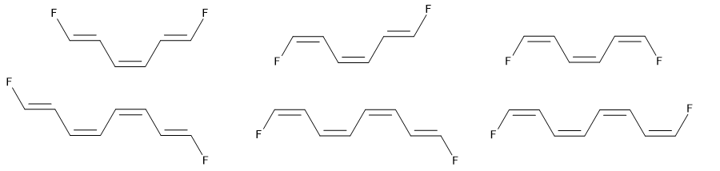
ZZ | EZ | EE

Scheme 2 Different structures of the cis isomers of 1,6-diflourohexa-1,3,5-triene (DFT) and 1,8-diflouroocta-1,3,5,7-tetraene (DOT): 1st row: (1E,3Z,5E)-DFT, (1Z,3Z,5Z)-DFT, and (1E,3Z,5Z)-DFT; 2nd row: (1E,3Z,5Z,7E)-DOT, (1Z,3Z,5Z,7E)-DOT, and (1Z,3Z,5Z,7Z)-DOT.

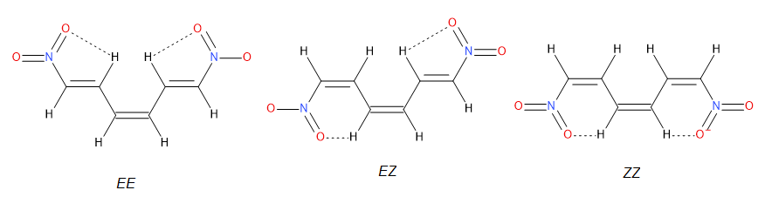
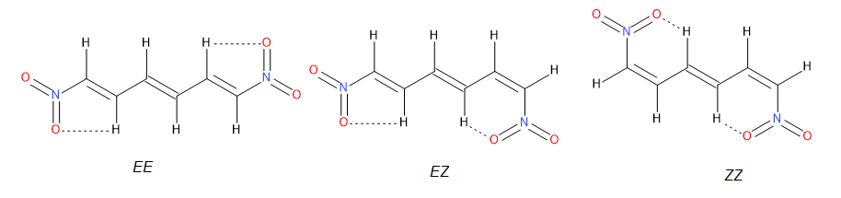
Scheme 3 Dominant interactions between the NO₂ groups and selected hydrogen atoms in the 1,n–disubstituted cis and trans polyene isomers.
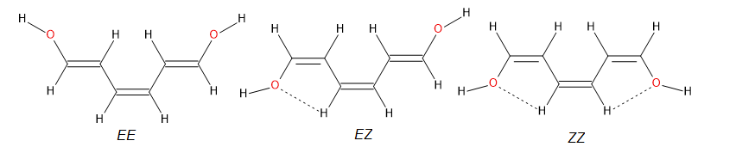
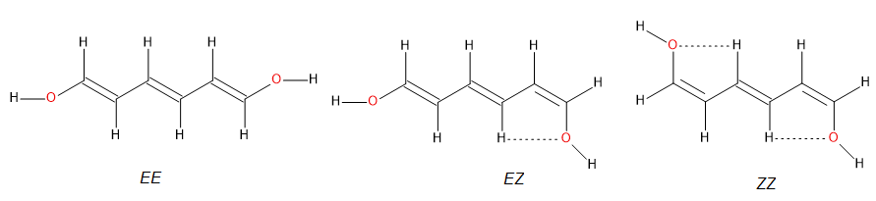
Scheme 4 Dominant contacts between the OH groups and selected hydrogen atoms in the 1,n–disubstituted cis and trans polyene isomers

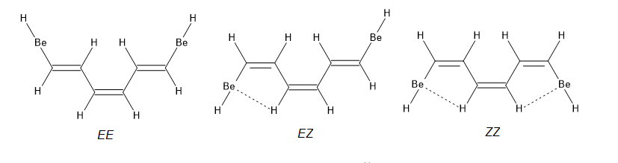
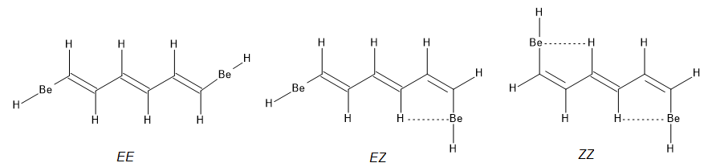
Scheme 5 Dominant contacts between the BeH groups and selected hydrogen atoms in the 1,n–disubstituted cis and trans polyene isomers. Pointed lines denote close contacts.
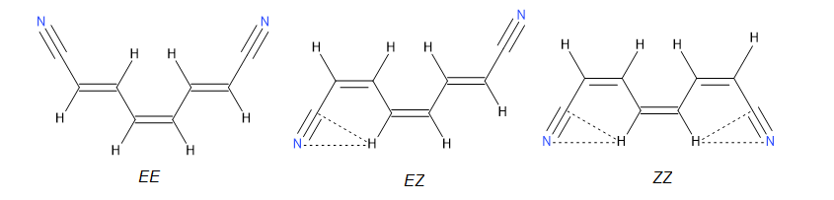
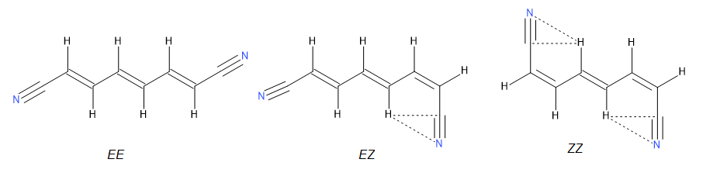
Scheme 6 Dominant interactions between the CN groups and selected hydrogen atoms in the 1,n–disubstituted cis and trans polyene isomers. Pointed lines denote close contacts.

(a) | 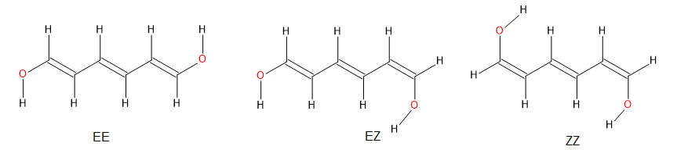
(b) | 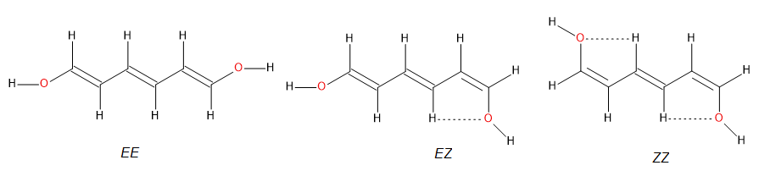
(c) | 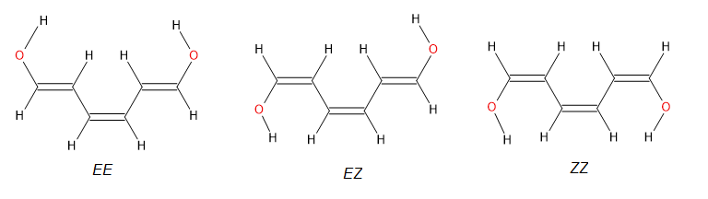
(d) | 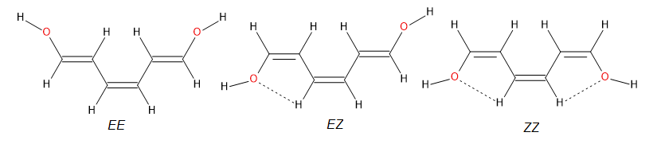
Scheme 7 Different CH-OH end group arrangements in various polyene chain forms: (a) transoidal arrangement in trans-isomers, (b) cisoidal arrangement in trans-isomers, (c) transoidal arrangement in cis-isomers, (d) cisoidal arrangement in cis-isomers. Pointed lines denote close contacts.

Scheme 8 Dominant interactions between the halogen atoms as substituents and selected hydrogen atoms in 1,n–disubstituted cis and trans polyalkene EE and ZZ isomers. Pointed lines denote close contacts.

Scheme 9 Dominant interactions between the substituents such as NO₂, BF₂, BH₂ and NH₂ and selected hydrogen atoms in 1,n–disubstituted cis and trans polyalkene ZZ isomers. Pointed lines denote close contacts.

Scheme 10 Dominant interactions between the substituents such as CH₃ and SiH₃ and selected hydrogen atoms in 1,n–disubstituted cis and trans polyalkene ZZ isomers. Pointed lines denote close contacts.

