Supplementary Information for
Halogen-free Ciamician-Dennstedt Single-Atom Skeletal Editing
Shaopeng Liu,¹† Yong Yang,¹† Qingmin Song,¹† Zhaohong Liu,¹* Paramasivam Sivaguru,¹ Yifan Zhang,¹ Graham de Ruiter,² Edward A. Anderson³* and Xihe Bi^{1,4}*
¹Department of Chemistry, Northeast Normal University; Changchun 130024, China.
²Schulich Faculty of Chemistry, Technion - Israel Institute of Technology, Technion City, 3200008, Haifa, Israel.
³Chemistry Research Laboratory, Department of Chemistry, University of Oxford, 12 Mansfield Road, Oxford OX1 3TA, UK
⁴State Key Laboratory of Elemento-Organic Chemistry, Nankai University, Tianjin 300071, China.
‡These authors contributed equally to this work.
*Corresponding author. Email: liuzh944@nenu.edu.cn; edward.anderson@chem.ox.ac.uk; bixh507@nenu.edu.cn.

Table of Contents
1. | General Information | S1
2. | Detailed Optimization of Conditions | S2
3. | Preparation of Starting Materials | S9
 | 3.1 The Preparation of Fluoroalkyl Substituted N-Triftosylhydrazones | S9
 | 3.2 The Preparation of N-Triftosylhydrazones-Derived from Aldehyde | S10
4. | Experimental Procedures | S11
 | 4.1 General Procedures for One-Carbon Insertion of Indoles with Fluoroalkyl N-Triftosylhydrazones | S11
 | 4.2 General Procedures for Defluorinative One-Carbon Insertion of Indoles with Fluoroalkyl N-triftosylhydrazones | S12
 | 4.3 General Procedures for One-Carbon Insertion of Indoles with Functionalized N-triftosylhydrazones | S13
 | 4.4 General Procedure for One-Carbon Insertion of Pyrroles with N-Triftosylhydrazones | S15
 | 4.5 Gram-scale Experiment | S16
 | 4.6 Total Synthesis of Bioactive Molecules using the One-Carbon Insertion as Key Step | S16
5. | Mechanistic Considerations | S27
 | 5.1 Controlled Experiment | S27
 | 5.2 Computational Details | S43
6. | Characterization Data of Products | S45
7. | References | S94
8. | NMR Spectra of Products | S96

1. General Information
The products were purified by column chromatography over silica gel (200-300 mesh). NMR spectra were recorded on a Brüker Advance 600 (¹H: 600 MHz, ¹³C: 150 MHz, ¹⁹F: 564 MHz) and Brüker Advance 500 (¹H: 500 MHz, ¹³C: 125 MHz, ¹⁹F: 470 MHz) at ambient temperature. ¹H and ¹³C NMR spectra were reported as chemical shifts in parts per million (ppm) downfield from tetramethylsilane, using the residual undeuterated solvent (CHCl₃ at 7.26 ppm ¹H NMR, 77.00 ppm ¹³C NMR) or tetramethylsilane as reference. ¹⁹F NMR spectra were reported as chemical shifts in parts per million (ppm) using CFCl₃ (0 ppm) in CDCl₃ as reference. Coupling constants were reported in hertz (Hz). The following abbreviations were used to explain the multiplicities: s = singlet, d = doublet, t = triplet, q = quartet, m = multiplet. High-resolution mass spectra (HRMS) were recorded on Bruck microTof by using ESI method. Melting points were determined with XRC-1 and are uncorrected.
All chemicals were purchased from Adamas-Beta, Energy Chemical Company, ALDRICH, and J&K Scientific Ltd, and were used as received from the commercial suppliers without further purification unless mentioned otherwise. All solvents were purified and dried according to standard methods prior to use. Unless otherwise stated, all reactions were carried out in flame-dried glassware under a dry argon atmosphere.

2. Detailed Optimization of Conditions

Table S1. Optimization of cyclopropanation of N-TBS indole and TFHZ-Tfs
Entry | Cat. [M] (mol%) | Base | Solvent | Temp. (°C) | Yield of 3'
1 | Tp^{Br3}Ag(THF) (10) | NaH | PhCF₃ | 60 | 12%
2 | Tp^{CF3}Ag(THF) (10) | NaH | PhCF₃ | 60 | trace
3 | Tp^{Br3}Cu(NCMe) (10) | NaH | PhCF₃ | 60 | 94%
4 | Tp^{Me2}Cu(NCMe) (10) | NaH | PhCF₃ | 60 | 27%
5 | [(PC_{NHC}P)Fe(H)₂N₂)] (5) | NaH | PhCF₃ | 60 | N.D.
6 | [((PC_{NHC}P)Fe(N₂))₂-µ-N₂)] (5) | NaH | PhCF₃ | 60 | N.D.
7 | PCP-Co(II)Cl₂ (5) | NaH | PhCF₃ | 60 | N.D.
8 | PCP-Co(I)-BArF (5) | NaH | PhCF₃ | 60 | N.D.
9 | Rh₂(OAc)₄ (1) | NaH | PhCF₃ | 60 | 13%
10 | Rh₂(Oct)₄ (1) | NaH | PhCF₃ | 60 | 45%
11 | Tp^{Br3}Cu(NCMe) (10) | Cs₂CO₃ | PhCF₃ | 60 | 61%
12 | Tp^{Br3}Cu(NCMe) (10) | DIPEA | PhCF₃ | 60 | trace
13 | Tp^{Br3}Cu(NCMe) (10) | NaH | DCM | 60 | 79%
14 | Tp^{Br3}Cu(NCMe) (10) | NaH | DCE | 60 | 73%
15 | Tp^{Br3}Cu(NCMe) (10) | NaH | PhMe | 60 | 62%
16 | Tp^{Br3}Cu(NCMe) (10) | NaH | PhCF₃ | 40 | 63%
17 | Tp^{Br3}Cu(NCMe) (10) | NaH | PhCF₃ | 80 | 84%
Reaction conditions: indole 1 (0.3 mmol), TFHZ-Tfs 2 (0.36 mmol, 1.2 equiv.), Cat. [M] (1-10 mol%), base (0.72 mmol, 2.4 equiv.), solvent (10 mL), under N₂ for 12 hours. The yield of cyclopropane 3' was determined by ¹H NMR analysis of the crude reaction mixture using dibromomethane as an internal standard. N.D. means that no product was detected.

Table S2. Optimization of ring-opening 3' to afford 3-(trifluoromethyl)quinoline 3
Entry | [F]-source | Solvent | Additive | Temp. (°C) | Yield of 3
1 | TBAF | THF | - | 25 | 44%
2 | TMAF | THF | - | 25 | N.D.
3 | TEAF | THF | - | 25 | N.D.
4 | TBAF | 1,4-dioxane | - | 25 | 28%
5 | TBAF | MeCN | - | 25 | 15%
6 | TBAF | THF | - | 0 | 52%
7 | TBAF | THF | - | -20 | 66%
8 | TBAF | THF | - | -60 | 71%
9 | TBAF | THF | DDQ | 25 | 92%
Reaction conditions: crude product 3, [F]-source (1.2 equiv.), additive (1.2 equiv.), was carried out in 10 mL of solvent for 10 min. Isolated yield. N.D. means that no product was detected.
The optimal reaction conditions for one-carbon insertion of indole with TFHZ-Tfs
Procedure: To an oven-dried screw-cap reaction tube was charged with N-TBS indole 1 (69.3 mg, 0.3 mmol), TFHZ-Tfs 2 (115.3 mg, 0.36 mmol, 1.2 equiv.), NaH (28.8 mg, 0.72 mmol, 2.4 equiv., 60 wt% dispersion in mineral oil), Tp^{Br3}Cu(NCMe) (36.0 mg, 10.0 mol%) and PhCF₃ (10 mL) inside a glove box with nitrogen atmosphere. After transfer out of the glove box, the reaction was stirred at 60 °C for 12 h. The reaction mixture was filtered through a short pad of silica gel with DCM as an eluent. After removal of the solvent in vacuo, the residue was added TBAF (0.36 mL, 0.36 mmol, 1.0 mol/L in THF, 1.2 equiv.), DDQ (102.2 mg, 0.45 mmol, 1.5 equiv.) and THF (10 mL). The resulting mixture was stirred at 25 °C for 10 min and filtered through a short pad of silica gel (pre-treated with triethylamine) with DCM as an eluent. After removal of the solvent in vacuo, the residue was purified by flash column chromatography on silica gel (pre-treated with trimethylamine, using petroleum ether-EtOAc as eluent) to give the product 3.

Table S3. Optimization for one-carbon insertion of indole with DFHZ-Tfs
Entry | Cat. [M] (mol%) | Base | Solvent | Temp. (°C) | t (h) | Yield of 26
1 | Tp^{Br3}Cu(NCMe) (10) | NaH | PhCF₃ | 60 | 12 | 40%
2 | Tp^{Br3}Ag(THF) (10) | NaH | PhCF₃ | 60 | 12 | N.D.
3 | [(PC_{NHC}P)Fe(H)₂N₂)] (5) | NaH | PhCF₃ | 60 | 12 | N.D.
4 | [((PC_{NHC}P)Fe(N₂))₂-µ-N₂)] (5) | NaH | PhCF₃ | 60 | 12 | N.D.
5 | PCP-Co(II)Cl₂ (5) | NaH | PhCF₃ | 60 | 12 | N.D.
6 | PCP-Co(I)-BArF (5) | NaH | PhCF₃ | 60 | 12 | N.D.
7 | Rh₂(OAc)₄ (1) | NaH | PhCF₃ | 60 | 12 | 36%
8 | Tp^{Br3}Cu(NCMe) (10) | NaH | PhCF₃ | 60 | 12 | trace
9 | Tp^{Br3}Cu(NCMe) (10) | DIPEA | PhCF₃ | 60 | 12 | 22%
10 | Tp^{Br3}Cu(NCMe) (10) | K₂CO₃ | PhCF₃ | 60 | 12 | 37%
11 | Tp^{Br3}Cu(NCMe) (10) | Cs₂CO₃ | PhCF₃ | 60 | 12 | 54%
12 | Tp^{Br3}Cu(NCMe) (10) | Cs₂CO₃ | DCM | 60 | 12 | 30%
13 | Tp^{Br3}Cu(NCMe) (10) | Cs₂CO₃ | 1,4-dioxane | 60 | 12 | 44%
14 | Tp^{Br3}Cu(NCMe) (10) | Cs₂CO₃ | PhCF₃ | 40 | 12 | 70%
15 | Tp^{Br3}Cu(NCMe) (10) | Cs₂CO₃ | PhCF₃ | 60 | 24 | 88%
Reaction conditions: indole 1 (0.3 mmol), DFHZ-Tfs (0.6 mmol, 2.0 equiv.), Cat. [M] (1-10 mol%), base (1.8 mmol, 6.0 equiv.), solvent (10 mL), under N₂ for 12 or 24 hours. Isolated yield. N.D. means that no product was detected.
The optimal reaction conditions for one-carbon insertion of indole with DFHZ-Tfs
Procedure: To an oven-dried screw-cap reaction tube was charged with DFHZ-Tfs (181.3 mg, 0.6 mmol, 2.0 equiv.), Cs₂CO₃ (586.5 mg, 1.8 mmol, 6.0 equiv.), N-TBS indole 1 (69.3 mg, 0.3 mmol, 1.0 equiv.), Tp^{Br3}Cu(NCMe) (36.0 mg, 10.0 mol%) and DCM (10 mL) inside a glove box with nitrogen atmosphere. After transfer out of the glove box, the reaction was stirred at 60 °C for 24 h. The reaction mixture was filtered through a short pad of silica gel with DCM as an eluent. After removal of the solvent in vacuo, the residue was added TBAF (0.36 mL, 0.36 mmol, 1.0 mol/L in THF, 1.2 equiv.), DDQ (102.2 mg, 0.45 mmol, 1.5 equiv.) and THF (10 mL). The resulting mixture was stirred at 25 °C for 10 min and filtered through a short pad of silica gel (pre-treated with triethylamine) with DCM as an eluent. After removal of the solvent in vacuo, the residue was purified by flash column chromatography on silica gel (pre-treated with trimethylamine, using petroleum ether-EtOAc as eluent) to give the product 26.

Table S4. Optimization for hydrodefluorinative one-carbon insertion of indole with fluoroalkyl N-triftosylhydrazone
Entry | [F]-source | Solvent | Additive | Temp. (°C) | Yield of 36 | Yield of 37
1 | TBAF | THF | DDQ (1.5 equiv.) | 25 | 60% | 20%
2 | TBAF | THF | - | 25 | 44% | 23%
3 | CsF | DMSO | - | 25 | 37% | 48%
4 | CsF | DMF | - | 25 | 36% | 46%
5 | CsF | DME | - | 25 | 40% | 47%
7 | CsF | DMSO | H₂O (20 equiv.) | 25 | n.d. | 98%
Reaction conditions: (1) indole 1 (0.3 mmol), N-triftosylhydrazone (0.6 mmol, 2.0 equiv.), Tp^{Br3}Cu(NCMe) (10 mol%), NaH (1.8 mmol, 6.0 equiv.), PhCF₃ (10 mL), under N₂ for 12 hours. (2) [F]-source (1.2 equiv.), additive, solvent (10 mL), 25 °C, under air for 10 min. Isolated yield.
The optimal reaction conditions for hydrodefluorinative one-carbon insertion reaction:
Procedure：To an oven-dried screw-cap reaction tube was charged with N-TBS indole 1 (69.3 mg, 0.3 mmol), N-triftosylhydrazone (222.0 mg, 0.6 mmol, 2.0 equiv.), NaH (72.0 mg, 1.8 mmol, 6.0 equiv., 60 wt% dispersion in mineral oil), Tp^{Br3}Cu(NCMe) (36mg, 10.0 mol%) and PhCF₃ (10 mL) inside a glove box with nitrogen atmosphere. After transfer out of the glove box, the reaction was stirred at 60 °C for 12 h. The reaction mixture was filtered through a short pad of silica gel with DCM as an eluent. After removal of the solvent in vacuo, the residue was added CsF (54.7 mg, 0.36 mmol, 1.2 equiv.), H₂O (20.0 equiv.) and DMSO (10 mL). The resulting mixture was stirred at 25 °C for 10 min and then was diluted with DCM, washed with brine, dried over anhydrous Na₂SO₄, filtered and the solvent was evaporated under reduced pressure to leave a crude product, which was purified by flash column chromatography on silica gel (pre-treated with trimethylamine, using petroleum ether-EtOAc as eluent) to give the product 37.

Table S5. Optimization for defluorinative formylation insertion of indole with TFHZ-Tfs leading to quinoline-3-carboxaldehyde
Entry | Solvent | Temp. (°C) | time | Yield of 56
1 | DMSO | 25 | 10 min | 15%
2 | DMSO | 0 | 1.0 h | 9%
3 | DMSO | 25 | 5.0 h | 54%
4 | DMSO | 40 | 5.0 h | 78%
5 | DMSO | 60 | 5.0 h | 77%
Reaction conditions: (1) indole 1 (0.3 mmol), N-triftosylhydrazone (0.36 mmol, 1.2 equiv.), Tp^{Br3}Cu(NCMe) (10 mol%), NaH (0.72 mmol, 2.4 equiv.), PhCF₃ (10 mL), under N₂ for 12 hours. (2) CsF (0.36 mmol, 1.2 equiv.), H₂O (20.0 equiv.), DMSO (10 mL), 0-60 °C, under air for 10 min-5 h. Isolated yield.
The optimal reaction conditions for defluorinative formylation one-carbon insertion reaction:
Procedure：To an oven-dried screw-cap reaction tube was charged with N-TBS indole 1 (69.3 mg, 0.3 mmol), N-triftosylhydrazone (115.3 mg, 0.36 mmol, 1.2 equiv.), NaH (28.8 mg, 0.72 mmol, 2.4 equiv., 60 wt% dispersion in mineral oil), Tp^{Br3}Cu(NCMe) (36.0 mg, 10.0 mol%) and PhCF₃ (10 mL) inside a glove box with nitrogen atmosphere. After transfer out of the glove box, the reaction was stirred at 60 °C for 12 h. After cooling to room temperature, the reaction mixture was filtered through a short pad of silica gel with DCM as an eluent. After removal of the solvent in vacuo, the residue was added CsF (54.7 mg, 0.36 mmol, 1.2 equiv.), H₂O (20.0 equiv.) and DMSO (10 mL). The resulting mixture was stirred at 40 °C for 5 h. After completion of the reaction, the mixture was diluted with DCM, washed with brine, dried over anhydrous Na₂SO₄, filtered and the solvent was evaporated under reduced pressure to leave a crude product, which was purified by flash column chromatography on silica gel (pre-treated with trimethylamine, using petroleum ether-EtOAc as eluent) to give product 56.

Table S6. Optimization for one-carbon insertion of indole with aryl-substituted N-triftosylhydrazone.
Entry | Cat. [M] (mol%) | Base | Solvent | Temp. (°C) | PG | Yield (%) of 70
1 | Tp^{Br3}Cu(NCMe) (10) | NaH | PhCF₃ | 60 | TBS | 20
2 | Tp^{Me2}Cu(NCMe) (10) | NaH | PhCF₃ | 60 | TBS | 13
3 | Tp^{Br3}Ag(THF) (10) | NaH | PhCF₃ | 60 | TBS | 97
4 | Tp^{(CF3)2}Ag(THF) (10) | NaH | PhCF₃ | 60 | TBS | 92
5 | AgOTf (10) | NaH | PhCF₃ | 60 | TBS | 48
6 | Rh₂(esp)₂ (1) | NaH | PhCF₃ | 60 | TBS | 83
7 | Pd(OAc)₂ (5) | NaH | PhCF₃ | 60 | TBS | trace
8 | Tp^{Br3}Ag(THF) (10) | Cs₂CO₃ | PhCF₃ | 60 | TBS | 77
9 | Tp^{Br3}Ag(THF) (10) | K₂CO₃ | PhCF₃ | 60 | TBS | 64
10 | Tp^{Br3}Ag(THF) (10) | LiO^{t}Bu | PhCF₃ | 60 | TBS | 72
11 | Tp^{Br3}Ag(THF) (10) | DIPEA | PhCF₃ | 60 | TBS | trace
12 | Tp^{Br3}Ag(THF) (10) | NaH | DCM | 60 | TBS | 34(32)
13 | Tp^{Br3}Ag(THF) (10) | NaH | DCE | 60 | TBS | 36(35)
14 | Tp^{Br3}Ag(THF) (10) | NaH | CHCl₃ | 60 | TBS | trace
15 | Tp^{Br3}Ag(THF) (10) | NaH | PhCF₃ | 40 | TBS | 57
16 | Tp^{Br3}Ag(THF) (10) | NaH | PhCF₃ | 80 | TBS | 94
17 | Tp^{Br3}Ag(THF) (10) | NaH | PhCF₃ | 60 | H | 43
18 | Tp^{Br3}Ag(THF) (10) | NaH | PhCF₃ | 60 | TMS | 82
19 | Tp^{Br3}Ag(THF) (10) | NaH | PhCF₃ | 60 | TIPS | 95
20 | Tp^{Br3}Ag(THF) (10) | NaH | PhCF₃ | 60 | Boc | 0(90)
Reaction conditions: (1) N-triftosylhydrazone (0.3 mmol, 1.0 equiv.), indole (0.6 mmol, 2.0 equiv.), Cat. [M] (1-10 mol%), base (0.6mmol, 2.0 equiv.) and solvent (5 mL), under N₂ for 12 hours. (2) TBAF (0.75 mmol, 2.5 equiv.), 25 °C, under air for 10 min. Isolated yield. Isolated yield. Yield in parentheses is unconverted cyclopropane.
Procedure：To an oven-dried screw-cap reaction tube was charged with N-triftosylhydrazone (102.6 mg, 0.3 mmol, 1.0 equiv.), base (0.6 mmol, 2.0 equiv.), N-protected indole (0.6 mmol, 2.0 equiv.), catalyst and solvent (5 mL) inside a glove box with nitrogen atmosphere. After transfer out of the glove box, the reaction was stirred at indicated temperature for 12 h. The reaction mixture was cooled to room temperature. Then, TBAF (0.75 mL, 0.75 mmol, 1.0 mol/L in THF, 2.5 equiv.) was added and stirred at 25 °C under air for 10 min. After completion of the reaction, the mixture was filtered through a short pad of silica gel (pre-treated with triethylamine) with DCM as an eluent. After removal of the solvent in vacuo, the residue was purified by flash chromatography on silica gel (pre-treated with trimethylamine, using petroleum ether-EtOAc.

Table S7. Optimization for one-carbon insertion of pyrrole with N-triftosylhydrazone
Entry | R | Cat. [M] (mol%) | Base | Solvent | Temp. (°C) | Yield of 119
1 | TBS | Tp^{Br3}Ag(THF) (10) | NaH | PhCF₃ | 60 | trace
2 | H | Tp^{Br3}Ag(THF) (10) | NaH | PhCF₃ | 60 | 11%
3 | H | Tp^{CF3}Ag(THF) (10 | NaH | PhCF₃ | 60 | 10%
4 | H | Tp^{Br3}Cu(CNMe) (10) | NaH | PhCF₃ | 60 | N.D.
5 | H | Tp^{Me2}Cu(CNMe) (10) | NaH | PhCF₃ | 60 | N.D.
6 | H | [(PC_{NHC}P)Fe(H)₂N₂)] (5) | NaH | PhCF₃ | 60 | N.D.
7 | H | PCP-Co(II)Cl₂ (5) | NaH | PhCF₃ | 60 | N.D.
8 | H | Rh₂(OAc)₄ (1) | NaH | PhCF₃ | 60 | 41%
9 | H | Rh₂(esp)₂ (1) | NaH | PhCF₃ | 60 | 48%
10 | H | Rh₂(esp)₂ (1) | Cs₂CO₃ | PhCF₃ | 60 | 18%
11 | H | Rh₂(esp)₂ (1) | K₂CO₃ | PhCF₃ | 60 | 15%
12 | H | Rh₂(esp)₂ (1) | LiO^{t}Bu | PhCF₃ | 60 | 22%
13 | H | Rh₂(esp)₂ (1) | NaH | DCM | 60 | 40%
14 | H | Rh₂(esp)₂ (1) | NaH | DCE | 60 | 23%
15 | H | Rh₂(esp)₂ (1) | NaH | PhCF₃ | 40 | 32%
16 | H | Rh₂(esp)₂ (1) | NaH | PhCF₃ | 80 | 46%
Reaction conditions: N-triftosylhydrazone (0.3 mmol, 1.0 equiv.), pyrrole (0.6 mmol, 2.0 equiv.), Cat. [M] (1-10 mol%), base (0.6mmol, 2.0 equiv.) and solvent (5 mL), under N₂ for 12 hours. Isolated yield. N.D. means that no product was detected.
Procedure: To an oven-dried screw-cap reaction tube was charged with N-triftosylhydrazone (98.4 mg, 0.3 mmol, 1.0 equiv.), base (0.6 mmol, equiv.), pyrrole (0.6 mmol, 2.0 equiv.) catlyst and 5 mL solvent inside a glove box with nitrogen atmosphere. After transfer out of the glove box, the reaction was stirred at the required temperature for 12 h. The mixture was filtered through a short pad of silica gel (pre-treated with triethylamine) with DCM as an eluent. After removal of the solvent in vacuo, the residue was purified by flash chromatography on silica gel (pre-treated with trimethylamine, using petroleum ether-EtOAc as eluent) to give the product 119.

3. Preparation of Starting Materials

3.1 The Preparation of Fluoroalkyl Substituted N-Triftosylhydrazones
Procedure: TFHZ-Tfs was prepared according to literature procedure^{[1]}. A 500 mL bottom flask was charged with trifluoroacetaldehyde monohydrate (14.9 g, 127.5 mmol), H₂NNHTfs (20.4 g, 85.0 mmol) and EtOAc (310.0 mL). Then AcOH (4.3 mL, 7.7 mmol) was added dropwise and stirred at ice water bath for 10 min under nitrogen. Then the mixture was transferred to room temperature and stirred for 80 min. After that, the mixture was transferred to 40 °C and stirred overnight. After the reaction was completion, the mixture was concentrated under reduced pressure and washed by PE/EtOAc to afford TFHZ-Tfs as a white solid, 90% yield, m.p: 124-125 °C; ¹H NMR (500 MHz, DMSO-d₆) δ 13.01 (s, 1H), 8.07 (d, J = 8.0 Hz, 1H), 7.90 (d, J = 8.0 Hz, 1H), 7.88 (t, J = 8.0 Hz, 1H), 7.81 (t, J = 8.0 Hz, 1H), 7.52 (q, J = 8.0 Hz, 1H). ¹³C NMR (150 MHz, DMSO-d₆) δ 137.5, 134.6, 133.5 (q, J = 37.6 Hz), 133.5 (q, J = 37.9 Hz), 132.1, 129.1 (q, J = 6.3 Hz), 127.0 (q, J = 33.0 Hz), 123.1 (q, J = 272.4 Hz), 120.4 (q, J = 271.5 Hz). ¹⁹F NMR (564 MHz, DMSO-d₆) δ -51.95, -61.95 (d, J = 3.8 Hz). HRMS (ESI) m/z calculated for C₉H₆F₆N₂NaO₂S⁺ [M+Na]⁺ 342.9946, found 342.9955. The spectrum was consistent with the previous literature ^{[1]}.
Procedure: Fluoroalkyl N-triftosylhydrazones were prepared according to literature procedure^{[2]}. A 250 mL bottom flask was charged with ethyl perfluorate (75.0 mmol) and EtOAc (200.0 mL). The LiAlH₄ (1.1 equiv.) was added into the reaction mixture dropwise at -30 °C under N₂ atmosphere. The reaction mixture were continued stired for 12 h at -30 °C. Then H₂NNHTfs (50.0 mmol) and AcOH (5.5 mmol) was added dropwise under N₂ atmosphere. The mixture was transferred to 40 ºC and stirred for 4-5 h, and monitored by TLC. After the reaction was complete, the mixture was concentrated under reduced pressure and washed by Pe/ PE/EtOAc to afford the desired N-triftosylhydrazones. DFHZ-Tfs: white solid. m.p: 86-87 ºC. ¹H NMR (500 MHz, CDCl₃) δ 9.07 (s, 1H), 8.35-8.30 (m, 1H), 7.93-7.90 (m, 1H), 7.82-7.77 (m, 2H), 7.22-7.19 (m, 1H), 5.99 (td, J = 54.5, 6.0 Hz, 1H). ¹³C NMR (125 MHz, CDCl₃) δ 139.7 (t, J = 33.5 Hz), 136.1, 134.1, 133.1, 132.8, 128.6 (q, J = 6.5 Hz), 127.8 (q, J = 33.0 Hz), 122.6 (q, J = 272.5 Hz), 112.2 (t, J = 234.5 Hz). ¹⁹F NMR (470 MHz, CDCl₃) δ -58.30, -117.13 (d, J = 54.5 Hz). HRMS (ESI) m/z calcd. for C₉H₇F₅N₂NaO₂S [M+Na]⁺ 325.0041, found 325.0047.

3.2 The Preparation of N-Triftosylhydrazone-Derived from Aldehyde
General Procedure: The N-triftosylhydrazone-derived from aldehyde was prepared according to the literature procedure^{[3]}. To a stirred solution of H₂NNHTfs (2.0 mmol) of methanol (2 mL), aldehyde (2.2 mmol, 1.1 equiv.) was added dropwise. The resulting the mixture was stirred at room temperature for 1-5 h. The mixture was filtered and the resulting solid was washed with ice cold diethyl ether and dried under reduced pressure to give the corresponding pure N-triftosylhydrazones.
Procedure : The alkynyl N-triftosylhydrazone was prepared according to literature procedure^{[4]}. To a rapidly stirred suspension of H₂NNHTfs (2.0 mmol, 1.0 equiv.) and La(OTf)₃ (2.0 mol %) in MeOH (10 mL), 3-(triisopropylsilyl)propiolaldehyde (2.2 mmol, 1.1 equiv.) was added dropwise. The resulting the mixture was stirred at 0 °C for 2 h (monitored by TLC) and the crude products are obtained as solid precipitates. Then the crude products were purified by flash chromatography on silica gel to afford the desired alkynyl N-triftosylhydrazones.

4. Experimental Procedures

4.1 General Procedures for One-Carbon Insertion of Indoles with Fluoroalkyl N-Triftosylhydrazones
General Procedure A: In a glove box, an oven-dried screw-cap reaction tube was charged with N-triftosylhydrazone (0.36 mmol, 1.2 equiv.), NaH (0.72 mmol, 2.4 equiv., 60 wt% dispersion in mineral oil), N-TBS indole (0.3 mmol, 1.0 equiv.), Tp^{Br3}Cu(NCMe) (36.0 mg, 10 mol%) and PhCF₃ (10 mL). Next, the sealed vial was removed from glovebox and stirred at 60 °C for 12 h. After cooling to room temperature, the reaction mixture was filtered through a short pad of silica gel with DCM as an eluent. After removal of the solvent in vacuo, the residue was added TBAF (0.36 mL, 0.36 mmol, 1.0 mol/L in THF, 1.2 equiv.) and DDQ (0.45 mmol, 1.5 equiv.) and THF (10 mL). The resulting mixture was stirred at 25 °C for 10 min and filtered through a short pad of silica gel (pre-treated with triethylamine) with DCM as an eluent. After removal of the solvent in vacuo, the residue was purified by flash column chromatography on silica gel (pre-treated with trimethylamine, using petroleum ether-EtOAc as eluent) to afford the products 3–25 and 34.
General Procedure B: In a glove box, an oven-dried screw-cap reaction tube was charged with N-triftosylhydrazones (0.6 mmol, 2.0 equiv.), Cs₂CO₃ (1.8 mmol, 6.0 equiv.), N-TBS indole (0.3 mmol, 1.0 equiv.), Tp^{Br3}Cu(NCMe) (36.0 mg, 10 mol%) and DCM (10 mL). Next, the sealed vial was removed from glovebox and stirred at 60 °C for 12 h. After cooling to room temperature, the reaction mixture was filtered through a short pad of silica gel with DCM as an eluent. After removal of the solvent in vacuo, the residue was added TBAF (0.36 mL, 0.36 mmol, 1.0 mol/L in THF, 1.2 equiv.), DDQ (0.45 mmol, 1.5 equiv.) and THF (10 mL). The resulting mixture was stirred at 25 °C for 10 min and filtered through a short pad of silica gel (pre-treated with triethylamine) with DCM as an eluent. After removal of the solvent in vacuo, the residue was purified by flash column chromatography on silica gel (pre-treated with trimethylamine, using petroleum ether-EtOAc as eluent) to give the products 26–33 and 35.
General Procedure C: In a glove box, an oven-dried screw-cap reaction tube was charged with N-triftosylhydrazone (0.6 mmol, 2.0 equiv.), NaH (1.8 mmol, 6.0 equiv., 60 wt% dispersion in mineral oil), N-TBS indole (0.3 mmol, 1.0 equiv.), Tp^{Br3}Cu(NCMe) (36.0 mg, 10 mol%) and PhCF₃ (10 mL). Next, the sealed vial was removed from glovebox and stirred at 60 °C for 12 h. After cooling to room temperature, the reaction mixture was filtered through a short pad of silica gel with DCM as an eluent. After removal of the solvent in vacuo, the residue was addeded TBAF (0.36 mL, 0.36 mmol, 1.0 mol/L in THF, 1.2 equiv.), DDQ (0.45 mmol, 1.5 equiv.) and THF (10 mL). The resulting mixture was stirred at 25 °C for 10 min and filtered through a short pad of silica gel (pre-treated with triethylamine) with DCM as an eluent. After removal of the solvent in vacuo, the residue was purified by flash column chromatography on silica gel (pre-treated with trimethylamine, using petroleum ether-EtOAc as eluent) to give the product 36 (44.5 mg, 60% yield).

4.2 General Procedures for Defluorinative One-Carbon Insertion of Indoles with Fluoroalkyl N-triftosylhydrazones
General Procedure D: In a glove box, an oven-dried screw-cap reaction tube was charged with N-triftosylhydrazone (0.6 mmol, 2.0 equiv.), NaH (1.8 mmol, 6.0 equiv., 60 wt% dispersion in mineral oil), N-TBS indole (0.3 mmol, 1.0 equiv.), Tp^{Br3}Cu(NCMe) (36.0 mg, 10.0 mol%) and PhCF₃ (10 mL). Next, the sealed vial was removed from glovebox and stirred at 60 °C for 12 h. After cooling to room temperature, the reaction mixture was filtered through a short pad of silica gel with DCM as an eluent. After removal of the solvent in vacuo, the residue was added CsF (0.36 mmol, 1.2 equiv.), H₂O (20.0 equiv.) and DMSO (10 mL). The resulting mixture was stirred at 25 °C for 10 min and diluted with DCM, washed with brine, dried over anhydrous Na₂SO₄, filtered and the solvent was evaporated under reduced pressure to leave a crude product, which was purified by flash column chromatography on silica gel (pre-treated with trimethylamine, using petroleum ether-EtOAc as eluent) to give the products 37–55.
General Procedure E: In a glove box, an oven-dried screw-cap reaction tube was charged with N-triftosylhydrazone (0.36 mmol, 1.2 equiv.), NaH (0.72 mmol, 2.4 equiv., 60 wt% dispersion in mineral oil), N-TBS indoles (0.3 mmol, 1.0 equiv.), Tp^{Br3}Cu(NCMe) (36.0 mg, 10 mol%) and PhCF₃ (10 mL). Next, the sealed vial was removed from glovebox and stirred at 60 °C for 12 h. After cooling to room temperature, the reaction mixture was filtered through a short pad of silica gel with DCM as an eluent. After removal of the solvent in vacuo, the residue was added CsF (0.36 mmol, 1.2 equiv.), H₂O (20.0 equiv.) and DMSO (10 mL). The resulting mixture was stirred at 25 °C for 10 min and diluted with DCM, washed with brine, dried over anhydrous Na₂SO₄, filtered and the solvent was evaporated under reduced pressure to leave a crude product, which was purified by flash column chromatography on silica gel (pre-treated with trimethylamine, using petroleum ether-EtOAc as eluent) to give the 3-formylquinoline products 56–69.

4.3 General Procedures for One-Carbon Insertion of Indoles with Functionalized N-triftosylhydrazones
General Procedure F: In a glove box, an oven-dried screw-cap reaction tube was charged with N-triftosylhydrazone (0.3 mmol, 1.0 equiv.), NaH (0.6 mmol, 2.0 equiv., 60 wt% dispersion in mineral oil), N-TBS indole (0.6 mmol, 2.0 equiv.), Tp^{Br3}Ag(THF) (36.0 mg, 10 mol%) and PhCF₃ (5.0 mL). Next, the sealed vial was removed from glovebox and stirred at 60 °C for 12 h. After cooling to room temperature, the reaction mixture was added TBAF (0.75 mL, 0.75 mmol, 1.0 mol/L in THF, 2.5 equiv.) and stired at 25 °C for 10 min. After completion of the reaction, the mixture was filtered through a short pad of silica gel (pre-treated with triethylamine) with DCM as an eluent. After removal of the solvent in vacuo, the residue was purified by flash chromatography on silica gel (pre-treated with trimethylamine, using petroleum ether-EtOAc as eluent) to give the corresponding 3-arylquinoline products.
General Procedure G: In a glove box, an oven-dried screw-cap reaction tube was charged with N-triftosylhydrazone (0.3 mmol, 1.0 equiv.), NaH (0.6 mmol, 2.0 equiv., 60 wt% dispersion in mineral oil), N-TBS indole (0.6 mmol, 2.0 equiv.), Tp^{Br3}Ag(THF) (36.0 mg, 10 mol%) and PhCF₃ (5.0 mL). Next, the sealed vial was removed from glovebox and stirred at 60 °C for 12 h. After cooling to room temperature, the reaction mixture was added TBAF (0.75 mL, 0.75 mmol, 1.0 mol/L in THF, 2.5 equiv.) and stired at 25 °C for 10 min. After completion of the reaction, the mixture was filtered through a short pad of silica gel (pre-treated with triethylamine) with DCM as an eluent. After removal of the solvent in vacuo, the residue was purified by flash chromatography on silica gel (pre-treated with trimethylamine, using petroleum ether-EtOAc as eluent) to give products 72, 84 and 107.
General Procedure H: In a glove box, an oven-dried screw-cap reaction tube was charged with N-triftosylhydrazones (0.3 mmol, 1.0 equiv.), NaH (0.6 mmol, 2.0 equiv., 60 wt% dispersion in mineral oil), N-TBS indole (0.6 mmol, 2.0 equiv.), Tp^{Br3}Ag(THF) (36.0 mg, 10 mol%) and PhCF₃ (5.0 mL). Next, the sealed vial was removed from glovebox and stirred at 60 °C for 12 h. After cooling to room temperature, the reaction mixture was filtered through a short pad of silica gel (pre-treated with triethylamine) with DCM as an eluent. After removal of the solvent in vacuo, the residue was added CsF (0.36 mmol, 2.5 equiv.) and DMSO (3.0 mL). The resulting mixture was stirred at 25 °C for 10 min and diluted with DCM, washed with brine, dried over anhydrous Na₂SO₄, filtered and the solvent was evaporated under reduced pressure to leave a crude product, which was purified by flash column chromatography on silica gel (pre-treated with trimethylamine, using petroleum ether-EtOAc as eluent) to give the products 75, 91, 98 and 115.
General Procedure I: In a glove box, an oven-dried screw-cap reaction tube was charged with N-triftosylhydrazone (0.3 mmol, 1.0 equiv.), NaH (0.6 mmol, 2.0 equiv., 60 wt% dispersion in mineral oil), N-TBS indole (0.6 mmol, 2.0 equiv.), Tp^{Br3}Ag(THF) (36.0 mg, 10 mol%) and DCM (5.0 mL). Next, the sealed vial was removed from glovebox and stirred at 60 °C for 12 h. After cooling to room temperature, the reaction mixture was filtered through a short pad of silica gel (pre-treated with triethylamine) with DCM as an eluent. After removal of the solvent in vacuo, the residue was added TBAF (0.75 mL, 0.75 mmol, 1.0 mol/L in THF, 2.5 equiv.) and THF (5.0 mL). The resulting mixture was stirred at 25 °C for 10 min and filtered through a short pad of silica gel (pre-treated with triethylamine) with DCM as an eluent. After removal of the solvent in vacuo, the residue was purified by flash chromatography on silica gel (pre-treated with trimethylamine, using petroleum ether-EtOAc as eluent) to give product 86 (21.6 mg, 35% yield).
General Procedure J: In a glove box, an oven-dried screw-cap reaction tube was charged with N-triftosylhydrazone (0.3 mmol, 1.0 equiv.), NaH (0.6 mmol, 2.0 equiv., 60 wt% dispersion in mineral oil), N-TBS indole (0.6 mmol, 2.0 equiv.), Rh₂(esp)₂ (1.0 mol%) and DCM (5.0 mL). Next, the sealed vial was removed from glovebox and stirred at 60 °C for 12 h. After cooling to room temperature, the reaction mixture was filtered through a short pad of silica gel with DCM as an eluent. After removal of the solvent in vacuo, the residue was added CsF (0.36 mmol, 2.5 equiv.) and DMF (3.0 mL). The resulting mixture was stirred at 25 °C for 2 h and diluted with DCM, washed with brine, dried over anhydrous Na₂SO₄, filtered and the solvent was evaporated under reduced pressure to leave a crude product, which was purified by flash column chromatography on silica gel (pre-treated with trimethylamine, using petroleum ether-EtOAc as eluent) to give the products 87–90.
General Procedure K: In a glove box, an oven-dried screw-cap reaction tube was charged with N-triftosylhydrazone (0.3 mmol, 1.0 equiv.), NaH (0.6 mmol, 2.0 equiv., 60 wt% dispersion in mineral oil), N-TBS indole (0.6 mmol, 2.0 equiv.), Rh₂(esp)₂ (1.0 mol%) and PhCF₃ (5.0 mL). Next, the sealed vial was removed from glovebox and stirred at 60 °C for 12 h. After cooling to room temperature, the reaction mixture was added TBAF (0.75 mL, 0.75 mmol, 1.0 mol/L in THF, 2.5 equiv.) and stirred at 25 °C for 10 min. After completion of the reaction, the mixture was filtered through a short pad of silica gel (pre-treated with triethylamine) with DCM as an eluent. After removal of the solvent in vacuo, the residue was purified by flash chromatography on silica gel (pre-treated with trimethylamine, using petroleum ether-EtOAc as eluent) to give the product 92 (28.0 mg, 40% yield).
Procedure L: In a glove box, an oven-dried screw-cap reaction tube was charged with N-triftosylhydrazone (0.3 mmol, 1.0 equiv.), NaH (0.6 mmol, 2.0 equiv., 60 wt% dispersion in mineral oil), N-TBS indole (0.6 mmol, 2.0 equiv.), Tp^{Br3}Ag(THF) (36.0 mg, 10 mol%) and PhCF₃ (5.0 mL). Next, the sealed vial was removed from glovebox and stirred at 80 °C for 12 h. After cooling to room temperature, the reaction mixture was filtered through a short pad of silica gel with DCM as an eluent. After removal of the solvent in vacuo, the residue was added CsF (0.36 mmol, 2.5 equiv.) and DMSO (3.0 mL). The resulting mixture was stirred at 25 °C for 10 min. After completion of the reaction, the mixture was diluted with DCM, washed with brine, dried over anhydrous Na₂SO₄, filtered and the solvent was evaporated under reduced pressure to leave a crude product, which was purified by flash column chromatography on silica gel (pre-treated with trimethylamine, using petroleum ether-EtOAc as eluent) to give the product 108 (74.5 mg, 93%).

4.4 General Procedure for One-Carbon Insertion of Pyrroles with N-Triftosylhydrazones
General Procedure M: In a glove box, an oven-dried screw-cap reaction tube was charged with N-triftosylhydrazones (0.3 mmol, 1.0 equiv.), NaH (0.6 mmol, 2.0 equiv., 60 wt% dispersion in mineral oil), pyrroles (0.6 mmol, 2.0 equiv.), Rh₂(esp)₂ (1.0 mol%) and PhCF₃ (5.0 mL). Next, the sealed vial was removed from glovebox and stirred at 60 °C for 12 h. After cooling to room temperature, the reaction mixture was filtered through a short pad of silica gel (pre-treated with triethylamine) with DCM as an eluent. After removal of the solvent in vacuo, the residue was purified by flash chromatography on silica gel (pre-treated with trimethylamine, using petroleum ether-EtOAc as eluent) to give the pyridine products 119–128.

4.5 Gram-scale Experiment
Procedure: In a glove box, an oven-dried 250 mL Schlenk tube containing a stir bar was charged with N-triftosylhydrazone (1.71g, 5.0 mmol, 1.0 equiv.), NaH (0.4 g, 2.0 equiv., 60 wt% dispersion in mineral oil), and PhCF₃ (50.0 mL). The reaction mixture was stirred at ambient temperature for 30 min, and then N-TBS indole (1.73 g, 7.5 mmol, 1.5 equiv.) and Tp^{Br3}Ag(THF) (0.6 g, 10.0 mol%) were added into the reaction mixture. Next, the sealed vial was removed from glovebox and stirred at 60 °C for 24 h. After cooling to room temperature, the reaction mixture was added TBAF (15.0 mL, 15.0 mmol, 1.0 mol/L in THF, 2.0 equiv.) and stirred at 25 °C for 10 min. The reaction mixture was filtered through a short pad of silica gel (pre-treated with triethylamine) with DCM as an eluent. After removal of the solvent in vacuo, the residue was purified by flash chromatography on silica gel (pre-treated with trimethylamine, using petroleum ether-EtOAc as eluent) to give the product 70 (1.02 g, 89% yield).

4.6 Total Synthesis of Bioactive Molecules using the One-Carbon Insertion as Key Step

Synthesis of compound 130
Procedure: In a glove box, an oven-dried tube was charged with N-triftosylhydrazone (137.4 mg, 0.3 mmol, 1.0 equiv.), NaH (24 mg, 0.6 mmol, 2.0 equiv., 60 wt% dispersion in mineral oil), 6-OTBS-N-TBS indole (216.6 mg, 0.6 mmol, 2.0 equiv.), Tp^{Br3}Ag(THF) (36.0 mg, 10.0 mol%) and PhCF₃ (5.0 mL). Next, the sealed vial was removed from glovebox and stirred at 60 °C for 24 h. After cooling to room temperature, the reaction mixture was filtered through a short pad of silica gel with DCM as an eluent. After removal of the solvent in vacuo, the residue was added CsF (304 mg, 2.0 mmol, 6.6 equiv.) and DMSO (3.0 mL). The resulting mixture was stirred at 25 °C for 10 min. After completion of the reaction, the mixture was diluted with DCM, washed with brine, dried over anhydrous Na₂SO₄, filtered and the solvent was evaporated under reduced pressure to leave a crude product, which was purified by flash column chromatography on silica gel (pre-treated with trimethylamine, using petroleum ether-EtOAc as eluent) to give the product 130 (54.7 mg, 77% yield), as a pale yellow solid solid; mp: 214-215 °C. ¹H NMR (500 MHz, DMSO-d₆) δ 10.12 (s, 1H), 9.62 (s, 1H), 9.02 (d, J = 2.0 Hz, 1H), 8.35 (d, J = 2.0 Hz, 1H), 7.84 (d, J = 9.0 Hz, 1H), 7.64 (d, J = 8.5 Hz, 2H), 7.25 (d, J = 2.0 Hz, 1H), 7.17 (dd, J = 9.0, 2.5 Hz, 1H), 6.91 (d, J = 8.5 Hz, 2H). ¹³C NMR (150 MHz, DMSO-d₆) δ 157.8, 149.0, 148.6, 147.7, 130.6, 130.2, 129.2, 127.3, 124.4, 122.2, 119.4, 114.4, 109.8. HRMS (ESI) m/z calcd. for C₁₅H₁₂NO₂⁺ [M + H]⁺ 238.0863, found 238.0875. The spectrum was consistent with the previous literature^{[5]}.

Synthesis of compound 131
Procedure: In a glove box, an oven-dried tube was charged with N-triftosylhydrazone (116.4 mg, 0.3 mmol, 1.0 equiv.), NaH (24 mg, 0.6 mmol, 2.0 equiv., 60 wt% dispersion in mineral oil), 6-OTBS-N-TBS indole (216.6 mg, 0.6 mmol, 2.0 equiv.), Tp^{Br3}Ag(THF) (36.0 mg, 10 mol%) and PhCF₃ (5.0 mL). Next, the sealed vial was removed from glovebox and stirred at 60 °C for 12 h. After cooling to room temperature, the reaction mixture was filtered through a short pad of silica gel with DCM as an eluent. After removal of the solvent in vacuo, the residue was added CsF (228 mg, 1.5 mmol, 5.0 equiv.) and DMSO (3.0 mL). The resulting mixture was stirred at 25 °C for 10 min. After completion of the reaction, the mixture was diluted with DCM, washed with brine, dried over anhydrous Na₂SO₄, filtered and the solvent was evaporated under reduced pressure to leave a crude product, which was purified by flash column chromatography on silica gel (pre-treated with trimethylamine, using petroleum ether-EtOAc as eluent) to give the product 131 (44.7 mg, 53% yield), as a pale solid solid; mp: 210-211 °C. ¹H NMR (500 MHz, DMSO-d₆) δ 10.13 (s, 1H), 8.82 (d, J = 2.0 Hz, 1H), 8.19 (d, J = 1.6 Hz, 1H), 7.82 (d, J = 9.0 Hz, 1H), 7.36 (d, J = 8.5 Hz, 1H), 7.24 (d, J = 2.0 Hz, 1H), 7.16 (dd, J = 9.0, 2.0 Hz, 1H), 6.72 (d, J = 2.5 Hz, 1H), 6.67 (dd, J = 8.5, 2.0 Hz, 1H), 3.83 (s, 3H), 3.80 (s, 3H). ¹³C NMR (150 MHz, DMSO-d₆) δ 160.6, 158.3, 157.5, 151.6, 147.9, 134.5, 131.2, 129.5, 128.4, 122.0, 119.5, 119.3, 109.8, 105.7, 99.1, 55.8, 55.5. HRMS (ESI) m/z calcd. for C₁₇H₁₆NO₃⁺ [M + H]⁺ 282.1125, found 282.1117. The spectrum was consistent with the previous literature^{[5]}.

Synthesis of compound 133
Step 1: In a glove box, an oven-dried tube was charged with N-triftosylhydrazone (328 mg, 1.0 mmol, 1.0 equiv.), NaH (80.0 mg, 2.0 mmol, 2.0 equiv., 60 wt% dispersion in mineral oil), 5-bromo-1-(tert-butyldimethylsilyl)-6-fluoro-1H-indole (654.0 mg, 2.0 mmol, 2.0 equiv.), Tp^{Br3}Ag(THF) (120.0 mg, 10.0 mol%) and PhCF₃ (10.0 mL). Next, the sealed vial was removed from glovebox and stirred at 60 °C for 12 h. After cooling to room temperature, the reaction mixture was added TBAF (2.5 mL, 2.5 mmol, 1.0 mol/L in THF, 2.5 equiv.) and stirred at 25 °C for 10 min. After completion of the reaction, the mixture was filtered through a short pad of silica gel (pre-treated with triethylamine) with DCM as an eluent. After removal of the solvent in vacuo, the residue was purified by flash chromatography on silica gel (pre- treated with trimethylamine, using petroleum ether-EtOAc as eluent) to give the product 133' (264.9 mg, 88% yield), as a white solid; mp: 164-166 °C. ¹H NMR (600 MHz, CDCl₃) δ 9.19 (d, J = 2.4 Hz, 1H), 8.22 (d, J = 2.4 Hz, 1H), 8.14 (d, J = 7.2 Hz, 1H), 7.84 (d, J = 9.6 Hz, 1H), 7.71-7.67 (m, 2H), 7.54 (t, J = 7.8 Hz, 2H), 7.48-7.44 (m, 1H). ¹³C NMR (125 MHz, CDCl₃) δ 158.7 (d, J = 250.0 Hz), 151.2, 147.0 (d, J = 11.2 Hz), 137.1, 134.1 (d, J = 2.5 Hz), 132.3, 131.9, 129.3, 128.4, 127.3, 125.9, 114.1 (d, J = 21.3 Hz), 110.9 (d, J = 25.0 Hz). ¹⁹F NMR (470 MHz, CDCl₃) δ -104.30 (t, J = 8.5 Hz). HRMS (ESI) m/z calcd. for C₁₅H₁₀BrFN⁺ [M + H]⁺ 301.9975, found 301.9962.
Step 2: ^{[6]} Compound 133' (90.3 mg, 0.3 mmol, 1.0 equiv.) and morpholine (31.4 mg, 0.36 mmol, 1.2 equiv.) were added to a mixture of Pd(OAc)₂ (3.4 mg, 5 mol%), BINAP (18.7 mg, 10 mol%), and KO^{t}Bu (40.4 mg, 0.36 mmol, 1.2 equiv.) in toluene (3 mL). The reaction mixture was reflux for 24 h. After completion of the reaction, the mixture was diluted with DCM, washed with brine, dried over anhydrous Na₂SO₄, filtered and the solvent was evaporated under reduced pressure to leave a crude product, which was purified by flash column chromatography on silica gel (pre-treated with trimethylamine, using petroleum ether-EtOAc as eluent) to give the product 133 (73.9 mg, 80% yield), as a pale yellow oil. ¹H NMR (500 MHz, CDCl₃) δ 9.02 (d, J = 2.0 Hz, 1H), 8.17 (d, J = 1.5 Hz, 1H), 7.72 (d, J = 13.5 Hz, 1H), 7.67 (d, J = 7.5 Hz, 2H), 7.51 (t, J = 7.5 Hz, 2H), 7.43 (t, J = 7.5 Hz, 1H), 7.21 (d, J = 9.0 Hz, 1H), 3.97-3.91 (m, 4H), 3.24-3.19 (m, 4H). ¹³C NMR (150 MHz, CDCl₃) δ 157.6 (d, J = 252.0 Hz), 148.5, 144.1 (d, J = 13.5 Hz), 141.3 (d, J = 10.0 Hz), 137.8, 133.5 (d, J = 1.5 Hz), 131.9, 129.1, 128.0, 127.3, 125.7, 114.2 (d, J = 4.5 Hz), 114.0 (d, J = 21.0 Hz), 66.8, 51.0 (d, J = 4.5 Hz). ¹⁹F NMR (564 MHz, CDCl₃) δ -117.46 (dd, J = 13.5, 9.0 Hz). HRMS (ESI) m/z calcd. for C₁₉H₁₈FN₂O⁺ [M + H]⁺ 309.1398, found 309.1409. The spectrum was consistent with the previous literature^{[7]}.

Synthesis of compound 134
Step 1: In a glove box, an oven-dried tube was charged with N-triftosylhydrazone (386.0 mg, 1.0 mmol, 1.0 equiv.), NaH (80 mg, 2.0 mmol, 2.0 equiv., 60 wt% dispersion in mineral oil), N-TBS indole (462.0 mg, 2.0 mmol, 2.0 equiv.), Tp^{Br3}Ag(THF) (120.0 mg, 10.0 mol%) and PhCF₃ (10.0 mL). Next, the sealed vial was removed from glovebox and stirred at 60 °C for 12 h. After cooling to room temperature, the reaction mixture was added TBAF (2.5 mL, 2.5 mmol, 1.0 mol/L in THF, 2.5 equiv.) and stirred at 25 °C for 10 min. After completion of the reaction, the mixture was filtered through a short pad of silica gel (pre-treated with triethylamine) with DCM as an eluent. After removal of the solvent in vacuo, the residue was purified by flash chromatography on silica gel (pre- treated with trimethylamine, using petroleum ether-EtOAc as eluent) to give the product 134' (234.1 mg, 88% yield), as a white solid; mp: 72-74 °C. ¹H NMR (500 MHz, CDCl₃) δ 9.16 (d, J = 2.0 Hz, 1H), 8.22 (d, J = 2.0 Hz, 1H), 8.12 (d, J = 8.0 Hz, 1H), 7.84 (d, J = 8.0 Hz, 1H), 7.71-7.65 (m, 1H), 7.65-7.60 (m, 2H), 7.54 (t, J = 7.5 Hz, 1H), 7.06-7.01 (m, 2H), 3.98 (t, J = 6.6 Hz, 2H), 1.89-1.80 (m, 2H), 1.07 (t, J = 7.5 Hz, 3H). ¹³C NMR (150 MHz, CDCl₃) δ 159.3, 149.8, 147.0, 133.5, 132.2, 130.0, 129.1, 128.9, 128.4, 128.1, 127.8, 126.8, 115.2, 69.6, 22.5, 10.5. HRMS (ESI) m/z calcd. for C₁₈H₁₈NO⁺ [M + H]⁺ 264.1383, found 264.1394.
Step 2: ^{[8]}To a 100 mL round bottom flask equipped with a magnetic stirbar, compound 134′ (131.6 mg, 0.5 mmol, 1.0 equiv.), m-chloroperbenzoic acid (172.6 mg, 2.0 mmol, 2.0 equiv.) and DCM (10.0 mL) were added. The mixture was stirred for 12 h at room temperature and then the organic phase was washed with a saturated aqueous NaHCO₃ solution (20 mL) and brine (20 mL). The aqueous layer was extracted with DCM (25 mL x 3). The combined organic layers were dried over anhydrous Na₂SO₄, filtered and concentrated under reduced pressure. The crude mixture was used in the following step without further purification. ^{[9]}To a stirred solution of crude mixture in anhydrous DMF (10.0 mL) at room temperature was added chlorinating reagent 1-Chloro-1,2-benziodoxol-3-(1H)-one (282.46 mg, 1.0 mmol), and the mixture was stirred for 12 h under air condition. After completion of reaction monitored by TLC, the resulting mixture quenched with saturated aqueous NaHCO₃, then extracted with ethyl acetate (15 mL × 3). The combined organic layer was dried over anhydrous Na₂SO₄ and filtered. The solution was removed by evaporation under reduced pressure to afford the crude product. The crude product was used in the following step without further purification. ^{[10]}Then the crude product was dissolved in toluene in round bottom flask with stirring at room temperature. And then PCl₃ (103.0 mg, 0.75 mmol) was added, and stirred at 50 °C for 3 h. Saturated NaHCO₃ was added to the reaction mixture, and extracted with ethyl acetate (15 mL × 3), washed with brine (15.0 mL), dried over anhydrous Na₂SO₄, filtered, and evaporated. The crude mixture was purified by column chromatography on silica gel to give the product 134'' (111.4 mg, 75% yield), as a white solid; mp: 76-77 °C. ¹H NMR (500 MHz, CDCl₃) δ 8.86 (s, 1H), 8.37-8.31 (m, 1H), 8.15 (d, J = 8.5 Hz, 1H), 7.80-7.73 (m, 1H), 7.70-7.65 (m, 1H), 7.51-7.46 (m, 2H), 7.08-7.01 (m, 2H), 4.00 (t, J = 6.5 Hz, 2H), 1.92-1.81 (m, 2H), 1.08 (t, J = 7.5 Hz, 3H). ¹³C NMR (125 MHz, CDCl₃) δ 159.3, 151.7, 147.7, 139.6, 132.9, 131.1, 129.8, 129.6, 128.3, 127.9, 126.5, 124.6, 114.5, 69.6, 22.6, 10.5. HRMS (ESI) m/z calcd. for C₁₈H₁₇ClNO⁺ [M + H]⁺ 298.0993, found 298.0980.
Step 3: ^{[11]}Under a N₂ atmosphere, a solution of 2-(diethylamino)ethanol (105.5 mg, 0.9 mmol, 3.0 equiv.) in dry DMF (1.00 mL) was added to a suspension of NaH (48 mg, 1.2 mmol, 60 wt% dispersion in mineral oil, 4.0 equiv.) in dry DMF (1.0 mL). After 10 min of stirring, a solution of compound 134'' (89.13 mg, 0.3 mmol, 1.0 equiv.) in dry DMF (1.0 mL) was added, and the reaction mixture was stirred at room temperature for 3 h. Then, the mixture was poured in ice/water and extracted with EtOAc (10 mL × 3). The organic layerwas washed with brine, dried over anhydrous Na₂SO₄, filtered, and evaporated. The crude mixture was purified by column chromatography on silica gel to give the product 134 (62.4 mg, 55% yield), as a yellow oil. ¹H NMR (500 MHz, CDCl₃) δ 8.84 (s, 1H), 8.31 (d, J = 8.5 Hz, 1H), 8.08 (d, J = 8.5 Hz, 1H), 7.72-7.67 (m, 1H), 7.59-7.52 (m, 3H), 7.04-6.99 (m, 2H), 3.98 (t, J = 6.5 Hz, 2H), 3.79 (t, J = 6.5 Hz, 2H), 2.71 (t, J = 6.5 Hz, 2H), 2.47 (q, J = 7.0 Hz, 4H), 1.89-1.80 (m, 2H), 1.07 (t, J = 7.5 Hz, 3H), 0.94 (t, J = 7.5 Hz, 6H). ¹³C NMR (150 MHz, CDCl₃) δ 159.4, 158.9, 153.4, 148.9, 130.4, 129.3, 129.1, 127.7, 126.3, 124.17, 124.15, 122.6, 114.8, 71.7, 69.6, 52.6, 47.3, 22.6, 11.7, 10.5. HRMS (ESI) m/z calcd. for C₂₄H₃₁N₂O₂⁺ [M + H]⁺ 397.2380, found 397.2397. The spectrum was consistent with the previous literature^{[11]}.

Synthesis of compound 138
Step 1: In a glove box, an oven-dried tube was charged with N-triftosylhydrazone (358.0 mg, 1.0 mmol, 1.0 equiv.), NaH (80 mg, 2.0 mmol, 2.0 equiv., 60 wt% dispersion in mineral oil), 1-(tert-butyldimethylsilyl)-2-methyl-1H-indole (490.0 mg, 2.0 mmol, 2.0 equiv.), Tp^{Br3}Ag(THF) (120.0 mg, 10.0 mol%) and PhCF₃ (10.0 mL). Next, the sealed vial was removed from glovebox and stirred at 100 °C for 24 h. After cooling to room temperature, the reaction mixture was added TBAF (2.5 mL, 2.5 mmol, 1.0 mol/L in THF, 2.5 equiv.) and stirred at 25 °C for 10 min. After completion of the reaction, the mixture was filtered through a short pad of silica gel (pre-treated with triethylamine) with DCM as an eluent. After removal of the solvent in vacuo, the residue was purified by flash chromatography on silica gel (pre- treated with trimethylamine, using petroleum ether-EtOAc as eluent) to give the product 137′ (199.2 mg, 80% yield), as a white solid; mp: 69-70 °C. ¹H NMR (500 MHz, CDCl₃) δ 8.06 (d, J = 8.5 Hz, 1H), 7.89 (s, 1H), 7.73 (d, J = 8.0 Hz, 1H), 7.68-7.63 (m, 1H), 7.45 (t, J = 7.5 Hz, 1H), 7.32-7.27 (m, 2H), 7.00-6.95 (m, 2H), 3.84 (s, 3H), 2.67 (s, 3H). ¹³C NMR (150 MHz, CDCl₃) δ 159.0, 157.5, 146.8, 135.8, 135.2, 132.0, 130.2, 129.0, 128.3, 127.2, 126.8, 125.8, 113.7, 55.2, 24.5. HRMS (ESI) m/z calcd. for C₁₇H₆NO⁺ [M + H]⁺ 250.1226, found 250.1225.
Step 2: ^{[12]}A mixture 137′ (124.5 mg, 0.5 mmol, 1.0 equiv.) and selenium dioxide (111.0 mg, 1.0 mmol, 2.0 equiv.) in 1,4-dioxane (5.0 mL) was heated to 100 °C for 2 h. The mixture was diluted with saturated aqueous NaHCO₃ (50 mL) and extracted with DCM (10 mL × 3). The combined organic layers were washed with H₂O followed by brine, dried over anhydrous Na₂SO₄, filtered, and evaporated. The crude mixture was purified by column chromatography on silica gel to give the product 137 (102.6 mg, 78% yield), as a white solid; mp: 105-106 °C. ¹H NMR (500 MHz, CDCl₃) δ 10.27 (s, 1H), 8.30 (d, J = 8.5 Hz, 1H), 8.18 (s, 1H), 7.88 (d, J = 8.0 Hz, 1H), 7.82-7.77 (m, 1H), 7.70-7.65 (m, 1H), 7.38-7.33 (m, 2H), 7.05-6.99 (m, 2H), 3.88 (s, 3H). ¹³C NMR (150 MHz, CDCl₃) δ 192.5, 159.7, 149.9, 146.9, 138.4, 135.5, 130.7, 130.5, 130.3, 129.3, 129.1, 128.9, 127.5, 114.0, 55.3. HRMS (ESI) m/z calcd. for C₁₇H₁₄NO₂⁺ [M + H]⁺ 264.1019, found 264.1022.
Step 3: ^{[13]}Compound 137 (78.9 mg, 0.3 mmol, 1.0 equiv.) and acetophenone (39.6 mg, 0.33 mmol, 1.1 equiv.) in EtOH (5.0 mL) were stirred at 0 °C for 15 min. Aqueous solution of KOH (6.0 equiv.) was added and the mixture was stirred at room temperature for 12 h. After the reaction reached completion, the resulting mixture was added 1 M HCl until pH 3 resulted and extracted with ethyl acetate (10 mL × 3). The organic layer was collected, dried over anhydrous Na₂SO₄, filtered, and evaporated. The crude mixture was purified by column chromatography on silica gel to give the product 138 (100.7 mg, 92% yield), as a white solid; mp: 140-142 °C. ¹H NMR (500 MHz, CDCl₃) δ 8.40 (d, J = 15.0 Hz, 1H), 8.19 (d, J = 8.5 Hz, 1H), 8.15-8.09 (m, 3H), 8.02 (d, J = 15.0 Hz, 1H), 7.84 (d, J = 8.0 Hz, 1H), 7.75 (t, J = 7.5 Hz, 1H), 7.62-7.55 (m, 2H), 7.52 (t, J = 7.5 Hz, 2H), 7.40-7.35 (m, 2H), 7.06-7.02 (m, 2H), 3.90 (s, 3H). ¹³C NMR (150 MHz, CDCl₃) δ 190.3, 159.6, 151.5, 147.2, 141.3, 138.0, 136.9, 136.3, 133.0, 131.1, 130.5, 129.8, 129.7, 128.8, 128.6, 128.3, 127.46, 127.45, 127.4, 114.2, 55.4. HRMS (ESI) m/z calcd. for C₂₅H₂₀NO₂⁺ [M + H]⁺ 366.1489, found 366.1492. The spectrum was consistent with the previous literature^{[13]}.

Synthesis of compound 139
Procedure A: ^{[14]}A mixture of 137 (78.9 mg, 0.3 mmol), phenyl magnesium bromide (0.9 mL, 0.9 mmol, 1 M solution in THF), and THF (10 mL) was stirded at 0 °C for 12 h. The reaction was quenched by addition of water (5.0 mL) and partitioned between H₂O (10 mL) and DCM (15 mL). The organic layer was washed with brine and dried over anhydrous Na₂SO₄, filtered, and evaporated. The crude mixture was purified by column chromatography on silica gel to give the product 139 (59.3 mg, 58% yield), as a white solid; mp: 115-117 °C. ¹H NMR (500 MHz, CDCl₃) δ 8.24 (d, J = 8.5 Hz, 1H), 7.93 (s, 1H), 7.82 (d, J = 8.0 Hz, 1H), 7.78 (t, J = 7.5 Hz, 1H), 7.58 (t, J = 7.5 Hz, 1H), 7.15-7.06 (m, 3H), 7.00-6.94 (m, 2H), 6.91-6.86 (m, 2H), 6.86-6.82 (m, 2H), 6.37 (d, J = 6.5 Hz, 1H), 6.05 (d, J = 6.5 Hz, 1H), 3.87 (s, 3H). ¹³C NMR (150 MHz, CDCl₃) δ 159.2, 159.0, 145.0, 142.3, 137.4, 133.8, 130.4, 130.0, 129.6, 128.5, 127.8, 127.5, 127.4, 127.3, 127.1, 126.7, 113.6, 72.7, 55.2. HRMS (ESI) m/z calcd. for C₂₃H₂₀NO₂⁺ [M + H]⁺ 342.1489, found 342.1488. The spectrum was consistent with the previous literature^{[14]}.

Synthesis of compound 140
Step 1: In a glove box, an oven-dried tube was charged with N-triftosylhydrazone (418.0 mg, 1.0 mmol, 1.0 equiv.), NaH (80 mg, 2.0 mmol, 2.0 equiv., 60 wt% dispersion in mineral oil), 1-(tert-butyldimethylsilyl)-2-methyl-1H-indole (490.0 mg, 2.0 mmol, 2.0 equiv.), Tp^{Br3}Ag(THF) (120.0 mg, 10.0 mol%) and PhCF₃ (10.0 mL). Next, the sealed vial was removed from glovebox and stirred at 100 °C for 24 h. After cooling to room temperature, the reaction mixture was added TBAF (2.5 mL, 2.5 mmol, 1.0 mol/L in THF, 2.5 equiv.) and stirred at 25 °C for 10 min. After completion of the reaction, the mixture was filtered through a short pad of silica gel (pre-treated with triethylamine) with DCM as an eluent. After removal of the solvent in vacuo, the residue was purified by flash chromatography on silica gel (pre- treated with trimethylamine, using petroleum ether-EtOAc as eluent) to give the product 140' (278.1 mg, 90% yield), as a pale yellow oil. ¹H NMR (500 MHz, CDCl₃) δ 8.05 (d, J = 8.5 Hz, 1H), 7.96 (s, 1H), 7.78 (d, J = 8.0 Hz, 1H), 7.68 (t, J = 7.5 Hz, 1H), 7.49 (t, J = 7.5 Hz, 1H), 6.59 (s, 2H), 3.94 (s, 3H), 3.88 (s, 6H), 2.69 (s, 3H). ¹³C NMR (150 MHz, CDCl₃) δ 157.2, 152.9, 147.0, 137.3, 135.8, 135.6, 135.5, 129.3, 128.4, 127.3, 126.6, 126.1, 106.4, 61.0, 56.2, 24.5. HRMS (ESI) m/z calcd. for C₁₉H₂₀NO₃⁺ [M + H]⁺ 310.1438, found 310.1449.
Step 2: ^{[12]}A mixture 140' (1.0 mmol, 1.0 equiv.) and selenium dioxide (2.0 mmol, 2.0 equiv.) in 1,4-dioxane (5.0 mL) was heated to 100 °C for 2 h. The mixture was diluted with saturated aqueous NaHCO₃ (50 mL) and extracted with DCM (10 mL × 3). The combined organic layers were washed with H₂O followed by brine, dried over anhydrous Na₂SO₄, filtered, and evaporated. The crude mixture was purified by column chromatography on silica gel to give the product 140'' (126.0 mg, 78% yield), as a white solide. mp: 140-142 ºC. ¹H NMR (500 MHz, CDCl₃) δ 10.28 (s, 1H), 8.34 (d, J = 8.5 Hz, 1H), 8.24 (s, 1H), 7.92 (d, J = 8.0 Hz, 1H), 7.86-7.81 (m, 1H), 7.74-7.69 (m, 1H), 6.63 (s, 2H), 3.94 (s, 3H), 3.89 (s, 6H). ¹³C NMR (125 MHz, CDCl₃) δ 192.3, 153.2, 149.9, 147.1, 138.3, 138.1, 135.9, 132.4, 130.61, 130.57, 129.5, 128.8, 127.5, 107.0, 61.0, 56.2. HRMS (ESI) m/z calcd. for C₁₉H₁₈NO₄⁺ [M + H]⁺ 324.1230, found 324.1218.
Step 3: ^{[12]}A mixture of 140'' (0.3 mmol), phenyl magnesium bromide (0.9 mmol, 0.9 mL of a 1 M solution in THF), and THF (10 mL) was stirded at 0 °C for 12 h. The reaction was quenched by addition of water (5.0 mL) and partitioned between H₂O (10 mL) and DCM (15 mL). The organic layer was washed with brine and dried over anhydrous Na₂SO₄, filtered, and evaporated. The crude product was used in the following step without further purification. ^{[12]}A mixture of the crude product and MnO₂ (10.0 mmol, 10 equiv.) in DCM (20 mL) was stirred at room temperature for 12 h. The reaction mixture was partitioned between H₂O (10 mL) and DCM (15 mL). The organic layer was washed with brine, dried over anhydrous Na₂SO₄, filtered, and evaporated. The crude mixture was purified by column chromatography on silica gel to give the product 140 (61.8 mg, 48% yield), as a white solid; mp: 152-153 °C. ¹H NMR (500 MHz, CDCl₃) δ 8.28 (s, 1H), 8.17 (d, J = 8.5 Hz, 1H), 7.93 (d, J = 8.0 Hz, 1H), 7.90-7.85 (m, 2H), 7.80-7.75 (m, 1H), 7.65 (t, J = 7.5 Hz, 1H), 6.91-6.86 (m, 2H), 6.61 (s, 2H), 3.85 (s, 3H), 3.83 (s, 3H), 3.69 (s, 6H). ¹³C NMR (125 MHz, CDCl₃) δ 194.0, 164.0, 156.9, 153.2, 146.1, 137.8, 136.5, 133.6, 133.1, 132.7, 130.1, 129.6, 129.4, 127.9, 127.8, 127.7, 113.8, 106.4, 60.8, 56.0, 55.5. HRMS (ESI) m/z calcd. for C₂₆H₂₄NO₅⁺ [M + H]⁺ 430.1649, found 430.1650. The spectrum was consistent with the previous literature^{[12]}.

Synthesis of compound 142
Step 1: In a glove box, an oven-dried tube was charged with N-triftosylhydrazone (358.0 mg, 1.0 mmol, 1.0 equiv.), NaH (80 mg, 2.0 mmol, 2.0 equiv., 60 wt% dispersion in mineral oil), 1-(tert-butyldimethylsilyl)-5-fluoro-2-methyl-1H-indole (526.0 mg, 2.0 mmol, 2.0 equiv.), Tp^{Br3}Ag(THF) (120.0 mg, 10.0 mol%) and PhCF₃ (10.0 mL). Next, the sealed vial was removed from glovebox and stirred at 100 °C for 24 h. After cooling to room temperature, the reaction mixture was added TBAF (2.5 mL, 2.5 mmol, 1.0 mol/L in THF, 2.5 equiv.) and stirred at 25 °C for 10 min. After completion of the reaction, the mixture was filtered through a short pad of silica gel (pre-treated with triethylamine) with DCM as an eluent. After removal of the solvent in vacuo, the residue was purified by flash chromatography on silica gel (pre- treated with trimethylamine, using petroleum ether-EtOAc as eluent) to give the product 142' (216.3 mg, 81% yield), as a white solid; mp: 86-88 °C. ¹H NMR (500 MHz, CDCl₃) δ 8.03 (dd, J = 9.0, 5.5 Hz, 1H), 7.87 (s, 1H), 7.43 (td, J = 9.0, 3.0 Hz, 1H), 7.37 (dd, J = 9.0, 3.0 Hz, 1H), 7.34-7.29 (m, 2H), 7.03-6.98 (m, 2H), 3.88 (s, 3H), 2.65 (s, 3H). ¹³C NMR (150 MHz, CDCl₃) δ 160.2 (d, J = 246.0 Hz), 159.3, 157.0 (d, J = 1.5 Hz), 144.0, 136.2, 135.3 (d, J = 4.5 Hz), 131.8, 130.8 (d, J = 7.5 Hz), 130.3, 127.4 (d, J = 10.5 Hz), 119.2 (d, J = 25.5 Hz), 113.9, 110.3 (d, J = 21.0 Hz), 55.3, 24.5. ¹⁹F NMR (564 MHz, CDCl₃) δ (-114.47)-(-114.59) (m). HRMS (ESI) m/z calcd. for C₁₇H₁₅FNO⁺ [M + H]⁺ 268.1132, found 268.1135.
Step 2: ^{[12]}A mixture 142' (133.5 mg, 0.5 mmol, 1.0 equiv.) and selenium dioxide (112.0 mg, 1.0 mmol, 2.0 equiv.) in 1,4-dioxane (5.0 mL) was heated to 100 °C for 2 h. The mixture was diluted with saturated aqueous NaHCO₃ (50 mL) and extracted with DCM (10 mL × 3). The combined organic layers were washed with H₂O followed by brine, dried over anhydrous Na₂SO₄, filtered, and evaporated. The crude mixture was purified by column chromatography on silica gel to give the product 142'' (111.0 mg, 79% yield), as a white solid; mp: 122-123 °C. ¹H NMR (500 MHz, CDCl₃) δ 10.24 (s, 1H), 8.32 (dd, J = 9.5, 5.5 Hz, 1H), 8.13 (s, 1H), 7.61-7.55 (m, 1H), 7.49 (dd, J = 8.5, 2.5 Hz, 1H), 7.39-7.33 (m, 2H), 7.06-7.00 (m, 2H), 3.89 (s, 3H). ¹³C NMR (150 MHz, CDCl₃) δ 192.2, 162.2 (d, J = 252.0 Hz), 159.9, 149.4 (d, J = 4.5 Hz), 144.1, 137.7 (d, J = 6.0 Hz), 136.3, 133.3 (d, J = 9.0 Hz), 130.8, 129.9 (d, J = 10.5 Hz), 128.7, 121.0 (d, J = 25.5 Hz), 114.1, 110.4 (d, J = 22.5 Hz), 55.4. ¹⁹F NMR (564 MHz, CDCl₃) δ (-115.37)-(-115.26) (m). HRMS (ESI) m/z calcd. for C₁₇H₁₃FNO₂⁺ [M + H]⁺ 282.0925, found 282.0927.
Step 3: ^{[19]}The compound 142'' (84.3 mg, 0.3 mmol, 1.0 equiv.) and 2,4-thiazolidinedione (52.7 mg, 0.45 mmol, 1.5 equiv.) were dissolved in anhydrous EtOH (10 mL) at room temperature and piperidine (0.1 mmol) was added to the reaction flask. The reaction mixture was stirred at 75 °C for 24 h and then allowed to cool down to room temperature until the reaction was completed. After removal of the solvent in vacuo, the residue was purified by flash chromatography on silica gel (pre-treated with trimethylamine, using petroleum ether-EtOAc as eluent) to give the product 142 (71.8 mg, 63% yield), as a red solide, mp: 297-298 °C. ¹H NMR (500 MHz, DMSO-d₆) δ 12.48 (s, 1H), 8.33 (s, 1H), 8.18 (dd, J = 9.0, 5.5 Hz, 1H), 7.80 (dd, J = 9.0, 2.5 Hz, 1H), 7.72 (td, J = 9.0, 3.0 Hz, 1H), 7.67 (s, 1H), 7.43 (d, J = 8.5 Hz, 2H), 7.14 (d, J = 8.5 Hz, 2H), 3.86 (s, 3H). ¹³C NMR (150 MHz, DMSO-d₆) δ 172.9, 167.9, 161.1 (d, J = 247.5 Hz), 159.9, 149.5, 143.5, 137.3, 137.1, 131.5, 131.4, 131.2, 129.5, 128.2 (d, J = 10.5 Hz), 124.9, 121.3 (d, J = 25.5 Hz), 114.8, 111.5 (d, J = 21.0 Hz), 55.8. ¹⁹F NMR (564 MHz, DMSO-d₆) δ (-110.85)-(-110.95) (m). HRMS (ESI) m/z calcd. for C₂₀H₁₄FN₂O₃S⁺ [M + H]⁺ 381.0704, found 381.0709.

5. Mechanistic Considerations

5.1 Controlled Experiment
Fig. S1. Controlled Experiment.

5.1.1 Identification of the Reaction Intermediate
To an oven-dried screw-cap reaction tube were added TFHZ-Tfs 2 (115.3 mg, 0.36 mmol, 1.2 equiv.), NaH (28.8 mg, 0.72 mmol, 60 wt% dispersion in mineral oil, 2.4 equiv.), methyl 1-(tert-butyldimethylsilyl)-1H-indole-5-carboxylate (86.7 mg, 0.3 mmol, 1.0 equiv.), Tp^{Br3}Cu(NCMe) (36.0 mg, 10.0 mol%) and PhCF₃ (10 mL) inside a glove box with nitrogen atmosphere. After transfer out of the glove box, the reaction was continued for an additional 12 h at 60 °C. The reaction mixture was filtered through a short pad of silica gel with DCM as an eluent. After removal of the solvent, the reside was purified by flash column chromatography on silica gel (using petroleum ether-EtOAc as eluent) to give the product 144 (105.7mg, 95% yield), as a white solide, mp: 110-112 °C. ¹H NMR (500 MHz, CDCl₃) δ 7.99 (s, 1H), 7.78 (d, J = 8.5 Hz, 1H), 6.73 (d, J = 8.5 Hz, 1H), 3.92 (s, 1H), 3.86 (s, 3H), 3.10 (d, J = 4.0 Hz, 1H), 0.99 (s, 9H), 0.80-0.73 (m, 1H), 0.43 (d, J = 17.0 Hz, 6H). ¹³C NMR (150 MHz, CDCl3) δ 167.1, 154.7, 130.1, 129.8, 126.3, 126.2 (q, J = 270.0 Hz), 119.8, 110.6, 51.7, 44.2 (q, J = 4.5 Hz), 26.4, 24.9 (q, J = 4.5 Hz), 21.3 (q, J = 36.0 Hz), 20.2, -4.6. ¹⁹F NMR (564 MHz, CDCl₃) δ -64.25 (d, J = 7.3 Hz). HRMS (ESI) m/z calcd. for C₁₈H₂₅F₃NO₂Si⁺ [M + H]⁺ 372.1601, found 372.1594.
Compound 144 (0.1 mmol, 1.0 equiv.) and CsF (0.12 mmol, 1.2 equiv.) in DMSO-d₆ (1.0 mL) were stirred at 40 °C for 5 h under N₂ atmosphere. The mixture was directly analyzed by ¹H NMR spectroscopy. The results showed that approximately 40% of the products 145 and 42% of the products 146 were produced in the reaction system. Product 145 can be separated by column chromatography, and the spectrum is shown below, while product 146 can not be separated by column chromatography.
Treating these mixtures of 145 and 146 to oxidative conditions in water furnished the quinoline-3-carboxaldehyde product 62 in 80% yield, indicating 145 or 146 could be the critical intermediate of the process.
(145) ¹H NMR (500 MHz, CDCl₃) δ 7.75-7.71 (m, 1H), 7.70 (s, 1H), 6.63 (d, J = 4.0 Hz, 1H), 6.57 (d, J = 8.0 Hz, 1H), 5.89 (s, 1H), 3.87 (s, 3H), 3.68 (s, 2H). ¹³C NMR (150 MHz, CDCl₃) δ 166.6, 141.4, 131.5, 129.4, 128.0 (q. J = 6.0 Hz), 124.8 (q, J = 267.0 Hz), 124.2, 98.5 (q, J = 33.0 Hz) 118.5, 114.2, 51.9, 24.1. ¹⁹F NMR (564 MHz, CDCl₃) δ -68.22. HRMS (ESI) m/z calcd. for C₁₂H₁₁F₃NO₂⁺ [M + H]⁺ 258.0736, found 258.0730.
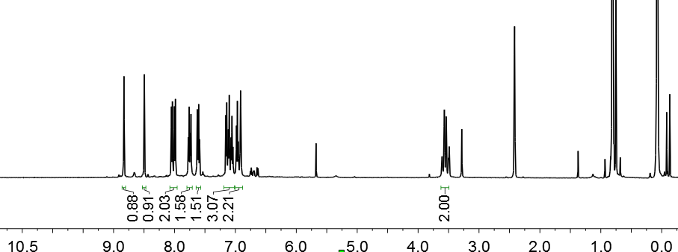
Fig. S2. The ¹H NMR spectrum of the mixture of 145 and 145
Fig. S3. The ¹⁹F NMR spectrum of of the mixture of 145 and 146
The compound 29 was dissolved in DMSO (5.0 mL). Then H₂O (20 equiv.) and CsF (54.7 mg, 1.2 equiv.) were added into the reaction mixture. The reaction was continued for an additional 5 h at 40 °C. The experimental results showed that no product 62 was generated, while compound 29 was almost completely recovered.

To an oven-dried screw-cap reaction tube were added N-triftosylhydrazone (102.6 mg, 0.3 mmol, 1.0 equiv.), NaH (24 mg, 2.0 equiv., 60 wt% dispersion in mineral oil), N-TBS indole (138.6 mg, 0.6 mmol, 2.0 equiv.), Tp^{Br3}Ag(THF) (36 mg, 10.0 mol%) and PhCF₃ inside a glove box with nitrogen atmosphere. After transfer out of the glove box, the reaction was continued for an additional 12 h at 60 °C and give the Cyclopropane 70 (97.5 mg, 97% yield). ¹H NMR (500 HMz, CDCl₃) δ 7.32 (d, J = 7.0 Hz, 1H), 7.13 (d, J = 6.5 Hz, 2H), 7.06 (t, J = 7.5 Hz, 1H), 6.93-6.85 (m, 2H), 6.82 (dd, J = 8.0, 2.5 Hz, 1H), 6.74 (td, J = 7.5, 2.5 Hz, 1H), 3.78-3.70 (m, 1H), 3.04-2.94 (m, 1H), 2.37 (s, 3H), 1.25-1.20 (m, 1H), 1.03 (s, 9H), 0.41 (s, 6H). ¹³C NMR (150 HMz, CDCl₃) δ 151.1, 139.2, 134.6, 133.3, 129.1, 126.3, 124.9, 124.0, 117.2, 110.9, 50.8, 32.8, 26.6, 20.9, 20.2, -4.4, -4.7. HRMS (ESI) m/z calcd. for C₂₂H₃₀NSi⁺ [M + H]⁺ 336.2142, found 336.2146.

Step 1: Cyclopropane 70 (33.5 mg, 0.1 mmol, 1.0 equiv.) and CsF (18.2 mg, 0.12 mmol, 1.2 equiv.) in DMSO-d₆ (1.0 mL) were stirred at 25 °C for 10 min under N₂ atmosphere. The mixture was directly analyzed by ¹H NMR spectroscopy and HRMS. The Intermediate 70 can be observed in the ¹H NMR spectrum of the reaction mixture.
Step 2: Then the reaction was continued for an additional 10 min at 25 °C under air atmosphere, and diluted with DCM, washed with brine, dried over anhydrous Na₂SO₄, filtered and the solvent was evaporated under reduced pressure to leave a crude product. The crude product was purified by flash column chromatography on silica gel (pre-treated with trimethylamine, using petroleum ether-EtOAc as eluent) to give the product 70 (80% yield).

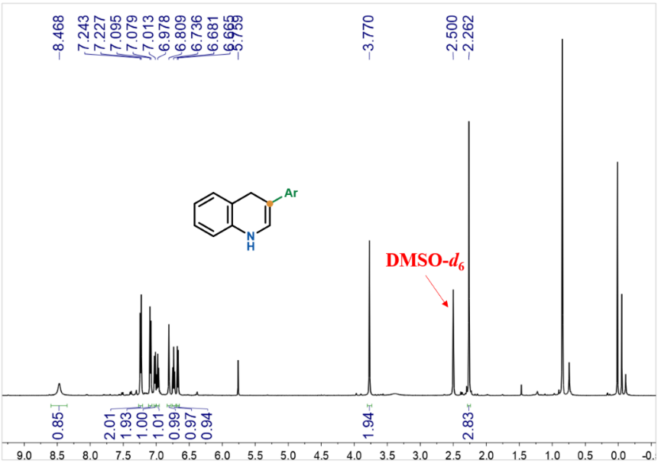
Fig. S4. Monitoring Intermediate 70 by ¹H NMR spectrum
Fig. S5. Monitoring Intermediate 70 by HRMS.
HRMS (ESI) m/z calcd. for C₁₆H₁₆N⁺ [M + H]⁺ 222.1277, found 222.1259.

5.1.2 Deuterium-Labeling Experiments
Procedure : The indole-d was prepared according to literature procedure. ^{[16]}Indole (585 mg, 5.0 mmol, 1.0 equiv.) was stirred in a 0.01 M solution of DCl in D₂O (20 mL) at 60°C for 4 h under N₂. The reaction was cooled and extracted three times with dry Et₂O. The organic layers were combined, dried over anhydrous Na₂SO₄ and filtered and reduced under vacuum. The resulting oil was triturated in pentane to afford a colorless solid. The solid ([1,3-D]indole) was dissolved in a mixture of Et₂O (20 mL) and H₂O (10 mL) and stirred for 2 h at room temperature. The layers were separated and the aqueous layer extracted twice with Et₂O (20 mL). The organic layers were combined, dried over anhydrous Na₂SO₄ and filtered and reduced under vacuum to give the indole-d as a white solid.
The 1-d in anhydrous THF (20 mL) was added dropwise to a stirred suspension of NaH (2.4 g, 6.0 mmol, 1.2 equiv., 60% dispersion in mineral oil) in THF (40 mL) at 0 °C. The mixture was allowed to slowly warm to room temperature over 30 min, cooled to 0 °C, and TBSCl (979.6 mg, 6.5 mmol, 1.3 equiv.) was added portionwise. The resulting mixture was slowly warmed to room temperature and stirred until full consumption of starting material as monitored by TLC. On completion, the reaction was quenched at 0 °C with sat. aqueous NH₄Cl solution (10 mL) and extracted with EtOAc (20 mL). The combined organic phases were washed with brine and dried over anhydrous Na₂SO₄. The crude mixture was concentrated under reduced pressure and purified by flash column chromatography to afford product 1-d as white solid (1.1 g, 95% yield).
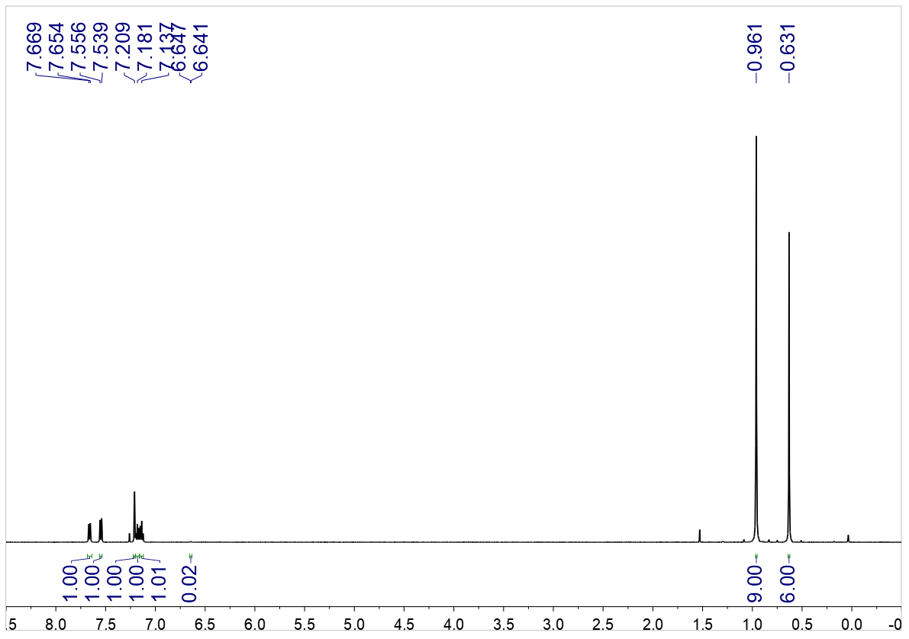
Fig. S6. The ¹H NMR spectrum of 1-d
¹H NMR (500 MHz, CDCl₃) δ 7.66 (d, J = 7.5 Hz, 1H), 7.55 (d, J = 8.0 Hz, 1H), 7.21 (s, 1H), 7.20-7.16 (m, 1H), 7.14 (t, J = 7.5 Hz, 1H), 6.64 (d, J = 3.0 Hz, 1H), 0.96 (s, 1H), 0.63 (s, 1H).
For trifluoromethyl-substituted N-triftosylhydrazone
To an oven-dried screw-cap reaction tube were added TFHZ-Tfs 2 (115.3 mg, 0.36 mmol, 1.2 equiv.), NaH (28.8 mg, 0.72 mmol, 60 wt% dispersion in mineral oil, 2.4 equiv.), N-TBS indole (69.4 mg, 0.3 mmol, 1.0 equiv.), Tp^{Br3}Cu(NCMe) (36.0 mg, 10.0 mol%) and PhCF₃inside a glove box with nitrogen atmosphere. After transfer out of the glove box, the reaction was continued for an additional 12 h at 60 °C. The reaction mixture was filtered through a short pad of silica gel with DCM as an eluent. After removal of the solvent in vacuo, the residue was purified by flash column chromatography on silica gel to give the product 147 (85.4 mg, 91% yield). ¹H NMR (500 MHz, CDCl₃) δ 7.34 (d, J = 7.5 Hz, 1H), 7.06 (dd, J = 11.5, 4.0 Hz, 1H), 6.78 (d, J = 8.0 Hz, 1H), 6.75 (dd, J = 11.5, 4.0 Hz, 1H), 3.92 (dd, J = 7.0, 2.0 Hz, 1H), 3.10 (dd, J = 7.0, 3.0 Hz, 1H), 1.00 (s, 9H), 0.44 (s, 3H), 0.40 (s, 3H). ¹³C NMR (150 MHz, CDCl₃) δ 150.3, 129.7, 127.2, 126.6 (q, J = 270.0 Hz), 124.6, 117.8, 111.4, 43.5 (q, J = 3.0 Hz), 26.5, 25.4 (q, J = 3.0 Hz), 21.1 (q, J = 36.0 Hz), 20.2, -4.65, -4.68. ¹⁹F NMR (564 MHz, CDCl₃) δ -64.04 (d, J = 7.3 Hz). HRMS (ESI) m/z calcd. for C₁₆H₂₃F₃NSi⁺ [M + H]⁺ 314.1546, found 314.1544.

To an oven-dried screw-cap reaction tube were added 147-d (31.4 mg, 0.1 mmol, 1.0 equiv.), TBAF (0.12 mL, 0.12 mmol, 1.0 mol/L in THF, 1.2 equiv.), D₂O (20 equiv.) were stired at 25 °C for 10 min under N₂ atmosphere. The mixture was directly analyzed by ¹H NMR spectroscopy and HRMS. The intermediate 148-d₂ can be observed in the ¹H NMR spectrum of the reaction mixture. And then CsF, H₂O and DMSO were added into the reaction mixture, and stired at 40 °C for 5 h under air atmosphere. The deuterated product 56-d can be obtained. The deuterium ratio is shown below.
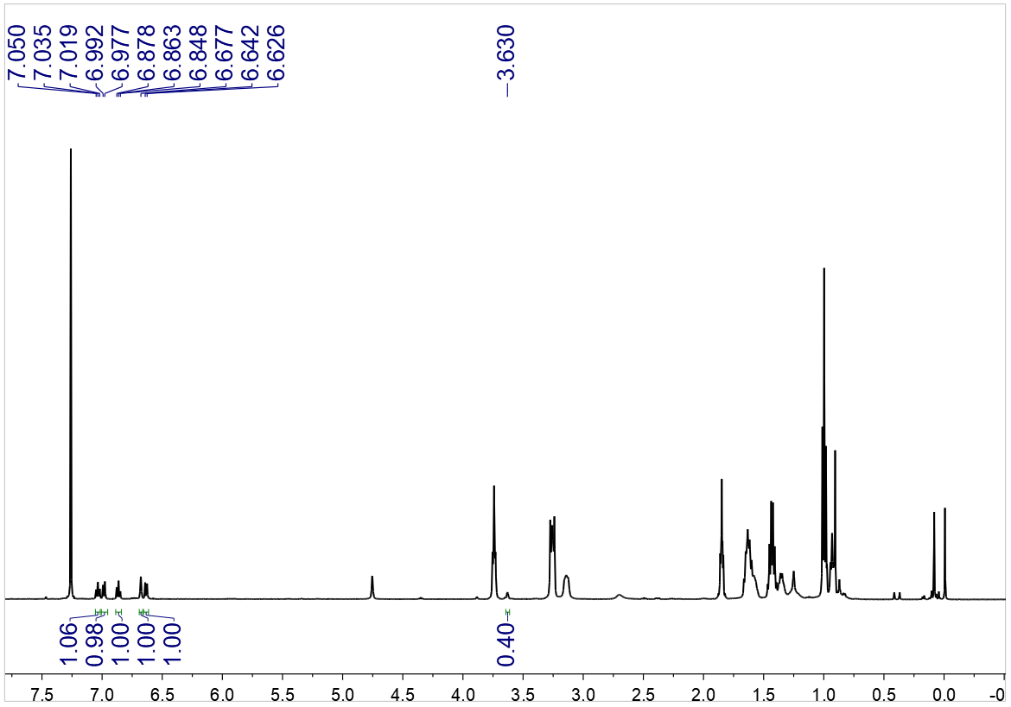
Fig. S7. The ¹H NMR spectrum of 148-d₂
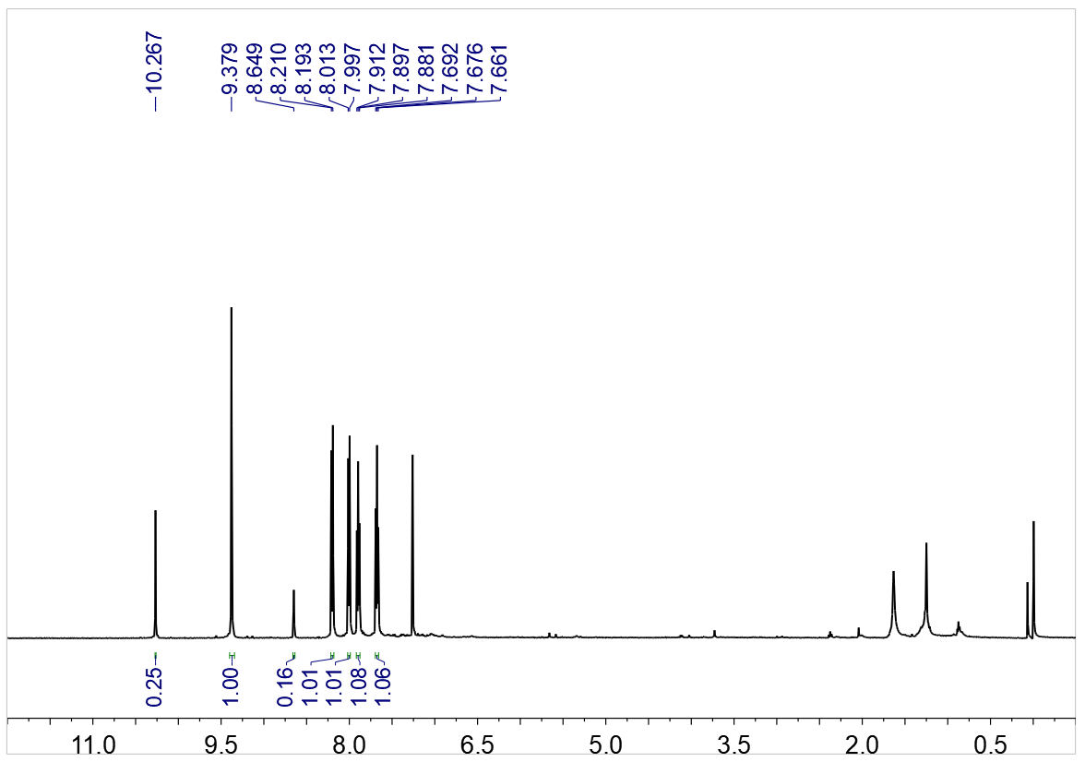
Fig. S8. The ¹H NMR spectrum of 56-d

Compound 147 (31.3 mg, 0.1 mmol, 1.0 equiv.), CsF (18.2 mg, 0.12 mmol, 1.2 equiv.), and H₂O (20 equiv.) in DMSO-d₆ (1.0 mL) were stirred at 25 °C for 10 min under N₂ atmosphere. The mixture was directly analyzed by ¹H NMR spectroscopy and HRMS. The intermediate 148-d₁ can be observed in the ¹H NMR spectrum of the reaction mixture. And then CsF, H₂O and DMSO were added into the reaction mixture, and stired at 40 °C for 5 h under air atmosphere. The deuterated product 56-d can be obtained. The deuterium ratio is shown below.
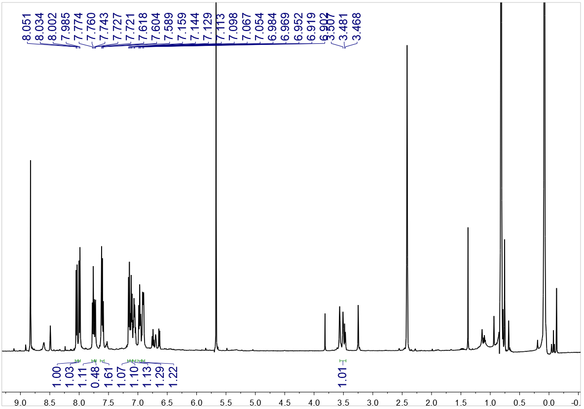
Fig. S9. The ¹H NMR spectrum of 148-d₁
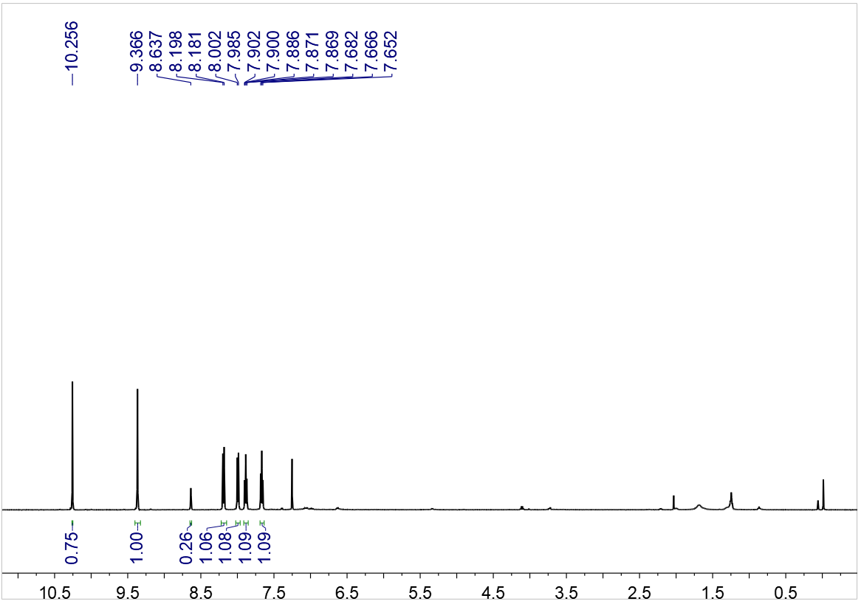
Fig. S10. The ¹H NMR spectrum of 56-d

^{[17]}To a pre-mixed solution of DMSO (3 mL) and D₂O (1 mL), 1-(chloromethyl)-4-methylbenzene (281.2 mg, 2.0 mmol), 4-picoline (745.0 mg, 8.0 mmol), K₃PO₄ (169.6 mg, 8.0 mmol) was added. The resulting mixture was stirred at 50 °C for 10 h. p-Nitrosodimethyl aniline (600.7 mg, 4.0 mmol) was then added at room temperature. The mixture was continuous stirred for 4 h at room temperature before slowly poured to stirred HCl (3 N, 12 mL) at 0 °C. The resulting mixture was stirred vigorously for 1 h before extracted with ethyl acetate (10 mL) for 3 times. The combined organic phase was washed with brine and dried with anhydrous Na₂SO₄. The crude product was vacuo evaporated and purified by flash column chromatography on a silica gel to give corresponding deuterated 4-methylbenzaldehyde (179.1 mg, 74% yield). And then preparing the deuterated N-triftosylhydrazone according to the literature.^{[3]}
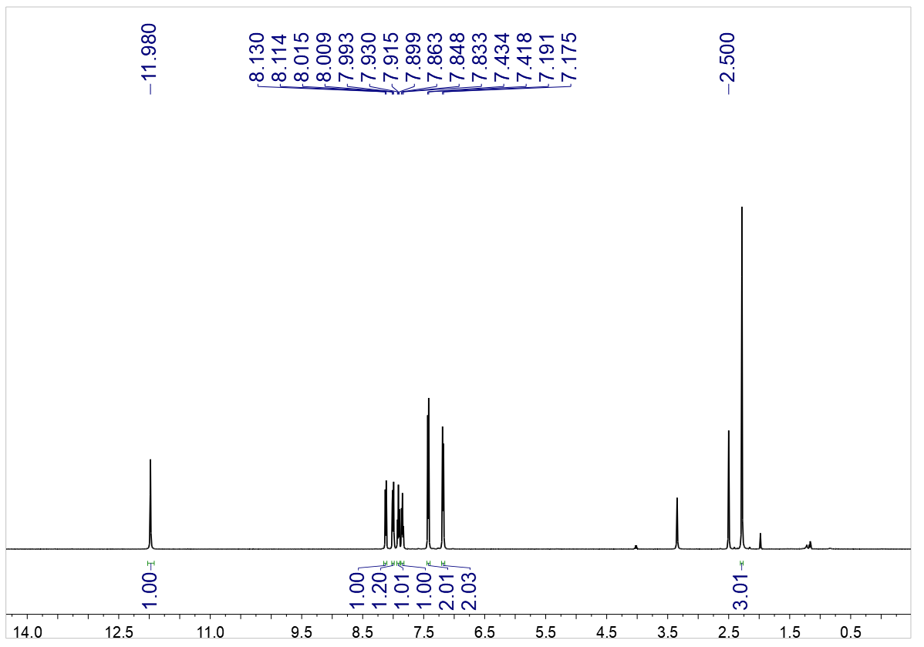
Fig. S11. The ¹H NMR spectrum of deuterated N-sulfonylhydrazone
¹H NMR (500 MHz, DMSO-d₆) δ 11.98 (s, 1H), 8.12 (d, J = 8.0 Hz, 1H), 8.03-7.96 (m, 2H), 7.91 (t, J = 7.5 Hz, 1H), 7.85 (t, J = 7.5 Hz, 1H), 7.43 (d, J = 8.0 Hz, 2H), 7.18 (d, J = 8.0 Hz, 2H), 2.28 (s, 3H).

Step 1: Cyclopropane 70 (33.5 mg, 0.1 mmol, 1.0 equiv.), D₂O (20 equiv.) and CsF (18.2 mg, 0.12 mmol, 1.2 equiv.) in DMSO-d₆ (1.0 mL) were stirred at 25 °C for 10 min under N₂ atmosphere. The mixture was directly analyzed by ¹H NMR spectroscopy and HRMS. The Intermediate 70-d can be observed in the ¹H NMR spectrum of the reaction mixture. The deuterium ratio is shown below (Fig. S12).
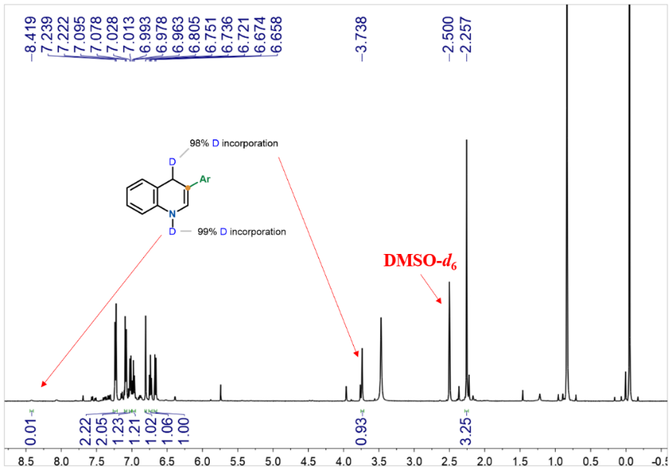
Fig. S12. ¹H NMR spectrum of Step 1 reaction mixture.
Step 2: Then the reaction was continued for an additional 10 min at 25 °C under air atmosphere, and diluted with DCM, washed with brine, dried over anhydrous Na₂SO₄, filtered and the solvent was evaporated under reduced pressure to leave a crude product. The crude product was purified by flash column chromatography on silica gel (pre-treated with trimethylamine, using petroleum ether-EtOAc as eluent) to give the product 70-d (80% yield). The deuterium ratio is shown below (Fig. S13).
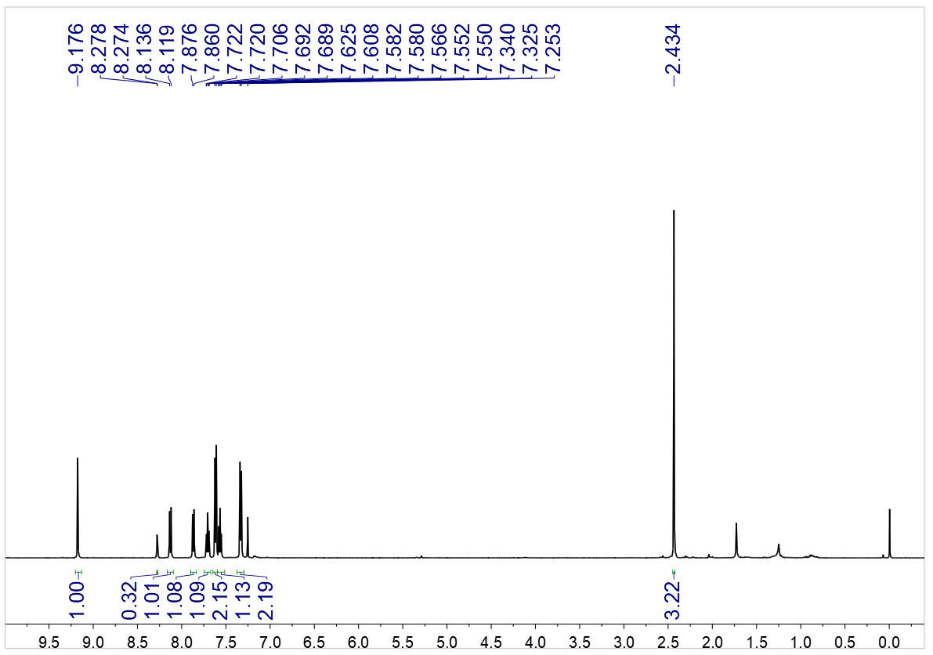
Fig. S13. ¹H NMR spectrum of 70-d.
Step 1: To an oven-dried screw-cap reaction tube were added N-triftosylhydrazone (102.6 mg, 0.3 mmol, 1.0 equiv.), NaH (24 mg, 0.6 mmol, 2.0 equiv., 60 wt% dispersion in mineral oil), 1-D (138.6 mg, 0.6 mmol, 2.0 equiv.), Tp^{Br3}Ag(THF) (36 mg, 10.0 mol%) and PhCF₃ inside a glove box with nitrogen atmosphere. After transfer out of the glove box, the reaction was continued for an additional 12 h at 60 °C and give the Cyclopropane 70-d (97% yield). The deuterium ratio is shown below (Fig. S14).
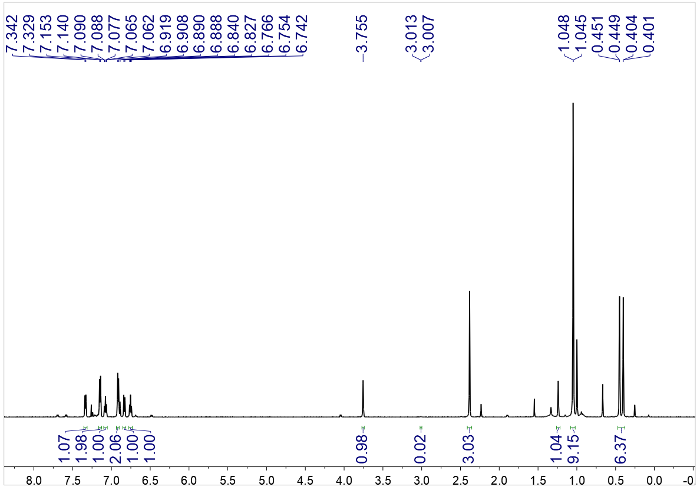
Fig. S14. ¹H NMR spectrum of Cyclopropane 70-d.
Step 2: Then the reaction was continued for an additional 10 min at 25 °C under air atmosphere, and diluted with DCM, washed with brine, dried over anhydrous Na₂SO₄, filtered and the solvent was evaporated under reduced pressure to leave a crude product. The crude product was purified by flash column chromatography on silica gel (pre-treated with trimethylamine, using petroleum ether-EtOAc as eluent) to give the product 70-d (80% yield). The deuterium ratio is shown below (Fig. S15).
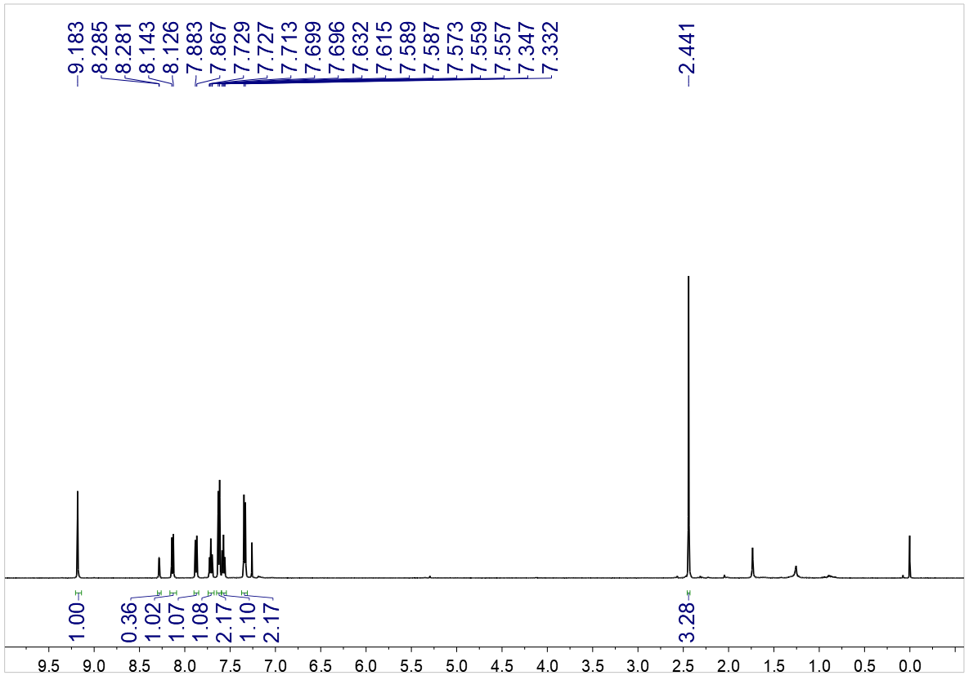
Fig. S15. ¹H NMR spectrum of 70-d.
Compound 149-d (28.5 mg, 0.1 mmol, 1.0 equiv.), TBAF (0.12 mL, 0.12 mmol, 1.2 equiv., 1.0 mol/L in THF) and THF (3.0 mL) were stirred at 25 °C for 10 min under N₂ atmosphere. The mixture was directly analyzed by ¹H NMR spectroscopy and HRMS. The deuterium ratio of 150 can be observed in the ¹H NMR spectrum of the reaction mixture. Then the reaction was continued for an additional 10 min at 25 °C under air atmosphere. The product 70-d (97% yield). The deuterium ratio is shown below (Fig. S16).
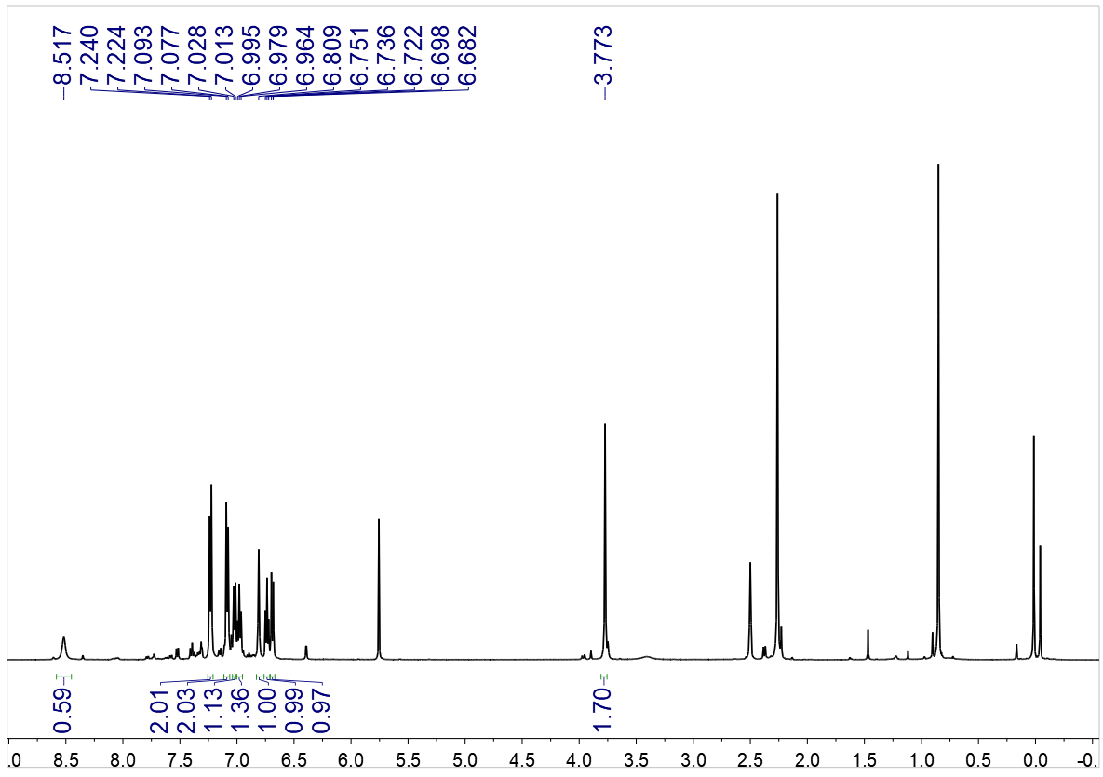
Fig. S16. ¹H NMR spectrum of 150.

5.1.3 ¹⁸O-Labeling Experiments
Compound 147 (93.9 mg, 0.3 mmol, 1.0 equiv.), CsF (54.7 mg, 0.36 mmol, 1.2 equiv.), and H₂¹⁸O (20 equiv.) in DMSO (5.0 mL) were stirred at 25 °C for 10 min. After completion of the reaction, the mixture was diluted with DCM, washed with brine, dried over anhydrous Na₂SO₄, filtered and the solvent was evaporated under reduced pressure to leave a crude product, which was purified by flash column chromatography on silica gel (pre-treated with trimethylamine, using petroleum ether-EtOAc as eluent) to give the product 56-¹⁸O. The product was analyzed by HRMS (Fig. S17).
Fig. S17. HRMS of 56-¹⁸O, HRMS (ESI) m/z, found 160.0630.

5.2 Computational Details
All DFT calculations described in this work were carried out with Gaussian16 suite of programs^{[18]}. All geometry optimizations were presented by using the M06 functional^{[19]} by using the SMD solvent model^{[20]}. For N-TBS-indole one carbon insertion process with aryl N-triftosylhydrazones to form 3-arylquinoline, toluene solvent was used. For N-TBS-indole one carbon insertion process with fluoroalkyl N-triftosylhydrazones to form 3-formylquinoline, DMSO solvent was used. The Br, Ag and Cs atoms were represented with the effective core potential SDD basis set,^{[21,22]} all the other atoms were described with 6-31G(d,p) basis set.^{[23-25]} Intrinsic Reaction Paths (IRPs)^{[26,27]} were traced from the various transition structures to obtain the connected intermediates. The nature of the local minima was established with analytical frequencies calculations and geometry optimizations were computed without any symmetry constraints. 3D structures of optimized geometries were generated using CYLview visualization software.^{[28]}
Fig. S18. (A) Comparision of 1,3-H transfer between CF₃- and CF₂CF₃-substituted carbenes. The change in conformation between Int8 and TS4' is larger than that between Int8-1 and TS4-1', thus the energy barrier for TS4-1' is lower than that for TS4'. (B) Comparision of Michael addition between CF₃- and CF₂CF₃-substituted carbenes. The difference in electronegativity between O and C atoms in TS4 (Δe = 2.005) is larger than that in TS4-1 (Δe = 1.489), thus the energy barrier for TS4 is lower than that for TS4-1. Values in e represent NPA charges. Most hydrogen atoms in 3D structures are omitted for clarity.
Fig. S19. The comparision of Michael addition and CsF-assisted 1,3-H transfer of intermediate Int8.
Fig. S20. The comparision of Michael addition and CsF-assisted 1,3-H transfer of intermediate Int8-1.

6. Characterization Data of Products

(3) 3-(Trifluoromethyl)quinolone
Prepared according to General Procedure A using TFHZ-Tfs 2 (115.3 mg, 0.36 mmol) and N-TBS indole (69.4 mg, 0.3 mmol) afforded 3 (50.9 mg, 86% yield) as a white solid; mp: 38-40 °C.
¹H NMR (500 MHz, CDCl₃) δ 9.10 (d, J = 2.0 Hz, 1H), 8.44 (s, 1H), 8.19 (d, J = 8.5 Hz, 1H), 7.92 (d, J = 8.0 Hz, 1H), 7.88-7.82 (m, 1H), 7.66 (t, J = 7.5 Hz, 1H).
¹³C NMR (150 MHz, CDCl₃) δ 149.3, 146.0 (q, J = 3.5 Hz), 133.9 (q, J = 4.5 Hz), 131.7, 129.6, 128.6, 128.0, 126.2, 123.7 (q, J = 271.5 Hz), 123.6 (q, J = 33.0 Hz).
¹⁹F NMR (564 MHz, CDCl₃) δ -61.81.
HRMS (ESI) m/z calcd. for C₁₀H₇F₃N⁺ [M + H]⁺ 198.0525, found 198.0528.
-----------------------------------------------------------------------------------------------------------------------------------------------------------------------------------------------
(4) 4-Methyl-3-(trifluoromethyl)quinolone
Prepared according to General Procedure A using TFHZ-Tfs 2 (115.3 mg, 0.36 mmol) and 1-(tert-butyldimethylsilyl)-3-methyl-1H-indole (73.6 mg, 0.3 mmol) afforded 4 (12.7 mg, 20% yield) as a white solid; mp: 58-60 °C.
¹H NMR (500 MHz, CDCl₃) δ 9.07 (s, 1H), 8.17 (t, J = 7.5 Hz, 2H), 7.83 (t, J = 7.5 Hz, 1H), 7.68 (t, J = 7.5 Hz, 1H), 2.87 (s, 3H).
¹³C NMR (150 MHz, CDCl₃) δ 149.0, 145.9 (q, J = 6.0 Hz), 145.1 (q, J = 1.5 Hz), 131.2, 130.3, 127.6, 127.3, 124.32, 124.30 (q, J = 273.0 Hz), 121.9 (q, J = 30.0 Hz), 14.7 (q, J = 1.5 Hz).
¹⁹F NMR (564 MHz, CDCl₃) δ -58.67.
HRMS (ESI) m/z calcd. for C₁₁H₉F₃N⁺ [M + H]⁺ 212.0682, found 212.0684.
-----------------------------------------------------------------------------------------------------------------------------------------------------------------------------------------------
(5) 5-Methyl-3-(trifluoromethyl)quinoline
Prepared according to General Procedure A using TFHZ-Tfs 2 (115.3 mg, 0.36 mmol) and 1-(tert-butyldimethylsilyl)-4-methyl-1H-indole (73.6 mg, 0.3 mmol) afforded 5 (46.9 mg, 74% yield) as a white solid; mp: 40-42 °C.
¹H NMR (500 MHz, CDCl₃) δ 9.10 (d, J = 2.0 Hz, 1H), 8.60 (s, 1H), 8.04 (d, J = 8.5 Hz, 1H), 7.77-7.71 (m, 1H), 7.49 (d, J = 7.0 Hz, 1H), 2.75 (s, 3H).
¹³C NMR (150 MHz, CDCl₃) δ 149.8, 145.6 (q, J = 3.0 Hz), 135.7, 131.5, 130.4 (q, J = 4.5 Hz), 128.4, 127.8, 125.8, 123.8 (q, J = 270.0 Hz), 123.1 (q, J = 31.5 Hz), 18.5.
¹⁹F NMR (564 MHz, CDCl₃) δ -61.58.
HRMS (ESI) m/z calcd. for C₁₁H₉F₃N⁺ [M + H]⁺ 212.0682, found 212.0684.
-----------------------------------------------------------------------------------------------------------------------------------------------------------------------------------------------
(6) 6-Methyl-3-(trifluoromethyl)quinoline
Prepared according to General Procedure A using TFHZ-Tfs 2 (115.3 mg, 0.36 mmol) and 1-(tert-butyldimethylsilyl)-5-methyl-1H-indole (73.6 mg, 0.3 mmol) afforded 6 (53.2 mg, 84% yield) as a white solid; mp: 68-70 °C.
¹H NMR (500 MHz, CDCl₃) δ 9.03 (d, J = 2.0 Hz, 1H), 8.35 (s, 1H), 8.07 (d, J = 9.0 Hz, 1H), 7.71-7.65 (m, 2H), 2.58 (s, 3H).
¹³C NMR (125 MHz, CDCl₃) δ 148.0, 145.1 (q, J = 4.5 Hz), 138.2, 134.1, 133.2 (q, J = 4.5 Hz), 129.2, 127.3, 126.3, 123.8 (q, J = 270.0 Hz), 123.5 (q, J = 32.5 Hz), 21.6.
¹⁹F NMR (470 MHz, CDCl₃) δ -61.76.
HRMS (ESI) m/z calcd. for C₁₁H₉F₃N⁺ [M + H]⁺ 212.0682, found 212.0683.
-----------------------------------------------------------------------------------------------------------------------------------------------------------------------------------------------
(7) 7-Methyl-3-(trifluoromethyl)quinoline
Prepared according to General Procedure A using TFHZ-Tfs 2 (115.3 mg, 0.36 mmol) and 1-(tert-butyldimethylsilyl)-6-methyl-1H-indole (73.6 mg, 0.3 mmol) afforded 7 (55.1 mg, 87% yield) as a white solid; mp: 51-53 °C.
¹H NMR (500 MHz, CDCl₃) δ 9.05 (s, 1H), 8.40 (s, 1H), 7.96 (s, 1H), 7.82 (d, J = 8.5 Hz, 1H), 7.50 (d, J = 8.5 Hz, 1H), 2.62 (s, 3H).
¹³C NMR (150 MHz, CDCl₃) δ 149.6, 146.0 (q, J = 3.5 Hz), 142.6, 133.5 (q, J = 4.5 Hz), 130.3, 128.6, 128.2, 124.3, 123.8 (q, J = 271.5 Hz), 122.7 (q, J = 33.0 Hz), 22.0.
¹⁹F NMR (564 MHz, CDCl₃) δ -61.65.
HRMS (ESI) m/z calcd. for C₁₁H₉F₃N⁺ [M + H]⁺ 212.0682, found 212.0684.
-----------------------------------------------------------------------------------------------------------------------------------------------------------------------------------------------
(8) 8-Methyl-3-(trifluoromethyl)quinoline
Prepared according to General Procedure A using TFHZ-Tfs 2 (115.3 mg, 0.36 mmol) and 1-(tert-butyldimethylsilyl)-7-methyl-1H-indole (73.6 mg, 0.3 mmol) afforded 8 (51.3 mg, 81% yield) as a white solid; mp: 39-41 °C.
¹H NMR (500 MHz, CDCl₃) δ 9.12 (d, J = 2.0 Hz, 1H), 8.42 (s, 1H), 7.77 (d, J = 8.0 Hz, 1H), 7.70 (d, J = 7.0 Hz, 1H), 7.55 (t, J = 7.5 Hz, 1H), 2.84 (s, 3H).
¹³C NMR (150 MHz, CDCl₃) δ 148.4, 144.8 (q, J = 3.0 Hz), 137.6, 134.1 (q, J = 4.5 Hz), 131.8, 127.8, 126.6, 126.3, 123.8 (q, J = 270.0 Hz), 123.3 (q, J = 31.5 Hz), 18.0.
¹⁹F NMR (564 MHz, CDCl₃) δ -61.77.
HRMS (ESI) m/z calcd. for C₁₁H₉F₃N⁺ [M + H]⁺ 212.0682, found 212.0684.
-----------------------------------------------------------------------------------------------------------------------------------------------------------------------------------------------
(9) Methyl 3-(trifluoromethyl)quinoline-6-carboxylate
Prepared according to General Procedure A using TFHZ-Tfs 2 (115.3 mg, 0.36 mmol) and methyl 1-(tert-butyldimethylsilyl)-1H-indole-5-carboxylate (86.8 mg, 0.3 mmol) afforded 9 (69.8 mg, 91% yield) as a white solid; mp: 102-104 °C.
¹H NMR (500 MHz, CDCl₃) δ 9.17 (d, J = 2.0 Hz, 1H), 8.68 (d, J = 1.5 Hz, 1H), 8.54 (s, 1H), 8.42 (dd, J = 9.0, 2.0 Hz, 1H), 8.22 (d, J = 9.0 Hz, 1H), 4.01 (s, 3H).
¹³C NMR (150 MHz, CDCl₃) δ 166.0, 151.0, 148.1 (q, J = 3.0 Hz), 135.1 (q, J = 4.5 Hz), 131.5, 131.2, 130.0, 129.6, 125.5, 124.4 (q, J = 33.0 Hz), 123.4 (q, J = 271.5 Hz), 52.6.
¹⁹F NMR (564 MHz, CDCl₃) δ -62.00.
HRMS (ESI) m/z calcd. for C₁₂H₉F₃NO₂⁺ [M + H]⁺ 256.0580, found 256.0578.
-----------------------------------------------------------------------------------------------------------------------------------------------------------------------------------------------
(10) 1-(3-(Trifluoromethyl)quinolin-6-yl)ethan-1-one
Prepared according to General Procedure A using TFHZ-Tfs 2 (115.3 mg, 0.36 mmol) and 1-(1-(tert-butyldimethylsilyl)-1H-indol-5-yl)ethan-1-one (82.0 mg, 0.3 mmol) afforded 10 (45.9 mg, 64% yield) as a white solid; mp: 87-89 °C.
¹H NMR (500 MHz, CDCl₃) δ 9.20 (d, J = 2.0 Hz, 1H), 8.60-8.54 (m, 2H), 8.41 (dd, J = 9.0, 2.0 Hz, 1H), 8.26 (d, J = 9.0 Hz, 1H), 2.77 (s, 3H).
¹³C NMR (150 MHz, CDCl₃) δ 196.8, 151.1, 148.2 (q, J = 3.0 Hz), 136.1, 135.3 (q, J = 3.0 Hz), 130.3, 130.0, 125.6, 124.6 (q, J = 33.0 Hz), 123.4 (q, J = 270.0 Hz), 26.8.
¹⁹F NMR (564 MHz, CDCl₃) δ -61.97.
HRMS (ESI) m/z calcd. for C₁₂H₉F₃NO⁺ [M + H]⁺ 240.0631, found 240.0632.
-----------------------------------------------------------------------------------------------------------------------------------------------------------------------------------------------
(11) 6-Bromo-3-(trifluoromethyl)quinoline
Prepared according to General Procedure A using TFHZ-Tfs 2 (115.3 mg, 0.36 mmol) and 5-bromo-1-(tert-butyldimethylsilyl)-1H-indole (93.1 mg, 0.3 mmol) afforded 11 (161.8 mg, 92% yield) as a white solid; mp: 89-91 °C.
¹H NMR (500 MHz, CDCl₃) δ 9.10 (d, J = 1.5 Hz, 1H), 8.36 (s, 1H), 8.10 (d, J = 1.5 Hz, 1H), 8.06 (d, J = 9.0 Hz, 1H), 7.93 (dd, J = 9.0, 2.0 Hz, 1H).
¹³C NMR (150 MHz, CDCl₃) δ 148.0, 146.4 (q, J = 3.0 Hz), 135.3, 132.9 (q, J = 4.5 Hz), 131.3, 130.5, 127.4, 124.7 (q, J = 33.0 Hz), 123.4 (q, J = 270.0 Hz), 122.1.
¹⁹F NMR (564 MHz, CDCl₃) δ -62.00.
HRMS (ESI) m/z calcd. for C₁₀H₆BrF₃N⁺ [M + H]⁺ 275.9630, found 275.9631.
-----------------------------------------------------------------------------------------------------------------------------------------------------------------------------------------------
(12) 6-Methoxy-3-(trifluoromethyl)quinoline
Prepared according to General Procedure A using TFHZ-Tfs 2 (115.3 mg, 0.36 mmol) and 1-(tert-butyldimethylsilyl)-5-methoxy-1H-indole (78.4 mg, 0.3 mmol) afforded 12 (49.1 mg, 72% yield) as a white solid; mp: 38-40 °C.
¹H NMR (500 MHz, CDCl₃) δ 8.93 (d, J = 1.0 Hz, 1H), 8.31 (s, 1H), 8.05 (d, J = 9.5 Hz, 1H), 7.48 (dd, J = 9.0, 2.5 Hz, 1H), 7.13 (d, J = 2.5 Hz, 1H), 3.94 (s, 3H).
¹³C NMR (150 MHz, CDCl₃) δ 158.8, 145.6, 143.5 (q, J = 3.0 Hz), 132.4 (q, J = 4.5 Hz), 131.0, 127.5, 124.7, 123.9 (q, J = 33.0 Hz), 123.8 (q, J = 271.5 Hz), 105.6, 55.6.
¹⁹F NMR (564 MHz, CDCl₃) δ -61.81.
HRMS (ESI) m/z calcd. for C₁₁H₉F₃NO⁺ [M + H]⁺ 228.0631, found 228.0630.
-----------------------------------------------------------------------------------------------------------------------------------------------------------------------------------------------
(13) tert-Butyl (3-(trifluoromethyl)quinolin-6-yl)carbamate
Prepared acording to General Procedure A using TFHZ-Tfs 2 (115.3 mg, 0.36 mmol) and tert-butyl (1-(tert-butyldimethylsilyl)-1H-indol-5-yl)carbamate (104.0 mg, 0.3 mmol) afforded 13 (54.3 mg, 58% yield) as a white solid; mp: 145-147 °C.
¹H NMR (500 MHz, CDCl₃) δ 8.96 (d, J = 1.5 Hz, 1H), 8.34 (s, 1H), 8.21 (s, 1H), 8.07 (d, J = 9.0 Hz, 1H), 7.61 (dd, J = 9.0, 2.5 Hz, 1H), 6.97 (s, 1H), 1.55 (s, 9H).
¹³C NMR (150 MHz, CDCl₃) δ 152.5, 146.0, 144.4 (q, J = 3.0 Hz), 137.7, 133.2 (q, J = 4.5 Hz), 130.3, 127.2, 124.6, 124.1 (q, J = 33.0 Hz), 123.7 (q, J = 271.5 Hz), 114.1, 81.4, 28.3.
¹⁹F NMR (564 MHz, CDCl₃) δ -61.93.
HRMS (ESI) m/z calcd. for C₁₅H₁₆F₃N₂O₂⁺ [M + H]⁺ 313.1158, found 313.1155.
-----------------------------------------------------------------------------------------------------------------------------------------------------------------------------------------------
(14) 6-Phenyl-3-(trifluoromethyl)quinoline
Prepared according to General Procedure A using TFHZ-Tfs 2 (115.3 mg, 0.36 mmol) and 1-(tert-butyldimethylsilyl)-5-phenyl-1H-indole (92.3 mg, 0.3 mmol) afforded 14 (71.3 mg, 87% yield) as a white solid; mp: 72-74 °C.
¹H NMR (600 MHz, CDCl₃) δ 9.10 (d, J = 1.8 Hz, 1H), 8.49 (s, 1H), 8.25 (d, J = 8.4 Hz, 1H), 8.11 (dd, J = 8.4, 1.8 Hz, 1H), 8.08 (d, J = 1.8 Hz, 1H), 7.74-7.69 (m, 2H), 7.55-7.49 (m, 2H), 7.47-7.42 (m, 1H).
¹³C NMR (150 MHz, CDCl₃) δ 148.7, 145.9 (q, J = 3.0 Hz), 140.8, 139.5, 134.0 (q, J = 4.5 Hz), 131.5, 130.0, 129.1, 128.2, 127.4, 126.5, 126.0, 123.9 (q, J = 33.0 Hz), 123.7 (q, J = 270.0 Hz).
¹⁹F NMR (564 MHz, CDCl₃) δ -61.80.
HRMS (ESI) m/z calcd. for C₁₆H₁₁F₃N⁺ [M + H]⁺ 274.0838, found 274.0840.
-----------------------------------------------------------------------------------------------------------------------------------------------------------------------------------------------
(15) 6-(Pyridin-2-yl)-3-(trifluoromethyl)quinoline
Prepared according to General Procedure A using TFHZ-Tfs 2 (115.3 mg, 0.36 mmol) and 1-(tert-butyldimethylsilyl)-5-(pyridin-2-yl)-1H-indole (92.6 mg, 0.3 mmol) afforded 15 (25.5 mg, 31% yield) as a white solid; mp: 118-120 °C.
¹H NMR (500 MHz, CDCl₃) δ 9.10 (d, J = 1.0 Hz, 1H), 8.76 (d, J = 4.5 Hz, 1H), 8.56 (s, 1H), 8.54-8.47 (m, 2H), 8.26 (d, J = 9.0 Hz, 1H), 7.88 (d, J = 8.0 Hz, 1H), 7.85-7.79 (m, 1H), 7.34-7.28 (m, 1H).
¹³C NMR (125 MHz, CDCl₃) δ 155.6, 150.0, 149.5, 146.4 (q, J = 3.8 Hz), 138.8, 137.1, 134.5 (q, J = 3.8 Hz), 130.5, 130.0, 126.6, 126.4, 124.0 (q, J = 32.5 Hz), 123.6 (q, J = 270.0 Hz), 122.9, 120.9.
¹⁹F NMR (470 MHz, CDCl₃) δ -61.86.
HRMS (ESI) m/z calcd. for C₁₅H₁₀F₃N₂⁺ [M + H]⁺ 275.0791, found 275.0792.
-----------------------------------------------------------------------------------------------------------------------------------------------------------------------------------------------
(16) 6-(Allyloxy)-3-(trifluoromethyl)quinoline
Prepared according to General Procedure A using TFHZ-Tfs 2 (115.3 mg, 0.36 mmol) and 5-(allyloxy)-1-(tert-butyldimethylsilyl)-1H-indole (86.2 mg, 0.3 mmol) afforded 16 (63.7 mg, 84% yield) as a white solid; mp: 43-45 °C.
¹H NMR (500 MHz, CDCl₃) δ 8.94 (d, J = 1.5 Hz, 1H), 8.31 (s, 1H), 8.08 (d, J = 9.0 Hz, 1H), 7.53 (dd, J = 9.0, 2.5 Hz, 1H), 7.16 (d, J = 2.5 Hz, 1H), 6.17-6.05 (m, 1H), 5.52-5.46 (m, 1H), 5.38-5.34 (m, 1H), 4.70-4.65 (m, 2H).
¹³C NMR (150 MHz, CDCl₃) δ 157.7, 145.6, 143.6 (q, J = 3.0 Hz), 132.5 (q, J = 4.5 Hz), 132.4, 131.0, 127.5, 125.0, 123.9 (q, J = 33.0 Hz), 123.8 (q, J = 271.5 Hz), 118.3, 106.8, 69.2.
¹⁹F NMR (564 MHz, CDCl₃) δ -61.79.
HRMS (ESI) m/z calcd. for C₁₃H₁₁F₃NO⁺ [M + H]⁺ 254.0787, found 254.0789.
-----------------------------------------------------------------------------------------------------------------------------------------------------------------------------------------------
(17) 6-(Phenylethynyl)-3-(trifluoromethyl)quinoline
Prepared according to General Procedure A using TFHZ-Tfs 2 (115.3 mg, 0.36 mmol) and 1-(tert-butyldimethylsilyl)-5-(phenylethynyl)-1H-indole (99.5 mg, 0.3 mmol) afforded 17 (79.3 mg, 89% yield) as a white solid; mp: 110-112 °C.
¹H NMR (500 MHz, CDCl₃) δ 9.08 (s, 1H), 8.39 (s, 1H), 8.15 (d, J = 9.0 Hz, 1H), 8.09 (s, 1H), 7.94 (d, J = 8.0 Hz, 1H), 7.63-7.55 (m, 2H), 7.44-7.34 (m, 3H).
¹³C NMR (125 MHz, CDCl₃) δ 148.6, 146.4 (q, J = 3.8 Hz), 134.4, 133.5 (q, J = 3.8 Hz), 131.8, 131.5, 129.7, 128.9, 128.5, 126.1, 124.3 (q, J = 32.5 Hz), 123.5 (q, J = 270.0 Hz), 123.3, 122.5, 91.9, 88.2.
¹⁹F NMR (470 MHz, CDCl₃) δ -61.92.
HRMS (ESI) m/z calcd. for C₁₈H₁₁F₃N⁺ [M + H]⁺ 298.0838, found 298.0840.
-----------------------------------------------------------------------------------------------------------------------------------------------------------------------------------------------
(18) 5-Chloro-3-(trifluoromethyl)quinoline
Prepared according to General Procedure A using TFHZ-Tfs 2 (115.3 mg, 0.36 mmol) and 1-(tert-butyldimethylsilyl)-4-chloro-1H-indole (79.8 mg, 0.3 mmol) afforded 18 (43.6 mg, 63% yield) as a white solid; mp: 33-35 °C.
¹H NMR (500 MHz, CDCl₃) δ 9.14 (d, J = 2.0 Hz, 1H), 8.86 (s, 1H), 8.12 (d, J = 8.0 Hz, 1H), 7.78 (t, J = 8.0 Hz, 1H), 7.76-7.72 (m, 1H).
¹³C NMR (150 MHz, CDCl₃) δ 150.0, 146.7 (q, J = 3.0 Hz), 132.2, 131.5, 131.1 (q, J = 4.5 Hz), 128.8, 128.0, 124.7, 124.5 (q, J = 34.5 Hz), 123.5 (q, J = 271.5 Hz).
¹⁹F NMR (564 MHz, CDCl₃) δ -61.82.
HRMS (ESI) m/z calcd. for C₁₀H₆ClF₃N⁺ [M + H]⁺ 232.0135, found 232.0130.
-----------------------------------------------------------------------------------------------------------------------------------------------------------------------------------------------
(19) 7-Iodo-3-(trifluoromethyl)quinoline
Prepared according to General Procedure A using TFHZ-Tfs 2 (115.3 mg, 0.36 mmol) and 1-(tert-butyldimethylsilyl)-6-iodo-1H-indole (107.2 mg, 0.3 mmol) afforded 19 (82.4 mg, 85% yield) as a white solid; mp: 74-76 °C.
¹H NMR (600 MHz, CDCl₃) δ 9.10 (d, J = 1.8 Hz, 1H), 8.333 (s, 1H), 8.331 (s, 1H), 8.09 (dd, J = 9.0, 1.8 Hz, 1H), 7.91 (d, J = 8.0 Hz, 1H).
¹³C NMR (150 MHz, CDCl₃) δ 148.3, 146.5 (q, J = 3.0 Hz), 140.5, 137.2, 132.7 (q, J = 4.5 Hz), 131.2, 127.9, 124.3 (q, J = 33.0 Hz), 123.4 (q, J = 270.0 Hz), 93.8.
¹⁹F NMR (564 MHz, CDCl₃) δ -61.97.
HRMS (ESI) m/z calcd. for C₁₀H₁₆F₃IN⁺ [M + H]⁺ 323.9492, found 323.9495.
-----------------------------------------------------------------------------------------------------------------------------------------------------------------------------------------------
(20) 7-(Benzyloxy)-3-(trifluoromethyl)quinoline
Prepared according to General Procedure A using TFHZ-Tfs 2 (115.3 mg, 0.36 mmol) and 6-(benzyloxy)-1-(tert-butyldimethylsilyl)-1H-indole (101.3 mg, 0.3 mmol) afforded 20 (76.4 mg, 84% yield) as a white solid; mp: 93-95 °C.
¹H NMR (500 MHz, CDCl₃) δ 9.02 (s, 1H), 8.34 (s, 1H), 7.80 (d, J = 9.0 Hz, 1H), 7.56 (s, 1H), 7.50 (d, J = 7.5 Hz, 2H), 7.42 (t, J = 7.5 Hz, 2H), 7.40-7.32 (m, 2H), 5.24 (s, 2H).
¹³C NMR (150 MHz, CDCl₃) δ 161.5, 151.3, 146.3 (q, J = 3.0 Hz), 135.9, 133.4 (q, J = 4.5 Hz), 129.6, 128.7, 128.3, 127.7, 123.9 (q, J = 270.0 Hz), 121.7, 121.6 (q, J = 33.0 Hz), 121.5, 108.6, 70.4.
¹⁹F NMR (564 MHz, CDCl₃) δ -61.39.
HRMS (ESI) m/z calcd. for C₁₇H₁₃F₃NO⁺ [M + H]⁺ 304.0944, found 304.0946.
-----------------------------------------------------------------------------------------------------------------------------------------------------------------------------------------------
(21) 8-Fluoro-3-(trifluoromethyl)quinoline
Prepared according to General Procedure A using TFHZ-Tfs 2 (115.3 mg, 0.36 mmol) and 1-(tert-butyldimethylsilyl)-7-fluoro-1H-indole (74.8 mg, 0.3 mmol) afforded 21 (52.2 mg, 81% yield) as a white solid; mp: 42-44 °C.
¹H NMR (500 MHz, CDCl₃) δ 9.06 (s, 1H), 8.40 (s, 1H), 8.20 (dd, J = 9.0, 5.0 Hz, 1H), 7.63 (td, J = 9.0, 2.5 Hz, 1H), 7.55 (dd, J = 8.5, 2.5 Hz, 1H).
¹³C NMR (150 MHz, CDCl₃) δ 161.1 (d, J = 249.0 Hz), 146.5, 145.5-145.2 (m), 133.4-133.1 (m), 132.3 (d, J = 9.0 Hz), 127.1 (d, J = 10.5 Hz), 124.4 (q, J = 31.5 Hz), 123.5 (q, J = 271.5 Hz), 122.2 (d, J = 25.5 Hz), 111.6 (d, J = 22.5 Hz).
¹⁹F NMR (564 MHz, CDCl₃) δ -61.97, (-110.50)-(-110.57) (m).
HRMS (ESI) m/z calcd. for C₁₀H₆F₄N⁺ [M + H]⁺ 216.0431, found 216.0433.
-----------------------------------------------------------------------------------------------------------------------------------------------------------------------------------------------
(22) 7-Bromo-6-fluoro-3-(trifluoromethyl)quinoline
Prepared according to General Procedure A using TFHZ-Tfs 2 (115.3 mg, 0.36 mmol) and 6-bromo-1-(tert-butyldimethylsilyl)-5-fluoro-1H-indole (98.5 mg, 0.3 mmol) afforded 22 (72.7 mg, 83% yield) as a white solid; mp: 92-94 °C.
¹H NMR (500 MHz, CDCl₃) δ 9.06 (s, 1H), 8.46 (d, J = 6.5 Hz, 1H), 8.38 (s, 1H), 7.61 (d, J = 8.0 Hz, 1H).
¹³C NMR (125 MHz, CDCl₃) δ 157.4 (d, J = 251.3 Hz), 146.5, 146.4-146.2 (m), 135.0, 133.2-133.0 (m), 126.1 (d, J = 8.8 Hz), 124.6 (q, J = 33.8 Hz), 123.3 (q, J = 271.3 Hz), 116.3 (d, J = 23.8 Hz), 112.3 (d, J = 23.8 Hz).
¹⁹F NMR (470 MHz, CDCl₃) δ -62.07, -105.37 (t, J = 7.5 Hz).
HRMS (ESI) m/z calcd. for C₁₀H₅BrF₄N⁺ [M + H]⁺ 293.9536, found 293.9539.
-----------------------------------------------------------------------------------------------------------------------------------------------------------------------------------------------
(23) Methyl 5-(3-(trifluoromethyl)quinolin-6-yl)furan-3-carboxylate
Prepared according to General Procedure A using TFHZ-Tfs 2 (115.3 mg, 0.36 mmol) and methyl 5-(1-(tert-butyldimethylsilyl)-1H-indol-5-yl)furan-3-carboxylate (106.7 mg, 0.3 mmol) afforded 23 (81.0 mg, 84% yield) as a white solid; mp: 152-154 °C.
¹H NMR (500 MHz, CDCl₃) δ 9.05 (d, J = 1.5 Hz, 1H), 8.43 (s, 1H), 8.20-8.15 (m, 2H), 8.12-8.06 (m, 2H), 7.16 (s, 1H), 3.89 (s, 3H).
¹³C NMR (150 MHz, CDCl₃) δ 163.1, 153.6, 148.9, 147.7, 146.1 (q, J = 3.0 Hz), 133.9 (q, J = 4.5 Hz), 130.3, 129.1, 127.9, 126.5, 124.4 (q, J = 33.0 Hz), 123.5 (q, J = 271.5 Hz), 122.8, 121.4, 106.7, 51.9.
¹⁹F NMR (564 MHz, CDCl₃) δ -61.98.
HRMS (ESI) m/z calcd. for C₁₆H₁₁F₃NO₃⁺ [M + H]⁺ 322.0686, found 322.0690.
-----------------------------------------------------------------------------------------------------------------------------------------------------------------------------------------------
(24) 3,7-Dimethylocta-2,6-dien-1-yl 3-(trifluoromethyl)quinoline-7-carboxylate
Prepared according to General Procedure A using TFHZ-Tfs 2 (115.3 mg, 0.36 mmol) and 3,7-dimethylocta-2,6-dien-1-yl 1-(tert-butyldimethylsilyl)-1H-indole-6-carboxylate (123.5 mg, 0.3 mmol) afforded 24 (84.9 mg, 75% yield) as a white solid; mp: 38-40 °C.
¹H NMR (500 MHz, CDCl₃) δ 9.14 (s, 1H), 8.87 (s, 1H), 8.45 (s, 1H), 8.24 (d, J = 8.5 Hz, 1H), 7.96 (d, J = 8.5 Hz, 1H), 5.51 (t, J = 6.5 Hz, 1H), 5.08 (t, J = 6.0 Hz, 1H), 4.92 (d, J = 7.0 Hz, 2H), 2.18-2.03 (m, 4H), 1.79 (s, 3H), 1.65 (s, 3H), 1.59 (s, 3H).
¹³C NMR (150 MHz, CDCl₃) δ 165.6, 148.8, 146.8 (q, J = 3.0 Hz), 143.1, 133.6 (q, J = 4.5 Hz), 133.5, 131.9, 131.8, 128.7, 128.4, 127.5, 125.0 (q, J = 33.0 Hz), 123.6, 123.3 (q, J = 271.5 Hz), 117.9, 62.5, 39.5, 26.2, 25.6, 17.6, 16.5.
¹⁹F NMR (564 MHz, CDCl₃) δ -62.10.
HRMS (ESI) m/z calcd. for C₂₁H₂₃F₃NO₂⁺ [M + H]⁺ 378.1675, found 378.1677.
-----------------------------------------------------------------------------------------------------------------------------------------------------------------------------------------------
(25) (4-(Prop-1-en-2-yl)cyclohex-1-en-1-yl)methyl 3-(trifluoromethyl)quinoline-7-carboxylate
Prepared according to General Procedure A using TFHZ-Tfs 2 (115.3 mg, 0.36 mmol) and (4-(prop-1-en-2-yl)cyclohex-1-en-1-yl)methyl 1-(tert-butyldimethylsilyl)-1H-indole-6-carboxylate (122.9 mg, 0.3 mmol) afforded 25 (75.5 mg, 67% yield) as a white solid; mp: 57-59 °C.
¹H NMR (500 MHz, CDCl₃) δ 9.17 (d, J = 2.0 Hz, 1H), 8.90 (s, 1H), 8.49 (s, 1H), 8.27 (dd, J = 8.5, 1.5 Hz, 1H), 8.00 (d, J = 8.5 Hz, 1H), 5.91 (s, 1H), 4.85-4.76 (m, 2H), 4.76-4.71 (m, 2H), 2.27-2.16 (m, 4H), 2.07-1.97 (m, 1H), 1.93-1.86 (m, 1H), 1.75 (s, 3H), 1.60-1.49 (m, 1H).
¹³C NMR (150 MHz, CDCl₃) δ 165.5, 149.5, 148.8, 146.9 (q, J = 3.0 Hz), 133.7 (q, J = 4.5 Hz), 133.4, 132.3, 131.9, 128.9, 128.6, 127.6, 126.5, 125.1 (q, J = 33.0 Hz), 123.4 (q, J = 271.5 Hz), 108.9, 69.7, 40.8, 30.5, 27.3, 26.5, 20.7.
¹⁹F NMR (564 MHz, CDCl₃) δ -62.07.
HRMS (ESI) m/z calcd. for C₂₁H₂₁F₃NO₂⁺ [M + H]⁺ 376.1519, found 376.1520.
-----------------------------------------------------------------------------------------------------------------------------------------------------------------------------------------------
(26) 3-(Difluoromethyl)quinoline
Prepared according to General Procedure B using DFHZ-Tfs (181.3 mg, 0.6 mmol) and N-TBS indole (69.4 mg, 0.3 mmol) afforded 26 (47.3 mg, 88% yield) as a white solid; mp: 28-30 °C.
¹H NMR (500 MHz, CDCl₃) δ 9.03 (s, 1H), 8.29 (s, 1H), 8.16 (d, J = 8.5 Hz, 1H), 7.89 (d, J = 8.0 Hz, 1H), 7.81 (t, J = 7.5 Hz, 1H), 7.62 (t, J = 8.0 Hz, 1H), 6.88 (t, J = 56.0 Hz, 1H).
¹³C NMR (150 MHz, CDCl₃) δ 149.1, 147.1 (t, J = 6.0 Hz), 133.8 (t, J = 7.5 Hz), 131.0, 129.5, 128.3, 127.6, 127.1 (t, J = 22.5 Hz), 126.8, 113.7 (t, J = 238.5 Hz).
¹⁹F NMR (564 MHz, CDCl₃) δ -111.53 (d, J = 56.0 Hz).
HRMS (ESI) m/z calcd. for C₁₀H₈F₂N⁺ [M + H]⁺ 180.0619, found 180.0621.
-----------------------------------------------------------------------------------------------------------------------------------------------------------------------------------------------
(27) 5-Chloro-3-(difluoromethyl)quinoline
Prepared according to General Procedure A using DFHZ-Tfs (181.3 mg, 0.6 mmol) and 1-(tert-butyldimethylsilyl)-4-chloro-1H-indole (79.8 mg, 0.3 mmol) afforded 27 (45.5 mg, 71% yield) as a white solid; mp: 44-46 °C.
¹H NMR (500 MHz, CDCl₃) δ 9.08 (s, 1H), 8.71 (s, 1H), 8.10 (d, J = 8.0 Hz, 1H), 7.77-7.66 (m, 2H), 6.93 (t, J = 55.5 Hz, 1H).
¹³C NMR (150 MHz, CDCl₃) δ 149.7, 147.8 (t, J = 4.5 Hz), 132.0, 131.0 (t, J = 7.5 Hz), 130.7, 128.8, 128.0 (t, J = 22.5 Hz), 127.6, 125.2, 113.5 (t, J = 238.5 Hz).
¹⁹F NMR (564 MHz, CDCl₃) δ -111.63 (d, J = 55.5 Hz).
HRMS (ESI) m/z calcd. for C₁₀H₇ClF₂N⁺ [M + H]⁺ 214.0230, found 214.0233.
-----------------------------------------------------------------------------------------------------------------------------------------------------------------------------------------------
(28) 3-(Difluoromethyl)-6-methoxyquinoline
Prepared according to General Procedure B using DFHZ-Tfs (181.3 mg, 0.6 mmol) and 1-(tert-butyldimethylsilyl)-5-methoxy-1H-indole (78.4 mg, 0.3 mmol) afforded 28 (50.8 mg, 81% yield) as a white solid; mp: 48-50 °C.
¹H NMR (500 MHz, CDCl₃) δ 8.86 (s, 1H), 8.17 (s, 1H), 8.03 (d, J = 9.2 Hz, 1H), 7.44 (dd, J = 9.2, 2.5 Hz, 1H), 7.10 (d, J = 2.5 Hz, 1H), 6.85 (t, J = 56.0 Hz, 1H), 3.93 (s, 3H).
¹³C NMR (150 MHz, CDCl₃) δ 158.4, 145.3, 144.5 (t, J = 6.0 Hz), 132.4 (t, J = 7.5 Hz), 130.8, 128.0, 127.4 (t, J = 22.5 Hz), 123.9, 113.8 (t, J = 238.5 Hz), 105.4, 55.6.
¹⁹F NMR (564 MHz, CDCl₃) δ -111.56 (d, J = 56.0 Hz).
HRMS (ESI) m/z calcd. for C₁₁H₁₀F₂NO⁺ [M + H]⁺ 210.0725, found 210.0728.
-----------------------------------------------------------------------------------------------------------------------------------------------------------------------------------------------
(29) Methyl 3-(difluoromethyl)quinoline-6-carboxylate
Prepared according to General Procedure B using DFHZ-Tfs (181.3 mg, 0.6 mmol) and methyl 1-(tert-butyldimethylsilyl)-1H-indole-5-carboxylate (86.8 mg, 0.3 mmol) afforded 29 (69.0 mg, 97% yield) as a white solid; mp: 105-107 °C.
¹H NMR (500 MHz, CDCl₃) δ 9.11 (s, 1H), 8.65 (s, 1H), 8.41-8.36 (m, 2H), 8.20 (d, J = 9.0 Hz, 1H), 6.91 (t, J = 56.0 Hz, 1H), 4.01 (s, 3H).
¹³C NMR (150 MHz, CDCl₃) δ 166.2, 150.8, 149.2 (t, J = 4.5 Hz), 135.0 (t, J = 7.5 Hz), 131.4, 130.5, 129.9, 129.2, 128.0 (t, J = 24.0 Hz), 126.0, 113.3 (t, J = 238.5 Hz), 52.6.
¹⁹F NMR (564 MHz, CDCl₃) δ -112.10 (d, J = 56.0 Hz).
HRMS (ESI) m/z calcd. for C₁₂H₁₀F₂NO₂⁺ [M + H]⁺ 238.0674, found 238.0677.
-----------------------------------------------------------------------------------------------------------------------------------------------------------------------------------------------
(30) 7-(Benzyloxy)-3-(difluoromethyl)quinoline
Prepared according to General Procedure B using DFHZ-Tfs (181.3 mg, 0.6 mmol) and 6-(benzyloxy)-1-(tert-butyldimethylsilyl)-1H-indole (101.3 mg, 0.3 mmol) afforded 30 (71.0 mg, 83% yield) as a white solid; mp: 61-63 °C.
¹H NMR (500 MHz, CDCl₃) δ 8.95 (s, 1H), 8.22 (s, 1H), 7.79 (d, J = 9.0 Hz, 1H), 7.55 (d, J = 2.0 Hz, 1H), 7.50 (d, J = 7.5 Hz, 2H), 7.42 (t, J = 7.5 Hz, 2H), 7.38-7.33 (m, 2H), 6.86 (t, J = 56.0 Hz, 1H), 5.24 (s, 2H).
¹³C NMR (150 MHz, CDCl₃) δ 161.0, 151.0, 147.4 (t, J = 6.0 Hz), 136.0, 133.5 (t, J = 6.0 Hz), 129.4, 128.7, 128.3, 127.7, 125.2 (t, J = 22.5 Hz), 122.2, 121.3, 113.9 (t, J = 237.0 Hz), 108.6, 70.4.
¹⁹F NMR (564 MHz, CDCl₃) δ -110.71 (d, J = 56.0 Hz).
HRMS (ESI) m/z calcd. for C₁₇H₁₄F₂NO⁺ [M + H]⁺ 286.1038, found 286.1041.
-----------------------------------------------------------------------------------------------------------------------------------------------------------------------------------------------
(31) 3-(Difluoromethyl)-8-fluoroquinoline
Prepared according to General Procedure B using DFHZ-Tfs (181.3 mg, 0.6 mmol) and 1-(tert-butyldimethylsilyl)-7-fluoro-1H-indole (74.8 mg, 0.3 mmol) afforded 31 (47.3 mg, 80% yield) as a white solid; mp: 71-73 °C.
¹H NMR (500 MHz, CDCl₃) δ 9.08 (s, 1H), 8.35 (s, 1H), 7.71 (d, J = 8.0 Hz, 1H), 7.61-7.55 (m, 1H), 7.54-7.47 (m, 1H), 6.91 (t, J = 56.0 Hz, 1H).
¹³C NMR (150 MHz, CDCl₃) δ 158.0 (d, J = 256.5 Hz), 147.4 (t, J = 4.5 Hz), 139.3 (d, J = 12.0 Hz), 133.6 (td, J = 7.5, 3.0 Hz), 128.4 (d, J = 1.5 Hz), 128.2 (t, J = 24.0 Hz), 127.6 (d, J = 7.5 Hz), 124.0 (d, J = 4.5 Hz), 115.1 (d, J = 19.5 Hz), 113.3 (t, J = 238.5 Hz).
¹⁹F NMR (564 MHz, CDCl₃) δ -112.24 (d, J = 56.0 Hz), (-124.41)-(-124.47,) (m).
HRMS (ESI) m/z calcd. for C₁₀H₇F₃N⁺ [M + H]⁺ 198.0525, found 198.0528.
-----------------------------------------------------------------------------------------------------------------------------------------------------------------------------------------------
(32) 7-Bromo-3-(difluoromethyl)-6-fluoroquinoline
Prepared according to General Procedure B using DFHZ-Tfs (181.3 mg, 0.6 mmol) and 6-bromo-1-(tert-butyldimethylsilyl)-5-fluoro-1H-indole (98.5 mg, 0.3 mmol) afforded 32 (73.7 mg, 89% yield) as a white solid; mp: 107-109 °C.
¹H NMR (500 MHz, CDCl₃) δ 8.99 (s, 1H), 8.44 (d, J = 6.5 Hz, 1H), 8.24 (s, 1H), 7.58 (d, J = 8.0 Hz, 1H), 6.87 (t, J = 55.5 Hz, 1H).
¹³C NMR (150 MHz, CDCl₃) δ 157.2 (d, J = 249.0 Hz), 147.5-147.3 (m), 146.3, 134.9, 133.0 (q, J = 6.0 Hz), 128.1 (t, J = 22.5 Hz), 126.6 (d, J = 9.0 Hz), 115.3 (d, J = 24.0 Hz), 113.2 (t, J = 237.0 Hz), 112.1 (d, J = 22.5 Hz).
¹⁹F NMR (564 MHz, CDCl₃) δ -106.28, (t, J = 6.6 Hz), -112.41 (d, J = 55.5 Hz).
HRMS (ESI) m/z calcd. for C₁₀H₆BrF₃N⁺ [M + H]⁺ 275.9630, found 275.9632.
-----------------------------------------------------------------------------------------------------------------------------------------------------------------------------------------------
(33) 3-(Difluoromethyl)-6-(phenylethynyl)quinoline
Prepared according to General Procedure B using DFHZ-Tfs (181.3 mg, 0.6 mmol) and 1-(tert-butyldimethylsilyl)-5-(phenylethynyl)-1H-indole (99.5 mg, 0.3 mmol) afforded 33 (78.8 mg, 94% yield) as a white solid; mp: 108-110 °C.
¹H NMR (500 MHz, CDCl₃) δ 9.02 (s, 1H), 8.26 (s, 1H), 8.13 (d, J = 8.5 Hz, 1H), 8.07 (d, J = 1.5 Hz, 1H), 7.90 (dd, J = 9.0, 1.5 Hz, 1H), 7.62-7.55 (m, 2H), 7.41-7.33 (m, 3H), 6.89 (t, J = 56.0 Hz, 1H).
¹³C NMR (150 MHz, CDCl₃) δ 148.4, 147.6 (t, J = 6.0 Hz), 133.7, 133.5 (t, J = 6.0 Hz), 131.7, 131.4, 129.6, 128.8, 128.5, 127.8 (t, J = 22.5 Hz), 126.7, 122.9, 122.7, 113.5 (d, J = 238.5 Hz), 91.5, 88.4.
¹⁹F NMR (564 MHz, CDCl₃) δ -111.92 (d, J = 56.0 Hz).
HRMS (ESI) m/z calcd. for C₁₈H₁₂F₂N⁺ [M + H]⁺ 280.0932, found 280.0937.
-----------------------------------------------------------------------------------------------------------------------------------------------------------------------------------------------
(34) 3-(Trifluoromethyl)-1,8-naphthyridine
Prepared according to General Procedure A using TFHZ-Tfs 2 (115.3 mg, 0.36 mmol) and 1-(tert-butyldimethylsilyl)-1H-pyrrolo[2,3-b]pyridine (69.7 mg, 0.3 mmol) afforded 34 (30.9 mg, 52% yield) as a white solid; mp: 174-176 °C.
¹H NMR (500 MHz, CDCl₃) δ 9.34 (d, J = 2.0 Hz, 1H), 9.29-9.24 (m, 1H), 8.52 (s, 1H), 8.33 (dd, J = 8.0, 1.5 Hz, 1H), 7.64 (dd, J = 8.0, 4.0 Hz, 1H).
¹³C NMR (125 MHz, CDCl₃) δ 157.0, 155.9, 149.4 (q, J = 2.5 Hz), 137.9, 135.3 (q, J = 3.8 Hz), 124.7 (q, J = 33.8 Hz), 123.5, 123.2 (q, J = 270.0 Hz), 121.1.
¹⁹F NMR (564 MHz, CDCl₃) δ -61.84.
HRMS (ESI) m/z calcd. for C₉H₆F₃N₂⁺ [M + H]⁺ 199.0478, found 199.0480.
-----------------------------------------------------------------------------------------------------------------------------------------------------------------------------------------------
(35) 3-(Difluoromethyl)-1,8-naphthyridine
Prepared according to General Procedure B using DFHZ-Tfs (181.3 mg, 0.6 mmol) and 1-(tert-butyldimethylsilyl)-1H-pyrrolo[2,3-b]pyridine (69.7 mg, 0.3 mmol) afforded 35 (37.3 mg, 69% yield) as a white solid; mp: 165-167 °C
¹H NMR (500 MHz, CDCl₃) δ 9.25 (d, J = 1.0 Hz, 1H), 9.24-9.20 (m, 1H), 8.37 (s, 1H), 8.29 (dd, J = 8.0, 1.5 Hz, 1H), 7.59 (dd, J = 8.5, 4.5 Hz, 1H), 6.93 (t, J = 56.0 Hz, 1H).
¹³C NMR (150 MHz, CDCl₃) δ 156.8, 155.1, 150.4 (t, J = 6.0 Hz), 137.6, 135.1 (t, J = 6.0 Hz), 128.3 (t, J = 24.0 Hz), 123.1, 121.6, 113.1 (t, J = 238.5 Hz).
¹⁹F NMR (564 MHz, CDCl₃) δ -112.18 (d, J = 56.0 Hz).
HRMS (ESI) m/z calcd. for C₉H₇F₂N₂⁺ [M + H]⁺ 181.0572, found 181.0576.
-----------------------------------------------------------------------------------------------------------------------------------------------------------------------------------------------
(36) 3-(Perfluoroethyl)quinoline
Prepared according to General Procedure B using N-triftosylhydrazone (222.0 mg, 0.6 mmol) derived from ethyl 2,2,3,3,3-pentafluoropropanoate and N-TBS indole (69.3 mg, 0.3 mmol) afforded 36 (44.5 mg, 60% yield) as a pale yellow iol.
¹H NMR (500 MHz, CDCl₃) δ 9.06 (s, 1H), 8.45 (s, 1H), 8.21 (d, J = 8.5 Hz, 1H), 7.96 (d, J = 8.0 Hz, 1H), 7.91-7.86 (m, 1H), 7.72-7.66 (m, 1H).
¹³C NMR (150 MHz, CDCl₃) δ 149.4, 146.4 (t, J = 5.0 Hz), 135.6 (t, J = 6.8 Hz), 131.9, 129.6, 128.5, 128.0, 126.3, 121.8 (t, J = 24.0 Hz), 119.1 (qt, J = 286.0, 39.0 Hz), 113.2 (tq, J = 254.7, 39.0 Hz).
¹⁹F NMR (564 MHz, CDCl₃) δ -84.7 (t, J = 2.0 Hz), -114.7 (q, J = 2.1 Hz).
HRMS (ESI) m/z calcd. for C₁₁H₇F₅N⁺ [M + H]⁺ 248.0493, found 248.0498.
-----------------------------------------------------------------------------------------------------------------------------------------------------------------------------------------------
(37) 3-(1,2,2,2-tetrafluoroethyl)quinoline
Prepared according to General Procedure D using N-triftosylhydrazone (222.0 mg, 0.6 mmol) derived from ethyl 2,2,3,3,3-pentafluoropropanoate and N-TBS indole (69.3 mg, 0.3 mmol) afforded 37 (67.3 mg, 98% yield) as a pale yellow solid; mp: 38-40 °C.
¹H NMR (500 MHz, CDCl₃) δ 8.95 (s, 1H), 8.29 (s, 1H), 8.16 (d, J = 8.5 Hz, 1H), 7.87 (d, J = 8.0 Hz, 1H), 7.83-7.77 (m, 1H), 7.64-7.59 (m, 1H), 5.83 (qd, J = 44.0, 6.0 Hz, 1H).
¹³C NMR (150 MHz, CDCl₃) δ 148.9, 148.0 (d, J = 6.0 Hz), 135.5 (d, J = 7.5 Hz), 131.0, 129.5, 128.2, 127.6, 127.0, 123.3 (d, J = 19.5 Hz), 122.0 (dq, J = 280.5, 28.5 Hz), 87.5 (dq, J = 186.0, 36.0 Hz).
¹⁹F NMR (564 MHz, CDCl₃) δ -78.56 (dd, J = 13.0, 6.8 Hz), -196.21 (dq, J = 44.0, 13.0 Hz).
HRMS (ESI) m/z calcd. for C₁₁H₈F₄N⁺ [M + H]⁺ 230.0587, found 230.0590.
-----------------------------------------------------------------------------------------------------------------------------------------------------------------------------------------------
(38) 5-Chloro-3-(1,2,2,2-tetrafluoroethyl)quinoline
Prepared according to General Procedure D using N-triftosylhydrazone (222.0 mg, 0.6 mmol) derived from ethyl 2,2,3,3,3-pentafluoropropanoate and 1-(tert-butyldimethylsilyl)-4-chloro-1H-indole (39.5 mg, 0.3 mmol) afforded 38 (47.5 mg, 50% yield) as a white solid; mp: 47-49 °C.
¹H NMR (500 MHz, CDCl₃) δ 9.01 (s, 1H), 8.69 (s, 1H), 8.10 (d, J = 8.0 Hz, 1H), 7.77-7.68 (m, 2H), 5.90 (dq, J = 44.0, 6.0 Hz, 1H).
¹³C NMR (150 MHz, CDCl₃) δ 149.5, 148.6 (d, J = 5.5 Hz), 132.5 (d, J = 7.5 Hz), 131.8, 130.7, 128.7, 127.7, 125.3, 124.3 (d, J = 19.5 Hz), 121.9 (qd, J = 279.0, 30.0 Hz), 87.5 (dq, J = 187.5, 36.0 Hz).
¹⁹F NMR (564 MHz, CDCl₃) δ -78.42 (dd, J = 13.0, 6.0 Hz), -196.65 (dq, J = 43.0, 13.0 Hz).
HRMS (ESI) m/z calcd. for C₁₁H₇ClF₄N⁺ [M + H]⁺ 264.0198, found 264.0201.
-----------------------------------------------------------------------------------------------------------------------------------------------------------------------------------------------
(39) 6-Bromo-3-(1,2,2,2-tetrafluoroethyl)quinoline
Prepared according to General Procedure D using N-triftosylhydrazone (222.0 mg, 0.6 mmol) derived from ethyl 2,2,3,3,3-pentafluoropropanoate and 5-bromo-1-(tert-butyldimethylsilyl)-1H-indole (92.7 mg, 0.3 mmol) afforded 39 (82.0 mg, 89% yield) as a white solid; mp: 79-81 °C.
¹H NMR (500 MHz, CDCl₃) δ 8.94 (s, 1H), 8.20 (s, 1H), 8.04 (d, J = 2.0 Hz, 1H), 8.02 (d, J = 9.0 Hz, 1H), 7.86 (dd, J = 9.0, 2.0 Hz, 1H), 5.84 (dq, J = 44.0, 6.0 Hz, 1H).
¹³C NMR (150 MHz, CDCl₃) δ 148.3 (d, J = 6.0 Hz), 147.5, 134.5, 134.3 (d, J = 7.5 Hz), 131.2, 130.2, 128.1, 124.2 (d, J = 19.5 Hz), 121.9 (qd, J = 280.5, 28.5 Hz), 121.7, 87.3 (dq, J = 186.0, 36.0 Hz).
¹⁹F NMR (564 MHz, CDCl₃) δ -78.52 (dd, J = 13.0, 6.0 Hz), -197.05 (dq, J = 43.4, 13.0 Hz).
HRMS (ESI) m/z calcd. for C₁₁H₇BrF₄N⁺ [M + H]⁺ 307.9693, found 307.9696.
-----------------------------------------------------------------------------------------------------------------------------------------------------------------------------------------------
(40) Methyl 3-(1,2,2,2-tetrafluoroethyl)quinoline-6-carboxylate
Prepared according to General Procedure D using N-triftosylhydrazone (222.0 mg, 0.6 mmol) derived from ethyl 2,2,3,3,3-pentafluoropropanoate and methyl 1-(tert-butyldimethylsilyl)-1H-indole-5-carboxylate (86.7 mg, 0.3 mmol) afforded 40 (80.1 mg, 93% yield) as a pale yellow solid; mp: 140-142 °C.
¹H NMR (500 MHz, CDCl₃) δ 9.04 (s, 1H), 8.66 (s, 1H), 8.42-8.36 (m, 2H), 8.20 (d, J = 9.0 Hz, 1H), 5.87 (dq, J = 44.0, 6.0 Hz, 1H), 4.01 (s,3H).
¹³C NMR (150 MHz, CDCl₃) δ 166.1, 150.6, 150.0 (d, J = 6.0 Hz), 136.6 (d, J = 7.5 Hz), 131.3, 130.5, 129.9, 129.2, 126.2, 124.2 (d, J = 19.5 Hz), 121.9 (qd, J = 280.5, 28.5 Hz), 87.3 (dq, J = 187.5, 36.0 Hz), 52.6.
¹⁹F NMR (564 MHz, CDCl₃) δ -78.51 (dd, J = 13.0, 6.0 Hz), -196.95 (dq, J = 44.0, 13.0 Hz).
HRMS (ESI) m/z calcd. for C₁₃H₁₀F₄NO₂⁺ [M + H]⁺ 288.0642, found 288.0645.
-----------------------------------------------------------------------------------------------------------------------------------------------------------------------------------------------
(41) 6-Methoxy-3-(1,2,2,2-tetrafluoroethyl)quinoline
Prepared according to General Procedure D using N-triftosylhydrazone (222.0 mg, 0.6 mmol) derived from ethyl 2,2,3,3,3-pentafluoropropanoate and 1-(tert-butyldimethylsilyl)-5-methoxy-1H-indole (138.6 mg, 0.3 mmol) afforded 41 (63.7 mg, 82% yield) as a white solid; mp: 70-72 °C.
¹H NMR (500 MHz, CDCl₃) δ 8.78 (s, 1H), 8.17 (s, 1H), 8.03 (d, J = 9.0 Hz, 1H), 7.44 (dd, J = 9.0, 2.5 Hz, 1H), 7.10 (d, J = 2.5 Hz, 1H), 5.80 (dq, J = 44.0, 6.0 Hz, 1H), 3.92 (s, 3H).
¹³C NMR (150 MHz, CDCl₃) δ 158.5, 145.5 (d, J = 6.0 Hz), 145.2, 134.0 (d, J = 7.5 Hz), 130.8, 128.2, 124.0, 123.5 (d, J = 19.5 Hz), 122.0 (dq, J = 280.5, 30.0 Hz), 105.3, 87.5 (dq, J = 186.0, 36.0 Hz), 55.6.
¹⁹F NMR (564 MHz, CDCl₃) δ -78.56 (dd, J = 13.0, 6.0 Hz), -196.20 (dq, J = 44.0, 13.0 Hz).
HRMS (ESI) m/z calcd. for C₁₂H₁₀F₄NO⁺ [M + H]⁺ 260.0693, found 260.0690.
-----------------------------------------------------------------------------------------------------------------------------------------------------------------------------------------------
(42) tert-Butyl (3-(1,2,2,2-tetrafluoroethyl)quinolin-6-yl)carbamate
Prepared according to General Procedure C using N-triftosylhydrazone (222.0 mg, 0.6 mmol) derived from ethyl 2,2,3,3,3-pentafluoropropanoate and tert-butyl (1-(tert-butyldimethylsilyl)-1H-indol-5-yl)carbamate (103.8 mg, 0.3 mmol) afforded 42 (76.4 mg, 74% yield) as a pale yellow solid; mp: 125-127 °C.
¹H NMR (500 MHz, CDCl₃) δ 8.82 (s, 1H), 8.23-8.17 (m, 2H), 8.06 (d, J = 9.0 Hz, 1H), 7.55 (dd, J = 9.0, 2.0 Hz, 1H), 6.84 (s, 1H), 5.80 (dq, J = 44.0, 6.0 Hz, 1H), 1.56 (s, 9H).
¹³C NMR (150 MHz, CDCl₃) δ 152.5, 146.4 (d, J = 6.0 Hz), 145.7, 137.3, 134.9 (d, J = 7.5 Hz), 130.2, 127.8, 124.0, 123.8 (d, J = 19.5 Hz), 122.0 (qd, J = 279.0, 28.5 Hz), 113.9, 87.6 (dq, J = 186.0, 36.0 Hz), 81.4, 28.3.
¹⁹F NMR (564 MHz, CDCl₃) δ -78.53 (dd, J = 13.0, 6.0 Hz), -196.35 (dq, J = 44.0, 13.0 Hz).
HRMS (ESI) m/z calcd. for C₁₆H₁₇F₄N₂O₂⁺ [M + H]⁺ 345.1121, found 345.1123.
-----------------------------------------------------------------------------------------------------------------------------------------------------------------------------------------------
(43) 7-(Benzyloxy)-3-(1,2,2,2-tetrafluoroethyl)quinoline
Prepared according to General Procedure D using N-triftosylhydrazone (222.0 mg, 0.6 mmol) derived from ethyl 2,2,3,3,3-pentafluoropropanoate and 6-(benzyloxy)-1-(tert-butyldimethylsilyl)-1H-indole (101.1 mg, 0.3 mmol) afforded 43 (68.3 mg, 68% yield) as a white solid; mp: 105-107 °C.
¹H NMR (500 MHz, CDCl₃) δ 8.87 (s, 1H), 8.21 (s, 1H), 7.78 (d, J = 9.0 Hz, 1H), 7.54 (s, 1H), 7.50 (d, J = 7.5 Hz, 2H), 7.42 (t, J = 7.5 Hz, 2H), 7.39-7.32 (m, 2H), 5.79 (dq, J = 44.0, 6.0 Hz, 1H), 5.24 (s, 2H).
¹³C NMR (125 MHz, CDCl₃) δ 161.0, 150.8, 148.5 (d, J = 7.5 Hz), 136.0, 135.1 (d, J = 7.5 Hz), 129.3, 128.7, 128.3, 127.7, 122.4, 122.1 (qd, J = 280.0, 28.8 Hz), 121.3, 121.1 (d, J = 21.3 Hz), 108.5, 87.6 (dq, J = 186.3, 36.3 Hz), 70.3.
¹⁹F NMR (470 MHz, CDCl₃) δ -78.57 (dd, J = 13.0, 6.0 Hz), -194.72 (dq, J = 44.0, 13.0 Hz).
HRMS (ESI) m/z calcd. for C₁₈H₁₄F₄NO⁺ [M + H]⁺ 336.1006, found 336.1008.
-----------------------------------------------------------------------------------------------------------------------------------------------------------------------------------------------
(44) 8-Methyl-3-(1,2,2,2-tetrafluoroethyl)quinoline
Prepared according to General Procedure D using N-triftosylhydrazone (222.0 mg, 0.6 mmol) derived from ethyl 2,2,3,3,3-pentafluoropropanoate and 1-(tert-butyldimethylsilyl)-7-methyl-1H-indole (73.5 mg, 0.3 mmol) afforded 44 (59.0 mg, 81% yield) as a white solid; mp: 49-50 °C.
¹H NMR (500 MHz, CDCl₃) δ 8.98 (s, 1H), 8.27 (s, 1H), 7.73 (d, J = 8.0 Hz, 1H), 7.66 (d, J = 7.0 Hz, 1H), 7.52 (t, J = 7.5 Hz, 1H), 5.84 (dq, J = 44.0, 6.0 Hz, 1H), 2.83 (s, 3H).
¹³C NMR (125 MHz, CDCl₃) δ 148.1, 146.9 (d, J = 5.5 Hz), 137.5, 135.7 (d, J = 6.3 Hz), 131.1, 127.4, 127.0, 126.2, 123.0 (d, J = 20.0 Hz), 122.1 (qd, J = 280.0, 28.8 Hz), 87.6 (dq, J = 186.3, 36.3 Hz), 18.0.
¹⁹F NMR (470 MHz, CDCl₃) δ -78.54 (dd, J = 13.0, 6.0 Hz), 196.09 (dq, J = 44.0, 13.0 Hz).
HRMS (ESI) m/z calcd. for C₁₂H₁₀F₄N⁺ [M + H]⁺ 244.0744, found 244.0746.
-----------------------------------------------------------------------------------------------------------------------------------------------------------------------------------------------
(45) 6-(Phenylethynyl)-3-(1,2,2,2-tetrafluoroethyl)quinoline
Prepared according to General Procedure D using N-triftosylhydrazone (222.0 mg, 0.6 mmol) derived from ethyl 2,2,3,3,3-pentafluoropropanoate and 1-(tert-butyldimethylsilyl)-5-(phenylethynyl)-1H-indole (99.3 mg, 0.3 mmol) afforded 45 (80.0 mg, 81% yield) as a white solid; mp: 103-105 °C.
¹H NMR (500 MHz, CDCl₃) δ 8.94 (s, 1H), 8.24 (s, 1H), 8.12 (d, J = 9.0 Hz, 1H), 8.06 (d, J = 1.0 Hz, 1H), 7.90 (dd, J = 9.0, 1.5 Hz, 1H), 7.62-7.55 (m, 2H), 7.42-7.35 (m, 3H), 5.83 (dq, J = 44.0, 6.0 Hz, 1H).
¹³C NMR (150 MHz, CDCl₃) δ 148.4 (d, J = 6.0 Hz), 148.2, 135.0 (d, J = 7.5 Hz), 133.7, 131.7, 131.2, 129.6, 128.8, 128.5, 126.8, 124.0 (d, J = 21.0 Hz), 122.9, 122.6, 121.9 (qd, J = 279.0, 28.5 Hz), 91.5, 88.4, 87.4 (dq, J = 186.0, 36.0 Hz).
¹⁹F NMR (564 MHz, CDCl₃) δ -78.48 (dd, J = 13.0, 6.8 Hz), -196.65 (dq, J = 44.0, 13.0 Hz).
HRMS (ESI) m/z calcd. for C₁₉H₁₂F₄N⁺ [M + H]⁺ 330.0900, found 330.0905.
-----------------------------------------------------------------------------------------------------------------------------------------------------------------------------------------------
(46) 6-(Allyloxy)-3-(1,2,2,2-tetrafluoroethyl)quinoline
Prepared according to General Procedure D using N-triftosylhydrazone (222.0 mg, 0.6 mmol) derived from ethyl 2,2,3,3,3-pentafluoropropanoate and 5-(Allyloxy)-1-(tert-butyldimethylsilyl)-1H-indole (86.1 mg, 0.3 mmol) afforded 46 (61.6 mg, 72% yield) as a white solid; mp: 55-57 °C.
¹H NMR (500 MHz, CDCl₃) δ 8.79 (s, 1H), 8.17 (s, 1H), 8.05 (d, J = 9.2 Hz, 1H), 7.48 (dd, J = 9.2, 2.5 Hz, 1H), 7.13 (d, J = 2.5 Hz, 1H), 6.18-6.05 (m, 1H), 5.80 (dq, J = 44.0, 6.0 Hz, 1H), 5.51-5.45 (m, 1H), 5.37-5.33 (m, 1H), 4.70-4.64 (m, 2H).
¹³C NMR (125 MHz, CDCl₃) δ 157.4, 145.6 (d, J = 5.0 Hz), 145.2, 134.0 (d, J = 6.3 Hz), 132.5, 130.9, 128.2, 124.3, 123.6 (d, J = 20.0 Hz), 122.0 (qd, J = 280.0, 28.9 Hz), 118.2, 106.5, 88.6 (dq, J = 186.3, 35.0 Hz), 69.1.
¹⁹F NMR (470 MHz, CDCl₃) δ -78.52 (dd, J = 13.0, 6.0 Hz), -196.18 (dq, J = 44.0, 13.0 Hz).
HRMS (ESI) m/z calcd. for C₁₄H₁₂F₄NO⁺ [M + H]⁺ 286.0580, found 286.0583.
-----------------------------------------------------------------------------------------------------------------------------------------------------------------------------------------------
(47) 7-Bromo-6-fluoro-3-(1,2,2,2-tetrafluoroethyl)quinoline
Prepared according to General Procedure D using N-triftosylhydrazone (222.0 mg, 0.6 mmol) derived from ethyl 2,2,3,3,3-pentafluoropropanoate and 6-bromo-1-(tert-butyldimethylsilyl)-5-fluoro-1H-indole (98.1 mg, 0.3 mmol) afforded 47 (79.0 mg, 81% yield) as a white solid; mp: 95-97 °C.
¹H NMR (500 MHz, CDCl₃) δ 8.91 (s, 1H), 8.44 (d, J = 7.0 Hz, 1H), 8.23 (s, 1H), 7.57 (d, J = 8.0 Hz, 1H), 5.83 (dq, J = 44.0, 6.0 Hz, 1H).
¹³C NMR (150 MHz, CDCl₃) δ 157.2 (d, J = 250.5 Hz), 148.2 (d, J = 3.0 Hz), 146.1, 134.8, 134.5 (t, J = 6.0 Hz), 126.8 (d, J = 9.0 Hz), 124.4 (d, J = 19.5 Hz), 121.8 (qd, J = 279.0, 28.5 Hz), 115.3 (d, J = 24.0 Hz), 111.9 (d, J = 24.0 Hz), 87.2 (dq, J = 187.5, 36.0 Hz).
¹⁹F NMR (564 MHz, CDCl₃) δ -78.49 (dd, J = 13.0, 6.0 Hz), -106.15 (t, J = 7.3 Hz), -197.40 (dq, J = 44.0, 13.0 Hz).
HRMS (ESI) m/z calcd. for C₁₁H₆BrF₅N⁺ [M + H]⁺ 325.9598, found 325.9595.
-----------------------------------------------------------------------------------------------------------------------------------------------------------------------------------------------
(48) 7-(1,2,2,2-Tetrafluoroethyl)-[1,3]dioxolo[4,5-g]quinoline
Prepared according to General Procedure D using N-triftosylhydrazone (222.0 mg, 0.6 mmol) derived from ethyl 2,2,3,3,3-pentafluoropropanoate and 5-(tert-butyldimethylsilyl)-5H-[1,3]dioxolo[4,5-f]indole (82.5 mg, 0.3 mmol) afforded 48 (42.6 mg, 52% yield) as a white solid; mp: 80-82 °C.
¹H NMR (500 MHz, CDCl₃) δ 8.71 (s, 1H), 8.07 (s, 1H), 7.40 (s, 1H), 7.08 (s, 1H), 6.14 (s, 2H), 5.75 (dq, J = 44.0, 6.0 Hz, 1H).
¹³C NMR (150 MHz, CDCl₃) δ 152.0, 148.2, 147.7, 146.0 (d, J = 6.0 Hz), 133.9 (d, J = 6.0 Hz), 124.4, 122.1 (qd, J = 279.0, 28.5 Hz), 121.6 (d, J = 19.5 Hz), 105.8, 102.9, 102.1, 87.5 (dq, J = 186.0, 34.5 Hz).
¹⁹F NMR (564 MHz, CDCl₃) δ -78.61 (dd, J = 13.5, 6.8 Hz), -195.14 (dq, J = 44.0, 13.5 Hz).
HRMS (ESI) m/z calcd. for C₁₂H₈F₄NO₂⁺ [M + H]⁺ 274.0486, found 274.0488.
-----------------------------------------------------------------------------------------------------------------------------------------------------------------------------------------------
(49) 3-(1,2,2,2-Tetrafluoroethyl)-1,8-naphthyridine
Prepared according to General Procedure D using N-triftosylhydrazone (222.0 mg, 0.6 mmol) derived from ethyl 2,2,3,3,3-pentafluoropropanoate and 1-(tert-butyldimethylsilyl)-1H-pyrrolo[2,3-b]pyridine (69.6 mg, 0.3 mmol) afforded 49 (30.4 mg, 44% yield) as a white solid; mp: 148-150 °C.
¹H NMR (500 MHz, CDCl₃) δ 9.23 (d, J = 3.0 Hz, 1H), 9.18 (s, 1H), 8.38 (s, 1H), 8.29 (d, J = 8.0 Hz, 1H), 7.60 (dd, J = 8.0, 4.5 Hz, 1H), 5.91 (dq, J = 44.0, 6.0 Hz, 1H).
¹³C NMR (150 MHz, CDCl₃) δ 156.6, 155.2, 151.3 (d, J = 6.0 Hz), 137.5, 136.6 (d, J = 6.0 Hz), 124.6 (d, J = 19.5 Hz), 123.1, 121.84 (qd, J = 280.5, 28.5 Hz), 121.78, 87.1 (dq, J = 187.5, 36.0 Hz).
¹⁹F NMR (564 MHz, CDCl₃) δ -78.52 (dd, J = 11.8, 5.1 Hz), -196.97 (dq, J = 44.0, 13.5 Hz).
HRMS (ESI) m/z calcd. for C₁₀H₇F₄N₂⁺ [M + H]⁺ 231.0540, found 231.0545.
-----------------------------------------------------------------------------------------------------------------------------------------------------------------------------------------------
(50) 3-(1,2,2,3,3,3-Hexafluoropropyl)quinoline
Prepared according to General Procedure D using N-triftosylhydrazone (252.0 mg, 0.6 mmol) derived from ethyl 2,2,3,3,4,4,4-heptafluorobutanoate and N-TBS indole (69.3 mg, 0.3 mmol) afforded 50 (67.8 mg, 81% yield) as a white solid; mp: 44-46 °C.
¹H NMR (500 MHz, CDCl₃) δ 9.05 (s, 1H), 8.41 (d, J = 1.5 Hz, 1H), 8.15 (d, J = 8.5 Hz, 1H), 7.91 (d, J = 8.0 Hz, 1H), 7.83 (t, J = 7.5 Hz, 1H), 7.65 (t, J = 7.5 Hz, 1H), 5.92 (dq, J = 33.5, 7.5 Hz, 1H).
¹³C NMR (150 MHz, CDCl₃) δ 148.9, 148.2 (q, J = 6.0 Hz), 136.0 (q, J = 7.5 Hz), 131.1, 129.5, 128.3, 127.7, 127.0, 122.7 (q, J = 21.0 Hz), 118.5 (qt, J = 285.0, 34.5 Hz), 110.9 (tqd, J = 260.0, 37.5, 29.0 Hz), 87.9 (ddd, J = 186.0, 34.5, 24.0 Hz).
¹⁹F NMR (564 MHz, CDCl₃) δ -81.97 (d, J = 11.0 Hz), -122.35 (dd, J = 284.3, 11.8 Hz), -131.35 (dt, J = 284.3, 16.4 Hz), (-197.31)-(-197.53) (m).
HRMS (ESI) m/z calcd. for C₁₂H₈F₆N⁺ [M + H]⁺ 280.0555, found 280.0557.
-----------------------------------------------------------------------------------------------------------------------------------------------------------------------------------------------
(51) 3-(1,2,2,3,3,4,4,4-Octafluorobutyl)quinoline
Prepared according to General Procedure D using N-triftosylhydrazone (282 mg, 0.6 mmol) derived from ethyl 2,2,3,3,4,4,5,5,5-nonafluoropentanoate and N-TBS indole (69.3 mg, 0.3 mmol) afforded 51 (81.9 mg, 83% yield) as a coloress oil.
¹H NMR (500 MHz, CDCl₃) δ 8.94 (s, 1H), 8.30 (s, 1H), 8.17 (d, J = 8.5 Hz, 1H), 7.89 (d, J = 8.0 Hz, 1H), 7.84-7.78 (m, 1H), 7.66-7.59 (m, 1H), 6.04 (ddd, J = 43.5, 19.0, 2.5 Hz, 1H).
¹³C NMR (150 MHz, CDCl₃) δ 148.9, 148.3 (d, J = 6.0 Hz), 136.1 (d, J = 7.5 Hz), 131.1, 129.5, 128.2, 127.6, 127.0, 122.7 (d, J = 21.0 Hz), 117.5 (qt, J = 288.0, 32.5 Hz), 114.8-106.3 (m, 2C), 86.8 (ddd, J = 187.5, 33.0, 22.5 Hz).
¹⁹F NMR (564 MHz, CDCl₃) δ (-80.76)-(-80.89) (m), (-119.35)-(-120.05) (m), (-126.26)-(-126.40) (m), (-126.47)-(126.55) (m), (-127.71)-(-128.43) (m), (-196.55)-(-196-79) (m).
HRMS (ESI) m/z calcd. for C₁₃H₈F₈N⁺ [M + H]⁺ 330.0524, found 330.0526.
-----------------------------------------------------------------------------------------------------------------------------------------------------------------------------------------------
(52) 3-(1,2,2,3,3,4,4,5,5,5-Decafluoropentyl)quinoline
Prepared according to General Procedure D using N-triftosylhydrazone (312.0 mg, 0.6 mmol) derived from ethyl 2,2,3,3,4,4,5,5,6,6,6-undecafluorohexanoate and N-TBS indole (69.3 mg, 0.3 mmol) afforded 52 (89.8 mg, 79% yield) as a pale yellow oil.
¹H NMR (500 MHz, CDCl₃) δ 8.94 (s, 1H), 8.28 (s, 1H), 8.16 (d, J = 8.5 Hz, 1H), 7.86 (d, J = 8.5 Hz, 1H), 7.79 (t, J = 7.5 Hz, 1H), 7.60 (t, J = 7.5 Hz, 1H), 6.04 (ddd, J = 43.5, 18.5, 2.0 Hz, 1H).
¹³C NMR (150 MHz, CDCl₃) δ 149.0, 148.3 (d, J = 6.0 Hz), 136.1 (d, J = 6.0 Hz), 131.1, 129.5, 128.2, 127.6, 127.0, 122.7 (d, J =19.5 Hz), 117.3 (qt, J = 288.0, 33.0 Hz), 115.4-106.0 (m, 3C), 87.0 (ddd, J = 187.5, 33.0, 24.0 Hz).
¹⁹F NMR (564 MHz, CDCl₃) δ (-81.02)-(81.11) (m), (-118.92)-(-119.67) (m), (-123.02)-(-123.21) (m), (-125.34)-(-127.54) (m), (-196.57)-(-196.82) (m).
HRMS (ESI) m/z calcd. for C₁₄H₈F₁₀N⁺ [M + H]⁺ 380.0492, found 380.0495.
-----------------------------------------------------------------------------------------------------------------------------------------------------------------------------------------------
(53) 3-(1,2,2,3,3,4,4,5,5,6,6,6-Dodecafluorohexyl)quinoline
Prepared according to General Procedure D using N-triftosylhydrazone (342.0 mg, 0.6 mmol) derived from ethyl 2,2,3,3,4,4,5,5,6,6,7,7,7-tridecafluoroheptanoate and N-TBS indole (69.3 mg, 0.3 mmol) afforded 53 (100.4 mg, 78% yield) as a pale yellow oil.
¹H NMR (500 MHz, CDCl₃) δ 8.95 (s, 1H), 8.31 (s, 1H), 8.17 (d, J = 8.5 Hz, 1H), 7.90 (d, J = 8.0 Hz, 1H), 7.82 (t, J = 7.5 Hz, 1H), 7.64 (t, J = 7.5 Hz, 1H), 6.06 (ddd, J = 43.5, 18.5, 2.5 Hz, 1H).
¹³C NMR (150 MHz, CDCl₃) δ 149.0, 148.4 (d, J = 6.0 Hz), 136.2 (d, J = 6.0 Hz), 131.1, 129.6, 128.3, 127.7, 127.0, 122.7 (d, J = 21.0 Hz), 117.2 (qt, J = 288.0, 32.5 Hz), 115.5-80.85 (m, 4C), 87.0 (ddd, J = 187.5, 33.0, 22.5 Hz).
¹⁹F NMR (564 MHz, CDCl₃) δ (-80.74)-(-) (m), (-118.69)-(-119.49) (m), (-121.43)-(-123.82) (m), (-125.31)-(-127.31) (m), (-196.40)-(-196.70) (m).
HRMS (ESI) m/z calcd. for C₁₅H₈F₁₂N⁺ [M + H]⁺ 430.0460, found 430.0462.
-----------------------------------------------------------------------------------------------------------------------------------------------------------------------------------------------
(54) 3-(1,2,2,3,3,4,4,5,5,6,6,7,7,7-Tetradecafluoroheptyl)quinoline
Prepared according to General Procedure D using N-triftosylhydrazone (394.8 mg, 0.6 mmol) derived from ethyl 2,2,3,3,4,4,5,5,6,6,7,7,8,8,8-pentadecafluorooctanoate and N-TBS indole (69.3 mg, 0.3 mmol) afforded 54 (110.6 mg, 77% yield) as a pale yellow solid; mp: 58-59 °C.
¹H NMR (500 MHz, CDCl₃) δ 8.95 (s, 1H), 8.30 (s, 1H), 8.17 (d, J = 8.5 Hz, 1H), 7.88 (d, J = 8.0 Hz, 1H), 7.81 (t, J = 7.5 Hz, 1H), 7.62 (t, J = 7.5 Hz, 1H), 6.05 (ddd, J = 43.5, 18.5, 2.5 Hz, 1H).
¹³C NMR (150 MHz, CDCl₃) δ 149.0, 148.3 (d, J = 6.0 Hz), 136.2 (d, J = 6.0 Hz), 131.1, 129.5, 128.2, 127.6, 127.0, 122.8 (d, J = 21.0 Hz), 117.1 (qt, J = 288.0, 33.0 Hz), 115.6-107.7 (m, 5C), 87.1 (ddd, J = 187.5, 34.5, 24.0 Hz).
¹⁹F NMR (564 MHz, CDCl₃) δ (-80.83)-(-80.95) (m), (-118.68)-(-119.47) (m), (-121.25)-(-123.65) (m), (-125.36)-(-127.26) (m), (-196.43)-(-196.68) (m).
HRMS (ESI) m/z calcd. for C₁₆H₈F₁₄N⁺ [M + H]⁺ 480.0428, found 480.0430.
-----------------------------------------------------------------------------------------------------------------------------------------------------------------------------------------------
(55) 3-(1,2,2,3,3,4,4,5,5,6,6,7,7,8,8,9,9,9-Octadecafluorononyl)quinoline
Prepared according to General Procedure D using N-triftosylhydrazone (454.8 mg, 0.6 mmol) derived from ethyl 2,2,3,3,4,4,5,5,6,6,7,7,8,8,9,9,10,10,10-nonadecafluorodecanoate and N-TBS indole (69.3 mg, 0.3 mmol) afforded 55 (110.6 mg, 65% yield) as a pale yellow solid; mp: 76-78 °C.
¹H NMR (600 MHz, CDCl₃) δ 8.95 (s, 1H), 8.32 (s, 1H), 8.18 (d, J = 8.4 Hz, 1H), 7.91 (d, J = 8.4 Hz, 1H), 7.86-7.81 (m, 1H), 7.67-7.62 (m, 1H), 6.07 (ddd, J = 43.5, 18.5, 2.5 Hz, 1H).
¹³C NMR (150 MHz, CDCl₃) δ 149.0, 148.4 (d, J = 6.0 Hz), 136.2 (d, J = 6.0 Hz), 131.1, 129.6, 128.3, 127.7, 127.0, 122.7 (d, J = 21.0 Hz), 117.1 (qt, J = 288.0, 32.5 Hz), 115.4-107.7 (m, 7C), 87.1 (ddd, J = 187.5, 33.0, 24.0 Hz).
¹⁹F NMR (564 MHz, CDCl₃) δ (-80.68)-(-80.78) (m), (-118.58)-(-119.40) (m), (-120.99)-(-123.48) (m), (-125.30)-(-127.18) (m), (-196.34)-(-196.63) (m).
HRMS (ESI) m/z calcd. for C₁₈H₈F₁₈N⁺ [M + H]⁺ 580.0364, found 580.0366.
-----------------------------------------------------------------------------------------------------------------------------------------------------------------------------------------------
(56) Quinoline-3-carbaldehyde
Prepared according to General Procedure E using TFHZ-Tfs 2 (115.3 mg, 0.36 mmol) and N-TBS indole (69.4 mg, 0.3 mmol) afforded 56 (36.8 mg, 78% yield) as a white solid; mp: 68-71 °C.
¹H NMR (500 MHz, CDCl₃) δ 10.26 (s, 1H), 9.37 (d, J = 2.0 Hz, 1H), 8.64 (d, J = 1.5 Hz, 1H), 8.19 (d, J = 8.5 Hz, 1H), 8.00 (d, J = 8.0 Hz, 1H), 7.89 (t, J = 8.0 Hz, 1H), 7.67 (t, J = 7.5 Hz, 1H).
¹³C NMR (125 MHz, CDCl₃) δ 190.7, 150.6, 149.1, 140.1, 132.7, 129.7, 129.4, 128.6, 127.9, 127.0.
HRMS (ESI) m/z calcd. for C₁₀H₈NO⁺ [M + H]⁺ 158.0600, found 158.0604.
-----------------------------------------------------------------------------------------------------------------------------------------------------------------------------------------------
(57) 5-Chloroquinoline-3-carbaldehyde
Prepared according to General Procedure E using TFHZ-Tfs 2 (115.3 mg, 0.36 mmol) and 1-(tert-butyldimethylsilyl)-4-chloro-1H-indole (79.8 mg, 0.3 mmol) afforded 57 (34.5 mg, 60% yield) as a white solid; mp: 132-134 °C.
¹H NMR (500 MHz, CDCl₃) δ 10.31 (s, 1H), 9.40 (d, J = 1.5 Hz, 1H), 9.03 (d, J = 1.5 Hz, 1H), 8.12 (d, J = 8.5 Hz, 1H), 7.80 (t, J = 7.5 Hz, 1H), 7.74 (d, J = 7.5 Hz, 1H).
¹³C NMR (125 MHz, CDCl₃) δ 190.5, 151.2, 149.5, 137.3, 133.0, 132.3, 129.1, 128.9, 127.9, 125.5.
HRMS (ESI) m/z calcd. for C₁₀H₇ClNO⁺ [M + H]⁺ 192.0211, found 192.0213.
-----------------------------------------------------------------------------------------------------------------------------------------------------------------------------------------------
(58) 5-Methylquinoline-3-carbaldehyde
Prepared according to General Procedure E using TFHZ-Tfs 2 (115.3 mg, 0.36 mmol) and 1-(tert-butyldimethylsilyl)-4-methyl-1H-indole (73.6 mg, 0.3 mmol) afforded 58 (35.4 mg, 69% yield) as a white solid; mp: 73-75 °C.
¹H NMR (500 MHz, CDCl₃) δ 10.27 (s, 1H), 9.34 (d, J = 1.5 Hz, 1H), 8.80 (d, J = 1.5 Hz, 1H), 8.02 (d, J = 8.5 Hz, 1H), 7.76 (t, J = 7.5 Hz, 1H), 7.48 (d, J = 7.0 Hz, 1H), 2.78 (s, 3H).
¹³C NMR (125 MHz, CDCl₃) δ 190.9, 151.1, 148.9, 136.7, 136.4, 132.4, 128.3, 128.1, 127.9, 126.5, 18.6.
HRMS (ESI) m/z calcd. for C₁₁H₁₀NO⁺ [M + H]⁺ 172.0757, found 172.0755.
-----------------------------------------------------------------------------------------------------------------------------------------------------------------------------------------------
(59) 6-Methoxyquinoline-3-carbaldehyde
Prepared according to General Procedure E using TFHZ-Tfs 2 (115.3 mg, 0.36 mmol) and 1-(tert-butyldimethylsilyl)-5-methoxy-1H-indole (78.4 mg, 0.3 mmol) afforded 59 (42.1 mg, 75% yield) as a white solid; mp: 83-85 °C.
¹H NMR (500 MHz, CDCl₃) δ 10.24 (s, 1H), 9.21 (d, J = 1.5 Hz, 1H), 8.53 (d, J = 1.5 Hz, 1H), 8.08 (d, J = 9.0 Hz, 1H), 7.53 (dd, J = 9.0, 2.5 Hz, 1H), 7.21 (d, J = 2.5 Hz, 1H), 3.97 (s, 3H).
¹³C NMR (150 MHz, CDCl₃) δ 191.0, 158.6, 146.98, 146.91, 138.3, 131.0, 128.8, 128.3, 125.6, 106.3, 55.7.
HRMS (ESI) m/z calcd. for C₁₁H₁₀NO₂⁺ [M + H]⁺ 188.0706, found 188.0704.
-----------------------------------------------------------------------------------------------------------------------------------------------------------------------------------------------
(60) 6-Bromoquinoline-3-carbaldehyde
Prepared according to General Procedure E using TFHZ-Tfs 2 (115.3 mg, 0.36 mmol) and 5-bromo-1-(tert-butyldimethylsilyl)-1H-indole (93.1 mg, 0.3 mmol) afforded 60 (62.3 mg, 88% yield) as a white solid; mp: 163-164 °C.
¹H NMR (500 MHz, CDCl₃) δ 10.25 (s, 1H), 9.36 (s, 1H), 8.53 (s, 1H), 8.14 (d, J = 2.0 Hz, 1H), 8.05 (d, J = 9.0 Hz, 1H), 7.93 (dd, J = 9.0, 2.0 Hz, 1H).
¹³C NMR (125 MHz, CDCl₃) δ 190.3, 149.4, 149.1, 138.7, 136.0, 131.4, 131.2, 129.1, 128.2, 121.9.
HRMS (ESI) m/z calcd. for C₁₀H₇BrNO⁺ [M + H]⁺ 235.9706, found 235.9703.
-----------------------------------------------------------------------------------------------------------------------------------------------------------------------------------------------
(61) 6-Phenylquinoline-3-carbaldehyde
Prepared according to General Procedure E using TFHZ-Tfs 2 (115.3 mg, 0.36 mmol) and 1-(tert-butyldimethylsilyl)-5-phenyl-1H-indole (92.3 mg, 0.3 mmol) afforded 61 (54.6 mg, 78% yield) as a white solid; mp: 70-72 °C.
¹H NMR (500 MHz, CDCl₃) δ 10.27 (s, 1H), 9.35 (d, J = 1.5 Hz, 1H), 8.68 (d, J = 1.5 Hz, 1H), 8.25 (d, J = 9.0 Hz, 1H), 8.17-8.12 (m, 2H), 7.72 (d, J = 7.5 Hz, 2H), 7.53 (t, J = 7.5 Hz, 2H), 7.45 (t, J = 7.0 Hz, 1H).
¹³C NMR (125 MHz, CDCl₃) δ 190.7, 149.9, 149.0, 140.8, 140.2, 139.5, 132.4, 130.1, 129.1, 129.0, 128.2, 127.5, 127.3, 126.8.
HRMS (ESI) m/z calcd. for C₁₆H₁₂NO⁺ [M + H]⁺ 234.0913, found 234.0911.
-----------------------------------------------------------------------------------------------------------------------------------------------------------------------------------------------
(62) Methyl 3-formylquinoline-6-carboxylate
Prepared according to General Procedure E using TFHZ-Tfs 2 (115.3 mg, 0.36 mmol) and 1-(tert-butyldimethylsilyl)-1H-indole-5-carboxylate (86.8 mg, 0.3 mmol) afforded 62 (57.4 mg, 89% yield) as a white solid; mp: 146-148 °C.
¹H NMR (500 MHz, CDCl₃) δ 10.28 (s, 1H), 9.45 (d, J = 2.0 Hz, 1H), 8.75 (d, J = 2.0 Hz, 1H), 8.73 (d, J =2.0 Hz, 1H), 8.46 (dd, J = 9.0, 2.0 Hz, 1H), 8.24 (d, J = 9.0 Hz, 1H), 4.03 (s, 3H).
¹³C NMR (125 MHz, CDCl₃) δ 190.2, 166.0, 152.2, 151.1, 141.1, 132.3, 132.0, 130.1, 129.5, 129.1, 126.3, 52.7.
HRMS (ESI) m/z calcd. for C₁₂H₁₀NO₃⁺ [M + H]⁺ 216.0655, found 216.0656.
-----------------------------------------------------------------------------------------------------------------------------------------------------------------------------------------------
(63) 6-(Phenylethynyl)quinoline-3-carbaldehyde
Prepared according to General Procedure E using TFHZ-Tfs 2 (115.3 mg, 0.36 mmol) and 1-(tert-butyldimethylsilyl)-5-(phenylethynyl)-1H-indole (99.5 mg, 0.3 mmol) afforded 63 (62.5 mg, 81% yield) as a white solid; mp: 105-107 °C.
¹H NMR (500 MHz, CDCl₃) δ 10.26 (s, 1H), 9.35 (s, 1H), 8.59 (s, 1H), 8.17-8.13 (m, 2H), 7.97 (d, J = 9.0 Hz, 1H), 7.62-7.55 (m, 2H), 7.42-7.35 (m, 3H).
¹³C NMR (125 MHz, CDCl₃) δ 190.5, 149.9, 149.6, 139.5, 135.2, 132.2, 131.8, 129.9, 129.1, 128.9, 128.5, 126.9, 123.2, 122.5, 91.9, 88.2.
HRMS (ESI) m/z calcd. for C₁₈H₁₂NO⁺ [M + H]⁺ 258.0913, found 258.0912.
-----------------------------------------------------------------------------------------------------------------------------------------------------------------------------------------------
(64) 7-(Benzyloxy)quinoline-3-carbaldehyde
Prepared according to General Procedure E using TFHZ-Tfs 2 (115.3 mg, 0.36 mmol) and 6-(benzyloxy)-1-(tert-butyldimethylsilyl)-1H-indole (101.3 mg, 0.3 mmol) afforded 64 (62.4 mg, 79% yield) as a white solid; mp: 125-127 °C.
¹H NMR (500 MHz, CDCl₃) δ 10.19 (s, 1H), 9.27 (d, J = 1.5 Hz, 1H), 8.54 (d, J = 1.5 Hz, 1H), 7.88 (d, J = 9.0 Hz, 1H), 7.57 (d, J = 2.0 Hz, 1H), 7.49 (d, J = 7.5 Hz, 2H), 7.42 (t, J = 7.0 Hz, 2H), 7.39-7.34 (m, 2H), 5.25 (s, 2H).
¹³C NMR (125 MHz, CDCl₃) δ 190.5, 162.4, 152.7, 150.0, 139.1, 135.7, 130.6, 128.7, 128.4, 127.7, 127.1, 122.3, 121.6, 108.9, 70.5.
HRMS (ESI) m/z calcd. for C₁₇H₁₄NO₂⁺ [M + H]⁺ 264.1019, found 264.1015.
-----------------------------------------------------------------------------------------------------------------------------------------------------------------------------------------------
(65) 8-Fluoroquinoline-3-carbaldehyde
Prepared according to General Procedure E using TFHZ-Tfs 2 (115.3 mg, 0.36 mmol) and 1-(tert-butyldimethylsilyl)-7-fluoro-1H-indole (74.8 mg, 0.3 mmol) afforded 65 (39.4 mg, 75% yield) as a white solid; mp: 91-93 °C.
¹H NMR (600 MHz, CDCl₃) δ 10.27 (s, 1H), 9.39 (d, J = 2.0 Hz, 1H), 8.66 (t, J = 1.5 Hz, 1H), 7.80 (d, J = 6.5 Hz, 1H), 7.63-7.59 (m, 1H), 7.59-7.54 (m, 1H).
¹³C NMR (150 MHz, CDCl₃) δ 190.4, 157.9 (d, J = 256.5 Hz), 149.2, 140.4 (d, J = 10.5 Hz), 139.6 (d, J = 3.0 Hz), 129.2, 128.6 (d, J = 1.5 Hz), 127.9 (d, J = 7.5 Hz), 125.0 (d, J = 4.5 Hz), 116.8 (d, J = 19.5 Hz).
¹⁹F NMR (564 MHz, CDCl₃) δ (-123.61)-(-123.70) (m).
HRMS (ESI) m/z calcd. for C₁₀H₇FNO⁺ [M + H]⁺ 176.0506, found 176.0508.
-----------------------------------------------------------------------------------------------------------------------------------------------------------------------------------------------
(66) [1,3]Dioxolo[4,5-g]quinoline-7-carbaldehyde
Prepared according to General Procedure E using TFHZ-Tfs 2 (115.3 mg, 0.36 mmol) and 5-(tert-butyldimethylsilyl)-5H-[1,3]dioxolo[4,5-f]indole (82.6 mg, 0.3 mmol) afforded 66 (47.1 mg, 78% yield) as a white solid; mp: 138-140 °C.
¹H NMR (500 MHz, CDCl₃) δ 10.17 (s, 1H), 9.13 (d, J = 2.0 Hz, 1H), 8.42 (d, J = 1.5 Hz, 1H), 7.44 (s, 1H), 7.18 (s, 1H), 6.18 (s, 2H).
¹³C NMR (150 MHz, CDCl₃) δ 190.7, 153.4, 149.8, 148.9, 148.0, 137.3, 127.4, 124.4, 106.2, 103.9, 102.4.
HRMS (ESI) m/z calcd. for C₁₁H₈NO₃⁺ [M + H]⁺ 202.0499, found 202.0497.
-----------------------------------------------------------------------------------------------------------------------------------------------------------------------------------------------
(67) 7-Bromo-6-fluoroquinoline-3-carbaldehyde
Prepared according to General Procedure E using TFHZ-Tfs 2 (115.3 mg, 0.36 mmol) and 6-bromo-1-(tert-butyldimethylsilyl)-5-fluoro-1H-indole (98.5 mg, 0.3 mmol) afforded 67 (57.2 mg, 75% yield) as a white solid; mp: 163-165 °C.
¹H NMR (600 MHz, CDCl₃) δ 10.26 (s, 1H), 9.33 (d, J = 1.5 Hz, 1H), 8.57 (d, J = 1.5 Hz, 1H), 8.48 (d, J = 6.6 Hz, 1H), 7.67 (d, J = 8.4 Hz, 1H).
¹³C NMR (150 MHz, CDCl₃) δ 190.1, 157.3 (d, J = 250.5 Hz), 149.5 (d, J = 3.0 Hz), 147.7, 138.9 (d, J = 6.0 Hz), 135.1, 129.1, 126.9 (d, J = 9.0 Hz), 117.1(d, J = 24.0 Hz), 112.9(d, J = 22.5 Hz).
¹⁹F NMR (564 MHz, CDCl₃) δ (-105.64)-(-105.71) (m).
HRMS (ESI) m/z calcd. for C₁₀H₆BrFNO⁺ [M + H]⁺ 253.9611, found 253.9612.
-----------------------------------------------------------------------------------------------------------------------------------------------------------------------------------------------
(68) (E)-3,7-Dimethylocta-2,6-dien-1-yl 3-formylquinoline-7-carboxylate
Prepared according to General Procedure E using TFHZ-Tfs 2 (115.3 mg, 0.36 mmol) and (E)-3,7-dimethylocta-2,6-dien-1-yl 1-(tert-butyldimethylsilyl)-1H-indole-6-carboxylate (123.5 mg, 0.3 mmol) afforded 68 (76.9 mg, 76% yield) as a white solid; mp: 88-90 °C.
¹H NMR (500 MHz, CDCl₃) δ 10.29 (s, 1H), 9.43 (d, J = 1.5 Hz, 1H), 8.89 (s, 1H), 8.66 (d, J = 1.5 Hz, 1H), 8.26 (dd, J = 8.5, 1.5 Hz, 1H), 8.05 (d, J = 8.5 Hz, 1H), 5.52 (t, J = 7.0 Hz, 1H), 5.13-5.06 (m, 1H), 4.93 (d, J = 7.0 Hz, 2H), 2.19-2.04 (m, 4H), 1.80 (s, 3H), 1.67 (s, 3H), 1.61 (s, 3H).
¹³C NMR (150 MHz, CDCl₃) δ 190.5, 165.7, 150.0, 149.8, 143.2, 139.7, 134.1, 132.0, 131.9, 129.5, 129.3, 127.4, 123.6, 117.8, 62.6, 39.5, 26.3, 25.7, 17.7, 16.6.
HRMS (ESI) m/z calcd. for C₂₁H₂₄NO₃⁺ [M + H]⁺ 338.1751, found 338.1751.
-----------------------------------------------------------------------------------------------------------------------------------------------------------------------------------------------
(69) (4-(Prop-1-en-2-yl)cyclohex-1-en-1-yl)methyl 3-formylquinoline-7-carboxylate
Prepared according to General Procedure E using TFHZ-Tfs 2 (115.3 mg, 0.36 mmol) and (4-(prop-1-en-2-yl)cyclohex-1-en-1-yl)methyl 1-(tert-butyldimethylsilyl)-1H-indole-6-carboxylate (122.9 mg, 0.3 mmol) afforded 69 (68.4 mg, 68% yield) as a white solid; mp: 97-99 °C.
¹H NMR (500 MHz, CDCl₃) δ 10.30 (s, 1H), 9.44 (d, J = 1.5 Hz, 1H), 8.90 (s, 1H), 8.68 (d, J = 1.5 Hz, 1H), 8.27 (dd, J = 8.5, 1.5 Hz, 1H), 8.07 (d, J = 8.5 Hz, 1H), 5.91 (s, 1H), 4.86-4.77 (m, 2H), 4.76-4.72 (m, 2H), 2.28-2.14 (m, 4H), 2.08-1.96 (m, 1H), 1.94-1.85 (m, 1H), 1.76 (s, 3H), 1.61-1.49 (m, 1H).
¹³C NMR (125 MHz, CDCl₃) δ 190.4, 165.6, 150.0, 149.9, 149.5, 139.7, 134.0, 132.3, 132.0, 129.62, 129.59, 129.4, 127.4, 126.5, 108.9, 69.7, 40.8, 30.5, 27.3, 26.5, 20.8.
HRMS (ESI) m/z calcd. for C₂₁H₂₂NO₃⁺ [M + H]⁺ 336.1594, found 336.1596.
-----------------------------------------------------------------------------------------------------------------------------------------------------------------------------------------------
(70) 3-(p-Tolyl)quinoline
Prepared according to General Procedure F using N-triftosylhydrazone (102.6 mg, 0.3 mmol) derived from 4-methylbenzaldehyde and N-TBS indole (138.6 mg, 0.6 mmol) afforded 70 (63.7 mg, 97% yield) as a white solid; mp: 79-80 °C.
¹H NMR (500 MHz, CDCl₃) δ 9.18 (s, 1H), 8.26 (s, 1H), 8.14 (d, J = 8.5 Hz, 1H), 7.85 (d, J = 8.0 Hz, 1H), 7.70 (t, J = 7.5 Hz, 1H), 7.61 (d, J = 7.5 Hz, 2H), 7.56 (t, J = 7.5 Hz, 1H), 7.33 (d, J = 7.5 Hz, 2H), 2.43 (s, 3H).
¹³C NMR (150 MHz, CDCl₃) δ 149.9, 147.2, 138.0, 134.9, 133.7, 132.7, 129.8, 129.2, 129.1, 128.0, 127.9, 127.2, 126.9, 21.1.
HRMS (ESI) m/z calcd. for C₁₆H₁₄N⁺ [M + H]⁺ 220.1121, found 220.1124.
-----------------------------------------------------------------------------------------------------------------------------------------------------------------------------------------------
(71) 3-Phenylquinoline
Prepared according to General Procedure F using N-triftosylhydrazone (98.4 mg, 0.3 mmol) derived from benzaldehyde and N-TBS indole (138.6 mg, 0.6 mmol) afforded 71 (54.1 mg, 88% yield) as a white solid; mp: 52-54 °C.
¹H NMR (500 MHz, CDCl₃) δ 9.19 (d, J = 2.5 Hz, 1H), 8.29 (d, J = 1.5 Hz, 1H), 8.15 (d, J = 8.5 Hz, 1H), 7.87 (d, J = 8.0 Hz, 1H), 7.75-7.68 (m, 3H), 7.57 (t, J = 7.5 Hz, 1H), 7.52 (t, J = 7.5 Hz, 2H), 7.44 (t, J = 7.4 Hz, 1H).
¹³C NMR (150 MHz, CDCl₃) δ 149.9, 147.3, 137.8, 133.8, 133.2, 129.3, 129.2, 129.1, 128.1, 128.0, 127.9, 127.4, 127.0.
HRMS (ESI) m/z calcd. for C₁₅H₁₂N⁺ [M + H]⁺ 206.0964, found 206.0966.
-----------------------------------------------------------------------------------------------------------------------------------------------------------------------------------------------
(72) 3-([1,1'-Biphenyl]-4-yl)quinoline
Prepared according to General Procedure G using N-triftosylhydrazone (121.2 mg, 0.3 mmol) derived from [1,1'-biphenyl]-4-carbaldehyde and N-TBS indole (138.6 mg, 0.6 mmol) afforded 72 (66.6 mg, 79% yield) as a white solid; mp: 145-147 °C.
¹H NMR (500 MHz, CDCl₃) δ 9.25 (d, J = 2.5 Hz, 1H), 8.35 (d, J = 2.0 Hz, 1H), 8.17 (d, J = 8.5 Hz, 1H), 7.90 (d, J = 8.0 Hz, 1H), 7.81 (d, J = 8.5 Hz, 2H), 7.76 (d, J = 8.5 Hz, 2H), 7.75-7.71 (m, 1H), 7.67 (d, J = 7.5 Hz, 2H), 7.59 (t, J = 7.5 Hz, 1H), 7.49 (t, J = 7.5 Hz, 2H), 7.40 (t, J = 7.5 Hz, 1H).
¹³C NMR (150 MHz, CDCl₃) δ 149.8, 147.4, 141.0, 140.4, 136.7, 133.3, 133.0, 129.4, 129.3, 128.9, 128.04, 127.99, 127.9, 127.7, 127.6, 127.1, 127.0.
HRMS (ESI) m/z calcd. for C₂₁H₁₆N⁺ [M + H]⁺ 282.1277, found 282.1279.
-----------------------------------------------------------------------------------------------------------------------------------------------------------------------------------------------
(73) 3-(4-(Trifluoromethyl)phenyl)quinoline
Prepared according to General Procedure F using N-triftosylhydrazone (118.8 mg, 0.3 mmol) derived from 4-(trifluoromethyl)benzaldehyde and N-TBS indole (138.6 mg, 0.6 mmol) afforded 73 (47.5 mg, 58% yield) as a white solid; mp: 136-137 °C.
¹H NMR (500 MHz, CDCl₃) δ 9.18 (d, J = 2.0 Hz, 1H), 8.35 (d, J = 2.0 Hz, 1H), 8.18 (d, J = 8.5 Hz, 1H), 7.92 (d, J = 8.0 Hz, 1H), 7.83 (d, J = 8.0 Hz, 2H), 7.81-7.75 (m, 3H), 7.62 (t, J = 7.5 Hz, 1H).
¹³C NMR (125 MHz, CDCl₃) δ 149.3, 147.6, 141.4, 134.0, 132.5, 130.3 (q, J = 32.5 Hz), 130.1, 129.2, 128.1, 127.83, 127.75, 127.4, 126.1 (q, J = 3.8 Hz), 124.1 (q, J = 271.3 Hz).
¹⁹F NMR (564 MHz, CDCl₃) δ -62.55.
HRMS (ESI) m/z calcd. for C₁₆H₁₁F₃N⁺ [M + H]⁺ 274.0838, found 274.0840.
-----------------------------------------------------------------------------------------------------------------------------------------------------------------------------------------------
(74) 3-(4-(Trifluoromethoxy)phenyl)quinoline
Prepared according to General Procedure F using N-triftosylhydrazone (123.6 mg, 0.3 mmol) derived from 4-(trifluoromethoxy)benzaldehyde and N-TBS indole (138.6 mg, 0.6 mmol) afforded 74 (70.2 mg, 81% yield) as a white solid; mp: 86-88 °C.
¹H NMR (500 MHz, CDCl₃) δ 9.14 (s, 1H), 8.27 (d, J = 1.0 Hz, 1H), 8.15 (d, J = 8.5 Hz, 1H), 7.87 (d, J = 8.0 Hz, 1H), 7.76-7.70 (m, 3H), 7.59 (t, J = 7.5 Hz, 1H), 7.37 (d, J = 8.5 Hz, 2H).
¹³C NMR (125 MHz, CDCl₃) δ 149.4, 149.2 (q, J = 1.3 Hz), 147.4, 136.5, 133.4, 132.5, 129.7, 129.2, 128.8, 128.0, 127.8, 127.2, 121.6, 120.5 (q, J = 256.3 Hz)
¹⁹F NMR (470 MHz, CDCl₃) δ -57.78.
HRMS (ESI) m/z calcd. for C₁₆H₁₁F₃NO⁺ [M + H]⁺ 290.0787, found 290.0782.
-----------------------------------------------------------------------------------------------------------------------------------------------------------------------------------------------
(75) 4-(Quinolin-3-yl)phenol
Prepared according to General Procedure H using N-triftosylhydrazone (137.4 mg, 0.3 mmol) derived from 4-((tert-butyldimethylsilyl)oxy)benzaldehyde and N-TBS indole (138.6 mg, 0.6 mmol) afforded 75 (42.4 mg, 64% yield) as a pale yellow solid; mp: 225-227 °C.
¹H NMR (500 MHz, DMSO-d₆) δ 9.76 (s, 1H), 9.20 (s, 1H), 8.51 (s, 1H), 8.01 (t, J = 8.0 Hz, 2H), 7.79-7.66 (m, 3H), 7.61 (t, J = 7.5 Hz, 1H), 6.94 (d, J = 8.5 Hz, 2H).
¹³C NMR (150 MHz, DMSO-d₆) δ 157.9, 149.4, 146.4, 132.9, 131.4, 129.1, 128.7, 128.5, 128.3, 127.9, 127.8, 127.0, 116.2.
HRMS (ESI) m/z calcd. for C₁₅H₁₂NO⁺ [M + H]⁺ 222.0913, found 222.0912.
-----------------------------------------------------------------------------------------------------------------------------------------------------------------------------------------------
(76) 3-(3-Bromophenyl)quinoline
Prepared according to General Procedure F using N-triftosylhydrazone (122.1 mg, 0.3 mmol) derived from 3-bromobenzaldehyde and N-TBS indole (138.6 mg, 0.6 mmol) afforded 76 (45.0 mg, 53% yield) as a white solid; mp: 88-90 °C.
¹H NMR (600 MHz, CDCl₃) δ 9.13 (d, J = 2.4 Hz, 1H), 8.27 (d, J = 1.8 Hz, 1H), 8.15 (d, J = 8.4 Hz, 1H), 7.88 (d, J = 7.8 Hz, 1H), 7.86-7.83 (m, 1H), 7.76-7.72 (m, 1H), 7.63 (d, J = 7.8 Hz, 1H), 7.59 (t, J = 7.8 Hz, 1H), 7.57-7.54 (m, 1H), 7.39 (t, J = 7.8 Hz, 1H).
¹³C NMR (150 MHz, CDCl₃) δ 149.4, 147.5, 140.0, 133.5, 132.4, 131.1, 130.6, 130.4, 129.8, 129.2, 128.0, 127.8, 127.2, 126.0, 123.3.
HRMS (ESI) m/z calcd. for C₁₅H₁₁BrN⁺ [M + H]⁺ 284.0069, found 284.0062.
-----------------------------------------------------------------------------------------------------------------------------------------------------------------------------------------------
(77) 3-(2-(Benzyloxy)phenyl)quinoline
Prepared according to General Procedure F using N-triftosylhydrazone (130.2 mg, 0.3 mmol) derived from 2-(benzyloxy)benzaldehyde and N-TBS indole (138.6 mg, 0.6 mmol) afforded 77 (81.2 mg, 87% yield) as a white solid; mp: 110-112 °C.
¹H NMR (600 MHz, CDCl₃) δ 9.17 (s, 1H), 8.28 (d, J = 1.8 Hz, 1H), 8.13 (d, J = 8.4 Hz, 1H), 7.78 (d, J = 8.4 Hz, 1H), 7.70-7.66 (m, 1H), 7.52 (t, J = 7.5 Hz, 1H), 7.44 (dd, J = 7.2, 1.2 Hz, 1H), 7.37-7.33 (m, 1H), 7.32-7.26 (m, 4H), 7.25-7.21 (m, 1H), 7.11-7.06 (m, 2H), 5.10 (s, 2H).
¹³C NMR (150 MHz, CDCl₃) δ 155.8, 151.9, 146.8, 136.6, 135.6, 131.6, 131.0, 129.5, 129.10, 129.05, 128.5, 127.9, 127.8, 127.7, 127.6, 126.9, 126.5, 121.5, 113.1, 70.5.
HRMS (ESI) m/z calcd. for C₂₂H₁₈NO⁺ [M + H]⁺ 312.1383, found 312.1380.
-----------------------------------------------------------------------------------------------------------------------------------------------------------------------------------------------
(78) 3-(3,4-Dichlorophenyl)quinoline
Prepared according to General Procedure F using N-triftosylhydrazone (119.1 mg, 0.3 mmol) derived from 3,4-dichlorobenzaldehyde and N-TBS indole (138.6 mg, 0.6 mmol) afforded 78 (41.9 mg, 51% yield) as a white solid; mp: 159-160 °C.
¹H NMR (500 MHz, CDCl₃) δ 9.11 (d, J = 2.0 Hz, 1H), 8.28 (d, J = 1.5 Hz, 1H), 8.15 (d, J = 8.5 Hz, 1H), 7.89 (d, J = 8.0 Hz, 1H), 7.80 (d, J = 2.0 Hz, 1H), 7.78-7.30 (m, 1H), 7.64-7.57 (m, 2H), 7.56-7.51 (m, 1H).
¹³C NMR (125 MHz, CDCl₃) δ 149.1, 147.6, 137.9, 133.44, 133.40, 132.5, 131.5, 131.1, 130.0, 129.3, 129.2, 128.0, 127.7, 127.4, 126.6.
HRMS (ESI) m/z calcd. for C₁₅H₁₀Cl₂N⁺ [M + H]⁺ 274.0185, found 274.0186.
-----------------------------------------------------------------------------------------------------------------------------------------------------------------------------------------------
(79) 3-(2,3-Dihydrobenzo[b][1,4]dioxin-6-yl)quinoline
Prepared according to General Procedure F using N-triftosylhydrazone (115.8 mg, 0.3 mmol) derived from 2,3-dihydrobenzo[b][1,4]dioxine-6-carbaldehyde and N-TBS indole (138.6 mg, 0.6 mmol) afforded 79 (77.3 mg, 98% yield) as a white solid; mp: 98-100 °C.
¹H NMR (500 MHz, CDCl₃) δ 9.12 (d, J = 2.5 Hz, 1H), 8.19 (d, J = 2.0 Hz, 1H), 8.11 (d, J = 8.5 Hz, 1H), 7.82 (d, J = 8.0 Hz, 1H), 7.70-7.63 (m, 1H), 7.53 (t, J = 7.5 Hz, 1H), 7.22 (d, J = 2.0 Hz, 1H), 7.18 (dd, J = 8.5, 2.5 Hz, 1H), 6.99 (d, J = 8.5 Hz, 1H), 4.29 (s, 4H).
¹³C NMR (150 MHz, CDCl₃) δ 149.7, 147.0, 144.0, 143.8, 133.1, 132.4, 131.2, 129.1, 129.0, 128.0, 127.8, 126.8, 120.3, 118.0, 116.0, 64.4, 64.3.
HRMS (ESI) m/z calcd. for C₁₇H₁₄NO₂⁺ [M + H]⁺ 264.1019, found 264.1022.
-----------------------------------------------------------------------------------------------------------------------------------------------------------------------------------------------
(80) 3-(3,4,5-Trimethoxyphenyl)quinoline
Prepared according to General Procedure F using N-triftosylhydrazone (125.4 mg, 0.3 mmol) derived from 3,4,5-trimethoxybenzaldehyde and N-TBS indole (138.6 mg, 0.6 mmol) afforded 80 (67.2 mg, 76% yield) as a white solid; mp: 99-100 °C.
¹H NMR (500 MHz, CDCl₃) δ 9.14 (d, J = 2.0 Hz, 1H), 8.25 (d, J = 2.0 Hz, 1H), 8.14 (d, J = 8.5 Hz, 1H), 7.88 (d, J = 8.0 Hz, 1H), 7.75-7.68 (m, 1H), 7.61-7.55 (m, 1H), 6.88 (s, 2H), 3.97 (s, 6H), 3.94 (s, 3H).
¹³C NMR (150 MHz, CDCl₃) δ 153.7, 149.8, 147.3, 138.2, 133.9, 133.7, 133.0, 129.4, 129.2, 127.89, 127.87, 127.1, 104.8, 61.1, 56.3.
HRMS (ESI) m/z calcd. for C₁₈H₁₈NO₃⁺ [M + H]⁺ 296.1281, found 296.1283.
-----------------------------------------------------------------------------------------------------------------------------------------------------------------------------------------------
(81) 3-(Naphthalen-2-yl)quinoline
Prepared according to General Procedure F using N-triftosylhydrazone (113.4 mg, 0.3 mmol) derived from 2-naphthaldehyde and N-TBS indole (138.6 mg, 0.6 mmol) afforded 81 (62.7 mg, 82% yield) as a white solid; mp: 111-113 °C.
¹H NMR (500 MHz, CDCl₃) δ 9.32 (d, J = 2.5 Hz, 1H), 8.41 (d, J = 1.0 Hz, 1H), 8.21-8.15 (m, 2H), 8.00 (d, J = 8.5 Hz, 1H), 7.97-7.93 (m, 1H), 7.93-7.88 (m, 2H), 7.84 (dd, J = 8.5, 1.5 Hz, 1H), 7.77-7.71 (m, 1H), 7.60 (t, J = 7.5 Hz, 1H), 7.58-7.51 (m, 2H).
¹³C NMR (150 MHz, CDCl₃) δ 150.1, 147.4, 135.1, 133.73, 133.65, 133.4, 132.9, 129.4, 129.3, 129.0, 128.3, 128.1, 128.0, 127.7, 127.0, 126.6, 126.5, 126.4, 125.2.
HRMS (ESI) m/z calcd. for C₁₉H₁₄N⁺ [M + H]⁺ 256.1121, found 256.1123.
-----------------------------------------------------------------------------------------------------------------------------------------------------------------------------------------------
(82) 3-(Furan-3-yl)quinoline
Prepared according to General Procedure F using N-triftosylhydrazone (95.4 mg, 0.3 mmol) derived from furan-3-carbaldehyde and N-TBS indole (138.6 mg, 0.6 mmol) afforded 82 (30.4 mg, 52% yield) as a white solid; mp: 75-78 °C.
¹H NMR (500 MHz, CDCl₃) δ 9.22 (d, J = 2.0 Hz, 1H), 8.36 (d, J = 1.5 Hz, 1H), 8.09 (d, J = 8.5 Hz, 1H), 7.84 (d, J = 8.0 Hz, 1H), 7.70-7.64 (m, 1H), 7.59-7.51 (m, 2H), 6.87 (d, J = 3.5 Hz, 1H), 6.57-6.52 (m, 1H).
¹³C NMR (150 MHz, CDCl₃) δ 151.4, 147.10, 147.08, 143.1, 129.3, 129.2, 129.1, 127.94, 127.87, 127.2, 124.1, 112.0, 106.7.
HRMS (ESI) m/z calcd. for C₁₃H₁₀NO⁺ [M + H]⁺ 196.0757, found 196.0762.
-----------------------------------------------------------------------------------------------------------------------------------------------------------------------------------------------
(83) 3-(Benzofuran-3-yl)quinoline
Prepared according to General Procedure F using N-triftosylhydrazone (110.4 mg, 0.3 mmol) derived from benzofuran-3-carbaldehyde and N-TBS indole (138.6 mg, 0.6 mmol) afforded 83 (52.9 mg, 72% yield) as a white solid; mp: 108-109 °C.
¹H NMR (500 MHz, CDCl₃) δ 9.21 (d, J = 2.0 Hz, 1H), 8.40 (d, J = 2.0 Hz, 1H), 8.17 (d, J = 8.5 Hz, 1H), 7.97 (s, 1H), 7.92-7.87 (m, 2H), 7.77-7.72 (m, 1H), 7.63-7.57 (m, 2H), 7.45-7.35 (m, 2H).
¹³C NMR (150 MHz, CDCl₃) δ 155.8, 149.8, 147.4, 142.0, 133.2, 129.41, 129.36, 128.1, 127.8, 127.2, 126.1, 125.4, 125.1, 123.4, 120.0, 119.1, 112.0.
HRMS (ESI) m/z calcd. for C₁₇H₁₂NO⁺ [M + H]⁺ 246.0913, found 246.0917.
-----------------------------------------------------------------------------------------------------------------------------------------------------------------------------------------------
(84) 3-(Benzo[b]thiophen-3-yl)quinoline
Prepared according to General Procedure G using N-triftosylhydrazone (115.2 mg, 0.3 mmol) derived from benzo[b]thiophene-3-carbaldehyde and N-TBS indole (138.6 mg, 0.6 mmol) afforded 84 (67.3 mg, 86% yield) as a white solid; mp: 108-110 °C.
¹H NMR (500 MHz, CDCl₃) δ 9.16 (d, J = 2.0 Hz, 1H), 8.33 (d, J = 2.0 Hz, 1H), 8.19 (d, J = 8.5 Hz, 1H), 7.99-7.90 (m, 2H), 7.88 (d, J = 8.0 Hz, 1H), 7.79-7.73 (m, 1H), 7.63-757 (m, 1H), 7.56 (s, 1H), 7.47-7.40 (m, 2H).
¹³C NMR (150 MHz, CDCl₃) δ 150.8, 147.4, 140.7, 137.6, 134.7, 134.4, 129.5, 129.3, 129.0, 127.9, 127.8, 127.1, 125.0, 124.8, 124.7, 123.1, 122.4.
HRMS (ESI) m/z calcd. for C₁₇H₁₂NS⁺ [M + H]⁺ 262.0685, found 262.0693.
-----------------------------------------------------------------------------------------------------------------------------------------------------------------------------------------------
(85) 3-(Thiophen-2-yl)quinoline
Prepared according to General Procedure I using N-triftosylhydrazone (100.2 mg, 0.3 mmol) derived from thiophene-2-carbaldehyde and N-TBS indole (138.6 mg, 0.6 mmol) afforded 85 (53.2 mg, 84% yield) as a white solid; mp: 67-68 °C.
¹H NMR (500 MHz, CDCl₃) δ 9.20 (d, J = 2.0 Hz, 1H), 8.24 (d, J = 2.0 Hz, 1H), 8.09 (d, J = 8.5 Hz, 1H), 7.81 (d, J = 8.0 Hz, 1H), 7.70-7.65 (m, 1H), 7.57-7.51 (m, 1H), 7.48 (d, J = 3.5 Hz, 1H), 7.38 (dd, J = 3.5, 1.0 Hz, 1H), 7.15 (d, J = 5.0, 4.0 Hz, 1H).
¹³C NMR (125 MHz, CDCl₃) δ 148.6, 147.2, 140.7, 131.3, 129.3, 128.4, 127.9, 127.8, 127.5, 127.2, 126.0, 124.4.
HRMS (ESI) m/z calcd. for C₁₃H₁₀NS⁺ [M + H]⁺ 212.0528, found 212.0529.
-----------------------------------------------------------------------------------------------------------------------------------------------------------------------------------------------

(86) 3-(Pyridin-3-yl)quinoline
Prepared according to General Procedure J using N-triftosylhydrazone (98.7 mg, 0.3 mmol) derived from nicotinaldehyde and N-TBS indole (138.6 mg, 0.6 mmol) afforded 86 (21.6 mg, 35% yield) as a white solid; mp: 118-120 °C.
¹H NMR (500 MHz, CDCl₃) δ 9.15 (d, J = 2.0 Hz, 1H), 8.97 (d, J = 1.5 Hz, 1H), 8.71-8.65 (m, 1H), 8.32 (d, J = 1.0 Hz, 1H), 8.15 (d, J = 8.5 Hz, 1H), 8.03-7.97 (m, 1H), 7.90 (d, J = 8.0 Hz, 1H), 7.79-7.72 (m, 1H), 7.64-7.57 (m, 1H), 7.45 (dd, J = 7.5, 5.0 Hz, 1H).
¹³C NMR (125 MHz, CDCl₃) δ 149.3, 149.2, 148.5, 147.7, 134.6, 133.62, 133.58, 130.6, 129.9, 129.3, 128.0, 127.8, 127.3, 123.8.
HRMS (ESI) m/z calcd. for C₁₄H₁₁N₂⁺ [M + H]⁺ 207.0917, found 207.0917.
-----------------------------------------------------------------------------------------------------------------------------------------------------------------------------------------------
(87) 3-Vinylquinoline
Prepared according to General Procedure J using N-triftosylhydrazone (166.8 mg, 0.6 mmol) derived from acrylaldehyde and N-TBS indole (69.3 mg, 0.3 mmol) afforded 87 (35.3 mg, 76% yield) as a pale yellow oil.
¹H NMR (500 MHz, CDCl₃) δ 9.03 (d, J = 1.5 Hz, 1H), 8.11-8.05 (m, 2H), 7.80 (d, J = 8.0 Hz, 1H), 7.71-7.65 (m, 1H), 7.56-7.51 (m, 1H), 6.87 (dd, J = 18.0, 11.0 Hz, 1H), 5.99 (d, J = 18.0 Hz, 1H), 5.47 (d, J = 11.0 Hz, 1H).
¹³C NMR (125 MHz, CDCl₃) δ 149.1, 147.6, 133.8, 132.5, 130.3, 129.3, 129.2, 128.0, 127.9, 126.9, 116.4.
HRMS (ESI) m/z calcd. for C₁₁H₀N⁺ [M + H]⁺ 156.0808, found 156.0808.
-----------------------------------------------------------------------------------------------------------------------------------------------------------------------------------------------
(88) 3-(Undec-1-en-1-yl)quinoline
Prepared according to General Procedure J using N-triftosylhydrazone (121.2 mg, 0.3 mmol) derived from dodec-2-enal and N-TBS indole (138.6 mg, 0.6 mmol) afforded 88 (74.2 mg, 88% yield) as a pale yellow oil.
¹H NMR (500 MHz, CDCl₃) δ 8.97 (d, J = 2.0 Hz, 1H), 8.05 (d, J = 8.5 Hz, 1H), 7.97 (d, J = 1.5 Hz, 1H), 7.76 (d, J = 8.0 Hz, 1H), 7.66-7.61 (m, 1H), 7.53-7.47 (m, 1H), 6.52 (d, J = 16.0 Hz, 1H), 6.47 (dt, J = 16.0, 6.5 Hz, 1H), 2.28 (q, J = 7.0 Hz, 2H), 1.56-1.47 (m, 2H), 1.42-1.20 (m, 14H), 0.88 (t, J = 6.8 Hz, 3H).
¹³C NMR (150 MHz, CDCl₃) δ 149.4, 147.2, 134.0, 131.4, 130.8, 129.2, 128.7, 128.2, 127.6, 126.7, 126.5, 33.3, 31.9, 29.6, 29.5, 29.31, 29.25, 29.2, 22.7, 14.1.
HRMS (ESI) m/z calcd. for C₂₀H₂₈N⁺ [M + H]⁺ 282.2216, found 282.2218.
-----------------------------------------------------------------------------------------------------------------------------------------------------------------------------------------------
(89) 3-(Undec-1-en-1-yl)quinoline
Prepared according to General Procedure J using N-triftosylhydrazone (91.8 mg, 0.3 mmol) derived from 3-methylbut-2-enal and N-TBS indole (138.6 mg, 0.6 mmol) afforded 89 (47.8 mg, 87% yield) as a pale yellow oil.
¹H NMR (500 MHz, CDCl₃) δ 8.80 (s, 1H), 8.06 (d, J = 8.5 Hz, 1H), 7.95 (s, 1H), 7.78 (d, J = 8.0 Hz, 1H), 7.66 (t, J = 7.5 Hz, 1H), 7.52 (t, J = 7.5 Hz, 1H), 6.38 (s, 1H), 1.99 (s, 3H), 1.95 (s, 3H).
¹³C NMR (150 MHz, CDCl₃) δ 152.0, 146.3, 138.8, 134.1, 131.6, 129.1, 128.7, 127.9, 127.6, 126.6, 121.6, 27.0, 19.6.
HRMS (ESI) m/z calcd. for C₁₃H₁₄N⁺ [M + H]⁺ 184.1121, found 184.1122.
-----------------------------------------------------------------------------------------------------------------------------------------------------------------------------------------------

(90) 3-(4-Methoxystyryl)quinoline
Prepared according to General Procedure K using N-triftosylhydrazone (115.2 mg, 0.3 mmol) derived from 3-(4-methoxyphenyl)acrylaldehyde and N-TBS indole (138.6 mg, 0.6 mmol) afforded 90 (64.2 mg, 82% yield) as a white solid; mp: 98-100 °C.
¹H NMR (500 MHz, CDCl₃) δ 9.11 (d, J = 2.0 Hz, 1H), 8.14 (d, J = 1.5 Hz, 1H), 8.08 (d, J = 8.5 Hz, 1H), 7.81 (d, J = 8.0 Hz, 1H), 7.69-7.63 (m, 1H), 7.57-7.50 (m, 3H), 7.29 (d, J = 16.5 Hz, 1H), 7.11 (d, J = 16.5 Hz, 1H), 6.96-6.91 (m, 2H), 3.85 (s, 3H).
¹³C NMR (150 MHz, CDCl₃) δ 159.8, 149.4, 147.2, 131.7, 130.7, 130.4, 129.5, 129.2, 129.0, 128.2, 128.0, 127.7, 126.9, 123.0, 114.3, 55.3.
HRMS (ESI) m/z calcd. for C₁₈H₁₆NO⁺ [M + H]⁺ 262.1226, found 262.1225.
-----------------------------------------------------------------------------------------------------------------------------------------------------------------------------------------------
(91) 3-Ethynylquinoline
Prepared according to General Procedure H using N-triftosylhydrazone (129.6 mg, 0.3 mmol) derived from 3-(triisopropylsilyl)propiolaldehyde and N-TBS indole (138.6 mg, 0.6 mmol) afforded 91 (21.6 mg, 47% yield) as a white solid; mp: 69-70 °C.
¹H NMR (500 MHz, CDCl₃) δ 8.95 (d, J = 1.5 Hz, 1H), 8.29 (d, J = 1.0 Hz, 1H), 8.10 (d, J = 8.0 Hz, 1H), 7.79 (d, J = 8.0 Hz, 1H), 7.76-7.71 (m, 1H), 7.60-7.55 (m, 1H), 3.28 (s, 1H).
¹³C NMR (150 MHz, CDCl₃) δ 152.3, 147.1, 139.3, 130.4, 129.5, 127.6, 127.4, 127.0, 116.2, 80.9, 80.5.
HRMS (ESI) m/z calcd. for C₁₁H₈N⁺ [M + H]⁺ 154.0651, found 154.0657.
-----------------------------------------------------------------------------------------------------------------------------------------------------------------------------------------------
(92) 3-Phenethylquinoline
Prepared according to General Procedure H using N-triftosylhydrazone (106.8 mg, 0.3 mmol) derived from 3-phenylpropanal and N-TBS indole (138.6 mg, 0.6 mmol) afforded 92 (28.0 mg, 40% yield) as a pale yellow oil.
¹H NMR (500 MHz, CDCl₃) δ 8.75 (s, 1H), 8.08 (d, J = 8.5 Hz, 1H), 7.87 (s, 1H), 7.74 (d, J = 8.0 Hz, 1H), 7.67 (t, J = 7.5 Hz, 1H), 7.52 (t, J = 7.5 Hz, 1H), 7.29 (t, J = 7.5 Hz, 2H), 7.24-7.20 (m, 1H), 7.19 (d, J = 7.5 Hz, 2H), 3.16-3.10 (m, 2H), 3.07-3.00 (m, 2H).
¹³C NMR (125 MHz, CDCl₃) δ 152.0, 146.9, 140.8, 134.4, 134.2, 129.2, 128.7, 128.5, 128.1, 127.3, 126.6, 126.2, 37.4, 35.1.
HRMS (ESI) m/z calcd. for C₁₇H₁₆N⁺ [M + H]⁺ 234.1277, found 234.1281.
-----------------------------------------------------------------------------------------------------------------------------------------------------------------------------------------------
(93) 6-Bromo-3-(p-tolyl)quinoline
Prepared according to General Procedure F using N-triftosylhydrazone (102.6 mg, 0.3 mmol) derived from 4-methylbenzaldehyde and 5-bromo-1-(tert-butyldimethylsilyl)-1H-indole (186.0 mg, 0.6 mmol) afforded 93 (82.2 mg, 92% yield) as a white solid; mp: 143-145 °C.
¹H NMR (500 MHz, CDCl₃) δ 9.16 (d, J = 2.0 Hz, 1H), 8.15 (d, J = 2.0 Hz, 1H), 8.01 (d, J = 2.0 Hz, 1H), 7.98 (d, J = 9.0 Hz, 1H), 7.75 (dd, J = 9.0, 2.0 Hz, 1H), 7.59 (d, J = 8.0 Hz, 2H), 7.33 (d, J = 8.0 Hz, 2H), 2.44 (s, 3H).
¹³C NMR (150 MHz, CDCl₃) δ 150.3, 145.7, 138.4, 134.6, 134.4, 132.6, 131.6, 130.9, 130.0, 129.9, 129.2, 127.2, 120.8, 21.2.
HRMS (ESI) m/z calcd. for C₁₆H₁₃BrN⁺ [M + H]⁺ 298.0226, found 298.0231.
-----------------------------------------------------------------------------------------------------------------------------------------------------------------------------------------------
(94) 6-Nitro-3-(p-tolyl)quinoline
Prepared according to General Procedure F N-triftosylhydrazone (102.6 mg, 0.3 mmol) derived from 4-methylbenzaldehyde and 1-(tert-butyldimethylsilyl)-5-nitro-1H-indole (165.6 mg, 0.6 mmol) afforded 94 (34.1 mg, 43% yield) as a yellow solide; mp: 183-185 °C.
¹H NMR (500 MHz, CDCl₃) δ 9.33 (d, J = 2.0 Hz, 1H), 8.83 (d, J = 2.0 Hz, 1H), 8.48-8.41 (m, 2H), 8.25 (d, J = 9.0 Hz, 1H), 7.63 (d, J = 8.0 Hz, 2H), 7.37 (d, J = 8.0 Hz, 2H), 2.45 (s, 3H).
¹³C NMR (150 MHz, CDCl₃) δ 153.5, 149.0, 145.9, 139.0, 135.7, 134.0, 133.6, 131.1, 130.2, 127.3, 127.0, 124.6, 122.5, 21.2.
HRMS (ESI) m/z calcd. for C₁₆H₁₃N₂O₂⁺ [M + H]⁺ 265.0972, found 265.0974.
-----------------------------------------------------------------------------------------------------------------------------------------------------------------------------------------------
(95) Methyl 3-(p-tolyl)quinoline-6-carboxylate
Prepared according to General Procedure F N-triftosylhydrazone (102.6 mg, 0.3 mmol) derived from 4-methylbenzaldehyde and methyl 1-(tert-butyldimethylsilyl)-1H-indole-5-carboxylate (173.4 mg, 0.6 mmol) afforded 95 (77.3 mg, 93% yield) as a white solid; mp: 123-125 °C.
¹H NMR (500 MHz, CDCl₃) δ 9.23 (s, 1H), 8.61 (s, 1H), 8.33 (s, 1H), 8.26 (d, J = 9.0 Hz, 1H), 8.14 (d, J = 9.0 Hz, 1H), 7.59 (d, J = 8.0 Hz, 2H), 7.33 (d, J = 8.0 Hz, 2H), 3.99 (s, 3H), 2.43 (s, 3H).
¹³C NMR (150 MHz, CDCl₃) δ 166.6, 152.0, 148.9, 138.4, 134.5, 134.3, 133.7, 131.1, 130.0, 129.5, 128.6, 128.4, 127.22, 127.17, 52.4, 21.1.
HRMS (ESI) m/z calcd. for C₁₈H₁₆NO₂⁺ [M + H]⁺ 278.1176, found 278.1177.
-----------------------------------------------------------------------------------------------------------------------------------------------------------------------------------------------
(96) 6-(Pyridin-2-yl)-3-(p-tolyl)quinoline
Prepared according to General ProcedureF using N-triftosylhydrazone (102.6 mg, 0.3 mmol) derived from 4-methylbenzaldehyde and 1-(tert-butyldimethylsilyl)-5-(pyridin-2-yl)-1H-indole (184.8 mg, 0.6 mmol) afforded 96 (38.2 mg, 43% yield) as a yellow oil.
¹H NMR (500 MHz, CDCl₃) δ 9.19 (d, J = 2.0 Hz, 1H), 8.77 (d, J = 5.0 Hz, 1H), 8.54 (d, J = 1.5 Hz, 1H), 8.37 (d, J = 2.0 Hz, 1H), 8.35 (dd, J = 8.5, 2.0 Hz, 1H), 8.22 (d, J = 8.5 Hz, 1H), 7.90 (d, J = 8.0 Hz, 1H), 7.82 (td, J = 7.5, 1.5 Hz, 1H)., 7.63 (d, J = 8.0 Hz, 2H), 7.35 (d, J = 8.0 Hz, 2H), 7.30 (dd, J = 7.5, 5.0 Hz, 1H), 2.45 (s, 3H).
¹³C NMR (125 MHz, CDCl₃) δ 156.5, 150.5, 149.9, 147.5, 138.2, 137.7, 136.9, 134.9, 134.2, 133.4, 129.9, 129.7, 128.2, 127.9, 127.2, 126.3, 122.5, 120.9, 21.2.
HRMS (ESI) m/z calcd. for C₂₁H₁₇N₂⁺ [M + H]⁺ 297.1386, found 297.1387.
-----------------------------------------------------------------------------------------------------------------------------------------------------------------------------------------------
(97) 6-(Allyloxy)-3-(p-tolyl)quinoline
Prepared according to General Procedure F N-triftosylhydrazone (102.6 mg, 0.3 mmol) derived from 4-methylbenzaldehyde and 5-(allyloxy)-1-(tert-butyldimethylsilyl)-1H-indole (172.2 mg, 0.6 mmol) afforded 97 (58.6 mg, 71% yield) as a white solid; mp: 75-77 °C.
¹H NMR (500 MHz, CDCl₃) δ 9.02 (d, J = 1.5 Hz, 1H), 8.15 (s, 1H), 8.03 (d, J = 9.0 Hz, 1H), 7.60 (d, J = 8.0 Hz, 2H), 7.39 (dd, J = 9.0, 2.5 Hz, 1H), 7.33 (d, J = 8.0 Hz, 2H), 7.13 (d, J = 2.5 Hz, 1H), 6.18-6.08 (m, 1H), 5.49 (d, J = 17.5 Hz, 1H), 5.35 (d, J = 10.5 Hz, 1H), 4.68 (d, J = 5.0 Hz, 2H), 2.43 (s, 3H).
¹³C NMR (150 MHz, CDCl₃) δ 157.0, 147.5, 143.4, 138.0, 135.1, 134.1, 132.8, 131.7, 130.6, 129.8, 129.1, 127.2, 122.2, 118.0, 106.5, 69.1, 21.2.
HRMS (ESI) m/z calcd. for C₁₉H₁₈NO⁺ [M + H]⁺ 276.1383, found 276.1385.
-----------------------------------------------------------------------------------------------------------------------------------------------------------------------------------------------
(98) 3-(p-Tolyl)quinolin-6-ol
Prepared according to General Procedure H using N-triftosylhydrazone (102.6 mg, 0.3 mmol) derived from 4-methylbenzaldehyde and 1-(tert-butyldimethylsilyl)-5-((tert-butyldimethylsilyl)oxy)-1H-indole (216.6 mg, 0.6 mmol) afforded 98 (57.1 mg, 81% yield) as a white solide mp: 246-248 °C.
¹H NMR (500 MHz, DMSO-d₆) δ 10.07 (s, 1H), 8.98 (d, J = 2.0 Hz, 1H), 8.37 (d, J = 1.5 Hz, 1H), 7.89 (d, J = 9.0 Hz, 1H), 7.73 (d, J = 8.0 Hz, 2H), 7.37-7.28 (m, 3H), 7.23 (d, J = 2.5 Hz, 1H), 2.36 (s, 3H).
¹³C NMR (150 MHz, DMSO-d₆) δ 156.0, 146.1, 142.2, 137.6, 134.6, 132.8, 130.7, 130.2, 129.9, 129.3, 127.0, 122.0, 108.7, 20.8.
HRMS (ESI) m/z calcd. for C₁₆H₁₄NO⁺ [M + H]⁺ 236.1070, found 236.1075.
-----------------------------------------------------------------------------------------------------------------------------------------------------------------------------------------------
(99) tert-Butyl (3-(p-tolyl)quinolin-6-yl)carbamate
Prepared according to General Procedure F using N-triftosylhydrazone (102.6 mg, 0.3 mmol) derived from 4-methylbenzaldehyde and tert-butyl (1-(tert-butyldimethylsilyl)-1H-indol-5-yl)carbamate (207.6 mg, 0.6 mmol) afforded 99 (53.1 mg, 53% yield) as a white solid; mp: 158-160 °C.
¹H NMR (500 MHz, CDCl₃) δ 9.04 (d, J = 2.0 Hz, 1H), 8.18 (d, J = 1.5 Hz, 1H), 8.15 (s, 1H), 8.02 (d, J = 9.0 Hz, 1H), 7.58 (d, J = 8.0 Hz, 2H), 7.45 (dd, J = 9.0, 2.5 Hz, 1H), 7.32 (d, J = 8.0 Hz, 2H), 6.88 (s, 1H), 2.43 (s, 3H), 1.56 (s, 9H).
¹³C NMR (150 MHz, CDCl₃) δ 152.7, 148.5, 144.0, 138.0, 136.6, 135.0, 134.2, 132.3, 129.9, 128.8, 127.2, 122.2, 114.0, 81.1, 28.3, 21.2.
HRMS (ESI) m/z calcd. for C₂₁H₂₃N₂O₂⁺ [M + H]⁺ 335.1754, found 335.1754.
-----------------------------------------------------------------------------------------------------------------------------------------------------------------------------------------------
(100) 2-Phenyl-3-(p-tolyl)quinoline
Prepared according to General Procedure F N-triftosylhydrazone (102.6 mg, 0.3 mmol) derived from 4-methylbenzaldehyde and 1-(tert-butyldimethylsilyl)-2-phenyl-1H-indole (184.2 mg, 0.6 mmol) afforded 100 (47.8 mg, 54% yield) as a pale yellow oil.
¹H NMR (500 MHz, CDCl₃) δ 8.20 (d, J = 8.5 Hz, 1H), 8.16 (s, 1H), 7.86 (d, J = 8.0 Hz, 1H), 7.73 (t, J = 7.5 Hz, 1H), 7.56 (t, J = 7.5 Hz, 1H), 7.50-7.44 (m, 2H), 7.34-7.26 (m, 3H), 7.14 (d, J = 8.0 Hz, 2H), 7.11 (d, J = 8.0 Hz, 2H), 2.36 (s, 3H).
¹³C NMR (150 MHz, CDCl₃) δ 158.5, 147.2, 140.6, 137.4, 137.0, 136.9, 134.5, 130.0, 129.6, 129.43, 129.40, 128.9, 127.9, 127.4, 127.3, 126.6, 21.1.
HRMS (ESI) m/z calcd. for C₂₂H₁₈N⁺ [M + H]⁺ 296.1434, found 296.1433.
-----------------------------------------------------------------------------------------------------------------------------------------------------------------------------------------------
(101) 5-Chloro-3-(p-tolyl)quinoline
Prepared according to General Procedure F using N-triftosylhydrazone (102.6 mg, 0.3 mmol) derived from 4-methylbenzaldehyde and 1-(tert-butyldimethylsilyl)-4-chloro-1H-indole (159.0 mg, 0.6 mmol) afforded 101 (63.0 mg, 83% yield) as a white solid; mp: 75-77 °C.
¹H NMR (500 MHz, CDCl₃) δ 9.20 (d, J = 2.0 Hz, 1H), 8.66 (d, J = 1.0 Hz, 1H), 8.05 (d, J = 8.0 Hz, 1H), 7.67-7.56 (m, 4H), 7.34 (d, J = 8.0 Hz, 2H), 2.44 (s, 3H).
¹³C NMR (150 MHz, CDCl₃) δ 150.5, 147.7, 138.4, 134.6, 134.5, 131.4, 129.9, 129.4, 128.7, 128.4, 127.3, 126.9, 126.2, 21.2.
HRMS (ESI) m/z calcd. for C₁₆H₁₃ClN⁺ [M + H]⁺ 254.0731, found 254.0733.
-----------------------------------------------------------------------------------------------------------------------------------------------------------------------------------------------
(102) 5-Methoxy-3-(p-tolyl)quinoline
Prepared according to General Procedure F using N-triftosylhydrazone (102.6 mg, 0.3 mmol) derived from 4-methylbenzaldehyde and 1-(tert-butyldimethylsilyl)-4-methoxy-1H-indole (156.6 mg, 0.6 mmol) afforded 102 (70.2 mg, 94% yield) as a white solid; mp: 101-102 °C.
¹H NMR (500 MHz, CDCl₃) δ 9.17 (d, J = 2.0 Hz, 1H), 8.72 (d, J = 1.5 Hz, 1H), 7.72 (d, J = 8.5 Hz, 1H), 7.64 (d, J = 8.0 Hz, 2H), 7.60 (t, J = 8.0 Hz, 1H), 7.32 (d, J = 8.0 Hz, 2H), 6.88 (d, J = 8.0 Hz, 1H), 4.03 (s, 3H), 2.43 (s, 3H).
¹³C NMR (150 MHz, CDCl₃) δ 155.3, 150.0, 147.9, 137.8, 135.2, 132.9, 129.8, 129.1, 127.7, 127.2, 121.3, 120.6, 104.5, 55.8, 21.1.
HRMS (ESI) m/z calcd. for C₁₇H₁₆NO⁺ [M + H]⁺ 250.1226, found 250.1222.
-----------------------------------------------------------------------------------------------------------------------------------------------------------------------------------------------
(103) 3-(p-Tolyl)quinoline-7-carbonitrile
Prepared according to General Procedure F using N-triftosylhydrazone (102.6 mg, 0.3 mmol) derived from 4-methylbenzaldehyde and 1-(tert-butyldimethylsilyl)-1H-indole-6-carbonitrile (153.6 mg, 0.6 mmol) afforded 103 (37.3 mg, 51% yield) as a white solid; mp: 155-158 °C.
¹H NMR (500 MHz, CDCl₃) δ 9.28 (d, J = 2.0 Hz, 1H), 8.49 (s, 1H), 8.31 (d, J = 2.0 Hz, 1H), 7.96 (d, J = 8.5 Hz, 1H), 7.71 (dd, J = 8.5, 1.5 Hz, 1H), 7.65-7.60 (m, 2H), 7.39-7.33 (m, 2H), 2.45 (s, 3H).
¹³C NMR (150 MHz, CDCl₃) δ 151.9, 145.9, 139.1, 136.3, 135.2, 133.9, 132.3, 130.2, 130.1, 129.3, 127.7, 127.3, 118.6, 112.4, 21.2.
HRMS (ESI) m/z calcd. for C₁₇H₁₃N₂⁺ [M + H]⁺ 245.1073, found 245.1080.
-----------------------------------------------------------------------------------------------------------------------------------------------------------------------------------------------
(104) 8-Fluoro-3-(p-tolyl)quinoline
Prepared according to General Procedure F using N-triftosylhydrazone (102.6 mg, 0.3 mmol) derived from 4-methylbenzaldehyde and 1-(tert-butyldimethylsilyl)-7-fluoro-1H-indole (149.4 mg, 0.6 mmol) afforded 104 (69.7 mg, 98% yield) as a white solid; mp: 81-82 °C.
¹H NMR (500 MHz, CDCl₃) δ 9.19 (d, J = 2.0 Hz, 1H), 8.25-8.22 (m, 1H), 7.61 (d, J = 8.5 Hz, 1H), 7.57 (d, J = 8.0 Hz, 2H), 7.49-7.42 (m, 1H), 7.38-7.32 (m, 1H), 7.30 (d, J = 8.0 Hz, 2H), 2.41 (s, 3H).
¹³C NMR (150 MHz, CDCl₃) δ 158.0 (d, J = 255.0 Hz), 150.0, 138.3, 137.2 (d, J = 12.0 Hz), 134.7, 134.3, 132.3 (d, J = 3.0 Hz), 129.9, 129.7 (d, J = 1.5 Hz), 127.1, 126.6 (d, J = 7.5 Hz), 123.4 (d, J = 4.5 Hz), 113.1 (d, J = 18.0 Hz), 21.1.
¹⁹F NMR (564 MHz, CDCl₃) δ (-125.69)- (-125.82) (m).
HRMS (ESI) m/z calcd. for C₁₆H₁₃FN⁺ [M + H]⁺ 238.1027, found 238.1034.
-----------------------------------------------------------------------------------------------------------------------------------------------------------------------------------------------

(105) 7-Bromo-6-fluoro-3-(p-tolyl)quinoline
Prepared according to General Procedure F using N-triftosylhydrazone (102.6 mg, 0.3 mmol) derived from 4-methylbenzaldehyde and 6-bromo-1-(tert-butyldimethylsilyl)-5-fluoro-1H-indole (196.8 mg, 0.6 mmol) afforded 105 (88.2 mg, 93% yield) as a white solid; mp: 164-166 °C.
¹H NMR (500 MHz, CDCl₃) δ 9.12 (d, J = 2.0 Hz, 1H), 8.37 (d, J = 6.5 Hz, 1H), 8.17 (d, J = 2.0 Hz, 1H), 7.60-7.56 (m, 2H), 7.52 (d, J = 8.5 Hz, 1H), 7.35-7.31 (m, 2H), 2.43 (s, 3H).
¹³C NMR (150 MHz, CDCl₃) δ 156.8 (d, J = 247.5 Hz), 150.2 (d, J = 3.0 Hz), 144.4, 138.6, 134.7, 134.4, 134.2, 131.7 (d, J = 6.0 Hz), 130.0, 127.9 (d, J = 7.5 Hz), 127.2, 112.7 (d, J = 25.5 Hz), 111.6 (d, J = 22.5 Hz), 21.2.
¹⁹F NMR (564 MHz, CDCl₃) δ -108.13 (t, J = 7.9 Hz).
HRMS (ESI) m/z calcd. for C₁₆H₁₂BrFN⁺ [M + H]⁺ 316.0132, found 316.0128.
-----------------------------------------------------------------------------------------------------------------------------------------------------------------------------------------------
(106) 7-(p-Tolyl)-[1,3]dioxolo[4,5-g]quinoline
Prepared according to General Procedure F using N-triftosylhydrazone (102.6 mg, 0.3 mmol) derived from 4-methylbenzaldehyde and 5-(tert-butyldimethylsilyl)-5H-[1,3]dioxolo[4,5-f]indole (165.0 mg, 0.6 mmol) afforded 106 (66.3 mg, 84% yield) as a white solid; mp: 166-168 °C.
¹H NMR (500 MHz, CDCl₃) δ 8.92 (d, J = 1.5 Hz, 1H), 8.02 (s, 1H), 7.53 (d, J = 7.5 Hz, 2H), 7.37 (s, 1H), 7.27 (d, J = 7.5 Hz, 2H), 7.02 (s, 1H), 6.05 (s, 2H), 2.40 (s, 3H).
¹³C NMR (150 MHz, CDCl₃) δ 150.4, 148.0, 147.2, 145.3, 137.6, 135.0, 132.1, 131.8, 129.7, 126.9, 125.0, 105.5, 102.7, 101.6, 21.0.
HRMS (ESI) m/z calcd. for C₁₇H₁₄NO₂⁺ [M + H]⁺ 264.1019, found 264.1021.
-----------------------------------------------------------------------------------------------------------------------------------------------------------------------------------------------

(107) 2,4-Dimethyl-3-(p-tolyl)quinoline
Prepared according to General Procedure G using N-triftosylhydrazone (102.6 mg, 0.3 mmol) derived from 4-methylbenzaldehyde and 1-(tert-butyldimethylsilyl)-2,3-dimethyl-1H-indole (155.4 mg, 0.6 mmol) afforded 107 (41.5 mg, 56% yield) as a white solid; mp: 66-68 °C.
¹H NMR (500 MHz, CDCl₃) δ 8.06 (d, J = 8.5 Hz, 1H), 8.00-7.97 (m, 1H), 7.71-7.66 (m, 1H), 7.55-7.49 (m, 1H), 7.29 (d, J = 8.0 Hz, 2H), 7.09 (d, J = 8.0 Hz, 2H), 2.45 (s, 3H), 2.44 (s, 3H), 2.39 (s, 3H).
¹³C NMR (150 MHz, CDCl₃) δ 157.8, 146.5, 141.3, 137.0, 136.5, 134.9, 129.3, 129.2, 129.1, 128.7, 126.8, 125.6, 124.1, 25.4, 21.2, 15.9.
HRMS (ESI) m/z calcd. for C₁₈H₁₈N⁺ [M + H]⁺ 248.1434, found 248.1432.
-----------------------------------------------------------------------------------------------------------------------------------------------------------------------------------------------
(108) 5-Fluoro-2-methyl-3-(p-tolyl)quinolin-6-ol
Prepared according to General Procedure L using N-triftosylhydrazone (102.6 mg, 0.3 mmol) derived from 4-methylbenzaldehyde and 1-(tert-butyldimethylsilyl)-5-((tert-butyldimethylsilyl)oxy)-4-fluoro-2-methyl-1H-indole (235.8 mg, 0.6 mmol) afforded 108 (66.5 mg, 83% yield) as a pale yellow solid; mp: 221-222 °C.
¹H NMR (500 MHz, CDCl₃) δ 8.16 (s, 1H), 7.85 (d, J = 9.5 Hz, 1H), 7.72 (t, J = 9.0 Hz, 1H), 7.32-7.27 (m, 4H), 5.98 (s, 1H), 2.66 (s, 3H), 2.44 (s, 3H).
¹³C NMR (150 MHz, CDCl₃) δ 157.4, 146.8 (d, J = 254.0 Hz), 143.6, 139.6 (d, J = 8.5 Hz), 137.7, 136.5, 136.3 (d, J = 1.5 Hz), 129.2, 129.0, 128.6 (d, J = 4.5 Hz), 124.7 (d, J = 4.5 Hz), 121.8, 118.4 (d, J = 12.0 Hz), 24.6, 21.2.
¹⁹F NMR (564 MHz, CDCl₃) δ -143.23 (d, J = 8.46 Hz).
HRMS (ESI) m/z calcd. for C₁₇H₁₅FNO⁺ [M + H]⁺ 268.1132, found 268.1135.
-----------------------------------------------------------------------------------------------------------------------------------------------------------------------------------------------
(109) 3-(p-Tolyl)-1,8-naphthyridine
Prepared according to General Procedure F using N-triftosylhydrazone (102.6 mg, 0.3 mmol) derived from 4-methylbenzaldehyde and 1-(tert-butyldimethylsilyl)-1H-pyrrolo[2,3-b]pyridine (139.2 mg, 0.6 mmol) afforded 109 (60.1 mg, 91% yield) as a white solid; mp: 163-165 °C.
¹H NMR (500 MHz, CDCl₃) δ 9.35 (s, 1H), 9.07 (s, 1H), 8.24 (s, 1H), 8.19 (d, J = 7.5 Hz, 1H), 7.57 (d, J = 7.5 Hz, 2H), 7.50-7.43 (m, 1H), 7.30 (d, J = 7.5 Hz, 2H), 2.40 (s, 3H).
¹³C NMR (150 MHz, CDCl₃) δ 155.3, 153.02, 152.96, 138.4, 137.1, 134.7, 133.9, 133.3, 129.9, 127.1, 122.5, 122.3, 21.1.
HRMS (ESI) m/z calcd. for C₁₅H₁₃N₂⁺ [M + H]⁺ 221.1073, found 221.1076.
-----------------------------------------------------------------------------------------------------------------------------------------------------------------------------------------------
(110) 3-Chloro-6-(p-tolyl)-1,8-naphthyridine
Prepared according to General Procedure F using N-triftosylhydrazone (102.6 mg, 0.3 mmol) derived from 4-methylbenzaldehyde and 1-(tert-butyldimethylsilyl)-5-chloro-1H-pyrrolo[2,3-b]pyridine (159.6 mg, 0.6 mmol) afforded 110 (67.8 mg, 89% yield) as a white solid; mp: 238-239 °C.
¹H NMR (500 MHz, CDCl₃) δ 9.37 (d, J = 2.5 Hz, 1H), 9.01 (d, J = 2.5 Hz, 1H), 8.24 (d, J = 2.5 Hz, 1H), 8.23 (d, J = 2.5 Hz, 1H), 7.61 (d, J = 8.0 Hz, 2H), 7.36 (d, J = 8.0 Hz, 2H), 2.45 (s, 3H).
¹³C NMR (125 MHz, CDCl₃) δ 153.4, 153.3, 152.4, 139.0, 135.9, 134.9, 133.5, 132.5, 130.1, 129.9, 127.3, 122.9, 21.2.
HRMS (ESI) m/z calcd. for C₁₅H₁₂ClN₂⁺ [M + H]⁺ 255.0684, found 255.0680.
-----------------------------------------------------------------------------------------------------------------------------------------------------------------------------------------------
(111) 2-(3-(p-Tolyl)quinolin-4-yl)ethan-1-ol
Prepared according to General Procedure F using N-triftosylhydrazone (102.6 mg, 0.3 mmol) derived from 4-methylbenzaldehyde and 1-(tert-butyldimethylsilyl)-3-(2-((tert-butyldimethylsilyl)oxy)ethyl)-1H-indole (233.4 mg, 0.6 mmol) afforded 111 (56.8 mg, 72% yield) as a white solid; mp: 108-110 °C.
¹H NMR (500 MHz, CDCl₃) δ 8.71 (s, 1H), 8.15 (d, J = 8.5 Hz, 1H), 8.09 (d, J = 8.5 Hz, 1H), 7.69 (t, J = 7.5 Hz, 1H), 7.59 (t, J = 7.5 Hz, 1H), 7.31-7.26 (m, 4H), 3.87 (t, J = 7.5 Hz, 2H), 3.38 (t, J = 7.5 Hz, 2H), 2.43 (s, 3H), 1.99 (s, 1H).
¹³C NMR (125 MHz, CDCl₃) δ 151.7, 147.3, 141.0, 137.6, 135.43, 135.41, 130.1, 129.6, 129.3, 128.9, 127.3, 126.9, 124.1, 62.7, 32.1, 21.2.
HRMS (ESI) m/z calcd. for C₁₈H₁₈NO⁺ [M + H]⁺ 264.1383, found 264.1385.
-----------------------------------------------------------------------------------------------------------------------------------------------------------------------------------------------
(112) N-(2-(6-Methoxy-3-(p-tolyl)quinolin-4-yl)ethyl)acetamide
Prepared according to General Procedure F using N-triftosylhydrazone (102.6 mg, 0.3 mmol) derived from 4-methylbenzaldehyde and tert-butyl (2-(1-(tert-butyldimethylsilyl)-5-methoxy-1H-indol-3-yl)ethyl)carbamate (242.4 mg, 0.6 mmol) afforded 112 (32.9 mg, 28% yield) as a white solid; mp: 186-188 °C.
¹H NMR (500 MHz, CDCl₃) δ 8.58 (s, 1H), 8.01 (d, J = 9.0 Hz, 1H), 7.75 (d, J = 2.5 Hz, 1H), 7.37 (dd, J = 9.0, 2.5 Hz, 1H), 7.30 (d, J = 8.0 Hz, 2H), 7.24 (d, J = 8.0 Hz, 2H), 5.62 (s, 1H), 4.06 (s, 3H), 3.45-3.38 (m, 2H), 3.29-3.22 (m, 2H), 2.44 (s, 3H), 1.90 (s, 3H).
¹³C NMR (125 MHz, CDCl₃) δ 170.3, 158.5, 148.9, 143.4, 139.8, 137.6, 135.7, 135.1, 131.3, 129.4, 129.3, 128.4, 121.9, 102.4, 56.0, 39.8, 29.1, 23.2, 21.2.
HRMS (ESI) m/z calcd. for C₂₄H₂₉N₂O₃⁺ [M + H]⁺ 393.2173, found 393.2175.
-----------------------------------------------------------------------------------------------------------------------------------------------------------------------------------------------

(113) Methyl 5-(3-(p-tolyl)quinolin-6-yl)furan-3-carboxylate
Prepared according to General Procedure F using N-triftosylhydrazone (102.6 mg, 0.3 mmol) derived from 4-methylbenzaldehyde and methyl 5-(1-(tert-butyldimethylsilyl)-1H-indol-5-yl)furan-3-carboxylate (213.0 mg, 0.6 mmol) afforded 113 (38.1 mg, 37% yield) as a white solid; mp: 188-189 °C.
¹H NMR (500 MHz, CDCl₃) δ 9.15 (d, J = 2.0 Hz, 1H), 8.28 (d, J = 1.5 Hz, 1H), 8.16 (d, J = 1.5 Hz, 1H), 8.14 (d, J = 9.0 Hz, 1H), 8.11 (s, 1H), 7.97 (dd, J = 8.5, 2.0 Hz, 1H), 7.62 (d, J = 8.0 Hz, 2H), 7.35 (d, J = 8.0 Hz, 2H), 7.14 (s, 1H), 3.89 (s, 3H), 2.45 (s, 3H).
¹³C NMR (125 MHz, CDCl₃) δ 163.4, 154.5, 150.2, 147.4, 146.8, 138.3, 134.7, 134.6, 132.9, 130.0, 129.9, 128.21, 128.15, 127.2, 125.5, 122.5, 121.2, 105.8, 51.8, 21.2.
HRMS (ESI) m/z calcd. for C₂₂H₁₈NO₃⁺ [M + H]⁺ 344.1281, found 344.1284.
-----------------------------------------------------------------------------------------------------------------------------------------------------------------------------------------------
(114) 3-Methyl-1-(3-(p-tolyl)quinolin-6-yl)butan-1-one
Prepared according to General Procedure F using N-triftosylhydrazone (102.6 mg, 0.3 mmol) derived from 4-methylbenzaldehyde and 1-(1-(tert-butyldimethylsilyl)-1H-indol-5-yl)-3-methylbutan-1-one (189.0 mg, 0.6 mmol) afforded 114 (41.8 mg, 46% yield) as a white solid; mp: 94-96 °C.
¹H NMR (500 MHz, CDCl₃) δ 9.25 (d, J = 2.0 Hz, 1H), 8.49 (d, J = 1.5 Hz, 1H), 8.39 (d, J = 2.0 Hz, 1H), 8.25 (dd, J = 9.0, 2.0 Hz, 1H), 8.17 (d, J = 9.0 Hz, 1H), 7.63 (d, J = 8.0 Hz, 2H), 7.36 (d, J = 8.0 Hz, 2H), 2.99 (d, J = 7.0 Hz, 2H), 2.45 (s, 3H), 2.43-2.33 (m, 1H), 1.05 (d, J = 7.0 Hz, 6H).
¹³C NMR (150 MHz, CDCl₃) δ δ 199.6, 152.1, 148.9, 138.5, 135.5, 134.7, 134.4, 134.0, 130.0, 129.8, 129.5, 127.5, 127.4, 127.2, 47.7, 25.3, 22.8, 21.2.
HRMS (ESI) m/z calcd. for C₂₁H₂₂NO⁺ [M + H]⁺ 304.1696, found 304.1701.
-----------------------------------------------------------------------------------------------------------------------------------------------------------------------------------------------
(115) 5-(Oxiran-2-ylmethoxy)-3-(p-tolyl)quinoline
Prepared according to General Procedure H using N-triftosylhydrazone (102.6 mg, 0.3 mmol) derived from 4-methylbenzaldehyde and 1-(tert-butyldimethylsilyl)-4-(oxiran-2-ylmethoxy)-1H-indole (181.1 mg, 0.6 mmol) afforded 115 (35.8 mg, 41% yield) as a white solid; mp: 96-98 °C.
¹H NMR (500 MHz, CDCl₃) δ 9.17 (d, J = 2.0 Hz, 1H), 8.74 (d, J = 1.5 Hz, 1H), 7.74 (d, J = 8.5 Hz, 1H), 7.64 (d, J = 8.0 Hz, 2H), 7.59 (t, J = 8.0 Hz, 1H), 7.34 (d, J = 8.0 Hz, 2H), 6.89 (d, J = 7.5 Hz, 1H), 4.47 (dd, J = 11.0, 3.0 Hz, 1H), 4.14 (dd, J = 11.0, 6.0 Hz, 1H), 3.55-3.49 (m, 1H), 2.99 (t, J = 4.5 Hz, 1H), 2.87-2.83 (m, 1H), 2.44 (s, 3H).
¹³C NMR (150 MHz, CDCl₃) δ 154.1, 150.2, 148.0, 137.9, 135.2, 133.1, 129.8, 128.9, 127.6, 127.3, 122.0, 120.6, 105.7, 69.5, 50.1, 44.7, 21.2.
HRMS (ESI) m/z calcd. for C₁₉H₁₈NO₂⁺ [M + H]⁺ 292.1332, found 292.1331.
-----------------------------------------------------------------------------------------------------------------------------------------------------------------------------------------------
(116) 17-acetyl-10,13-dimethyl-2,3,4,7,8,9,10,11,12,13,14,15,16,17-tetradecahydro-1H-cyclopenta[a]phenanthren-3-yl 3-(p-tolyl)quinoline-7-carboxylate
Prepared according to General Procedure F using N-triftosylhydrazone (102.6 mg, 0.3 mmol) derived from 4-methylbenzaldehyde and corresponding N-TBS indole (343.8 mg, 0.6 mmol) afforded 116 (70.7 mg, 42% yield) as a white solid; mp: >300 °C.
¹H NMR (500 MHz, CDCl₃) δ 9.25 (d, J = 2.0 Hz, 1H), 8.85 (s, 1H), 8.30 (s, 1H), 8.16 (d, J = 8.0 Hz, 1H), 7.91 (d, J = 8.5 Hz, 1H), 7.64 (d, J = 8.0 Hz, 2H), 7.35 (d, J = 8.0 Hz, 2H), 5.45 (d, J = 4.0 Hz, 1H), 4.99 -4.87 (m, 1H), 2.58-2.50 (m, 3H), 2.44 (s, 3H), 2.23-2.15 (m, 1H), 2.13 (s, 3H), 2.09-2.04 (m, 2H), 1.99-1.91 (m, 1H), 1.86-1.75 (m, 1H), 1.75-1.57 (m, 5H), 1.57-1.42 (m, 3H), 1.33-1.14 (m, 4H), 1.09 (s, 3H), 0.65 (s, 3H).
¹³C NMR (150 MHz, CDCl₃) δ 209.6, 165.7, 150.9, 146.4, 139.6, 138.6, 135.4, 134.4, 132.3, 131.8, 131.2, 130.5, 130.0, 128.1, 127.3, 126.5, 122.5, 74.9, 63.7, 56.9, 49.9, 44.0, 38.8, 38.2, 37.0, 36.7, 31.82, 31.79, 31.5, 27.9, 24.5, 22.8, 21.2, 21.1, 19.4, 13.2.
HRMS (ESI) m/z calcd. for C₃₈H₄₄NO₃⁺ [M + H]⁺ 562.3316, found 562.3314.
-----------------------------------------------------------------------------------------------------------------------------------------------------------------------------------------------
(117) (4-(Prop-1-en-2-yl)cyclohex-1-en-1-yl)methyl 3-(p-tolyl)quinoline-7-carboxylate
Prepared according to General Procedure F using N-triftosylhydrazone (102.6 mg, 0.3 mmol) derived from 4-methylbenzaldehyde and corresponding N-TBS indole (245.4 mg, 0.6 mmol) afforded 117 (104.8 mg, 88% yield) as a pale yellow oil.
¹H NMR (500 MHz, CDCl₃) δ 9.25 (d, J = 2.0 Hz, 1H), 8.86 (s, 1H), 8.30 (d, J = 1.5 Hz, 1H), 8.18 (dd, J = 8.5, 1.0 Hz, 1H), 7.91 (d, J = 8.5 Hz, 1H), 7.63 (d, J = 8.0 Hz, 2H), 7.35 (d, J = 8.0 Hz, 2H), 5.93-5.88 (m, 1H), 4.83-4.77 (m, 2H), 4.77-4.72 (m, 2H), 2.44 (s, 3H), 2.28-2.16 (m, 4H), 2.08-1.98 (m, 1H), 1.95-1.84 (m, 1H), 1.76 (s, 3H), 1.62-1.48 (m, 1H).
¹³C NMR (125 MHz, CDCl₃) δ 166.1, 150.9, 149.6, 146.4, 138.6, 135.4, 134.4, 132.5, 132.3, 131.8, 130.8, 130.6, 130.0, 128.1, 127.3, 126.5, 126.0, 108.8, 69.3, 40.8, 30.5, 27.4, 26.5, 21.2, 20.8.
HRMS (ESI) m/z calcd. for C₂₇H₂₈NO₂⁺ [M + H]⁺ 398.2115, found 398.2117.
-----------------------------------------------------------------------------------------------------------------------------------------------------------------------------------------------

(118) 3,7-Dimethylocta-2,6-dien-1-yl 3-(p-tolyl)quinoline-7-carboxylate
Prepared according to General Procedure F using N-triftosylhydrazone (102.6 mg, 0.3 mmol) derived from 4-methylbenzaldehyde and corresponding N-TBS indole (246.6 mg, 0.6 mmol) afforded 118 (93.4 mg, 78% yield) as a pale yellow oil.
¹H NMR (500 MHz, CDCl₃) δ 9.25 (s, 1H), 8.86 (s, 1H), 8.30 (s, 1H), 8.18 (d, J = 8.5 Hz, 1H), 7.91 (d, J = 8.5 Hz, 1H), 7.64 (d, J = 8.0 Hz, 2H), 7.35 (d, J = 8.0 Hz, 2H), 5.53 (t, J = 7.0 Hz, 1H), 5.11 (t, J = 6.5 Hz, 1H), 4.93 (d, J = 7.0 Hz, 2H), 2.45 (s, 3H), 2.19-2.07 (m, 4H), 1.80 (s, 3H), 1.68 (s, 3H), 1.62 (s, 3H).
¹³C NMR (125 MHz, CDCl₃) δ 166.3, 150.9, 146.5, 142.8, 138.6, 135.4, 134.4, 132.3, 131.9, 131.8, 131.0, 130.5, 130.0, 128.1, 127.3, 126.5, 123.7, 118.2, 62.3, 58.5, 39.6, 26.3, 25.7, 21.2, 16.6.
HRMS (ESI) m/z calcd. for C₂₇H₃₀NO₂⁺ [M + H]⁺ 400.2271, found 400.2270.
-----------------------------------------------------------------------------------------------------------------------------------------------------------------------------------------------
(119) 3-Phenylpyridine
Prepared according to General Procedure M using N-triftosylhydrazone (98.4 mg, 0.3 mmol) derived from benzaldehyde and pyrrole (40.2 mg, 0.6 mmol) afforded 119 (22.3 mg, 48% yield) as a coloress oil.
¹H NMR (500 MHz, CDCl₃) δ 8.86 (s, 1H), 8.59 (d, J = 4.0 Hz, 1H), 7.91-7.83 (m, 1H), 7.61-7.55 (m, 2H), 7.52-7.44 (m, 2H), 7.43-7.38 (m, 1H), 7.36 (dd, J = 8.0, 5.0 Hz, 1H).
¹³C NMR (125 MHz, CDCl₃) δ 148.4, 148.3, 137.8, 136.6, 134.3, 129.0, 128.0, 127.1, 123.5.
HRMS (ESI) m/z calcd. for C₁₁H₁₀N⁺ [M + H]⁺ 156.0808, found 156.0810.
-----------------------------------------------------------------------------------------------------------------------------------------------------------------------------------------------
(120) 3-(4-(Trifluoromethyl)phenyl)pyridine
Prepared according to General Procedure M using N-triftosylhydrazone (118.8 mg, 0.3 mmol) derived from 4-(trifluoromethyl)benzaldehyde and pyrrole (40.2 mg, 0.6 mmol) afforded 120 (54.2 mg, 81% yield) as a white solid; mp: 57-58 °C.
¹H NMR (500 MHz, CDCl₃) δ 8.86 (s, 1H), 8.68-8.62 (m, 1H), 7.91-7.86 (m, 1H), 7.74 (d, J = 8.0 Hz, 2H), 7.69 (d, J = 8.0 Hz, 2H), 7.40 (dd, J = 7.5, 5.0 Hz, 1H).
¹³C NMR (150 MHz, CDCl₃) δ 149.4, 148.3, 141.4, 135.2, 134.5, 130.2 (q, J = 31.5 Hz), 127.5, 126.0 (q, J = 4.5 Hz), 124.0 (q, J = 270.0 Hz), 123.7.
¹⁹F NMR (564 MHz, CDCl₃) δ -62.55.
HRMS (ESI) m/z calcd. for C₁₂H₉F₃N⁺ [M + H]⁺ 224.0682, found 224.0684.
-----------------------------------------------------------------------------------------------------------------------------------------------------------------------------------------------
(121) 3-(3-Fluorophenyl)pyridine
Prepared according to General Procedure M using N-triftosylhydrazone (103.8 mg, 0.3 mmol) derived from 4-fluorobenzaldehyde and pyrrole (40.2 mg, 0.6 mmol) afforded 121 (32.7 mg, 63% yield) as a white oil.
¹H NMR (600 MHz, CDCl₃) δ 8.83 (d, J = 1.8 Hz, 1H), 8.64-8.58 (m, 1H), 7.88-7.82 (m, 1H), 7.47-7.41 (m, 1H), 7.40-7.33 (m, 2H), 7.30-7.25 (m, 1H), 7.10 (td, J = 8.4, 1.8 Hz, 1H).
¹³C NMR (150 MHz, CDCl₃) δ 163.2 (d, J = 246.0 Hz), 149.0, 148.2, 140.0 (d, J = 7.5 Hz), 135.4 (d, J = 1.5 Hz), 134.3, 130.6 (d, J = 9.0 Hz), 123.6, 122.8 (d, J = 3.0 Hz), 114.9 (d, J = 21.0 Hz), 114.1 (d, J = 22.0 Hz).
¹⁹F NMR (564 MHz, CDCl₃) δ (-112.19)-(112.29) (m).
HRMS (ESI) m/z calcd. for C₁₁H₉FN⁺ [M + H]⁺ 174.0714, found 174.0715.
-----------------------------------------------------------------------------------------------------------------------------------------------------------------------------------------------
(122) Methyl 4-(pyridin-3-yl)benzoate
Prepared according to General Procedure M using N-triftosylhydrazone (115.8 mg, 0.3 mmol) derived from methyl 4-formylbenzoate and pyrrole (40.2 mg, 0.6 mmol) afforded 122 (36.4 mg, 57% yield) as a white solid; mp: 100-103 °C.
¹H NMR (500 MHz, CDCl₃) δ 8.87 (d, J = 1.5 Hz, 1H), 8.66-8.60 (m, 1H), 8.14 (d, J = 8.5 Hz, 2H), 7.92-7.87 (m, 1H), 7.65 (d, J = 8.5 Hz, 2H), 7.41-7.36 (m, 1H), 3.94 (s, 3H).
¹³C NMR (150 MHz, CDCl₃) δ 166.7, 149.2, 148.3, 142.2, 135.5, 134.4, 130.3, 129.7, 127.0, 123.6, 52.2.
HRMS (ESI) m/z calcd. for C₁₃H₁₂NO₂⁺ [M + H]⁺ 214.0863, found 214.0862.
-----------------------------------------------------------------------------------------------------------------------------------------------------------------------------------------------
(123) 3-(p-Tolyl)pyridine
Prepared according to General Procedure M using N-triftosylhydrazone (102.6 mg, 0.3 mmol) derived from 4-methylbenzaldehyde and and pyrrole (40.2 mg, 0.6 mmol) afforded 123 (20.3 mg, 40% yield) as a white solid; mp: 45-46 °C.
¹H NMR (500 MHz, CDCl₃) δ 8.84 (d, J = 1.5 Hz, 1H), 8.60-8.54 (m, 1H), 7.87-7.81 (m, 1H), 7.48 (d, J = 8.0 Hz, 2H), 7.33 (dd, J = 8.0, 5.0 Hz, 1H), 7.28 (d, J = 8.0 Hz, 2H), 2.40 (s, 3H).
¹³C NMR (125 MHz, CDCl₃) δ 148.14, 148.12, 137.9, 136.5, 134.9, 134.0, 129.7, 126.9, 123.4, 21.1.
HRMS (ESI) m/z calcd. for C₁₂H₁₂N⁺ [M + H]⁺ 170.0964, found 170.0961.
-----------------------------------------------------------------------------------------------------------------------------------------------------------------------------------------------
(124) 3-(3,4-Dichlorophenyl)pyridine
Prepared according to General Procedure M using N-triftosylhydrazone (119.1 mg, 0.3 mmol) derived from 3,4-dichlorobenzaldehyde and pyrrole (40.2 mg, 0.6 mmol) afforded 124 (41.7 mg, 62% yield) as a white solid; mp: 86-88 °C.
¹H NMR (600 MHz, CDCl₃) δ 8.80 (d, J = 1.8 Hz, 1H), 8.66-8.60 (m, 1H), 7.83 (dt, J = 8.4, 1.8 Hz, 1H), 7.66 (d, J = 1.8 Hz, 1H), 7.55 (d, J = 8.4 Hz, 1H), 7.41 (dd, J = 8.4, 2.4 Hz, 1H), 7.38 (dd, J = 7.8, 4.8 Hz, 1H).
¹³C NMR (125 MHz, CDCl₃) δ 149.3, 148.0, 137.8, 134.4, 134.2, 133.3, 132.5, 131.0, 129.0, 126.3, 123.7
HRMS (ESI) m/z calcd. for C₁₁H₈Cl₂N⁺ [M + H]⁺ 224.0028, found 224.0033.
-----------------------------------------------------------------------------------------------------------------------------------------------------------------------------------------------
(125) 3-(3,5-Bis(trifluoromethyl)phenyl)pyridine
Prepared according to General Procedure M using N-triftosylhydrazone (139.2 mg, 0.3 mmol) derived from 3,5-bis(trifluoromethyl)benzaldehyde and pyrrole (40.2 mg, 0.6 mmol) afforded 125 (57.6 mg, 66% yield) as a white solid; mp: 53-55 °C.
¹H NMR (500 MHz, CDCl₃) δ 8.87 (s, 1H), 8.70 (d, J = 4.5Hz, 1H), 8.01 (s, 2H), 7.94-7.89 (m, 2H), 7.44 (dd, J = 8.0, 5.0 Hz, 1H).
¹³C NMR (150 MHz, CDCl₃) δ 150.1, 148.2, 140.1, 134.5, 133.9, 132.5 (q, J = 33.0 Hz), 127.3 (q, J = 3.0 Hz), 123.8, 123.0 (q, J = 271.5 Hz), 121.9-121.6 (m).
¹⁹F NMR (564 MHz, CDCl₃) δ -62.94.
HRMS (ESI) m/z calcd. for C₁₃H₈F₆N⁺ [M + H]⁺ 292.0555, found 292.0554.
-----------------------------------------------------------------------------------------------------------------------------------------------------------------------------------------------
(126) 2,2,2-Trichloro-1-(5-(4-(trifluoromethyl)phenyl)pyridin-2-yl)ethan-1-one
Prepared according to General Procedure M using N-triftosylhydrazone (118.8 mg, 0.3 mmol) derived from 4-(trifluoromethyl)benzaldehyde and 2,2,2-trichloro-1-(1H-pyrrol-2-yl)ethan-1-one (127.2 mg, 0.9 mmol) afforded 126 (58.9 mg, 59% yield) as a white solid; mp: 97-98 °C.
¹H NMR (500 MHz, CDCl₃) δ 8.95 (d, J = 1.5 Hz, 1H), 8.29 (d, J = 8.0 Hz, 1H), 8.12 (dd, J = 8.0, 2.0 Hz, 1H), 7.80 (d, J = 8.5 Hz, 2H), 7.76 (d, J = 8.5 Hz, 2H), 7.65 (s, 1H).
¹³C NMR (150 MHz, CDCl₃) δ 186.3, 148.7, 147.8, 139.9, 139.8, 135.9, 131.3 (q, J = 33.0 Hz), 127.8, 126.3 (q, J = 3.0 Hz), 124.5, 123.8 (q, J = 270.0 Hz), 66.1.
¹⁹F NMR (564 MHz, CDCl₃) δ -62.72.
HRMS (ESI) m/z calcd. for C₁₄H₉Cl₂F₃NO⁺ [M + H]⁺ 334.0008, found 334.0003.
-----------------------------------------------------------------------------------------------------------------------------------------------------------------------------------------------
(127) 3-Methyl-5-(4-(trifluoromethyl)phenyl)pyridine
Prepared according to General Procedure M using N-triftosylhydrazone (118.8 mg, 0.3 mmol) derived from 4-(trifluoromethyl)benzaldehyde and 3-methyl-1H-pyrrole (48.6 mg, 0.6 mmol) afforded 127 (22.7 mg, 32% yield) as a white solid; mp: 55-56 °C.
¹H NMR (500 MHz, CDCl₃) δ 8.66 (d, J = 1.5 Hz, 1H), 8.48 (s, 1H), 7.73 (d, J = 8.5 Hz, 2H), 7.70-7.66 (m, 3H), 2.42 (s, 3H).
¹³C NMR (150 MHz, CDCl₃) δ 149.9, 145.5, 141.5, 135.1, 134.8, 133.3, 130.1 (q, J = 33.0 Hz), 127.5, 125.9 (q, J = 3.0 Hz), 124.1 (q, J = 270.0 Hz), 18.4.
¹⁹F NMR (564 MHz, CDCl₃) δ -62.54.
HRMS (ESI) m/z calcd. for C₁₃H₁₁F₃N⁺ [M + H]⁺ 238.0838, found 238.0844.
-----------------------------------------------------------------------------------------------------------------------------------------------------------------------------------------------
(128) 4-Methyl-3-(4-(trifluoromethyl)phenyl)pyridine
Prepared according to General Procedure M using N-triftosylhydrazone (118.8 mg, 0.3 mmol) derived from 4-(trifluoromethyl)benzaldehyde and 3-methyl-1H-pyrrole (48.6 mg, 0.6 mmol) afforded 128 (17.1 mg, 24% yield) as a white solid; mp: 58-60 °C.
¹H NMR (500 MHz, CDCl₃) δ 8.49 (d, J = 5.0 Hz, 1H), 8.43 (s, 1H), 7.72 (d, J = 8.0 Hz, 1H), 7.45 (d, J = 8.0 Hz, 1H), 7.22 (d, J = 5.0 Hz, 1H), 2.29 (s, 3H).
¹³C NMR (150 MHz, CDCl₃) δ 149.7, 149.0, 144.4, 141.6, 136.4, 129.9 (q, J = 31.5 Hz), 129.7, 125.4 (q, J = 3.0 Hz), 125.3, 124.1 (q, J = 270.0 Hz), 19.7.
¹⁹F NMR (564 MHz, CDCl₃) δ -62.54.
HRMS (ESI) m/z calcd. for C₁₃H₁₁F₃N⁺ [M + H]⁺ 238.0838, found 238.0842.
-----------------------------------------------------------------------------------------------------------------------------------------------------------------------------------------------

7. References
- Zhang, X. et al. Use of trifluoroacetaldehyde N-tfsylhydrazone as a trifluorodiazoethane surrogate and its synthetic applications. Nat. Commun. 10, 284 (2019).
- Ning, Y. et al. Difluoroacetaldehyde N-triftosylhydrazone (DFHZ-Tfs) as a bench-stable crystalline diazo surrogate for diazoacetaldehyde and difluorodiazoethane. Angew. Chem. Int. Ed. 59, 6473–6481 (2020).
- Liu, Z. et al. Site-selective C–H benzylation of alkanes with N-triftosylhydrazones leading to alkyl aromatics. Chem 6, 2110–2114 (2020).
- Ning, Y. et al. Ag-catalyzed insertion of alkynyl carbenes into C–C bonds of β-ketocarbonyls: a formal C(sp²) insertion. Org. Lett. 24, 631–636 (2022).
- Hu, Y. et al. Antitumor and topoisomerase Ⅱα inhibitory activities of 3-aryl-7-hydroxyquinolines. Chin. J. Org. Chem. 39, 3230–3236 (2019).
- Smith, J. A., Jones, R. K., Booker G. W. & Pyke S. M. Sequential and selective Buchwald-Hartwig amination reactions for the controlled functionalization of 6-bromo-2-chloroquinoline: synthesis of ligands for the Tec Src Homology 3 Domain. J. Org. Chem. 73, 8880–8892 (2008).
- Thandra, D. R. & Allikayala, R. Synthesis, characterization, molecular structure determination by single crystal X-ray diffraction, and Hirshfeld surface analysis of 7-fluoro-6-morpholino-3-phenylquinolin-1-ium chloride salt and computational studies of its cation. J. Mol. Struct. 1250, 131701 (2022).
- Jo, W., Kim, J., Choi, S. & Cho, S. H. Transition-metal-free regioselective alkylation of pyridine N-Oxides using 1,1-diborylalkanes as alkylating reagents. Angew. Chem. Int. Ed. 55, 9690–9694 (2016).
- Wang, M. et al. Story of an age-old reagent: an electrophilic chlorination of arenes and heterocycles by 1-chloro-1,2-benziodoxol-3-one. Org. Lett. 18, 1976–1979 (2016).
- Yadav, S., Kant, R. & Kuram, M. R. Metal-free transfer hydrogenation/cycloaddition cascade of activated quinolines and isoquinolines with tosyl azides. Chem. Commun. 59, 7088–7091 (2023).
- Felicetti, T. et al. Modifications on C6 and C7 positions of 3-phenylquinolone efflux pump inhibitors led to potent and safe antimycobacterial treatment adjuvants. ACS Infect. Dis. 5, 982–1000 (2019).
- Yang, C.-Y. et al. Discovery of 2-substituted 3-arylquinoline derivatives as potential anti-inflammatory agents through inhibition of LPS-induced inflammatory responses in macrophages. Molecules 24, 1162 (2019).
- Tseng, C.-H. et al. Synthesis and antiproliferative evaluation of 3-phenylquinolinylchalcone derivatives against non-small cell lung cancers and breast cancers. Eur. J. Med. Chem. 59, 274–282 (2013).
- Tseng, C.-H. et al. Synthesis, antiproliferative and anti-dengue virus evaluations of 2-aroyl-3-arylquinoline derivatives. Eur. J. Med.Chem. 79, 66–76 (2014).
- Jung, K.-Y. et al. Structural modifications of (Z)-3-(2-aminoethyl)-5-(4-ethoxybenzylidene) thiazolidine-2,4-dione that improve selectivity for inhibiting the proliferation of melanoma cells containing active ERK signaling. Org. Biomol. Chem. 11, 3706–3732 (2013).
- Li, G. et al. Zinc(II)-catalyzed intramolecular hydroarylation-redox cross-dehydrogenative coupling of N-propargylanilines with diverse carbon pronucleophiles: facile access to functionalized tetrahydroquinolines. Chem. Commun.56, 7333–7336 (2020).
- Li, X. et al. One-pot synthesis of deuterated aldehydes from arylmethyl halides. Org. Lett. 20, 1712–1715 (2018).
- Gaussian 16 Revision C.01, Frisch, M. J., Trucks, G. W., Schlegel, H. B., Scuseria, G. E., Robb, M. A., Cheeseman, J. R., Scalmani, G., Barone, V., Petersson, G. A., Nakatsuji, H., Li, X., Caricato, M., Marenich, A. V., Bloino, J., Janesko, B. G., Gomperts, R., Mennucci, B., Hratchian, H. P., Ortiz, J. V., Izmaylov, A. F., Sonnenberg, J. L., Williams-Young, D., Ding, F., Lipparini, F., Egidi, F., Goings, J., Peng, B., Petrone, A., Henderson, T., Ranasinghe, D., Zakrzewski, V. G., Gao, J., Rega, N., Zheng, G., Liang, W., Hada, M., Ehara, M., Toyota, K., Fukuda, R., Hasegawa, J., Ishida, M., Nakajima, T., Honda, Y., Kitao, O., Nakai, H., Vreven, T., Throssell, K., Montgomery, J. A., Peralta, Jr. J. E., Ogliaro, F., Bearpark, M. J., Heyd, J. J., Brothers, E. N., Kudin, K. N., Staroverov, V. N., Keith, T. A., Kobayashi, R., Normand, J., Raghavachari, K., Rendell, A. P., Burant, J. C., Iyengar, S. S., Tomasi, J., Cossi, M., Millam, J. M., Klene, M., Adamo, C., Cammi, R., Ochterski, J. W., Martin, R. L., Morokuma, K., Farkas, O., Foresman, J. B. & Fox, D. J. Gaussian, Inc., Wallingford CT, 2019.
- Zhao, Y. & Truhlar, D. G. The M06 suite of density functionals for main group thermochemistry, thermochemical kinetics, noncovalent interactions, excited states, and transition elements: two new functionals and systematic testing of four M06-class functionals and 12 other functionals. Theor Chem Account 120, 215–241 (2008).
- Tomasi, J., Mennucci, B. & Cammi, R. Quantum mechanical continuum solvation models. Chem. Rev. 105, 2999–3094 (2005).
- Küchle, W. Dolg, M. Stoll, H. & Preuss, H. Energy‐adjusted pseudopotentials for the actinides. Parameter sets and test calculations for thorium and thorium monoxide. J. Chem. Phys. 100, 7535–7542 (1994).
- Cao, X., Dolg, M. & Stoll, H. Valence basis sets for relativistic energy-consistent small-core actinide pseudopotentials. J. Chem. Phys. 118, 487–496 (2003).
- Andzelm, J. & Huzinaga, S. Gaussian basis sets for molecular calculations, Elsevier Science, New York, 1984.
- Hehre, W. J., Ditchfield, R. & Pople, J. A. Self-consistent molecular orbital methods. XII. Further extensions of Gaussian-type basis sets for use in molecular orbital studies of organic molecules. J. Chem. Phys. 56, 2257–2261 (1972).
- Dill, J. D. & Pople, J. A. Self‐consistent molecular orbital methods. XV. Extended Gaussian‐type basis sets for lithium, beryllium, and boron. J. Chem. Phys. 62, 2921–2923 (1975).
- Gonzalez, C. & Schlegel, H. B. An improved algorithm for reaction path following. J. Chem. Phys. 90, 2154–2161 (1989).
- Gonzalez, C. & Schlegel, H. B. Reaction path following in mass-weighted internal coordinates. J. Chem. Phys. 94, 5523–5527 (1990).
- C. Y. Legault, CYLview, 20; Université de Sherbrooke, 2020. Available at: http://www.cylview.org.

8. NMR Spectra of Products

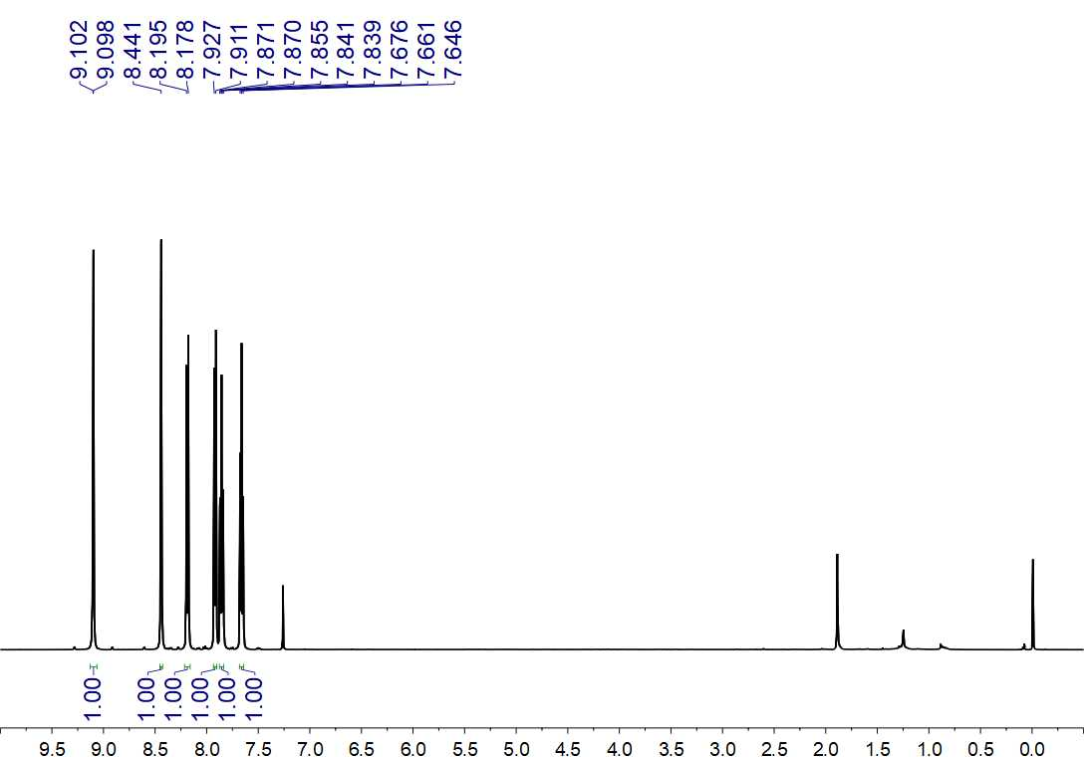
Fig. S21. ¹H NMR (500 MHz, CDCl₃) spectrum of 3

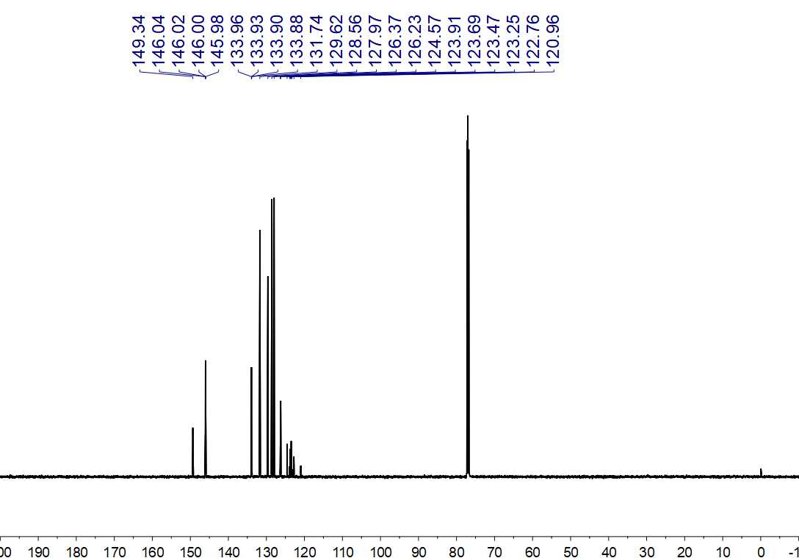
Fig. S22. ¹³C NMR (150 MHz, CDCl₃) spectrum of 3

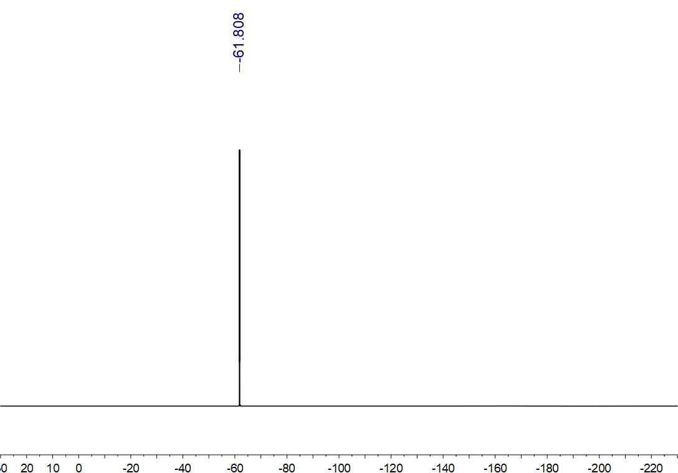
Fig. S23. ¹⁹F NMR (564 MHz, CDCl₃) spectrum of 3

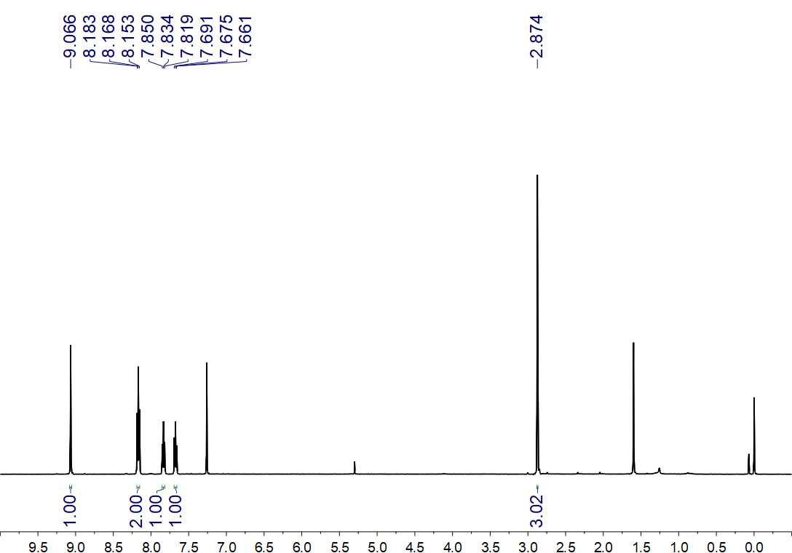
Fig. S24. ¹H NMR (500 MHz, CDCl₃) spectrum of 4

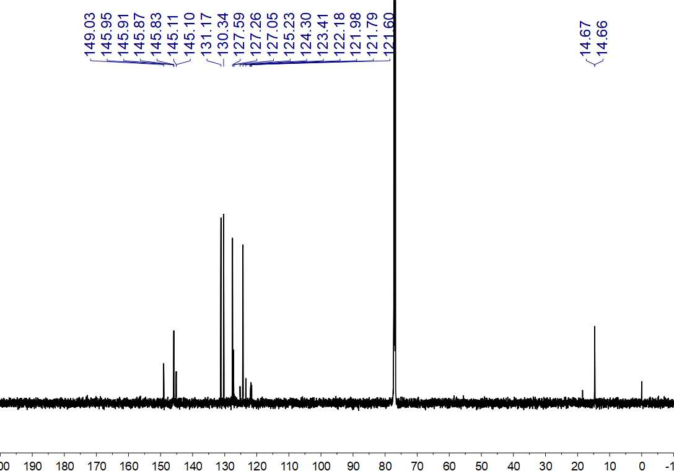
Fig. S25. ¹³C NMR (150 MHz, CDCl₃) spectrum of 4

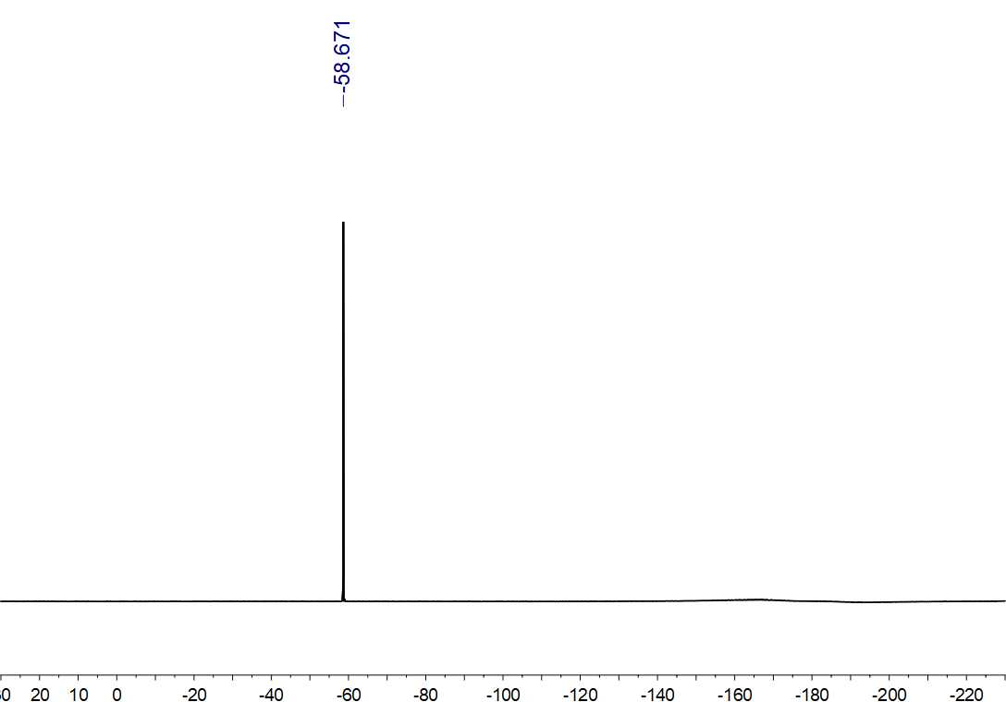
Fig. S26. ¹⁹F NMR (564 MHz, CDCl₃) spectrum of 4

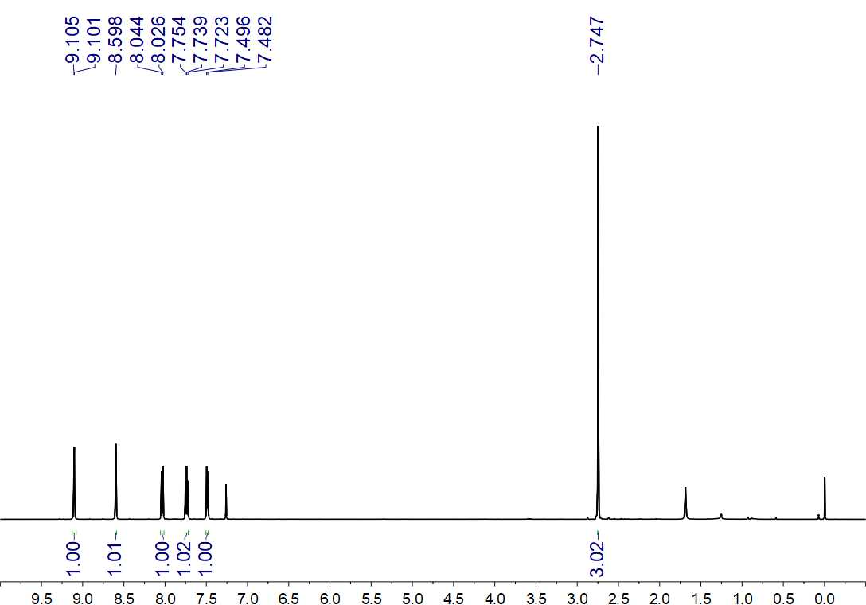
Fig. S27. ¹H NMR (500 MHz, CDCl₃) spectrum of 5

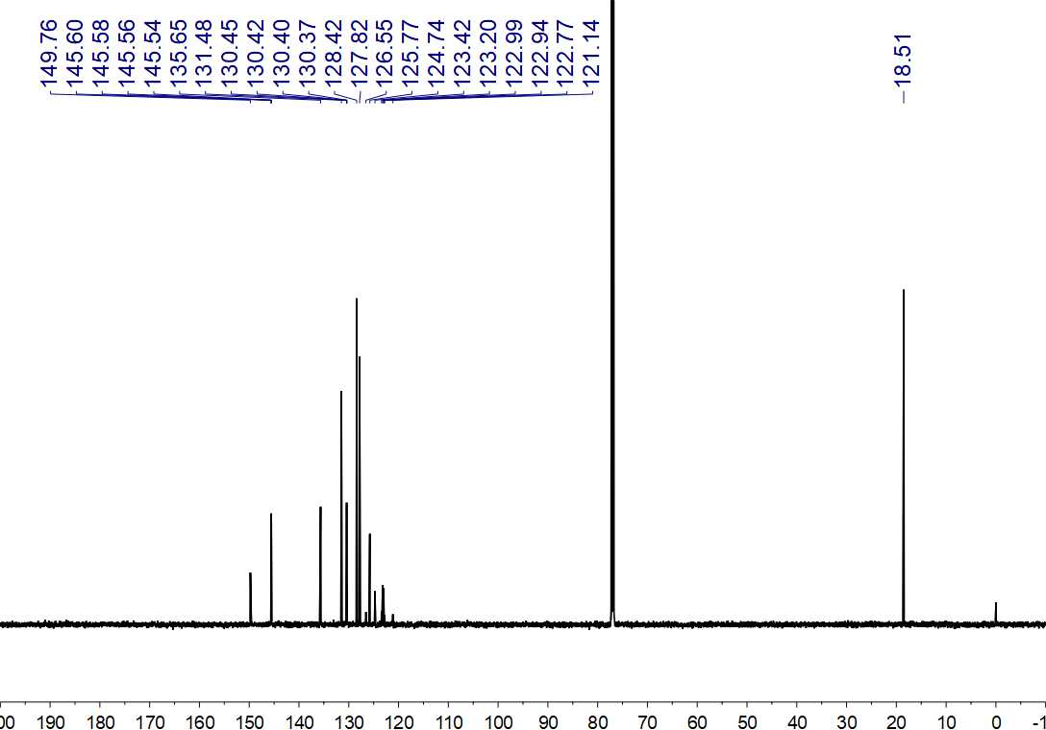
Fig. S28. ¹³C NMR (150 MHz, CDCl₃) spectrum of 5

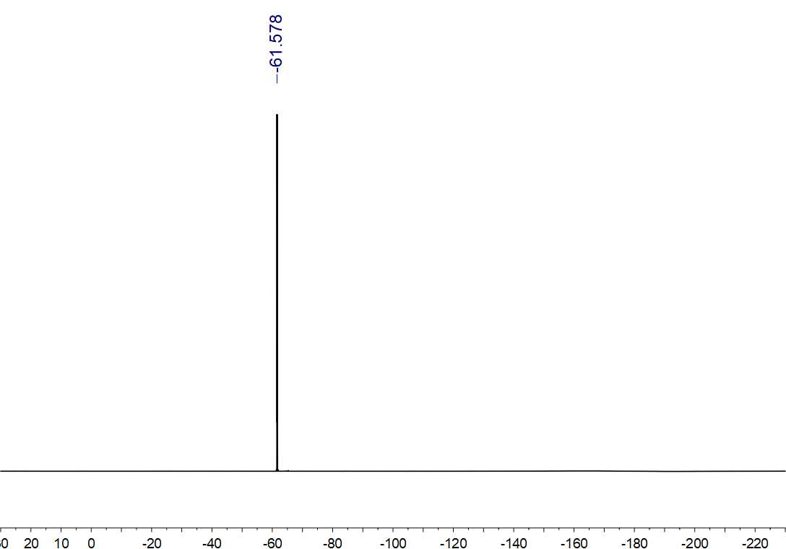
Fig. S29. ¹⁹F NMR (564 MHz, CDCl₃) spectrum of 5

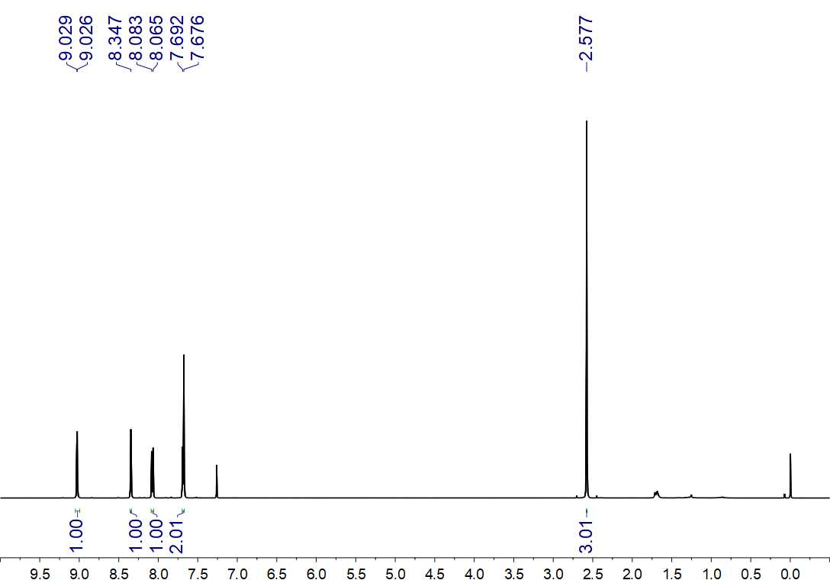
Fig. S30. ¹H NMR (500 MHz, CDCl₃) spectrum of 6

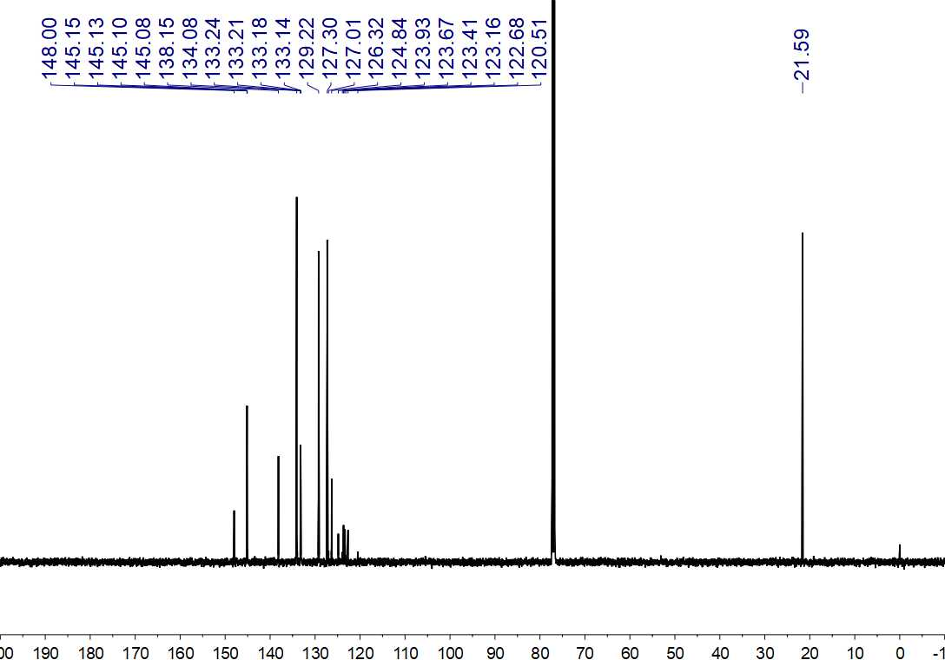
Fig. S30. ¹³C NMR (125 MHz, CDCl₃) spectrum of 6

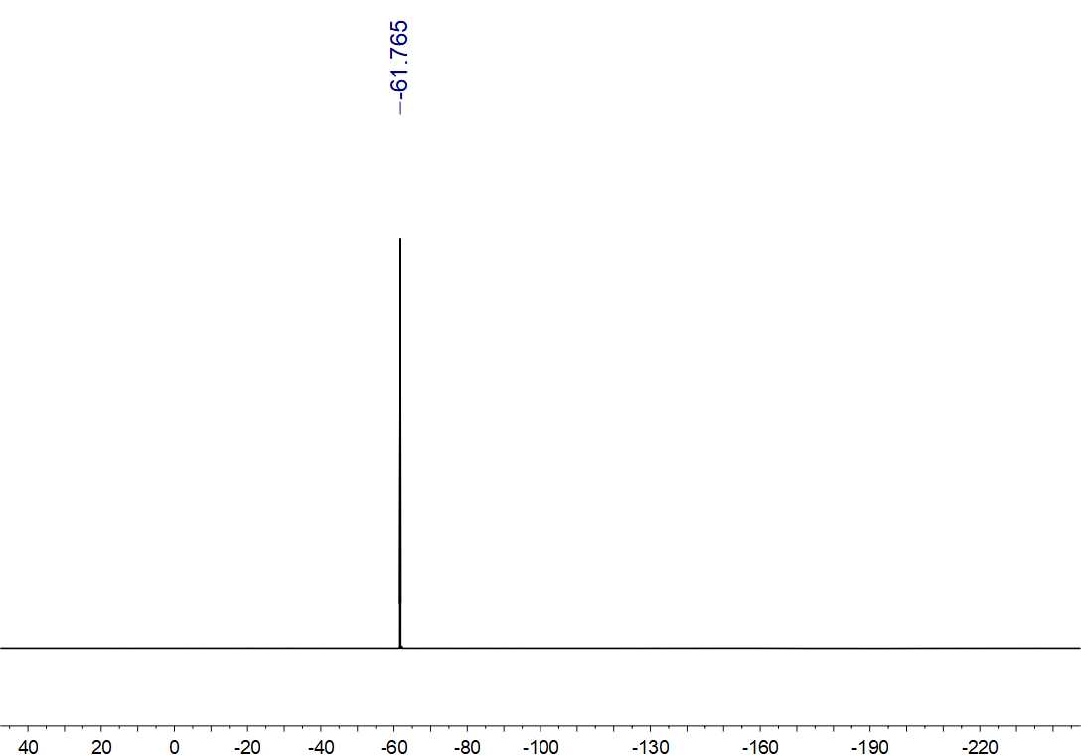
Fig. S32. ¹⁹F NMR (470 MHz, CDCl₃) spectrum of 6

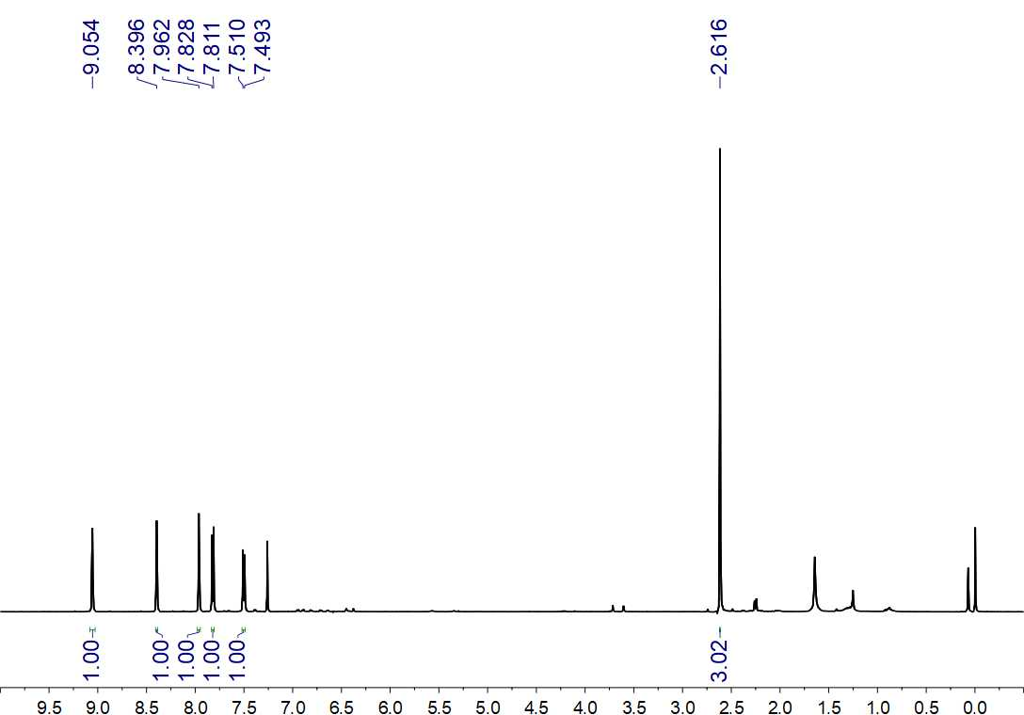
Fig. S33. ¹H NMR (500 MHz, CDCl₃) spectrum of 7

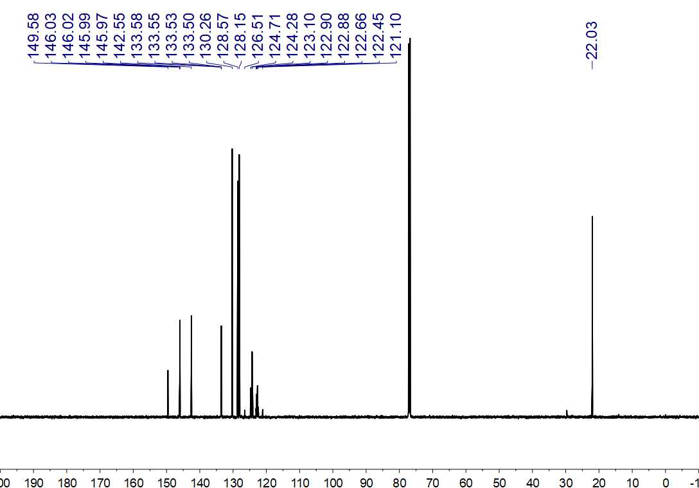
Fig. S34. ¹³C NMR (150 MHz, CDCl₃) spectrum of 7

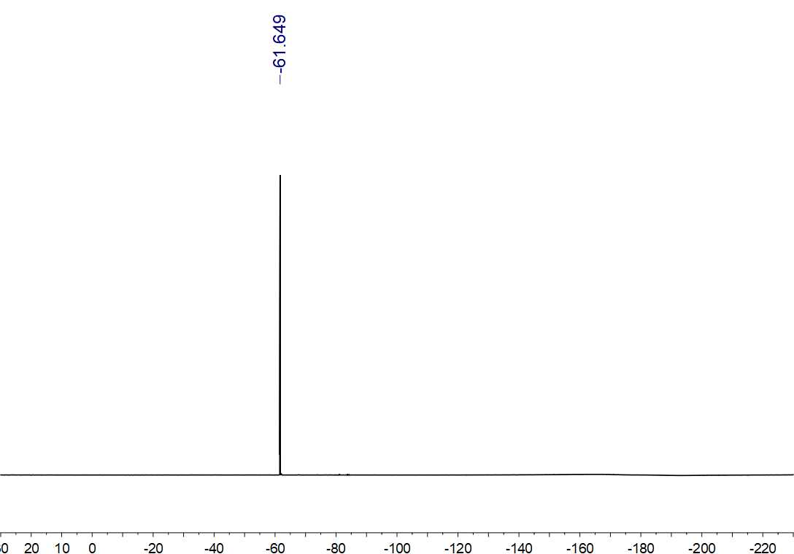
Fig. S35. ¹⁹F NMR (564 MHz, CDCl₃) spectrum of 7

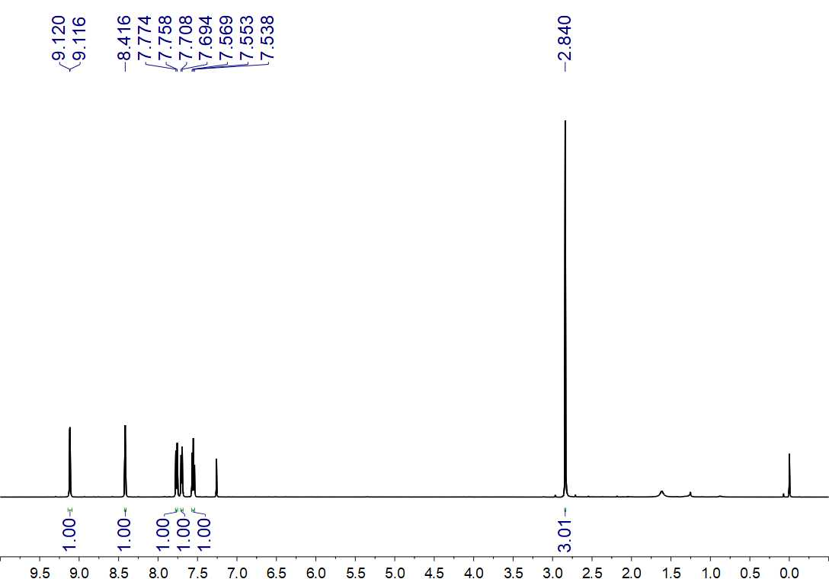
Fig. S36. ¹H NMR (500 MHz, CDCl₃) spectrum of 8

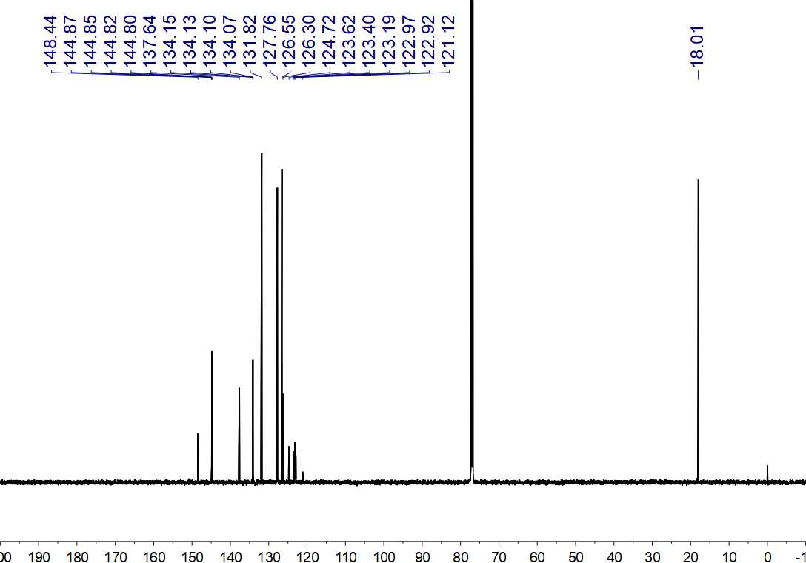
Fig. S37. ¹³C NMR (150 MHz, CDCl₃) spectrum of 8

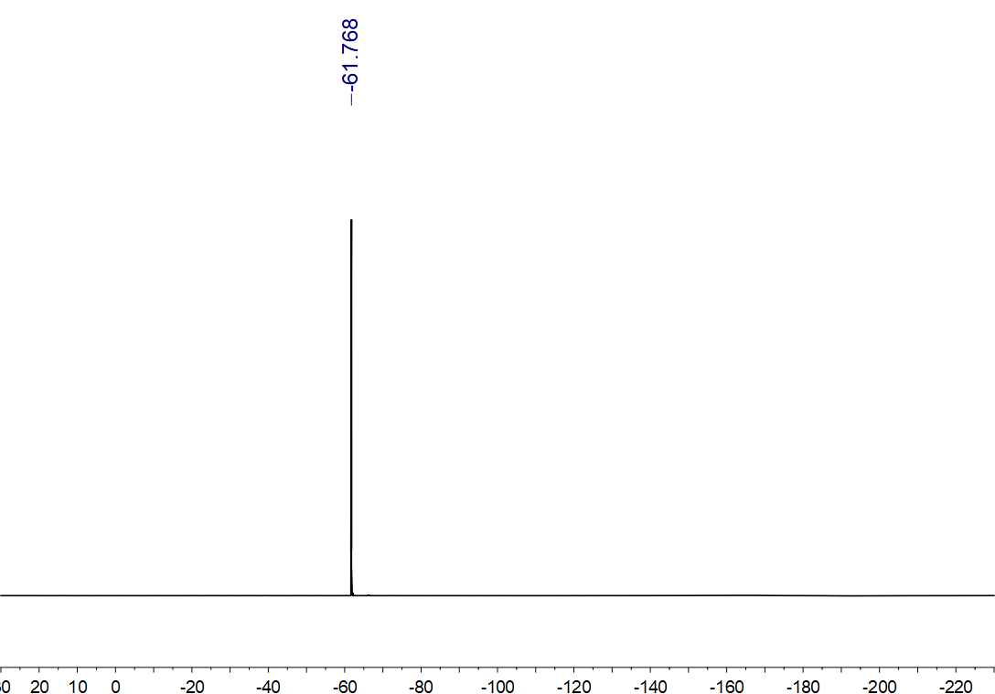
Fig. S38. ¹⁹F NMR (564 MHz, CDCl₃) spectrum of 8

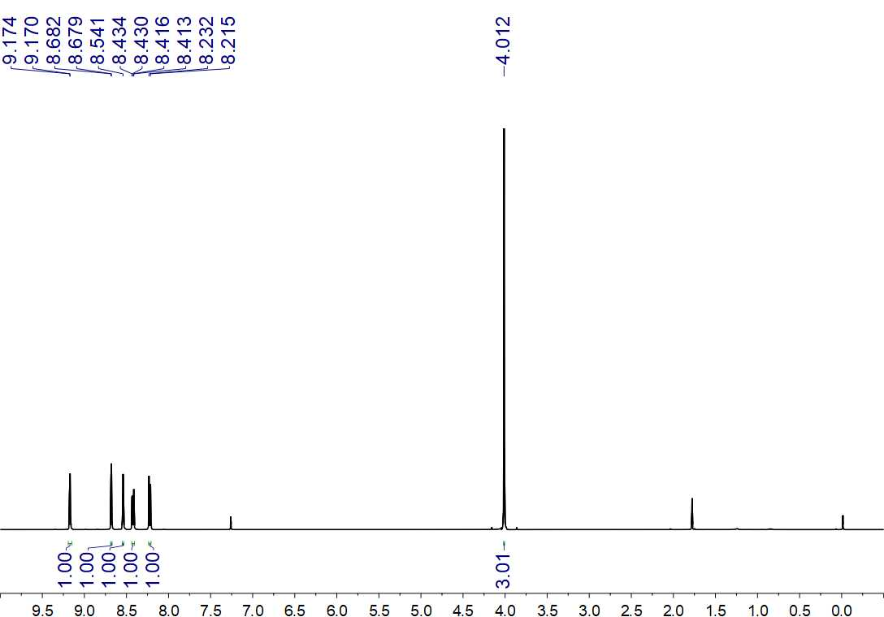
Fig. S39. ¹H NMR (500 MHz, CDCl₃) spectrum of 9

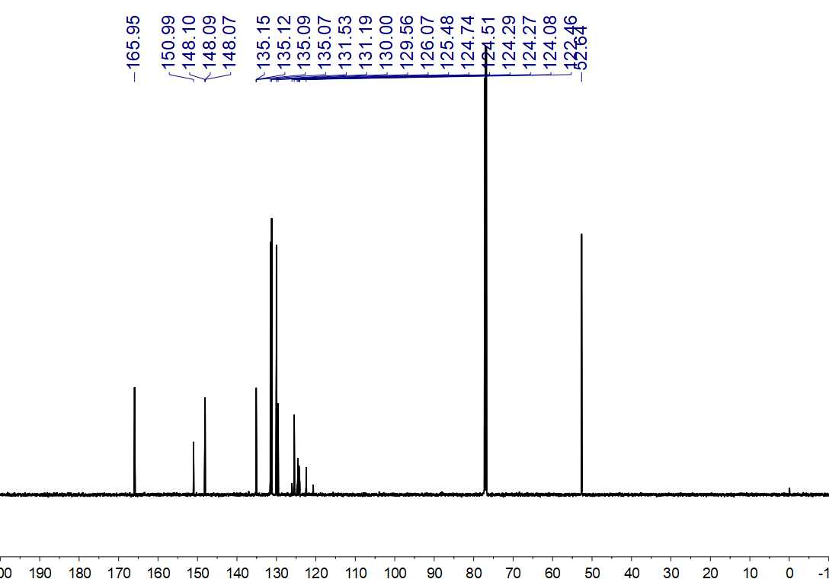
Fig. S40. ¹³C NMR (150 MHz, CDCl₃) spectrum of 9

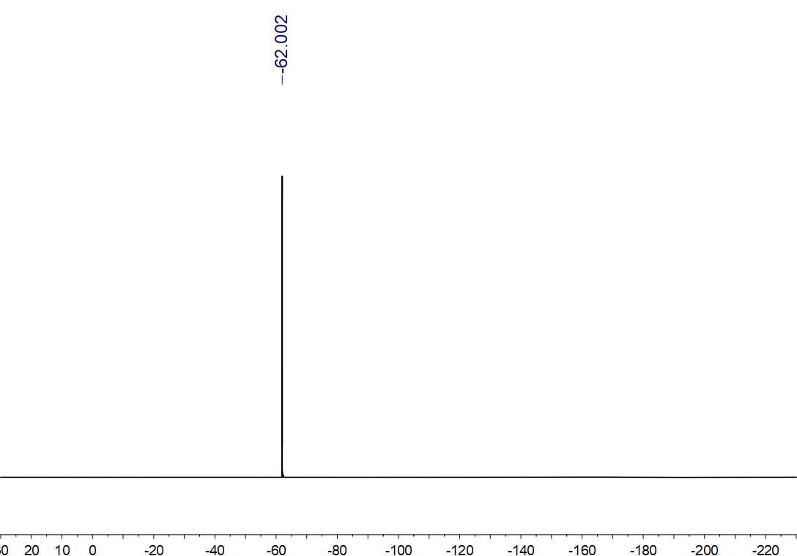
Fig. S41. ¹⁹F NMR (564 MHz, CDCl₃) spectrum of 9

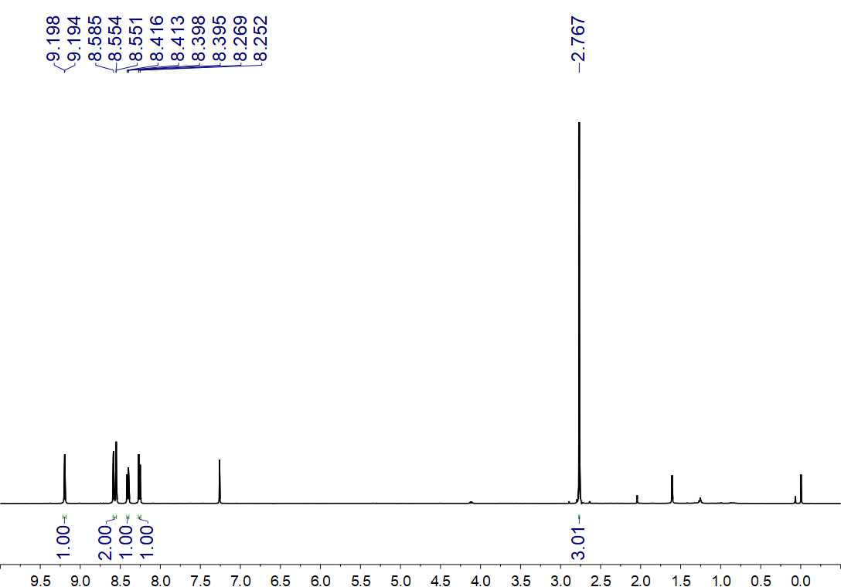
Fig. S42. ¹H NMR (500 MHz, CDCl₃) spectrum of 10

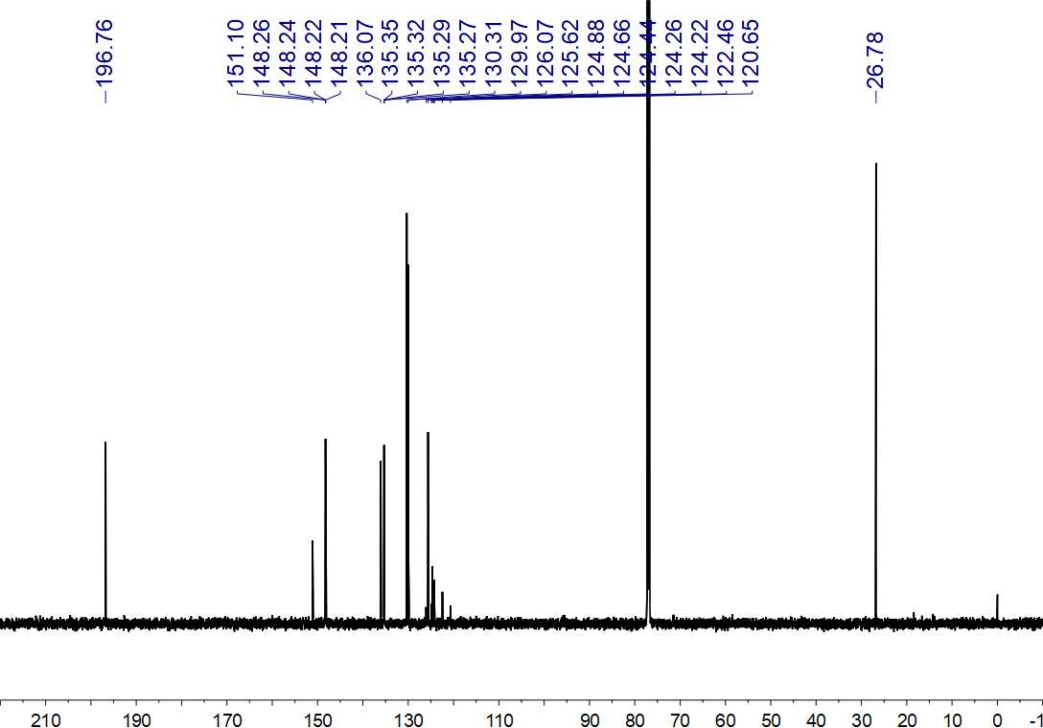
Fig. S43. ¹³C NMR (150 MHz, CDCl₃) spectrum of 10

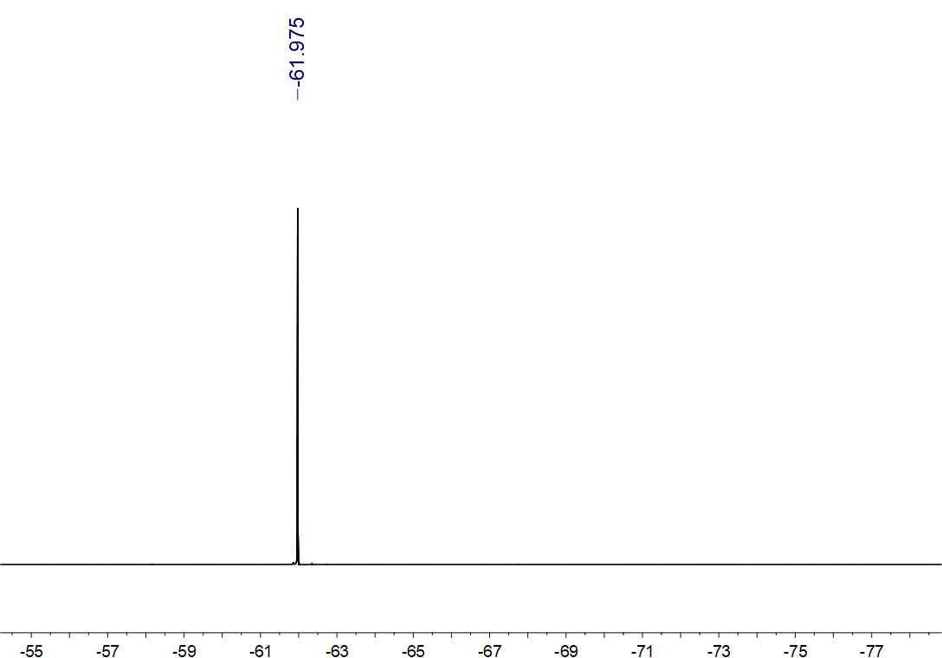
Fig. S44. ¹⁹F NMR (564 MHz, CDCl₃) spectrum of 10

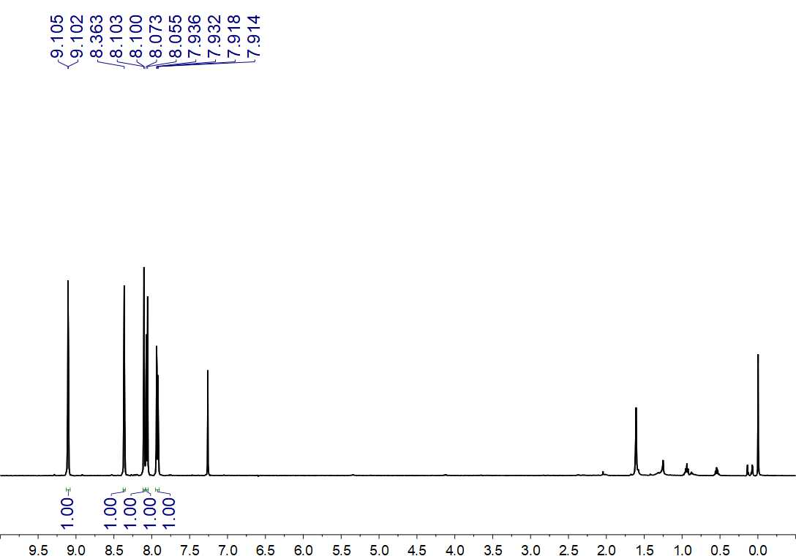
Fig. S45. ¹H NMR (500 MHz, CDCl₃) spectrum of 11

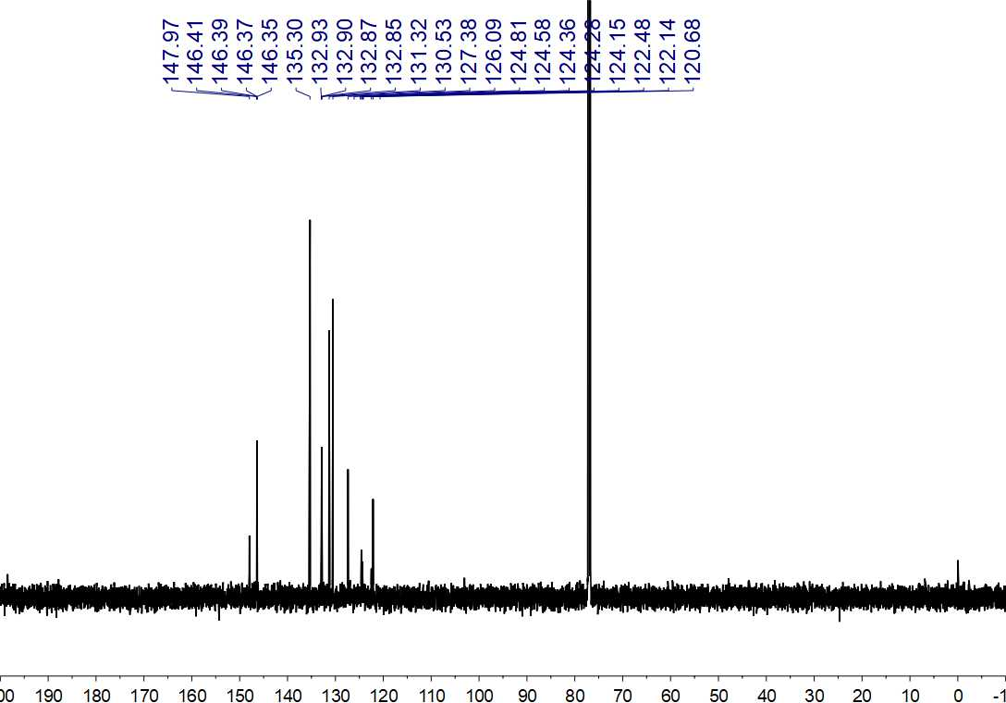
Fig. S46. ¹³C NMR (150 MHz, CDCl₃) spectrum of 11

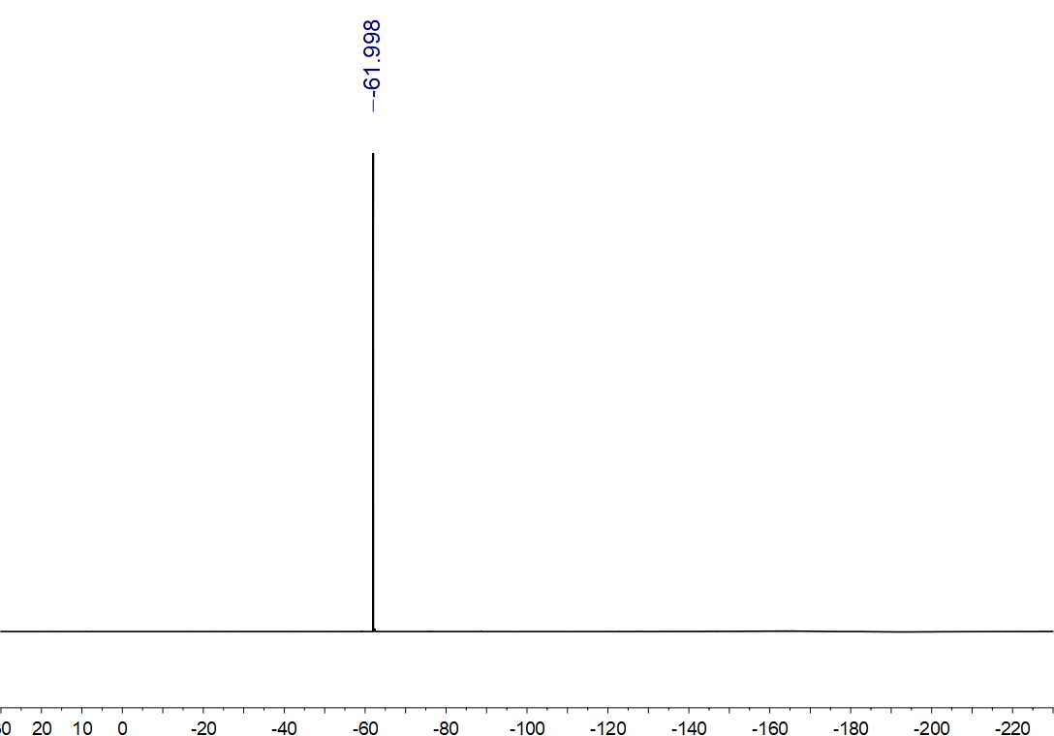
Fig. S47. ¹⁹F NMR (564 MHz, CDCl₃) spectrum of 11

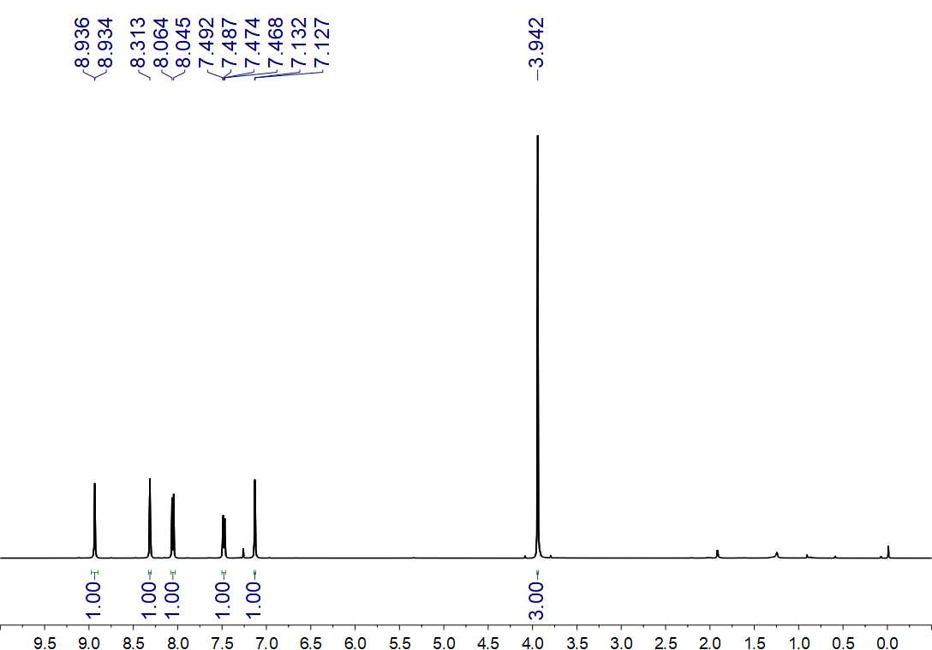
Fig. S48. ¹H NMR (500 MHz, CDCl₃) spectrum of 12

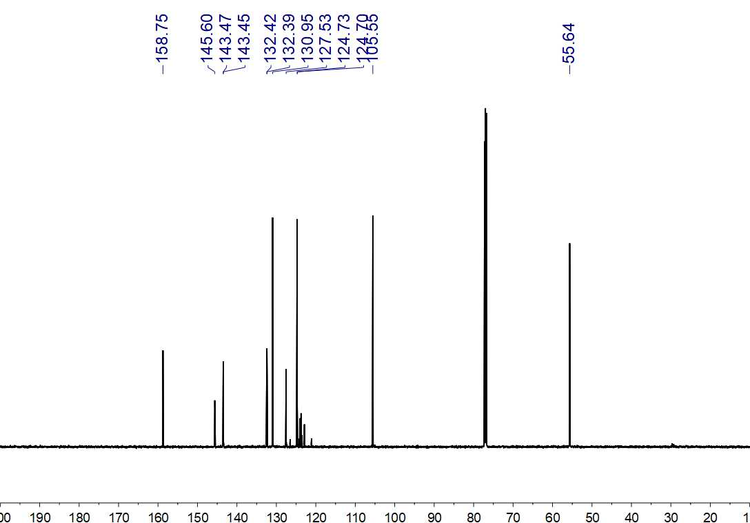
Fig. S49. ¹³C NMR (150 MHz, CDCl₃) spectrum of 12

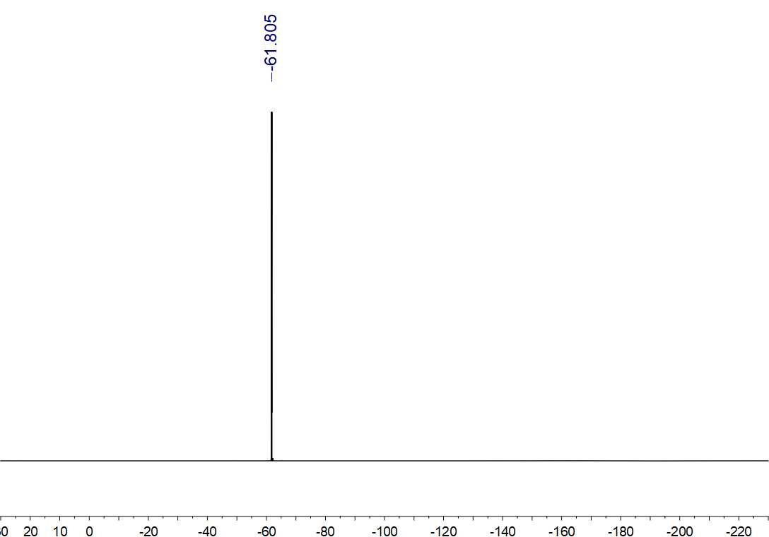
Fig. S50. ¹⁹F NMR (564 MHz, CDCl₃) spectrum of 12

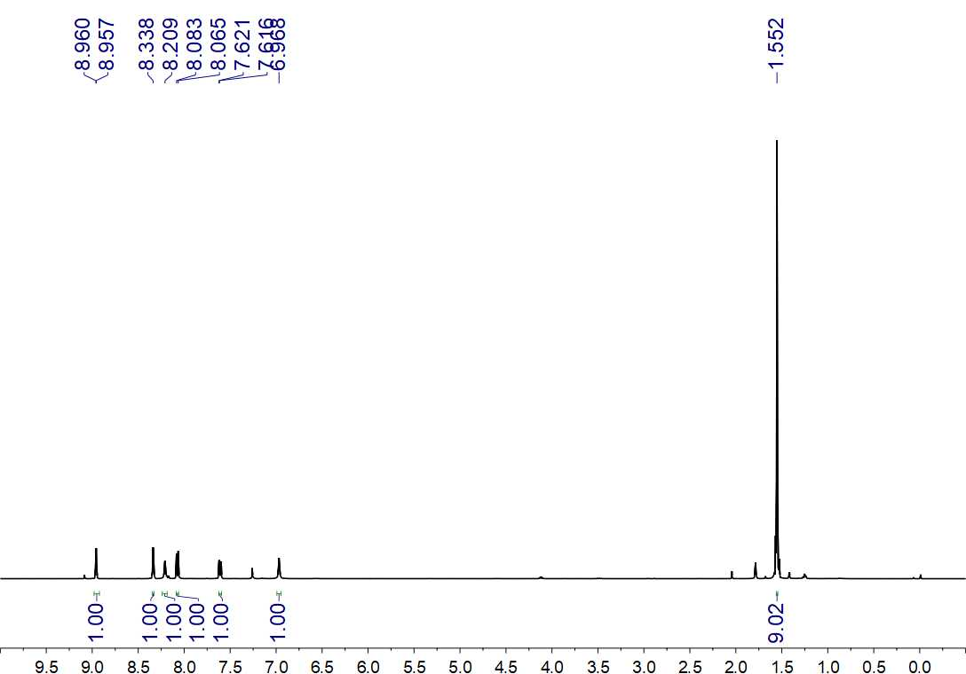
Fig. S51. ¹H NMR (500 MHz, CDCl₃) spectrum of 13

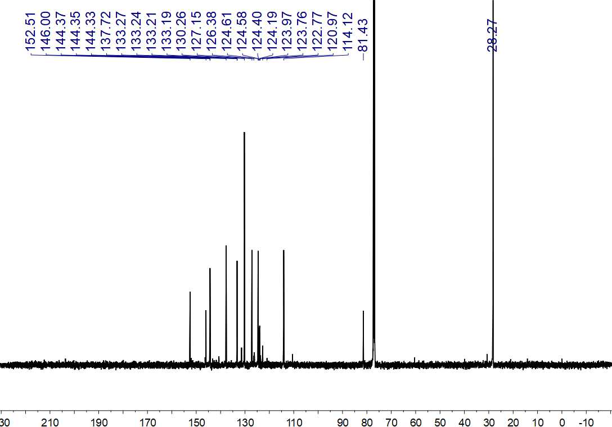
Fig. S52. ¹³C NMR (150 MHz, CDCl₃) spectrum of 13

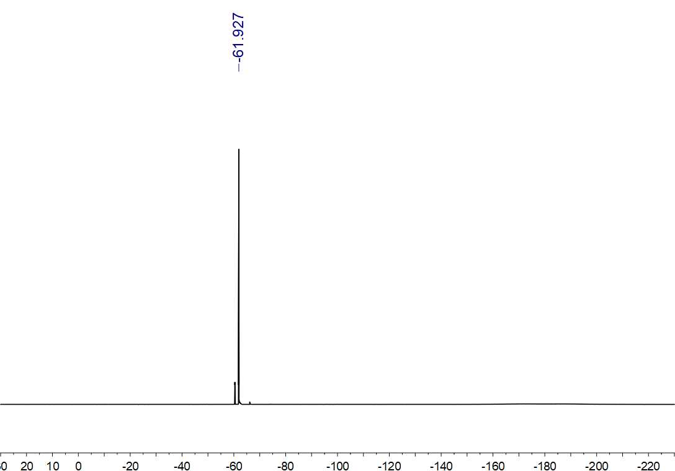
Fig. S53. ¹⁹F NMR (564 MHz, CDCl₃) spectrum of 13

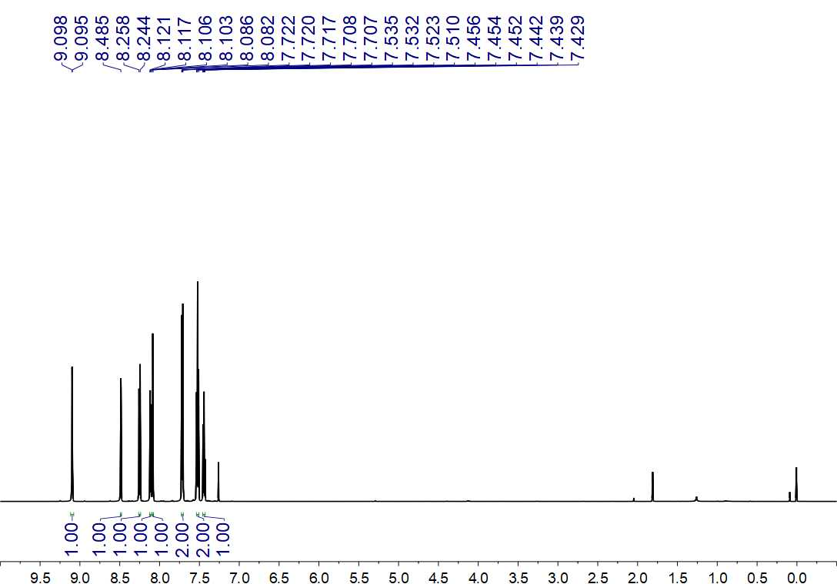
Fig. S54. ¹H NMR (600 MHz, CDCl₃) spectrum of 14

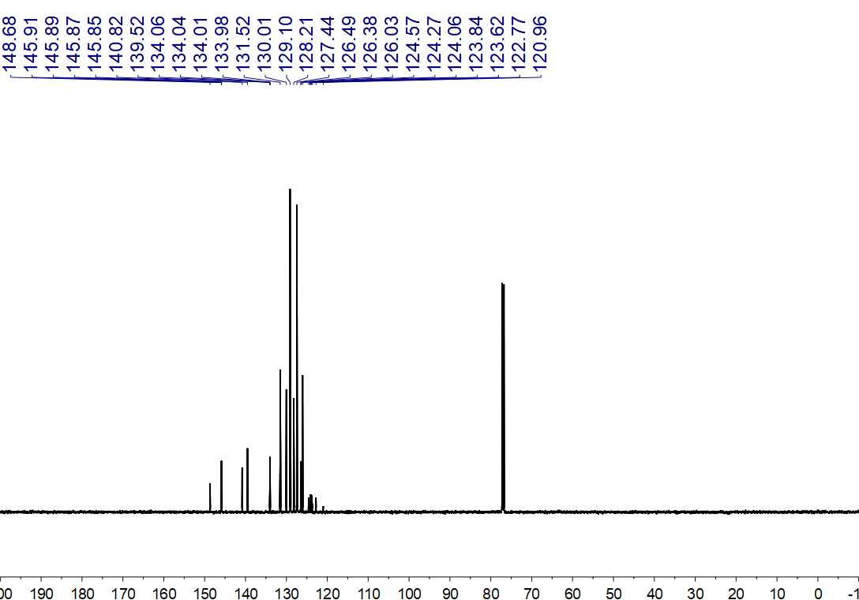
Fig. S55. ¹³C NMR (150 MHz, CDCl₃) spectrum of 14

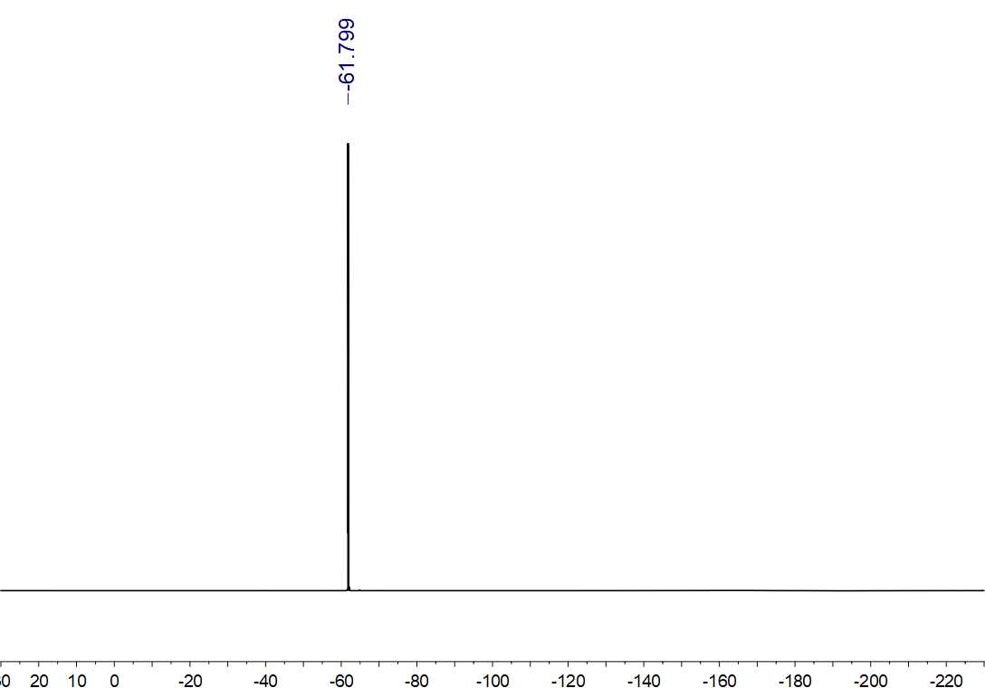
Fig. S56. ¹⁹F NMR (564 MHz, CDCl₃) spectrum of 14

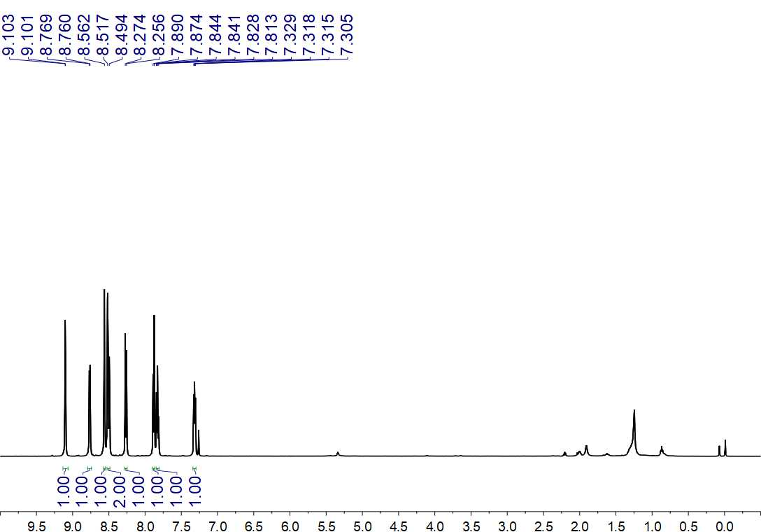
Fig. S57. ¹H NMR (500 MHz, CDCl₃) spectrum of 15

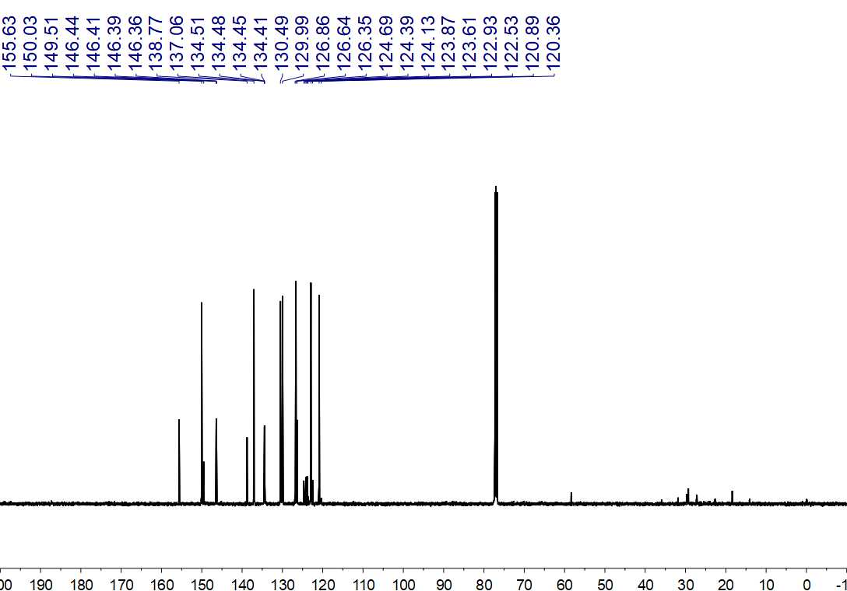
Fig. S58. ¹³C NMR (125 MHz, CDCl₃) spectrum of 15

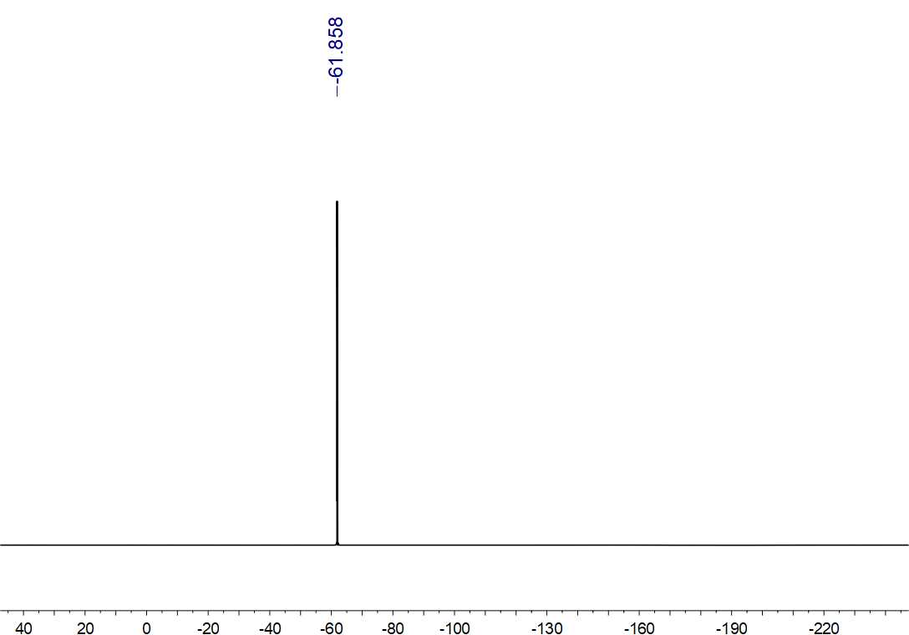
Fig. S59. ¹⁹F NMR (470 MHz, CDCl₃) spectrum of 15

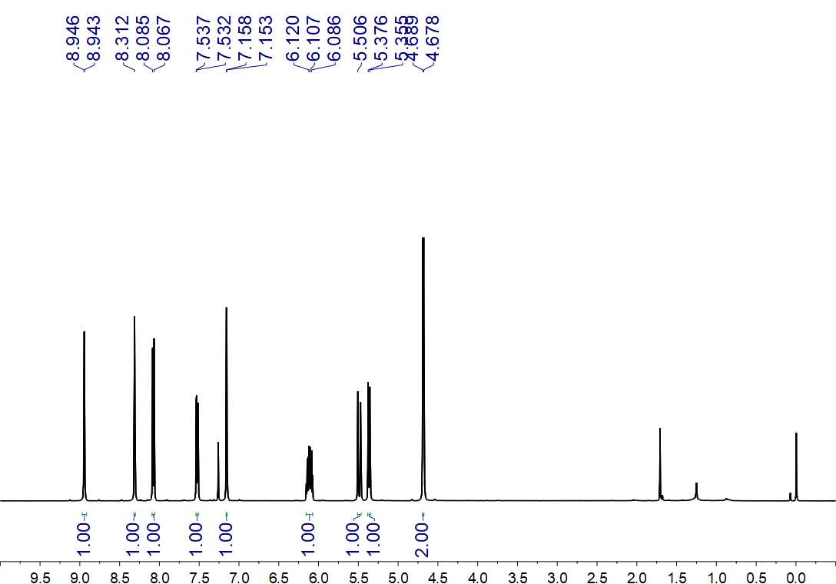
Fig. S60. ¹H NMR (500 MHz, CDCl₃) spectrum of 16

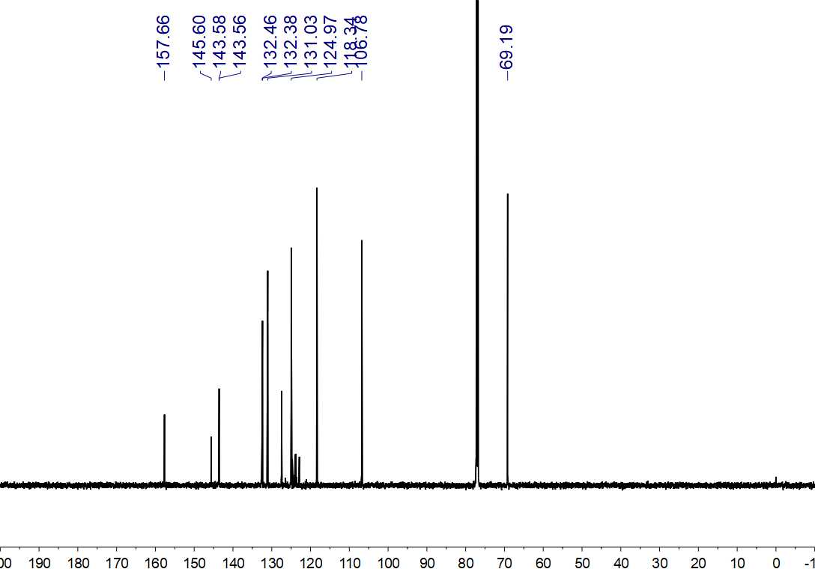
Fig. S61. ¹³C NMR (150 MHz, CDCl₃) spectrum of 16

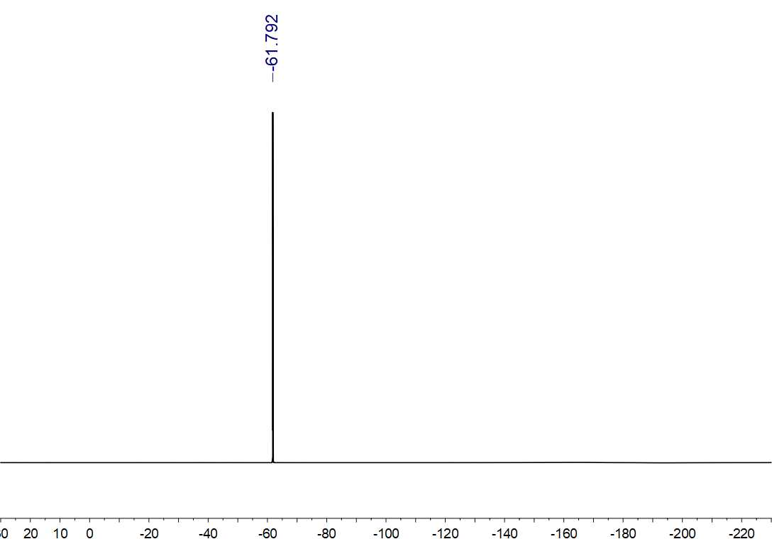
Fig. S62. ¹⁹F NMR (564 MHz, CDCl₃) spectrum of 16

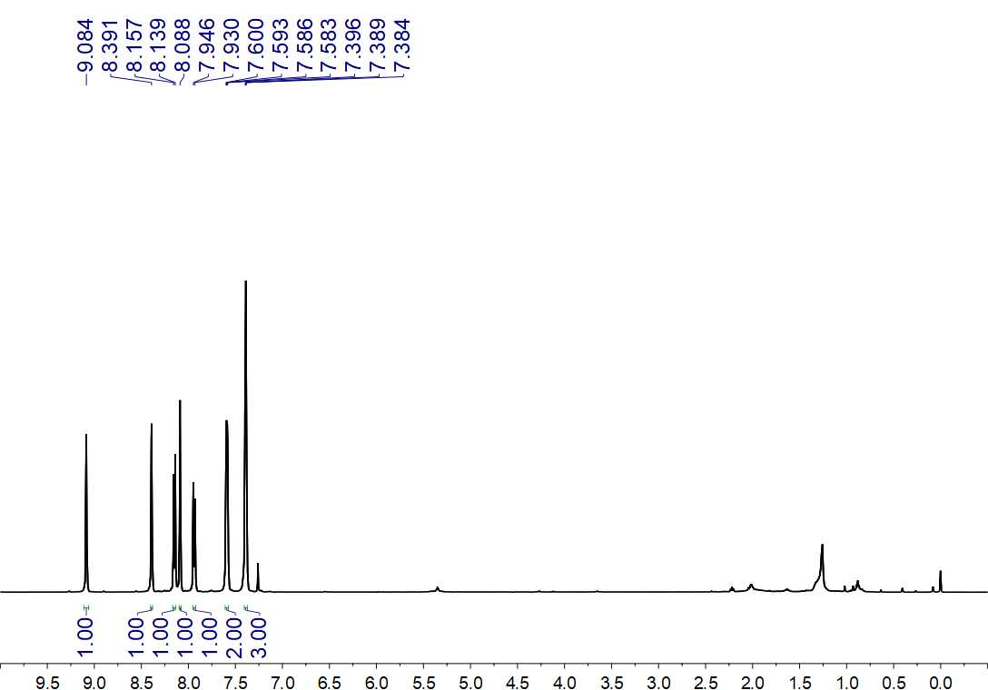
Fig. S63. ¹H NMR (500 MHz, CDCl₃) spectrum of 17

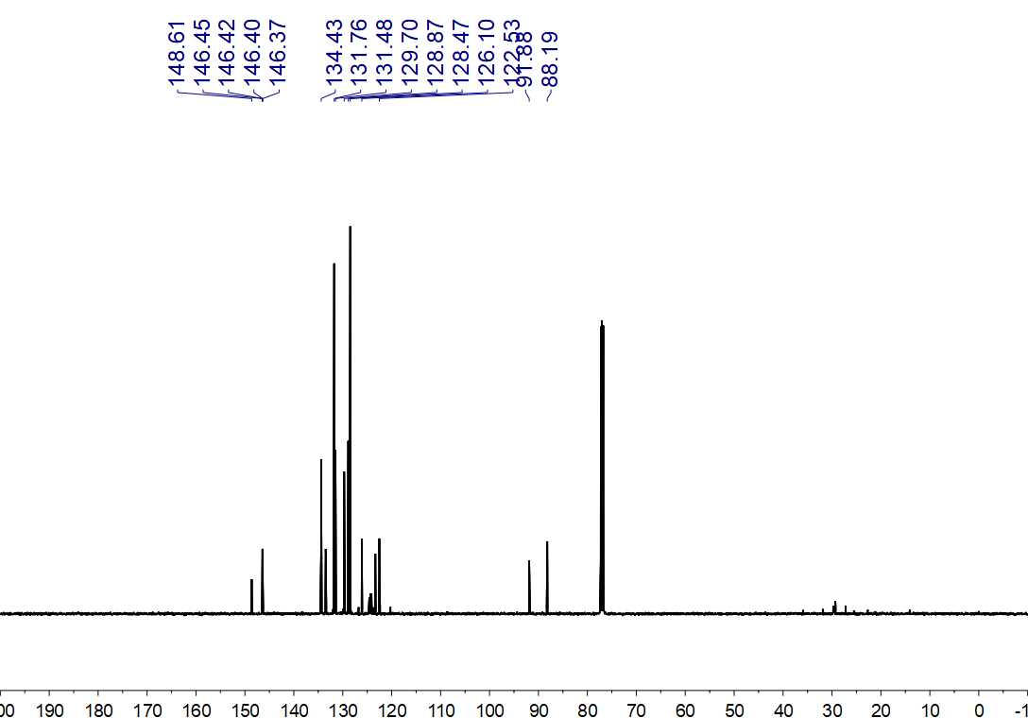
Fig. S64. ¹³C NMR (125 MHz, CDCl₃) spectrum of 17

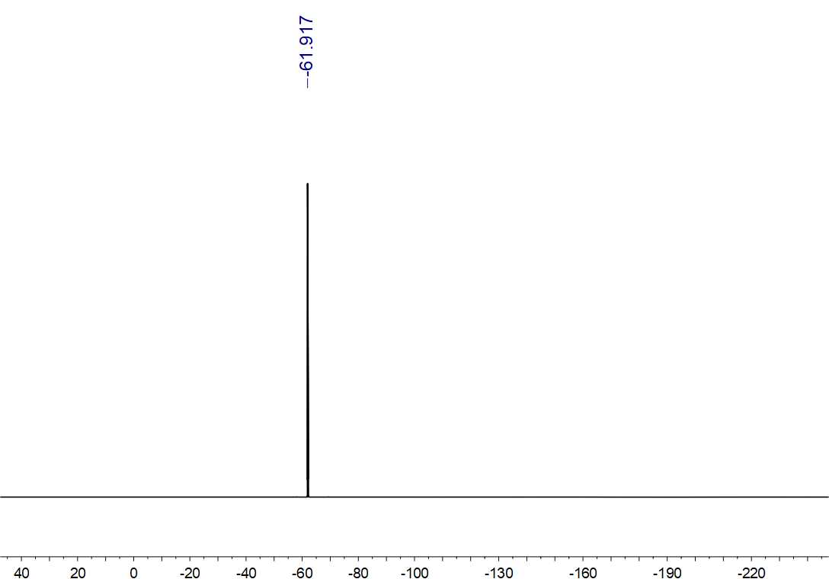
Fig. S65. ¹⁹F NMR (470 MHz, CDCl₃) spectrum of 17

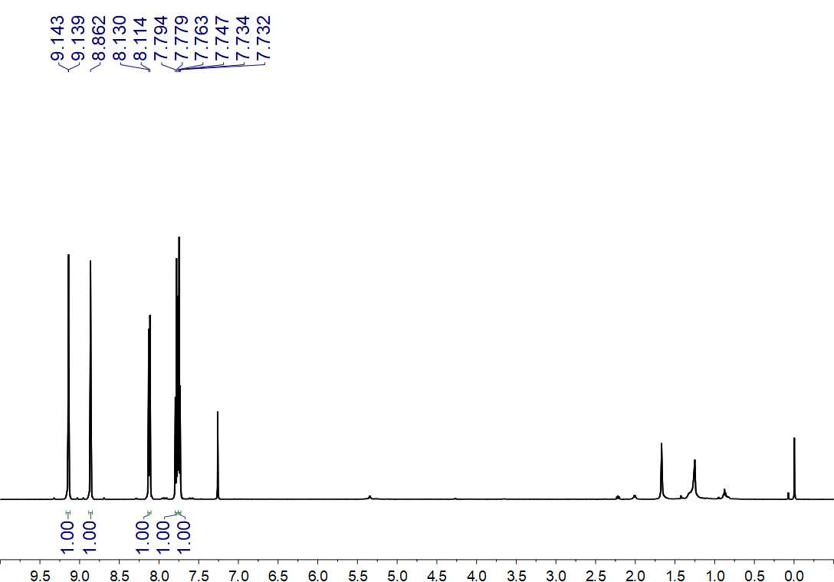
Fig. S66. ¹H NMR (500 MHz, CDCl₃) spectrum of 18

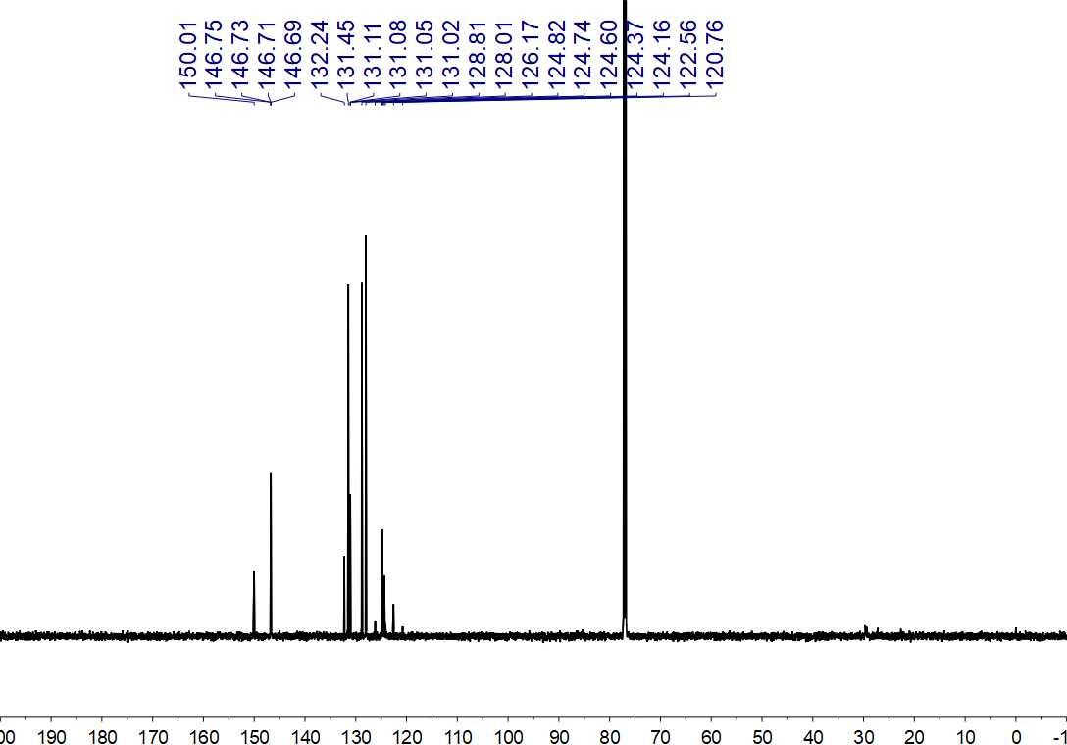
Fig. S67. ¹³C NMR (150 MHz, CDCl₃) spectrum of 18

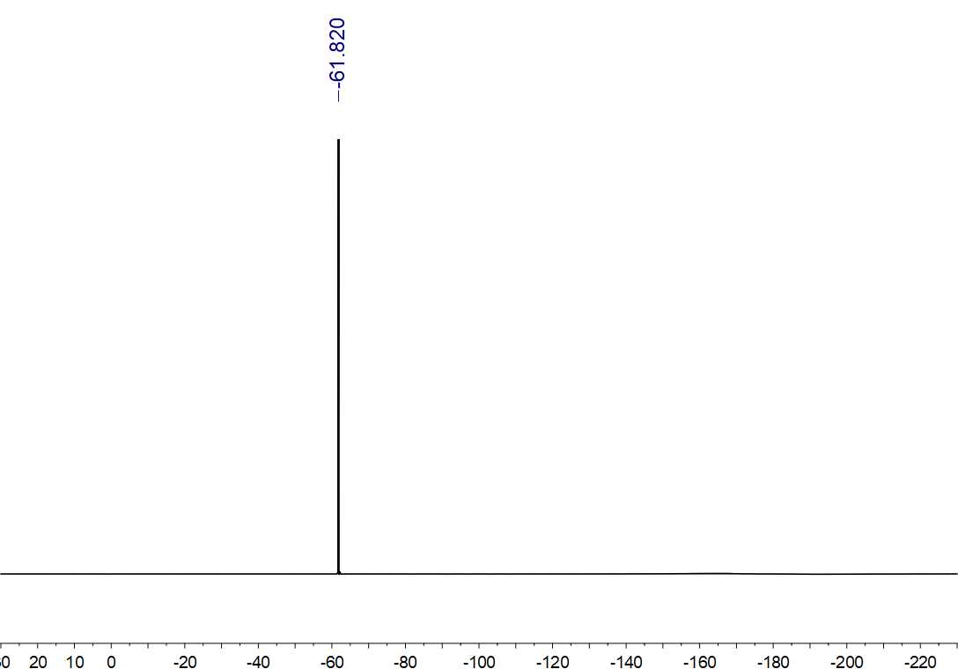
Fig. S68. ¹⁹F NMR (564 MHz, CDCl₃) spectrum of 18

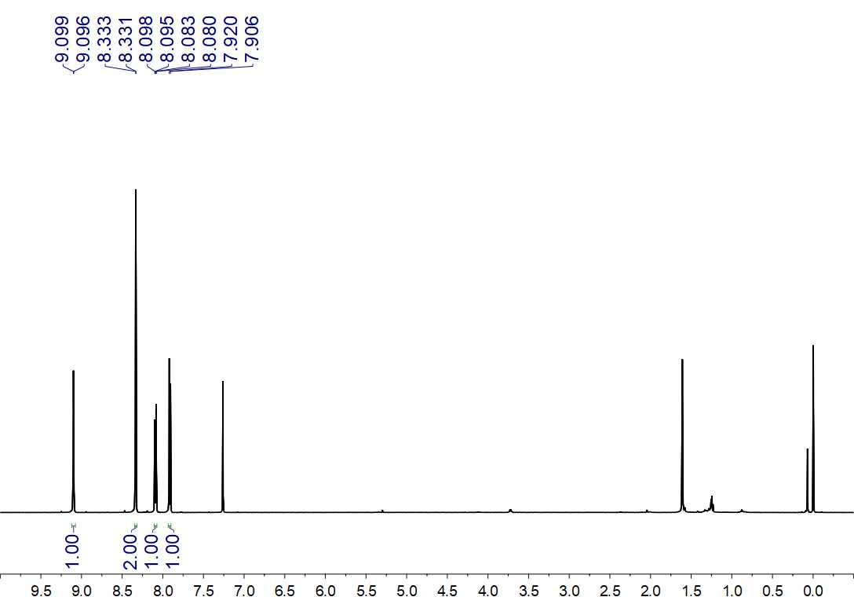
Fig. S69. ¹H NMR (500 MHz, CDCl₃) spectrum of 19

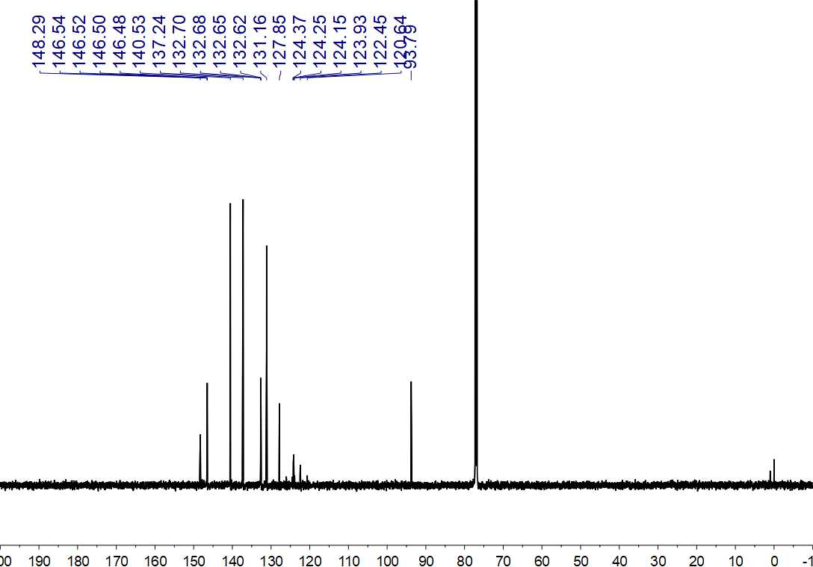
Fig. S70. ¹³C NMR (150 MHz, CDCl₃) spectrum of 19

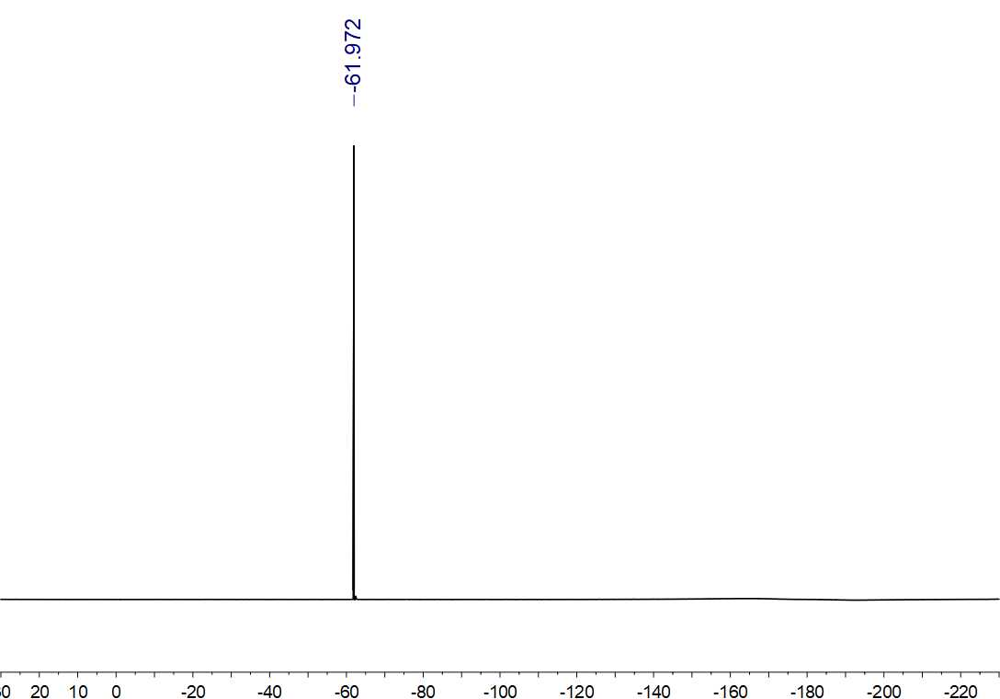
Fig. S71. ¹⁹F NMR (564 MHz, CDCl₃) spectrum of 19

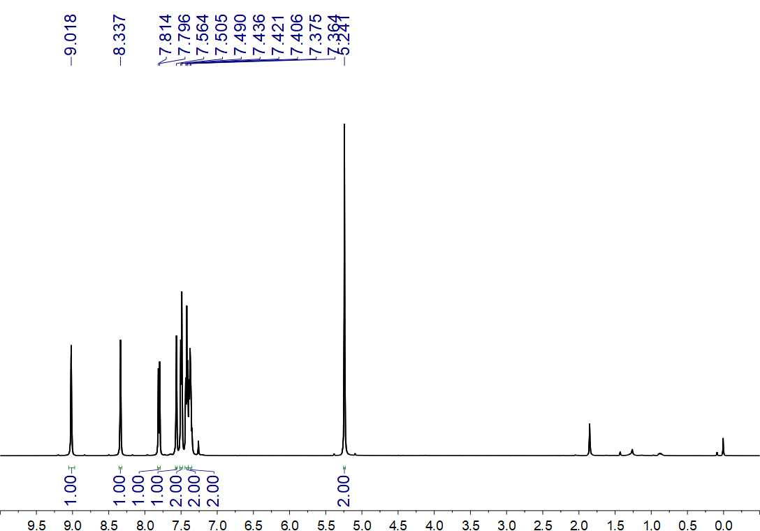
Fig. S72. ¹H NMR (500 MHz, CDCl₃) spectrum of 20

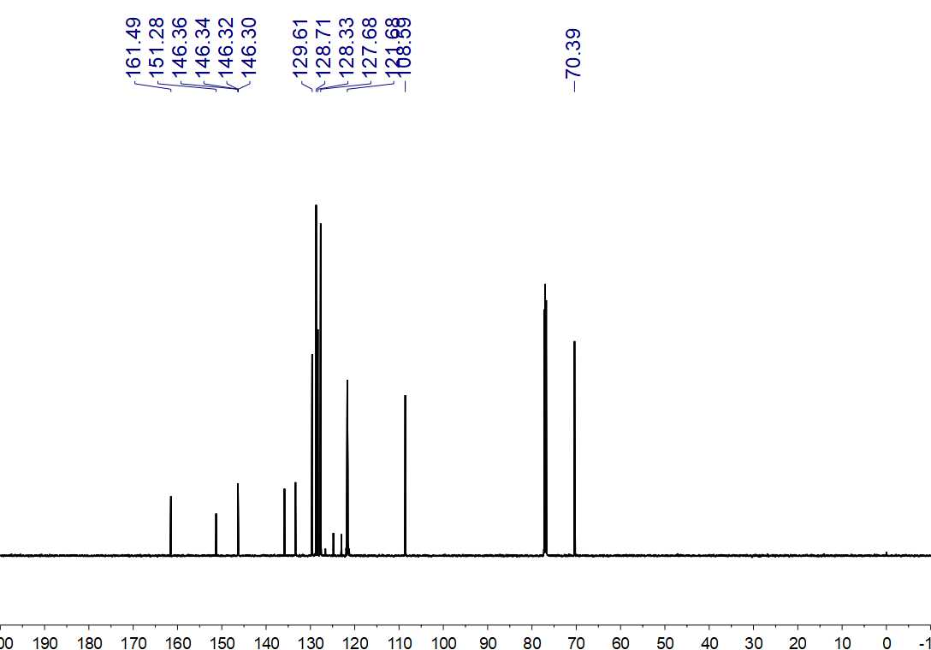
Fig. S73. ¹³C NMR (150 MHz, CDCl₃) spectrum of 20

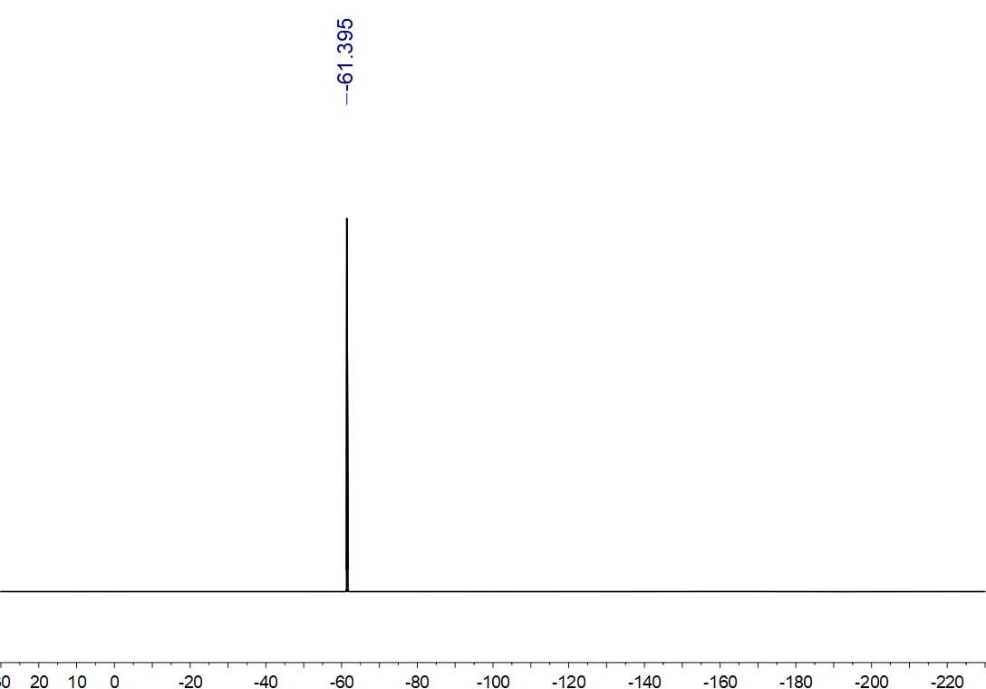
Fig. S74. ¹⁹F NMR (564 MHz, CDCl₃) spectrum of 20

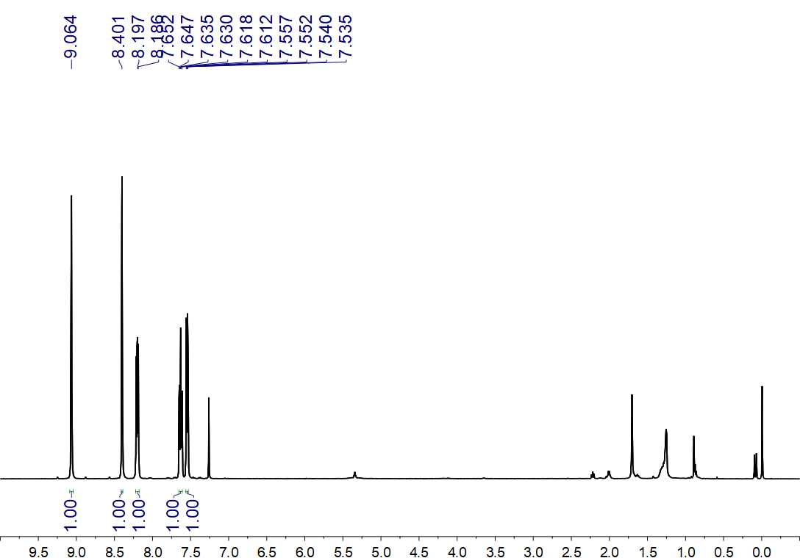
Fig. S75. ¹H NMR (500 MHz, CDCl₃) spectrum of 21

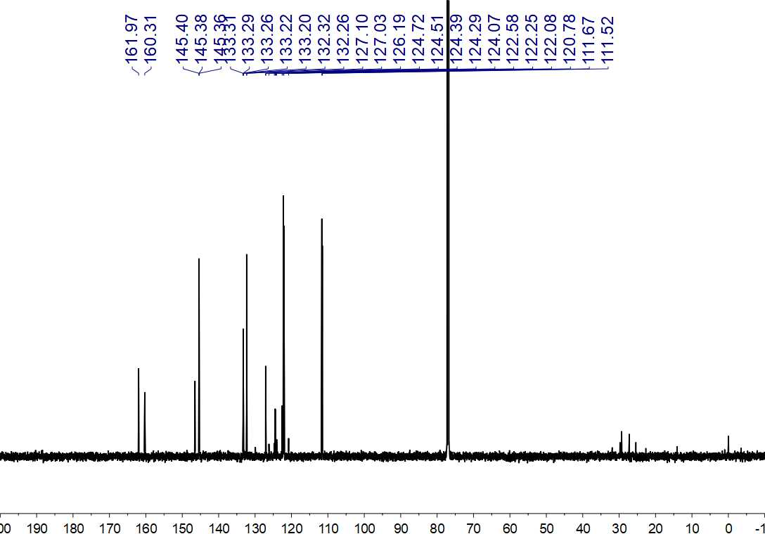
Fig. S76. ¹³C NMR (150 MHz, CDCl₃) spectrum of 21

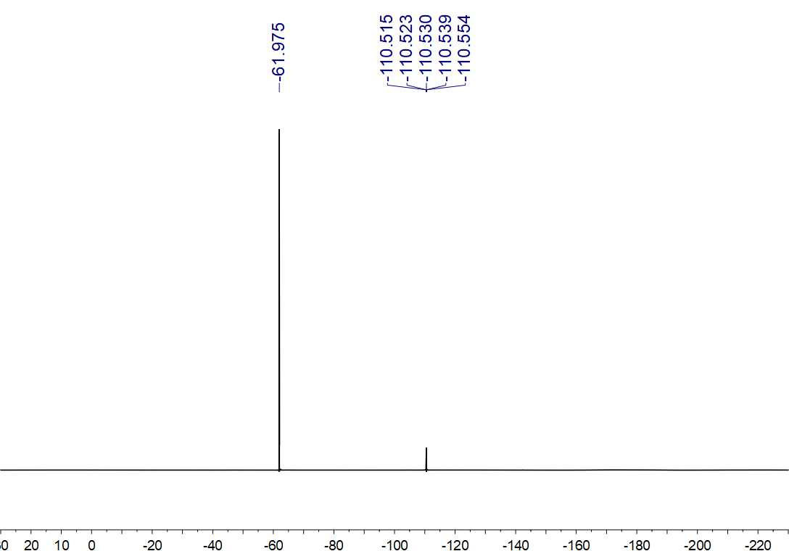
Fig. S77. ¹⁹F NMR (564 MHz, CDCl₃) spectrum of 21

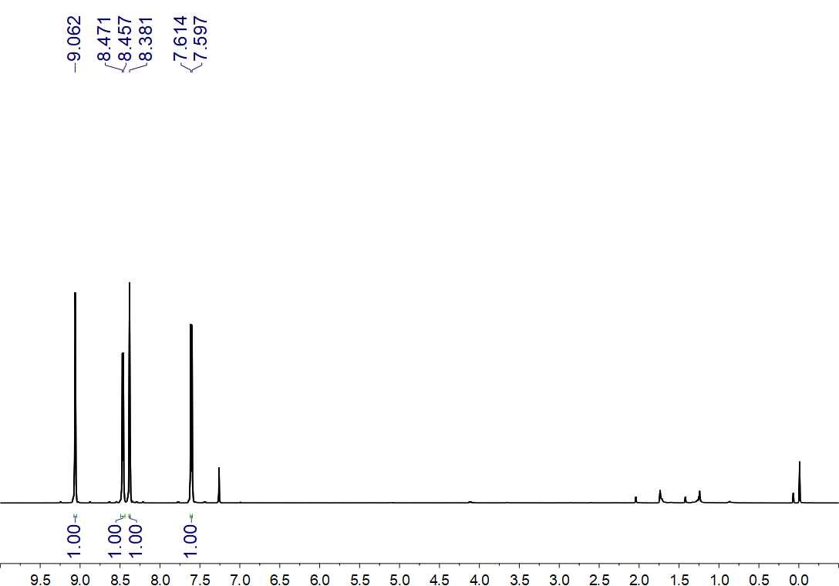
Fig. S78. ¹H NMR (500 MHz, CDCl₃) spectrum of 22

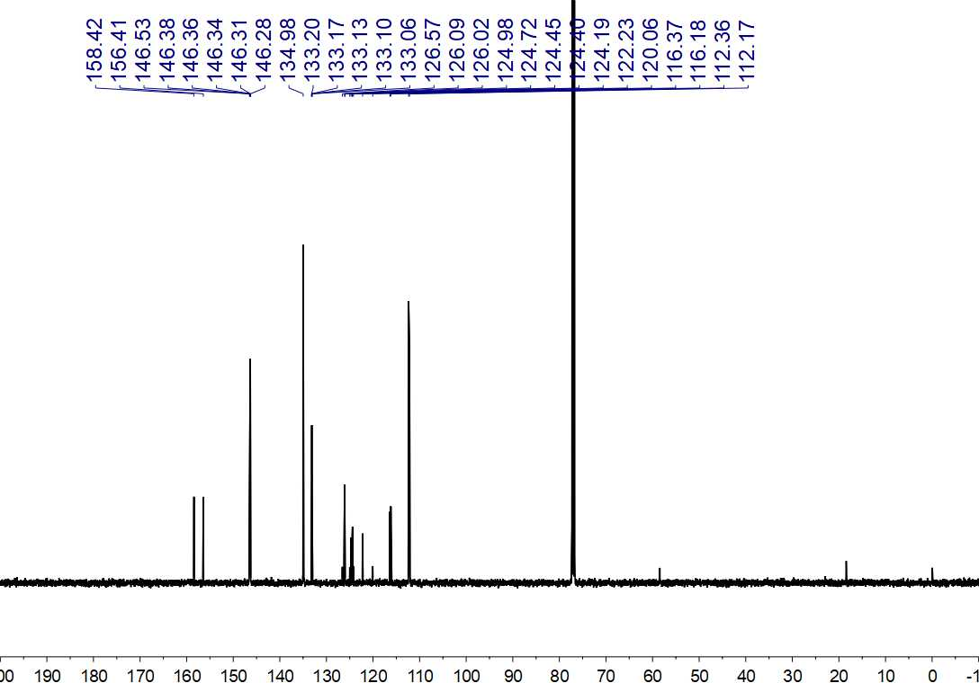
Fig. S79. ¹³C NMR (125 MHz, CDCl₃) spectrum of 22

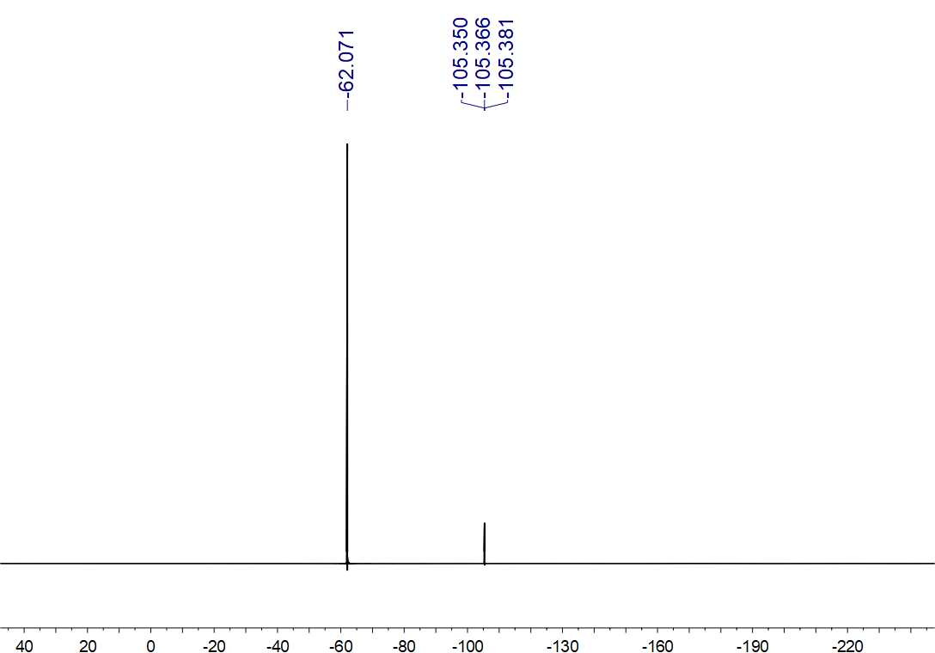
Fig. S80. ¹⁹F NMR (470 MHz, CDCl₃) spectrum of 22

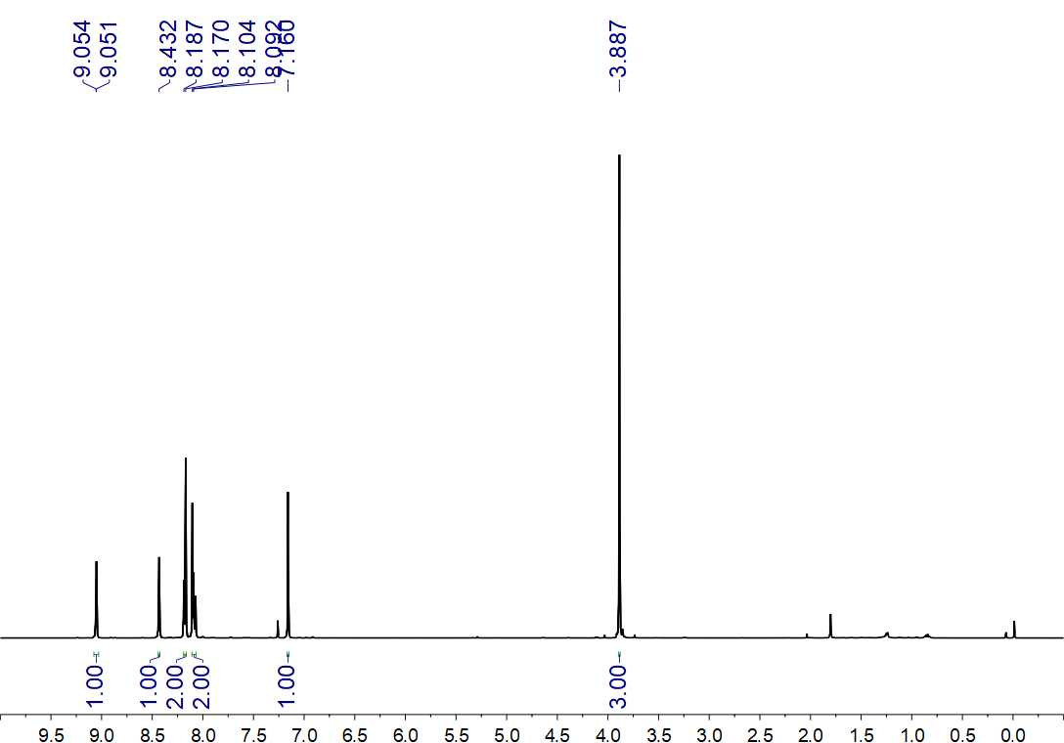
Fig. S81. ¹H NMR (500 MHz, CDCl₃) spectrum of 23

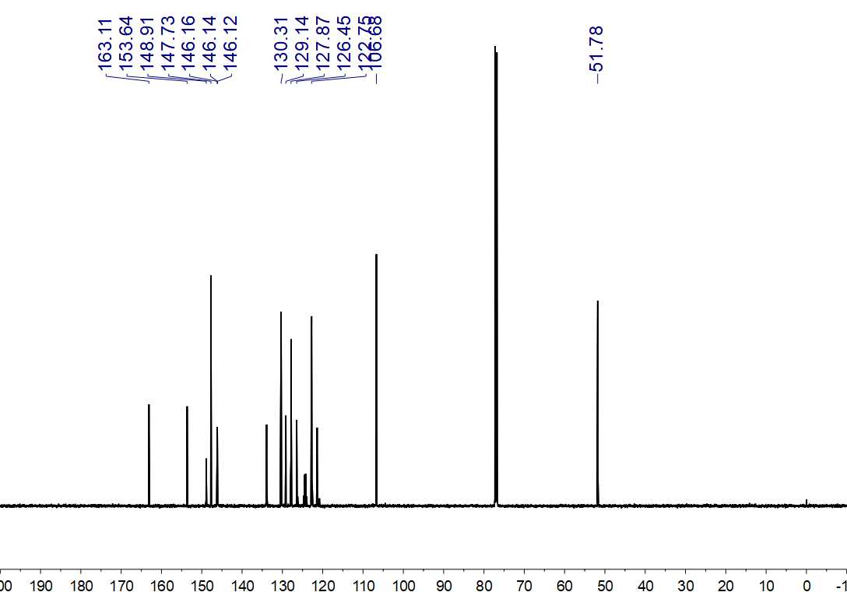
Fig. S82. ¹³C NMR (150 MHz, CDCl₃) spectrum of 23

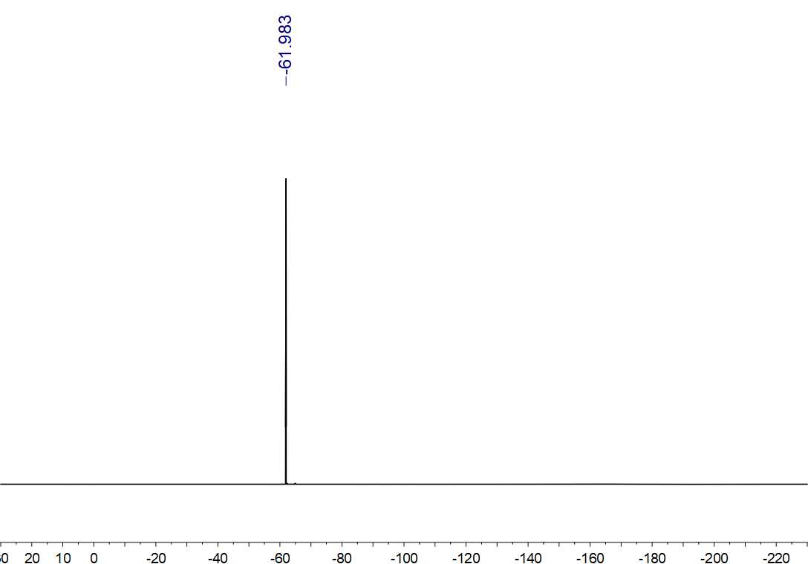
Fig. S83. ¹⁹F NMR (564 MHz, CDCl₃) spectrum of 23

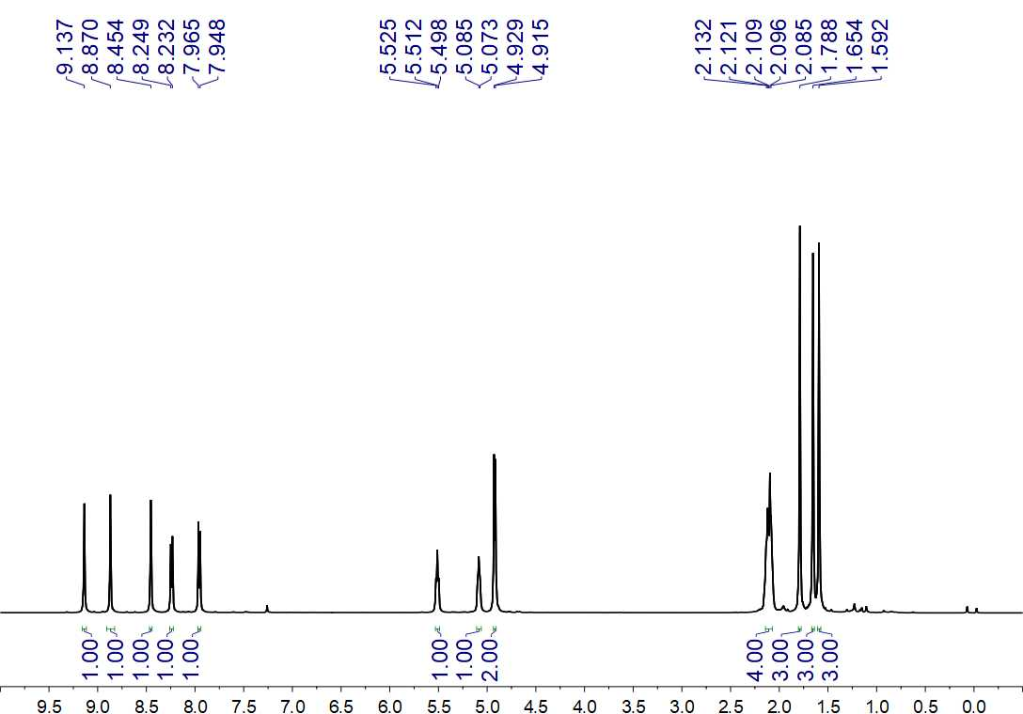
Fig. S84. ¹H NMR (500 MHz, CDCl₃) spectrum of 24

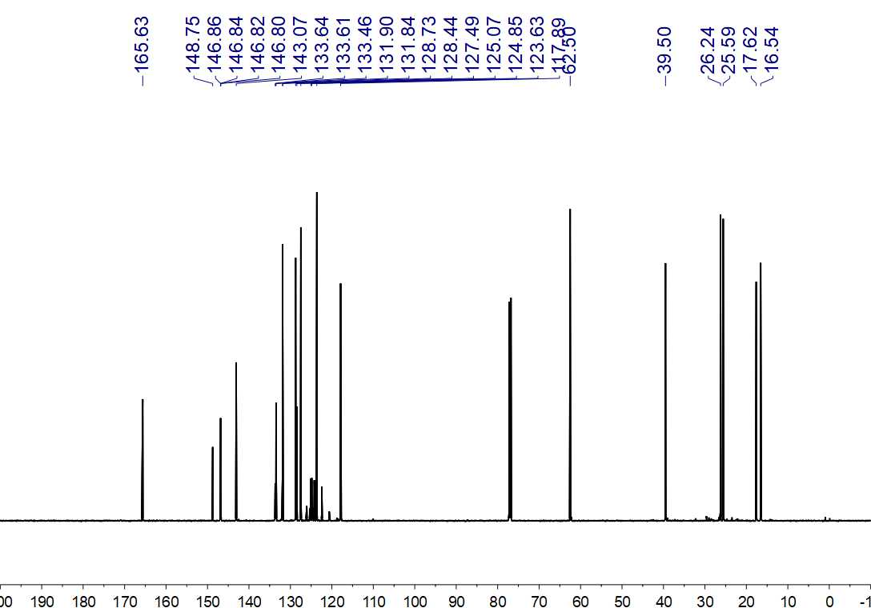
Fig. S85. ¹³C NMR (150 MHz, CDCl₃) spectrum of 24

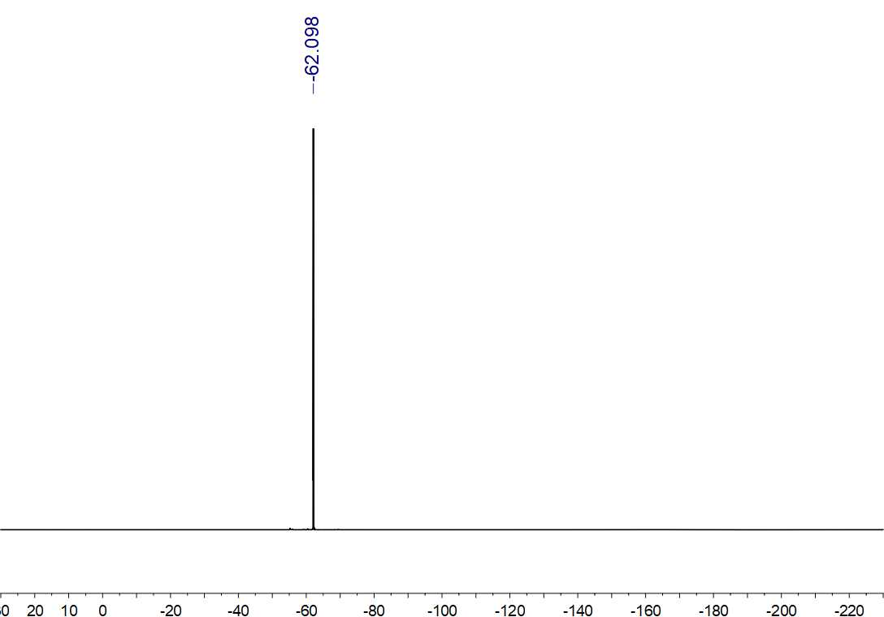
Fig. S83. ¹⁹F NMR (564 MHz, CDCl₃) spectrum of 24

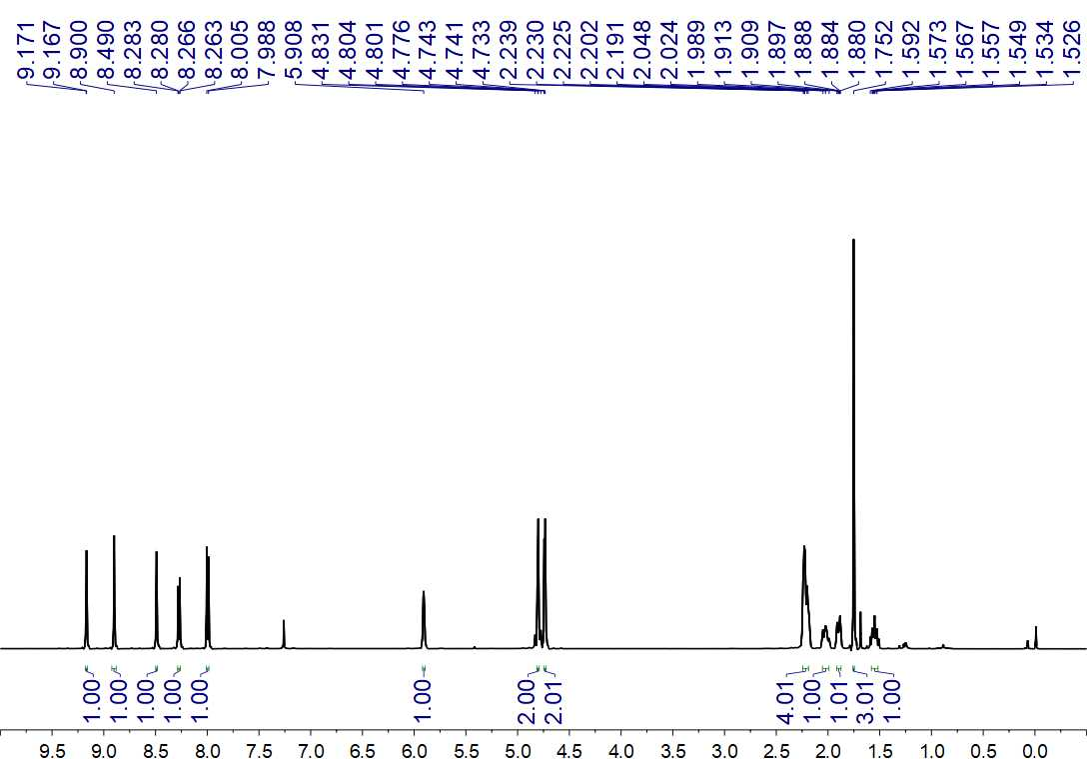
Fig. S87. ¹H NMR (500 MHz, CDCl₃) spectrum of 25

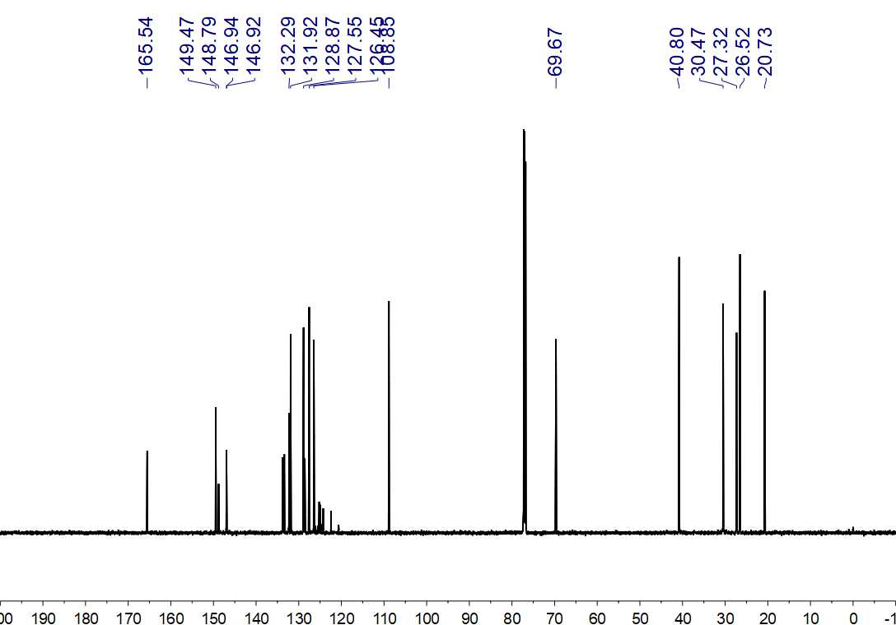
Fig. S88. ¹³C NMR (150 MHz, CDCl₃) spectrum of 25

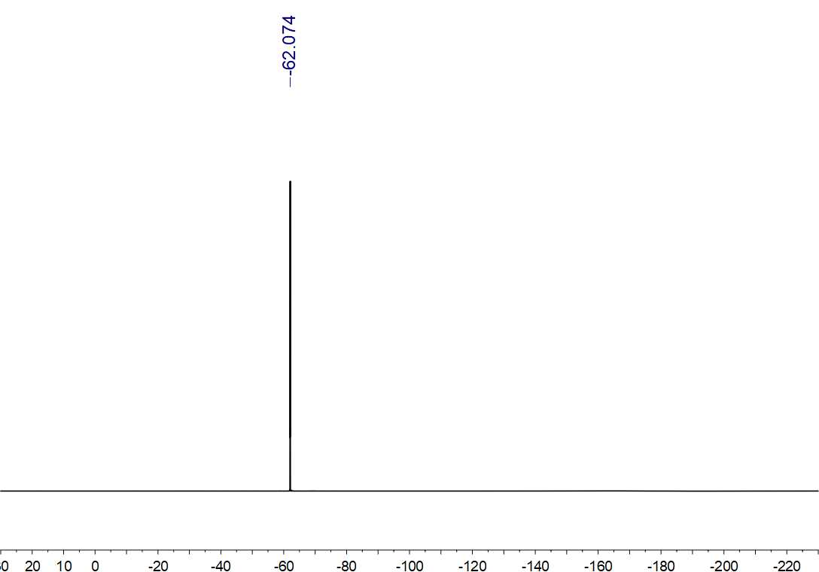
Fig. S89. ¹⁹F NMR (564 MHz, CDCl₃) spectrum of 25

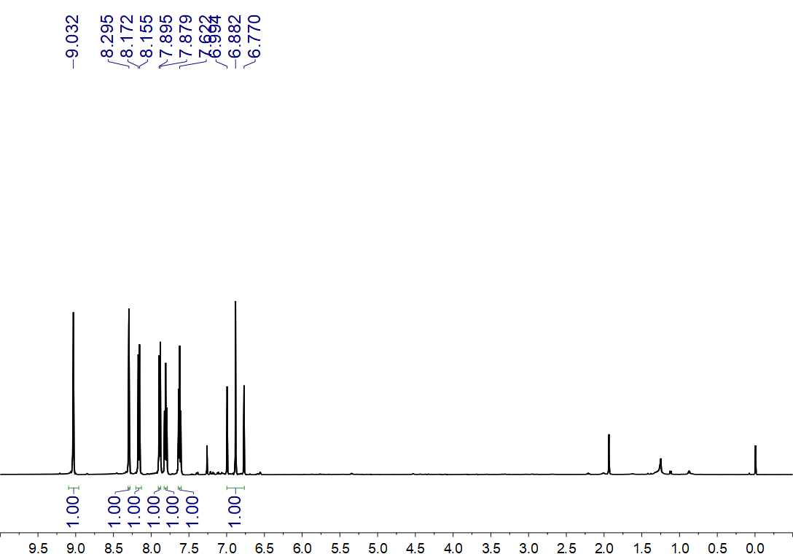
Fig. S90. ¹H NMR (500 MHz, CDCl₃) spectrum of 26

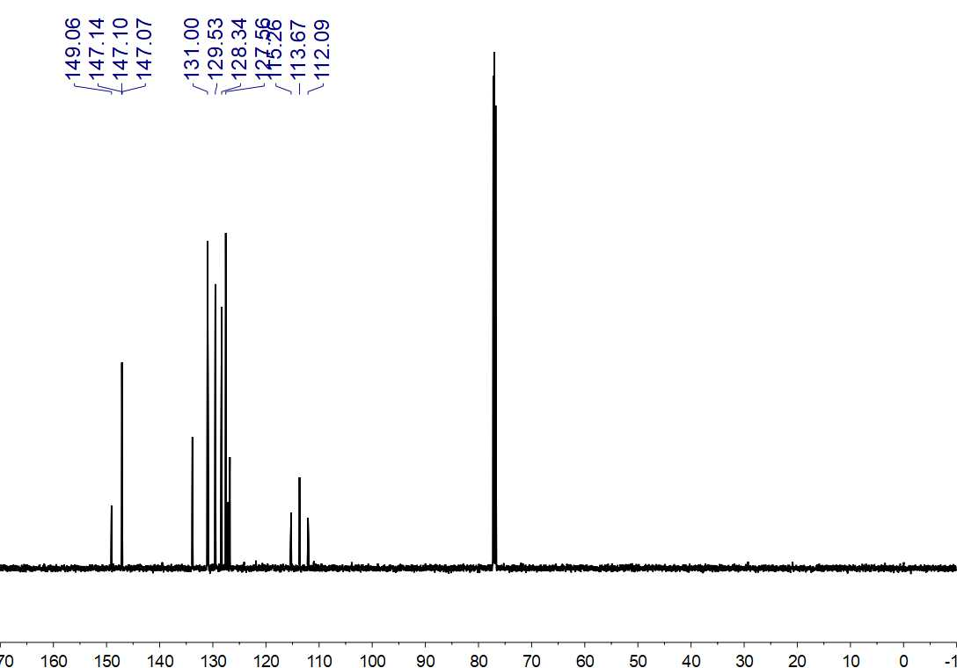
Fig. S91. ¹³C NMR (150 MHz, CDCl₃) spectrum of 26

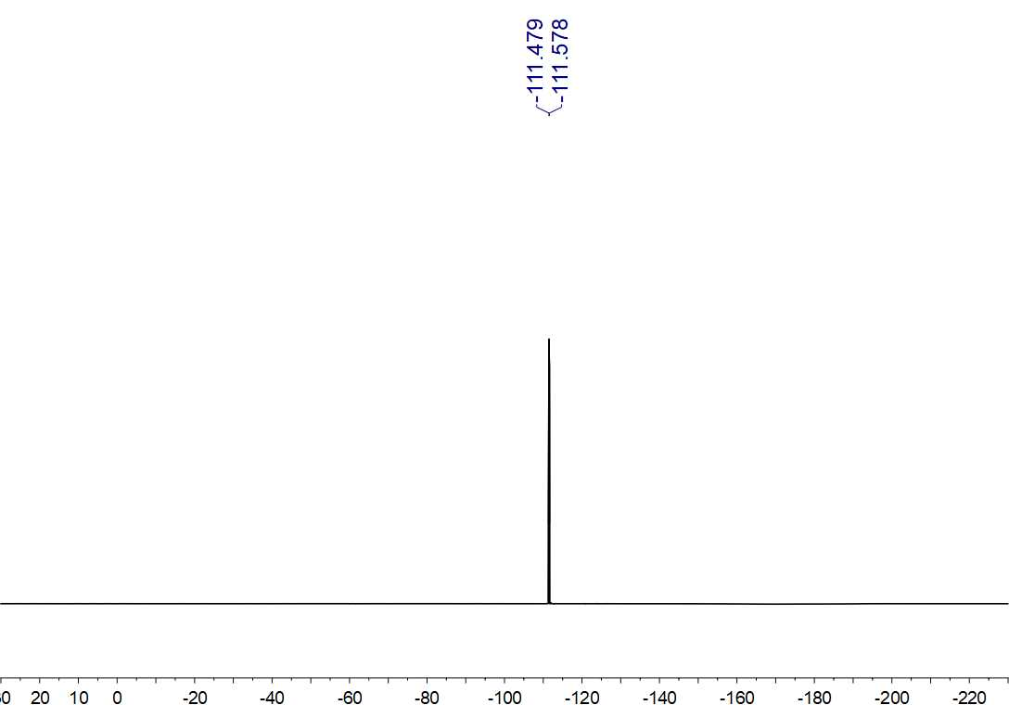
Fig. S92. ¹⁹F NMR (564 MHz, CDCl₃) spectrum of 26

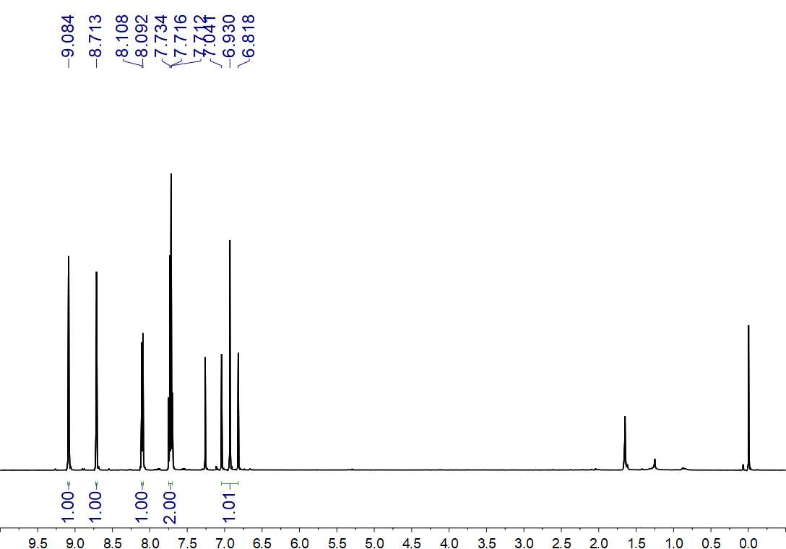
Fig. S93. ¹H NMR (500 MHz, CDCl₃) spectrum of 27

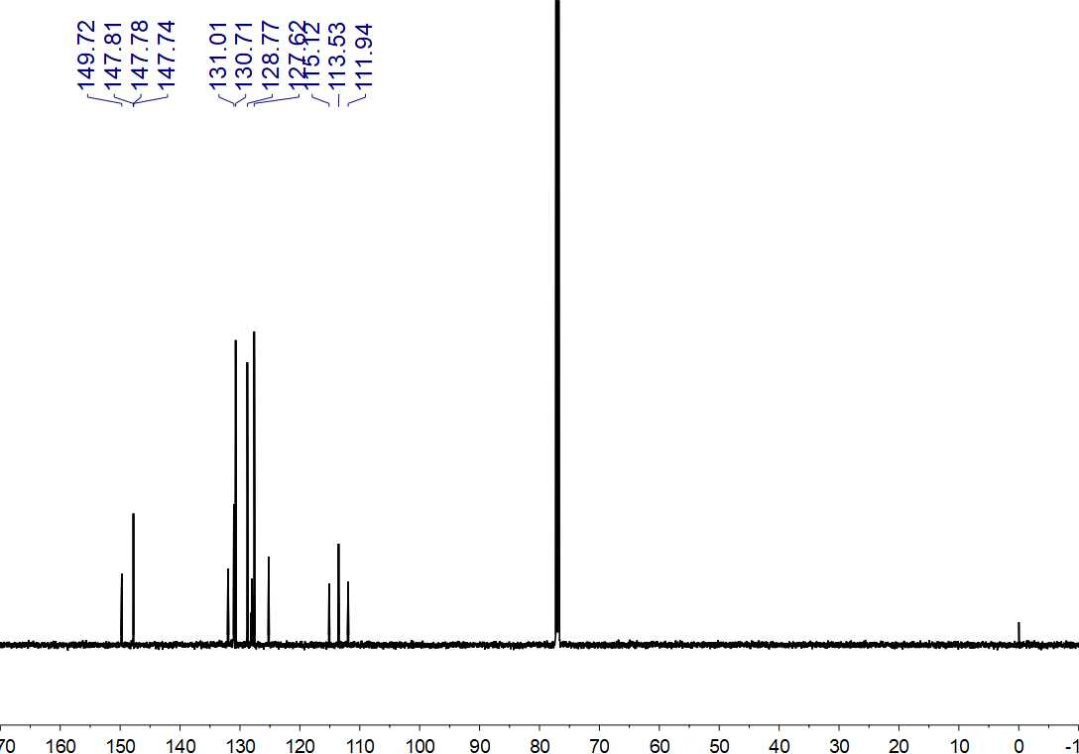
Fig. S94. ¹³C NMR (150 MHz, CDCl₃) spectrum of 27

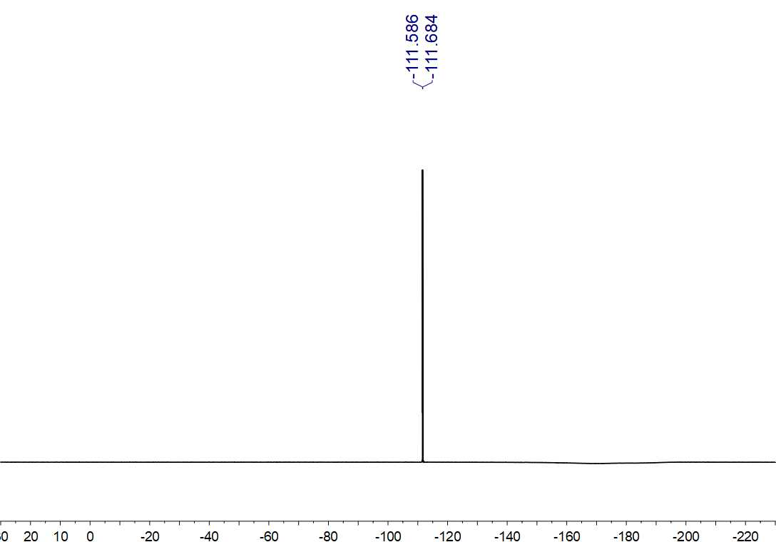
Fig. S95. ¹⁹F NMR (564 MHz, CDCl₃) spectrum of 27

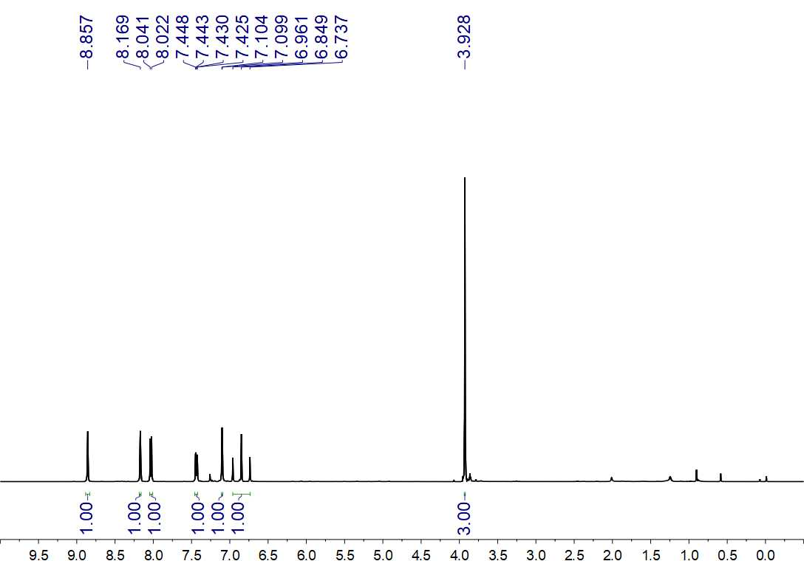
Fig. S96. ¹H NMR (500 MHz, CDCl₃) spectrum of 28

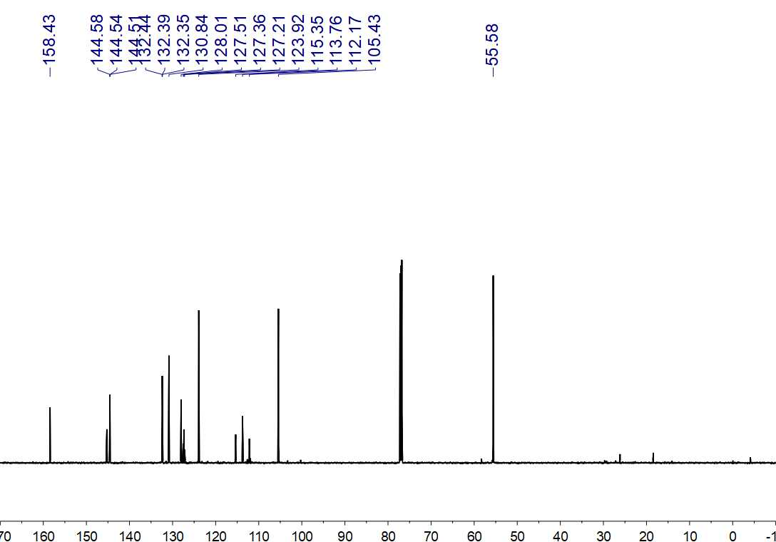
Fig. S97. ¹³C NMR (150 MHz, CDCl₃) spectrum of 28

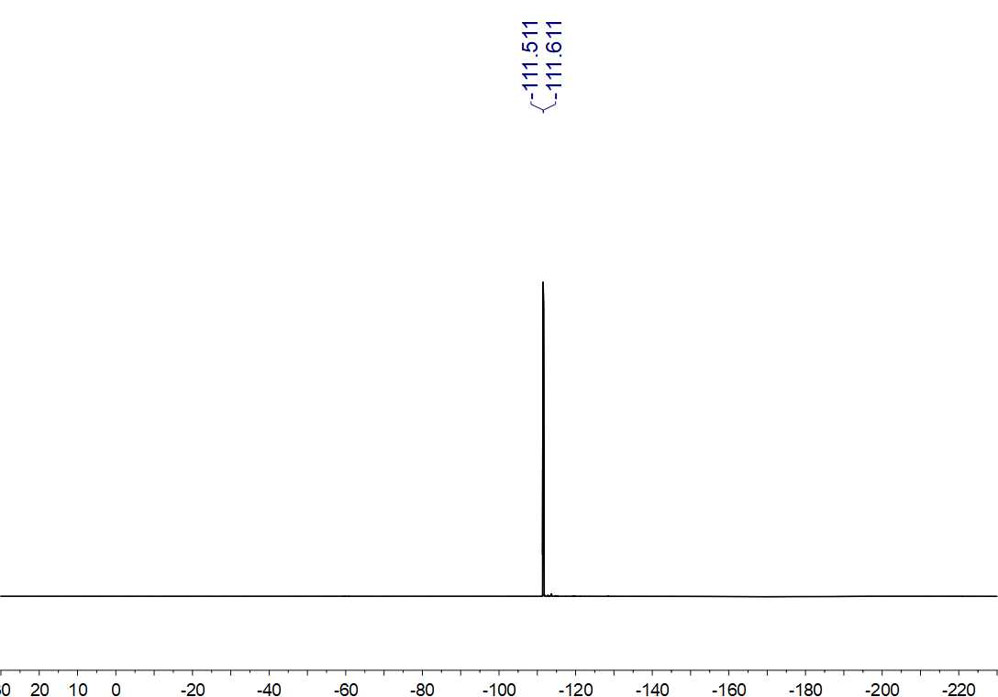
Fig. S98. ¹⁹F NMR (564 MHz, CDCl₃) spectrum of 28

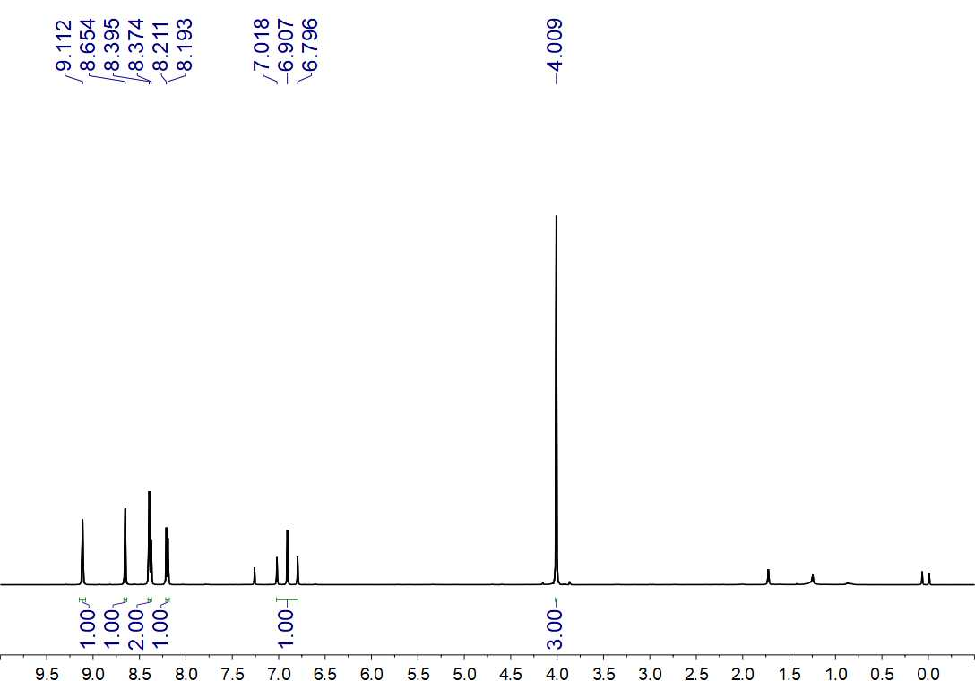
Fig. S99. ¹H NMR (500 MHz, CDCl₃) spectrum of 29

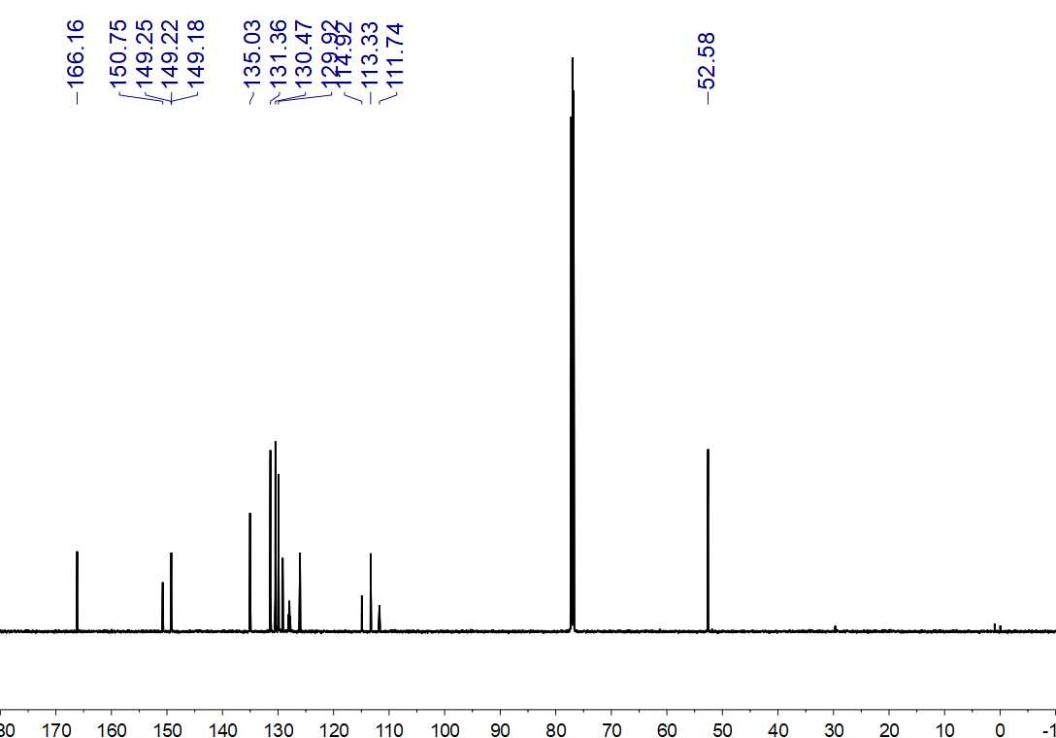
Fig. S100. ¹³C NMR (150 MHz, CDCl₃) spectrum of 29

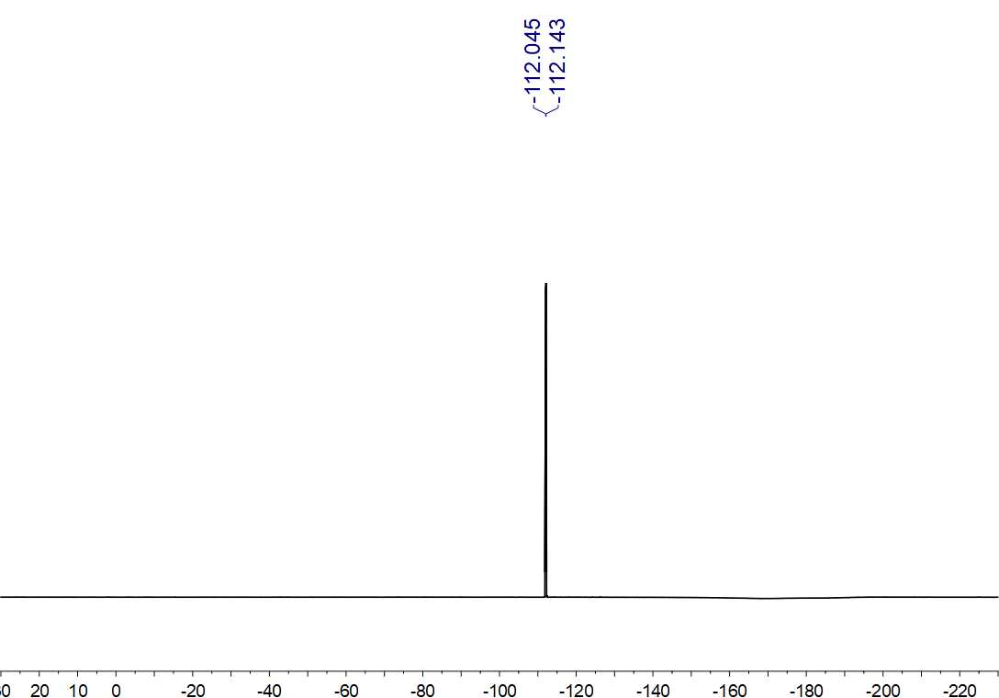
Fig. S101. ¹⁹F NMR (564 MHz, CDCl₃) spectrum of 29

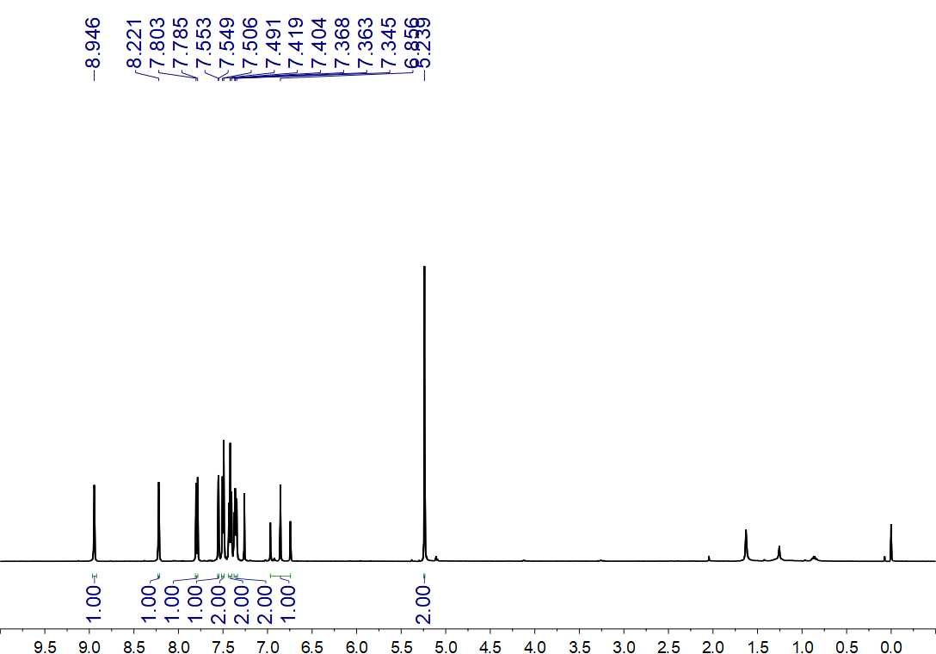
Fig. S102. ¹H NMR (500 MHz, CDCl₃) spectrum of 30

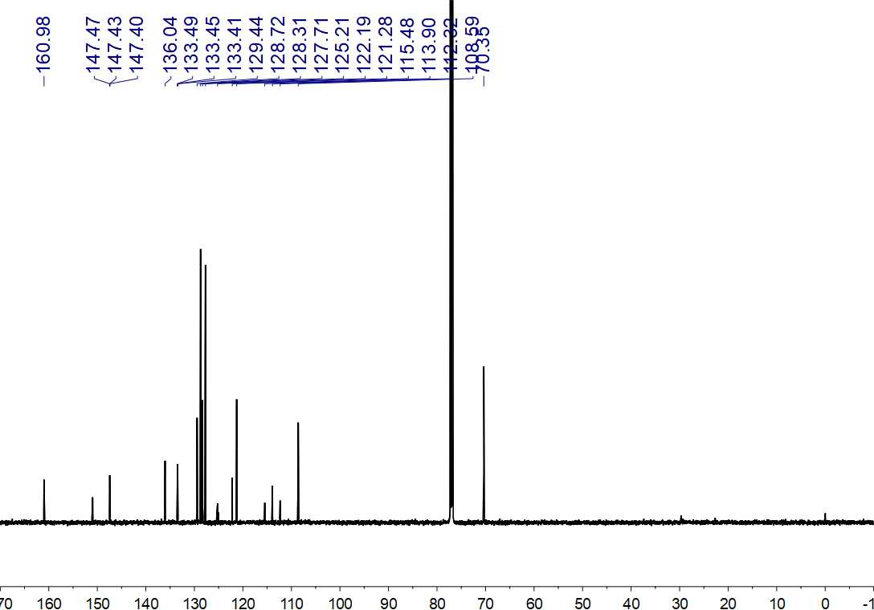
Fig. S103. ¹³C NMR (150 MHz, CDCl₃) spectrum of 30

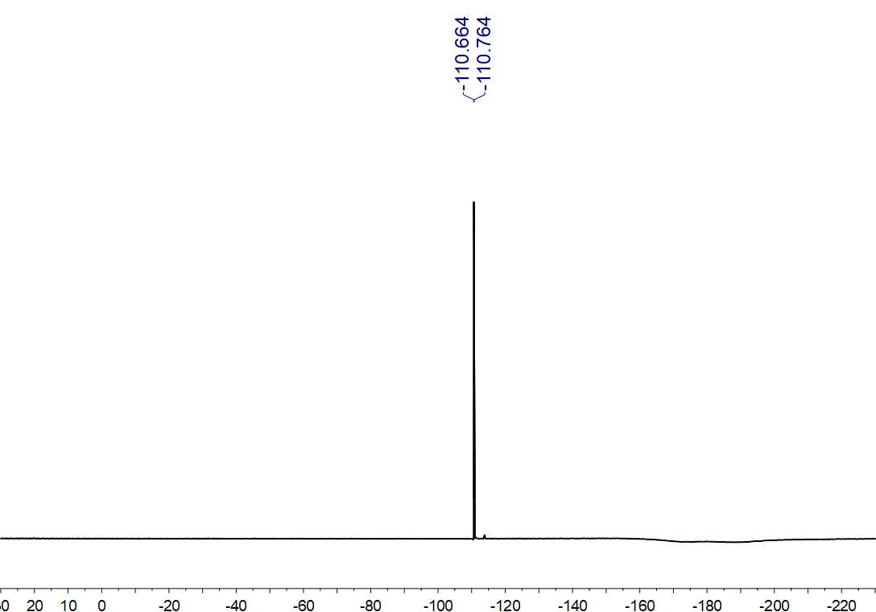
Fig. S104. ¹⁹F NMR (564 MHz, CDCl₃) spectrum of 30

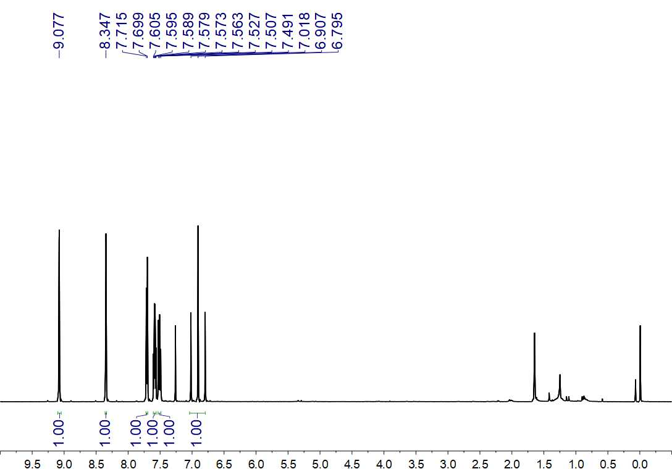
Fig. S105. ¹H NMR (500 MHz, CDCl₃) spectrum of 31

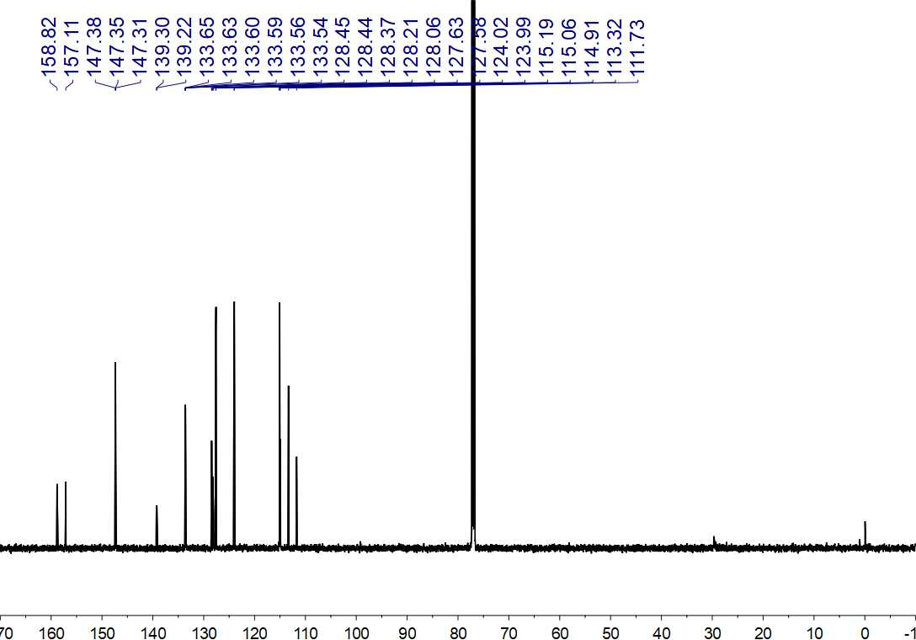
Fig. S106. ¹³C NMR (150 MHz, CDCl₃) spectrum of 31

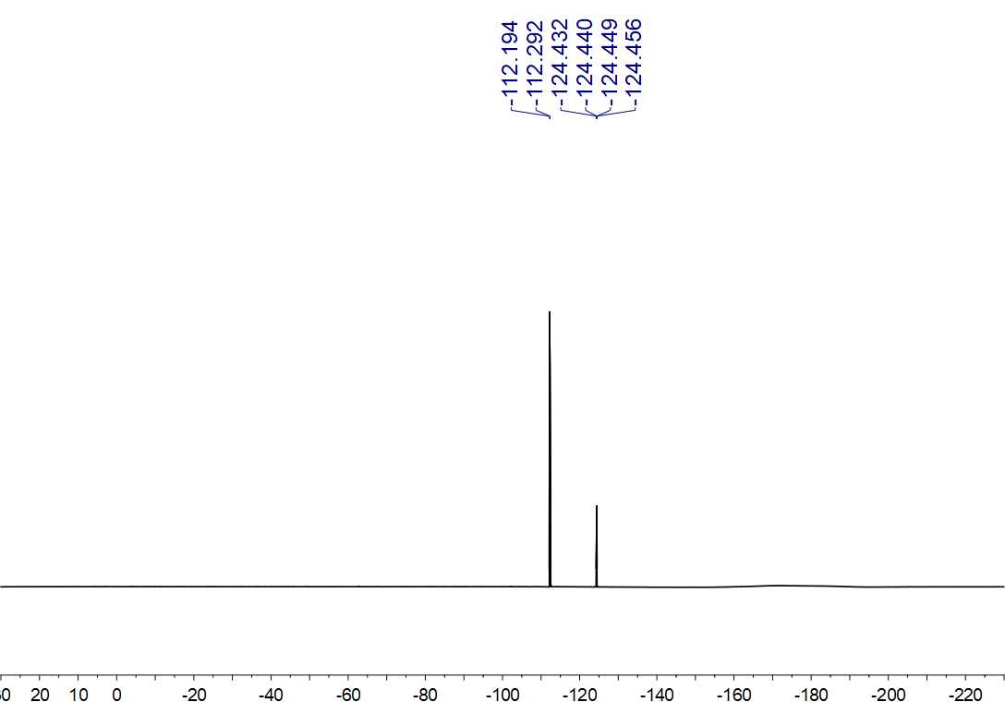
Fig. S107. ¹⁹F NMR (564 MHz, CDCl₃) spectrum of 31

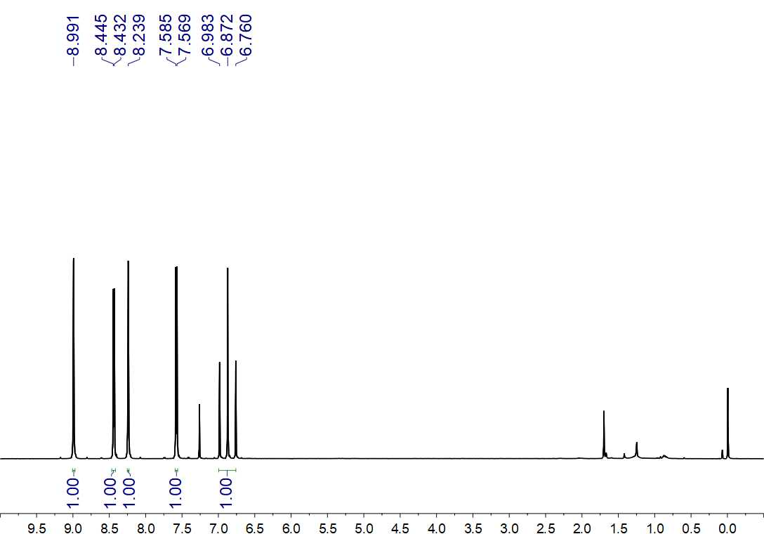
Fig. S108. ¹H NMR (500 MHz, CDCl₃) spectrum of 32

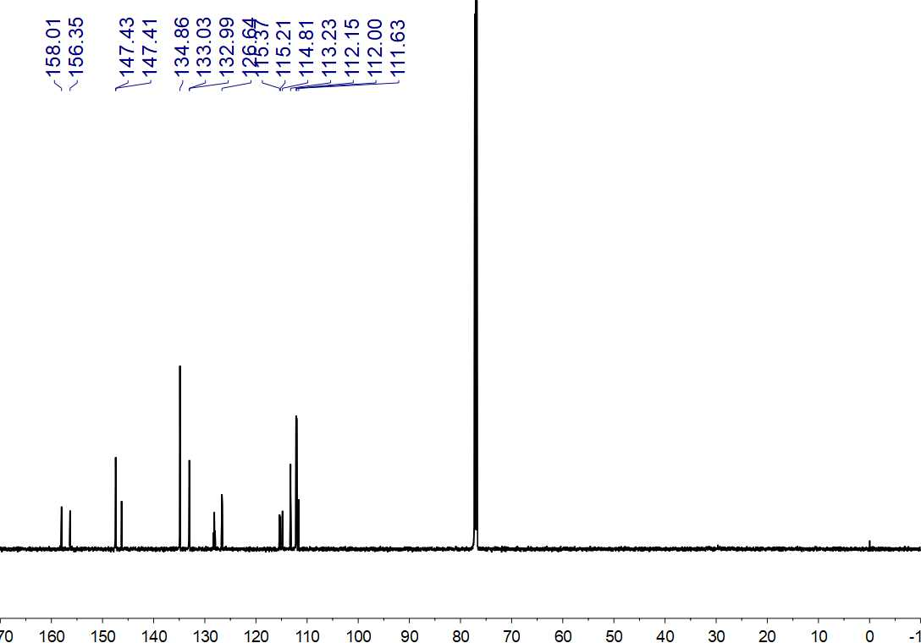
Fig. S109. ¹³C NMR (150 MHz, CDCl₃) spectrum of 32

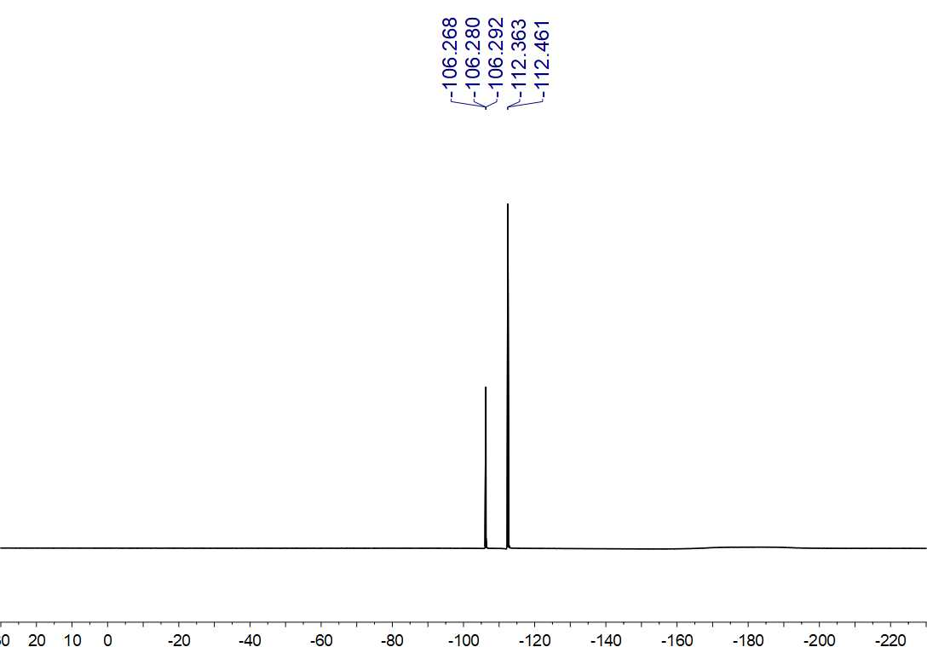
Fig. S110. ¹⁹F NMR (564 MHz, CDCl₃) spectrum of 32

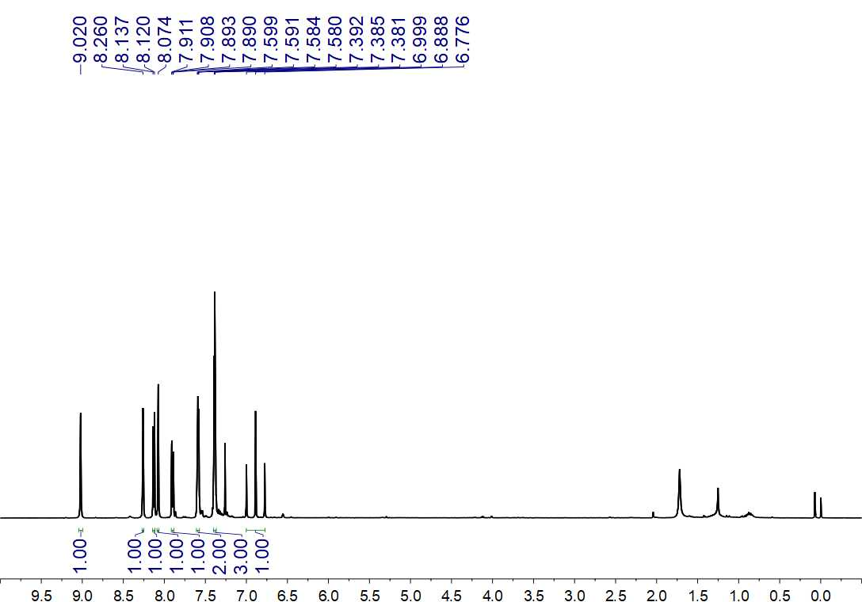
Fig. S111. ¹H NMR (500 MHz, CDCl₃) spectrum of 33

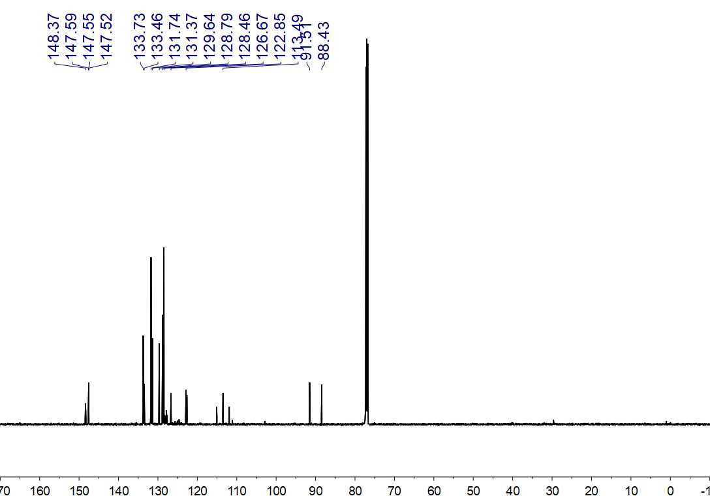
Fig. S112. ¹³C NMR (150 MHz, CDCl₃) spectrum of 33

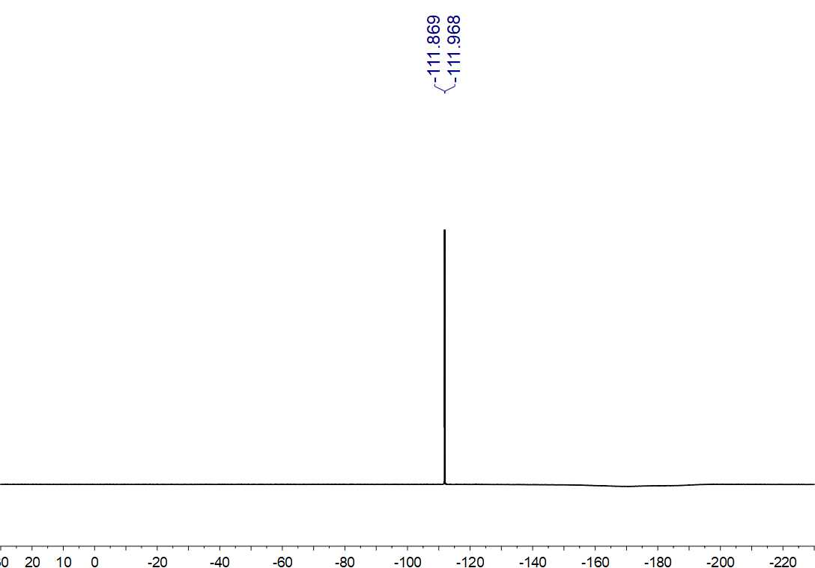
Fig. S113. ¹⁹F NMR (564 MHz, CDCl₃) spectrum of 33

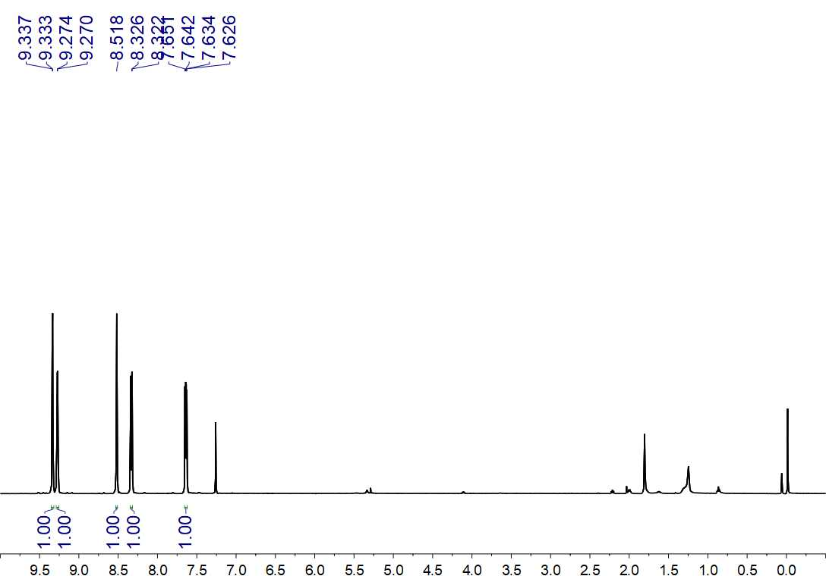
Fig. S114. ¹H NMR (500 MHz, CDCl₃) spectrum of 34

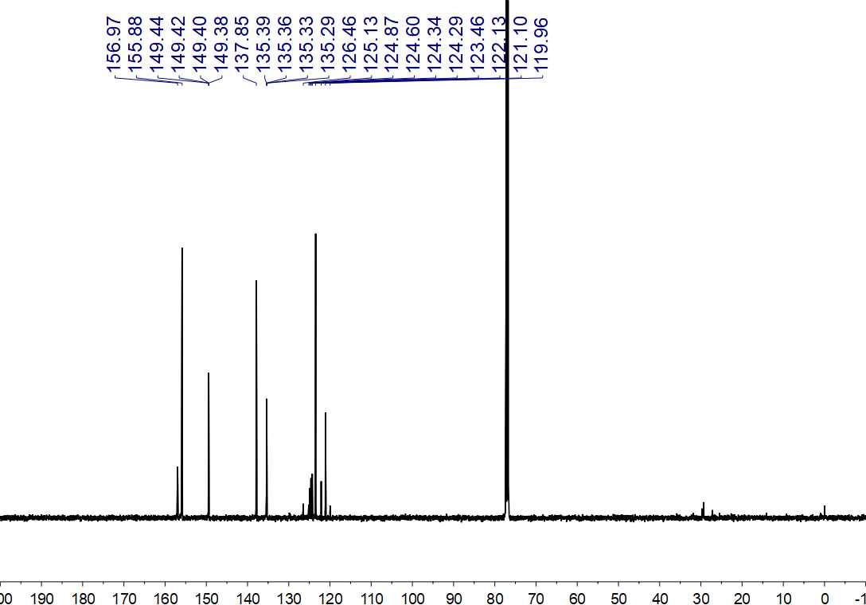
Fig. S115. ¹³C NMR (125 MHz, CDCl₃) spectrum of 34

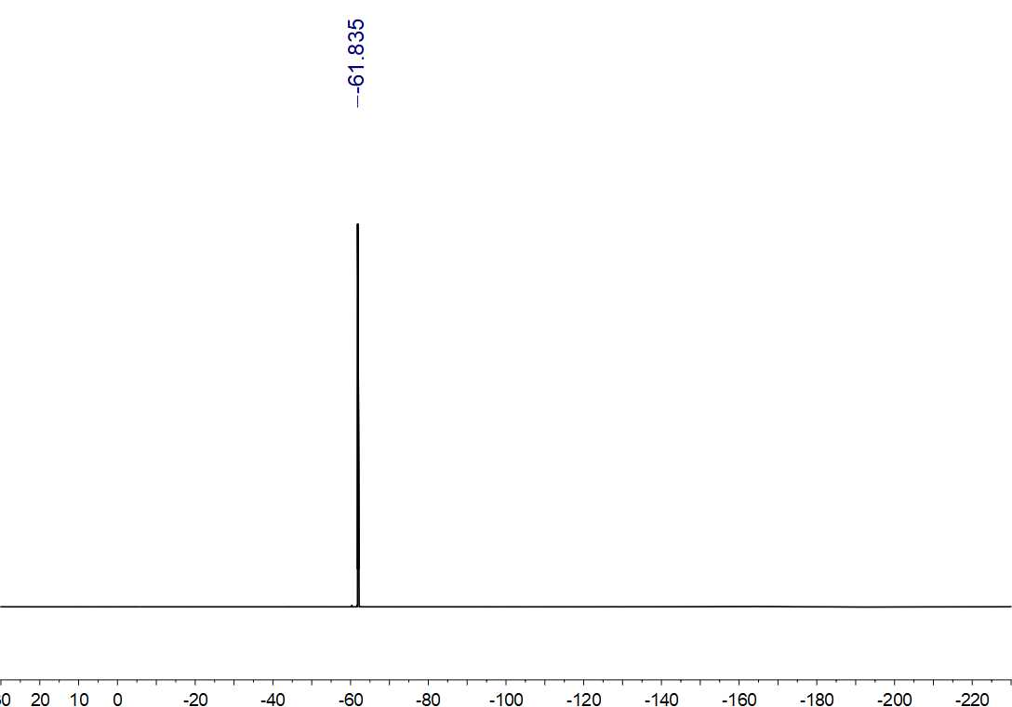
Fig. S116. ¹⁹F NMR (564 MHz, CDCl₃) spectrum of 34

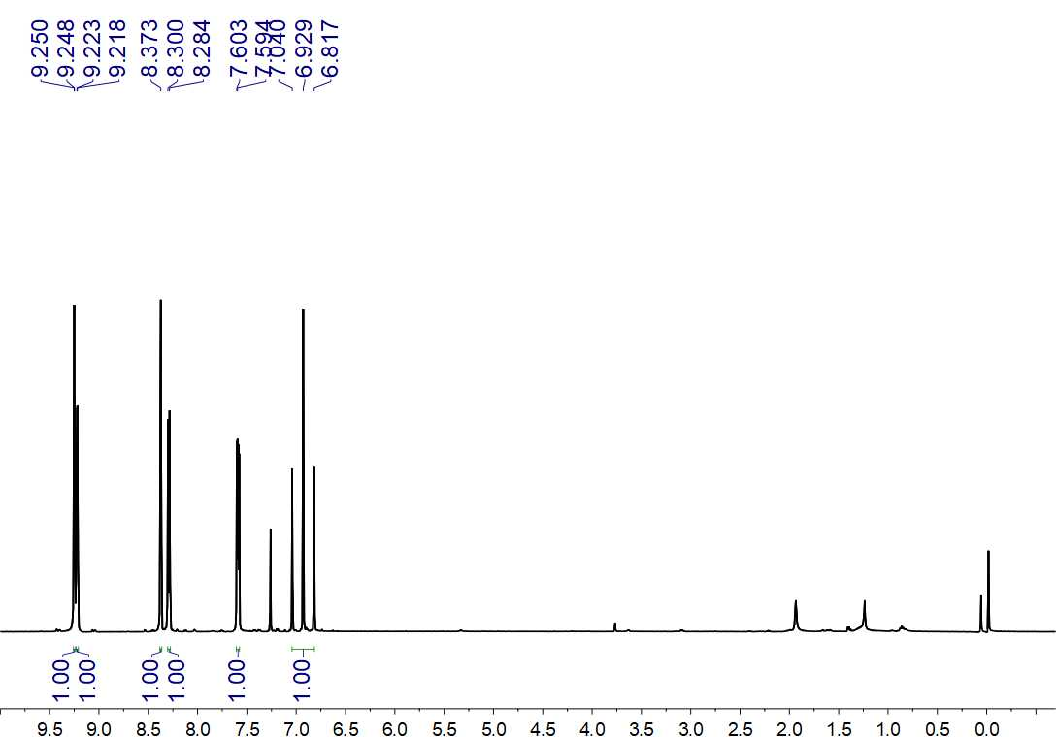
Fig. S117. ¹H NMR (500 MHz, CDCl₃) spectrum of 35

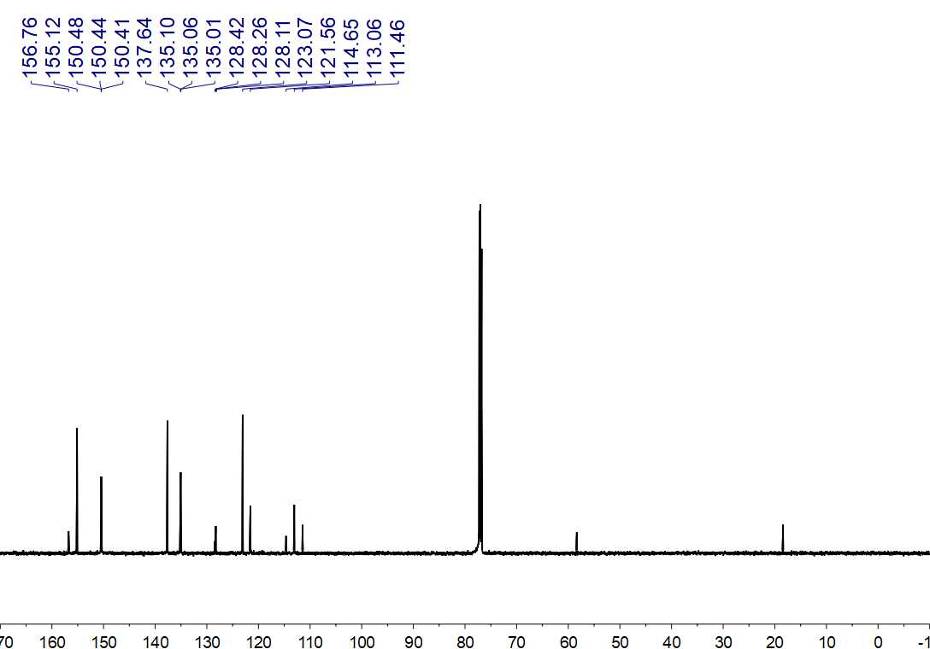
Fig. S118. ¹³C NMR (150 MHz, CDCl₃) spectrum of 35

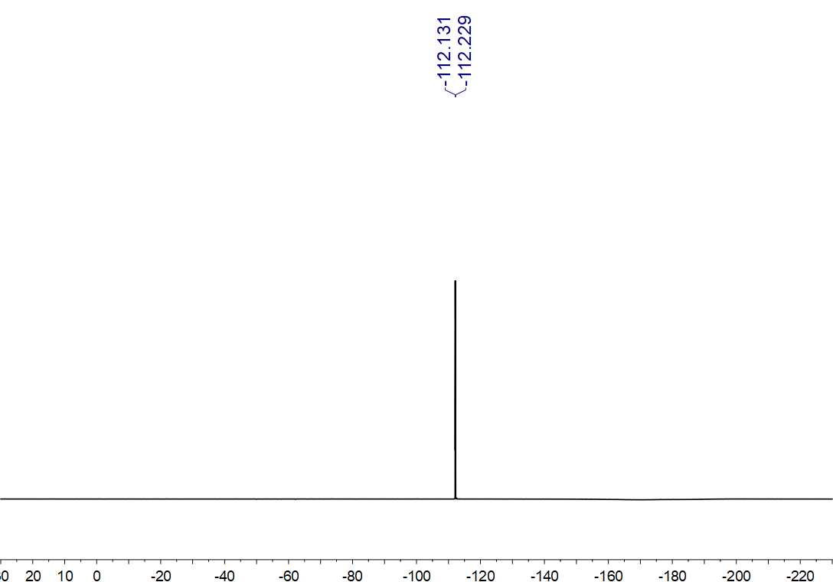
Fig. S119. ¹⁹F NMR (564 MHz, CDCl₃) spectrum of 35

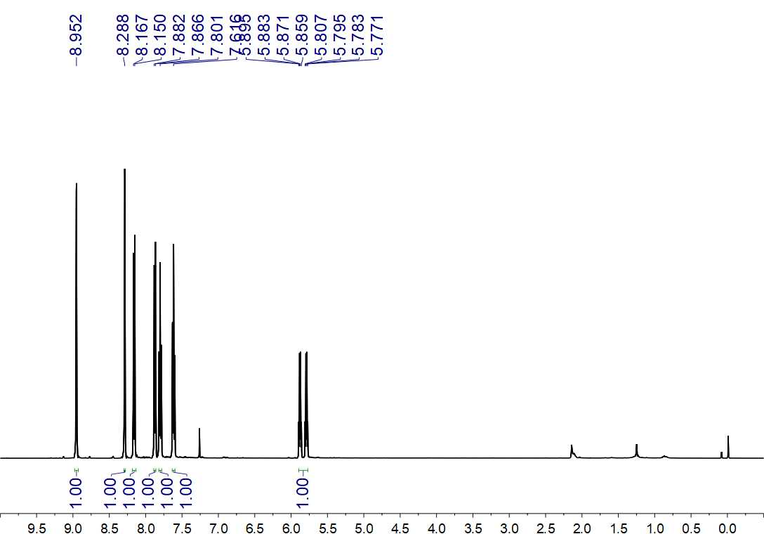
Fig. S120. ¹H NMR (500 MHz, CDCl₃) spectrum of 37

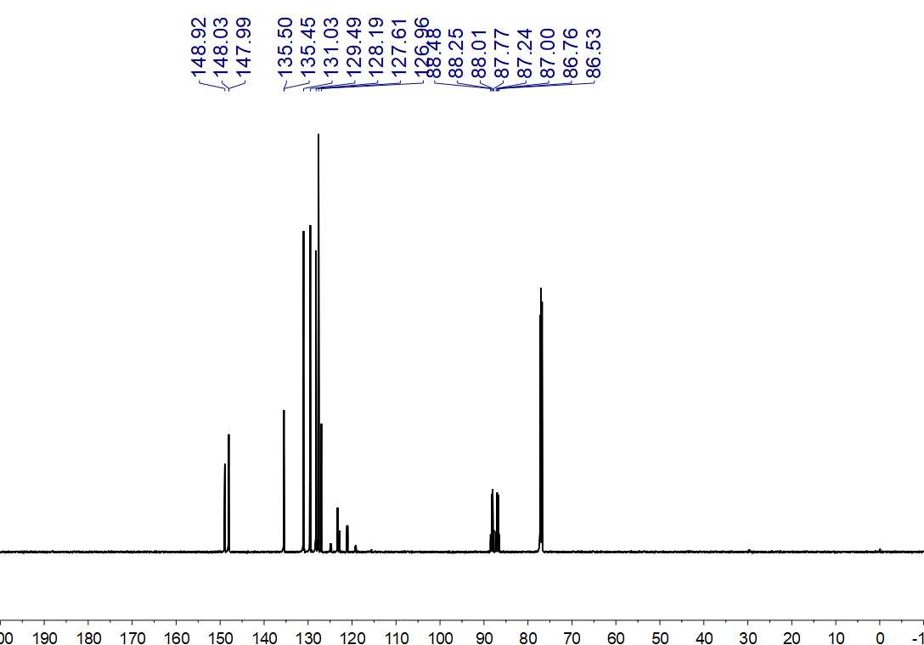
Fig. S121. ¹³C NMR (150 MHz, CDCl₃) spectrum of 37

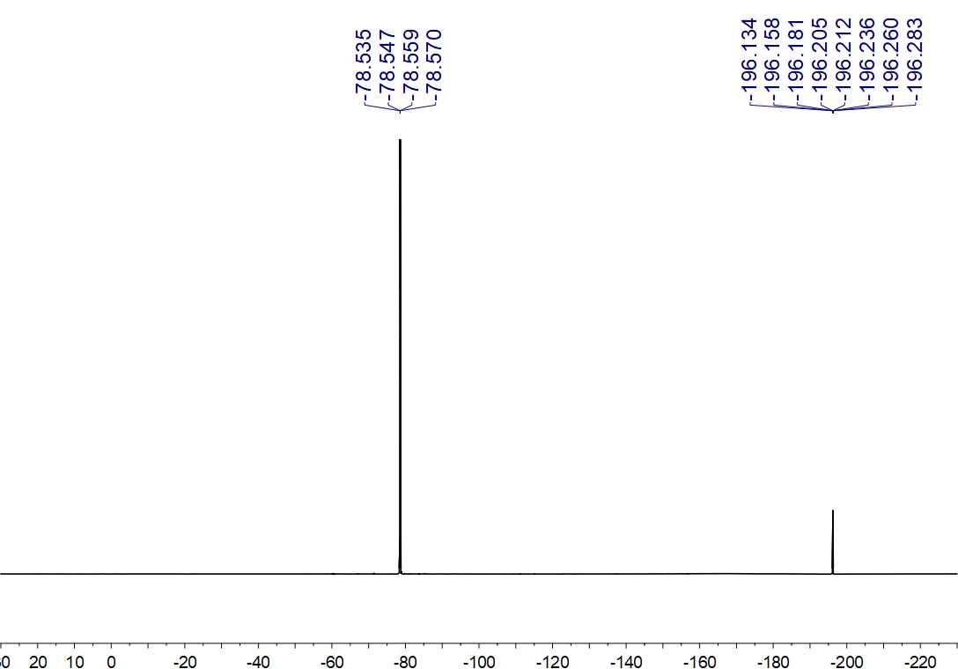
Fig. S122. ¹⁹F NMR (564 MHz, CDCl₃) spectrum of 37

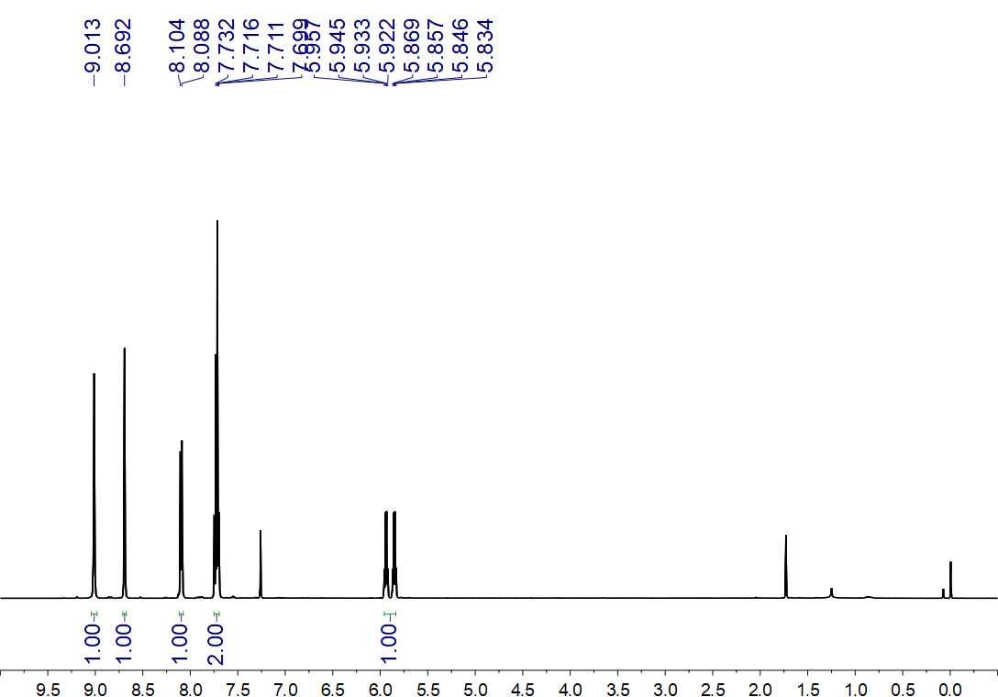
Fig. S123. ¹H NMR (500 MHz, CDCl₃) spectrum of 38

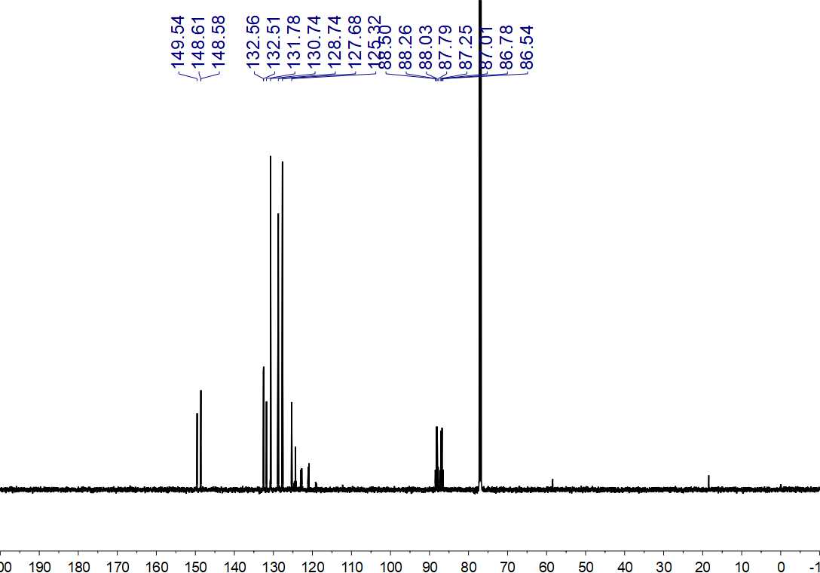
Fig. S124. ¹³C NMR (150 MHz, CDCl₃) spectrum of 38

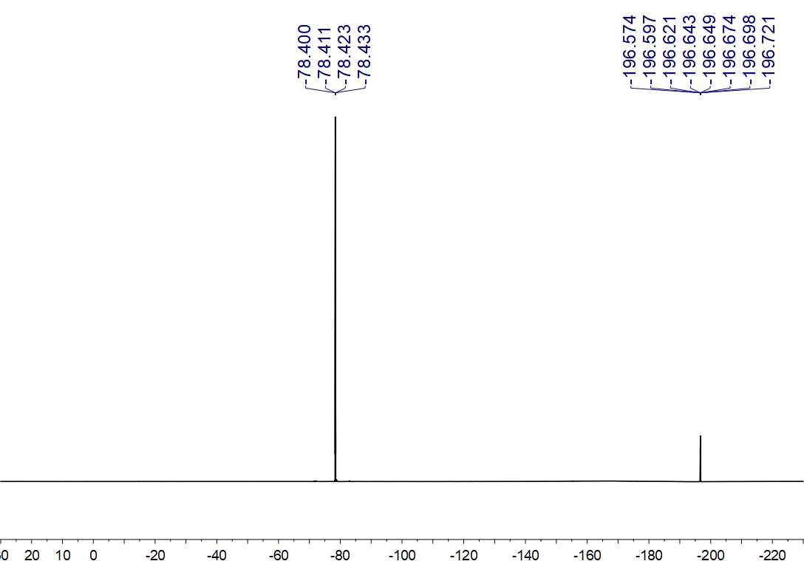
Fig. S125. ¹⁹F NMR (564 MHz, CDCl₃) spectrum of 38

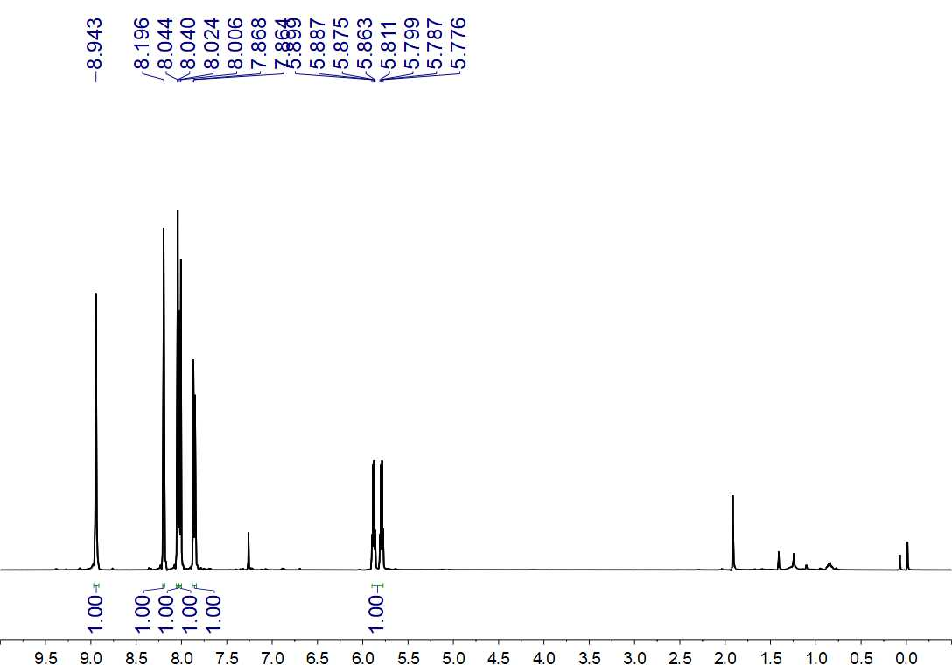
Fig. S126. ¹H NMR (500 MHz, CDCl₃) spectrum of 39

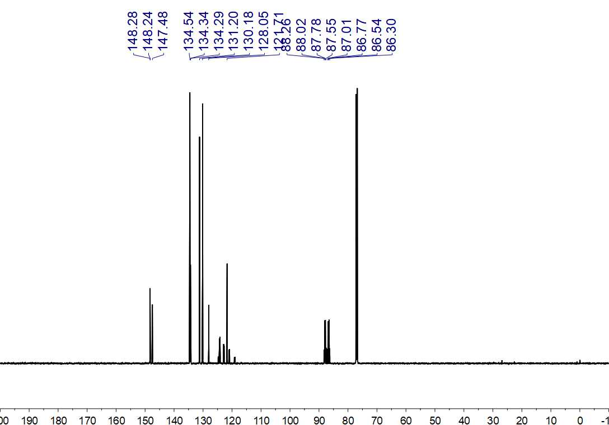
Fig. S127. ¹³C NMR (150 MHz, CDCl₃) spectrum of 39

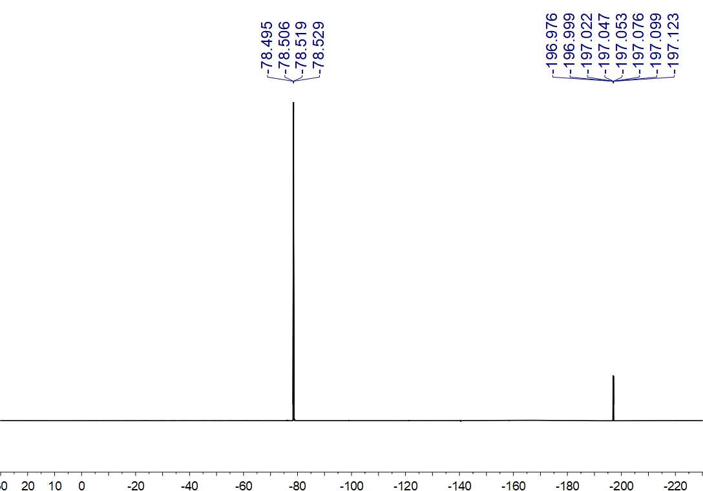
Fig. S128. ¹⁹F NMR (564 MHz, CDCl₃) spectrum of 39

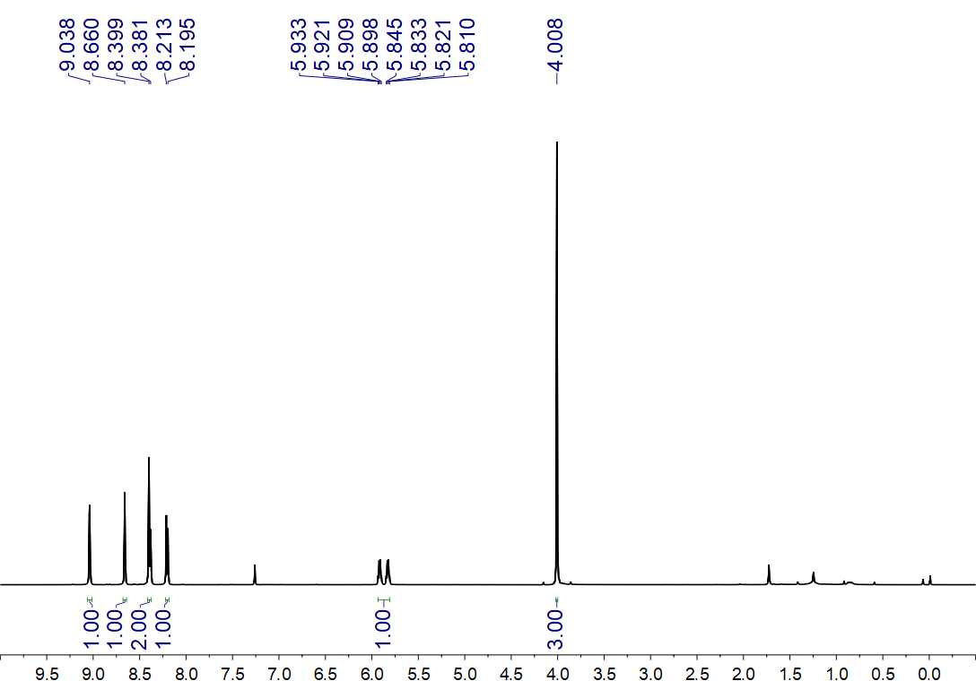
Fig. S129. ¹H NMR (500 MHz, CDCl₃) spectrum of 40

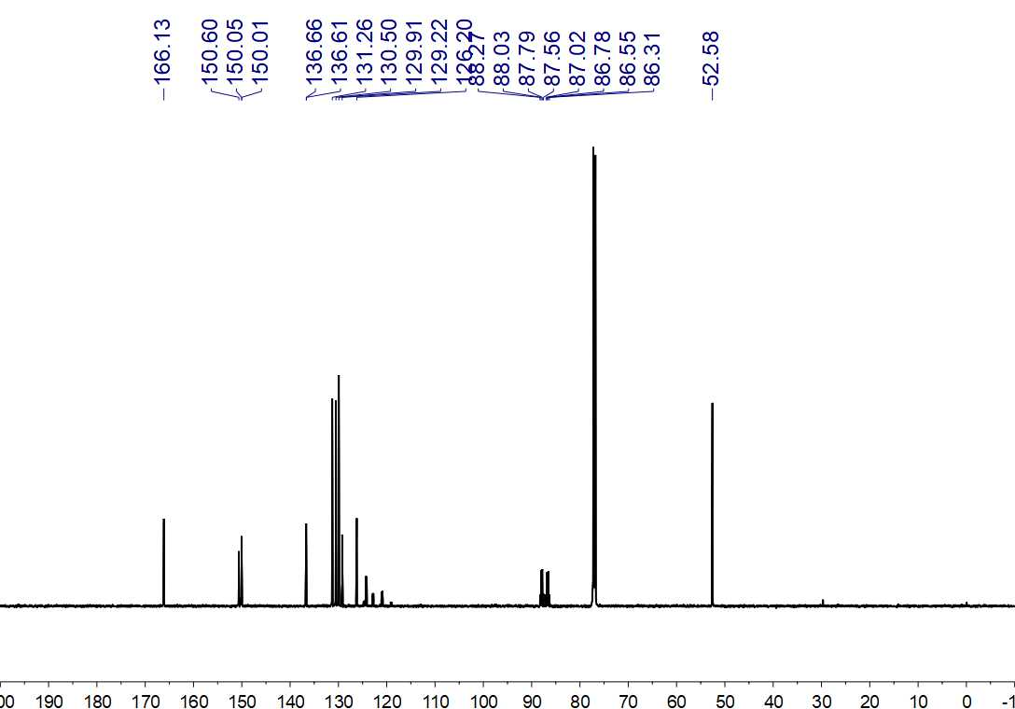
Fig. S130. ¹³C NMR (150 MHz, CDCl₃) spectrum of 40

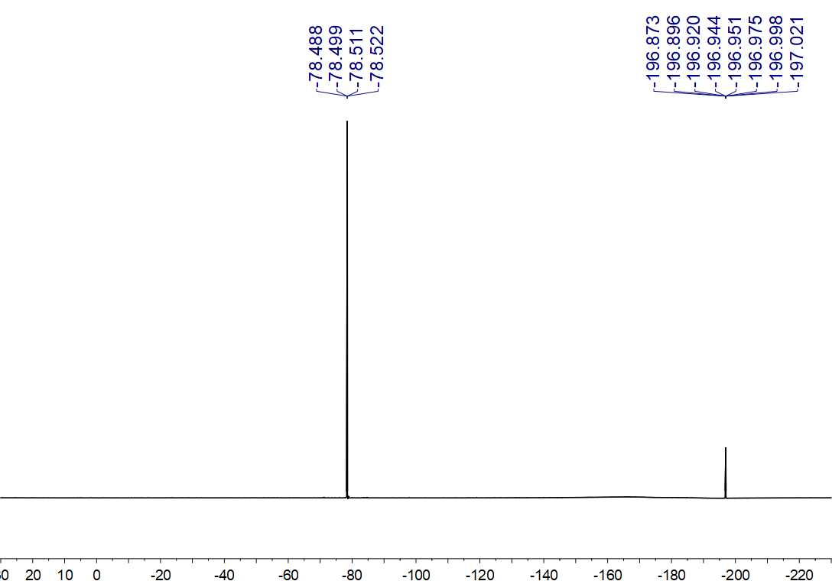
Fig. S131. ¹⁹F NMR (564 MHz, CDCl₃) spectrum of 40

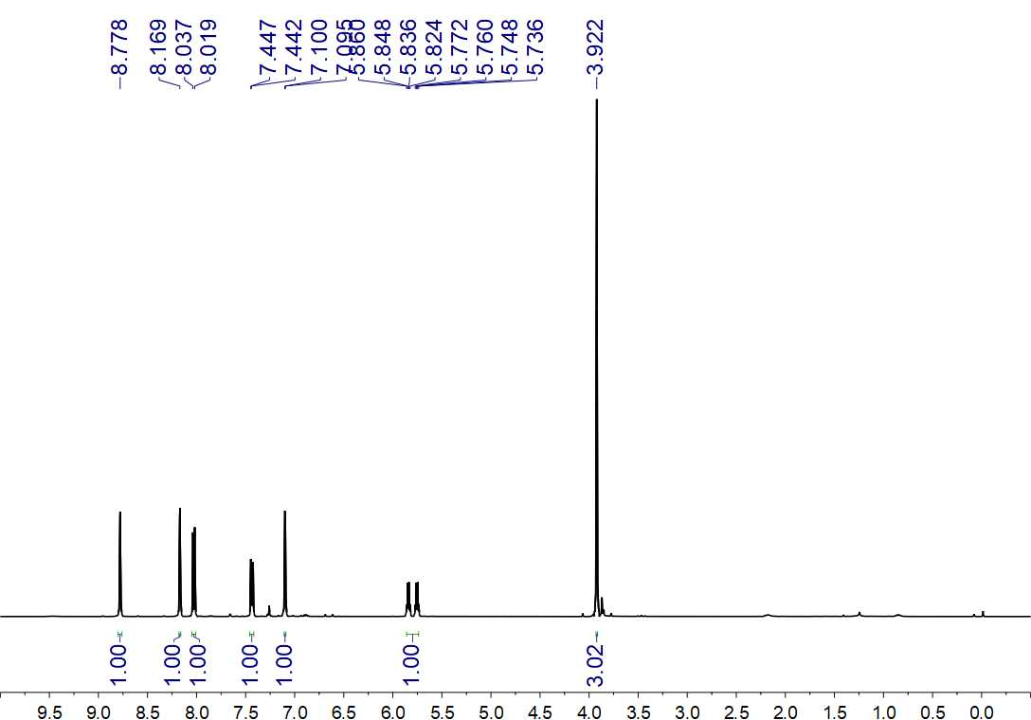
Fig. S132. ¹H NMR (500 MHz, CDCl₃) spectrum of 41

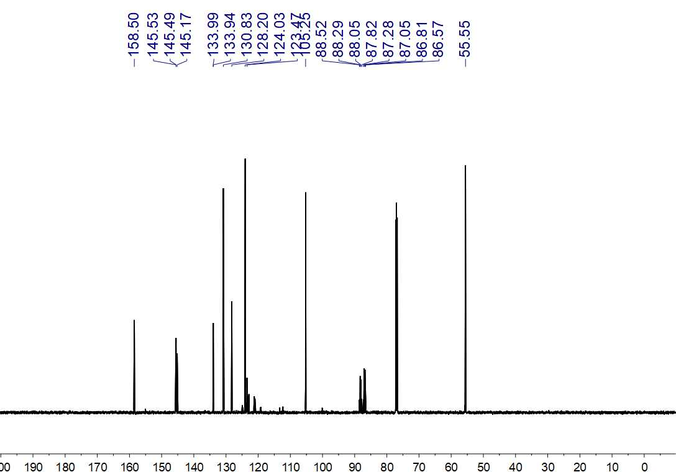
Fig. S133. ¹³C NMR (150 MHz, CDCl₃) spectrum of 41

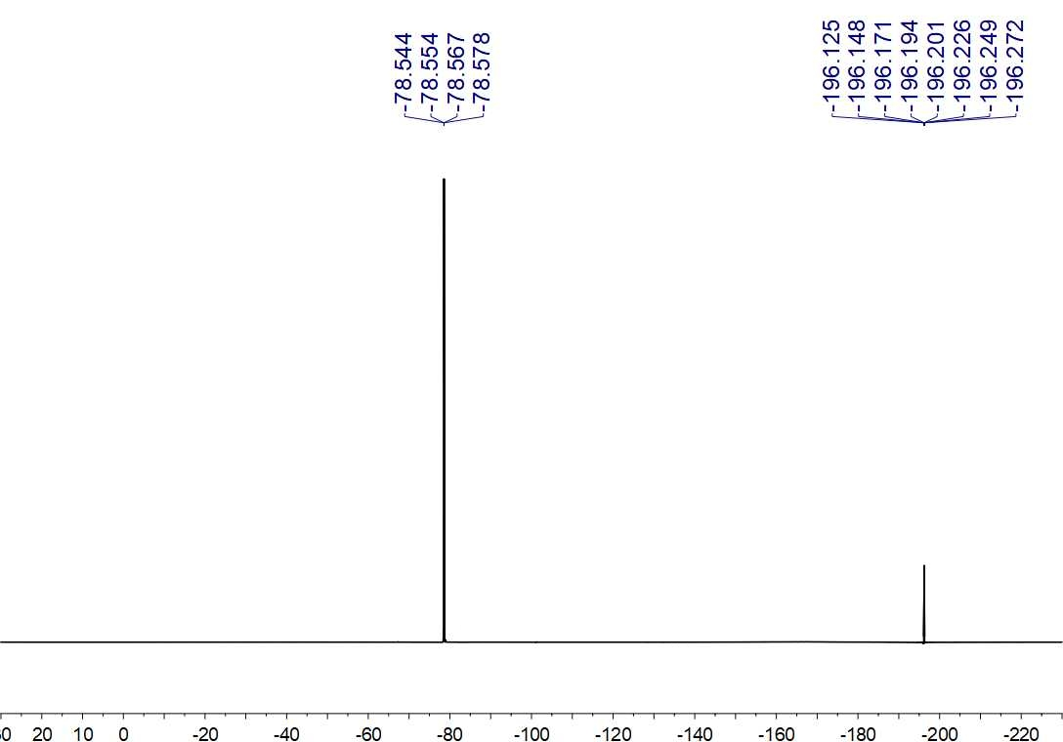
Fig. S134. ¹⁹F NMR (564 MHz, CDCl₃) spectrum of 41

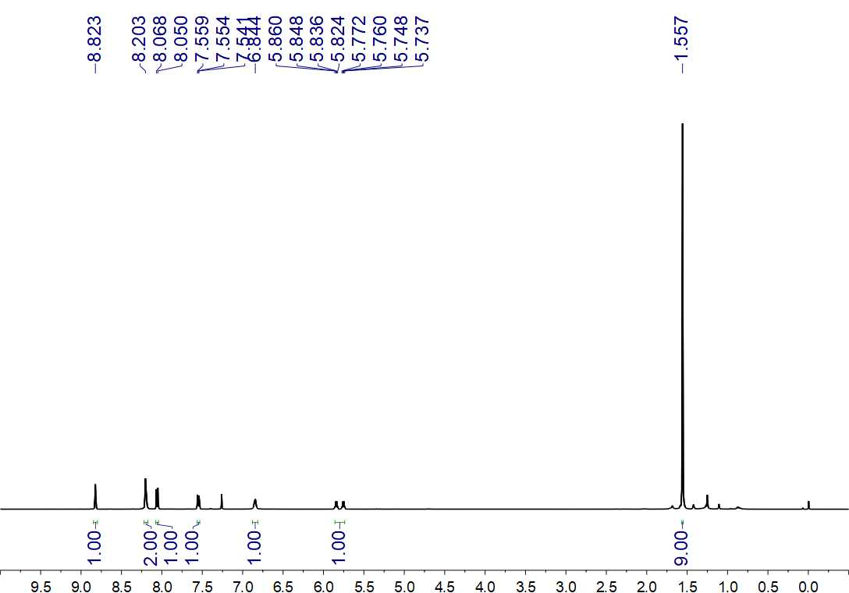
Fig. S135. ¹H NMR (500 MHz, CDCl₃) spectrum of 42

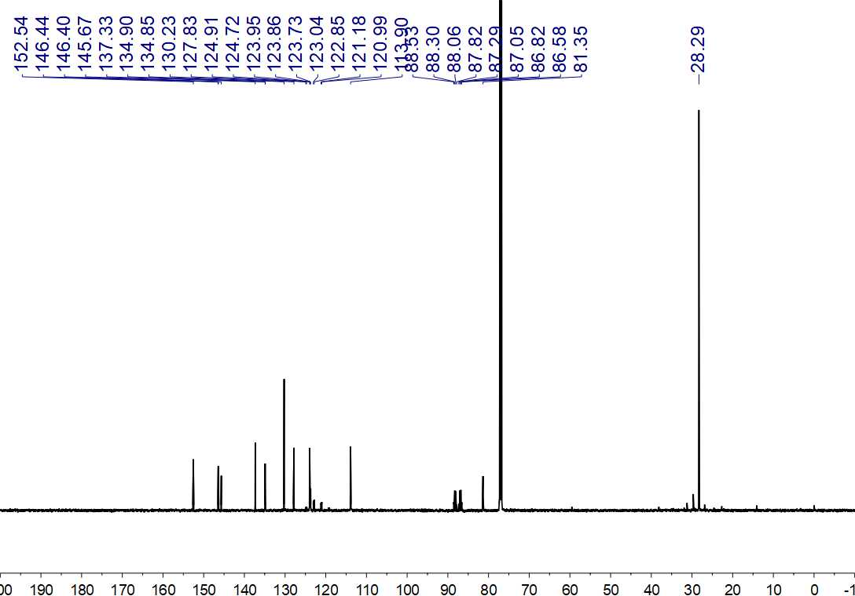
Fig. S136. ¹³C NMR (150 MHz, CDCl₃) spectrum of 42

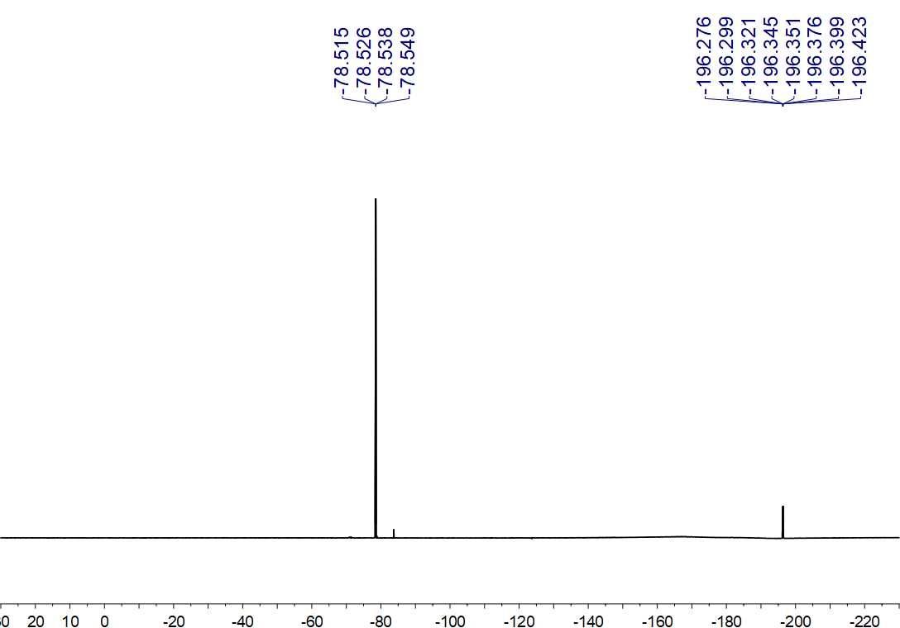
Fig. S137. ¹⁹F NMR (564 MHz, CDCl₃) spectrum of 42

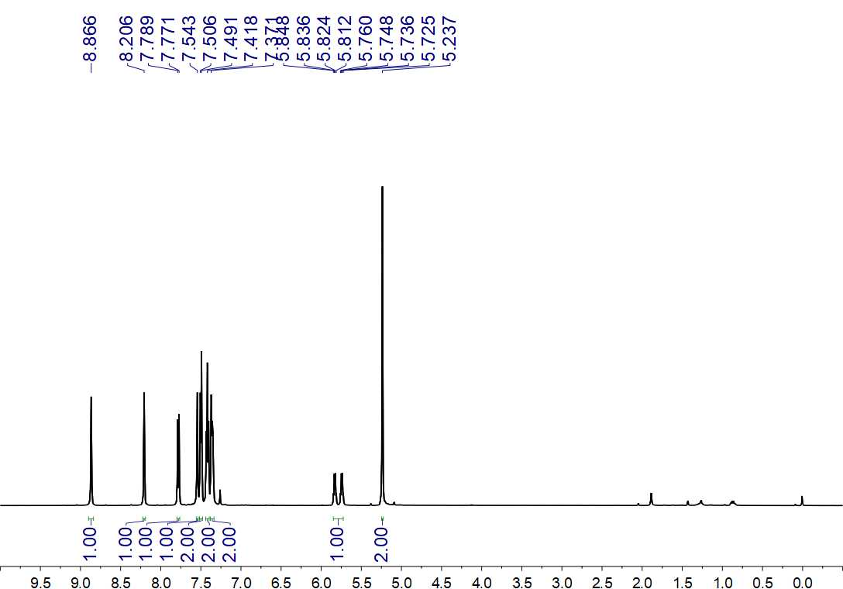
Fig. S138. ¹H NMR (500 MHz, CDCl₃) spectrum of 43

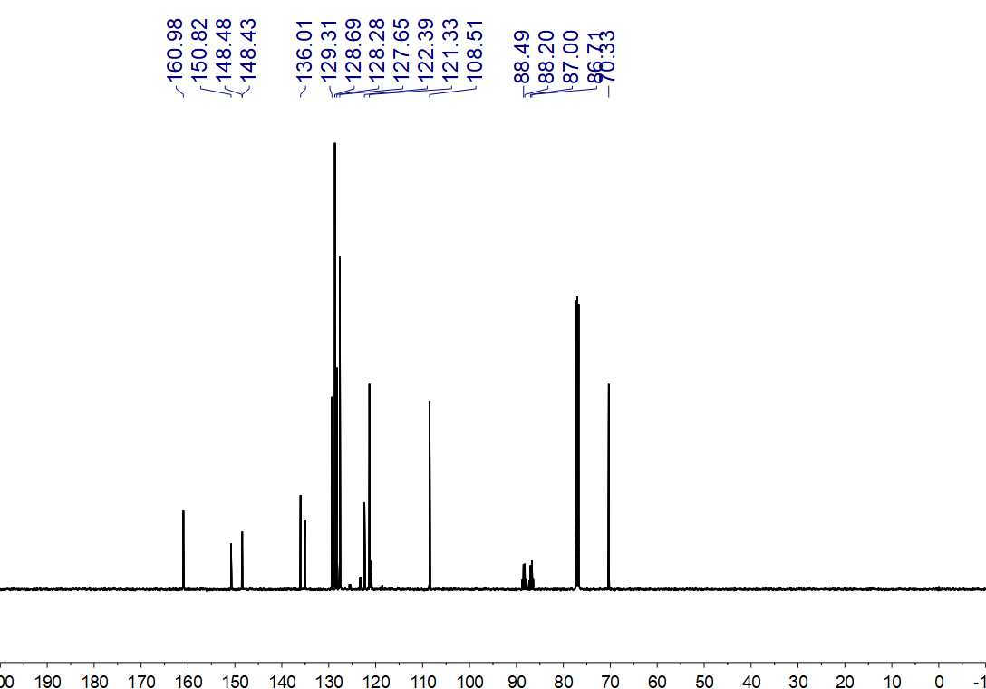
Fig. S139. ¹³C NMR (125 MHz, CDCl₃) spectrum of 43

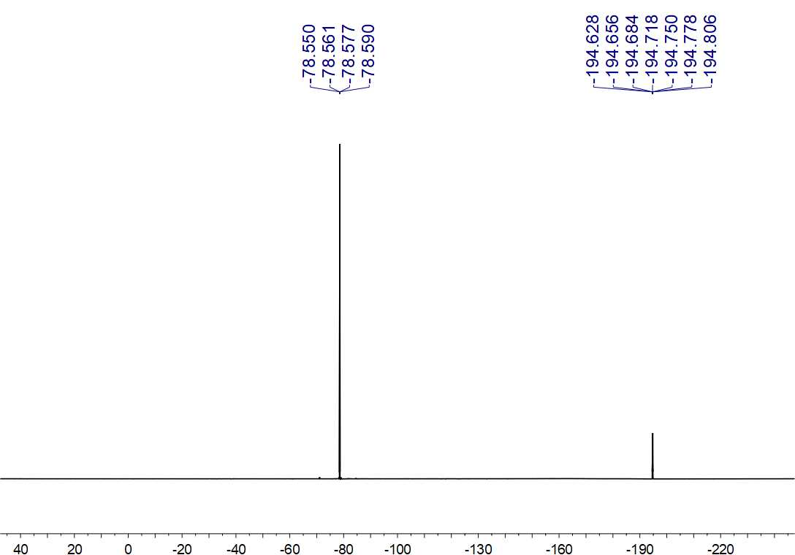
Fig. S140. ¹⁹F NMR (470 MHz, CDCl₃) spectrum of 43

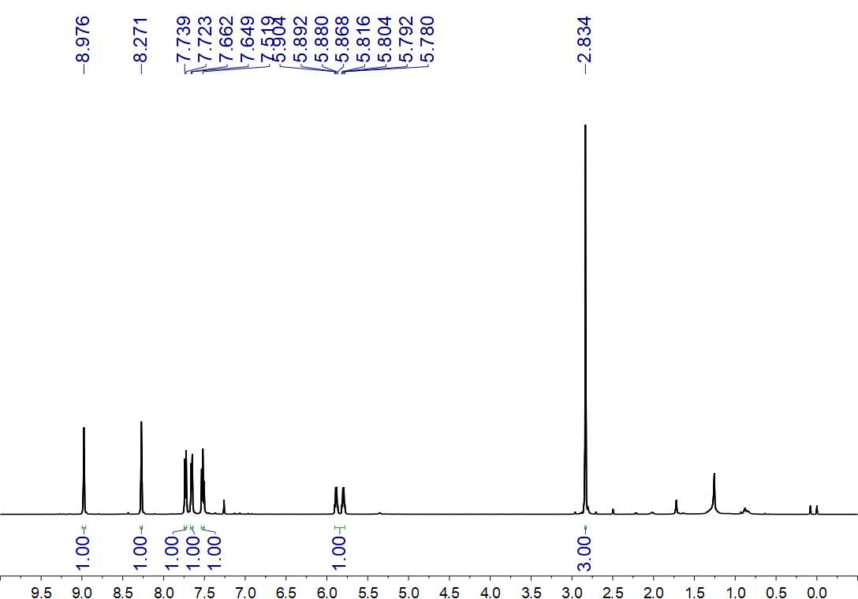
Fig. S141. ¹H NMR (500 MHz, CDCl₃) spectrum of 44

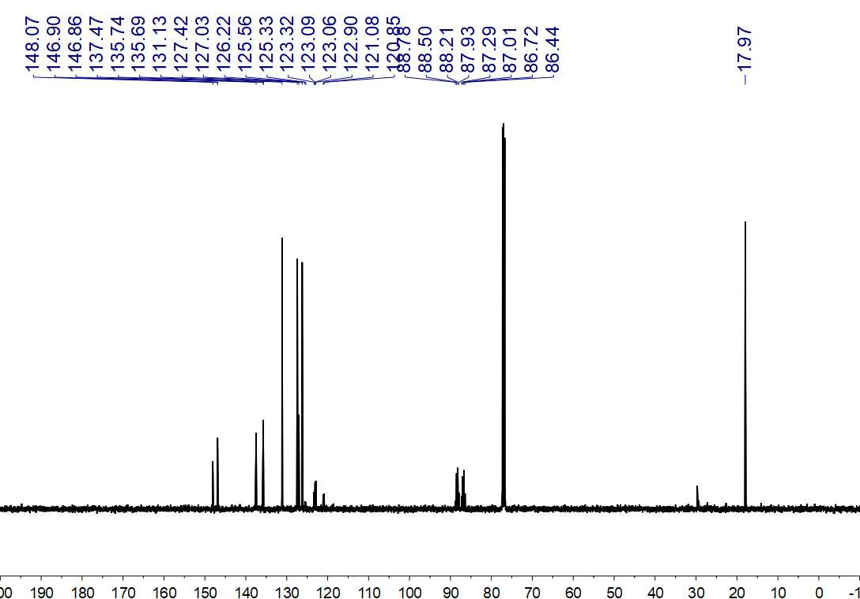
Fig. S142. ¹³C NMR (125 MHz, CDCl₃) spectrum of 44

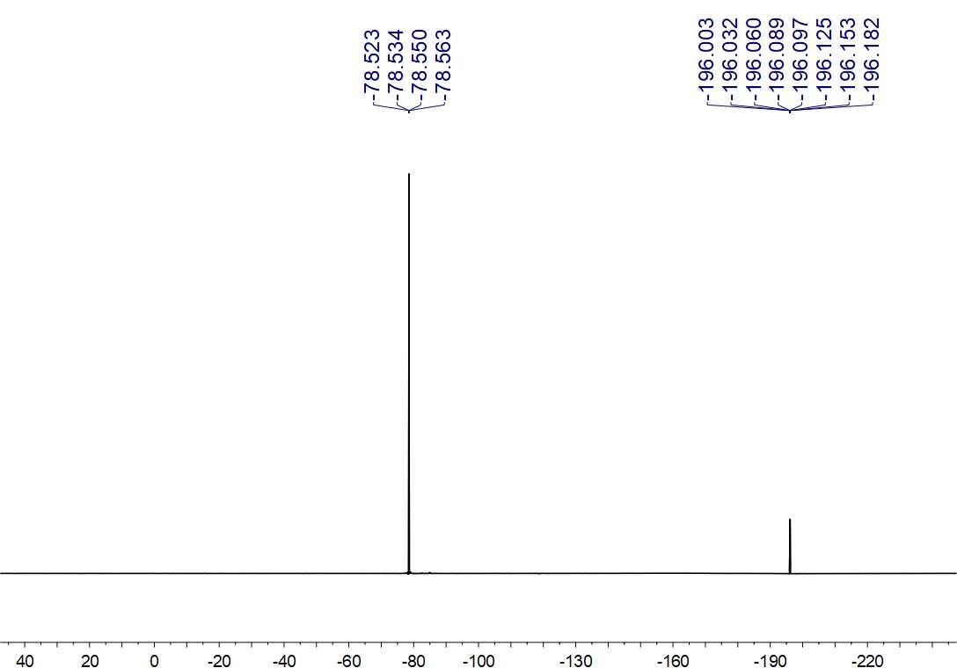
Fig. S143. ¹⁹F NMR (470 MHz, CDCl₃) spectrum of 44

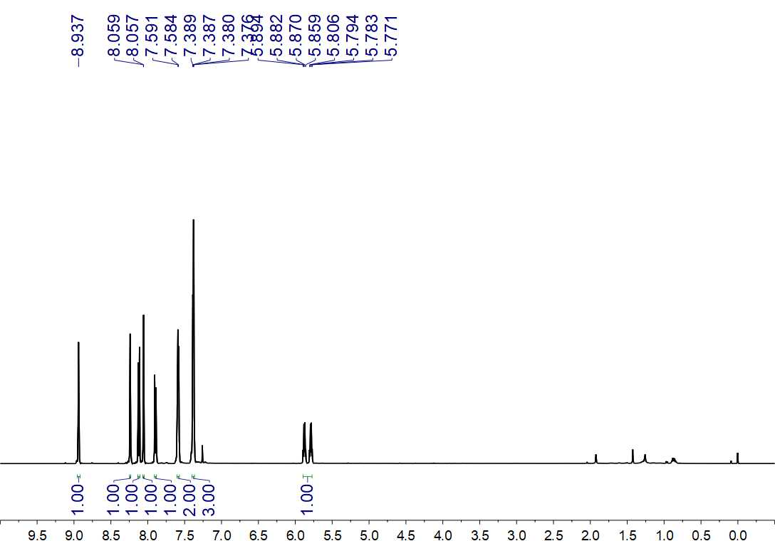Fig. S144. ¹H NMR (500 MHz, CDCl₃) spectrum of 45

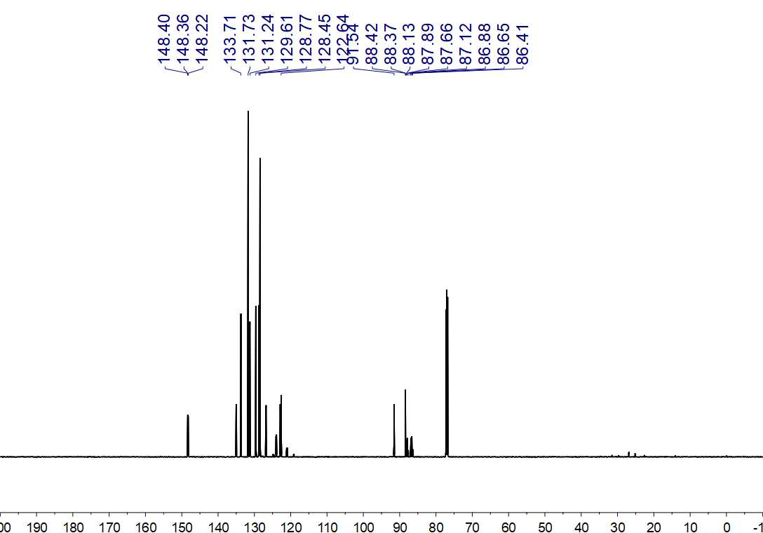
Fig. S145. ¹³C NMR (150 MHz, CDCl₃) spectrum of 45

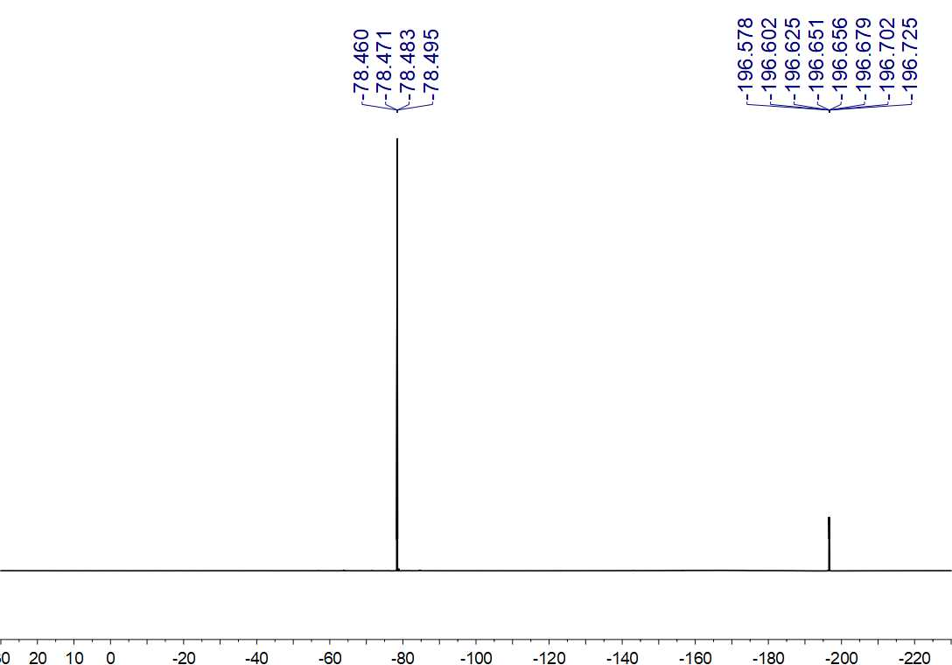
Fig. S146. ¹⁹F NMR (564 MHz, CDCl₃) spectrum of 45

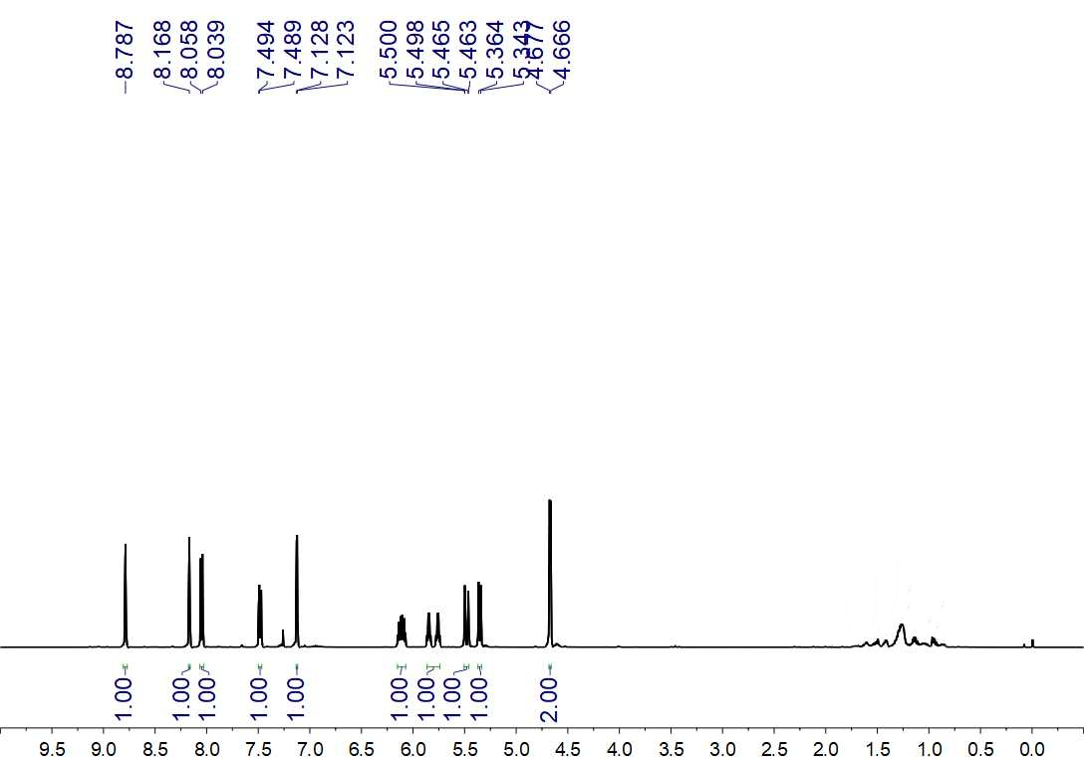
Fig. S147. ¹H NMR (500 MHz, CDCl₃) spectrum of 46

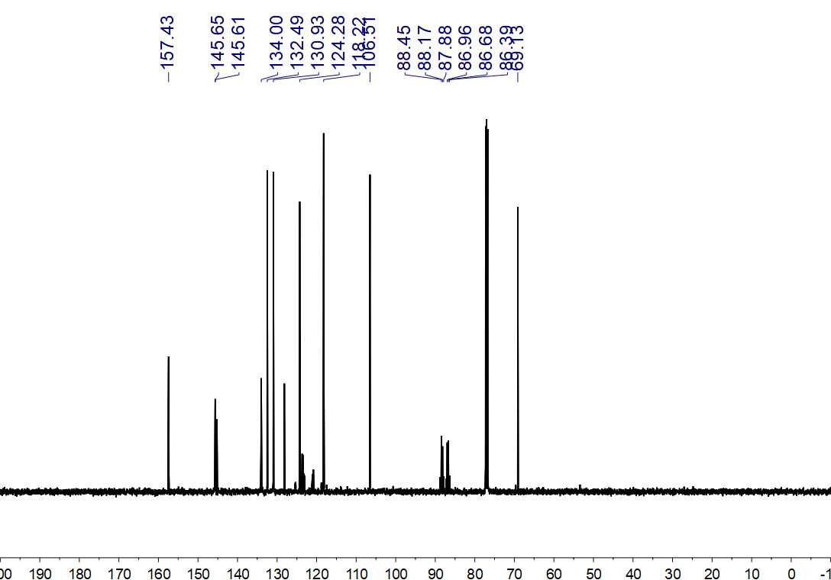
Fig. S148. ¹³C NMR (125 MHz, CDCl₃) spectrum of 46

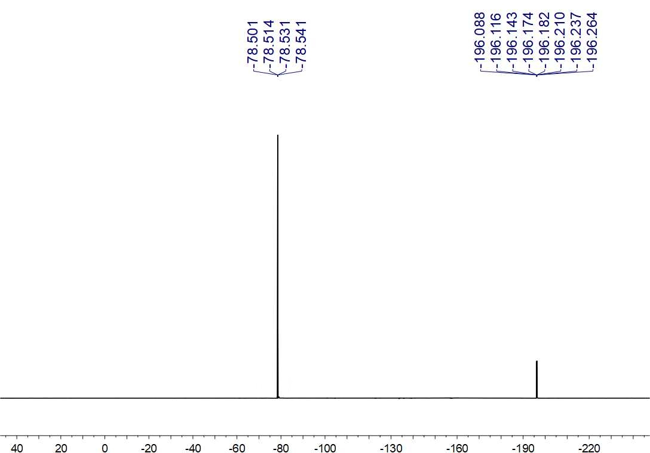
Fig. S149. ¹⁹F NMR (470 MHz, CDCl₃) spectrum of 46

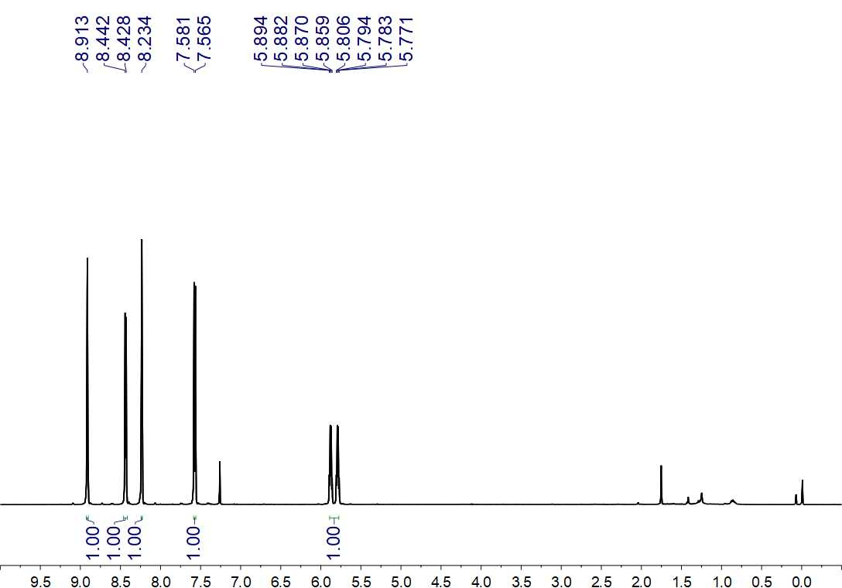
Fig. S150. ¹H NMR (500 MHz, CDCl₃) spectrum of 47

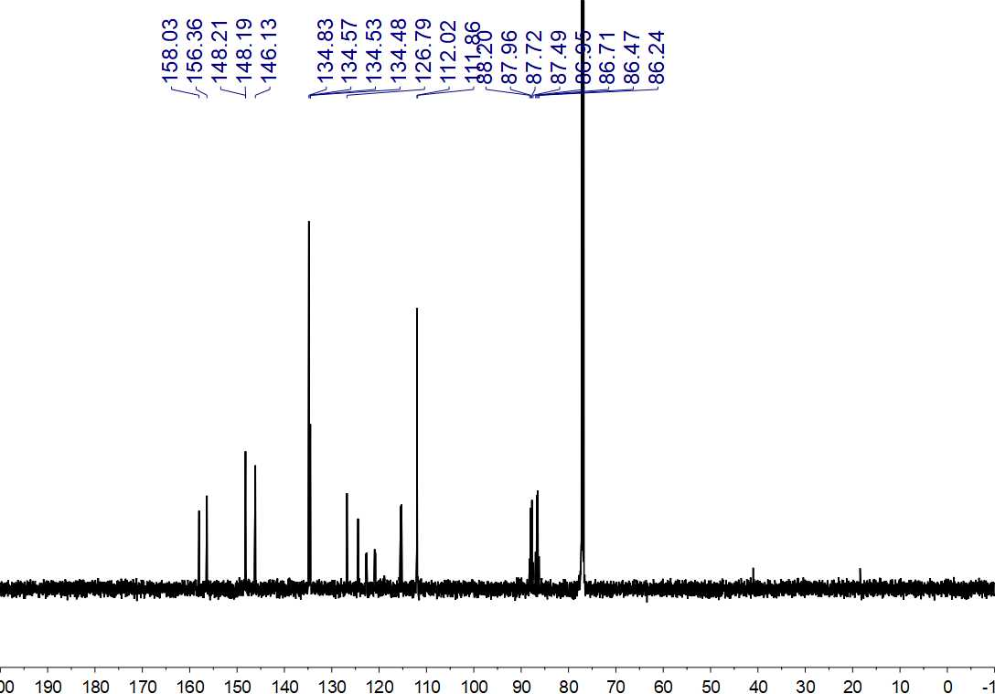
Fig. S151. ¹³C NMR (150 MHz, CDCl₃) spectrum of 47

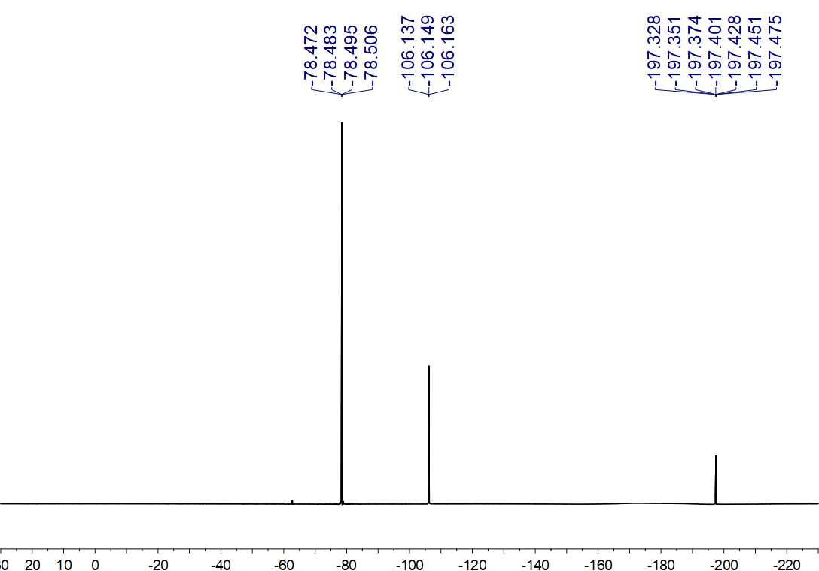
Fig. S152. ¹⁹F NMR (564 MHz, CDCl₃) spectrum of 47

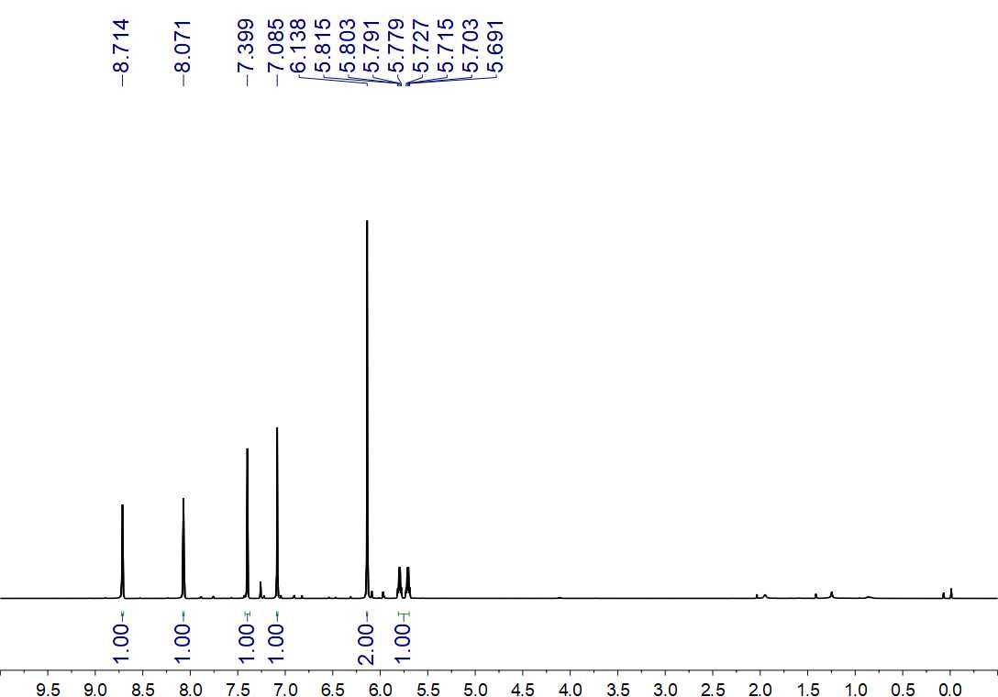
Fig. S153. ¹H NMR (500 MHz, CDCl₃) spectrum of 48

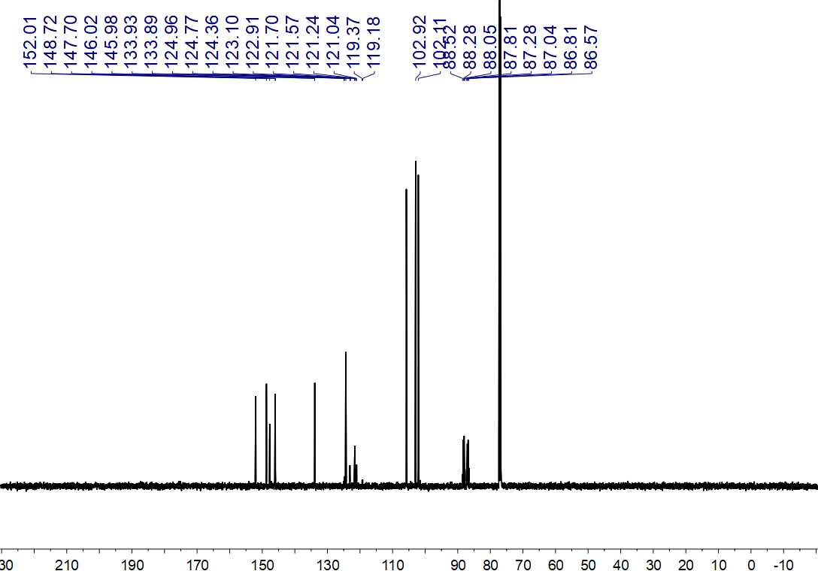
Fig. S154. ¹³C NMR (150 MHz, CDCl₃) spectrum of 48

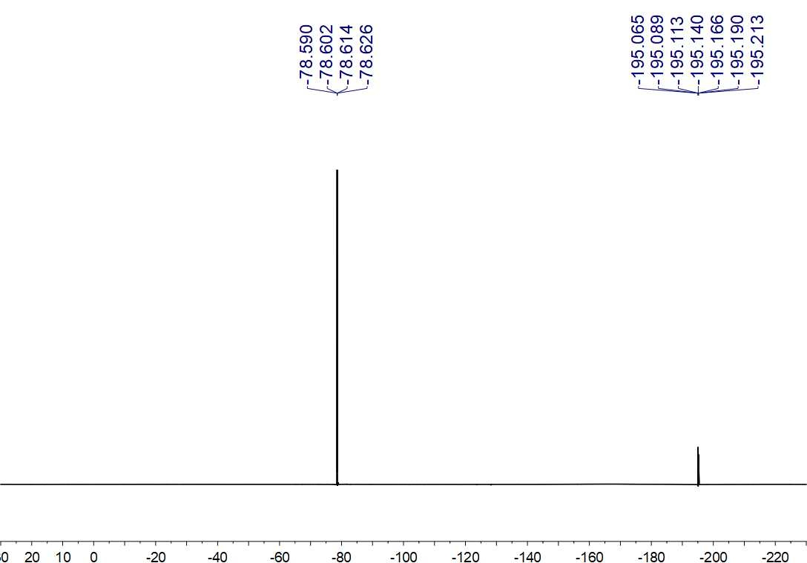
Fig. S155. ¹⁹F NMR (564 MHz, CDCl₃) spectrum of 48

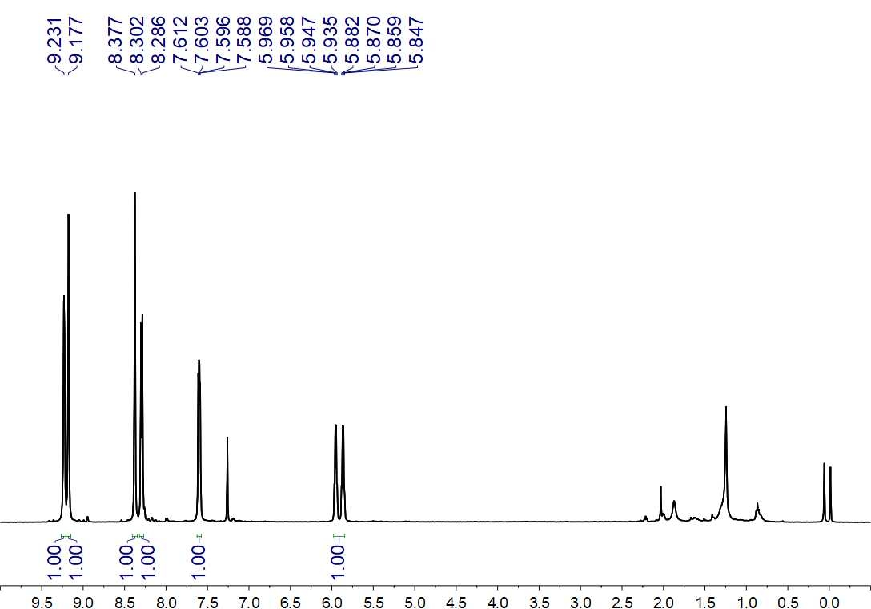
Fig. S156. ¹H NMR (500 MHz, CDCl₃) spectrum of 49

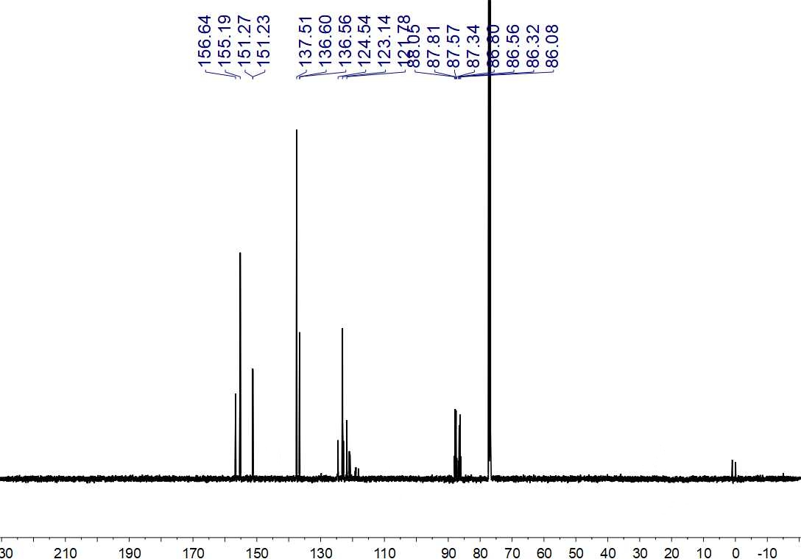
Fig. S157. ¹³C NMR (150 MHz, CDCl₃) spectrum of 49

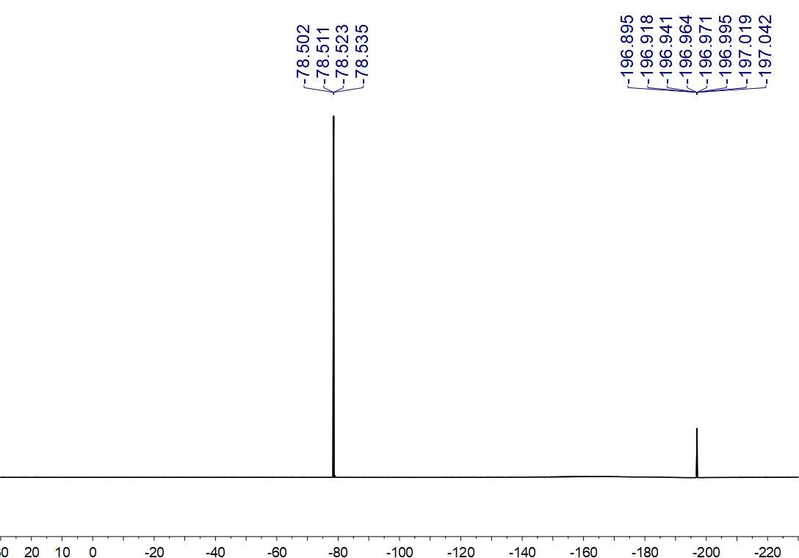
Fig. S158. ¹⁹F NMR (564 MHz, CDCl₃) spectrum of 49

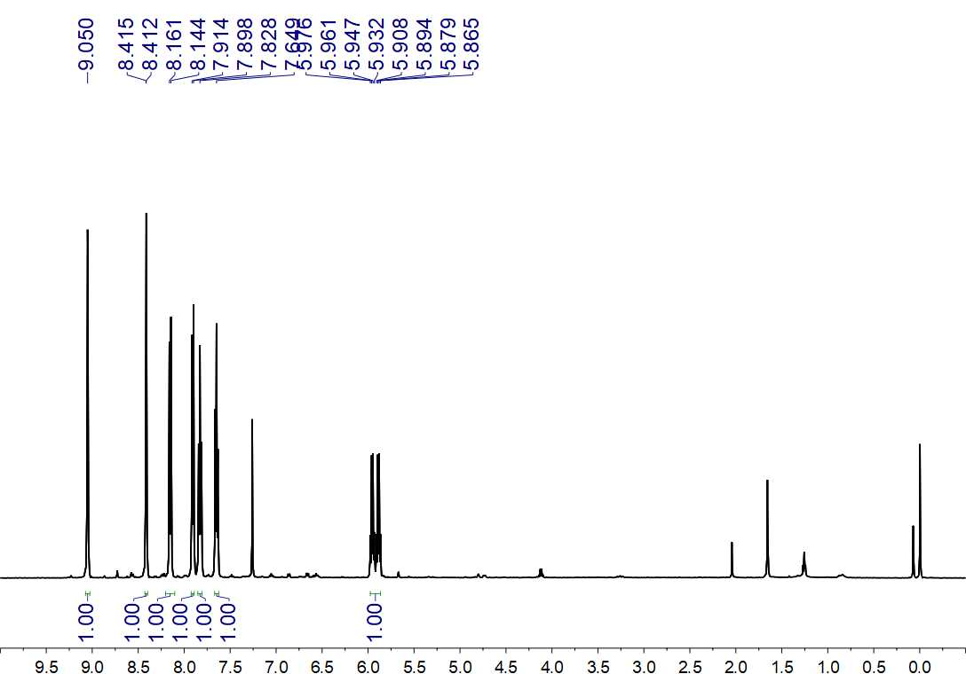
Fig. S159. ¹H NMR (500 MHz, CDCl₃) spectrum of 50

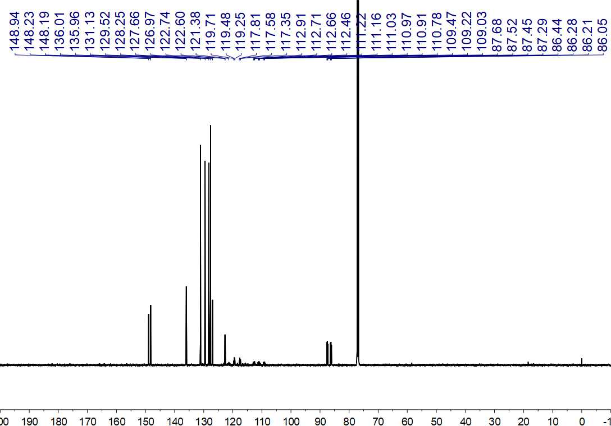
Fig. S160. ¹³C NMR (150 MHz, CDCl₃) spectrum of 50

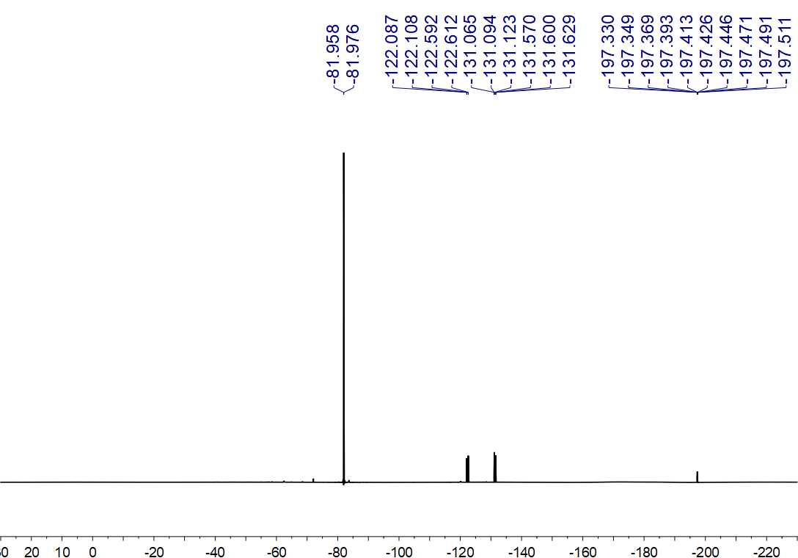
Fig. S161. ¹⁹F NMR (564 MHz, CDCl₃) spectrum of 50

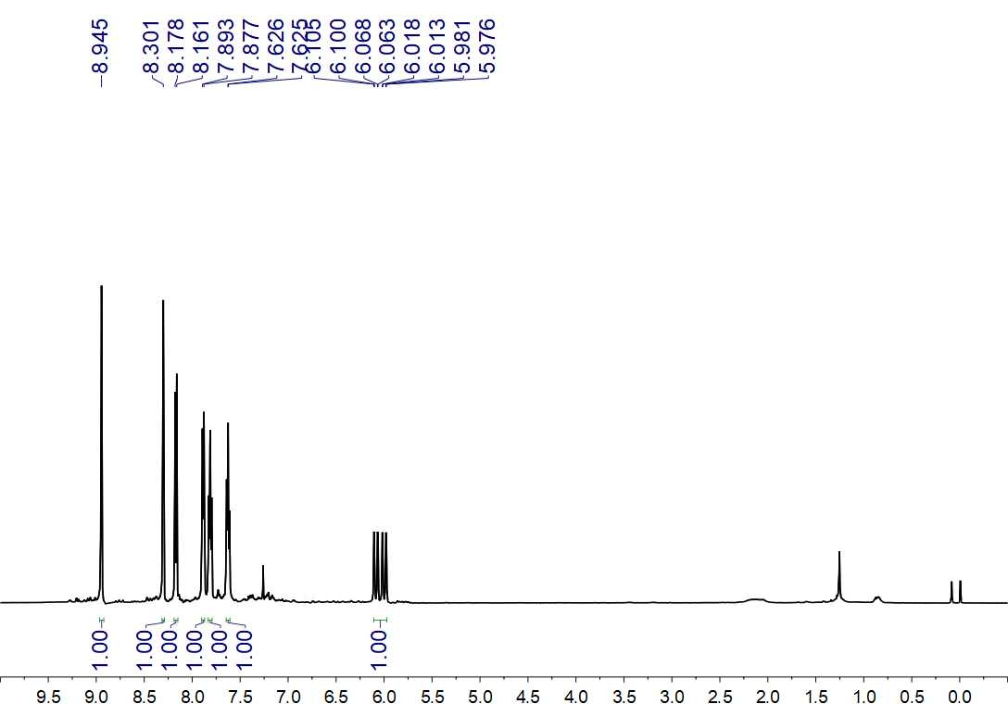
Fig. S162. ¹H NMR (500 MHz, CDCl₃) spectrum of 51

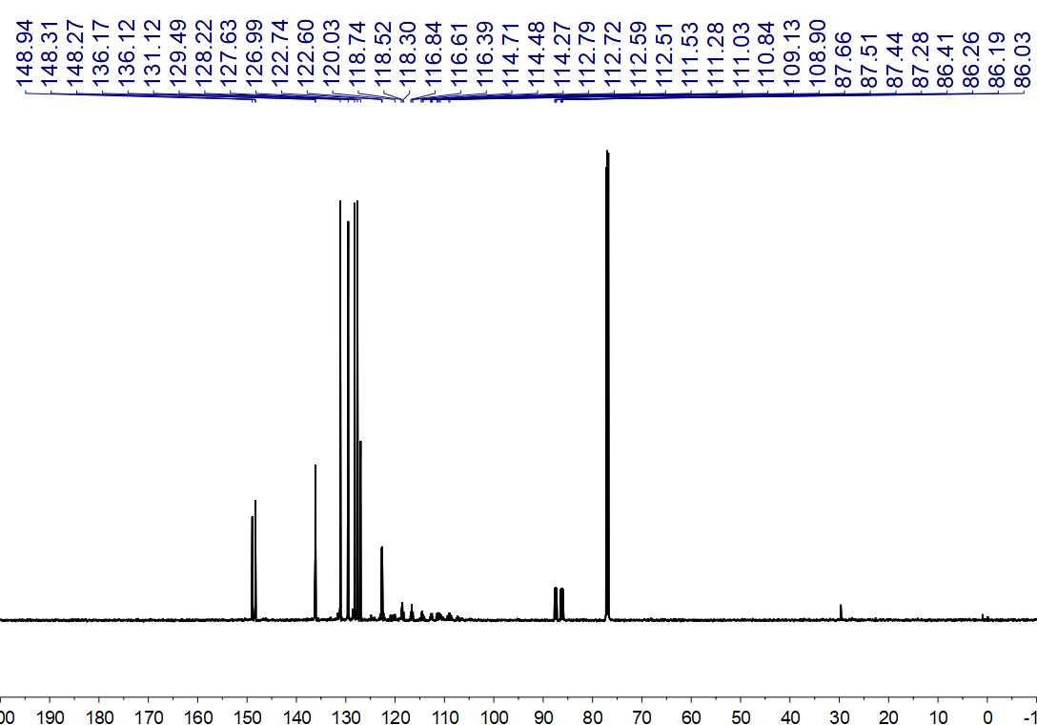
Fig. S163. ¹³C NMR (150 MHz, CDCl₃) spectrum of 51

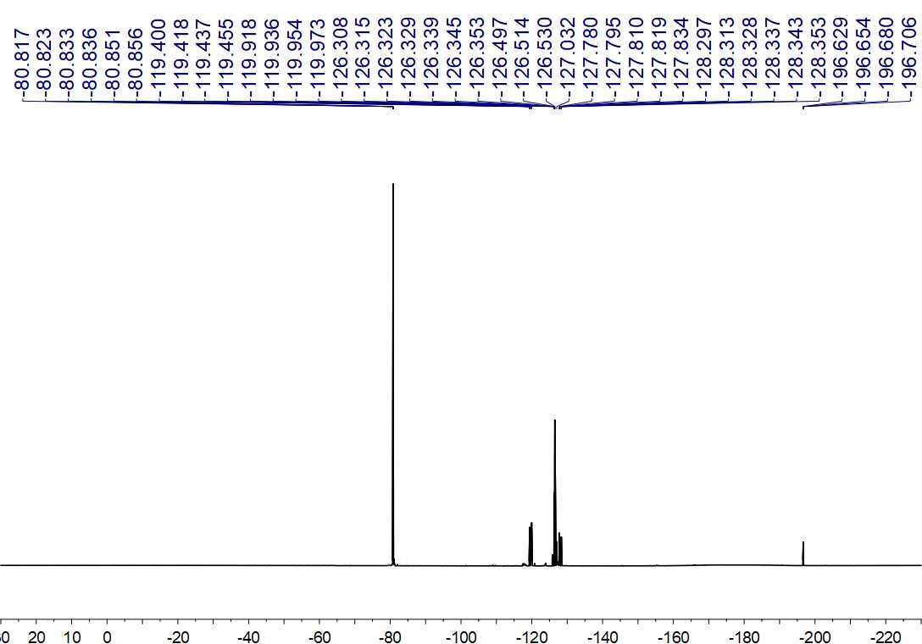
Fig. S164. ¹⁹F NMR (564 MHz, CDCl₃) spectrum of 51

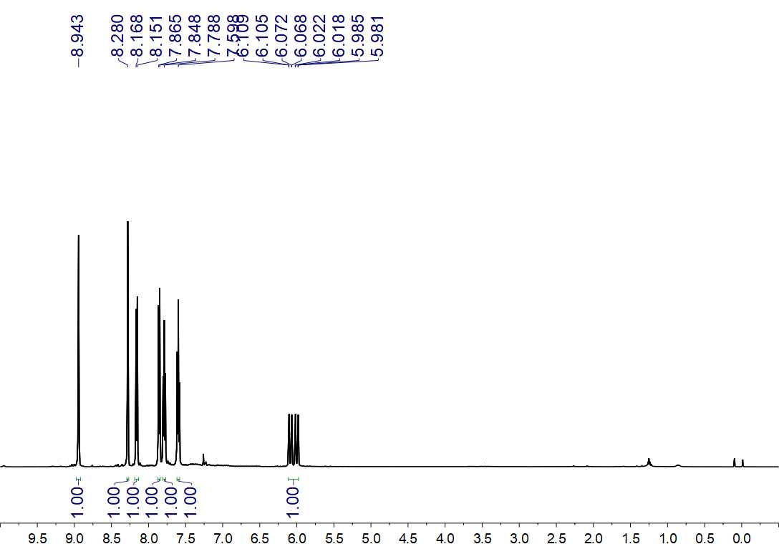
Fig. S165. ¹H NMR (500 MHz, CDCl₃) spectrum of 52

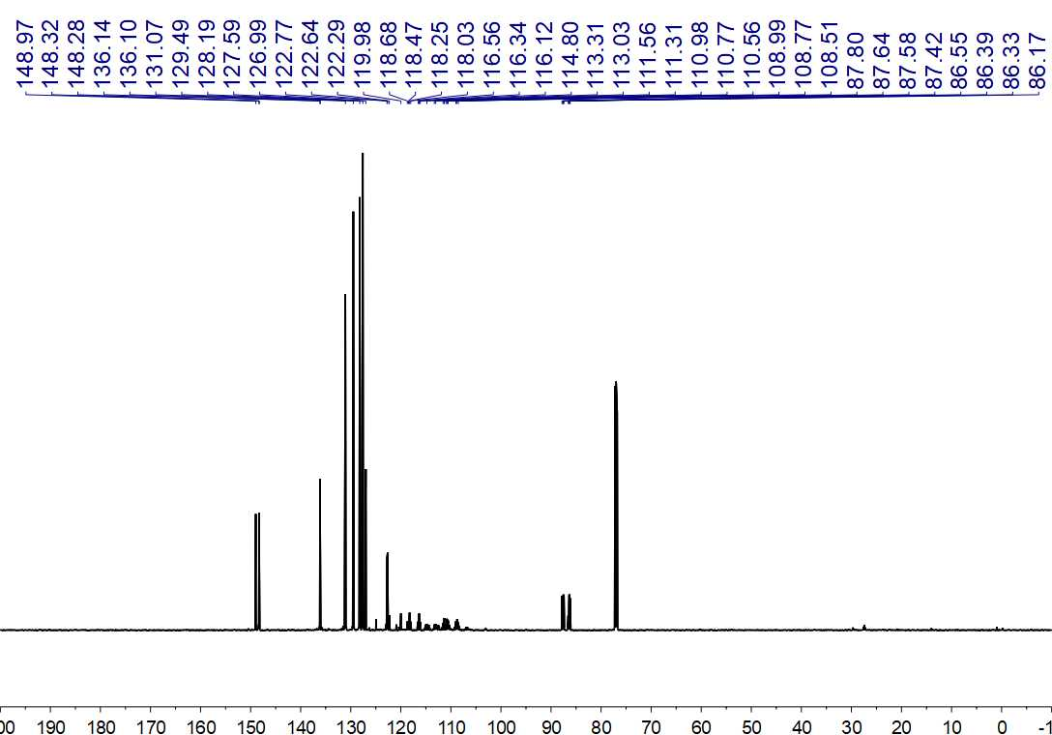
Fig. S166. ¹³C NMR (150 MHz, CDCl₃) spectrum of 52

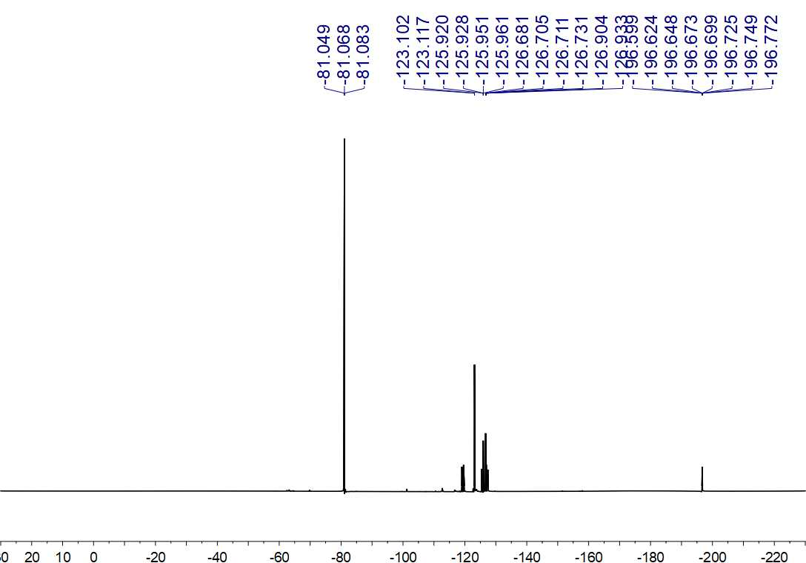
Fig. S167. ¹⁹F NMR (564 MHz, CDCl₃) spectrum of 52

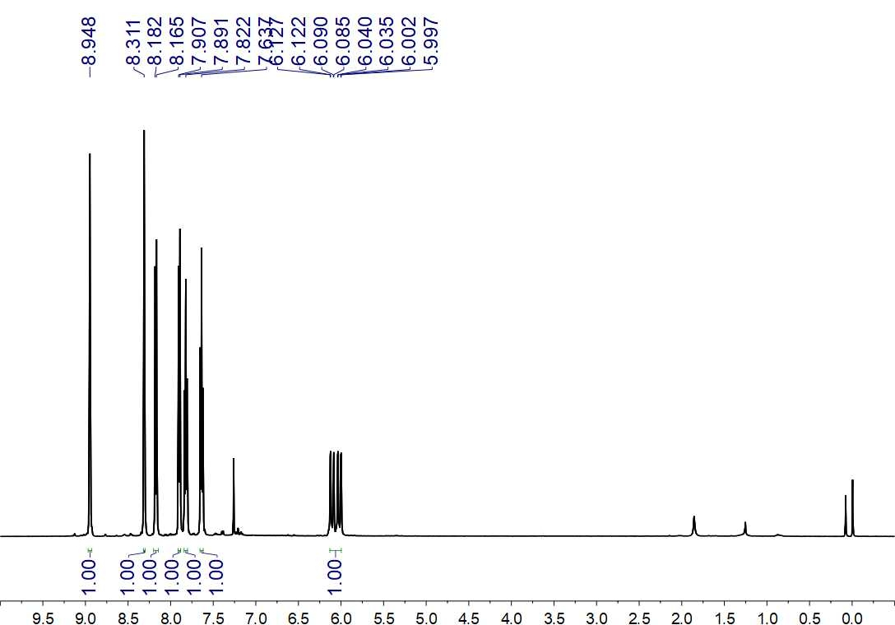
Fig. S168. ¹H NMR (500 MHz, CDCl₃) spectrum of 53

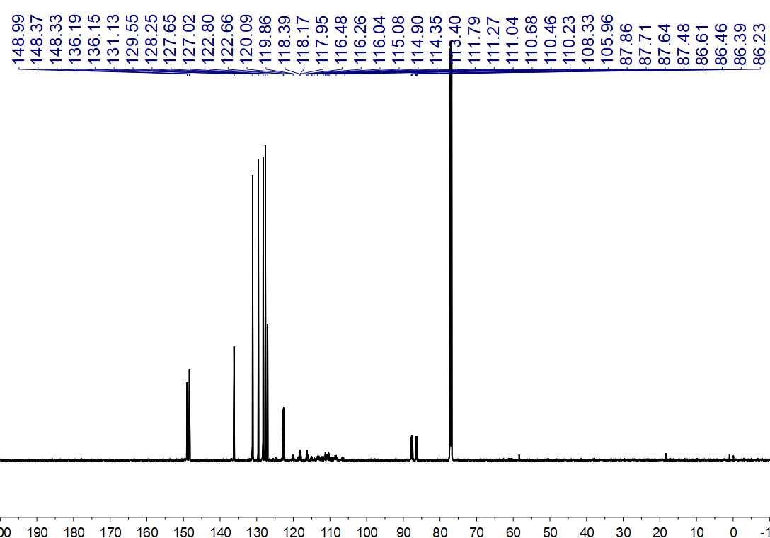
Fig. S169. ¹³C NMR (150 MHz, CDCl₃) spectrum of 53

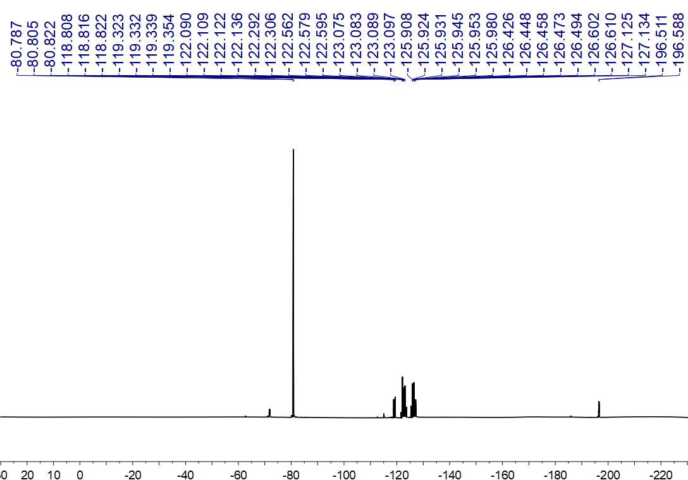
Fig. S170. ¹⁹F NMR (564 MHz, CDCl₃) spectrum of 53

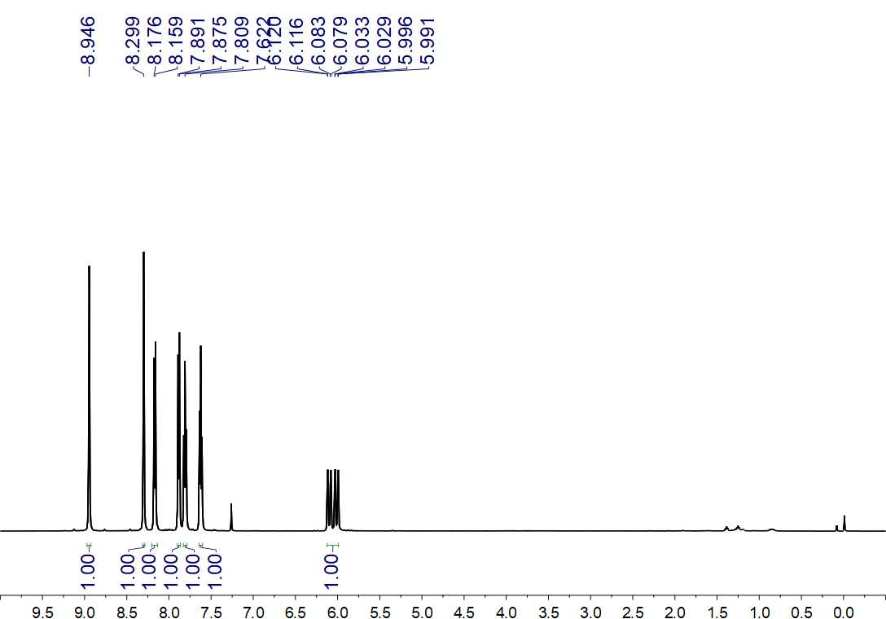
Fig. S171. ¹H NMR (500 MHz, CDCl₃) spectrum of 54

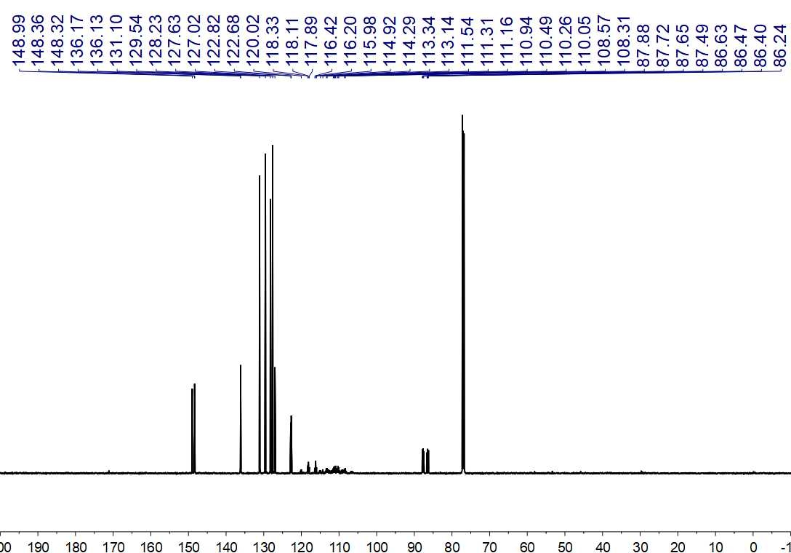
Fig. S172. ¹³C NMR (150 MHz, CDCl₃) spectrum of 54

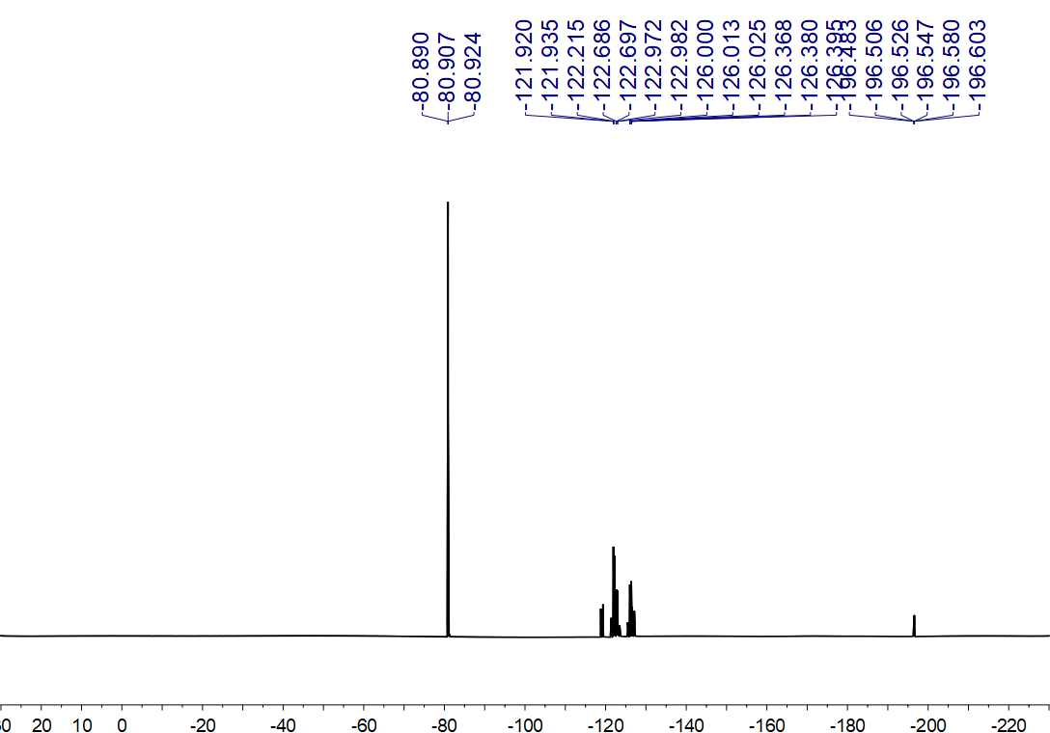
Fig. S173. ¹⁹F NMR (564 MHz, CDCl₃) spectrum of 54

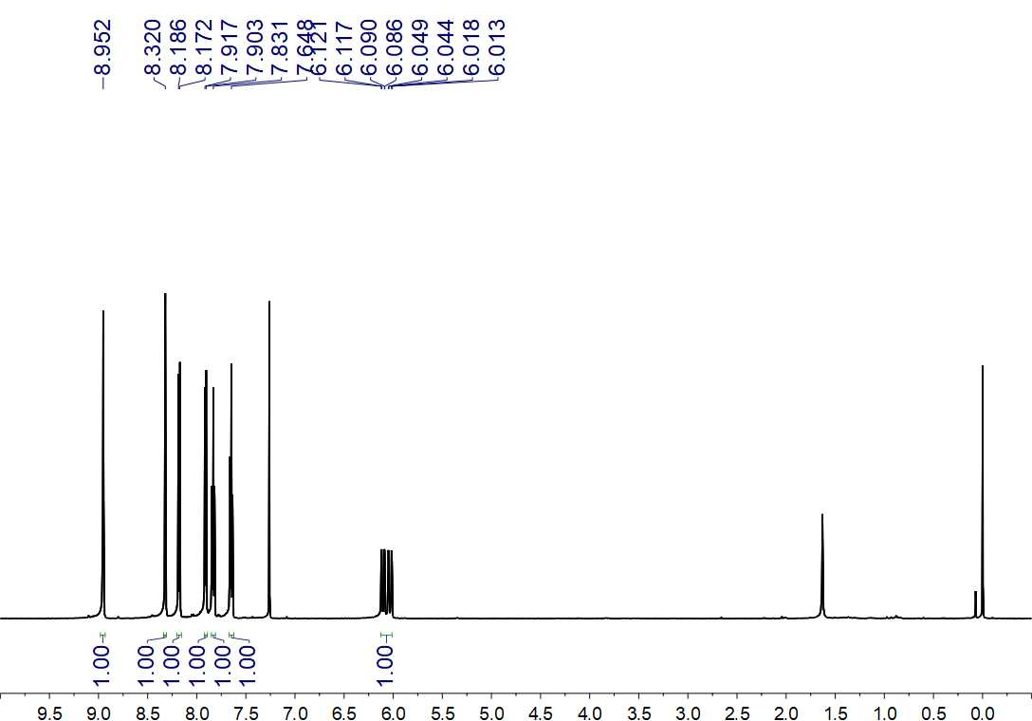
Fig. S174. ¹H NMR (600 MHz, CDCl₃) spectrum of 55

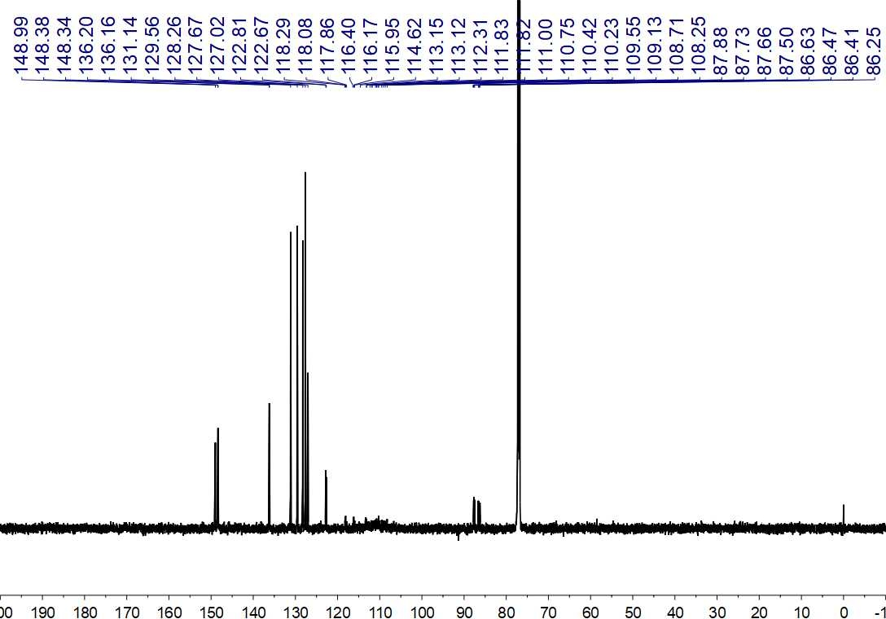
Fig. S175. ¹³C NMR (150 MHz, CDCl₃) spectrum of 55

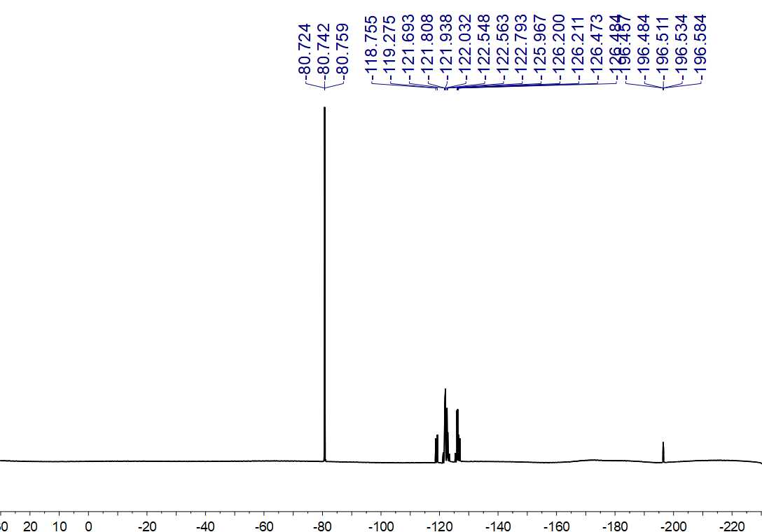
Fig. S176. ¹⁹F NMR (564 MHz, CDCl₃) spectrum of 55

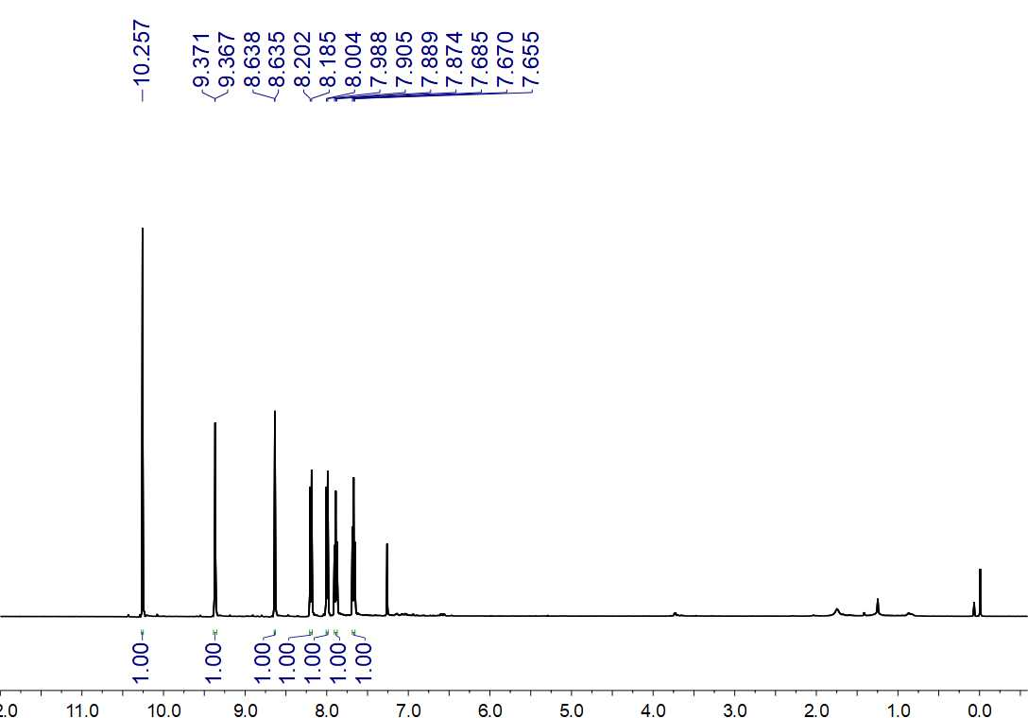
Fig. S177. ¹H NMR (500 MHz, CDCl₃) spectrum of 56

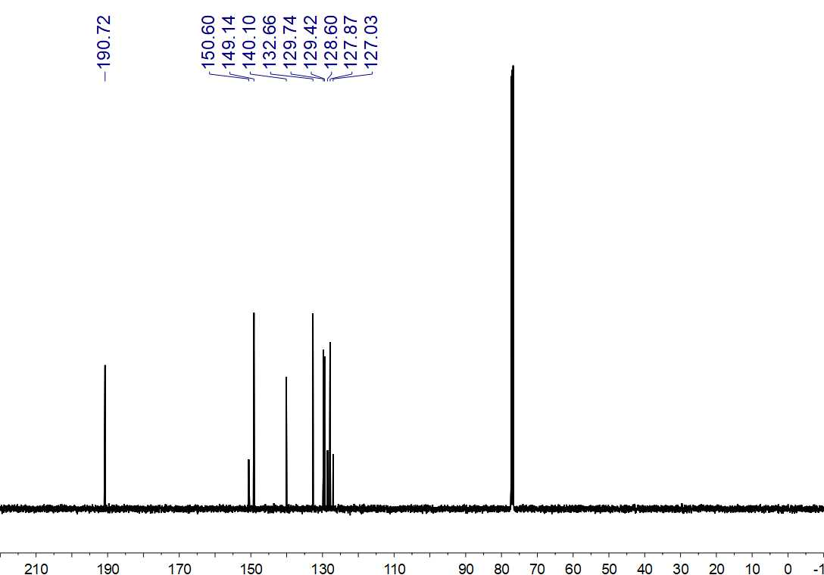
Fig. S178. ¹³C NMR (125 MHz, CDCl₃) spectrum of 56

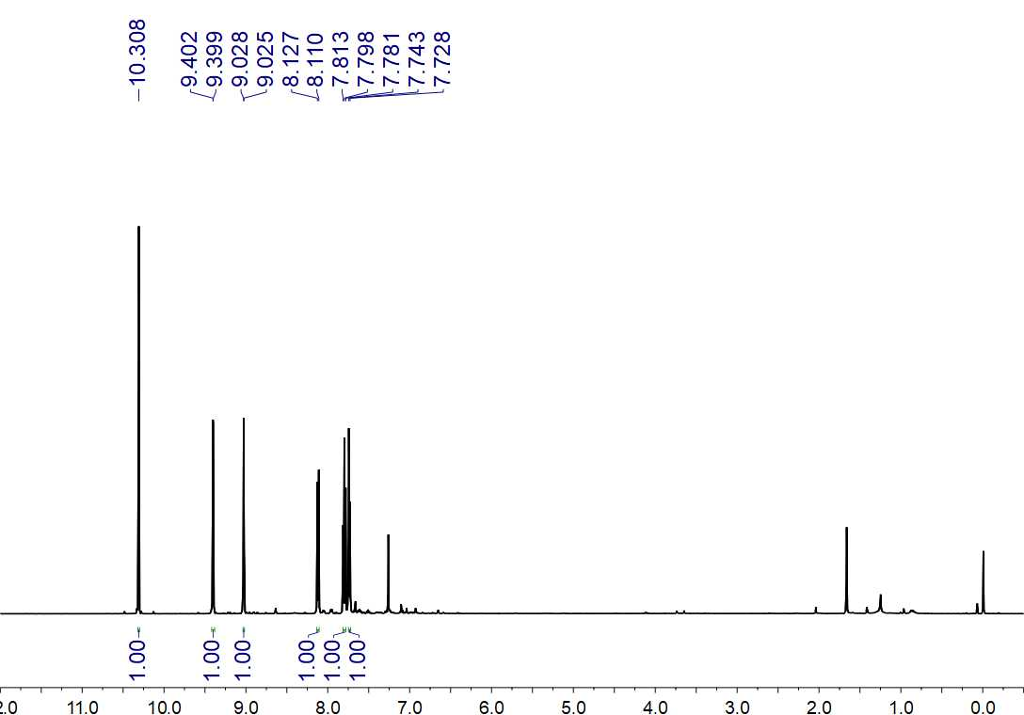
Fig. S179. ¹H NMR (500 MHz, CDCl₃) spectrum of 57

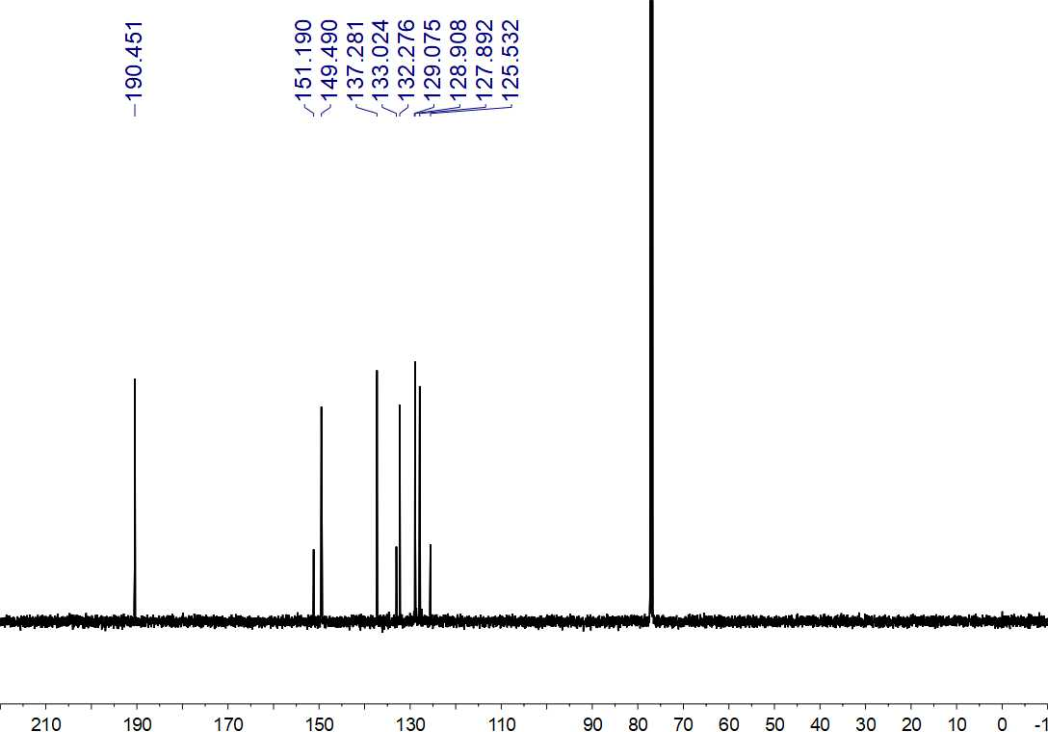
Fig. S180. ¹³C NMR (125 MHz, CDCl₃) spectrum of 57

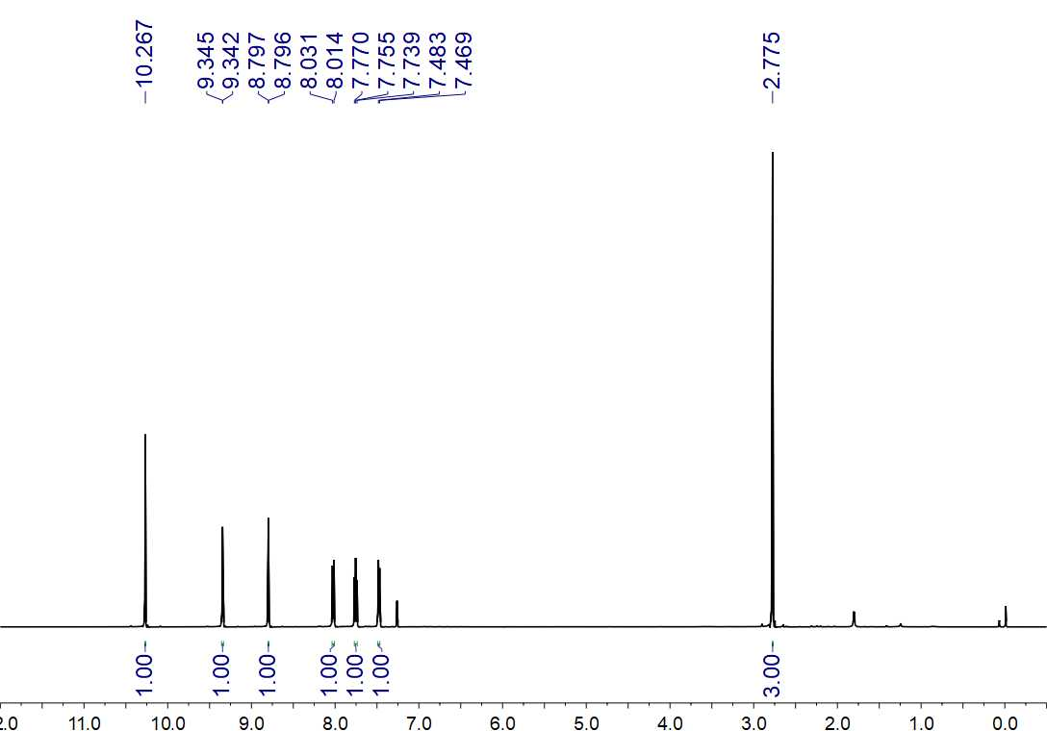
Fig. S181 ¹H NMR (500 MHz, CDCl₃) spectrum of 58

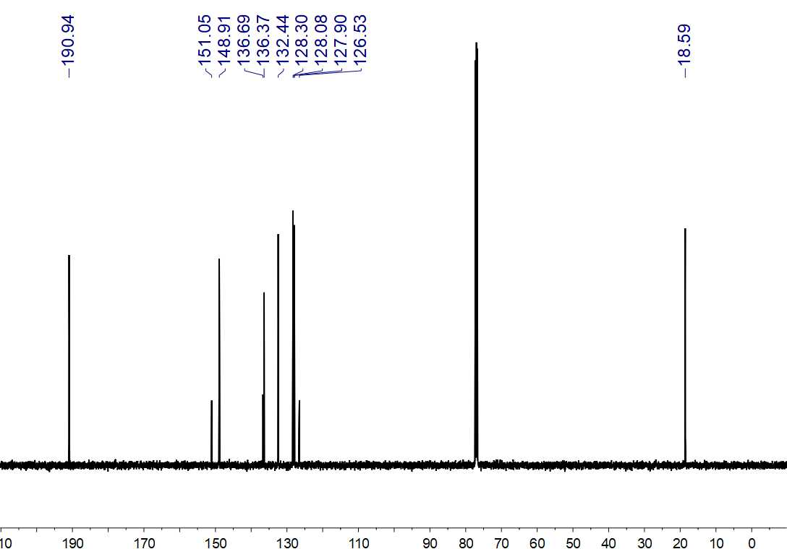
Fig. S182. ¹³C NMR (125 MHz, CDCl₃) spectrum of 58

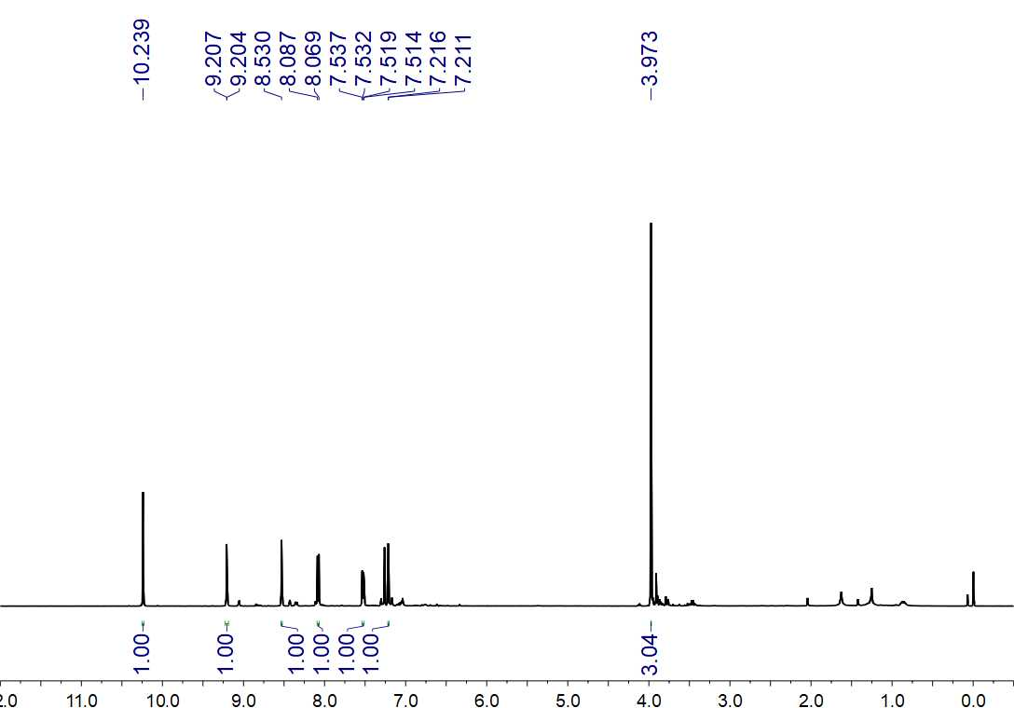
Fig. S183. ¹H NMR (500 MHz, CDCl₃) spectrum of 59

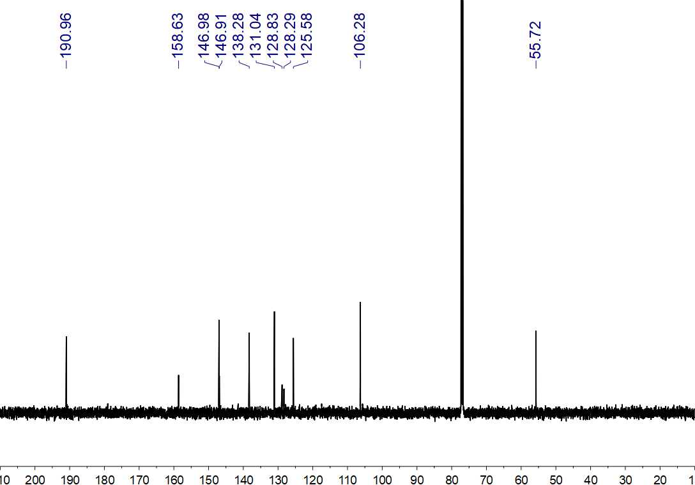
Fig. S184. ¹³C NMR (150 MHz, CDCl₃) spectrum of 59

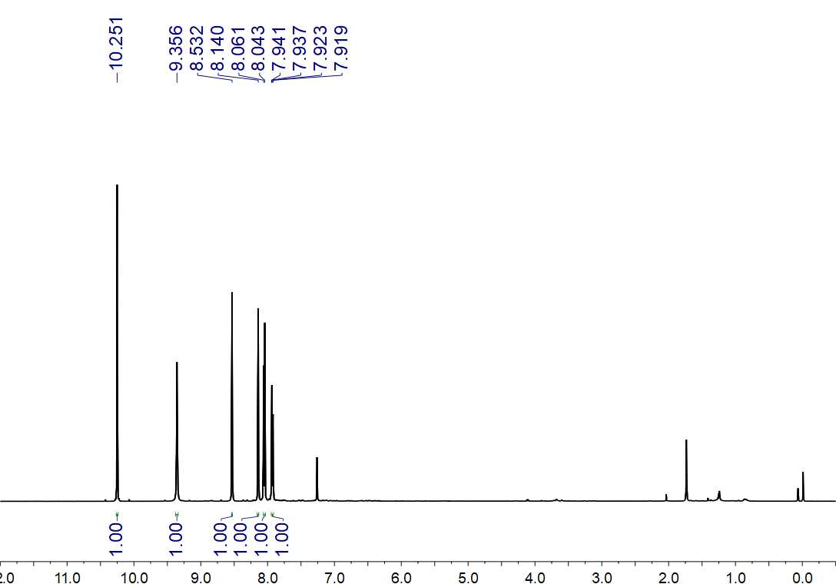
Fig. S185. ¹H NMR (500 MHz, CDCl₃) spectrum of 60

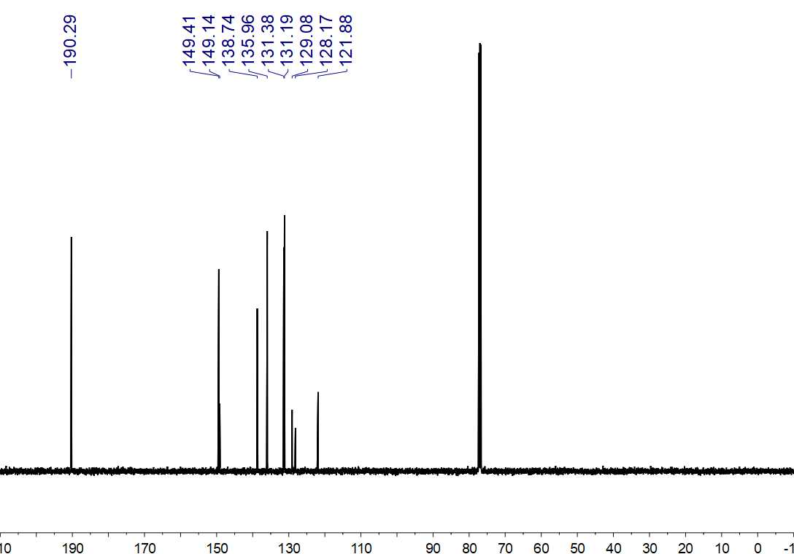
Fig. S186. ¹³C NMR (125 MHz, CDCl₃) spectrum of 60

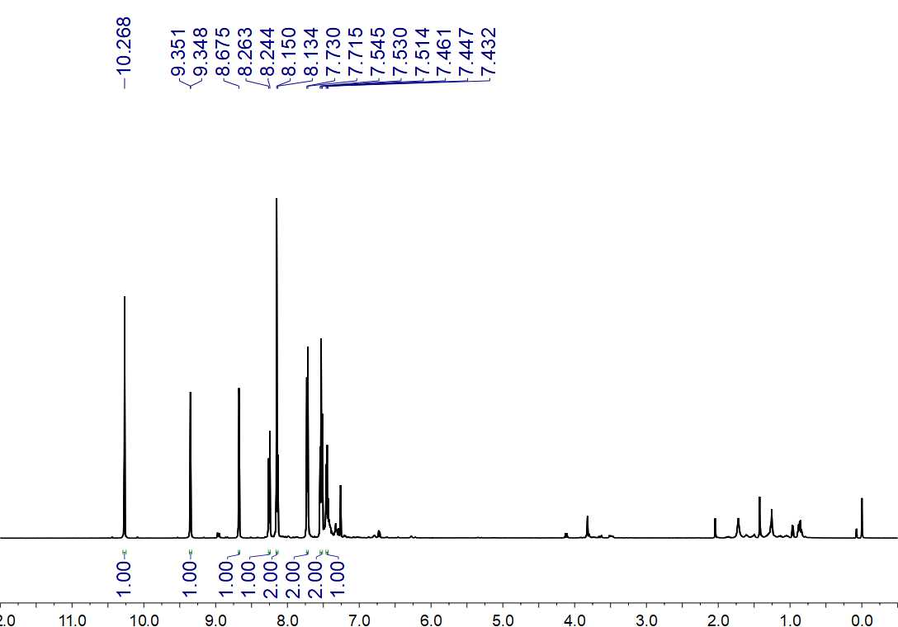
Fig. S187. ¹H NMR (500 MHz, CDCl₃) spectrum of 61

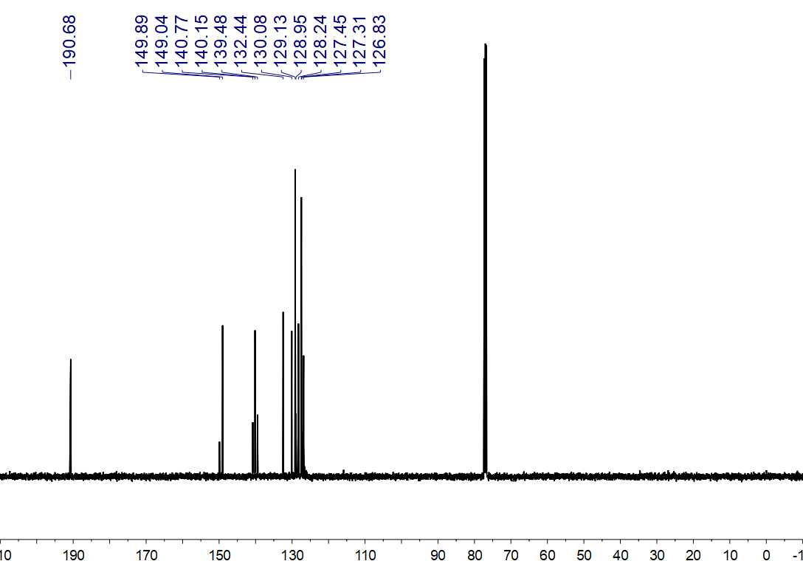
Fig. S188. ¹³C NMR (125 MHz, CDCl₃) spectrum of 61

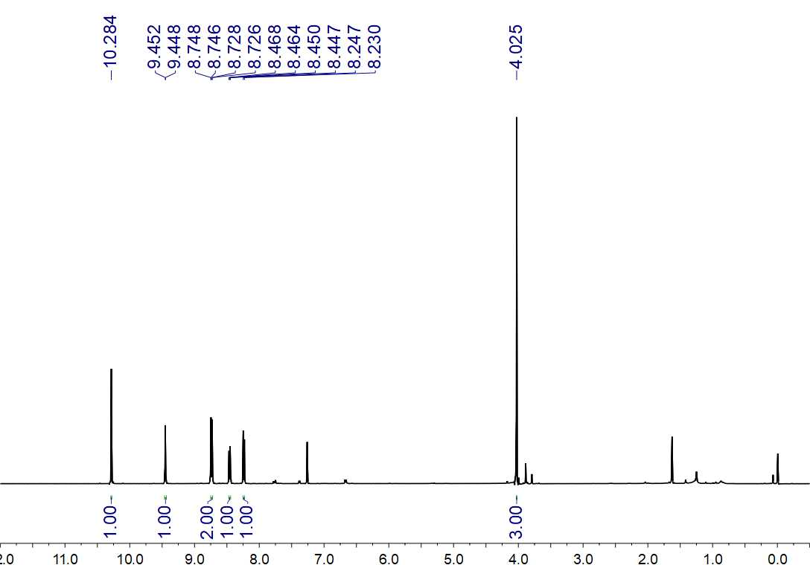
Fig. S189. ¹H NMR (500 MHz, CDCl₃) spectrum of 62

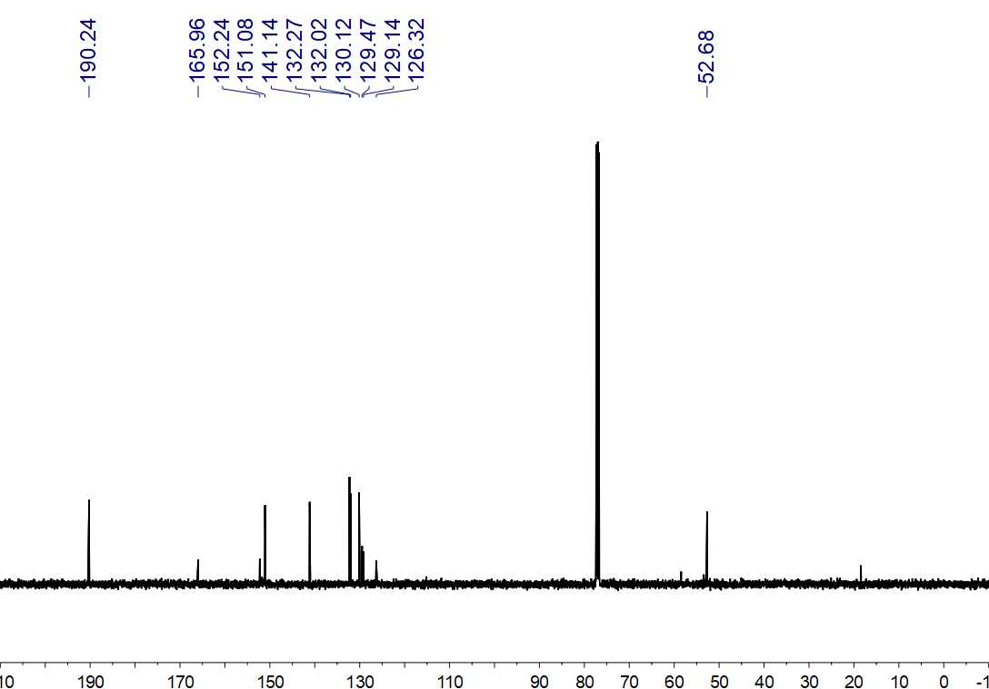
Fig. S190. ¹³C NMR (125 MHz, CDCl₃) spectrum of 62

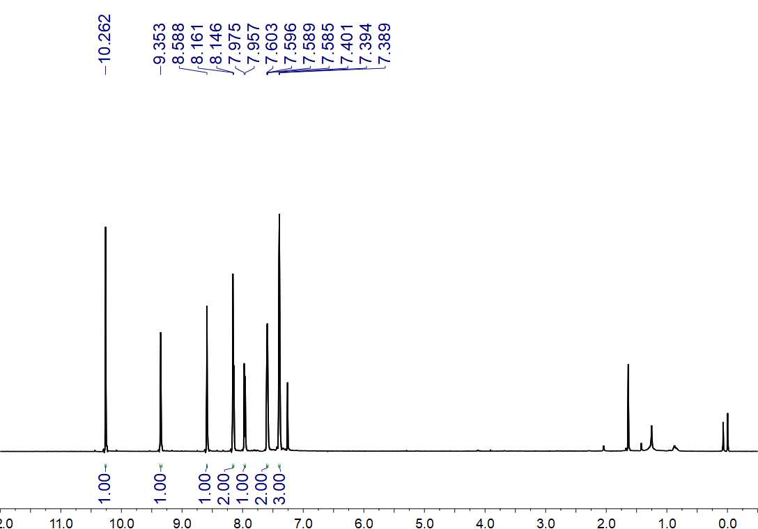
Fig. S191. ¹H NMR (500 MHz, CDCl₃) spectrum of 63

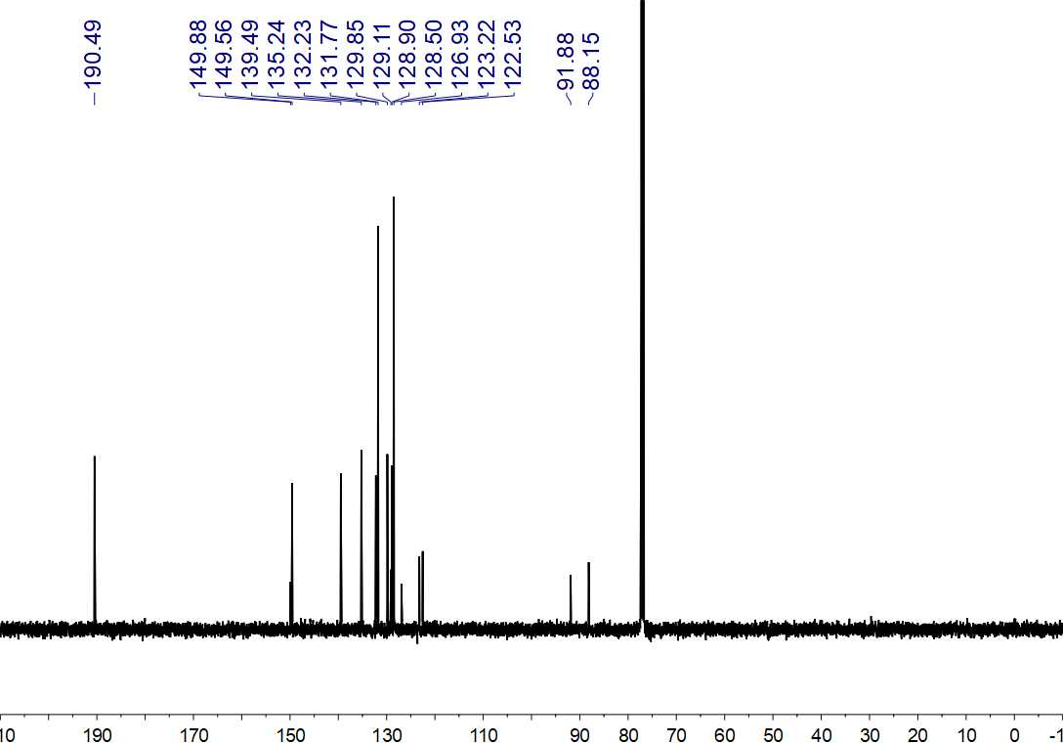
Fig. S192. ¹³C NMR (125 MHz, CDCl₃) spectrum of 63

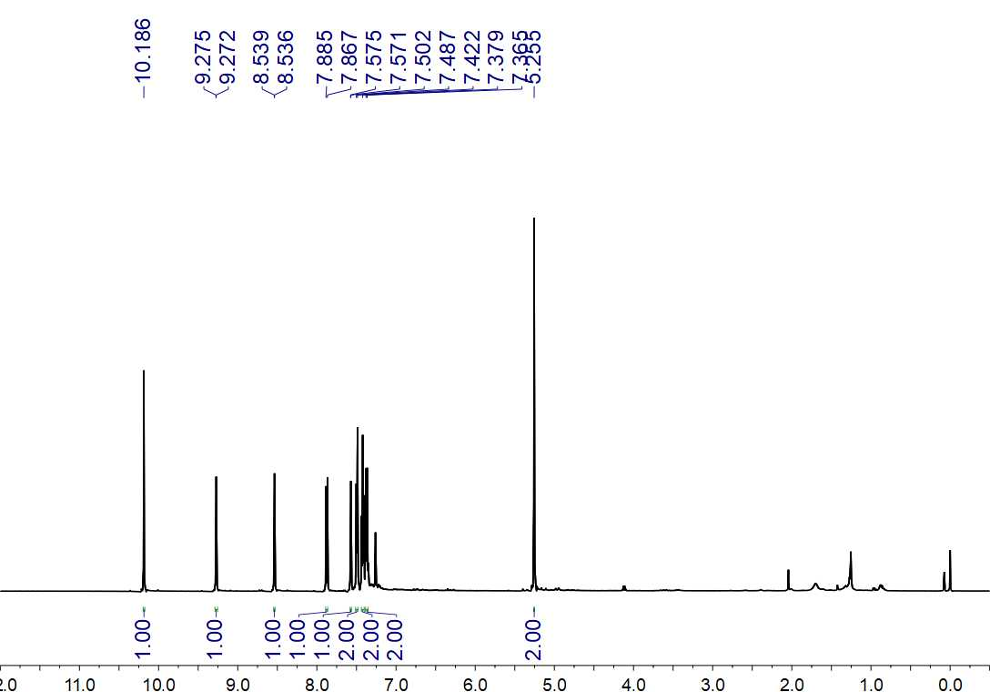
Fig. S193. ¹H NMR (500 MHz, CDCl₃) spectrum of 64

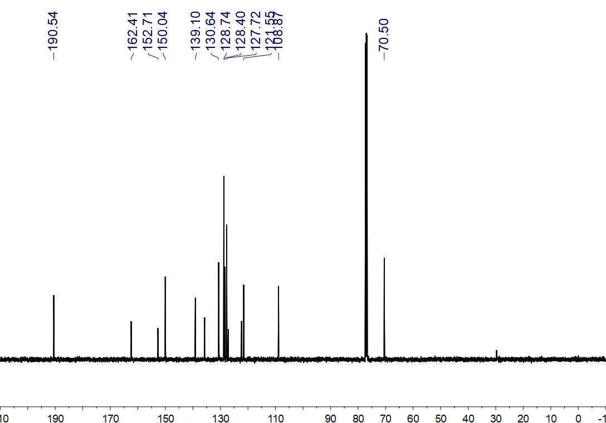
Fig. S194. ¹³C NMR (125 MHz, CDCl₃) spectrum of 64

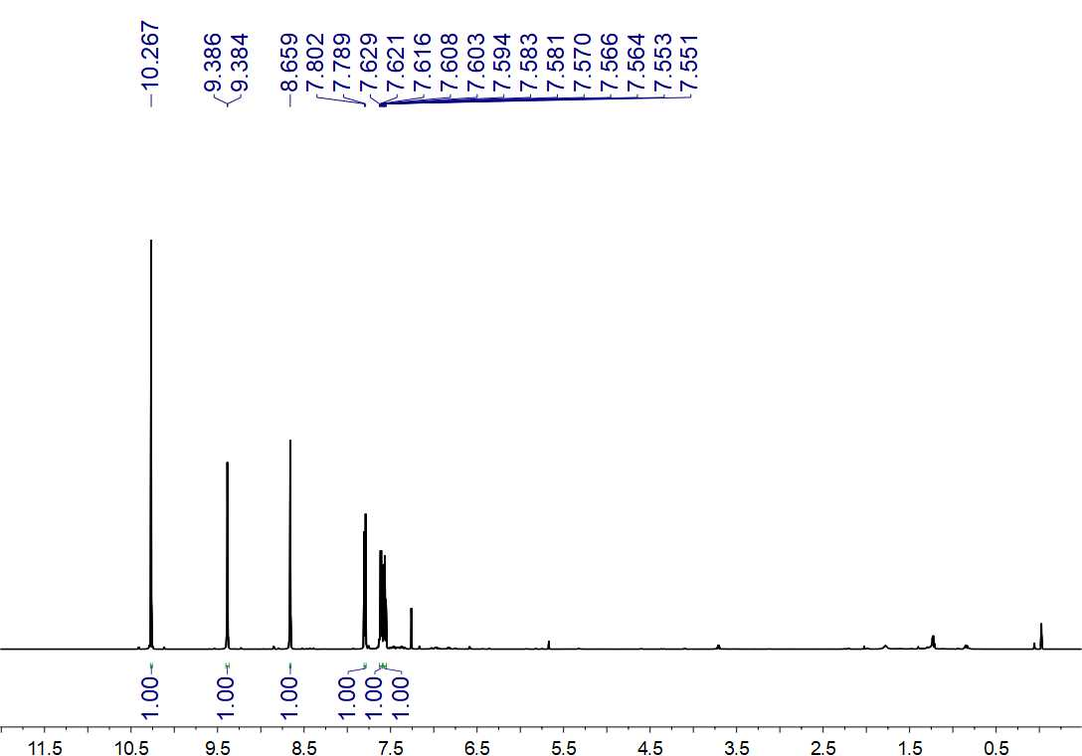Fig. S195. ¹H NMR (600 MHz, CDCl₃) spectrum of 65

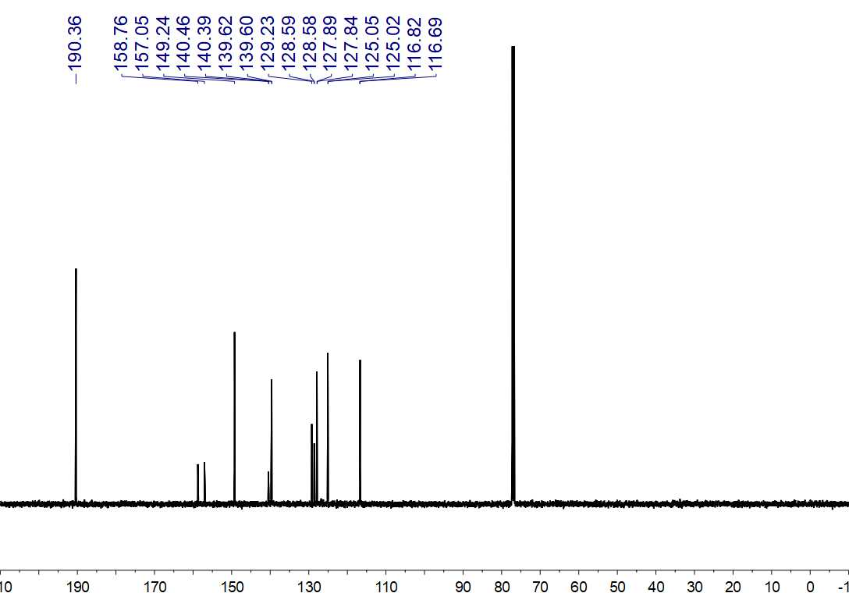
Fig. S196. ¹³C NMR (150 MHz, CDCl₃) spectrum of 65

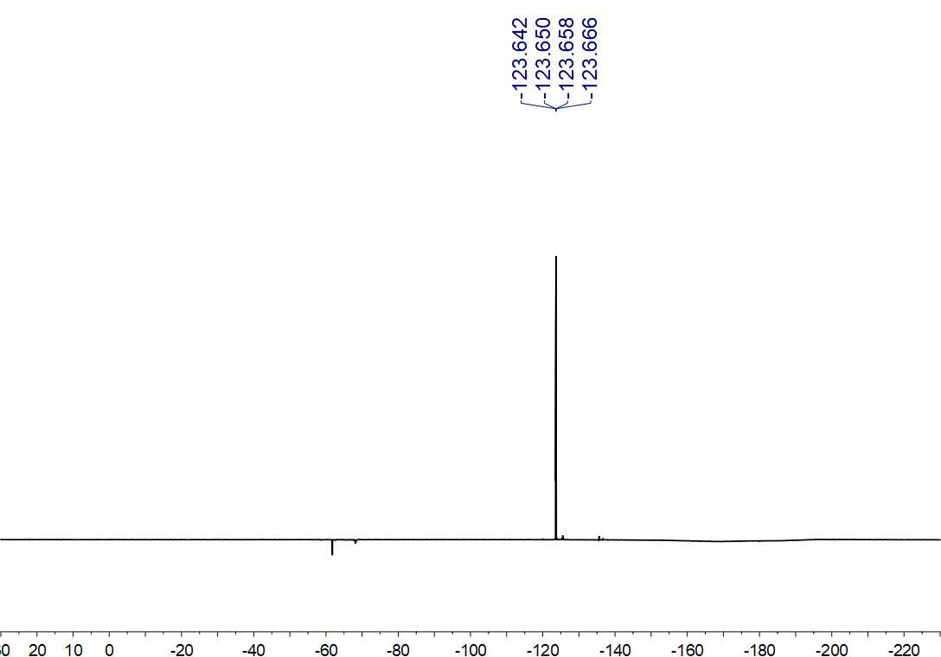
Fig. S197. ¹⁹F NMR (564 MHz, CDCl₃) spectrum of 65

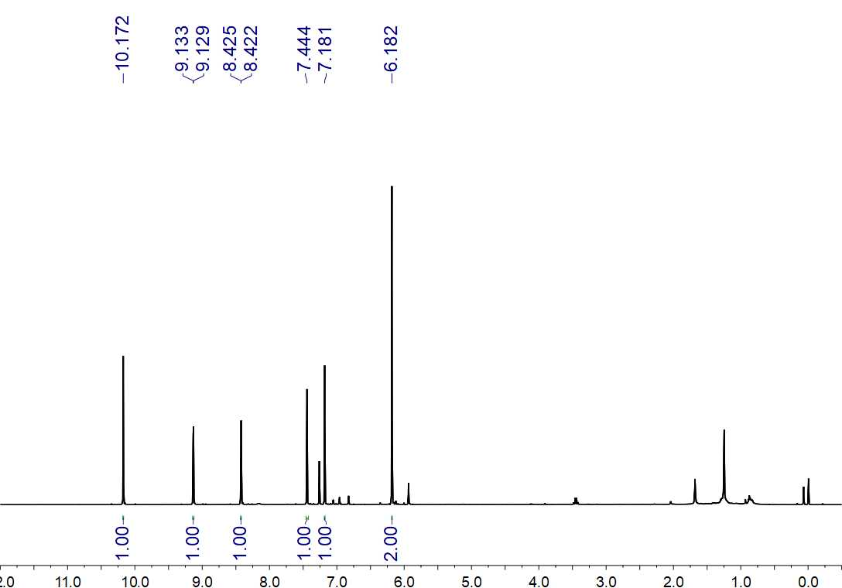
Fig. S198. ¹H NMR (500 MHz, CDCl₃) spectrum of 66

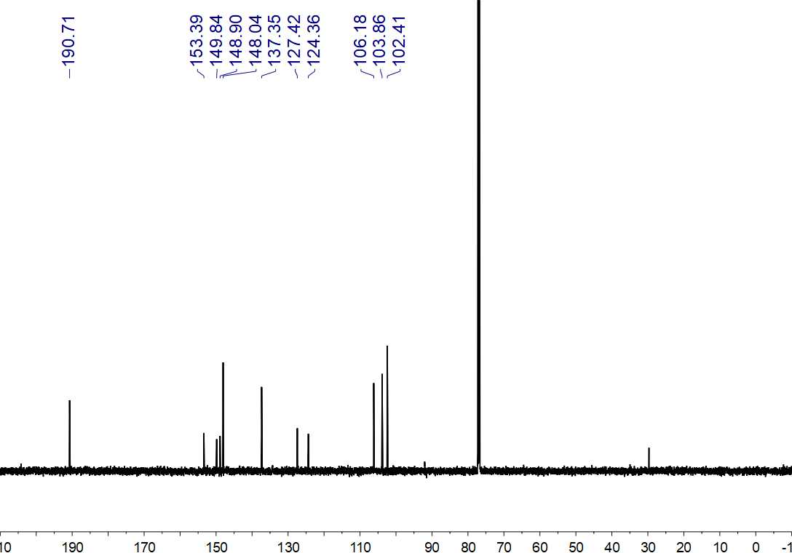
Fig. S199. ¹³C NMR (150 MHz, CDCl₃) spectrum of 66

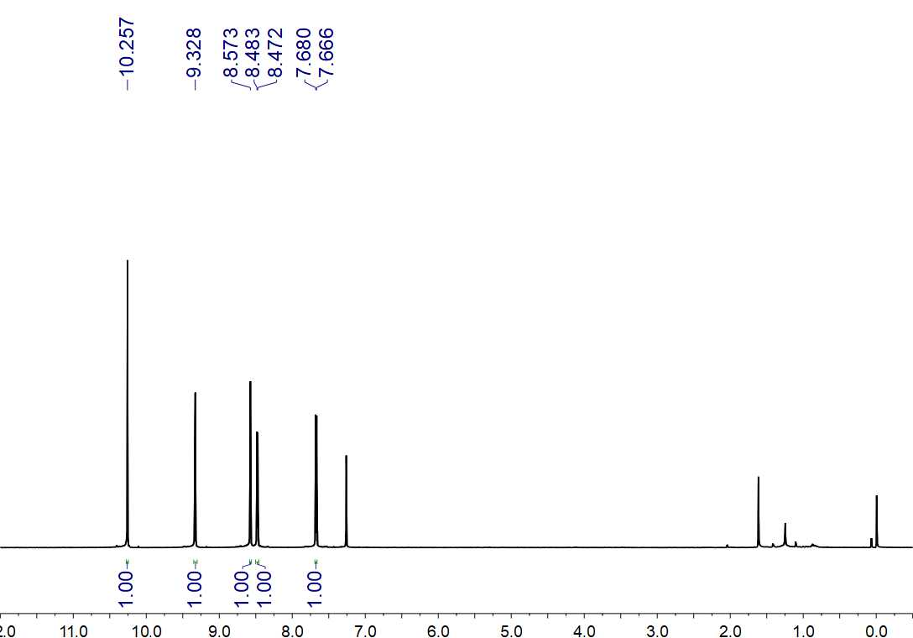
Fig. S200. ¹H NMR (600 MHz, CDCl₃) spectrum of 67

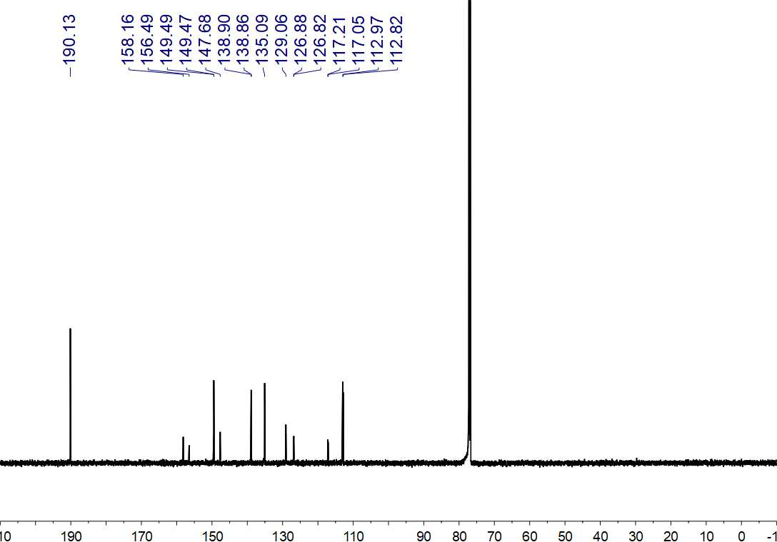
Fig. S201. ¹³C NMR (150 MHz, CDCl₃) spectrum of 67

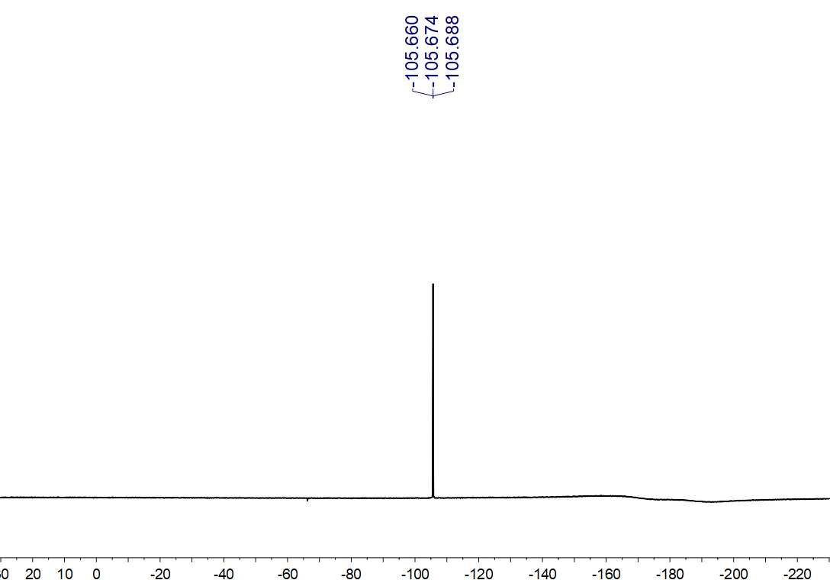
Fig. S202. ¹⁹F NMR (564 MHz, CDCl₃) spectrum of 67

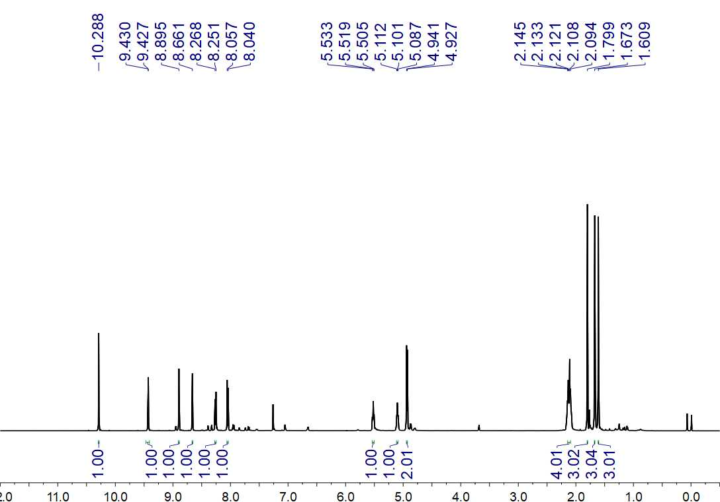
Fig. S203. ¹H NMR (500 MHz, CDCl₃) spectrum of 68

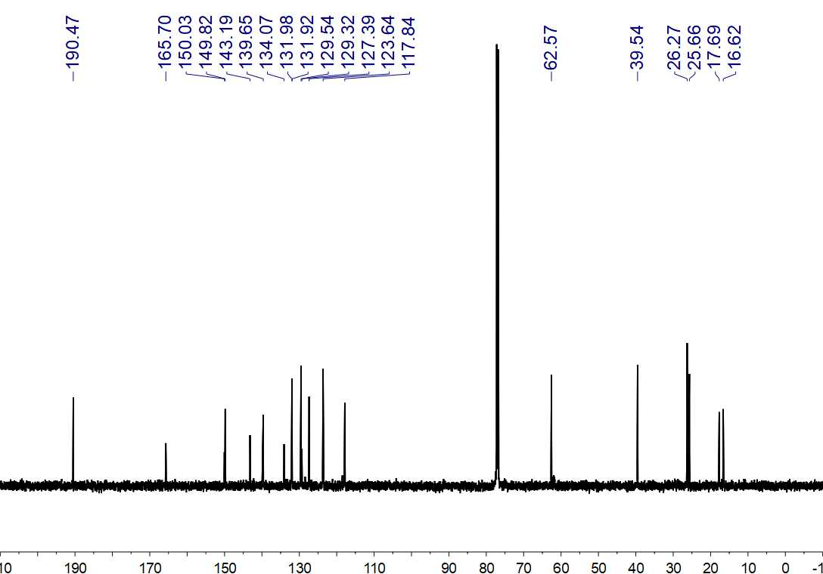
Fig. S204. ¹³C NMR (150 MHz, CDCl₃) spectrum of 68

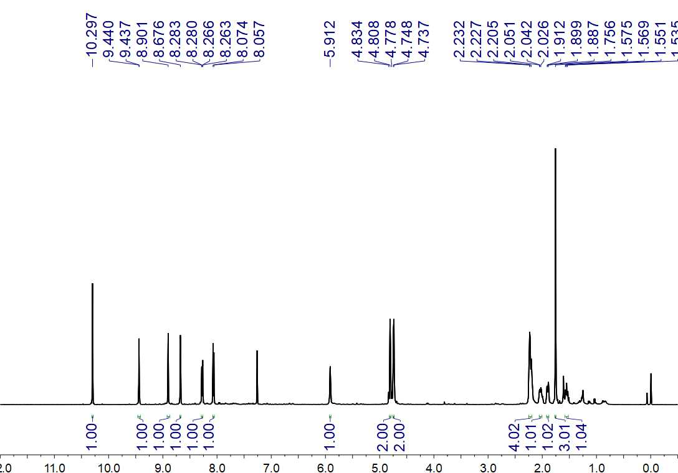
Fig. S205. ¹H NMR (500 MHz, CDCl₃) spectrum of 69

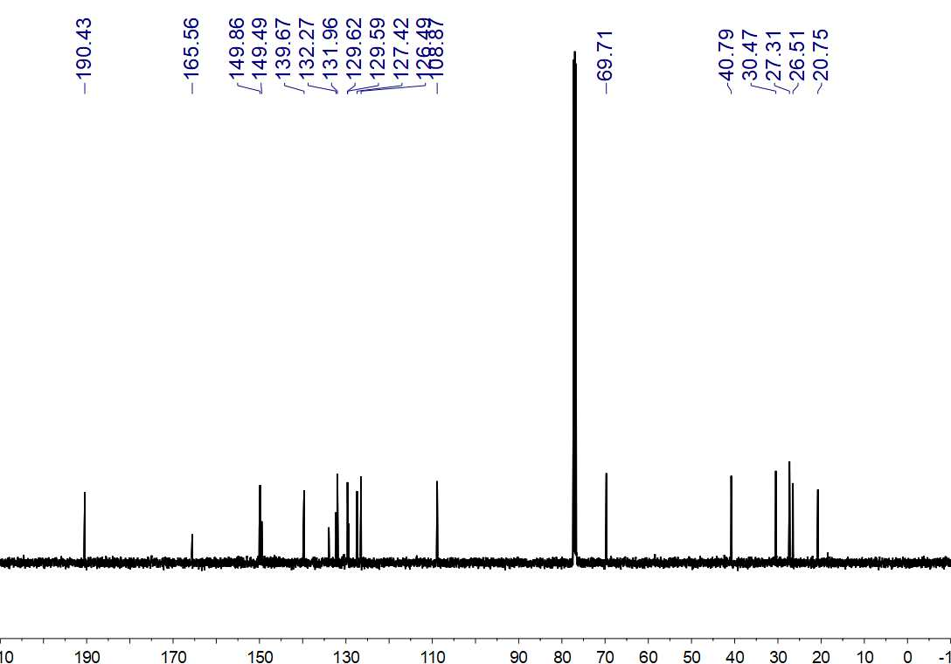
Fig. S206. ¹³C NMR (125 MHz, CDCl₃) spectrum of 69

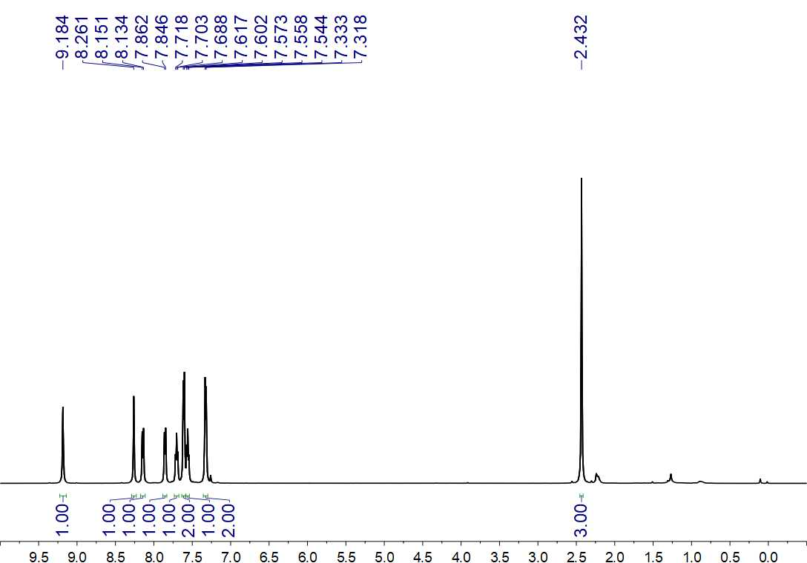
Fig. S207. ¹H NMR (500 MHz, CDCl₃) spectrum of 70

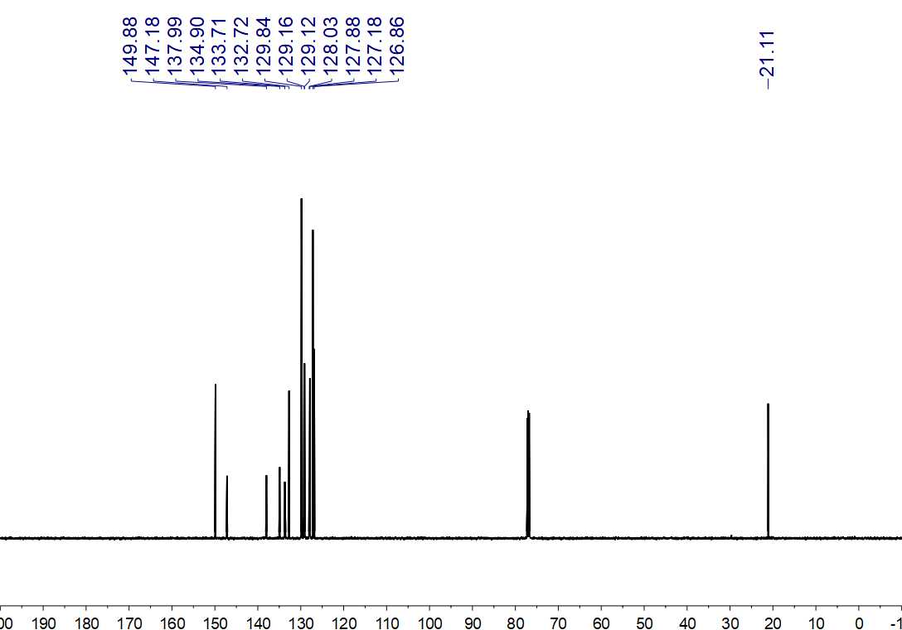
Fig. S208. ¹³C NMR (150 MHz, CDCl₃) spectrum of 70
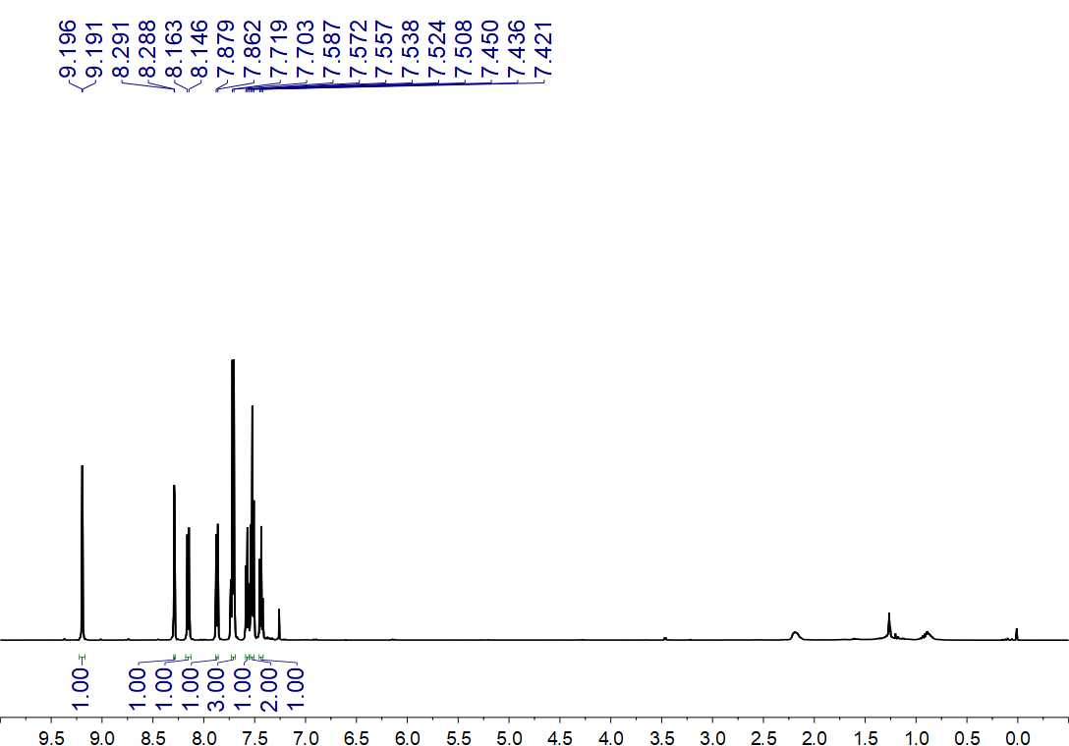
Fig. S209. ¹H NMR (500 MHz, CDCl₃) spectrum of 71

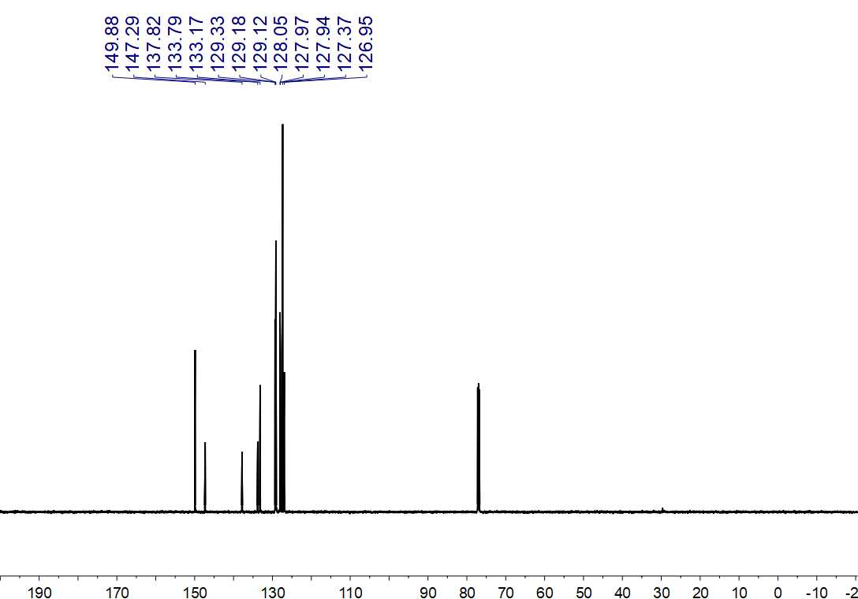
Fig. S210. ¹³C NMR (150 MHz, CDCl₃) spectrum of 71

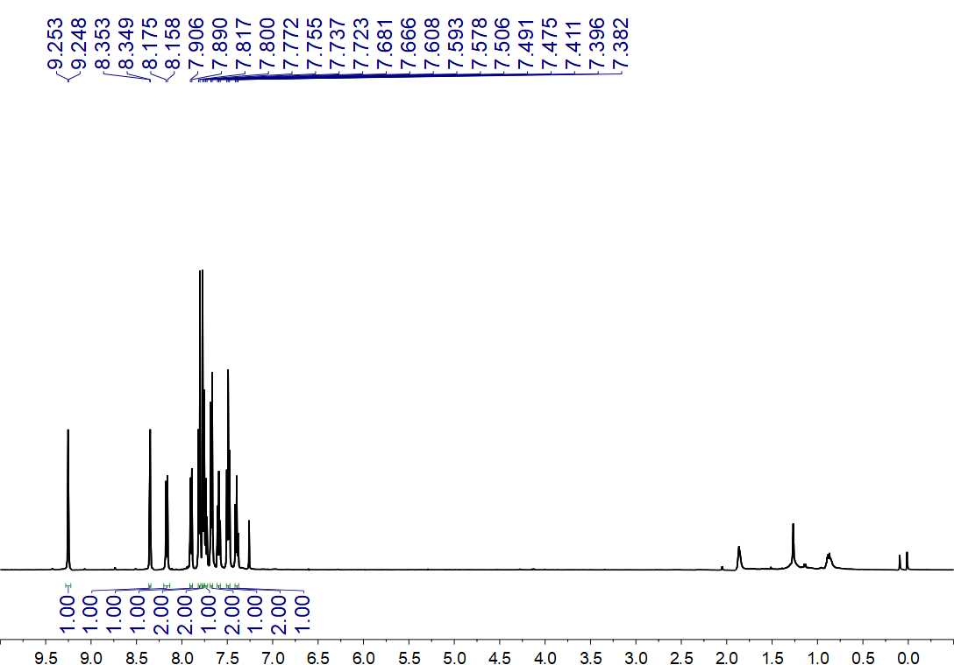
Fig. S211. ¹H NMR (500 MHz, CDCl₃) spectrum of 72

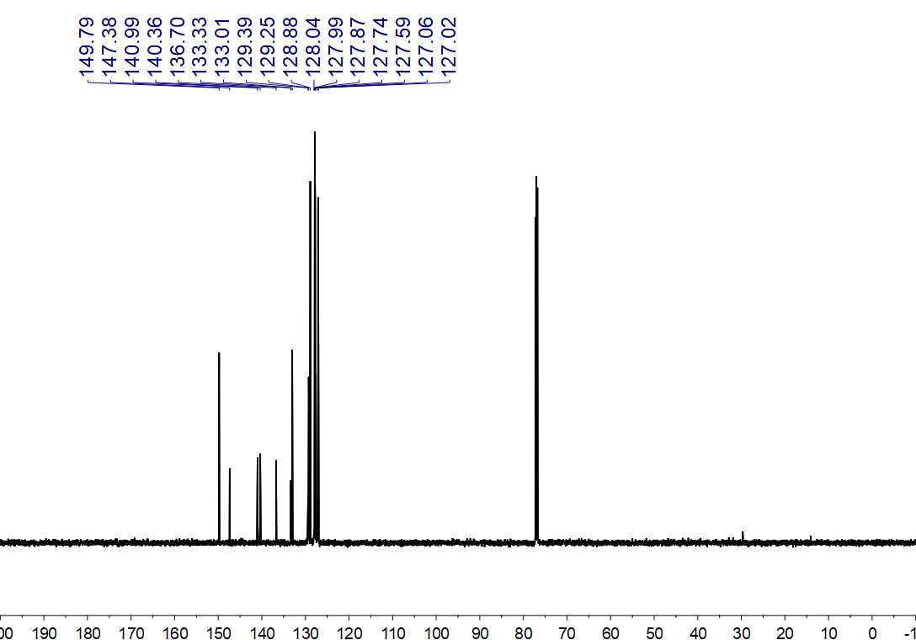
Fig. S212. ¹³C NMR (150 MHz, CDCl₃) spectrum of 72

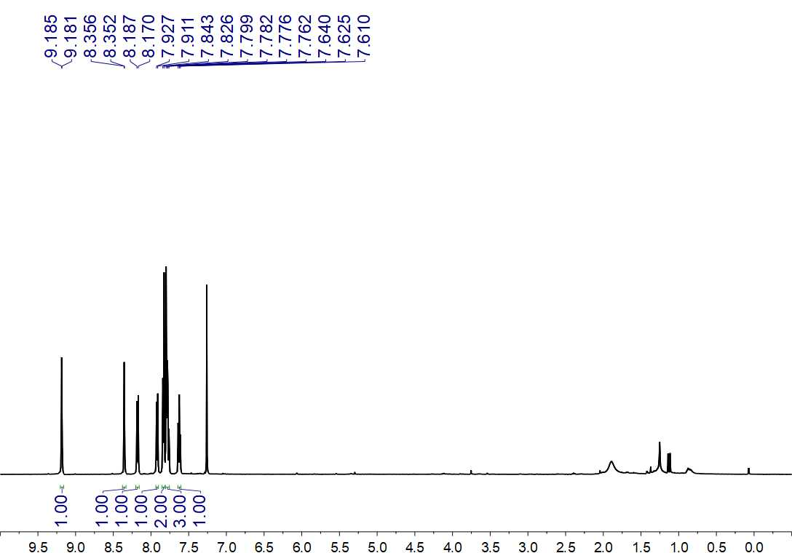
Fig. S213. ¹H NMR (500 MHz, CDCl₃) spectrum of 73

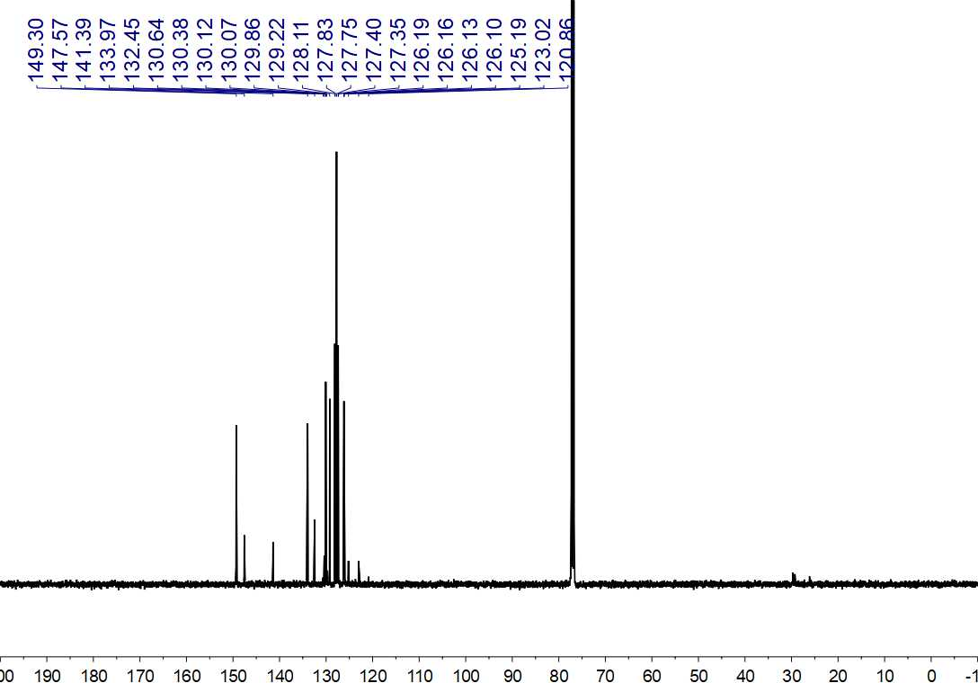
Fig. S214. ¹³C NMR (125 MHz, CDCl₃) spectrum of 73

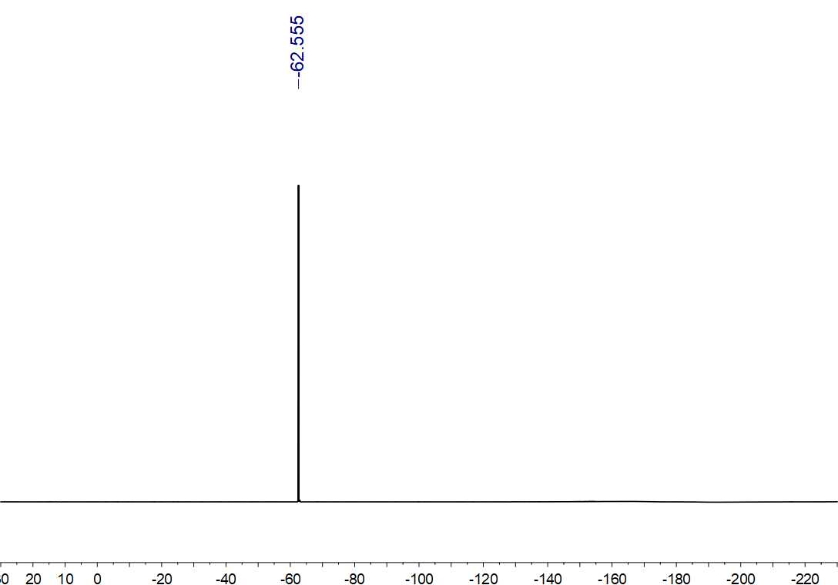
Fig. S215. ¹⁹F NMR (564 MHz, CDCl₃) spectrum of 72

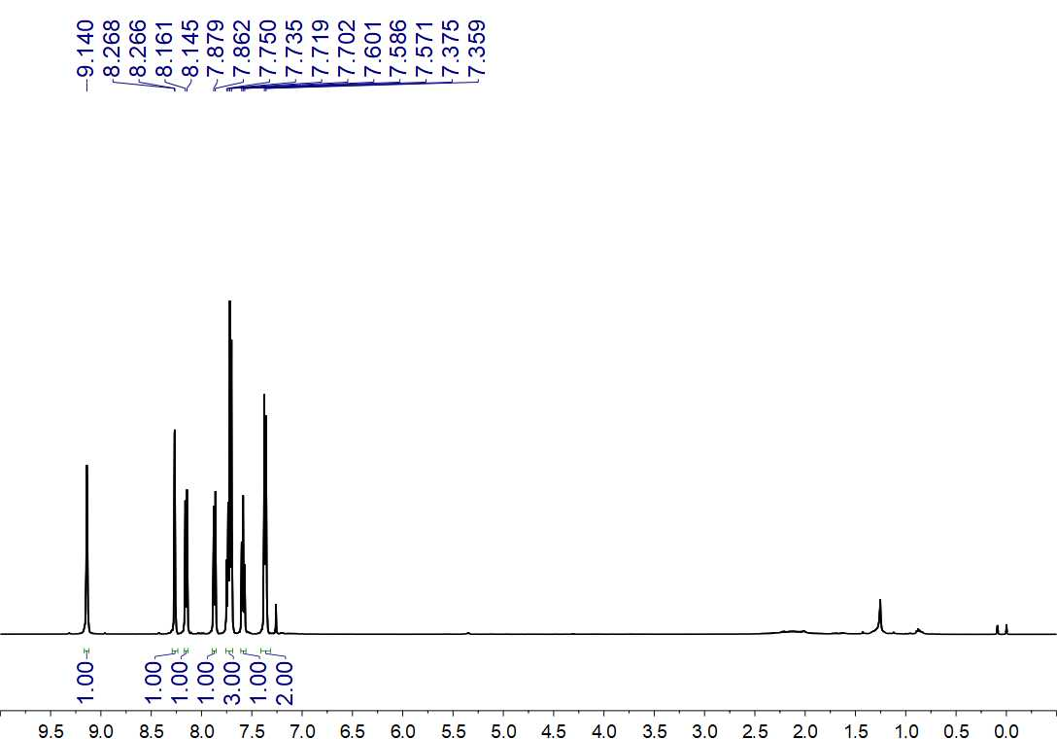
Fig. S216. ¹H NMR (500 MHz, CDCl₃) spectrum of 74

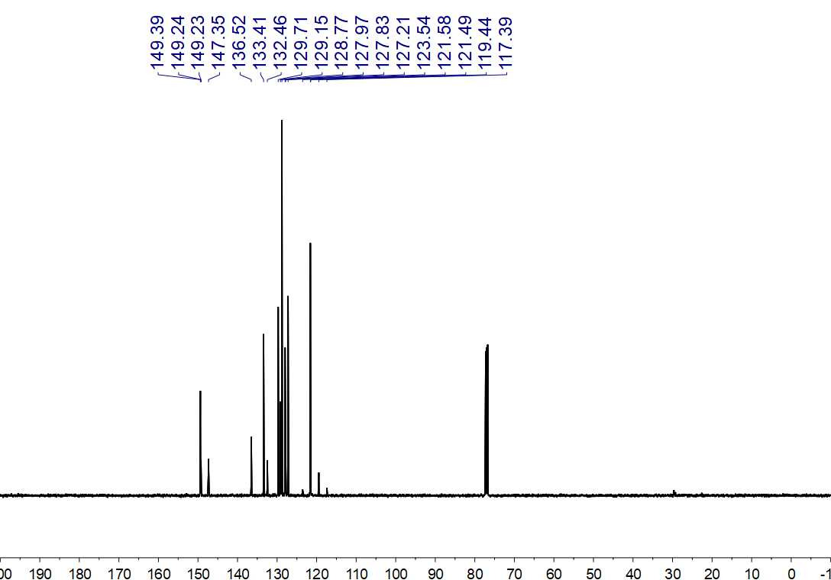
Fig. S217. ¹³C NMR (125 MHz, CDCl₃) spectrum of 74

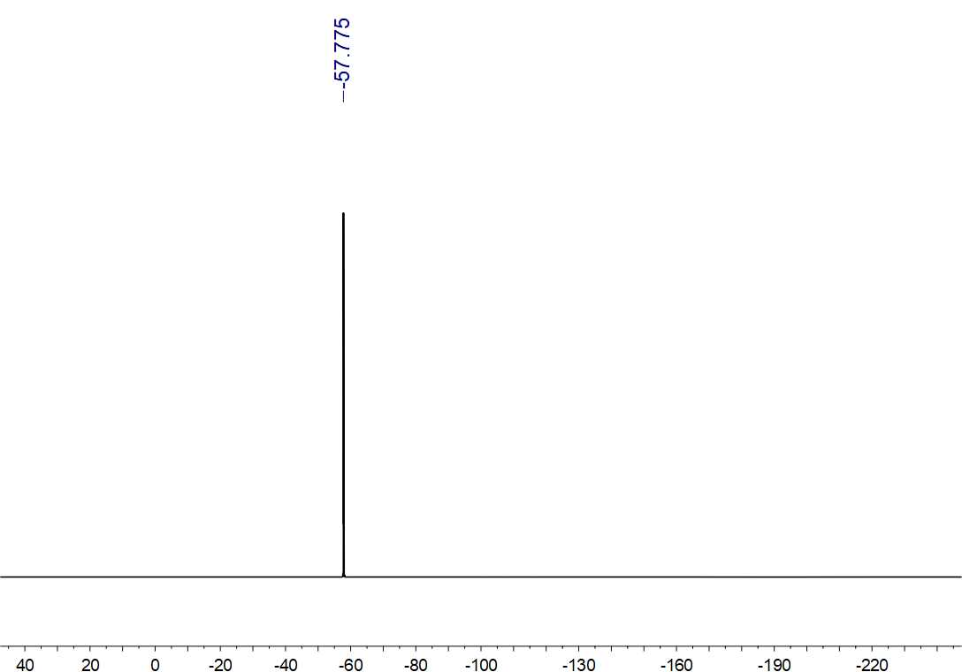
Fig. S218. ¹⁹F NMR (470 MHz, CDCl₃) spectrum of 74

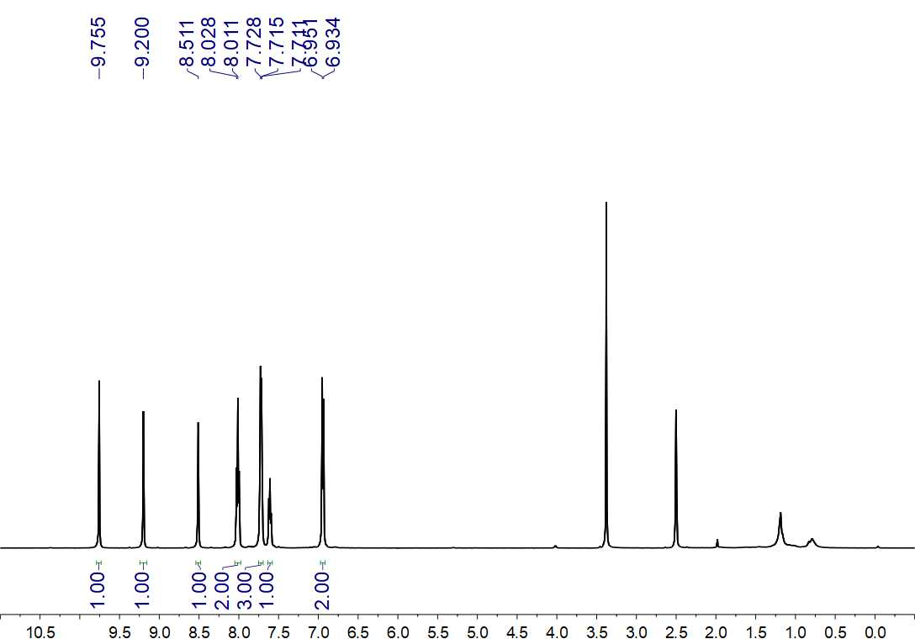
Fig. S219. ¹H NMR (500 MHz, DMSO-d₆) spectrum of 75

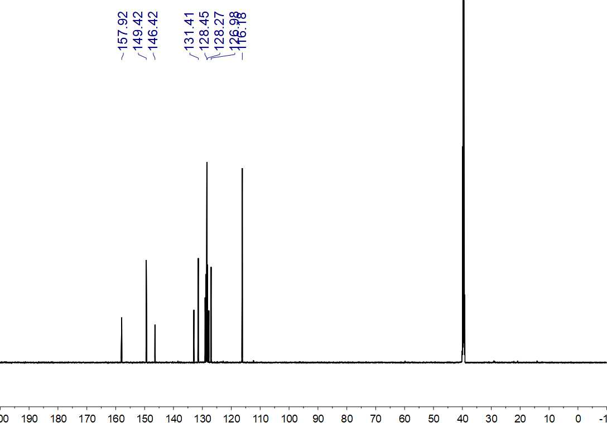
Fig. S220. ¹³C NMR (150 MHz, DMSO-d₆) spectrum of 75

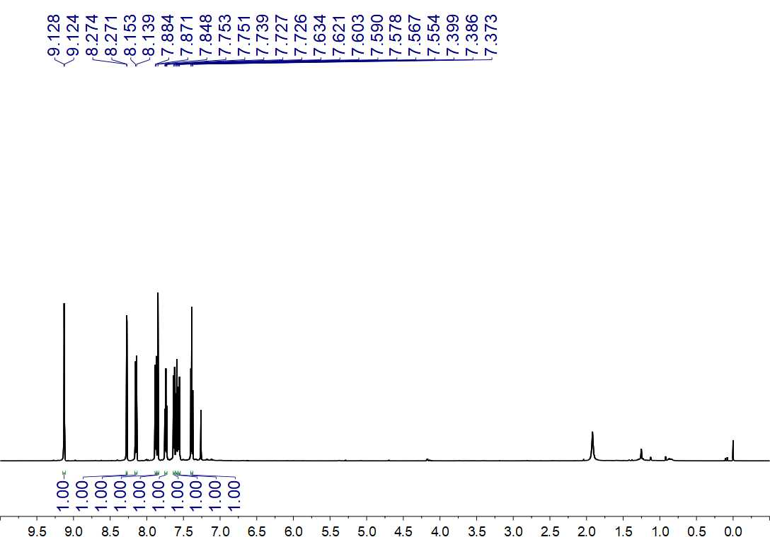
Fig. S221. ¹H NMR (600 MHz, CDCl₃) spectrum of 76

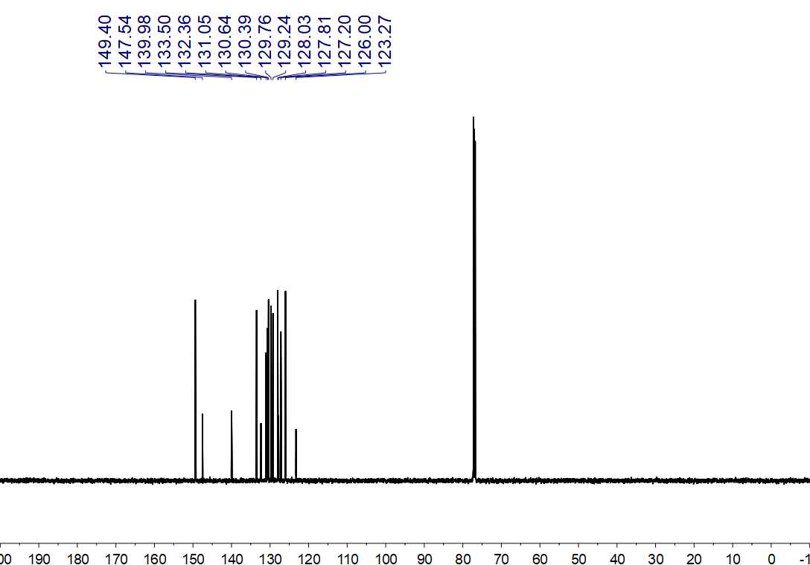
Fig. S222. ¹³C NMR (150 MHz, CDCl₃) spectrum of 76

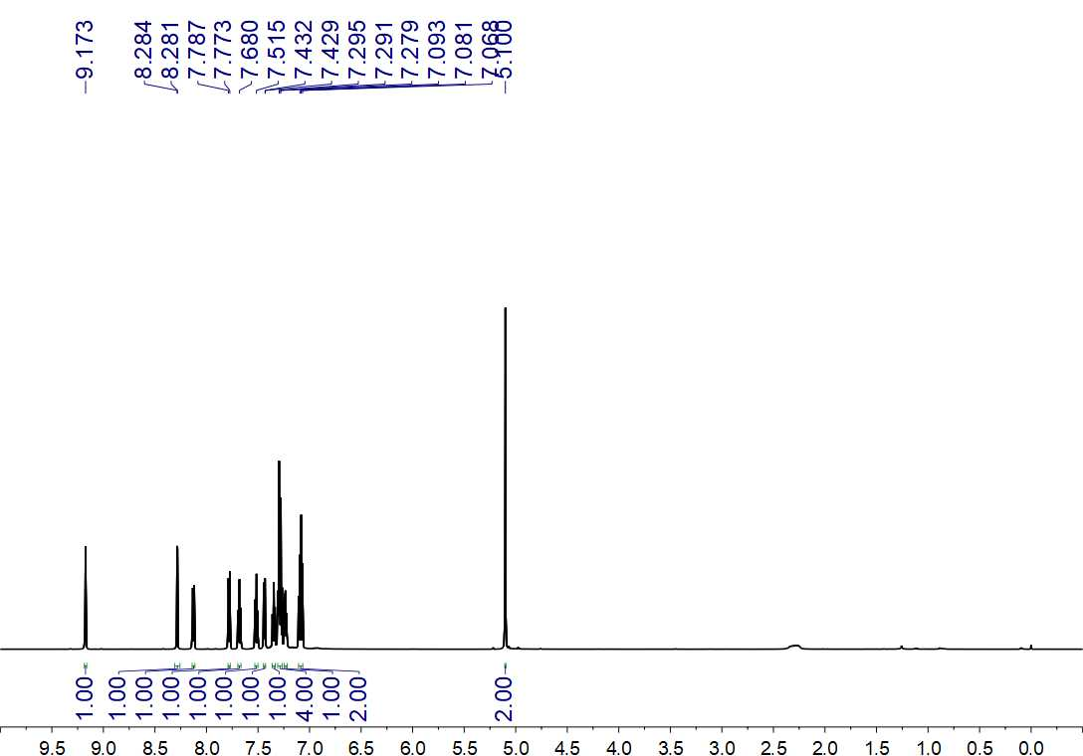
Fig. S224. ¹H NMR (600 MHz, CDCl₃) spectrum of 77

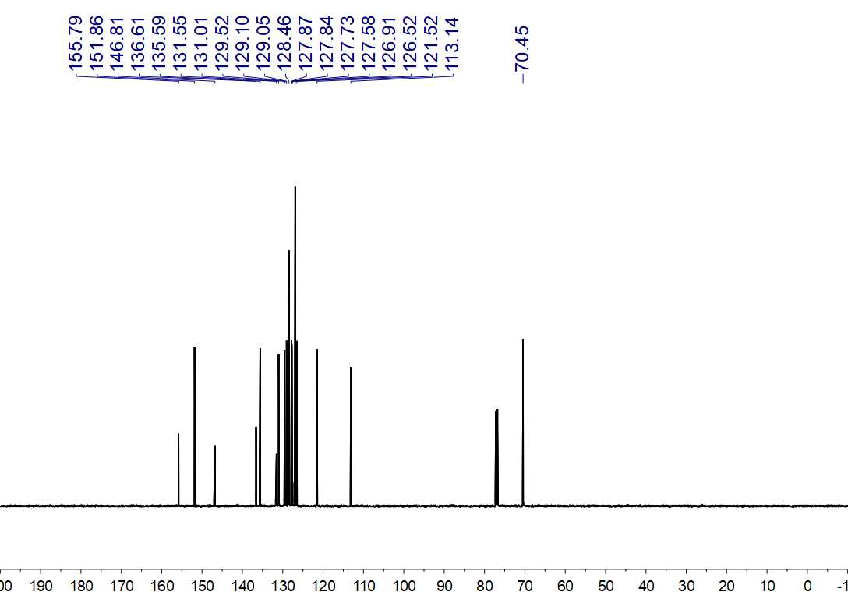
Fig. S224. ¹³C NMR (150 MHz, CDCl₃) spectrum of 77

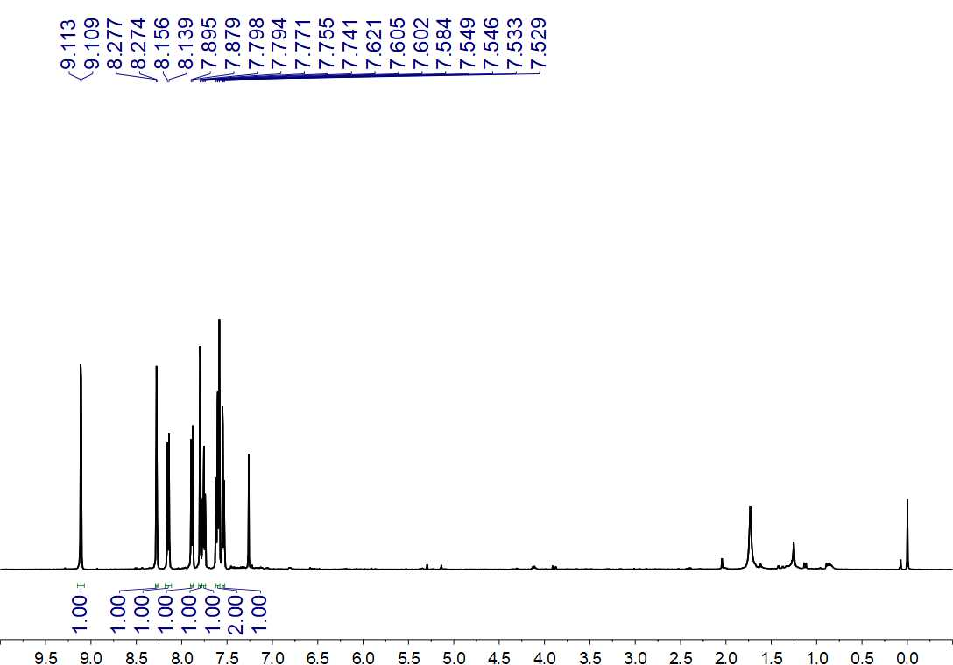
Fig. S225. ¹H NMR (500 MHz, CDCl₃) spectrum of 78

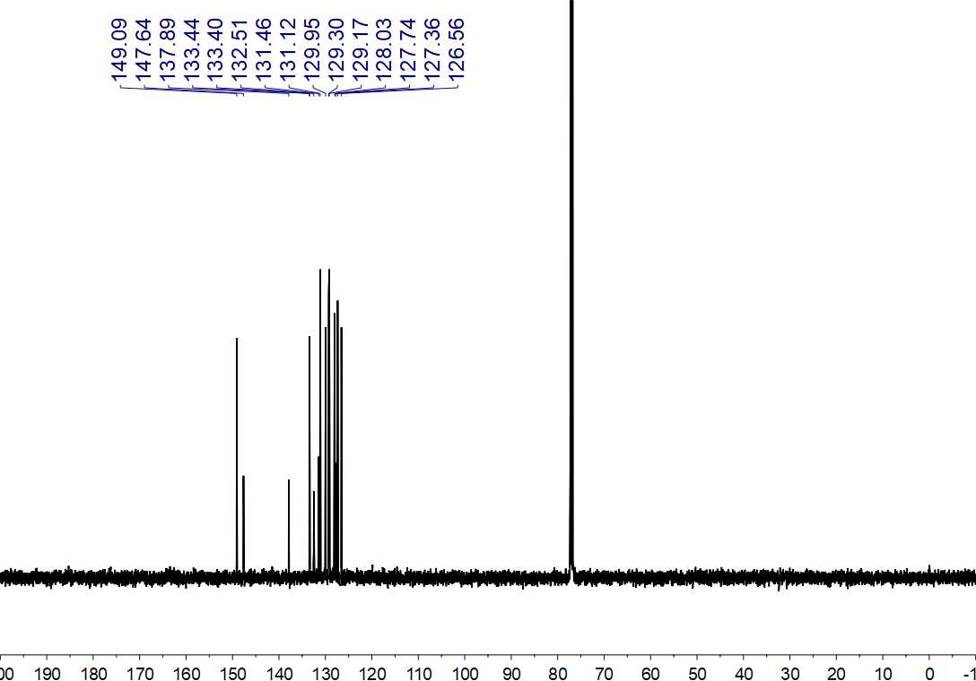
Fig. S226. ¹³C NMR (125 MHz, CDCl₃) spectrum of 78

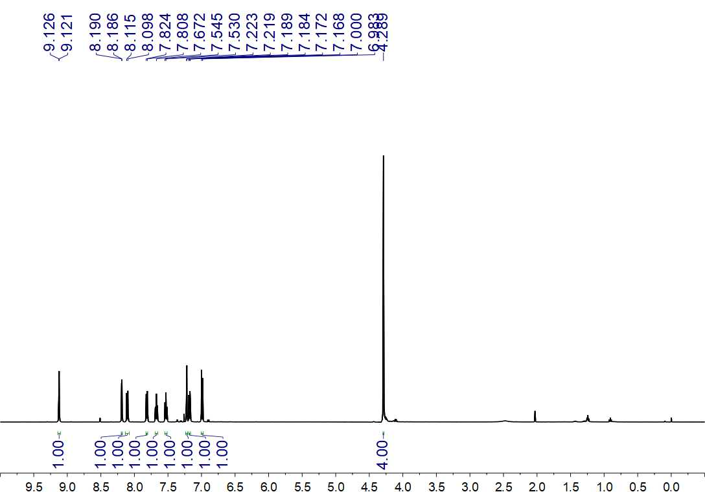
Fig. S227. ¹H NMR (500 MHz, CDCl₃) spectrum of 79

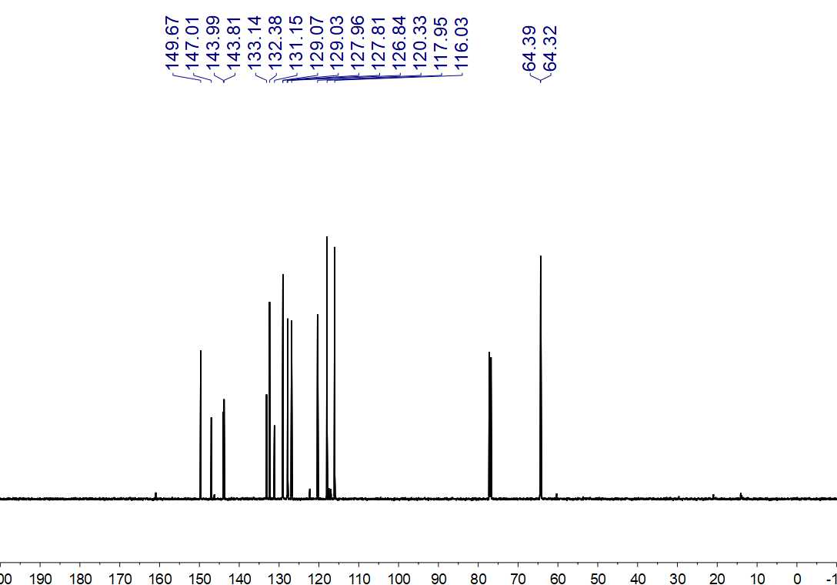
Fig. S228. ¹³C NMR (150 MHz, CDCl₃) spectrum of 79

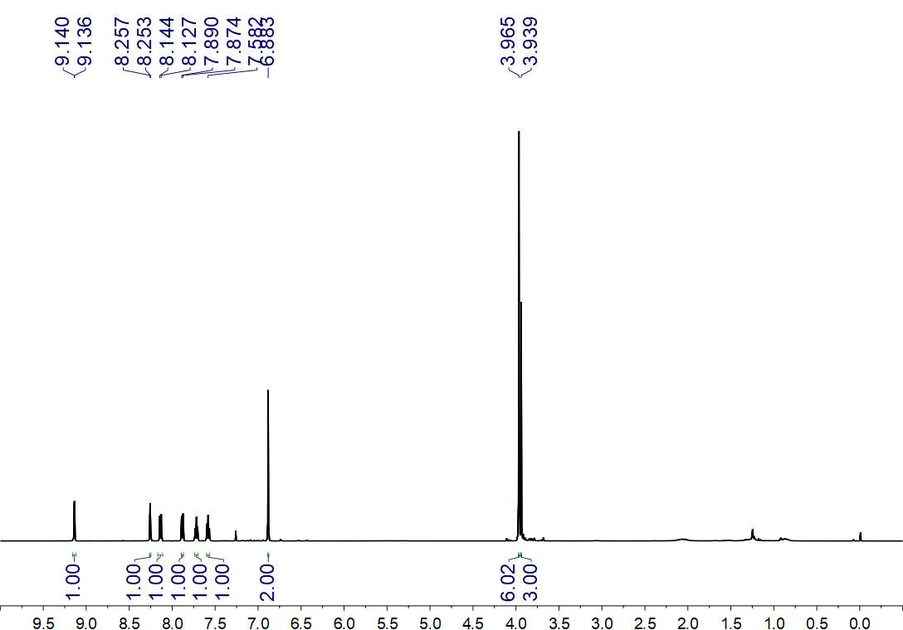
Fig. S229. ¹H NMR (500 MHz, CDCl₃) spectrum of 80

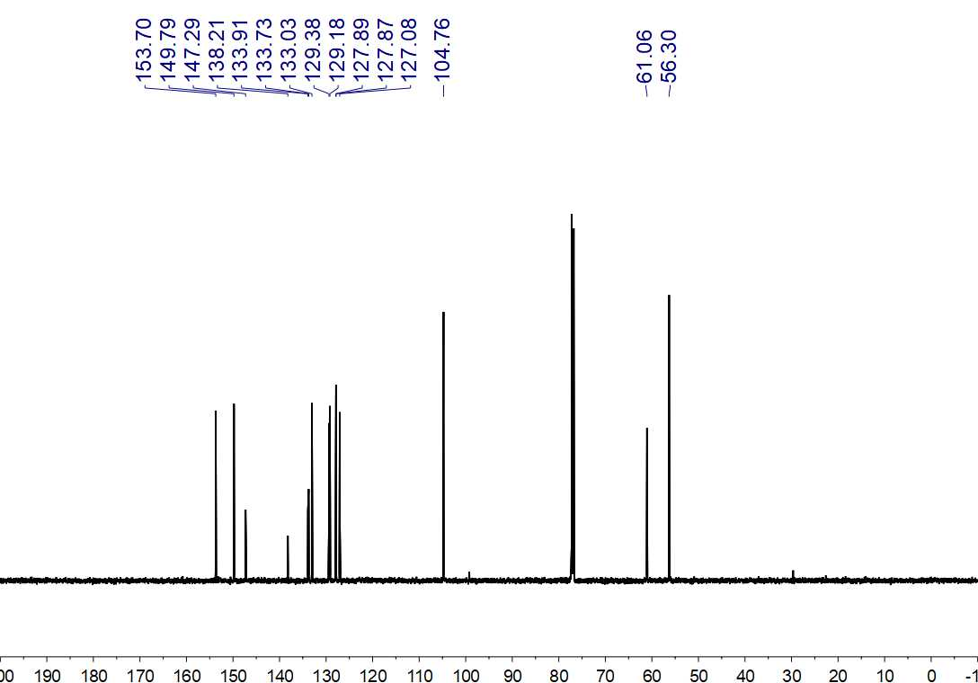
Fig. S330. ¹³C NMR (150 MHz, CDCl₃) spectrum of 80

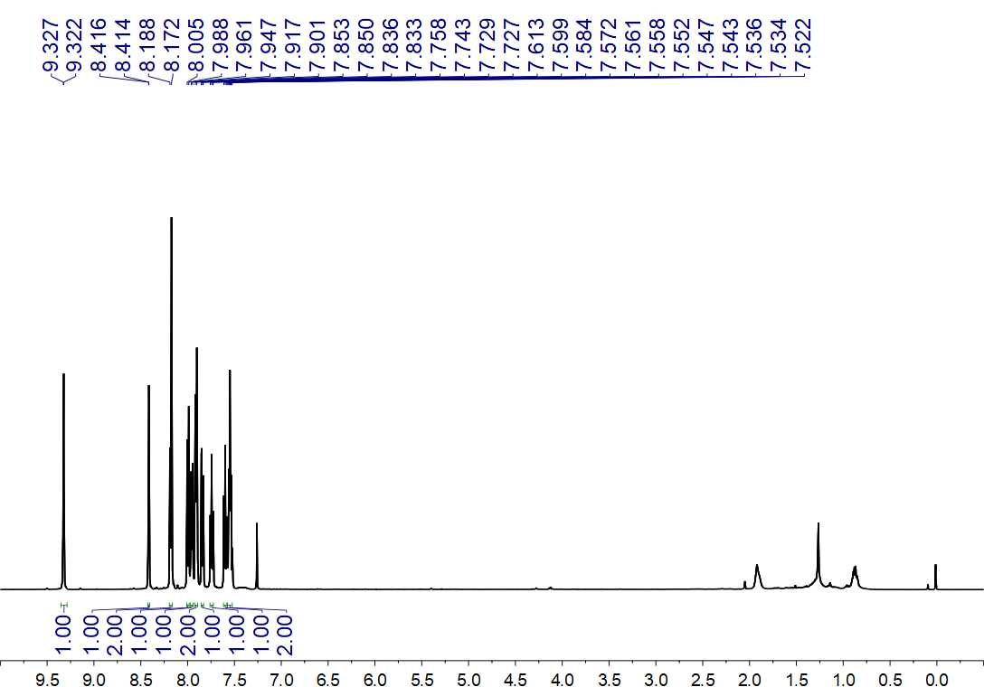
Fig. S231. ¹H NMR (500 MHz, CDCl₃) spectrum of 81

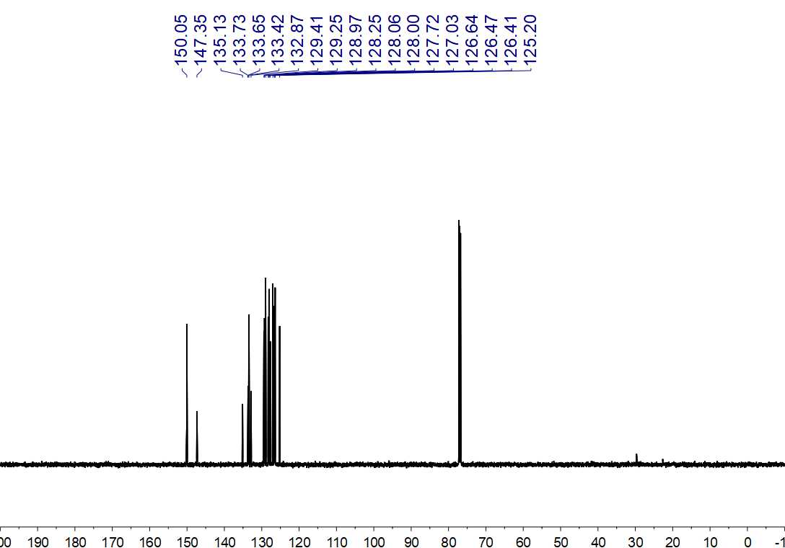
Fig. S232. ¹³C NMR (150 MHz, CDCl₃) spectrum of 81

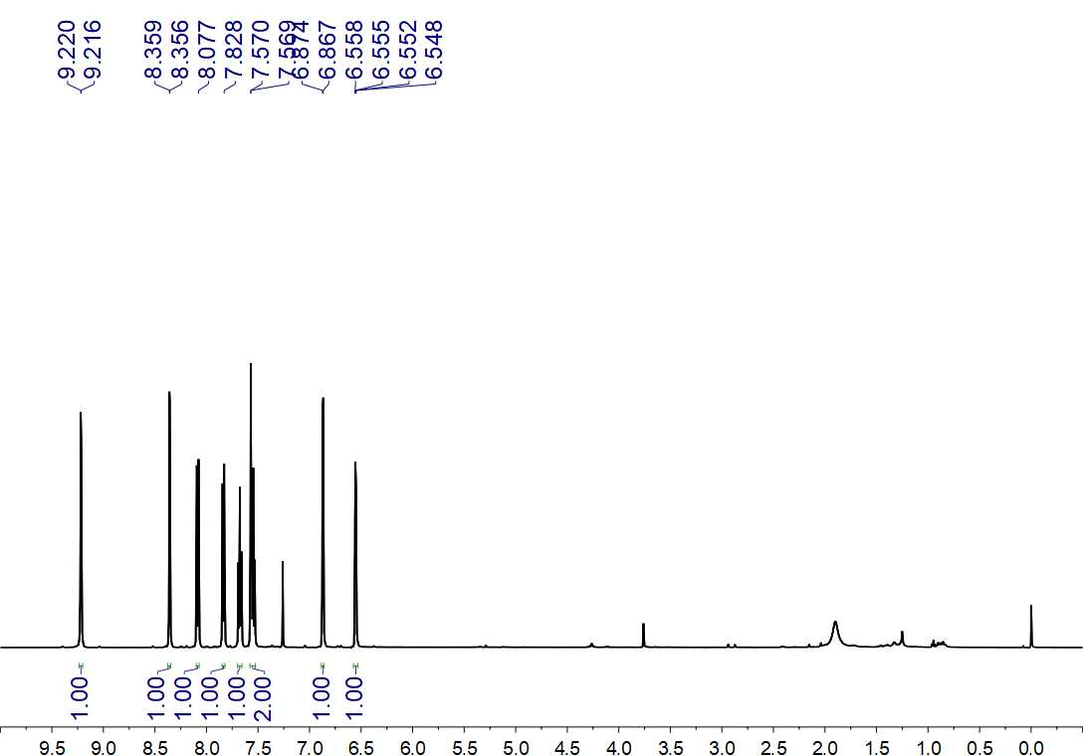
Fig. S233. ¹H NMR (500 MHz, CDCl₃) spectrum of 82

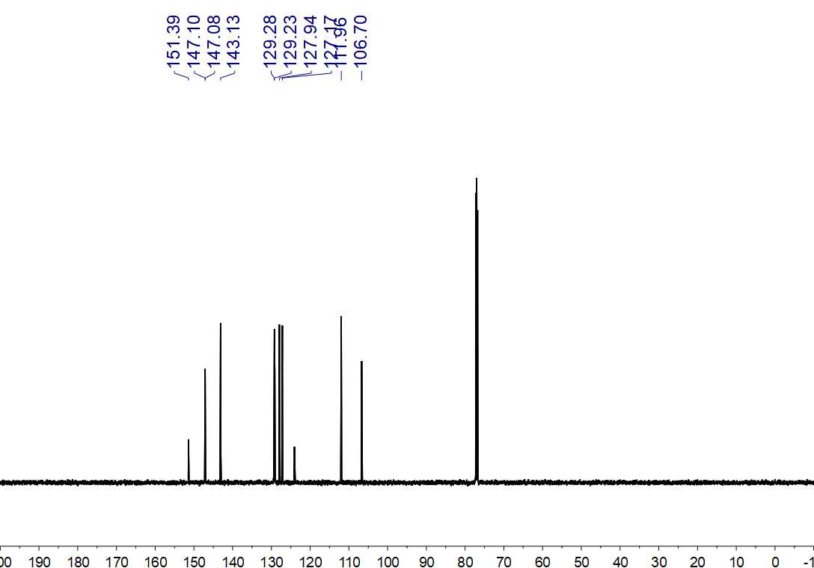
Fig. S234. ¹³C NMR (150 MHz, CDCl₃) spectrum of 82

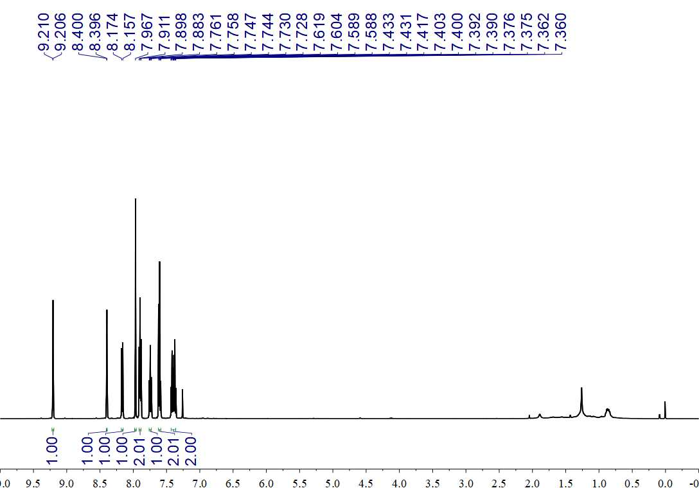
Fig. S235. ¹H NMR (500 MHz, CDCl₃) spectrum of 83

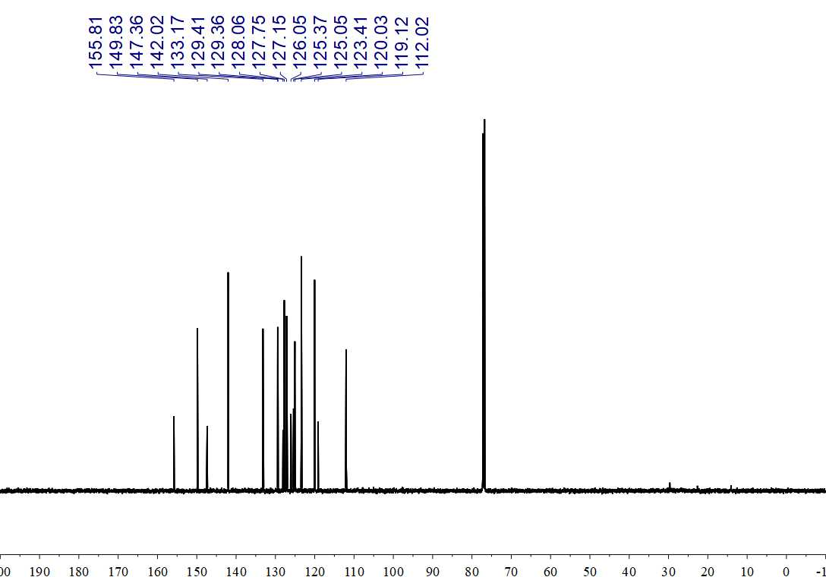
Fig. S236. ¹³C NMR (150 MHz, CDCl₃) spectrum of 83

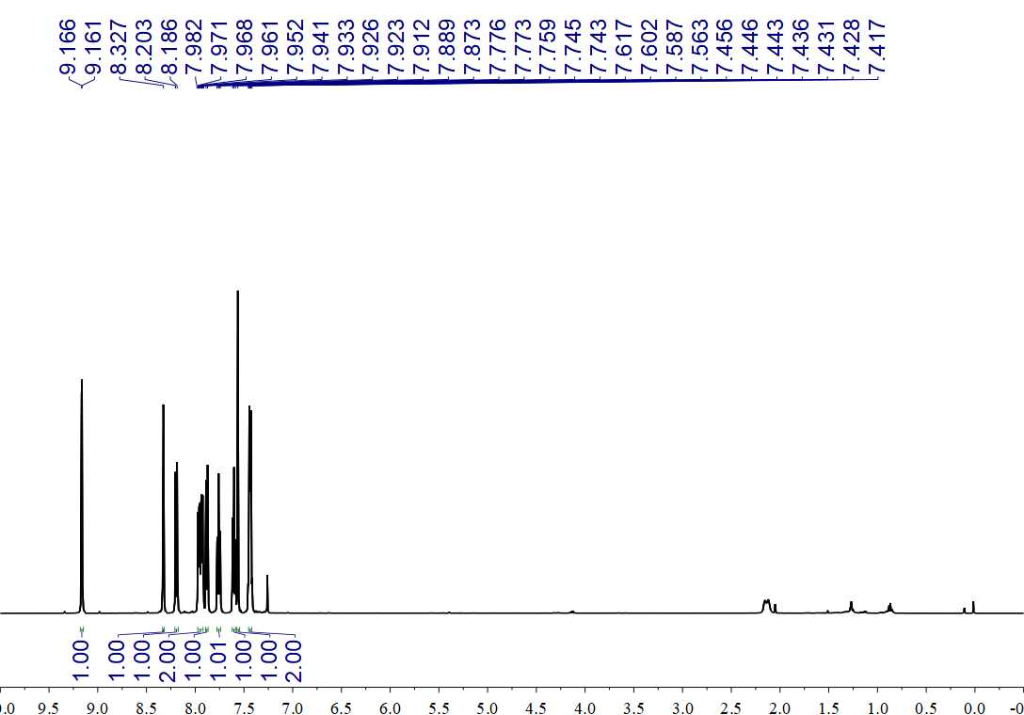
Fig. S237. ¹H NMR (500 MHz, CDCl₃) spectrum of 84

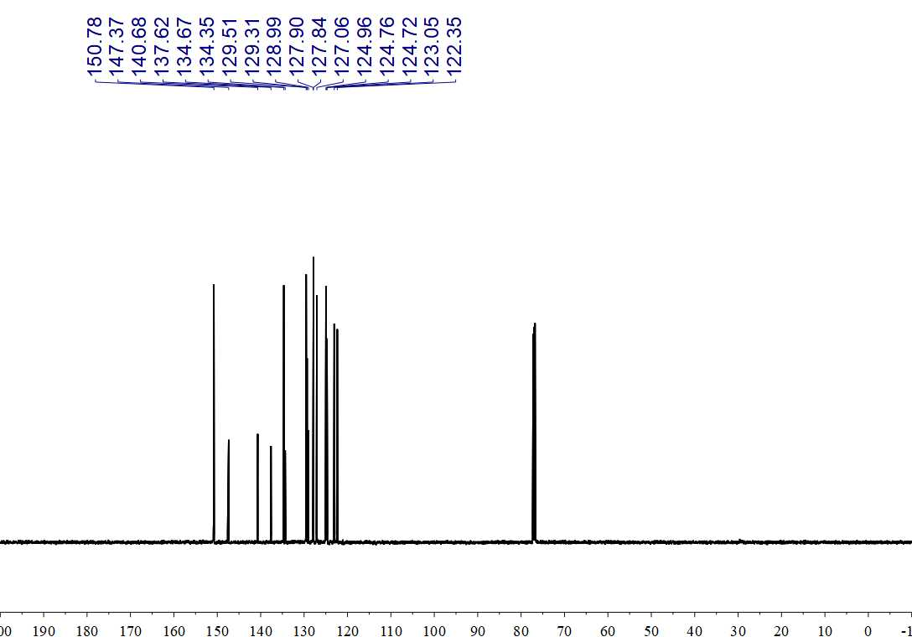
Fig. S238. ¹³C NMR (150 MHz, CDCl₃) spectrum of 84

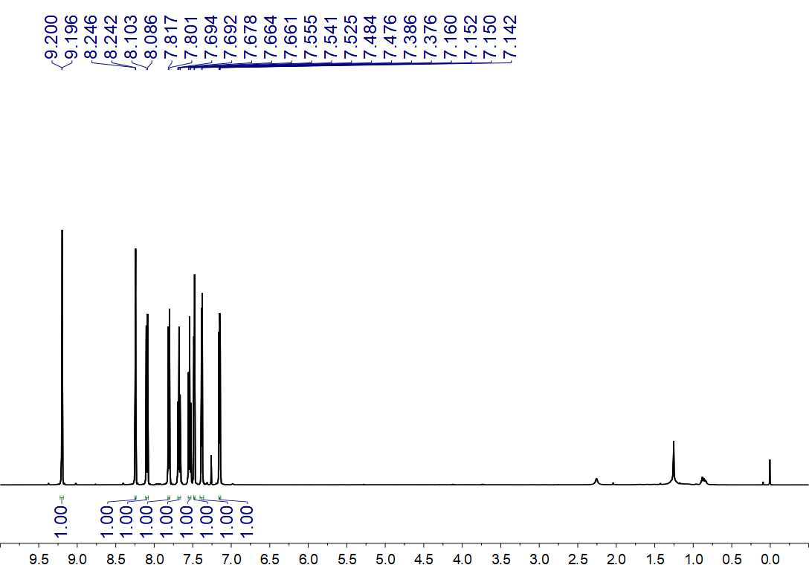
Fig. S239. ¹H NMR (500 MHz, CDCl₃) spectrum of 85

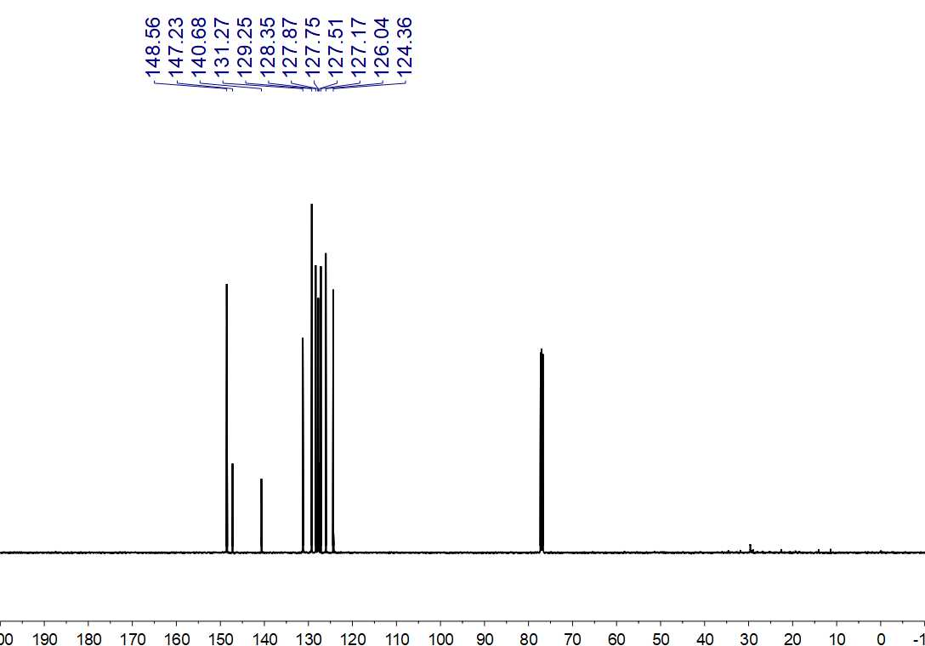
Fig. S240. ¹³C NMR (125 MHz, CDCl₃) spectrum of 85

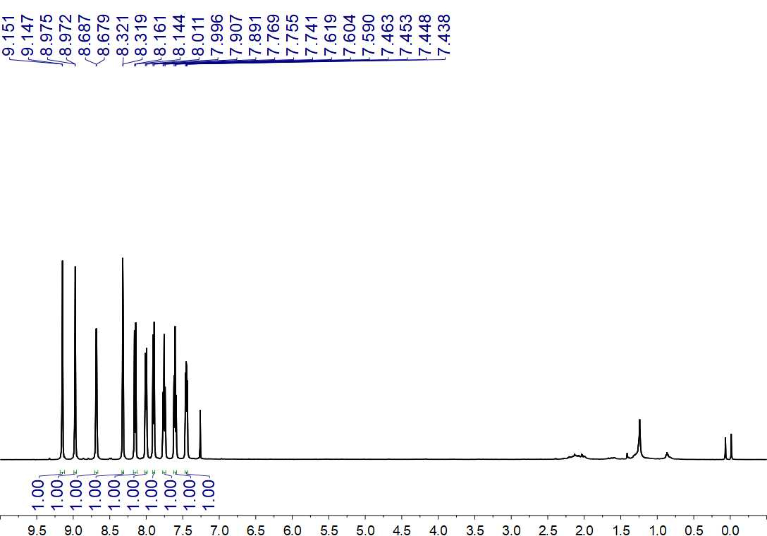
Fig. S241. ¹H NMR (500 MHz, CDCl₃) spectrum of 86

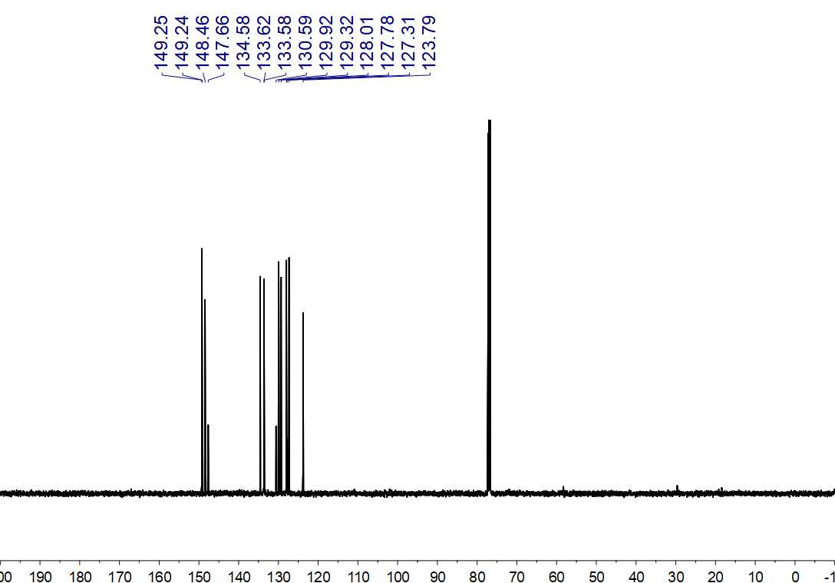
Fig. S242. ¹³C NMR (125 MHz, CDCl₃) spectrum of 86

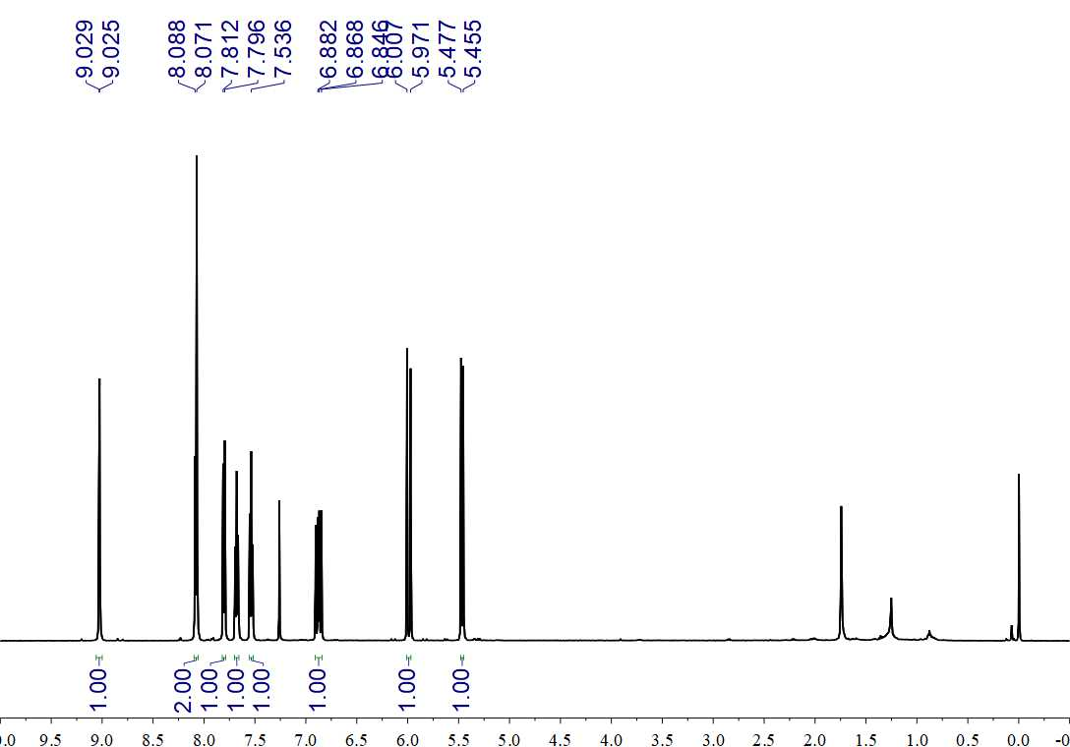
Fig. S243. ¹H NMR (500 MHz, CDCl₃) spectrum of 87

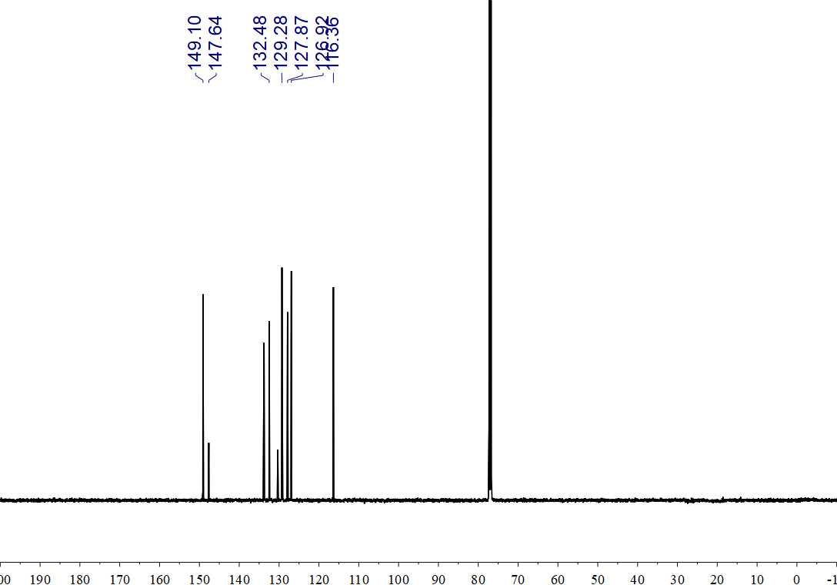
Fig. S44. ¹³C NMR (125 MHz, CDCl₃) spectrum of 88

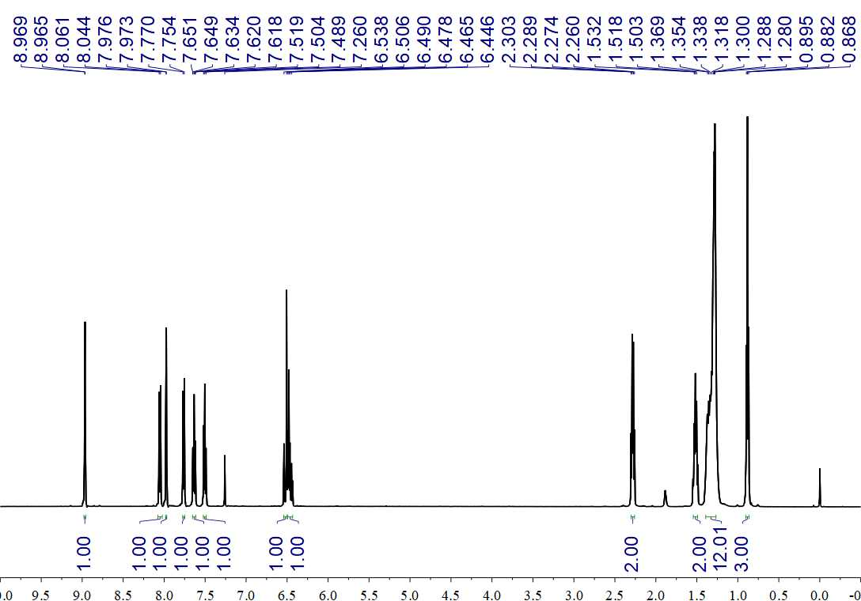
Fig. S245. ¹H NMR (500 MHz, CDCl₃) spectrum of 88

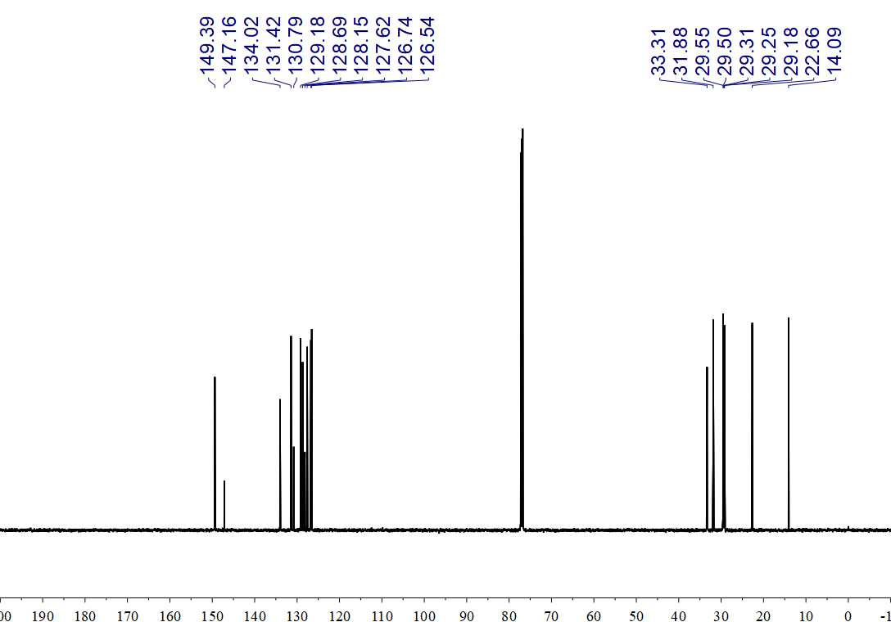
Fig. S246. ¹³C NMR (150 MHz, CDCl₃) spectrum of 88

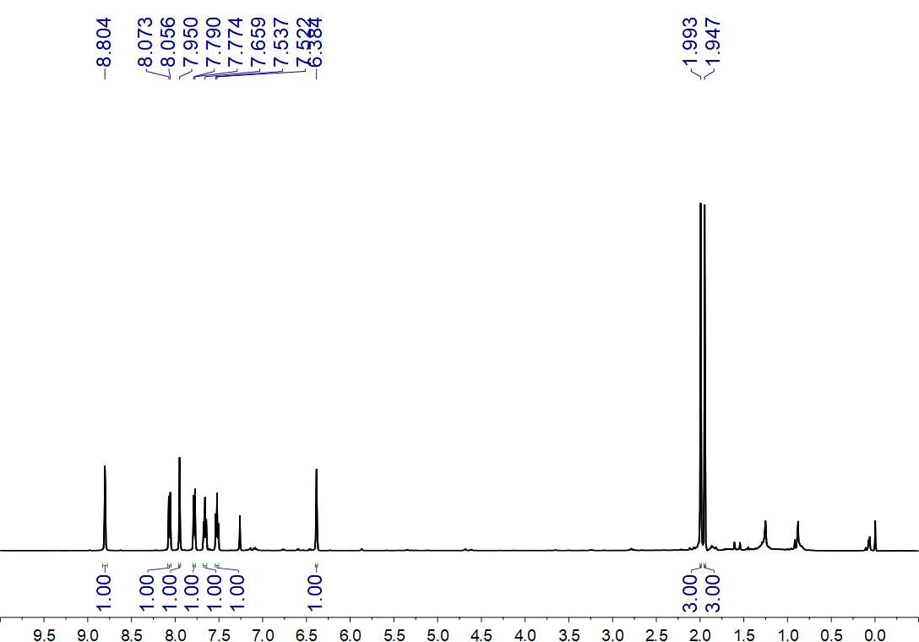
Fig. S247. ¹H NMR (500 MHz, CDCl₃) spectrum of 89

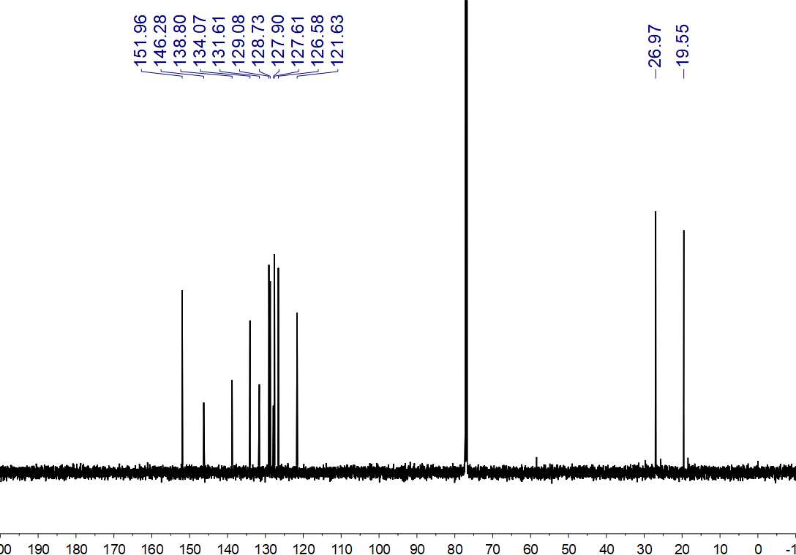
Fig. S248. ¹³C NMR (150 MHz, CDCl₃) spectrum of 89

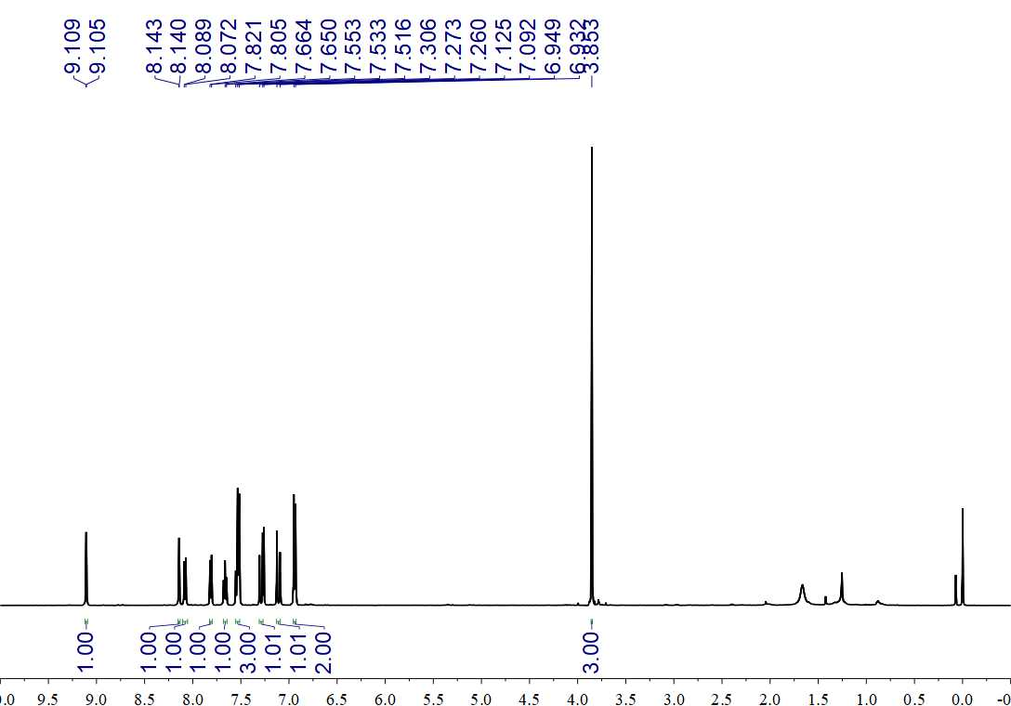
Fig. S249. ¹H NMR (500 MHz, CDCl₃) spectrum of 90

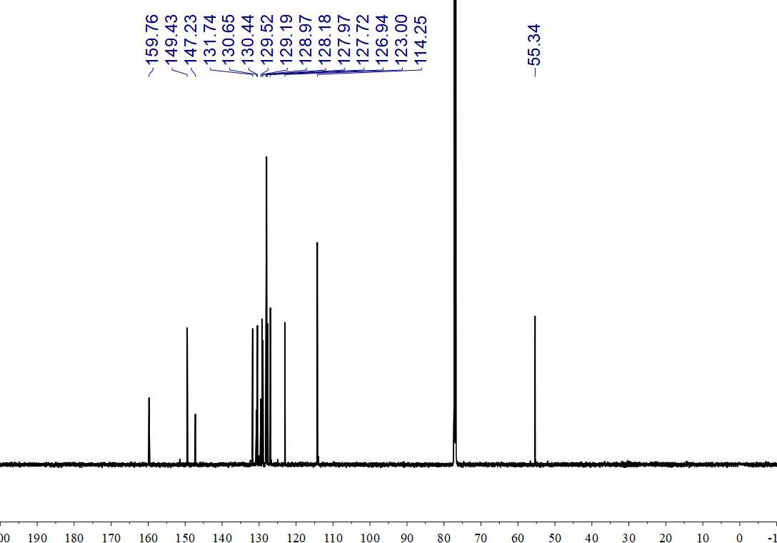
Fig. S250. ¹³C NMR (150 MHz, CDCl₃) spectrum of 90

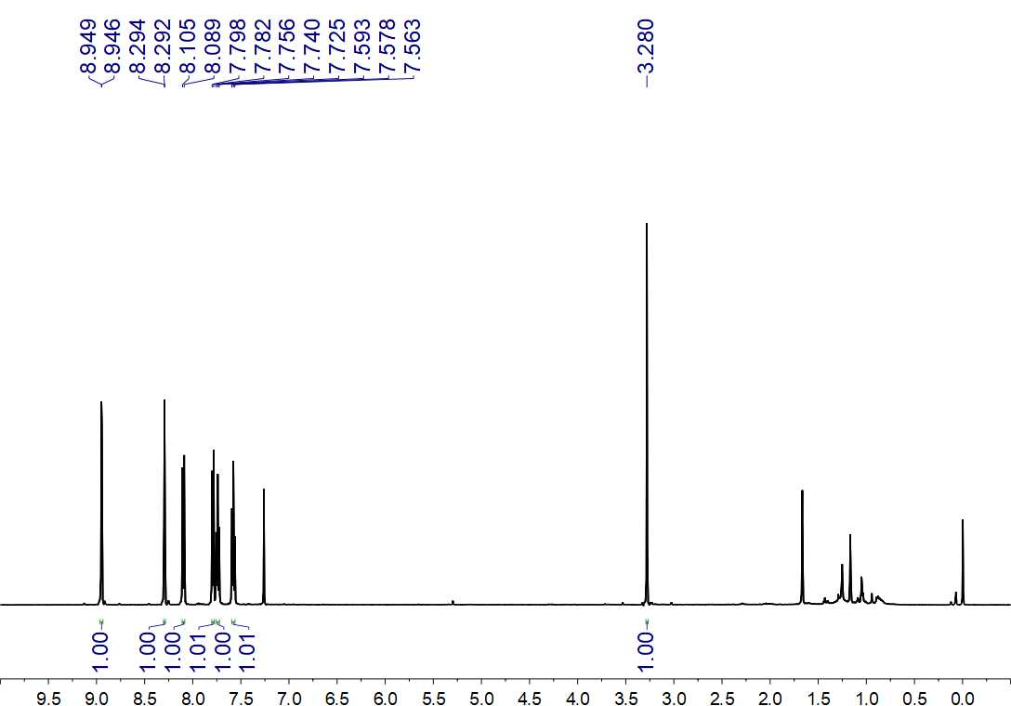
Fig. S251. ¹H NMR (500 MHz, CDCl₃) spectrum of 91

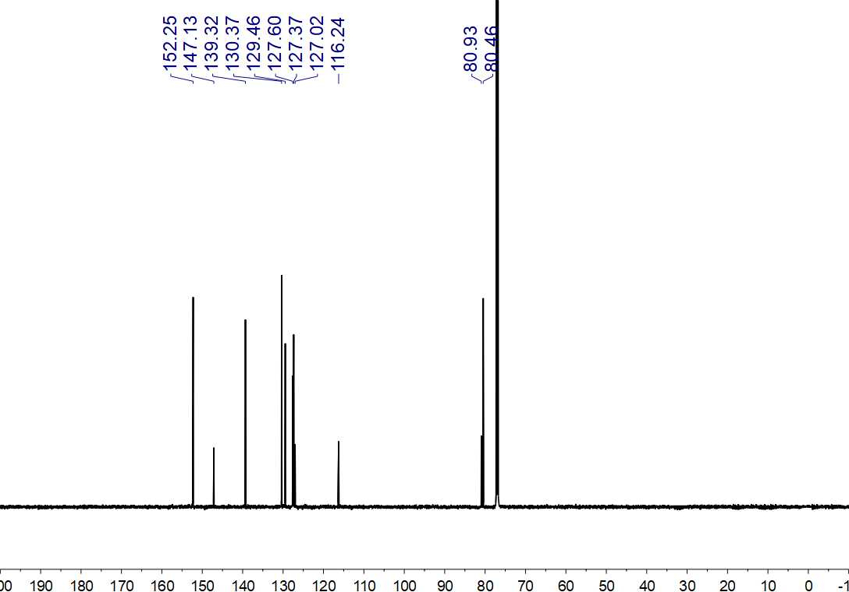
Fig. S252. ¹³C NMR (150 MHz, CDCl₃) spectrum of 91

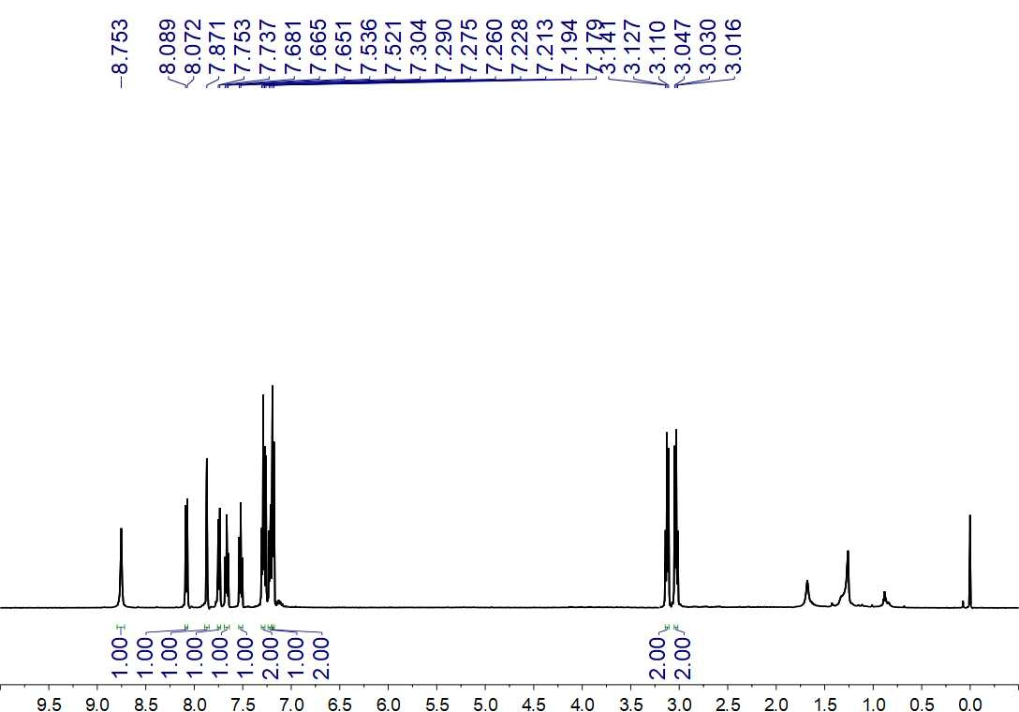
Fig. S253. ¹H NMR (500 MHz, CDCl₃) spectrum of 92

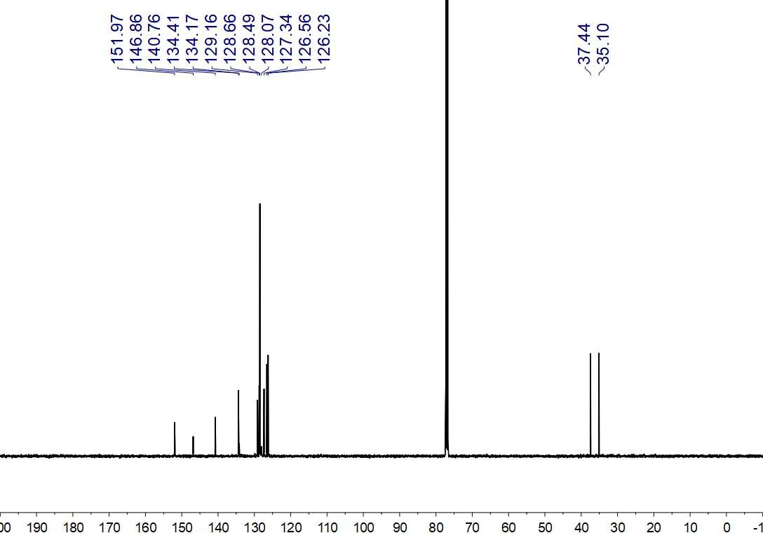
Fig. S254. ¹³C NMR (125 MHz, CDCl₃) spectrum of 92

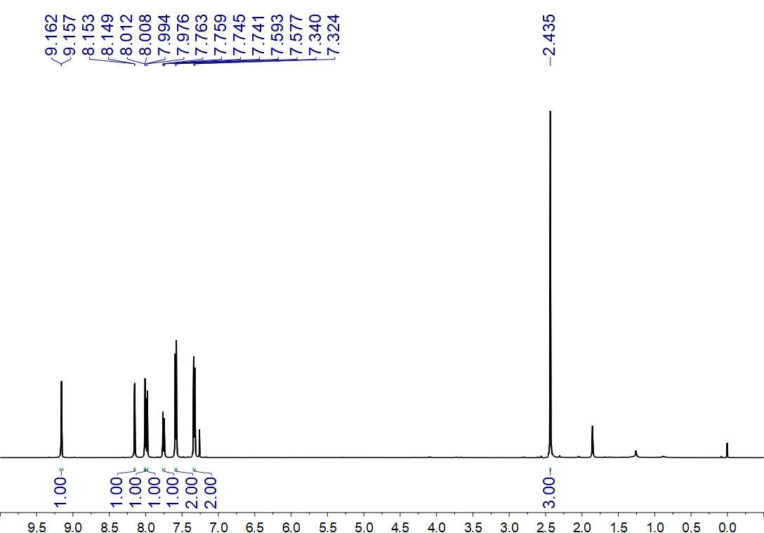
Fig. S255. ¹H NMR (500 MHz, CDCl₃) spectrum of 93

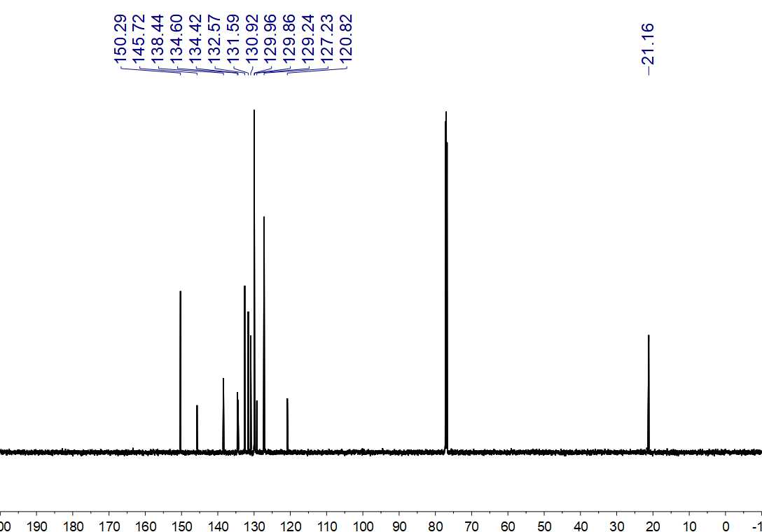
Fig. S256. ¹³C NMR (150 MHz, CDCl₃) spectrum of 93

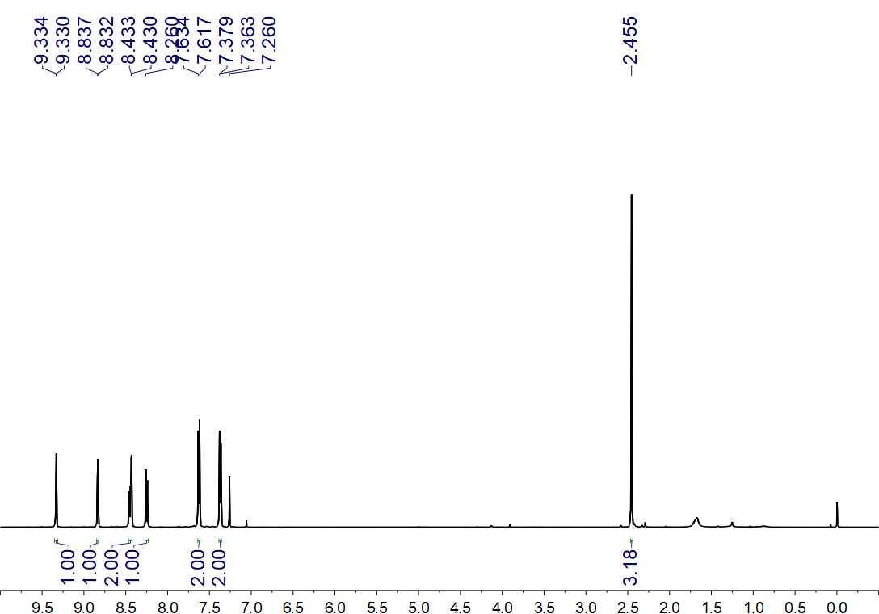
Fig. S257. ¹H NMR (500 MHz, CDCl₃) spectrum of 94

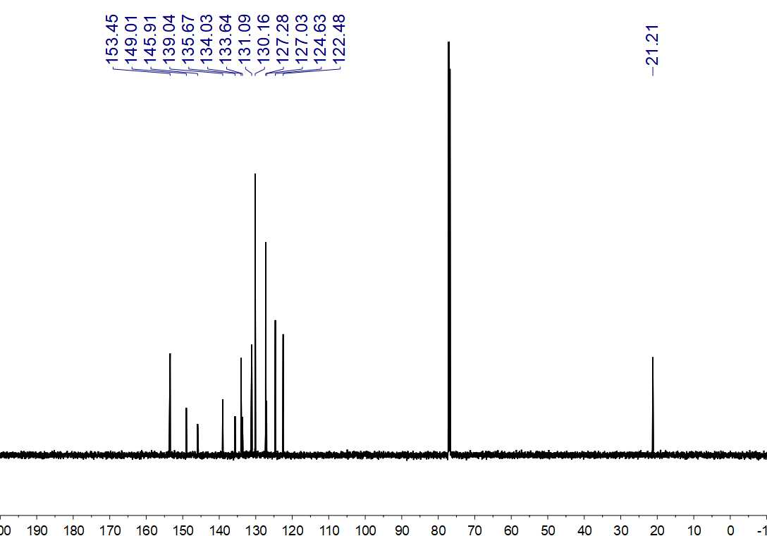
Fig. S258. ¹³C NMR (150 MHz, CDCl₃) spectrum of 94

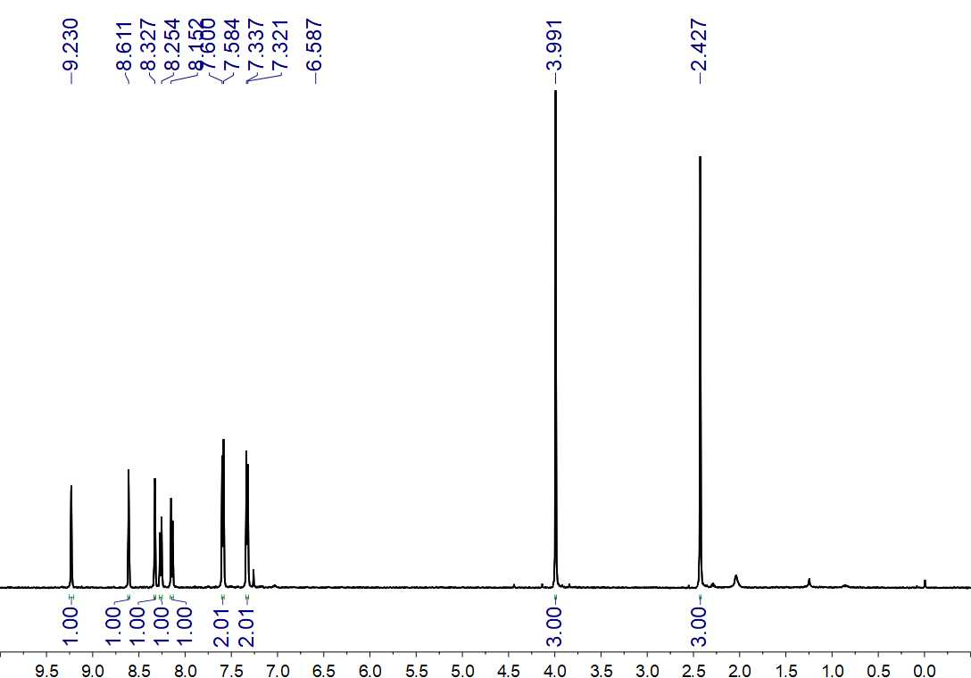
Fig. S259. ¹H NMR (500 MHz, CDCl₃) spectrum of 95

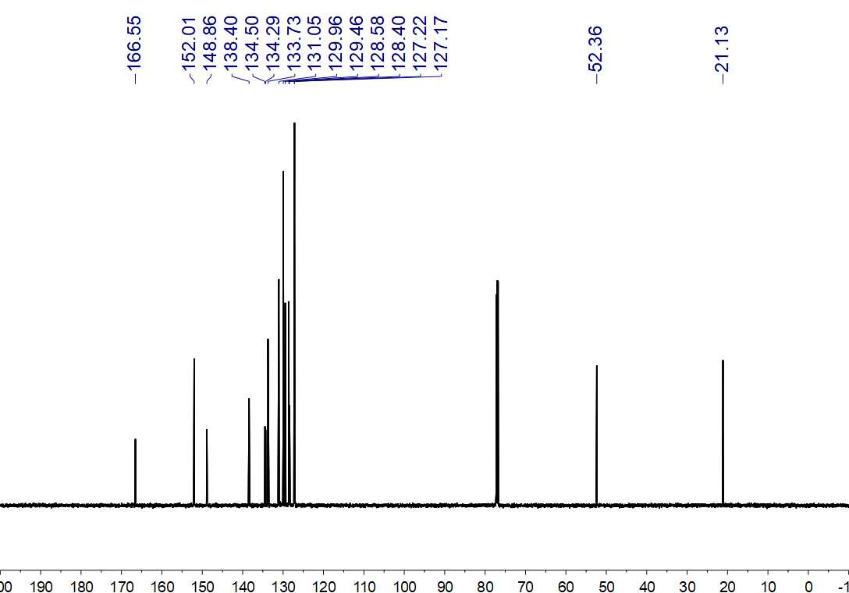
Fig. S260. ¹³C NMR (150 MHz, CDCl₃) spectrum of 95

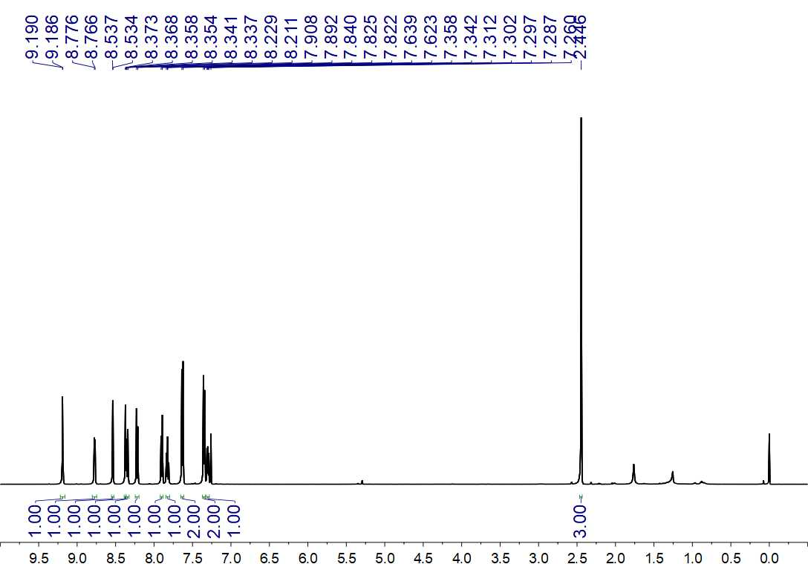
Fig. S261 ¹H NMR (500 MHz, CDCl₃) spectrum of 96

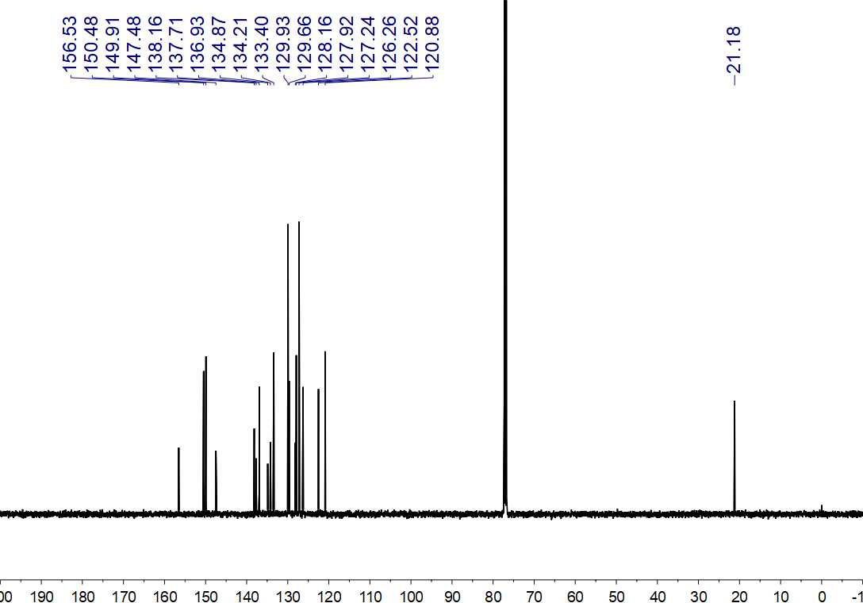
Fig. S262. ¹³C NMR (125 MHz, CDCl₃) spectrum of 96

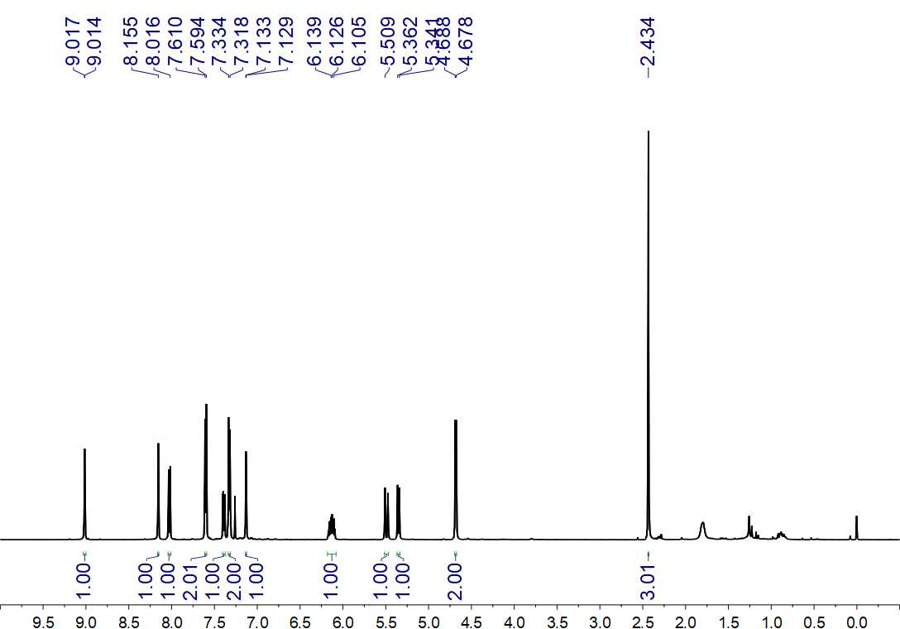
Fig. S263. ¹H NMR (500 MHz, CDCl₃) spectrum of 98

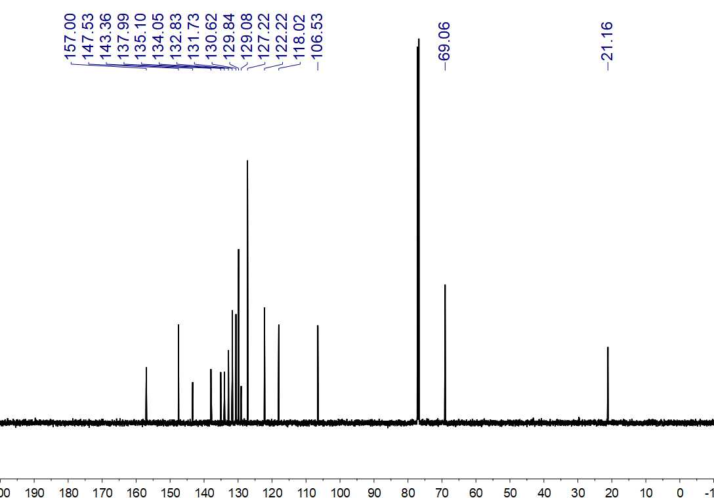
Fig. S264. ¹³C NMR (150 MHz, CDCl₃) spectrum of 98

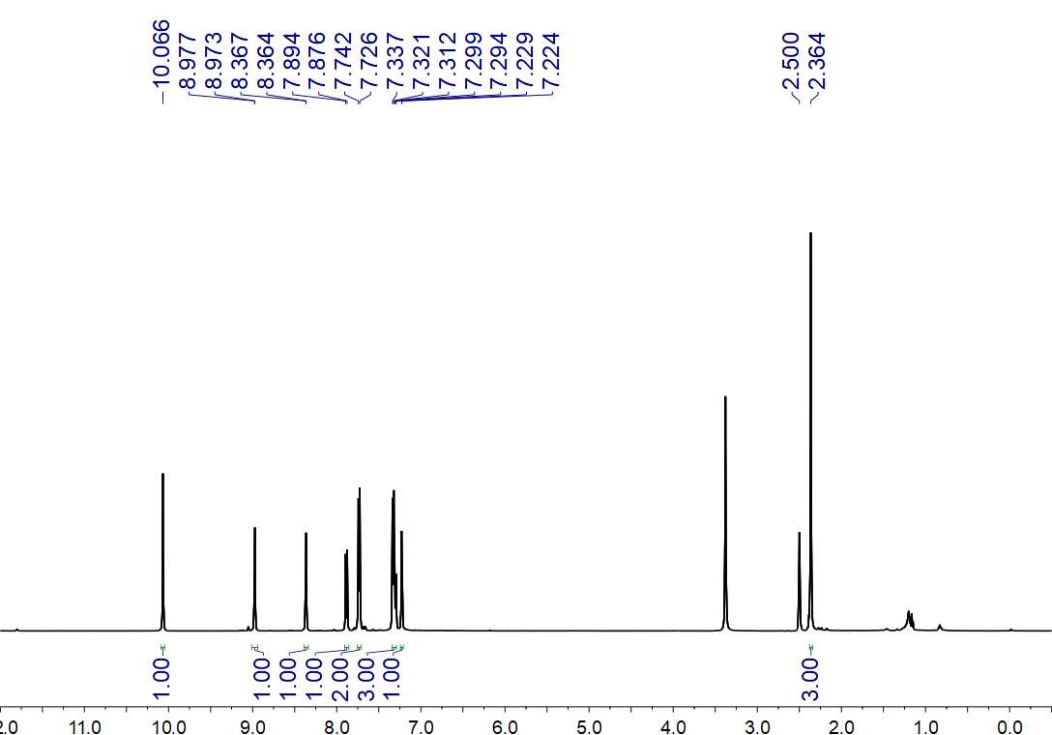
Fig. S265. ¹H NMR (500 MHz, DMSO-d₆) spectrum of 98

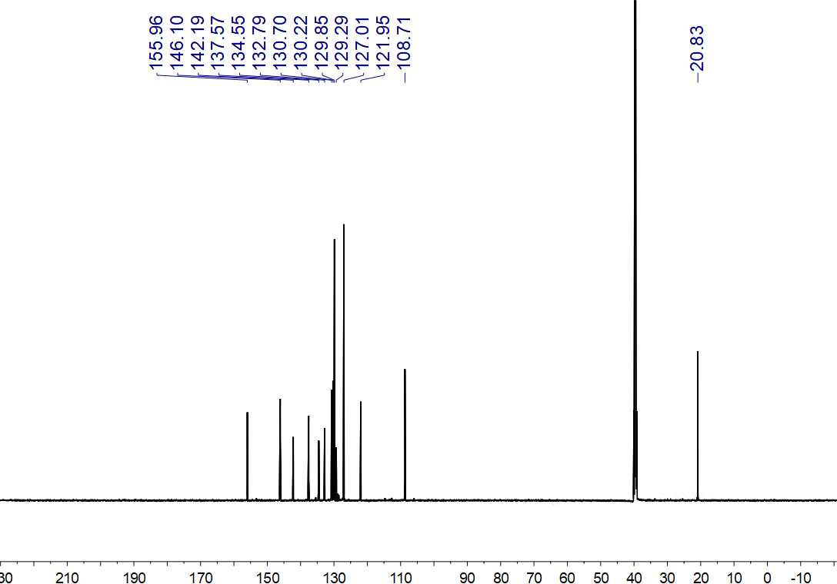
Fig. S266. ¹³C NMR (150 MHz, DMSO-d₆) spectrum of 98

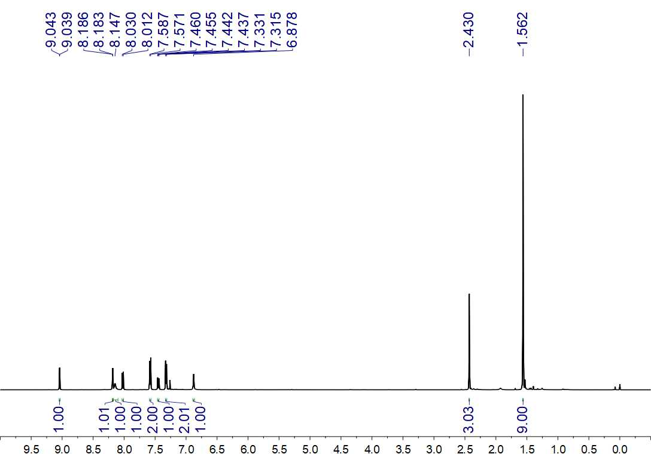
Fig. S267. ¹H NMR (500 MHz, CDCl₃) spectrum of 99

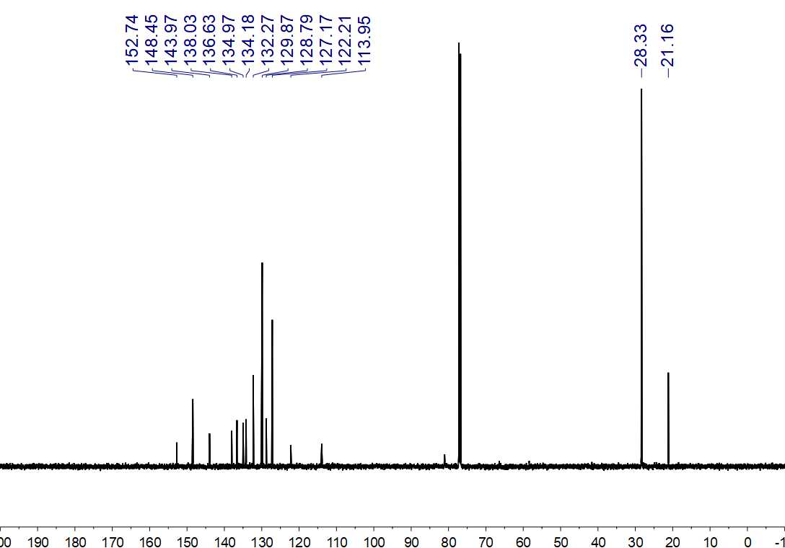
Fig. S268. ¹³C NMR (150 MHz, CDCl₃) spectrum of 99

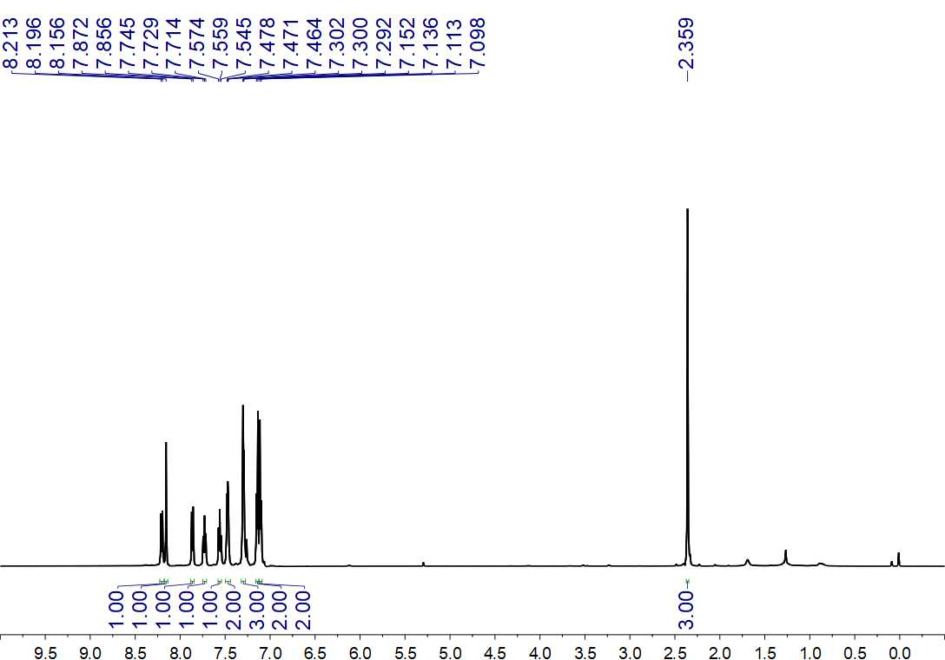
Fig. S269. ¹H NMR (500 MHz, CDCl₃) spectrum of 100

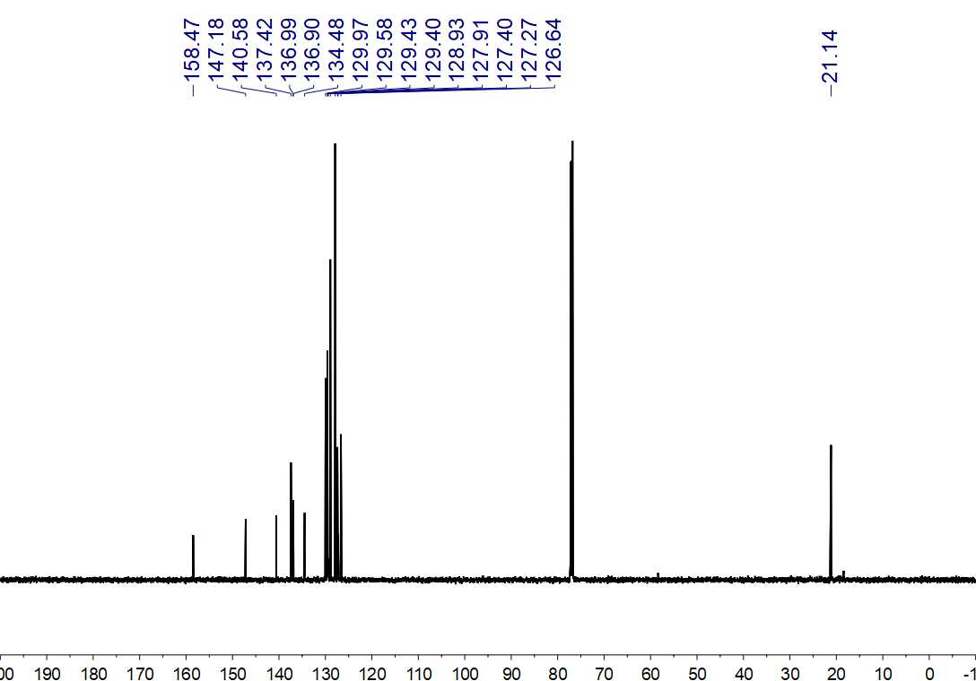
Fig. S270. ¹³C NMR (150 MHz, CDCl₃) spectrum of 100

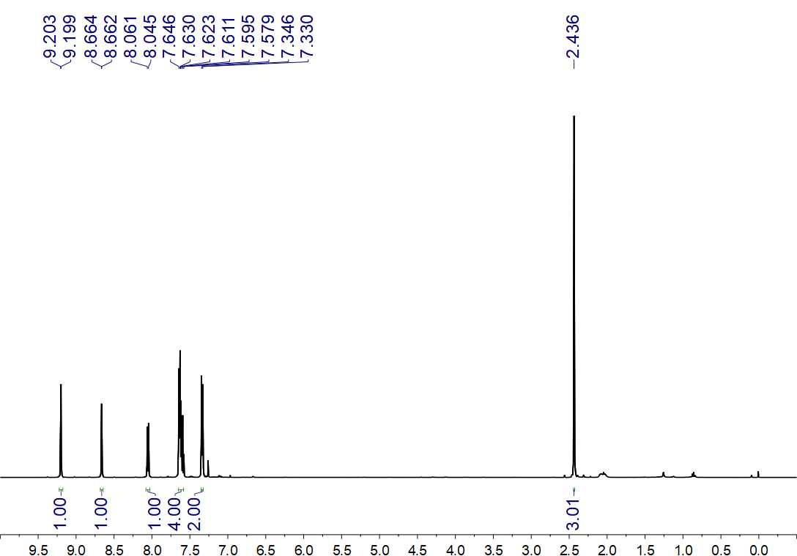
Fig. S271. ¹H NMR (500 MHz, CDCl₃) spectrum of 101

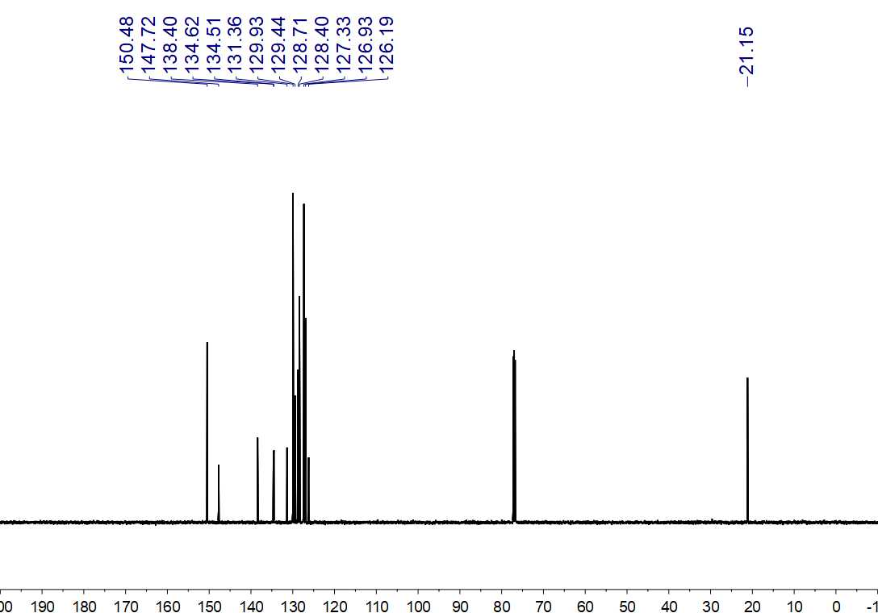
Fig. S272. ¹³C NMR (150 MHz, CDCl₃) spectrum of 101

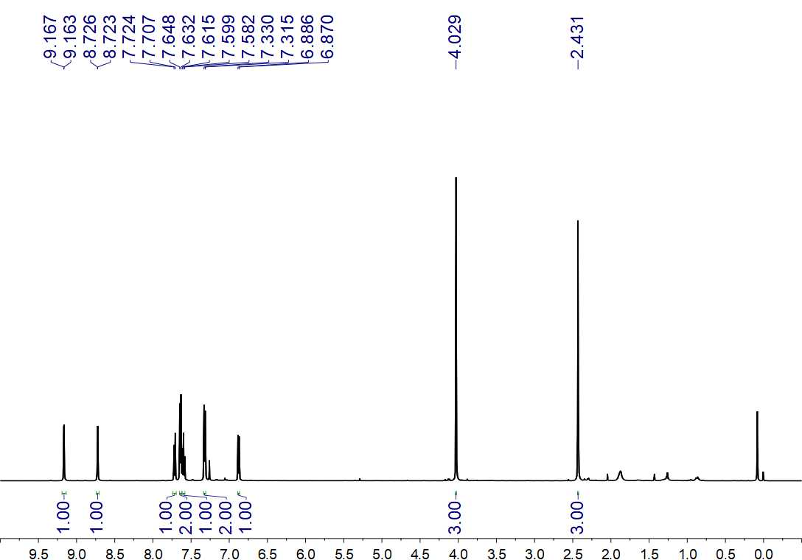
Fig. S273. ¹H NMR (500 MHz, CDCl₃) spectrum of 102

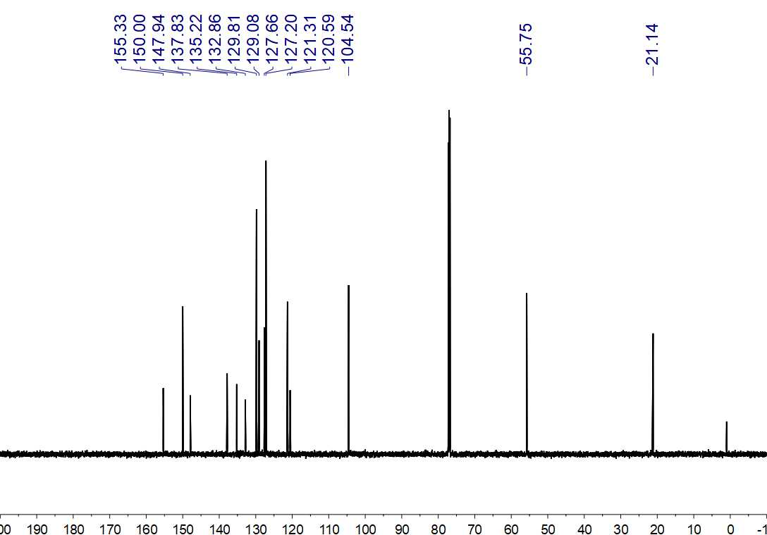
Fig. S274. ¹³C NMR (150 MHz, CDCl₃) spectrum of 102

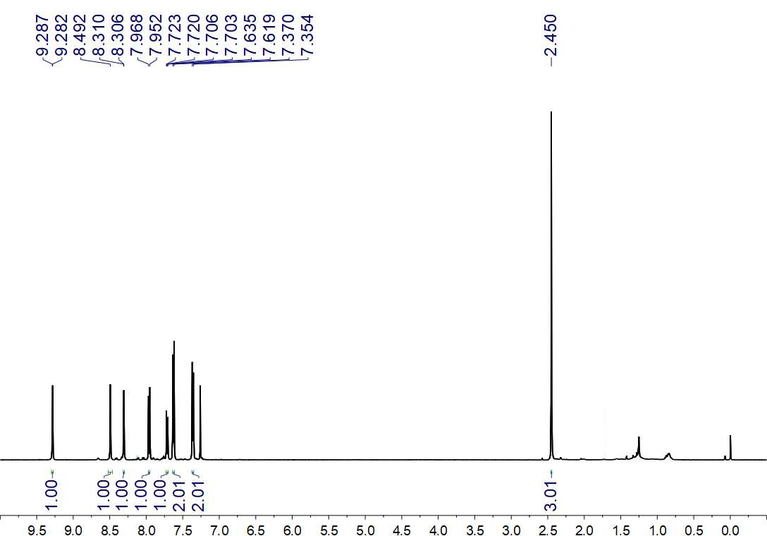
Fig. S275. ¹H NMR (500 MHz, CDCl₃) spectrum of 103

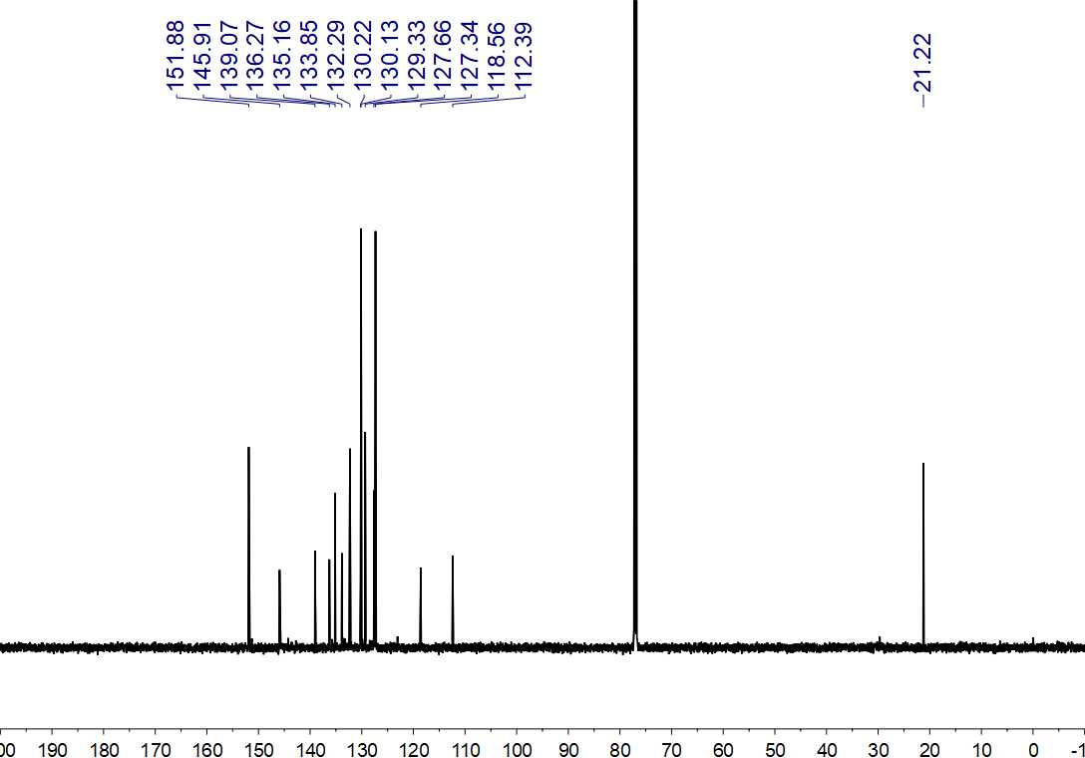Fig. S276. ¹³C NMR (150 MHz, CDCl₃) spectrum of 103

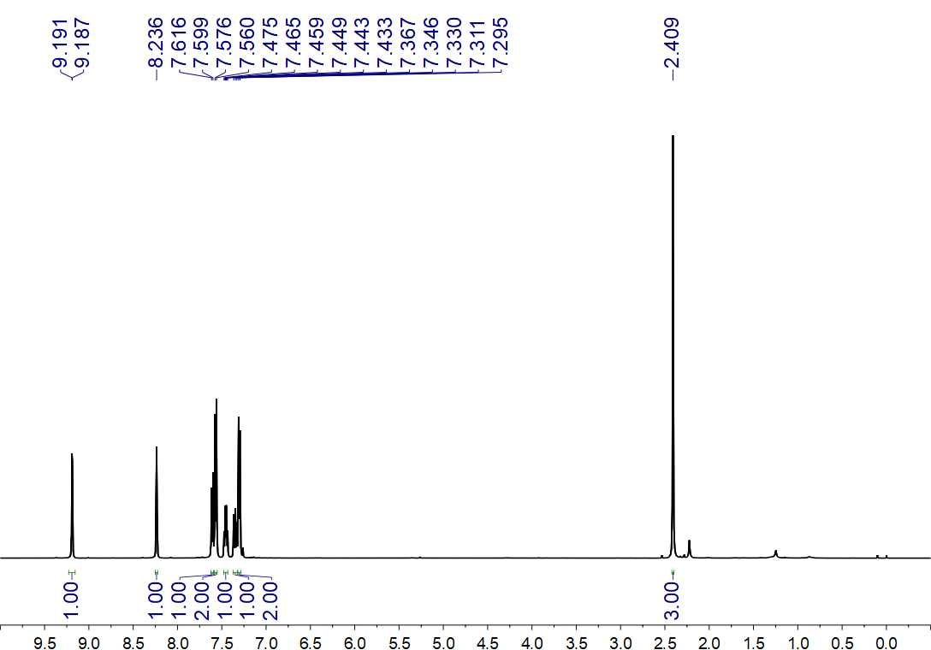
Fig. S277. ¹H NMR (500 MHz, CDCl₃) spectrum of 104

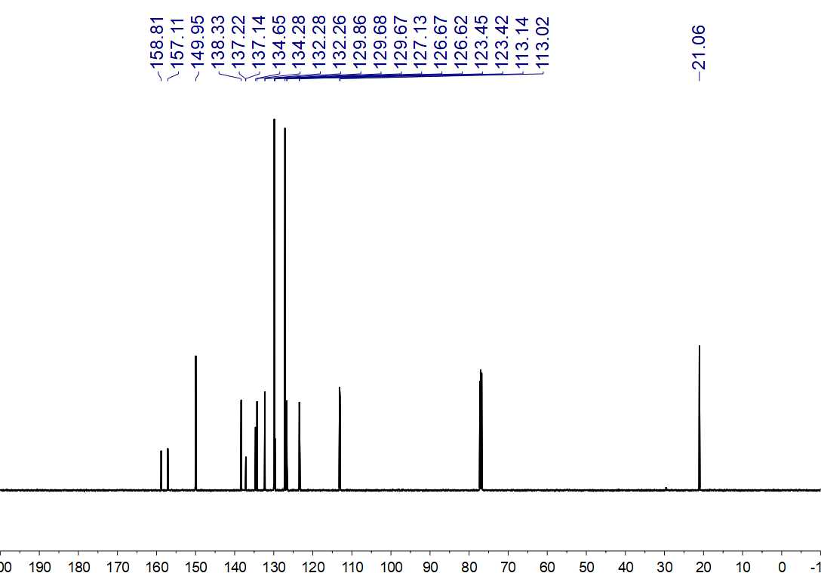
Fig. S278. ¹³C NMR (150 MHz, CDCl₃) spectrum of 104

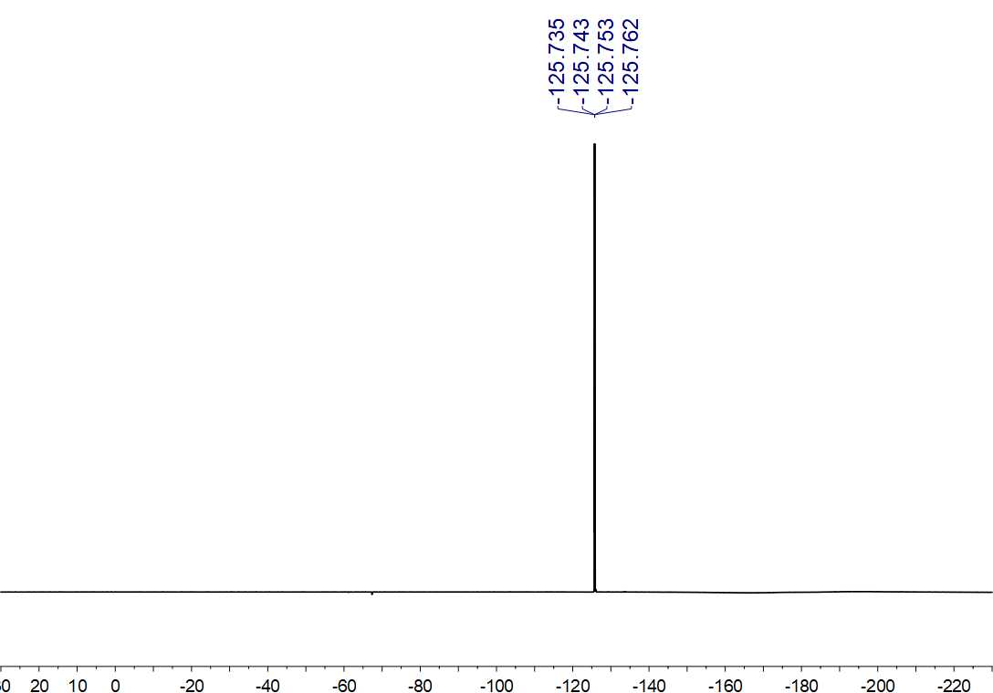
Fig. S279. ¹⁹F NMR (564 MHz, CDCl₃) spectrum of 104

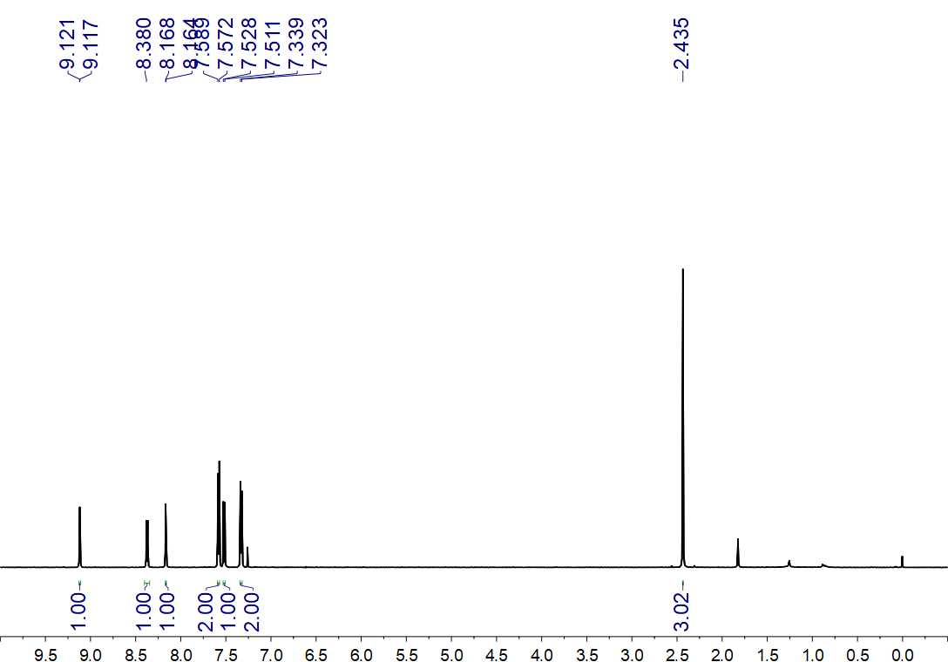
Fig. S280. ¹H NMR (500 MHz, CDCl₃) spectrum of 105

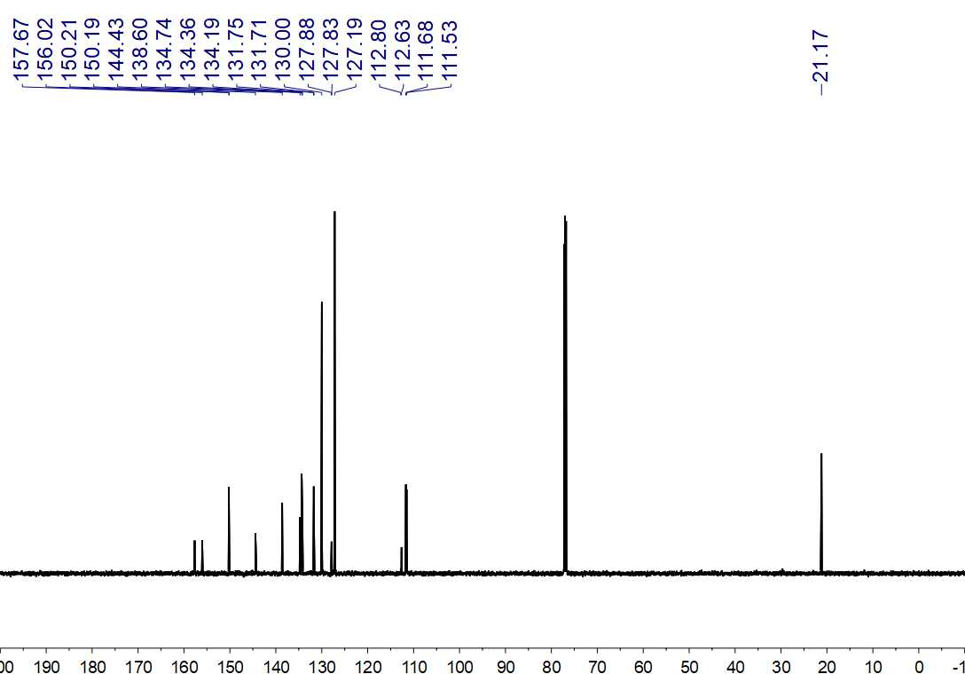
Fig. S281. ¹³C NMR (150 MHz, CDCl₃) spectrum of 105

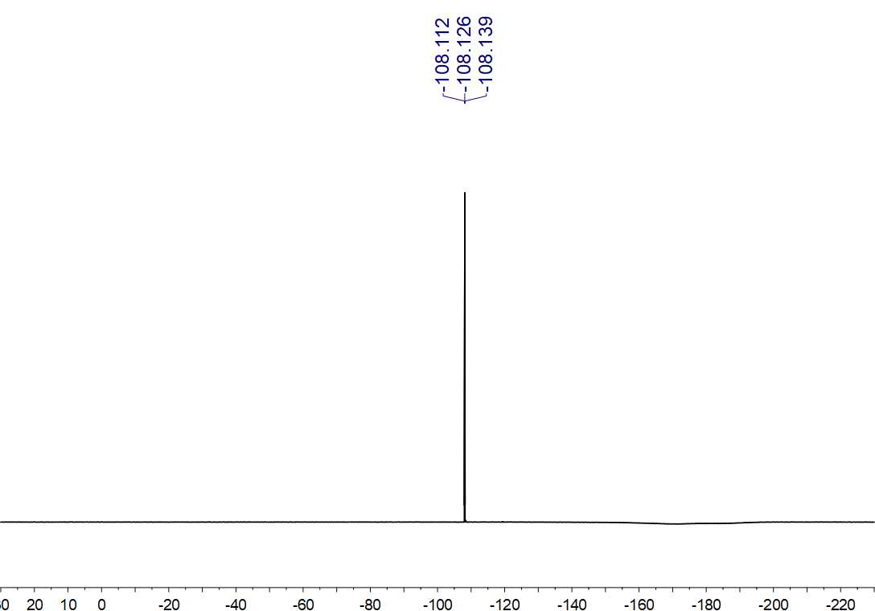
Fig. S282. ¹⁹F NMR (564 MHz, CDCl₃) spectrum of 105

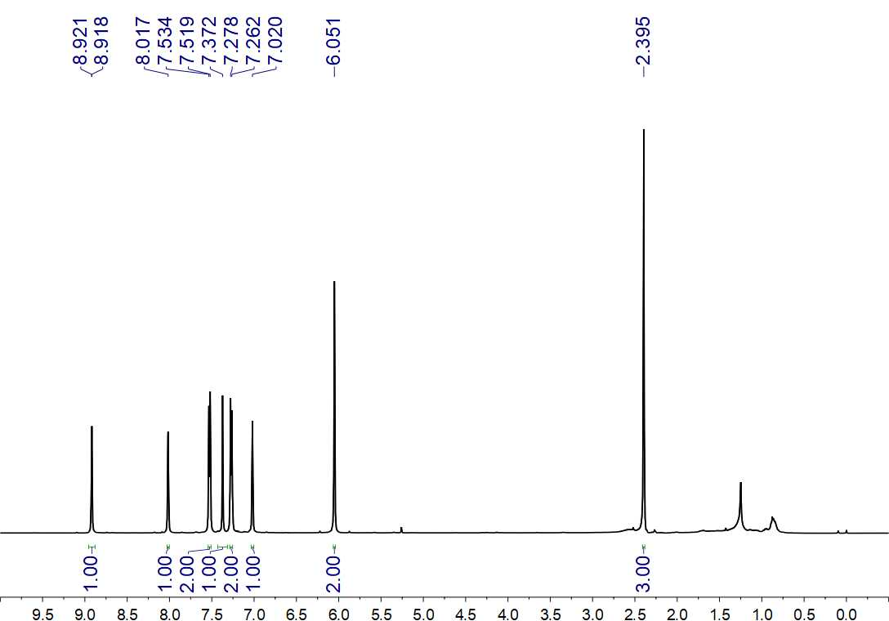
Fig. S283. ¹H NMR (500 MHz, CDCl₃) spectrum of 106

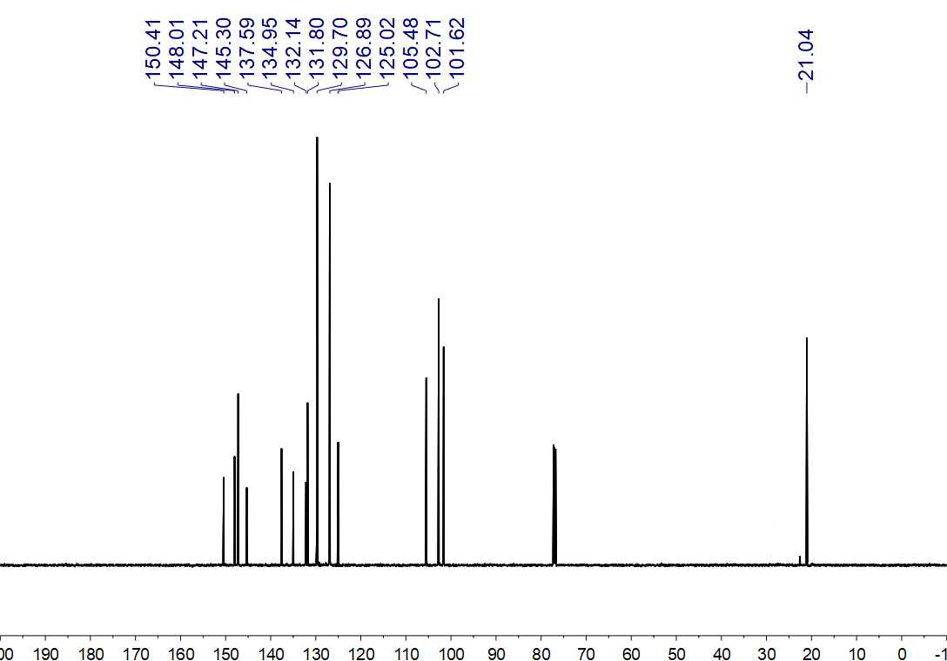
Fig. S284. ¹³C NMR (150 MHz, CDCl₃) spectrum of 106

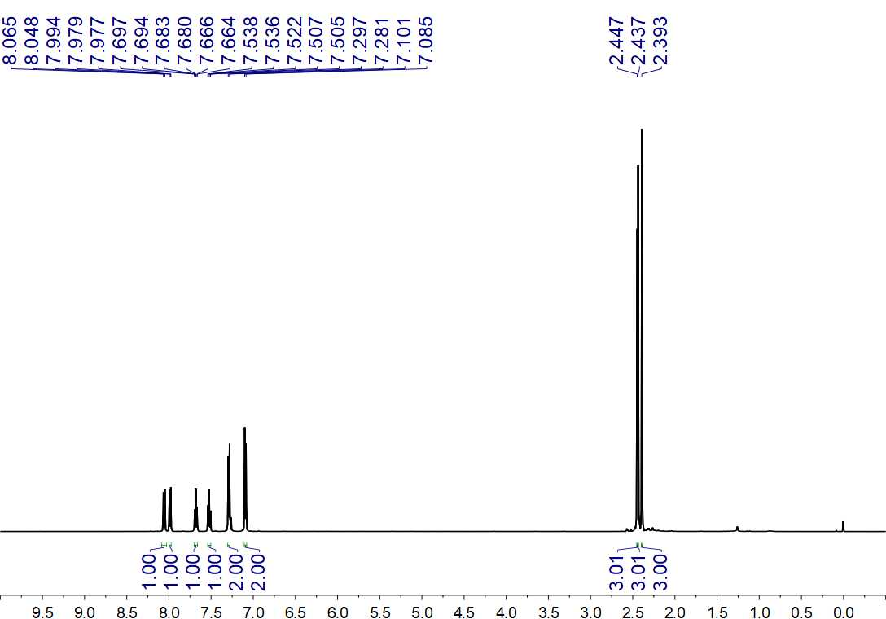
Fig. S285. ¹H NMR (500 MHz, CDCl₃) spectrum of 107

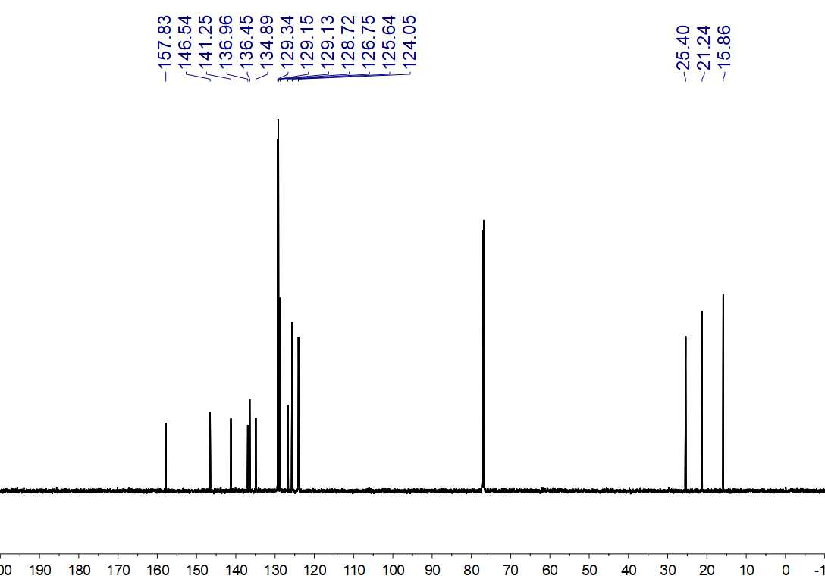
Fig. S286. ¹³C NMR (150 MHz, CDCl₃) spectrum of 107

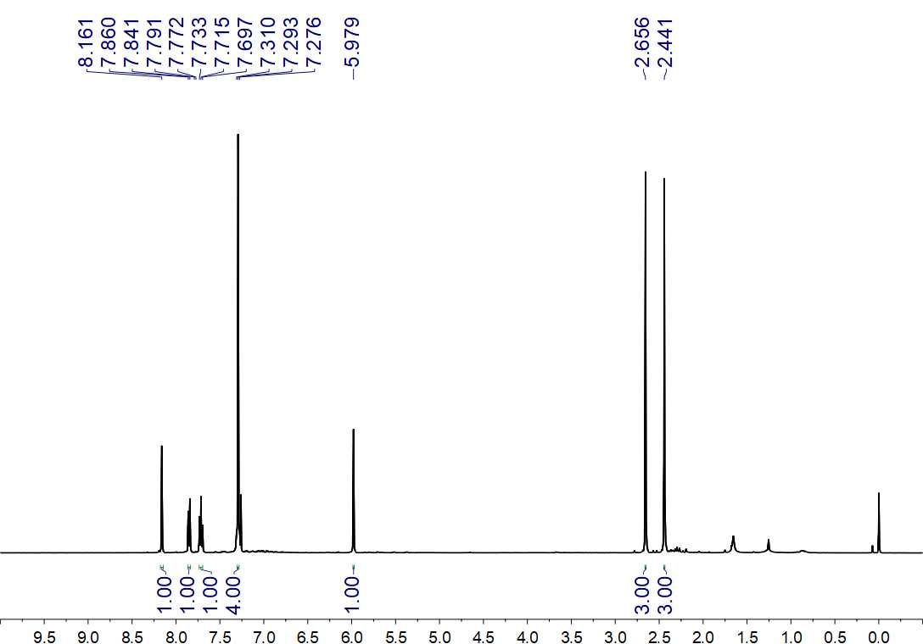
Fig. S287. ¹H NMR (500 MHz, CDCl₃) spectrum of 108

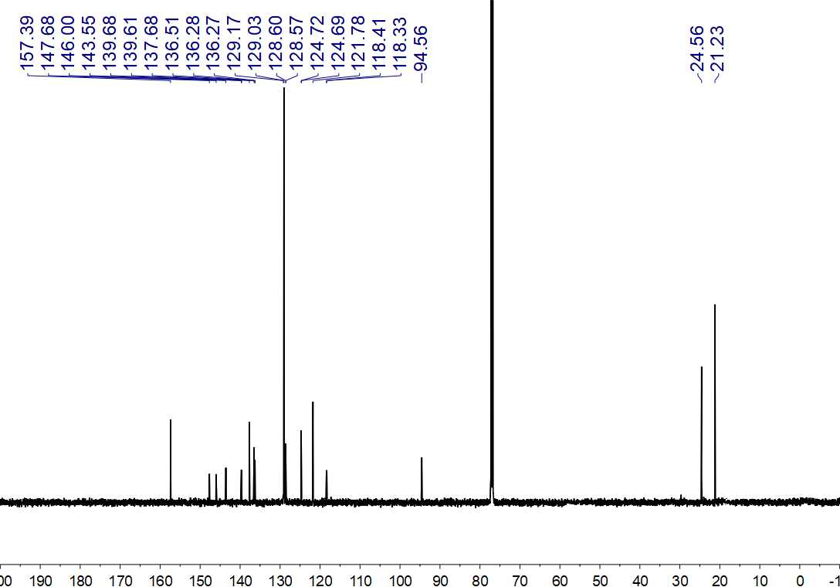
Fig. S288. ¹³C NMR (150 MHz, CDCl₃) spectrum of 108

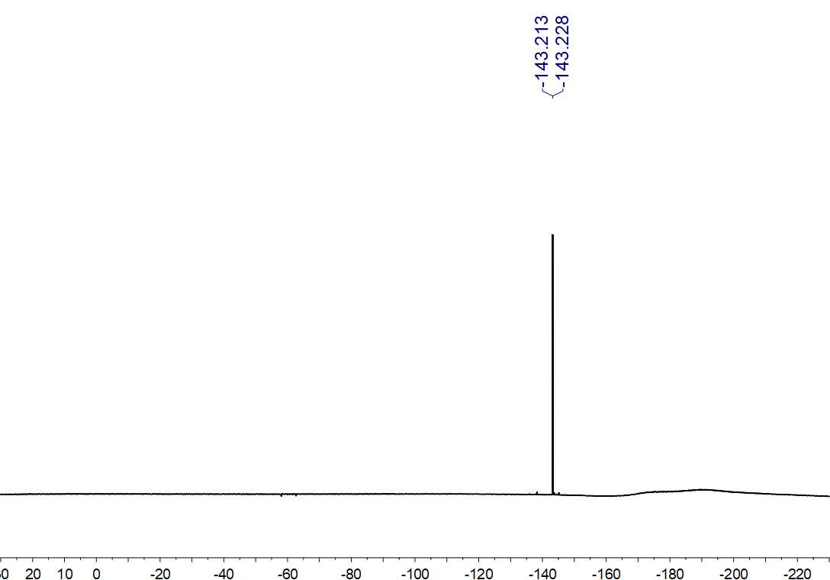
Fig. S289. ¹⁹F NMR (564 MHz, CDCl₃) spectrum of 108

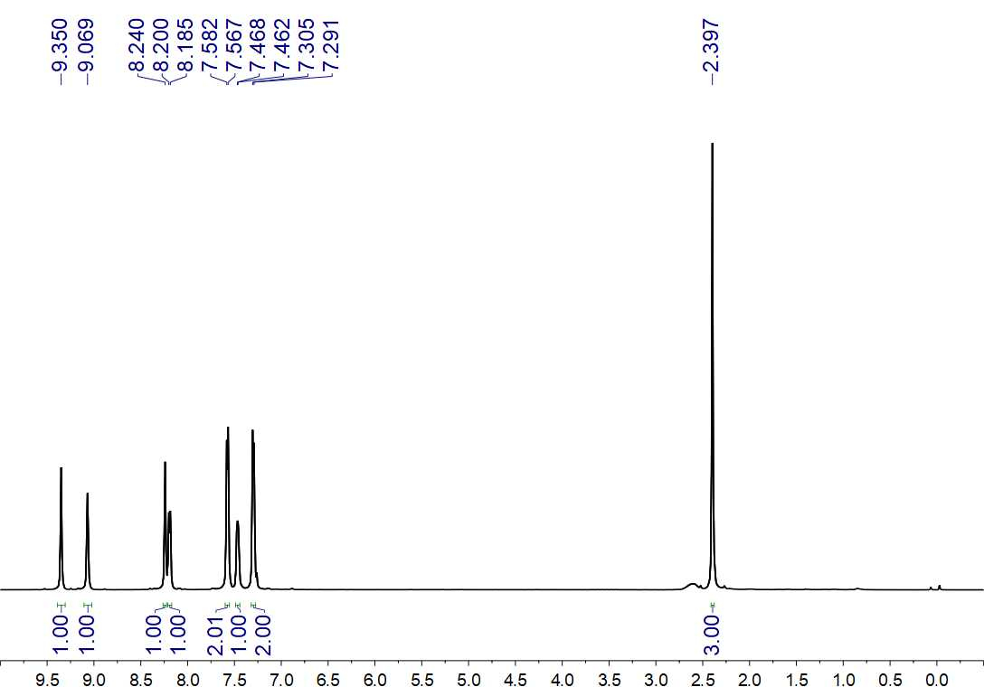
Fig. S290. ¹H NMR (500 MHz, CDCl₃) spectrum of 109

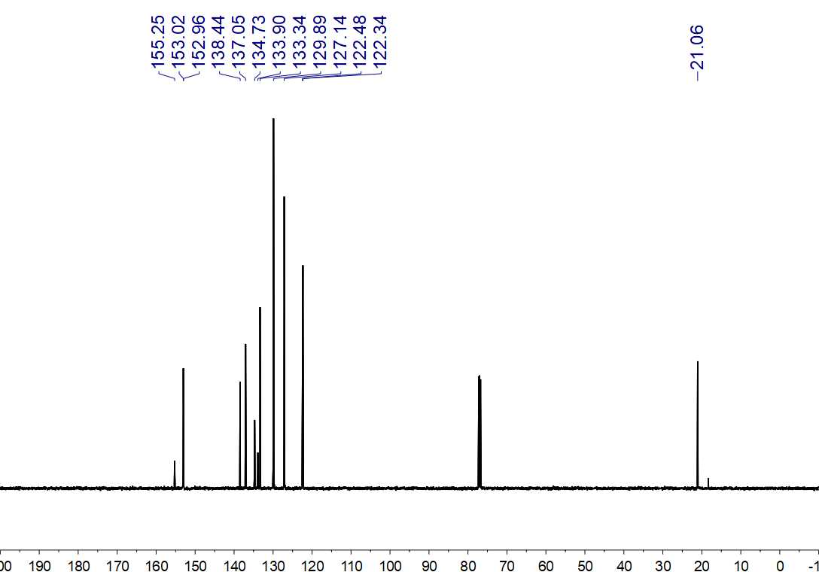
Fig. S291. ¹³C NMR (150 MHz, CDCl₃) spectrum of 109

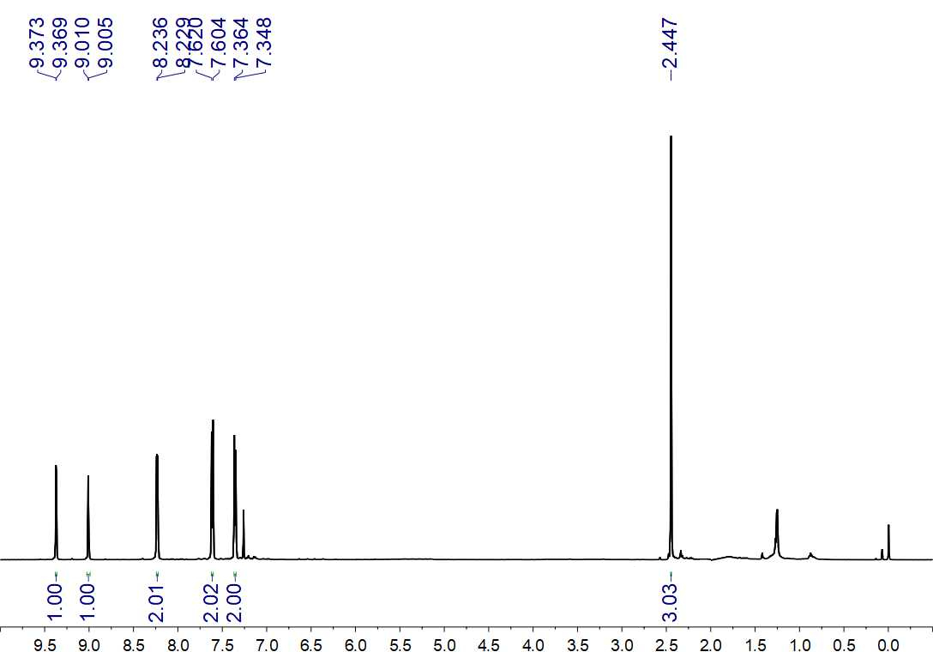
Fig. S292. ¹H NMR (500 MHz, CDCl₃) spectrum of 110

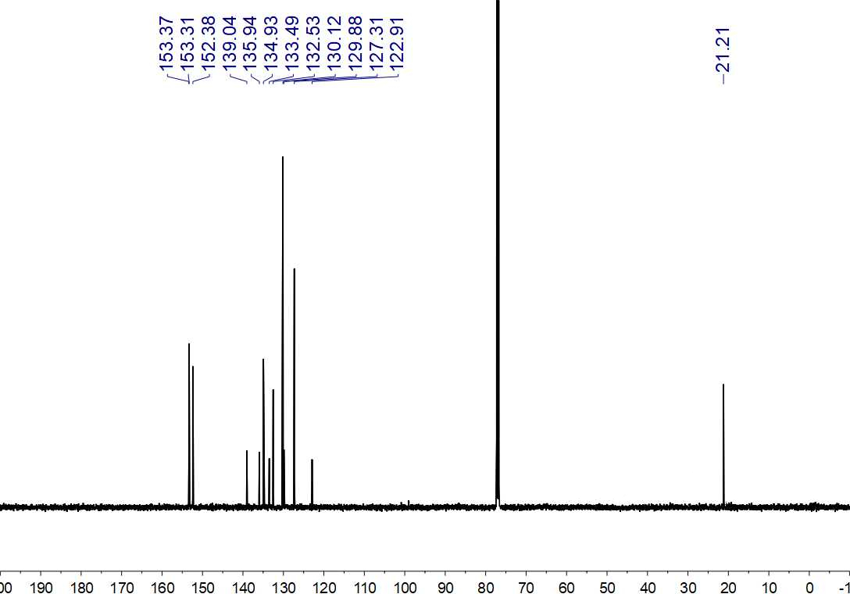
Fig. S293. ¹³C NMR (125 MHz, CDCl₃) spectrum of 110

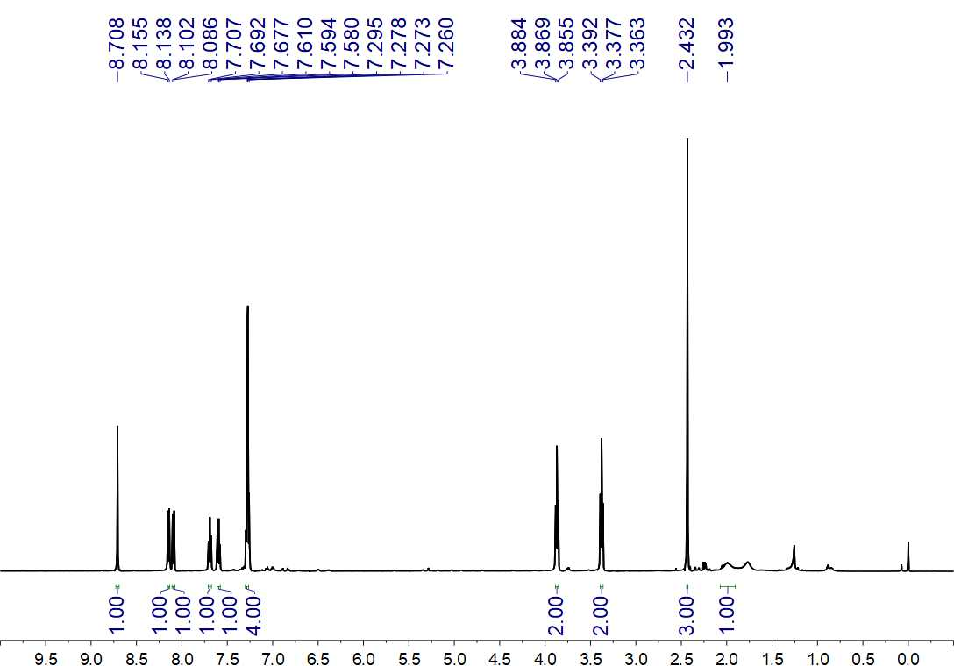
Fig. S294. ¹H NMR (500 MHz, CDCl₃) spectrum of 111

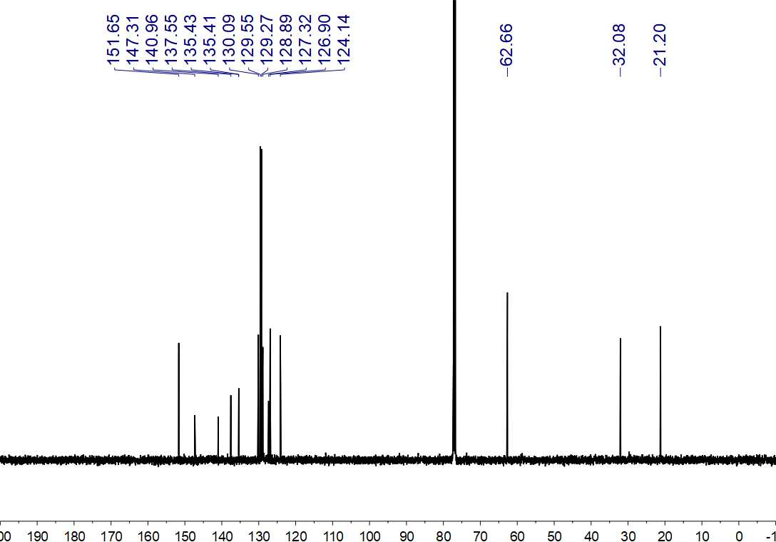
Fig. S295. ¹³C NMR (125 MHz, CDCl₃) spectrum of 111

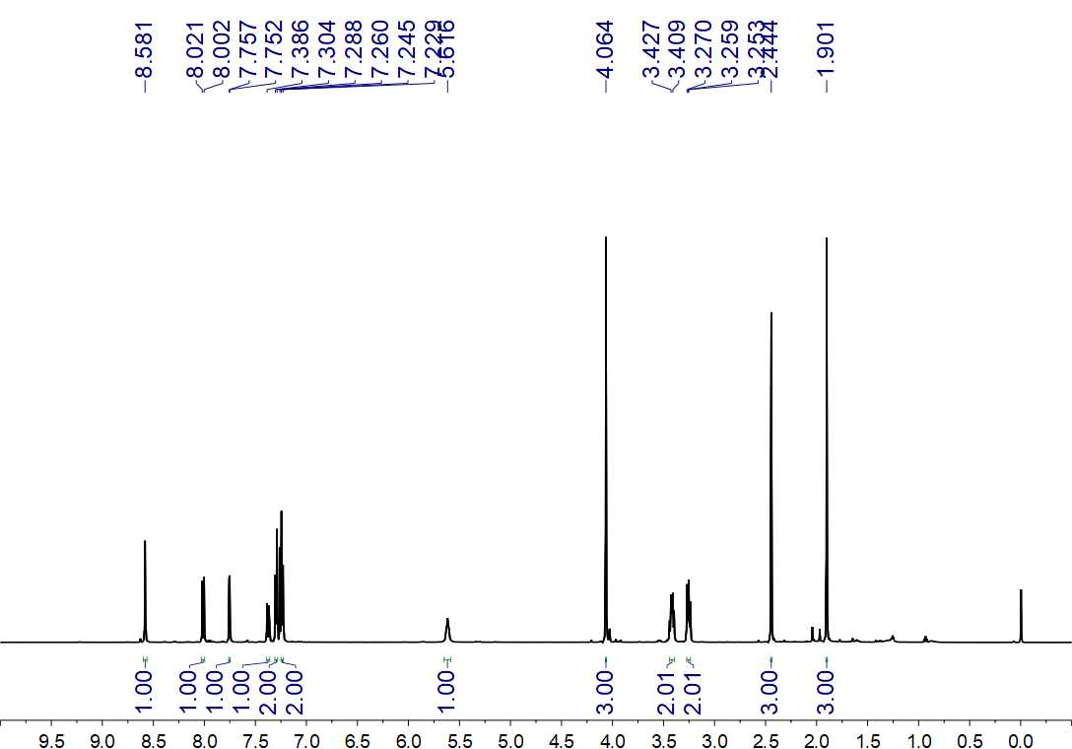
Fig. S296. ¹H NMR (500 MHz, CDCl₃) spectrum of 112

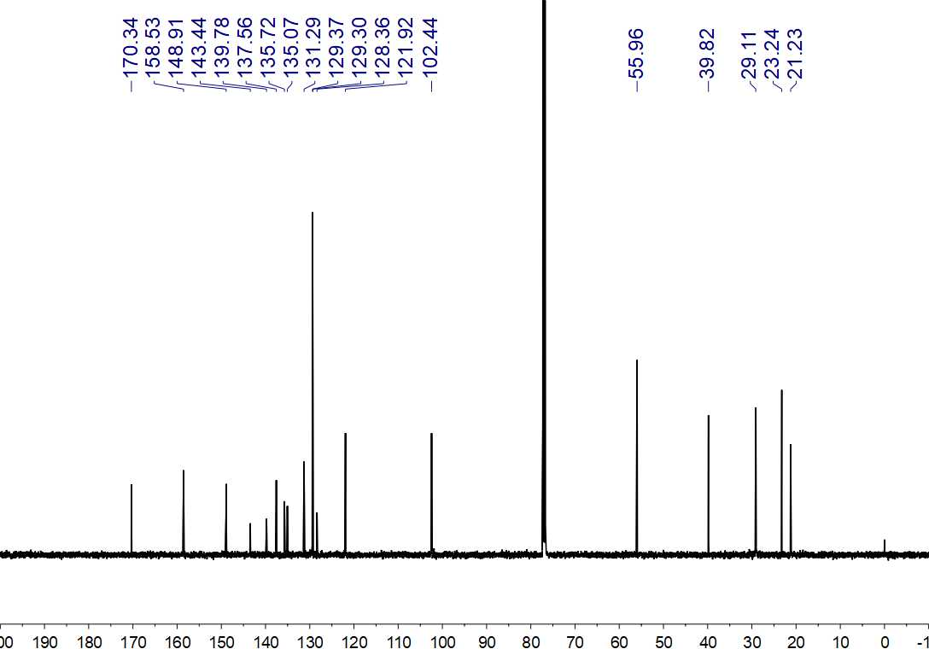
Fig. S297. ¹³C NMR (125 MHz, CDCl₃) spectrum of 112

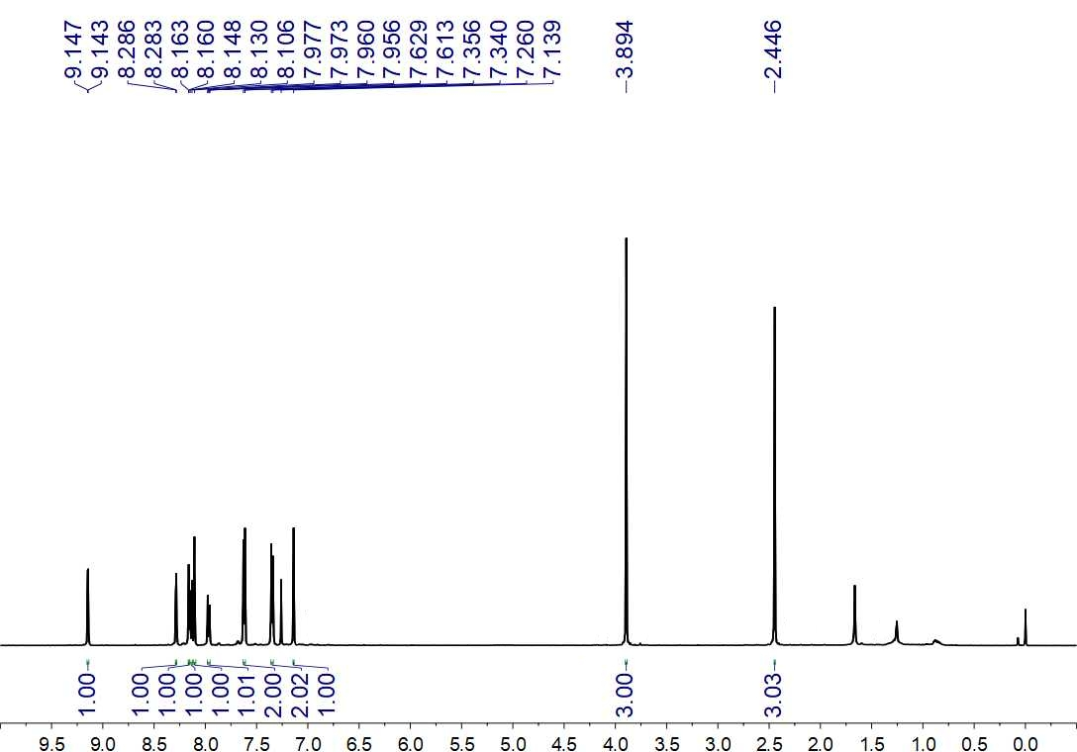
Fig. S298. ¹H NMR (500 MHz, CDCl₃) spectrum of 113

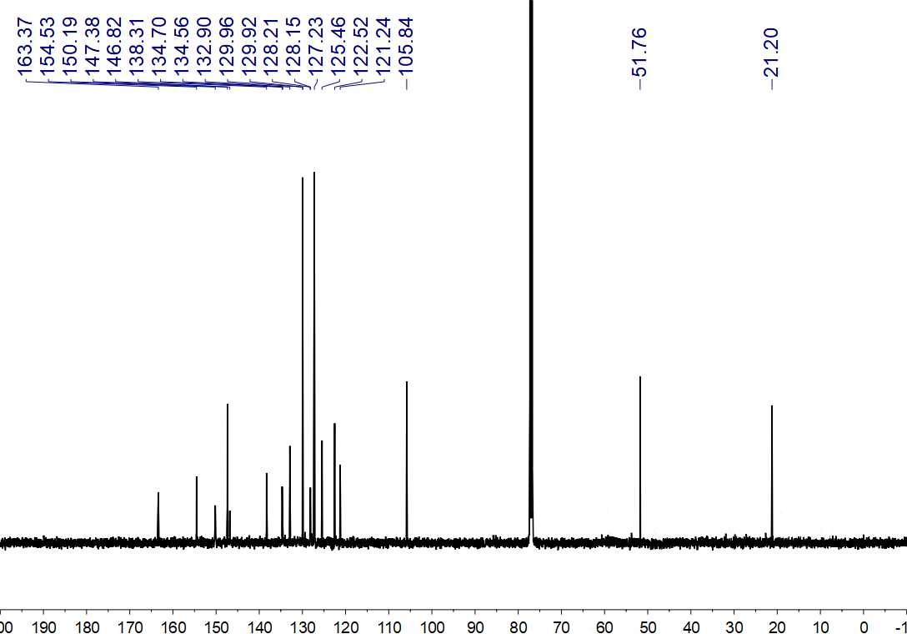
Fig. S299. ¹³C NMR (125 MHz, CDCl₃) spectrum of 113

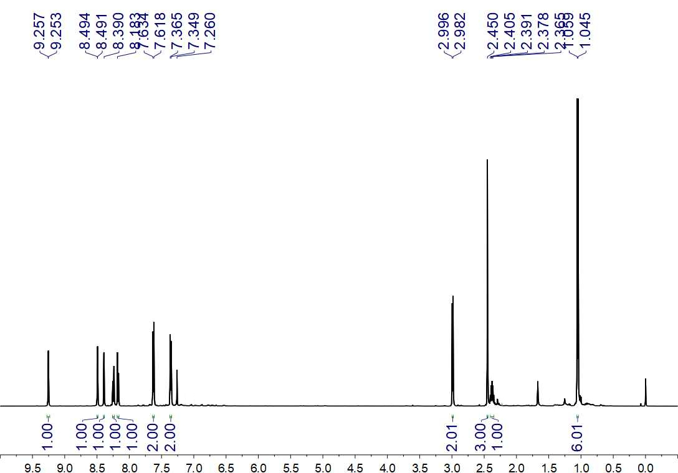
Fig. S300. ¹H NMR (500 MHz, CDCl₃) spectrum of 114

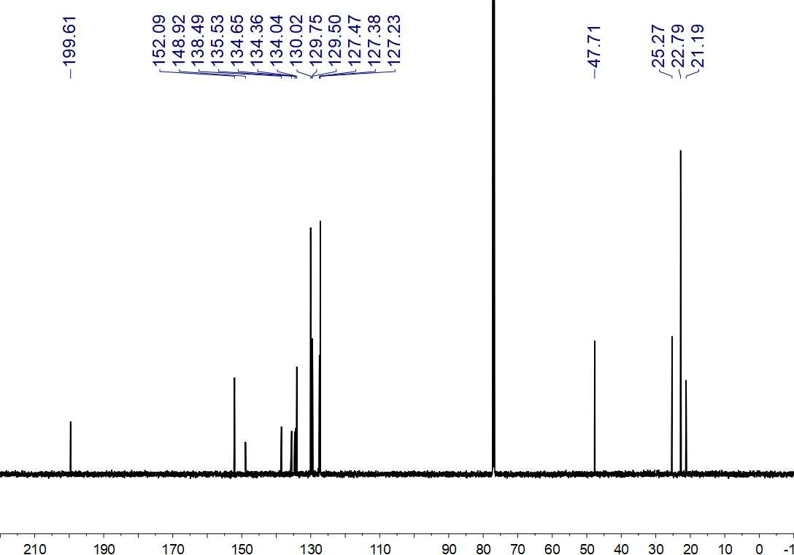
Fig. S301. ¹³C NMR (150 MHz, CDCl₃) spectrum of 114

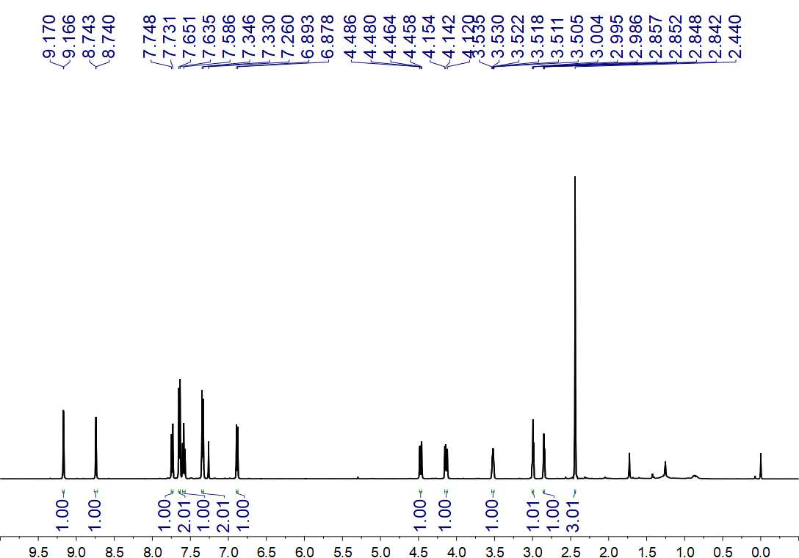
Fig. S302. ¹H NMR (500 MHz, CDCl₃) spectrum of 115

Fig. S303. ¹³C NMR (150 MHz, CDCl₃) spectrum of 115

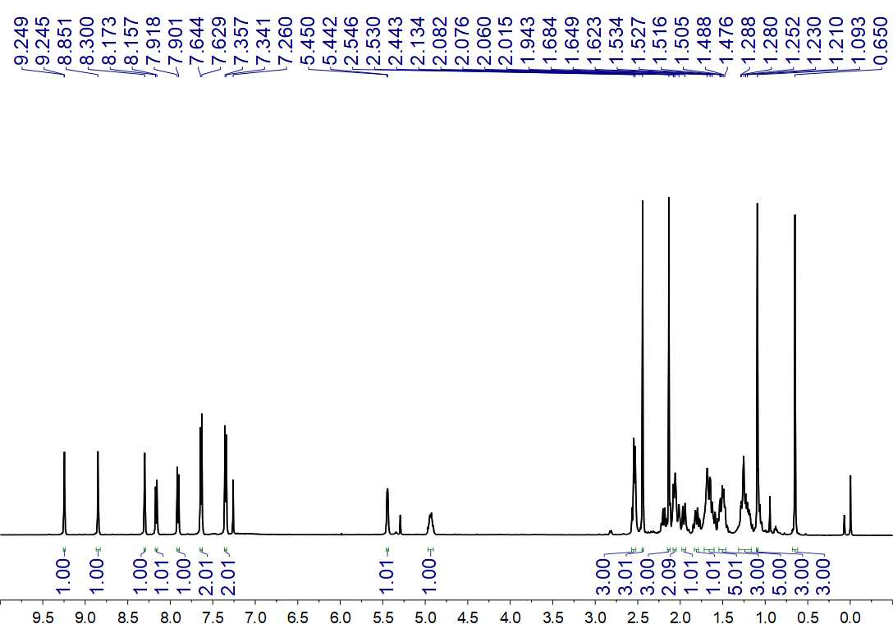
Fig. S304. ¹H NMR (500 MHz, CDCl₃) spectrum of 116

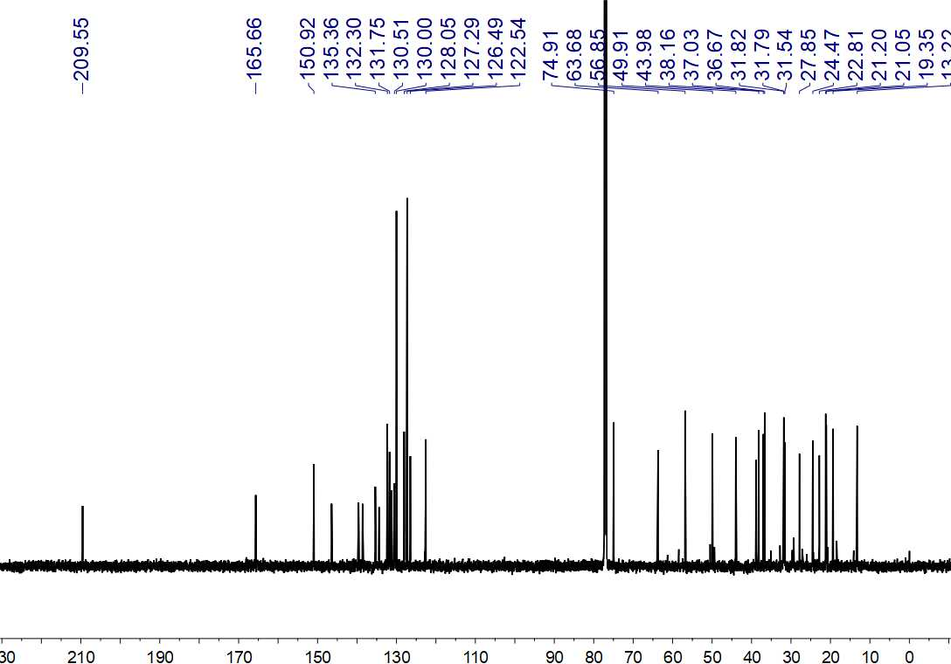
Fig. S305. ¹³C NMR (150 MHz, CDCl₃) spectrum of 116

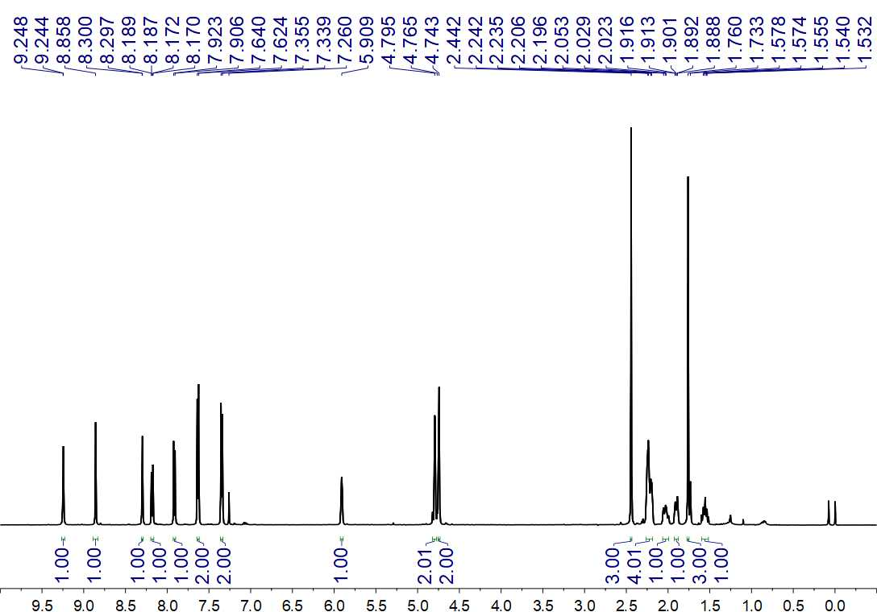
Fig. S306. ¹H NMR (500 MHz, CDCl₃) spectrum of 117

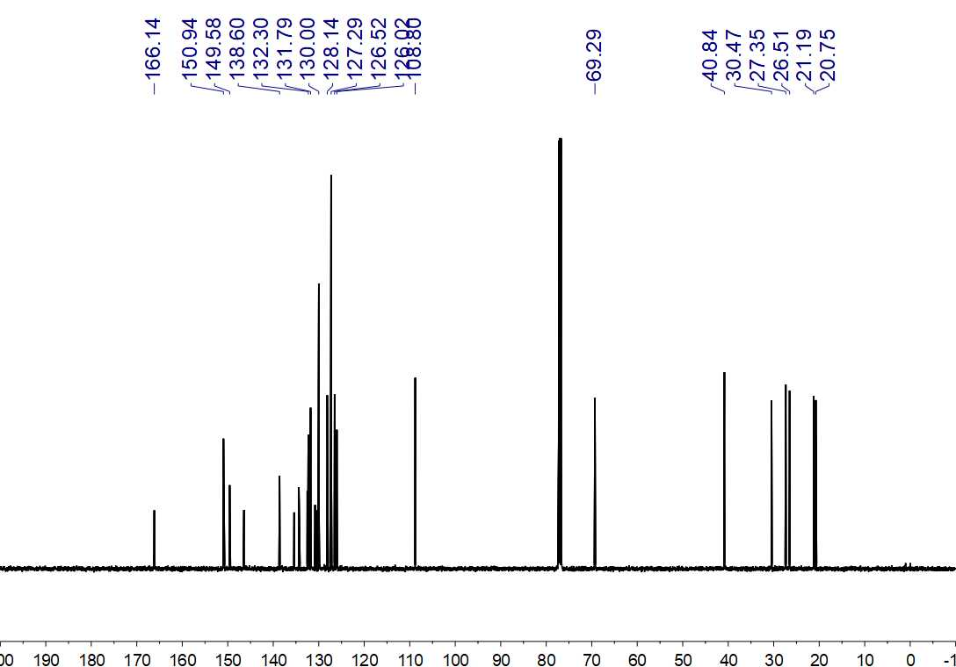
Fig. S307. ¹³C NMR (125 MHz, CDCl₃) spectrum of 117

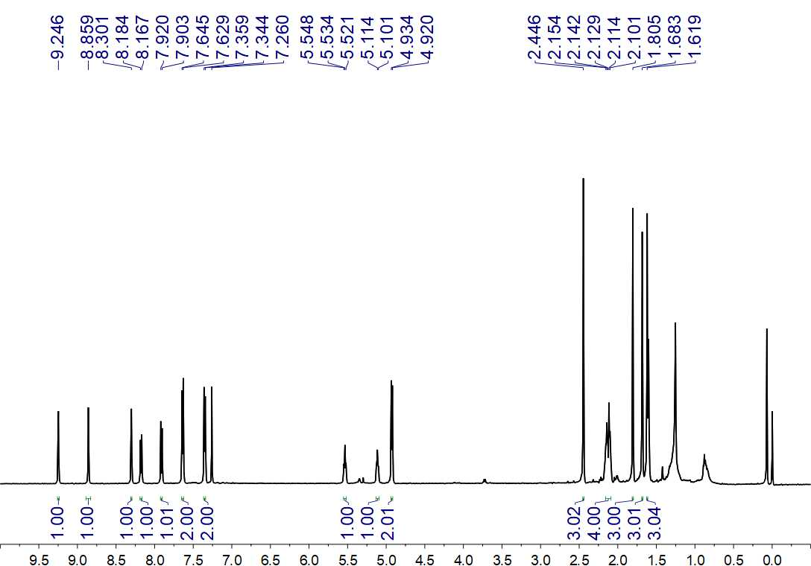
Fig. S308. ¹H NMR (500 MHz, CDCl₃) spectrum of 118

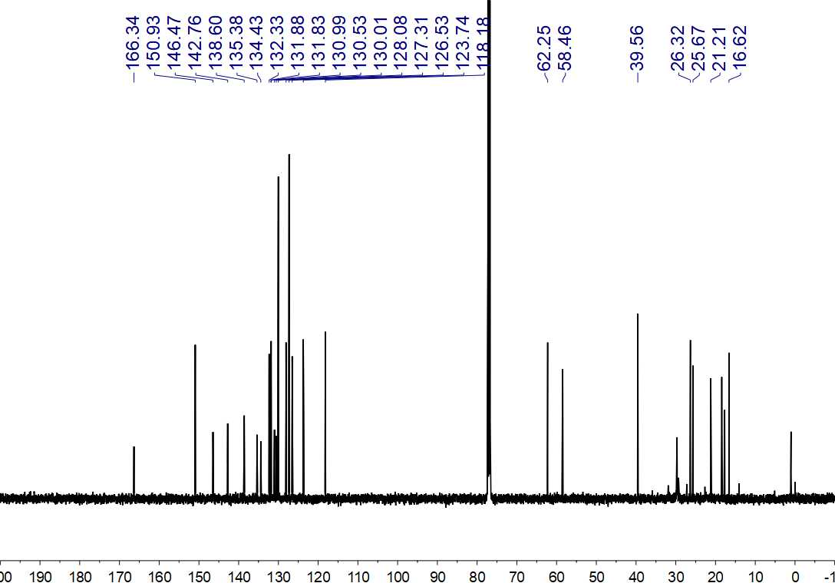
Fig. S309. ¹³C NMR (125 MHz, CDCl₃) spectrum of 118

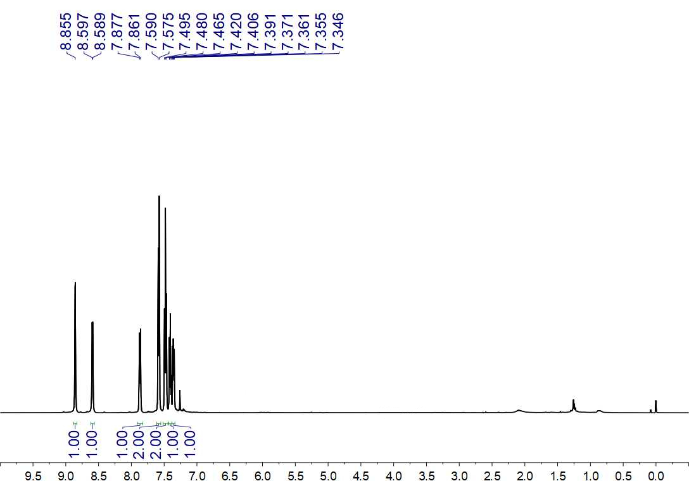
Fig. S310. ¹H NMR (500 MHz, CDCl₃) spectrum of 119

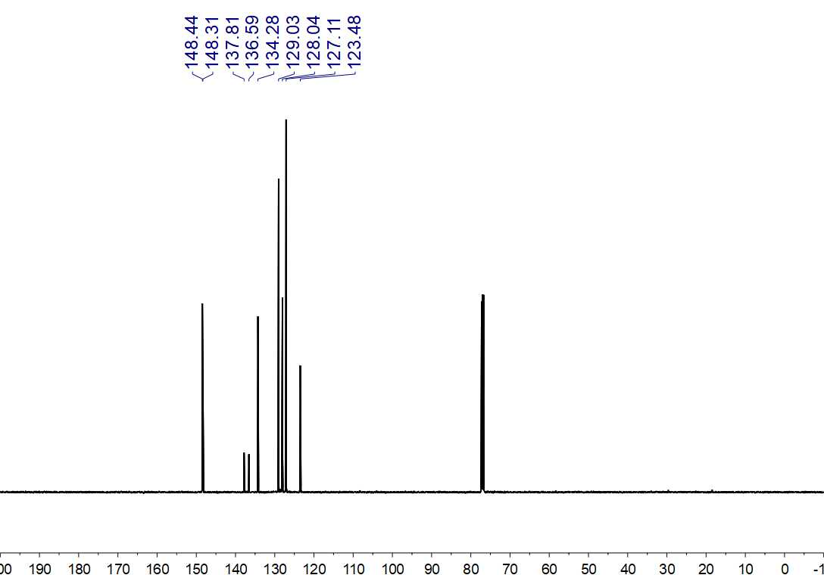
Fig. S311. ¹³C NMR (125 MHz, CDCl₃) spectrum of 119

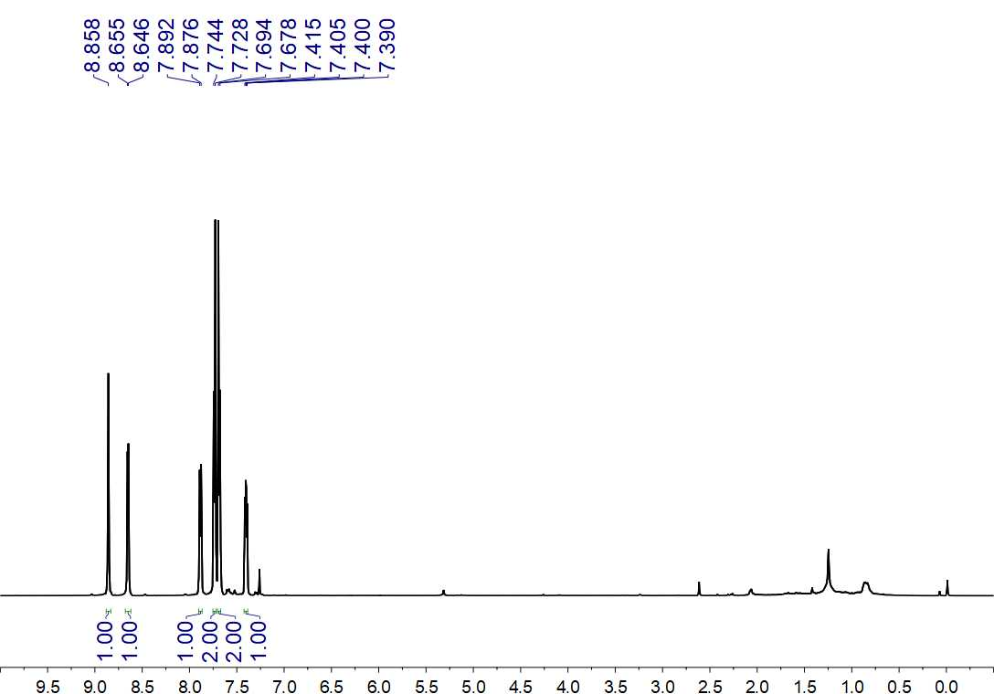
Fig. S312. ¹H NMR (500 MHz, CDCl₃) spectrum of 120

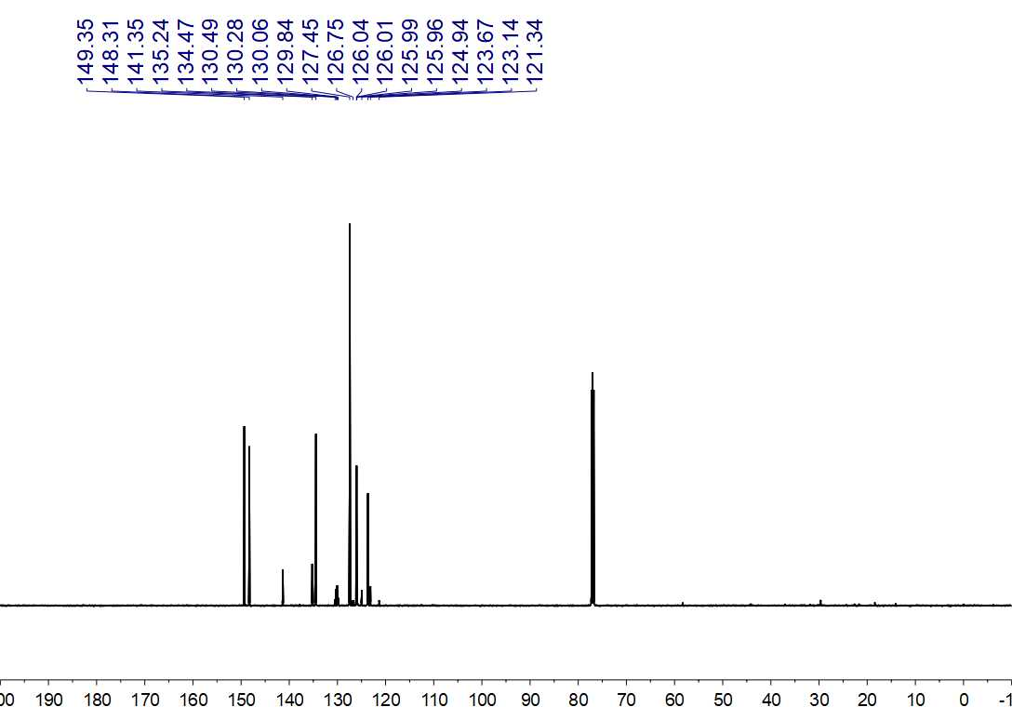
Fig. S313. ¹³C NMR (150 MHz, CDCl₃) spectrum of 120

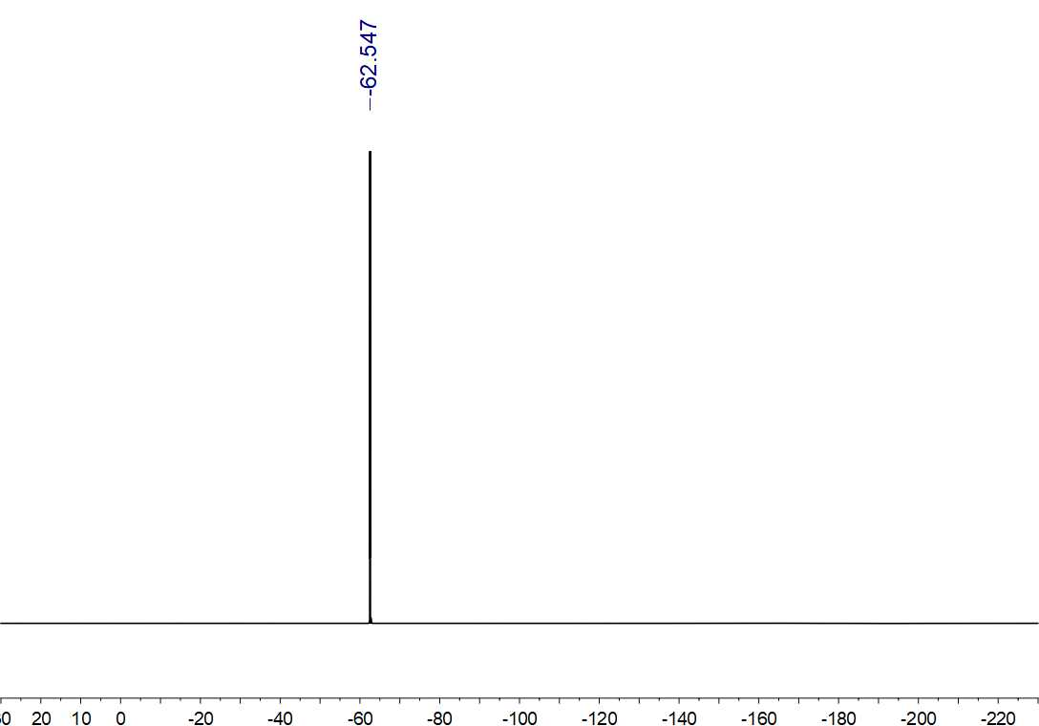
Fig. S314. ¹⁹F NMR (564 MHz, CDCl₃) spectrum of 120

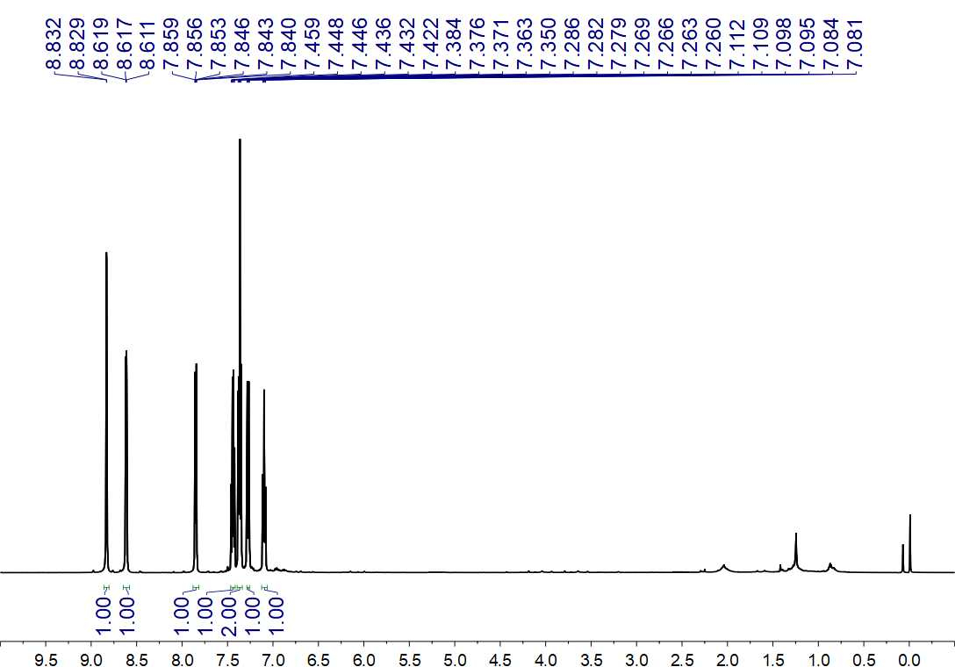
Fig. S315. ¹H NMR (600 MHz, CDCl₃) spectrum of 121

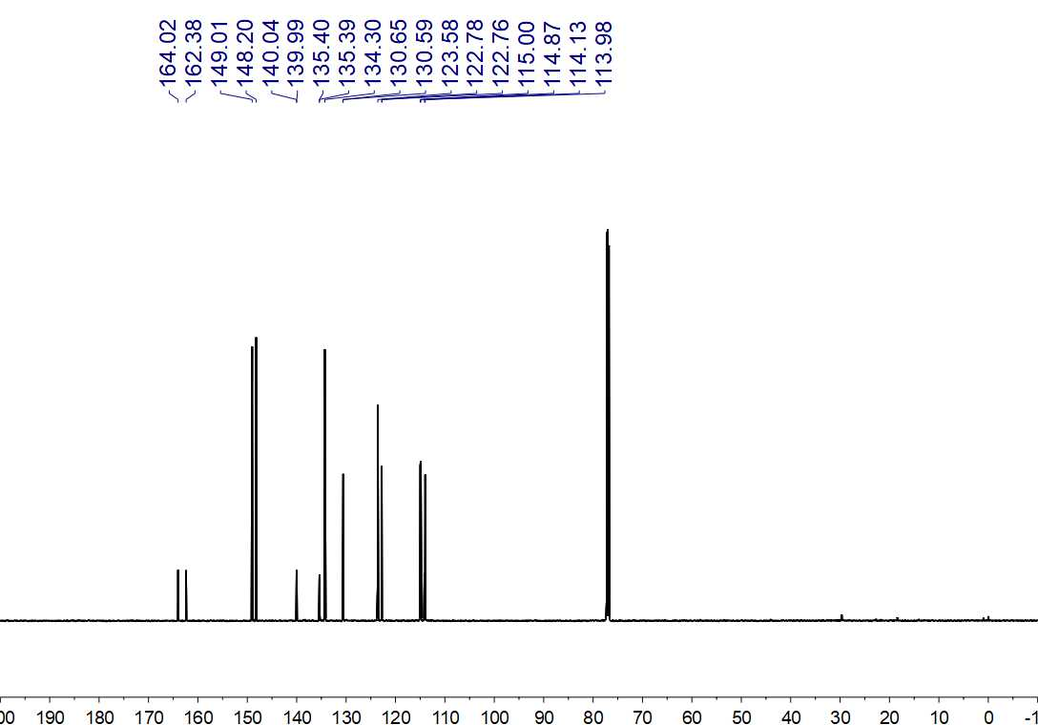
Fig. S316. ¹³C NMR (150 MHz, CDCl₃) spectrum of 121

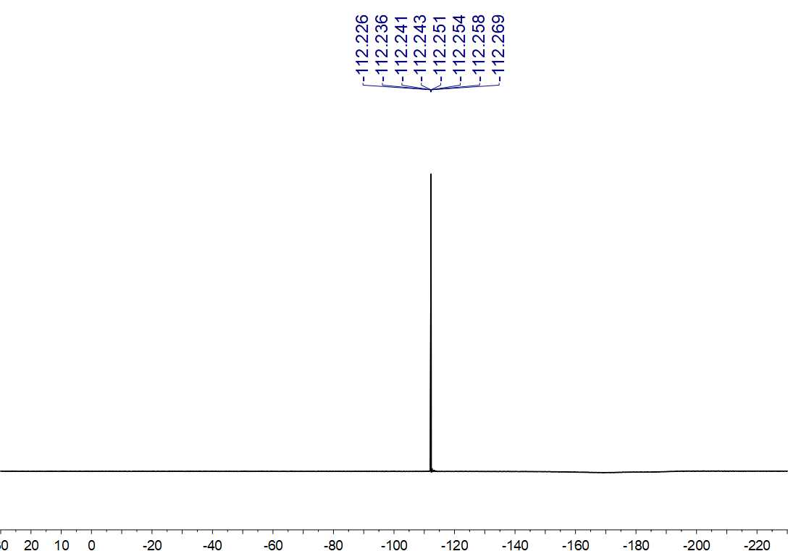
Fig. S317. ¹⁹F NMR (564 MHz, CDCl₃) spectrum of 121

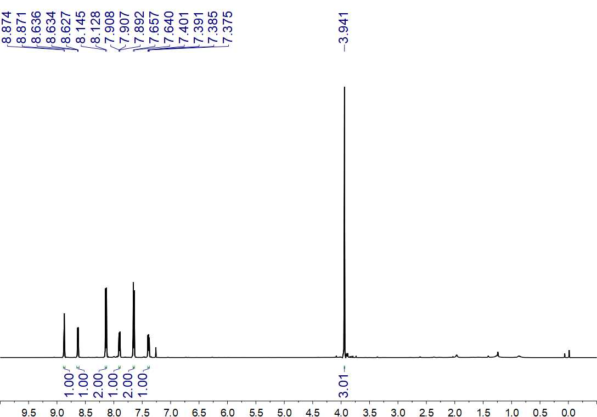
Fig. S318. ¹H NMR (500 MHz, CDCl₃) spectrum of 122

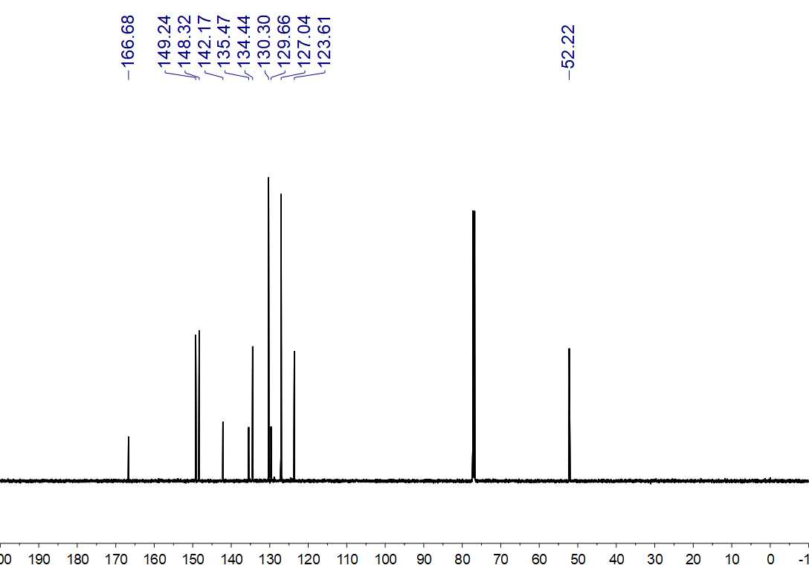
Fig. S319. ¹³C NMR (150 MHz, CDCl₃) spectrum of 122

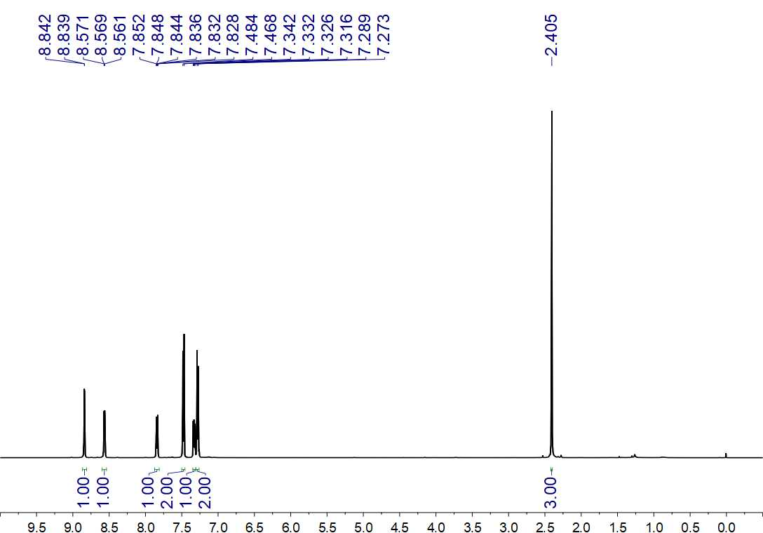
Fig. S320. ¹H NMR (500 MHz, CDCl₃) spectrum of 123

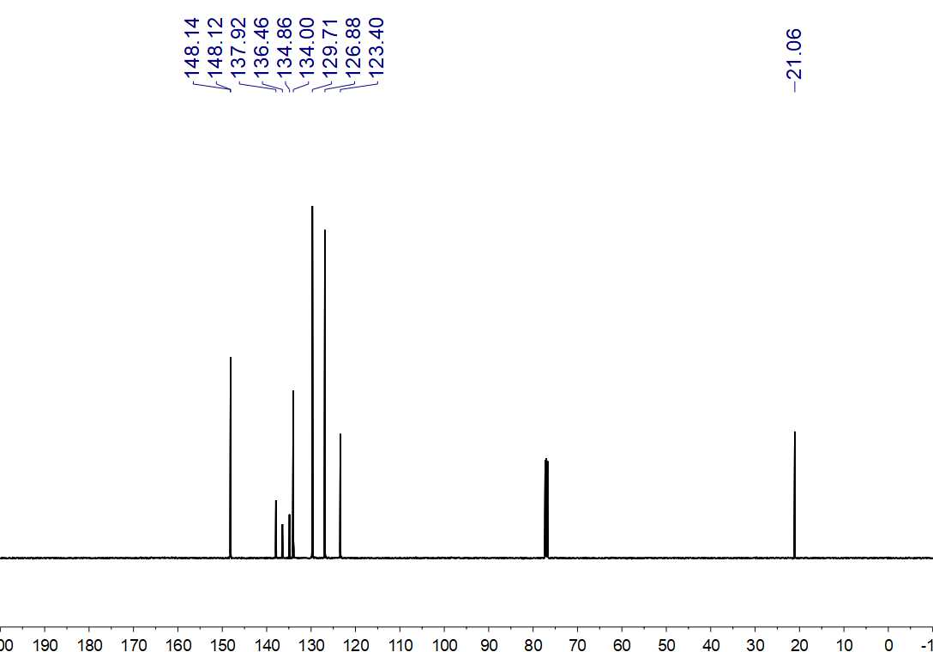
Fig. S321. ¹³C NMR (150 MHz, CDCl₃) spectrum of 123

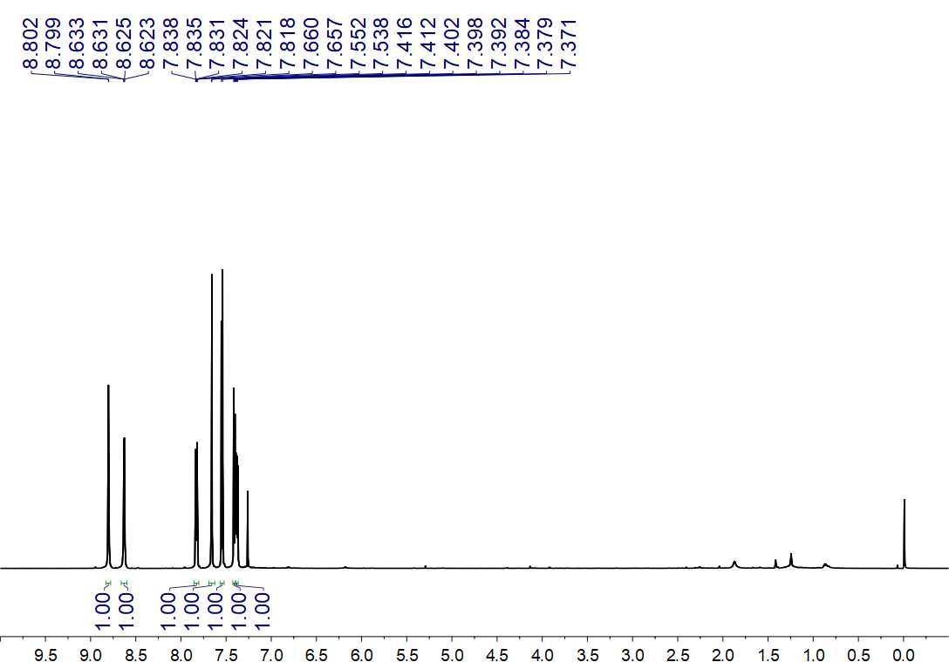
Fig. S322. ¹H NMR (600 MHz, CDCl₃) spectrum of 124

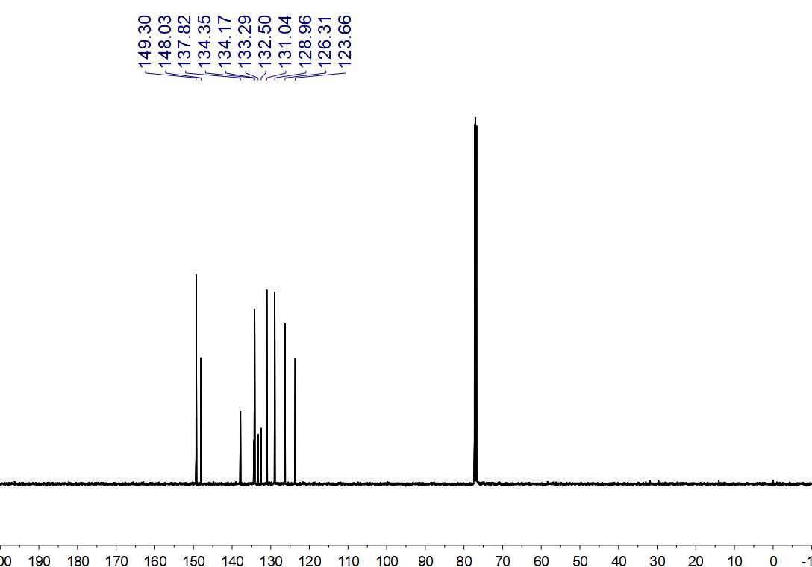
Fig. S323. ¹³C NMR (125 MHz, CDCl₃) spectrum of 124

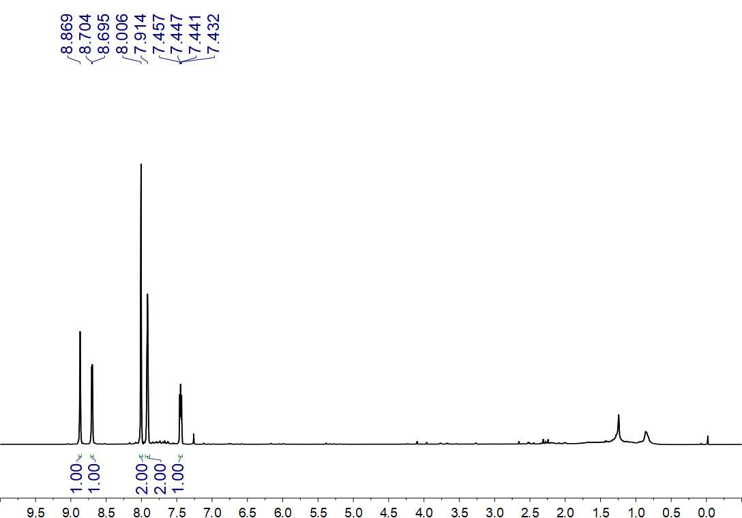
Fig. S324. ¹H NMR (500 MHz, CDCl₃) spectrum of 125

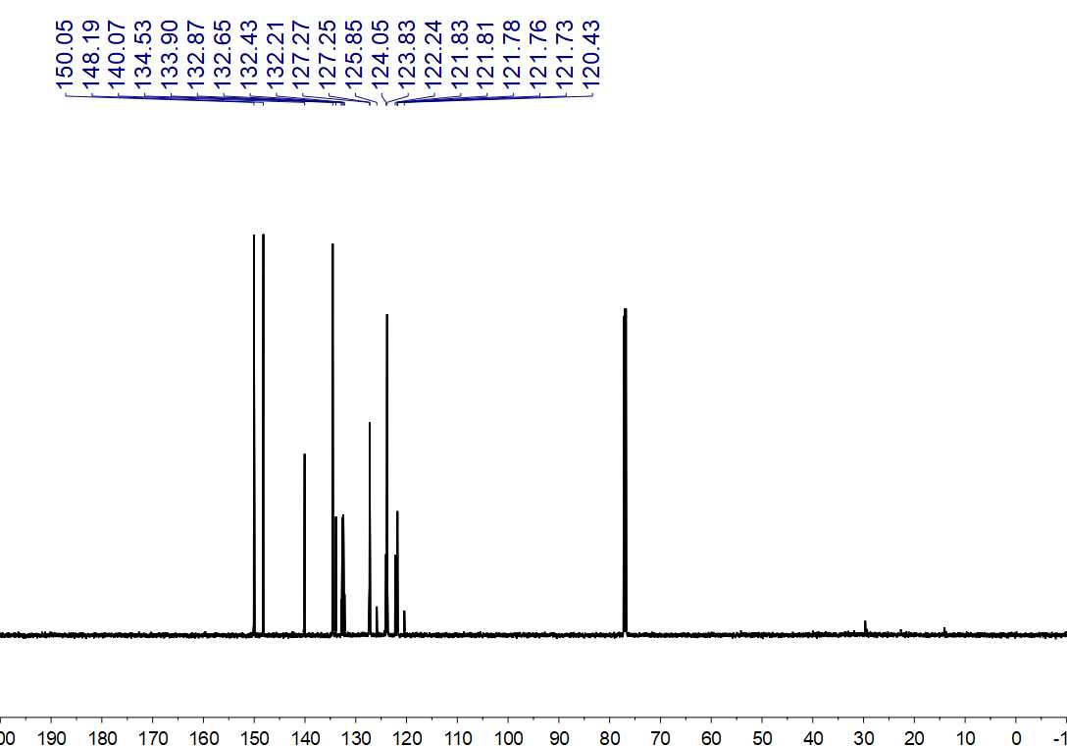
Fig. S325. ¹³C NMR (150 MHz, CDCl₃) spectrum of 125

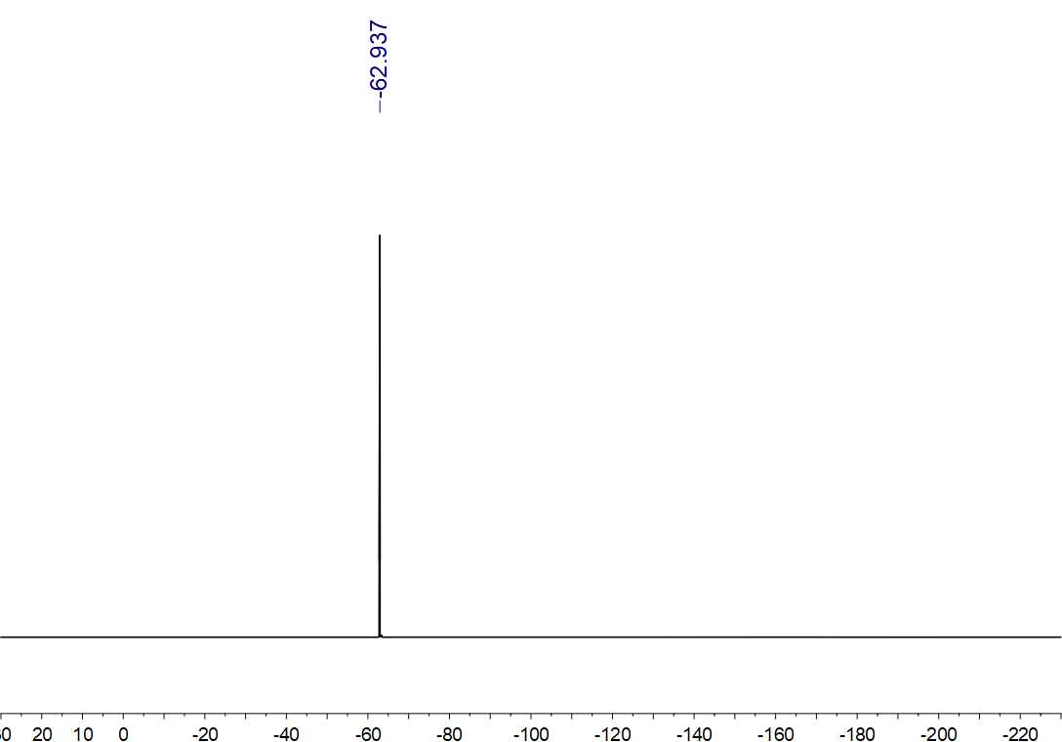
Fig. S326. ¹⁹F NMR (564 MHz, CDCl₃) spectrum of 125

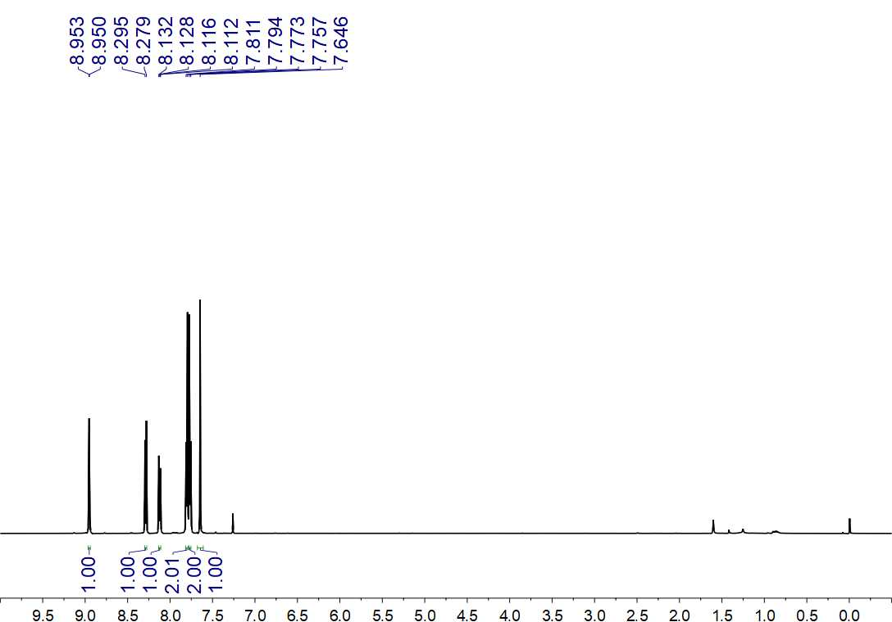
Fig. S327. ¹H NMR (500 MHz, CDCl₃) spectrum of 126

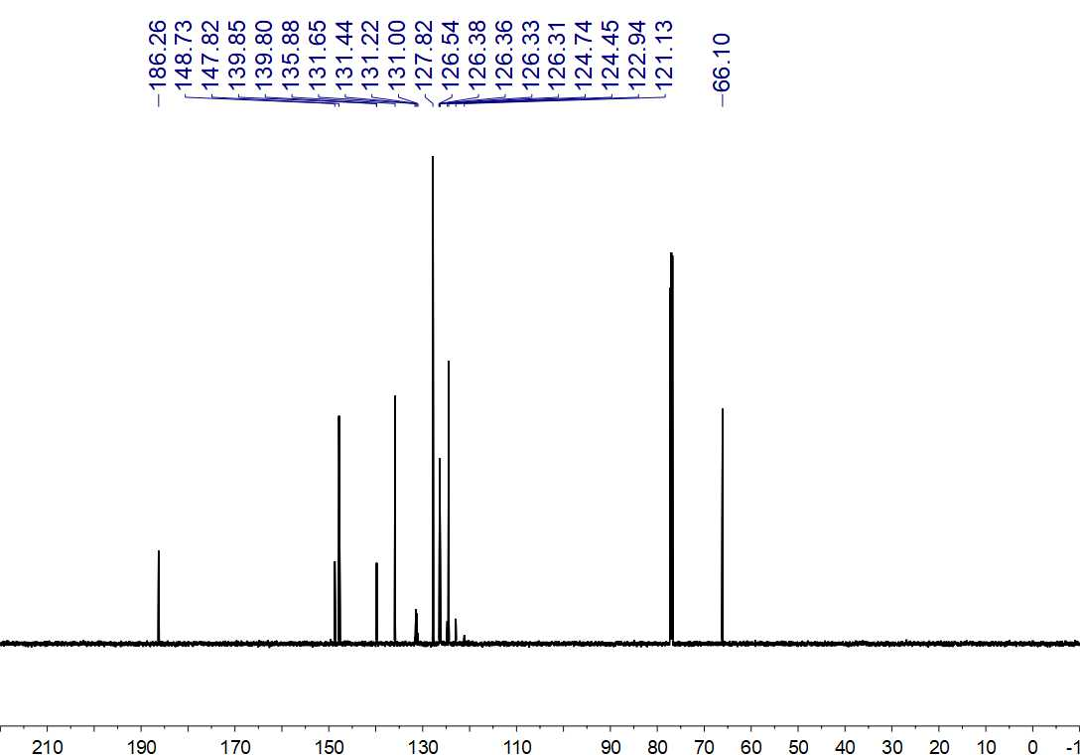
Fig. S328. ¹³C NMR (150 MHz, CDCl₃) spectrum of 126

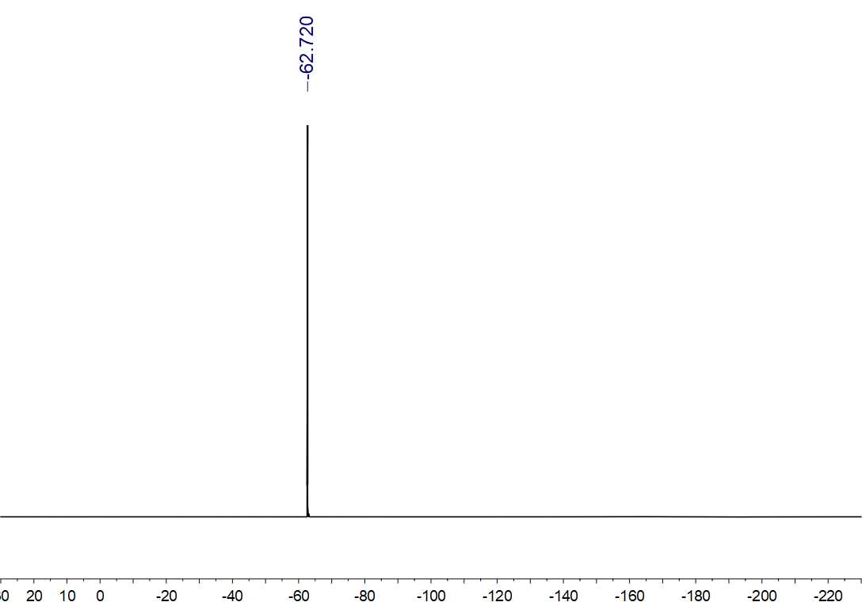
Fig. S329. ¹⁹F NMR (564 MHz, CDCl₃) spectrum of 126

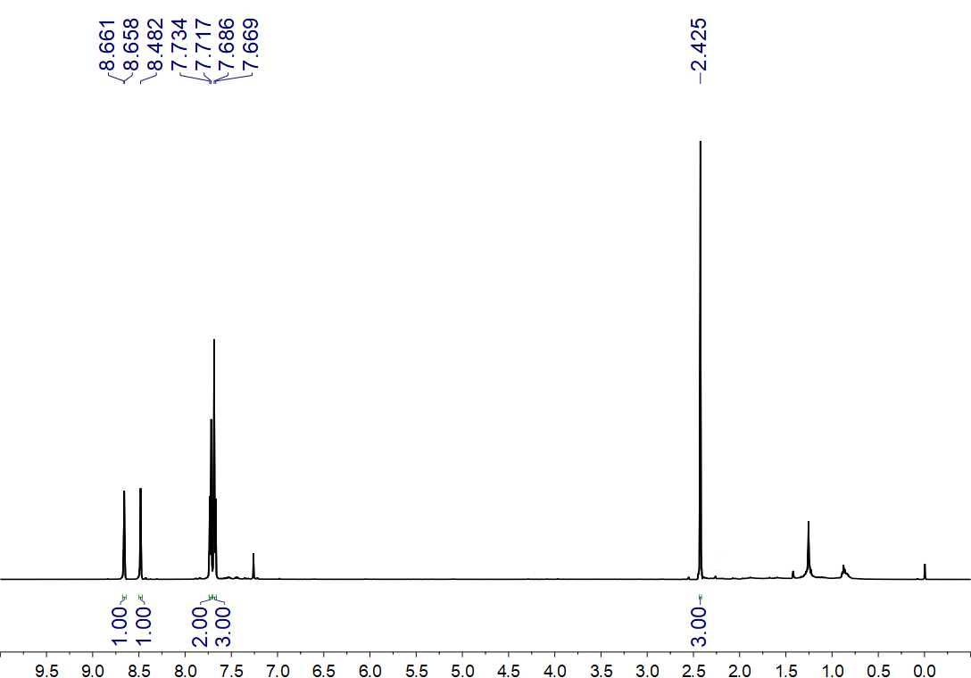
Fig. S330. ¹H NMR (500 MHz, CDCl₃) spectrum of 127

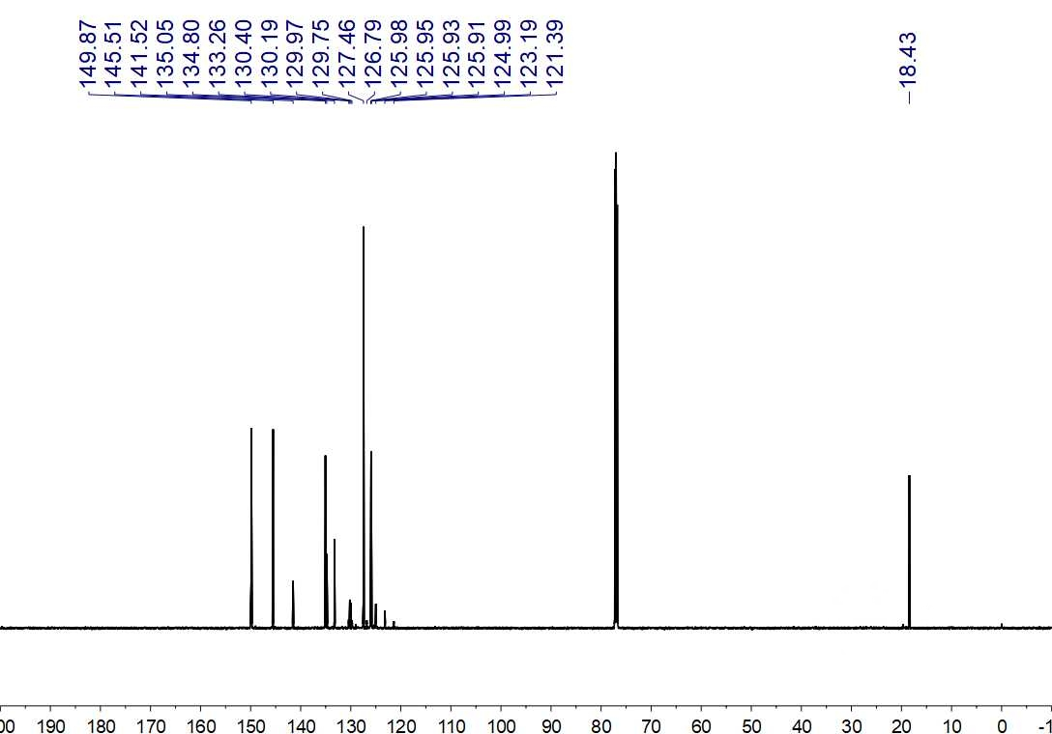
Fig. S331. ¹³C NMR (150 MHz, CDCl₃) spectrum of 127

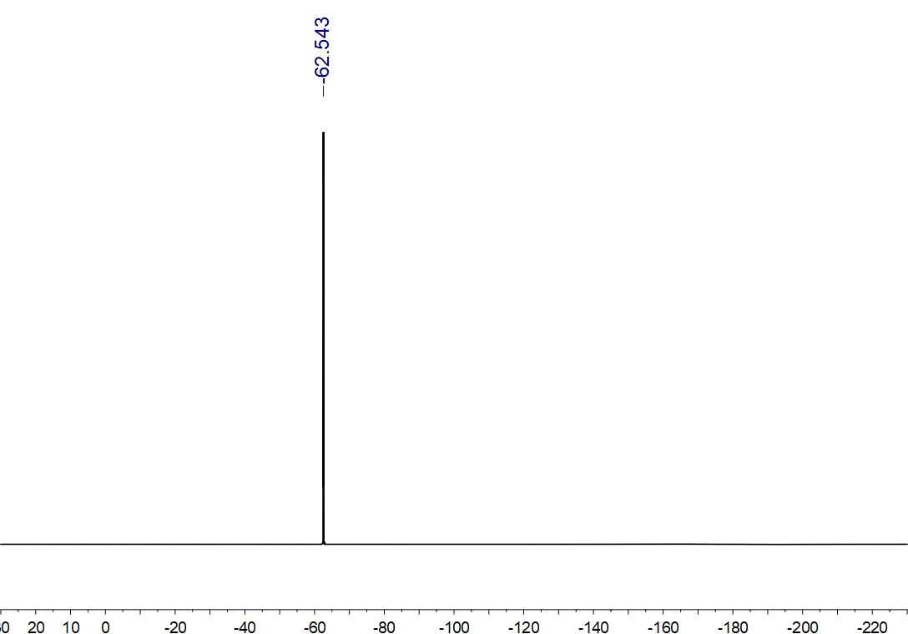
Fig. S332. ¹⁹F NMR (564 MHz, CDCl₃) spectrum of 127

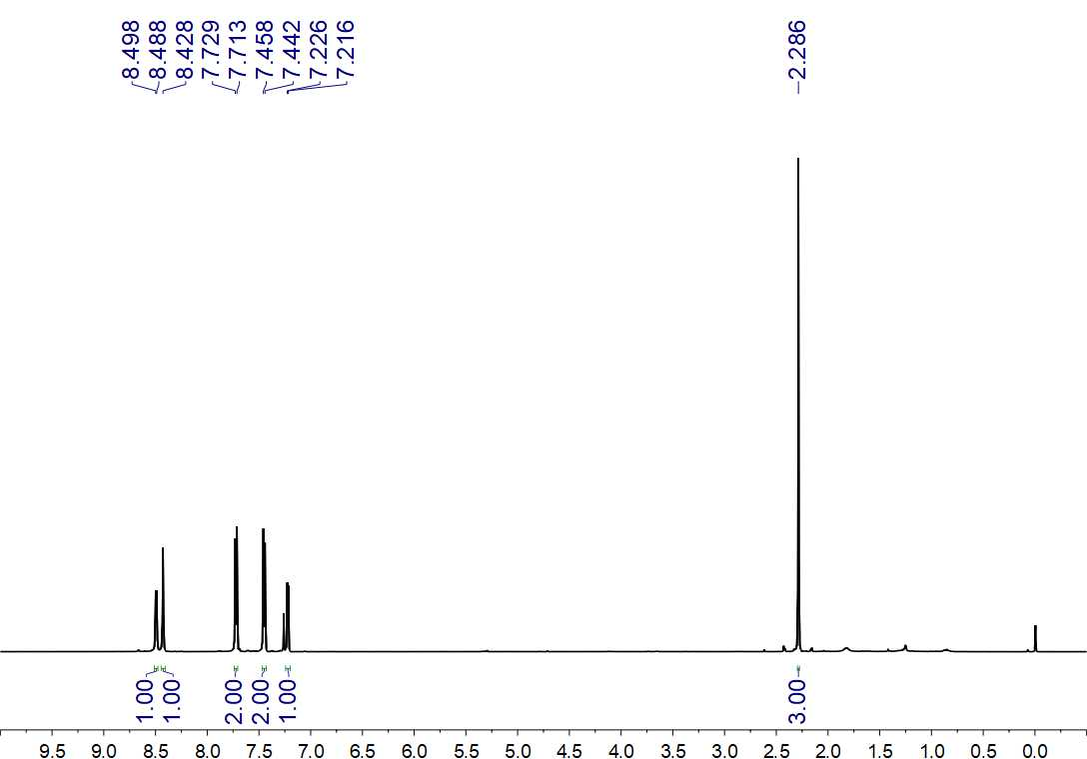
Fig. S333. ¹H NMR (500 MHz, CDCl₃) spectrum of 128

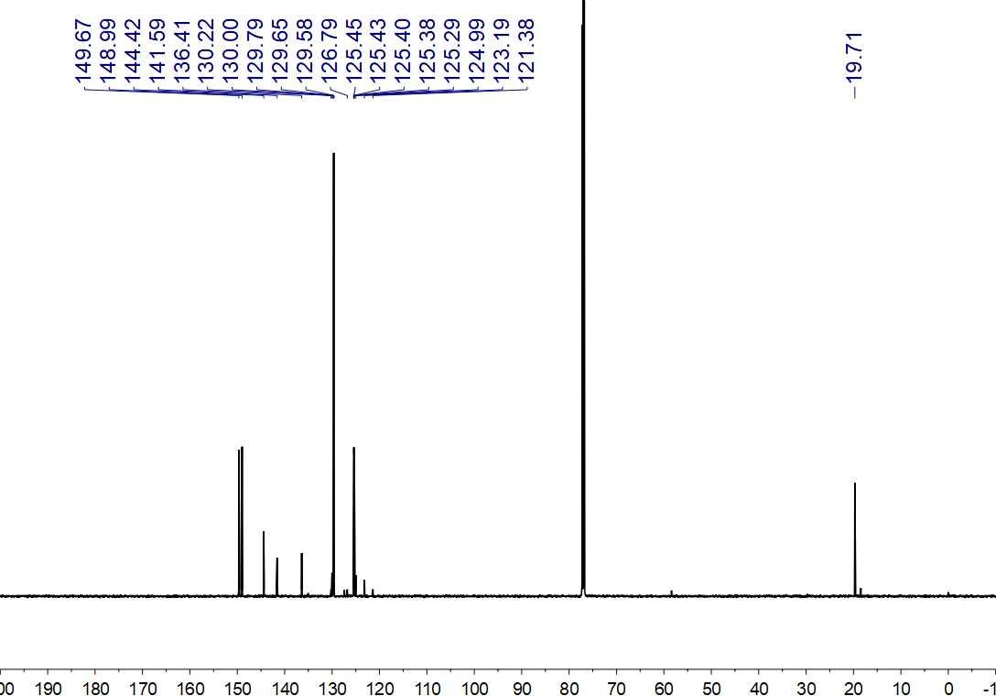
Fig. S334. ¹³C NMR (150 MHz, CDCl₃) spectrum of 128

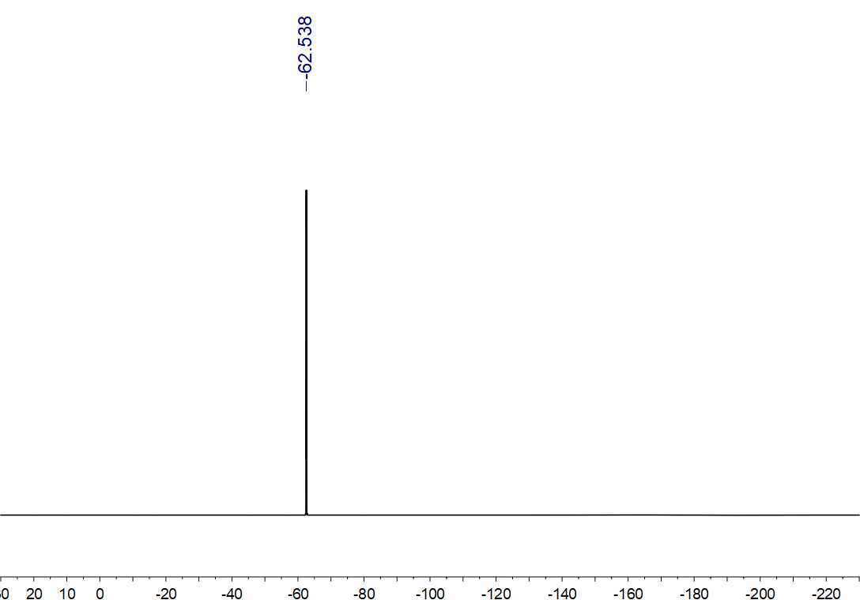
Fig. S335. ¹⁹F NMR (564 MHz, CDCl₃) spectrum of 129

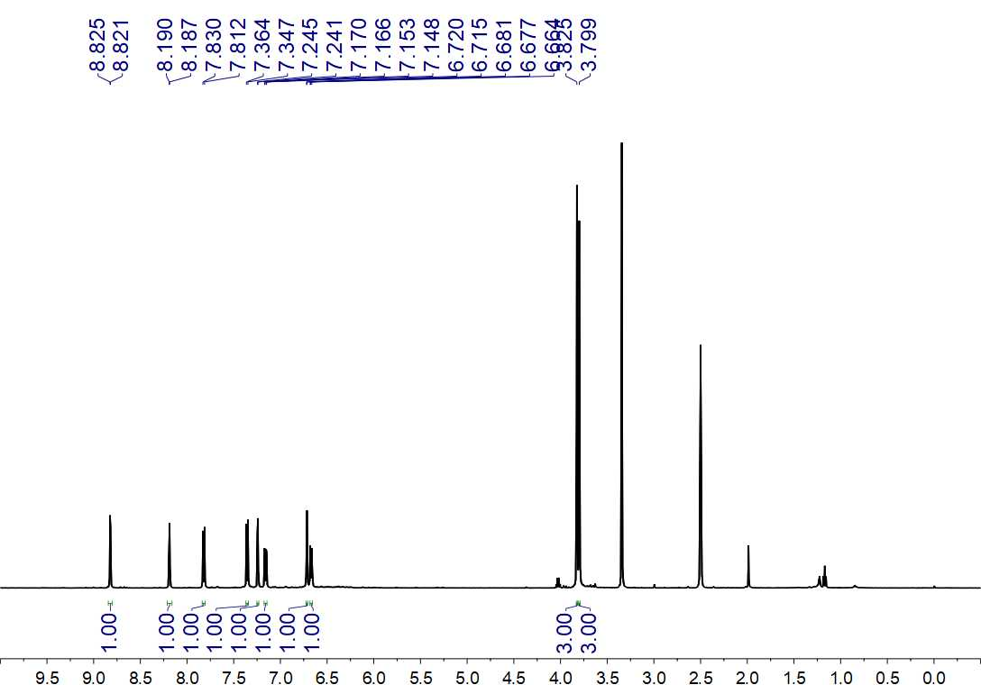
Fig. S336 ¹H NMR (500 MHz, DMSO-d₆) spectrum of 131

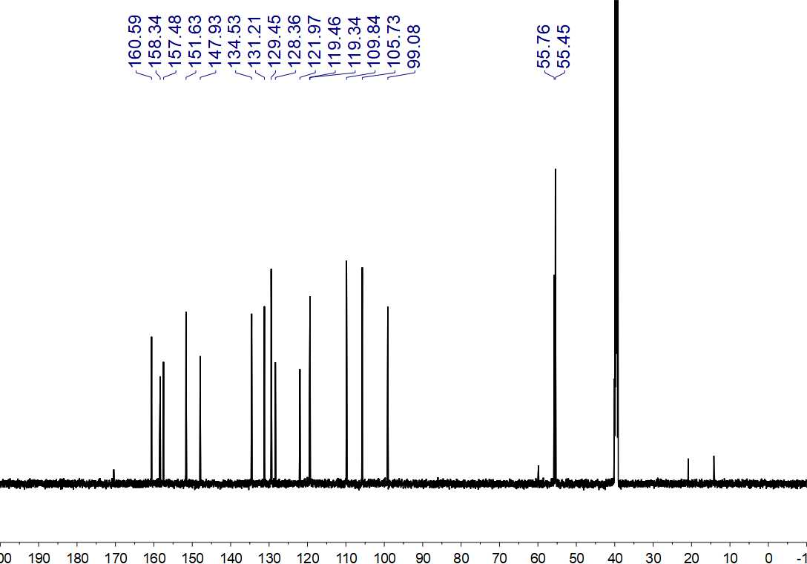
Fig. S337. ¹³C NMR (150 MHz, DMSO-d₆) spectrum of 131

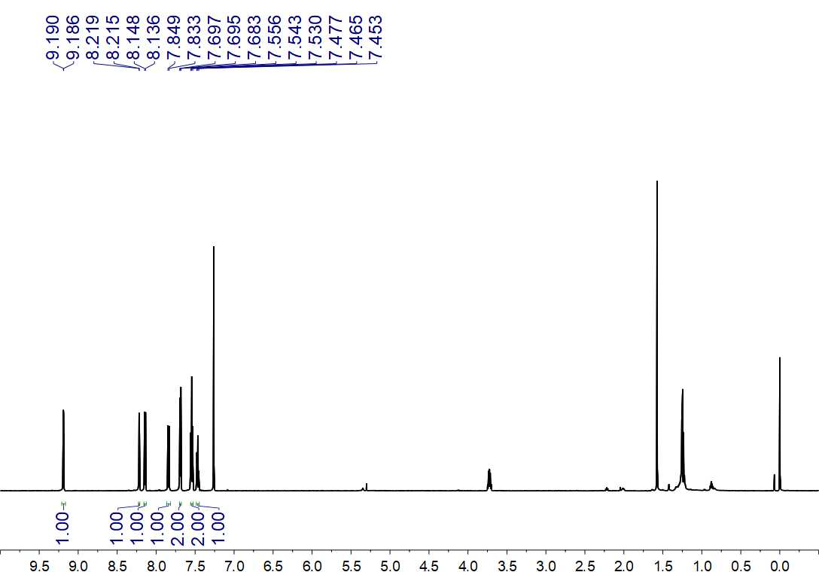
Fig. S338. ¹H NMR (600 MHz, CDCl₃) spectrum of 133ʹ

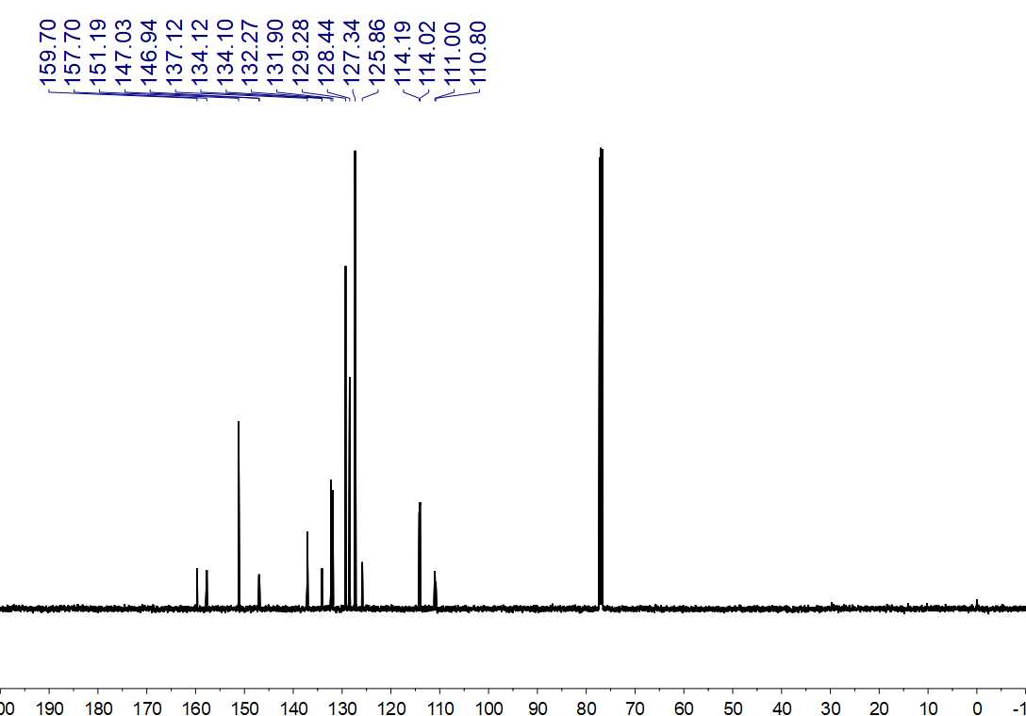
Fig. S339. ¹³C NMR (125 MHz, CDCl₃) spectrum of 133ʹ

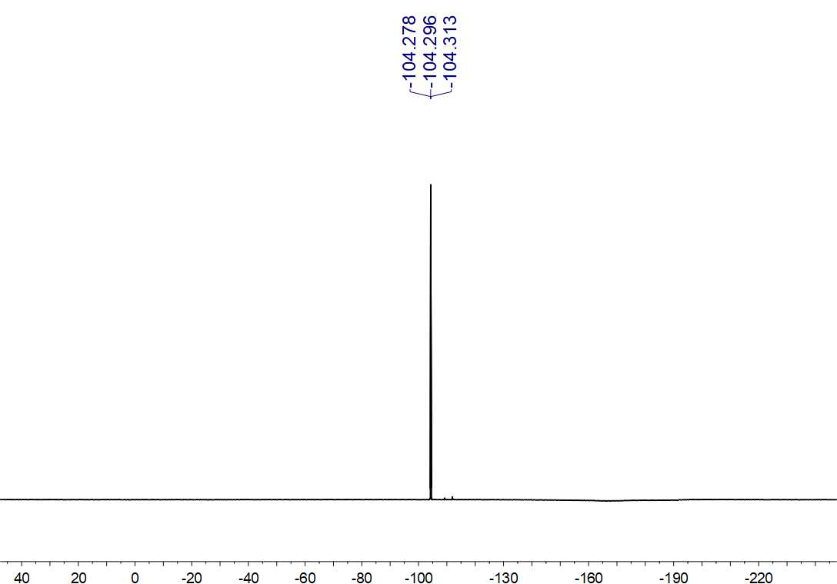
Fig. S340. ¹⁹F NMR (470 MHz, CDCl₃) spectrum of 133ʹ

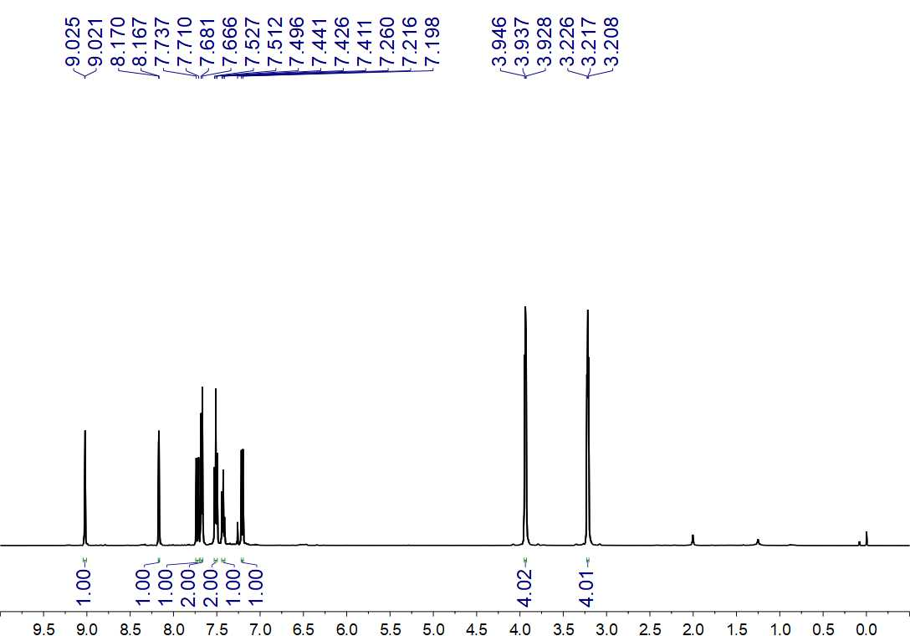
Fig. S341. ¹H NMR (500 MHz, CDCl₃) spectrum of 133

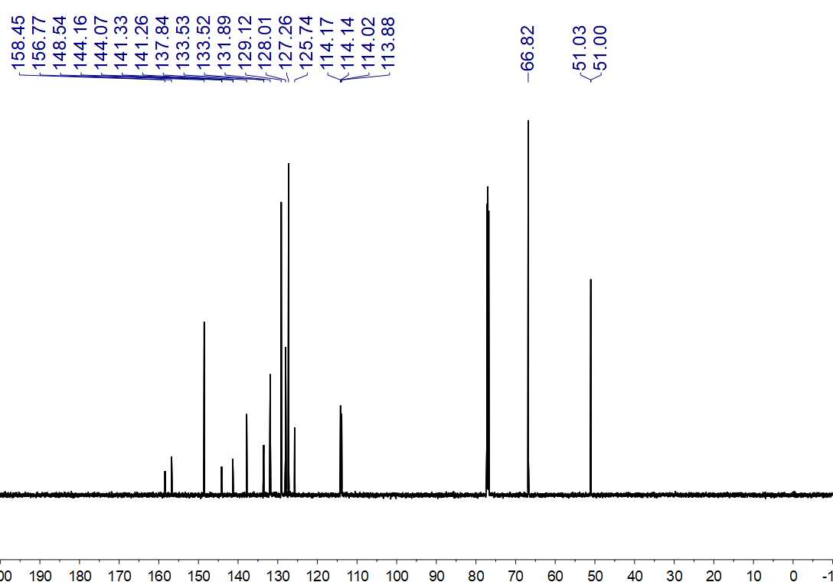
Fig. S342. ¹³C NMR (150 MHz, CDCl₃) spectrum of 133

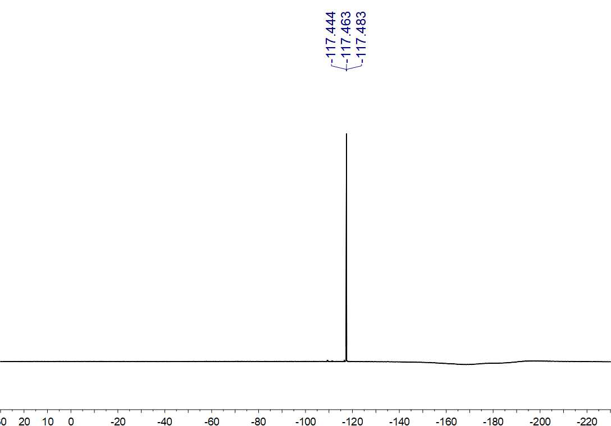
Fig. S343. ¹⁹F NMR (564 MHz, CDCl₃) spectrum of 133

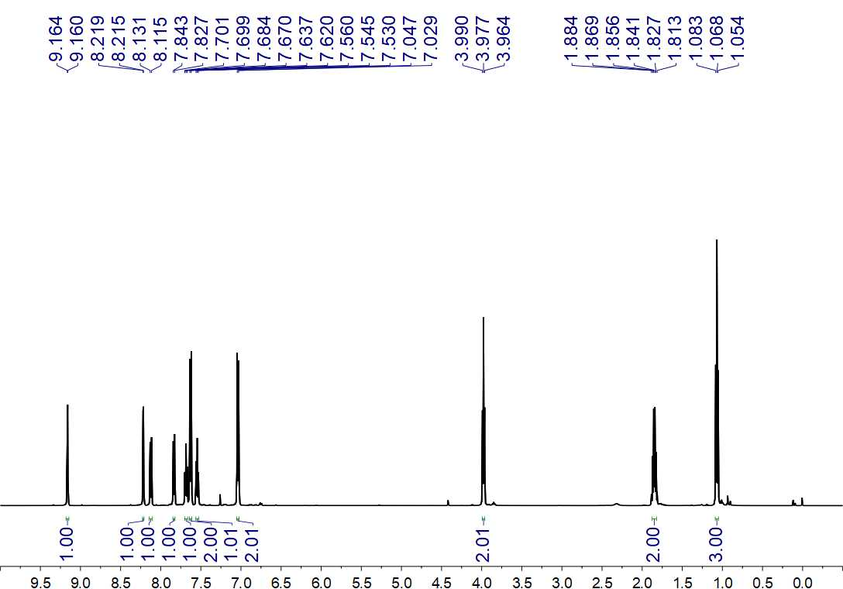
Fig. S344. ¹H NMR (500 MHz, CDCl₃) spectrum of 134ʹ

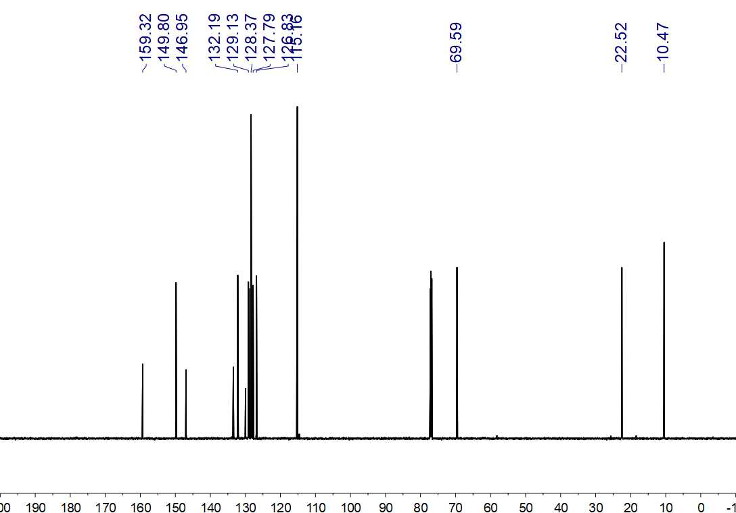
Fig. S345. ¹³C NMR (150 MHz, CDCl₃) spectrum of 134ʹ

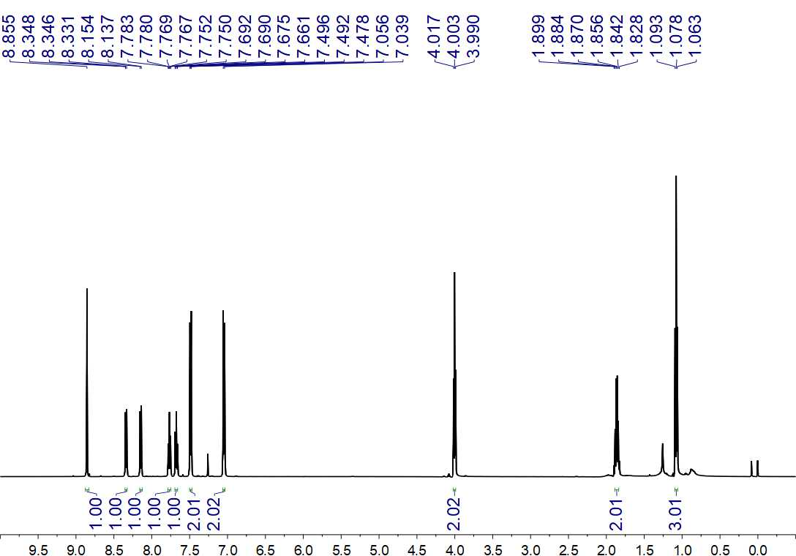
Fig. S346. ¹H NMR (500 MHz, CDCl₃) spectrum of 134ʹʹ

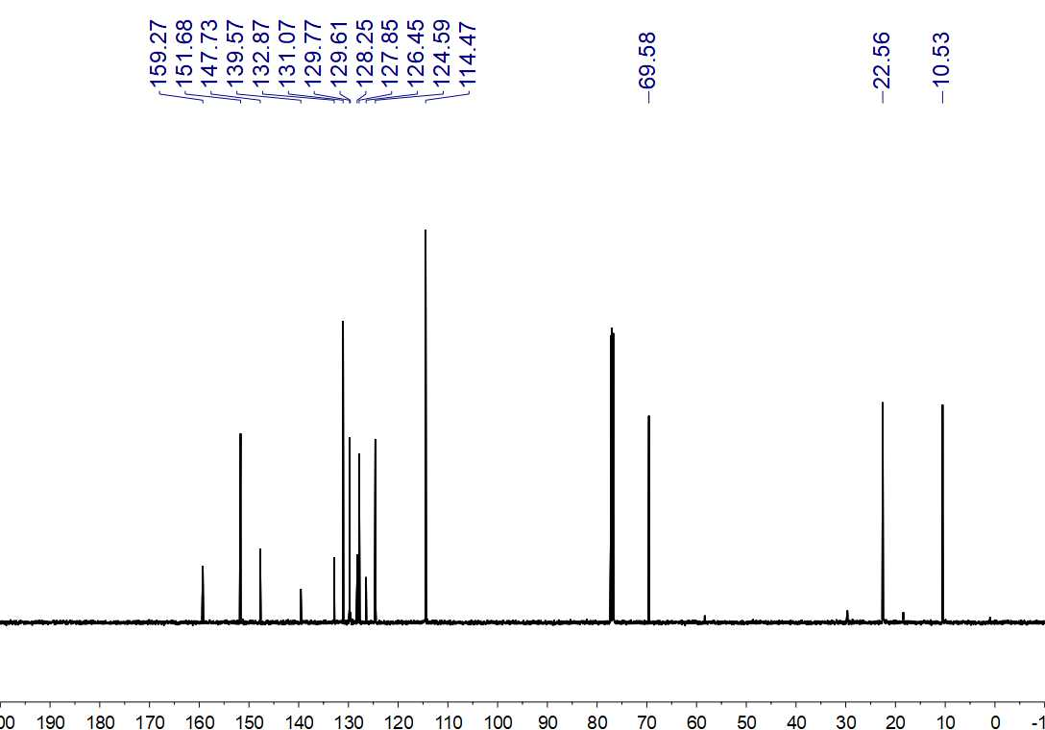
Fig. S347. ¹³C NMR (125 MHz, CDCl₃) spectrum of 134ʹʹ

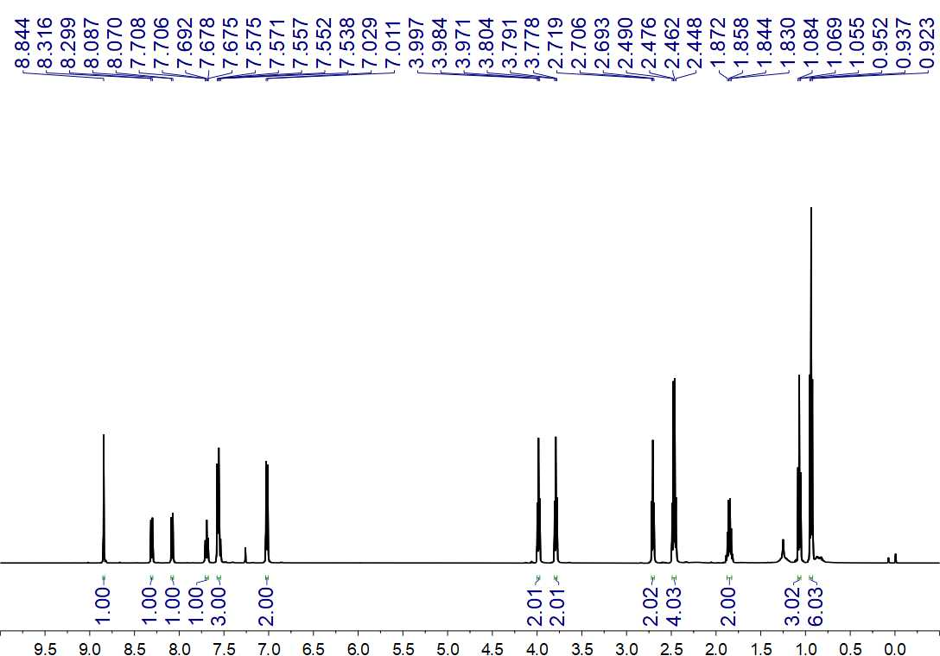
Fig. S348. ¹H NMR (500 MHz, CDCl₃) spectrum of 134

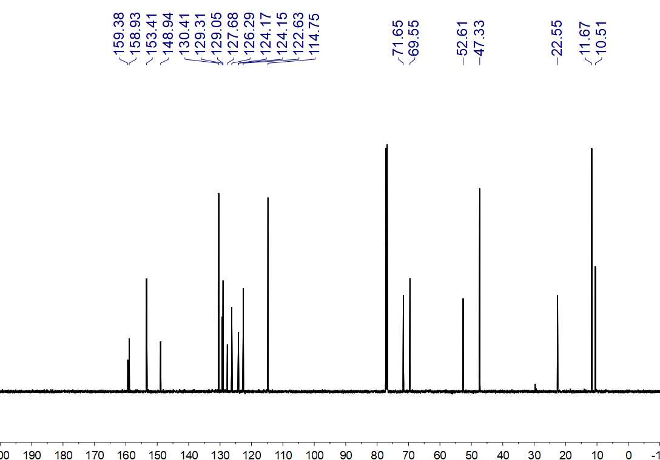
Fig. S349. ¹³C NMR (150 MHz, CDCl₃) spectrum of 134

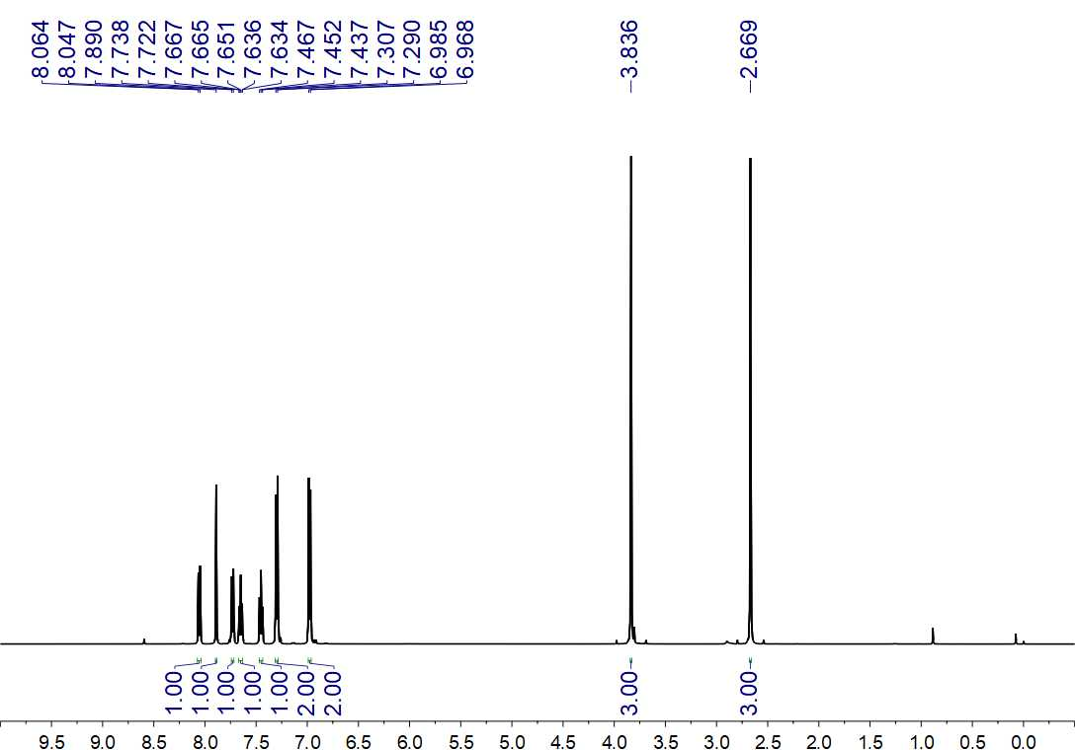
Fig. S350. ¹H NMR (500 MHz, CDCl₃) spectrum of 137ʹ

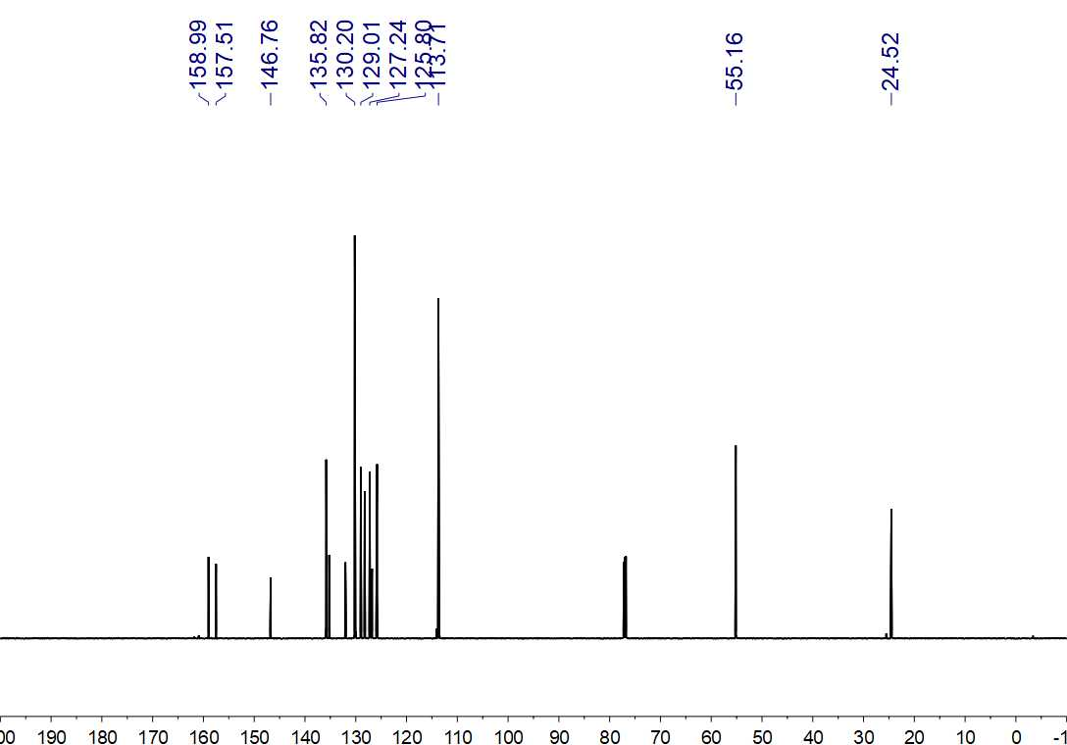
Fig. S351. ¹³C NMR (150 MHz, CDCl₃) spectrum of 137ʹ

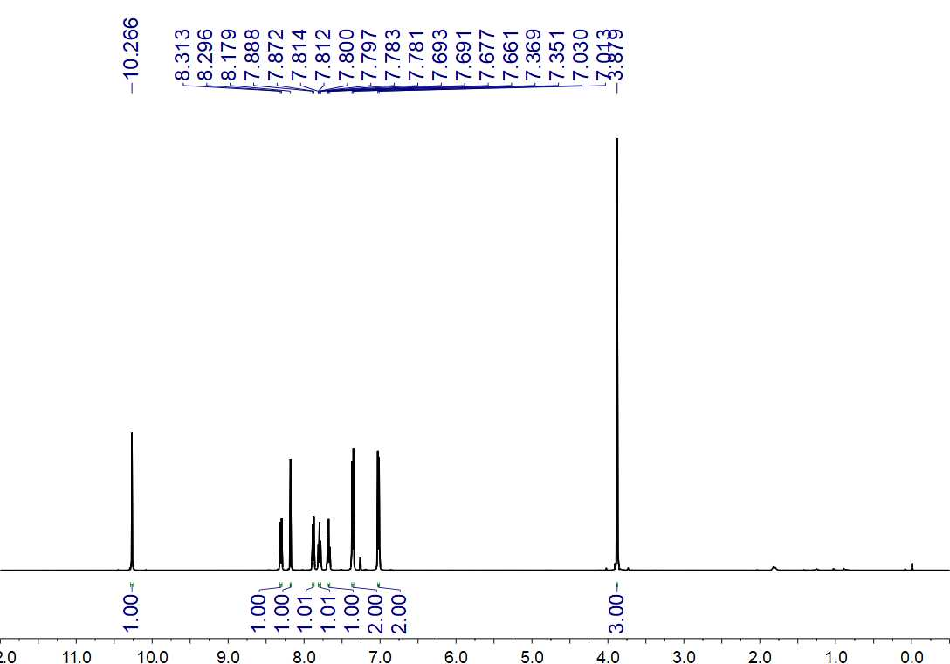
Fig. S352. ¹H NMR (500 MHz, CDCl₃) spectrum of 137

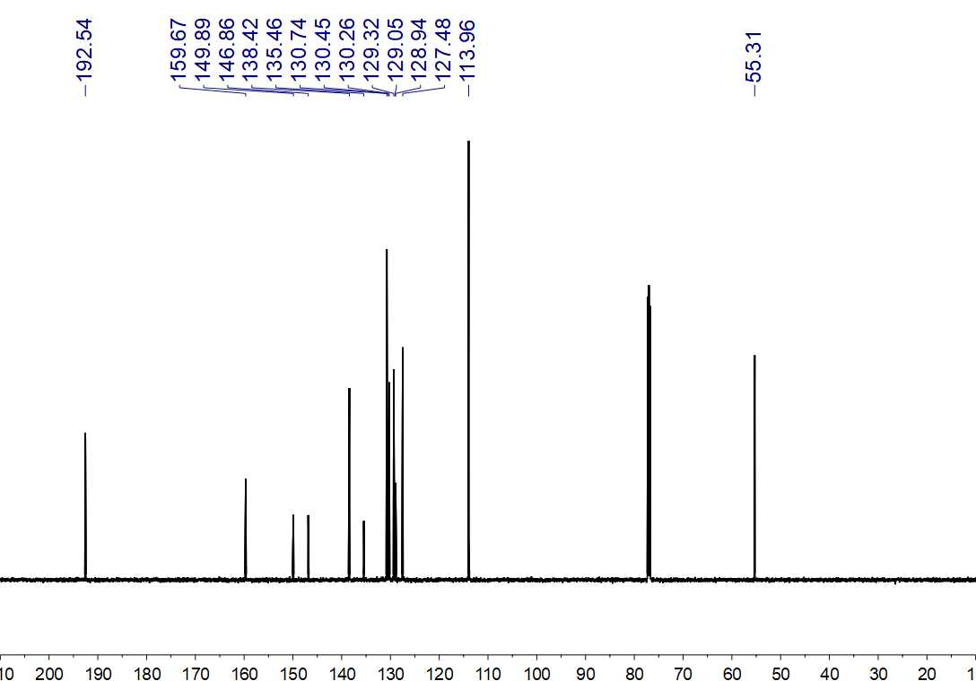
Fig. S353. ¹³C NMR (150 MHz, CDCl₃) spectrum of 137

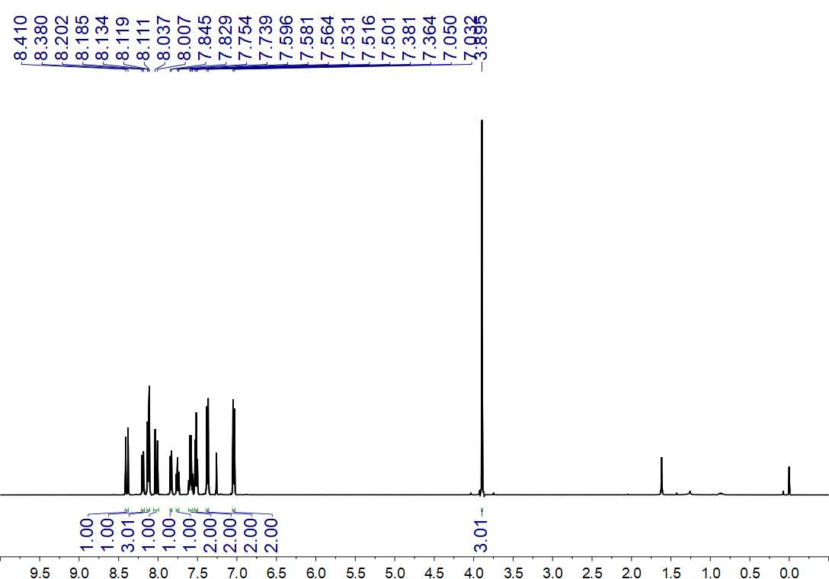
Fig. S354. ¹H NMR (500 MHz, CDCl₃) spectrum of 138

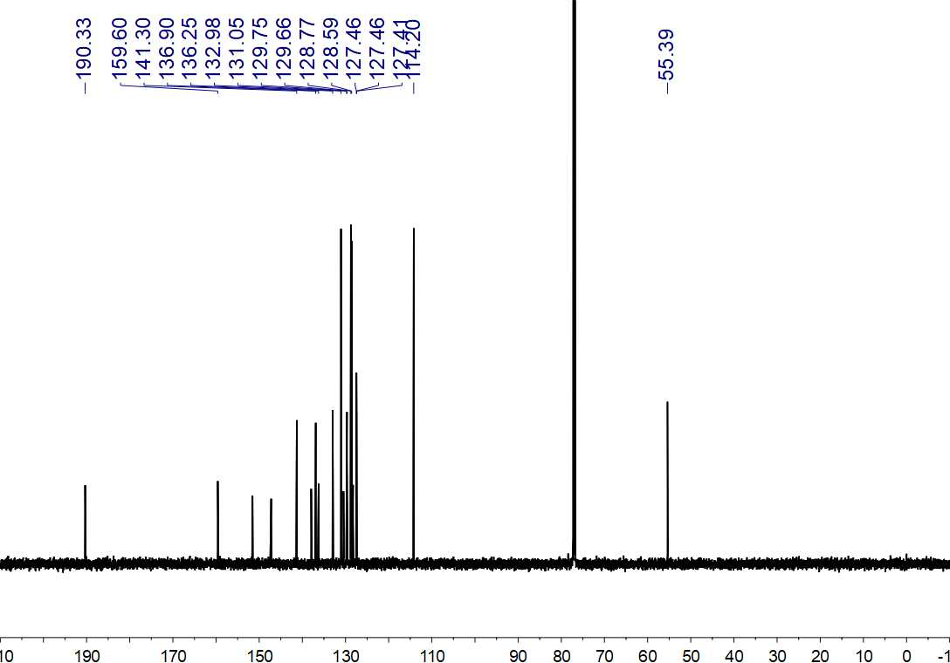
Fig. S355. ¹³C NMR (150 MHz, CDCl₃) spectrum of 138

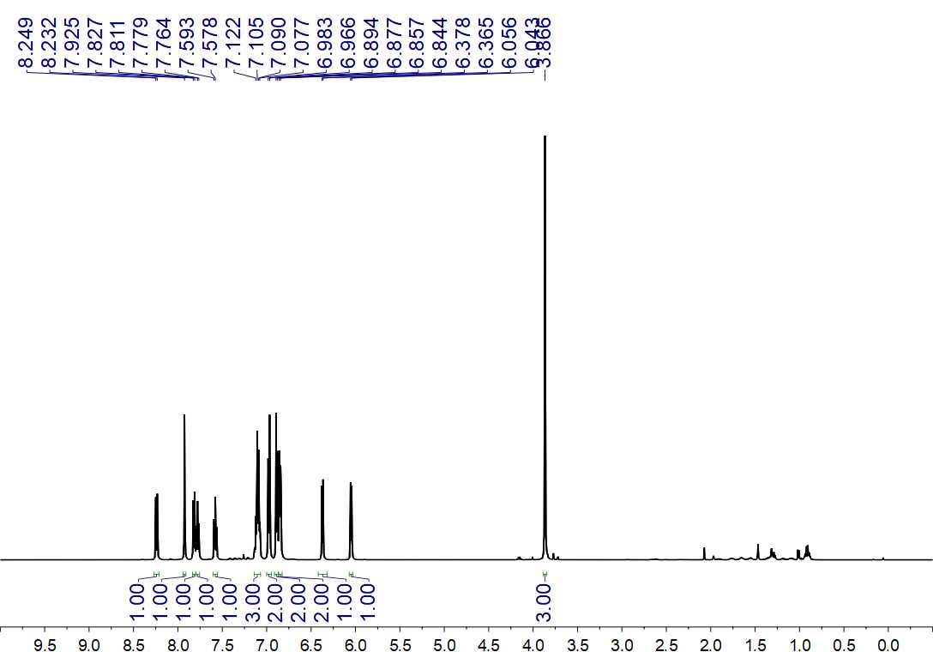
Fig. S356. ¹H NMR (500 MHz, CDCl₃) spectrum of 139

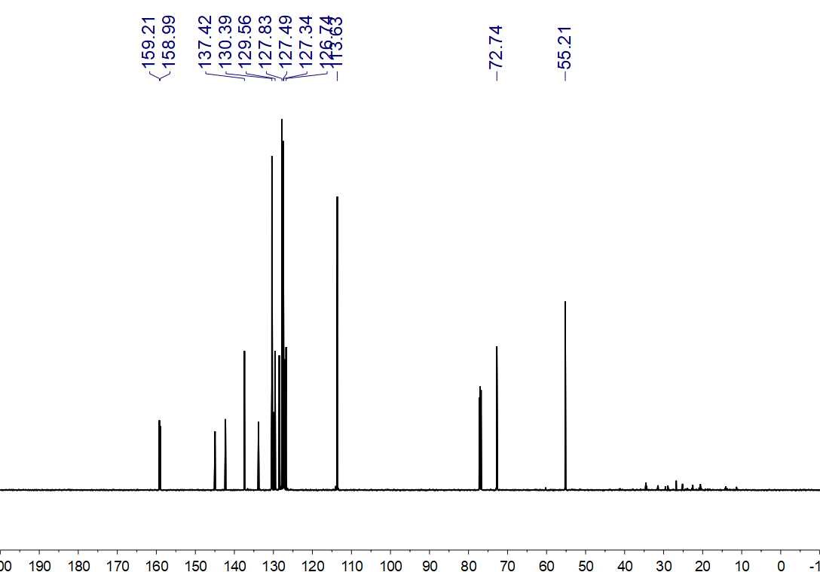
Fig. S357. ¹³C NMR (150 MHz, CDCl₃) spectrum of 139

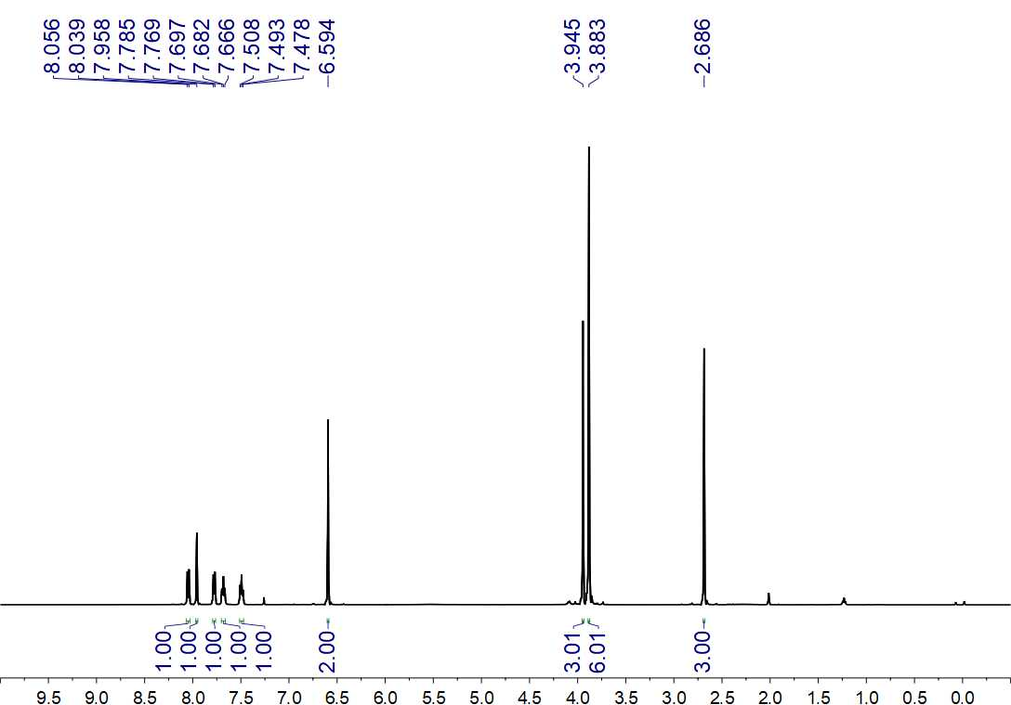
Fig. S358. ¹H NMR (500 MHz, CDCl₃) spectrum of 140ʹ

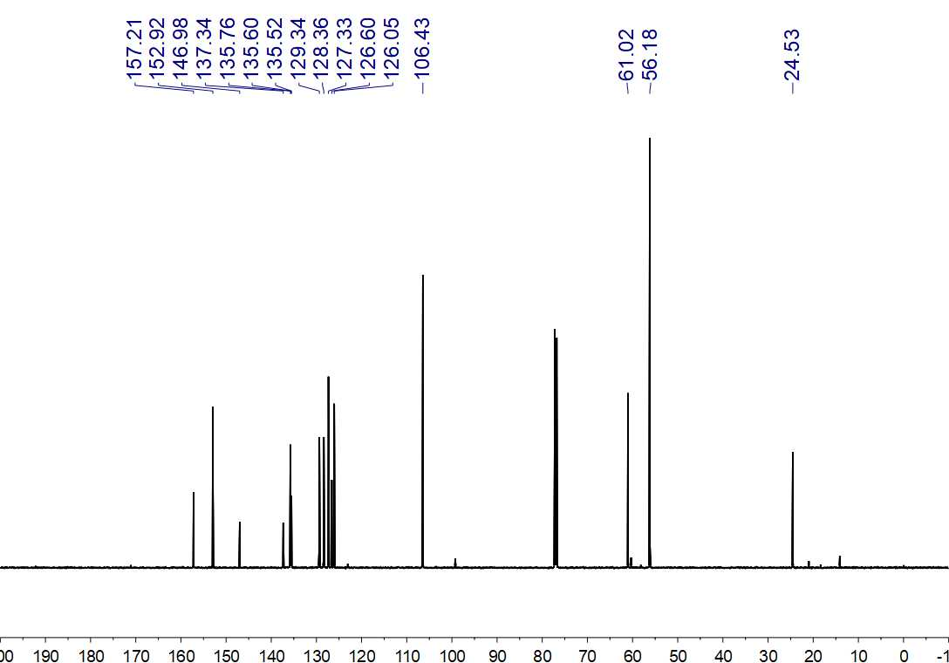
Fig. S359. ¹³C NMR (150 MHz, CDCl₃) spectrum of 140ʹ

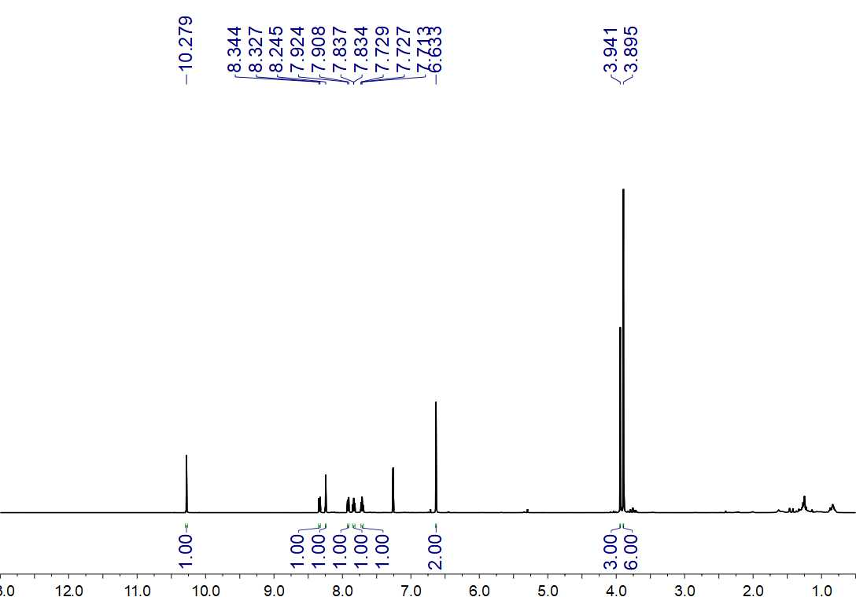
Fig. S360. ¹H NMR (500 MHz, CDCl₃) spectrum of 140ʹʹ

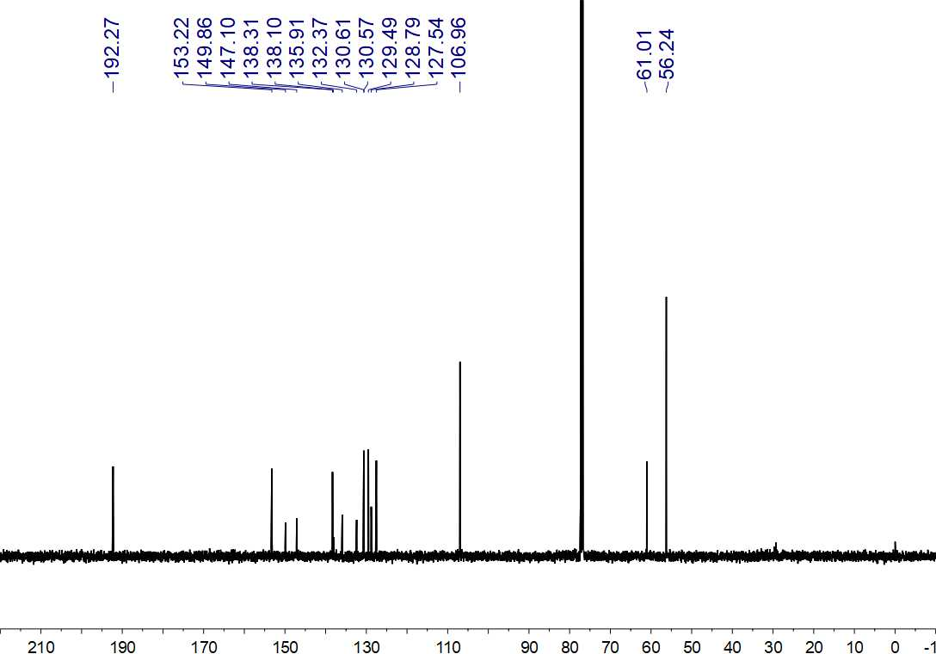
Fig. S361. ¹³C NMR (125 MHz, CDCl₃) spectrum of 140ʹʹ

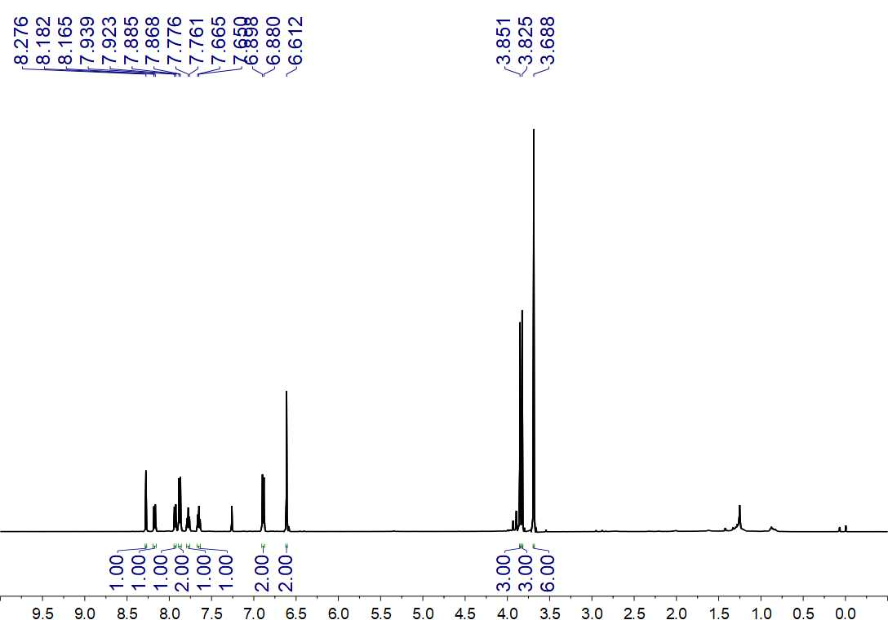
Fig. S362. ¹H NMR (500 MHz, CDCl₃) spectrum of 140

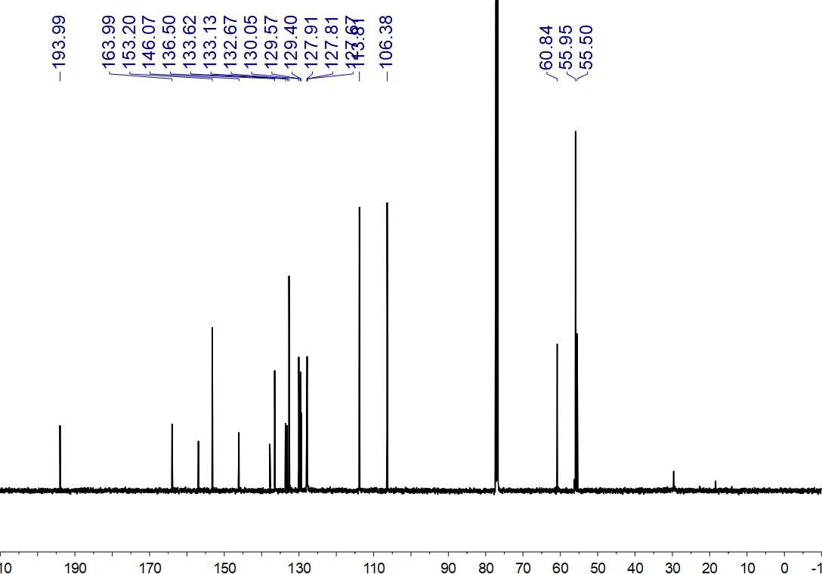
Fig. S363. ¹³C NMR (125 MHz, CDCl₃) spectrum of 140

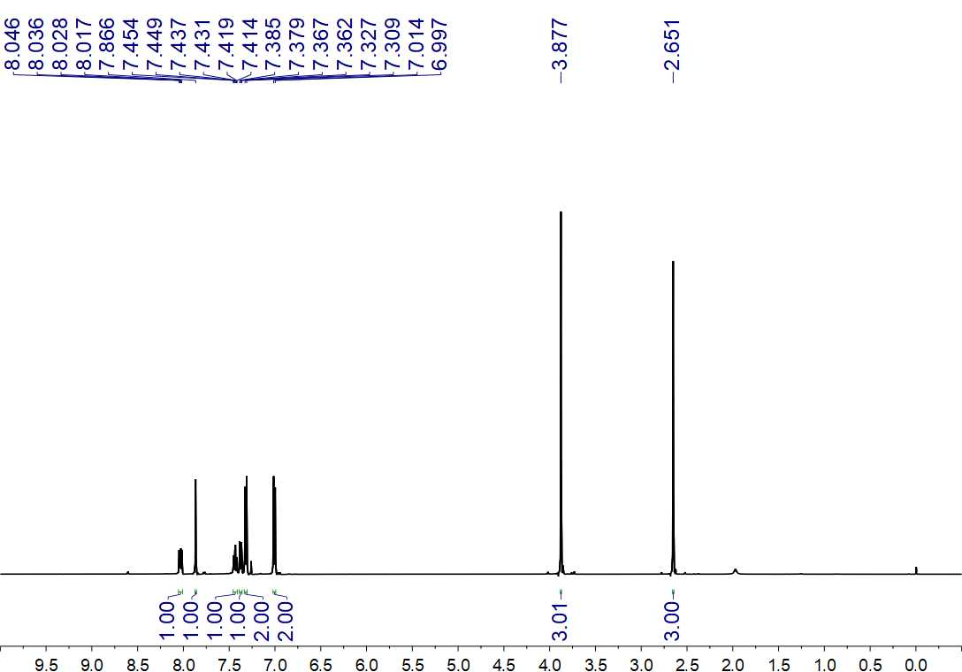
Fig. S364. ¹H NMR (500 MHz, CDCl₃) spectrum of 142ʹ

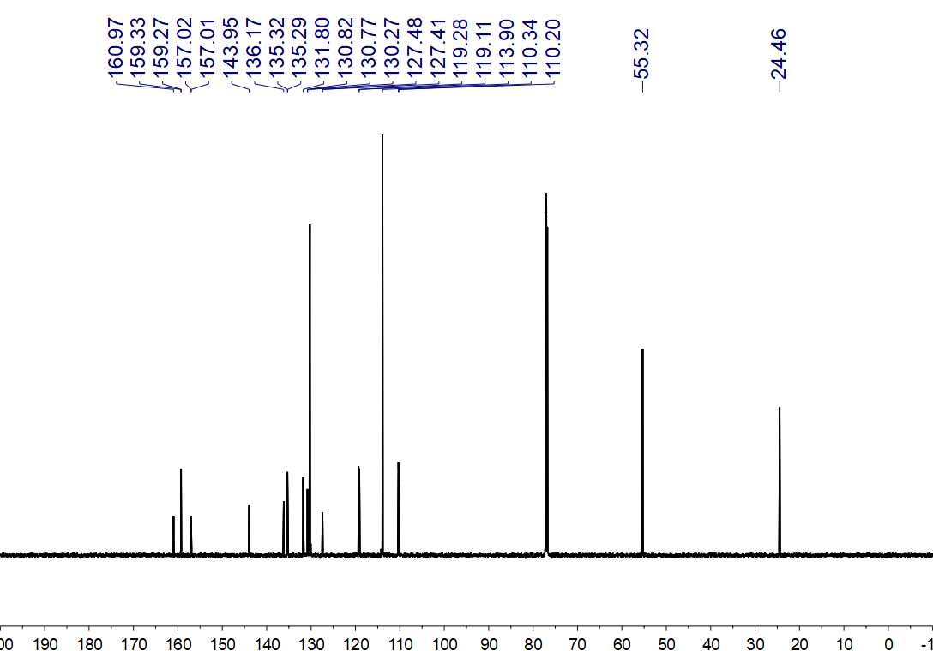
Fig. S365. ¹³C NMR (150 MHz, CDCl₃) spectrum of 142ʹ

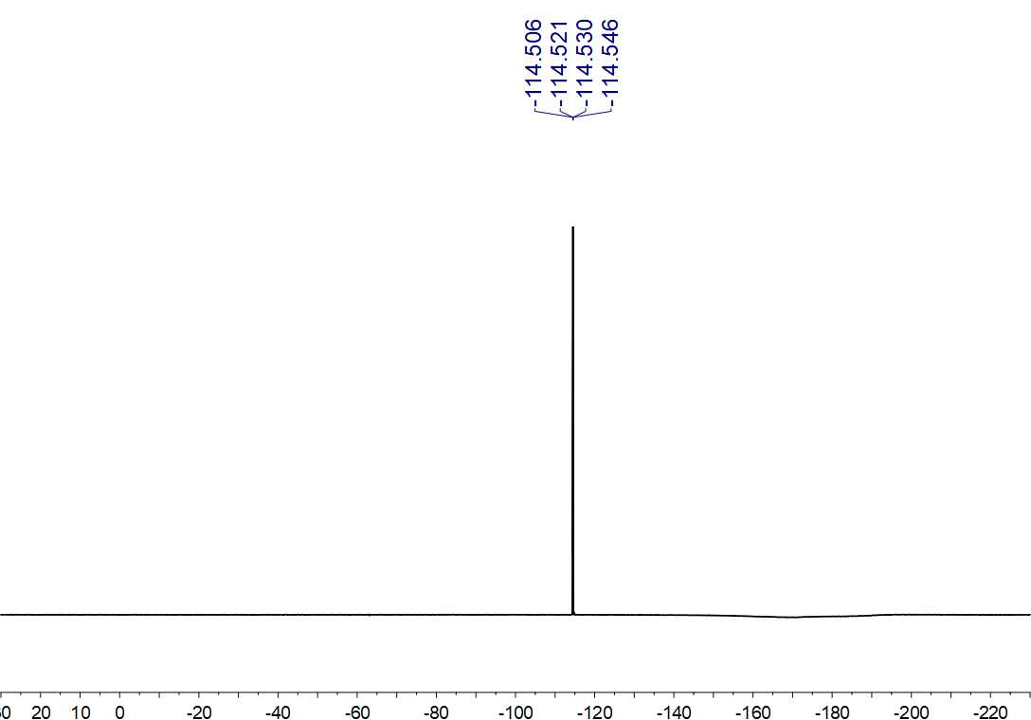Fig. S366. ¹⁹F NMR (564 MHz, CDCl₃) spectrum of 142ʹ

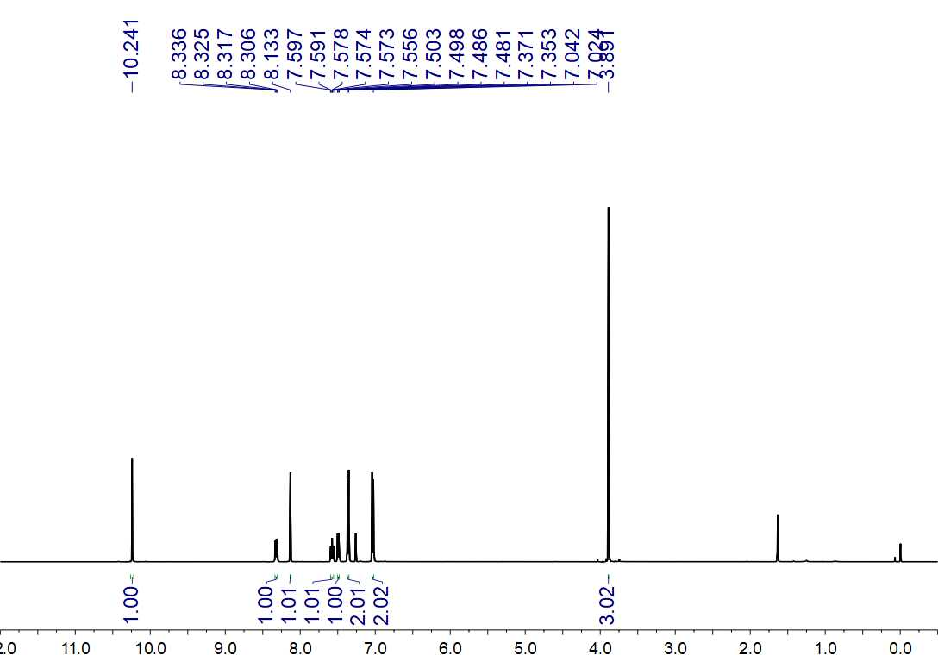
Fig. S367. ¹H NMR (500 MHz, CDCl₃) spectrum of 142ʹʹ

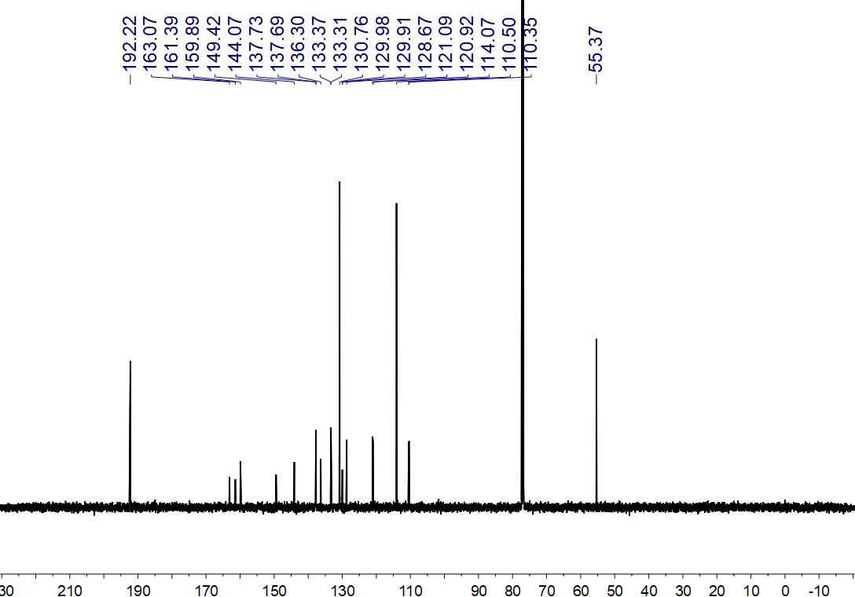
Fig. S368. ¹³C NMR (150 MHz, CDCl₃) spectrum of 142ʹʹ

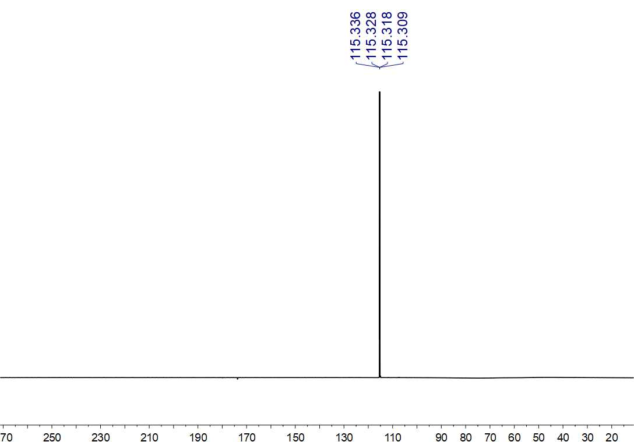
Fig. S369. ¹⁹F NMR (564 MHz, CDCl₃) spectrum of 142ʹʹ

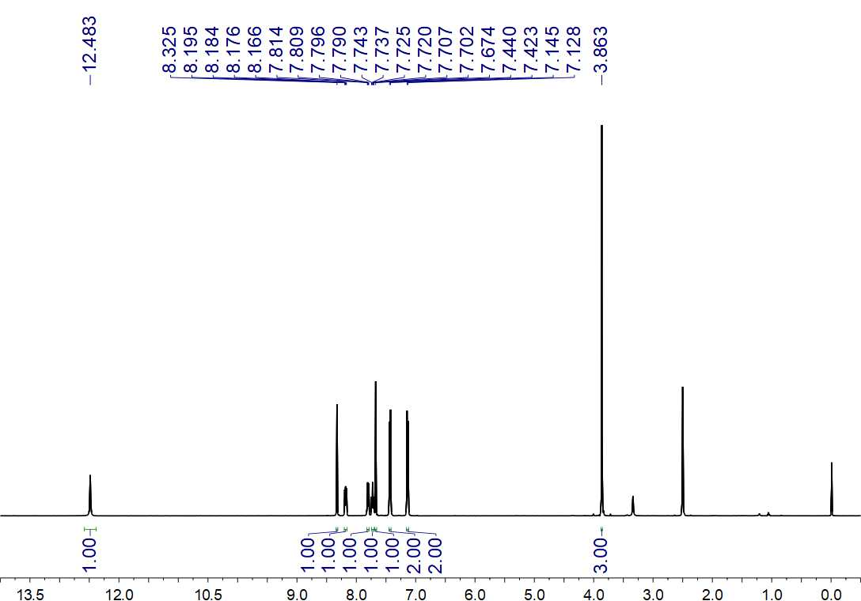
Fig. S370. ¹H NMR (500 MHz, DMSO-d₆) spectrum of 142

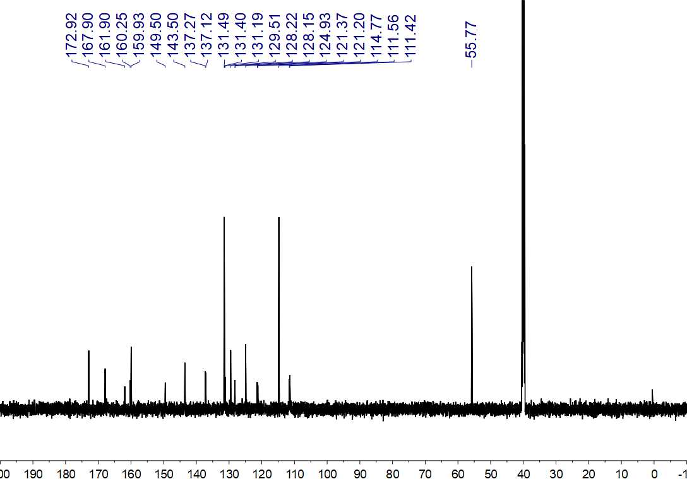
Fig. S371. ¹³C NMR (150 MHz, DMSO-d₆) spectrum of 142

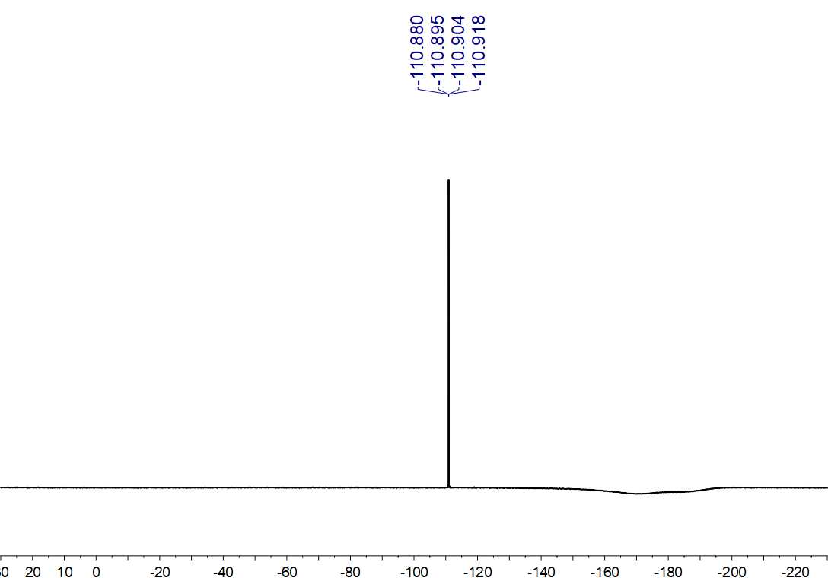
Fig. S372. ¹⁹F NMR (564 MHz, DMSO-d₆) spectrum of 142

