Table1. Tumor Cell Viability Assays of MMAF Analogous.
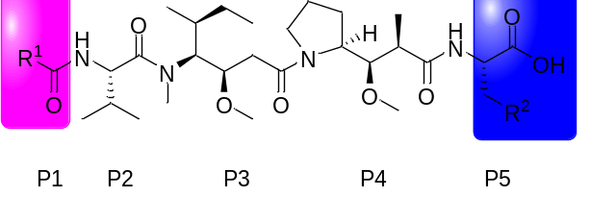
compound | R¹ | R² | IC₅₀ (μM)ª | IC₅₀ (μM) | IC₅₀ (μM)
 |  |  | A549 | HCT116 | A549/Taxol
11a | 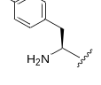 | 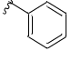 | 0.55±0.06 | 0.19±0.12 | 3.71±1.21
11b | 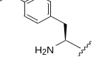 |  | 1.08±0.09 | 0.34±0.06 | 4.93±1.05
11c | 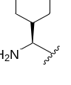 |  | 1.08±0.12 | 0.58±0.10 | 0.37±0.09
11d | 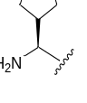 |  | 0.60±0.08 | 0.49±0.10 | 14.14±1.97
11e | 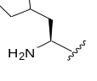 |  | 1.36±0.13 | 0.80±0.01 | 29.33±2.94
11f | 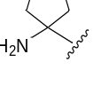 |  | 0.20±0.01 | 0.50±0.06 | 0.64±0.05
11g | 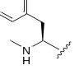 |  | 0.14±0.01 | 0.74±0.10 | 5.89±0.79
11h | 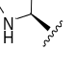 |  | 1.11±0.06 | 1.26±0.09 | 4.45±0.29
11i | 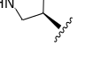 |  | 0.41±0.02 | 0.94±0.09 | 2.63±0.30
11J | 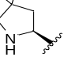 |  | 1.02±0.09 | 1.78±0.21 | 4.96±0.65
11k | 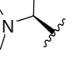 |  | 0.24±0.03 | 0.31±0.04 | 1.63±0.21
11l | 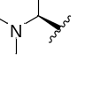 |  | 0.33±0.04 | 0.37±0.04 | 1.54±0.15
18a | 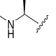 | 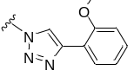 | 0.34±0.02 | 0.75±0.06 | 34.81±3.87
18b |  | 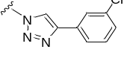 | 0.19±0.02 | 0.13±0.01 | 18.76±2.71
18c |  | 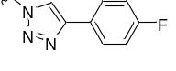 | 0.60±0.05 | 0.73±0.06 | 9.30±2.63
18d |  | 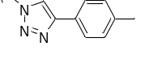 | 0.63±0.04 | 0.09±0.01 | 18.95±1.39
MMAF |  |  | 0.08±0.01 | 0.14±0.01 | 0.32±0.03
ªThree repeated experiments were performed to calculate the average IC₅₀

