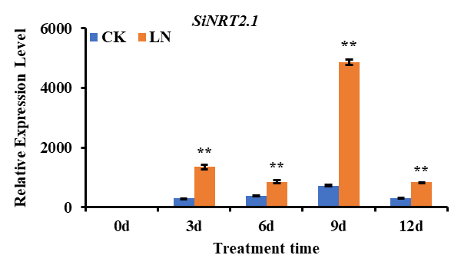
Figure S1 Real-time PCR analysis of the SiNRT2.1 gene in ZZHL05 under low N treatment. ** Means significant differences according to the Duncan’s multiple range, P<0.01, n = 3.

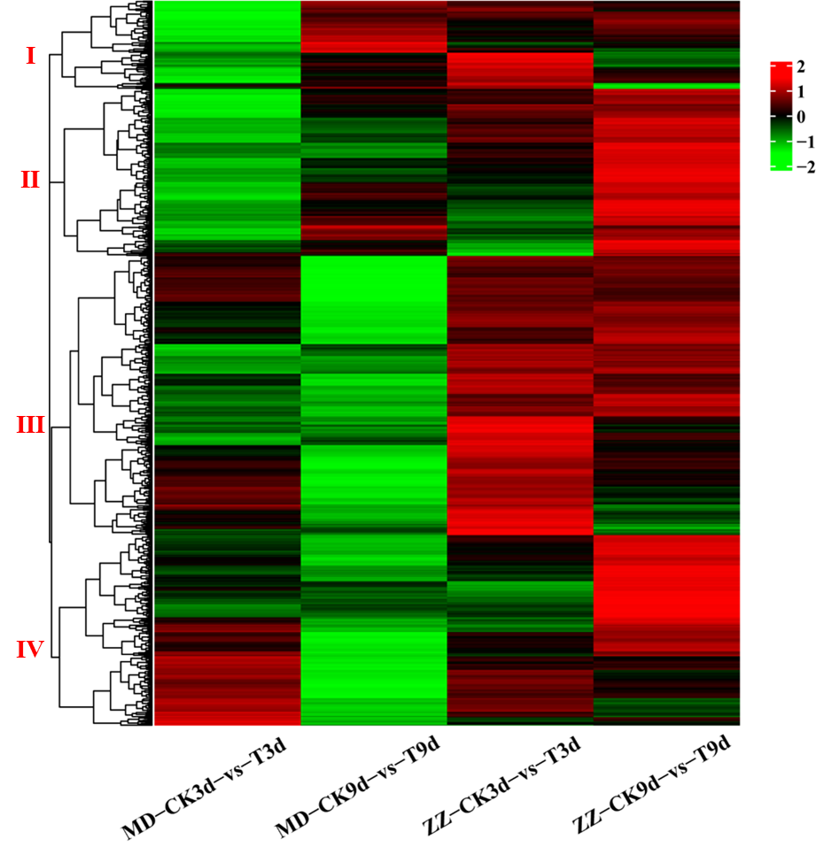
Figure S2 Hierarchical cluster analysis of low nitrogen tolerance related DEGs.
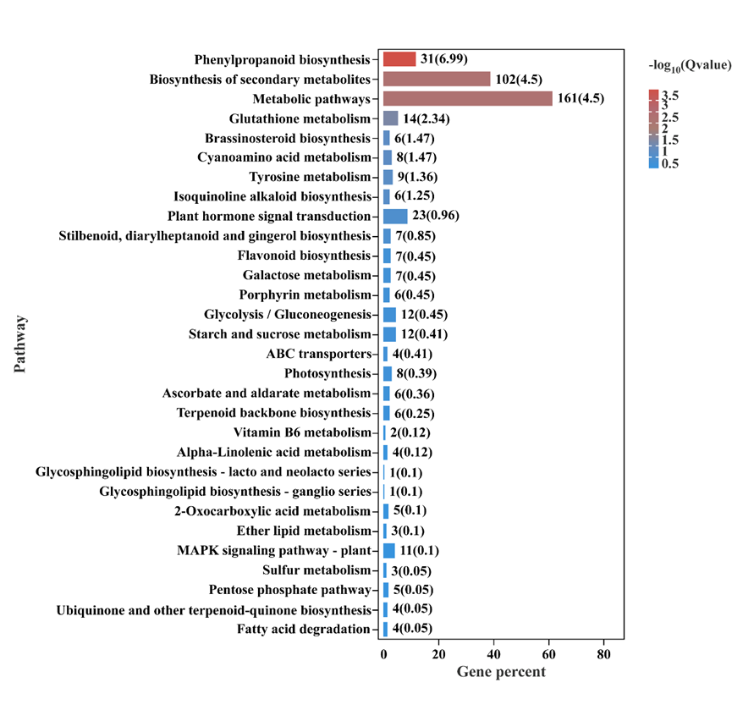
Figure S3 KEGG enrichment analysis of LN tolerance related DEGs.

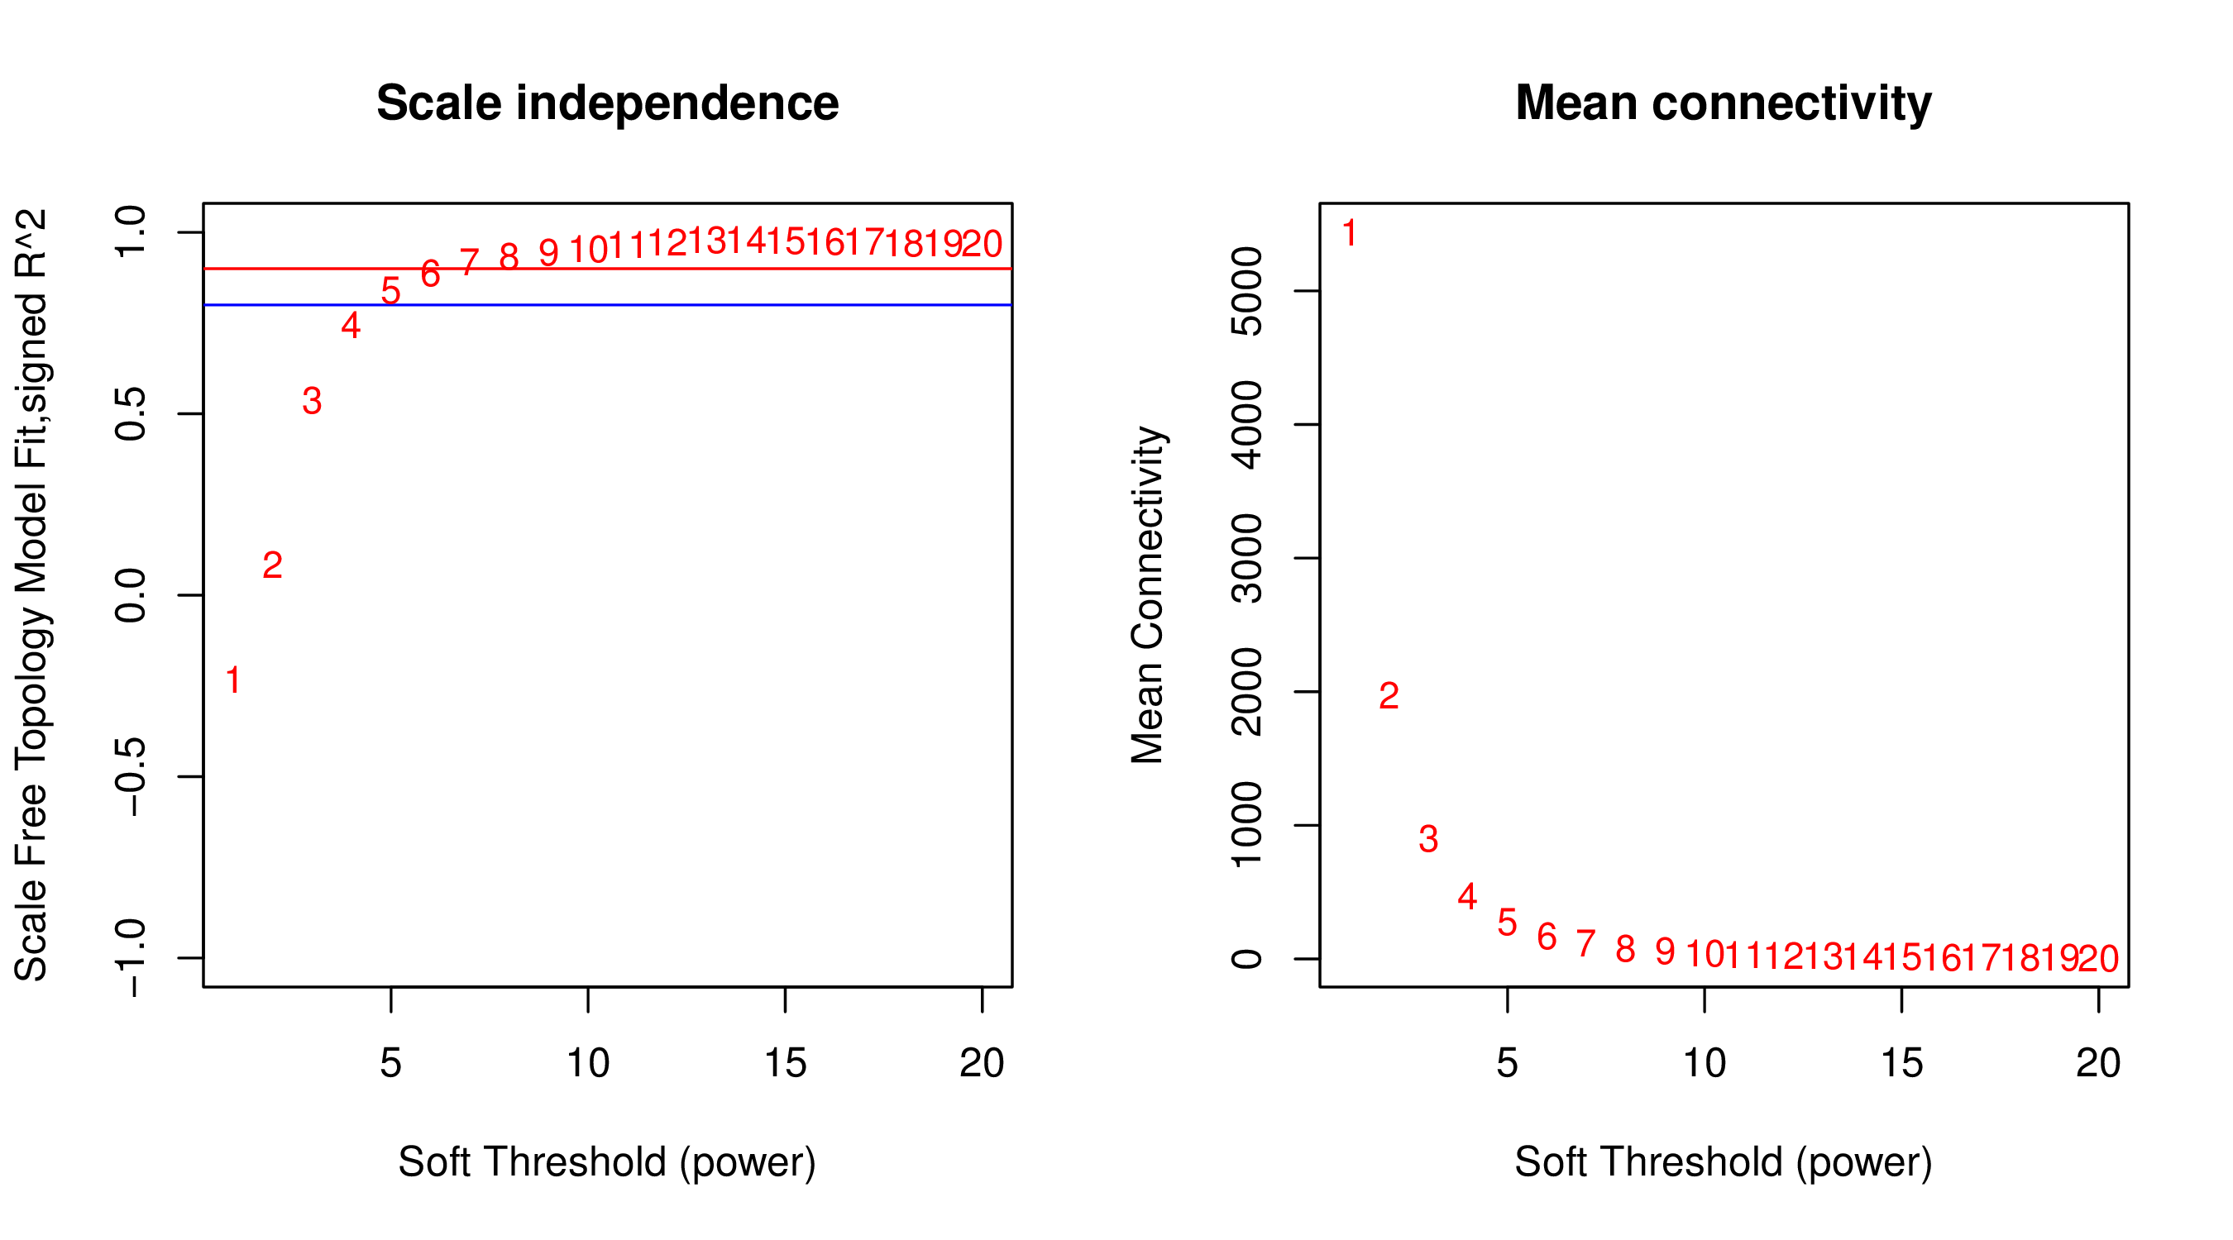
Figure S4 Determination of soft thresholding power in the WGCNA. The left panel shows the influence of soft threshold power on the scale free topological fit index; the right panel shows the influence of soft threshold power on the average connectivity.

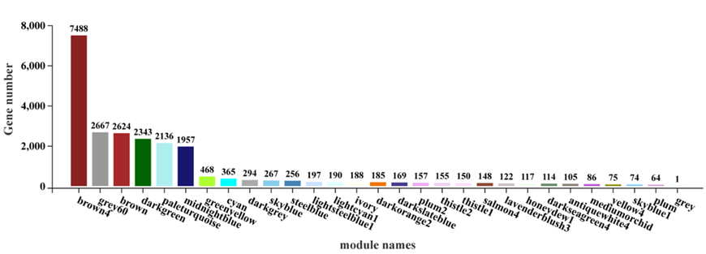
Figure S5 The gene number of each module.

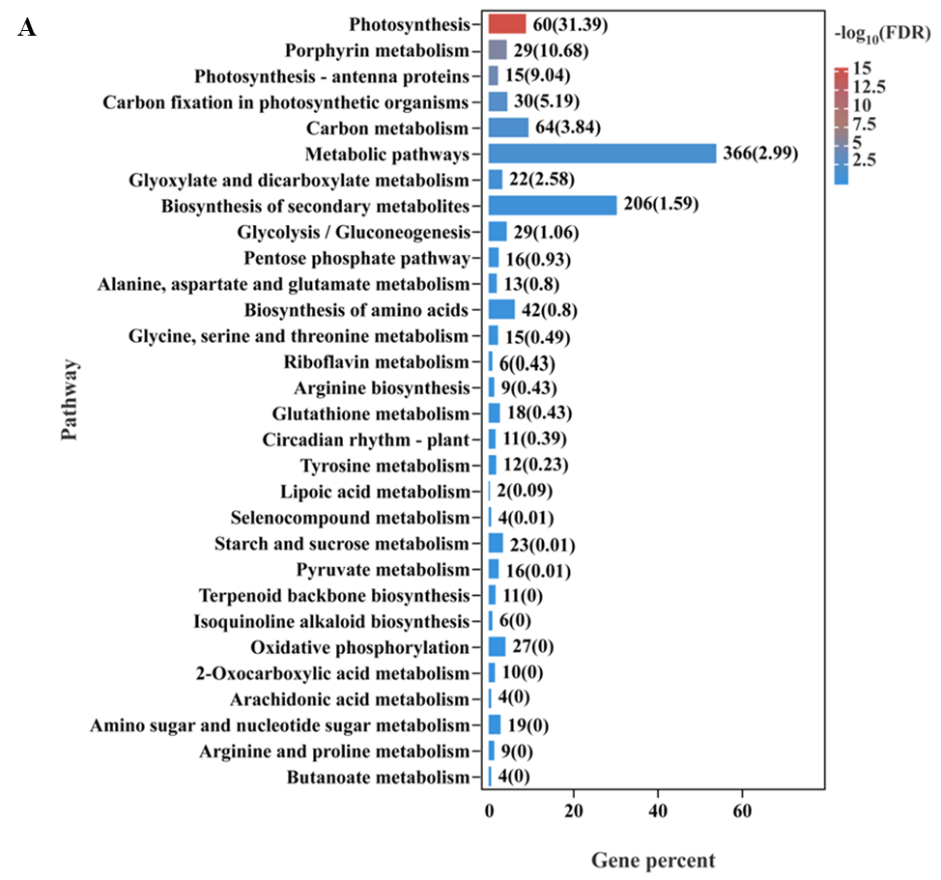
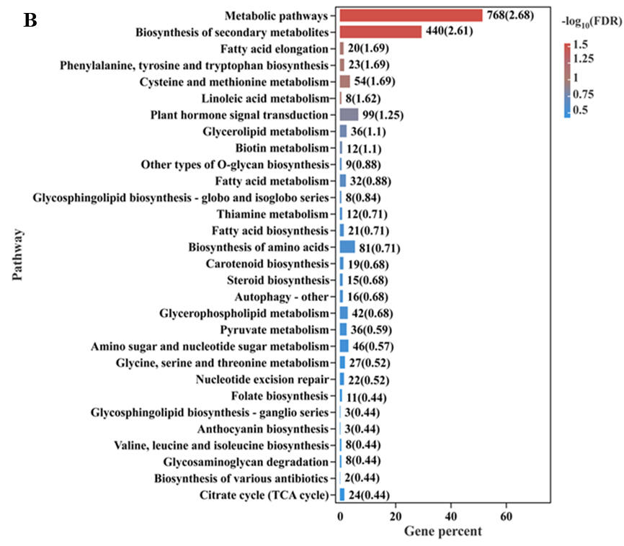
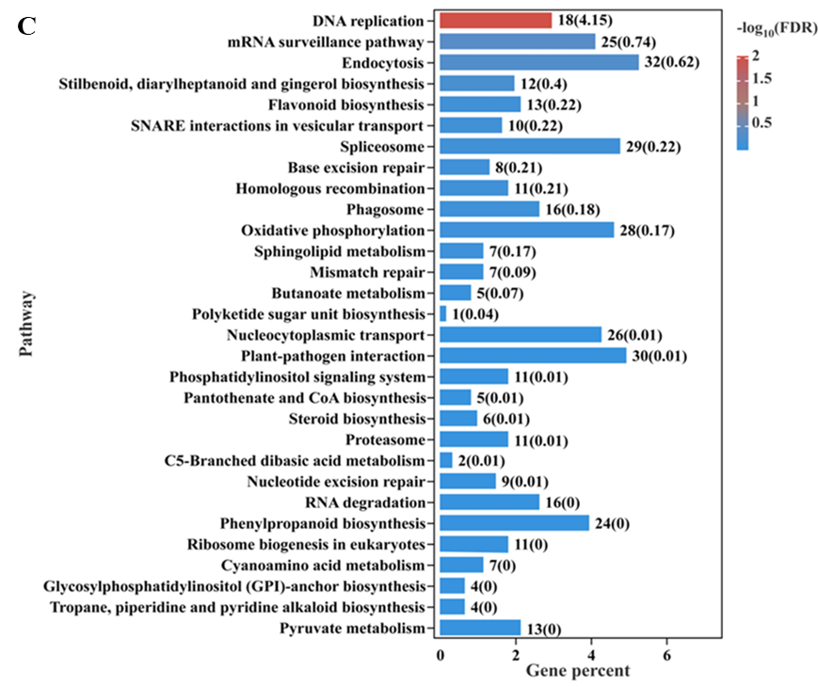
Figure S6 KEGG enrichment analysis of brown(A), brown4(B) and darkgreen(C) modules.

