Suppl Fig.1
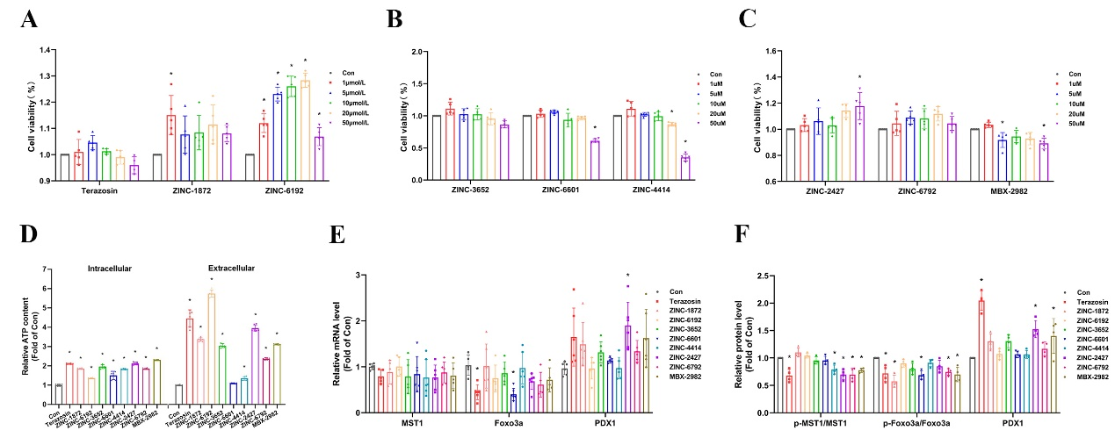

Suppl Fig.2
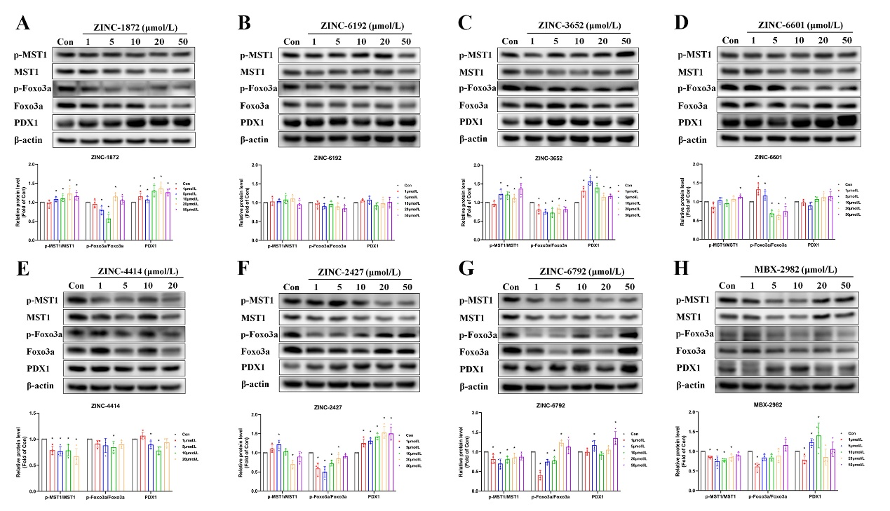

Suppl Fig.3
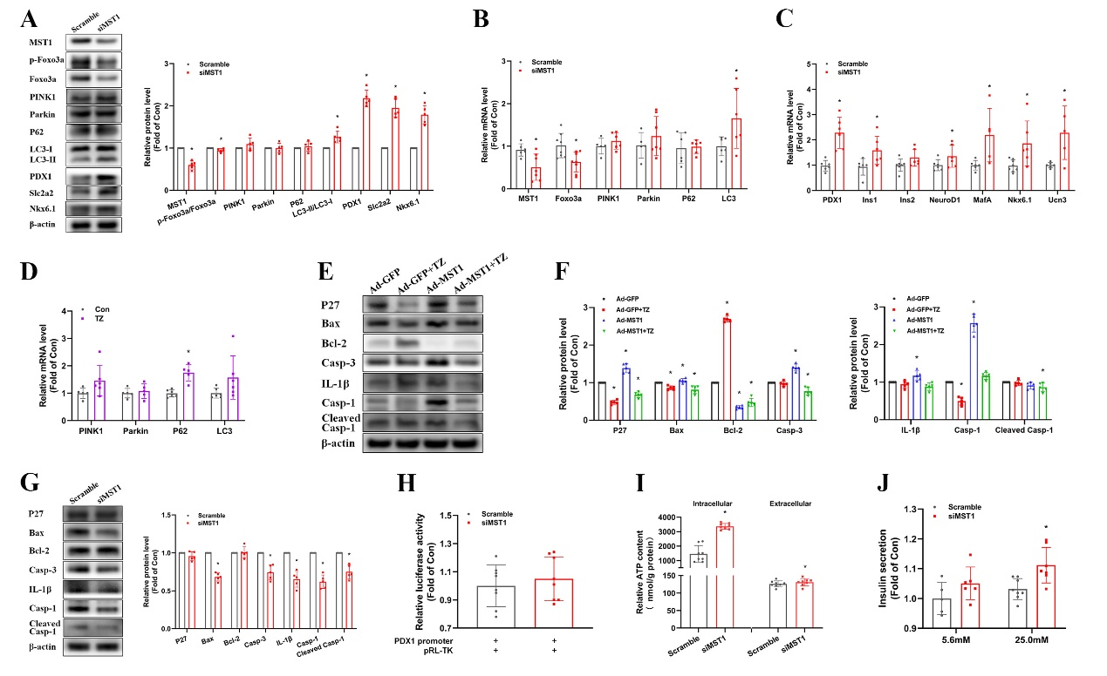

Suppl Fig.4
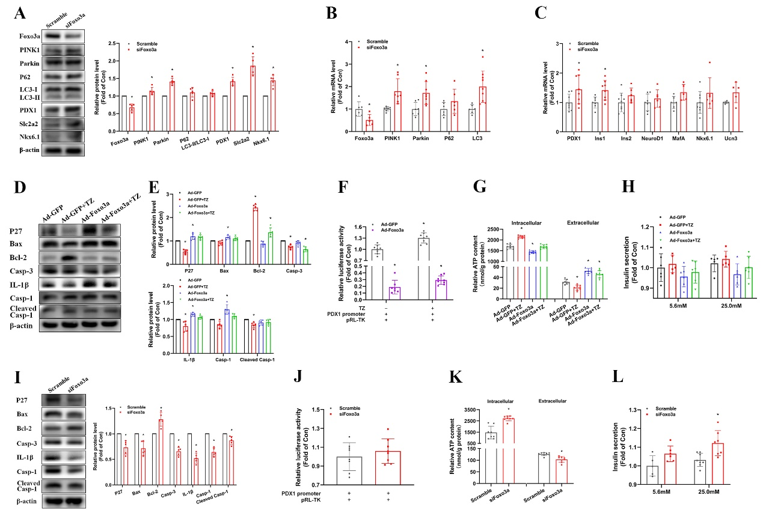

Suppl Fig.5
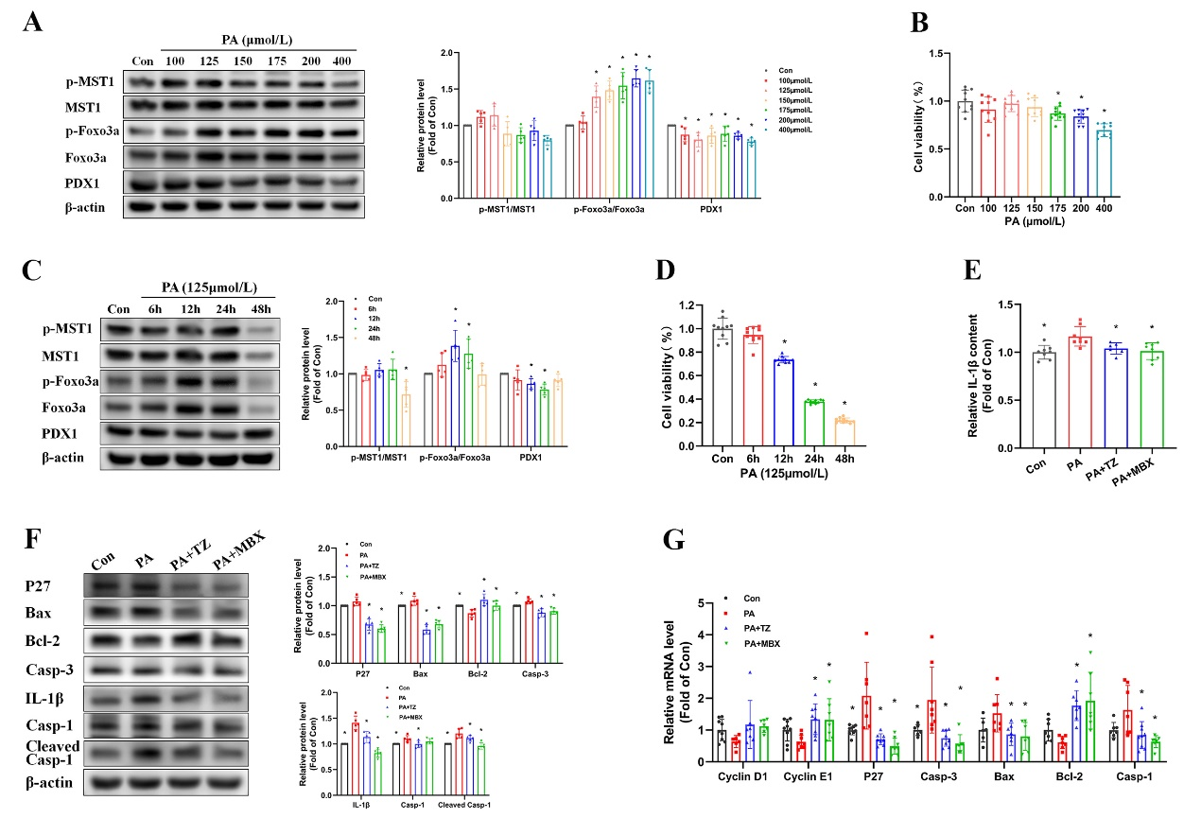

Suppl Fig.6
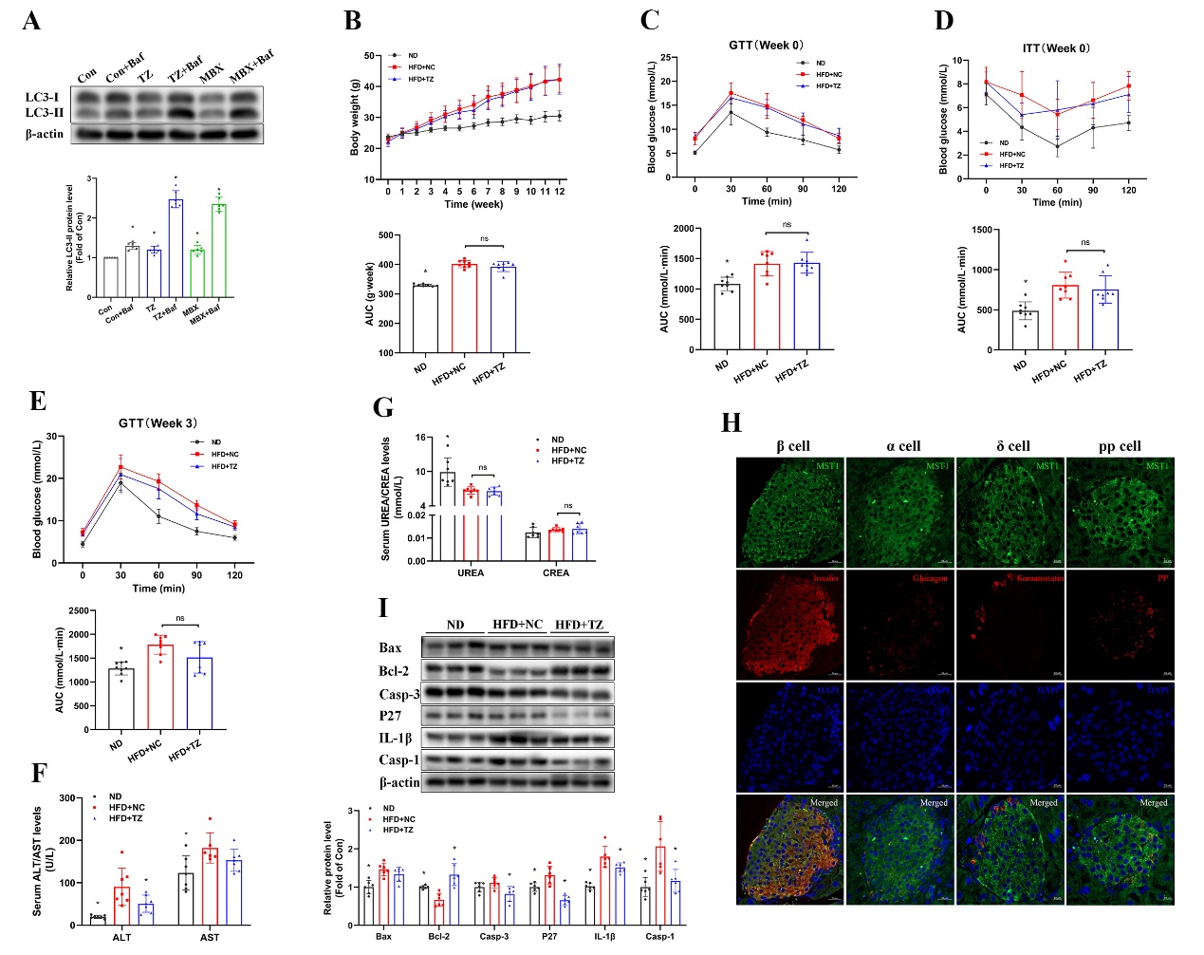

Suppl Fig.7
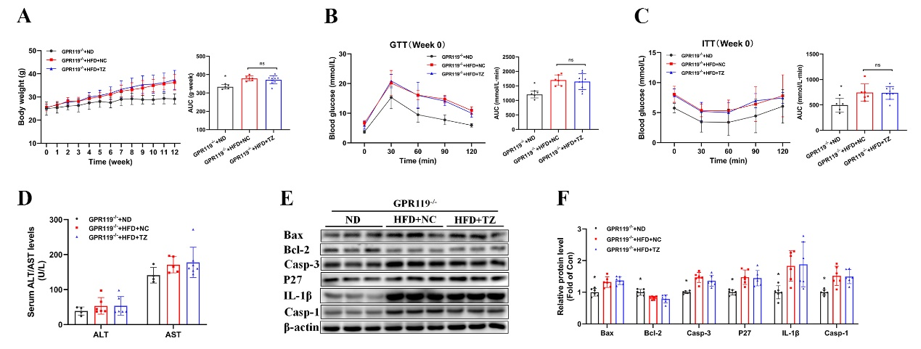

Suppl Table 1
Gene | Forward primer | Reverse Primer
mouse-MST1 | GGGCTGGTTCTGTATCTGATATC | ATTTCCCGCCTTGATATCTCG
mouse Foxo3a | CTCACTTTGTCCCAGATCTACG | CTTCATTCTGAACGCGCATG
mouse PINK1 | CCTCATCTGTGCCCCTCCTG | CCAGGGACAGCCATCTGAGT
mouse Parkin | GGCAGTTTGTCCACGATGCT | TAATCAGGGAGTTGGGACAGCC
mouse P62 | CCTATACCCACATCTCCCACC | TGTCGTAATTCTTGGTCTGTAGG
mouse LC3 | ACAAAGAGTGGAAGATGTCCG | CCCCTTGTATCGCTCTATAATCAC
mouse PDX1 | CGCCACCCCAGTTTACAAGC | TGTAAGCACCTCCTGCCCA
mouse Ins1 | CCATCAGCAAGCAGGTCATTGT | TAGAAGAAGCCACGCTCCCC
mouse Ins2 | AGGACCCACAAGTGGCACAA | GGTAGGCTGGGTAGTGGTGG
mouse NeuroD1 | GAACCTTTTAACAACAGGAAGTGGA | CGCTCTCGCTGTATGATTTGGT
mouse MafA | AGGAGGAGGTCATCCGACTG | CTTCTCGCTCTCCAGAATGTG
mouse Nkx6.1 | GAGAGTCAGGTCAAGGTCTGGTT | CCACCGCTCGATTTGTGCTT
mouse Ucn3 | AGTCCACTTACAGGGAGCGAT | TGATCTGGAGGTGCGTTTGGT
mouse Cyclin D1 | AGTGCGTGCAGAAGGAGATT | CACAACTTCTCGGCAGTCAA
mouse Cyclin E1 | CCTCCAAAGTTGCACCAGTT | GGACGCACAGGTCTACAAGC
mouse P27 | GCGGTGCCTTTAATTGGGT | ATTCTTAATTCGGAGCTGTTTACG
mouse Caspase3 | CTTCATCATTCAGGCCTGCCG | GAACCACGACCCGTCCTTTG
mouse Bax | GATCATGAAGACAGGGGCCTTTT | CTCGATCCTGGATGAAACCCTGTA
mouse Bcl-2 | TGGAGAGCGTCAACAGGGAG | CACAAAGGCATCCCAGCCTC
mouse Caspase1 | TGCCCAGAGCACAAGACTTC | CACTCCTTGTTTCTCTCCACGG
mouse β actin | ACCTTCTACAATGAGCTGCG | CTGGATGGCTACGTACATGG

