Supporting information
MnO, Co and Ni Nanoparticle Synthesis by Oleylamie and Oleic Acid
Wencai Heª, Yifang Qiª, Uppalaiah Erugu^{b}, Jaiden Mooreª, Xianchun Zhuª, Fengxiang Hanª, Jinke Tang^{b}, Qilin Daiª*
ªDepartment of Chemistry, Physics, and Atmospheric Sciences, Jackson State University, Jackson, MS, 39217, United States
^{b} Department of Physics & Astronomy, University of Wyoming Laramie, Wyoming 82071, USA

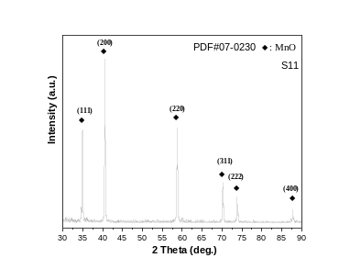
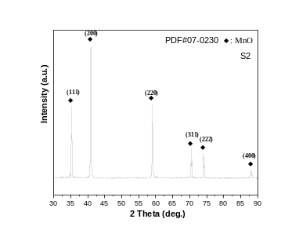
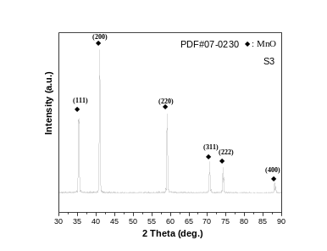
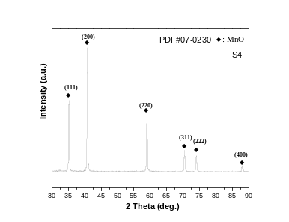
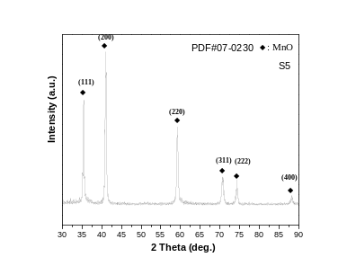
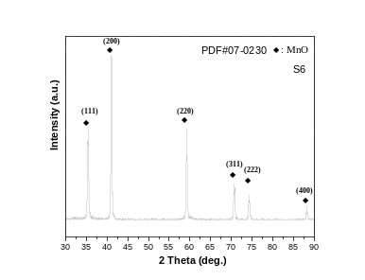
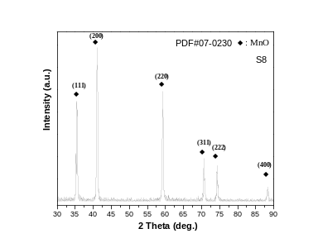
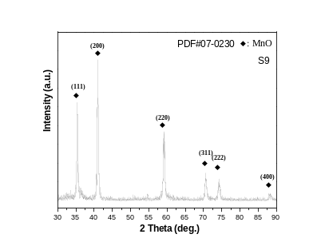
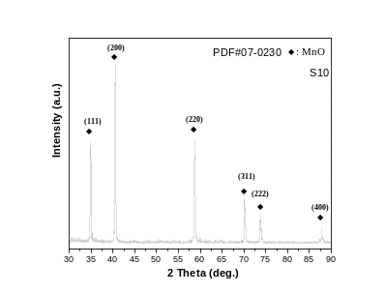
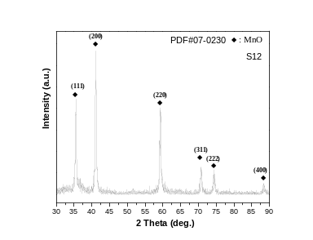
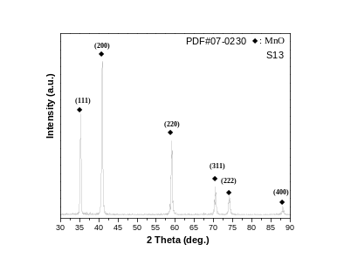
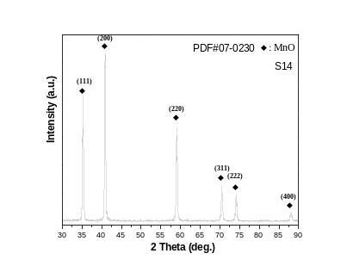
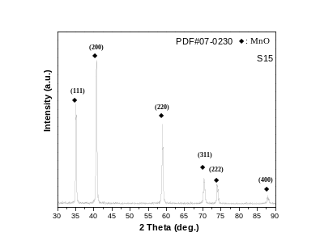

Figure S1 XRD diffraction patterns of S2-S15

