Supplementary Information for

Electroreduction-Driven Distorted Nanotwins to Activate Pure Cu for Efficient Hydrogen Evolution
Zhe Li^{1, 2#}, Yueshuai Wang^{3#}, Hui Liu^{4#}, Xiwen Du⁴, Zhiheng Xie⁵, Jihan Zhou^{5*}, Yang Liu¹, Yun Song¹, Fei Wang^{1,6}, Manling Sui³, Yue Lu^{3*}, Dalin Sun^{1,6*}, Fang Fang^{1,6*}

1 Department of Materials Science, Fudan University, Shanghai, 200433, China
Email: dlsun@fudan.edu.cn; f_fang@fudan.edu.cn
2 Institute of Molecular Plus, School of Chemical Engineering and Technology, Tianjin University, Tianjin, 300072, China
3 Beijing Key Lab of Microstructure and Property of Advanced Materials, College of Materials Science and Engineering, Beijing University of Technology, Beijing, 100124, China
Email: luyue@bjut.edu.cn
4 Institute of New Energy Materials, School of Materials Science and Engineering, Tianjin University, Tianjin, 300072, China
5 Beijing National Laboratory for Molecular Sciences, Center for Integrated Spectroscopy, College of Chemistry and Molecular Engineering, Peking University, 100871 Beijing, China.
Email: jhzhou@pku.edu.cn
6 School of Materials Science and Engineering, Anhui University, Hefei 230601, China
#These authors contributed equally to this work.

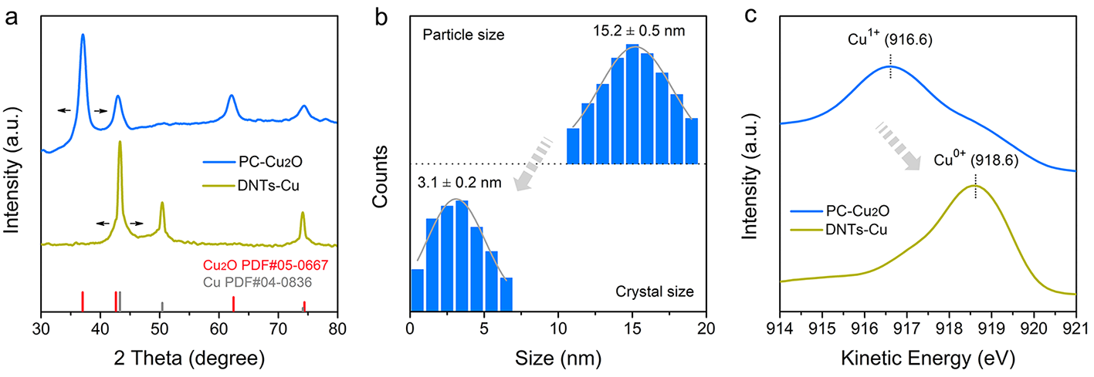
Supplementary Figure 1 | Characterization of PC-Cu₂O and DNTs-Cu (-1.2V). a, XRD patterns of PC-Cu₂O nanoparticles and DNTs-Cu (-1.2 V) catalysts. The arrows are shown to guide the eye for peak broadening. b, Particle size and crystal size distribution of PC-Cu₂O nanoparticles deduced from statistics of TEM images. c, Auger electron spectroscopy (AES spectrum) of PC-Cu₂O nanoparticles and DNTs-Cu (-1.2 V) catalysts.

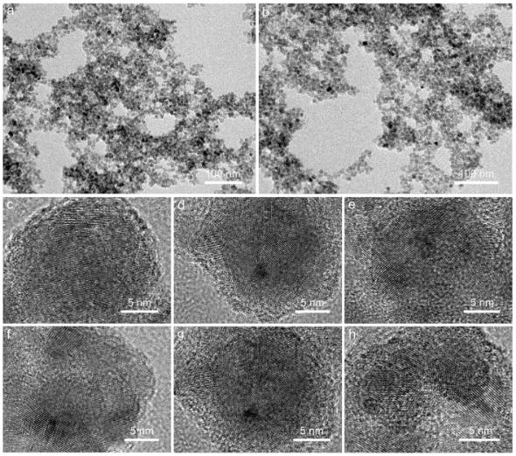
Supplementary Figure 2 | Low (a,b) and High (c-h) resolution TEM images of PC-Cu₂O nanoparticles.

Supplementary Figure 3 | XRD patterns of DNTs-Cu catalysts derived from electroreduction of PC-Cu₂O nanoparticles under different potential (-0.8 V, -1.0 V, -1.2 V and -1.4 V). a, DNTs-Cu (-0.8 V). b, DNTs-Cu (-1.0 V). c, DNTs-Cu (-1.2 V). d, DNTs-Cu (-1.4 V). The shadow regions represent the peak width of the (111) XRD pattern. The insets show the grain thickness in the normal direction of each crystal plane, which are calculated according to Scherrer formula.

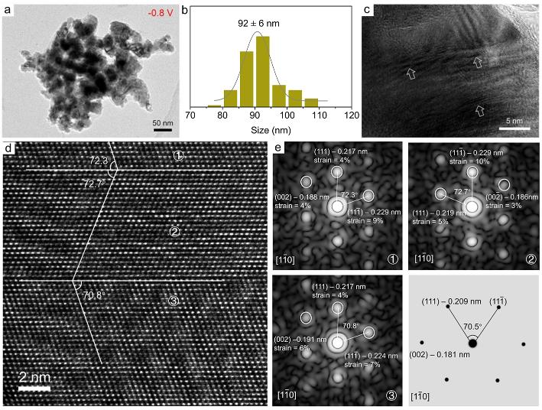
Supplementary Figure 4 | TEM characterization of DNTs-Cu derived from electroreduction of PC-Cu₂O nanoparticles under -0.8 V. a, Low-resolution TEM image of DNTs-Cu (-0.8 V). b, Particle size distribution deduced from statistics of TEM images. c, High-resolution TEM image of DNTs-Cu (-0.8 V). The arrows represent slight nanotwins. d, Aberration-corrected atomic resolution TEM image of DNTs-Cu (-0.8 V). e, The corresponding FFT patterns of nanotwins at different areas in (d) and diffraction simulation of perfect Cu crystal, from which the lattice strain could be calculated.

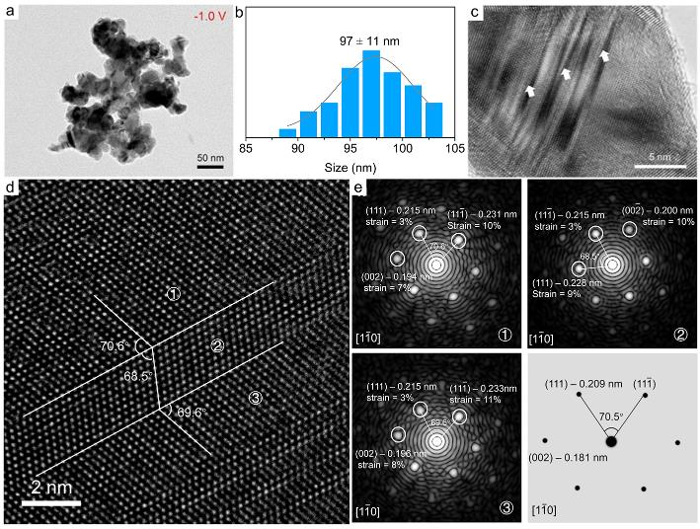
Supplementary Figure 5 | TEM characterization of DNTs-Cu derived from electroreduction of PC-Cu₂O nanoparticles under -1.0 V. a, Low-resolution TEM image of DNTs-Cu (-1.0 V). b, Particle size distribution deduced from statistics of TEM images. c, High-resolution TEM image of DNTs-Cu (-1.0 V). The arrows represent slight nanotwins. d, Aberration-corrected HRTEM image of DNTs-Cu with -1.0 V electroreduction potential. e, Corresponding FFT patterns of nanotwins in (d) and diffraction simulation of perfect Cu crystal, the lattice strains were measure in these FFT images.

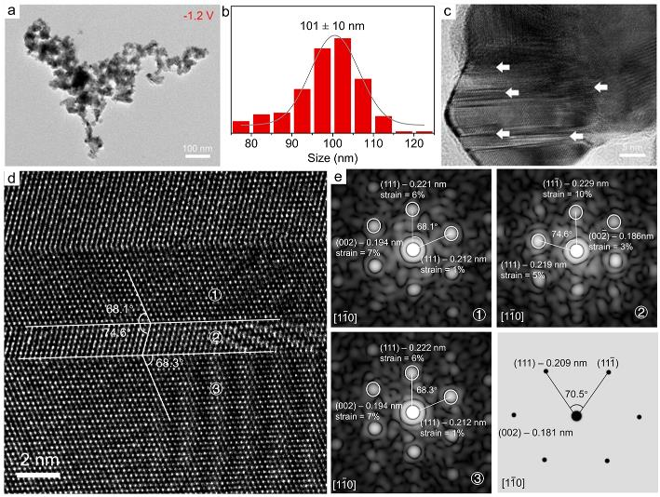
Supplementary Figure 6 | TEM characterization of DNTs-Cu derived from electroreduction of PC-Cu₂O nanoparticles under -1.2 V. a, Low-resolution TEM image of DNTs-Cu (-1.2 V). b, Particle size distribution deduced from statistics of TEM images. c, High-resolution TEM image of DNTs-Cu (-1.2 V). The arrows represent slight nanotwins. d, Atomic resolution aberration-corrected TEM image of DNTs-Cu (-1.2 V). e, Corresponding FFT patterns of nanotwins in (d) and diffraction simulation of perfect Cu crystal, the lattice strains was measure and marked in the FFT images.

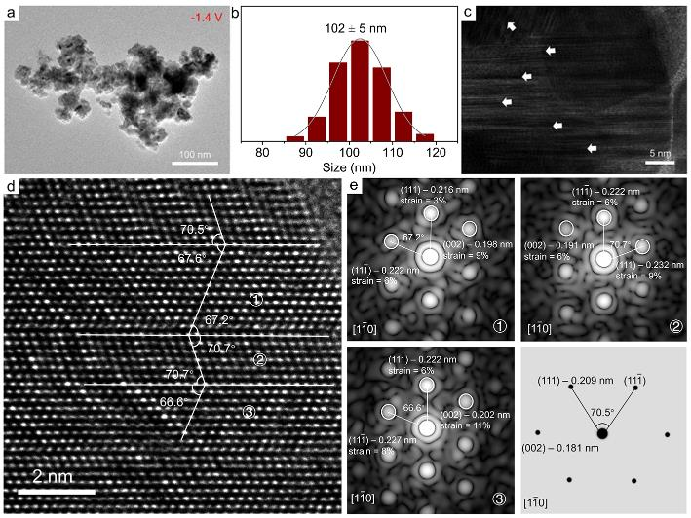
Supplementary Figure 7 | TEM characterization of DNTs-Cu derived from electroreduction of PC-Cu₂O nanoparticles under -1.4 V. a, Low-resolution TEM image of DNTs-Cu (-1.4 V). b, Particle size distribution deduced from statistics of TEM images. c, High-resolution TEM image of DNTs-Cu (-1.4 V). The arrows represent slight nanotwins. d, Atomic resolution aberration-corrected TEM image DNTs-Cu (-1.4 V). e, Corresponding FFT patterns of nanotwins in (d) and diffraction simulation of the pure Cu crystal.

Supplementary Figure 8 | Characterization of in situ electrochemical liquid cell set-up. a, The schematic side view of in situ electrochemical liquid cell set-up. b, Low-resolution SEM image of carbon cloth loaded with catalysts in in situ XAS observation. c, How-resolution SEM image of carbon cloth loaded with catalysts in in situ XAS observation.

Supplementary Figure 9 | Cu K-edge EXAFS fitting curves at R space. a, Atomic coordination environment of Cu with perfect crystal structure. The mark number shows the coordination number of perfect Cu. b, DNTs-Cu (-0.8 V). c, DNTs-Cu (-1.0 V). d, DNTs-Cu (-1.2 V). e, DNTs-Cu (-1.4 V). f, Cu foil.
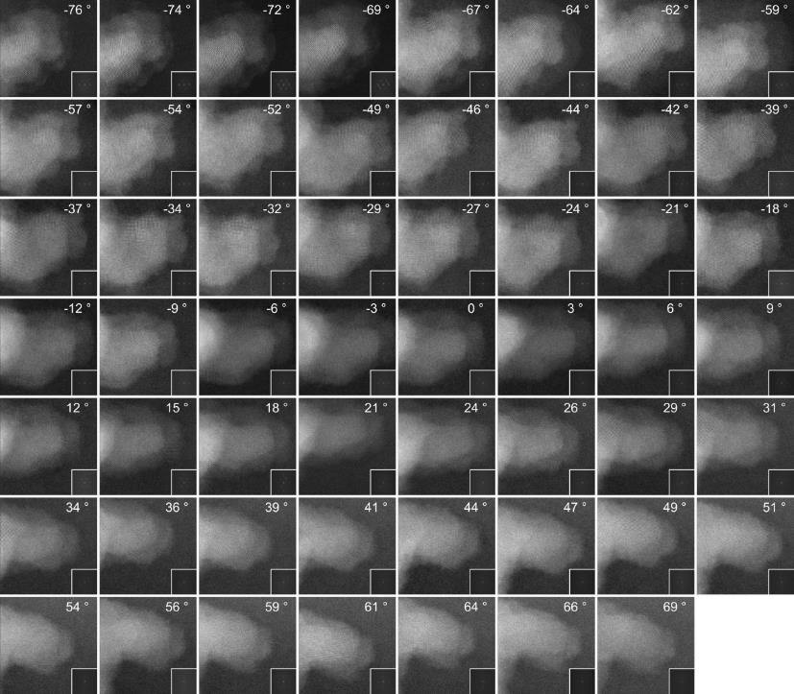
Supplementary Figure 10 | Tomographic tilt series of DNTs-Cu. 55 ADF-STEM images with a tilt range from -76° to +69°. The insets show the FFT of each image. Scale bar is 2 nm.

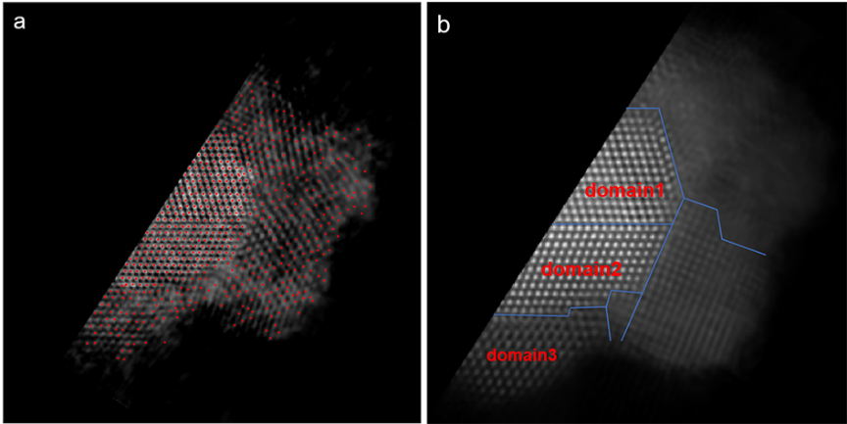
Supplementary Figure 11 | Reconstructed structure of DNTs-Cu. a, A 2.1-Å-thick slice of the 3D volume, atom positions are traced and labelled in red. b, The 2D projection of the 3D reconstruction volume, boundaries (blue line) and monocrystal domains are labelled.

Supplementary Figure 12 | 3D Strain tensor analysis of DNTs-Cu. a, Atom model in eight successive 2-atom-thick layers of the DNTs-Cu particle, where some surface and boundary atoms in red are excluded for displacement field and strain measurements. b-d, 3D lattice displacement field of the particle in 3 directions. e-j, six components of the full 3D strain tensor of DNTs-Cu particle.
Supplementary Figure 13 | Atomic model of Cu (111) surface with different coordination number. a, Atomic coordination environment of perfect Cu (111) surface. b, Atomic model of catalytic site with coordination number 9. c, Atomic model of catalytic site with coordination number 8. d, Atomic model of catalytic site with coordination number 7. e, Atomic model of catalytic site with coordination number 6. f, Atomic model of catalytic site with coordination number 5.

Supplementary Figure 14 | Atomic model of Cu (110) surface with different coordination number. a, Atomic coordination environment of perfect Cu (110) surface. b, Atomic model of catalytic site with coordination number 7. c, Atomic model of catalytic site with coordination number 6. d, Atomic model of catalytic site with coordination number 5.

Supplementary Figure 15 | The scheme of atomic structure with different coordination number. a, Cu (111) plane. b, Cu (110) plane. The top line is top view and the bottom line is the side view.

Supplementary Figure 16 | Hydrogen adsorption Gibbs free energy (ΔG_{H*}) of Pt (111) and Pt (110) surface. The inset are atomic model of Pt (111) and Pt (110) surface.

Supplementary Figure 17 | The effect of tensile strain and atomic coordination number on electronic structure and hydrogen adsorption Gibbs free energy (ΔG_{H*}) . a, The deformation charge density contour plot as a function of tensile strain (0%, 3% and 6%) and coordination number (CN=9, CN=7 and CN=5) on Cu (111) surface. b, The electron-density-difference contour plot as a function of tensile strain (0%, 3% and 5%) and coordination number (CN=7, CN=6 and CN=5) on Cu (110) surface. The negative values represent electrons missing and the positive values represent electron enrichment. c, The d-band center as a function of strain and coordination number on Cu (111) surface. d, The d-band center as a function of strain and coordination number on Cu (110) surface. e, ΔG_{H*} as a function of strain and coordination number on Cu (111) surface. f, ΔG_{H*} as a function of strain and coordination number on Cu (111) surface. The dashed lines are shown to guide the eye.
For electrocatalysts, their electrocatalytic activity depends on the electronic structure. Thus, to explore the electronic states of DNTs-Cu, the change of the charge distribution along with the reduction of coordination number and/or the increase of tensile strain was firstly investigated by differential charge density. As shown in Supplementary Fig. 17a for Cu (111) surface and Supplementary Fig. 17b for Cu (110) surface, the shared electron density between adjacent Cu atoms decreases with the reduction of coordination number and also does with the increase of tensile strain from 0% to 6%. When considering the combined effect of the decrease in coordination number and the increase in tensile strain, the decrease in the shared electron density is more significant, which indicate an enhanced localization of extranuclear electrons of Cu atoms. According to the classical d-band center theory, the decrease in the shared electron density would result in an upshift of d-band center. Therefore, the relationship of d-band center with tensile strain and coordination number was also studied by DFT calculation. Supplementary Fig. 17c shows the upshift of the d-band center on Cu (111) surface. The d-band center on Cu (111) surface moves up from -2.352 eV to -1.901 eV when the coordination number decreases from 9 to 5, and does from -2.352 eV to -2.049 eV when the tensile strain increases from 0% to 6%. More importantly, the synergistic effect of the decrease in coordination number and the increase in tensile stress moves the d-band center on Cu (111) surface up to -1.346 eV. Similarly, the d-band center of (110) plane also upshifts in Supplementary Fig. 17d. In detail, the d-band center shifts up from -2.114 eV to -1.247 eV when the coordination number decreases from 7 to 5 while the tensile stress increases from 0% to 6%. These obvious upshifts of d-band center indicate that for HER process, the adsorption capacity of catalytic intermediate H* is enhanced significantly on both Cu (111) and Cu (110) surfaces. The corresponding hydrogen adsorption free energy (ΔG_{H*}) was calculated and shown in Supplementary Fig. 17e and 17f. With the change of coordination number and tensile strain, the ΔG_{H*} could be tuned between 0.249 eV to 0.019 eV on Cu (111) surface in Supplementary Fig. 17e and between 0.209 eV to 0.001 eV on Cu (110) surface Supplementary Fig. 17f. For comparison, the perfect crystal planes of Pt (111) and Pt (110) were also calculated in Supplementary Fig. 16. Obviously, when the coordination number decreases to 5 and the tensile strain increases to 6%, the ΔG_{H*} could almost be adjusted to zero, even better than noble metal Pt (ΔG_{H*}=-0.1 eV on Pt (111), ΔG_{H*}=-0.37 eV on Pt (110)), indicating a fantastic HER catalytic performance.
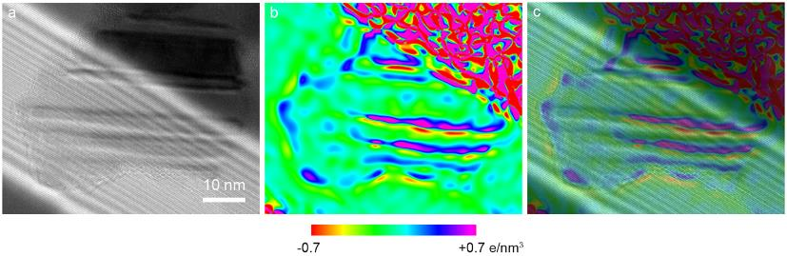
Supplementary Figure 18 | Charge distribution of DNTs-Cu (-1.2 V). a, TEM image of DNTs-Cu (-1.2 V). b, Charge distribution map in (a). c, The mixed image of (a) and (b).

Supplementary Figure 19 | Calibration of the reference saturated calomel electrode (SCE) to reversible hydrogen electrode (RHE). a, Scheme of the calibration set up. b, The cyclic voltammetry curves in calibration process. The calibration was performed in a high purity hydrogen-saturated electrolyte with a Pt sheet as the working electrode. Before the test, the Pt sheet electrode was polished and washed for several times. Cyclic voltammetry run at a scan rate of 1 mV/s, and the average of the two potentials at which the current value was zero was taken as the thermodynamic potential.

Supplementary Figure 20 | Scheme of preparation for self-supported DNTs-Cu electrode at Cu foam in HER activity tests.

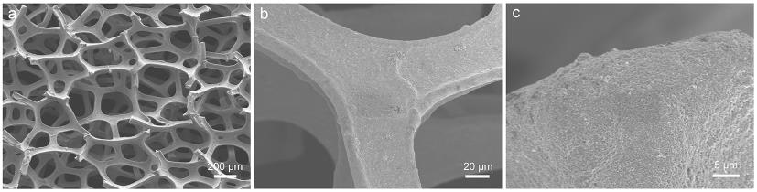
Supplementary Figure 21 | SEM characterization of PC-Cu₂O@Cu foam electrode. a, Low-resolution SEM image. b - c, High-resolution SEM images.

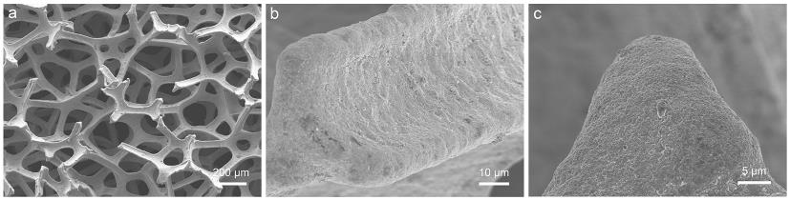
Supplementary Figure 22 | SEM characterization of DNTs-Cu@Cu foam electrode. a, Low-resolution SEM image. b - c, High-resolution SEM images.

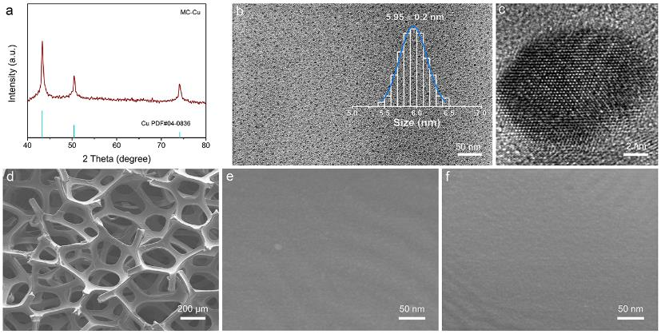
Supplementary Figure 23 | Characterization of MC-Cu prepared by magnetron sputtering. a, XRD pattern. b, Low-resolution TEM image. The inset is particle size distribution pattern. The fitting was determined with Gauss fit. c, High-resolution TEM image. d, Low-resolution SEM image. e - f, High-resolution SEM images.

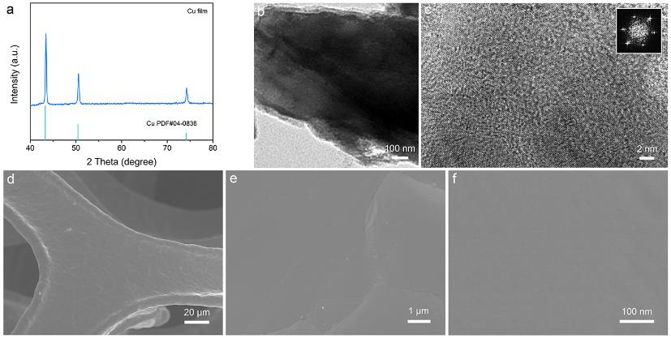
Supplementary Figure 24 | Characterization of Cu film prepared by thermal evaporation. a, XRD pattern. b, Low-resolution TEM image. c, High-resolution TEM image. The inset is corresponding Fast Fourier Transform (FFT) pattern. d, Low-resolution SEM image. e - f, High-resolution SEM images.
Supplementary Figure 25 | HER activity of blank Cu foam electrode in Ar-saturated 0.5 M H₂SO₄ aqueous electrolyte. a, Polarization curve. b, Corresponding Tafel plot of polarization curve in (a).

Supplementary Figure 26 | HER activity of DNTs-Cu (-1.2 V) and DNTs-Cu (-1.4 V) in Ar-saturated 0.5 M H₂SO₄ aqueous electrolyte. a, Polarization curve. b, Corresponding Tafel plot of polarization curve in (a). c, Comparison of overpotential and Tafel slope.

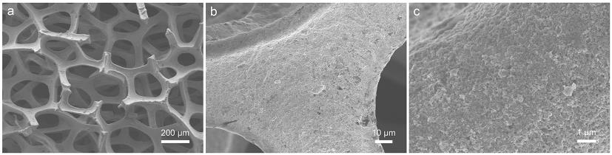
Supplementary Figure 27 | SEM characterization of DNTs-Cu (-1.2 V)@Cu foam electrode after annealing. a, Low-resolution SEM image. b - c, High-resolution SEM images.
Supplementary Figure 28 | XRD patterns of DNTs-Cu (-1.2 V) before { DNTs-Cu (-1.2 V) } and after { Annealed-DNTs-Cu (-1.2 V) } annealing. The shadow regions and arrows represent peak width of XRD patterns.

Supplementary Figure 29 | TEM characterization of annealed-DNTs-Cu (-1.2 V). a, Low-resolution TEM image. b - f, High-resolution TEM images.

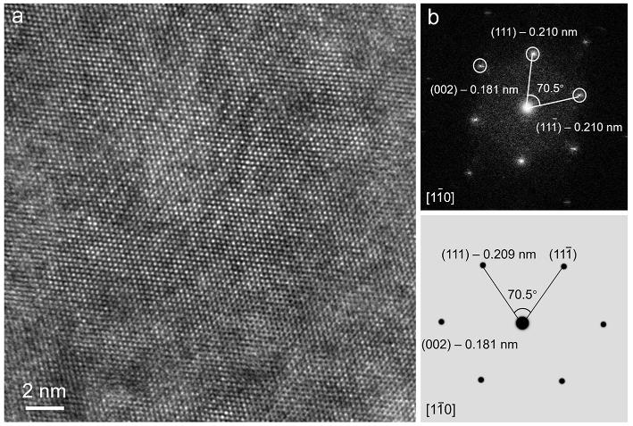
Supplementary Figure 30 | TEM characterization of annealed-DNTs-Cu (-1.2 V). a, Atomic resolution aberration-corrected TEM image. b, Corresponding FFT patterns and diffraction simulation.

Supplementary Figure 31 | In situ XAS characterizations of annealed-DNTs-Cu (-1.2 V). a, In situ Fourier transformed (FT) k³-weighted χ (k)-function EXAFS spectra at Cu K-edge. b, Cu K-edge EXAFS fitting curves at R space.

Supplementary Figure 32 | HER activity of DNTs-Cu (-1.2 V) and annealed-DNTs-Cu (-1.2 V). a, Polarization curves. b, Tafel plots.

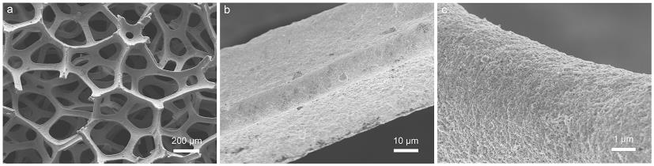
Supplementary Figure 33 | SEM characterization of DNTs-Cu (-1.2 V)@Cu foam electrode after stability test. a, Low-resolution SEM image. b - c, High-resolution SEM images.

Supplementary Figure 34 | TEM characterization of DNTs-Cu (-1.2 V) after stability test. a - d, High-resolution TEM images of DNTs-Cu (-1.2 V) after stability test.
Supplementary Figure 35 | In situ XAS characterizations of DNTs-Cu (-1.2 V) after stability test. a, In situ Fourier transformed (FT) k³-weighted χ (k)-function EXAFS spectra at Cu K-edge. b, Cu K-edge EXAFS fitting curves at R space.

Supplementary Figure 36 | Characterizations of PC-Cu₂O nanoparticles after annealing. a, Size distribution from statistics of TEM images. The fitting was determined with Gauss fit. The inset is the TEM images. b, XRD pattern of PC-Cu₂O nanoparticles before annealing. c, XRD pattern of PC-Cu₂O nanoparticles after annealing. The shadow regions and arrows represent peak width of XRD patterns.
Supplementary Figure 37 | Characterization of DNTs-Cu catalysts { Annealed-PC-Cu (-1.2 V) } derived from electroreduction of PC-Cu₂O nanoparticles after annealing under potential of -1.2 V. a, XRD patterns of DNTs-Cu catalysts derived from electroreduction of PC-Cu₂O nanoparticles before { DNTs-Cu (-1.2 V) } and after annealing { Annealed-PC-Cu (-1.2 V) } under potential of -1.2 V. The shadow regions and arrows represent peak width of XRD patterns. b - d, High-resolution TEM images. e and f, HER activity of DNTs-Cu catalysts derived from electroreduction of PC-Cu2O nanoparticles before { DNTs-Cu (-1.2 V) } and after { Annealed-PC-Cu (-1.2 V) } annealing under potential of -1.2 V.

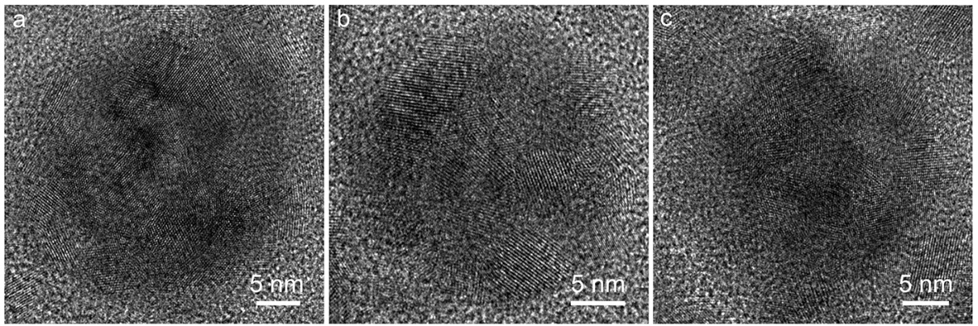
Supplementary Figure 38 | High resolution TEM images of polycrystal Ag₂O nanoparticles produced by Pulsed laser ablation treatment.

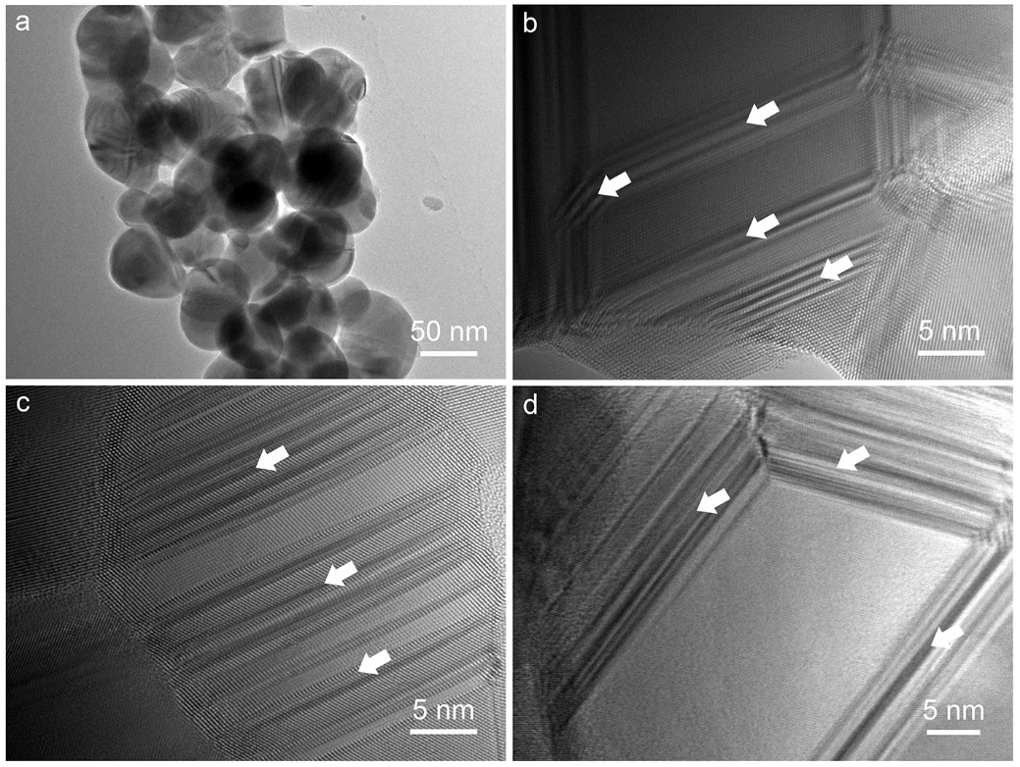
Supplementary Figure 39 | TEM characterization of Ag with nanotwins derived from electroreduction of polycrystal Ag₂O nanoparticles under -1.2 V. a, Low-resolution TEM image. b - d, High-resolution TEM image. The arrows represent nanotwins.

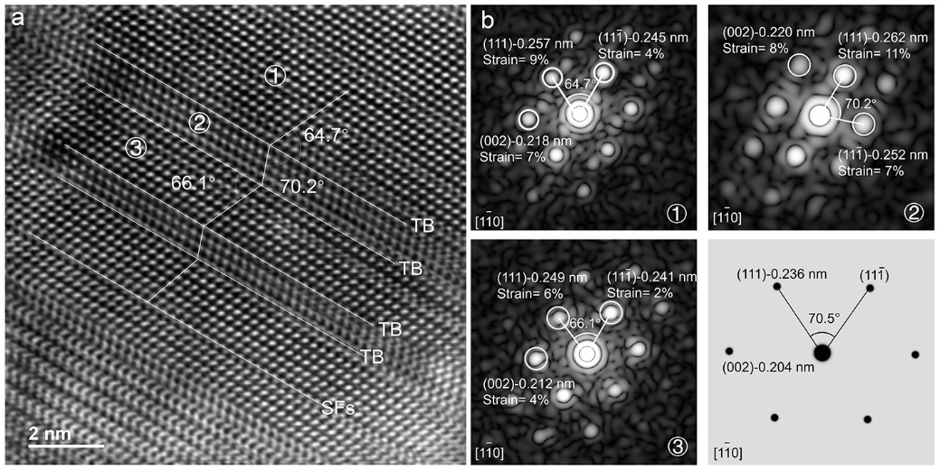
Supplementary Figure 40 | TEM characterization of Ag with strained nanotwins derived from electroreduction of polycrystal Ag₂O nanoparticles under -1.2 V. a, Aberration-corrected atomic resolution TEM image. b, The corresponding FFT patterns of strained nanotwins at different areas in (a) and diffraction simulation of perfect Ag crystal, from which the lattice strain could be calculated.

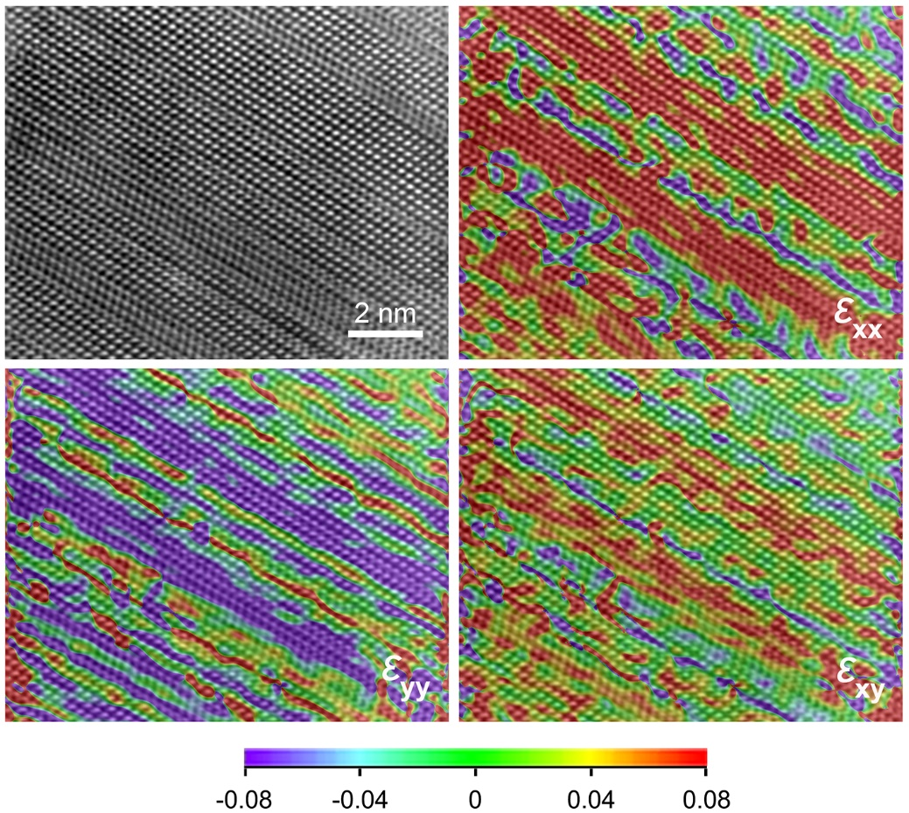
Supplementary Figure 41 | Geometric-phase analysis (GPA) of Ag with strained nanotwins derived from electroreduction of polycrystal Ag₂O nanoparticles under -1.2 V.
Supplementary Figure 42 | HER activity of Ag with strained nanotwins derived from electroreduction of polycrystal Ag₂O nanoparticles under -1.2 V and commercial Ag nanoparticles. a, Polarization curves. b, Tafel plots.

Supplementary Table 1 Summary of recently reported representative HER electrocatalysts in 0.5 M H₂SO₄.
Catalyst | Electrode | Overpotential (mV) | Tafel (mV/dec) | Reference
DNTs-Cu (-1.2 V) | Cu foam | 61 | 33 | This work
Cu NPs/CNFS | CNFs | 200 | 152 | [ 1 ]
NiCu | GCE | 200 | 83.5 | [ 2 ]
Cu@WC | Cu foam | 92 | 50.5 | [ 3 ]
Cu/CF | Cu foam | 276 | 141.7 | [ 3 ]
CuMoS | GCE | 170 | 52 | [ 4 ]
Cu@GD | GCE | 179 | 69 | [ 5 ]
Cu NA | GCE | 441 | 113 | [ 5 ]
Cu-MoS₂ | GCE | 400 | 90 | [ 6 ]
NiCuP | Ni sheet | 150 | 69 | [ 7 ]
Cu | Cu sheet | 450 | 200 | [ 8 ]
CuCo | GCE | 145 | 79 | [ 9 ]
NiCu | Graphite | 81 | 87.4 | [ 10 ]
Pd/Cu | GCE | 88.7 | 98 | [ 11 ]
RuCu | GCE | 102 | 82.8 | [ 12 ]
RuCu | GCE | 78 | 50 | [ 13 ]
PdCu@Pd | GCE | 68 | 35 | [ 14 ]
Cu film | Graphite | 479 | 115 | [ 15 ]
Cu NWs  Cu-D  CuS  Cu@MoS₂  PS-Cu  MSC-Cu  FSC-Cu  OE-Cu | Graphite  Cu plate  GCE  GCE  Cu plate  Cu plate  Cu plate  Cu foam | 355  247  133  131  190  323  234  273 | 78  82  48  51  110  106  120  124 | [ 15 ]  [ 16 ]  [ 17 ]  [ 17 ]  [ 18 ]  [ 19 ]  [ 20 ]  [ 21 ]

Supplementary Table 2 Crystal Structure parameters for EXAFS fitting using ARTEMIS module of IFEFFIT.
Sample | CN | R (Å)
Cu foil | 12 | 2.158 ± 0.01
Cu film | 11.6 ± 0.1 | 2.158 ± 0.01
MC-Cu | 11.1 ± 0.2 | 2.158 ± 0.02
DNTs-Cu (-0.8 V) | 10.9 ± 0.3 | 2.185 ± 0.04
DNTs-Cu (-1.0 V) | 10.1 ± 0.2 | 2.211 ± 0.02
DNTs-Cu (-1.2 V) | 9.5 ± 0.2 | 2.255 ± 0.03
DNTs-Cu (-1.4 V) | 9.5 ± 0.3 | 2.255 ± 0.05
Annealed-PC-Cu (-1.2 V) | 11.2 ± 0.2 | 2.174 ± 0.01
Annealed-DNTs-Cu (-1.2 V) | 11.6 ± 0.2 | 2.161 ± 0.02
DNTs-Cu (-1.2 V) after stability test | 9.6 ± 0.3 | 2.255 ± 0.02
CN: coordination number; R: bond length;

Supplementary References
- Wang, J. et al. Small and well-dispersed Cu nanoparticles on carbon nanofibers: Self-supported electrode materials for efficient hydrogen evolution reaction. Int. J. Hydrogen Energ. 41, 18044-18049 (2016).
- Javan, H. et al. A low-cost platinum-free electrocatalyst based on carbon quantum dots decorated NieCu hierarchical nanocomposites for hydrogen evolution reaction. Int. J. Hydrogen Energ. 45, 19324-19334 (2020).
- Yao, M. Q. et al. Rational design of self-supported Cu@WC core-shell mesoporous nanowires for pH-universal hydrogen evolution reaction. Appl. Catalysis B: Environmental 280, 656-661 (2019).
- Tiwari, A. P. et al. Highly active and stable layered ternary transition metal chalcogenide for hydrogen evolution reaction. Nano Energy 28, 366-372 (2016).
- Xue, Y. R. et al. Self-catalyzed growth of Cu@graphdiyne core-shell nanowires array for high efficient hydrogen evolution cathode. Nano Energy 30, 858-866 (2016).
- Li, F. et al. Synthesis of CueMoS₂/rGO hybrid as non-noble metal electrocatalysts for the hydrogen evolution reaction. J. Power Sources 292, 15-22 (2015).
- Cao, M. et al. Facile Electrodeposition of Ni-Cu-P Dendrite Nanotube Films with Enhanced Hydrogen Evolution Reaction Activity and Durability. ACS Appl. Mater. Interfaces 10, 35224-35233 (2018).
- Zhao, J. et al. Achieving High Electrocatalytic Efficiency on Copper: A Low-Cost Alternative to Platinum for Hydrogen Generation in Water. ACS Catal. 5, 4115-4120 (2015).
- Kuang, M., Wang, Q. H., Han, P. & Zheng, G. F. Cu, Co-Embedded N-Enriched Mesoporous Carbon for Efficient Oxygen Reduction and Hydrogen Evolution Reactions. Adv. Energy Mater. 7, 1700193 (2017).
- Shen, Y. et al. Nickel-Copper Alloy Encapsulated in Graphitic Carbon Shells as Electrocatalysts for Hydrogen Evolution Reaction. Adv. Energy Mater. 8, 1701759 (2018).
- Chao, T. T. et al. Atomically Dispersed Copper-Platinum Dual Sites Alloyed with Palladium Nanorings Catalyze the Hydrogen Evolution Reaction. Angew. Chem. Int. Ed. 56, 16047-16051 (2017).
- Yao, Q. et al. Channel-Rich RuCu Nanosheets for pH-Universal Overall Water Splitting Electrocatalysis. Angew. Chem. Int. Ed. 58, 13983-13988 (2019).
- Liu, Y. et al. A General Route to Prepare Low-Ruthenium-Content Bimetallic Electrocatalysts for pH-Universal Hydrogen Evolution Reaction by Using Carbon Quantum Dots. Angew. Chem. Int. Ed. 59, 1718-1726 (2020).
- Li, J. et al. PdCu@Pd Nanocube with Pt-like Activity for Hydrogen Evolution Reaction. ACS Appl. Mater. Interfaces 9, 8151-8160 (2017).
- Manikandan, A. et al. Graphene-coated copper nanowire networks as a highly stable transparent electrode in harsh environments toward efficient electrocatalytic hydrogen evolution reactions. J. Mater. Chem. A 5, 13320-13328 (2017).
- Hou, M. Y. et al. Coralline-like CoP₃@Cu as an efficient electrocatalyst for the hydrogen evolution reaction in acidic and alkaline solutions. New J. Chem. 44, 18601-18607 (2020).
- Ji, L. et al. One-pot synthesis of porous 1T-phase MoS₂ integrated with single-atom Cu doping for enhancing electrocatalytic hydrogen evolution reaction. Appl. Catalysis B: Environmental 251, 87-93 (2019).
- Kang, W. J. et al. Strain-activated copper catalyst for pH-universal hydrogen evolution reaction. Adv. Func. Mater. 32, 2112367 (2022).
- Feng, Y. et al. Mechanically processing copper plate into active catalyst for electrochemical hydrogen production. Acta Materialia 237, 118164 (2022).
- Ji, L. P. et al. Epitaxial growth of high-energy copper facets for promoting hydrogen evolution reaction. Small 18, 2107481 (2022).
- Ruan, Y. C. et al. Exposing Cu(100) surface via ion-implantation-induced oxidization and etching for promoting hydrogen evolution reaction. Langmuir 38, 2993-2999 (2022).

