Supplementary Figures

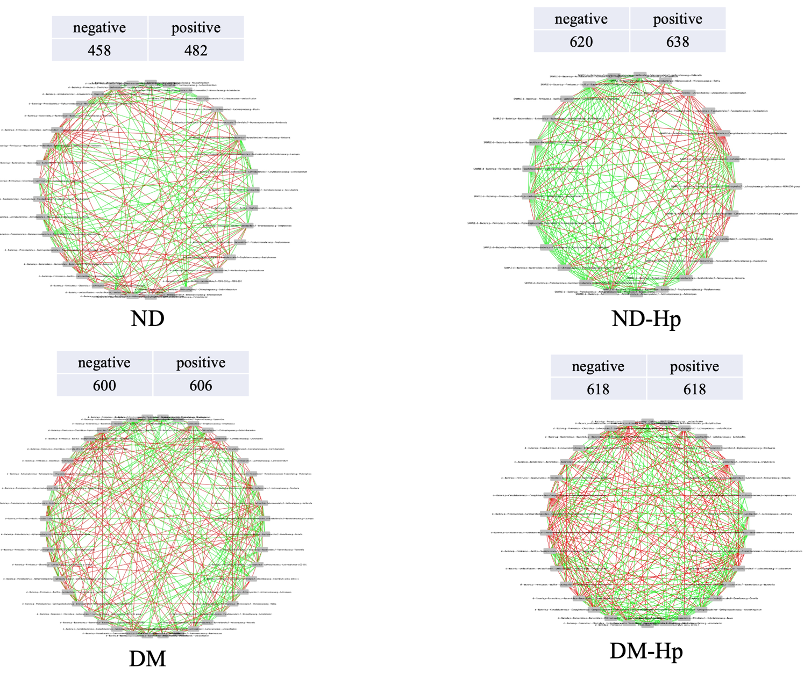

Supplementary Figure S1. The characteristics of groups network of gastric microbiome
The nomenclature of the groups represents non-diabetic without H. pylori infection (ND), non-diabetic with H. pylori infection (ND-HP), diabetic without H. pylori infection (DM), and diabetic with H. pylori infection (DM-HP). Green edges indicate a positive network, while red represents a negative network.

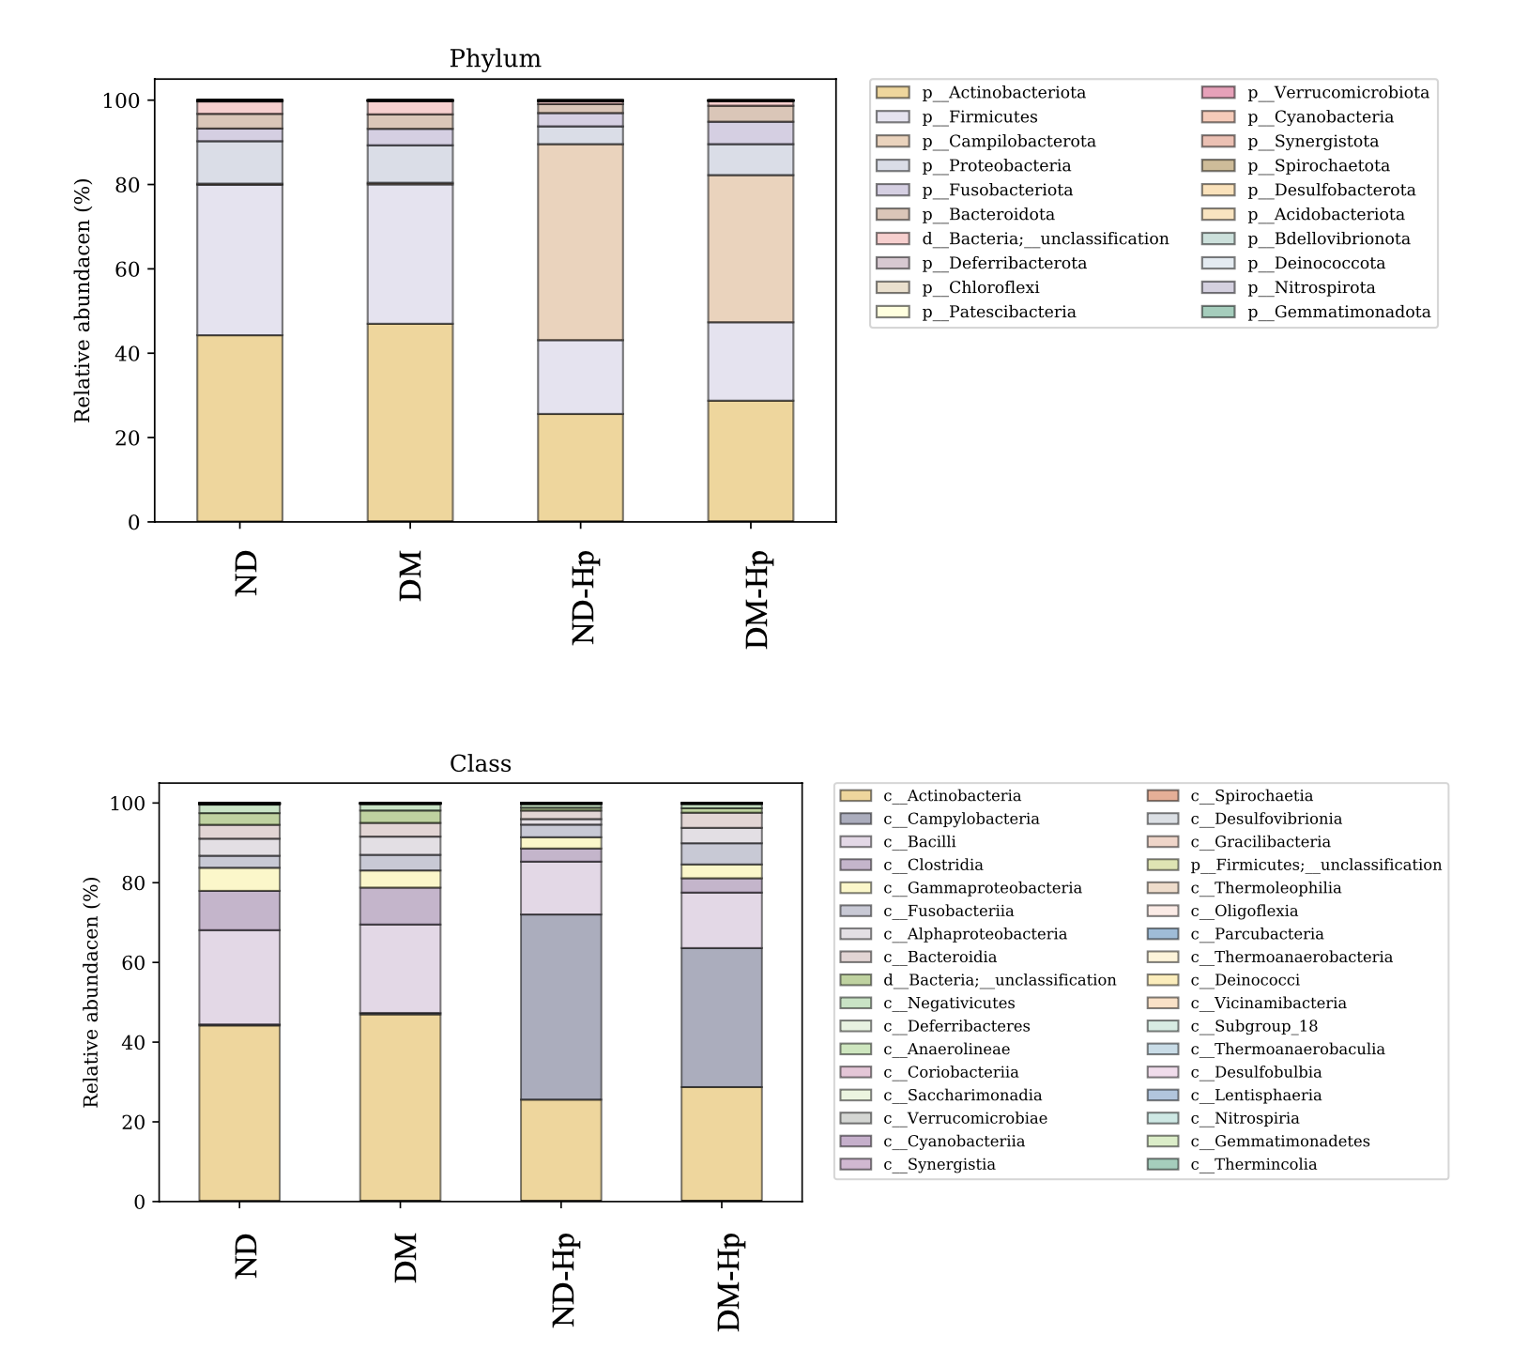

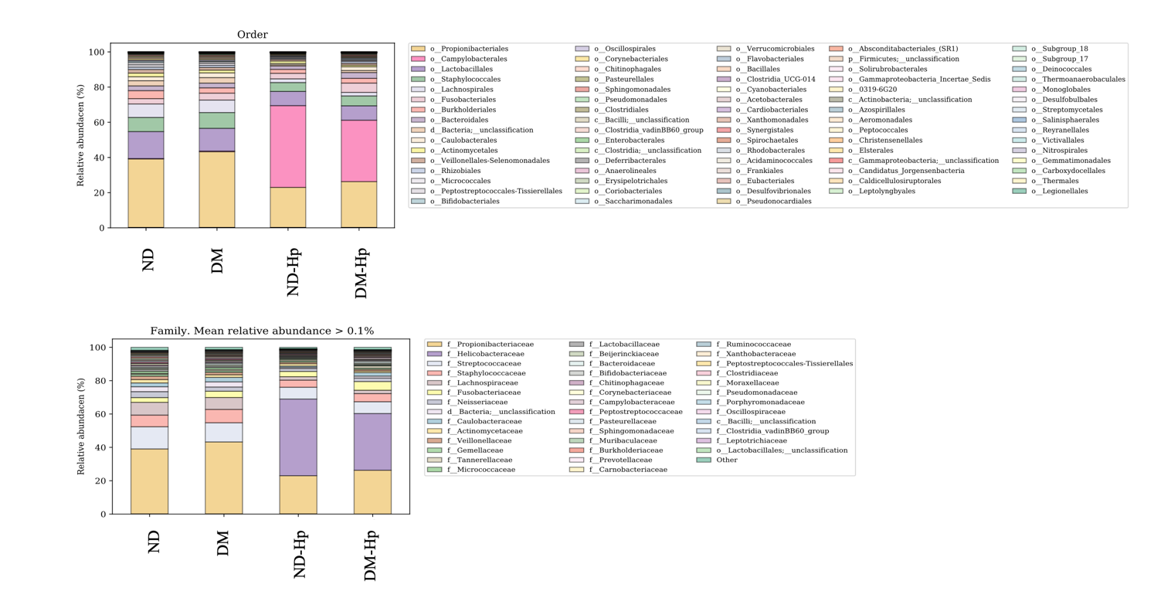
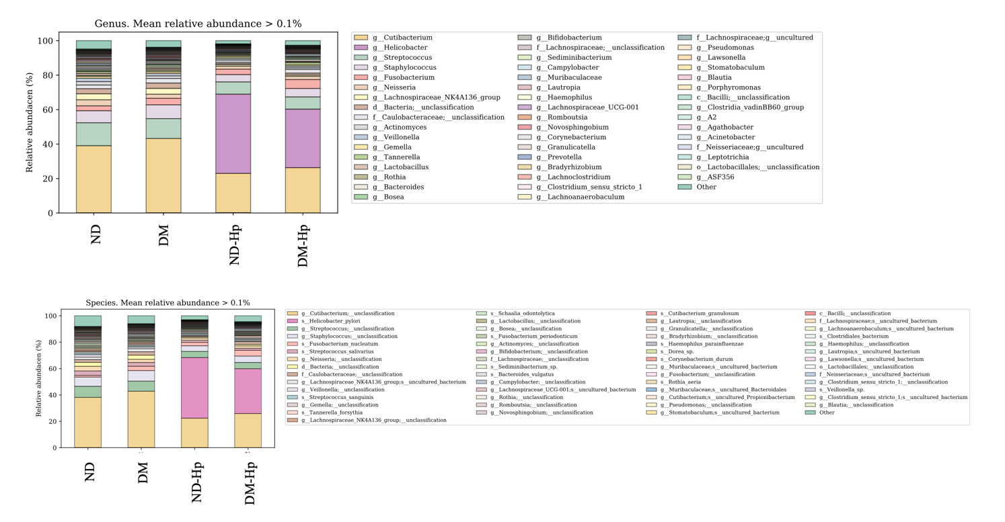
Supplementary Figure S2. The taxonomy profiling in the four groups.
From top to bottom, it refers to phylum, class, order, family, genus, and species

