Supplements

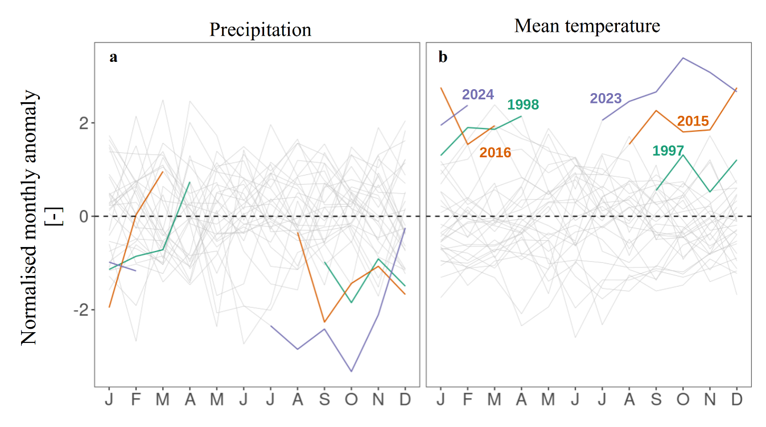

Figure S1: Seasonal cycle of the precipitation (subplot a) and mean temperature (subplot b) normalised anomalies. In each subplot the individual years of the 1994-2023 period are represented by the thin grey lines. Major dry and hot episodes (1997-1998, 2015-2016, 2023-2024) are highlighted with the coloured lines. Compared to Figure 1 (main text), the anomalies were normalised by the monthly standard deviations of the respective variables.
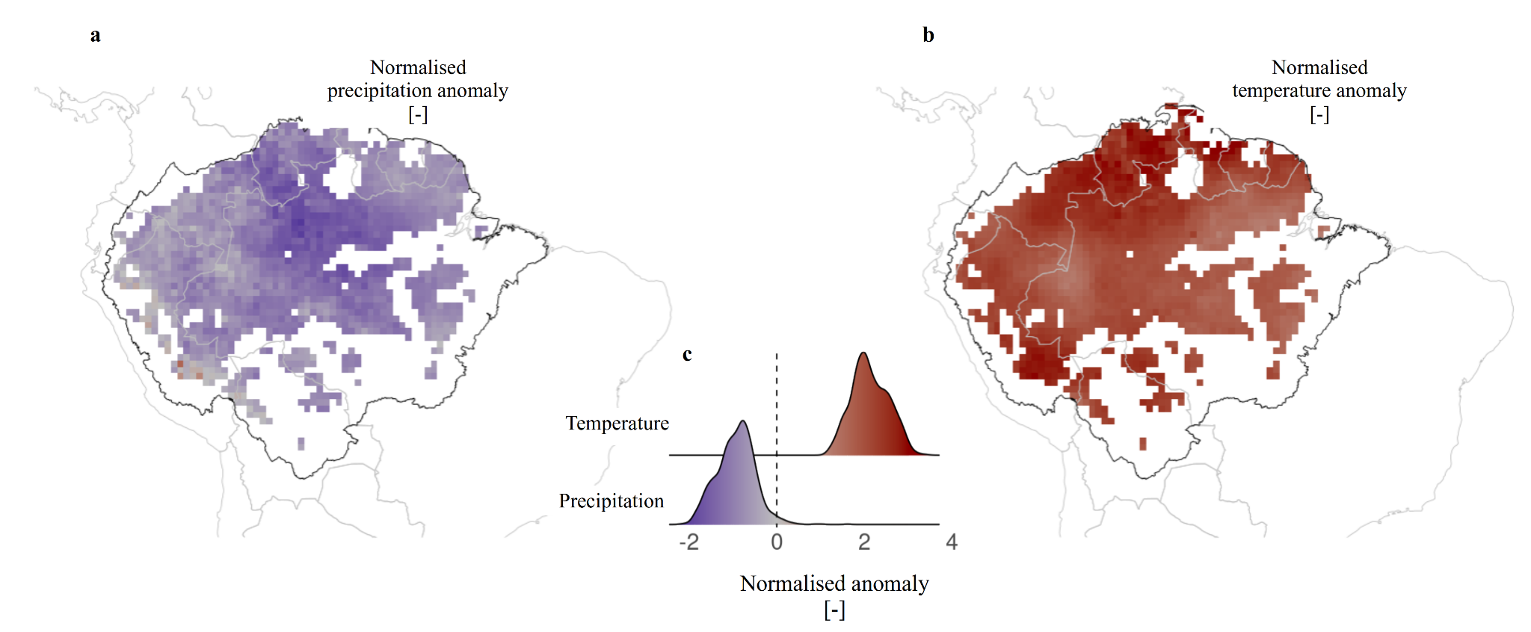

Figure S2: Spatial distribution of the average normalised precipitation (subplot a) and temperature (subplot b) anomalies for the dry and hot episode of 2023-2024 according to ERA5 reanalysis. In subplots a and b, the black line delineates our study area and only intact forests were included in the analysis (white grid cells within the Amazon basin are mostly not intact forests). Subplots c shows the marginal density distributions of those anomalies.

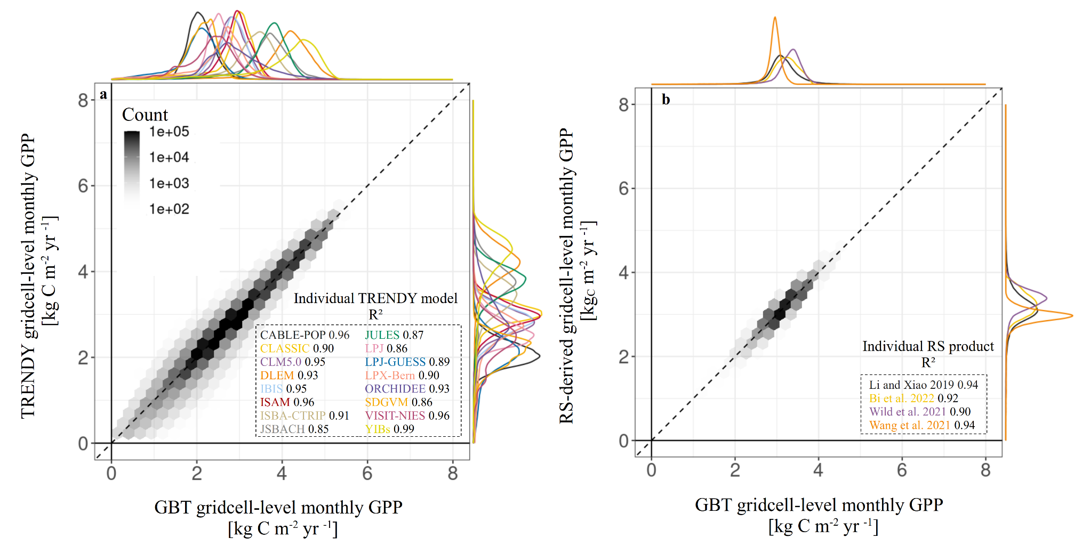Figure S3: Quality of fit of the GBT models trained on TRENDY models (subplot a) or on remote sensing products (subplot b). In each plot, the GBT model predictions of the grid cell monthly GPP are plotted against the actual process-based model predictions (left) or the remote sensing data (right) for the test data only. The marginal density distributions of the predictions and of the test data are also shown on the top and on the side of each subplot, respectively.

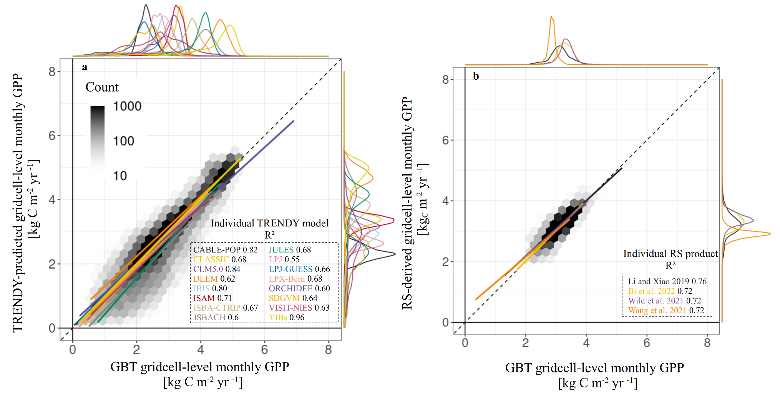

Figure S4: Quality of fit of the GBT models trained on TRENDY models (subplot a) or on remote sensing products (subplot b), using pre-2015 data only for training. In each plot, the GBT model predictions of the grid cell monthly GPP are plotted against the actual process-based model predictions (left) or the remote sensing data (right) for the 2015-2016 dry and hot period only. The marginal density distributions of the predictions and of the test data are also shown on the top and on the side of each subplot, respectively.
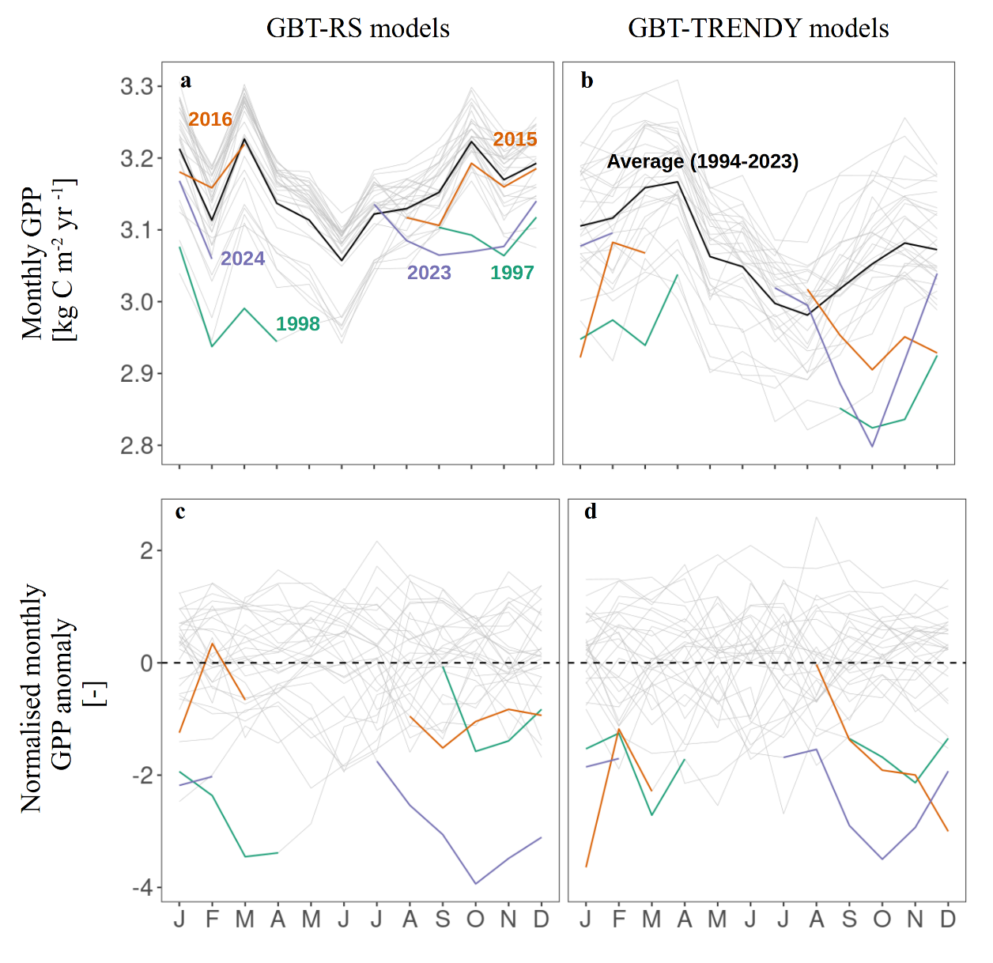

Figure S5: Seasonal cycle of the intact Amazon forest GPP (subplots a-b) and its normalised anomalies (subplots c-d) from GBT-models trained on remote sensing products (subplots a-c) and TRENDY model simulations (subplots b and d). The individual years of the 1994-2023 period are represented by the thin grey lines (subplots a-d) and their averages, by the thick black line (subplot a-b). Large droughts (1997-1998, 2015-2016, 2023-2024) are highlighted with the coloured lines and are discontinuous because they overlap two calendar years.

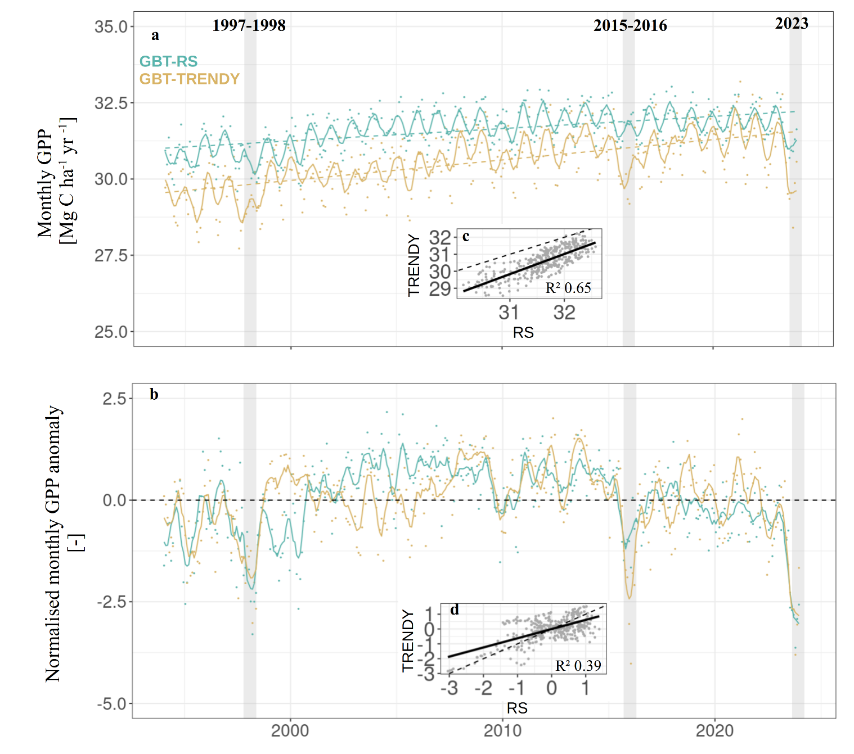

Figure S6: Time series of the monthly GPP (subplot a) and its normalised anomalies (subplot b) over the intact Amazon forests for the 1994-2023 time period, as generated by GBT models trained on TRENDY simulations (yellow, TRENDY) or remote sensing products (green, RS) with JRA-55 reanalysis as model features. The anomalies were normalised by the standard deviations of the respective months and sources. The coloured dots are the monthly values while the curves are rolling averages over a 6-month time window. In subplot a, the dashed lines represent the respective linear increases used to detrend GPP. The insets (subplots c and d) show the correlations between the TRENDY model ensemble mean and the average of the remote sensing products. In subplot a, the R² of the linear models are 0.24 and 0.32 for RS and TRENDY models, respectively (p-value < 0.001).

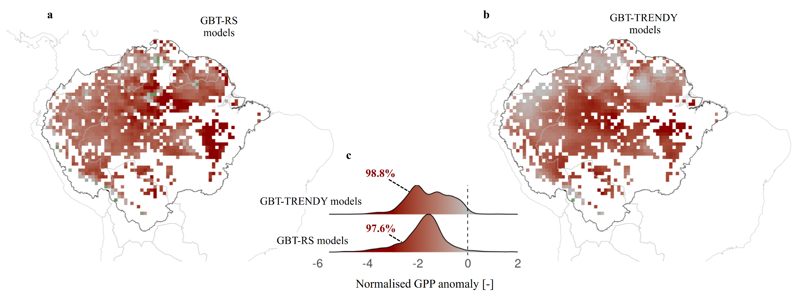

Figure S7: Spatial distribution of the average normalised GPP anomaly for the 2023-2024 dry and hot period as predicted from GBT models trained on remote sensing products (subplot a), or TRENDY models (subplot b) with JRA-55 as model features. Subplots c shows the marginal density distribution of the anomalies in both cases.

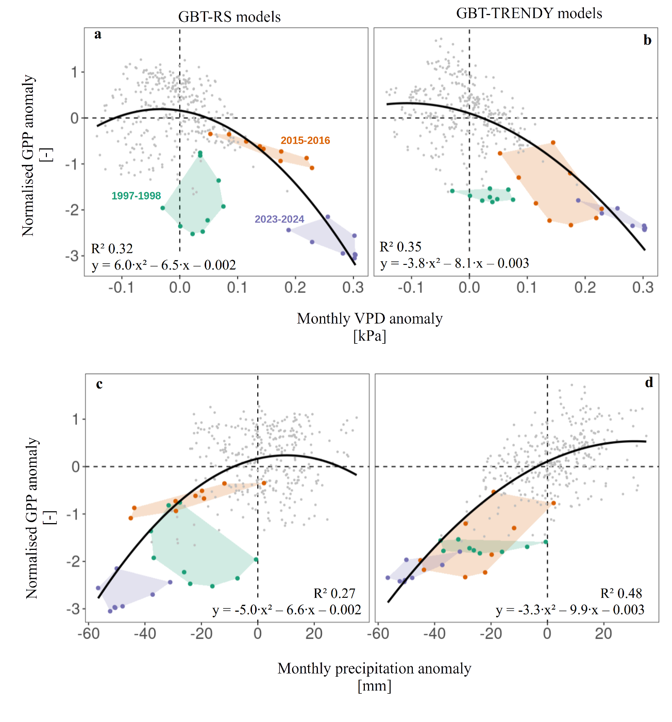

Figure S8: Relationships between normalised monthly GPP anomalies and monthly VPD temperature (top) and precipitation (bottom) anomalies for the intact Amazon forests, based on GBT models trained on remote sensing (subplot a and c) or TRENDY models estimates of GPP (subplot b and d). All p-values of the second-order polynomial models are < 0.001. GPP anomalies were detrended and normalised against their monthly standard deviations. In subplots a-b, temperature and GPP anomalies were smoothed using a moving average over a 6-month time period and the coloured dots and zones correspond to the recent major dry and hot episodes.

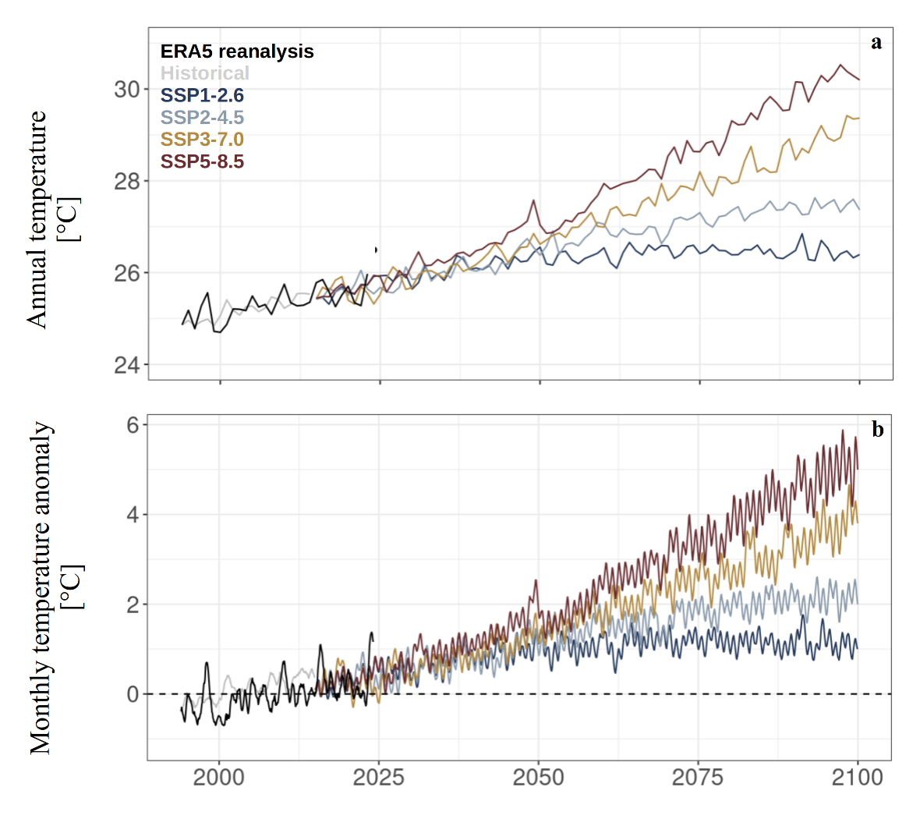Figure S9: Times series of the mean annual temperature (subplot a) and the monthly temperature anomaly (subplot b) over the intact Amazon forests, from the ERA5 reanalysis (black) or from CMIP6 model simulations for the historical period (1980-2014) or according to the different shared socioeconomic pathways (coloured lines).

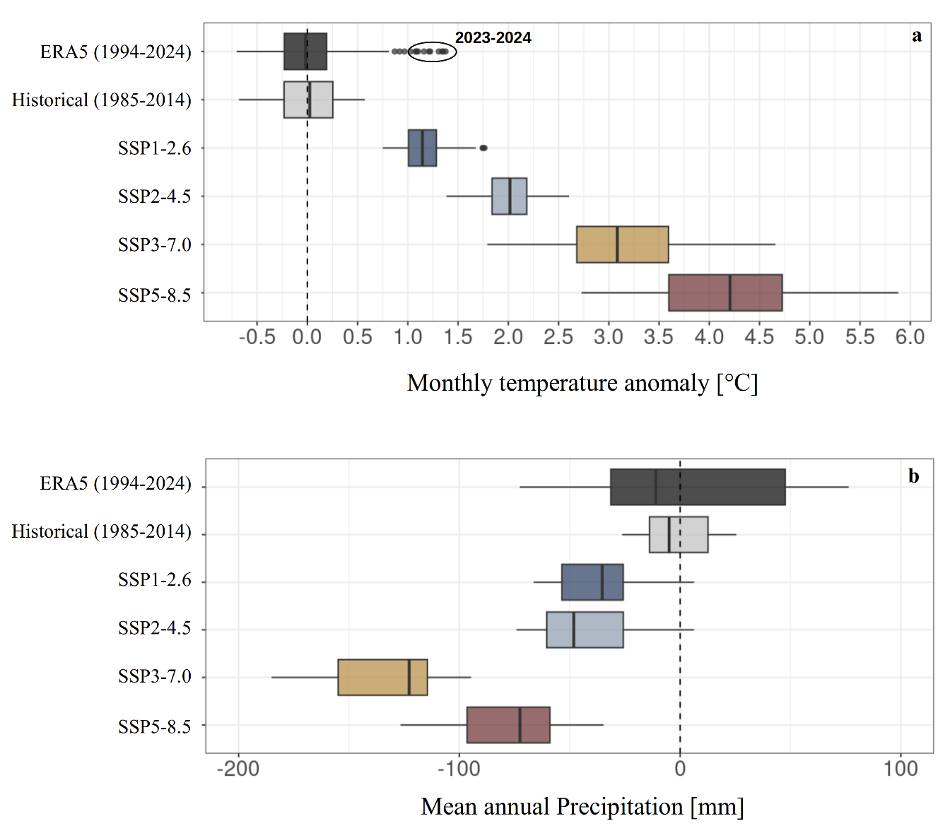

Figure S10: Monthly temperature (subplot a) and mean annual precipitation (subplot b) anomalies for the intact Amazon forests, as predicted from CMIP6 model simulations for the historical period (1985-2014) or for the end of the century (2071-2100) according to the different shared socioeconomic pathways, in comparison with present-day (1994-2024) according to ERA5 reanalysis.

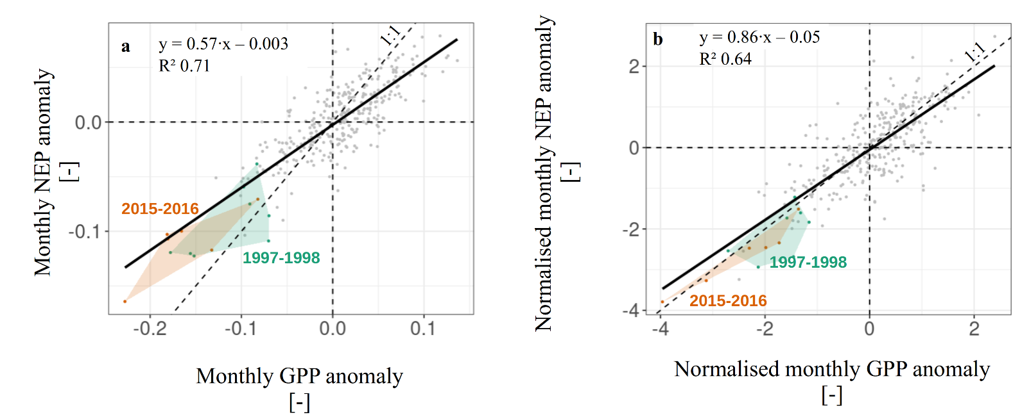

Figure S11: Relationship between (normalised) monthly GPP and NEP anomalies, according to the average of all available TRENDY models, for the 1994-2021 time period.

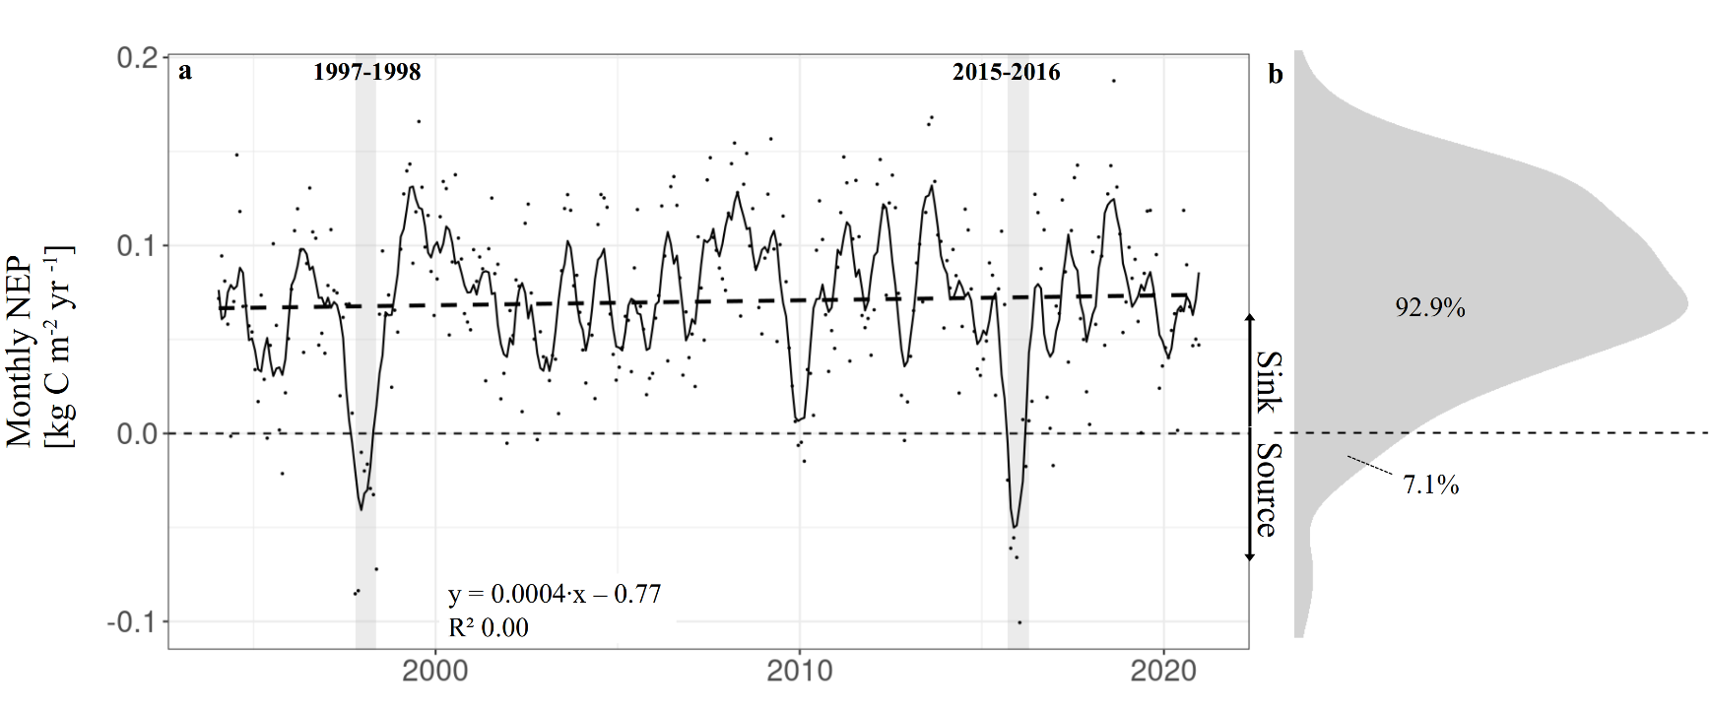

Figure S12: Time series (1994-2021) of monthly (dots) or 6-months averaged (solid line) NEP (subplot a) and marginal density distribution of the monthly NEP for the corresponding time period (subplot b), according to the average of all available TRENDY models.

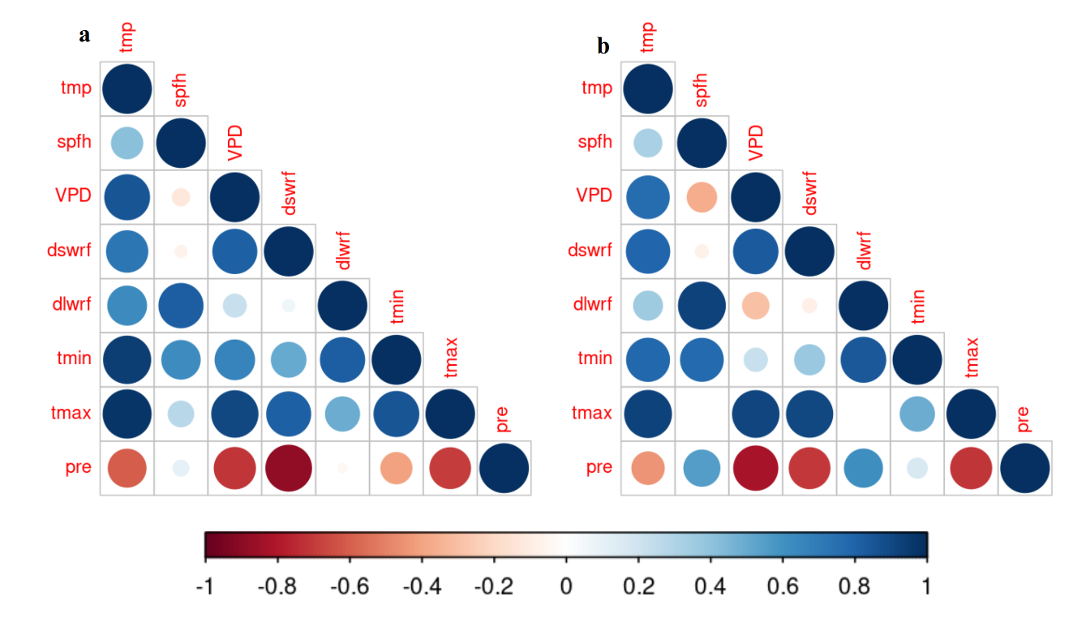

Figure S13: Correlation between climatic variables (subplot a) and their normalised anomalies (subplot b). tmp = mean temperature; spfh = specific humidity; VPD = vapour pressure deficit; dswrf = downward shortwave radiation flux; dlwrf = downward longwave radiation flux; tmin = monthly mean of daily minimum temperature; tmax = monthly mean of daily maximum temperature; pre = precipitation.

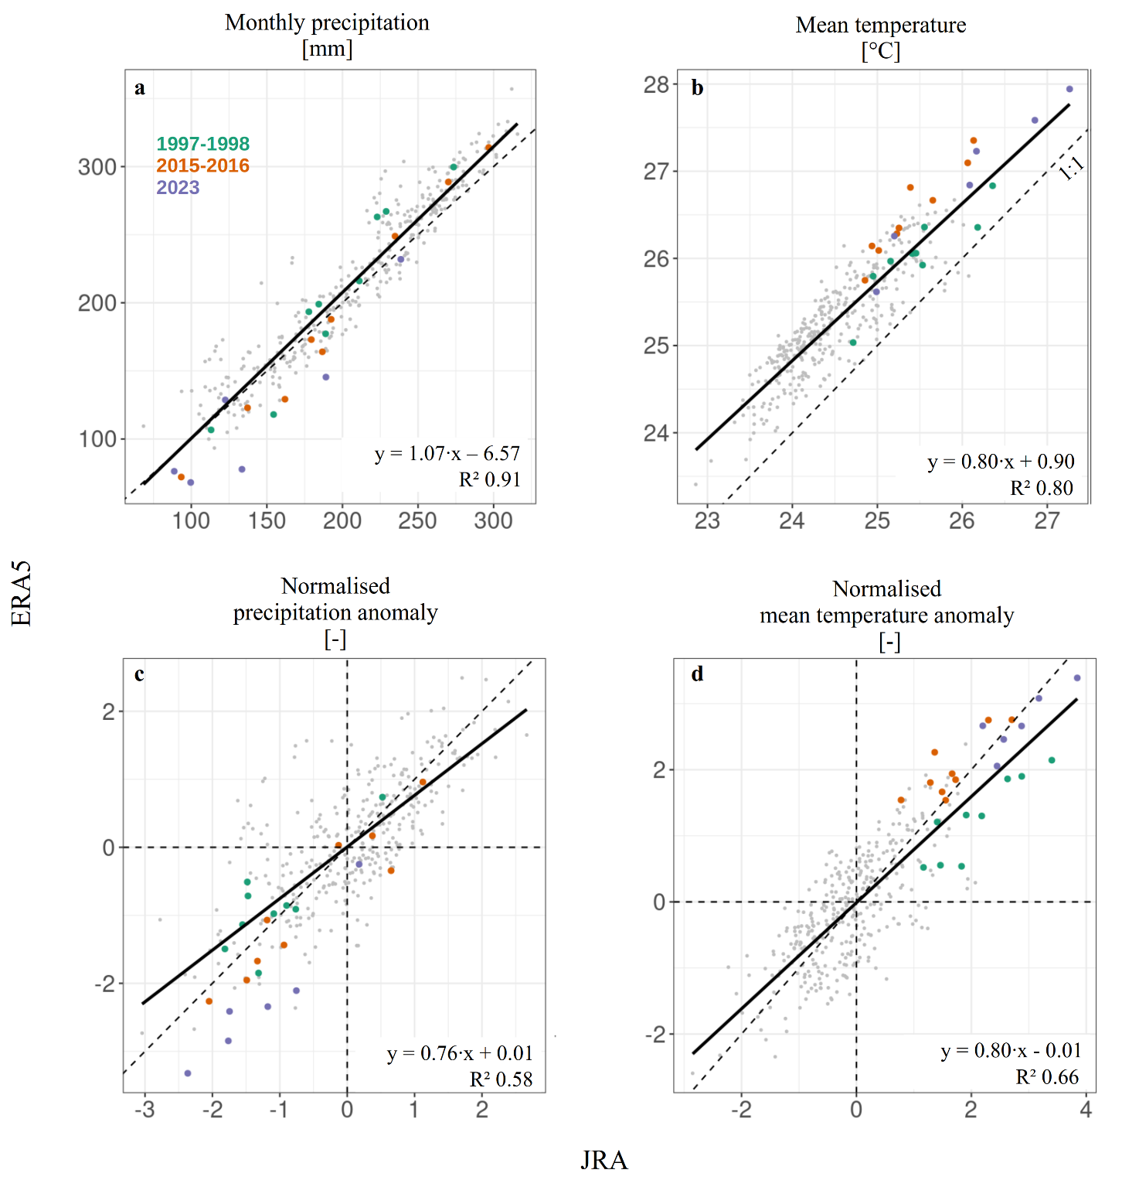
Figure S14: Relationship between JRA-55 and ERA5 monthly precipitation (subplot a), mean temperature (subplot b), and their respectively normalised anomalies (subplots c and d). In each subplot, the major dry and hot episodes (1997-1998, 2015-2016, and 2023-2024) are highlighted with the coloured dots. The mean bias between ERA5 and JRA-55 mean monthly temperature is 0.77°C.
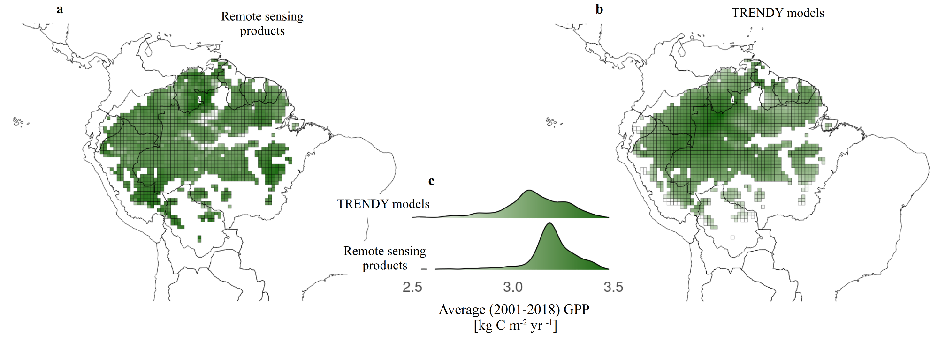

Figure S15: Spatial distribution of the intact Amazon forest GPP, according to the average of remote sensing products (subplot a) or the mean ensemble of TRENDY models (subplot b) over the period 2001-2018 which is common to all products and models. Subplots c shows the density distribution of GPP in both cases.

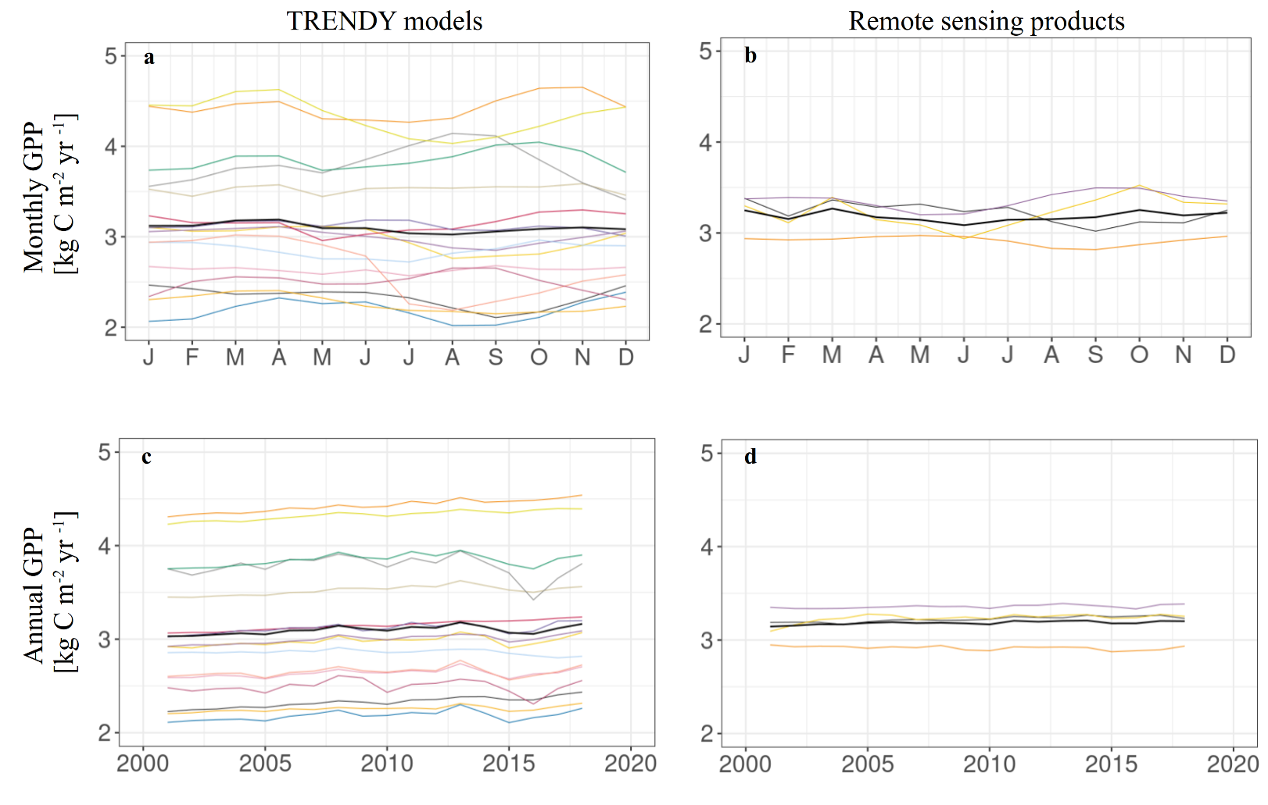

Figure S16: Seasonal cycle (subplots a-b) and interannual changes (subplots c-d) of the intact Amazon forests GPP according to the individual TRENDY models (subplots a and c, coloured lines), the individual remote sensing products (subplots b and d, coloured lines), or their averages (thick black lines in each subplot). We only used the full years available for each and every model/product for this Figure (2001-2018). The colour legend for the individual TRENDY models and the remote sensing products is the same as supplementary Figures S3-4.

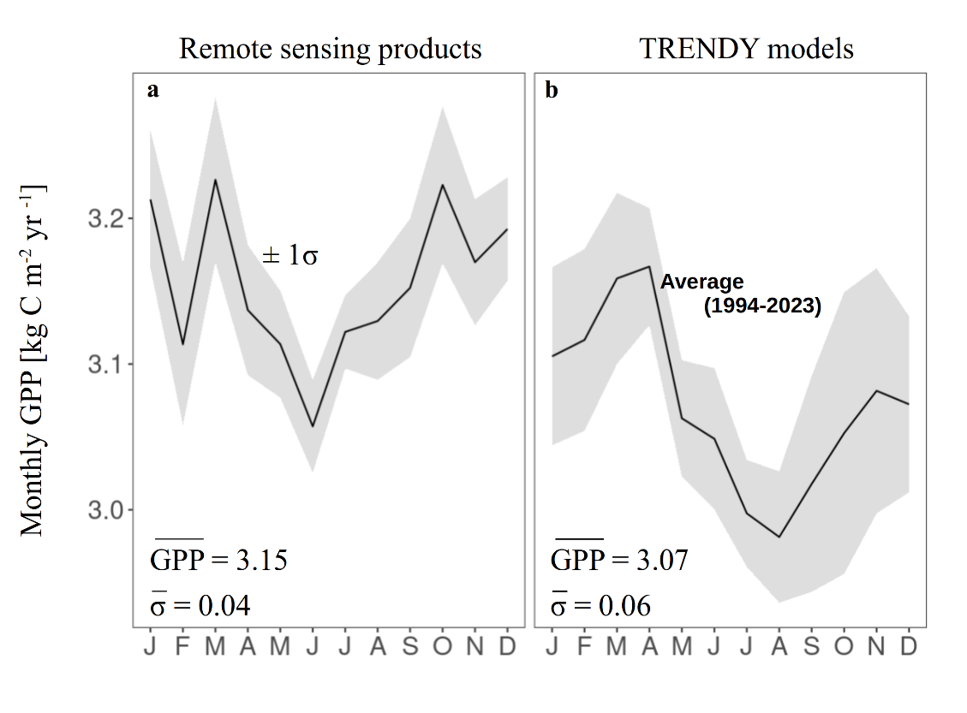

Figure S17: Seasonal cycle of the intact Amazon forest GPP for the remote sensing products (subplot a) and the TRENDY models (subplot b). In each subplot, the shaded envelopes encompass plus or minus one monthly GPP standard deviation during the recent period (1994-2023), used in the analyses to normalise the monthly GPP anomalies. The solid lines represent the average of that period of time, while the numbers are the mean GPP ($\underline{GPP}$)and its mean standard deviation ($\underline{σ}$) throughout the year.

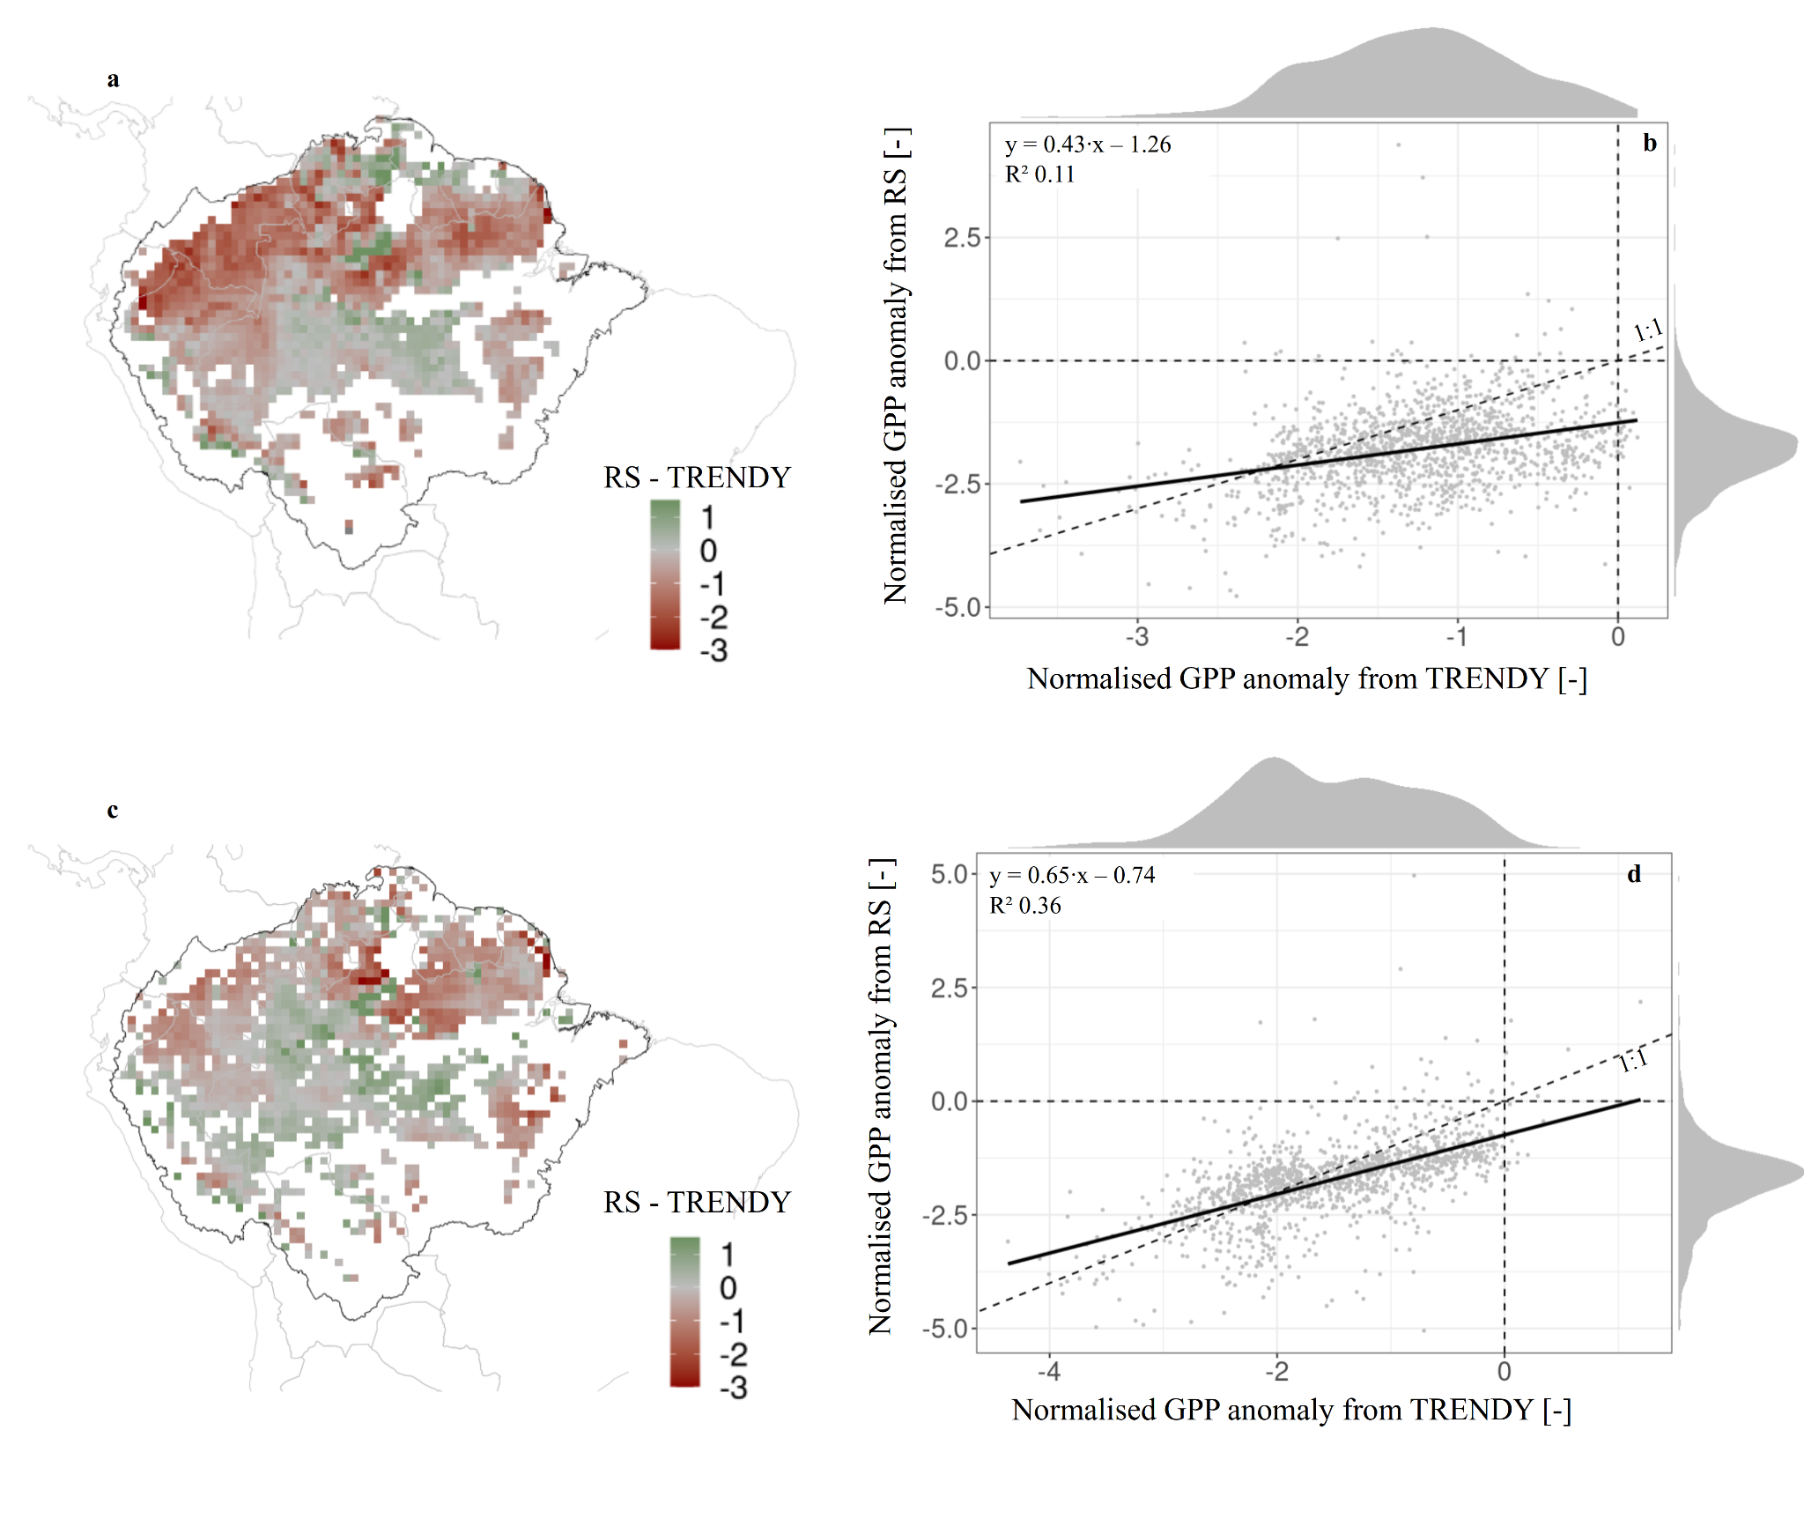

Figure S18: Spatial distribution of the average GPP normalised anomaly difference between remote sensing and TRENDY GBT models for the dry and hot episode of 2023-24 (subplots a and c) and their spatial correlation (subplot b and d), using either ERA5 (subplots a and b) or JRA-55 (subplot c and d) as climatic drivers.

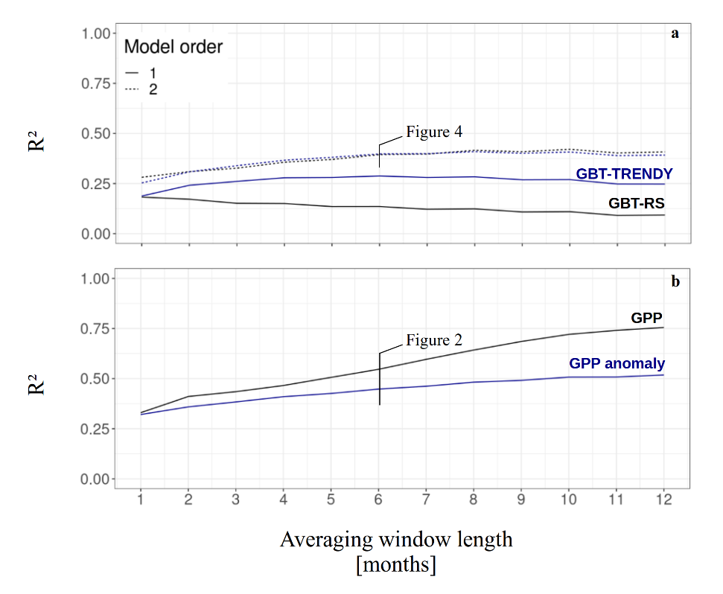

Figure S19: Adjusted R² for the linear (solid lines) and second-order (dashed) models between normalised monthly GPP anomalies and monthly mean air temperature anomalies for the intact Amazon forests, based on GBT models trained on remote sensing (black) or TRENDY models estimates of GPP (blue) for different moving average windows (subplot a). R² of the linear model between mean RS and TRENDY monthly GPP (black) or its normalised anomalies (blue) for different moving average windows (subplot b). A moving average window of 6 months was used to generate Figures 2 (subplots c and d) and 4 (subplots a-b).

