Supporting information

Unraveling Cation Intercalation Mechanism in MXene for Enhanced Supercapacitor Performance

Xiaodan Yin†, Wei Zheng†*, Haifeng Tang, Li Yang, Chengjie Lu*, Long Pan*, Peigen Zhang*, ZhengMing Sun*

Key Laboratory of Advanced Metallic Materials of Jiangsu Province, School of Materials Science and Engineering, Southeast University, Nanjing 211189, P. R. China.
† These authors contributed equally

E-mail: zhengwei22@seu.edu.cn (W.Z.); chengjie.lu@seu.edu.cn (C.L.); panlong@seu.edu.cn (L.P.)；zhpeigen@seu.edu.cn (P.Z.); zmsun@seu.edu.cn (Z.M.S.)

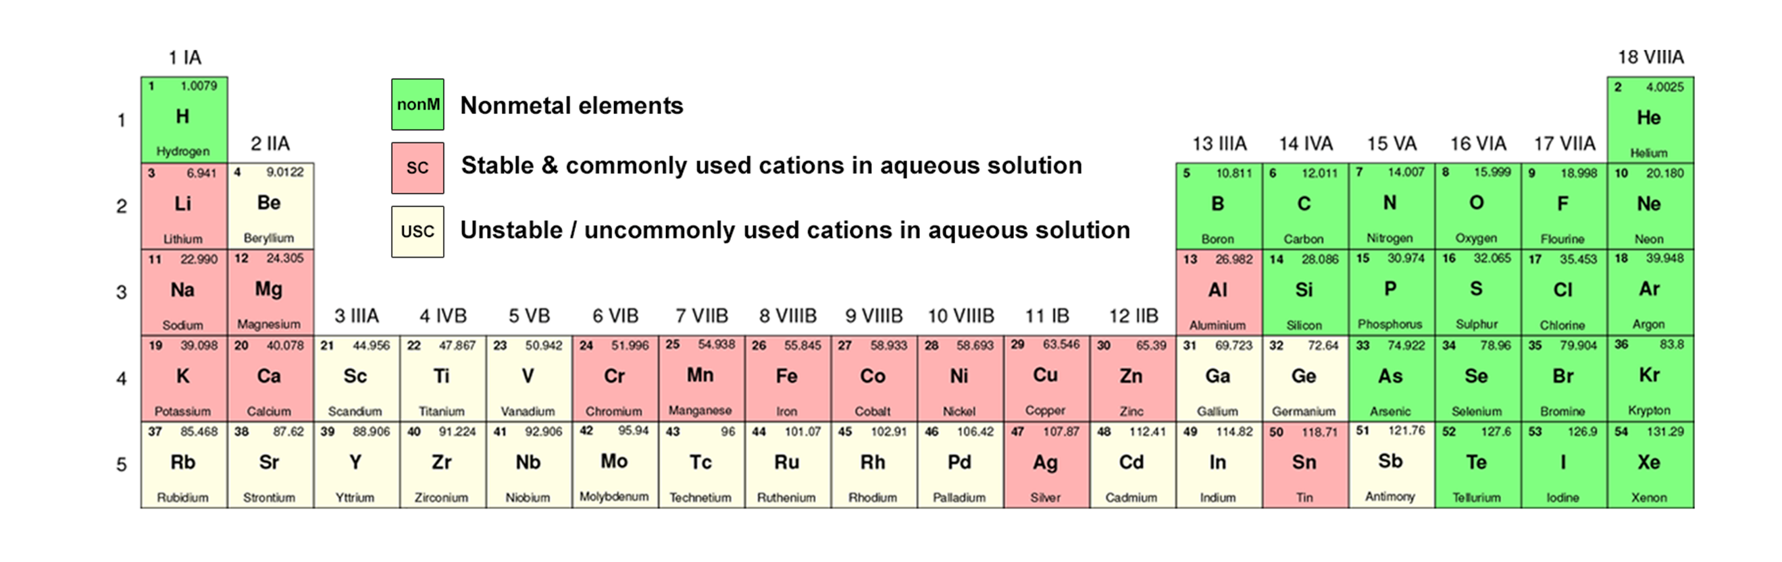
Figure S1 Fragment of the periodic table of elements, demonstrating the selection of investigated cations.

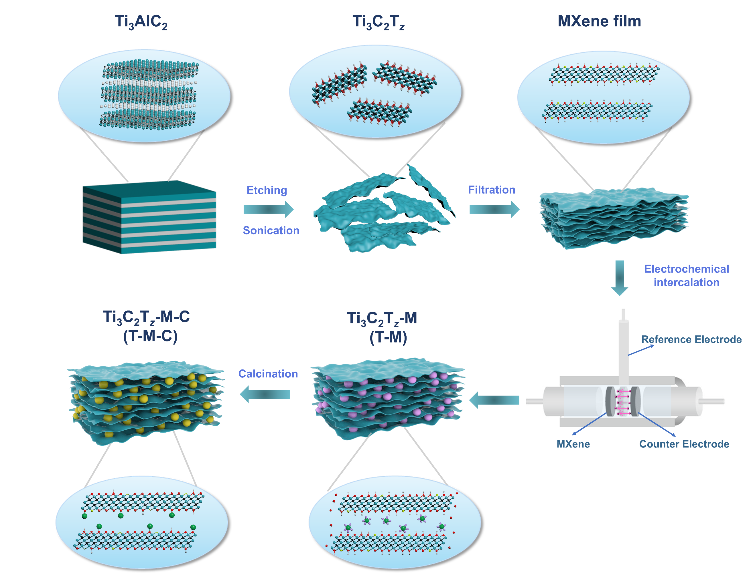
Figure S2 Schematic illustration for the synthesis of T-M-C.
The ECI possesses advantages such as controlling the amount of intercalated ions and achieving a more uniform interlayer distance compared with the traditional ion intercalation ¹. By utilizing the charging and discharging behavior in the electrochemical process, metal cations from the electrolytes were intercalated into the interlayer spaces of Ti₃C₂T_{z}. To investigate the effect of different metal cations on the electrochemical properties of the electrodes, 1 M MSO₄-based electrolytes (M represents metal elements) were selected as intercalators. It should be noted that certain metallic-based salts demonstrate limited solubility, rendering them unsuitable for use as electrolytes. Examples of such elements include calcium (Ca) and silver (Ag). Additionally, certain intercalation processes may render MXene fragile, with copper (Cu), chromium (Cr), cobalt (Co), and nickel (Ni) being prime examples (in Figure S3), aligning with findings from previous studies ². Ultimately, Li₂SO₄, Na₂SO₄, K₂SO₄, MnSO₄, ZnSO₄, MgSO₄, and Al₂(SO₄)₃ are chosen as intercalators. Ion intercalation expands the interlayer distance, creating more active sites and charge storage space, which facilitates ion diffusion in MXene ³⁻⁵. Additionally, the Ti₃C₂T_{z} also possesses abundant surface terminations such as -OH, -O, and -F, which significantly affect the electrochemical properties. Previous works show that introducing more -O terminations can enhance the PC properties of Ti₃C₂T_{z} ^{6, 7}. The calcination was selected to achieve additional modification of the surface terminations. This method is straightforward and rapid compared to other approaches for modifying surface terminations ^{8,9}. Surface terminations exhibit different transformations at different calcination temperatures ¹⁰. However, it should be noted that higher temperatures can reduce the mechanical properties of the Ti₃C₂T_{z} substrate, making it unsuitable for freestanding electrodes. The calcination process at 400 °C under an Ar atmosphere for 2 hours was chosen to strike a balance.

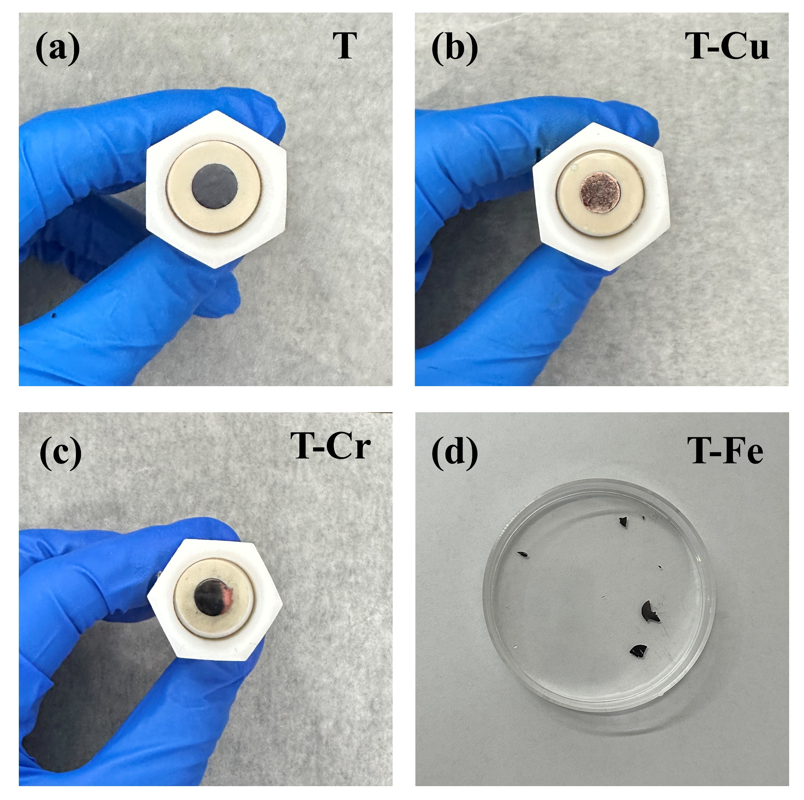
Figure S3 Optical pictures of Ti₃C₂T_{z}, T-Cu, T-Cr and T-Fe³⁺.

Figure S4 (a)-(b) SEM images of Ti₃AlC₂ and its enlargement. (c)-(d) SEM images of m-Ti₃C₂T_{z} and its enlargement.

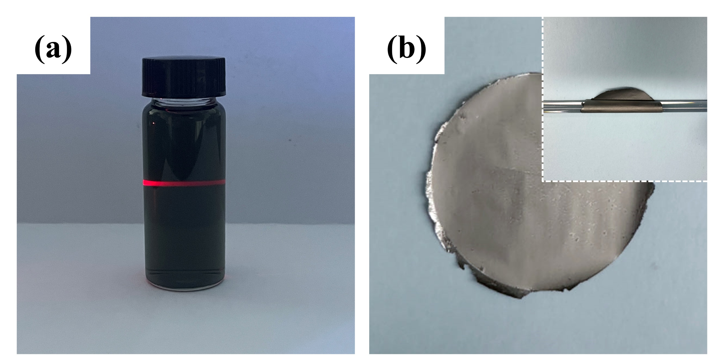
Figure S5 (a) The Tyndall effect of Ti₃C₂T_{z} suspension; (b) Ti₃C₂T_{z} freestanding films and inset shows its excellent mechanical properties.

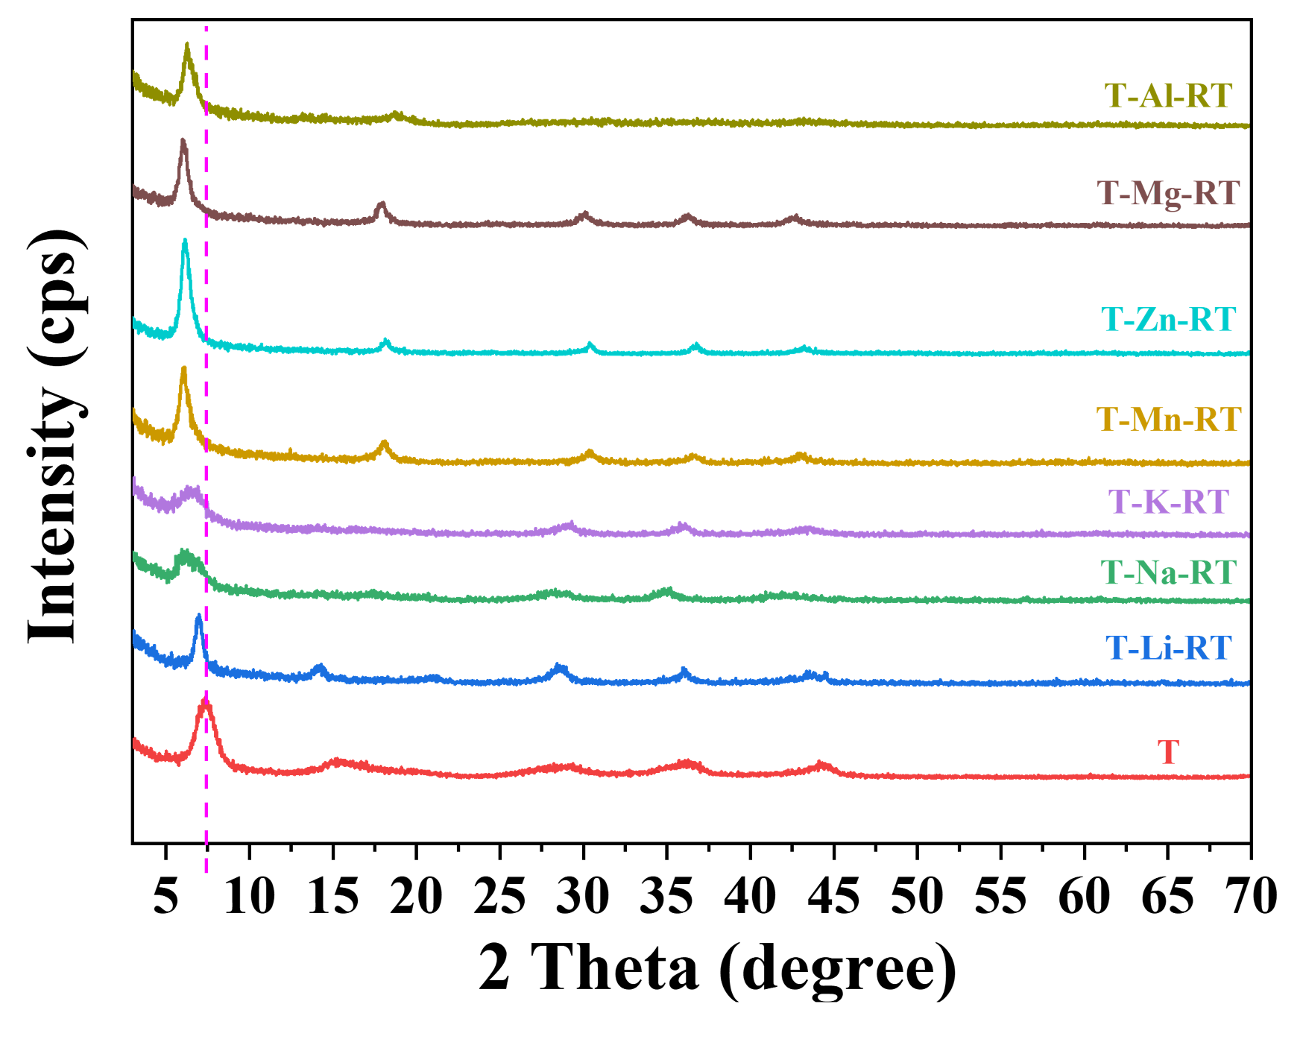
Figure S6 XRD patterns of T-M-RT.

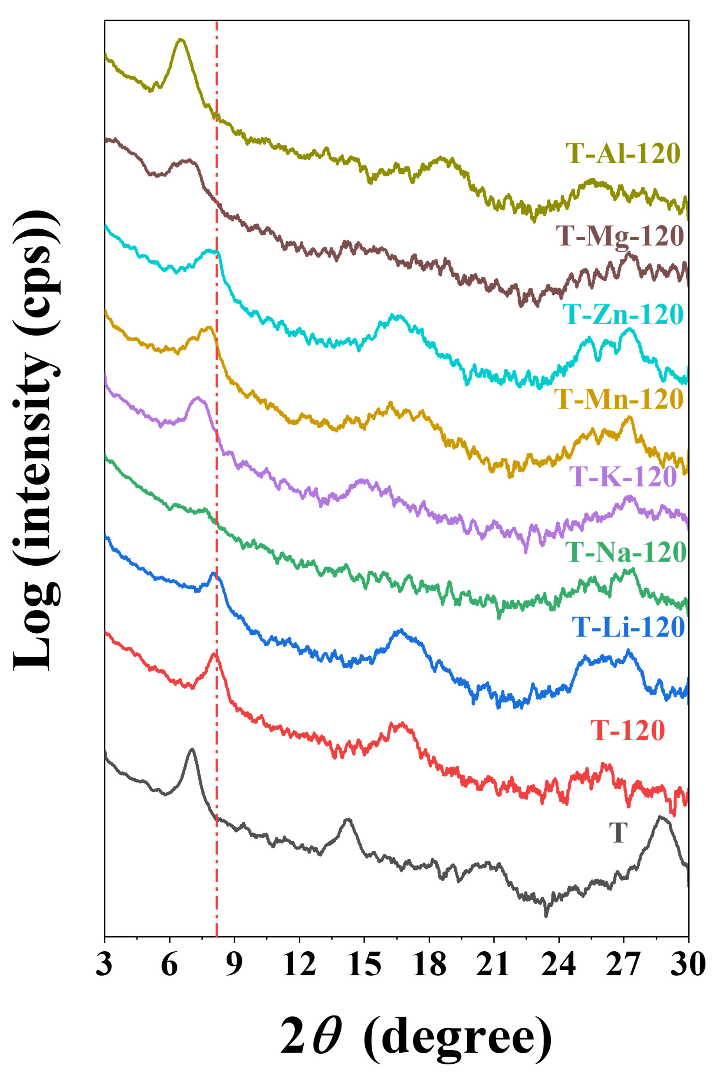
Figure S7 XRD patterns of T-M-120.
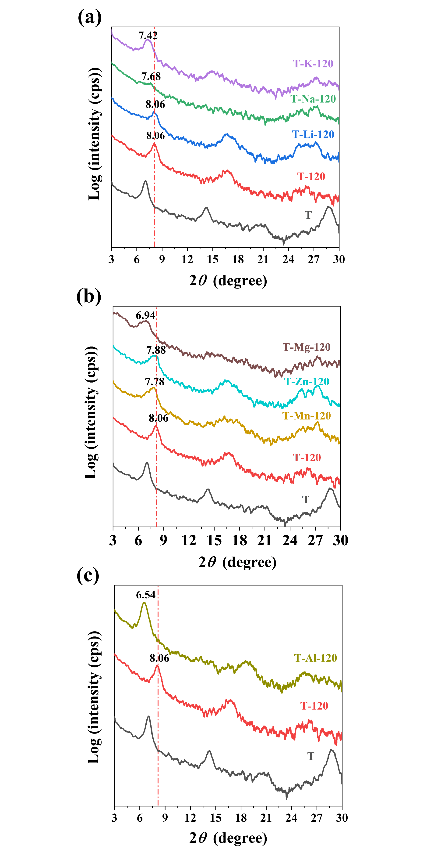
Figure S8 XRD patterns of T-M-120 for monovalent (a), divalent (b) and trivalent (c) cations.

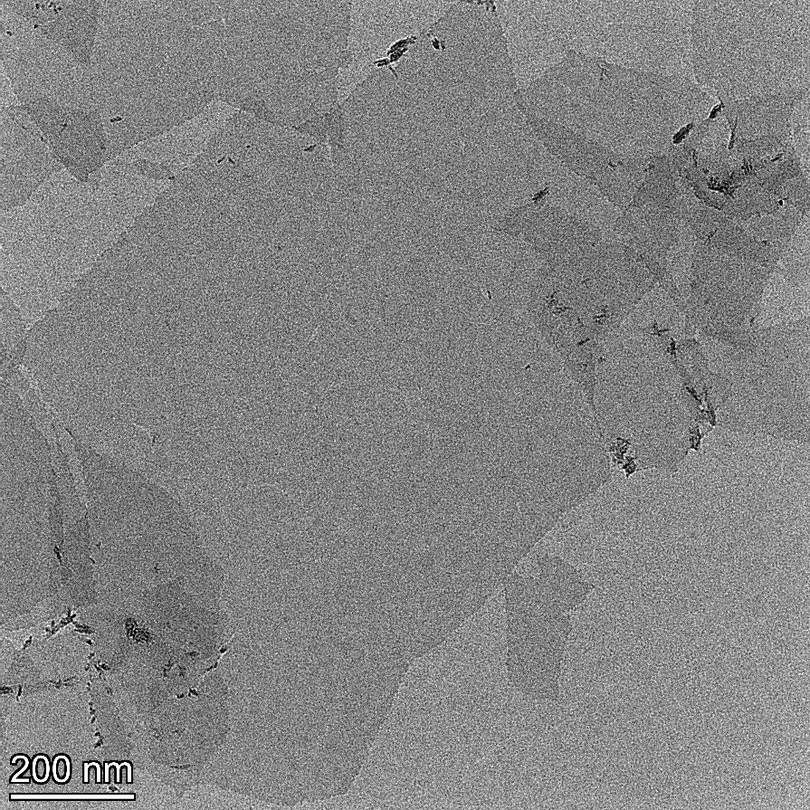
Figure S9 TEM image of Ti₃C₂T_{z}.

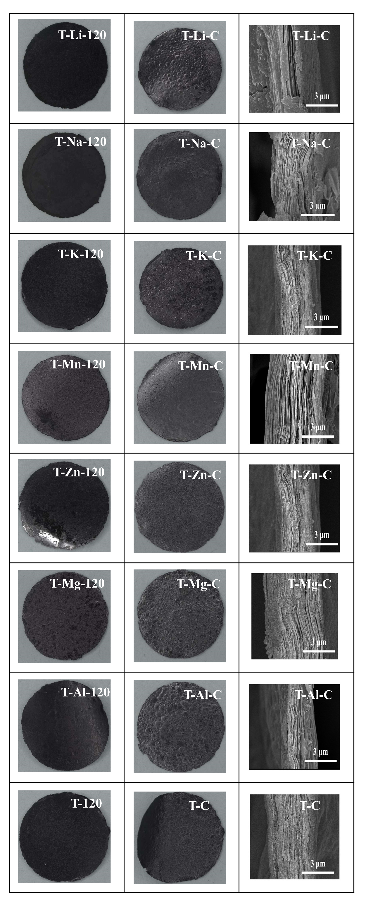
Figure S10 Optical microscope image and cross-section SEM image of T-M-120 and T-M-C.

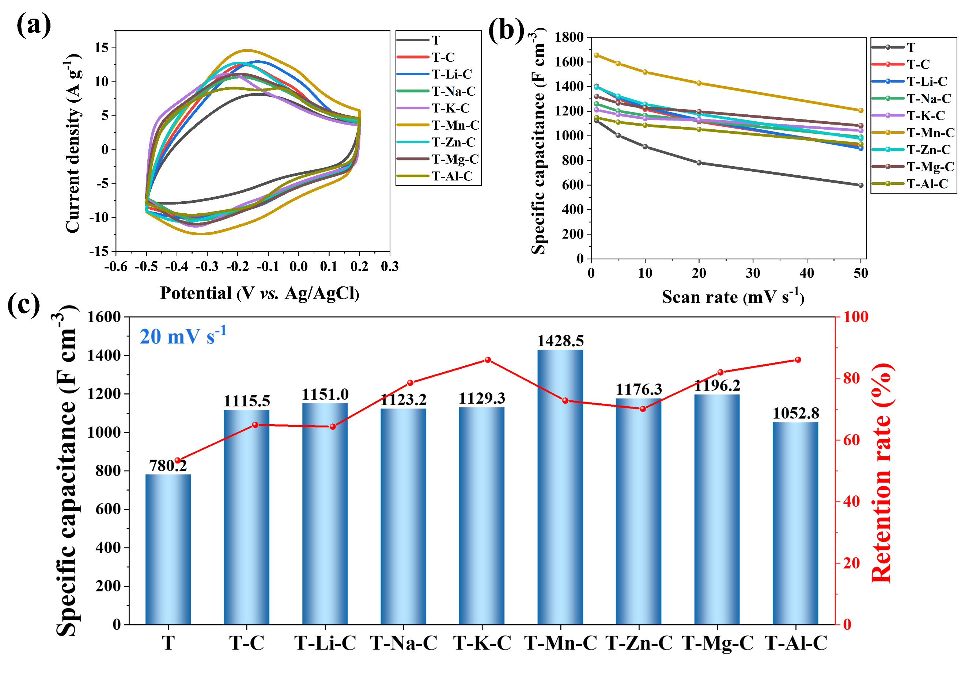
Figure S11 Electrochemical performance of T, T-C, and T-M-C electrodes in a three-electrode system. (a) CV curves at a scan rate of 20 mV s⁻¹, (b) The specific capacitances at different scan rates, and (c) specific capacitances and capacitance retention rates.

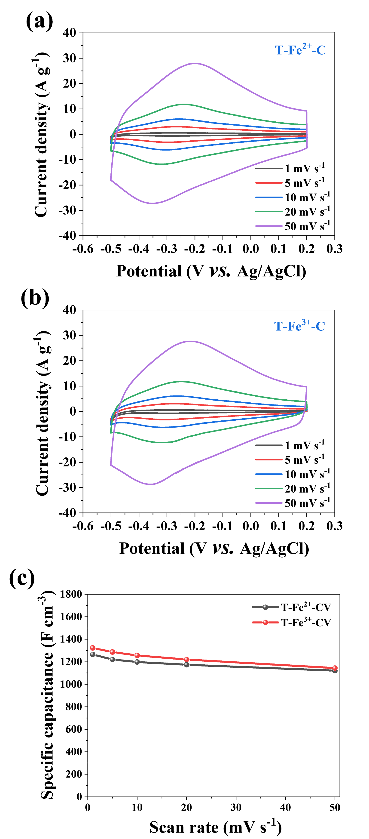
Figure S12 The electrochemical properties of T-Fe²⁺-C and T-Fe³⁺-C are compared. (a)-(b) CV curves at different scan rates of T-Fe²⁺-C and T-Fe³⁺-C. (c) Specific capacitances at different scan rates of T-Fe²⁺-C and T-Fe³⁺-C.

Figure S13 CV curves at different scan rates and GCD curves at different current densities of T-Li-C, T-Na-C, and T-K-C.
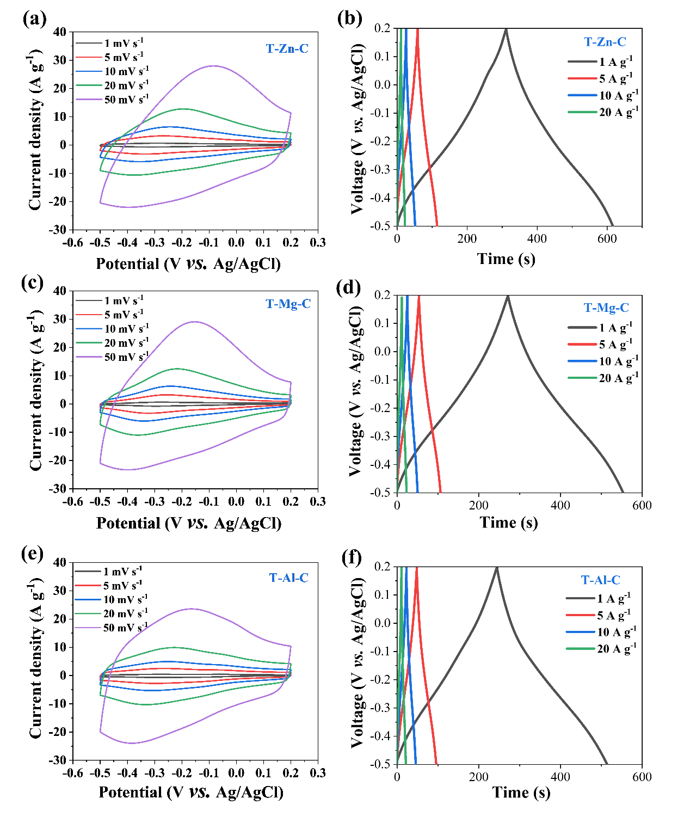
Figure S14 CV curves at different scan rates and GCD curves at different current densities of T-Zn-C, T-Mg-C, and T-Al-C.

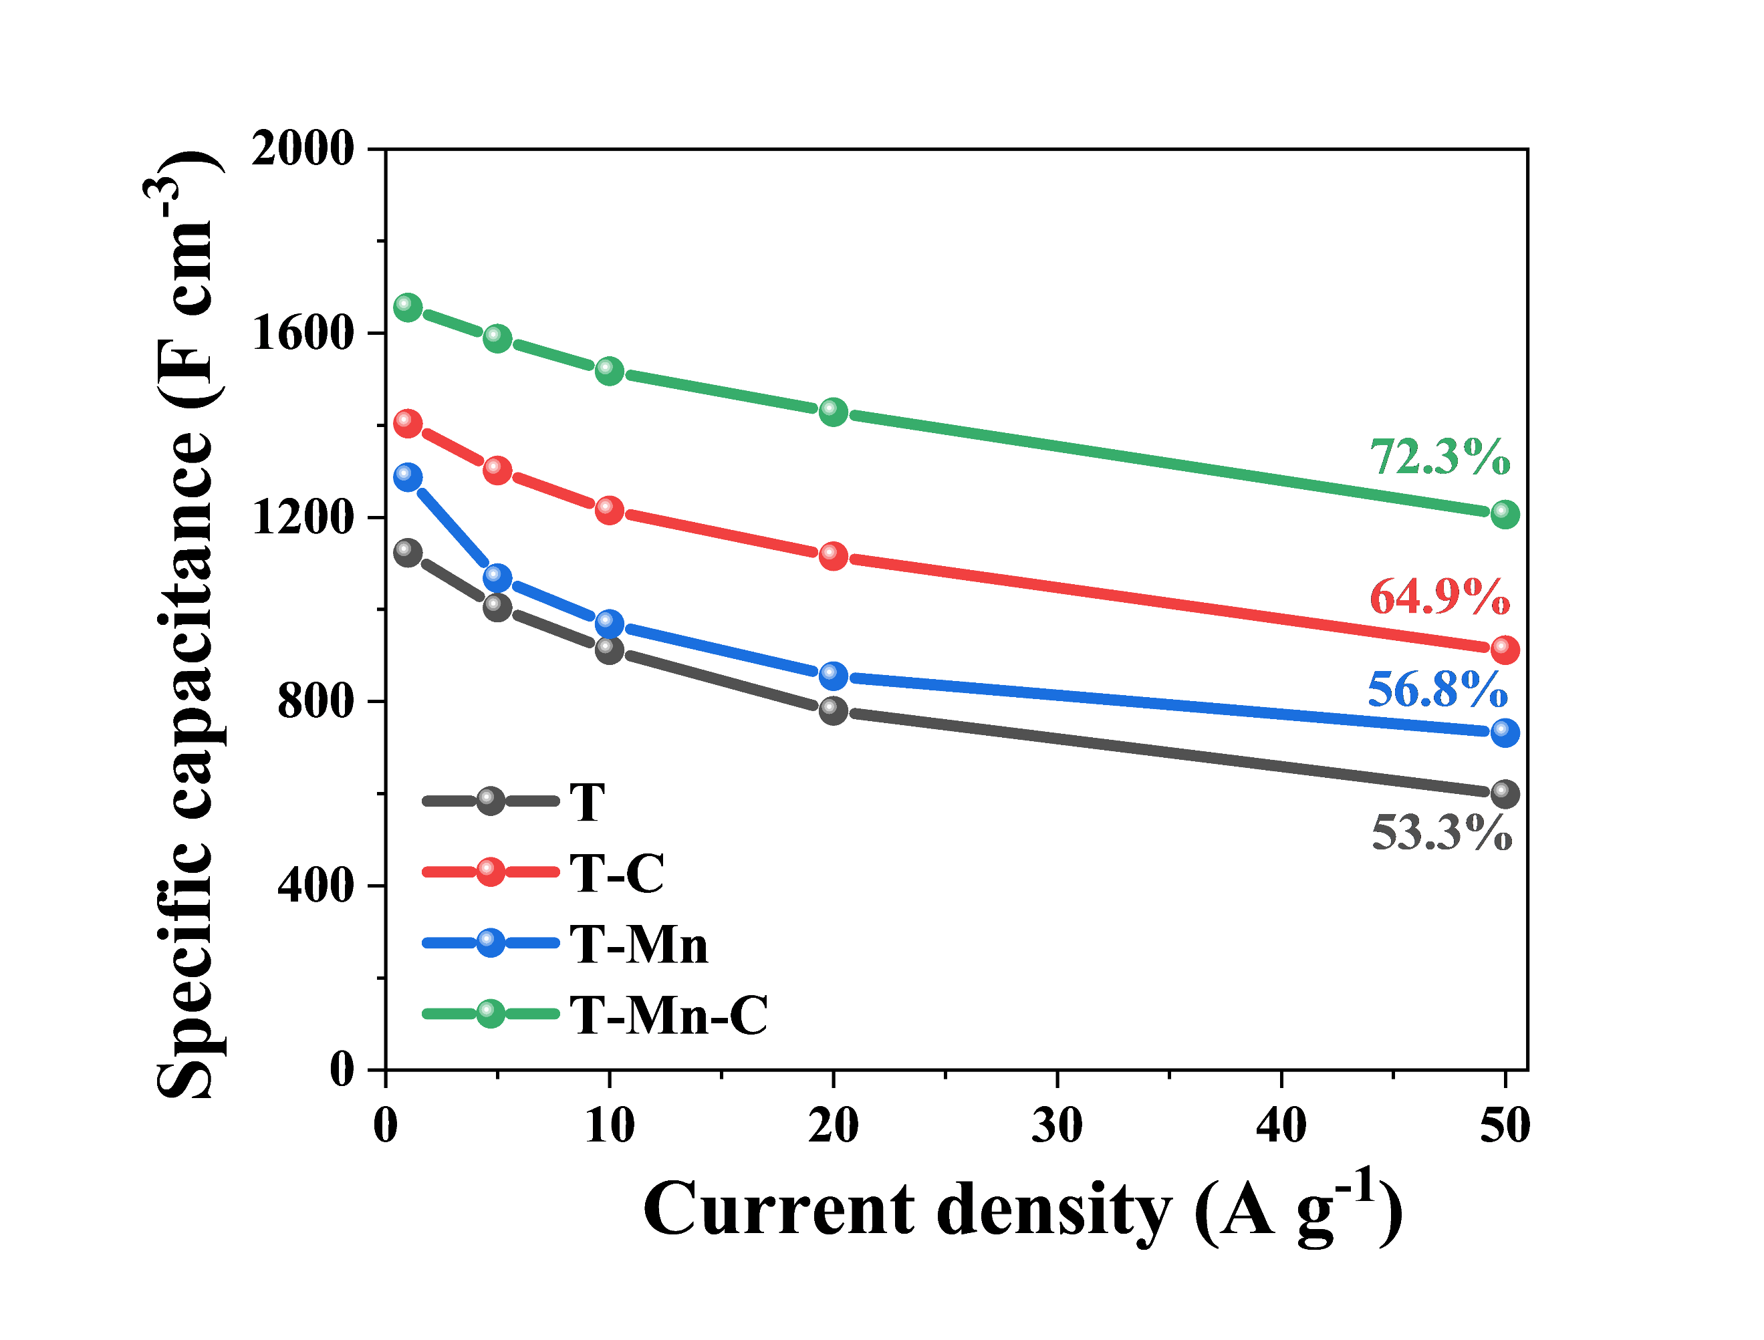
Figure S15 The volumetric capacitances (C_{v}) of the T, T-C, T-Mn, and T-Mn-C electrodes plotted as a function of current densities.

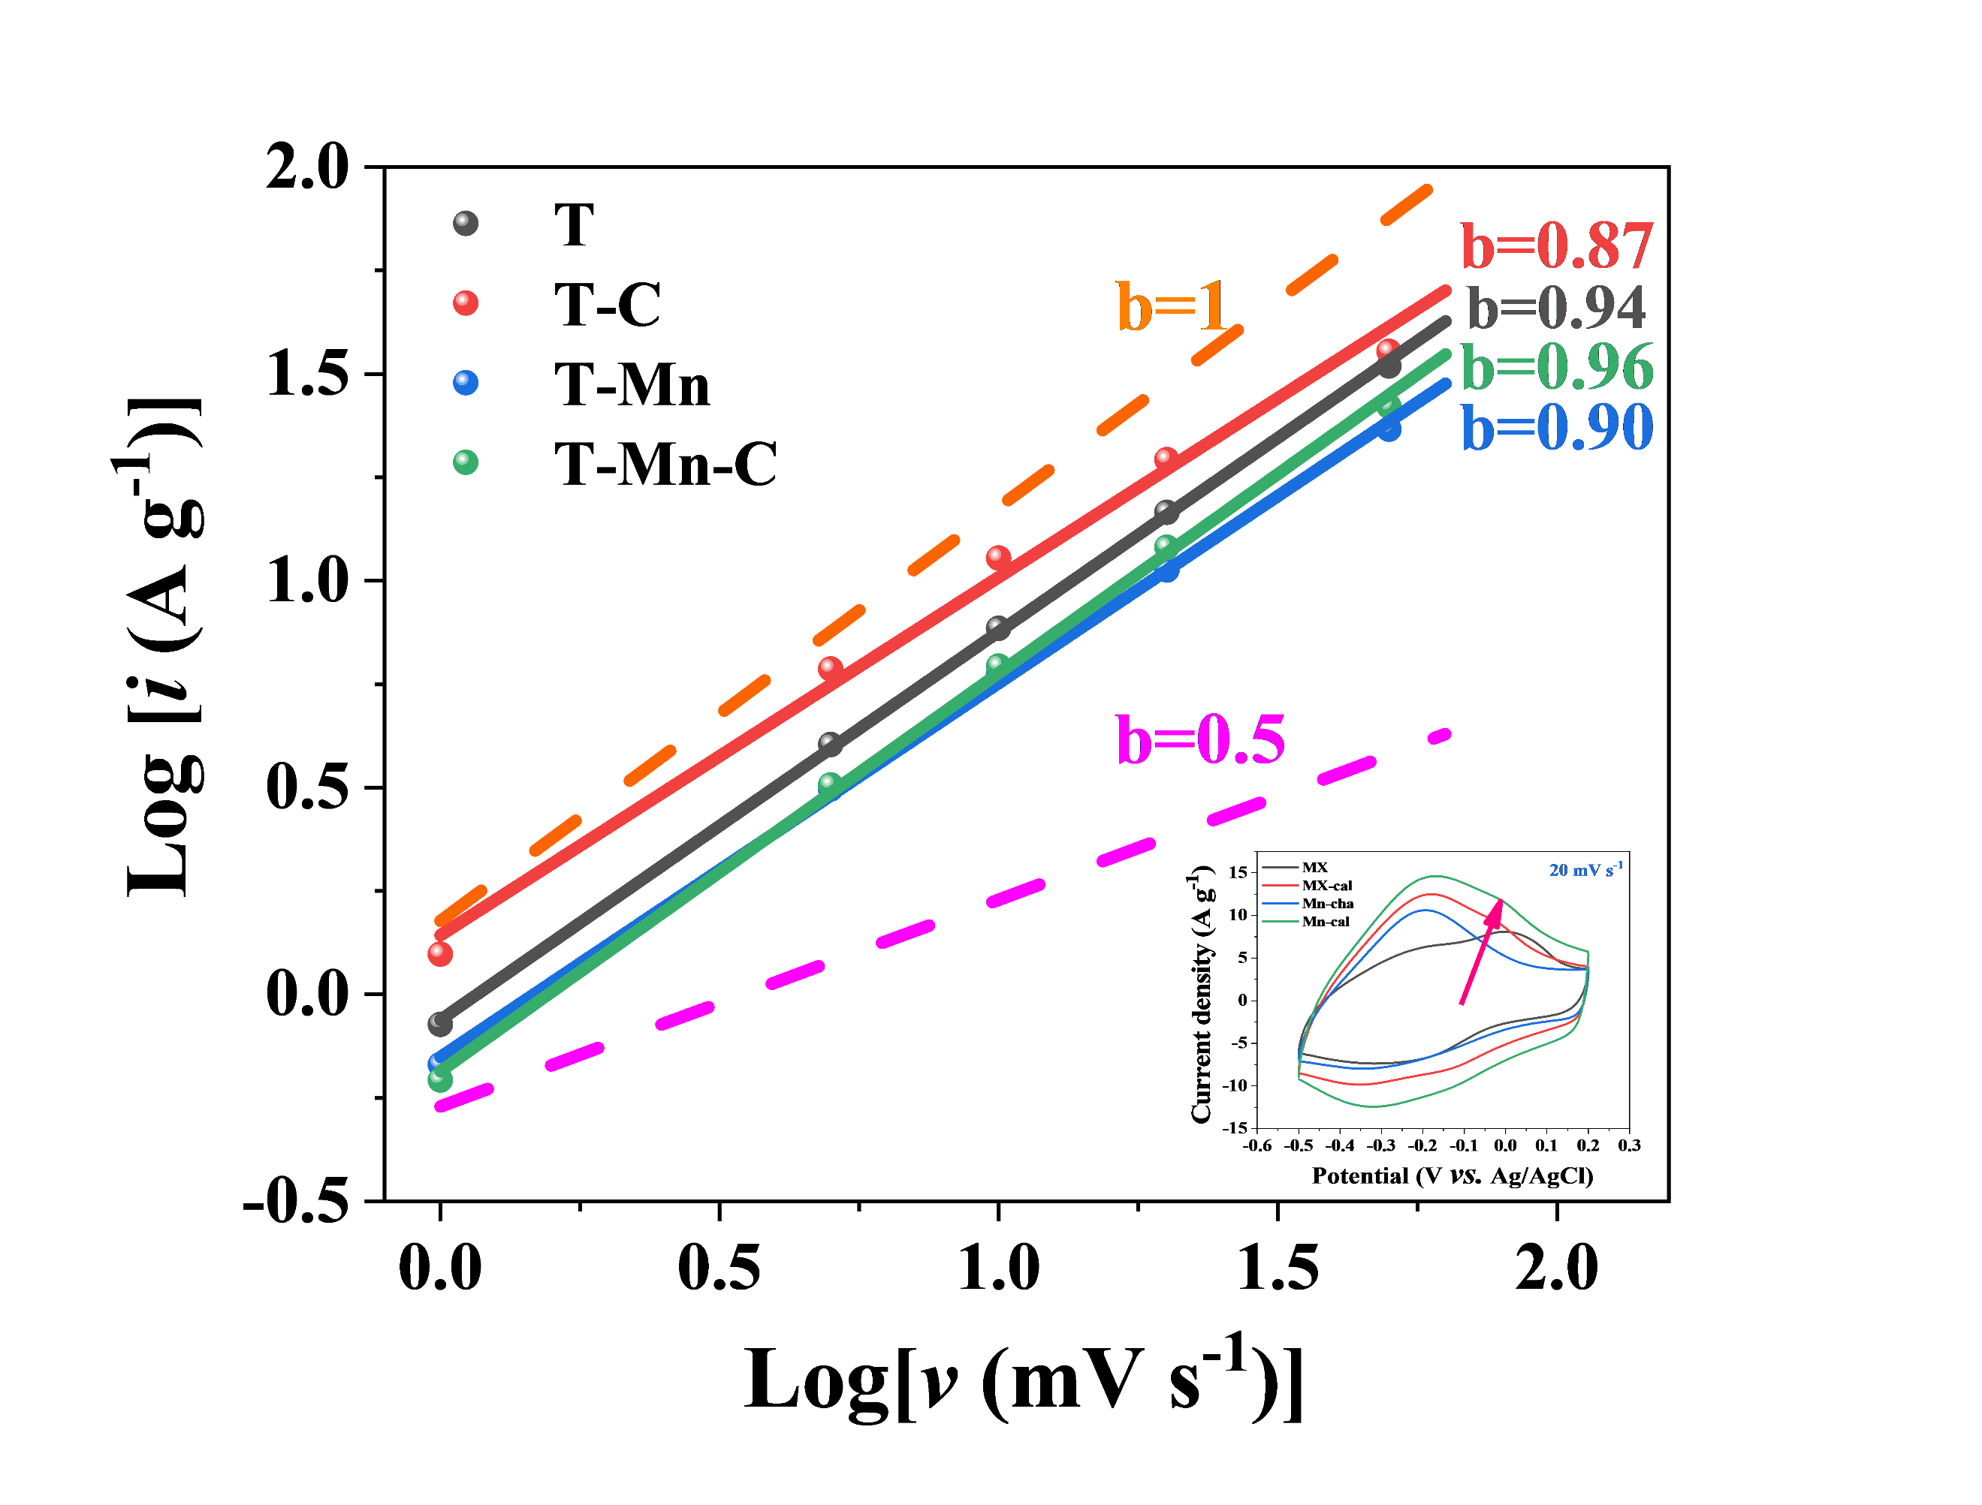
Figure S16 The b values are estimated by fitting the data for T, T-C, T-Mn, and T-Mn-C, respectively.

The charge storage kinetics is assessed by analyzing the relationship between peak current (i_{p}) and scan rate (v), according to the following equation S(1):
$i_{p}=a^{b}$ S(1)
where a and b are variables. The b values are calculated of log i_{p} vs log v. The b value is close to 1 for T-Mn-C, indicating that the electrochemical mechanism is a surface-controlled process ¹¹.
Figure S17 (a)-(b) The CV and GCD curves of the T-Mn-sa electrodes. (c)-(d) The CV and GCD curves of the T-Mn-sa-C electrodes. (e) The CV curves at 20 mV s⁻¹ of T, T-Mn-C, and T-Mn-sa-C. (f) The C_{v} of the T, T-Mn-C, and T-Mn-sa-C electrodes plotted as a function of current densities.
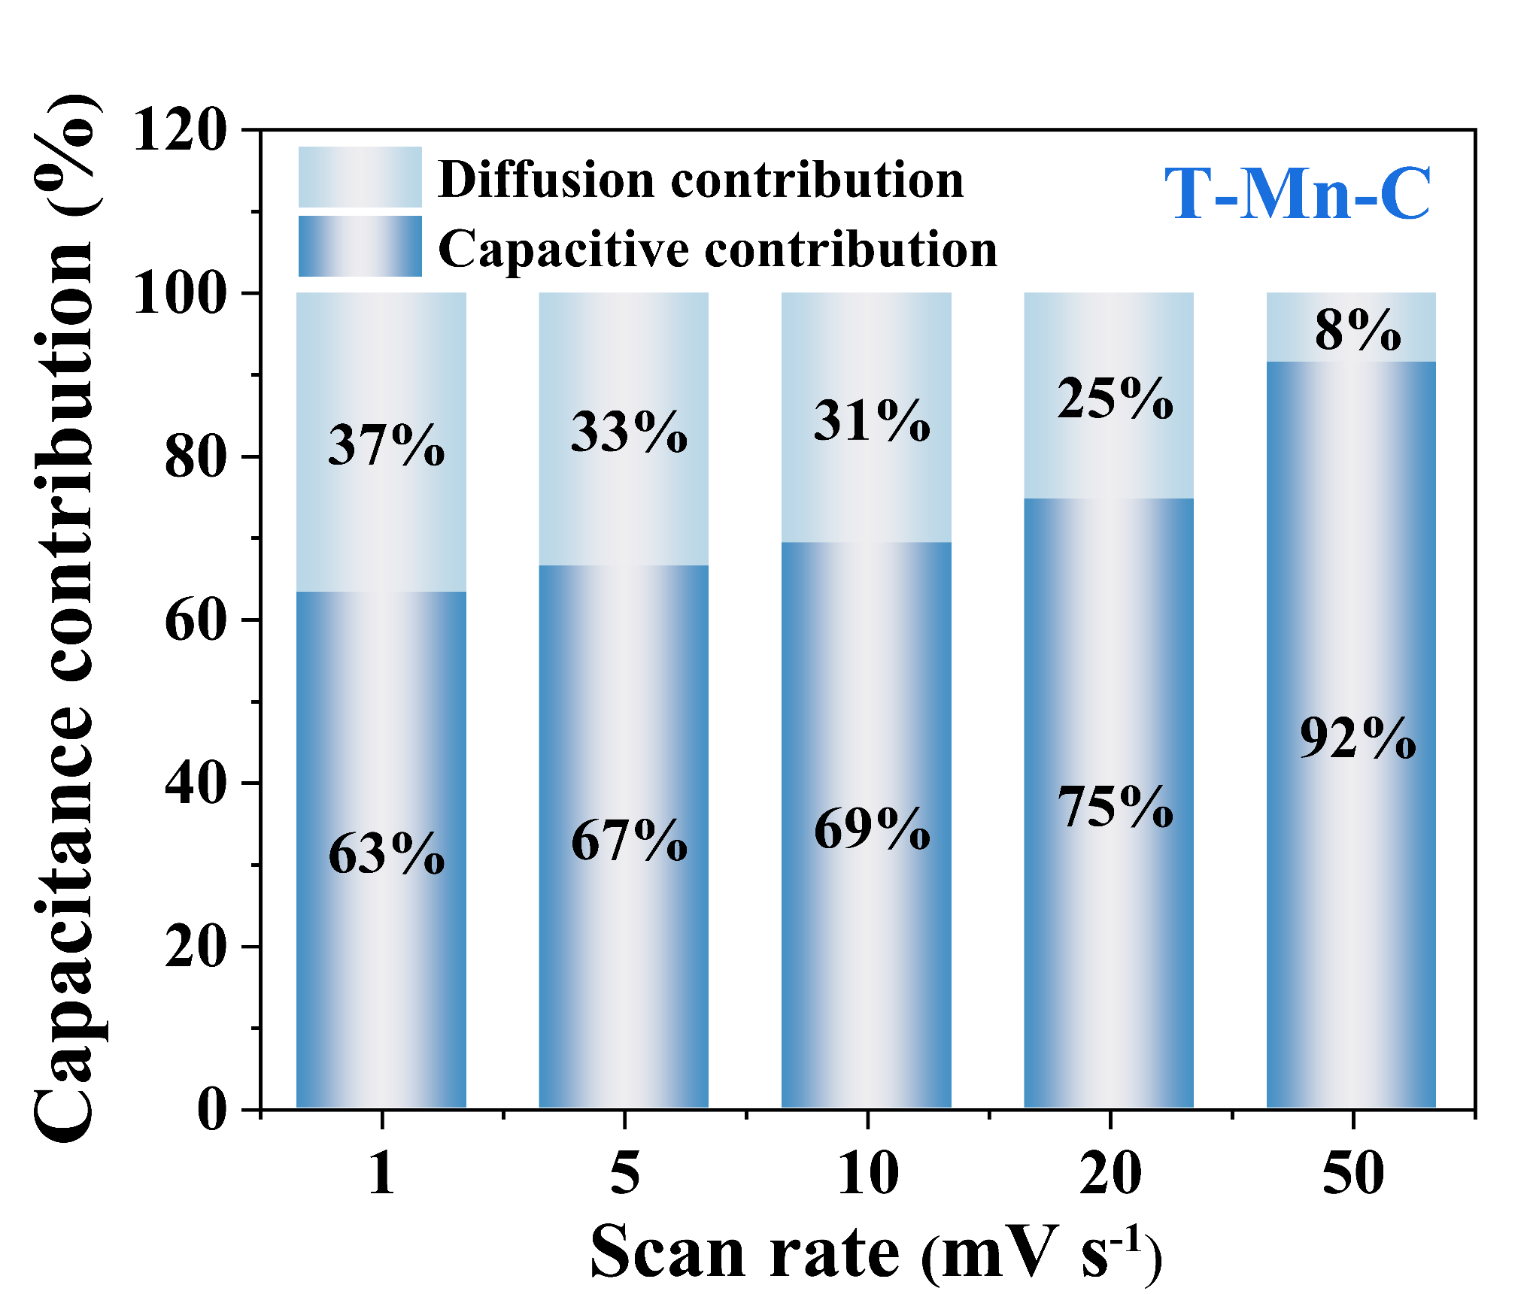
Figure S18 CV partition analysis shows the capacitive contribution to the total current at selected scan rates of T-Mn-C.

The capacitance of the T-Mn-C electrode is divided into two parts: a slow diffusion-controlled component (i_{diff}) and a capacitance-dominated component (i_{cap}), which can be described using equation S(2) ¹²:
$i_{total}=i_{cap}+i_{diff}$ S(2)
To further quantify the capacitive and diffusion-limited contributions to the total capacitance, equations S(3)-(4) can be used ¹³:
$i_{total}=i_{cap}+i_{diff}=k_{1}{v+k_{2}v^{\frac{1}{2}}}$ S(3)
$i∕v^{\frac{1}{2}}=k_{1}v^{\frac{1}{2}}+k_{2}$ S(4)
By solving for the adjustable values (k₁, k₂) at each potential, it is possible to distinguish between diffusion-controlled currents, which are proportional to v, and capacitive-like currents, which are proportional to v^{1/2}.

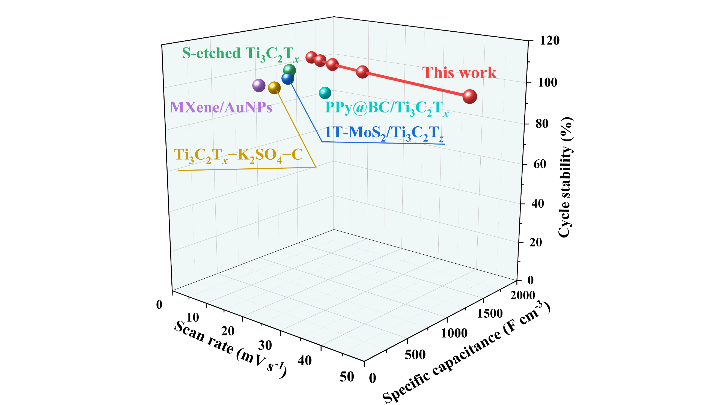
Figure S19 Comparison of the volumetric capacitances and cycling stabilities of T-Mn-C electrodes with those reported in the literature ¹⁴⁻¹⁸ (10000 cycles are used to make a comparison).

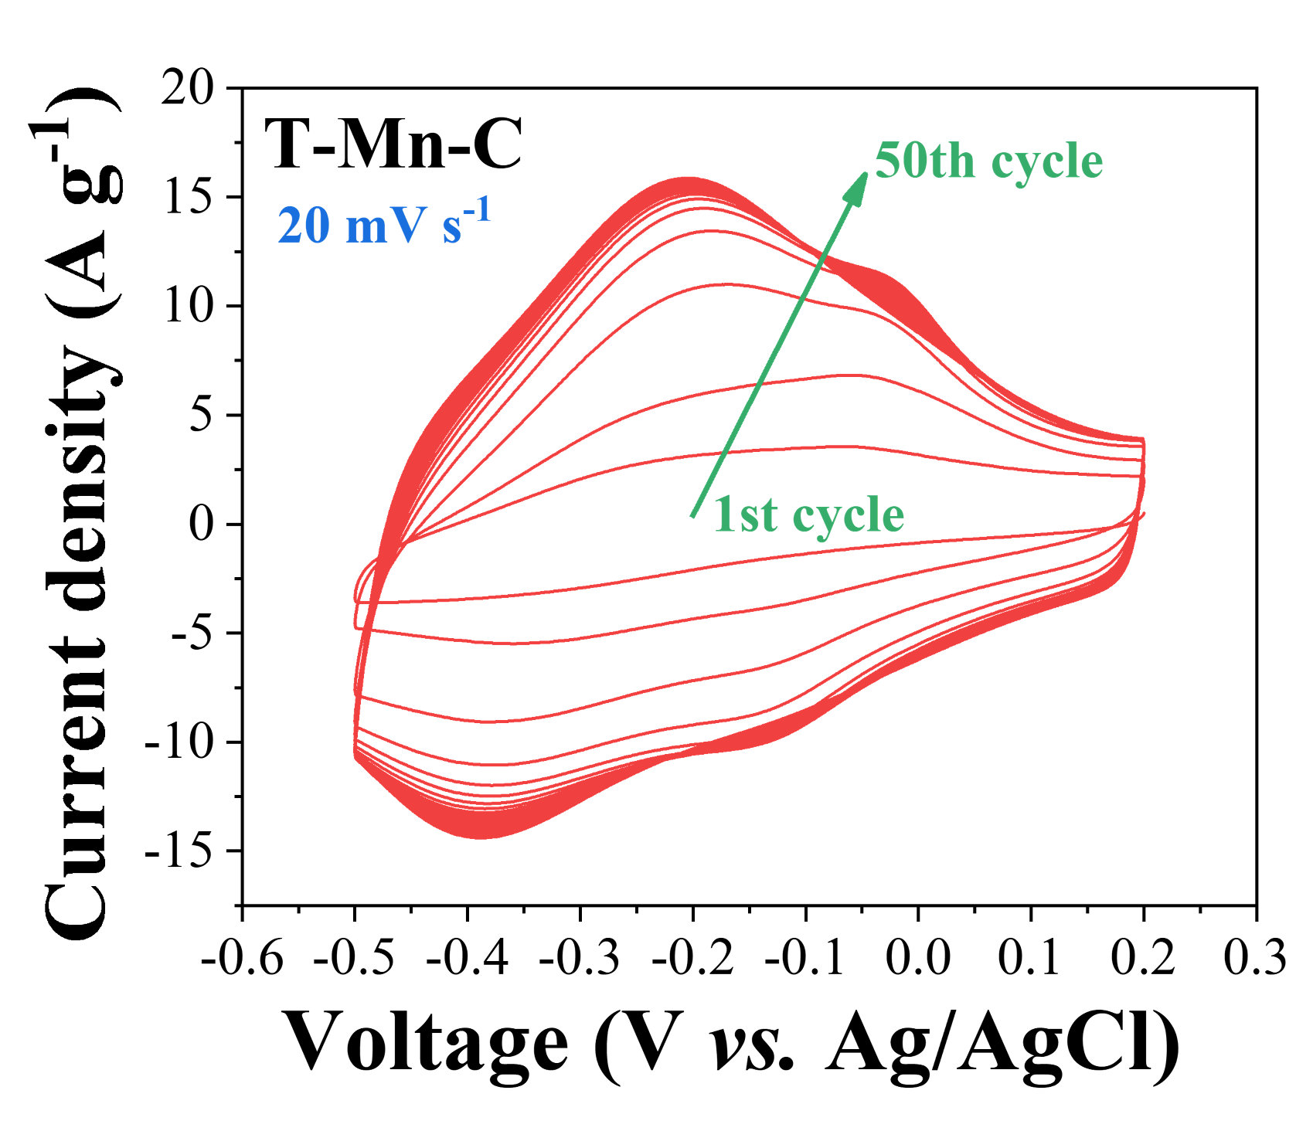
Figure S20 The CV curves of pre-cycle 50 of T-Mn-C electrodes

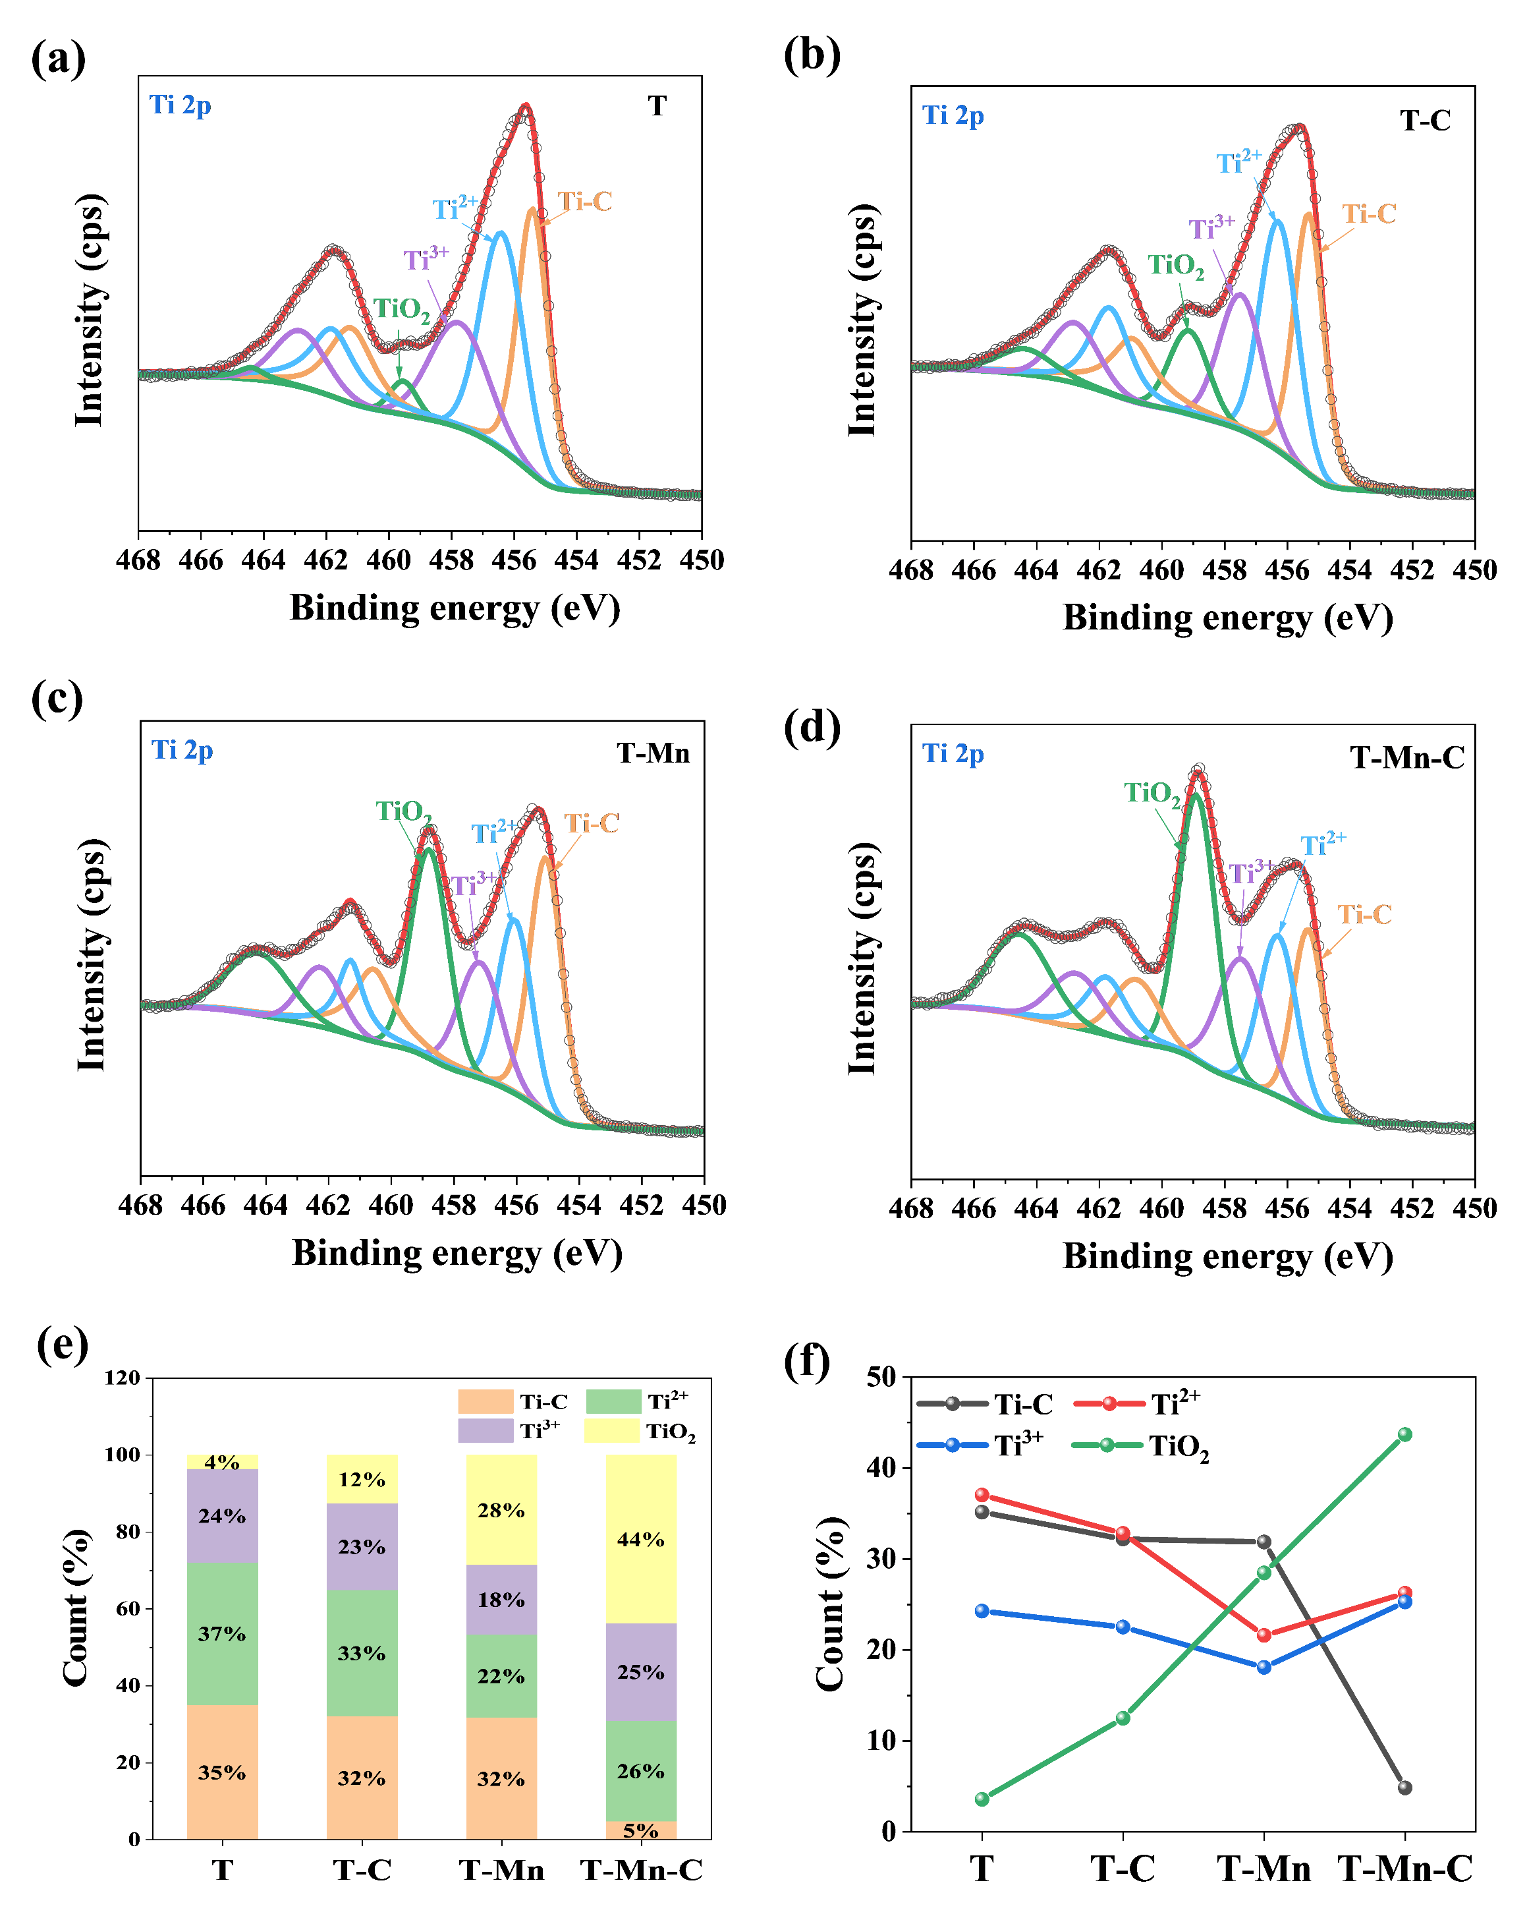
Figure S21 (a)-(d) Ti 2p XPS spectra of T, T-C, T-Mn, and T-Mn-C electrodes. (e)-(f) Comparison of the proportion of different valence states in T i2p.

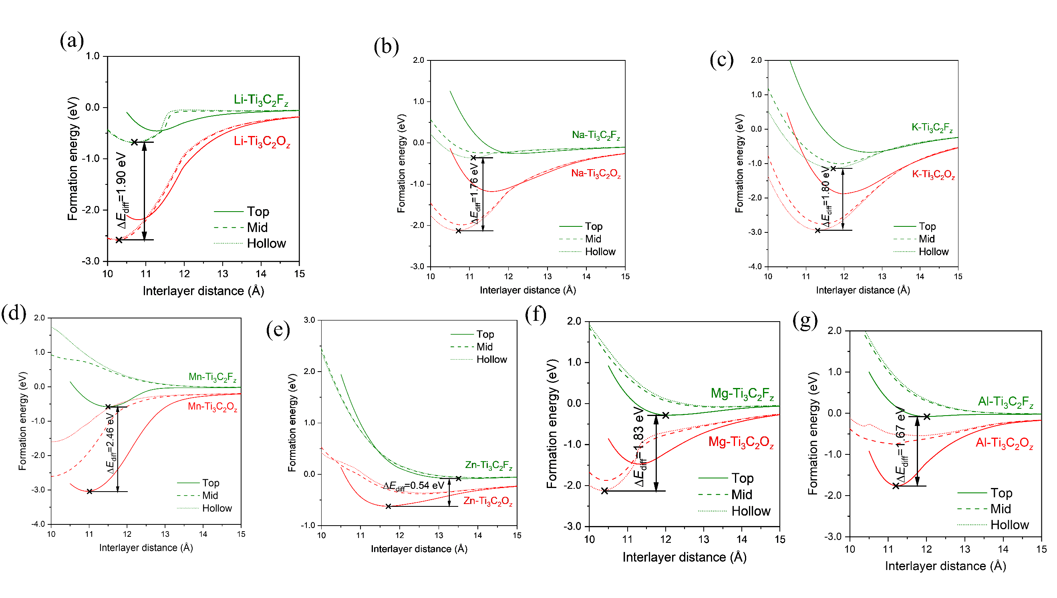
Figure S22 The function plots of formation energy (eV) versus interlayer distance (Å) of T-M (M is Li, Na, K, Mn, Zn, Mg, and Al) systems.

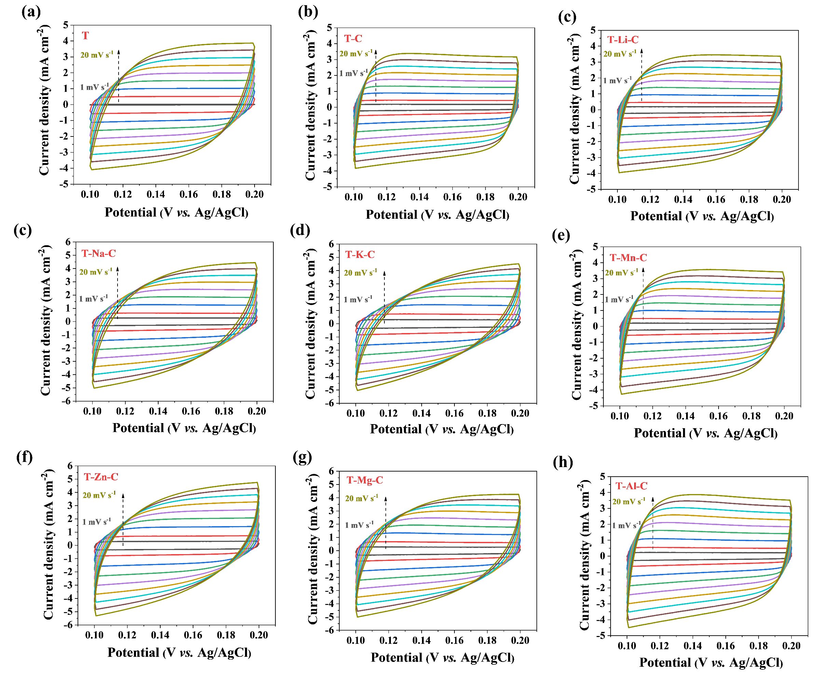
Figure S23 Determination of EDL-like capacitance. (a)-(h) CV curves in the potential region of -0.1-0.2 V vs. Ag/AgCl of T, T-C, and T-M-C.

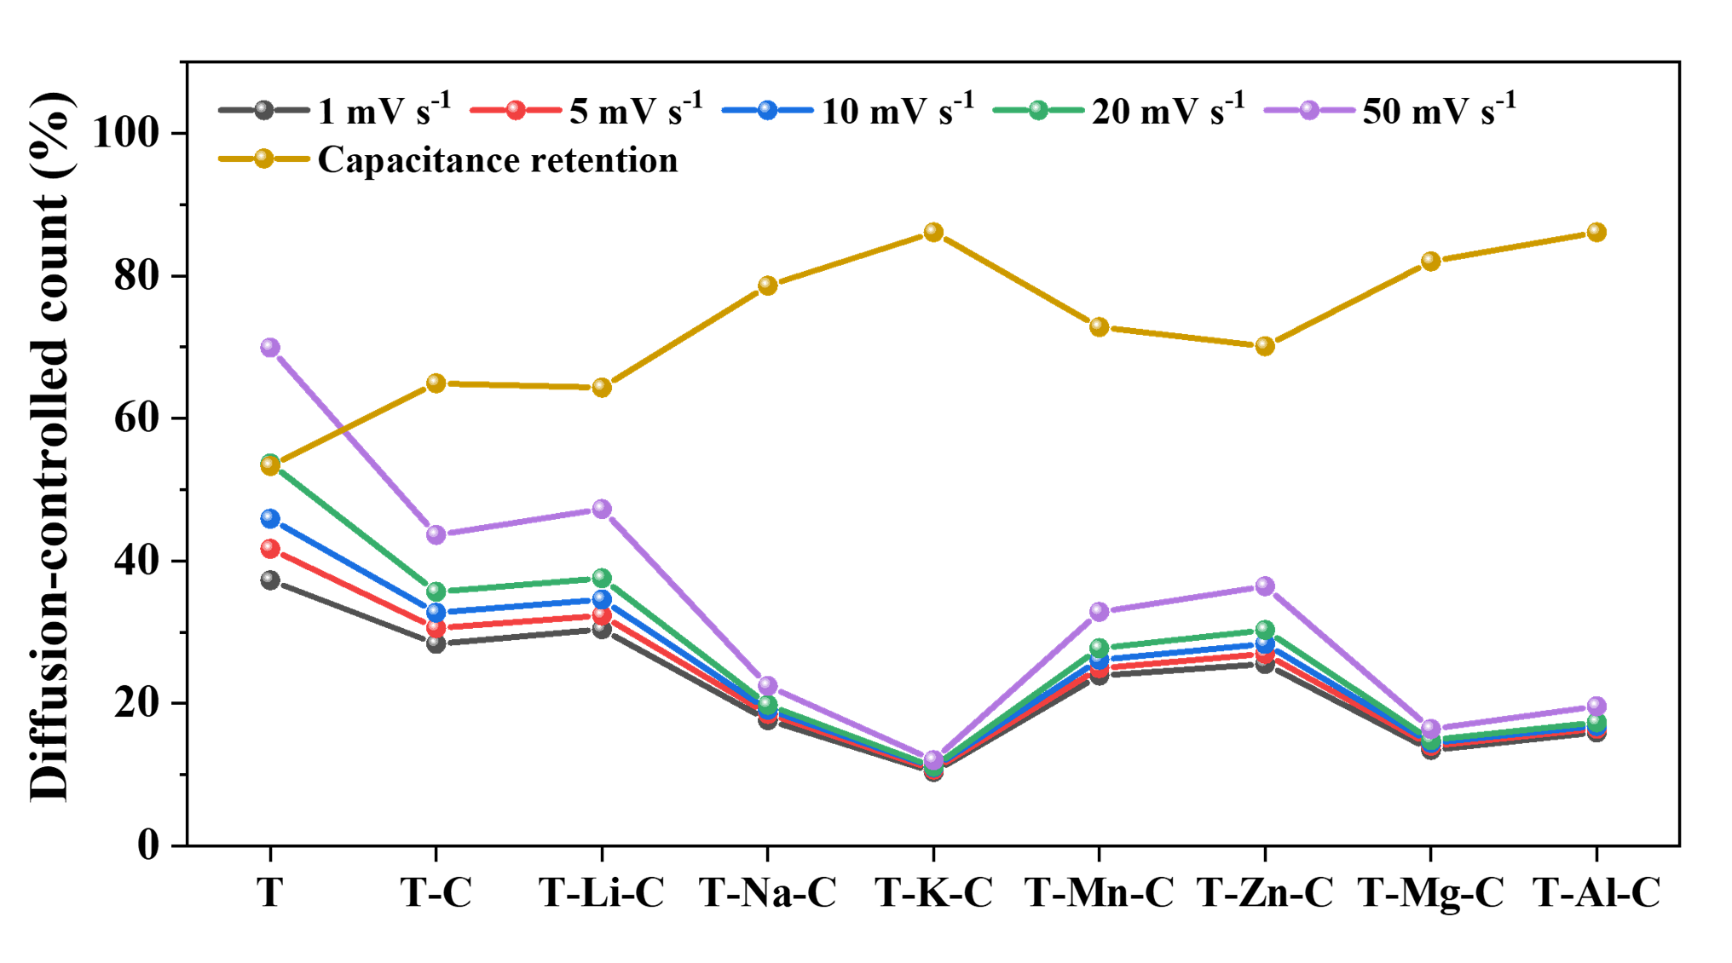
Figure S24 Relationship between diffusion-controlled capacitance ratio and capacitance retention for T, T-C, and T-M-C.

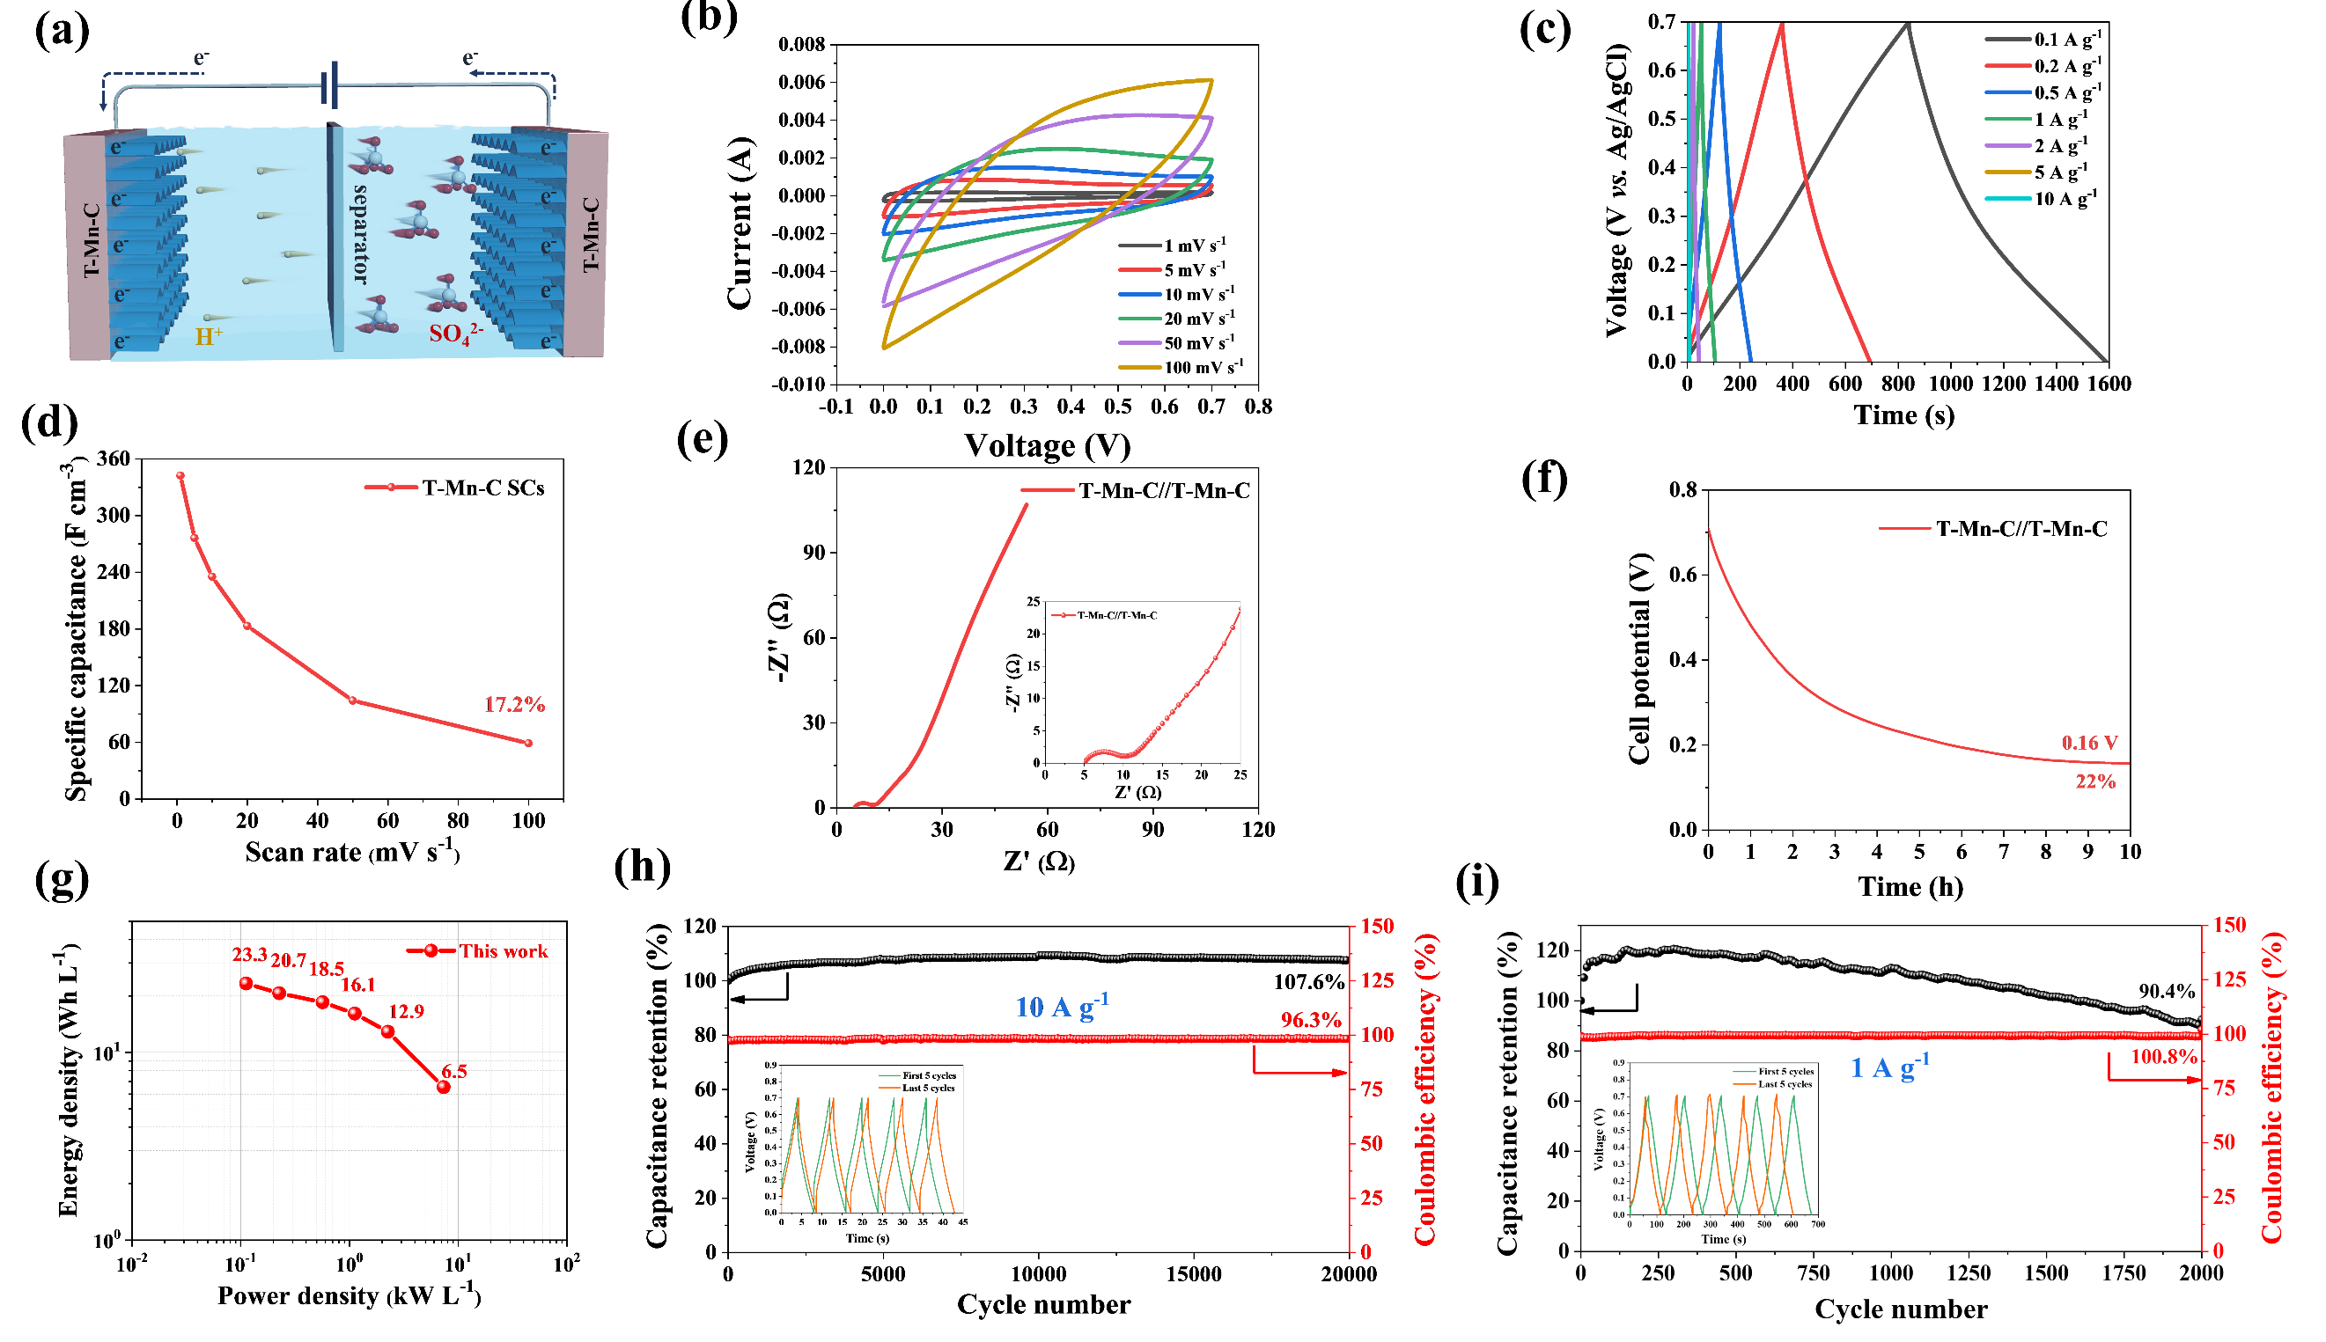
Figure S25 Electrochemical properties of T-Mn-C//T-Mn-C SSCs. (a) Schematic of the T-Mn-C SCs. (b) CV curves at different scan rates. (c) GCD curves at different current densities. (d) Specific capacitances at different scan rates. (e) Electrochemical impedance spectroscopy data of T-Mn-C SSCs. The inset shows the magnified high-frequency region. (f) Self-discharge curves. (g) Ragone plots. (h)-(i) Cycling performance at a current density of 10 A g⁻¹ and 1 A g⁻¹ for 20000 cycles (inset shows GCD curves of the first and last 5 cycles).

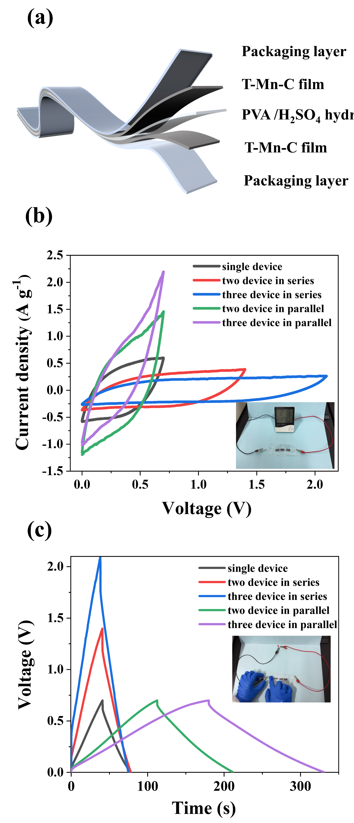
Figure S26 Electrochemical performance of the all-solid-state T-Mn-C SSCs. (a) Schematic of T-Mn-C SSCs using PVA/H₂SO₄ electrolyte. (b)-(c) CV curves and GCD curves of serially and parallel connected T-Mn-C SSCs from 1 to 3 cells.
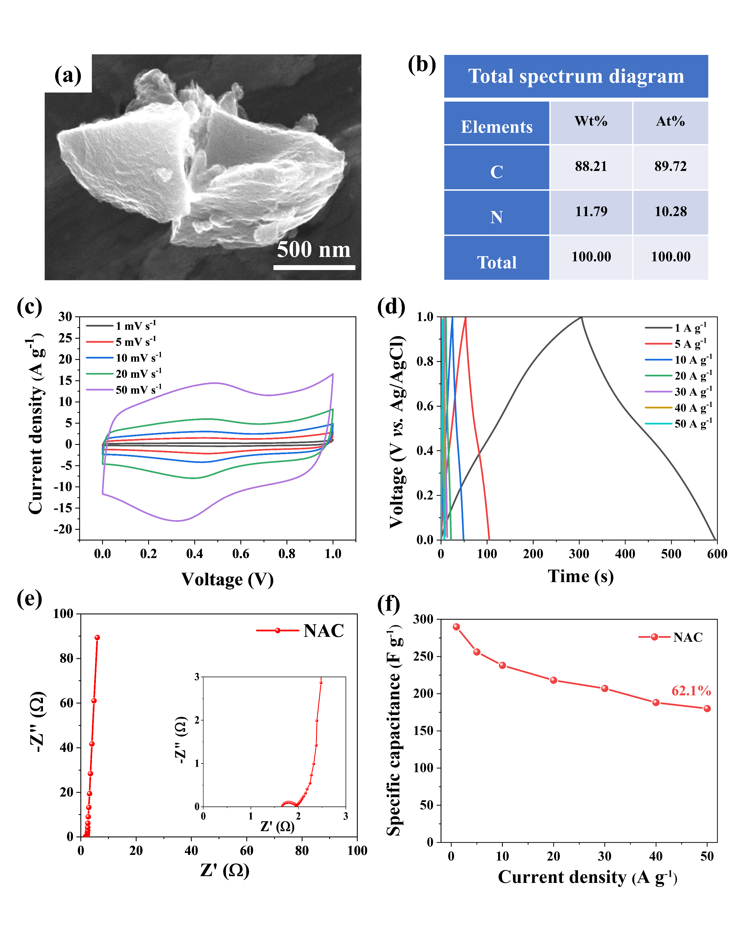
Figure S27 (a)-(b) SEM and EDS of NAC. (c)-(e) CV curves at different scan rates, GCD curves at different current densities, and EIS of NAC. (f) The gravimetric capacitance (C_{g}) of NAC electrode is plotted as a function of current densities.

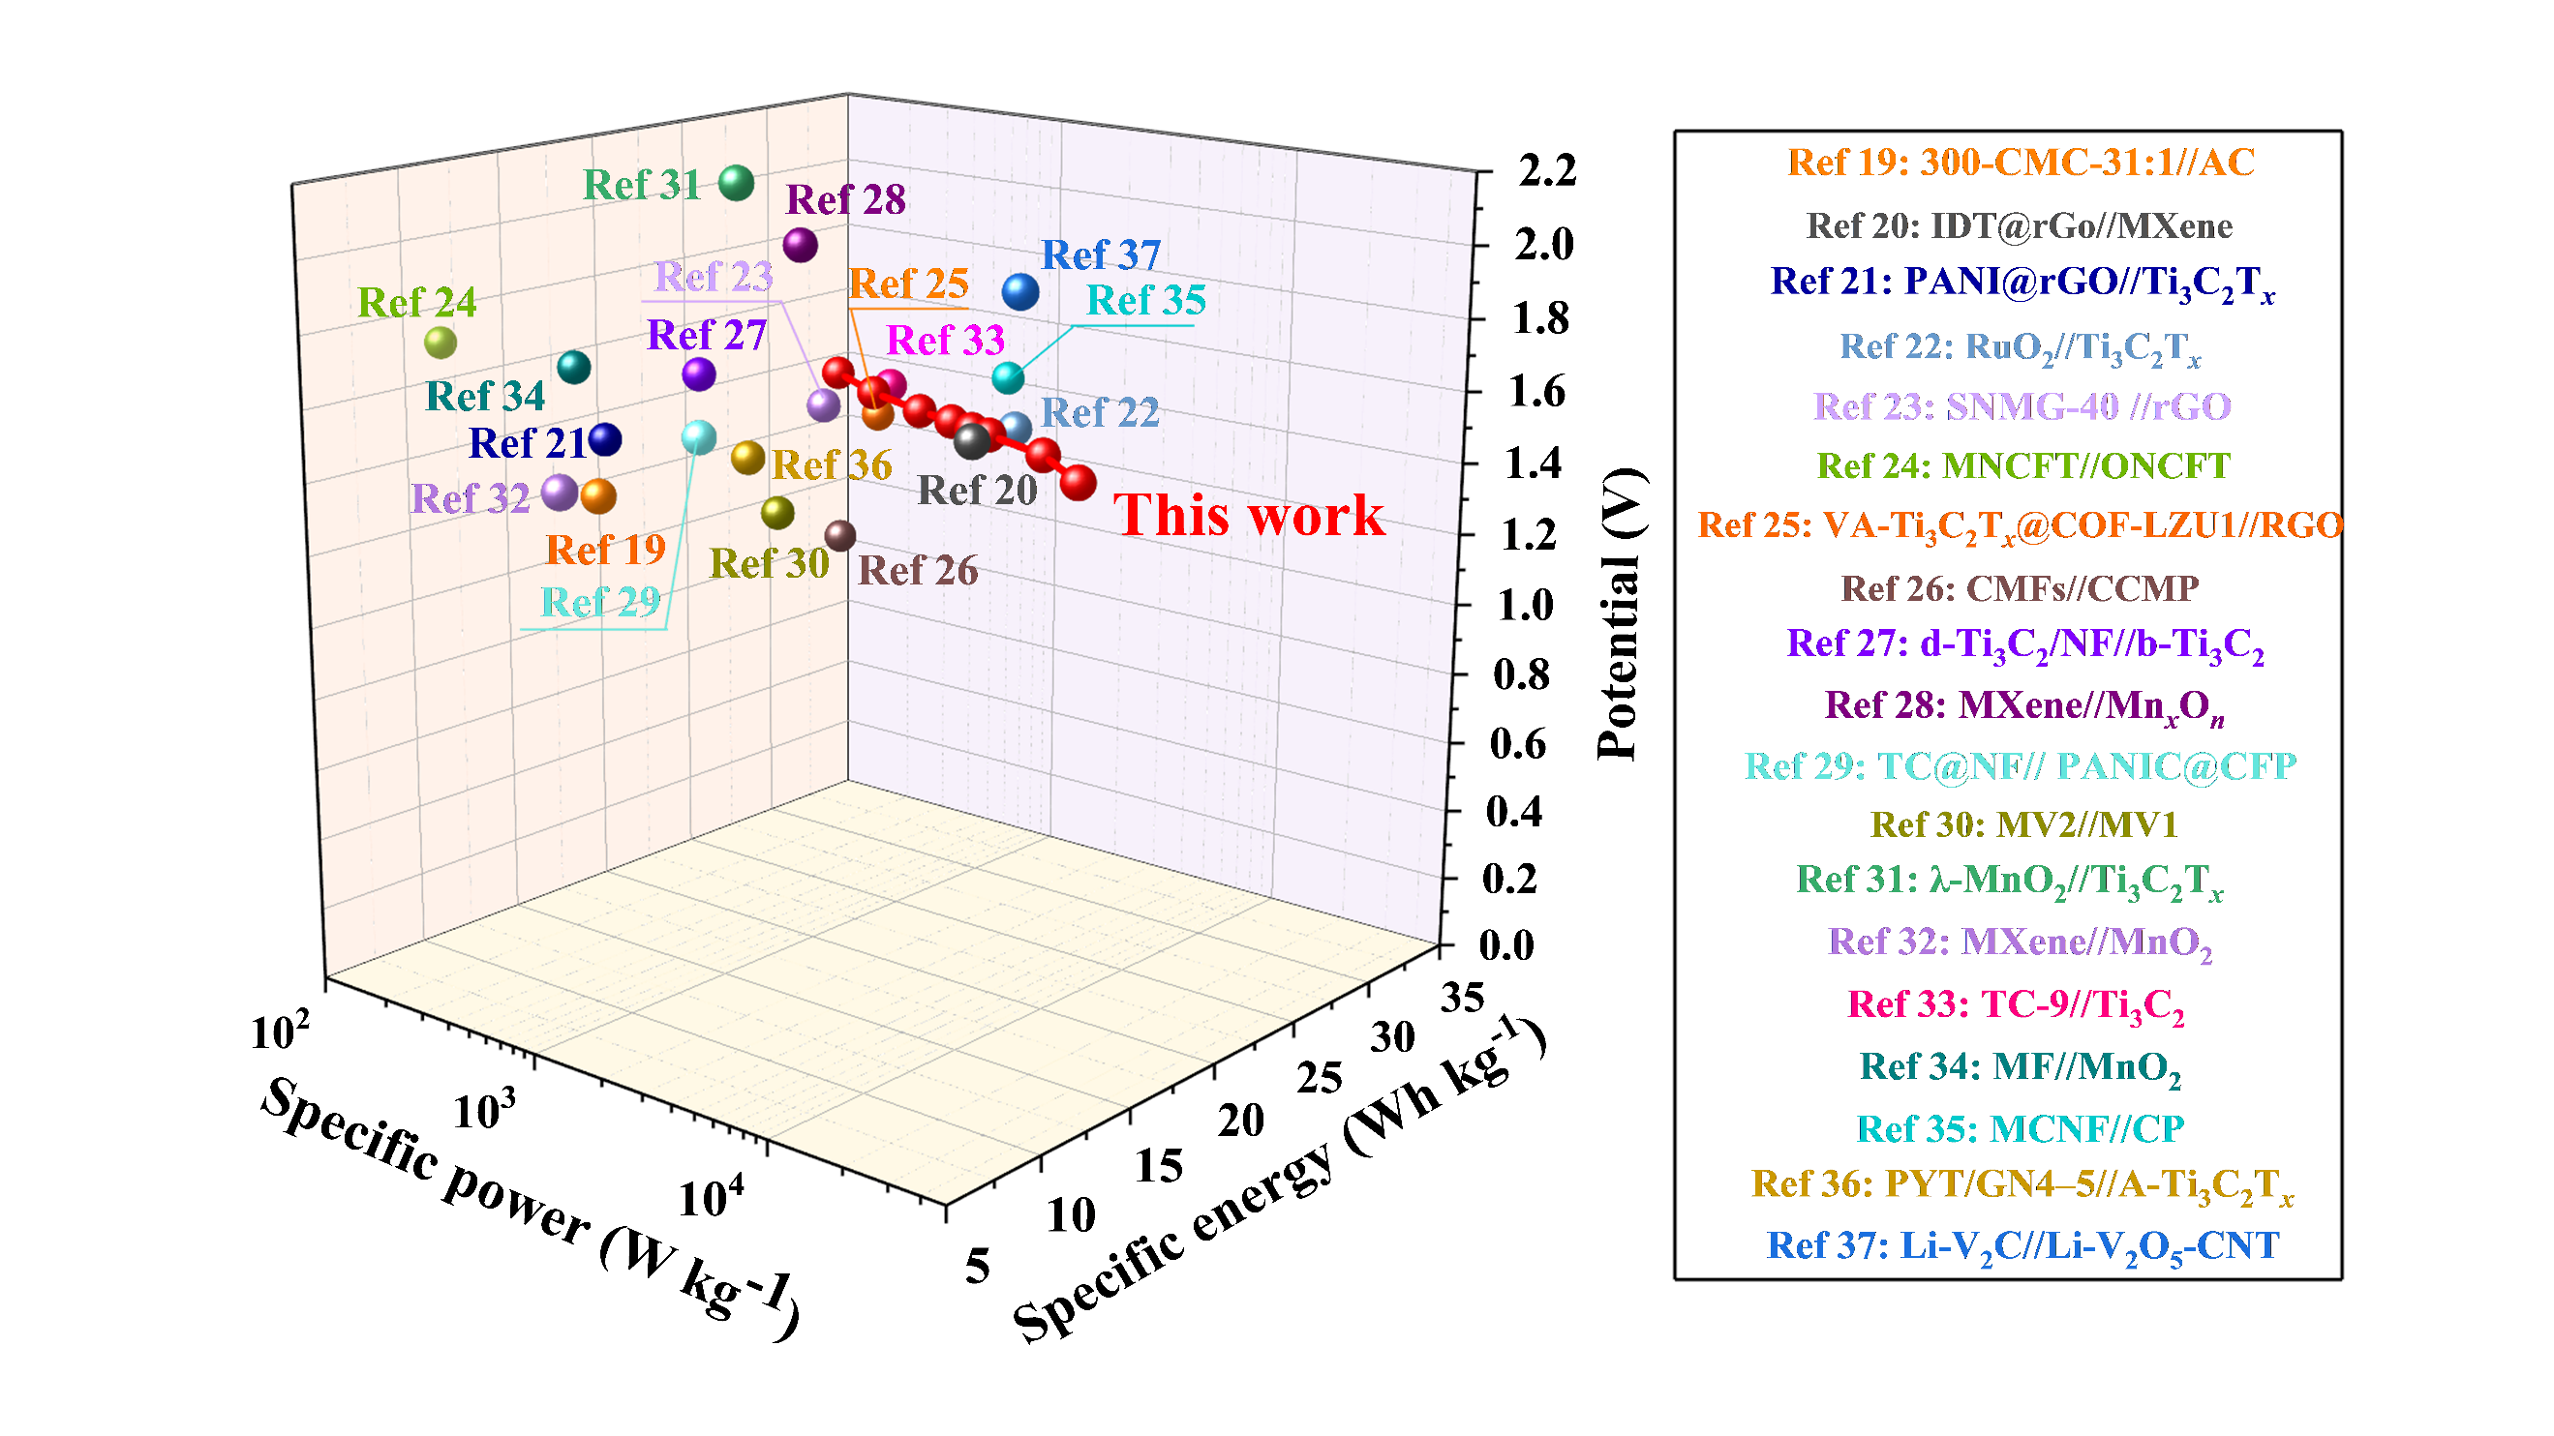
Figure S28 Ragone plots of NAC//T-Mn-C (mass values) ¹⁹⁻³⁷.
Table S1. Calculated and measured results of the interlayer distance.
 | Minus Li⁺ spacing  （nm） | Ion diameter  （nm） | Calculation results  （nm） | Test results  （nm）
Na⁺ | 0.961 | 0.190 | 1.151 | 1.135
K⁺ | 0.961 | 0.266 | 1.227 | 1.174
Mn²⁺ | 0.961 | 0.160 | 1.121 | 1.120
Zn²⁺ | 0.961 | 0.148 | 1.109 | 1.106
Mg²⁺ | 0.961 | 0.130 | 1.091 | 1.302
Mg²⁺ | 0.961 | 0.856 (Hydrated ion) | 1.817 | 1.302
Al³⁺ | 0.961 | 0.100 | 1.061 | 1.332
Al³⁺ | 0.961 | 0.950 (Hydrated ion) | 1.911 | 1.332

Table S2. Comparative study of 2D electrodes for specific capacitances.
Electrode material | Electrolyte | Specific capacitance for 3-electrode | Cycle stability | Refs.
T-Mn-C | 3 M H₂SO₄ | 1655.4 F cm⁻³ at 1 mV s⁻¹  (517.3 F g⁻¹ at 1 mV s⁻¹) | 101.1% for 10000 cycles | Our work
S-etched Ti₃C₂T_{x} films | 3 M H₂SO₄ | 1200.0 F cm⁻³ at 5 mV s⁻¹ | 99.3% for 10000 cycles | 14
1T-MoS₂/Ti₃C₂T_{z} | 3 M H₂SO₄ | 393.0 F g⁻¹ at 5 mV s⁻¹ | 95.5% for 10000 cycles | 15
PPy@BC/Ti₃C₂T_{x} | 3 M H₂SO₄ | 550.0 F g⁻¹ at 5 mV s⁻¹ | 83.5% for 10000 cycles | 16
MXene/AuNPs | 1 M H₂SO₄ | 278.0 F g⁻¹ at 5 mV s⁻¹ | 95.0% for 10000 cycles | 17
Ti₃C₂T_{x}−K₂SO₄−C | 1 M H₂SO₄ | 380.0 F g⁻¹ at 2 mV s⁻¹ | 90.0% for 10000 cycles | 18
TFPDQGO | 1 M NaCl | 429 F g⁻¹ at 2 A g⁻¹ | - | 38
PANI@MXene/GQDs | 1 M H₂SO₄ | 547 F g⁻¹ at 1 A g⁻¹ | - | 39
α-MnO₂/S, N co-doped rGO | 1 M Na₂SO₄ | 381 F g⁻¹ at 5 A g⁻¹ | 80% for 5000 cycles | 40
MnO₂/MoS₂/rGO | 1 M Na₂SO₄ | 743 F g⁻¹ at 1 A g⁻¹ | 88.5% after 5000 cycles | 41
rGO/CoO/Co₃O₄ | 0.1 M KOH | 276.1 F g⁻¹ at 5 mV s⁻¹ | 82.4% for 10000 cycles | 42
P-MXene/C_{PAQ}-A | 3 M H₂SO₄ | 532.9 F g⁻¹ at 5 mV s⁻¹ | 97.1% for 40000 cycles | 43
MCNF-4 | 1 M H₂SO₄ | 562.0 mF cm⁻² at 5 mV s⁻¹ | - | 44
MXene_{0.9} | 1 M H₂SO₄ | 318.5 F g-1 at 1 A g⁻¹ | 92.0% for 10000 cycles | 45
SNMG-40 | 1 M H₂SO₄ | 698.5 F cm⁻³ at 1 A g⁻¹ | 97.8% for 30000 cycles | 46
MXene-coated cotton yarn | 1 M H₂SO₄ | 759.5 mF cm⁻¹ at 2 mV s⁻¹ | 100.0% for 10000 cycles | 47
MXene “nacre” | 1 M H₂SO₄ | 190.0 F g⁻¹ at 10 mV s⁻¹ | 87.4% for 5000 cycles | 48
Li-V₂T_{x} film | 3 M H₂SO₄ | 475.0 F g⁻¹ at 2 mV s⁻¹ | - | 49
Ti₃C₂T_{x}−Mn | 3 M H₂SO₄ | 369.0 F g⁻¹ at 2 mV s⁻¹ | 87.4% for 5000 cycles | 50
PANI/Ti₃C₂T_{x}  nanohybrid | 1 M H₂SO₄ | 462.0 F·g⁻¹ at 1 A g⁻¹ | - | 51
Ti₃C₂ FIBER | 1 M H₂SO₄ | 309.0 F g⁻¹ at 1 A g⁻¹ | 97.2% for 10000 cycles | 52
A-Ti₃C₂T_{x} | 1 M H₂SO₄ | 431.0 F g⁻¹ at 3 A g⁻¹ | - | 53
MXene hybrid  aerogel | 1 M H₂SO₄ | 760.0 F g⁻¹ at 1 A g⁻¹ | 97.0% for 10000 cycles | 54

Table S3 Distinguish capacitance into diffusion-controlled capacitance, capacitive EDLC, and capacitive PC for T, T-C, and T-M-C.
 | Diffusion-controlled capacitance  (F cm⁻³) | Capacitive EDLC  (F cm⁻³) | Capacitive PC  (F cm⁻³) | Total capacitance  (F cm⁻³)
T | 418.2 | 255.4 | 237.8 | 911.4
T-C | 397.8 | 257.0 | 560.3 | 1215.1
T-Li-C | 424.6 | 268.2 | 535.4 | 1228.2
T-Na-C | 222.4 | 279.0 | 663.4 | 1164.8
T-K-C | 125.4 | 284.2 | 730.6 | 1140.2
T-Mn-C | 395.8 | 287.4 | 833.9 | 1517.1
T-Zn-C | 356.5 | 283.5 | 616.6 | 1256.6
T-Mg-C | 177.9 | 289.9 | 760.3 | 1228.1
T-Al-C | 182.7 | 297.3 | 605.8 | 1085.8

Table S4. Comparative study of MXene-based asymmetric device for long cycling performance.
Electrodes | Electrolytes | Cycling stability | Refs.
NAC//T-Mn-C | 3 M H₂SO₄ | 101.1% for 10000 cycles  (10 A g⁻¹) | Our work
TMA-Nb₄C₃// Li-V₂O₅-CNT | 5 M LiCl | 95.0% for 10000 cycles  (5 A g⁻¹) | 55
MPC(G)1:1//MXP-3:1 | 1 M TEABF₄/DMSO | 94.1% for 10000 cycles  (8 A g⁻¹) | 56
MBC-0//MBC-6 | 3 M H₂SO₄ | 82.0% for 5000 cycles  (10 mA cm⁻³) | 57
PYT/GN4-5//A-Ti₃C₂T_{x} | 1 M H₂SO₄ | 83.8% for 8000 cycles  (3 A g⁻¹) | 53
MCO/TCX//AC | 1 M HCl | 91.0% for 5000 cycles  (5 A g⁻¹) | 58
MCNF//CP | PVA/H₂SO₄ | 86.0% for 5000 cycles  (10 A g⁻¹) | 44
Co₃O₄@NF//MX-5@PCNF | 3 M KOH | 96.4% for 10000 cycles  (1 A g⁻¹) | 59
CMFs//CCMP | 1 M PVA/H₂SO₄ | 88.9% for 20000 cycles  (5 A g⁻¹) | 60
1@Ti₃C₂T_{x}//ACL | 2 M H₃PO₄ | 79% for 10000 cycles  (20 A g⁻¹) | 61
W₁₈O₄₉/Ti₃C₂T_{x}// AC | 1 M H₂SO₄ | 99.1% for 10000 cycles  (10 A g⁻¹) | 62
W-MX/CF-4//NiCo₂S₄-13@W-MX/CF-4 | 2 M KOH | 85.1% for 10000 cycles  (15.5 mA cm⁻²) | 63
V₂CT_{x}//AC | 2 M ZnSO₄ | 79.0% for 100000 cycles  (10 A g⁻¹) | 64
V₂CT_{x}@NiCoMn-OH-20//AC | 3 M KOH | 91.8% for 5000 cycles  (20 A g⁻¹) | 65
TCM//NRGO | 1 M Na₂SO₄ | 92.2% for 10000 cycles  (7 A g⁻¹) | 66
EGN//PANI/Ti₃C₂T_{x} | 1 M Na₂SO₄ | 89.7% for 5000 cycles  (2 A g⁻¹) | 51
Ti₃C₂T_{z}//MO | 14 M LiCl | 96.2% for 30000 cycles  (10 A g⁻¹) | 67
GA@UiO-66-NH₂//Ti₃C₂T_{x} | 1 M Na₂SO₄ | 88.0% for 10000 cycles  (5.2 A g⁻¹) | 68

Reference
1. Zhang, Y.F., Ang, E.H., Yang, Y., Ye, M.H., Du, W.C., and Li, C.C. (2021). Interlayer Chemistry of Layered Electrode Materials in Energy Storage Devices. ADVANCED FUNCTIONAL MATERIALS 31, 2007358, 2007358. 10.1002/adfm.202007358.
2. Li, J., Yuan, X.T., Lin, C., Yang, Y.Q., Xu, L., Du, X., Xie, J.L., Lin, J.H., and Sun, J.L. (2017). Achieving High Pseudocapacitance of 2D Titanium Carbide (MXene) by Cation Intercalation and Surface Modification. ADVANCED ENERGY MATERIALS 7, 1602725, 1602725. 10.1002/aenm.201602725.
3. Gao, X.Y., Yin, L.X., Zhang, L.L., Zhao, Y.F., and Zhang, B. (2020). Decoration of NiCoP nanowires with interlayer-expanded few-layer MoSe2 nanosheets: A novel electrode material for asymmetric supercapacitors. CHEMICAL ENGINEERING JOURNAL 395, 125058, 125058. 10.1016/j.cej.2020.125058.
4. Come, J., Black, J.M., Lukatskaya, M.R., Naguib, M., Beidaghi, M., Rondinone, A.J., Kalinin, S.V., Wesolowski, D.J., Gogotsi, Y., and Balke, N. (2015). Controlling the actuation properties of MXene paper electrodes upon cation intercalation. NANO ENERGY 17, 27-35. 10.1016/j.nanoen.2015.07.028.
5. Liu, Z.X., Qin, L.P., Cao, X.X., Zhou, J., Pan, A.Q., Fang, G.Z., Wang, S.Y., and Liang, S.Q. (2022). Ion migration and defect effect of electrode materials in multivalent-ion batteries. PROGRESS IN MATERIALS SCIENCE 125, 100911, 100911. 10.1016/j.pmatsci.2021.100911.
6. Ramachandran, R., Rajavel, K., Wenlu, X.L., Lin, D.H., and Wang, F. (2018). Influence of Ti3C2Tx (MXene) intercalation pseudocapacitance on electrochemical performance of Co-MOF binder-free electrode. CERAMICS INTERNATIONAL 44, 14425-14431. 10.1016/j.ceramint.2018.05.055.
7. Cai, L.R., Li, Z., Zhang, S.S., Prenger, K., Naguib, M., and Pol, V.G. (2021). Safer lithium-ion battery anode based on Ti3C2Tz MXene with thermal safety mechanistic elucidation. CHEMICAL ENGINEERING JOURNAL 419, 129387, 129387. 10.1016/j.cej.2021.129387.
8. Sherryna, A., and Tahir, M. (2022). Role of surface morphology and terminating groups in titanium carbide MXenes (Ti3C2Tx) cocatalysts with engineering aspects for modulating solar hydrogen production: A critical review. CHEMICAL ENGINEERING JOURNAL 433, 134573, 134573. 10.1016/j.cej.2022.134573.
9. Wang, H., Wu, Y., Yuan, X.Z., Zeng, G.M., Zhou, J., Wang, X., and Chew, J.W. (2018). Clay-Inspired MXene-Based Electrochemical Devices and Photo-Electrocatalyst: State-of-the-Art Progresses and Challenges. ADVANCED MATERIALS 30, 1704561, 1704561. 10.1002/adma.201704561.
10. Persson, I., Naslund, L.A., Halim, J., Barsoum, M.W., Darakchieva, V., Palisaitis, J., Rosen, J., and Persson, P.O.A. (2018). On the organization and thermal behavior of functional groups on Ti3C2 MXene surfaces in vacuum. 2D MATERIALS 5, 015002, 015002. 10.1088/2053-1583/aa89cd.
11. Lukatskaya, M.R., Kota, S., Lin, Z.F., Zhao, M.Q., Shpigel, N., Levi, M.D., Halim, J., Taberna, P.L., Barsoum, M., Simon, P., and Gogotsi, Y. (2017). Ultra-high-rate pseudocapacitive energy storage in two-dimensional transition metal carbides. NATURE ENERGY 2, 1-6, 17105. 10.1038/nenergy.2017.105.
12. Niu, S.S., Wang, Z.Y., Yu, M.L., Yu, M.Z., Xiu, L.Y., Wang, S., Wu, X.H., and Qiu, J.S. (2018). MXene-Based Electrode with Enhanced Pseudocapacitance and Volumetric Capacity for Power-Type and Ultra-Long Life Lithium Storage. ACS NANO 12, 3928-3937. 10.1021/acsnano.8b01459.
13. Kim, H.S., Cook, J.B., Lin, H., Ko, J.S., Tolbert, S.H., Ozolins, V., and Dunn, B. (2017). Oxygen vacancies enhance pseudocapacitive charge storage properties of MoO3-x. NATURE MATERIALS 16, 454-460. 10.1038/NMAT4810.
14. Tang, J., Mathis, T., Zhong, X.W., Xiao, X., Wang, H., Anayee, M., Pan, F., Xu, B.M., and Gogotsi, Y. (2021). Optimizing Ion Pathway in Titanium Carbide MXene for Practical High-Rate Supercapacitor. ADVANCED ENERGY MATERIALS 11, 2003025, 2003025. 10.1002/aenm.202003025.
15. Huang, X.W., Huang, J.H., Yang, D., and Wu, P.Y. (2021). A Multi-Scale Structural Engineering Strategy for High-Performance MXene Hydrogel Supercapacitor Electrode. ADVANCED SCIENCE 8, 2101664, 2101664. 10.1002/advs.202101664.
16. Song, Q.C., Zhan, Z.Y., Chen, B.X., Zhou, Z.H., and Lu, C.H. (2020). Biotemplate synthesis of polypyrrole@bacterial cellulose/MXene nanocomposites with synergistically enhanced electrochemical performance. CELLULOSE 27, 7475-7488. 10.1007/s10570-020-03310-7.
17. Zheng, Z.X., Wu, W., Yang, T., Wang, E.H., Du, Z.T., Hou, X.M., Liang, T.X., and Wang, H.L. (2021). In situ reduced MXene/AuNPs composite toward enhanced charging/discharging and specific capacitance. JOURNAL OF ADVANCED CERAMICS 10, 1061-1071. 10.1007/s40145-021-0491-0.
18. Li, Z.J., Dai, J., Li, Y.R., Sun, C.L., Meng, A.L., Cheng, R.F., Zhao, J., Hu, M.M., and Wang, X.H. (2022). Intercalation-deintercalation design in MXenes for high-performance supercapacitors. NANO RESEARCH 15, 3213-3221. 10.1007/s12274-021-3939-1.
19. Liao, L., Zhang, A., Zheng, K., Liu, R., Cheng, Y., Wang, L., Li, A., and Liu, J. (2021). Fabrication of Cobaltous Sulfide Nanoparticle-Modified 3D MXene/Carbon Foam Hybrid Aerogels for All-Solid-State Supercapacitors. ACS APPLIED MATERIALS & INTERFACES 13, 28222-28230. 10.1021/acsami.1c05904.
20. Xu, Y., Pan, B., Li, W.-S., Dong, L., Wang, X., and Zhao, F.-G. (2021). High-Performance Flexible Asymmetric Supercapacitor Paired with Indanthrone@Graphene Heterojunctions and MXene Electrodes. ACS APPLIED MATERIALS & INTERFACES 13, 41537-41544. 10.1021/acsami.1c08406.
21. Boota, M., and Gogotsi, Y. (2019). MXene-Conducting Polymer Asymmetric Pseudocapacitors. ADVANCED ENERGY MATERIALS 9, 1802917, 1802917. 10.1002/aenm.201802917.
22. Jiang, Q., Kurra, N., Alhabeb, M., Gogotsi, Y., and Alshareef, H.N. (2018). All Pseudocapacitive MXene-RuO2 Asymmetric Supercapacitors. ADVANCED ENERGY MATERIALS 8, 1703043, 1703043. 10.1002/aenm.201703043.
23. Liao, L., Jiang, D., Zheng, K., Zhang, M., and Liu, J. (2021). Industry-Scale and Environmentally Stable Ti3C2Tx MXene Based Film for Flexible Energy Storage Devices. ADVANCED FUNCTIONAL MATERIALS 31, 2103960. 10.1002/adfm.202103960.
24. Wang, Y., Wang, X., Li, X., Li, X., Liu, Y., Bai, Y., Xiao, H., and Yuan, G. (2021). A High-Performance, Tailorable, Wearable, and Foldable Solid-State Supercapacitor Enabled by Arranging Pseudocapacitive Groups and MXene Flakes on Textile Electrode Surface. ADVANCED FUNCTIONAL MATERIALS 31, 2008185, 2008185. 10.1002/adfm.202008185.
25. Zhu, X., Zhang, Y., Man, Z., Lu, W., Chen, W., Xu, J., Bao, N., Chen, W., and Wu, G. (2023). Microfluidic-Assembled Covalent Organic Frameworks@Ti3 C2 Tx MXene Vertical Fibers for High-Performance Electrochemical Supercapacitors. ADVANCED MATERIALS 35, 2307186.
26. An, N., Guo, Z., Guo, C., Wei, M., Sun, D., He, Y., Li, W., Zhou, L., Hu, Z., and Dong, X. (2023). A novel COF/MXene film electrode with fast redox kinetics for high-performance flexible supercapacitor. CHEMICAL ENGINEERING JOURNAL 458, 141434. 10.1016/j.cej.2023.141434.
27. Guo, J., Zhao, Y., Liu, A., and Ma, T. (2019). Electrostatic self-assembly of 2D delaminated MXene (Ti3C2) onto Ni foam with superior electrochemical performance for supercapacitor. ELECTROCHIMICA ACTA 305, 164-174. 10.1016/j.electacta.2019.03.025.
28. El Ghazaly, A., Zheng, W., Halim, J., Tseng, E.N., Persson, P.O.A., Ahmed, B., and Rosen, J. (2021). Enhanced supercapacitive performance of Mo1.33C MXene based asymmetric supercapacitors in lithium chloride electrolyte. ENERGY STORAGE MATERIALS 41, 203-208. 10.1016/j.ensm.2021.05.006.
29. Zhang, Y., Cao, J., Yuan, Z., Zhao, L., Wang, L., and Han, W. (2021). Assembling Co3O4 Nanoparticles into MXene with Enhanced electrochemical performance for advanced asymmetric supercapacitors. JOURNAL OF COLLOID AND INTERFACE SCIENCE 599, 109-118. 10.1016/j.jcis.2021.04.089.
30. Luo, W., Sun, Y., Lin, Z., Li, X., Han, Y., Ding, J., Li, T., Hou, C., and Ma, Y. (2023). Flexible Ti3C2Tx MXene/V2O5 composite films for high-performance all-solid supercapacitors. JOURNAL OF ENERGY STORAGE 62, 106807, 106807. 10.1016/j.est.2023.106807.
31. Vetrikarasan, B.T., Nair, A.R., Karthick, T., Shinde, S.K., Kim, D.-Y., Sawant, S.N., and Jagadale, A.D. (2023). Co-precipitation synthesis of pseudocapacitive A-MnO2 for 2D MXene (Ti3C2Tx) based asymmetric flexible supercapacitor. JOURNAL OF ENERGY STORAGE 72, 108403, 108403. 10.1016/j.est.2023.108403.
32. Wei, Y., Zheng, M., Luo, W., Dai, B., Ren, J., Ma, M., Li, T., and Ma, Y. (2022). All pseudocapacitive MXene-MnO2 flexible asymmetric supercapacitor. JOURNAL OF ENERGY STORAGE 45, 103715, 103715. 10.1016/j.est.2021.103715.
33. Pan, Z., Cao, F., Hu, X., and Ji, X. (2019). A facile method for synthesizing CuS decorated Ti3C2 MXene with enhanced performance for asymmetric supercapacitors (vol 7, pg 8984, 2019). JOURNAL OF MATERIALS CHEMISTRY A 7, 10815-10815. 10.1039/c9ta90093d.
34. Zhu, Y., Rajoua, K., Le Vot, S., Fontaine, O., Simon, P., and Favier, F. (2020). Modifications of MXene layers for supercapacitors. NANO ENERGY 73, 104734, 104734. 10.1016/j.nanoen.2020.104734.
35. Bi, X., Li, M., Zhou, G., Liu, C., Huang, R., Shi, Y., Bin Xu, B., Guo, Z., Fan, W., Algadi, H., and Ge, S. (2023). High-performance flexible all -solid-state asymmetric supercapacitors based on binder -free MXene/cellulose nanofiber anode and carbon cloth/polyaniline cathode. NANO RESEARCH 16, 7696-7709. 10.1007/s12274-023-5586-1.
36. Shi, M., Peng, C., and Zhang, X. (2023). A Novel Aqueous Asymmetric Supercapacitor based on Pyrene-4,5,9,10-Tetraone Functionalized Graphene as the Cathode and Annealed Ti3C2Tx MXene as the Anode. SMALL 19. 10.1002/smll.202301449.
37. Saraf, M., Zhang, T., Averianov, T., Shuck, C.E.E., Lord, R.W.W., Pomerantseva, E., and Gogotsi, Y. (2023). Vanadium and Niobium MXenes-Bilayered V2O5 Asymmetric Supercapacitors. SMALL METHODS. 10.1002/smtd.202201551.
38. Xu, L.M., Liu, Y., Ding, Z.B., Xu, X.T., Liu, X.J., Gong, Z.W., Li, J.B., Lu, T., and Pan, L.K. (2023). Solvent-Free Synthesis of Covalent Organic Framework/Graphene Nanohybrids: High-Performance Faradaic Cathodes for Supercapacitors and Hybrid Capacitive Deionization. SMALL, 2307843. 10.1002/smll.202307843.
39. Qiu, H., Qu, X.W., Zhang, Y.J., Chen, S., and Shen, Y.Z. (2023). Robust PANI@MXene/GQDs-Based Fiber Fabric Electrodes via Microfluidic Wet-Fusing Spinning Chemistry. ADVANCED MATERIALS, 2302326. 10.1002/adma.202302326.
40. Lee, H.J., Noor, N., Gumeci, C., Dale, N., Parrondo, J., and Higgins, D.C. (2022). Understanding the Impact of the Morphology, Phase Structure, and Mass Fraction of MnO2 within MnO2/Reduced Graphene Oxide Composites for Supercapacitor Applications. JOURNAL OF PHYSICAL CHEMISTRY C 126, 13004-13014. 10.1021/acs.jpcc.2c0273113004J.
41. Ran, J., Liu, Y.F., Yang, T.T., Feng, H.X., Zhan, H.Y., and Shi, H.X. (2023). MnO2@MoS2/RGO hollow structure as high-performance supercapacitor electrode materials. JOURNAL OF ENERGY STORAGE 64, 107216, 107216. 10.1016/j.est.2023.107216.
42. Kumar, R., Sahoo, S., Tan, W.K., Kawamura, G., Matsuda, A., and Kar, K.K. (2021). Microwave-assisted thin reduced graphene oxide-cobalt oxide nanoparticles as hybrids for electrode materials in supercapacitor. JOURNAL OF ENERGY STORAGE 40, 102724, 102724. 10.1016/j.est.2021.102724.
43. Ma, R., Zhang, X.J., Zhuo, J.T., Cao, L.Y., Song, Y.T., Yin, Y.J., Wang, X.F., Yang, G.W., and Yi, F. (2022). Self-Supporting, Binder-Free, and Flexible Ti<sub>3</sub>C<sub>2</sub>TX MXene-Based Supercapacitor Electrode with Improved Electrochemical Performance. ACS NANO 16, 9713-9727. 10.1021/acsnano.2c03351.
44. Bi, X.Y., Li, M.C., Zhou, G.Q., Liu, C.Z., Huang, R.Z., Shi, Y., Xu, B.B., Guo, Z.H., Fan, W., Algadi, H., and Ge, S.B. (2023). High-performance flexible all-solid-state asymmetric supercapacitors based on binder-free MXene/cellulose nanofiber anode and carbon cloth/polyaniline cathode. NANO RESEARCH 16, 7696-7709. 10.1007/s12274-023-5586-1.
45. Sun, J.K., Liu, Y.J., Huang, J.Y., Li, J.T., Chen, M.M., Hu, X.Y., Liu, Y.T., Wanga, R., Shen, Y.A., Li, J.J., et al. (2021). Size-refinement enhanced flexibility and electrochemical performance of MXene electrodes for flexible waterproof supercapacitors. JOURNAL OF ENERGY CHEMISTRY 63, 594-603. 10.1016/j.jechem.2021.08.034.
46. Liao, L.P., Jiang, D.G., Zheng, K., Zhang, M.Z., and Liu, J.Q. (2021). Industry-Scale and Environmentally Stable Ti3C2Tx MXene Based Film for Flexible Energy Storage Devices. ADVANCED FUNCTIONAL MATERIALS 31, 2103960, 2103960. 10.1002/adfm.202103960.
47. Uzun, S., Seyedin, S., Stoltzfus, A.L., Levitt, A.S., Alhabeb, M., Anayee, M., Strobel, C.J., Razal, J.M., Dion, G., and Gogotsi, Y. (2019). Knittable and Washable Multifunctional MXene-Coated Cellulose Yarns. ADVANCED FUNCTIONAL MATERIALS 29, 1905015, 1905015. 10.1002/adfm.201905015.
48. Cai, C.Y., Zhou, W.B., and Fu, Y. (2021). Bioinspired MXene nacre with mechanical robustness for highly flexible all-solid-state photothermo-supercapacitor. CHEMICAL ENGINEERING JOURNAL 418, 129275, 129275. 10.1016/j.cej.2021.129275.
49. Zhang, T., Matthews, K., VahidMohammadi, A., Han, M.K., and Gogotsi, Y. (2022). Pseudocapacitance of Vanadium Carbide MXenes in Basic and Acidic Aqueous Electrolytes. ACS ENERGY LETTERS 7, 3864-3870. 10.1021/acsenergylett.2c01508.
50. Xu, H.J., Fan, J.X., Su, H., Liu, C.F., Chen, G., Dall'Agnese, Y., and Gao, Y. (2023). Metal Ion-Induced Porous MXene for All-Solid-State Flexible Supercapacitors. NANO LETTERS 23, 283-290. 10.1021/acs.nanolett.2c04320.
51. Zhou, J.H., Kang, Q., Xu, S.C., Li, X.G., Liu, C., Ni, L., Chen, N.N., Lu, C.L., Wang, X.Z., Peng, L.M., et al. (2022). Ultrahigh rate capability of 1D/2D polyaniline/titanium carbide (MXene) nanohybrid for advanced asymmetric supercapacitors. NANO RESEARCH 15, 285-295. 10.1007/s12274-021-3472-2.
52. Zhu, C., and Geng, F.X. (2021). Macroscopic MXene ribbon with oriented sheet stacking for high-performance flexible supercapacitors. CARBON ENERGY 3, 142-152. 10.1002/cey2.65.
53. Shi, M.M., Peng, C., and Zhang, X.Y. (2023). A Novel Aqueous Asymmetric Supercapacitor based on Pyrene-4,5,9,10-Tetraone Functionalized Graphene as the Cathode and Annealed Ti3C2Tx MXene as the Anode. SMALL 19, 2301449. 10.1002/smll.202301449.
54. Li, P.X., Guan, G.Z., Shi, X., Lu, L., Fan, Y.C., Xu, J., Shang, Y.Y., Zhang, Y.J., Wei, J.Q., and Guo, F.M. (2023). Bidirectionally aligned MXene hybrid aerogels assembled with MXene nanosheets and microgels for supercapacitors. RARE METALS 42, 1249-1260. 10.1007/s12598-022-02189-6.
55. Saraf, M., Zhang, T., Averianov, T., Shuck, C.E., Lord, R.W., Pomerantseva, E., and Gogotsi, Y. (2023). Vanadium and Niobium MXenes-Bilayered V2O5 Asymmetric Supercapacitors. SMALL METHODS, 2201551.
56. De, S.B.N., Acharya, S., Maity, C.K., and Nayak, G.C. (2023). Polyindole-Stabilized Nanocellulose-Wrapped Ti3C2TX (MXene) Nanocomposite for Asymmetric Supercapacitor Devices. ACS APPLIED ENERGY MATERIALS 6, 969-980. 10.1021/acsaem.2c03423.
57. Cui, Y.H., Shi, Q.S., Liu, Z., Lv, J.C., Wang, C., Xie, X.B., and Zhang, S.H. (2023). MXene/biomass/chitosan carbon aerogel (MBC) with shared cathode and anode for the construction of high-efficiency asymmetric supercapacitor. CHEMICAL ENGINEERING JOURNAL 472, 144701. 10.1016/j.cej.2023.144701.
58. Pathak, M., Mane, P., Chakraborty, B., and Rout, C.S. (2023). Facile in-situ grown spinel MnCo2O4/MWCNT and MnCo2O4/Ti3C2 MXene composites for high-performance asymmetric supercapacitor with theoretical insight. JOURNAL OF ENERGY STORAGE 66, 107475, 107475. 10.1016/j.est.2023.107475.
59. Pathak, I., Acharya, D., Chhetri, K., Lohani, P.C., Subedi, S., Muthurasu, A., Kim, T., Ko, T.H., Dahal, B., and Kim, H.Y. (2023). Ti3C2Tx MXene embedded metal-organic framework-based porous electrospun carbon nanofibers as a freestanding electrode for supercapacitors. JOURNAL OF MATERIALS CHEMISTRY A 11, 5001-5014. 10.1039/d2ta09726e.
60. An, N., Guo, Z., Guo, C., Wei, M.Q., Sun, D.M., He, Y.Y., Li, W.L., Zhou, L., Hu, Z.A., and Dong, X.Y. (2023). A novel COF/MXene film electrode with fast redox kinetics for high-performance flexible supercapacitor. CHEMICAL ENGINEERING JOURNAL 458, 141434, 141434. 10.1016/j.cej.2023.141434.
61. Wang, G.N., Guo, S.Y., Wu, Y., Wu, J.Q., Zhang, F., Li, L., Zhang, M.Y., Yao, C.B., Gomez-Garcia, C.J., Wang, T.Y., et al. (2022). POMCPs with Novel Two Water-Assisted Proton Channels Accommodated by MXenes for Asymmetric Supercapacitors. SMALL 18, 2202087, 2202087. 10.1002/smll.202202087.
62. Liu, S., Zeng, T., Zhang, Y.Y., Wan, Q.J., and Yang, N.J. (2022). Coupling W18O49/Ti3C2Tx MXene Pseudocapacitive Electrodes with Redox Electrolytes to Construct High-Performance Asymmetric Supercapacitors. SMALL 18, 2204829. 10.1002/smll.202204829.
63. Khumujam, D.D., Kshetri, T., Singh, T.I., Kim, N.H., and Lee, J.H. (2022). Fibrous asymmetric supercapacitor based on wet spun MXene/PAN Fiber-derived multichannel porous MXene/CF negatrode and NiCo2S4 electrodeposited MXene/CF positrode. CHEMICAL ENGINEERING JOURNAL 449, 137732, 137732. 10.1016/j.cej.2022.137732.
64. Chen, W.X., Zhang, L., Ren, H., Miao, T.Y., Wang, Z., Zhan, K., Yang, J.H., and Zhao, B. (2022). V2CTx MXene as novel anode for aqueous asymmetric supercapacitor with superb durability in ZnSO4 electrolyte. JOURNAL OF COLLOID AND INTERFACE SCIENCE 626, 59-67. 10.1016/j.jcis.2022.06.142.
65. Yu, T.T., Li, S.B., Zhang, L., Li, F.B., Wang, J.X., Pan, H., and Zhang, D.Q. (2023). In situ growth of ZIF-67-derived nickel-cobalt-manganese hydroxides on 2D V2CTx MXene for dual-functional orientation as high-performance asymmetric supercapacitor and electrochemical hydroquinone sensor. JOURNAL OF COLLOID AND INTERFACE SCIENCE 629, 546-558. 10.1016/j.jcis.2022.09.107.
66. Li, S.L., Peng, Z.Y., Huang, Y.T., Tan, L.C., and Chen, Y.W. (2022). Electrostatic self-assembly of MXene and carbon nanotube@MnO2 multilevel hybrids for achieving fast charge storage kinetics in aqueous asymmetric supercapacitors. JOURNAL OF MATERIALS CHEMISTRY A 10, 23886-23895. 10.1039/d2ta07123a.
67. Zheng, W., Halim, J., Sun, Z.M., Rosen, J., and Barsoum, M.W. (2021). MXene-manganese oxides aqueous asymmetric supercapacitors with high mass loadings, high cell voltages and slow self-discharge. ENERGY STORAGE MATERIALS 38, 438-446. 10.1016/j.ensm.2021.03.011.
68. Jayaramulu, K., Horn, M., Schneemann, A., Saini, H., Bakandritsos, A., Ranc, V., Petr, M., Stavila, V., Narayana, C., Scheibe, B., et al. (2021). Covalent Graphene-MOF Hybrids for High-Performance Asymmetric Supercapacitors. ADVANCED MATERIALS 33, 2004560, 2004560. 10.1002/adma.202004560.

