Multi-scenario surveillance of respiratory viruses in aerosols with a sub-single molecule spatial resolution
Bao Li ^{a,b,#}, Baobao Lin ^{a,#}, Yan Wang ^{c,#}, Ye Shi ^{d,#}, Zeng Wu ^{a,b}, Yulan Zhao ^{b}, Ying Gu ^{e}, Hui Gao ^{c}, Hao Cheng ^{c}, Xiaoqun Zheng ^{d}, Guangxin Xiang ^{d,*}, Guiqiang Wang ^{c, f, g,*} and Peng Liu ^{a, b,*}
ª School of Biomedical Engineering, Tsinghua University, Beijing, China.
^{b} Changping Laboratory, Beijing, China.
^{c} Department of Infectious Diseases, Peking University First Hospital, Beijing, China.
^{d} School of Laboratory Medicine and Life Sciences, Wenzhou Medical University, Zhejiang, China.
^{e} State Key Laboratory of Space Medicine, China Astronaut Research and Training Center, Beijing, China.
^{f} Department of Infectious Diseases, Peking University International Hospital, Beijing, China.
^{g} Beijing Key Laboratory of Hepatitis C and Immunotherapy for Liver Diseases, Beijing, China.
# These authors contributed equally as co-first authors.
* Corresponding authors:
Peng Liu, School of Biomedical Engineering, Tsinghua University, Haidian District, Beijing 100084, China. Email: pliu@tsinghua.edu.cn;
Guiqiang Wang, Department of Infectious Disease, Center for Liver Disease, Peking University First Hospital, Beijing 100034, China. Email: john131212@126.com;
Guangxin Xiang, School of Laboratory Medicine and Life Sciences, Wenzhou Medical University, Wenzhou, Zhejiang 325035, China. Email: xiangguangxinwmu@qq.com.
This supplementary file includes the following information:
- Supplementary Table 1. The sequences (5’ to 3’) of the primers and the probes.
- Supplementary Table 2. Detailed information about reagents and materials.
- Supplementary Fig. 1. Illustration depicting the step-by-step assembly process of the microfluidic cartridge.
- Supplementary Fig. 2. Schematic diagram and typical amplification curves of the in-situ multiplex PCR.
- Supplementary Fig. 3. The structure, principle, and performance evaluation of aerosol sampler.
- Supplementary Fig. 4. Schematic diagram and optical images of S-RIAMs structure.
- Supplementary Fig. 5. Schematic diagram of R-RIAMs structure.
- Supplementary Fig. 6. Performance evaluation of S-RIAMs using a test-bed condition.
- Supplementary Video. 1. The workflow of the microfluidic cartridge.
- Supplementary Video. 2. The workflow of S-RIAMs for continuous surveillance of respiratory viruses.

Supplementary Table 1. The sequences (5’ to 3’) of the primers and the probes.

Supplementary Table 2. Detailed information about reagents and materials.

Supplementary Fig. 1 | Illustration depicting the step-by-step assembly process of the microfluidic cartridge. (I) Different lengths of hollow steel needles were inserted into the interface of the microfluidic chip, and UV-curable glue was applied at the base of the needles and cured under UV light. (II) The inner shell of the housing was fixed to the microfluidic chip by buckles. (III) Microfluidic components were inserted into their corresponding positions. (IV) The outer shell and top cover of the microfluidic cartridge were assembled, completing the assembly process.
Supplementary Fig. 2 | Schematic diagram and typical amplification curves of the in-situ multiplex PCR. a, Four sets of primers are used at the same time to realize the simultaneous detection of four viruses. b, Schematic diagram of the principle of in-situ PCR amplification based on CM filter paper. c, Typical amplification curves demonstrating the simultaneous detection of SARS-CoV-2, Influenza A, Influenza B, and RSV by RIAMs at 50 copies/mL. d, Simultaneous detection of the N gene of SARS-CoV-2 and its Omicron variant at 50 copies/mL.
Supplementary Fig. 3 | The structure, principle, and performance evaluation of aerosol sampler. a, Schematic diagram of the structure and collection principle of the aerosol sampler. Aerosols are procured and concentrated utilizing a cyclonic sinking method, with subsequent collection in a sample tube containing lysis. b, Flow cytometry data analysis diagram of aerosol sampler collecting fluorescent polystyrene particles of various sizes, demonstrating its collection capability down to 0.2μm aerosol particle. c, Physical collection efficiency curves of the aerosol sampler when collecting polystyrene latex microspheres with different sizes ranging from 0.5, 0.8, 1, 1.28, 2.0, and 4.0 μm.

Supplementary Fig. 4 | Structure schematic diagram and optical images of S-RIAMs. a, Schematic diagram of RIAMs containing four core modules: circuit control unit, aerosol collection unit, microfluidic cartridge loading unit, and multiplex PCR detection unit. b, Optical images of the internal structure of the S-RIAMs.
Supplementary Fig. 5 | Schematic diagram of R-RIAMs structure.

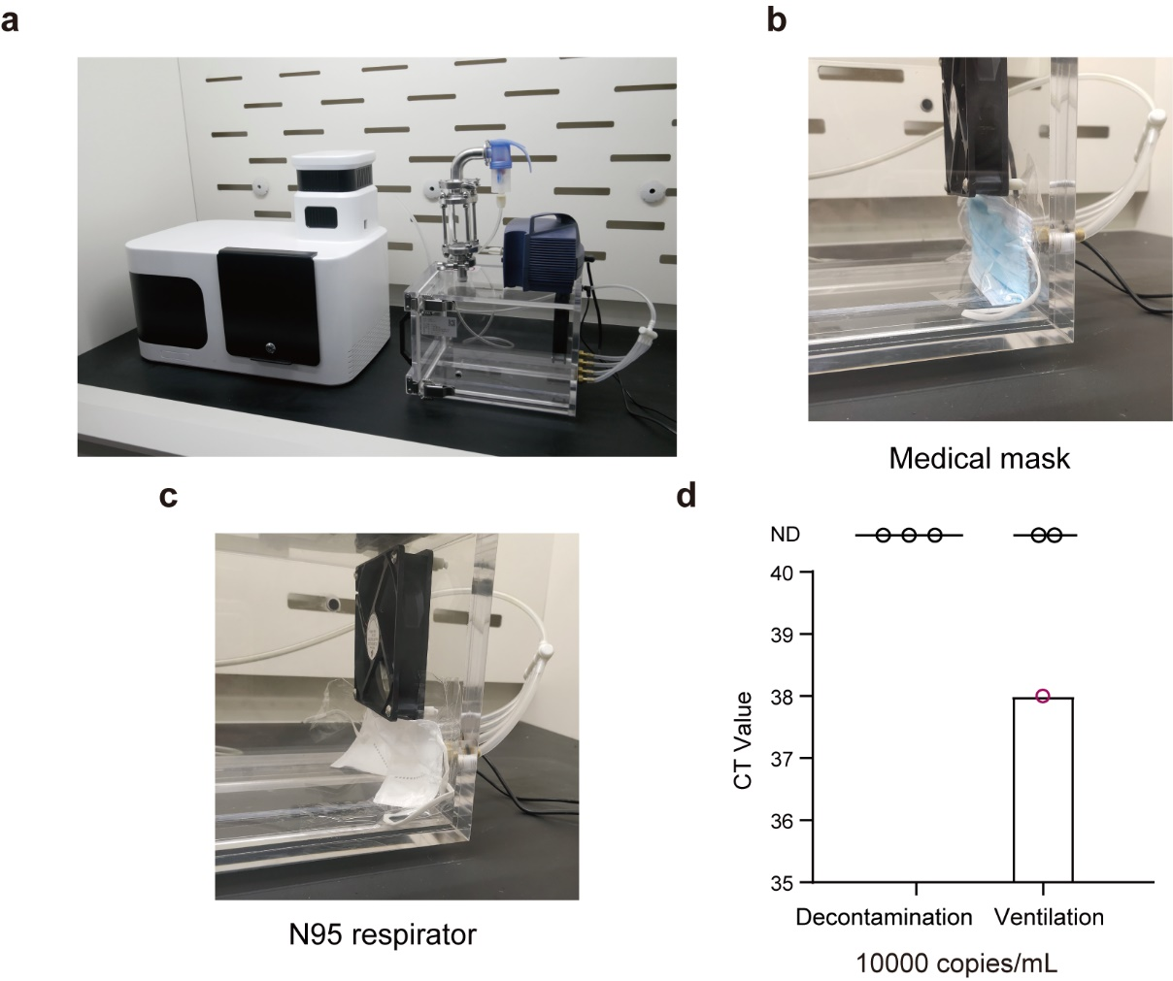
Supplementary Fig. 6 | Performance evaluation of S-RIAMs using a test-bed condition. a, Optical images of the experimental setup in a biosafety cabinet. b, Optical image of validation of the effectiveness of medical masks in blocking airborne SARS-CoV-2. c, Optical image of validation of the effectiveness of N95 respirators in blocking airborne SARS-CoV-2. d, Ct values of evaluation of decontaminating the environment and strengthening indoor ventilation to prevent the airborne transmission of SARS-CoV-2.

