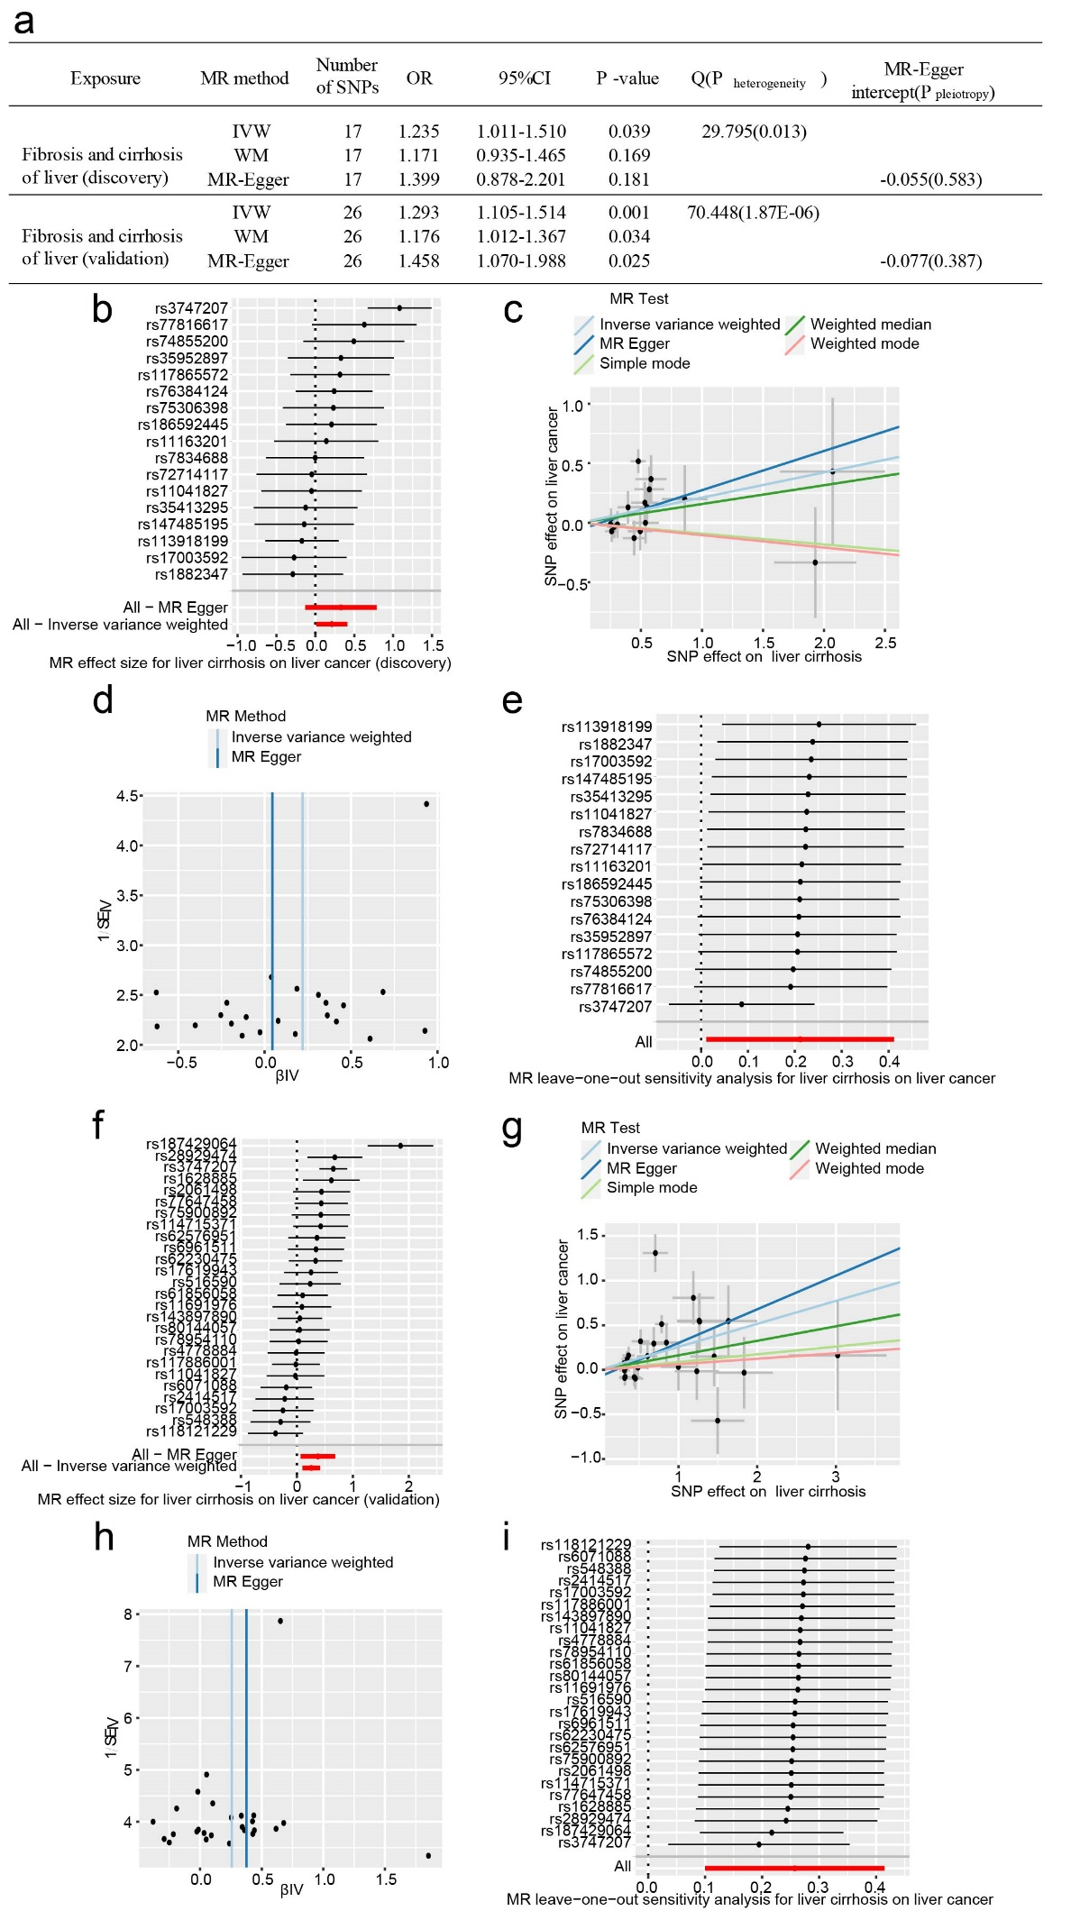
Fig. S1 Cirrhosis is a risk factor for liver cancer and is positively correlated with liver cancer. (a) IVW results showed that liver fibrosis was a risk factor for liver cancer. WMM and MR-Egger obtained similar results. The consistent results were obtained by repeated verification with different GWAS datasets. Due to significant heterogeneity (P heterogeneity < 0.05), the random effects model was used for this IVW analysis. No pleiotropy was observed in the MR-Egger analysis (P pleiotropy > 0.05). The forest plot(b), scatter plot(c), funnel plot(d) and leave-one-out plot(e) show liver cirrhosis as a risk factor for liver cancer in the discovery experiment. The forest plot(f), scatter plot(g), funnel plot(h), and leave-one-out plot(i) show liver cirrhosis as a risk factor for liver cancer in the validated experiment.

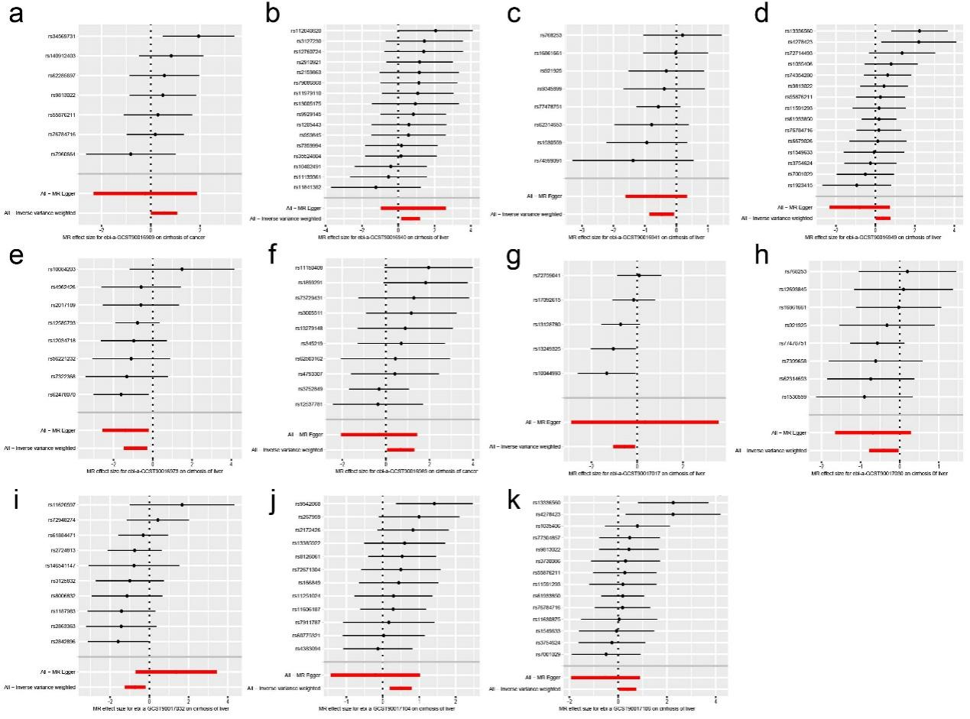
Fig. S2 MR analysis of gut microbiotas on liver cirrhosis (discovery experiment). The above figures represent (a) class Alphaproteobacteria (b) family Lachnospiraceae (c) family Lactobacillaceae (d) family Rhodospirillaceae (e) genus Butyricicoccus (f) genus Dorea (g) genus Hungatella (h) genus Lactobacillus (i) genus Marvinbryantia (j) order NB1n (k) order Rhodospirillales as exposure factors, respectively. The above figure mentioned gut microbiotas represented with their GWAS ID number.

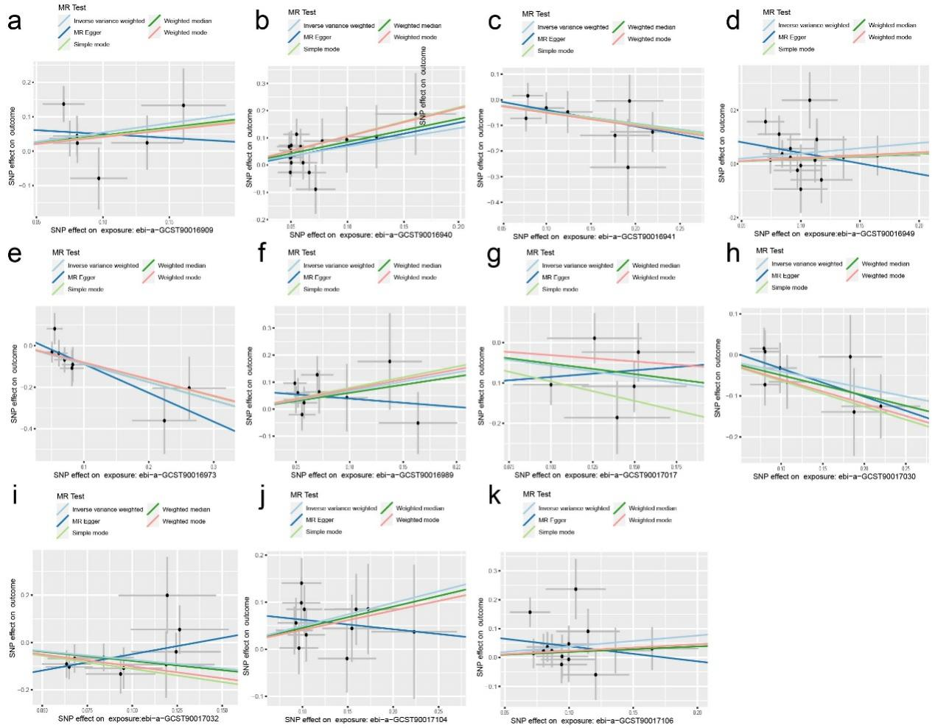
Fig. S3 Scatter plots of gut microbiota on liver cirrhosis (discovery experiment). The above figures represent (a) class Alphaproteobacteria (b) family Lachnospiraceae (c) family Lactobacillaceae (d) family Rhodospirillaceae (e) genus Butyricicoccus (f) genus Dorea (g) genus Hungatella (h) genus Lactobacillus (i) genus Marvinbryantia (j) order NB1n (k) order Rhodospirillales as exposure factors, respectively. The above figure mentioned gut microbiotas represented with their GWAS ID number.

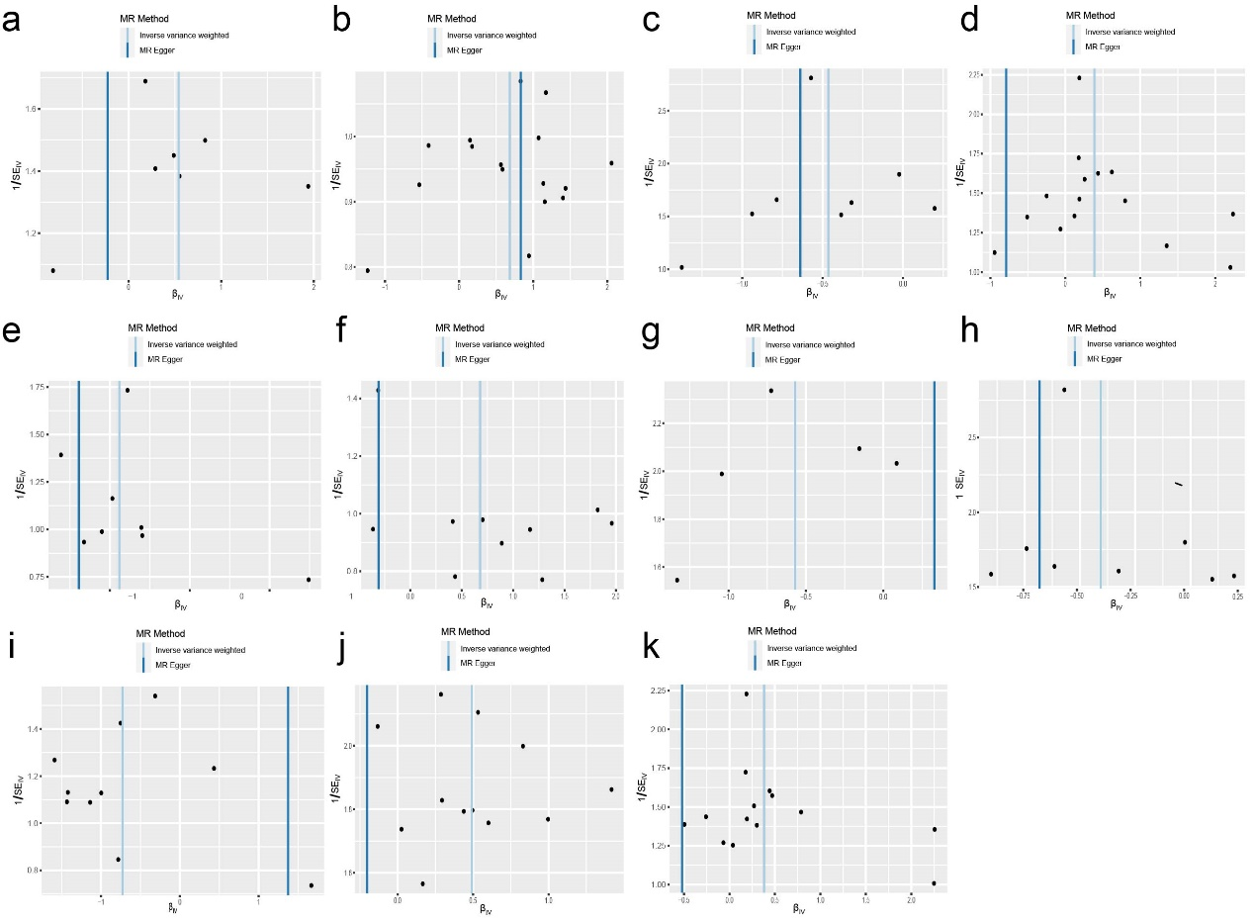
Fig. S4 Funnel plots of gut microbiota on liver cirrhosis (discovery experiment). The above figures represent (a) class Alphaproteobacteria (b) family Lachnospiraceae (c) family Lactobacillaceae (d) family Rhodospirillaceae (e) genus Butyricicoccus (f) genus Dorea (g) genus Hungatella (h) genus Lactobacillus (i) genus Marvinbryantia (j) order NB1n (k) order Rhodospirillales as exposure factors, respectively.
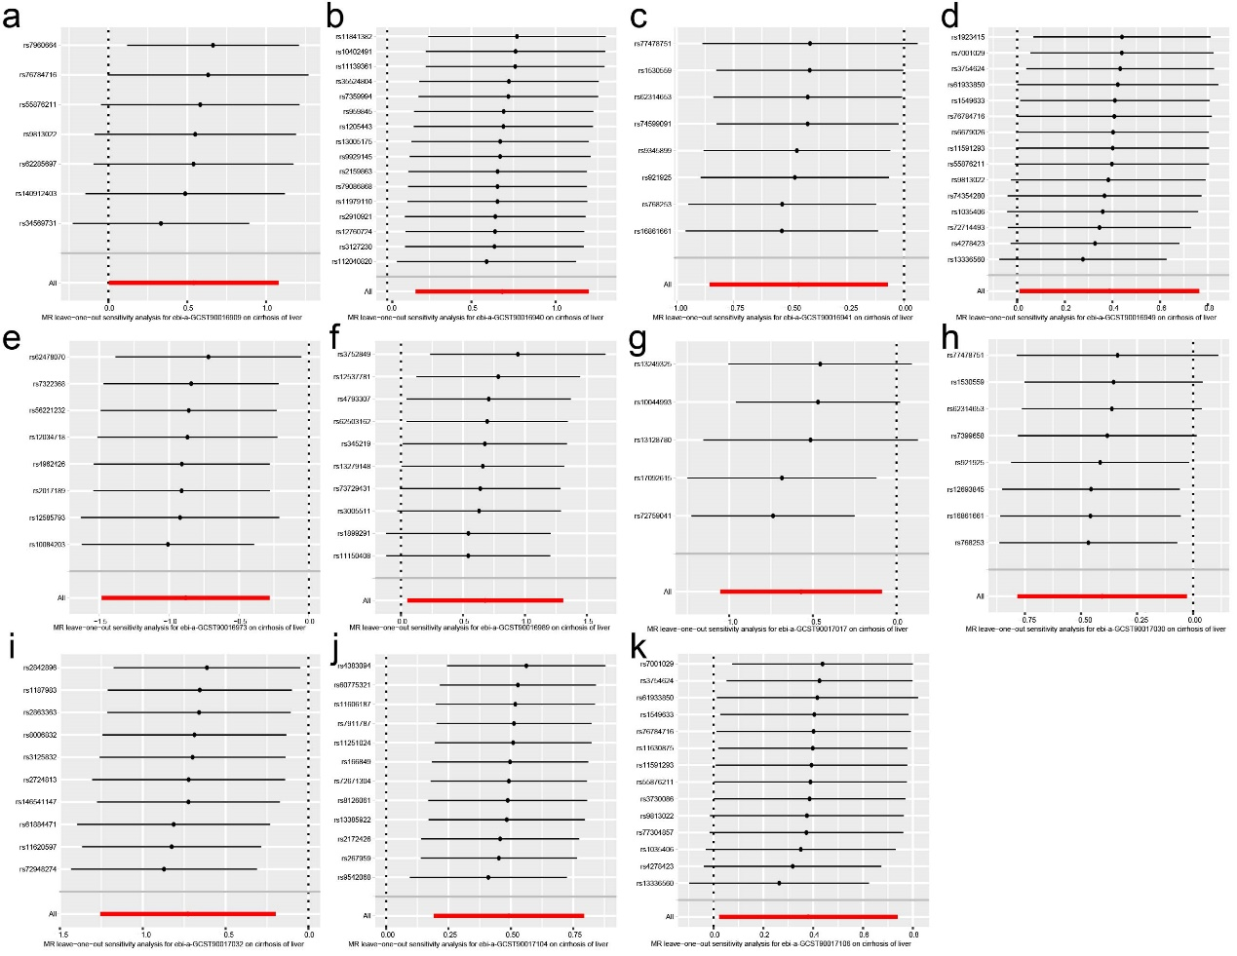
Fig. S5 Leave-one-out sensitivity analysis of gut microbiota on liver cirrhosis (discovery experiment). The above figures represent (a) class Alphaproteobacteria (b) family Lachnospiraceae (c) family Lactobacillaceae (d) family Rhodospirillaceae (e) genus Butyricicoccus (f) genus Dorea (g) genus Hungatella (h) genus Lactobacillus (i) genus Marvinbryantia (j) order NB1n (k) order Rhodospirillales as exposure factors, respectively. The above figure mentioned gut microbiotas represented with their GWAS ID number.

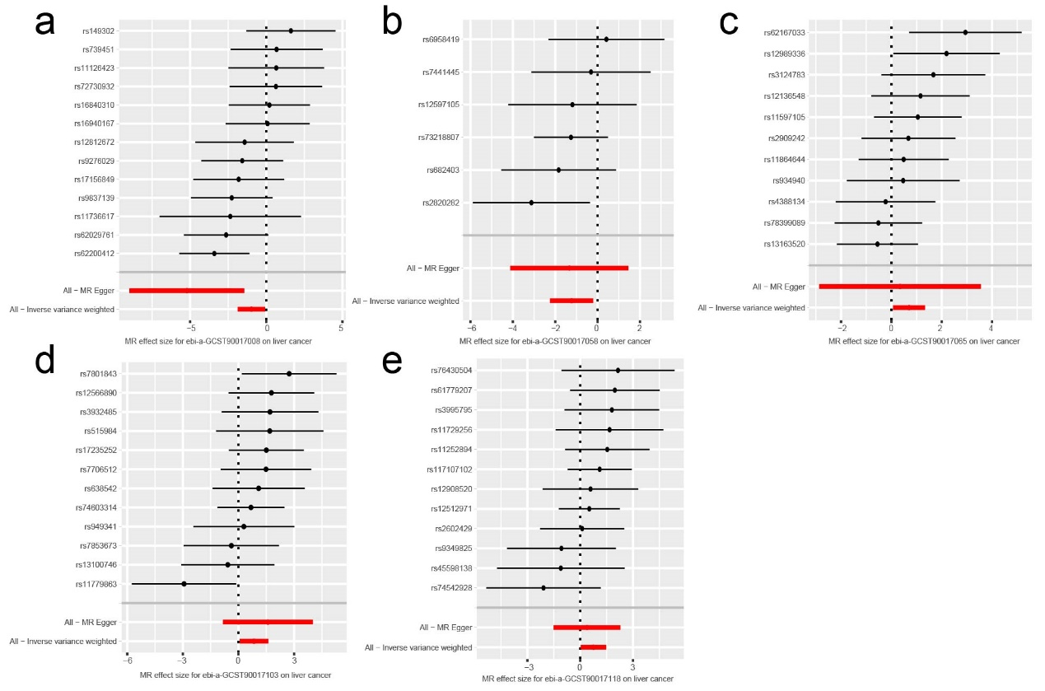
Fig. S6 MR analysis of gut microbiota on liver cancer. The above figures represent (a) genus Family XIII AD3011 group, (b) genus Ruminococcaceae UCG010, (c) genus Ruminococcus gnavus group, (d) order Mollicutes RF9 (e) phylum Verrucomicrobia as exposure factors, respectively. The above figure mentioned gut microbiotas represented with their GWAS ID number.

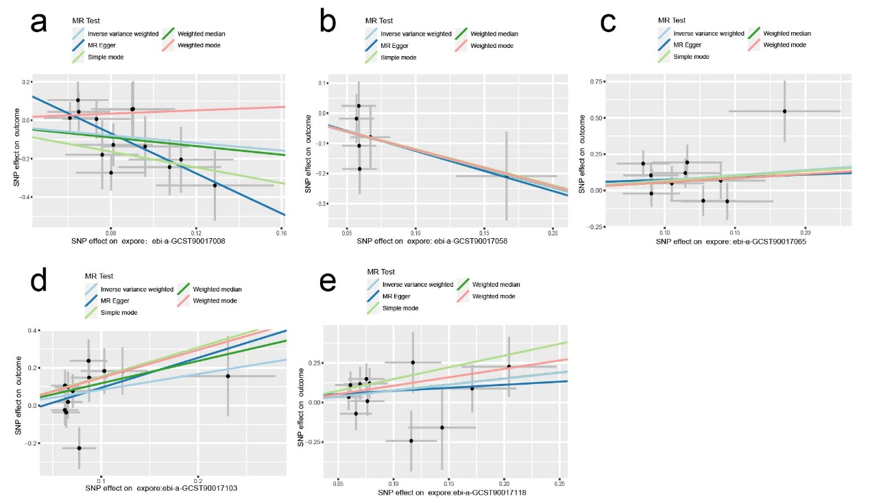
Fig. S7 Scatter plots of gut microbiota on liver cancer. The above figures represent (a) genus Family XIII AD3011 group, (b) genus Ruminococcaceae UCG010, (c) genus Ruminococcus gnavus group, (d) order Mollicutes RF9 (e) phylum Verrucomicrobia as exposure factors, respectively. The above figure mentioned gut microbiotas represented with their GWAS ID number.

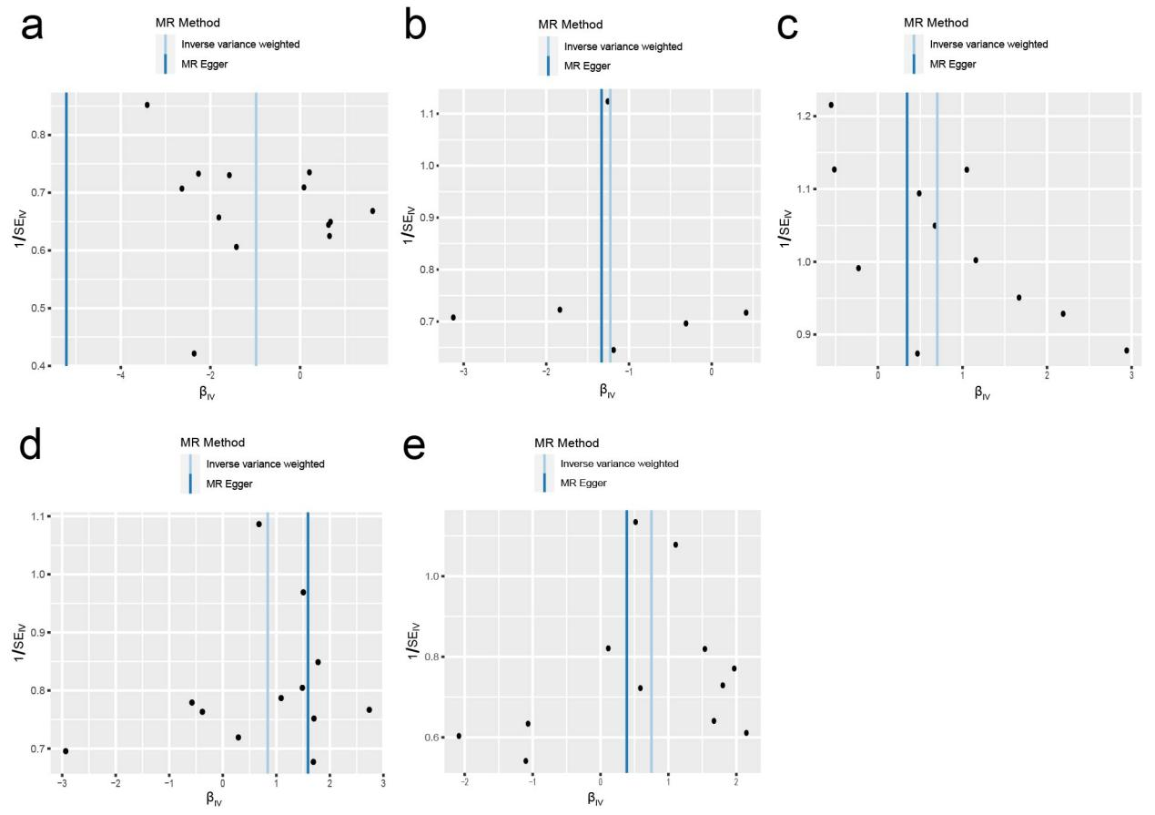
Fig. S8 Funnel plots of gut microbiota on liver cancer. The above figures represent (a) genus Family XIII AD3011 group, (b) genus Ruminococcaceae UCG010, (c) genus Ruminococcus gnavus group, (d) order Mollicutes RF9 (e) phylum Verrucomicrobia as exposure factors, respectively.
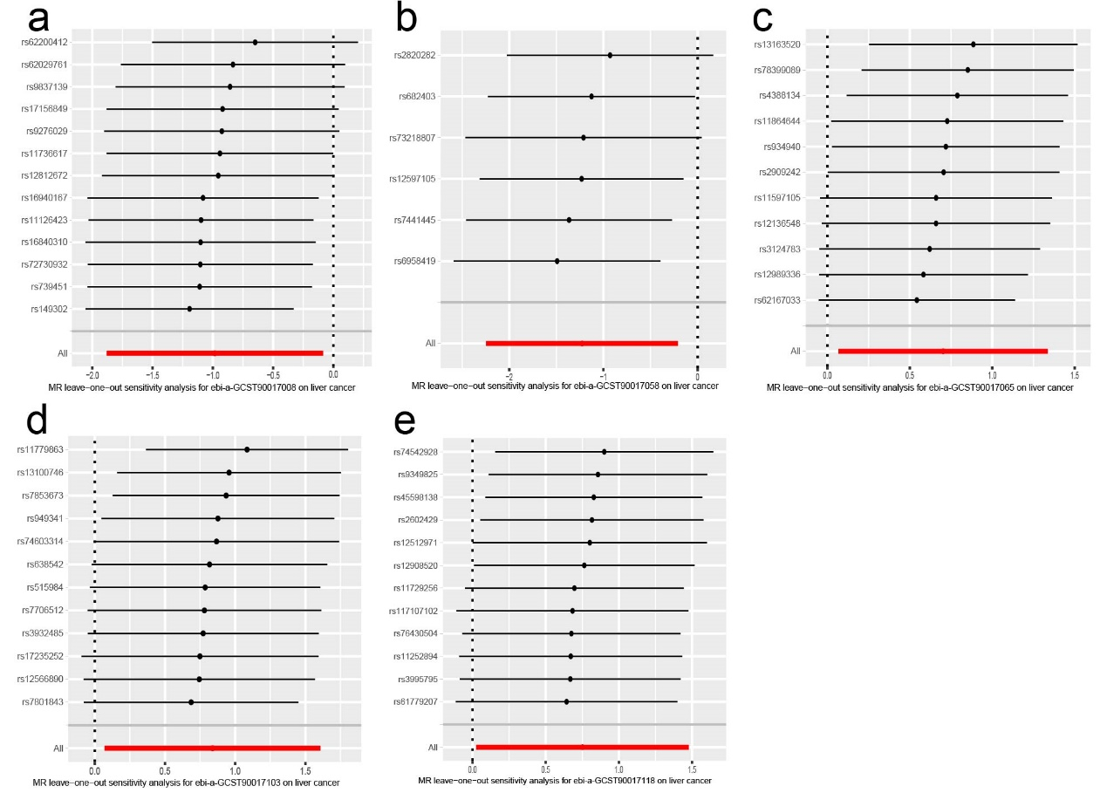
Fig. S9 Leave-one-out sensitivity analysis of gut microbiota on liver cancer. The above figures represent (a) genus Family XIII AD3011 group, (b) genus Ruminococcaceae UCG010, (c) genus Ruminococcus gnavus group, (d) order Mollicutes RF9 (e) phylum Verrucomicrobia as exposure factors, respectively. The above figure mentioned gut microbiotas represented with their GWAS ID number.

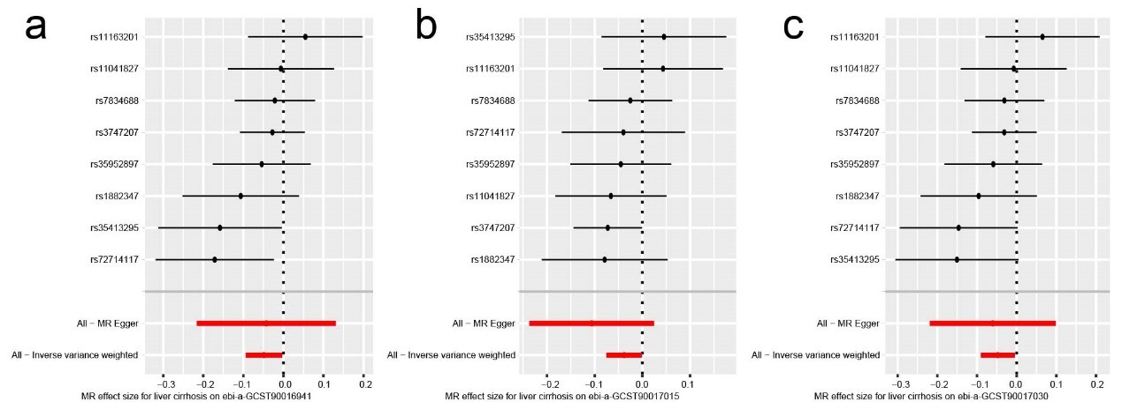
Fig. S10 MR analysis of liver cirrhosis on gut microbiota. The above figures represent (a) family Lachnospiraceae, (b) genus Butyricicoccus, (c) genus Marvinbryantia, and (d) order NB1n as exposure factors, respectively. The above figure mentioned gut microbiotas represented with their GWAS ID number.
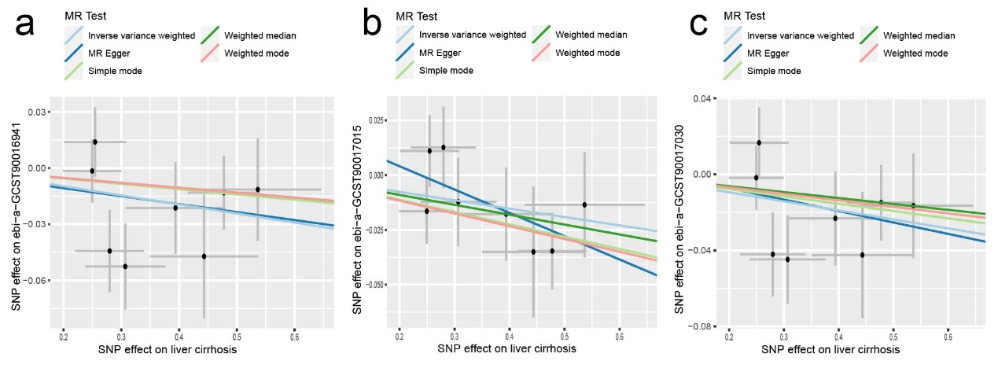
Fig. S11 Scatter plots of liver cirrhosis on gut microbiota. The above figures represent (a) family Lachnospiraceae, (b) genus Butyricicoccus, (c) genus Marvinbryantia, and (d) order NB1n as exposure factors, respectively. The above figure mentioned gut microbiotas represented with their GWAS ID number.

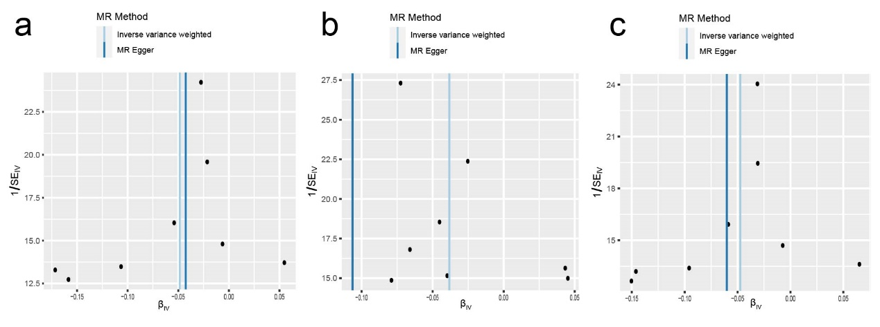
Fig. S12 Funnel plots of liver cirrhosis on gut microbiota. The above figures represent (a) family Lachnospiraceae, (b) genus Butyricicoccus, (c) genus Marvinbryantia, and (d) order NB1n as exposure factors, respectively.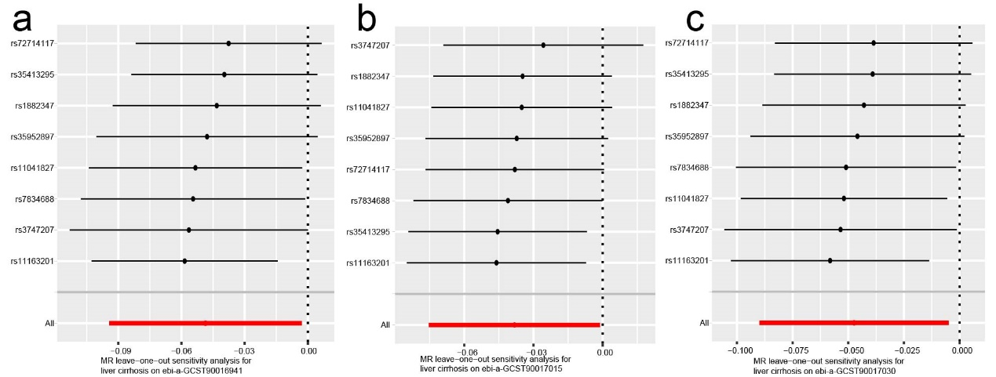
Fig. S13 Leave-one-out sensitivity analysis of liver cirrhosis on gut microbiota. The above figures represent (a) family Lachnospiraceae, (b) genus Butyricicoccus, (c) genus Marvinbryantia, and (d) order NB1n as exposure factors, respectively. The above figure mentioned gut microbiotas represented with their GWAS ID number.

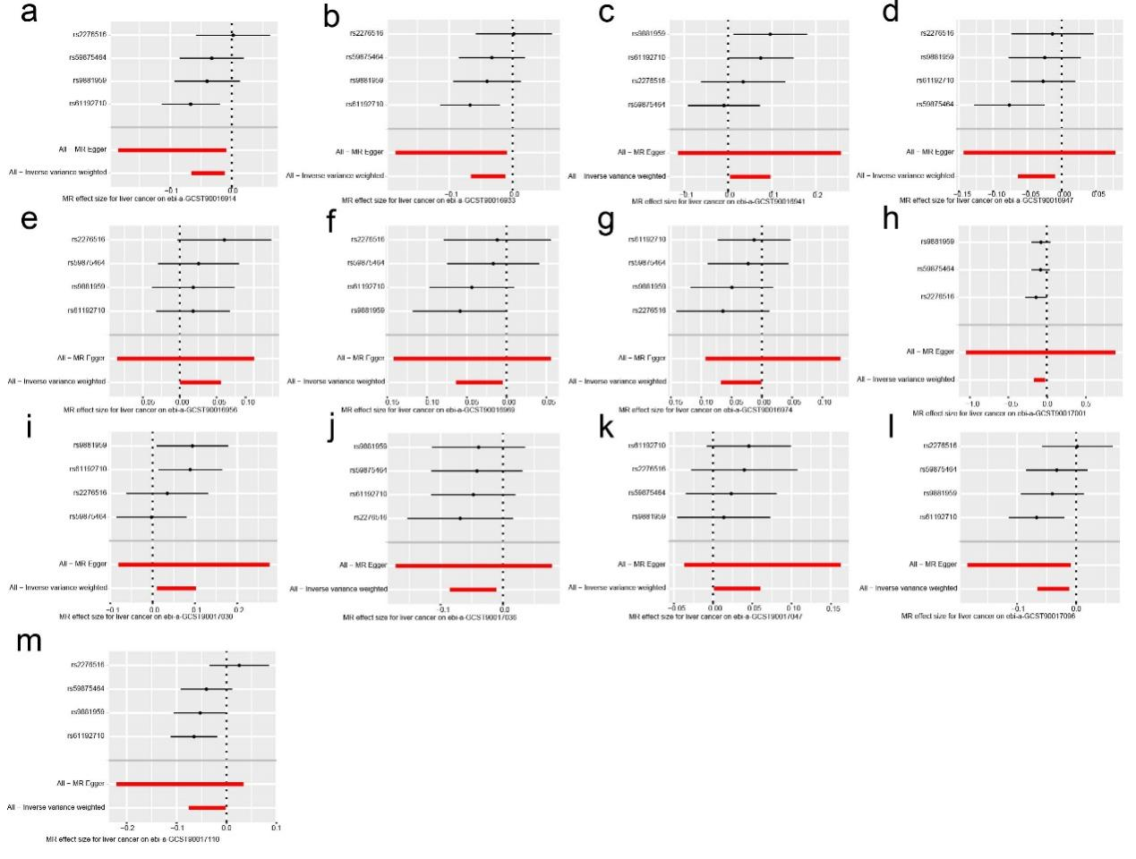Fig. S14 MR analysis of liver cancer on gut microbiota. The above figures represent (a) genus Family XIII AD3011 group, (b) genus Ruminococcaceae UCG010, (c) genus Ruminococcus gnavus group, (d) order Mollicutes RF9 (e) phylum Verrucomicrobia as exposure factors, respectively. The above figure mentioned gut microbiotas represented with their GWAS ID number.

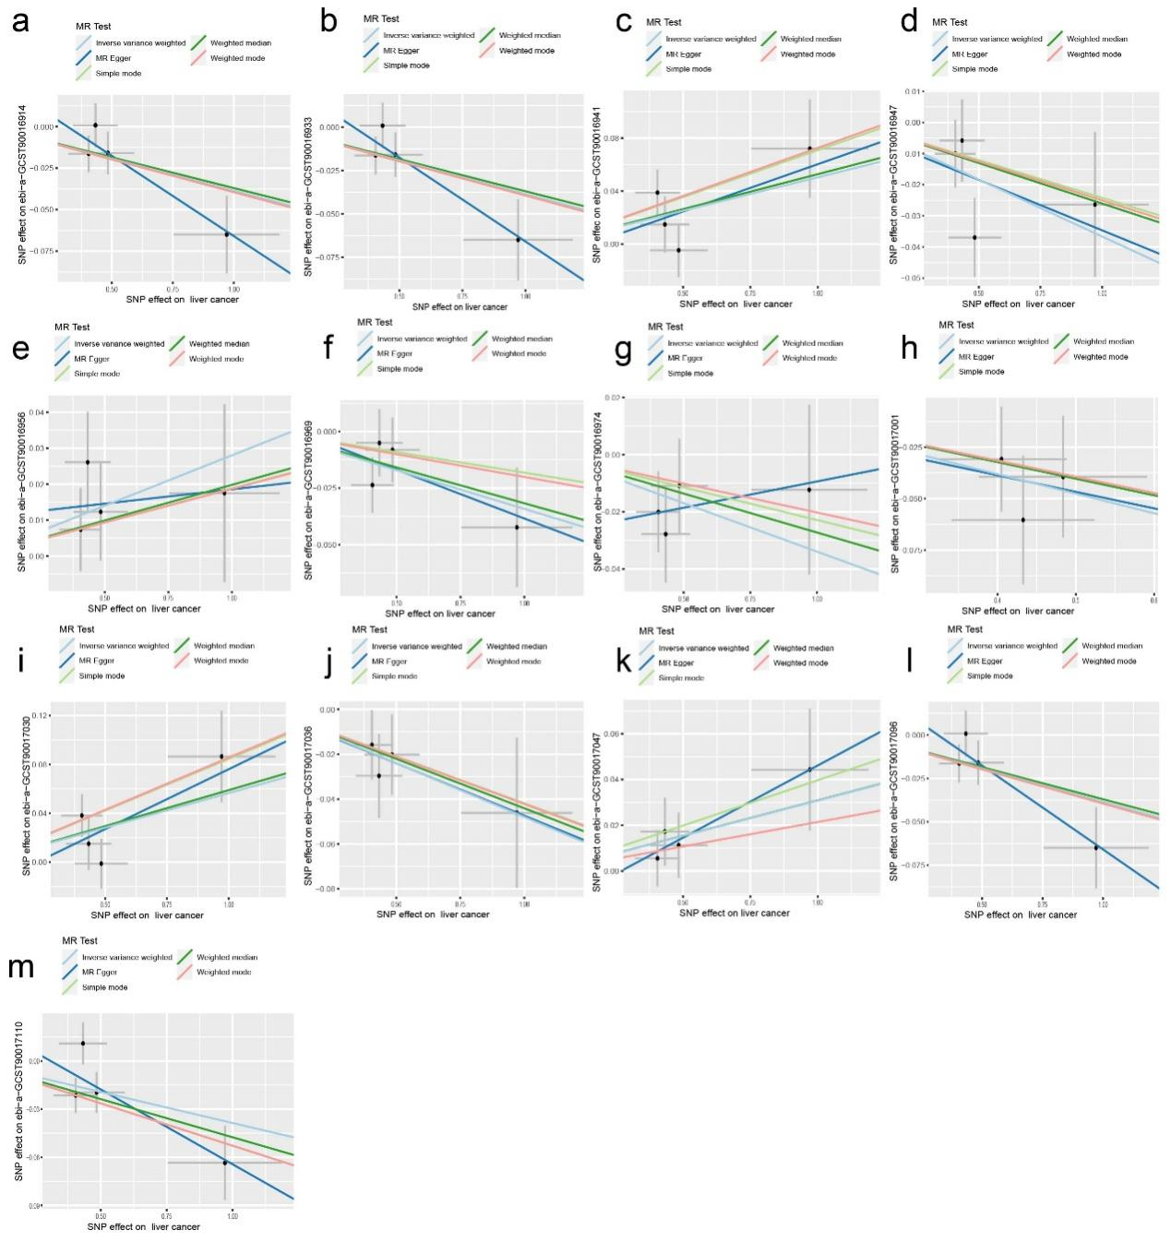
Fig. S15 Scatter plots of liver cancer on gut microbiota. The above figures represent (a) genus Family XIII AD3011 group, (b) genus Ruminococcaceae UCG010, (c) genus Ruminococcus gnavus group, (d) order Mollicutes RF9 (e) phylum Verrucomicrobia as exposure factors, respectively. The above figure mentioned gut microbiotas represented with their GWAS ID number.

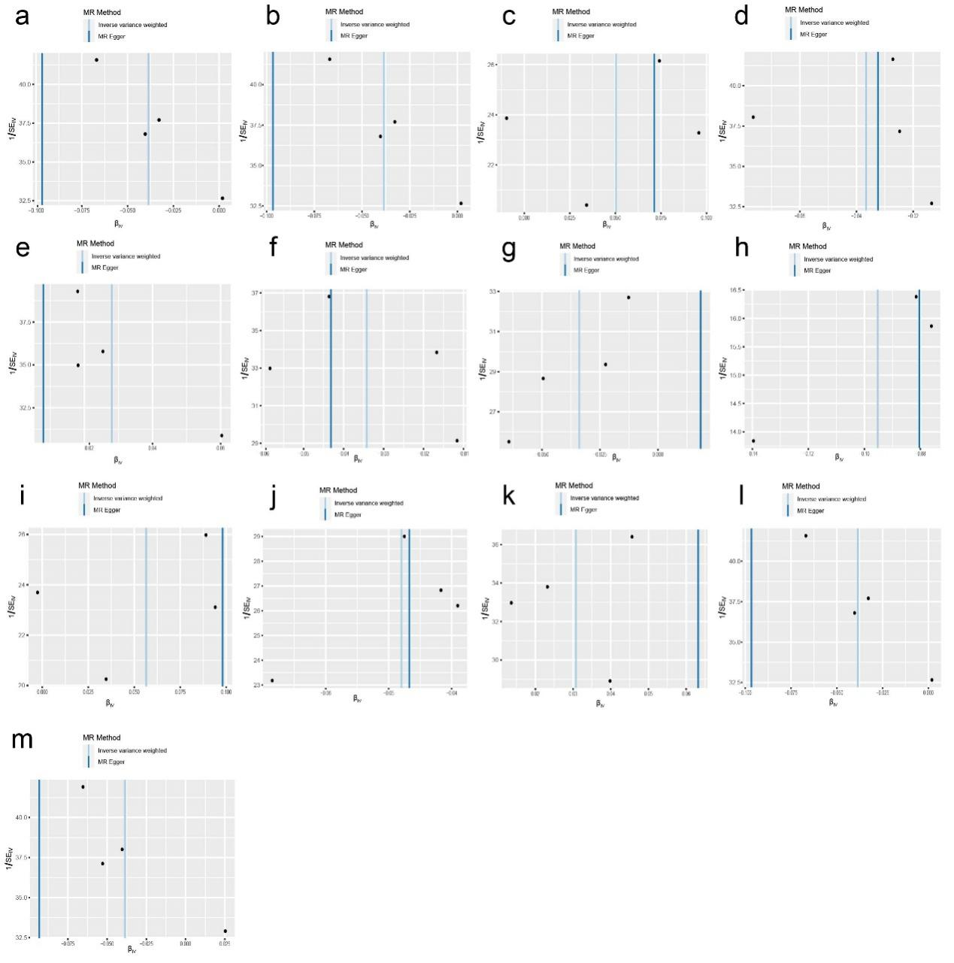
Fig. S16 Funnel plots of liver cancer on gut microbiota. The above figures represent (a) genus Family XIII AD3011 group, (b) genus Ruminococcaceae UCG010, (c) genus Ruminococcus gnavus group, (d) order Mollicutes RF9 (e) phylum Verrucomicrobia as exposure factors, respectively.
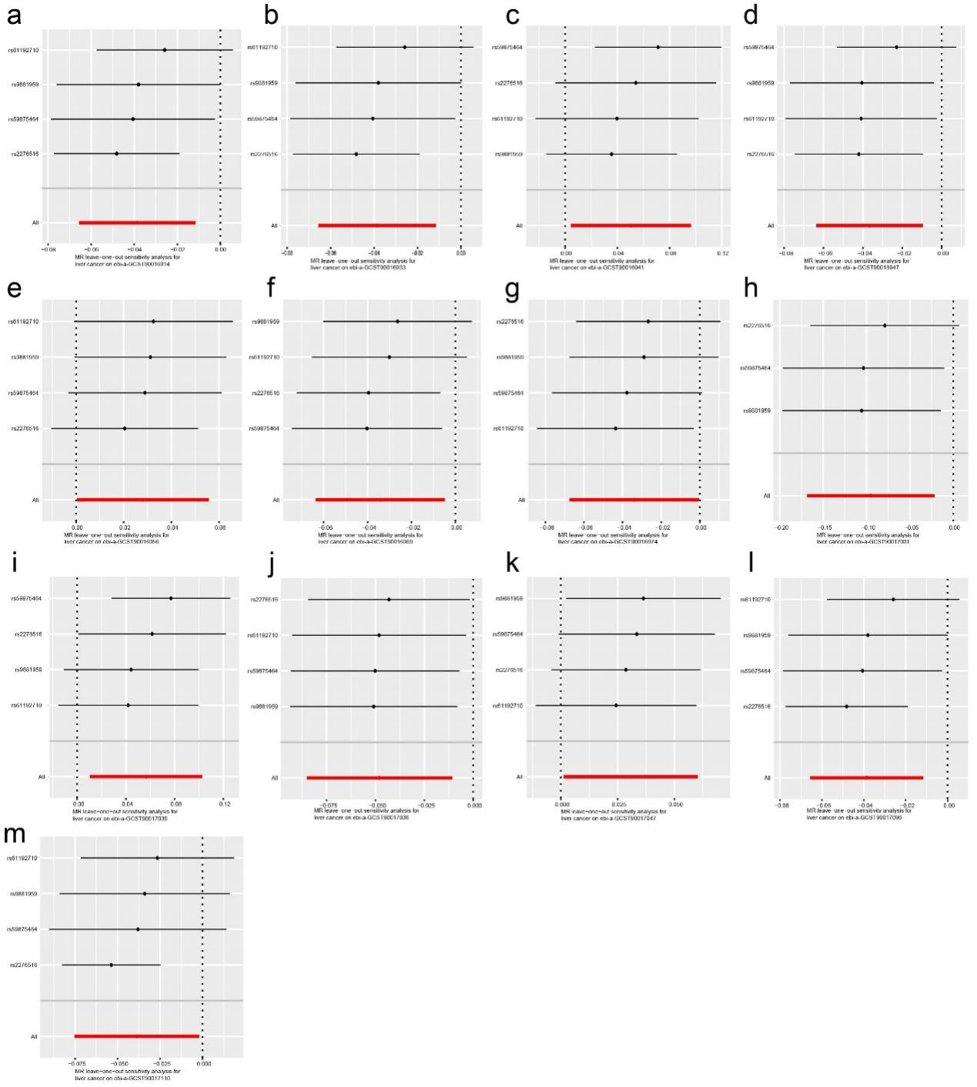
Fig. S17 Leave-one-out sensitivity analysis of liver cancer on gut microbiota. The above figures represent (a) genus Family XIII AD3011 group, (b) genus Ruminococcaceae UCG010, (c) genus Ruminococcus gnavus group, (d) order Mollicutes RF9 (e) phylum Verrucomicrobia as exposure factors, respectively. The above figure mentioned gut microbiotas represented with their GWAS ID number.

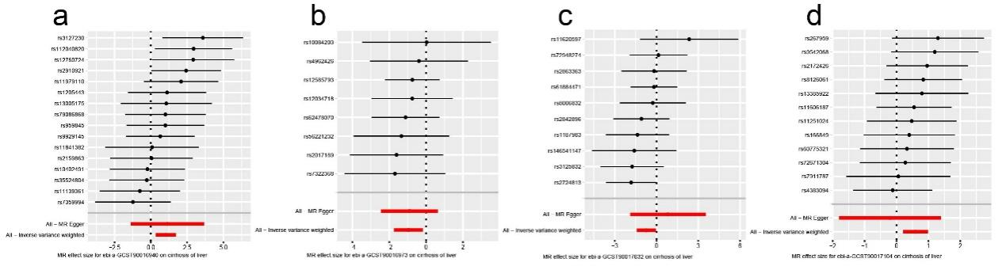
Fig. S18 MR analysis of gut microbiota on liver cirrhosis (validated experiment). The above figures represent (a) family Lactobacillaceae, (b) genus Holdemania, and (c) genus Lactobacillus as exposure factors, respectively. The above figure mentioned gut microbiotas represented with their GWAS ID number.
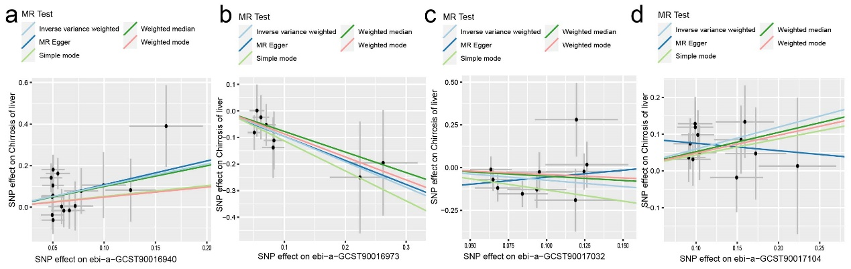
Fig. S19 Scatter plots of gut microbiota on liver cirrhosis (validated experiment). The above figures represent (a) family Lactobacillaceae, (b) genus Holdemania, and (c) genus Lactobacillus as exposure factors, respectively. The above figure mentioned gut microbiotas represented with their GWAS ID number.

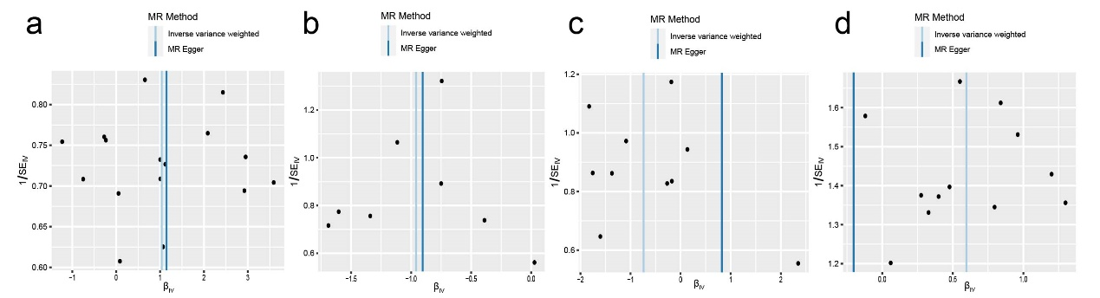
Fig. S20 Funnel plots of gut microbiota on liver cirrhosis (validated experiment). The above figures represent (a) family Lactobacillaceae, (b) genus Holdemania, and (c) genus Lactobacillus as exposure factors, respectively.
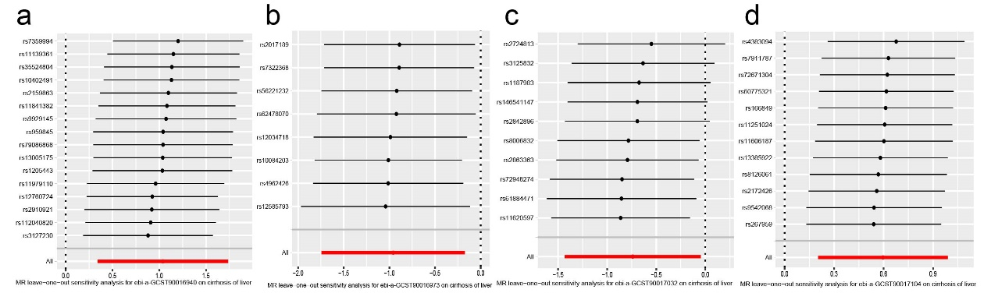
Fig. S21 Leave-one-out sensitivity analysis of gut microbiota on liver cirrhosis (validated experiment). The above figures represent (a) family Lactobacillaceae, (b) genus Holdemania, and (c) genus Lactobacillus as exposure factors, respectively. The above figure mentioned gut microbiotas represented with their GWAS ID number.

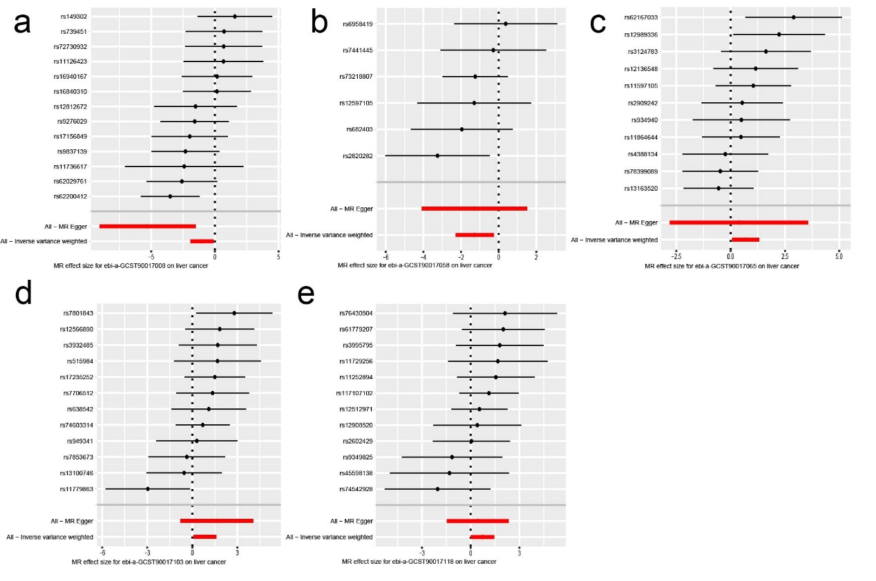
Fig. S22 MR analysis of gut microbiota on liver cancer (validated experiment). The above figures represent (a) family Lachnospiraceae, (b) genus Butyricicoccus, (c) genus Marvinbryantia, and (d) order NB1n as exposure factors, respectively. The above figure mentioned gut microbiotas represented with their GWAS ID number.

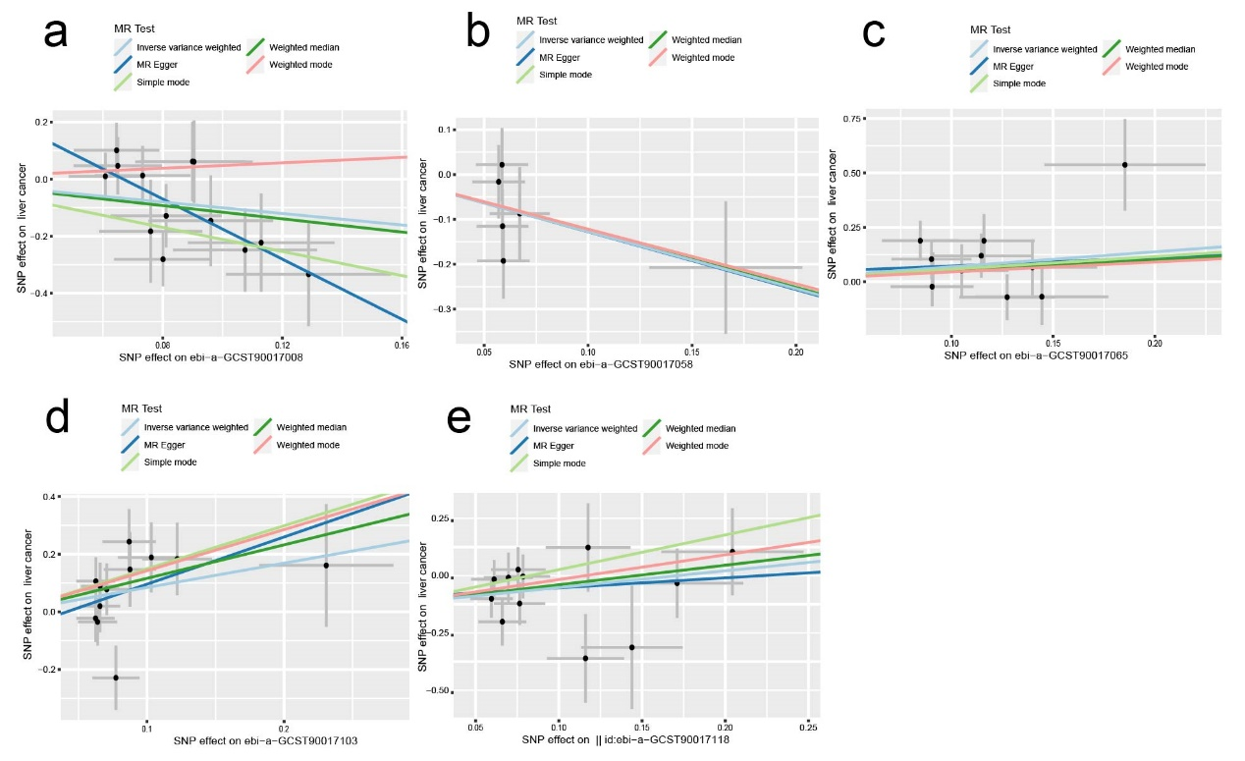
Fig. S23 Scatter plots of gut microbiota on liver cancer (validated experiment). The above figures represent (a) family Lachnospiraceae, (b) genus Butyricicoccus, (c) genus Marvinbryantia, and (d) order NB1n as exposure factors, respectively. The above figure mentioned gut microbiotas represented with their GWAS ID number.

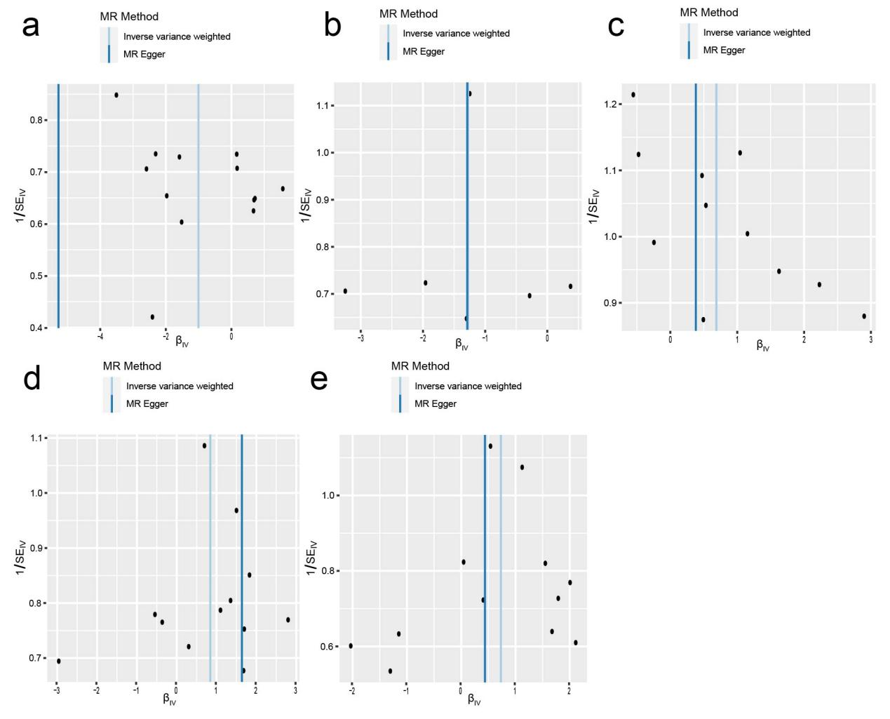
Fig. S24 Funnel plots of gut microbiota on liver cancer (validated experiment). The above figures represent (a) family Lachnospiraceae, (b) genus Butyricicoccus, (c) genus Marvinbryantia, and (d) order NB1n as exposure factors, respectively.
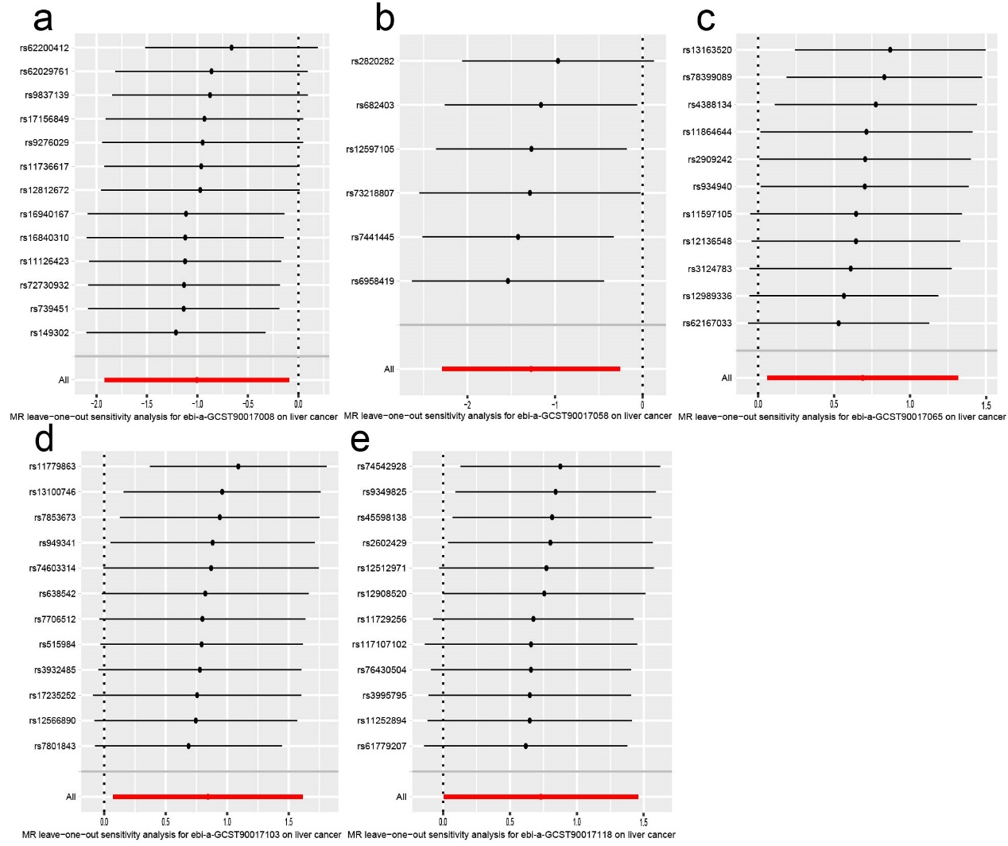
Fig. S25 Leave-one-out sensitivity analysis of gut microbiota on liver cancer (validated experiment). The above figures represent (a) family Lachnospiraceae, (b) genus Butyricicoccus, (c) genus Marvinbryantia, and (d) order NB1n as exposure factors, respectively. The above figure mentioned gut microbiotas represented with their GWAS ID number.

