Applied Microbiology and Biotechnology

Enhancing Thermostability of Bacillus licheniformis Lipase with LEA Peptide Co-expression System.
Ammar Khazaal Kadhim Almansoori¹, Kang Siang Yu¹, Faisal Mohamed ¹, Shinya Ikeno³, Rajesh B. Patil⁴, Ropón-Palacios G.⁵ and Rashidah Abdul Rahim^{1&2}*

¹School of Biological Sciences, Universiti Sains Malaysia, 11800 Penang, Malaysia.
² Centre for Chemical Biology (CCB@USM), Level 1, Block B, 10, Persiaran Bukit Jambul, 11900 Bayan Lepas, Penang, MALAYSIA.
³Department of Biological Functions and Engineering, Graduate School of Life Science and System Engineering, Kyushu Institute of Technology, 2-4 Hibikino, Wakamatsu Ward, Kitakyushu, 808-0196, Japan.
⁴Department of Pharmaceutical Chemistry, Sinhgad Technical Education Societys, Sinhgad College of Pharmacy, Vadgaon (Bk), Pune 411041, Maharashtra, India.
⁵Laboratório de Modelagem Computacional - LaModel, Instituto de Ciências Exatas-ICEx, Universidade Federal de Alfenas - UNIFAL-MG, Alfenas, Brasil.

*Corresponding author: rshidah@usm.my
Phone: 604-6536158
Fax No: 604-6565125

Supplementary 1. The sequence of LEA peptides and lipase, origin of the plasmid along with primers and the constructed map.

1. The DNA sequences of LEA-like peptides were shown in Table 1.

Table 1: Nucleotide sequences of LEA-like peptides and lipase

LEA-like peptides& lipase | Sequences
LEA I peptide | ATG GAT GCG AAA GAT GGC ACC AAA GAA AAA GCG GGC GAA
LEA II peptide | ATG GAT GCG AAA GAT GGC CTG AAA GAA AAA GCG GGC GAA
LEA E peptide | ATG GAT GCG AAA GAT GAA CTG AAA GAA AAA GCG GAA GAA
LEA K peptide | ATG GAT GCG AAA GAT AAA CTG AAA GAA AAA GCG AAA GAA
lipase gene | ATGGCTTCCCACAATCCGGTCGTCATGGTCCACGGCATCGGCG  GAGCCGATTATAACTTCATCGGCATTAAATCGTATTTACAATC  TCAAGGCTGGACAAGCAGTGAGCTTTACGCCATCAACTTTAT  CGATAAAACGGGAAATAATATAAACAATGCTCCGAGATTAT  CCGAATACATCAAGCGTGTGCTGAATCAAACAGGAGCATCA  AAAGTCGATATTGTCGCCCACAGCATGGGCGGGGCCAATAC  GCTCTATTATATTAAAAATCTGGATGGTGCGGATAAAGTCGG  ACATGTCGTCACCCTTGGGGGCGCTAATCGTCTCGTTACAAA  CACGGCGCCTCAGAATGACAAAATCTCATACACTTCGATTTA  CAGCACAAGCGACTATATCGTCTTAAACAGCCTCTCCAAACT  TGATGGTGCAAACAATGTGCAAATCTCAGGCGTAAGCCATGT  CGGTCTTTTGTTCAGCAGCAAAGTAAATGCCTTGATTAAAGAC  GGGCTGACCGCCAGCGGGAAATAA

2. LEA peptides Primer design
The forward primer (FP BamHI T7) was designed based on the first 20 nucleotides of T7 promoter present on the second multiple cloning site of pRSF-LEA vectors and was incorporated with BamHI restriction site: 5’ AAAA GGA TCC TAA TAC GAC TCA CTA TA 3’ whereas the reverse primer (RP HindT7) was designed based on the last 20 nucleotides of T7 terminator and incorporated with HindIII restriction site: 5’ GGGG AAG CTT GCT AGT TAT TGC TCA GC 3’.

3. Constructed map
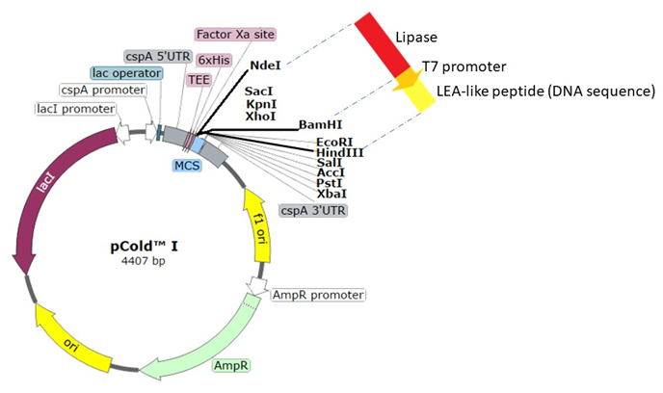

Fig. 3: Genetic map of pCold™ I vector and cloning sites of the LipA_{B.licheniformis} and T7-LEA DNA fragments.

Supplementary 2. The lipase activity, relative activity, and residual activity equations

1. $Lipase activity (U/mL)=\frac{\begin{aligned}Amount of p-nitrophenol released (µmol)/ \\ time of incubation (min)\end{aligned}}{Volume of lipase sample (mL)}$

For relative temperature study, the lipase sample was mixed with substrate mixture and incubated at 37 ºC and 45 ºC, respectively. After incubation for 10 mins, the absorbance readings were measured at OD410 and the lipase activity was calculated. For temperature stability study, the lipase sample was incubated at 45 ºC for an hour, followed by pNPL colourimetric assay at 37 ºC for 10 mins to identify the lipase activity. The relative activity and residual activity were calculated based on the formulas shown below.

$$2. Relative activity \left(\%\right)=\frac{Lipase activity at 45 °C \left(U/mL\right)}{Lipase activity at optimum temperature \left(37 °C\right)\left(U/mL\right)}×100\%$$
$$3. Residual activity \left(\%\right)=\frac{Lipase activity at 45 °C incubation \left(U/mL\right)}{\begin{aligned}Lipase activity at optimum temperature \\ without incubation \left(37 °C\right)\left(U/mL\right)\end{aligned}} ×100\%$$

Supplementary 3. The expression and purification of lipases produced from LEA co-expression system LEA co-expression system as shown in SDS- polyacrylamide gel in Figure 1 and 2.

M 1 2 3 4 5

Fig. 1: SDS-PAGE (15%) of total proteins expressed by recombinant E. coli BL21 (DE3) carrying pCold-lipase vector in lane 1, pCold-lipase-LEA I vector in lane 2, pCold-lip-LEA II vector in lane 3, pCold-lip-LEA E vector in lane 4, pCold-lip-LEA K vector in lane 5. And Lane M is Blue Plus® Protein marker.

M 1 2 3 4 5

Fig. 2: SDS-PAGE (15%) of IMAC-purified lipases expressed from pCold expression system. Lane M is Blue Plus® Protein marker. Lane 1 is IMAC-purified lipase expressed from pCold-lip vector, lane 2 is IMAC-purified LipA_{B.licheniformis} expressed from pCold-lip-LEA I vector, lane 3 is IMAC-purified lipase expressed from pCold-lip-LEA II vector, lane 4 is IMAC-purified lipase expressed from pCold-lip-LEA E vector and lane 5 is IMAC-purified lipase expressed from pCold-lip-LEA K vector.

Supplementary 4. The 2D structure, LEA II structures the validation of the 3D structures

1. LipA_{B.licheniformis} secondary structure
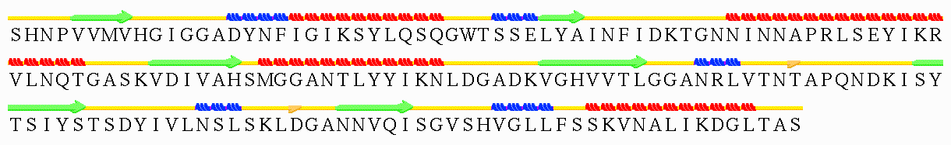
αF
αC
β8
β7
β6
β5
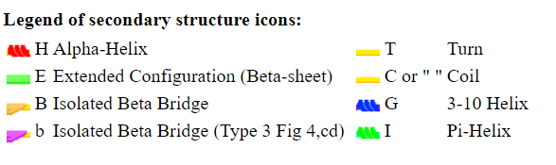
Fig. 1: The secondary structure of LipA_{B.licheniformis} assigned using Stride webserver (http://webclu.bio.wzw.tum.de/stride/). The amino acid residues of catalytic triad are boxed and the secondary structures are labelled.

2. Prediction of the LEA II peptide structure through PEP-FOLD, PEPstrMOD and I-TASSER webservers and 3D validation using Ramachandran plot
Since LEA II peptide showed the best improvement in the expression and heat resistance of LipA_{B.licheniformis}, the interactions between this peptide and LipA_{B.licheniformis} was studied. Before AutoDock was carried out to study the interaction, the 3D tertiary structure of LEA II peptide was predicted by using PEP-FOLD, PEPstrMOD and I-TASSER webservers. As shown in Figure 2, the LEA II peptide predicted by PEPstrMOD was made up of loop only while predicted LEA II peptide with the highest sOPEP score from PEP-FOLD and C-score from I-TASSER consist of an α-helix at the center of the structure.
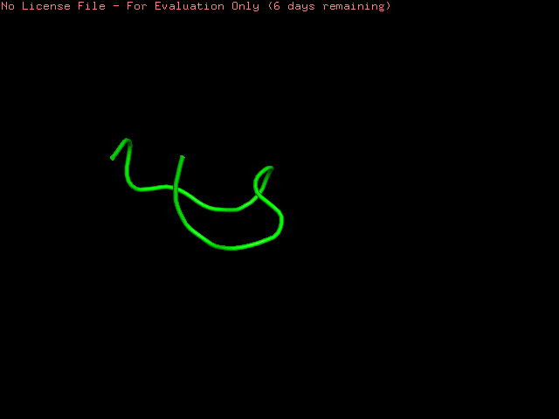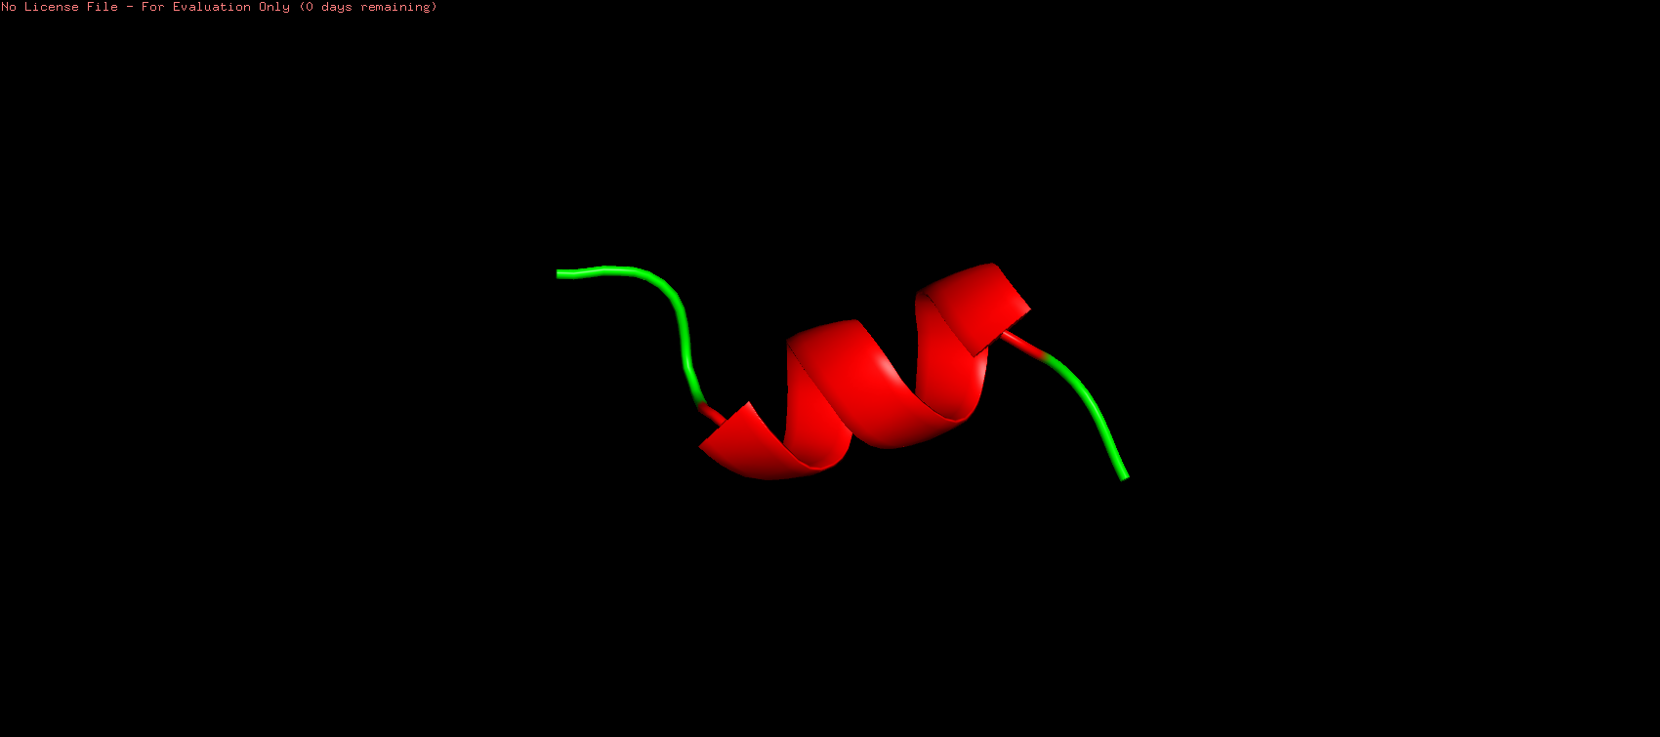
(A) (B) (C)
C
C
C
N
N
N
Fig. 2: The predicted 3D tertiary structure of LEA II peptide using PEPstrMOD, PEP-FOLD and I-TASSER webservers. N-terminus and C-terminus are labelled as N and C, respectively. The α-helix is coloured in red while the loop is coloured in green. (A): LEA II peptide predicted by PEPstrMOD. (B): LEA II peptide predicted by PEP-FOLD. (C) LEA II peptide predicted by I-TASSER.

According to Table 1, the structures of LEA II peptide predicted by PEPstrMOD, PEP-FOLD and I-TASSER webservers had good stereochemical quality as all residues were distributed within the favoured and allowed regions of Ramachandran plot (Figure 3) and showed 100 % overall quality factor in ERRAT but all of the structures were failed to be assessed by Verify3D. By comparing the structural validation among the three modelling webservers, the structure of LEA II peptide predicted by PEP-FOLD was selected for docking with LipA_{B.licheniformis} because it has the highest G-factors, indicating that it has the best stereochemical property among the three structures.
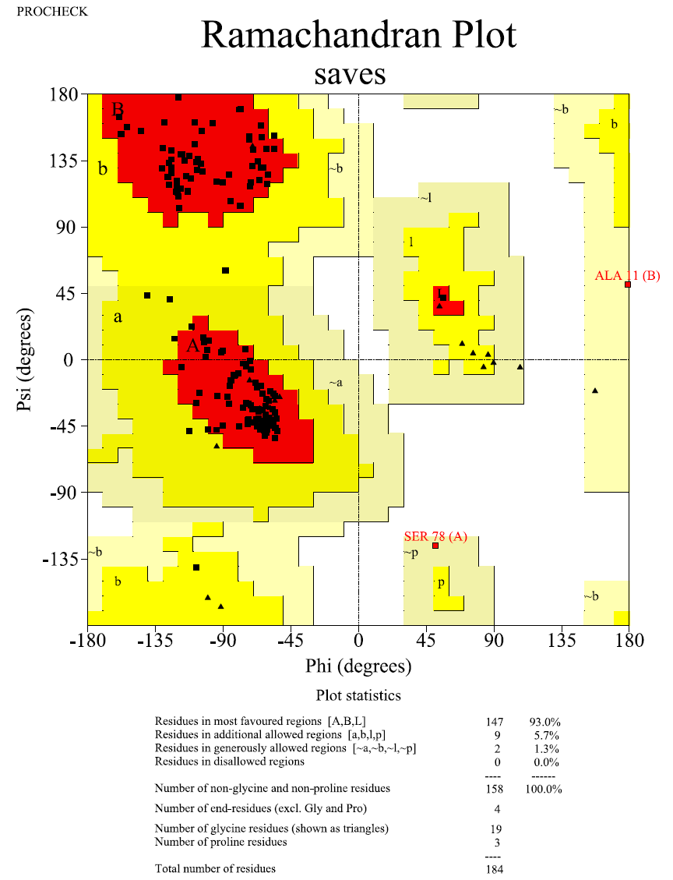
Fig. 3A: Ramachandran plot of Phyre2 webserver predicted LipA_{B.licheniformis} generated by PROCHECK of SAVES v6.0 webserver.

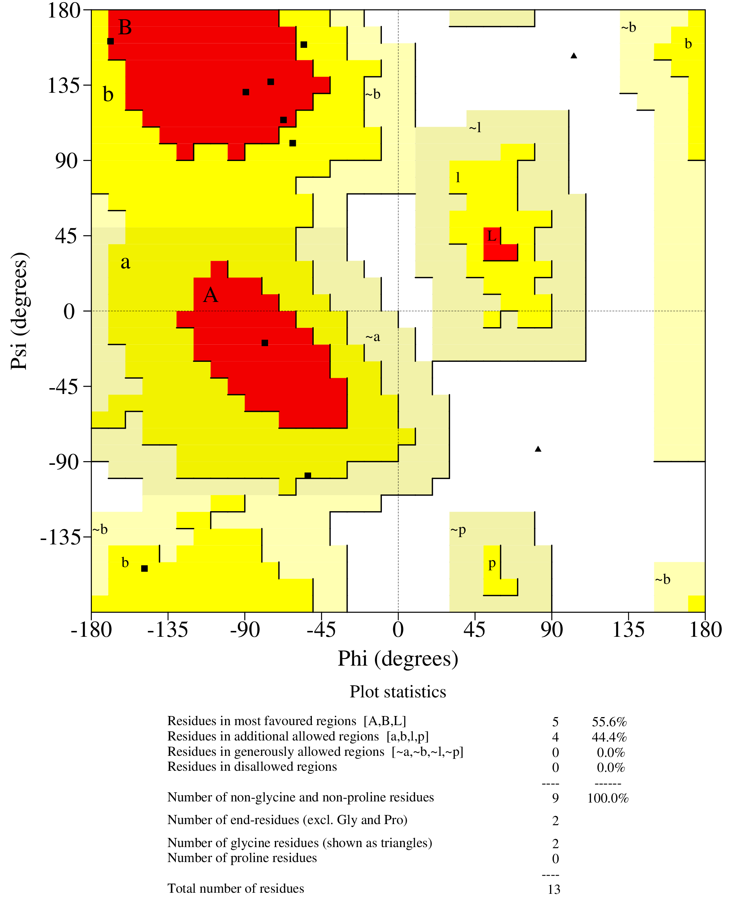
Fig. 3B: Ramachandran plot of PEPstrMOD predicted LEA II peptide generated by PROCHECK of SAVES v6.0 webserver.
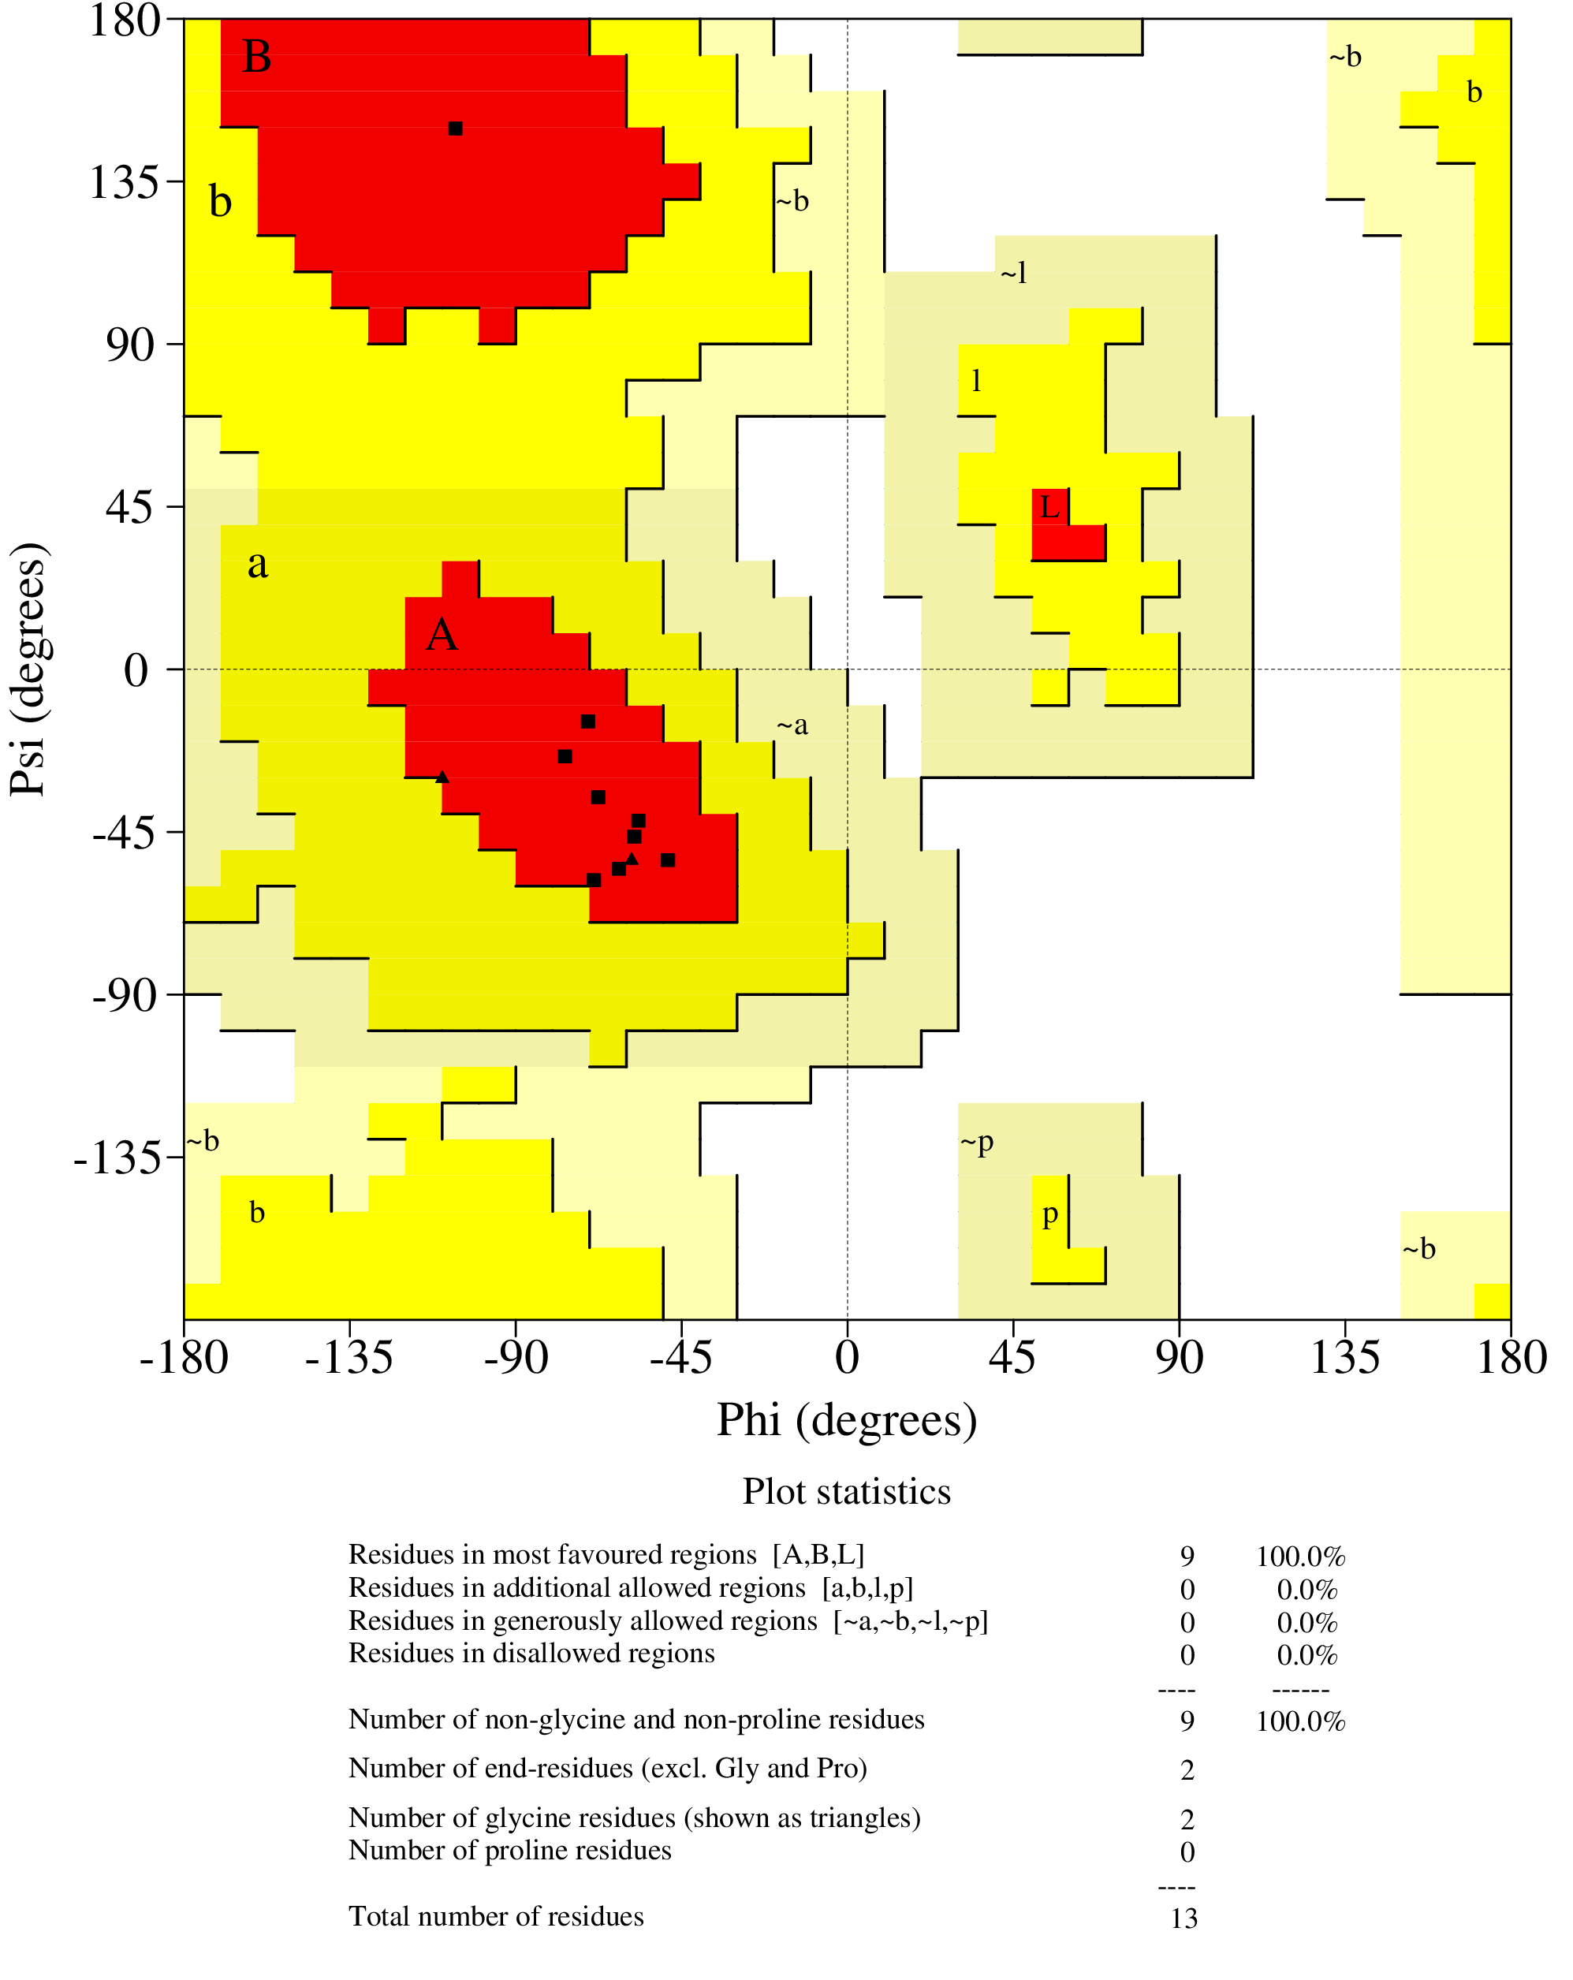
Fig. 3C: Ramachandran plot of PEP-FOLD predicted LEA II peptide generated by PROCHECK of SAVES v6.0 webserver.

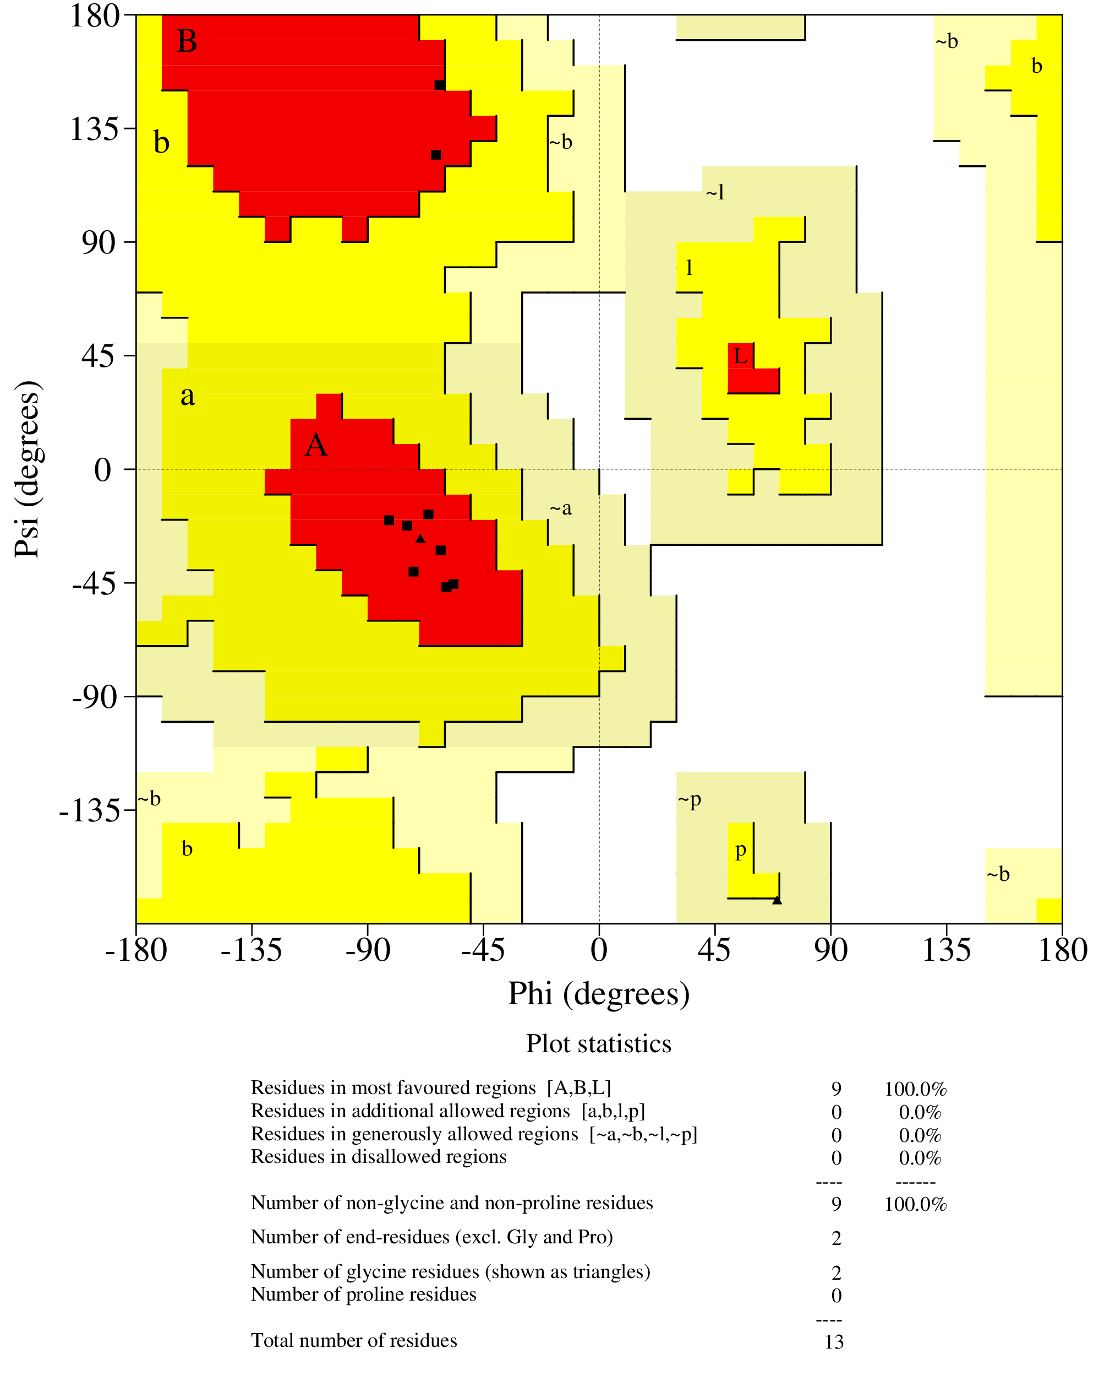
Fig. 3: Ramachandran plot of I-TASSER predicted LEA II peptide generated by PROCHECK of SAVES v6.0 webserver.

Table 1: Structural validation of LEA II peptide predicted by different modelling webservers
Modelling webservers | ERRAT  (%) | PROCHECK  Ramanchandran Plot (%)
Modelling webservers | ERRAT  (%) | Favoured | Allowed | Generous | Disallowed | G-factors
PEPstrMOD | 100 | 55.6 | 44.4 | 0 | 0 | -1.38
PEP-FOLD | 100 | 100 | 0 | 0 | 0 | -0.26
I-TASSER | 100 | 100 | 0 | 0 | 0 | -0.28

* The output data from molecular docking and dynamic simulation will be provided upon request.

Supplementary 5: Graphical Abstract

