Novel Fe/Ca oxide co-coated biochar enables efficient phosphorus recovery
Anqi Hu a,c†, Yongcan Jiang a,b† *, Jiaqi An ^{c}, Xiaodian Huang ª, Abdelbaky Hossam Elgarhy ^{c,d}, Huafen Cao ^{c}, Guanglong Liu ^{c}

Affiliation
ª PowerChina Huadong Engineering Corporation Ltd., Hangzhou 311122, Zhejiang Province, China;
^{b} Institute of Soil and Water Resources and Environmental Science, College of Environmental and Resource Sciences, Zhejiang University, Hangzhou 310058, Zhejiang Province, China;
^{c} State Environmental Protection Key Laboratory of Soil Health and Green Remediation, College of Resources and Environment, Huazhong Agricultural University, Wuhan 430070, China;
^{d} Central Laboratory for Environmental Quality Monitoring (CLEQM), National Water Research Center (NWRC), Qalyobia, 13621, Egypt.

*Corresponding author:
Mr. Yongcan Jiang. E-mail: jiangyc6@zju.edu.cn. Tel:+86-130-1592-2119
† Contributed equally to this work.
CONTENTS:
Table S1 Surface area and pore structure of BC and FCBC
Table S2 Parameters for adsorption isotherm of P on FCBC
Table S3 Comparison of the maximum adsorption capacity of different biochar adsorbents for P
Table S4 Parameters for adsorption kinetics of P on FCBC
Fig. S1 Element mapping of BC(a) and FCBC(b)
Fig. S2 C 1s (a) and O 1s (b) XPS spectra of BC
Fig. S3 Phosphorus adsorption capacity of FCBC at different pyrolysis temperatures
Fig. S4 The abundance ratio of phosphates in solutions of varying pH
Fig. S5 Determination of the point of zero charge of FCBC

Table S1 Surface area and pore structure of BC and FCBC
 | S_{BET} (m²/g) | Pore volume (cm³/g) | Pore size (nm)
BC | 291.2934 | 0.218585 | 4.2745
FCBC | 441.5189 | 0.263961 | 3.3788

Table S2 Parameters for adsorption isotherm of P on FCBC
Models | Parameter 1 | Parameter 2 | R²
Langmuir | K_{L}=0.01623 L/mg | Q_{m}=53.3131 mg P/g | R²=0.9982
Freundlich | K_{F}=4.1684 mg^{1-1/n}·g⁻¹·L^{1/n} | 1/n=0.4168 | R²=0.9631

Table S3 Comparison of the maximum adsorption capacity of different biochar adsorbents for P
Adsorpant | Isotherm | Kinetics | Q_{max} (mg/g) | References
MgO-modified biochar | F | S | 18.98 | (Wu et al. 2019)
Palm waste biochar | L | S | 26.90 | (Fseha et al. 2021)
Lime sludge modified biochar | R-P | S | 15 | (Yang et al. 2021)
Hydrocotyle vulgaris derived novel biochar beads | L | S | 20.32 | (Fu et al. 2022)
Fe/Mg-Biochar Nanocomposites | L-F | S | 6.95 | (Tao et al. 2020)
Lanthanum-ammonia-modified hydrothermal biochar | L | S | 43.1 | (Shang et al. 2022)
ZrO₂ nanoparticles embedded in biochar modified with layered double oxides nanosheets | L | S | 20.36 | (Song et al. 2024)
FCBC | L | S | 53.31 | This study
F, L, R-P, and S represent Freundlich, Langmuir, Redlich-Peterson, and Pseudo-second-order, respectively.

Table S4 Parameters for adsorption kinetics of P on FCBC
Models | Parameter 1 | Parameter 2 | R²
Pseudo-first-order | k₁=0.0049 | Q_{e}=18.1213 mg P/L | R²=0.9844
Pseudo-second-order | k₂=0.0002 | Q_{e}=22.2797 mg P/L | R²=0.9939
Intraparticle diffusion | k_{i1}=0.8783 | C₁=-1.0271 | R²=0.9961
Intraparticle diffusion | k_{i2}=0.6253 | C₂=2.4845 | R²=0.9921
Intraparticle diffusion | k_{i3}=0.0701 | C₃=16.4141 | R²=0.9911

Table S5 Physical and chemical properties of water samples
Parameters | Samples
Parameters | Ponds | Farmlands | Ditches
pH | 8.14±0.064 | 8.79±0.089 | 8.02±0.042
DOC (mg/L) | 10.3±0.505 | 11.5±0.156 | 15.8±0.459
TP (mg/L) | 0.34±0.004 | 0.53±0.005 | 0.11±0.002
DOP (mg/L) | 0.21±0.002 | 0.37±0.003 | 0.084±0.001
TN (mg/L) | 0.92±0.014 | 1.13±0.014 | 0.89±0.014
NO₃⁻-N (mg/L) | 0.150±0.001 | 0.140±0.001 | 0.525±0.002
NO₂⁻-N (mg/L) | 0.009±0.002 | 0.010±0.001 | 0.072±0.002

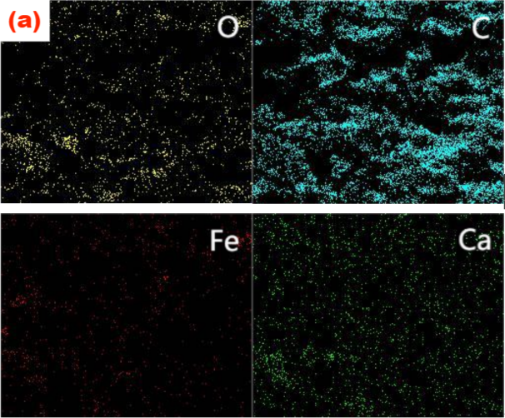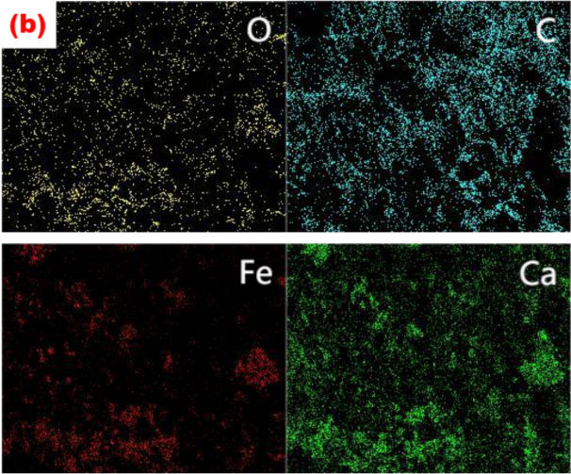
Fig. S1 Element mapping of BC(a) and FCBC(b)
Fig. S2a demonstrated that the C1s XPS spectra of BC can be categorized into five distinct peaks, which corresponded to C-C/C-H (284.8 eV), C-O (286.1 eV), C=O (287.8 eV), O-C=O* (289.3 eV), and CO₃²⁻ (290.3 eV). The O1s spectra of BC (Fig. S2b) exhibited three distinct peaks corresponding to C-O-C/C-O-H (532.5 eV), O=C-O* (533.9 eV), and C=O/CO₃²⁻ (531.1 eV).
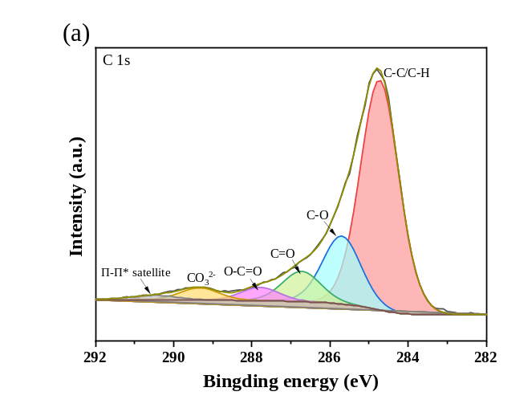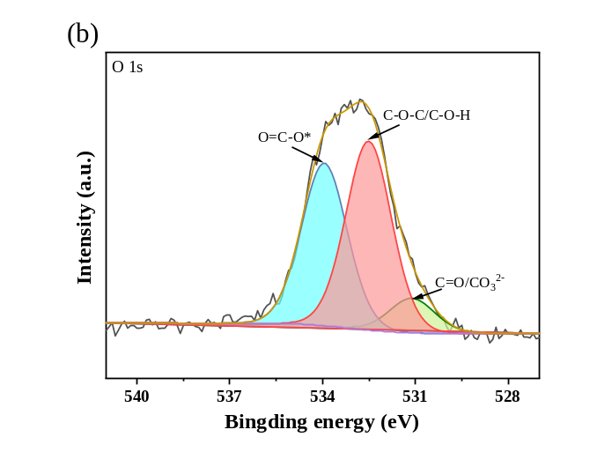
Fig. S2 C 1s (a) and O 1s (b) XPS spectra of BC

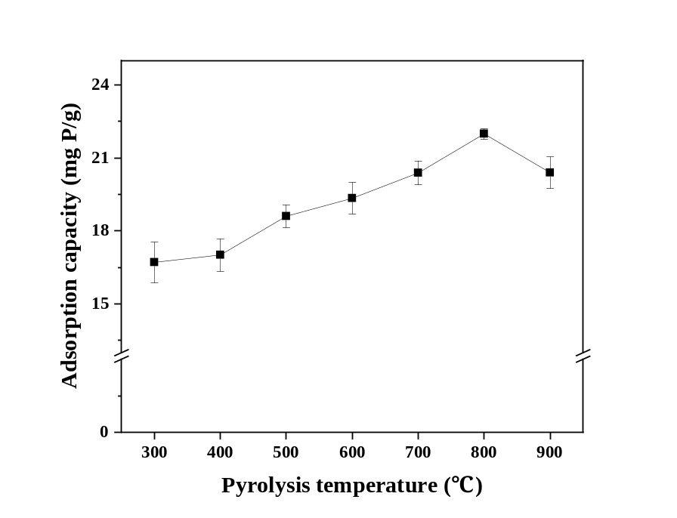
Fig. S3 Phosphorus adsorption capacity of FCBC at different pyrolysis temperatures

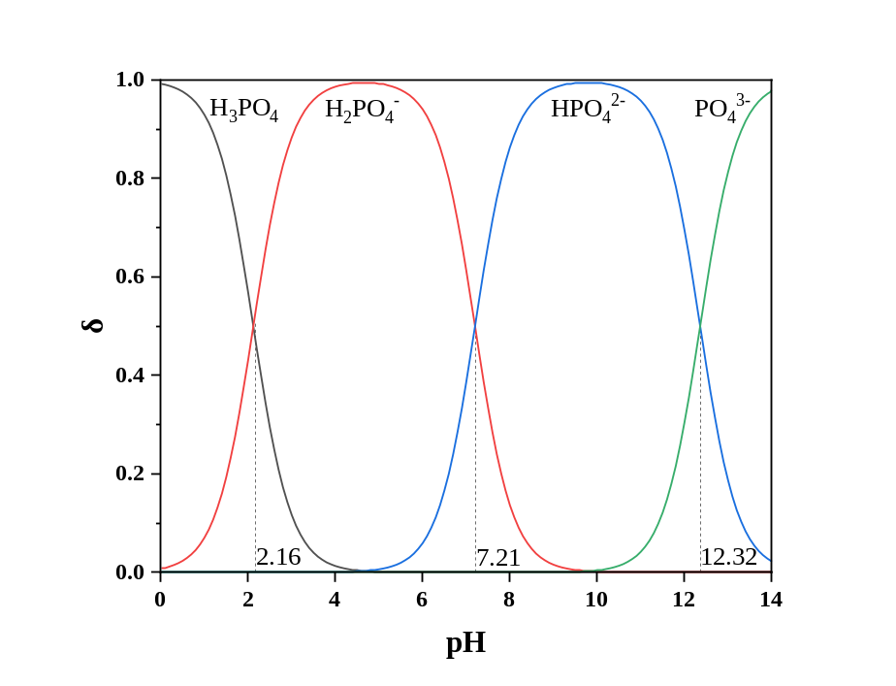
Fig. S4 The abundance ratio of phosphates in solutions of varying pH (Yin et al. 2018)

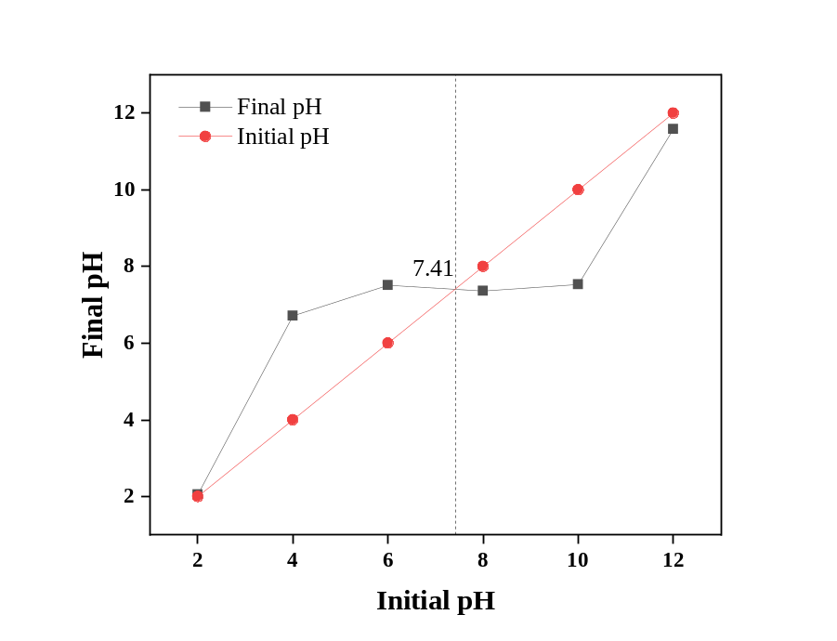
Fig. S5 Determination of the point of zero charge of FCBC

References
Fseha YH, Sizirici B, Yildiz I (2021) The potential of date palm waste biochar for single and simultaneous removal of ammonium and phosphate from aqueous solutions. J Environ Chem Eng 9. https://doi.org/10.1016/j.jece.2021.106598
Fu XX, Wang P, Wu JD, Zheng PY, Wang TT, Li XX, Ren MZ (2022) Hydrocotyle vulgaris derived novel biochar beads for phosphorus removal: static and dynamic adsorption assessment. J Environ Chem Eng 10. https://doi.org/10.1016/j.jece.2022.108177
Shang ZX, Wang YR, Wang SQ, Jin FL, Hu Z (2022) Enhanced phosphorus removal of constructed wetland modified with novel Lanthanum-ammonia-modified hydrothermal biochar: Performance and mechanism. Chem Eng J 449. https://doi.org/10.1016/j.cej.2022.137818
Song X, Chen X, Chen WQ, Ao TQ (2024) ZrO₂ nanoparticles embedded in biochar modified with layered double oxides nanosheets for phosphorus removal by capacitive deionization. Sep Purif Technol 328. https://doi.org/10.1016/j.seppur.2023.125117
Tao XF, Huang T, Lv B (2020) Synthesis of Fe/Mg-Biochar Nanocomposites for Phosphate Removal. Materials (Basel) 13. https://doi.org/10.3390/ma13040816
Wu LP, Wei CB, Zhang SR, Wang YD, Kuzyakov Y, Ding XD (2019) MgO-modified biochar increases phosphate retention and rice yields in saline-alkaline soil. J Cleaner Prod 235:901-9. https://doi.org/10.1016/j.jclepro.2019.07.043
Yang SM, Katuwal S, Zheng W, Sharma B, Cooke R (2021) Capture and recover dissolved phosphorous from aqueous solutions by a designer biochar: Mechanism and performance insights. Chemosphere 274:129717. https://doi.org/10.1016/j.chemosphere.2021.129717
Yin QQ, Ren HP, Wang RK, Zhao ZH (2018) Evaluation of nitrate and phosphate adsorption on Al-modified biochar: Influence of Al content. Sci Total Environ 631-632:895-903. https://doi.org/10.1016/j.scitotenv.2018.03.091

