Supplementary Material

Impact of Biocontrol Agents on Biochemical Changes of Aquatic Weed water hyacinth, Pontederia crassipes (Mart.) Solms-Laubach
Deblina Misra ^{1,2}, Writuparna Dutta ¹, Jorge Galarza Prieto ² and Puja Ray ^{1*}
¹ Multitrophic Interactions and Biocontrol Research Laboratory, Department of Life Sciences, Presidency University, 86/1 College Street, Kolkata -700073, India; d.writuparna@gmail.com; puja.ray@gmail.com
² Department of Biology, New Mexico State University, Las Cruces, NM 88003, USA; deblina.misra541@gmail.com ; jorge_1@nmsu.edu
* Correspondence: Deblina Misra, Dr. Puja Ray
deblina.misra541@gmail.com; puja.ray@gmail.com
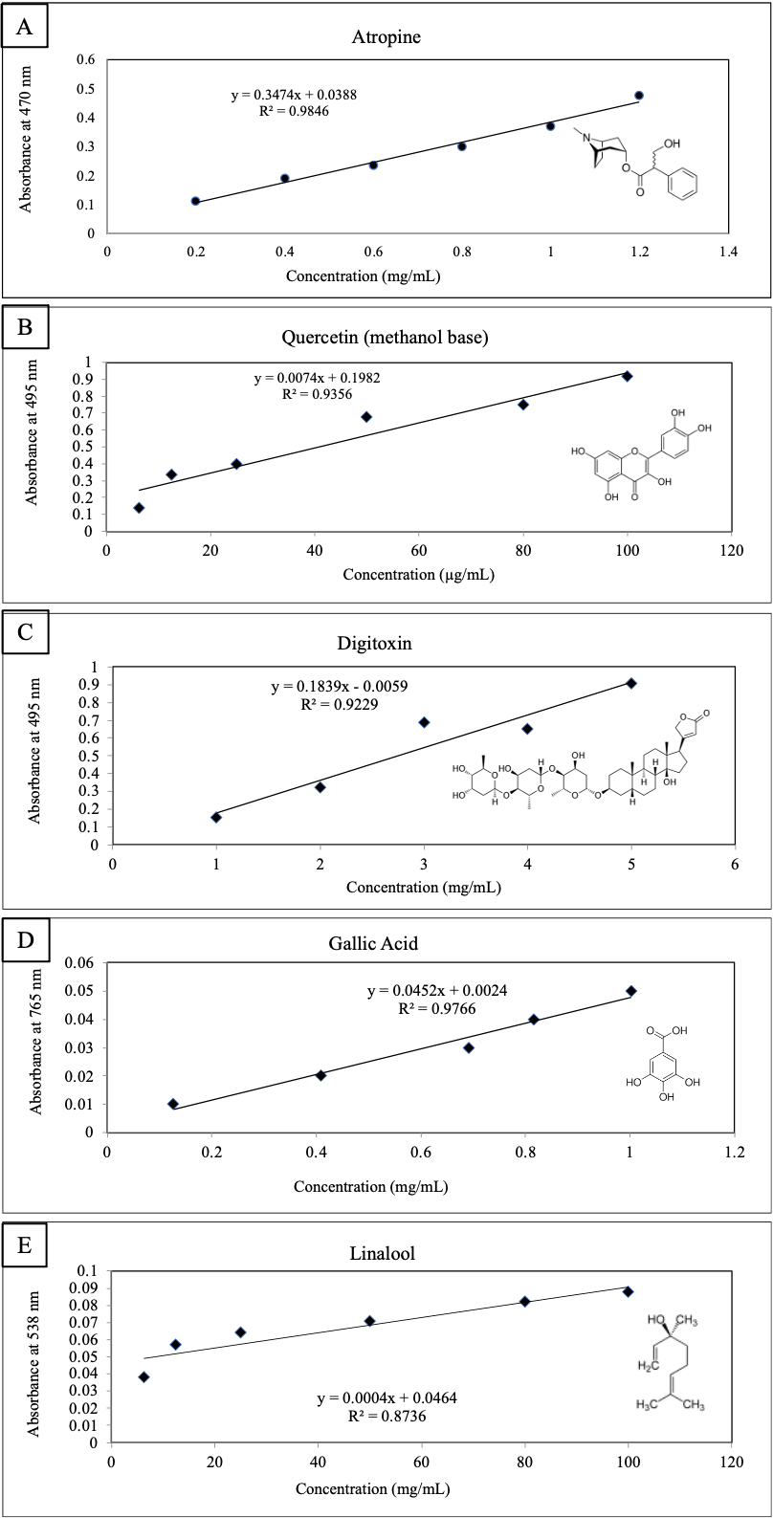

Figure S1: Standards for A: alkaloid prepared using atropine; B: flavonoid prepared using quercetin (methanol base); C: glycoside prepared using digitoxin; D: phenol and tannin prepared using Gallic Acid; E: terpenoid using Linalool
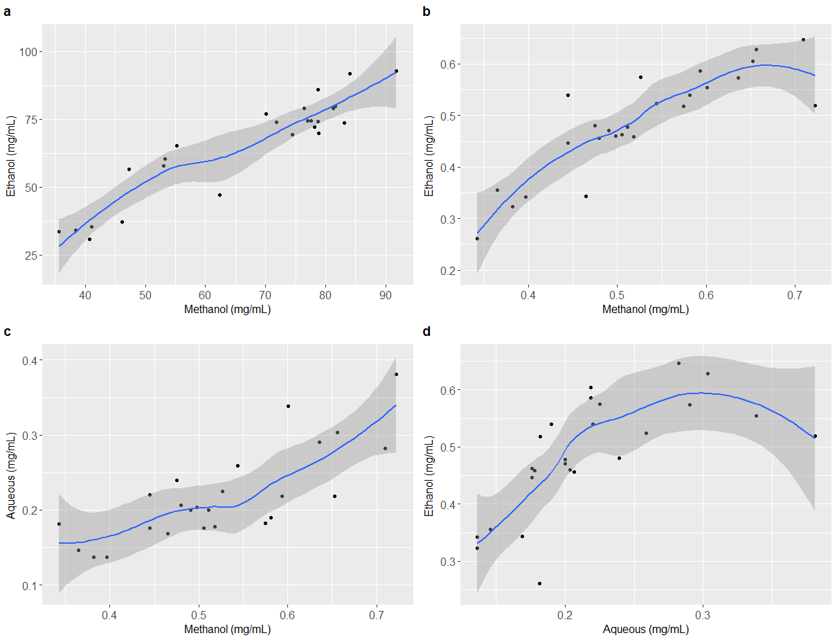
Figure S2: (A) Phenol, Methanol (mg/mL) ~ Ethanol (mg/mL) Spearman’s Rank correlation. rho: 0.87, p-value: 2.396e-08. (B) Glycoside, Methanol (mg/mL) ~ Ethanol (mg/mL) Spearman’s Rank correlation. rho: 0.85, p-value: 9.553e-08. (C) Glycoside, Methanol (mg/mL) ~ Aqueous (mg/mL) Spearman’s Rank correlation. rho: 0.74, p-value: 2.488e-05. (D) Glycoside, Aqueous (mg/mL) ~ Ethanol (mg/mL) Spearman’s Rank correlation. rho: 0.80, p-value: 1.94e-06.

