Appendix 2
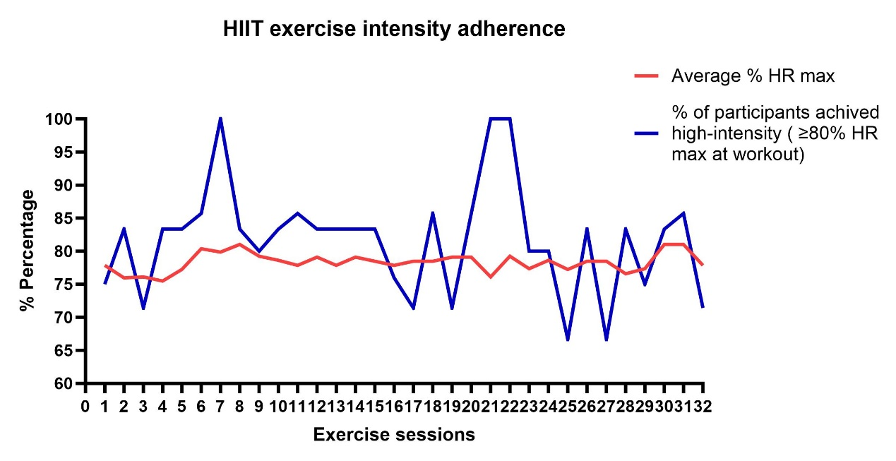
Fig S1. The exercise intensity achieved over the course of the HIIT sessions as indexed by average % HRmax, and % of participants achieved high-intensity (≥80%HRmax at workout).
HR: heart rate; HIIT: High-intensity interval training.

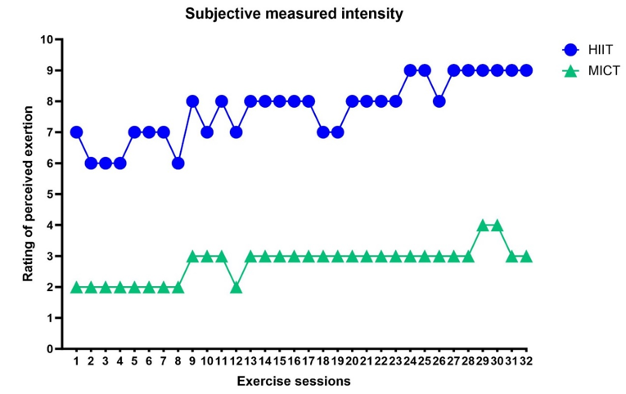

Fig. S2. Group average for exercise intensity achieved over the course of the exercise sessions as indexed by RPE. For the HIIT group, the data indicate overall RPE of ten HIIT workouts collected immediately after the completion of the 10th HIIT work in each HIIT session. For MICT-BDJ group, the data indicate overall RPE of Baduanjin exercise collected immediately after the completion of the last Baduanjin movement in each Baduanjin session.
RPE: rating of perceived exertion; HIIT: high-intensity interval training; MICT-BDJ: moderate-intensity continuous training-Baduanjin.

