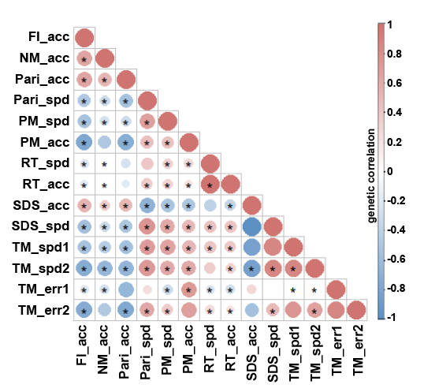
Figure S1. Genetic correlation estimations for 14 cognitive traits using LDSC. The size and color indicate the value of genetic correlation, and the sign (*) indicates the statistical significance after Bonferroni correction (p < 0.05/91). A full description of the abbreviation is in the Table S2.

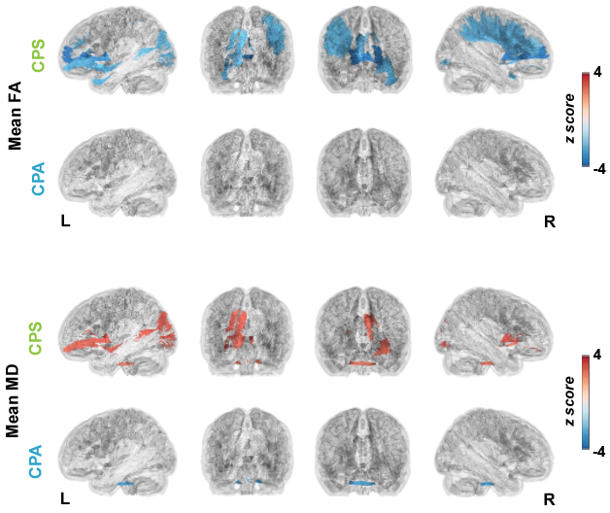
Figure S2. Genetic correlation between the two factors and microstructure in 27 white matter tracts. The color indicates the z-score of the genetic correlation (estimation/standard error), non-significant results are gray in the figure.
CPS = cognitive processing speed, CPA = cognitive processing accuracy.

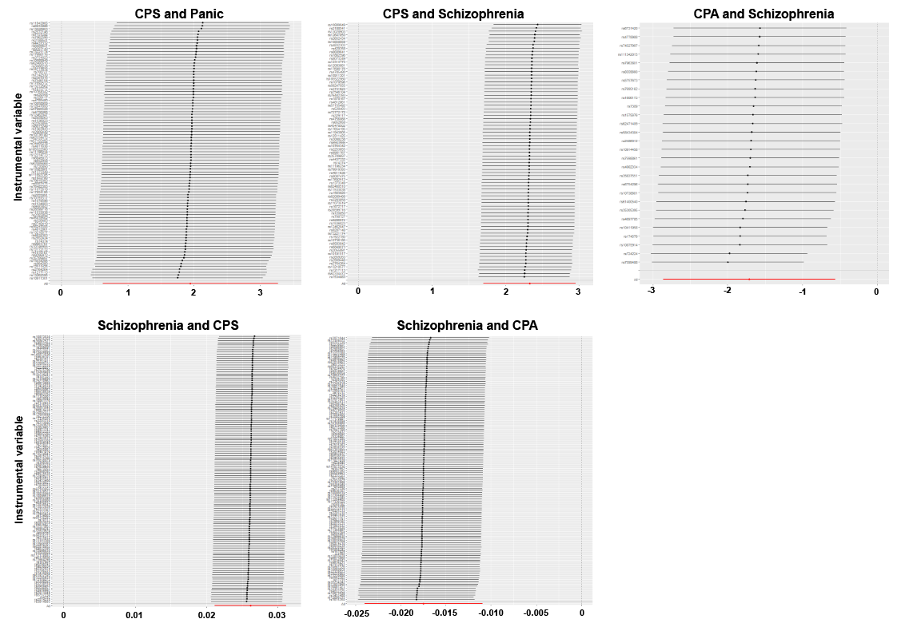
Figure S3. Leave-one-out sensitivity analysis in the two-sample Mendelian randomization analyses. The x-axis indicates the estimation of the single instrumental variable (black line) and all the instrumental variables (red line).
CPS = cognitive processing speed, CPA = cognitive processing accuracy.

