Mycorrhiza
Contrasting metabolic responses of two chickpea varieties to root infection by Phytophthora are influenced by arbuscular mycorrhizal inoculation
Natascha V. Weinberger^{1,}*, Jeff R. Powell¹, Meena Mikhael³, Krista L. Plett^{1,2}, Jonathan M. Plett¹
¹Hawkesbury Institute for the Environment, Western Sydney University, Penrith, NSW, Australia
² Elizabeth Macarthur Agricultural Institute, NSW Department of Primary Industries, Menangle, NSW, 2568
³Western Sydney University Mass Spectrometry Unit, Campbelltown, NSW, Australia
*Corresponding author: n.weinberger@westernsydney.edu.au

Supplementary Material
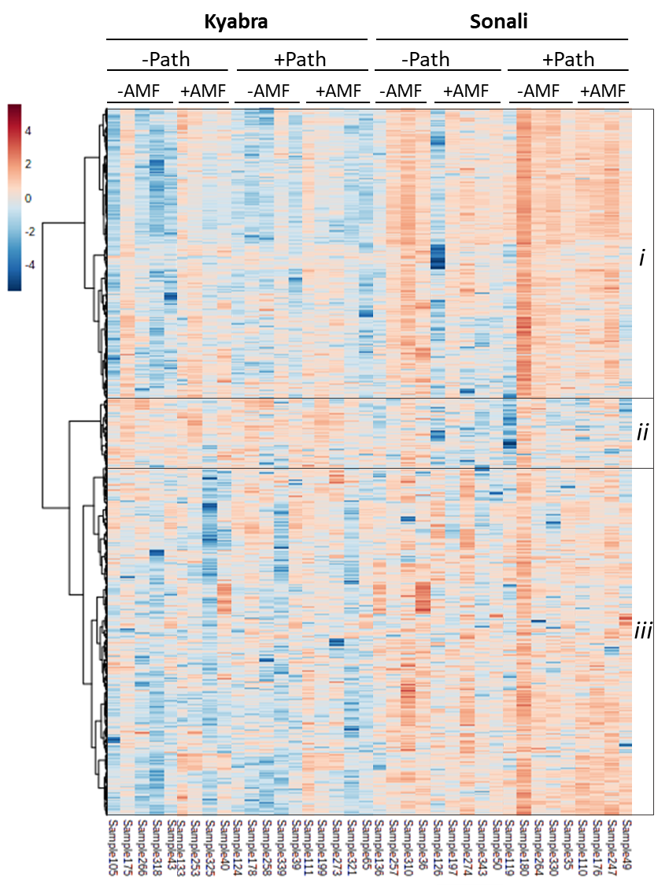
Figure.S1 Hierarchical clustering of the normalized data points of all 300 significant features in negative mode, detected in the two varieties Kyabra and Sonali with (+AMF) or without (-AMF) AM fungal inoculation and/or pathogen treatment with Phytophthora medicaginis (+/-Path) ranked by ANOVA (P<0.05) using log10 transformed and weight-specific normalized data. Euclidean distance measure and Ward method were used for clustering. Red values indicate high metabolite occurrence while blue indicates low metabolite occurrence

Table.S2 Number of up/down regulated features in all the treatment comparisons in Kyabra and Sonali, in positive mode. Downregulated features shaded in blue.
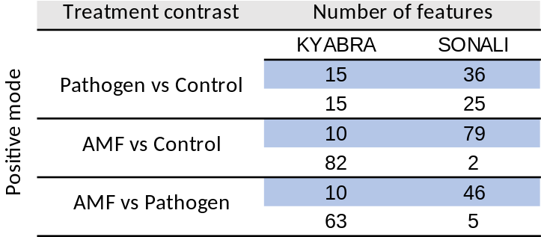

Table.S3 Number of up/down regulated features in all three treatment comparisons in Kyabra and Sonali, in negative mode. Downregulated features shaded in blue
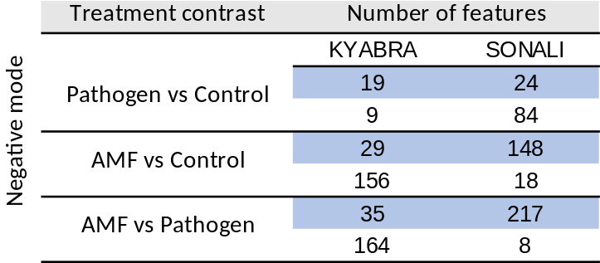
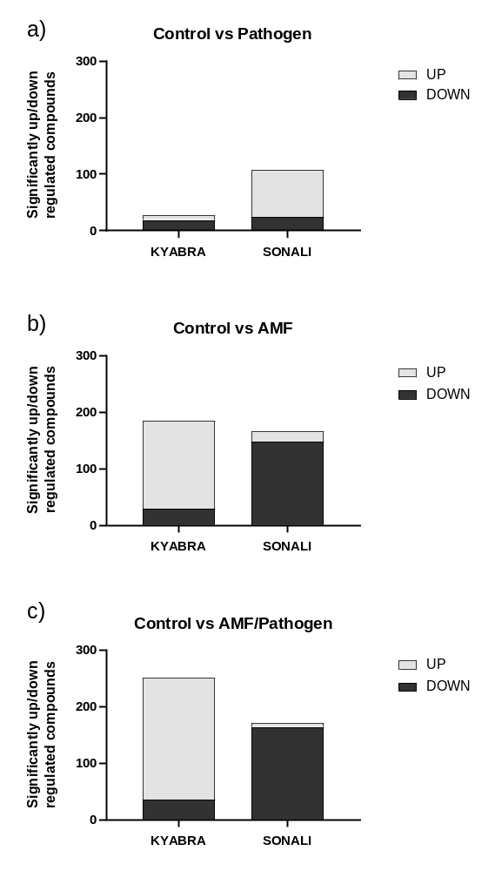
Figure.S2 Analysis of the number of features in each of the three treatment contrasts in negative mode. a Pathogen contrast (Ctrl vs Path treatment), b AMF contrast (Ctrl vs AMF treatment), c tripartite contrast of AMF/Pathogen (Control vs AMF/Path treatment)

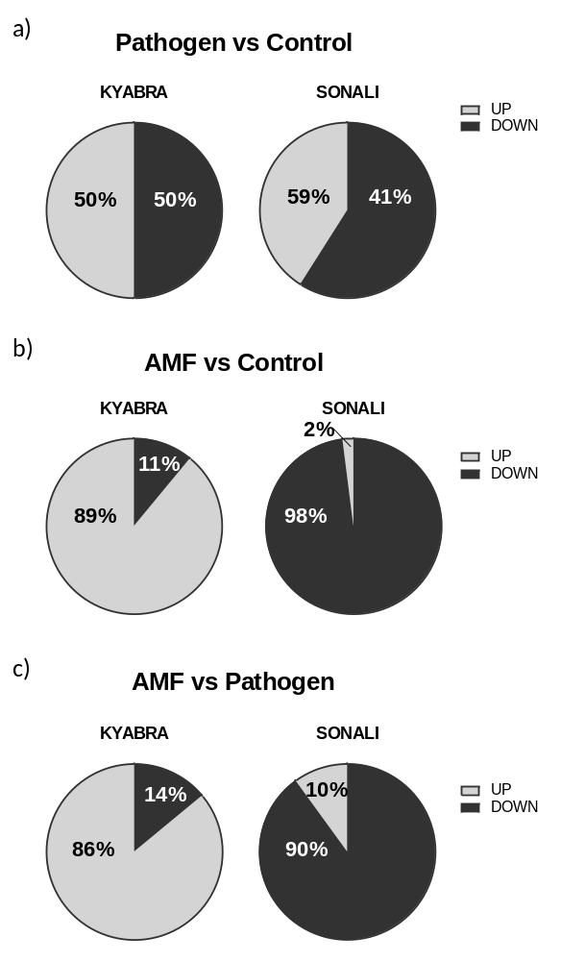
Figure.S3 Analysis of the percentage of features in each of the three treatment contrasts. a Pathogen contrast (Ctrl vs Path treatment), b AMF contrast (Ctrl vs AMF treatment), c tripartite contrast of AMF/Pathogen (Control vs AMF/Path treatment)

